LIGO Laboratory / LIGO Scientific Collaboration

E1000393-v3 LIGO 21 Oct. 2010

Stage 0-1 Horizontal Actuator Assy Procedure

S.BISCANS, M.HILLARD

Distribution of this document:
Advanced LIGO Project

This is an internal working note
of the LIGO Laboratory.

California Institute of Technology  LIGO Project – MS 18-34  1200 E. California Blvd.  Pasadena, CA 91125  Phone (626) 395-2129  Fax (626) 304-9834  E-mail: info@ligo.caltech.edu | Massachusetts Institute of Technology  LIGO Project – NW22-295  185 Albany St  Cambridge, MA 02139  Phone (617) 253-4824  Fax (617) 253-7014  E-mail: info@ligo.mit.edu
LIGO Hanford Observatory  P.O. Box 1970  Mail Stop S9-02  Richland WA 99352  Phone 509-372-8106  Fax 509-372-8137 | LIGO Livingston Observatory  P.O. Box 940  Livingston, LA 70754  Phone 225-686-3100  Fax 225-686-7189

Note : ! Make sure there is no trash in the coil !
Remove the shoulder screws and watch carefully inside the coil.

Clean room standards
For a clean assembly all LIGO standards should be followed, as presented in the latest version of the LIGO Contamination Control Plan (E0900047). Clean room garb including UHV gloves should be worn when working with parts.
All tools that come in contact with assembly should be cleaned to class B standards.
Assembly will be done under a portable clean room. Any time a part of the assembly is not covered by the portable clean room or not being actively worked on it should be covered with appropriate clean covers. (C3 polyester or equivalent).

Parts prep work: alignment pins and helicoils
To facilitate assembly, parts requiring helicoils and/or pins to be inserted before assembly will be listed to allow preliminary preparation of the parts, after cleaning and before starting general assembly. See E1000402 Current Rev.

Helicoil:

1. D0902424

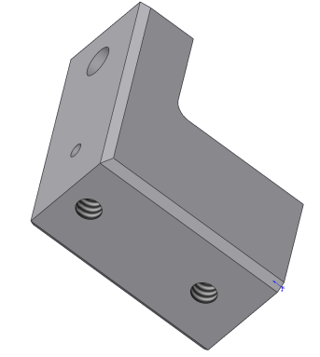
Helicoil 1/4-20, length 2XDIA, #1185-4EN .500

2. D0902427
Helicoil 1/4-20, length 2XDIA, #1185-4EN .500
Helicoil 3/8-16, length 2XDIA, #1185-6EN .750

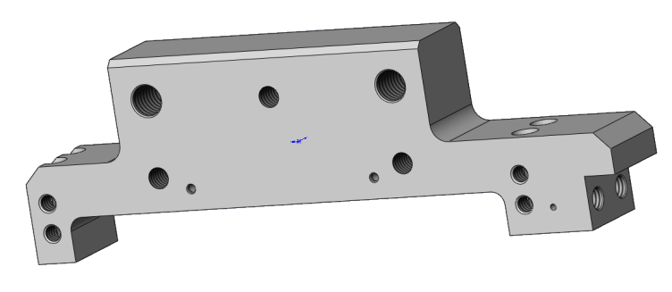
Helicoil 10-32, length 1.5XDIA, #1191-3EN .285
Helicoil 1/4-20, length 1.5XDIA, #1185-4EN .375

3. D0902310
Helicoil 5/16-18, length 2XDIA, #1185-5EN .625

Helicoil 1/4-20, length 1.5XDIA, #1185-4EN .375

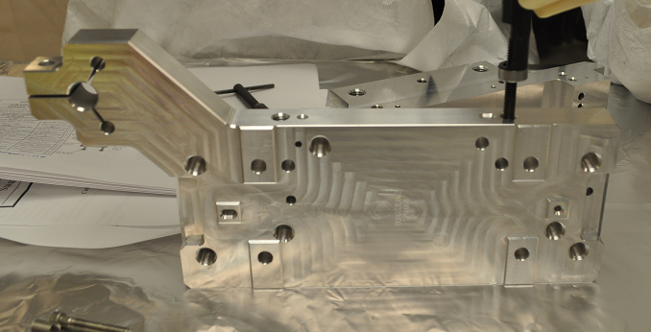

Dowel:

1. D0902310
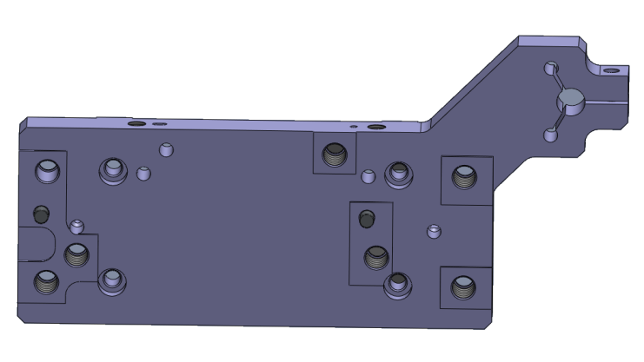
Dowel Pin 1/4X5/8
MC MASTER 90145A539
2. D0902436

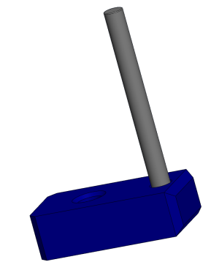  Dowel Pin 1/8X11/2  MC MASTER 98380A479 | 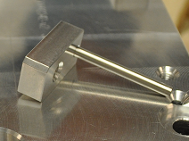

3. D0902427

Dowel Pin 3/32X1/2
MC MASTER 90145A438
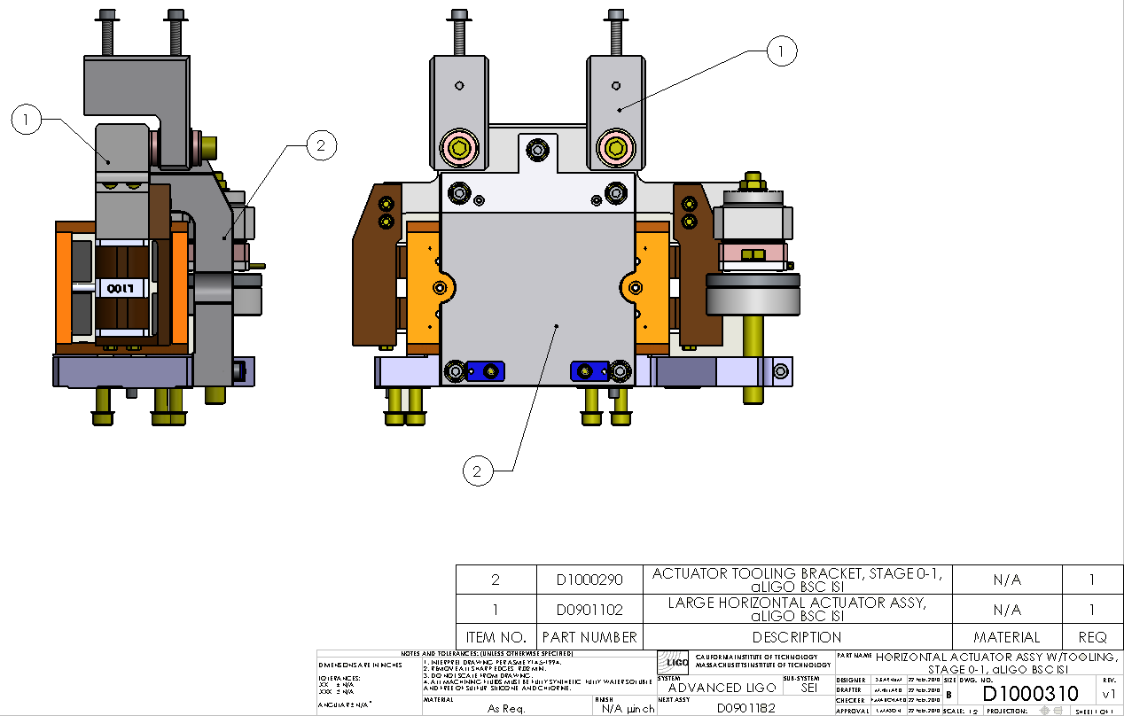

Reference D1000310 : Intermediate Assembly with tooling
Reference D0901102 : Final assembly between Stage 0 and Stage 1

Assembly Instructions

1. Insert Item (23) (D10002282) Step Pin into Item (3) (D0902749) Large Actuator.

Note : Non pined face
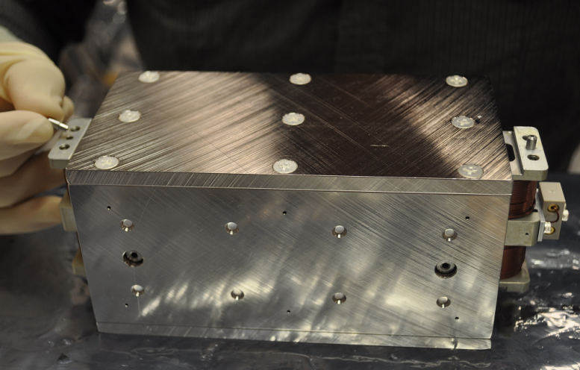

2. Attach Item (2) (D0902427) Actuator Coil Bracket as shown Figure 2, to Item (23) (D10002282) Step Pin and Item (3) (D0902749) Large Actuator using Item (12) vent washer and Item (13) screw.
10-32 X 1.375 lg.
MSC 04214292
Torque value : 31.7 in-lbs

3  2 | 0.195 ID, 0.354 OD, 0.032 THK #10  UC COMPONENTS WFV-10

Note : edge of Item 7 and the yellow block are on the same side
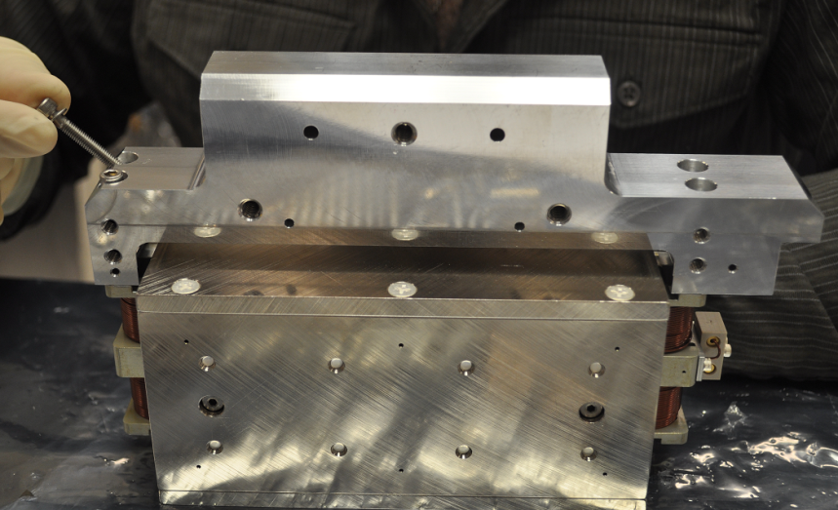

3. Attach Items (7) (D1000175) Left Thermal Bar and Item (6) (D1000176) Right Thermal Bar, to Item (3) (D0902749) Large Actuator and Item (2) (D0902427) Actuator Coil Bracket using Item (12) washer and Items (10)/(11) screws.
0.195 ID, 0.354 OD, 0.032 THK #10  UC COMPONENTS WFV-10  10-32 X 0.62 lg.  MSC 05678065  Torque value : 31.7 in-lbs | Hex machine screw10-32 X 3/8 lg. vented  UC COMPONENT H-1006

4. Insert Item Dowel Pin into Item (3) (D0902749) Large Actuator.

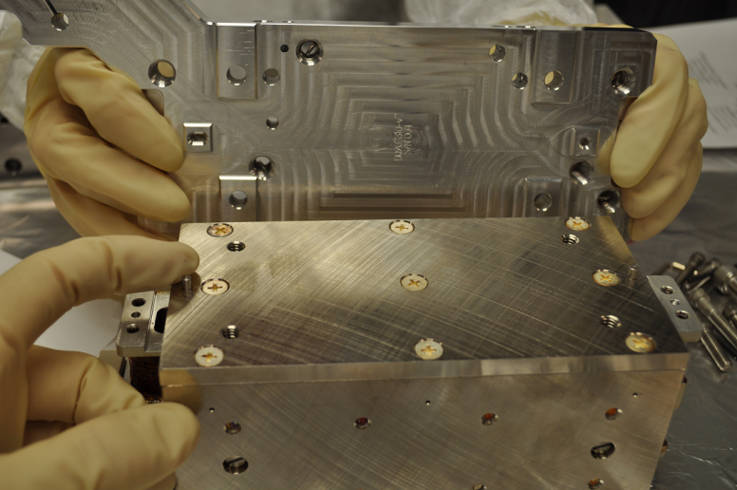
1/8 X 7/16 lg.
MC MASTER 90145A481

5. Attach Item (1) (D0902310) Actuator Magnet Bracket to the Bottom of Item (3) Actuator as shown Figure 4 using Items (17) vent washer and Item (18) screw.
1/4-20X0.875 lg.
HOLOKROME 78060
Torque value : 100 in-lbs
3  1  Note : the two edges are on the same side | 0.255 ID, 0.46 OD, 0.032 THK  UCC WFV-25
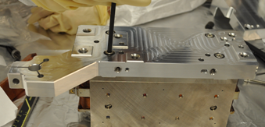

6. Tooling Bracket Assembly

Attach only the top of Item (2) (D1000290) tooling Bracket Assembly with 3 screws.
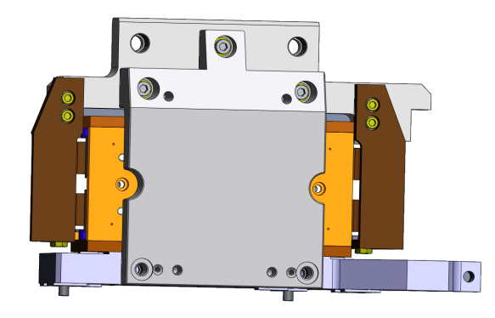

Torque value : 100 in-lbs

7. Loose the 4 shoulder screws of Item (3) (D0902749) Large Actuator.

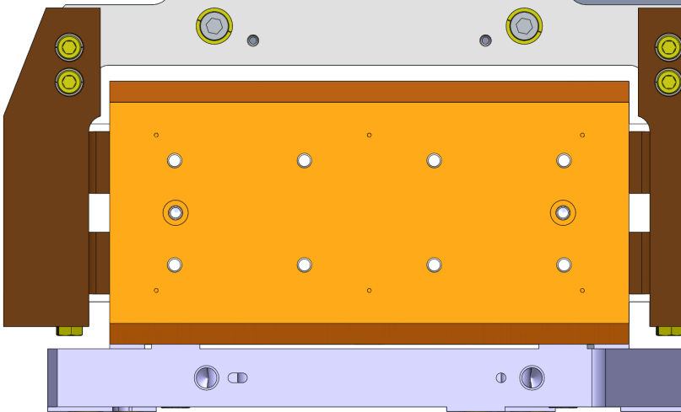

8. Slide Pin Carrier (D0902436) into the Tooling Bar and Item 1 (D0902310).

9. Remove the 4 shoulder screws of Item (2) (D0902749) Large Actuator.

10. Add the two last screws and washers in the Tooling Bar.
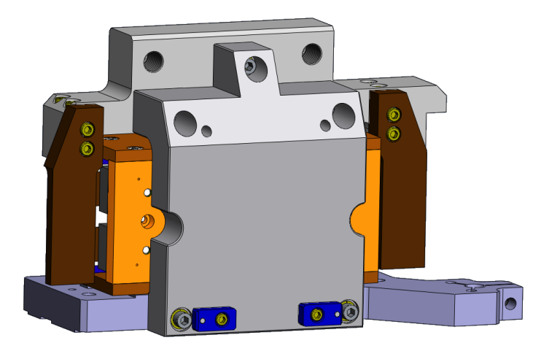 | 0.255 ID X 0.468 OD X 0.032 THK  UC COMPONENT WFV-25  1/4-20X1.5 lg.  HOLOKROME 78066  Torque value : 100 in-lbs

11. Remove the Pin Carrier (D0902436).

Gap Test : Go / No Go

- Check the gap between the coil and the magnet with shims on both sides.
Go : 0.085 inches
No Go : 0.115 inches

