LASER INTERFEROMETER GRAVITATIONAL WAVE OBSERVATORY
-LIGO-
CALIFORNIA INSTITUTE OF TECHNOLOGY
MASSACHUSETTS INSTITUTE OF TECHNOLOGY
Safety Protocol LIGO-M1000228-V1 13 October 2010

LIGO Livingston Observatory Laser Safety Plan
R. S. Amin, D. Kinzel

------------------------------------------------ ---------------------------------------------------

LIGO Hanford Observatory LIGO Livingston Observatory
P.O. Box 1970; Mail Stop S9-02 19100 LIGO Lane
Richland, WA 99352 Livingston, LA 70754
Phone (509) 37208106 Phone (225) 686-3100
Fax (509) 372-8137 Fax (225) 686-7189
E-mail: info@ligo.caltech.edu E-mail: info@ligo.caltech.edu

California Institute of Technology Massachusetts Institute of Technology
LIGO project – MS 18-34 LIGO project – MS 20B-145
Pasadena, CA 91125 Cambridge, MA 01239
Phone (626) 395-2129 Phone (617) 253-4824
Fax (626) 304-9834 Fax (617) 253-7014
E-mail: info@ligo.caltech.edu E-mail: info@ligo.mit.edu

Contents
1 Introduction 3
2 Site Safety and Responsibility 4
2.1 Observatory Head 4
2.2 Observatory Manager/Site Safety Officer (SSO) 4
2.3 Laser Safety Officer (LSO) 4
2.4 On-Duty Control Room Operator 5
2.5 Responsible Laser Operator (RLO) 5
3 Laser Status Signs 6
3.1 Laser Status Sign 6
4 Access Cards 9
5 Nominal Hazard Zones and Access Controls 11
5.1 LVEA 11
5.2 PSL Enclosure/LDR NHZs 15
5.3 Optics Lab NHZ 17
5.4 VEAX and VEAY 18
5.5 HPLF 20
6 Temporary NHZ 21
7 Emergency Hardware Locations 22
7.1 Emergency Laser Shutdown Buttons 22
7.2 Telephones/Intercoms: 22
7.3 Fire extinguishers: 22
7.4 Eyewash/Chemical Shower Stations: 22
8 Personnel Protection 24
8.1 Physical Barriers: Boxes, Shields, and Beam Dumps 24
8.2 Personal Protection Equipment 24
9 Laser Application Policy 25
9.1 Application Packet List 25
10 LLO Lab Laser Safety Rules 26
10.1 LVEA 26
10.2 VEAX/VEAY 27
10.3 PSL Enclosure/LDR 28
10.4 HPLF 29
10.5 Optics Lab 30
10.6 Posting Rules 30
11 Audits 31
12 Schedules 32
13 References 33

Introduction
This document contains laser safety information pertinent to the health and safety of staff and the protection of equipment at the LIGO Livingston Observatory (LLO). This document addresses laser specific hazard issues exclusively at the LLO.

This document relies on the LIGO Laser Safety Plan M960001 and ANSI Z136.1. Failure to follow the policies in this document may result in injury or loss of privileges.

Other LIGO sites have similar policies, however, staff and visitors are reminded that each location has a site specific laser and safety plan.

All LLO laser safety procedures, standard operating procedures, and FMEAs fall under this safety policy. In any scenarios, the LLO laser safety policy may be amended or altered on-site by the standing Laser Safety Officer or Observatory Manager.

Site Safety and Responsibility
The LIGO Directorate requires all on-site personnel and guests to keep a safe working environment. Each individual has a right and responsibility to halt any activity that violates safety policy and/or procedure. Any individual who identifies a hazard must make that information known to group leaders.

At each site, there are four individuals who share primary responsibility for site and staff safety.

Observatory Head
The Observatory Head is ultimately responsible for all personnel and equipment at LIGO Livingston Observatory. The Observatory Head’s authority extends from the LIGO Directorate. To accelerate and execute the LIGO Safety Plan LIGO-M950046, the responsibility is delegated to the Observatory Manager.

Observatory Manager/Site Safety Officer (SSO)
The Observatory Manager’s primary safety duties pertain to carrying out the LIGO Safety Plan in a means that minimally affects progress and maximizes staff safety. The Observatory Manager as Site Safety Officer (SSO) is responsible for general safety of site personnel and equipment, making certain that personnel and equipment are following current practices for safety. This officer is responsible for advocating the mentality of safety to groups or individuals working at LLO, taking the lead in safety decisions, conducting work permit meetings, and updating the staff in general hazards due to work on-site. Lapses in safety are reportable to the Observatory Manager. Pending actions will be determined by this officer and the Laser Safety Officer.

Laser Safety Officer (LSO)
The Laser Safety Officer (LSO) assists the Observatory Manager in matters of laser safety. The LSO executes the LIGO Laser Safety Plan LIGO-M960001 as it applies to the LIGO Livingston Observatory, maintains site specific laser safety documents, and enforces the document’s safety policies.

LSO duties:
- Maintains laser documents
- Provide basic laser safety training
- Maintain the list of qualified laser operators
- Maintain an updated list of site authorized class 3B and class 4 lasers
- Periodically inspect laser safety controls
- Provide adequate personal protective equipment (PPE) for all qualified laser operators and guests
- Inspect standard operating procedures (SOP)
- Inspect failure mode effects analyses (FMEA) relevant to LLO
- Inspect hardware compliance
- Participates in the LIGO Safety Steering Committee (LSSC)
- Investigate laser incidents and file reports with the LSSC, Observatory Manager, and Observatory Head as required
- Authorizes nominal hazard zone key cards
- Consult with laser sponsors on SOP/FMEA and laser applications
- Approve laser installations before initial activation and periodically certify their safety for continued operation

In the absence of the Laser Safety Officer, the Observatory Manager will assume full responsibility for laser safety.

On-Duty Control Room Operator
During nominal operations, the on-duty control room operator is responsible for the immediate safety of all personnel on site. All work related activities must be cleared and coordinated through the control room operator before work begins. This includes generic work in the technical areas, laser operations, and changes to the optical configuration.

The on-duty control room operator is responsible for yielding or denying permission to begin work. He may also suggest alternative scheduling to prevent possible conflicts with regard to personnel health, safety, and/or equipment use.

If scheduling does not permit control room operators to be on shift, trained and authorized members of staff may serve as acting operators.

To prevent conflicts of interest, staff scientists and engineers are not permitted to be control room operators. The control room operators are trained personnel who not only know how to operate the interferometer but are also knowledgeable in the general emergency procedure.

Responsible Laser Operator (RLO)
The responsible laser operator (RLO) is a qualified laser operator who is charged with the general safety of other individuals and the coordination of activity around an optical table. This person serves as the primary point-of-contact during optical table work. The qualified laser operator filing a work permit is designated the RLO unless otherwise indicated. When work permits are closed, the RLO designation is dissolved.

Laser Status Signs
LIGO recognizes two safety conditions, “LASER SAFE” and “LASER HAZARD.”

The “Laser Safe” condition exists only when all class 3B and class 4 laser power supplies have been locked and tagged out or cannot physically enter a lab area’s nominal hazard zone (NHZ) due to qualified enclosures. In this condition, any person entering a lab area must follow semi-clean guidelines indicated by the Observatory Manager and/or LSO.

The “Laser Hazard” condition exists any time a class 3B or class 4 laser in a given lab area is capable conveying radiation into a lab area (i.e., plugged in but turned off). In this condition, site laser safety protocols, specific laser lab, and pertinent operating procedures rules must be followed. Laser goggles must be worn at all times in this condition.

Laser Status Sign
Two basic types of laser status signs are found at LLO. These are “Illuminated Wall Signs” and “Portable Signs.”

Type 1: Illuminated Wall Signs

Illuminated wall signs are mounted at the following locations:
- The main LLO LVEA door
- The PSL enclosure door
- The LVEA large airlock door (portable style)
- The VEAX and VEAY NHZ main door
- The optics lab NHZ curtain entrance
- The HPLF main door

Illuminated, wall-mounted signs are able to display either “NO HAZARD” or “DANGER” (see Figure 1). These represent “LASER SAFE” and “LASER HAZARD” respectively. These signs are mounted adjacent to primary entrances and indicate the official hazard state of a laser lab. A key-operated switch changes the displayed hazard condition of a lab area. Status sign keys are kept in the control room key safe. Status keys may not be removed from the control room unless a lab area is transitioning from one hazard condition to another.

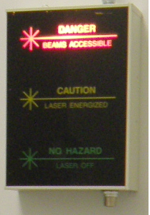
Figure 1: A typical wall mounted laser safety sign. This one shows that an area is presently in laser hazard. The status key switch (silver) can be found in the lower right of the picture. The “Caution” state is never to be used.

LIGO Livingston’s illuminated wall signs have a “Caution” setting. Illuminated wall signs are not permitted to be in this state.

Type 2: Portable Signs

Portable signs are found at the following locations:
- Side entry personnel door in the LVEA large airlock
- Instrument sensing and control tables, input/output table
- Emergency egress doors
- Temporary NHZs

Portable signs subdivide into lit signs and placards. Lit portable signs that indicate “LASER HAZARD” condition (see Figure 2) when turned on. Placards hanging on emergency egress doors or temporary NHZ barriers indicate the potential of laser hazard. Placards may not be removed or covered without LSO’s consent.

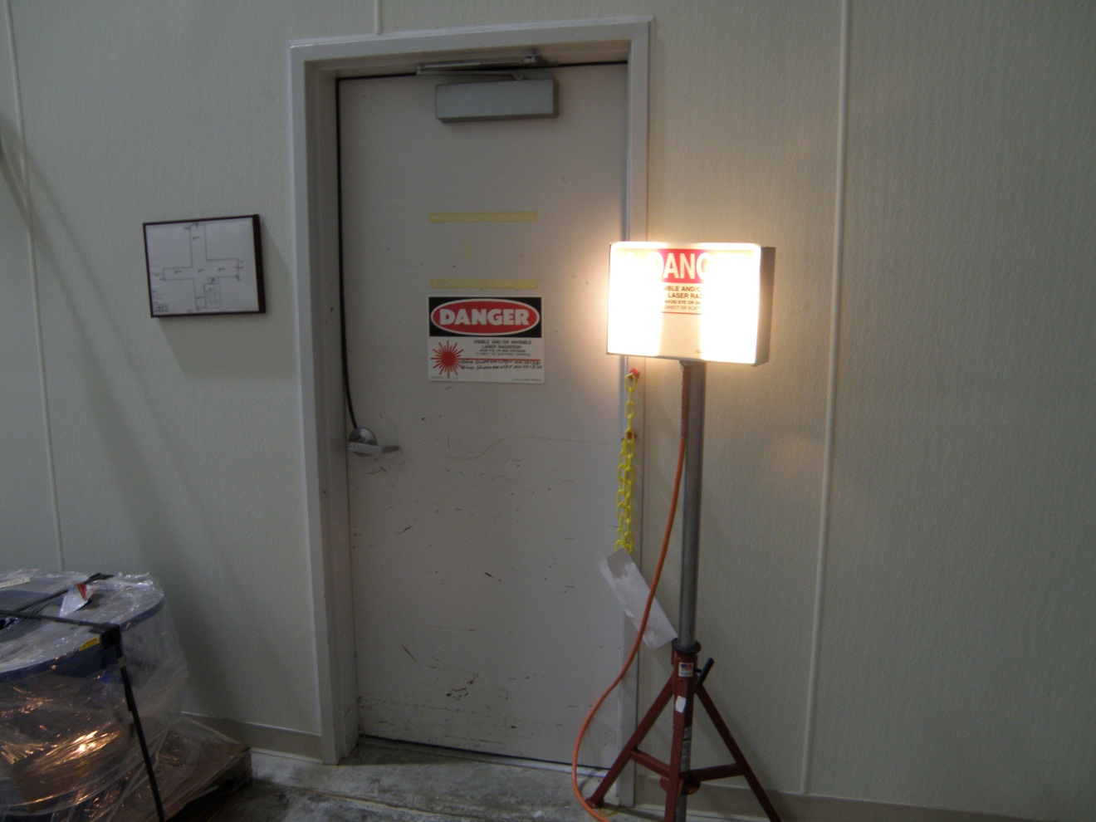
Figure 2: An example of a portable illuminated sign on the right. A posted unlit sign can be seen on the door. This photo was taken in the LVEA large airlock.

Access Cards
LLO’s NHZs and interferometer optical tables (IOT, ISCT, Transmission Sensors, Photon Calibrators, and TCS) are secured by Kantech Access Control Systems. This system is a card based system and requires personnel to individualized carry magnetic cards. The facility Kantech security computer monitors “enter” and “exit” access card readers and triggers door strikers according to user clearance. Card readers are shown in Figure 3. Tables have no strikers. Instead the computer permits tables to be opened following successful access swipes without alerting the on-duty control room operator and LSO. The facility Kantech security computer also records each person’s location with respect to the site’s NHZs and optical tables.

Access card protocol for monitored doors and optical table:

Entry (Exit) Doors:
- Locate the “enter” (“exit”) access card reader.
- Pass access card through the “enter” reader starting from the LED side.
- Wait for the card reader’s LED to change to green and the door striker to disengage.
- Open door and enter (exit) the NHZ.
- Close the door.

Enter Optical Tables:
- Locate the “enter” access card reader.
- Pass access card through the reader starting from the LED side.
- Wait for the card reader’s LED to change to green and the door striker to disengage.
- Open door and begin work.

Exit Optical Tables
- Locate the “exit” access card reader.
- Close and secure table doors.
- Pass access card through the “exit” reader starting from the LED side.
- Wait for the card reader’s LED to change to green and the door striker to disengage.

Breaches in access card protocol will alarm the on-duty control room operator and the LSO. Forced entries into the PSL acoustic enclosure or TCS tables will additionally result in an immediate shut down of the table’s laser head.

All NHZ access doors must remain unlocked from the inside in case of emergency.

Personnel doors leading into NHZs are monitored and unlocked by facility Kantech computers that monitor access card readers and activate door strikers. These are visible in Figure 3. Qualified laser operators and authorized visitors unlock entrances by swiping individualized cards. Kantech computers record the swipe attempt and automatically unlock doors for authorized individuals. LEDs on the card reader momentarily change from red to green when an entry request is successful. Unsuccessful entry attempts result in the card swipe’s light flashing from red to green. Interferometer sensing tables do not have strikers. Therefore, qualified laser operators must wait for a card reader’s LED to indicate a successful swipe before opening an optical table. Forced entries are recorded and an alarm is sent to the on-duty control room operator and the LSO. Forced entries into the PSL acoustic enclosure or TCS tables will result in an immediate shut down of the table’s laser head.

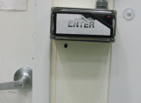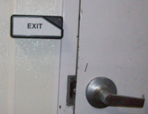
Figure 3: Entry and exit door swipes for the LVEA. On the right photo, a Kantech automated door striker is visible to the left of the door handle.

Nominal Hazard Zones and Access Controls
Class 3B and class 4 lasers must be confined to nominal hazard zones (NHZs). NHZs are defined as regions where class 3B and class 4 radiation is accessible and may cause eye injury. These zones are associated with lab areas or sections of lab areas, not necessarily the entire building.

Seven laser lab areas exist at LLO. Their NHZs, floor plans, and features are described and illustrated in the following diagrams.

LVEA
The large vacuum equipment area (LVEA) contains the large diameter vacuum manifold, turbo pumps, and the majority of LIGO’s scientific hardware. The entire floor space of this “+”-shaped room is an NHZ (see Figure 4 light green area). Access to the LVEA is on an as-needed basis. The LVEA is equipped with various class 4 lasers, 5 ton overhead cranes, technical power, telephony, and cooling water.

Side Entry Personnel Door: There is a personnel door connecting the large airlock to the LVEA. This entrance is not an authorized LVEA entrance and is not monitored by the facility Kantech security computer. Laser safety glasses and shoe covers must be worn before entering the LVEA while in “LASER HAZARD.” In an emergency, this door may be used to vacate the LVEA.

Roll up Door (Large Equipment Door/Large Airlock): A key operates the roll up door for the large equipment access airlock. The key is kept in the site administrator’s office when not in use. The facility Kantech security computer will register the activation of this door. Note: All personnel in the air lock are to have on laser safety goggles when the LVEA is in “LASER HAZARD” prior to opening the roll up door. This roll up door is not to be left open and unattended.

ISC/IO Table Enclosures: Interferometer sensing and control (ISC )/input output (IO) tables contain diagnostic equipment used in interferometer control. The facility Kantech security computer monitors the doors of each table. Each table has an “enter” and “exit” access card reader. A qualified laser operator’s access card is required to open and later close a table according to protocol. Opening the table doors without using an authorized access card generates an alarm for the on-duty control room operator and the LSO. This breach of protocol is a laser incident and requires the RLO or group leader to inform the LSO.

Emergency Egress Doors: Four doors are located about the LVEA to expedite emergency evacuations. These doors are connected to the facility Kantech security computer. The on-duty control room operator and the LSO will be alerted during forced door events.

View Ports Covers, Illuminators, Camera Housings etc.: Removal of vacuum envelope hardware requires permission of the LSO and Observatory Manager. The operator on duty must be notified.

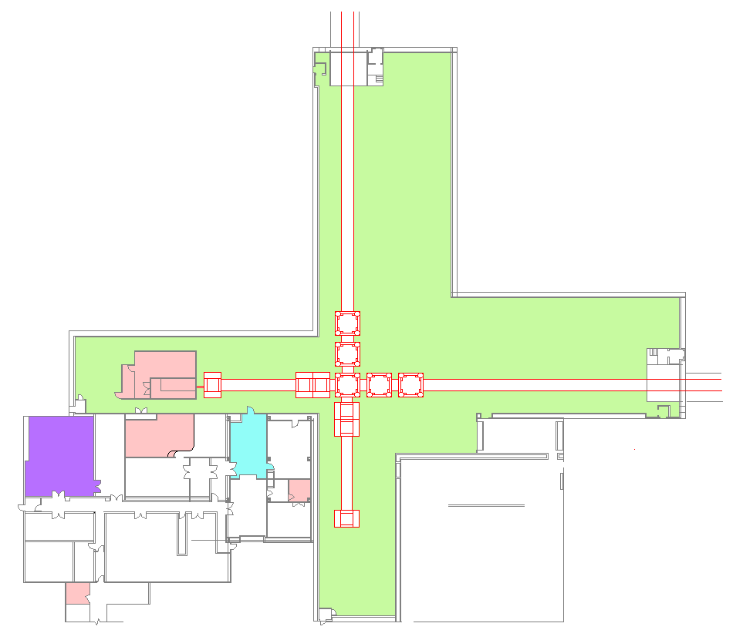
Pre-Stabilized Laser (PSL) Enclosure
LVEA Entrance
Laser Diode Room (LDR)
Control Room

To VEAy
To VEAx
Laser Safety Officer (LSO)
LVEA NHZ
Emergency Egress Doors (to Outside)
Emergency Egress Doors (to Outside)
Emergency Egress Doors (to Outside)
Emergency Egress Doors (to Outside)
Large Airlock
Side Entry Personnel Door
Optics Lab
Roll Up Door
Figure 4: The Corner station floor plan. The LVEA, Optics lab, and PSL enclosure NHZs are pointed out in this overview. Vacuum system is outlined in red. The LVEA area in green is considered the LVEA NHZ.

LVEA Entrance
The LVEA entrance door is found in the cleaning and receiving room. It requires an authorized access card to enter and exit the LVEA. The facility Kantech security computer records the time and the card identification number upon door latch activations. In an emergency, the door may be opened from inside the LVEA to exit. Forced door conditions are result in the on-duty control room operator and LSO being alerted.

Large Slider Door: The large slider door sits next to the primary LVEA entrance. This powered equipment door allows oversize items to enter the LVEA. It operates using the same access card reader as the LVEA primary entrance. A pull-rope next to the west wall entrance room operates this door. Forced door conditions are result in the on-duty control room operator and LSO being alerted.

Inner Roll up Door (Old Shipping and Receiving Bay): The inner roll-up door forms the LVEA entrance room’s north wall. This overhead door does not immediately access the LVEA. The switch to operate the roll up door between the cleaning area and shipping/receiving is not to be activated while the large slider door leading to the LVEA is opened. This preserves the airlock behavior of the LVEA entrance.

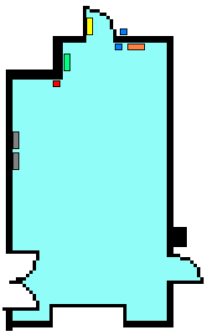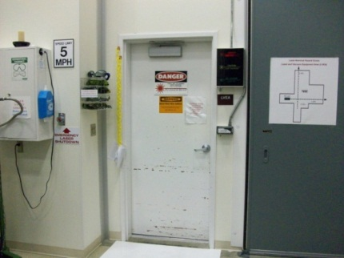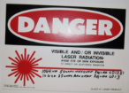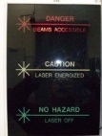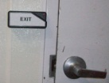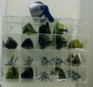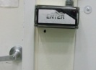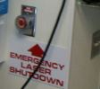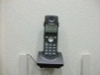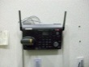

Exit Card Reader
Entrance
Card Reader
Laser Safety Glasses
Laser Hazard
Status Sign
Telephone
Extension 183
(LVEA Portable)
Telephone
Extension 180
(LVEA Portable)
Panic Button
(Emergency
Laser
Shut-off)
Danger Sign on LVEA Entrance Door
Figure 5: LVEA main entrance. The various features are noted including telephones and emergency shutdown buttons.

Inner Roll-up Door
Large Sliding Door
LVEA Entrance Door
Figure 6: The LVEA main entrance: The Large Sliding Door and Inner Roll-up Door are pointed out. The large sliding door is actuated by a pull-rope near the door.

PSL Enclosure/LDR NHZs
The PSL enclosure sits in the east arm of the LVEA. An access card with qualified laser operator clearance is required to enter the PSL enclosure as well as the PSL acoustic enclosure. Time and card identification numbers are recorded by the facility Kantech security computer. Should the acoustic enclosure doors be opened without swiping the card reader, an interlock connected to the facility Kantech security computer will shut down the PSL resulting in an automatic safety incident.
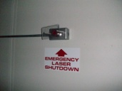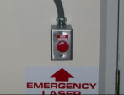

NHZ

PSL Enclosure
NHZ
MOPA
PSL Table
PSL Acoustic Enclosure
PSL Anteroom
Fibers from LDR

PSL Electronics Racks
Emergency Laser Shut-off
Emergency Laser Shut-off
Figure 7: Pre-Stabilized Laser (PSL) NHZ. This figure points out the location of the MOPA [LLO’s main laser] on the PSL table and the position of the PSL electronics racks. Yellow boxes indicate illuminated laser hazard status signs.

P

NHZ

Not NHZ
PSL Chiller
Pump Laser Diodes (PLD)
Clean Suits and Goggles
Laser Status Panel
Equipment Doors
Laser Hazard Status Sign
Emergency Shutdown Buttons
Figure 8 Laser Diode Room (LDR) floor plan: This figure points out features of the LDR gowning room and NHZ. The yellow boxes indicate illuminated laser hazard status signs.

Optics Lab NHZ
Entry Curtain:
A soft floor-to-ceiling laser curtain bounds the Optics Lab’s NHZ entrance. Access card readers and laser hazard status sign controls sit next to the jamb. The state of both the laser status sign and the card readers is logged by the facility Kantech security computer. During “laser hazard”, qualified laser operator clearance is required to enter the NHZ. Forced curtain doors result in the on-duty controller and LSO being notified.

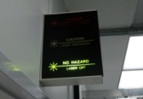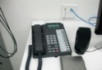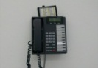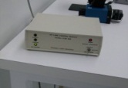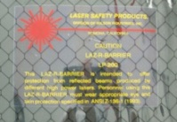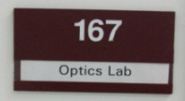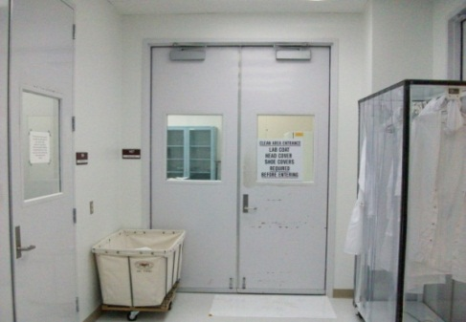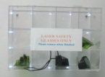

NHZ

NHZ

Clean, NOT NHZ
Exit Card Reader
Entrance Card Reader
Laser Safety Glasses
Laser Hazard
Status Sign
Telephone
Extension 126
Telephone
Extension xxx
Status Sign
Controller
Laser Protection
Barrier Curtain

Figure 9: Optics Lab NHZ with features shown. The purple line indicates the soft laser curtain between the NHZ region and the non-NHZ region.

VEAX and VEAY

External Entry Doors: Access cards with unescorted access clearance are required to enter the primary entrance leading to the end station inspection/shipping and receiving bay. These doors are monitored. The facility Kantech security computer in the control room records the time and the card identification number upon door latch activations. In an emergency, these doors can be opened from inside the end station to exit. Forced door conditions will alert the on-duty control room operator and the LSO.

VEA/Change Room: The doors connecting the inspection/shipping and receiving bay to the change rooms and VEAs require an access card. Unescorted access clearance is required to enter and exit the VEA change room. The facility Kantech security computer in the control room records the time and the card identification number upon door latch activations. In an emergency, these doors can be opened from inside the end station to exit. Forced door conditions will alert the on-duty control room operator and the LSO.

Transmission Monitor Enclosures: Access to transmission monitors is controlled through access card readers. The tables follow the access card protocol of the ISC/IO tables in the LVEA. These monitors are identical to ISC/IO tables as potential direct beam hazards. Breaches in access card protocol the reader before opening the enclosure will alarm in the on-duty control room and the LSO.

Photon Calibrator Enclosure (VEAX only): Access to the photon calibration enclosure is controlled through access card readers. This enclosure is similar to ISC/IO tables as potential direct beam hazards. Breaches in the access card protocol correctly before opening the enclosure will shut down the on-board laser and alert the on-duty control room operator and LSO.

View ports, Illuminators, Camera Covers, etc.: Removal requires permission from the LSO and Observatory Manager. The on-duty control room operator must be notified.

Emergency Egress Doors: Two doors are located about the VEAs to expedite emergency evacuations. These doors are monitored by the facility Kantech security computer. Opening these doors will alert the on-duty control room operator and LSO.

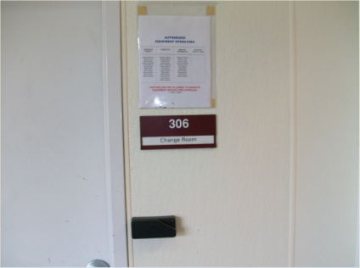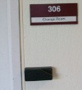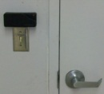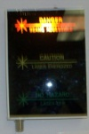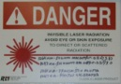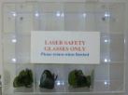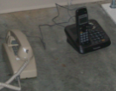

NHZ
Exit Card
Reader
Entrance
Card Reader
Laser Safety Glasses
Telephone
Extension 151

Laser Hazard
Status Sign

Danger Sign on
Entrance Door

Camera 8
Figure 10: VEAX NHZ at X-End station.
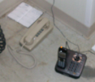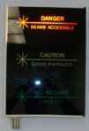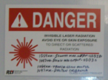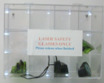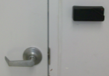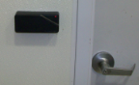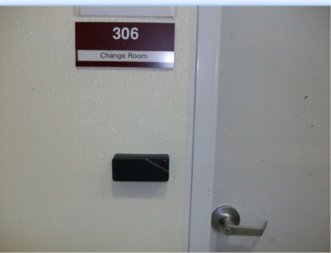

NHZ
Exit Card
Reader
Entrance
Card Reader
Laser Safety Glasses
Telephone
Extension 187

Laser Hazard
Status Sign

Danger Sign on
Entrance Door

Camera 5
Figure 11: VEAY NHZ at Y-End station.

HPLF
Main Entry Door: The primary HPLF access door is in the staging building’s multi-lab high bay. It requires an authorized access card to enter and exit. The facility Kantech security computer in the control room records the time and the card identification number upon door latch activations. In an emergency, the door can be opened from inside the HPLF to exit. Forced doors generate alarm records for the on-duty control room operator and the LSO. Kantech security computers automatically shut down interlocked class 3B and 4 lasers in the HPLF during a forced door event.

Double Equipment Doors: Two doors are located next to the main HPLF main entrance to expedite equipment installation. The facility Kantech security computer does not monitor these doors. Before opening these doors, the RLO must inform the LSO or the on duty control room operator of the pending operation and make certain the HPLF is in laser safe condition.

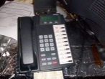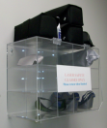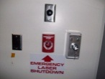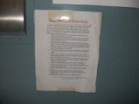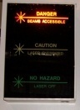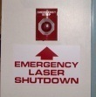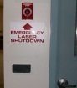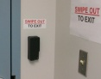

NHZ

Telephone
Extension 158
Laser Safety Glasses
Panic Button
(Emergency
Laser
Shut-off)
Lab Rules Sign
On HPLF Entrance Door
Laser Hazard
Status Sign
Panic Button
(Emergency
Laser
Shut-off)
Door
Card Readers
HPLF Table
Laser Rack
Camera 14
Fire Extinguisher
Not NHZ
Figure 12: HPLF NHZ floor plan with features shown

Temporary NHZ
Temporary NHZs may be setup in the either pre-existing experiment halls, labs or in non-standard locations. These NHZs require extra measures to insure the safety of personnel inside and outside the NHZ. Temporary NHZs must comply with the following check list before the LSO and Observatory Manager will inspect the both the temporary NHZ’s safety features or experiment setup.

- ___ Authorization from the LSO and the Observatory Manager
- ___ SOPs, FMEAs, and work permits must be authorized and available
- ___ Two-meter-tall, laser-grade barriers must be setup to encircle the NHZ
- ___ Labyrinth entrance to the temporary NHZ
- ___ Correctly marked portable laser status signs
- ___ Signs indicating the laser specifications
- ___ LSO approved technical power for the laser power supplies
- ___ Portable fire extinguisher locations
- ___ Beam dumps
- ___ Viewing devices
- ___ Approved personal protective equipment (i.e. laser goggles)
- ___ Telephones inside the temporary NHZ
- ___ A list of personnel authorized to work in the temporary NHZ

Optical Table
Laser Grade Barriers
Curtain Door
Extinguisher
Equipment Rack
Warning Notices

Warning Signs
Figure 13: An example layout of a temporary NHZ.

Emergency Hardware Locations
Operational emergency equipment is required in each lab apart from personal protective equipment. These devices must either shut down and safe laser hardware or suppress further disruption to the observatory. Labs are not permitted to operate without the following hardware on-hand.

Emergency Laser Shutdown Buttons
Emergency laser shutdown buttons result in the immediate termination of class 3B and class 4 laser radiation. These buttons function by signaling the Kantech computers to terminate 110 VAC electrical power supplying class 3b and class 4 lasers. Shutdown buttons in the corner station only affect corner LVEA lasers. Shutdown buttons in the HPLF affect only HPLF lasers.

All class 3B and 4 lasers must be connected to sanctioned wall electrical sockets.

LVEA Emergency Laser Shutdown Buttons (location):
- Control room (back wall),
- LVEA main entrance (see Figure 5),
- LDR gowning room (Figure 8),
- PSL enclosure entrance door (see Figure 7),
- PSL acoustic enclosure (see Figure 7).

HPLF Emergency Laser Shutdown Buttons:
- HPLF main door (see Figure 12),
- HPLF NHZ adjacent double doors [equipment doors] (see Figure 12)

Telephones/Intercoms:
Telephones are located near each NHZ entry door or inside the NHZ. These phones serve as an intercom and a public announcement device. During NHZ work, telephones are required to be within personal proximity should immediate/emergency personnel need to be contacted.

Fire extinguishers:
The American National Standards Institute considers class 3B and class 4 lasers as fire hazards. Most NHZs are equipped with smoke detection and overhead sprinklers. The HPLF’s NHZ maintains a portable extinguisher and sprinklers due to the increased fire risk. The PSL enclosure contains a portable fire extinguisher due to lack of sprinklers.

Eyewash/Chemical Shower Stations:
Neither eyewash nor chemical showers are immediate laser emergency hardware. However, these stations can be used to cool laser burns or can be used to rapidly wash off solvents (acetone and methanol). These shower stations are located at the north, east, west, and south walls of the LVEA, on the optics lab sink, and in the machine shop.

Personnel Protection
LLO has several layers of personnel protection. The first LLO layer is the user’s personal understanding of the dangers associated with the laser systems. The second layer consists of physical barriers that contain and control the laser light. These barriers are part of the NHZ’s setup and as such are chosen and placed to prevent immediate injury. The thrid layer consists of of personal protective equipment (PPE), in particular laser goggles, face shields, and gloves.

Physical Barriers: Boxes, Shields, and Beam Dumps
Most LVEA, VEAX, and VEAY optical tables are enclosed in an aluminized light box. These light boxes’ primary effect reduces ambient light on photosensors and mitigates air currents. These light boxes also prevents scattered light from leaving the optical table when closed. Razor blade dumps and conical beam dumps are accepted methods of terminating stray and unused beams on these tables. The light boxes’ walls may not be used as a beam dump.

TCS and HPLF optical tables are futher required to have perimeter plates. These perimeter plates require specific finishes and materials to contain direct laser radiation without failing. The plates must be secured throughout operation. Beam dumps on this table terminating unused beams or strays must be adequate enough to handle the full beam power.

Personal Protection Equipment

Approved laser goggles are provided by the LSO for anyone needing to work in an NHZ. Goggles must be worn in an NHZ that is in “LASER HAZARD” condition.

The required goggles for each hazard area vary due to differences in laser hardware. Occasionally, there are lab areas that require laser goggles with more than one wavelength suppression. Required optical density (OD) for all laser hazards are located in applicable SOPs, on warning placards, or they may be obtained from the LSO.

Qualified laser operators are resposible for verifying goggle integrity and report failed goggle to the LSO. The LSO is responsible for auditing goggles on a regular basis.

No eyewear is guaranteed to stop a focused class 3B/4 laser. They are meant to provide attenuation from scatter and low power stray light.

Users of LIGO hardware are reminded that goggles are their last line of defense before severe personal safety risks are taken.

Note: LIGO’s provision of shared eyewear near lab entrances does not automatically guarantee such eyewary is appropriate for that lab.

Laser Application Policy
Laser application packet contain several pieces of information pertinent to bringing a laser on site. Laser sponsors are requested to generate a packet to the LSO before shipping laser hardware. If review of a laser application packet is successful, the sponsor group will be granted approval to begin shipping and installation of laser hardware.

After the installation is complete, the LSO and Observatory Manager will inspect the equipment for safety protocol compliance and compliance to SOP/FMEA regarding the installation procedures. The SOP and FMEA regarding the specific laser will be placed in a visible location near the laser’s table.

All laser applications must comply with M960001.

Application Packet List
All portions of the following list must be submitted to the LSO before installation can begin.

Packet Contents and Checklist:
- ___ Formal request e-mail to the LSO and Observatory Manager
- ___ Completed SOPs for normal operation
- ___ Completed FMEAs for normal operation
- ___ Laser specifications including location of installation
- ___ A list of emergency hardware as required
- ___ A list of electrical power requirements
- ___ Requirement for cooling water
- ___ Emergency contacts and cognizant engineer

LLO Lab Laser Safety Rules
Each research lab and experiment hall has a set of rules that must be followed.

LVEA
- A work permit will be filed for any laser work in the LVEA.
- The on-duty control room will be informed before an inteferometer subsystem is worked on.
- An RLO must be designated on the work permit. The RLO coordinates all activities on specified tables and verifies safe working practices.
- Laser safety goggles must be worn during “LASER HAZARD” conditions.
- No jewelery, watches, or dangling clothing while working on optical tables
- Only authorized personnel are permitted to be in the lab area during table work
- All mounts (including temporary diagnositic tools) must be secured to the optical table.
- All safety incidents (including “near misses” and forced doors) must be reported to the LSO and the on-duty control room operator.
- Before a laser table is completely opened, the RLO must scan the table for stray beams or unblocked specular reflections. If any are found, the LSO must be notified immediately. Else the RLO and associated team members may proceed with care.
- Upon completion of work, the RLO must scan the table for any stray beams or specular reflections. All stray beams and specular reflections must be terminated using approved beam dumps before securing a table. (This minimizes scattered light noise.)
- Any person responsible for manipluating an optical mount or changing the trajectory of a beam is responsible for terminating all stray beams and scattered light generated
- Restricted areas must be created for all ISC tables (ISCT) before work commences
- Laser warning lights next to ISCT/IOT must be lit. If they fail, it is the responsibility of the qualified laser operator to replace the bulb or report the failure.
- Any new identified hazards must be reported to the LSO or the Observatory Manager
- During extended work periods, table enclosures must be closed as much as practical
- All unused beams must be terminated using authorized beam dumps
- No intrabeam viewing except by accepted hardware
- No upward propagating beams. Any required height changes must be marked.
- All permanent beam dumps must be marked and cataloged
- All significant changes to the beamline must be documented and authorized by cognizent engineers
- In case of emergency, contact immediate personnel and initiate appropriate emergency protocols
- Sensor cards or IR viewers must be used to trace beamlines

VEAX/VEAY
The rules for the VEAx and VEAy experiment halls are the same as for the LVEA.

PSL Enclosure/LDR
- A work permit will be filed for any laser work in the LVEA.
- For any work in the PSL Enclosure and/or LDR, the on-duty control room will be informed before work begins.
- An RLO must be designated on the work permit. The RLO coordinates all activities on specified tables and verifies safe working practices.
- Laser safety goggles must be worn during “LASER HAZARD” conditions.
- No jewelery, watches, or dangling clothing while working on optical tables
- Only authorized personnel are permitted to be in the lab area during table work
- All mounts (including temporary diagnositic tools) must be secured to the optical table.
- All safety incidents (including “near misses”, forced doors) must be reported to the LSO and the on-duty control room operator
- Before a laser table is completely opened, the RLO must scan the table for stray beams or unblocked specular reflections. If any are found, the LSO must be notified immediately. Else the RLO and associated team members may proceed with care.
- Upon completion of work, the RLO must scan the table for any stray beams or specular reflections. All stray beams and specular reflections must be terminated using approved beam dumps before securing a table. (This minimizes scattered light noise.)
- Any person responsible for manipluating an optical mount or changing the trajectory of a beam is responsible for terminating all stray beams and scattered If the PSL laser head is to be opened, the RLO must make certain that all associated personnel are wearing goggles approved for 1064 nm and 808 nm radiation
- All cross table cables must be secured beneath or above the beamline
- The RLO is accountable for activity in the PSL and LDR
- Fibers in the LDR may not be removed without a work permit
- The PSL head and LDR pump diode laser box may not be dismantled without conscent from the cognizent engineers.
- All unused beams must be terminated using authorized beam dumps
- No intrabeam viewing except by accepted hardware
- No upward propagating beams. Any required height changes must be marked.
- All permanent beam dumps must be marked and cataloged
- All significant changes to the beamline must be documented and authorized by cognizent engineers
- In case of emergency, contact immediate personnel and initiate appropriate emergency protocols
- Two person teams are required when working on the PSL table or on the LDR pump diode laser box. The exception to this rule are restarts or shutdowns.
- Sensor cards or IR viewers must be used to trace beamlines

HPLF
Registered and qualified laser operators are granted permission to operate HPLF equipment by UF and the LLO LSO. The HPLF is off limits to unauthorized persons unless given escort by authorized qualified laser operators or clear permission by the LLO HPLF representatives. Warning signs at the HPLF entrance indicates the hazard condition of the lab. When the lab is in hazard state, there will be no entry unless the personnel are authorized or escorted. Qualified and authorized personnel must first indicate their intent to enter the NHZ prior to opening the inner vestibule door.

- The on-duty control room operator must be notified about personnel in the HPLF and becomes the immediate personnel for accident reporting
- Work permits will be filed by an HPLF authorized and qualified laser operator.
- The RLO is noted on the work permit and is responsible for maintaining and verifying safe working practices. The work plan/work permit must be copied and posted on the main entrance.
- HPLF crew members must inspect all forms of PPE for integrity and usability. All failed PPE devices must be reported to the LSO for immediate replacement.
- No jewelry, loose clothing, or wrist watches are allowed when manipulating the beam. Operators with hair that drapes into the beamline must tie it up.
- Only authorized personnel are permitted to be in the lab area during table work
- All mounts (including temporary diagnositic tools) must be secured to the optical table.
- All safety incidents (including “near misses”, forced doors) must be reported to the LSO and the on-duty control room operator
- Laser safety goggles must be worn during “LASER HAZARD” conditions.
- Dust must be kept to a minimum.
- When any laser capable of greater than 10 W are energized, the RLO verbally indicate the the laser’s powered state
- When placing or altering optical components in the HPLF beamline, a visual inspection must be made to check that the free beam is completely blocked.
- The laser beam trajectory must be marked on the table when it leaves the horizontal plane of the table. Under no circumstances may the laser leave the table’s containment box (4’x10’x1’).
- A perimeter belt must be completely installed before any laser emissions are allowed.
- All beams are stopped using approved beam dumps. The perimeter belt is NOT to be used to catch direct beams.
- Scattering of laser light must be minimized through alignment and cleaning
- All optical mounts are to be fastened to the laser table when in use
- IR viewers and sensor cards must be used to find stray beams, general scatter, and check alignment
- No intrabeam viewing.
- All coarse beam alignments must be done below 10 W.
- Two persons are required when HPLF work is in progress
- Lasers may not be activated until laser status signs are appropriately lit
- UF and the LSO must be informed before destructive testing may begin.

Optics Lab
Unauthorized individuals are not permitted in the optics lab without escort while lasers are powered. An illuminated warning sign has been placed in an area prior to the entrance to the NHZ.
- The on-duty control room operator must be told about Optics Lab laser activity before anyone enters the Optics Lab.
- No intrabeam viewing with eyes, IR viewers, or attenuated IR viewers.
- Laser safety goggles must be worn during “LASER HAZARD” conditions.
- No jewelery, watches, or dangling clothing while working on optical tables
- Only authorized personnel are permitted to be in the lab area during table work
- People intending to enter the optics lab NHZ must announce their intent before entering.
- Laser safety goggles must be worn at all times when the laser status sign is lit.
- All stray beams and specular scatter will be terminated using appropriate beam dumps when qualified laser operators alter beam paths or optical hardware.
- All unused beams must be dumped using appropriate hardware.
- Scattered light must be reduced to a minimum.
- Beams may not be directed at the NHZ curtain. Beams may not land on the NHZ curtain.
- All optical mounts are to be sercruely fasted to their respective optics table.
- Prior to opening any laser shutters, qualified operators mus t first verfiy that no individual is at risk of being exposed to direct radiation.
- Work permits are required for extended class 4 laser operations..

Posting Rules
Lab rules must be posted at the entrance of each experiment hall/lab area. The rules must be updated on a 3 month basis and signed off by the LSO.

Audits
The LLO LSO must provide means to verify the operational performance of personnel and equipment.

Qualified laser operators and candidates must take a biannual certification test. This certification test will be specific for an applicant’s NHZ. Exams will be graded by the LSO.. Those qualified laser operators who fail to take the test will be denied access to LIGO’s NHZs.

The LLO LSO or Observatory Manager must conduct periodic audits of standard operating procedures and system recovery procedures. Failures in SOP/FMEA or system recovery procedures will result in laser sponsors/cognizant engineers being informed. Until corrections are made, the LSO and Observatory Manager equipment operation is at their discretion.

Schedules
The LSO will publish a schedule for maintaining this auditing document, certifying qualified laser operators, auditing SOP and FMEA, auditing the facility Kantech security system, and auditing safety rules.

References

- LIGO Safety Plan LIGO-M0950046
- LIGO Laser Safety Plan LIGO-M960001
- LIGO Transition Procedure LIGO-M0900287
- ANSI Z136.1—2007

