AUTHOR(S) | DATE | Document Change Notice, Release or Approval
Luke Williams, Giacomo Ciani, Joe Gleason | 03 Jul 2013 | see LIGO DCC record Status

Objective and Scope
The objective and scope of this document is to specify how to assemble the Advanced LIGO HAM Auxiliary Suspension (HAM AUX), D1000120. This document also details how to use appropriate fixtures, detailed in D1001167, and how to balance the optic.

Applicable Documents
LIGO-D1000120 "ALIGO IO HAM AUX SUS ASSEMBLY"
LIGO-D1001167 “ALIGO IO HAM AUX SUS ASSEMBLY FIXTURES ASSEMBLY”
LIGO-D070097 “ALIGO STEERING MIRROR SUBSTRATE”
LIGO-D0901065 “AOSEM ASSEMBLY”
LIGO-T1000526 “HAM Auxiliary Suspensions Design Requirements”
LIGO-T0900495 “HAM Auxiliary Suspensions Electronics Requirements”
LIGO-T1000339 “HAM Auxiliary Suspension modeling and test results”
LIGO-T970135-02 “Small Optic Suspension Final Design”
LIGO-E970037-F “Small Optics Suspension Assembly Specification”

Tools List
All tools used in assembly must be class B clean (see sections 3.1 & 3.2 below).
Required tools not included in D1001167:
- hex keys and ball end drivers for the sizes .028”, 5/64”, 3/32”, 1/8”, 9/64”, 3/16”
- hex socket driver for #10 nut (3/8” socket) and for #4 nut (1/4” socket)
- wire cutters (such as McMaster 3719A1)
- helicoil insertion, extraction, and tang removal tools for #4-40, #8-32, and #10-32 helicoils
- non-magnetic tweezers and dental pick
- gauss meter
- 1/4-20 X ½” SHCS (4) for optic height block installation
- 0.025” feeler gauge

Vacuum Compatibility Requirements

General Handling
All procedures listed under these specifications for assembly and balancing must be performed in a clean room environment while suited up in clean room clothing including, but not limited to: frock, shoe covers, bouffant cap, LIGO-approved latex gloves, and facial mask. This applies to anyone handling or near clean pieces or pieces being cleaned.
For further detailed handling and clean room garbing requirements see the LIGO Contamination Control Plan, E0900047. In the terminology of that document, the optic, suspension structure and associated parts are Class A hardware (i.e., destined to be installed in vacuum) and once cleaned and baked should not come into contact with anything but Class A and B hardware.

Cleaning and Baking
Before assembly, all parts are to be cleaned and baked in preparation for installation according to LIGO-E960022, LIGO Vacuum Compatibility, Cleaning Methods and Qualifications. Information on vendors and part numbers for C.P. Stat and UHV foil and other clean room supplies is given in that document.
Cleaning is to be performed in a “clean manufacturing area” separated from all other operations. This space should have non-shedding floors, walls and ceiling. In addition, the atmosphere for this “clean manufacturing area” must not exchange directly with the shop floor area; the air must be carbon and HEPA filtered and monitored with a hydrocarbon meter.
After cleaning and baking, suspension component surfaces shall not be touched by skin or other contaminants.
Only C.P. Stat plastic sheet, UHV aluminum foil and LIGO-approved swabs and latex gloves are acceptable. All suspension parts shall be double bagged (C.P.Stat plastic) or protected by a Class 100 cleanroom atmosphere. Small components can be bagged together with other small pieces.

Cleaning Inspection and Testing
Check the cleanliness of all tapped holes with a clean swab dampened with alcohol. If any discoloration of the swab is evident, then the part must go through at least one more wash before repeating a check of the cleanliness. If any machining chips are found:
(a) A HEPA filtered vacuum cleaner may be used to remove the chips from the holes, and (b) The holes must be cleaned with a solvent dampened swab.
After inspection and testing, wrap the component as described in E960022.

Baking Inspection
After baking, sample check the cleanliness of blind tapped and through tapped holes with a clean swab dampened with alcohol for a minimum of 10% of the holes in case any material has leached out during baking. If any discoloration of the swab is evident, then the part must go through at least one more wash cycle before repeating the bake.
After inspection, wrap the component as described in E960022.

Notes

Working with wires, including under tension
The wire used in all of our suspensions is made of spring steel which has stored energy such that it can curl back on itself. It therefore needs careful handling to avoid injury to personnel. In particular, safety glasses must be worn at all times when working with this wire.

Materials Note
Throughout the assembly steps, the silver plated hardware should be used in stainless threads; stainless steel hardware should be used in aluminum threads. Instances requiring silver plated hardware are also bolded in the text below.

Process optimization
The assembly procedure involves a great number of different parts and fasteners; this can be difficult and lengthy to locate in the clean room. If a given part is used in more than one assembly step, the procedure usually calls for collecting and setting aside the total amount needed on the first usage of the part. If assembling more than one HAUX (as it is usually the case), it is also recommended that the user try to group tasks involving similar tools/hardware and perform them for all HAUX at one. Examples include assembling the blade supports, preparing the optic holders, assembling the earthquake stoppers, and so on. This will require some additional space to store the sub-assemblies, but will save a lot of time otherwise needed to repeatedly locate the needed hardware. The opportunity of performing a given task for all HAUX at once should appear clear when it is performed for the first of them.

Orientation Nomenclature
For orientation treat the suspension like a small person. The HR side of the optic is the face, the OSEMs are the back. Left is where the small person would have its left arm, etc.
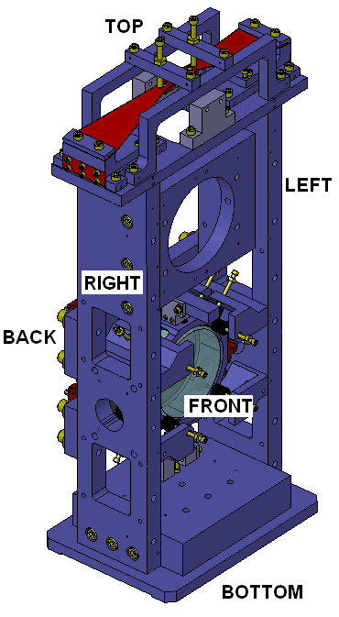

Quality Assurance / Control
For each optic, make a copy of the HAM AUX Process Traveler, TBD. Obtain an E-series document number for the copy, using as a title “Process Traveler for <name of optic>”, e.g., “Process Traveler for SM1, L1”. As an alternative to a traveler, this information may be stored in the Inventory Control System (ICS) database. In the process traveler record the actual optic masses and the thickness on the thick side of the wedge, after they have been weighed and measured. Also record the optic serial number and AOSEM serial numbers and positions.

Wire Clamp Testing
Test the wire clamps to make sure that the grooves were machined to the proper depth. Collect two each of the following parts: D1000096, D1000097, D100291, and D100292. Collect four silver plated #2-56 x 3/16” SHCS and four silver plated #2-56 x 5/16” SHCS. Assemble the parts as shown below. The shorter screws are for D1000097.
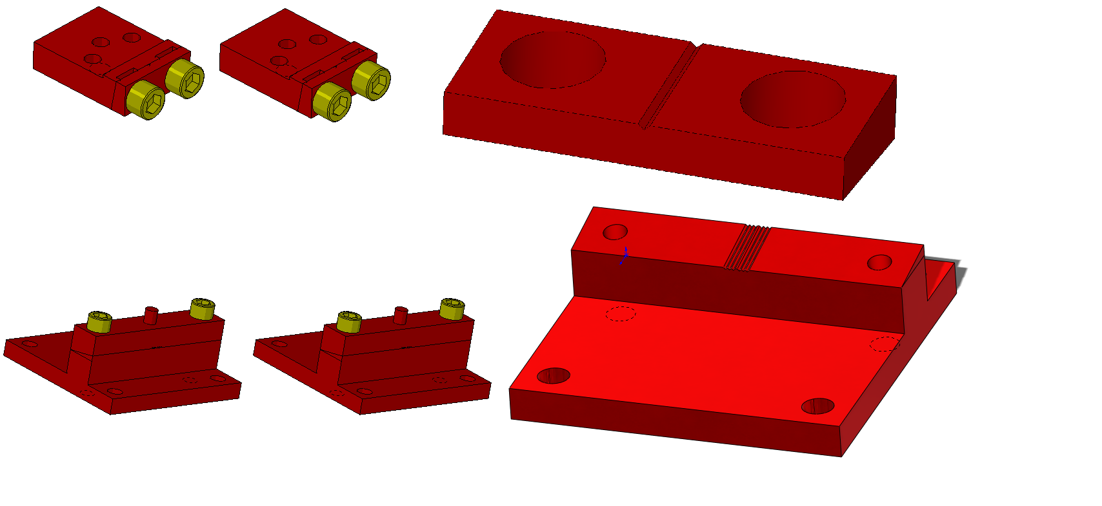
Take a piece of 0.006” diameter music wire and try to insert it into all of the wire grooves. If the wire can enter any of the grooves, that clamp will need to be re-machined and cannot yet be used in the assembly.
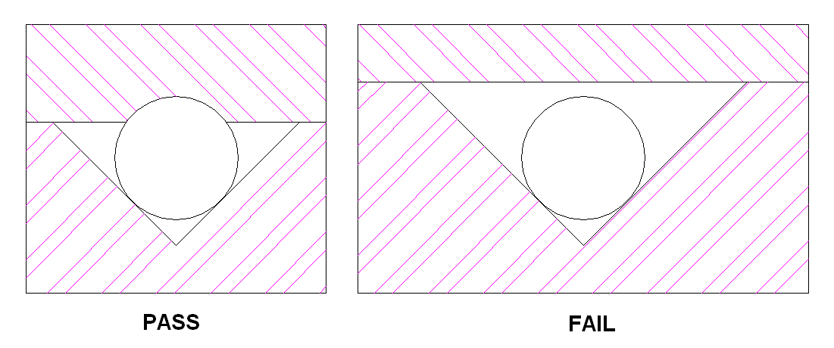
If the clamps are suitable, leave them in this state of assembly and set them aside for later.

Blade Inspection
Examine the blades (D1000095) for flatness. Set each blade on the blade test block (D1002457). If the blade sits perfectly flat it can be used for assembly. If the blade bows up in the middle, flip it over. Press the base down and check if the tip is above the raised surface. If it is above the edge, the blade cannot be used in the assembly.
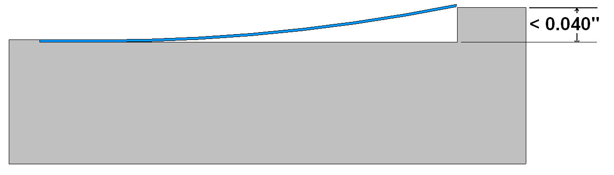
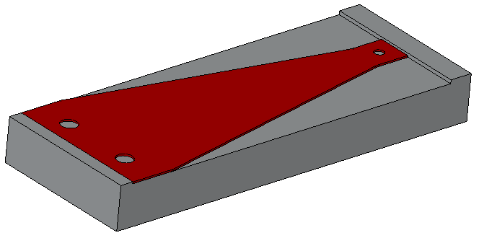

Helicoil Installation
Various parts in the assembly require helicoils. All of the helicoils must be made from Nitronic 60, and all must be installed following instructions in the most recent version of Emhart Helicoil Product Catalog, HC2000 Some parts require free-running helicoils (part# begins 1185 or 1191) and some require self-locking helicoils (part# begins 3585 or 3591). Below is a list of the parts that need to have helicoils installed, along with the quantity and type of helicoils. In cases where the helicoil is installed in a through hole, the helicoil should be centered between the front and back faces of the hole.
  - Optic Holder (D1000264)
Two 3585-2EN164
  - Balancing Block (D1002096)
One 1191-3EN380
  - Blade Base Plate (D1000091) (twice)
Five 3585-04EN112 (per part)
  - Blade Pitch Adjuster (D1000092) (twice)
Five 3585-04EN112 (per part)
Two 3585-2EN328 (per part)
  - Upper OSEM Bracket (D1000398)
One 1185-04EN168
  - Lower OSEM Bracket (D1000547)
One 1185-04EN168
  - Lower Left Earthquake Stop (D1000539)
Five 1185-04EN168
  - Lower Right Earthquake Stop (D1000540)
Five 1185-04EN168
  - Upper Right Earthquake Stop (D1002360)
Five 1185-04EN168
  - Upper Left Earthquake Stop (D1002361)
Five 1185-04EN168
  - Upper Damper Bracket (D1000541)
Three 1185-04EN168
  - Lower Damper Bracket (D1002378)
Three 1185-04EN168

Assembly procedure

Magnet holders installation
The figure below shows the final orientation of the magnets on the optic holder (D1000264).
The magnets are attached to the optic holder by sticking them to 4 stainless steel posts using only magnetic force. The posts will be press fit on the four nubs on the backside of the optic holder.
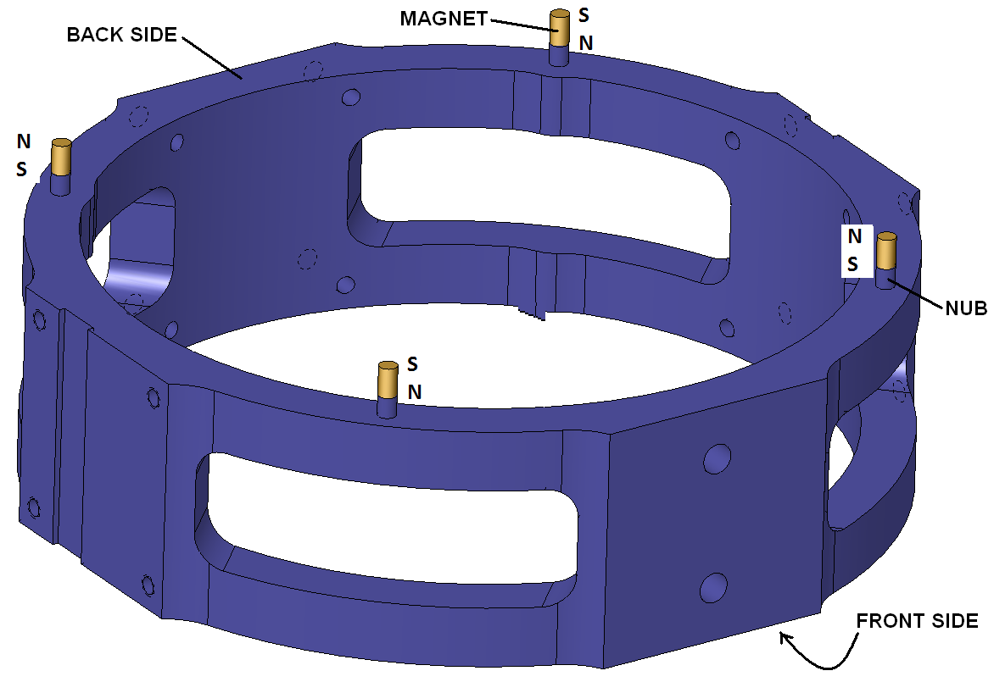
S
N
N
S
N
S
S
N

Inspect the optic holder posts for damages or burrs

Press fit all four stainless steel posts by hand

With the post downwards, press the holder on an hard, flat surface to ensure all 4 posts are evenly pressed in.

Attach four magnets on the posts (orientation is not important at this stage) and verify that they are sitting stably and straight on top of the posts.

Remove the magnets and set them aside, to be installed later.

Blade Assembly

Attach the blade hinge plate (D1000093) to the blade base plate (D1000091) with three #4-40 x 3/8” SHCS. Make sure that the hinge plate is flush with the alignment tab of the base plate.
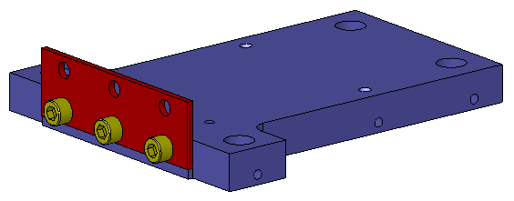

Attach the blade pitch adjuster (D1000092) to the hinge plate with three #4-40 x 3/8” SHCS. Make sure that the hinge plate is flush with the alignment tab of the pitch adjuster.
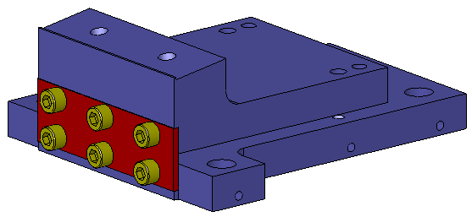

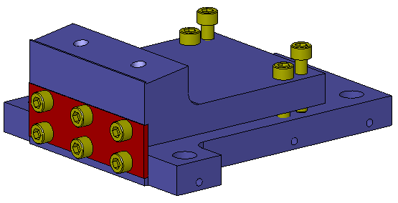
Attach four #4-40 x ½” SHCS to the assembly finger tight. These screws will later be used for fine adjustment of the blade tip height.

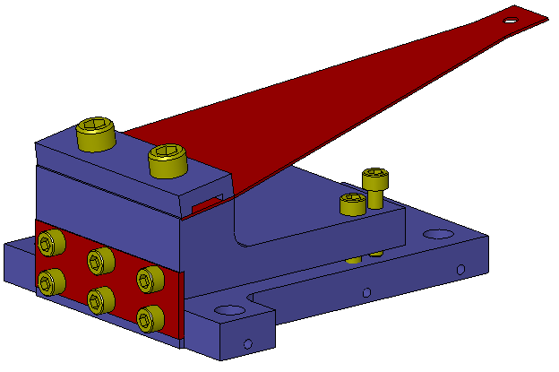
Attach the blade (D1000095) to the blade pitch adjuster with the blade clamp (D1000094) and two #8-32 x 5/8” SHCS. If there is any curvature to the blade, attach it so that the blade curves upwards. Make sure that the base of the blade, and the blade clamp, are flush with the alignment edge on the pitch adjuster. Be careful to avoid damaging the alignment edge.

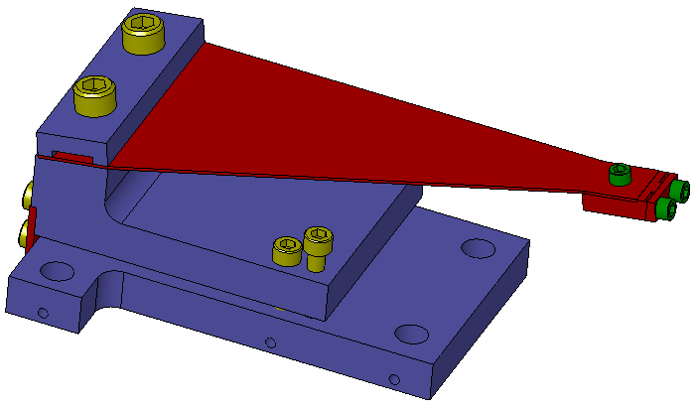
Attach the pre-assembled blade wire clamp to the blade with a silver coated #2-56 x 1/8” SHCS. Make sure that the alignment edge of the wire clamp is flush with the blade.

Set the assembly aside and repeat steps 8.2.1-8.2.5 to create a second blade assembly.

Optic Holder Assembly

Attach the two pre-assembled optic holder wire clamps to the slotted faces on the optic holder with eight #2-56 x 5/16” SHCS. Make sure that the vent slots line up with the silver plated screws.
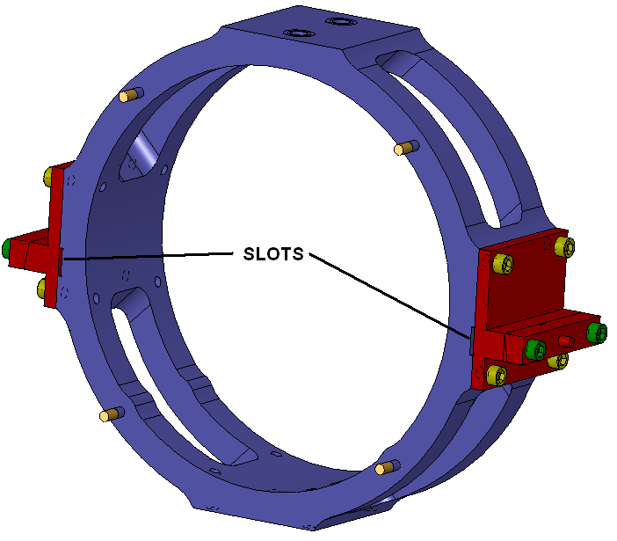

Attach the balancing block (D1000265) to the optic holder with four #2-56 x 5/16” SHCS. Make sure that the cylindrical axis of the balancing block is parallel to the cylindrical axis of the optic holder.
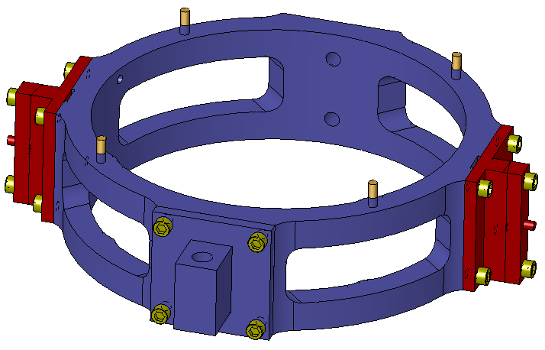

Thread a #10-32 x 2” copper threaded rod into the balance block until it is approximately centered.
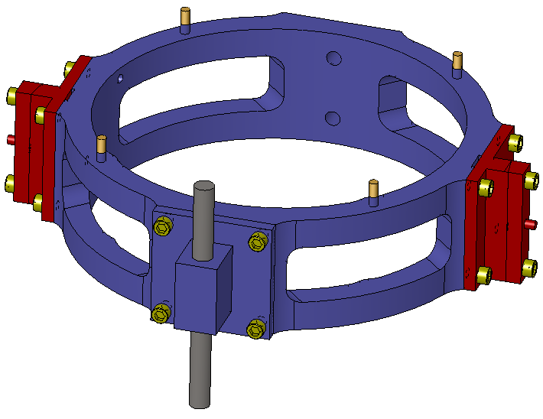

Thread two #8-32 x 3/16 PEEK set screws into the helicoils in the optic holder. Stop turning them when the tops become flush with the optic holder.
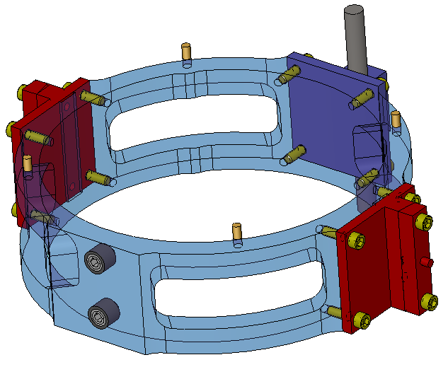

Set the optic holder assembly aside.

Main Structure

The tower base, D1000320, is asymmetrical. The tapped holes on the sides are closer to the back than the front.
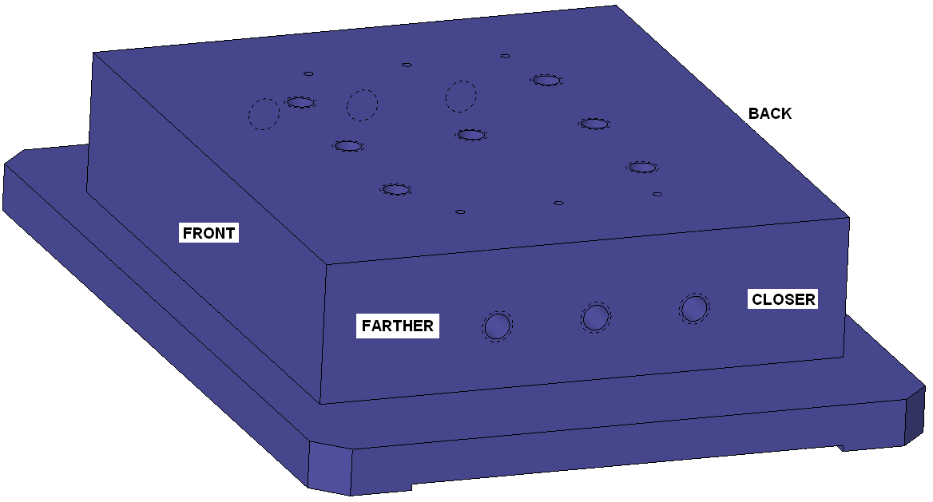

Attach the leg location fixture (D1001209) to the front face of the tower base.
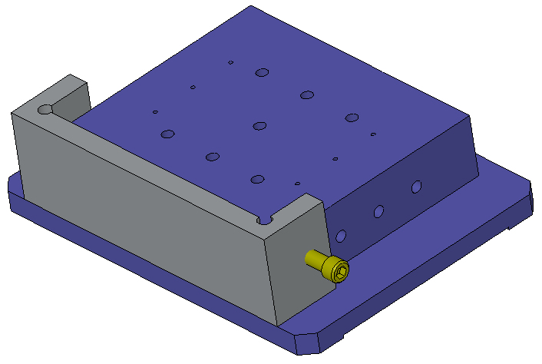

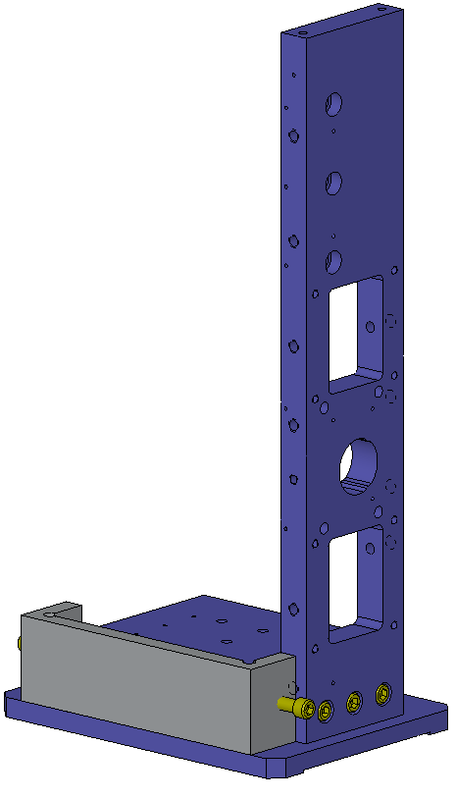
Align the left side plate (D0902774) to the leg location fixture and attach it with three ¼-20 x 1” SHCS.

Align the right side plate (D0902775) to the leg location fixture and attach it with three ¼-20 x 1” SHCS.

Remove the leg location fixture.

Attach the lower left earthquake stop (D1000539) to the left side plate with two #4-40 x ½” SHCS. Make sure that the front face of the earthquake stop is flush with the side plate.
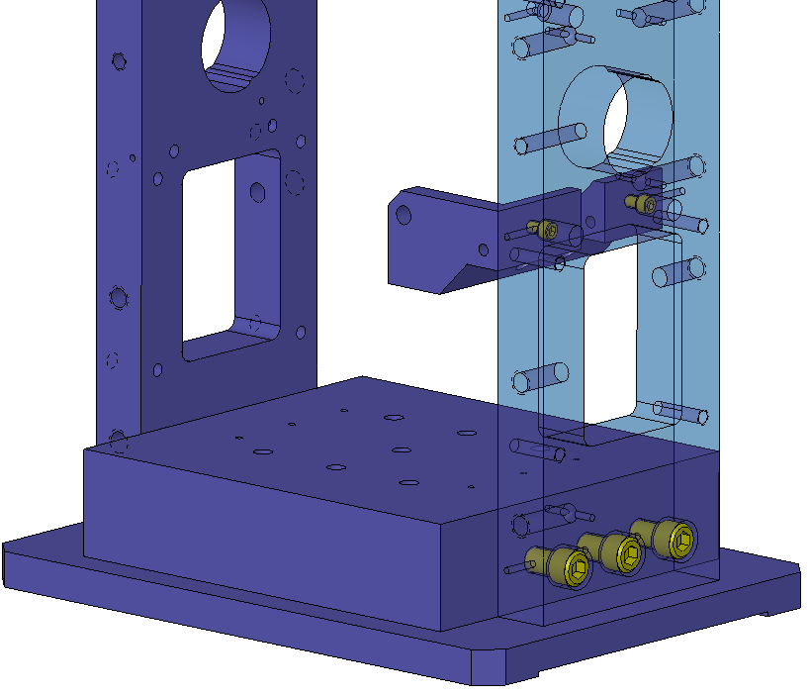

Attach the lower right earthquake stop (D1000540) to the right side plate with two #4-40 x ½” SHCS. Make sure that the front face of the earthquake stop is flush with the side plate.
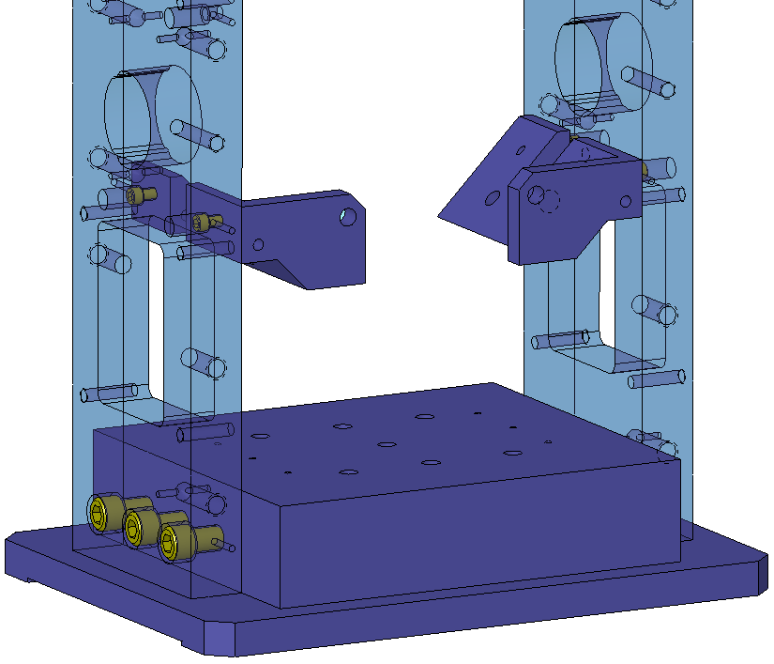

Attach the upper right earthquake stop (D1002360) to the right side plate with two #4-40 x ½” SHCS. Make sure that the front face of the earthquake stop is flush with the side plate.
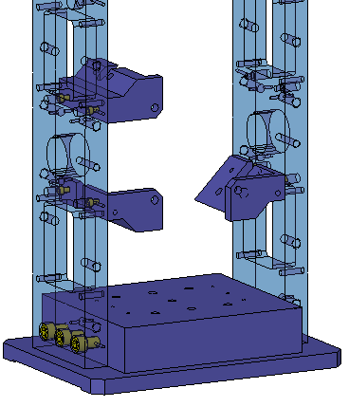

Attach the upper left earthquake stop (D1002361) to the left side plate with two #4-40 x ½” SHCS. Make sure that the front face of the earthquake stop is flush with the side plate.
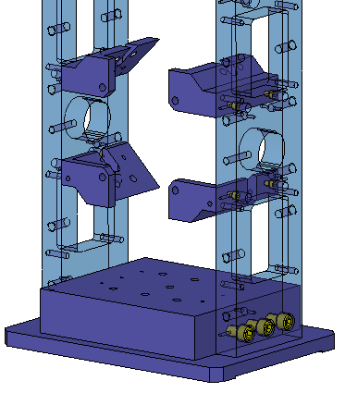

Attach the stiffener plate (D1000400) to both side plates with six ¼-20 x 1” SHCS.
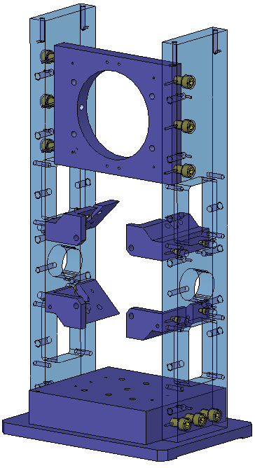

Attach the top plate location fixture (D1001231) to the side plates with two ¼-20 SHCS.
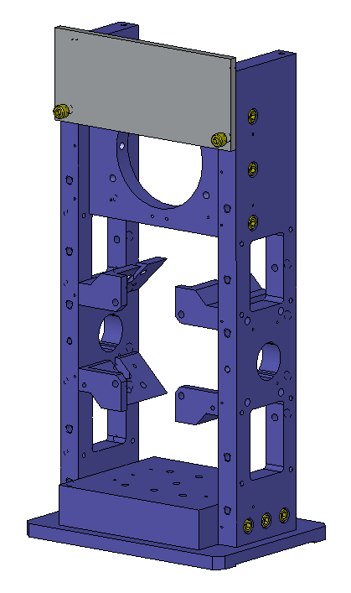

Align the top plate (D1000098) to the top plate location fixture, and attach it to the side plates with four #8-32 x ¾” SHCS. Make sure that the plate is oriented as shown in the figure below, specifically the location of the tapped holes at the corners. After attaching the top plate, remove the location fixture.
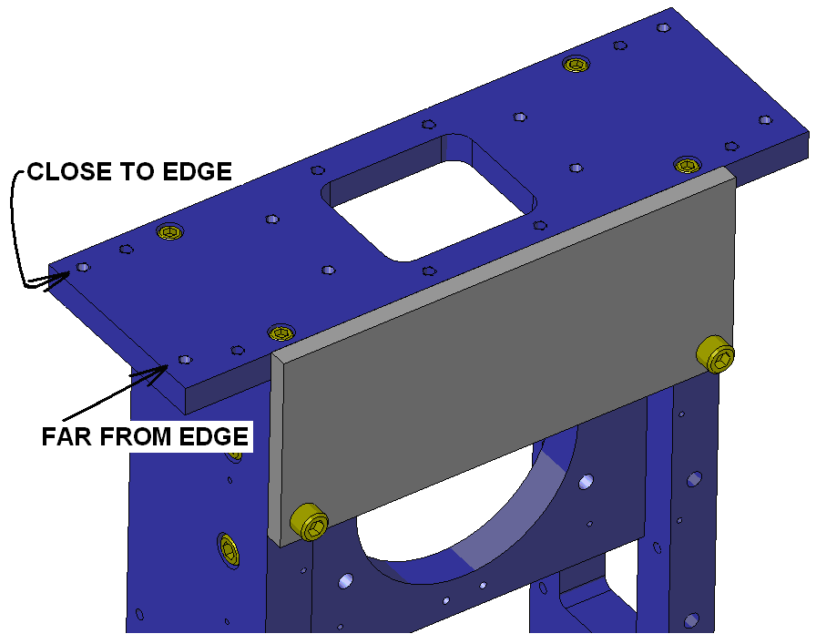

Attach two blade tip adjustment fixtures (D1001211) to the top plate with four #8-32 x ¾” SHCS.
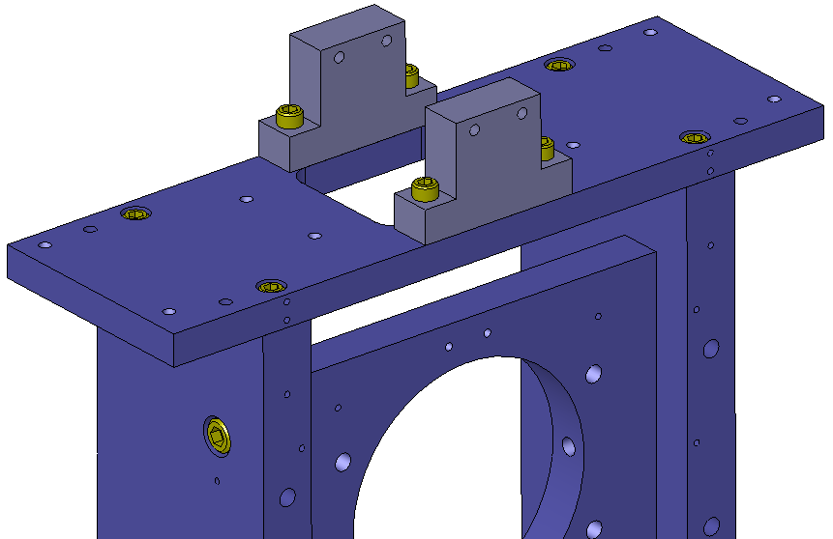

Thread fourteen silver plated #4-40 nuts onto fourteen fully threaded #4-40 x 1.25” SHCS and set two sets aside.
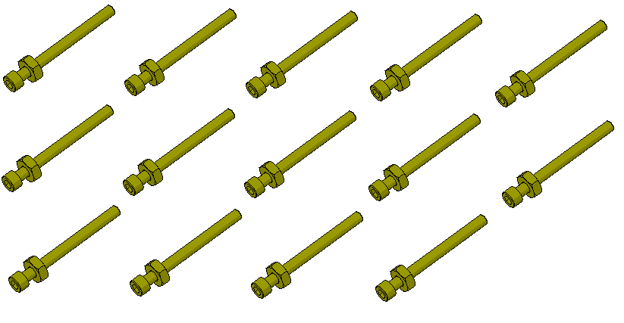

Insert the screws into the open holes on the earthquake stop brackets.
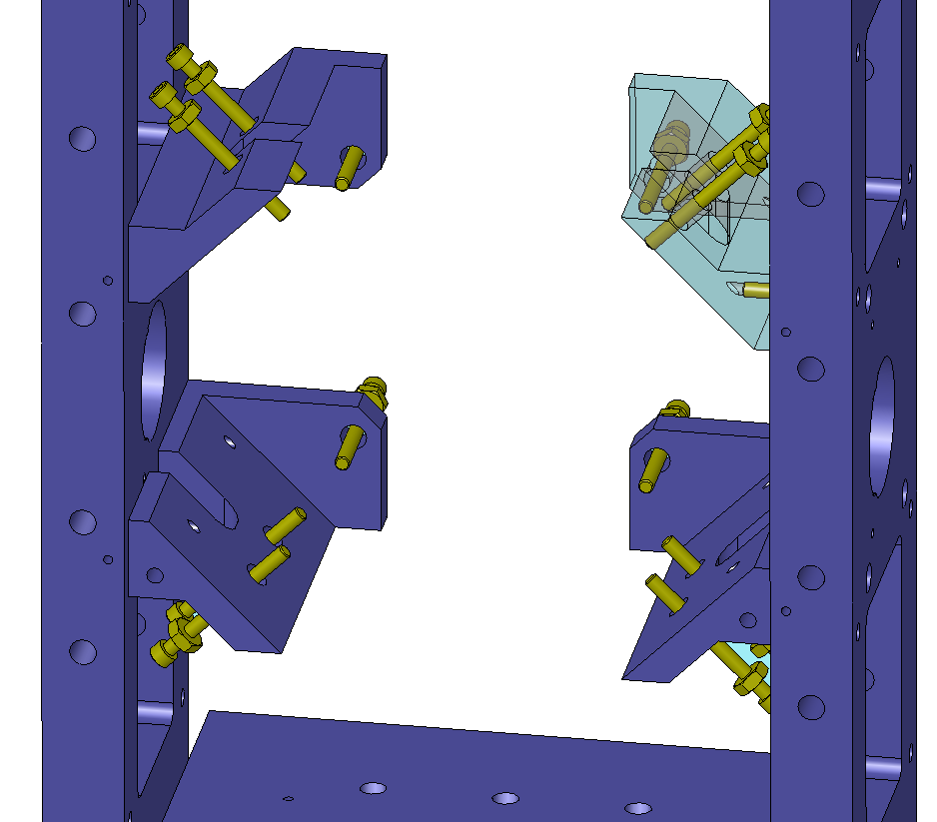

Thread twelve viton earthquake stop tips (D060546) onto the ends of the screws and set two additional tips aside, together with the #4-40 screws prepared in step 8.4.14. Please note that the viton tips have no stop for the threads. Try to screw all the bolts roughly the same, about half the way, into the viton tips. Back the screws out until the viton tips contact the brackets.
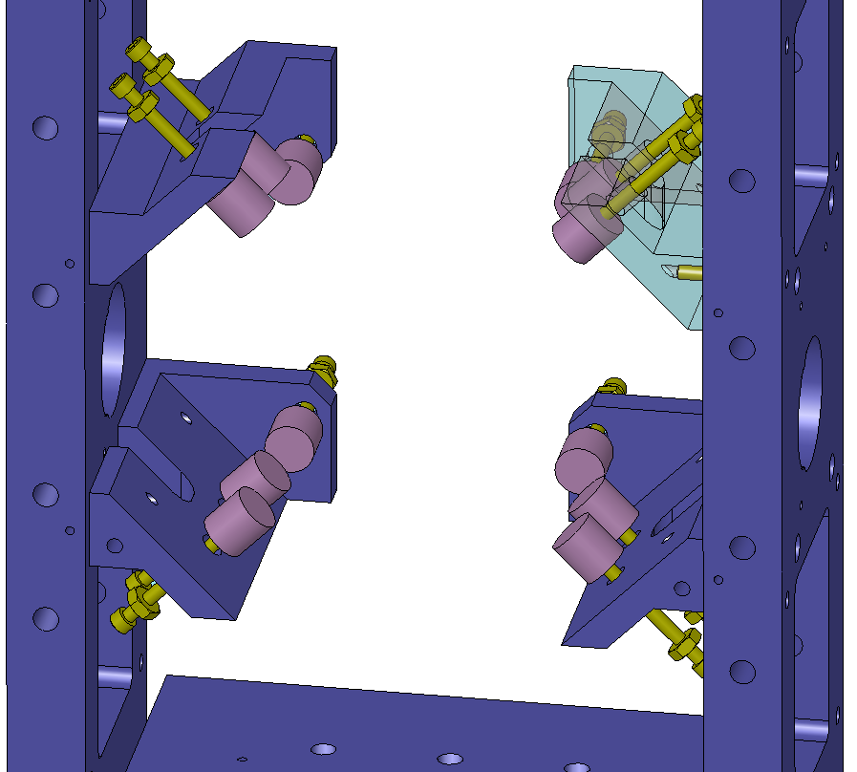

Insert two copper plugs (D1000490) into the holes in the sides of the side plates and lock them into place with two #10-32 x ½” set screws. The flanges should be in contact with the side plates.
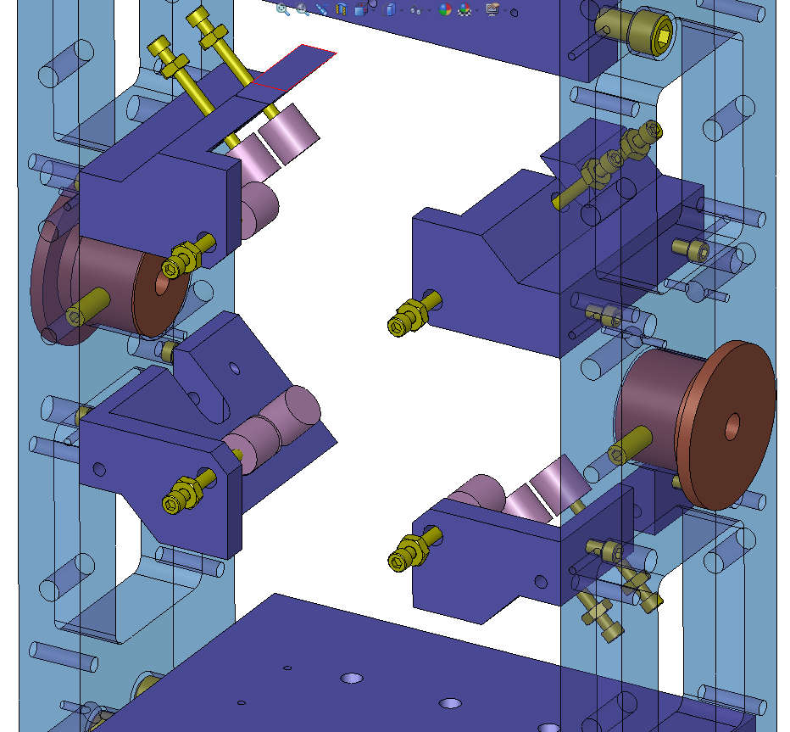

Attach the optic height block (D1001208) to the tower base with four ¼-20 x 1” SHCS.
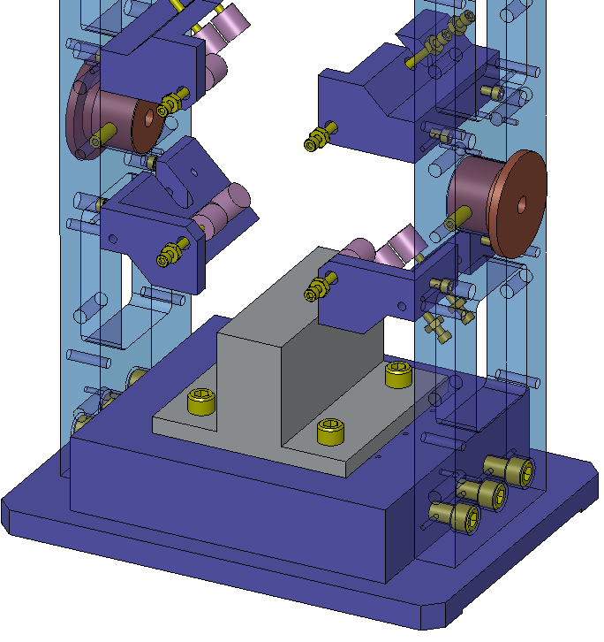

Place the optic holder assembly on the optic height block. The face that does not have magnets posts goes against the viton tips.
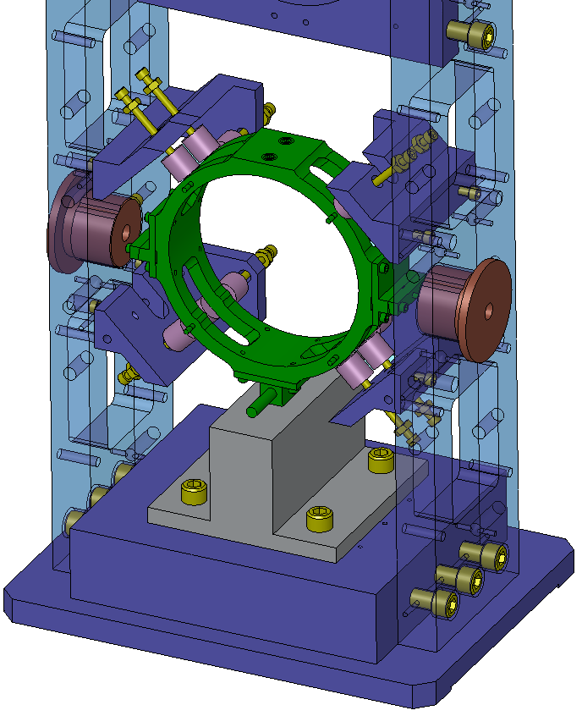

Look through the holes in the copper plugs and align the optic holder so that the nubs on the wire clamps are horizontally centered with the hole. Tighten all 10 earthquake stops until they touch the optic holder, confirm that the nubs are still centered, confirm that the optic holder is still sitting flush on the optic height block, and confirm that the optic holder is centered left to right. If necessary, loosen the stops and re-align the optic holder. When finished tighten the locking nuts on the earthquake stops.
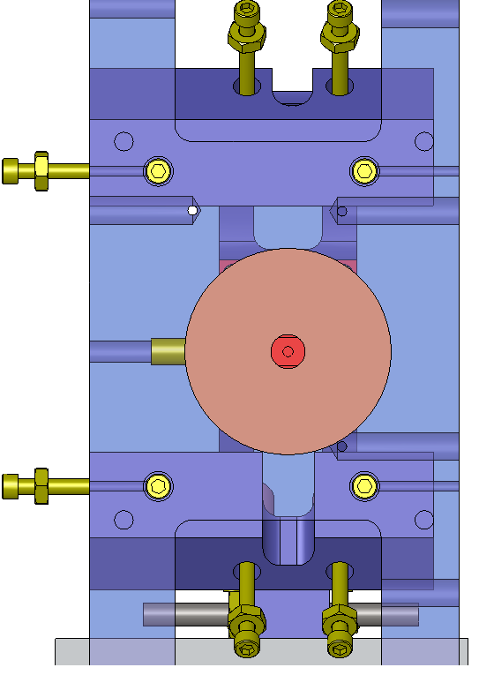
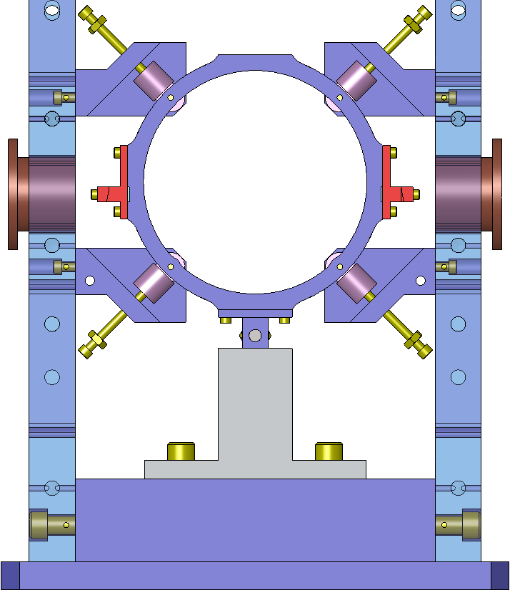

At this point the suspension frame can be stored until it is time to suspend the optic. (NOTE: figure is inaccurate, as blades are not installed at this stage)
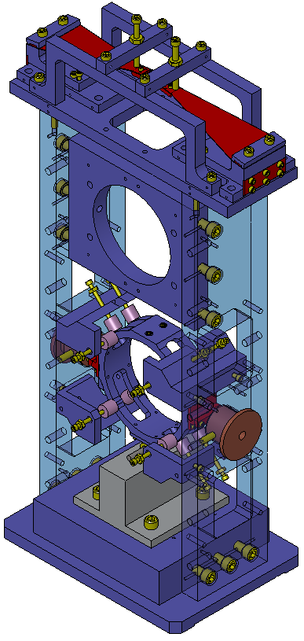

Optic Installation
Remark. The optic will be installed so that the arrow on the barrel is directly under the PEEK set screws. The arrow head will be on the side of the optic holder that does not have magnets. The arrow head points to the HR surface of the optic. The HR face will be aligned flush with the front surface of the optic holder.

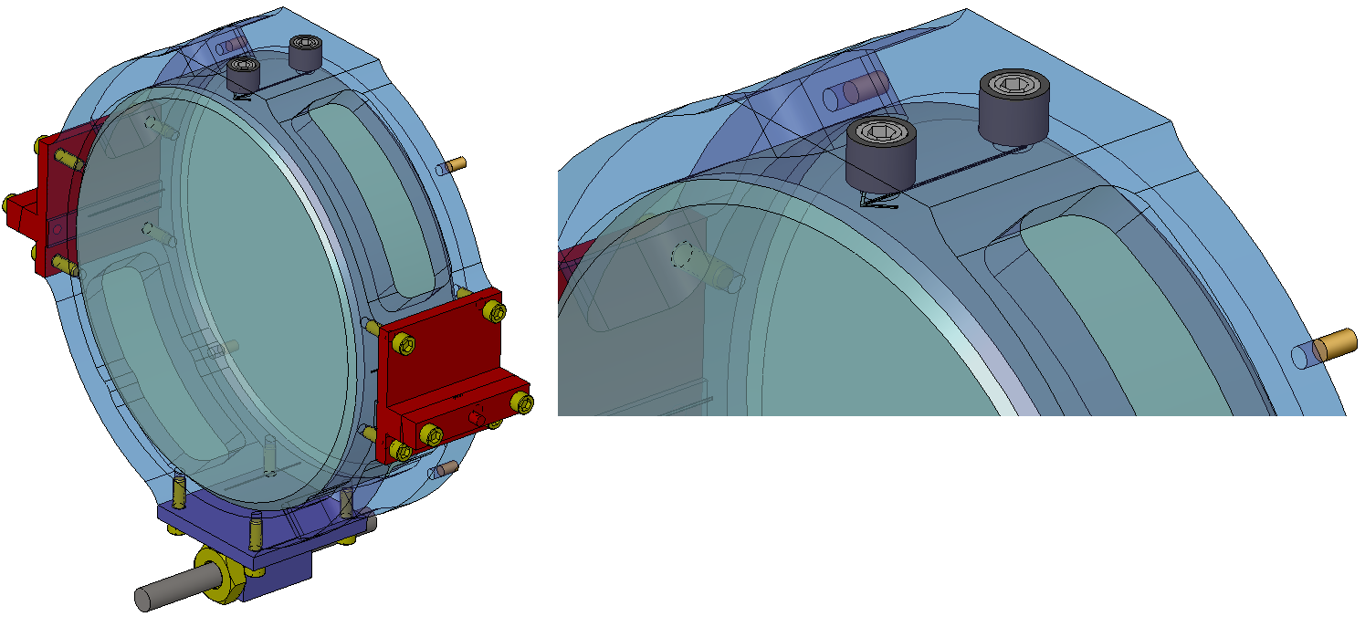

Loosen the top four earthquake stops and remove the optic holder from the suspension.
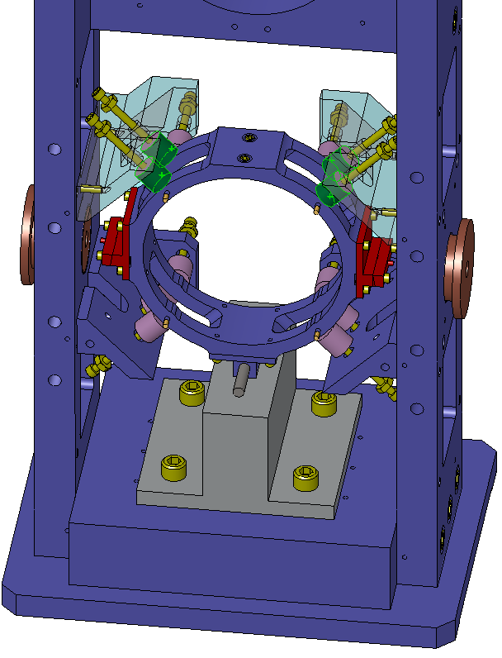

Place the optic-to-ring installation fixture (D1001247) on the table with the bosses facing up.
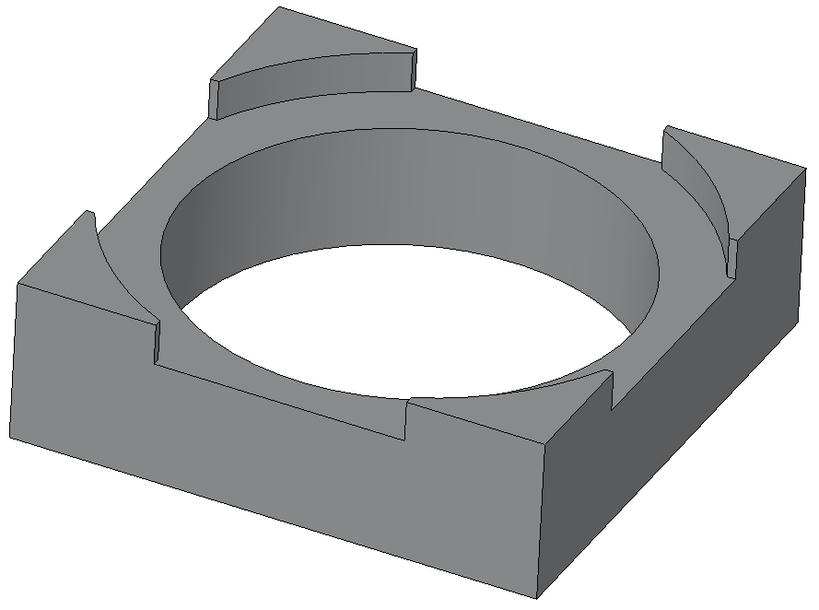

Handle the optic only by the barrel. Carefully place the optic into the fixture. The arrow should point downwards and be centered between two bosses. The optic should be concentric with the bore in the fixture. If the optic is not concentric with the bore, pick it up and re-center it. DO NOT SLIDE THE OPTIC ON THE FIXTURE.
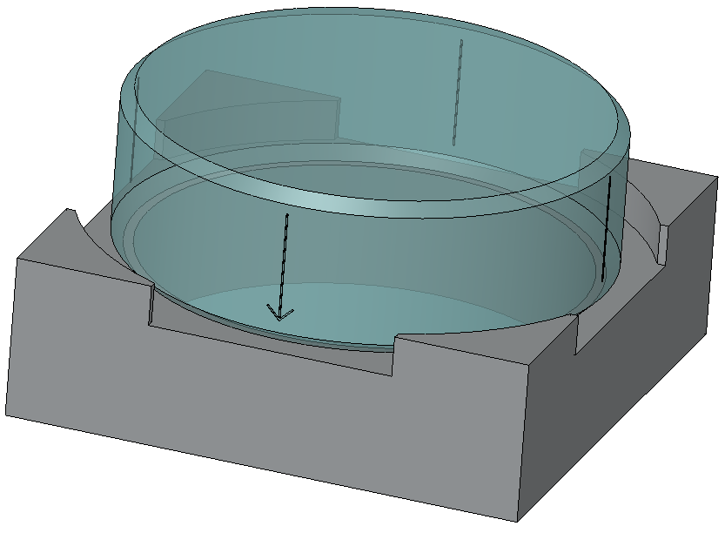

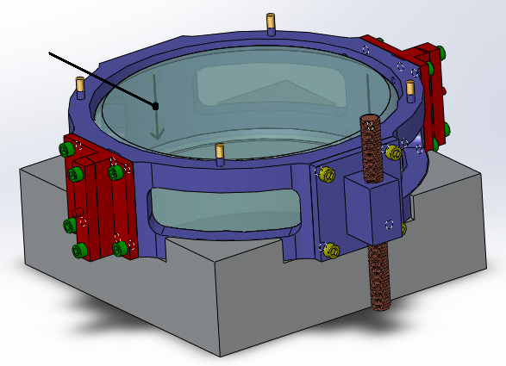
Carefully slide the optic holder over the barrel of the optic. The magnets should be facing up. Remove one of the PEEK set screws and position yourself so that you can see through the set screw hole to verify that the arrow is centered.

Tighten both PEEK set screws with a hex key until they are snug. Be sure that the screws are in contact with the optic and that the optic is in contact with the optic holder. To avoid the optic from tilting under the pressure of a single screw, tighten them alternatively and progressively, starting with a very light torque. The contact point of the screw on the optic barrel should be visible through the optic face, providing hint on the correct centering.
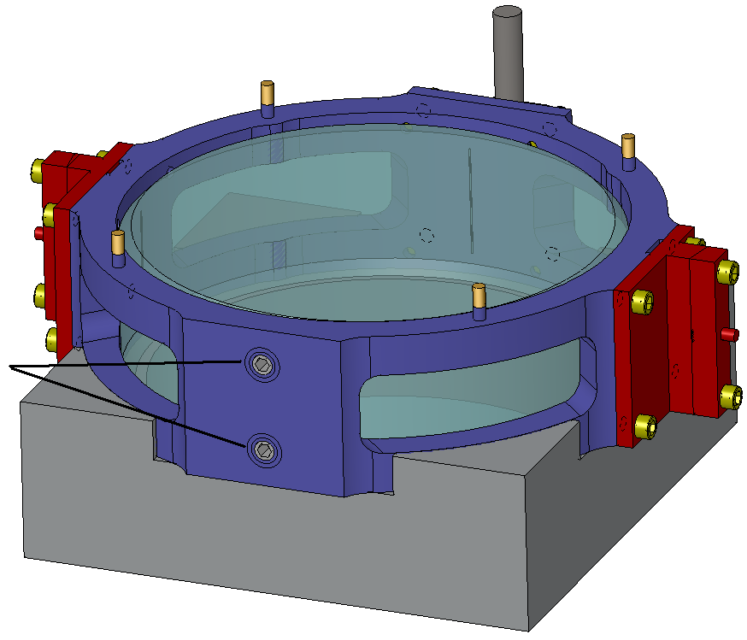

Lift the optic holder ~2mm above the contact surface of the fixture and tap the optic holder with your finger to verify that the optic is locked into place.
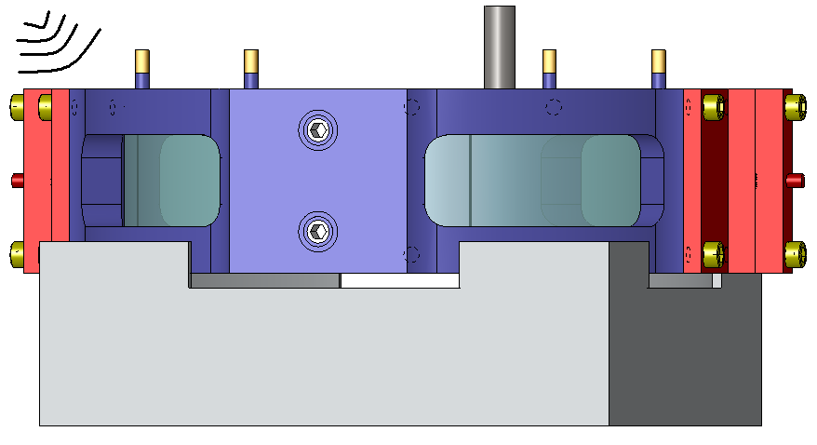

Suspension Wires

Level the table with a mechanical bubble level to within +/- 0.05mrad.

Attach two bottom clamp assembly fixtures (D1001251) to the wire clamps on the optic holders with four #0-80 set screws. The set screws should come from the bottom (side with balance rod), so that the fixture will prevent the clamps from sliding upward while tightening. Leave a small gap between the fixture and the clamp, so that the clamp can be loosened for wire insertion.
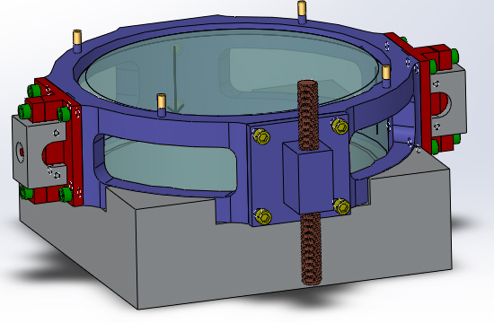

Cut two lengths of suspension wire (0.006” diameter), each ~30” [76cm] long. Make sure that they are free of kinks.

Attach a top clamp assembly fixture (D1002148) with two #0-80 set screws to the blade wire clamps. The set screws should be on the top side, so that they prevent the clamp from sliding down when the clamp is tightened. Leave a small gap between the fixture and the clamp, so that the clamp can be loosened for wire insertion.
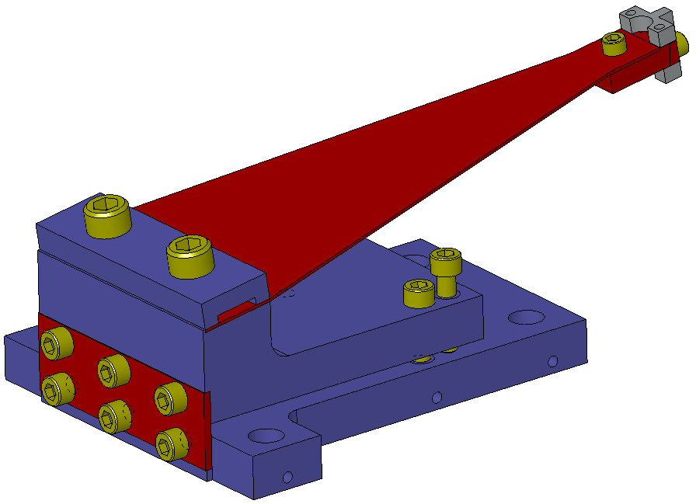

Take one of the blade assemblies and insert a wire into the wire groove from below. Leave ~2” [5cm] of wire sticking out of the top of the groove. Tighten the clamping screws so that the wire is secured. Remove the clamp assembly fixture.

Repeat steps 8.6.4-8.6.5 for another blade assembly.

Feed the wires through the opening in the top plate and attach the two blade spring assemblies to the top plate with eight #8-32 x 5/8” SHCS.
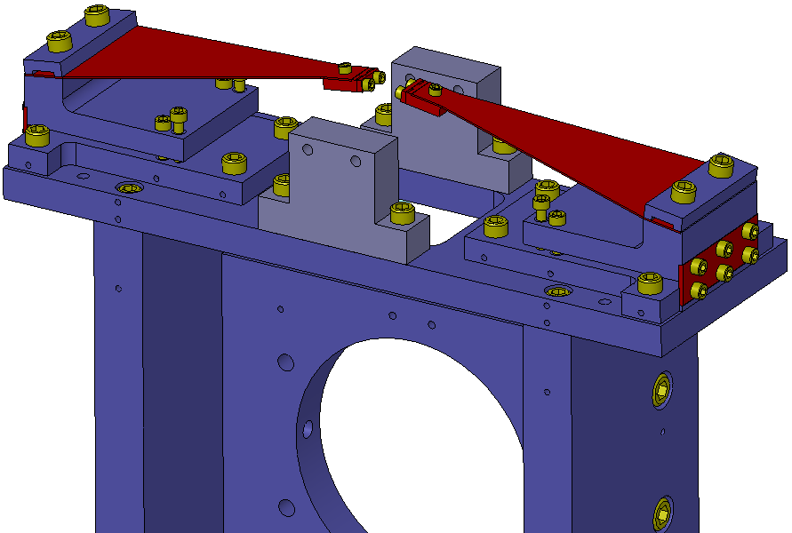

Check that the tips of the blades are at the same height. If they aren’t, use the adjuster screws to set them to equal heights. Be careful to ensure that the wires do not get kinked and do not get near the surface of the mirror.
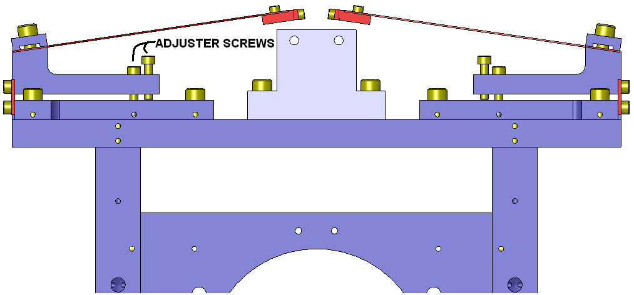

Attach two blade stop risers (D1000537) to the top plate with four #8-32 x ¾” SHCS.
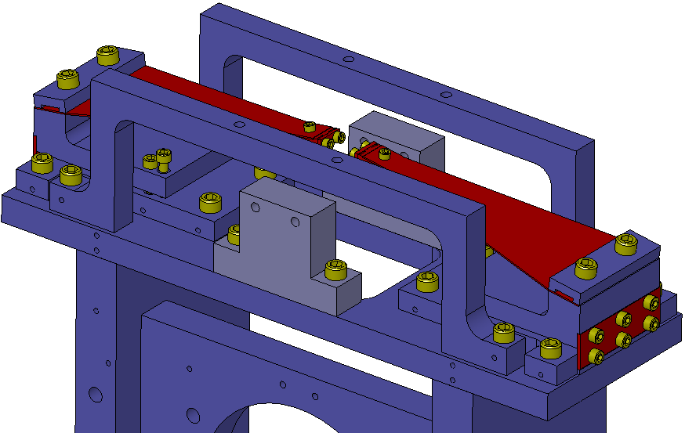

Attach two blade stop crosses (D1000538) to the blade stop risers with four #8-32 x ¾” SHCS. Make sure that the tapped holes in the blade stop crosses are closer to the rear of the suspension than the front.
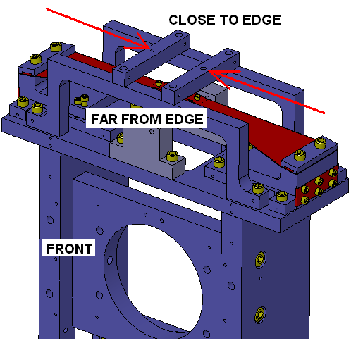

Thread two silver plated #8-32 nuts onto two fully threaded #8-32 x 1.5” SHCS. Insert the screws into the tapped holes in the blade stop crosses and set them ~1mm from the top of the blades.
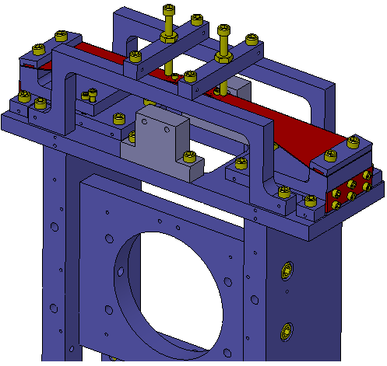

Check traveler (TBD) for the measured thickness of the optic and round to the nearest 0.5mm. The drawing below indicates which groove to use in the lower wire clamp. Do not use the three grooves that are closest to the AR side of the optic.
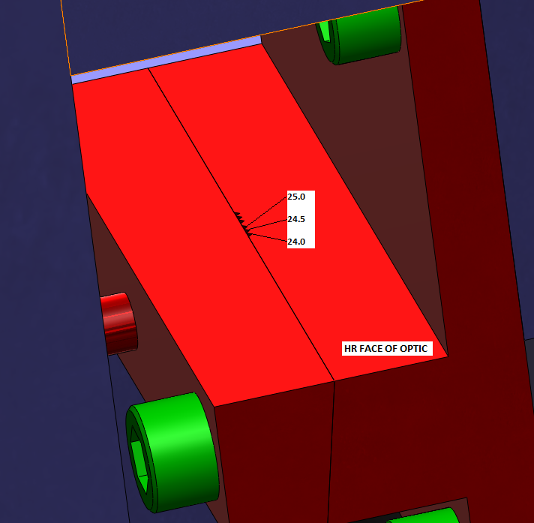

Keep the optic in the optic-to-holder fixture, and place them on the working surface, close to the back side of the suspension frame, with the balancing rod away from the frame. The wires coming down from the blades should easily reach the clamps on the optic holder. The optic holder riser structure can be used to obtain a more comfortable working position.

Slide both wires down through the appropriate groove. Slightly tighten the clamps so that the wires can still slide into the groove, but not jump from a groove to another. Move the holder as close as possible to the frame and remove any excess slack in the wire between the holder and the blades, without putting the wire in tension. Be careful to ensure that the wires do not get kinked and do not get near the surface of the mirror.

Remove the optic holder from the support and, keeping it vertical near the frame (a few inches from its final position) feed both wires through the lower access hole in the side plate.

Place the optic holder assembly into the suspension. To allow the wires to pass into the opening between the earthquake stops and then find their position into the cutouts, this operation requires “yawing” the holder, moving in into position sideways and then “yawing” it back at the end. When in position, push it against the front earthquake stops, and retighten the top four earthquake stops. Check that the centering is still good. Remove any slack from the wires.
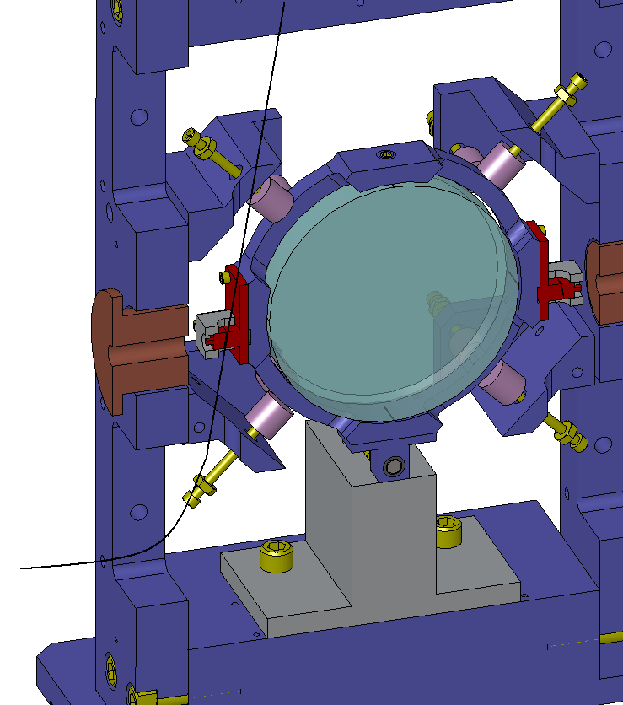

Slide a 1/8” x 2” stainless steel dowel pin (McMaster 90145A480) into the pin hole of the lower earthquake bracket, with the wire passing below the dowel pin.
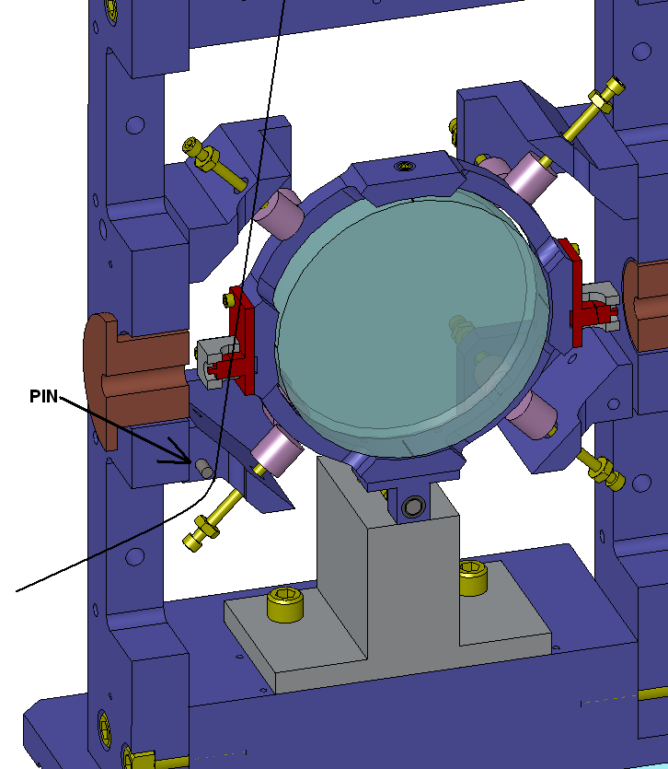

Get the wire routing fixture (D1001246), the wire crank (D1004212), three #2-56 x 5/16” SHCS, and two cotter pins (McMaster 92375A100). Slide the crank into the routing fixture, and then attach it with the cotter pins. Screw one of the screws into the hole in the shaft, and then lock the crank in place with the other two screws.
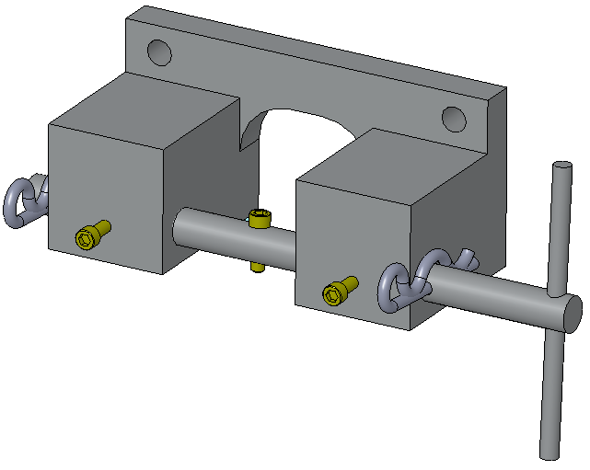

Attach the wire routing fixture to the side plate with two #8-32 x ¾” SHCS. Wrap the suspension wire around the screw in the crank and tighten the screw so that the wire is locked into place.
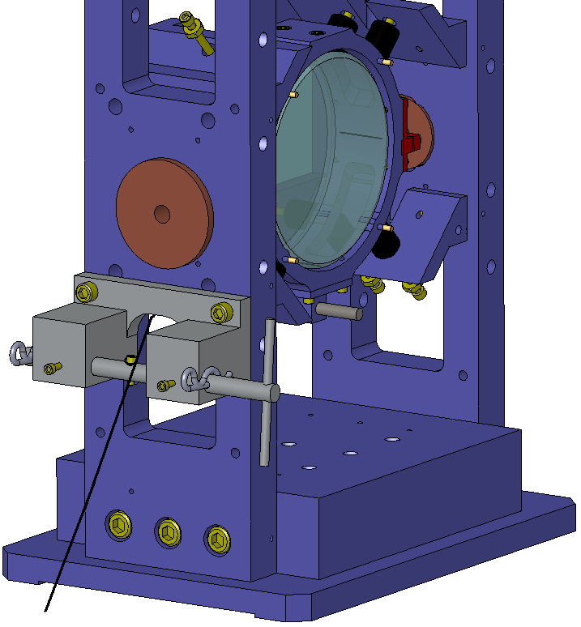

Loosen the locking screws on the crank and turn it until the lower side of the upper blade clamp is centered in the aperture of the blade tip adjustment fixture (left side of figure below). Lock the crank in this position. Check that the wire is still located in the proper groove on the lower blade clamp, and then tighten the lower blade clamp. Use a pair of wire cutters to remove the excess wire. Position the blade stop ~1mm above the blade. Remove the wire routing fixture. (NOTE: the figure is simprecise, as the clamp assembly fixtures on the blade tips have already been removed at this stage).
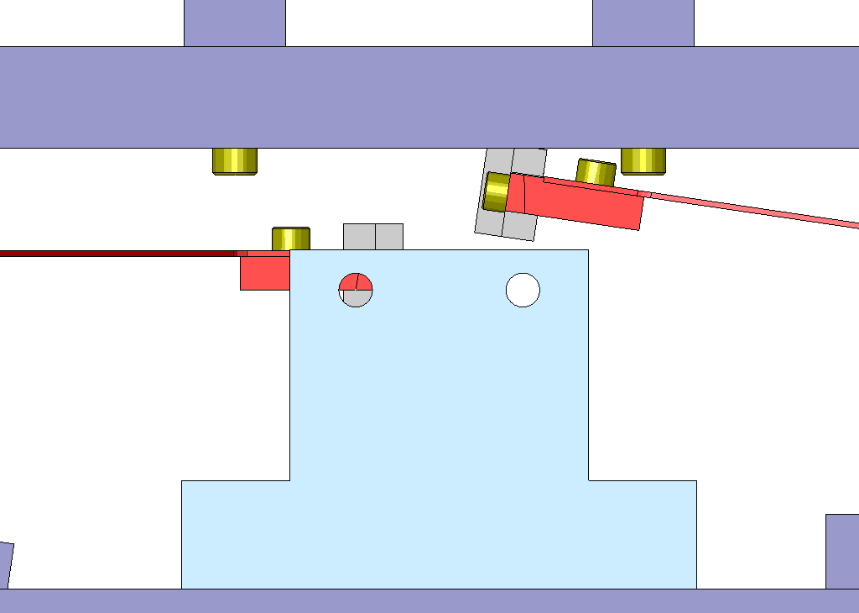

Repeat steps 8.6.17-8.6.20 for the other side.

Remove the dowel pins. Remove the clamp assembly fixtures from the optic holder. At this stage, the suspension can be safely laid down, optic AR face up, to gain easier access to the clamp assembly fixtures screws.

Optic Alignment

Remove the optic height block from the tower base.

Thread a #10-32 hat-shaped nut onto the threaded rod starting from the side of the optic holder that does not have magnets. (NOTE: the figures does not show the correct nut type).
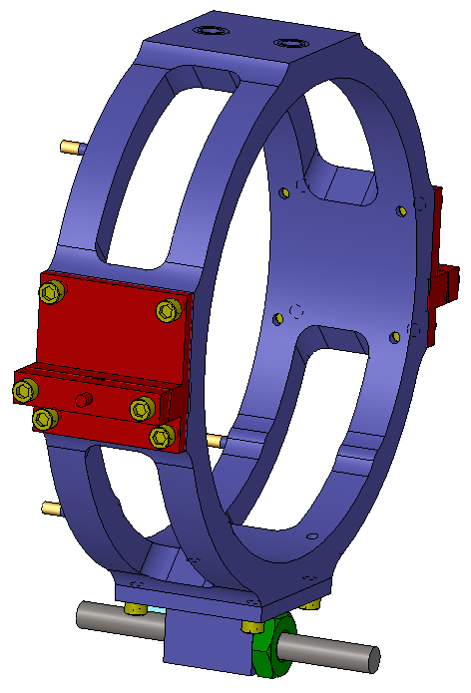

Loosen each of the earthquake stops by one full turn.

Loosen the screws that attach the blade assemblies to the top plate and move the assemblies until the nubs are horizontally centered with the holes in the copper plugs. Confirm that the blade tips are still horizontally centered in the apertures of the blade tip adjustment fixtures. When both criteria are met, tighten the screws to lock the blade assemblies to the top plate.
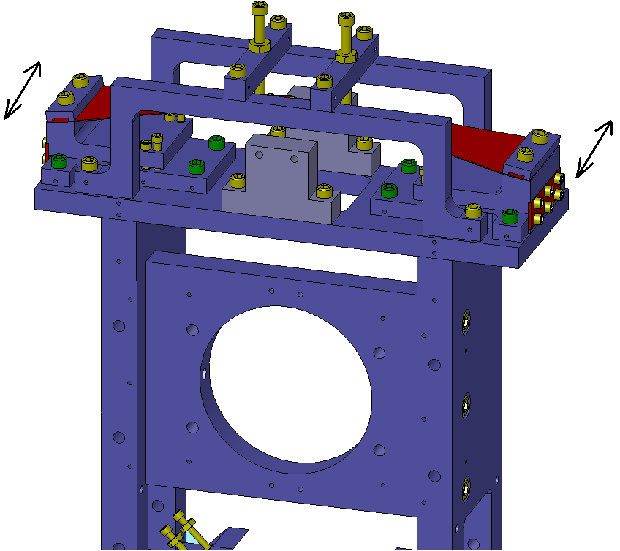
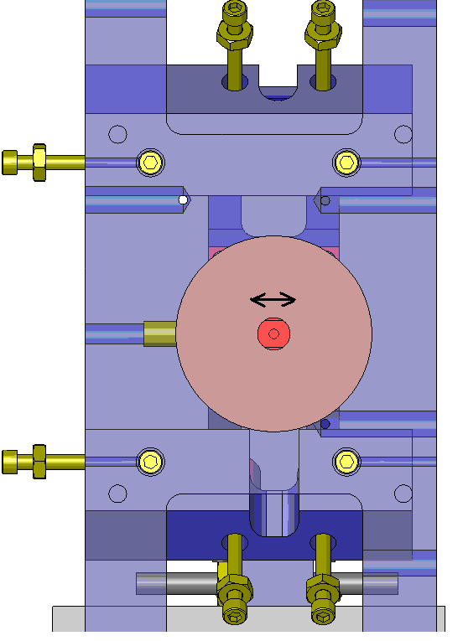
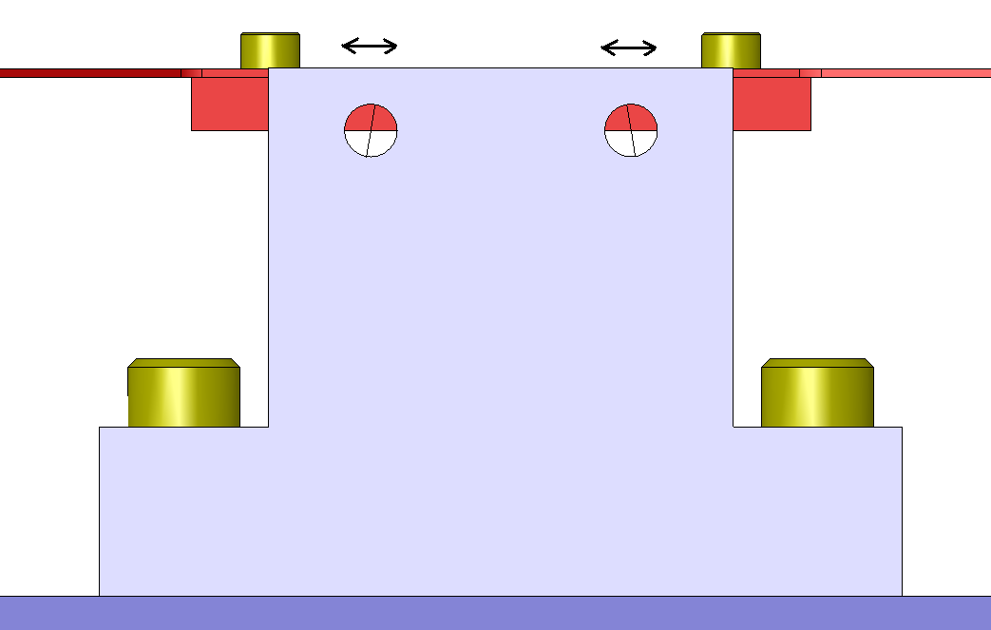

Check that the blade tips are vertically centered in the apertures of the blade tip adjustment fixtures. If they are not vertically centered, adjust the blade heights with the adjuster screws. Cross check that the nubs on the optic holder are vertically centered with the holes in the copper plugs.
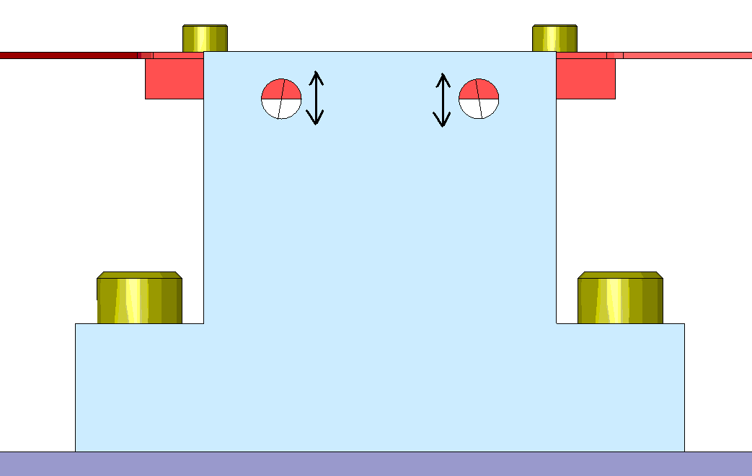

Check that the optic holder is not touching any of the earthquake stops and that the suspension wires contact nothing but the wire clamps. Re-check that the HR face of the optic is level, that the nubs on the lower blade clamps are centered with the aperture holes in the copper plugs, and that the blade tips are horizontally and vertically centered with the apertures of the blade tip adjustment fixtures. If any of these checks fail, repeat steps 8.7.3-8.7.5. Clamp the optic holder with the earthquake stops in this position. Remove the copper plugs.

Attach the magnets to the optic holder following the orientation illustrated in 8.1 (looking at the optic AR face, the TL magnet has the south facing away from the optic, and the others follow alternating polarity).

OSEM and damper installation

Lower Damper

Put two eddy current magnets (D1002368) into the magnet holder (D1002369) and secure them with two #8-32 x 3/16” PEEK set screws. The magnets must be oriented in opposite directions. Use a Gauss meter to verify that the magnets are oriented with the polarities shown below.
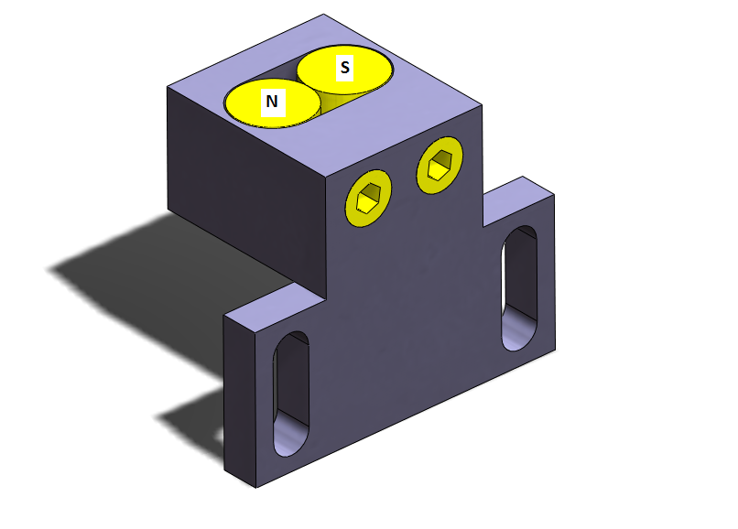

Attach the magnet holder to the lower damper bracket (D1002378) in the fully retracted position with (2) Lock Washers and (2) #4 -40 x .625” SHCS.
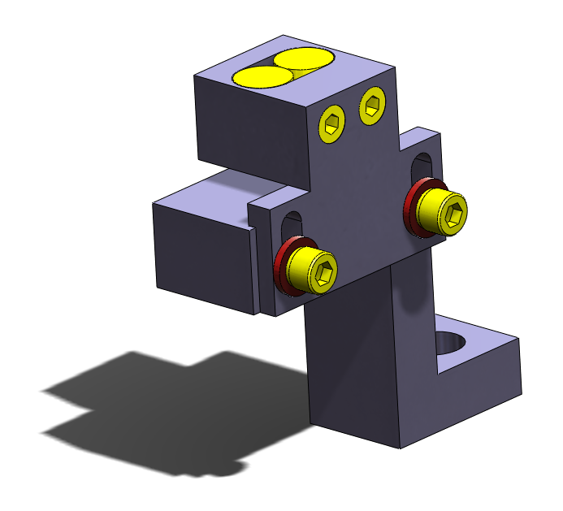

Attach the lower damper assembly to the tower base with a ¼-20 x 1” SHCS. Loosen the two locking screws. Set the gap between the magnet holder to the lower damper bracket to 0.05” using two 0.025” feeler gauges.
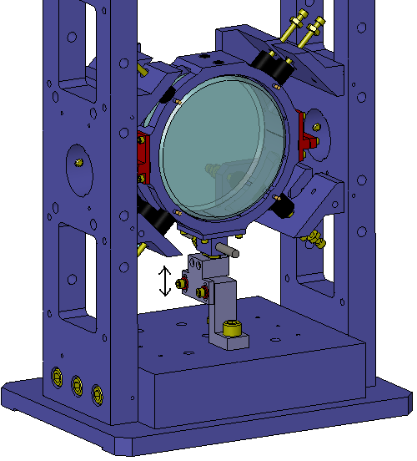

Lower OSEM Bracket.

Take one of the earthquake stop assembly set aside in steps 8.4.14. Thread the screw into the lower OSEM bracket (D1000547) and thread a viton tip onto it. Back the screw out so that the tip is flush with the bracket. Thread two 1/4 - 20 x ½” set screws to the bracket, all the way down until they are flush with the hole for the OSEM.
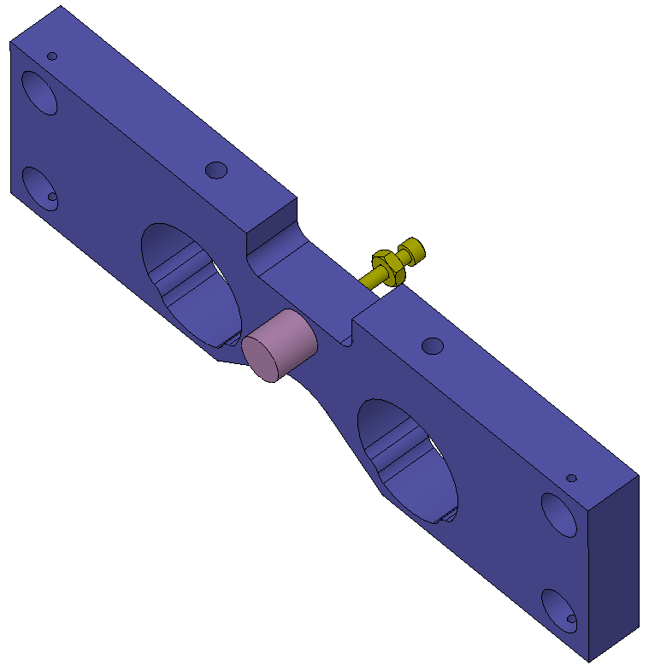

Use four ¼-20 x 1” SHCS, four ¼” lock washers (McMaster 92147A029), and four ¼” flat washers (McMaster 91950A029) to attach the lower OSEM bracket assembly to the back of the suspension frame.

Insert two OSEMs and lock them into place with the set screws. The front face of the OSEM should be about 2 mm from the magnets, so to minimize parallax error during centering while preventing them from kicking the magnets off the posts.

Loosen the screws slightly and adjust the bracket location until the two lower magnets on the optic holder are centered on the OSEMs.
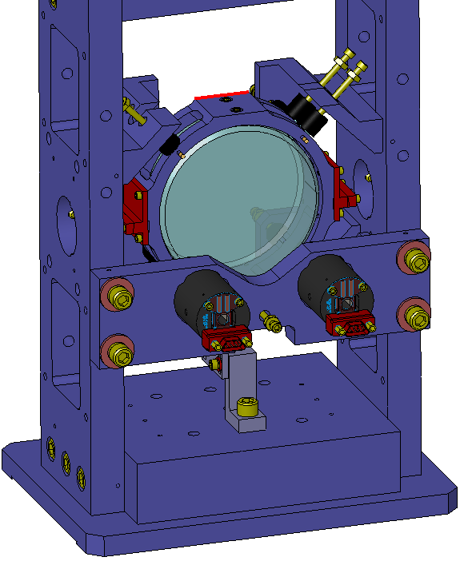

Upper OSEM Bracket

Assemble another eddy current damper, like in steps 8.8.1-8.8.2, except use the upper damper bracket (D1000541) in place of the lower damper bracket. Adjust the damper in its mounting slots so that the magnets are closest to the mounting screws.
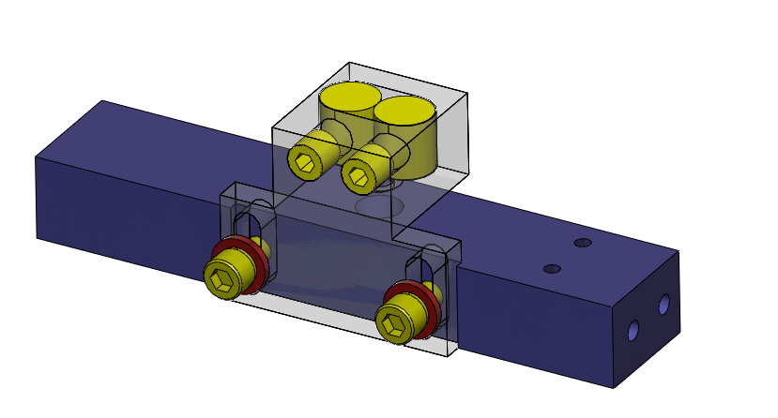

Attach the assembly to the upper OSEM bracket (D1000398) with two #4-40 x ½” SHCS.
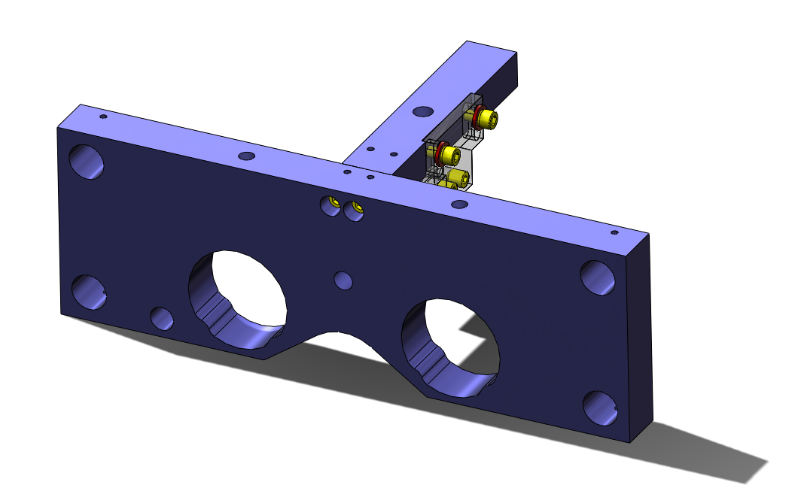

Attach an earthquake stop to the bracket, similar to step 8.8.4.
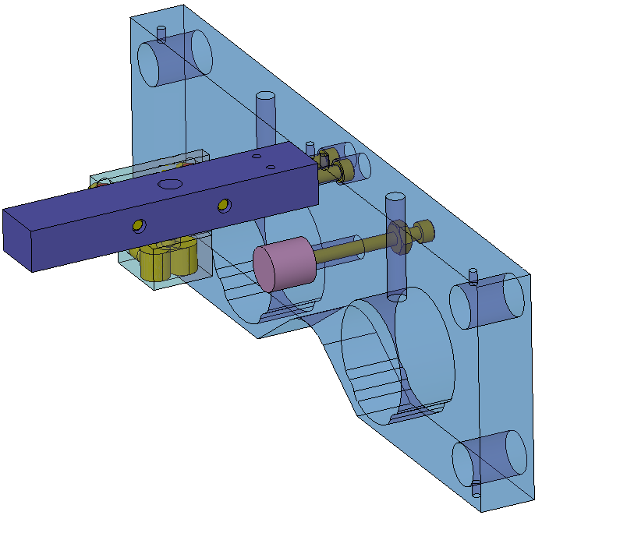

Attach the assembly to the suspension frame, insert two OSEMs and center the mounting bracket similar to steps 8.8.5-8.8.7.

Attach two OSEMs to the bracket and center them to the magnet, similar to step 15.2.3 and 15.2.4.
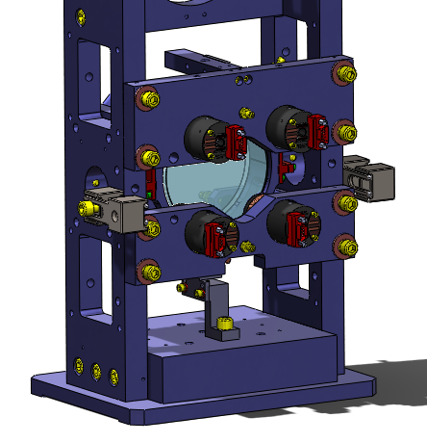
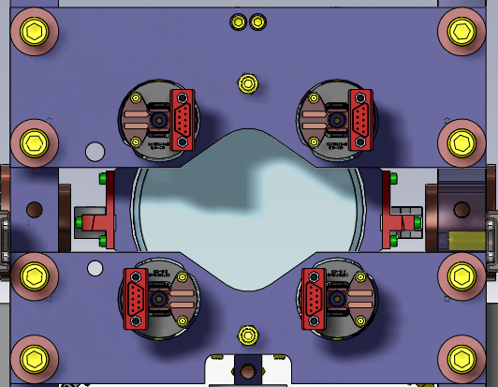

Loosen the locking screws on the upper eddy current damper until the lock washers are almost completely relaxed. Set the gap between the magnet holder to the upper damper bracket to 0.05” using two 0.025” feeler gauges, as in step 8.8.3.
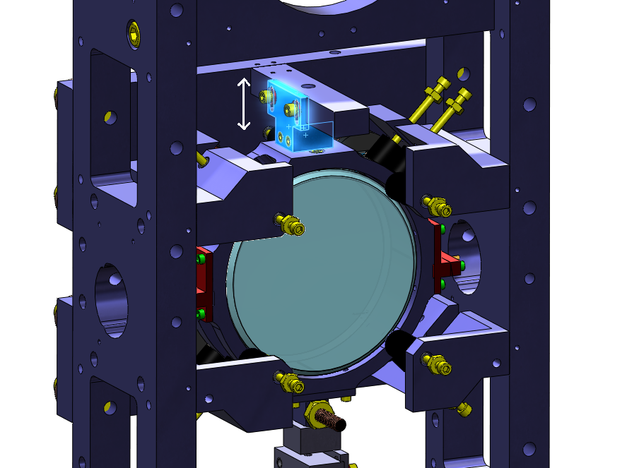

Lock the two earthquake stops on the OSEM plates to the optic holder. At this point the optic holder should be locked by all 14 earthquake stops. The basic assembly is complete.

Riser

The Suspension is to be fitted with a riser block to elevate the optic to the appropriate height. The Suspensions for L1 are to be fit with D1000137, the ones for H1 with D1000138 and the ones for H2 with D1000139. They are attached using four #10 – 32 SHCS threaded from the base of the suspension

Optic Alignment

Set up an optical lever and adjust the balance rod until the HR face of the optic is locally vertical to within 1mrad. Lock the balance rod with the locking nut, and verify that the level is still within spec.
