LIGO Laboratory / LIGO Scientific Collaboration

LIGO- E1000311 LIGO March 16th, 2012

aLIGO HAM-ISI, Pre-integration Test Report, Phase I,
LHO Unit #2 (post-assembly, before storage, after replacement of faulty parts)
E1000311 – V9

Hugh Radkins, Jim Warner, Robinson Mitchel, Corey Gray, Gregory Grabeel, Eric Allwine
Hugo Paris, Fabrice Matichard, Vincent Lhuillier

Distribution of this document:
Advanced LIGO Project

This is an internal working note
of the LIGO Laboratory

California Institute of Technology  LIGO Project – MS 18-34  1200 E. California Blvd.  Pasadena, CA 91125  Phone (626) 395-2129  Fax (626) 304-9834  E-mail: info@ligo.caltech.edu | Massachusetts Institute of Technology  LIGO Project – NW22-295  185 Albany St  Cambridge, MA 02139  Phone (617) 253-4824  Fax (617) 253-7014  E-mail: info@ligo.mit.edu
LIGO Hanford Observatory  P.O. Box 1970  Mail Stop S9-02  Richland WA 99352  Phone 509-372-8106  Fax 509-372-8137 | LIGO Livingston Observatory  P.O. Box 940  Livingston, LA 70754  Phone 225-686-3100  Fax 225-686-7189

Table of contents:
Introduction 2
I. Pre-Assembly Testing 3
▪ Step 1: Position Sensors 3
▪ Step 2: GS13 4
▪ Step 3: Actuators 9
II. Tests to be performed during assembly 10
▪ Step 1: Parts Inventory (E1000052) 10
▪ Step 2: Check torques on all bolts 11
▪ Step 3: Check gaps under Support Posts 11
▪ Step 4: Pitchfork/Boxwork flatness before Optical Table install 12
▪ Step 5: Blade spring profile 12
▪ Step 6: Gap checks on actuators-after installation on Stage 1 13
▪ Step 7: Check level of Stage 0 14
▪ Step 8: Check level of Stage 1 Optical Table 15
▪ Step 9: Mass budget 16
▪ Step 10: Shim thickness 18
▪ Step 11: Lockers adjustment 18
III. Tests to be performed after assembly 19
▪ Step 1 - Electronics Inventory 19
▪ Step 2 - Set up sensors gap 19
▪ Step 3 - Measure the Sensor gap 20
▪ Step 4 - Check Sensor gaps after the platform release 20
▪ Step 5 – Performance of the limiter 21
▪ Step 5.1 - Test Nº1 - Pushing “in the general coordinates” 21
▪ Step 5.2 - Test Nº2 – Pushing “locally” 21
▪ Step 6 - Position Sensors unlocked/locked Power Spectrum 22
▪ Step 7 - GS13 power spectrum -tabled tilted 25
▪ Step 8- GS13 pressure readout 26
▪ Step 9 - Coil Driver, cabling and resistance check 27
▪ Step 10 - Actuators Sign and range of motion (Local drive) 28
▪ Step 11 - Vertical Sensor Calibration 29
▪ Step 12 - Vertical Spring Constant 30
▪ Step 13 - Static Testing (Tests in the local basis) 30
▪ Step 14 - Linearity test 31
▪ Step 15 - Cartesian Basis Static Testing 33
▪ Step 16- Frequency response 34
▪ Step 16.1 - Local to local measurements 34
▪ Step 16.2 - Cartesian to Cartesian measurements 37
▪ Step 17 - Transfer function comparison with Reference 40
▪ Step 17.1 - Local to local - Comparison with Reference 40
▪ Step 17.2 - Cartesian to Cartesian - Comparison with Reference 43
▪ Step 18 - Lower Zero Moment Plane 46
IV. HAM-ISI Unit #2 testing summary 48
▪ List of tests that failed and don’t need to be redone: 48
▪ Tests that failed and need to be done during phase II 48
▪ List of test that were skipped and that we will not do because they are not essential 49

Introduction
HAM-ISI Unit #2 was initially built and tested in September 2010. Since then, it has been disassembled and reassembled due to faulty parts that needed to be replaced. The replacement of these parts implied the need of going through the testing process again, which has been performed during February 2012, until March 2012, and is presented here.
Stage-0 L4Cs were not installed during tests. If installed in chamber 8 or 2, as planned, this unit will not need feedforward L4Cs.
Every GS13 was removed prior to storage. No GS13 stored with the ISI.
The procedure document used to perform these tests is:
- E1000309–V9 - aLIGO HAM-ISI, Pre-Integration Testing Procedure, Phase I (post assembly, before storage)
The report done prior to HAM-ISI Unit #2 disassembly/reassembly is posted under V3:
- E1000311_aLIGO_SEI_Testing_Report_HAM-ISI_LHO_Unit_2_V3
Other useful information can be found in:
- E1000300 - HAM-ISI LLO test stand: software and electronic check

Remark regarding SVN paths:
Units need to be tested under a folder that matches medm channels’ names. Since MEDM channels’ names all refer to HAMX during this phase of testing, units are all tested under:
/SeiSVN/seismic/HAM-ISI/X1/HAMX/
Once a unit is tested, a folder called after its order of assembly is created. For Unit #2 the name of this folder will be:
/SeiSVN/seismic/HAM-ISI/X1/Unit_2/
Test data is then moved from HAMX testing folder to this final folder. All the data related to the Phase I testing of this unit is then stored in this folder. The data set names, the location of the test results, and the locations of the programs used to obtain them are specified along this document.
Even if they are tested under HAMX, units are called per their order of assembly in programs, figures and data files.

Pre-Assembly Testing

Step 1: Position Sensors

Note: The back panel reads 0.508V/0.001"
S/N sensor | S/N board | ADE Gap Standoff (mm) | Location on the Jig | Gap Standoff on Jig (mm/in) | Voltage before zeroing | Voltage after zeroing. Prebake | Voltage after zeroing. Post bake
11999 | 11844 | NR | x | ~2.057 | x | ~.01 | x
11998 | 11830 | NR | x | ~2.057 | x | ~.01 | x
11987 | 11841 | NR | x | ~2.057 | x | ~.01 | x
11990 | 11849 | NR | x | ~2.057 | x | ~.01 | x
12041 | 11897 | NR | x | ~2.057 | 1 | ~.01 | x
12048 | 11880 | NR | x | ~2.057 | 1 | ~.01 | x

NR: not recorded
*: not recorded. Estimation based on nominal value. Will be measured for the next units.

Sensors noise spectra measured before baking, and before shielding per procedure T1000636:

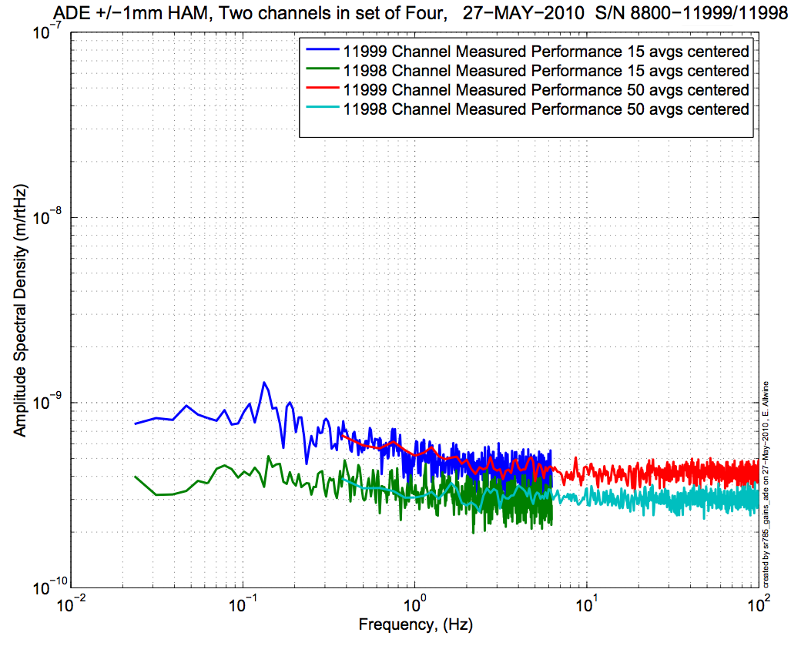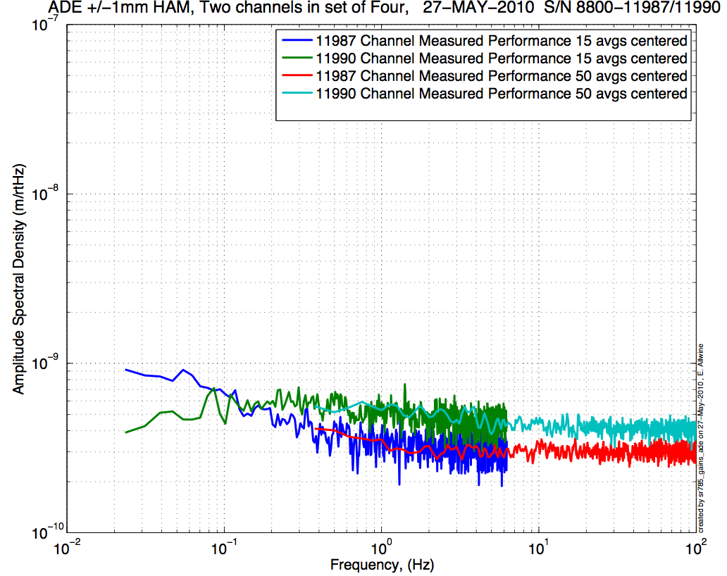
Figure - H1 and V1 sensor noise Figure - H2 and V2 sensor noise

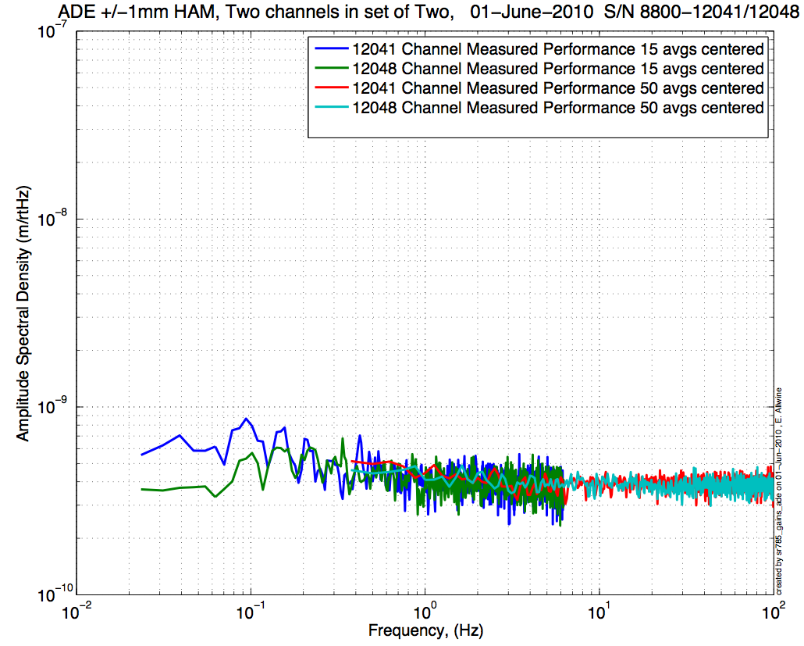
Figure - H3 and V3 sensor noise

Issues/difficulties/comments regarding this test:
The CPS #11999 (H1) is borderline at 9.e-10 m/√Hz.

Acceptance Criteria:
- Power spectrum magnitudes must be lower than:
  - 9.e-10 m/√Hz at 0.1Hz
  - 6.e-10 m/√Hz at 1Hz

Test result: Passed: X Failed: .

Step 2: GS13
All the data related to GS-13 post podding testing can be found in the SVN at:
All the data related to GS-13 post podding testing can be found in the SVN at : \SeismicSVN\seismic\Common\Data\aLIGO_GS13_TestData\PostMod_TestResults_PDFs.
Power spectra measured after shipment from LLO can be found at
\SeismicSVN\ seismic\Common\Data\aLIGO_GS13_TestData_LHO\
aLIGO GS13 Testing page is E1100367. It contains links to:
- LIGO-E1000058: aLIGO GS-13 Status Chart
- LIGO-24: aLIGO GS-13 as received testing results
- LIGO-E1100394: aLIGO GS-13 prior shipping testing results
- LIGO-E1100395: aLIGO GS-13 Post Modification testing results
- LIGO-F0900070: GS-13 Inspection Checklist

Step 2.1 – Horizontal GS-13s

Huddle testing
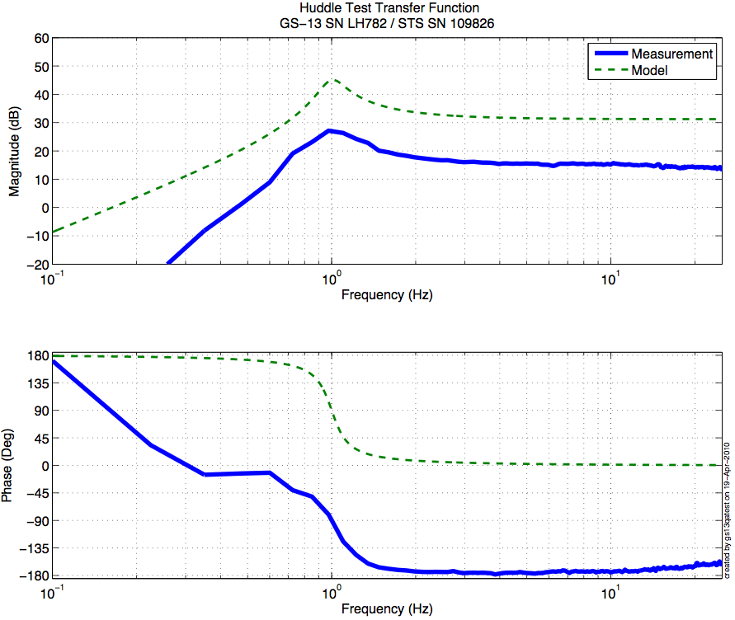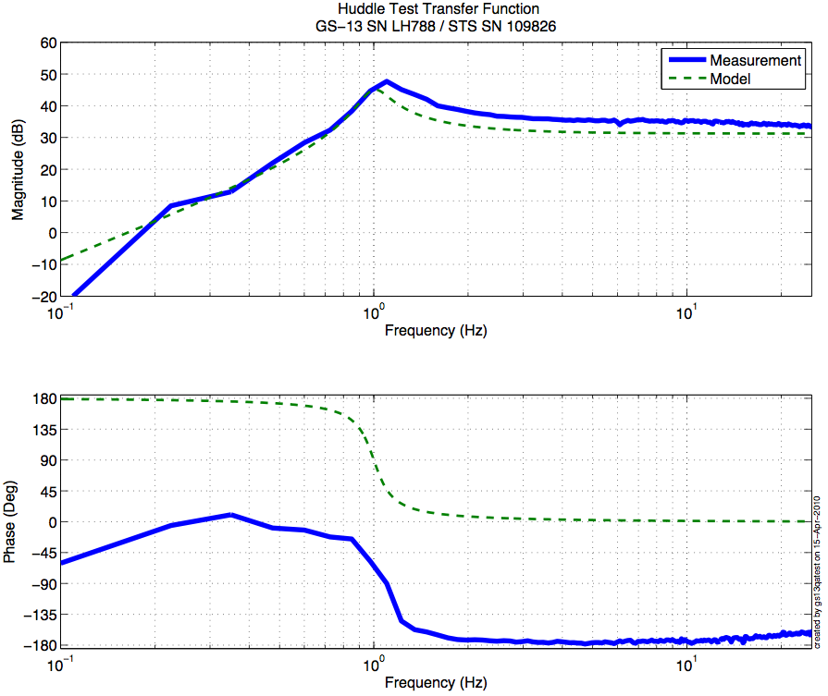
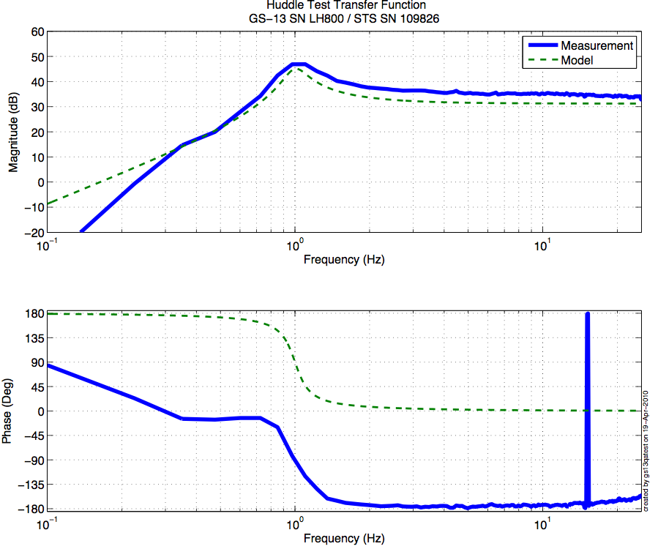
Figure - Huddle testing of Horiz GS-13 782(H1), 788(H2), and 800(H3) after aLIGO modifications

Step 2.2 – Vertical GS-13s

Huddle testing
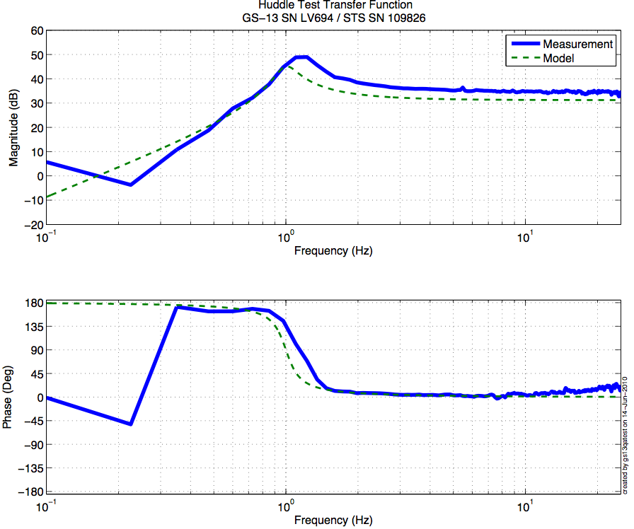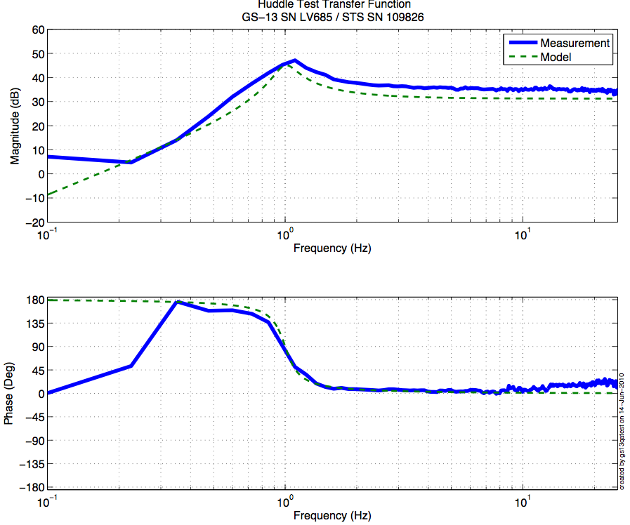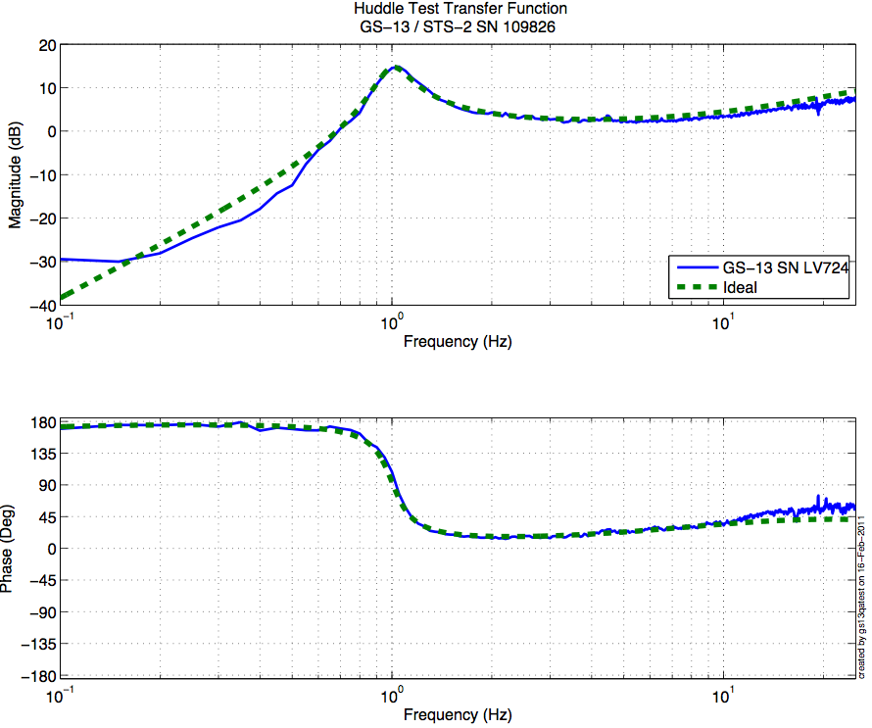

Figure - Huddle testing of Vertical GS-13 694(V1),685(V2), and 724(V3) after aLIGO modifications
Driven testing

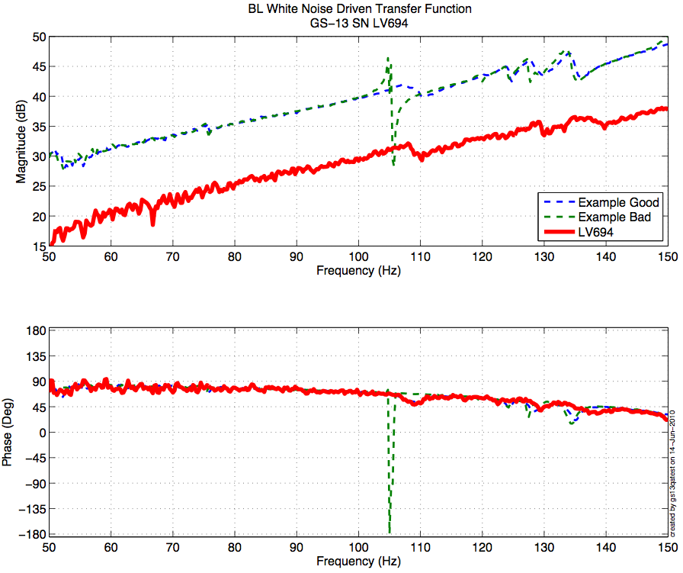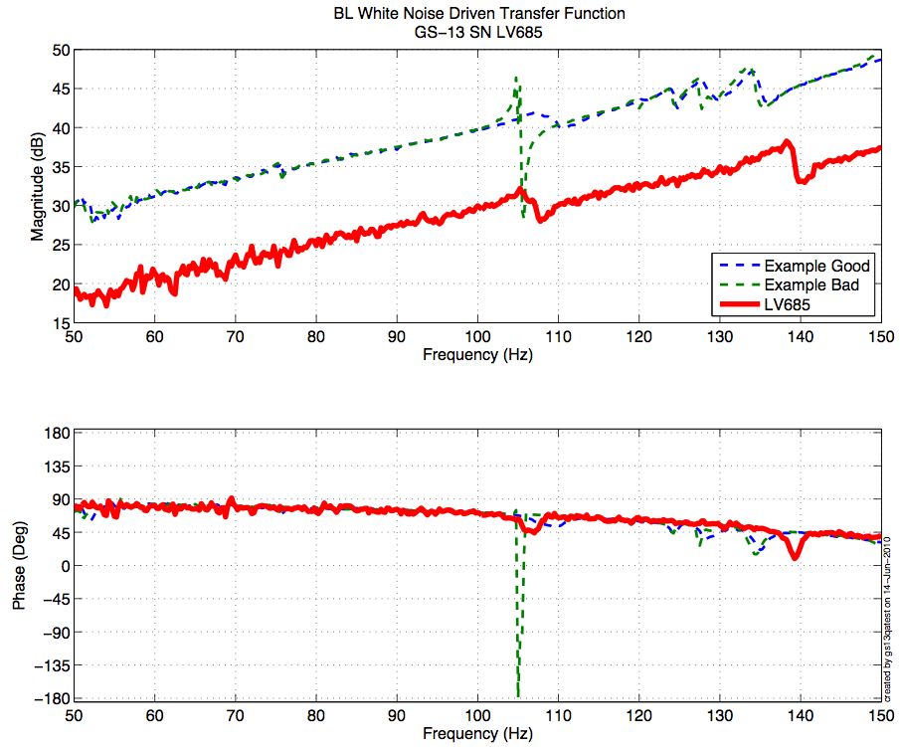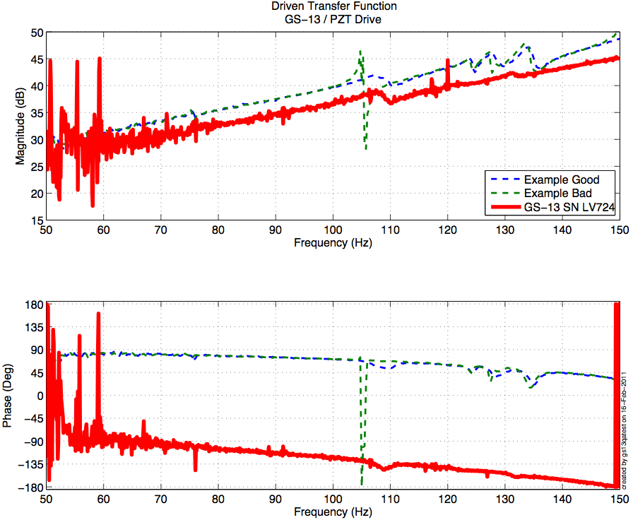
Figure - Driven testing of Vertical GS-13 694(V1),685(V2), and 724(V3) after aLIGO modifications

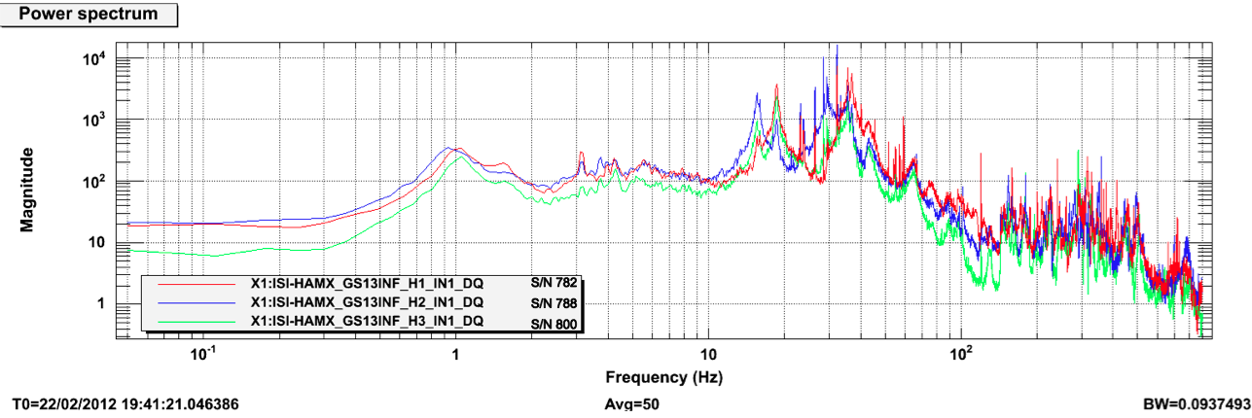

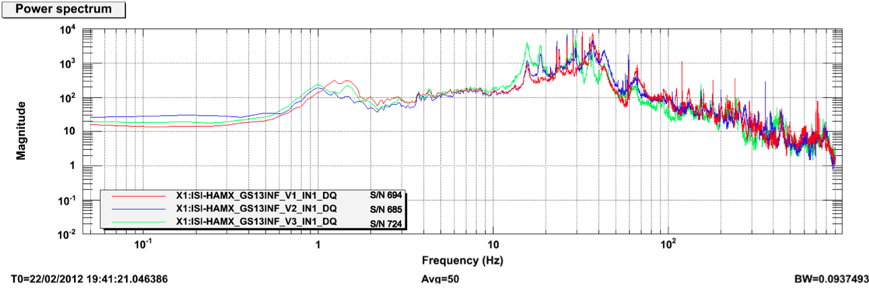
Figure - GS13 Power Spectra after installation at LHO

Issues/difficulties/comments regarding this test:
The production GS13 Pod # 94 was initially installed as H3. It appeared to have a gain of ½ (LHO aLog entry #2012). It was then replaced with the spare production pod we had on site: Pod #71. This Pod was working when tested after shipment at LHO. However, its response was bad below 20Hz when we decided to install it on the unit a few days later. Inspection of the pod revealed a broken flexure (LHO aLog entry #2369). The test pod #66 was installed on H3. It has been removed at the end of the testing phase. A production pod needs to be installed as H3 before cartridge install.

Acceptance Criteria:
- GS13 have already been tested at LLO. GS13 Inspection/Pod Assembly is described in document D047810. Checklist is defined in F090070-v6
- After reception the geophones at LHO, ASDs of the geophones must confirm that they are still functioning after shipping.

Test result: Passed: Failed: X .

Note:
The set of production pods will be completed for the side-chamber testing.

Step 3: Actuators
Actuator data can be found at: T0900564-V2. Actuator inventory is made at Section II – Step 1.

Actuator Serial #: L058  Operator Name: Gordon, Matt  Date: 9/24/2009 Time: 1:04 PM  Actuator Coil Resistance: 6.38 Ohms, PASS Ambient Temperature: 74.3 F Hi Pot  Test Results: 1000 MOhms, PASS  X Travel Limit (inches): 0.526  Y Travel Limit (inches): 0.205  Z Travel Limit (inches): 0.502 | Actuator Serial #: L038  Operator Name: Hartmann Donna  Date: 9/23/2009 Time: 9:39 AM  Actuator Coil Resistance: 6.37 Ohms,  PASS Ambient Temperature: 72.9 F Hi Pot  Test Results: 1000 MOhms, PASS  X Travel Limit (inches): 0.524  Y Travel Limit (inches): 0.205  Z Travel Limit (inches): 0.505
Actuator Serial #: L035  Operator Name: Gordon, Matt  Date: 9/24/2009 Time: 9:01 AM  Actuator Coil Resistance: 6.29 Ohms, PASS Ambient Temperature: 69.7 F Hi Pot  Test Results: 1000 MOhms, PASS  X Travel Limit (inches): 0.523  Y Travel Limit (inches): 0.205  Z Travel Limit (inches): 0.504 | Actuator Serial #: L037  Operator Name: Hartmann Donna  Date: 9/23/2009 Time: 8:45 AM  Actuator Coil Resistance: 6.38 Ohms, PASS Ambient Temperature: 72.0 F Hi Pot  Test Results: 1000 MOhms, PASS  X Travel Limit (inches): 0.526  Y Travel Limit (inches): 0.205  Z Travel Limit (inches): 0.502
Actuator Serial #: L044  Operator Name: Gordon, Matt  Date: 9/25/2009 Time: 8:40 AM  Actuator Coil Resistance: 6.31 Ohms, PASS Ambient Temperature: 70.4 F Hi Pot  Test Results: 1000 MOhms, PASS  X Travel Limit (inches): 0.532  Y Travel Limit (inches): 0.205  Z Travel Limit (inches): 0.502s | Actuator Serial #: L040  Operator Name: Gordon, Matt  Date: 9/23/2009 Time: 2:07 PM  Actuator Coil Resistance: 6.26 Ohms, PASS Ambient Temperature: 73.2 F Hi Pot  Test Results: 1000 MOhms, PASS  X Travel Limit (inches): 0.523  Y Travel Limit (inches): 0.205  Z Travel Limit (inches): 0.504

Acceptance Criteria:
- Actuators were previously tested and results are reported in T0900564-V2.

Test result: Passed: X Failed: .

Tests to be performed during assembly

Step 1: Parts Inventory (E1000052)
DCC Number | Part name | Configuration | Corner 1 S/N | Corner 2 S/N | Corner 3 S/N
D071001 | Stage 0 base | NA | 004
D071051 | Stage 1 base | NA | 003
D071050 | Optical table | NA | 003
D071002 | Spring Post | NA | 27 | 044 | 26
D071100 | Spring | NA | 25 | 6 | 27
D071102 | Flexure | NA | 32 | 37 | 11
ADE | Position sensor | Horizontal | 11999  Master 0 | 11987  Slave 180 | 12041  Slave 0
 |  | Vertical | 11998  Slave180 | 11990  Slave 0 | 12048  Slave 180
D047812 | GS-13 pod | Horizontal | 44 | 07 | 66 (T)
 |  | Vertical | 5 | 11 | 48
D047823 | L4C pod | Horizontal | NA | NA | NA
 |  | Vertical | NA | NA | NA
D0902749 | Actuator | Horizontal | 58 | 35 | 44
 |  | Vertical | 38 | 37 | 40
Table – Parts inventory

Cable Connects |  | Cable S/N
Part Name | Configuration | Corner 1 | Corner 2 | Corner 3
GS13 | Horizontal | S1106661 | S1104776 | S1106660
GS13 | Vertical
L4C | Horizontal | NA | NA | NA
L4C | Vertical | NA | NA | NA
Actuator | Horizontal | S1104489 | S1104765 | S1104768
 | Vertical | S1104495 | S1104487 | S1104761
Table – Cables inventory
NR: Not recorded; NA: Not applicable
T: Test pod
Highlighted S/N needs to be checked at the beginning of the chamber-side testing.

Issues/difficulties/comments regarding this test:
The production GS13 Pod # 94 was initially installed as H3. It appeared to have a gain of ½ (LHO aLog entry #2012). It was then replaced with the spare production pod we had on site: Pod #71. This Pod was working when tested after shipment at LHO. However, its response was bad below 20Hz when we decided to install it on the unit a few days later. Inspection of the pod revealed a broken flexure (LHO aLog entry #2369). The test pod #66 was installed on H3. It will have to be replaced with a production pod before cartridge install.
Every GS13 was removed prior to storage. No GS13 stored with the ISI.

Step 2: Check torques on all bolts

Acceptance Criteria:
- All bolts should trip the wrench, and start moving immediately after. If any bolts in a pattern move before torque is reached, recheck after all bolts are brought to spec.

Test result: Passed: X Failed: .

Step 3: Check gaps under Support Posts
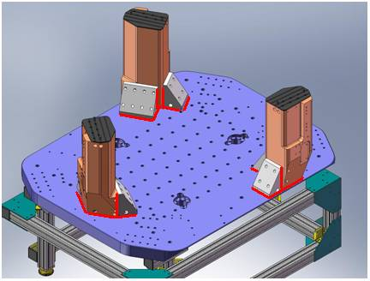
Figure - Showing edges that need checked on support posts and gussets

Acceptance Criteria:
- A 0.001 inch shim cannot be passed freely through any connection to Stage 0 or between post and gussets. If shim can pass through, loosen all constraining bolts, and then retighten iteratively from the center of the part to the edges. Retest.

Test result: Passed: X Failed: .

Step 4: Pitchfork/Boxwork flatness before Optical Table install
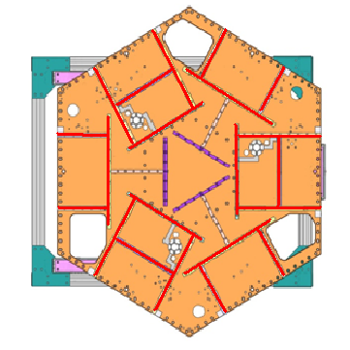
Figure – Showing what needs to be checked on Boxworks and Pitchforks

Acceptance Criteria:
- Shim inserted won’t pass between parts.

Test result: Passed: X Failed: .

Step 5: Blade spring profile
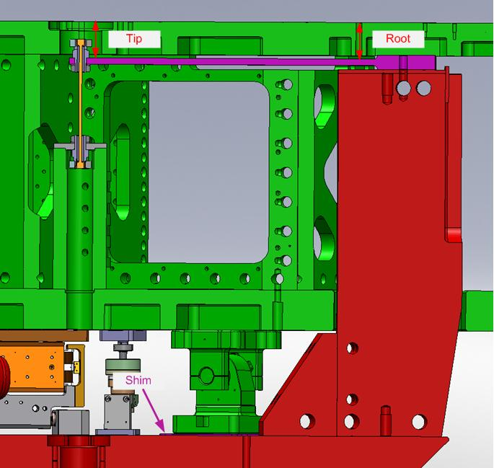
figure – Blade spring profile measurement points

Blade # | Root (Mils) | Tip(Mils) | Flatness (mils)
1 | 618 | 629 | 11
2 | 618 | 628 | 10
3 | 607 | 623 | 16

Table 1 - Blade profile

Acceptance Criteria:
- Blades must be flat within 0.015" inches.

Note that the tip measurement should be constant and that root value can be impacted by shims change.

Test result: Passed: Failed: X .

Note:
The weight of the plunge micrometer lowers Stage1 by up to 0.002”. This should reduce the Root level making the flatness over-evaluated by 0.002”. Hence, the result on blade #3 should be discussed.

Step 6: Gap checks on actuators-after installation on Stage 1
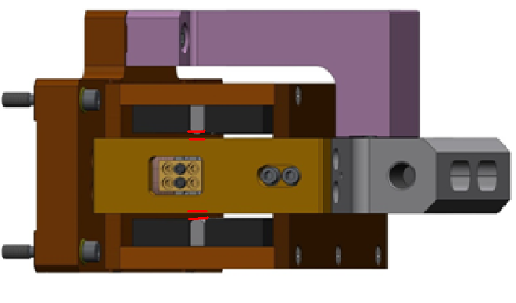
Figure - Showing gaps that need to be checked on actuators.

Issues/difficulties/comments regarding this test:
Since layers of shims are difficult to use accurately, a Go (70mils shim set) vs. No Go (90 mils shim set) technique was used for this test. To pass the test an actuator gap has to allow the 70mils shim set to be inserted and refuse the 90mils shim set.
The gaps on the backside of horizontal actuators are hard to access.

Acceptance Criteria
- Gaps must be within 0.010” of design (i.e. 0.090” and .070” pass, but 0.095” and 0.065” doesn’t).

Test result: Passed: X Failed: .

Step 7: Check level of Stage 0

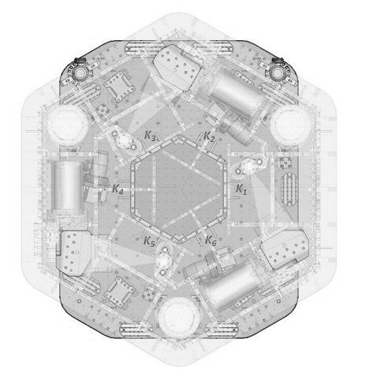
0
CORNER 1
0
-3
-2
-1
-2
-3
-5
Figure – Level measured on Stage 0

Issues/difficulties/comments regarding this test:
The accuracy of the measurement limited by the measurement tool: optical level + ruler on a block. The ruler only has 1/100” graduations. Values are deduced from the relative distance to graduations. The uncertainty is about 1mil.
Max angle is calculated between the opposite points that have the most different level.
The optical level was set up, and the test stand was leveled, since the previous version of this report.
Max angle=0.004/57 (± 0.001/57) = 85.10 (±17.4) µrad
Acceptance Criteria
- The maximum angle of the table with the horizontal mustn’t exceed ~100µrad

Test result: Passed: X Failed: .

Step 8: Check level of Stage 1 Optical Table

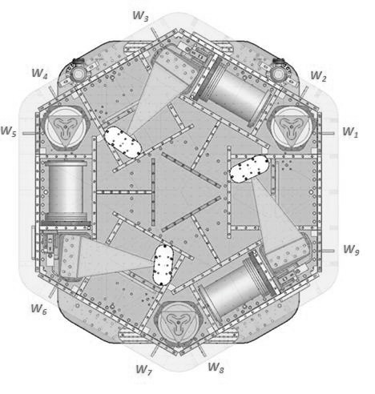
-3
-4
1
-3
CORNER 1
0
-2
Figure – Level measured on Stage 1

Issues/difficulties/comments regarding this test:
The accuracy of the measurement is limited by the measurement tool: optical level + ruler on a block. The ruler only has 1/100” graduations. Values are deduced from the relative distance to graduations. The uncertainty is about 1mil.
Max angle is calculated between the opposite points that have the most different level.
The optical level was set up, and the test stand was leveled, since the previous version of this report.
Max angle = 0.005/76 (± 0.001/76) = 65.8 (± 13.1) µrad

Acceptance Criteria
- The maximum angle of the table with the horizontal mustn’t exceed ~100µrad

Test result: Passed: X Failed: .

Step 9: Mass budget
 | 00 | 01 | 02 | 03 | 04 | 05 | 06
 | 0.6 | 1.1 | 2.2 | 4.5 | 7.9 | 15.6 | 27.2 | lbs | kgs
W9 | 1 | 2 |  |  |  | 2 |  | 34 | 15.42
W1 |  |  |  |  |  |  | 2 | 54.4 | 24.68
W2 | 1 |  | 1 |  |  |  | 1 | 30 | 13.61
W3 |  |  |  |  |  | 2 |  | 31.2 | 14.15
W4 |  |  |  |  |  |  | 2 | 54.4 | 24.68
W5 | 1 | 1 | 2 |  | 1 |  | 1 | 41.2 | 18.69
W6 |  |  |  |  |  | 2 |  | 31.2 | 14.15
W7 |  |  |  |  |  |  | 2 | 54.4 | 24.68
W8 |  |  | 1 |  | 1 |  | 1 | 37.3 | 16.92
Side Masses Total | 3 | 3 | 4 | 0 | 2 | 6 | 9 | 368.1 | 166.97
Table – Wall masses distribution

 | 00 | 01 | 02 | 03 | 04 | 05 | 06
 | 0.6 | 1.1 | 2.2 | 4.5 | 7.9 | 15.6 | 27.2 | lbs | kgs
K1 |  |  |  |  |  | 2 |  | 31.2 | 14.15
K2 |  |  |  |  | 1 |  | 1 | 35.1 | 15.92
K3 |  |  |  |  |  | 2 |  | 31.2 | 14.15
K4 |  |  |  |  | 1 |  | 1 | 35.1 | 15.92
K5 |  |  |  |  |  | 2 |  | 31.2 | 14.15
K6 |  |  |  |  | 1 |  | 1 | 35.1 | 15.92
Keel Masses Total | 0 | 0 | 0 | 0 | 3 | 6 | 3 | 198.9 | 90.22
Table – Keel masses distribution

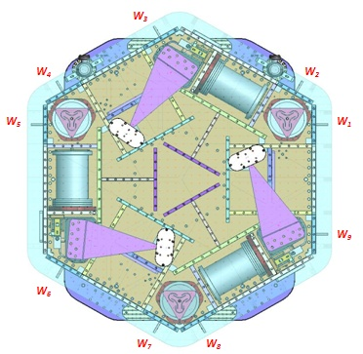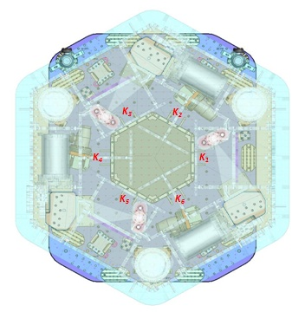
Figure – Wall Masses (W) and Keel masses (K) location. South of picture = corner 1

 | Mass (kg)
T1 | 15.00
T2 | 270.79
T3 | 15.00
T4 | 15.00
Total | 315.79
Table – Optic table masses distribution

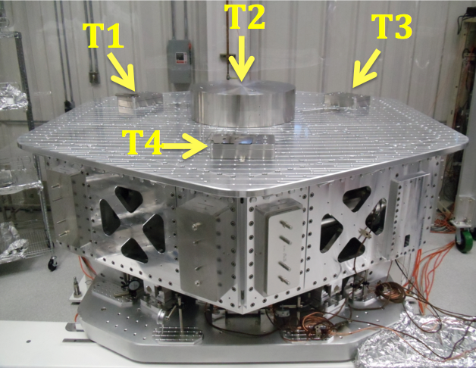
Picture – Optic table masses distribution

 | Side | Keel | Top | Total
Weigh (kg) | 166.97 | 90.22 | 315.79 | 572.98
Table – Mass budget sum up

Issues/difficulties/comments regarding this test:
- T2 mass evaluated at nominal value: 270.79lbs. Gauge not available for measurement.
- A few shims were used for balancing. Their weight is negligible in comparison with the mass budget. Hence their weight is not reported in the mass budget.
- The previous version of this report (E1000311-v3, before disassembly/reassembly of the unit) featured a total mass of 576.97kgs. The current mass budget is 4.99kg lower. This mass budget difference could be associated with the parts changed during disassembly/reassembly.

Acceptance Criteria
The Mass budget must be
- 579.1 Kg (cf. E1100427)+/-25Kg (5%)

Test result: Passed: X Failed: .

Step 10: Shim thickness

Lockers | Shim thickness (mils)
A | 126
B | 122
C | 124
D | 126
Table – Shims Thickness
Acceptance Criteria
- The shim thickness should be 125 mils +/-5
Test result: Passed: X Failed: .

Step 11: Lockers adjustment

D.I. at Locker | Vertical D.I. | Horizontal D.I.
A | 0.5 | 1.5
B | 1 | 1.5
C | 0.5 | 0
D | 0 | 1
Table – Dial indicators read-out (in thousands of an inch)

Acceptance Criteria
- Vertical and horizontal displacement near the lockers must be lower than 2 mils (0.002”

Test result: Passed: X Failed:

Tests to be performed after assembly

Step 1 - Electronics Inventory

Hardware | LIGO reference | S/N
Coil driver | D0902744 | S1000266
 |  | S1000269
Anti Image filter | D070081 | S1000250
Anti aliasing filter | D1000269 | S1102694
 |  | S1102679
Interface chassis | D1000067 | 1102223
 |  | 1102224
 |  | 1102214
Table - Inventory electronics

Acceptance Criteria
- Inventory is complete
Test result: Passed: X Failed: .

Step 2 - Set up sensors gap

 | Locked, 10 Kg masses at each corners |  | Locked /no mass |  | Unlocked /no mass
Table locked | ADE boxes on |  | ADE boxes on |  | ADE boxes on
Sensors | Offset (Mean) | Std deviation | Offset (Mean) | Std deviation | Offset (Mean) | Std deviation
H1 | -104.38 | 7.25 | -215.52 | 7.95 | 167.96 | 18.68
H2 | -23.32 | 7.02 | 52.40 | 8.83 | 366.53 | 17.58
H3 | -360.22 | 6.78 | -80.63 | 10.55 | 398.79 | 29.14
V1 | -40.27 | 7.31 | 80.52 | 13.41 | -32.02 | 21.00
V2 | 226.42 | 8.93 | 244.56 | 12.03 | -290.36 | 19.58
V3 | -306.06 | 9.89 | 37.65 | 11.94 | -188.04 | 21.00
Capacitive position sensor readout after gap set-up

Acceptance criteria:
- All mean values must be lower than 400 cts (a bit less than .0005”).
- All standard deviations below 5 counts.
- No cross talk

Test result: Passed: Failed: X .

Note: Failed because of standard deviation. However, a CPS was set on a test-jig and featured 4.3 counts of standard deviation, which is within specs. Hence, the high standard deviation observed is correlated to the 10Hz-100Hz peaks observed on the locked/unlocked GS13 and CPS ASDs. As shown in SEI Logbook entry #15, these peaks are caused by ground motion. Hence, high standard deviations should not be associated with sensor noise.

Step 3 - Measure the Sensor gap
Issues/difficulties/comments regarding this test:
Measured in the previous version of this report (E1000311-V3, p11). Waived to avoid scratching targets.

Acceptance criteria:
Sensors gap measured on the jig and on the optical table must be:
- 0.080” +/-0.002”

Test result: Passed: Failed: X .

Step 4 - Check Sensor gaps after the platform release

 | Table locked |  | Table unlocked
Sensors | Mean | Std Deviation | Mean | Std Deviation | Difference
H1 | -215.52 | 7.95 | 167.96 | 18.68 | 383.48
H2 | 52.40 | 8.83 | 366.53 | 17.58 | 314.13
H3 | -80.63 | 10.55 | 398.79 | 29.14 | 479.42
V1 | 80.52 | 13.41 | -32.02 | 21.00 | 112.54
V2 | 244.56 | 12.03 | -290.36 | 19.58 | 534.92
V3 | 37.65 | 11.94 | -188.04 | 21.00 | 225.69
Table – Sensor gaps after platform release

Acceptance criteria:

- Absolute values of the difference between the unlocked and the locked table must be below:
  - 1600 cts for horizontal sensors (~0.002”)
  - 1600 cts for vertical sensors (~0.002”)
- All mean values must be lower than:
  - 2000 cts for horizontal sensors (~0.0025”)
  - 2000 cts for vertical sensors (~0.0025”)

Test result: Passed: X Failed: .

Step 5 – Performance of the limiter

Step 5.1 - Test Nº1 - Pushing “in the general coordinates”
Pushing Z,-Z | CPS read out |  | Calculated after calibration |  | ROM
Sensors | UP (Counts) | Down (Counts) | UP (mil) | Down (mil)
V1 | 20600 | -19000 | 24.8 | -22.8 | 39600
V2 | 20000 | -19500 | 24.0 | -23.4 | 39500
V3 | 20500 | -20300 | 24.6 | -24.4 | 40800
Pushing RZ, -RZ | CPS read out |  | Calculated after calibration |  | ROM
Sensors | CCW (+RZ) | CW(-RZ) | CW (mil) | CCW (mil)
H1 | -22200 | 21350 | -26.7 | 25.7 | 43550
H2 | -22700 | 21900 | -27.3 | 26.3 | 44600
H3 | -21600 | 20100 | -26.0 | 24.2 | 41700
Table - Optic table range of motion

Step 5.2 - Test Nº2 – Pushing “locally”
Pushing Locally | Push in positive direction | Push in negative direction | Railing | Actuator Gap Check | ROM
H1 | -25800 | 23500 |  | X | 49300
H2 | -22500 | 23000 |  | X | 45500
H3 | -24300 | 22800 |  | X | 47100
V1 | 20100 | -20100 |  | X | 40200
V2 | 32767 | -32700 | X | X | 65467
V3 | 22900 | -23800 |  | X | 46700
Table - Optic table range of motion

Issues/difficulties encountered during this test:
Contact points are difficult to check on vertical actuators.

Acceptance criteria:
- The vertical sensor readout must be positive when the optic table is pushed in the +Z direction
- The horizontal sensor readout must be negative when the optic table is pushed in the +RZ direction
- Step 5.1
  - Absolutes value of all estimated motions must be higher than 16000counts (~0.020”)
- Step 5.2
  - No contact point on sensors
  - Absolute value of sensor read out must be higher than 16000counts (~0.020”)
  - No contact point on actuators

Test result: Passed: X Failed: .

Step 6 - Position Sensors unlocked/locked Power Spectra

Scripts files for processing and plotting in SVN at:
/SeiSVN/seismic/HAM-ISI/Common/Testing_Functions_HAM_ISI/
- ASD_Measurements_Locked_Unlocked_HAM_ISI.m

Data in SVN at:
SeiSVN/seismic/ HAM-ISI/X1/HAMX/Data/Spectra/Undamped/
- LHO_ISI_UNIT_2_ASD_m_CPS_T240_L4C_GS13_Locked_vs_Unlocked_2012_03_04.mat

Figures in SVN at:
/SeiSVN/seismic/HAM-ISI/X1/HAMX/Data/Figures/Spectra/Undamped
- LHO_ISI_UNIT_2_ASD_m_GS13_Requirements_Locked_vs_Unlocked_2012_03_04.fig
- LHO_ISI_UNIT_2_ASD_m_CPS_Requirements_Locked_vs_Unlocked_2012_03_04.fig

Locked/Unlocked Power Spectra are presented below.
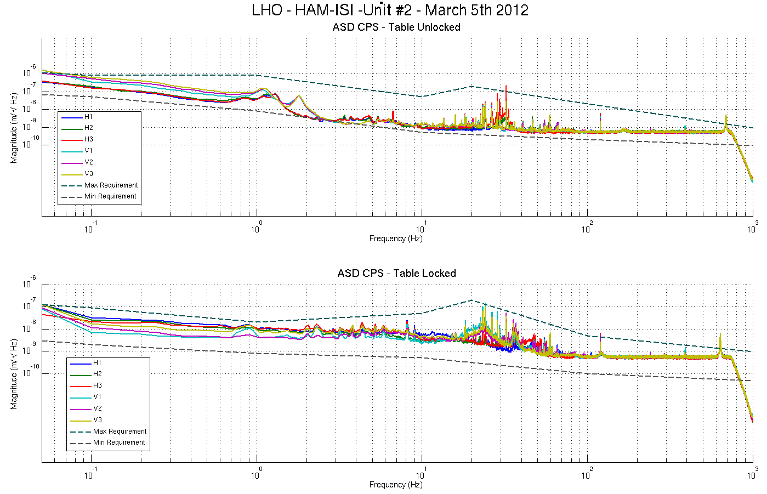
Figure - Calibrated CPS power spectra

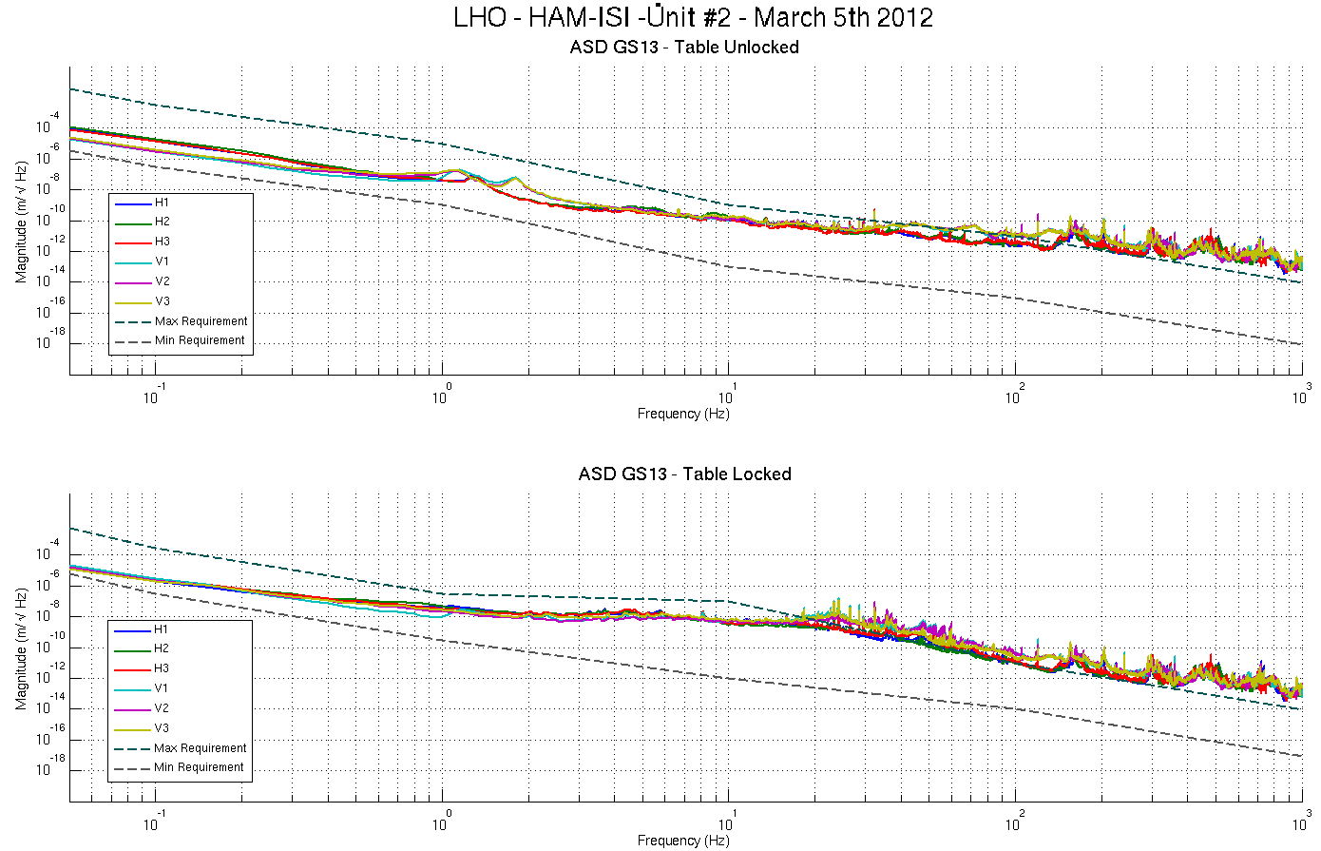
Figure – Calibrated GS13 Power spectra

Issues/difficulties/comments regarding this test:
- 10Hz-100Hz peaks were investigated for the testing phase I of Unit #3 (HAM10), and reported in Part 1, last step: Capacitive Position Sensor Investigation, of the related report (Document #E1000312-v3)

Acceptance criteria:
- No cross talk (peaks at low frequencies + harmonics on measurements)
- Magnitudes of power spectra must be between requirement curves

Test result: Passed: X Failed: .

Note:
When a seismometer fails, its low frequency response is affected. Spectra are within requirements in low frequency. The GS13s installed on this unit are functional.

Step 7 - GS13 power spectrum -tabled tilted

Scripts files for processing and plotting in SVN at:
SeiSVN/seismic/HAM-ISI/Common/Testing_Functions_HAM_ISI/
- ASD_Measurements_Stages_Tilted_HAM_ISI.m

Figures in SVN at:
SeiSVN/seismic/HAM-ISI/X1/HAMX/Data/Figures/Spectra/Undamped
- LHO_ISI_UNIT_2_m_PSD_GS13_Tilted_2012_03_01.fig

The figure below presents the GS13 power spectrum when the table is unlocked and loaded with a 10Kg mass at each of its corner.

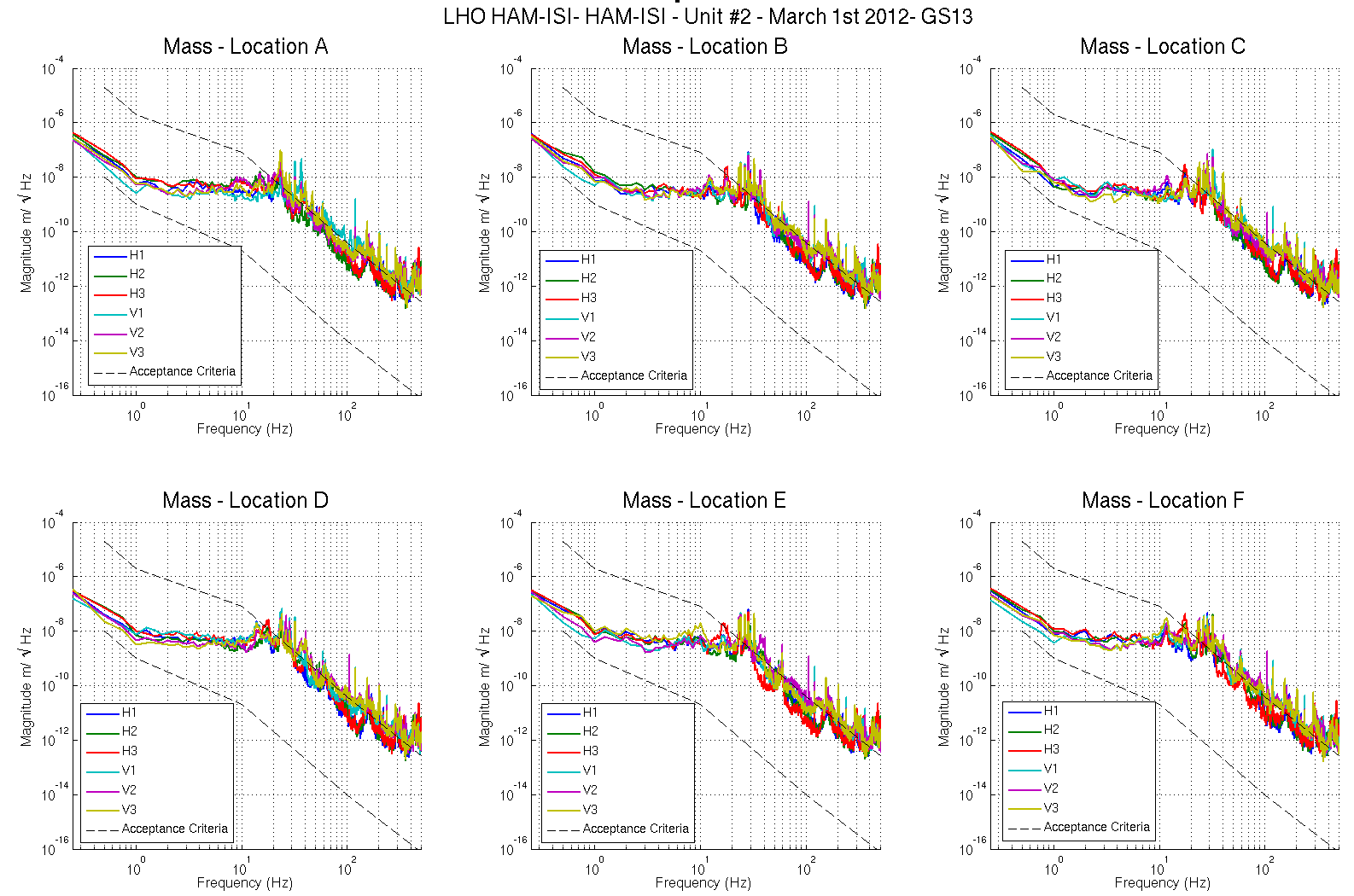
Figure – Power spectrum Calibrated GS13 with mass at corners A to F

Acceptance criteria:
- With table unlocked and tilted, magnitudes of power spectra must be fully included within requirement curves.

Test result: Passed: X Failed: .
Note:
When a seismometer fails, its low frequency response is affected. Spectra are within requirements in low frequency. The GS13s installed on this unit are functional.

Step 8- GS13 pressure readout

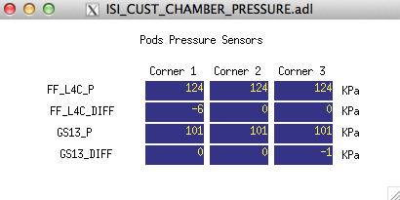
Figure – Pressure Readouts

Issues/difficulties/comments regarding this test
- The MEMD screen for GS13 pressure sensors displays constant Pressure=101KPa which corresponds to 24589 counts
- GS13_Diff=0 for each corner that has two production GS13s.
- The little discrepancy noticeable on corner 3 could come from the test-pod used as the horizontal seismometer of that corner.

Acceptance criteria:
- The pressure on GS13_P channels must be 102KPa +/-8 KPa (25000 counts +/- 3000 counts)
- GS13_P must vary the same way in each corner and GS13_DIFF must be constant (channels follow comparable trend)

Test result: Passed: X Failed: .

Step 9 - Coil Driver, cabling and resistance check

Actuator | V1 |  | H1 |  | V2
Coil driver | S1000266 - Coarse 2 |  | S1000266 - Coarse 1 |  | S1000269 - Coarse 2
Cable # | S1104760 |  | S1104762 |  | S1104773
Resistance | P1 - P2 | P2 - P3 | P1 - P2 | P2 - P3 | P1 - P2 | P2 - P3
(Ohm) | O.L (infinity) | 6.5 | O.L (infinity) | 6.45 | O.L (infinity) | 6.6
MEDM offset | Measurement P2 (+)  P1&P3 (-) |  | Measurement P2 (+)  P1&P3 (-) |  | Measurement P2 (+)  P1&P3 (-)
(1000 counts) | 0.3070V |  | 0.3117V |  | 0.3115V
Actuator | H2 |  | V3 |  | H3
Coil driver | S1000269 - Coarse 1 |  | S1102692 - Coarse 2 |  | S1102692 - Coarse 1
Cable # | S1104776 |  | S1104494 |  | S1104493
Resistance | P1 - P2 | P2 - P3 | P1 - P2 | P2 - P3 | P1 - P2 | P2 - P3
(Ohm) | O.L (infinity) | 6.5 | O.L (infinity) | 6.6 | O.L (infinity) | 6.6
MEDM offset | Measurement P2 (+)  P1&P3 (-) |  | Measurement P2 (+)  P1&P3 (-) |  | Measurement P2 (+)  P1&P3 (-)
(1000 counts) | 0.3138V |  | 0.3044V |  | 0.3106V
Table - Actuators resistance check

Issues/difficulties/comments regarding this test:
- Voltages measured from Pin #2 (+) to pin #3 (-) with compensation filters engaged.

Acceptance criteria:
- The measured resistance between the middle pin and one side pin must be 6.5 +/-1 ohms
- Actuator neutral pins must be connected on pin #3 (left side pin of the plug)
- Actuator drive pins must be connected on pin #2 (middle pin of the plug)
- Actuator ground shield pins must be connected on pin #1 (right pin of the plug)
- All LEDs on the coil driver front panel must be green

Test result: Passed: X Failed: .

Step 10 - Actuators Sign and range of motion (Local drive)

 | Negative drive | No Drive | Positive drive
H1 readout (count) | -24483 | -37 | 24156
H2 readout (count) | -23949 | -53 | 24319
H3 readout (count) | -24690 | 76 | 25499
V1 readout (count) | -19566 | 30 | 19466
V2 readout (count) | -25877 | -11 | 26424
V3 readout (count) | -21837 | 83 | 22694
Table - Range of motion - Local drive

Issues/difficulties/comments regarding this test:
- Compensation filters are ON.

Acceptance criteria:
- Main couplings sensors readout must be at least 16000 counts (~0.02”)
- A positive offset drive on one actuator must give positive sensor readout on the collocated sensor. Signs will also be tested when measuring local-to-local transfer functions.

Test result: Passed: X Failed: .

Step 11 - Vertical Sensor Calibration

Lockers | D.I readout with for  a negative drive | D.I readout without any drive | D.I readout with for  a positive drive
A | 19.20 | 0.00 | -19.20
B | 19.10 | 0.00 | -19.20
C | 18.50 | 0.00 | -18.10
D | 18.20 | 0.00 | -18.20
Average | 18.75 | 0.00 | -18.68
Sensors | Counts | Counts | Counts | Difference
V1 | -14189.00 | 821.00 | 16005.00 | 30194.00
V2 | -15065.00 | 960.00 | 16862.00 | 31927.00
V3 | -15889.00 | 222.00 | 16031.00 | 31920.00
Vertical Sensibility
837.60 | Count/mil
0.51 | V/mil
30.32 | nm/count
-0.29 | % variation from ref. (840nm/count)

Table - Calibration of capacitive position sensors

Acceptance criteria:

- Deviation from nominal value < 2%. Nominal value is 840 count/mil.

Test result: Passed: X Failed: .

Step 12 - Vertical Spring Constant

Results presented below are obtained after the initial sensors calibration.

Sensors | Mean diff counts | Mean diff m | K (N/m) | Error with average
V1 | -8001 | -2.416E-04 | 82867 | 0.78%
V2 | -8100 | -2.446E-04 | 81856 | -0.44%
V3 | -8092 | -2.444E-04 | 81943 | -0.34%
 |  | Average (N/m) | 246665
 |  |  | -0.15 | % Variation from nominal

Table - Vertical spring constant

Acceptance criteria:
- +/-2 % of 2.4704e5 N/m (i.e. between 2.421e5 and 2.520e5 N/m)
- +/- 5% of variation between each spring and the average

Test result: Passed: X Failed:

Step 13 - Static Testing (Tests in the local basis)

 | Sensors (counts)
 | H1 | H2 | H3 | V1 | V2 | V3
H1 | 2130 | 1338 | 1331 | 11 | -8 | -48
H2 | 1290 | 2088 | 1301 | 16 | -13 | -39
H3 | 1284 | 1287 | 2058 | -4 | -14 | -49
V1 | 176 | 171 | -394 | 1482 | -45 | -678
V2 | -385 | 195 | 189 | -631 | 1482 | -81
V3 | 175 | -384 | 198 | -46 | -644 | 1402
Table - Main couplings and cross couplings

Acceptance criteria:
- Vertical
For a +1000 count offset drive on vertical actuators
  - Collocated sensors must be 1400 counts +/- 10%

- Horizontal
For a +1000 count offset drive on horizontal actuators
  - Collocated sensors must be 2000 counts +/- 10%
  - Non-collocated horizontal sensors must be 1250 counts +/-10%

Test result: Passed: X Failed: .

Step 14 - Linearity test

 | Slope | Offset | Average slope | Variation from  average(%)
H1 | 2.1172 | 569.2396 | 2.08 | 1.71
H2 | 2.0778 | 712.3 |  | -0.19
H3 | 2.05 | 853.0512 |  | -1.52
V1 | 1.4806 | -83.6029 | 1.47 | 0.99
V2 | 1.472 | -182.4432 |  | 0.40
V3 | 1.4458 | -271.9174 |  | -1.39
Table - Slopes and offset of the triplet ‘Actuators - HAM-ISI – Sensors’

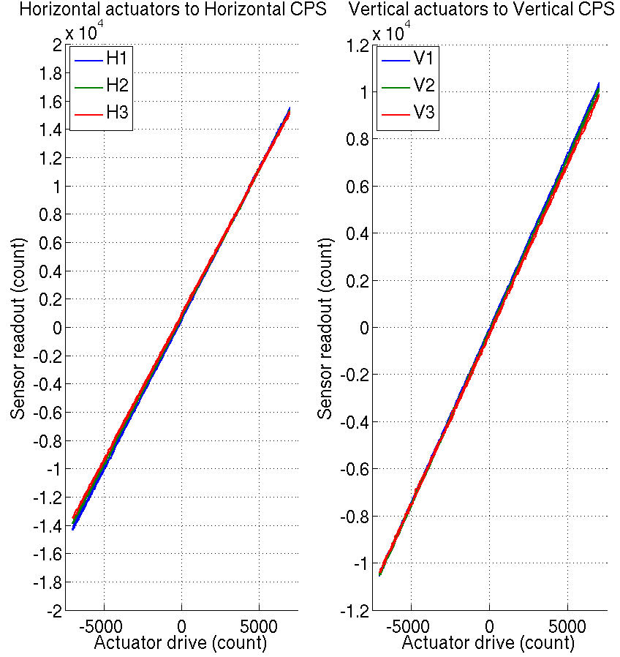
Figure - Linearity test on the triplet ‘actuators - HAM-ISI – sensors’
in both Horizontal and vertical directions

Issues/difficulties encountered during this test:
- H1, H3 and V3 do not meet our requirements.

Acceptance criteria:
- Horizontal and vertical slopes of the triplet actuators x HAM-ISI x sensors: Average slope +/- 1%

Test result: Passed: Failed: X .

Note:
The tendencies on linearity test slopes seem to match the tendencies on cable resistance (coildriver to feedthrough section). Cable resistance, which is proportional to cable length, would then be a possible explanation for the linearity results obtained.

Step 15 - Cartesian Basis Static Testing

1000 counts Drive | X | Y | Z | RX | RY | RZ | Direction read out
X Drive | 520.6 | -4.8838 | 4.7994 | 20.338 | 3.2833 | -28.214 | 520.6
Y Drive | -5.1264 | 527.42 | -60.818 | 1.978 | 2.5221 | 24.16 | 527.42
Z Drive | -6.9527 | -0.47908 | 266.99 | 13.494 | 6.8748 | 5.8121 | 266.99
Rx Drive | -3.4324 | 4.8204 | -9.2767 | 2574.6 | 40.992 | -5.6893 | 2574.6
Ry Drive | -10.06 | -2.3539 | -13.598 | 11.032 | 2656.1 | -49.378 | 2656.1
Rz Drive | -24.323 | -4.8144 | -4.9748 | 13.691 | 58.631 | 2564 | 2564
Table – Static testing: Drive in the Cartesian basis, response in the Cartesian basis

1000 counts Drive | H1 | H2 | H3 | V1 | V2 | V3 | Direction read out
X Drive | 280.82 | 283.28 | -501.53 | 3.09 | -5.9328 | -5.7772 | 520.6
Y Drive | -479.6 | 438.1 | -13.757 | 24.139 | -9.2697 | -15.03 | 527.42
Z Drive | -2.2052 | -1.8308 | -6.5996 | 262.09 | 256.3 | 252.07 | 266.99
Rx Drive | -454.66 | 469.21 | 11.138 | -507.8 | 1699 | -1230.7 | 2574.6
Ry Drive | -249.31 | -249.63 | 556.48 | -1728.9 | 413.56 | 1271.8 | 2656.1
Rz Drive | -2024.1 | -2034.7 | -2017.7 | -20.568 | -16.908 | -5.9293 | 2564
Table – Static testing: Drive in the Cartesian basis, response in the Local basis

1000 counts Drive | H1 | H2 | H3 | V1 | V2 | V3 | Direction read out
X Drive | + | + | - |  |  |  | +
Y Drive | - | + | 0 |  |  |  | +
Z Drive |  |  |  | + | + | + | +
Rx Drive |  |  |  | - | + | - | +
Ry Drive |  |  |  | - | + | + | +
Rz Drive | - | - | - |  |  |  | +
Table – Cartesian static testing reference table

Acceptance criteria:
For a positive drive in the Cartesian basis:
- Local sensor readout must have the same sign that the reference table
- Cartesian sensors read out must be positive in the drive direction

Test result: Passed: X Failed: .

Step 16- Frequency response

Step 16.1 - Local to local measurements

FREQ. RANGE |  |  | DRIVE |  | MEAS. TIME
Min | Max | Freq. Res. (Hz) | H | V | Time for 1 Rep. (s) | Number of Reps | Time (min)
0.01 | 0.1 | 0.01 | 10500 | 10500 | 620.0 | 4 | 41.3
0.1 | 0.5 | 0.02 | 600 | 600 | 320.0 | 8 | 42.7
0.5 | 5 | 0.025 | 35 | 35 | 260.0 | 16 | 69.3
5 | 200 | 0.1 | 300 | 300 | 80.0 | 40 | 53.3
200 | 1000 | 0.2 | 135 | 135 | 50.0 | 90 | 75.0
 |  |  |  |  | Total Meas. Time(h) |  | 4.7
Table – Transfer function settings, by frequency band

Data files in SVN at:
/SeiSVN/seismic/HAM-ISI/X1/HAMX/Data/Transfer_Functions/Measurements/Undamped/
- LHO_ISI_HAM_Unit_2_Data_TF_L2L_10mHz_100mHz_20120310-003723.mat
- LHO_ISI_HAM_Unit_2_Data_TF_L2L_100mHz_500mHz_20120309-215539.mat
- LHO_ISI_HAM_Unit_2_Data_TF_L2L_500mHz_5Hz_20120309-180601.mat
- LHO_ISI_HAM_Unit_2_Data_TF_L2L_5Hz_200Hz_20120309-171228.mat
- LHO_ISI_HAM_Unit_2_Data_TF_L2L_200Hz_1000Hz_20120309-155455.mat
Data collection script files:
/SeiSVN/seismic/HAM-ISI/Common//Transfer_Function_Scripts/
- Run_TF_L2L_10mHz_100mHz.m
- Run_TF_L2L_100mHz_500mHz.m
- Run_TF_L2L_500mHz_5Hz.m
- Run_TF_L2L_5Hz_100Hz.m
- Run_TF_L2L_100Hz_1000Hz.m
Scripts files for processing and plotting in SVN at:
/SeiSVN/seismic/HAM-ISI/X1/HAMX/Scripts/Control_Scripts/
- Step_1_Plot_TF_L2L_HAM_Testing.m
Figures in SVN at:
/SeiSVN/seismic/HAM-ISI/X1/HAMX/Data/ Figures/Transfer_Functions/Measurements/Undamped/
- LHO_ISI_Unit_2_TF_L2L_Raw_from_ACT_to_GS13_2012_03_10.fig
- LHO_ISI_Unit_2_TF_L2L_Raw_from_ACT_to_CPS_2012_03_10
Storage of measured transfer functions in the SVN at:
/SeiSVN/seismic/HAM-ISI/X1/HAMX/Data/Transfer_functions/ Simulations/Undamped/
- LHO_ISI_Unit_2_TF_L2L_Raw_2012_03_10.mat

The local-to-local transfer functions are presented below.

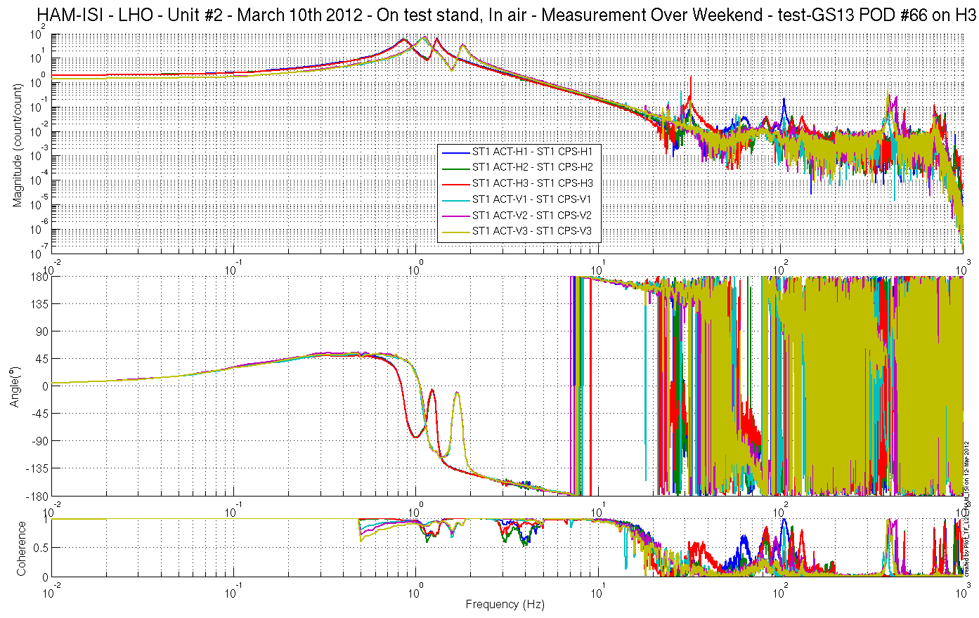
Figure - local-to-Local Measurements – Capacitive sensors

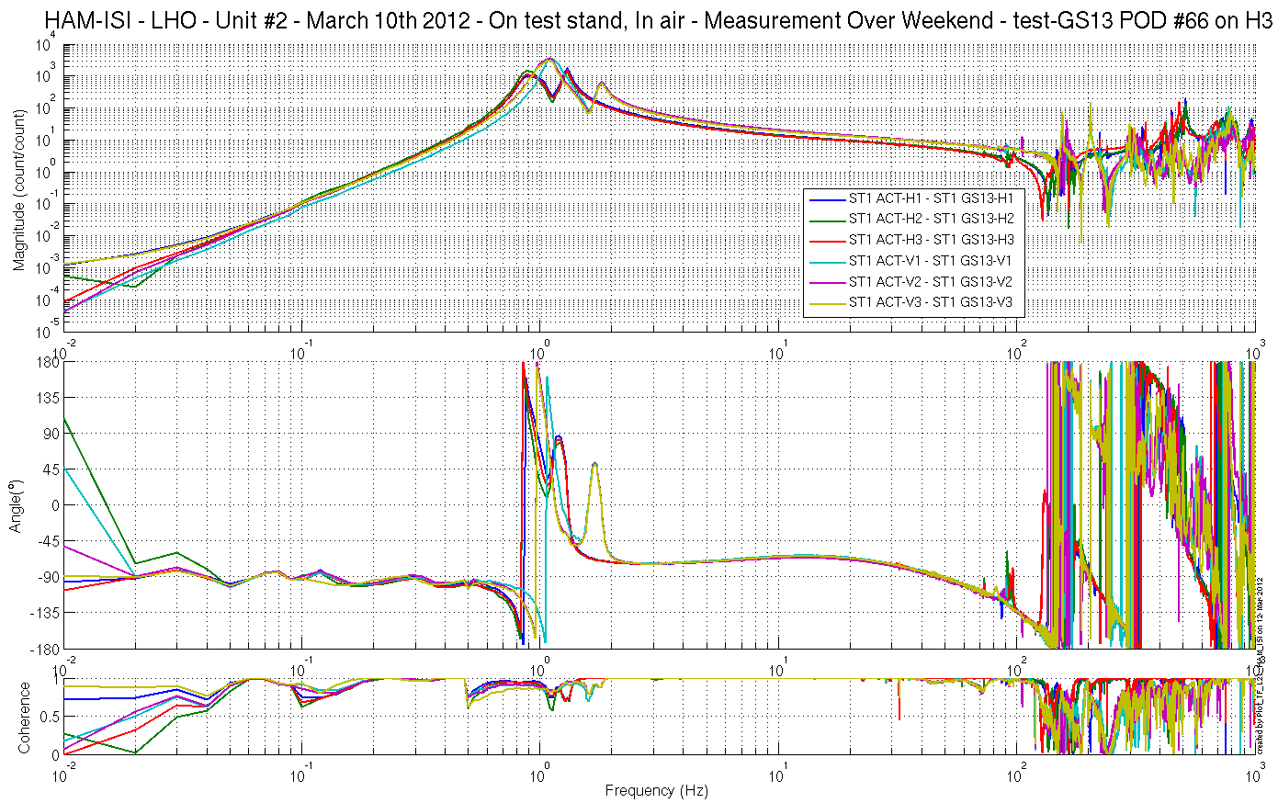
V1: See Note Below
Figure - local-to-Local Measurements – Inertial sensors

Note regarding the importance of symmetrization filters:

The transfer function measured with the GS13-V1 features a first-resonance slightly different from what is recorded by the other GS13s. This feature does not appear on measurements performed with CPSs, which confirms that it is not structural.

We extracted the responses of the GS13s from the transfer function measurement (figure below). We can note that GS13-V1 has its resonance frequency higher than the other GS13s. This observation
would tend to confirm the need for symmetrization filters.

The response measured for the huddle test of this instrument features the same shift in its resonance frequency (see below). This information confirms that the instrument properties have not been drifting along time/shipping/handling.

The symmetrized transfer functions were computed (see below). They match well which will allow to apply the damping and control filters more efficiently.

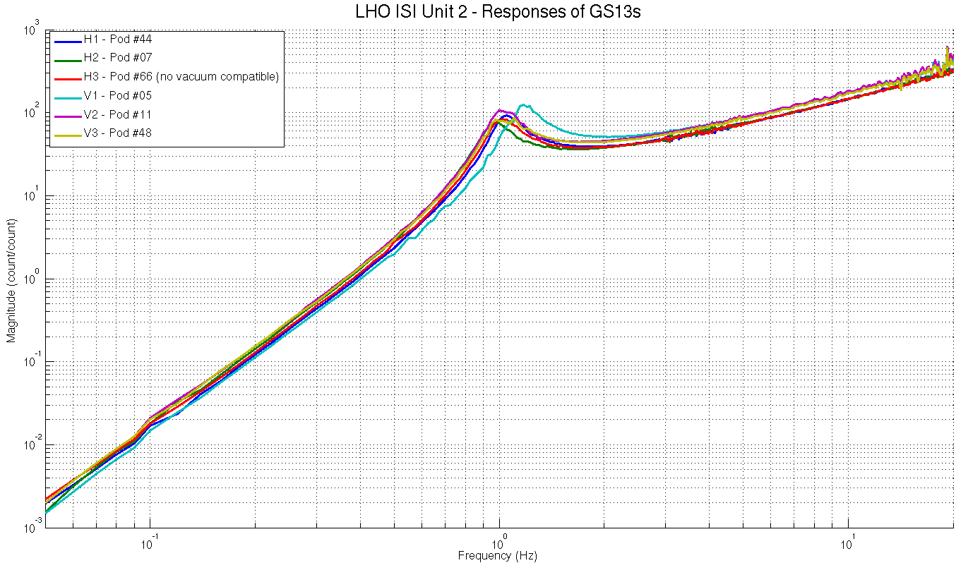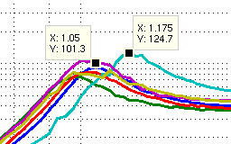
Figure –GS13 responses – Extracted from TF mesurements
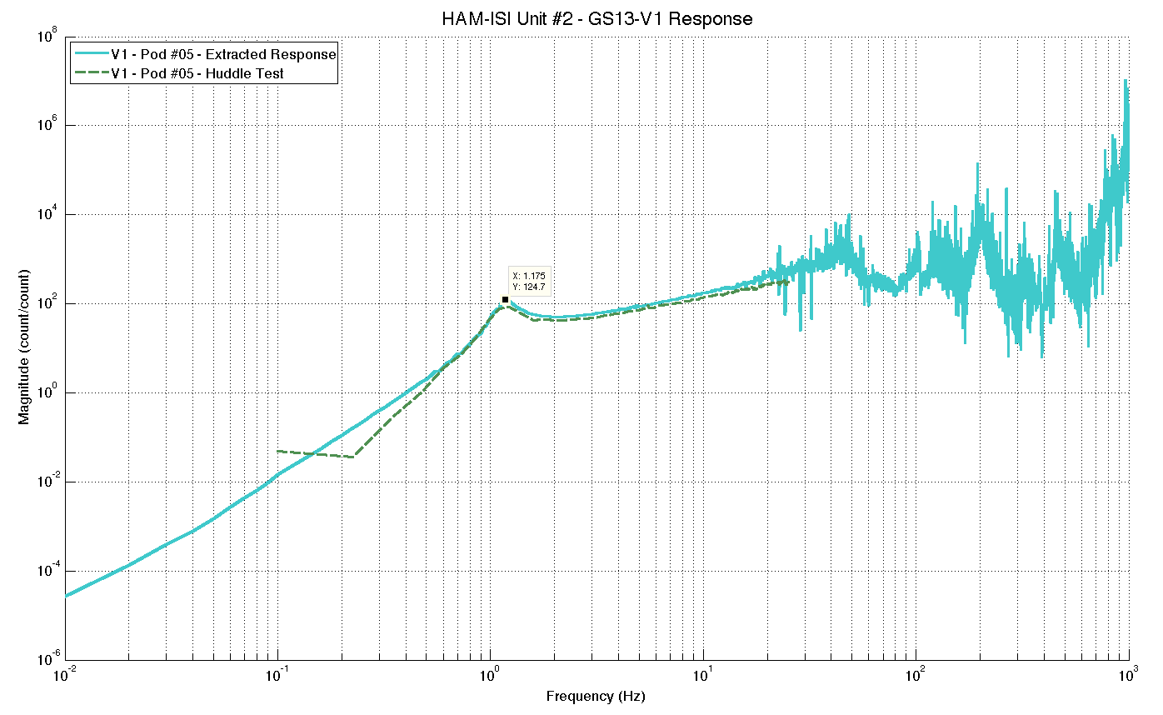
Figure –GS13 V1 – Pod #05– Huddle Test Result

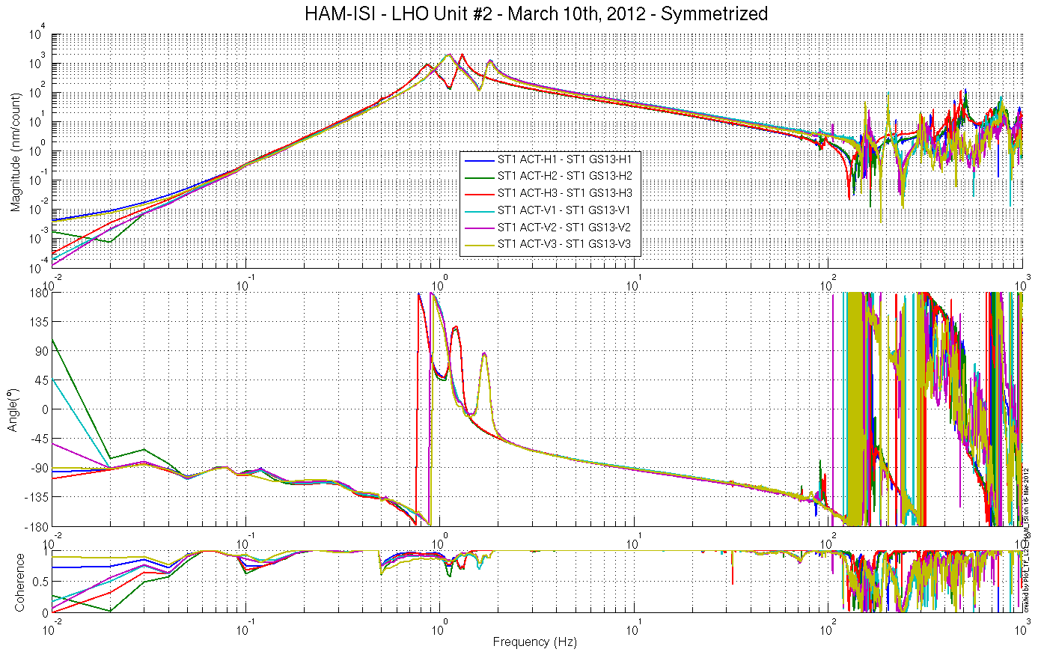
Figure - local-to-Local Measurements – Inertial sensors – After Symmetrization
Scripts file and functions for processing and plotting in SVN at:
/SeiSVN/seismic/HAM-ISI/X1/HAMX/Scripts/Data_Collection/
- X1_HAMX_Extraction_Response_GS13.m
- Extracting_GS13_HAM_ISI.m
- Plot_GS13_Response_Comparison.m

Figures in the SVN at:
/SeiSVN/seismic/HAM-ISI/X1/HAMX/Data/Figures/GS13_Responses/
- GS13_05_Inst_694_V1__Extracted_Response_Vs_Huddle_Test.fig
- LHO_HAM_ISI_Unit_2_GS13_Fitted-Responses_Comparison_2012_03_14.fig
- LHO_HAM_ISI_Unit_2_GS13_Responses_Comparison_2012_03_14.fig

Step 16.2 - Cartesian to Cartesian measurements

FREQ. RANGE |  |  | DRIVE |  |  |  |  |  | MEAS. TIME
Min | Max | Freq. Res. (Hz) | X | Y | RZ | Z | RX | RY | Time for 1 Rep. (s) | Number of Reps | Time (min)
0.01 | 0.1 | 0.01 | 7000 | 7000 | 7000 | 7000 | 7000 | 7000 | 620.0 | 10 | 103.3
0.1 | 0.5 | 0.02 | 740 | 740 | 740 | 740 | 740 | 740 | 320.0 | 30 | 160.0
0.5 | 5 | 0.025 | 30 | 30 | 35 | 45 | 12 | 12 | 260.0 | 55 | 238.3
5 | 100 | 0.1 | 680 | 680 | 450 | 1200 | 560 | 450 | 80.0 | 50 | 66.7
100 | 1000 | 0.2 | 300 | 300 | 360 | 525 | 225 | 200 | 50.0 | 150 | 125.0
 |  |  |  |  |  |  |  |  | Total Meas. time(h) |  | 11.6

Table – Transfer function settings, by frequency band

Data files in SVN at:
SeiSVN/seismic/HAM-ISI/X1/HAMX/Data/Transfer_Functions/Measurements/
Undamped/
- LHO_ISI_HAM_Unit_2_Data_TF_C2C_10mHz_100mHz_20120310-112138
- LHO_ISI_HAM_Unit_2_Data_TF_C2C_100mHz_500mHz_20120310-084000
- LHO_ISI_HAM_Unit_2_Data_TF_C2C_500mHz_5Hz_20120310-045025
- LHO_ISI_HAM_Unit_2_Data_TF_C2C_5Hz_100Hz_20120310-035652
- LHO_ISI_HAM_Unit_2_Data_TF_C2C_100Hz_1000Hz_20120310-023917
Data collection script files:
/SeiSVN/seismic/HAM-ISI/Common//Transfer_Function_Scripts/
- Run_TF_C2C_10mHz_100mHz.m
- Run_TF_C2C_100mHz_500mHz.m
- Run_TF_C2C_500mHz_5Hz.m
- Run_TF_C2C_5Hz_100Hz.m
- Run_TF_C2C_100Hz_1000Hz.m
Scripts files for processing and plotting in SVN at:
/SeiSVN/seismic/HAM-ISI/X1/HAMX/Scripts/Control_Scripts/
- Step_3_Plot_TF_C2C_HAM_Testing.m
Figures in SVN at:
/SeiSVN/seismic/HAM-ISI/X1/HAMX/Data/ Figures/Transfer_Functions/Measurements/Undamped/
- LHO_ISI_Unit_2_TF_C2C_Raw_from_ACT_to_CPS_2012_03_10.fig
- LHO_ISI_Unit_2_TF_C2C_Raw_from_ACT_to_GS13_2012_03_10.fig
Storage of measured transfer functions in the SVN at:
/SeiSVN/seismic/HAM-ISI/X1/HAMX/Data/Transfer_functions/ Simulations/Undamped/
- LHO_ISI_Unit_2_TF_C2C_Raw_2012_03_10.mat

The Cartesian to Cartesian transfer functions are presented below:

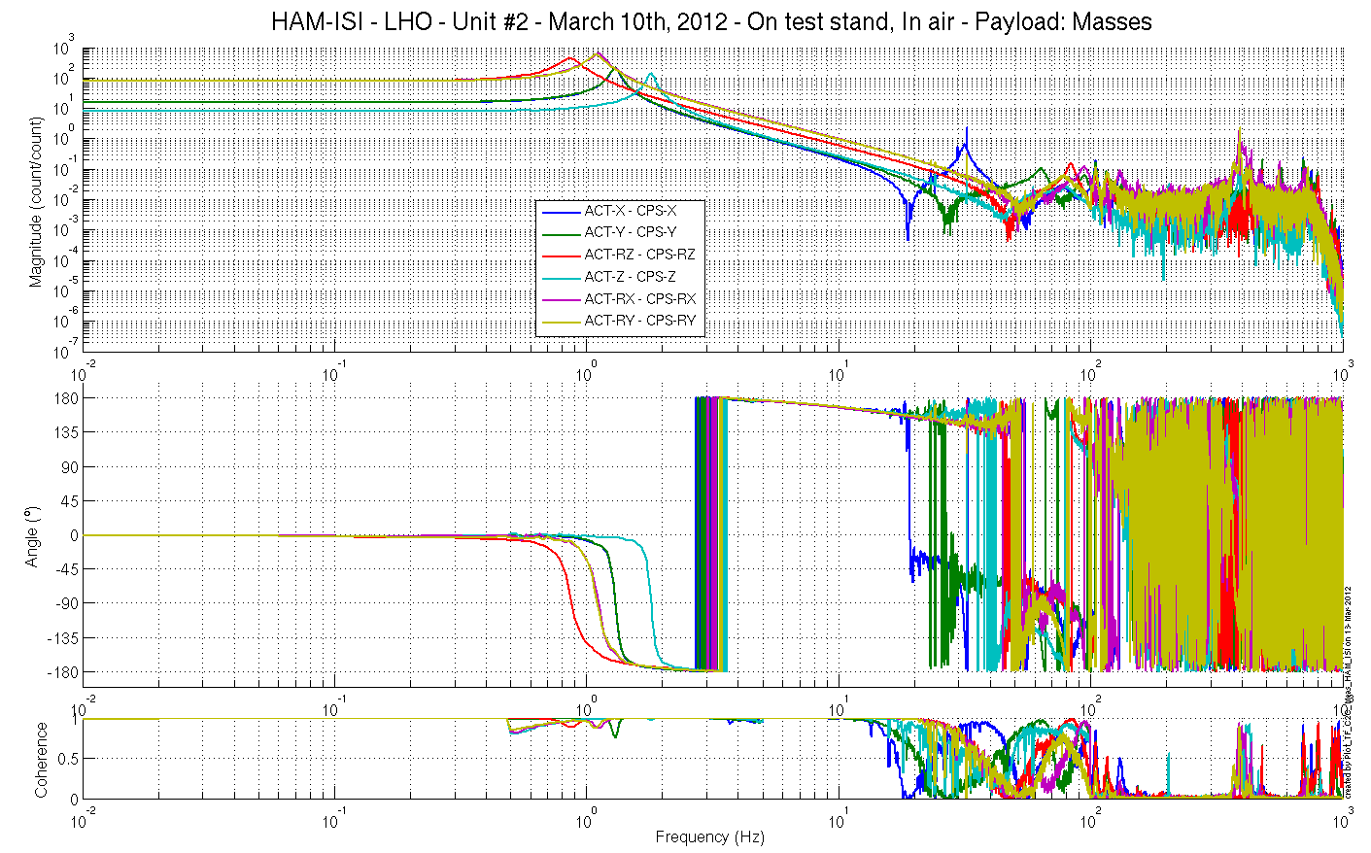
Figure – Cartesian to Cartesian Measurements – Capacitive sensors

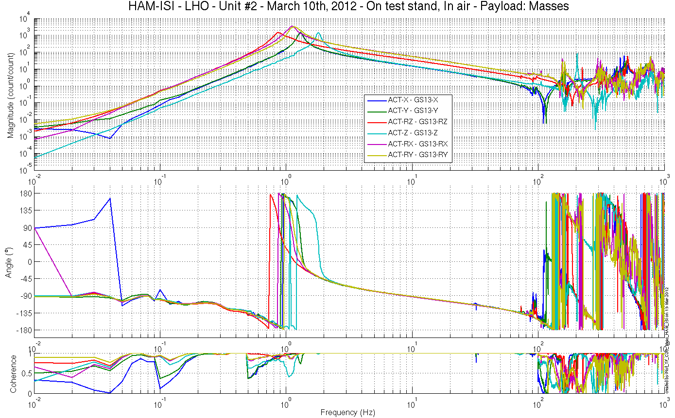
Figure – Cartesian to Cartesian Measurements – Inertial sensors

Issues/difficulties encountered during this test:
A gain of -1 was left on the excitation channels of C2C measurements: Damp. A gain of -1 was applied on C2C Transfer function results before display.

Acceptance criteria:
- Local to local measurements
  - On CPS, the phase must be 0º at DC
  - On Geophones, the phase must be -90º at DC
  - Identical shape in each corner
- Cartesian to Cartesian measurements
  - On CPS, the phase must be 0º at DC
  - On Geophones, the phase must be -90º at DC
  - Identical shape X/Y and RX/RY

Test result: Passed: X Failed: .

Step 17 - Transfer function comparison with Reference

Step 17.1 - Local to local - Comparison with Reference
Scripts files for processing and plotting in SVN at:
/SeiSVN/seismic/HAM-ISI/X1/HAMX/Scripts/Control_Scripts/
- Step_1_Plot_TF_L2L_HAM_Testing.m
/SeiSVN/seismic/HAM-ISI/Common/Testing_Functions_HAM_ISI/
- Plot_TF_L2L_HAM_Testing_With_LHO_Unit_1_Reference.m

Local to local figures in SVN at:
/SeiSVN/seismic/ HAM-ISI/X1/HAMX/Data/ Figures/Transfer_Functions/Measurements/Comparisons/L2L/
- LHO_ISI_Unit_2_TF_L2L_Raw_from_ACT_H_to_CPS_H_vs_UNIT_1_2012_02_02_With_3_Washers_Under_Top_Mass.fig
- LHO_ISI_Unit_2_TF_L2L_Raw_from_ACT_H_to_GS13_H_vs_UNIT_1_2012_02_02_With_3_Washers_Under_Top_Mass.fig
- LHO_ISI_Unit_2_TF_L2L_Raw_from_ACT_V_to_CPS_V_vs_UNIT_1_2012_02_02_With_3_Washers_Under_Top_Mass.fig
- LHO_ISI_Unit_2_TF_L2L_Raw_from_ACT_V_to_GS13_V_vs_UNIT_1_2012_02_02_With_3_Washers_Under_Top_Mass.fig

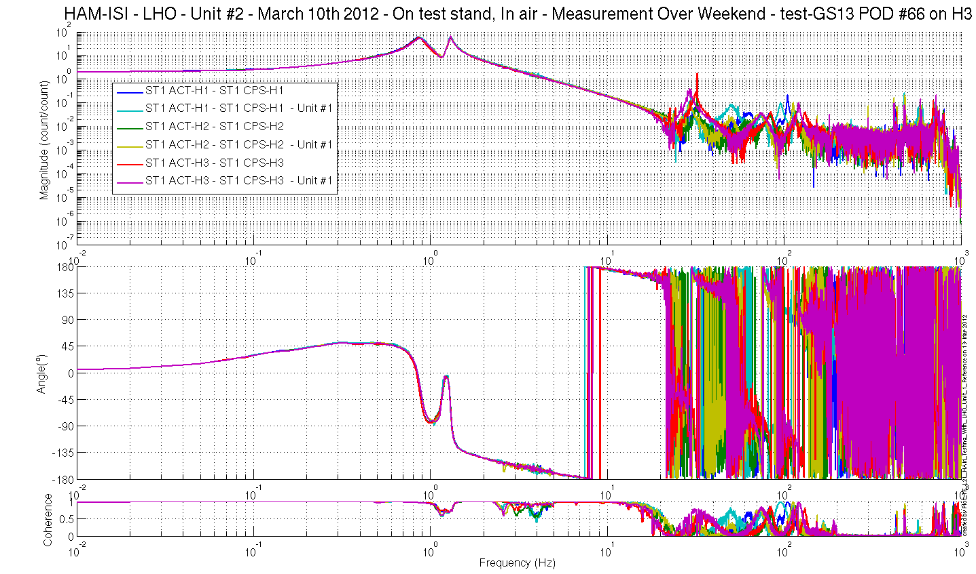
Figure – local-to-Local measurements, comparison with Unit #1 reference
Capacitive Position Sensors - Horizontal motion

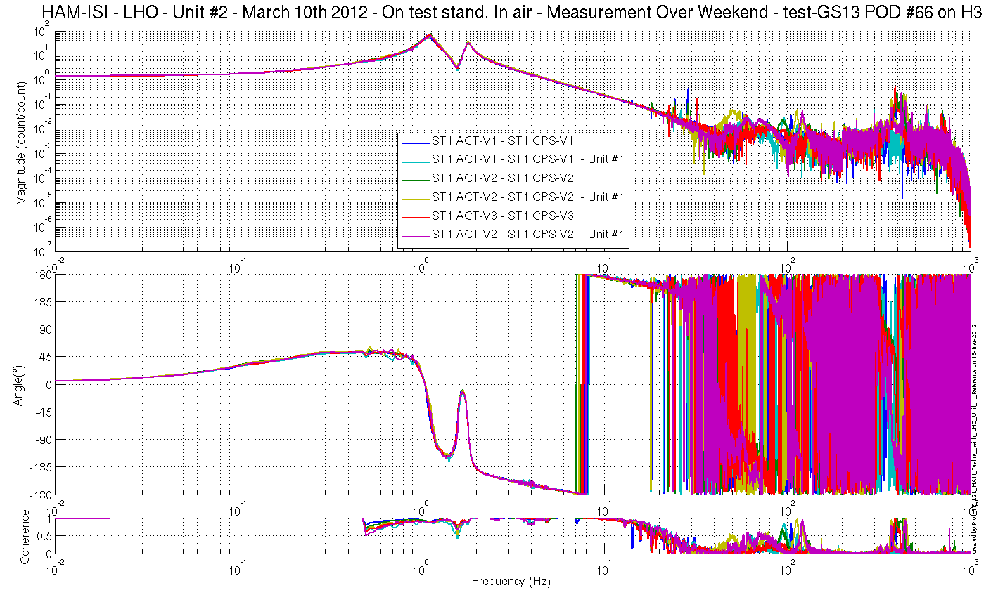
Figure – local-to-Local measurements, comparison with Unit #1 reference
Capacitive Position Sensors - Vertical motion

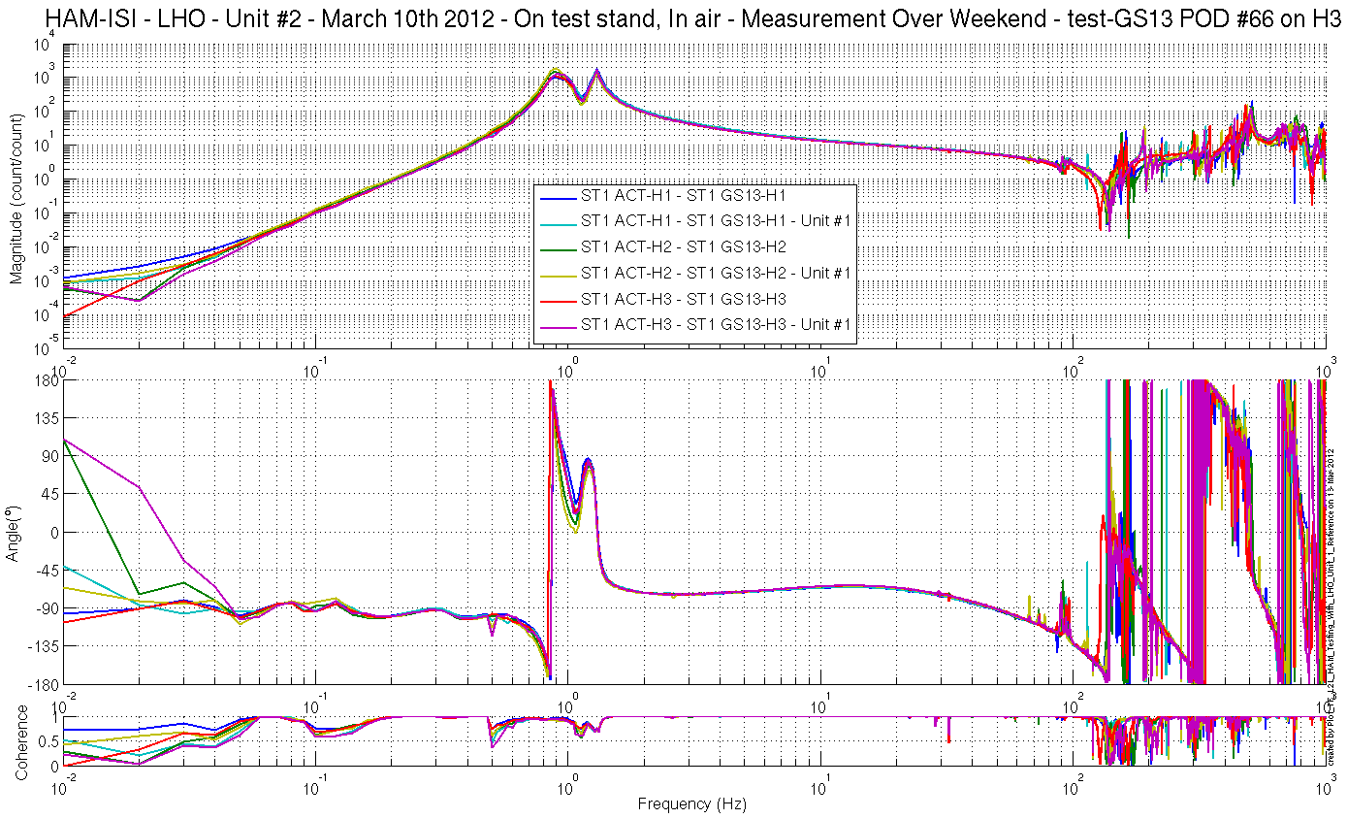
Figure – local-to-Local measurements, comparison with Unit #1 reference
Inertial Sensors - Horizontal motion
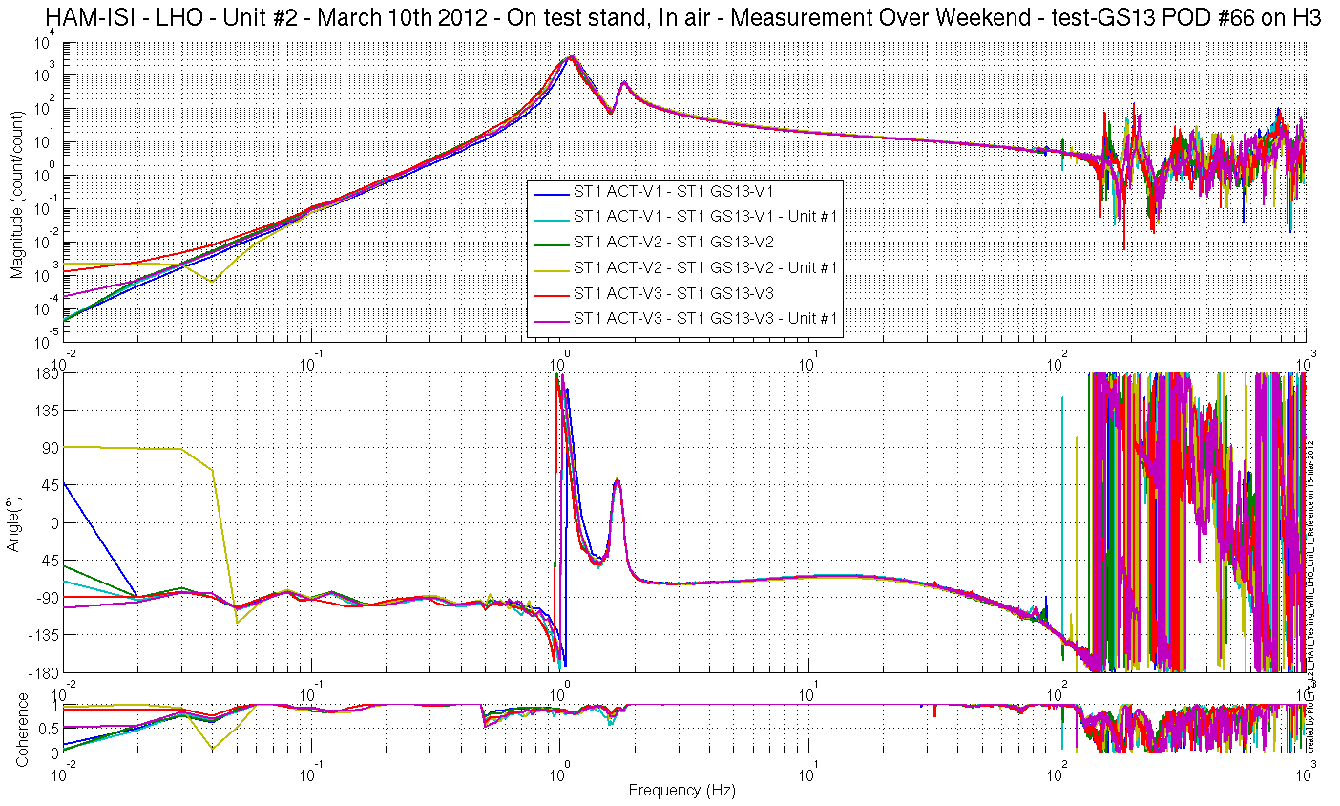
Figure – local-to-Local measurements, comparison with Unit #1 reference
Inertial Sensors - Vertical motion

Step 17.2 - Cartesian to Cartesian - Comparison with Reference

Scripts files for processing and plotting in SVN at:
/SeiSVN/seismic/HAM-ISI/X1/HAMX/Scripts/Control_Scripts/
- Step_3_Plot_TF_C2C_HAM_Testing.m
/SeiSVN/seismic/HAM-ISI/Common/Testing_Functions_HAM_ISI/
- Plot_TF_C2C_HAM_Testing_With_LHO_Unit_1_Reference.m

Cartesian to Cartesian figures in SVN at:
/SeiSVN/seismic/ HAM-ISI/X1/HAMX/Data/ Figures/Transfer_Functions/Measurements/Comparisons/C2C/
- LHO_ISI_Unit_2_TF_C2C_Raw_from_ACT_H_to_CPS_H_vs_Unit_1_2012_03_10.fig
- LHO_ISI_Unit_2_TF_C2C_Raw_from_ACT_H_to_GS13_H_vs_Unit_1_2012_03_10.fig
- LHO_ISI_Unit_2_TF_C2C_Raw_from_ACT_V_to_CPS_V_vs_Unit_1_2012_03_10.fig
- LHO_ISI_Unit_2_TF_C2C_Raw_from_ACT_V_to_GS13_V_vs_Unit_1_2012_03_10.fig

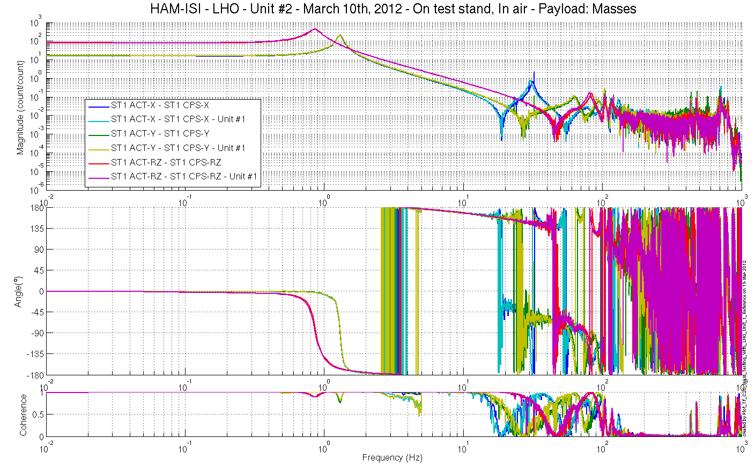
Figure – Cartesian to Cartesian measurements, comparison with Unit #1 reference
Capacitive Position Sensors - Horizontal motion

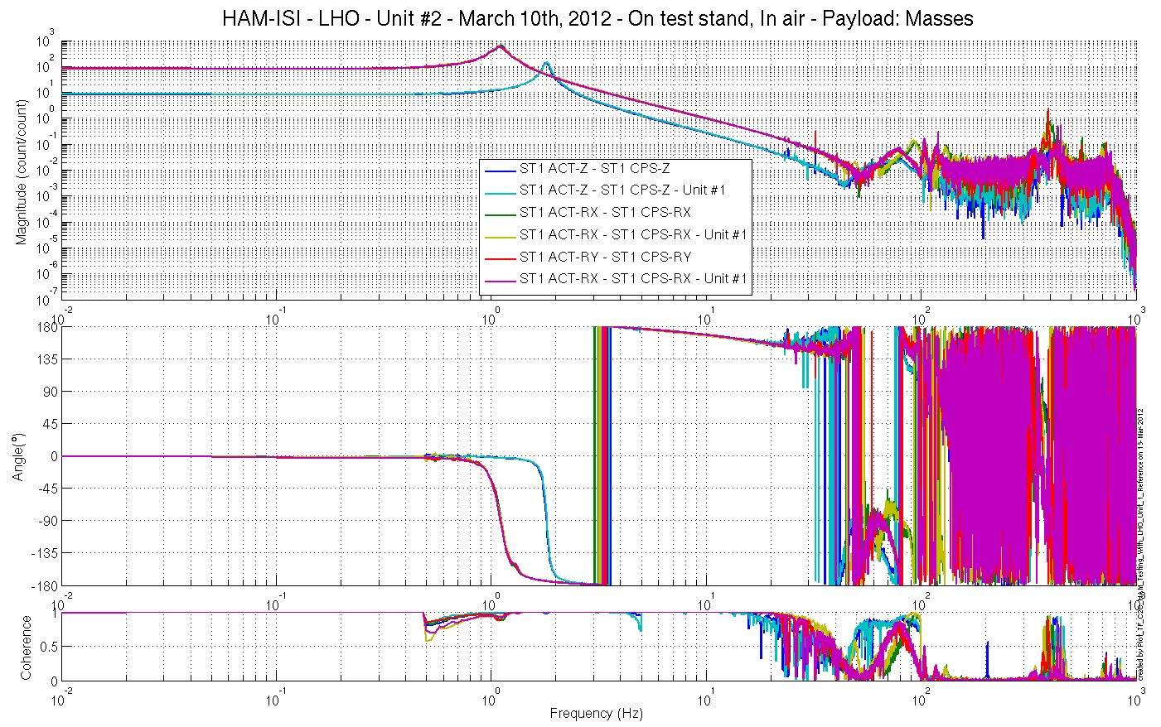
Figure – Cartesian to Cartesian measurements, comparison with Unit #1 reference
Capacitive Position Sensors - Vertical motion

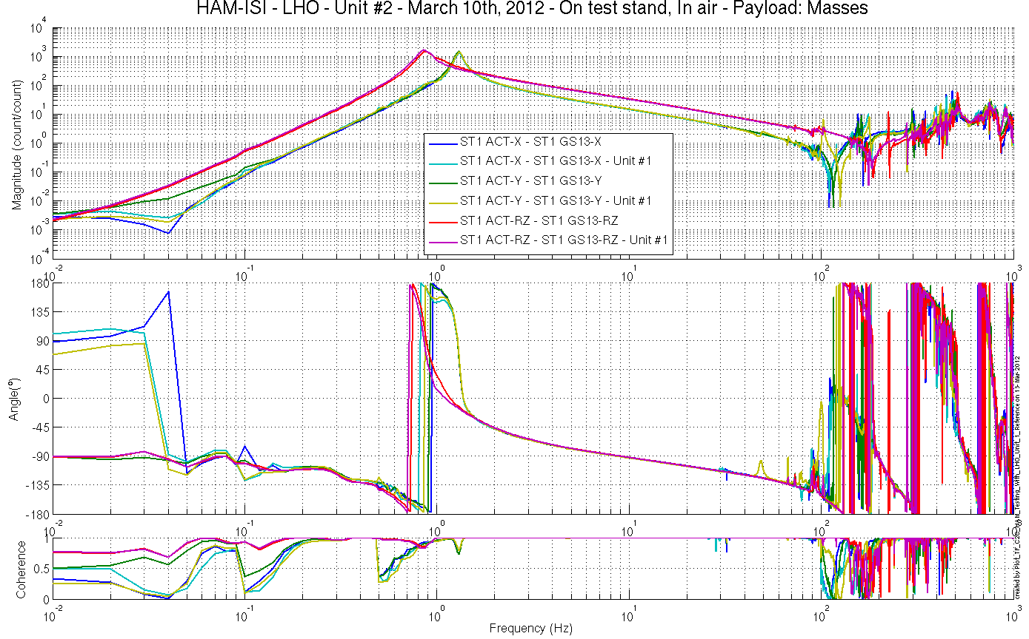
Figure – Cartesian to Cartesian measurements, comparison with Unit #1 reference – Inertial Sensors
Horizontal motion

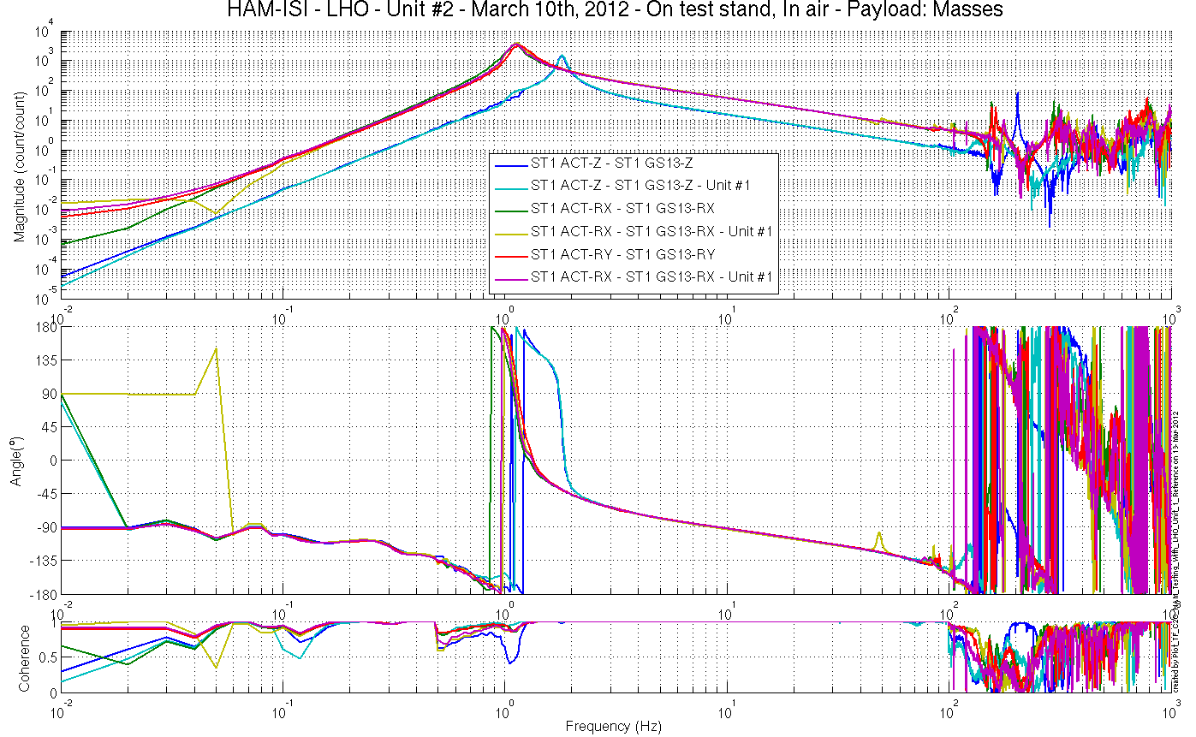
Figure – Cartesian to Cartesian measurements, comparison with Unit #1 reference
Inertial Sensors - Vertical motion

Issues/difficulties encountered during this test:
A gain of -1 was left on the excitation channels of C2C measurements: Damp. A gain of -1 was applied on C2C Transfer function results before display.

Acceptance criteria:
- No difference with the reference transfer functions (SVN)
  - Phase – less than 10º - In Phase – Out of Phase
  - Damping (fit by eye with Reference transfer functions)
  - DC gain
  - Eigen frequencies shift less than 10%

Test result: Passed: X Failed: .

Step 18 - Lower Zero Moment Plane
Data collection script files:
/SeiSVN/seismic/HAM-ISI/Common/Transfer_Function_Scripts/
- Run_TF_C2C_10mHz_100mHz_LZMP_HAM_ISI.m
Data files in SVN at:
/SeiSVN/seismic/HAM-ISI/X1/HAMX/Data/Transfer_Functions/Measurements/Undamped/
- LHO_ISI_HAM_Unit_2_Data_TF_C2C_10mHz_100mHz_LZMP_20120312-160927
Scripts files for processing and plotting in SVN at:
/SeiSVN/seismic/HAM-ISI/Common/Testing_Functions_HAM_ISI/
- LZMP_HAM_ISI.m

Figures in SVN at:
/SeiSVN/seismic/HAM-ISI/X1/HAMX/Data/ Figures/Transfer_Functions/Measurements/Undamped/
- LHO_ISI_UNIT_2_LZMP_20120312.fig

The result of the measurement performed is presented below.

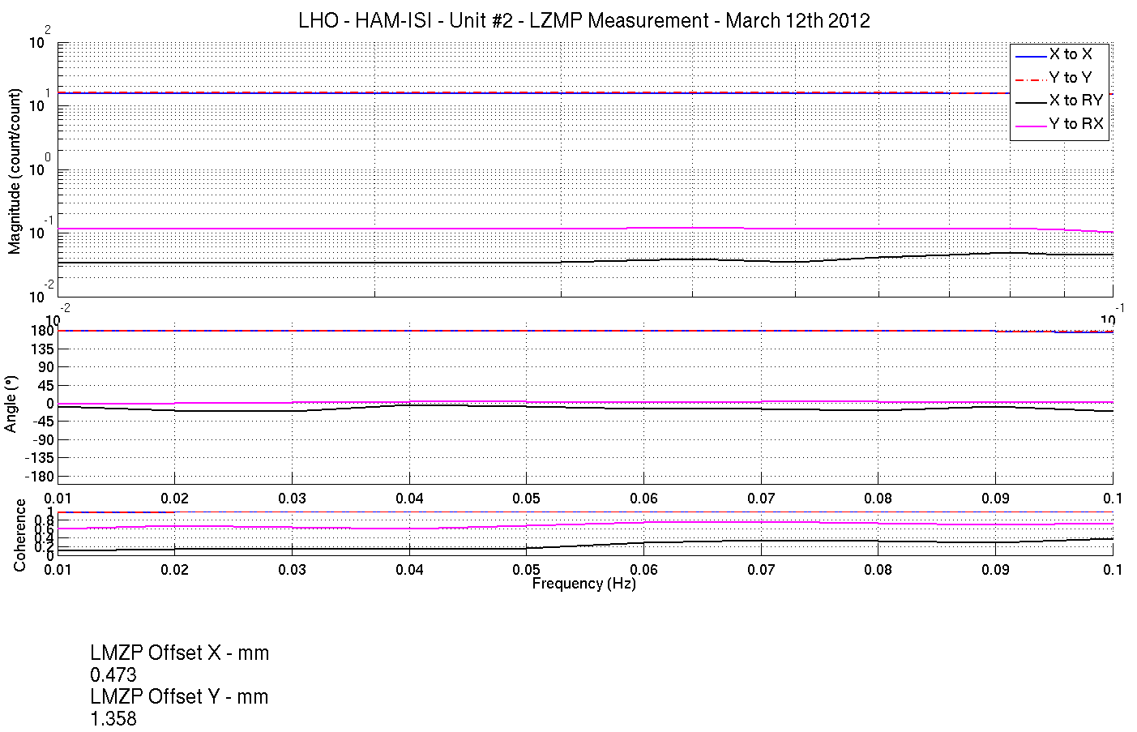
Figure - Lower Zero Moment Plane – Main and cross couplings at low frequency

Acceptance criteria:
- X offset must be less than 2 mm
- Y offset must be less than 2 mm

Test result: Passed: X Failed: .

Step 19 - Damping loops
In this step, HAM6 damping loops are implemented. First, damping performances are evaluated in simulation. Second, Damping loops are implemented and performance is experimentally measured.

Step 19.1 - Transfer functions - Simulation
Continuous HAM6 filters are located in the SVN at:
/SeiSVN/seismic/HAM-ISI/Common/HAM6_Main_Results/
- HAM6_LLO_Damping_Filters.mat

Scripts files used to evaluate damping loops performance from measurementsare located in SVN at:
/SeiSVN/seismic/HAM-ISI/X1/HAMX/Scripts/Control_Scripts/
- Step_4_Damping_Filters_X1_ISI_HAMX.m

Save file is located in the SVN at:
/seismic/HAM-ISI/X2/Data/Unit_2/Transfer_Functions/Simulations/Damping/
- X1_ISI_HAMX_TF_C2C_Damped_2012_03_10

Figures in SVN at:
/SeiSVN/seismic/HAM-ISI/X1/HAMX/Data/Figures/Transfer_Functions/Simulations/Damped/
- X1_ISI_HAMX_Damping_TF_MIMO_ST1_ACT_RX_to_ST1_GS13_RX_2012_03_10.fig
- X1_ISI_HAMX_Damping_TF_MIMO_ST1_ACT_RY_to_ST1_GS13_RY_2012_03_10.fig
- X1_ISI_HAMX_Damping_TF_MIMO_ST1_ACT_RZ_to_ST1_GS13_RZ_2012_03_10.fig
- X1_ISI_HAMX_Damping_TF_MIMO_ST1_ACT_X_to_ST1_GS13_X_2012_03_10.fig
- X1_ISI_HAMX_Damping_TF_MIMO_ST1_ACT_Y_to_ST1_GS13_Y_2012_03_10.fig
- X1_ISI_HAMX_Damping_TF_MIMO_ST1_ACT_Z_to_ST1_GS13_Z_2012_03_10.fig
- X1_ISI_HAMX_TF_Damped_SISO_ACT_RX_to_GS13_RX_2012_03_10.fig
- X1_ISI_HAMX_TF_Damped_SISO_ACT_RY_to_GS13_RY_2012_03_10.fig
- X1_ISI_HAMX_TF_Damped_SISO_ACT_RZ_to_GS13_RZ_2012_03_10.fig
- X1_ISI_HAMX_TF_Damped_SISO_ACT_X_to_GS13_X_2012_03_10.fig
- X1_ISI_HAMX_TF_Damped_SISO_ACT_Y_to_GS13_Y_2012_03_10.fig
- X1_ISI_HAMX_TF_Damped_SISO_ACT_Z_to_GS13_Z_2012_03_10.fig

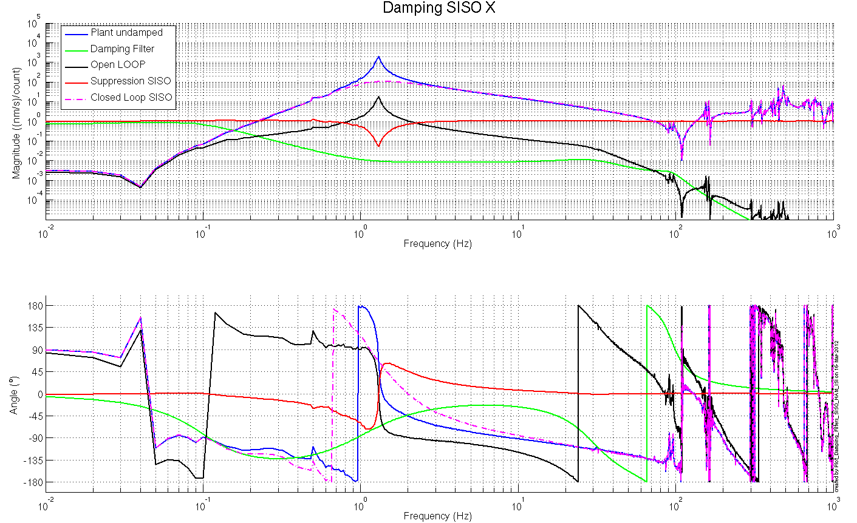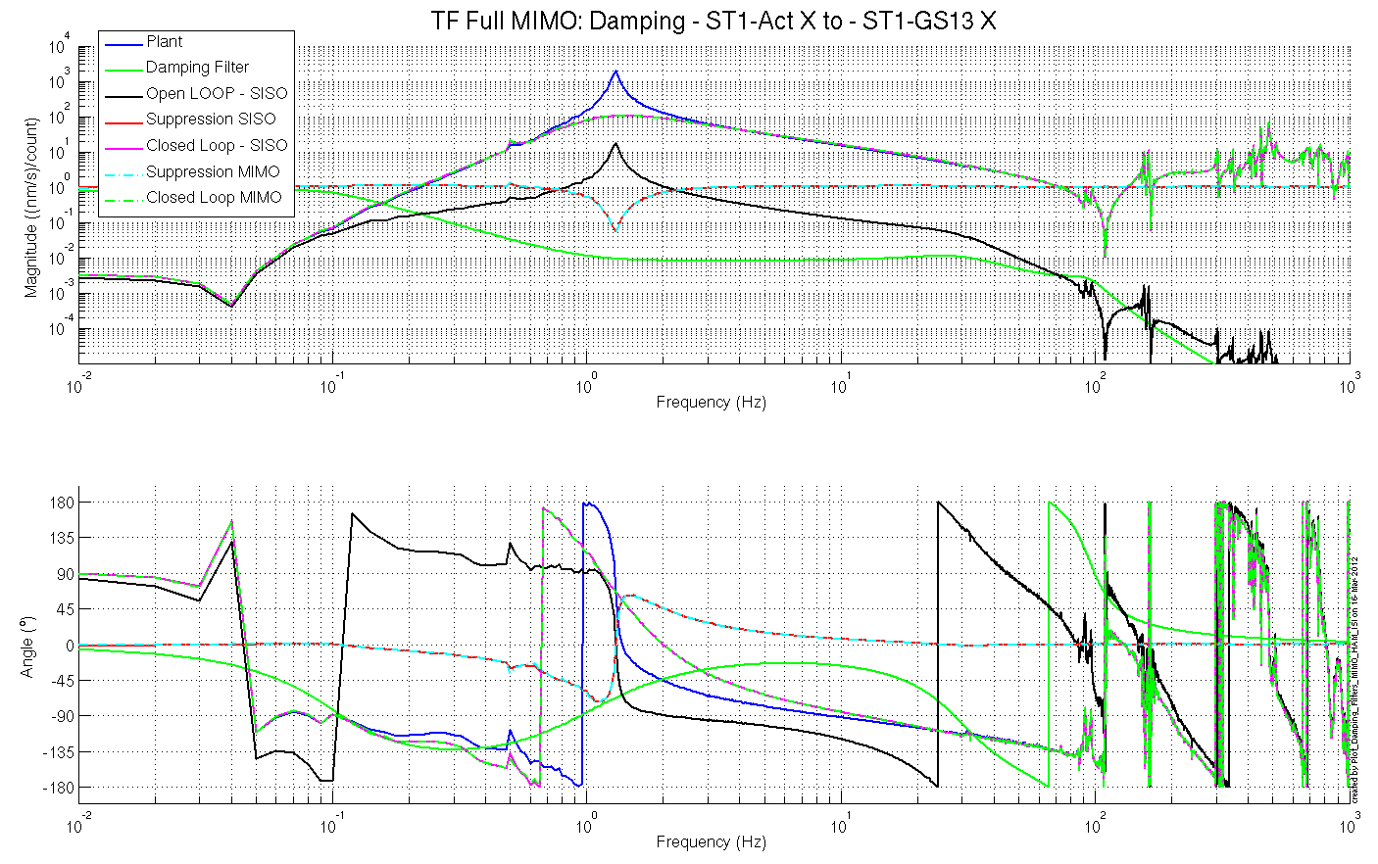
Figure – Simulated damping performances

Acceptance criteria:

- HAM6 damping loops must implemented and stable with
  - Phase margin must be at least 45º
  - Gain margin must be at least 20dB

Test result: Passed: X Failed: .

Step 19.2 - Powerspectra – Experimental

Scripts files for taking data and plotting in SVN at:
/SeiSVN/seismic/HAM-ISI/X1/Scripts/Data_Collection/
- Master_TEST_X1_ISI_Unit_2.m (lines 99 to 114)
Data files in SVN at:
/SeiSVN/seismic/HAM-ISI/X1/HAMX/Data/Spectra/Damped/
- LHO_ISI_UNIT_2_ASD_m_CPS_GS13_Undamped_vs_Damped_2012_03_16_154951.mat
Figures in SVN at:
/SeiSVN/seismic/HAM-ISI/X1/HAMX/Data/Figures/Spectra/Damped/
- LHO_ISI_UNIT_2_ASD_CT_CPS_CART_Undamped_vs_Damped2012_03_16_154951.fig
- LHO_ISI_UNIT_2_ASD_CT_GS13_CART_Undamped_vs_Damped2012_03_16_154951.fig
- LHO_ISI_UNIT_2_ASD_m_CPS_CART_Undamped_vs_Damped2012_03_16_154951.fig
- LHO_ISI_UNIT_2_ASD_m_GS13_CART_Undamped_vs_Damped2012_03_16_154951.fig
- LLO_HAM_ISI_Unit_2_Calibrated_PSD_CPS_Undamped_Damped_2011_06_28.fig

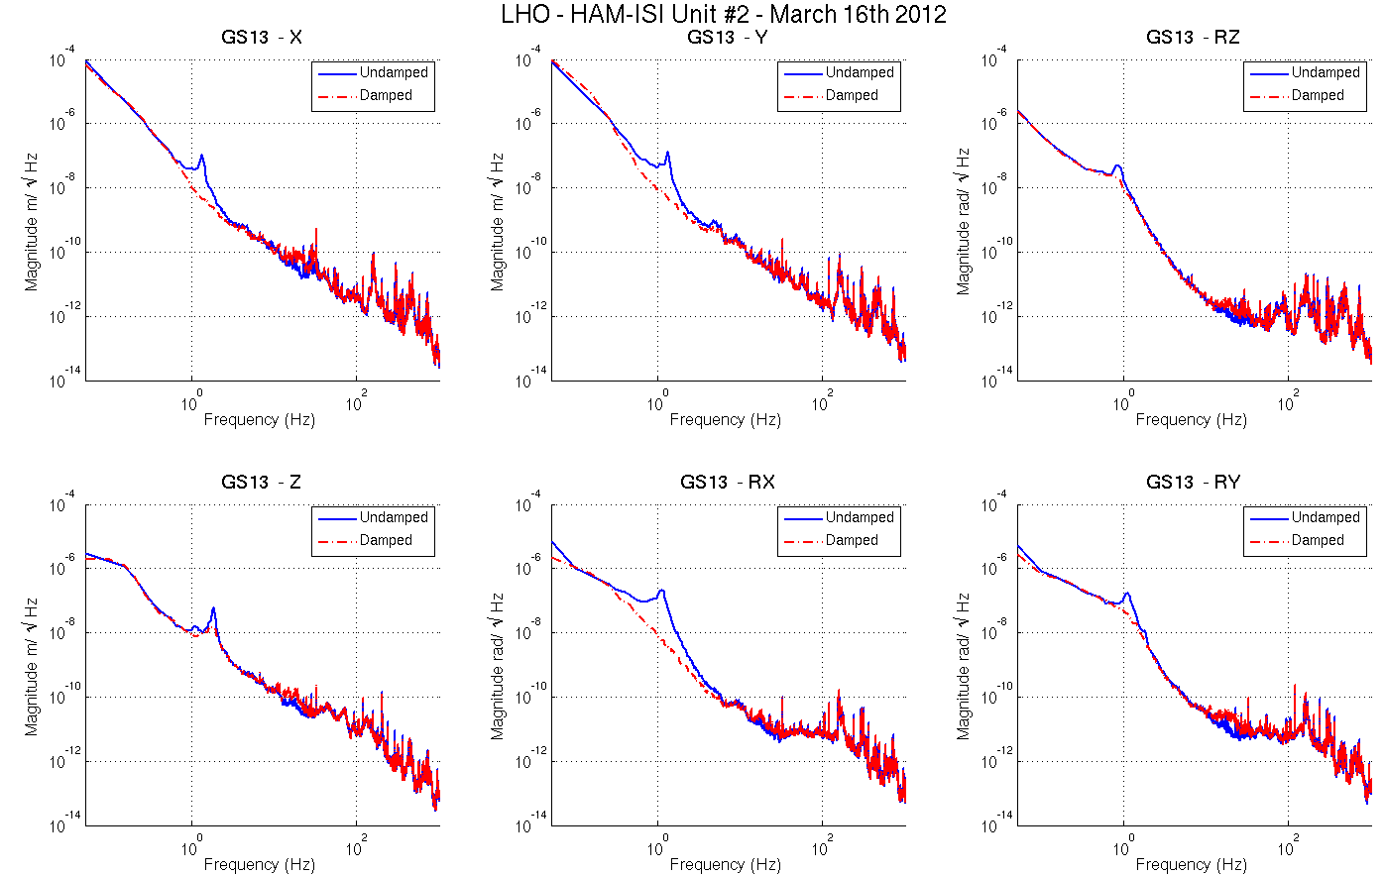
Figure - Damped/Undamped GS-13 Power Spectra comparison

Acceptance criteria:

- HAM6 damping loop must stable when all damping loops are engaged
- Similar damping effect than in simulated plots

Test result: Passed: X Failed: .

HAM-ISI Unit #2 testing summary

HAM-ISI Unit #2 was initially built and tested in September 2010. Faulty part replacement implied the need of disassembling and reassembling the unit. Once reassembled, the unit had to be re-tested. Tests presented here were performed during February 2012 until early March 2012. Tests were performed in accordance with E1000309-V9 procedure.

Particularities:
Two of the Horizontal production GS13 failed (Pod #94 and Pod #71). One was intended to this Unit (#94), and the other was a spare (#71). A testing-GS13 (Pod #66) was used as horizontal seismometer on corner 3.
So far, there is no HAM-ISI Unit fully loaded with production GS13 at LHO. This situation should change as soon as possible. However, there is a currently a shortage of well-functioning permanent-GS13s on site (LHO). As, we knew that the production-Pod-set of that HAM-ISI Unit #2 is not complete, it appeared beneficial to keep Unit #2 available while assembling the Unit #4 in order to have production pods to complete the set (5 received from LLO) of production Pods of Unit #4. Every GS13 was removed prior to storage. No GS13 stored with the ISI.

Evolution from initial testing (prior to disassembly/reassembly):
Mass budget is now lower of 4.99kg in comparison with the mass budget measured prior to disassembly/reassembly.

Complementary inquiries:
- Extraction of GS13s’ frequency-responses in order to explain discrepancies observed on TFs, between corners.
- Confirmation of the need, and functionality, of symmetrization filters.
- Comparison of extracted responses with huddle test for the instrument that has its resonance frequency shifted. The instrument already had this feature when huddle-tested. Hence, the resonance frequency shift was not caused by handling/shipping. Attention will be kept on this matter to make sure that no resonance frequency shift occurs post huddle-testing.

FAILED AND WAIVED TESTS

List of tests that failed and don’t need to be redone:
Step II.5: Blade spring profile slightly out of requirements on corner 1. However, it did not appear to seriously affect the response of the ISI.
Step III.2: Excessive standard deviation on CPSs is associated to ground motion (SEI logbook, entry #15). Sensor noise is acceptable.

Tests that failed and need to be done during phase II
Step I.2: It must be checked that final GS13s have already been tested at LLO and that their Inspection/Pod Assembly is described in document D047810.
Step III.6-7: GS13-ASDs locked, unlocked and table tilted are borderline. They should also be performed again once all final GS13s are installed.
Step III.14: Actuators appear to be linear on measurements. However, deviation from average slope is out of spec. It seems to correlate with cable+actuator resistance measurements. Make sure that linearity test results correlate with the final field cables.
This scale factor, which varies from an actuation point to another, could be corrected with an adjustment gain applied on the excitation signal sent to the actuators.

List of test that were skipped and that we will not do because they are not essential
Step III.3: Sensor gap measurement with a jig. Waved to avoid scratching targets. Distance between sensor and target has also been checked during the assembly while adjusting target distance.

