Wiring and Construction Details for 64 Channel Binary Input and Binary Output Chassis

The Binary Input and Binary Output PCBs, D1001036 and D1001266 respectively, require a positive 18 volt supply. This is provided directly from the rack power supply. A male Conec power connector (Conec p/n 3003W3PXX42A10X) is attached to the rear panel of the chassis with a standard DSUB mounting screw kit (Mouser p/n 523-17-D20418-2-TX). Next to the DC input is a single green LED (Digikey p/n L10005_ND) and an ETA circuit breaker (Allied p/n 3130-F120-P7T1-W02Q-1A).
Refer to photo number 1. A 13” length of black, 18 AWG wire and the cathode (white) wire of the LED are soldered into the center pin of the DC connector. Shrink tubing is slipped over these wires before they are soldered into place. A 6” length of orange, 18 AWG wire is soldered into the positive pin of the DC connector with shrink tubing added for strain relief. A female, crimp-on connector (Digikey p/n 920044-18-ND) will be installed on the opposite end of this wire. This connector has a shrink tubing sleeve for strain relief.

- DC wiring Detail
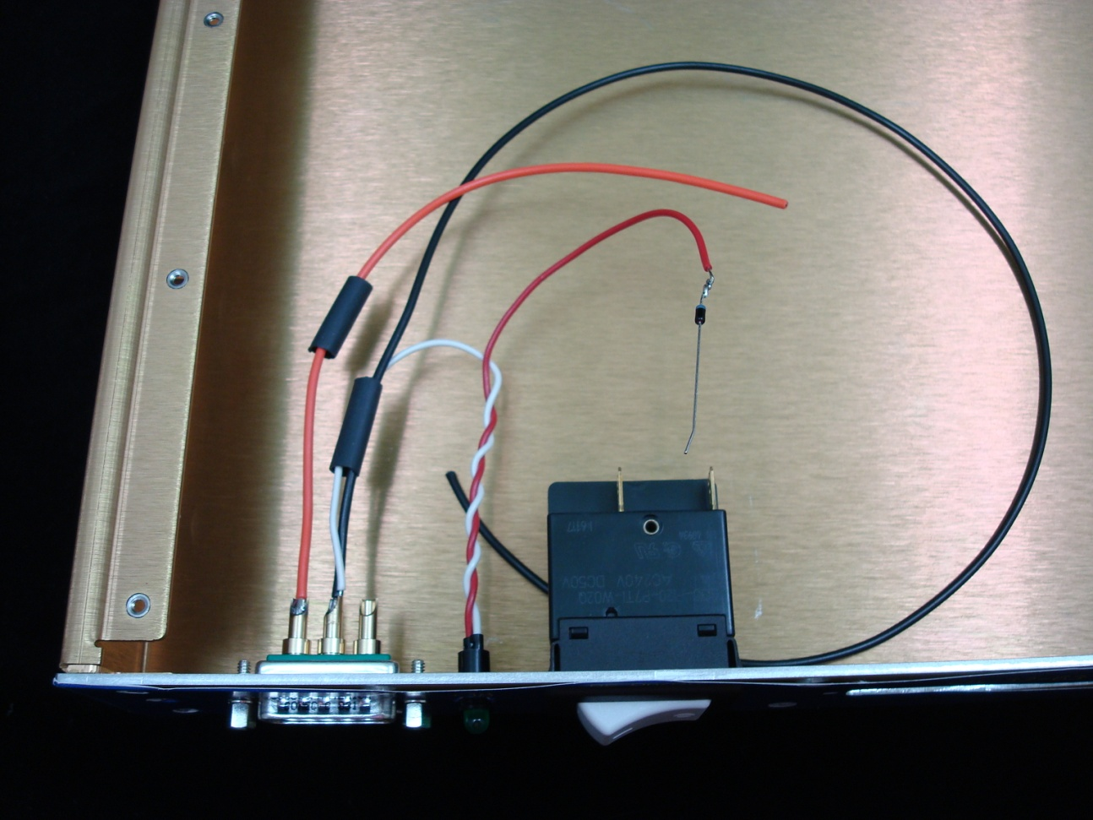
A current limiting diode (Digikey p/n 610-1N5314) cathode lead (the lead on the striped end of the diode body) is soldered onto the end of the anode (red) wire of the LED. Now refer to photo number 2. The other lead of the diode is then soldered to a 13” length of orange, 18AWG wire as shown in the photo. Shrink tubing is then used to hold the body of the diode and the LED lead securely to the orange wire.

- DC Wiring Detail

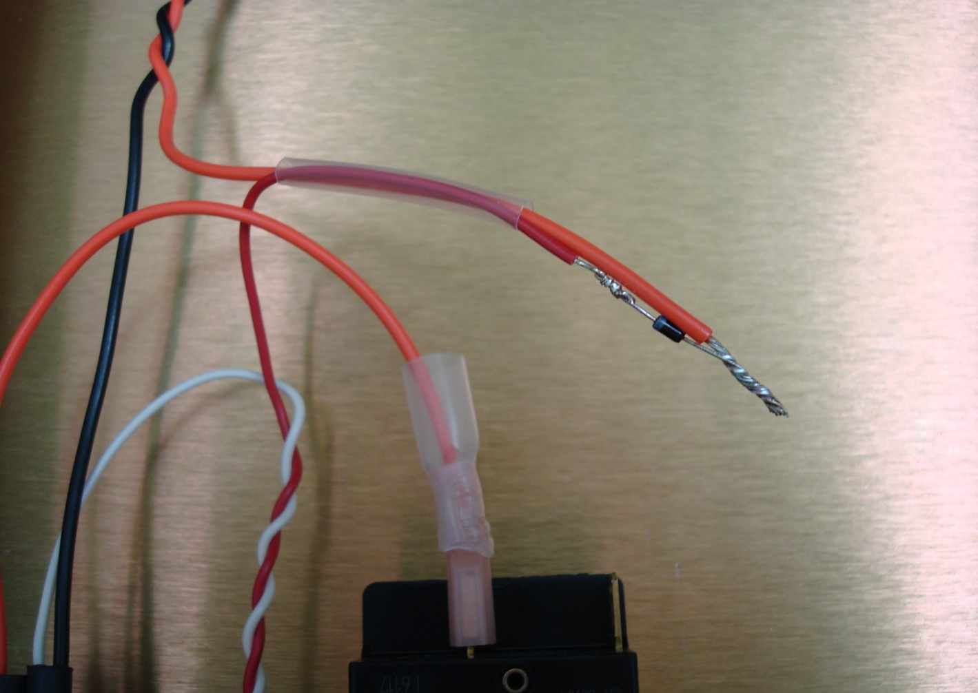

A female, crimp-on connector is installed on the end of the wire/diode assembly and both orange wires are connected to the circuit breaker lugs as shown in photo number 3. The ends of the black and orange, 13” wires are then fitted with Molex connector terminals (Digikey p/n WM2305-ND) and installed into a 3-pin, keyed Molex connector housing (Digikey p/n WM2112-ND). Please note the wire placement in the housing as shown in the photo. Wire ties are added to keep the finished wiring assembly in order.

- Finished DC Wiring Harness
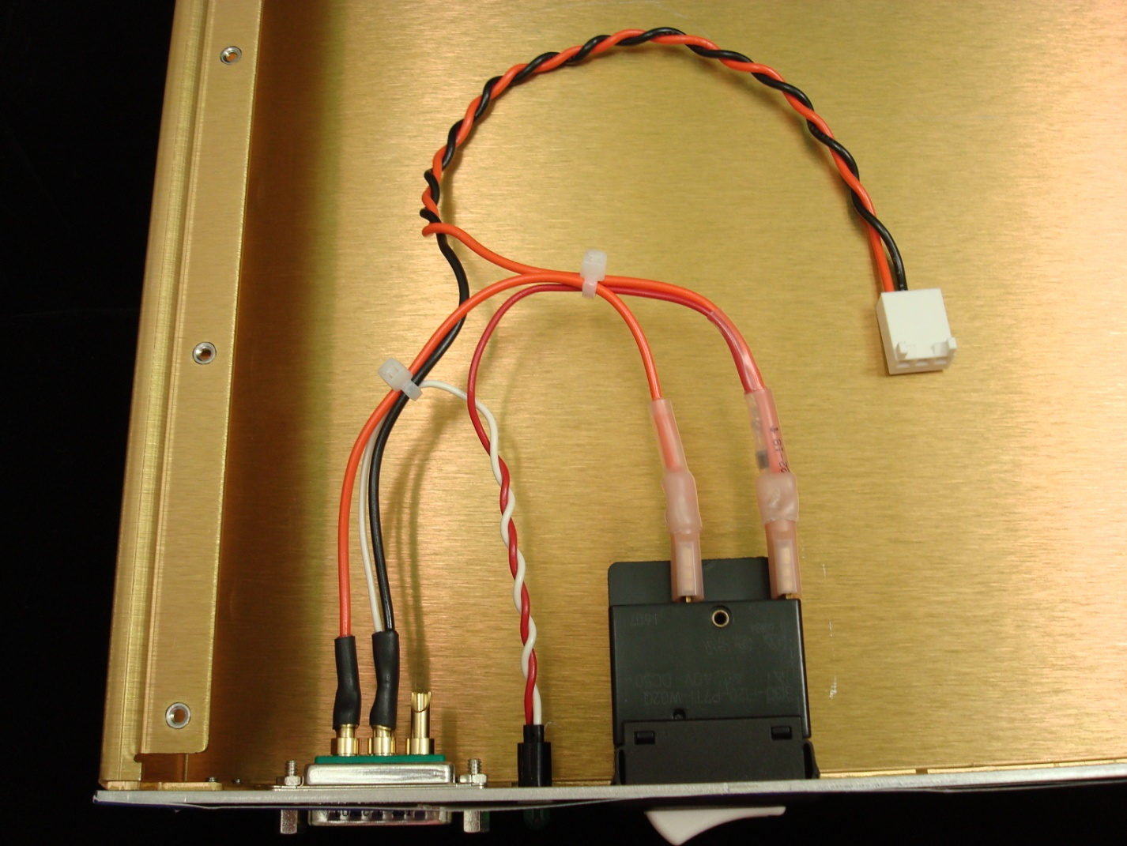

Two 37-conductor male-to-female ribbon cable assemblies are required for the Binary Input and Binary Output chassis. The ribbon cable (3M p/n 3365/37 or equivalent) used for the channel 0-31 connection is cut to 14” and the cable for the channel 32-63 connection is cut to 15½” inches. Photo number 4 shows how the finished cables should look when installed. The male connector (Digikey p/n CMM37G-ND) is held to the female, PCB-mounted connector with a pair of #4-40x0.75” screws (McMaster-Carr p/n 90279A103). The female connectors (Newark p/n 42K6647) have threaded inserts and are attached to the rear panel with the DSUB mounting jack screws and lock washers.
The PCB is attached to the front panel with the DSUB mounting jack screws. Three flathead machine screws (McMaster-Carr p/n 91771A111) are used to hold the PCB-mounted stand-offs to the bottom of the chassis.

- PCB Placement and Ribbon Cable Installation
