LIGO-T1000453-v3
Construction and Wiring Details for Quad I&Q RF Demodulator Chassis

Overview
This document describes the construction and internal wiring process for a Quad I&Q RF Demodulator Chassis (D0902796). Each chassis contains: four RF demodulator boards, one power regulator board, internal cabling between the demodulator boards and the back panel, internal cabling between the back panel, power regulator and demodulator boards, some chassis also contain a power splitter, as described below. All this is assembled into a 19” wide rack-mount, vented chassis, with custom front and rear panels.
There are two variants of the chassis, as shown in D0902796, with somewhat different internal cabling and different back panels. In variant A, there are four SMA back-panel chassis feed-throughs that are connected with coaxial cables directly to the four demodulator boards. In variant B, a single SMA back-panel feed-through is cabled internally to the input of a 4-way power splitter (mounted to the chassis bottom panel), and the outputs of the splitter are cabled to each of the four demodulator boards.

Ribbon Cable Wiring
Three ribbon cable assemblies are required for each chassis. In Photo 1, the cables are labeled A (LIGO-D1002028), B and C (LIGO-D1002029). Cable A has four male 9-pin DSUB connectors (Digikey p/n CMM09G-ND), labeled A1, A2, A3, and A4. These each connect to the female, 9-pin DSUB J18 on each PCB labeled “I/Q Output” at channels 1, 2, 3, and 4 respectively. The opposite end of the cable terminates at a 25-pin female DSUB connector (Digikey p/n AFL25B-ND) mounted on the rear panel, labeled “I and Q Outputs”.
Cable B and C in Photo 1 each have two male 9-pin DSUB connectors labeled B1/B2 and C1/C2 respectively. Connectors B1/B2 connect to the female 9-pin DSUB J19 on the first two PCBs, connectors C1/C2 connect to the female 9-pin DSUB J19 on the second two PCBs. The B and C cables terminate in 9-pin female DSUB connectors, (Digikey p/n AFL09B-ND) mounted through the rear panel and labeled “Ch. 1&2” (B cable) and “Ch. 3&4” (C cable).
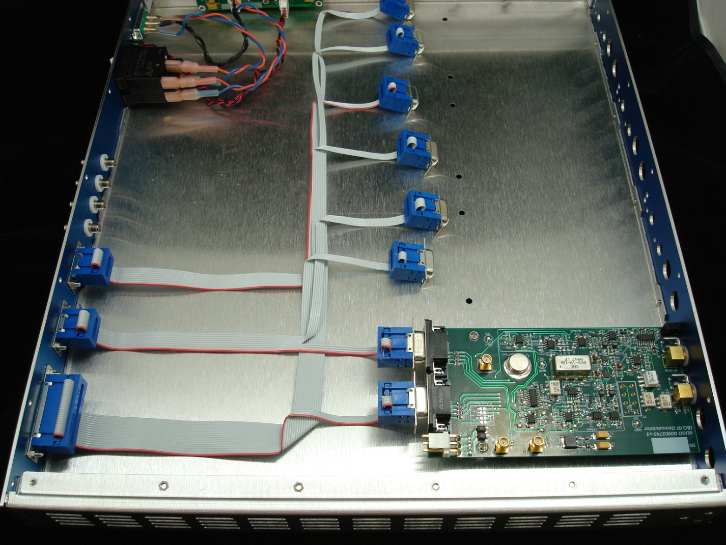
C2
C1
C
B2
B1
B
A4
A3
A2
A1
A
Photo 1. Layout of the Three Output Signal Ribbon Cable Assemblies. Note: only one of the four demodulator boards is installed in this photo.

Power wiring
Photograph 2 shows the input power wiring and position of the chassis and panel mounted components. Six inch lengths of 18 AWG wire are soldered to the Conec power connector (Conec p/n 3003W3PXX42A10X) and then strain relieved with shrink tubing. The DC wire color code used for this chassis is orange-positive voltage, blue-negative voltage, black-zero volts or ground. The black wires go directly to the 4-pin Molex connector (Digikey p/n WM2113-ND) after the terminals (Digikey p/n WM2305-ND) are crimped and the orange and blue wires are terminated with female crimp on terminals (Digikey p/n 9220044-18-ND). These terminals have shrink tubing strain reliefs built in.
The orange and blue wires are then connected to the ETA 2A circuit breaker (p/n 3130-F120-P7T1-W02Q-2A). A second set of wires are then assembled with the female terminals and the Molex connector terminals. These will connect the circuit breaker to the 4-pin Molex connector housing, in the manner shown in the photo. This connector attaches to P1 on the regulator PCB.
After installing the rear panel power indictor LEDs, each lead will have a smaller Molex terminal (Digikey p/n WM2624-ND) crimped on for use with a 0.100”, 4-pin Molex connector housing (Digikey p/n WM2614-ND). Take care to orient the leads in the connector so that it matches the labels on the power regulator PCB and the rear panel of the chassis.

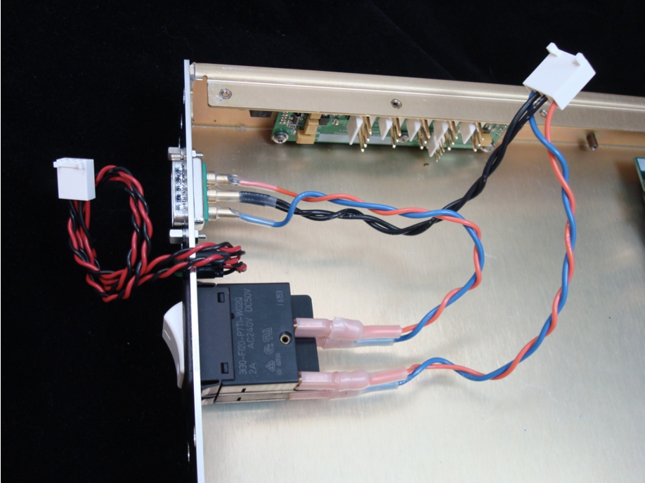Four cable assemblies will be constructed with 3-pin, 0.156” Molex connectors (Digikey p/n WM2112-ND), the associated terminals and 18 AWG blue, orange and black wires. Refer to photo number 3 and LIGO-D1002034 for the wire arrangement with regards to the connector polarity keying. These will provide DC voltages to the individual I&Q demodulator PCBs at P1, labeled “DC Power”. The lengths of each assembly are 7”, 10”, 14”, and 17”. The 7” cable connects the channel 4 PCB to P2 of the regulator PCB. The 10” cable connects the channel 3 PCB to P3 of the regulator PCB. The 14” cable connects 2 to P4 and the17” cable connects channel 1 to P5.
E cable
D cable
Photo 2. Input Power Wiring

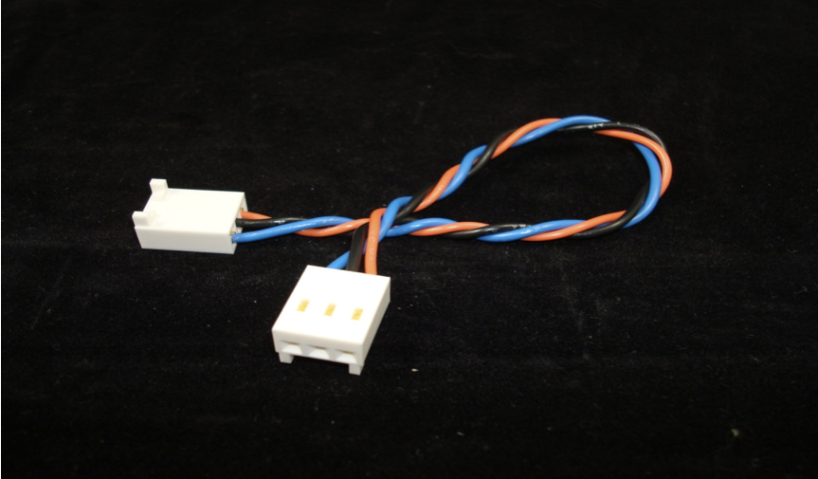
Photo 3. DC board power cable.

Coaxial Cables
For module variant A, the RF coaxial cables are installed as shown in photo 4 (only one of four cables shown). Four isolated SMA feed-throughs (Pasternak p/n PE9067) are installed on the rear panel in the holes labeled “Local Oscillator In”. The SMA-to right angle SMA, 12” cable assembly (Pasternak p/n PE3513-12) is installed from the feed-through to jack J3, labeled “LO IN” on the demodulator PCB. A 6” SMA-to-BNC cable (Pasternak p/n PE3681-6) is installed between jacks J1 (labeled “Q MON”) and the “Q-Mon” front panel opening and J6 (labeled “I MON”) and the “I-Mon” front panel hole.
For module variant B, a single isolated SMA feed-through is installed on the rear panel. Inside the chassis, this feed-through is connected to the S-input of a 4-way RF power splitter using a short coaxial cable (or possibly an SMA male-to-male coupler). The four outputs of the splitter are cabled to the J3 jack of the four demodulator boards. The power splitter is mounted on nylon stand-offs to the bottom panel of the chassis, using the bracket on the splitter case. The splitter must remain electrically isolated from the chassis.

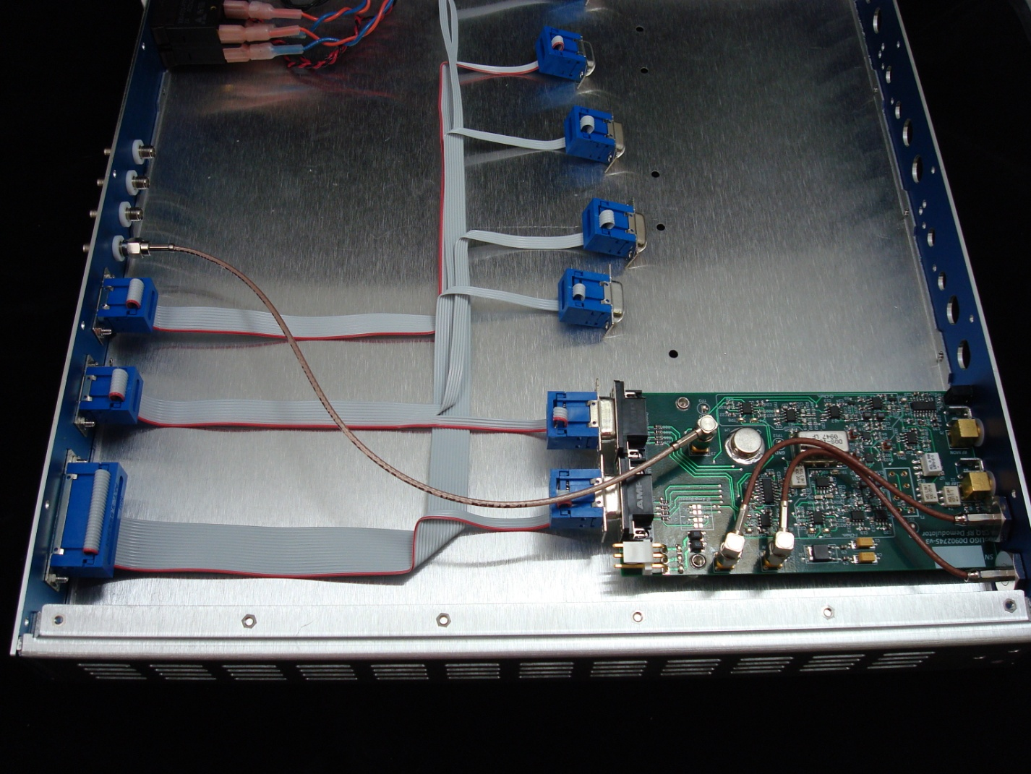
Photo 4. RF Coaxial Cable for one board of variant A chassis.

PCB Mounting.
All four demodulator PCBs are held in place in the same fashion. Two 3/8”, threaded stand-offs are soldered to the PCB from the bottom. These will align with countersunk holes drilled in the bottom of the chassis and are secured with #4-40 flathead machine screws (McMaster-Carr p/n 9177A111). The front panel edge of the PCB has two right-angle brackets that align with two countersunk holes in the front panel. The same #4-40 flathead machine screws are used to secure the brackets to the front panel.
The two right-angle SMA connectors, J2 (RF In) and J5 (RF Mon) are isolated from the oversized holes they pass through in the front panel with two nylon shoulder washers each (Digikey p/n 7687K-ND). The right-angle SMA connectors (Digikey p/n J569-ND) come with a hex nut and lock-washer. The nut is used to secure the SMA connector and nylon washers to the front panel. The lock-washer is omitted. Refer to photo 5 to see a close up of the front panel bracket and SMA connector/shoulder washer attachment to the front panel.

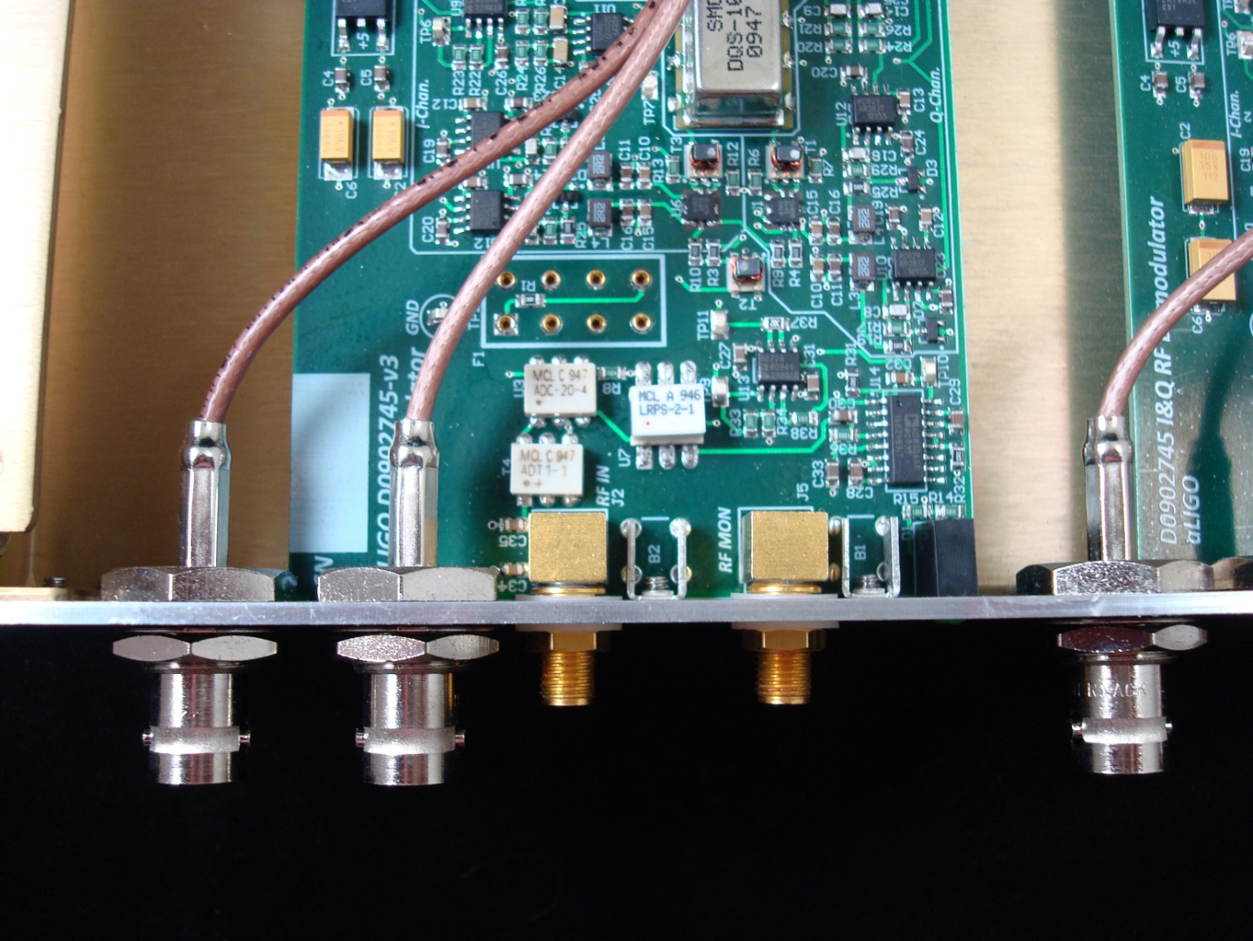
Photo 5. Demodulator PCB mounted to front panel.

