AUTHOR(S) | DATE | Document Change Notice, Release or Approval
Eric James | 23 Aug, 2012 | see LIGO DCC record Status
This document is intended to serve as a description of this assembly until a real assembly drawing can be made.

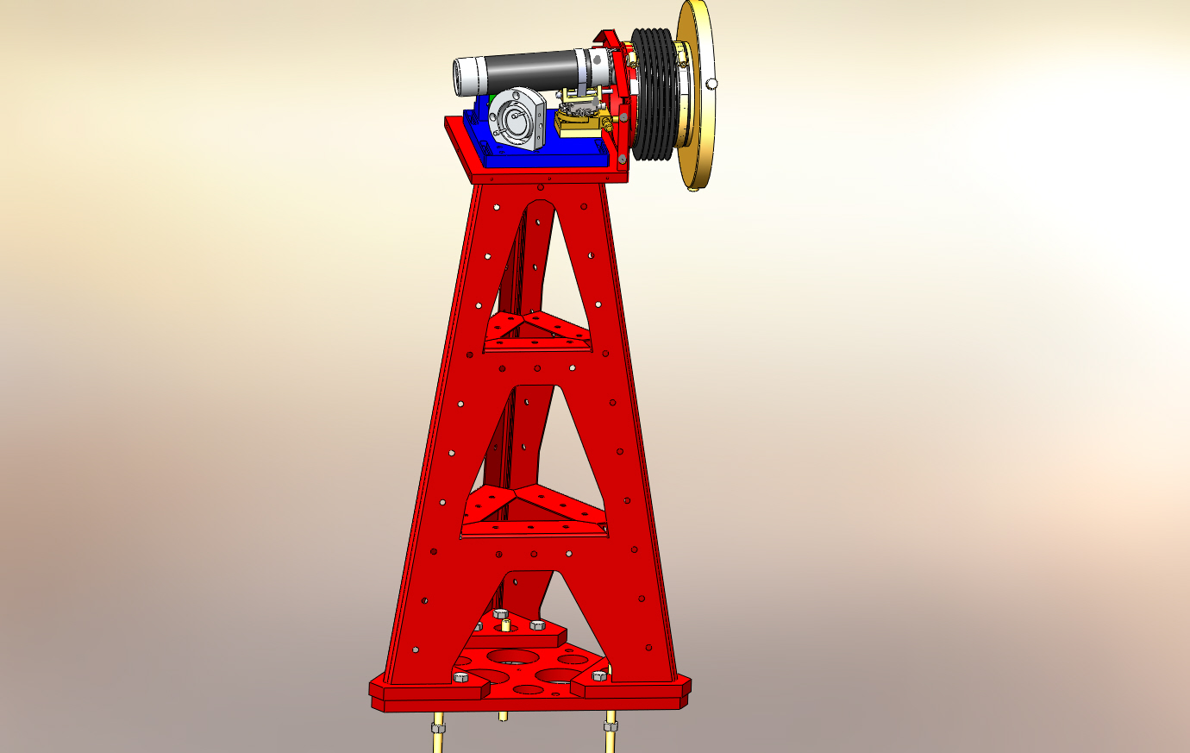

Figure 1: HAM Transceiver Pier Assembly. Shown with cover removed.

Bill of Material
Item | Part number | Description | Quant.
1 | D1001854 | TRX Pier Weldment | 1
2 | D1000434 | Pier Footing | 1
3 | D1001627 | TRX Mounting Base | 1
4 | D1001620 | QPD Bracket | 1
5 | D1100290 | QPD Board Assembly | 1
6 |  | 15-pin M-M Cable, Photodiode Board | 1
7 | KSP-60-C1A-S05 | OptoSigma Rotary Stage | 1
8 | GOHT40A10-MO2 0600-S10 | OptoSigma Goniometer | 1
9 | SL38 | Newport Gimbol Mirror Mount | 1
10 |  | Pico Motors w/Cables | 2
11 | D1102242 | Transmitter Telescope Mount | 1
12 | D0901362-1 | Projection Telescope Assembly, Short | 1
13 | D1200463 | Transceiver Enclosure Assembly | 1
14 | D1200622 | 6-inch Reducer | 1
15 | CT-6 | Gortiflex 6" Rubber Bellows | 1
16 |  | 1/2-20 x 1.5" Hex head cap screw | 9
17 |  | 1/4-20 x 3/4" SHCS | 10
18 |  | 1/4-20 x 3" SHCS | 1
19 |  | #8-32 x 1/2" SHCS | 11
20 |  | #8 Flat Washer | 11
21 |  | M3 x 10 SHCS | 4
22 |  | M3 x 6 SHCS | 4
23 |  | #4-40 x 5/8" SHCS | 4
24 |  | 3" Band Clamp | 1
25 | 45945K37 | McMaster -Carr 6" Band Clamp | 2
26 | 92421A540 | McMaster -Carr 1/4-20 Brass Thumb Screw | 3
27 | 9600K62 | McMaster-Carr Rubber Grommet | 1
28 | F12 635S | Fermion Laser w/ 10m fiber | 1
29 | D1200461 | Laser Power Board | 1
30 | D1100013 | Whitening Chassis | 1
31 | D1101248 | Anti-aliasing Chassis | 1
32 |  | 9-pin M-F Cable, Anti-aliasing Chassis | 1
33 |  | BNC M-M Cable, Laser | 1
34
35

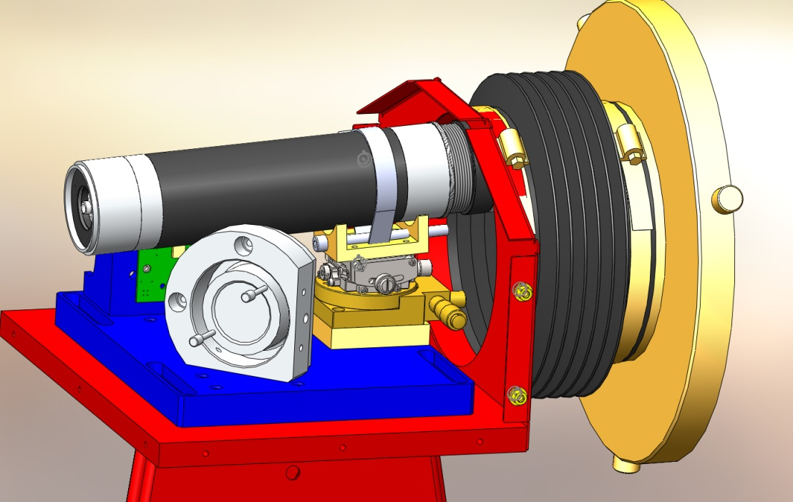
Figure 2: Telescope mounting hardware
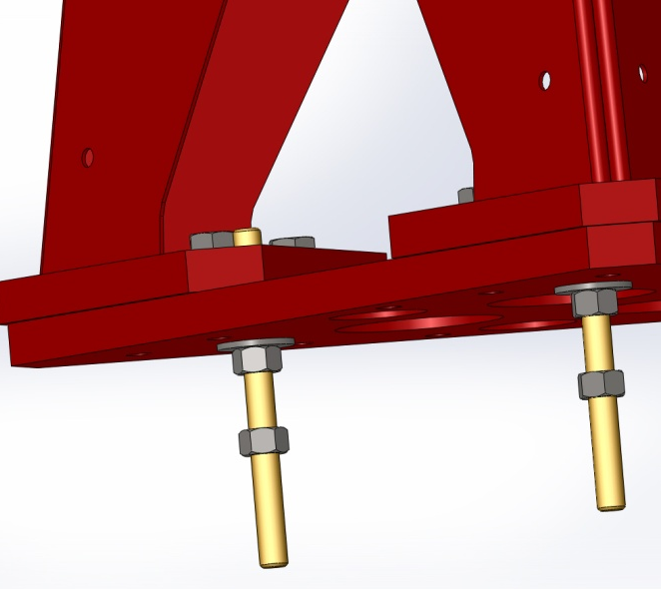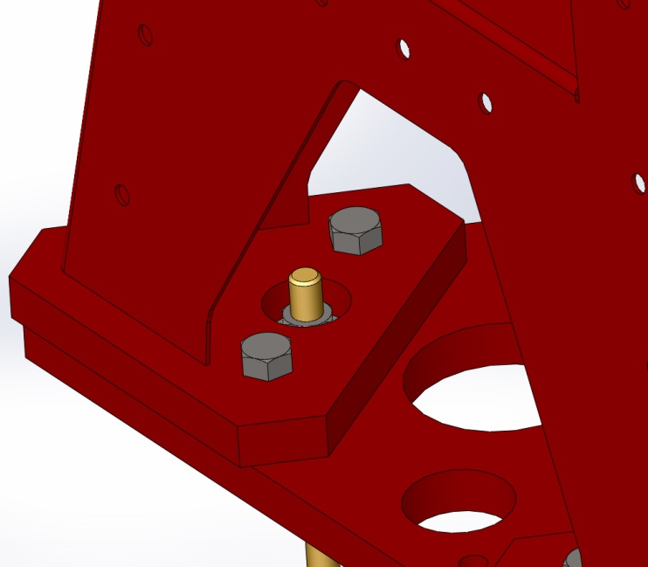
Figure 3:Base plate details

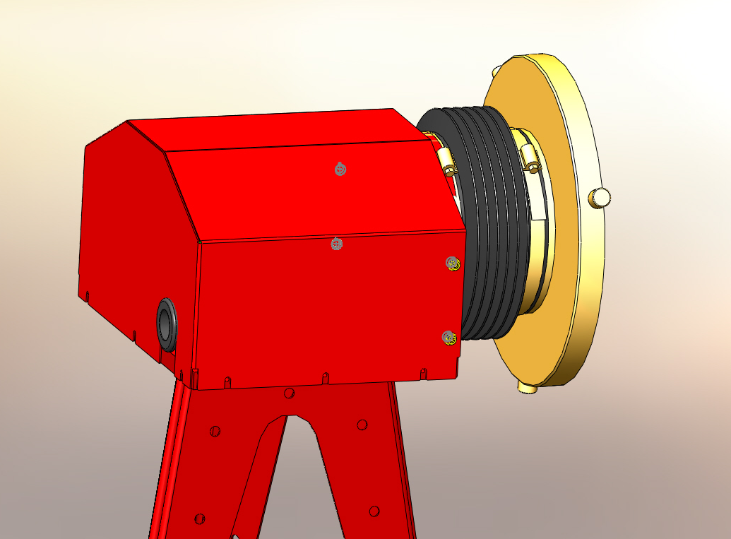
Figure 4: Cover installed

Notes, August 23, 2012:
During installation, it was discovered that the telescope was too long for the return beam to get behind it and to the QPD. The solution was to raise the telescope mount using a 1/2" shim (see below) and lower the folding mirror mount by omitting the block under it (D1001628). It was necessary to drill new holes in the base plate (D1001627) to mount the mirror without the block. This left the QPD too high to steer the beam to it so the bracket was installed backwards (turned 180°) and make a new set of #4-40 holes in the bracket at a lower elevation.

Since the telescope for the beam splitter transceiver is much smaller, it was not necessary to make the same changes for the beam splitters which otherwise use the same transceiver design.

