LIGO Laboratory / LIGO Scientific Collaboration

LIGO-T1000157-v1 LIGO March 25, 2010

Optical Lever: Long Term Test of Laser Diode

Tar Chalermsongsak, Riccardo DeSalvo, Eric Black

Distribution of this document:
LIGO Scientific Collaboration

This is an internal working note
of the LIGO Laboratory.

California Institute of Technology  LIGO Project – MS 18-34  1200 E. California Blvd.  Pasadena, CA 91125  Phone (626) 395-2129  Fax (626) 304-9834  E-mail: info@ligo.caltech.edu | Massachusetts Institute of Technology  LIGO Project – NW22-295  185 Albany St  Cambridge, MA 02139  Phone (617) 253-4824  Fax (617) 253-7014  E-mail: info@ligo.mit.edu
LIGO Hanford Observatory  P.O. Box 1970  Richland WA 99352  Phone 509-372-8106  Fax 509-372-8137 | LIGO Livingston Observatory  P.O. Box 940  Livingston, LA 70754  Phone 225-686-3100  Fax 225-686-7189
http://www.ligo.caltech.edu/

Introduction
This is the 50 hr test of the laser diode [Thorlabs LPS-635-FC]. We want to see how good the laser’s pointing stability of our table top setting is.

Setup
The laser is mounted on lens holder with an adaptor from the lens holder to the laser. The laser points to the QPD and the data is recorded for roughly 50 hours. There is a long term drift from relaxing fiber on vertical position (fig. 1.) We subtract the corresponding linear fit from the data and plot on fig. 2.

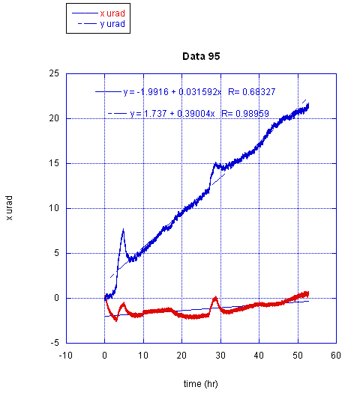

Fig1) Position of the beam spot on the QPD over 50 hours. The linear drift is obvious on vertical direction. The kink around 30 hr is a result of temperature change.( I came in the lab to check if the computer was running properly.)

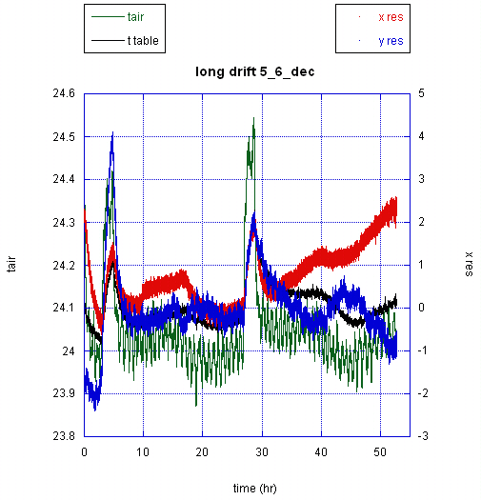

Fig. 2) After the position is subtracted from the drift, the residues are plotted. On the right is the scale for position change in micro radian. On the left is the scale for temperature change in Celsius. Red and blue are x and y positions, green and black are the room and the table’s temperature respectively. 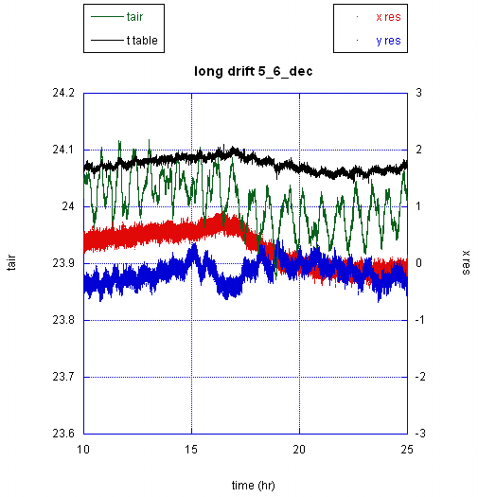
Fig 3. A closer look of the above plot, from 10 to 25 hour.

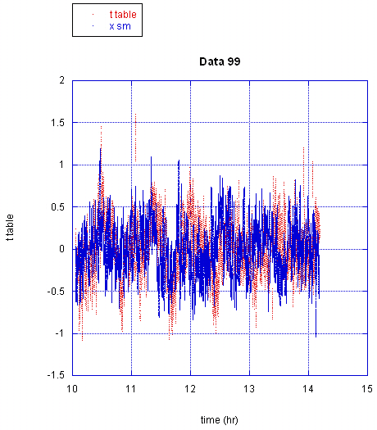
Fig4. The table’s temperature and the spot’s horizontal position are plotted together to see the correlation. The data is rescaled to arbitrary units.
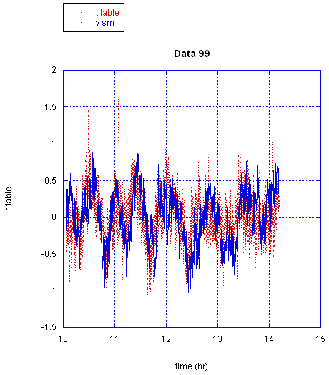
Fig5. The table’s temperature and the spot’s vertical position are plotted together to see the correlation. The data is rescaled to arbitrary units. They appear to be highly correlated, as we might expect from the table warping.

