LIGO Laboratory / LIGO Scientific Collaboration

LIGO- T1000137_v1 LIGO Date: 03/15/2010

Drag Wiping with Methanol vs First Contact

Margot Phelps, Liyuan Zhang, Rand Dannenburg

Distribution of this document:
LIGO Scientific Collaboration

This is an internal working note
of the LIGO Laboratory.

California Institute of Technology  LIGO Project – MS 18-34  1200 E. California Blvd.  Pasadena, CA 91125  Phone (626) 395-2129  Fax (626) 304-9834  E-mail: info@ligo.caltech.edu | Massachusetts Institute of Technology  LIGO Project – NW22-295  185 Albany St  Cambridge, MA 02139  Phone (617) 253-4824  Fax (617) 253-7014  E-mail: info@ligo.mit.edu
LIGO Hanford Observatory  P.O. Box 159  Richland WA 99352  Phone 509-372-8106  Fax 509-372-8137 | LIGO Livingston Observatory  P.O. Box 940  Livingston, LA 70754  Phone 225-686-3100  Fax 225-686-7189
http://www.ligo.caltech.edu/

Introduction
The purpose of this document is to outline the strengths and weaknesses of using a methanol drag wipe vs first contact for cleaning optics. Liyuan Zhang’s CASI scatterometer was used to take BRDF measurements of the surface of an optic before and after it had been cleaned by drag wiping and by first contact. Using these BRDF measurements maps of the optic’s scatter and average scatter values were obtained, see Fig.1-Fig.8.
Relevant Documents:
LIGO doc #T0900402, drag wiping procedure for large optics
LIGO doc# E1000079, First Contact procedure for large optics

Drag wiping tests
Two different ways of drag wiping were tested, using first old methanol and then new gradient grade methanol. The reason for distinguishing between the old and new methanol was observations made at LHO that the older methanol gets, the more residue it leaves on optics. The procedure that was developed at LHO for drag wiping large optics is documented in T0900402. The procedure in T0900402 was followed in the tests listed below.

Old methanol
The following scans show the scatter from the first attempts to drag wipe with old methanol. It is evident in this scan that the drag wipe leaves a significant amount of residue behind on an otherwise clean optic. Fig. 1 is a surface map of the optic prior to any cleaning, and Figure 2 is the same surface after a drag wipe using methanol that had been sitting around in the lab.
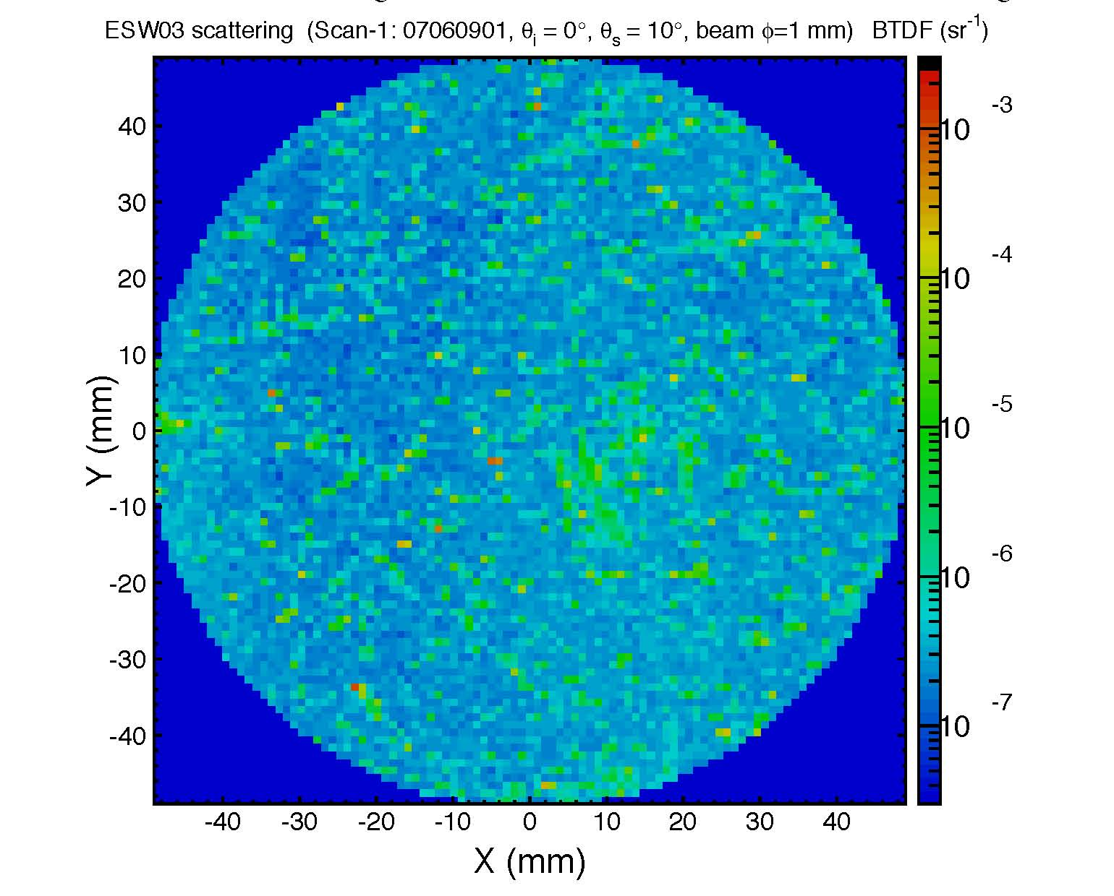
Figure 1: 2.05 ppm scatter on optic before cleaning
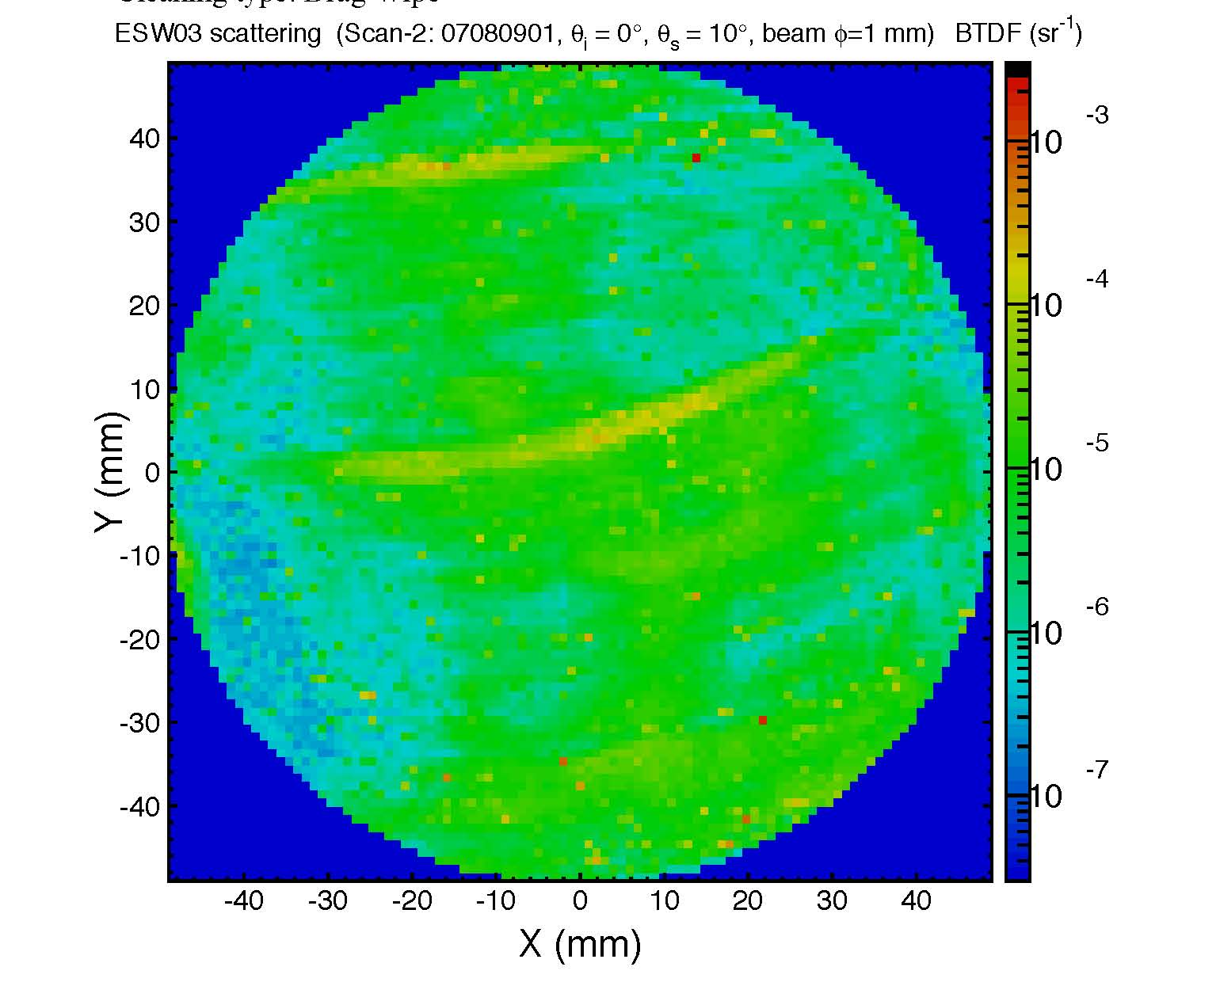
Figure 2: 10.7 ppm scatter on optic after old methanol drag wipe

First Contact
After the drag wiping, cleaning with First Contact was tried to see if it would get rid of the methanol residue. Figure 3 is the result of cleaning with First Contact.

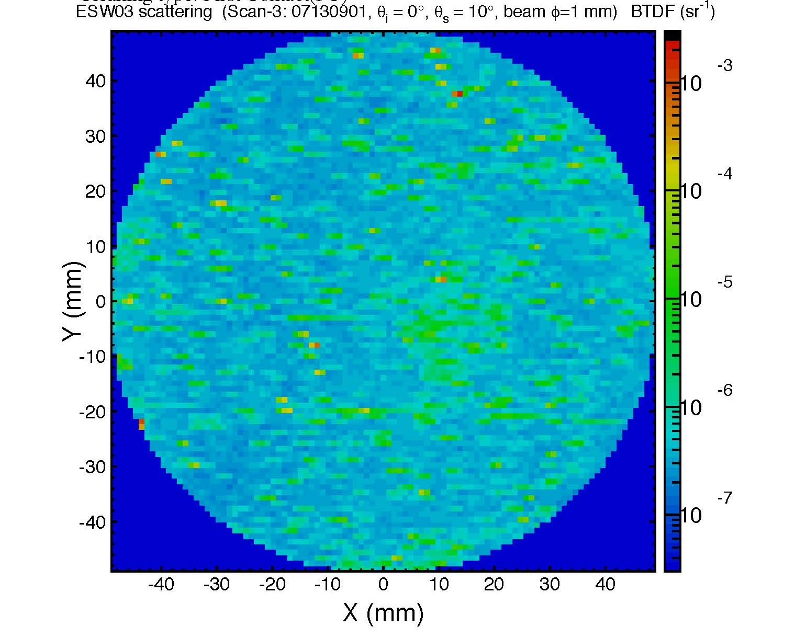
Figure 3: 2.41 ppm scatter after cleaning with first contact
Not only did cleaning with First Contact leave no residue, it also removed nearly all the residue left by the methanol. The developer and manufacturer of FC, Photonic Cleaning Technologies, states that FC was developed to get optics cleaner than is possible with drag wiping, which is what is shown here in the first three scans, as well as in the scans after them. There are 26 scans total, see LIGO #T1000162 for pdf of all cleanings done on this optic.

First Contact and Methanol
Methanol is commonly used at LIGO to clean optics. Acetone can be used in place of methanol, although there is no data in this paper to support this. Methanol dissolves FC very quickly. However, it also seems to mix with the First Contact solvent to create some sort of residue. Drag wiping an optic that has some FC on it can result in residue on the optic's surface that is difficult to get off. This only becomes a problem if FC is accidentally left on the optic’s surface and then spread around when drag wiping. In Figure 4 the surface map shows bits of dried First Contact on the top, right side and bottom that were left on the surface on purpose to see if drag wiping removed them.
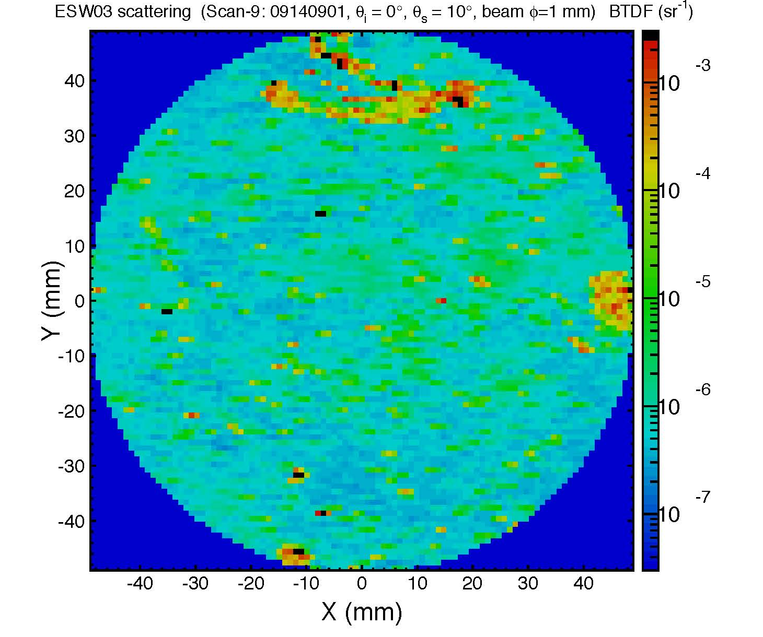
Figure 4: 47.5 ppm scatter after a messy FC removal
To see if it was the interaction between the methanol and the first contact that was causing the residue, the optic was submerged in a methanol bath for ten minutes with the dried first contact still on the surface. If the residue following this methanol bath and first contact cleaning, shown in Figure 5, was solely made up of first contact, it would have recombined with the new layer of first contact when it was applied and left the surface clean. This was not the case, which indicates that the methanol mixed with the first contact to create a residue.

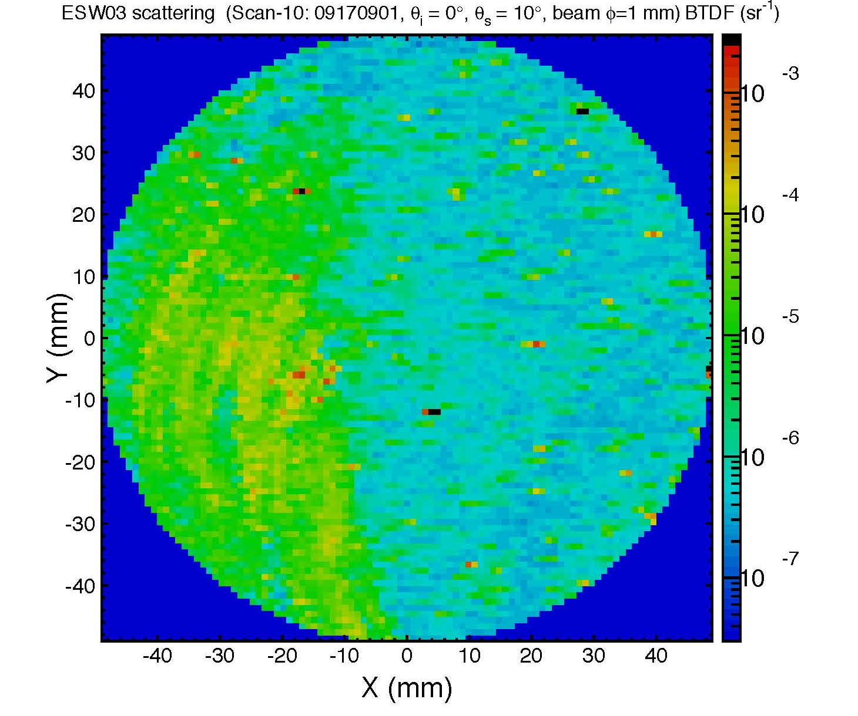
Figure 5: 25.6 ppm scatter on optic after cleaning in a methanol bath followed by a drag wipe AND a first contact cleaning.
The methanol bath did not seem to work as a cleaning method so for the next six cleanings the optic was dragwiped and then first contact was applied. Figure 6 is the result of those six cleanings, the scatter has improved but the residue is still visible on the left side.

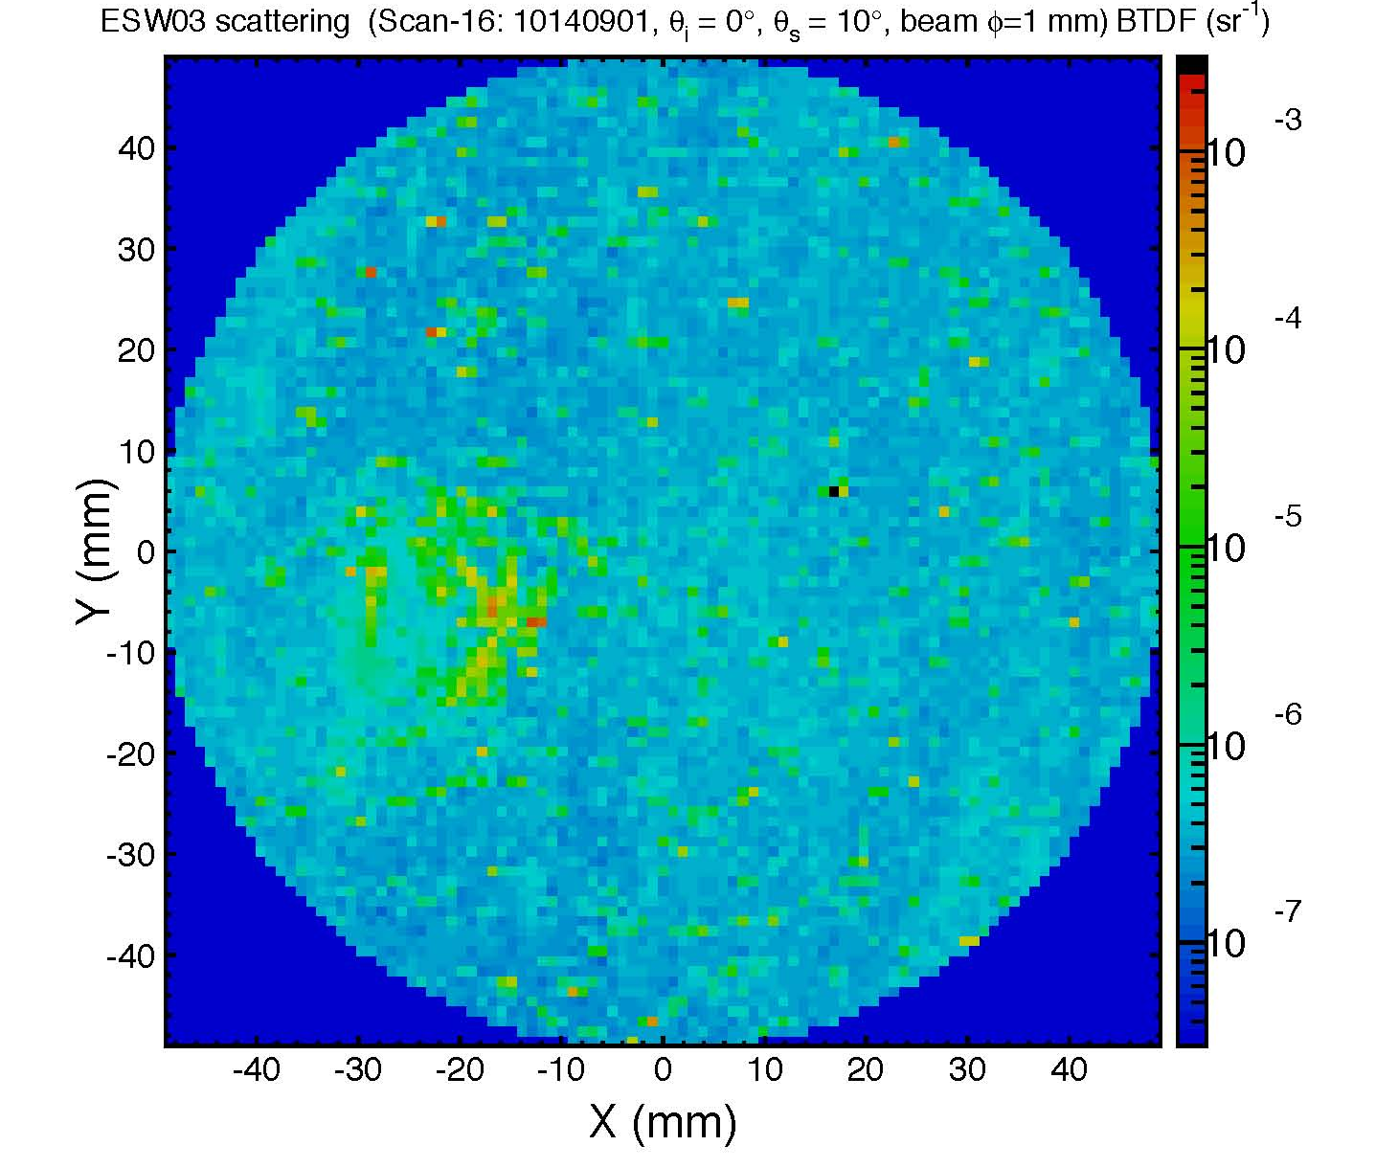
Figure 6: 6.76 ppm scatter. After six consecutive cleanings (drag wiping followed by first contact every time), the residue is lessened but not gone.

First Contact without dragwiping
After being unable to fully remove the residue in Figure 6, a different optic was used to see how clean it would stay using first contact as the only cleaning method. Figure 7 shows the optical surface after it had sat around the lab, covered in a small plastic lens cap. Figure 8 shows the surface of the same optic, in the same orientation, after eight consecutive first contact cleanings. Drag wiping with methanol, isopropanol or acetone was not used at any time on this optic. There was no residue after any of the first contact cleanings, as there was after the drag wiping on the previous optic. The optical surface just gets cleaner and cleaner with each application.

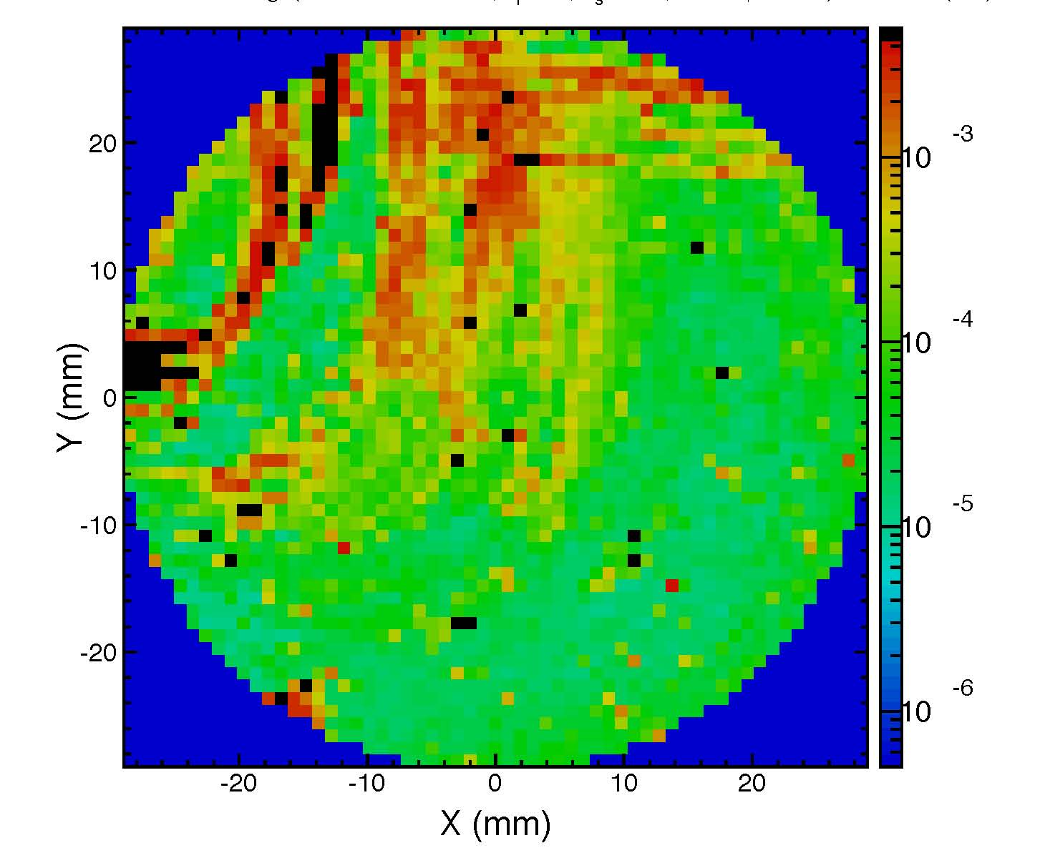
Figure 7: 610 ppm scatter background measurement of optic surface before cleaning

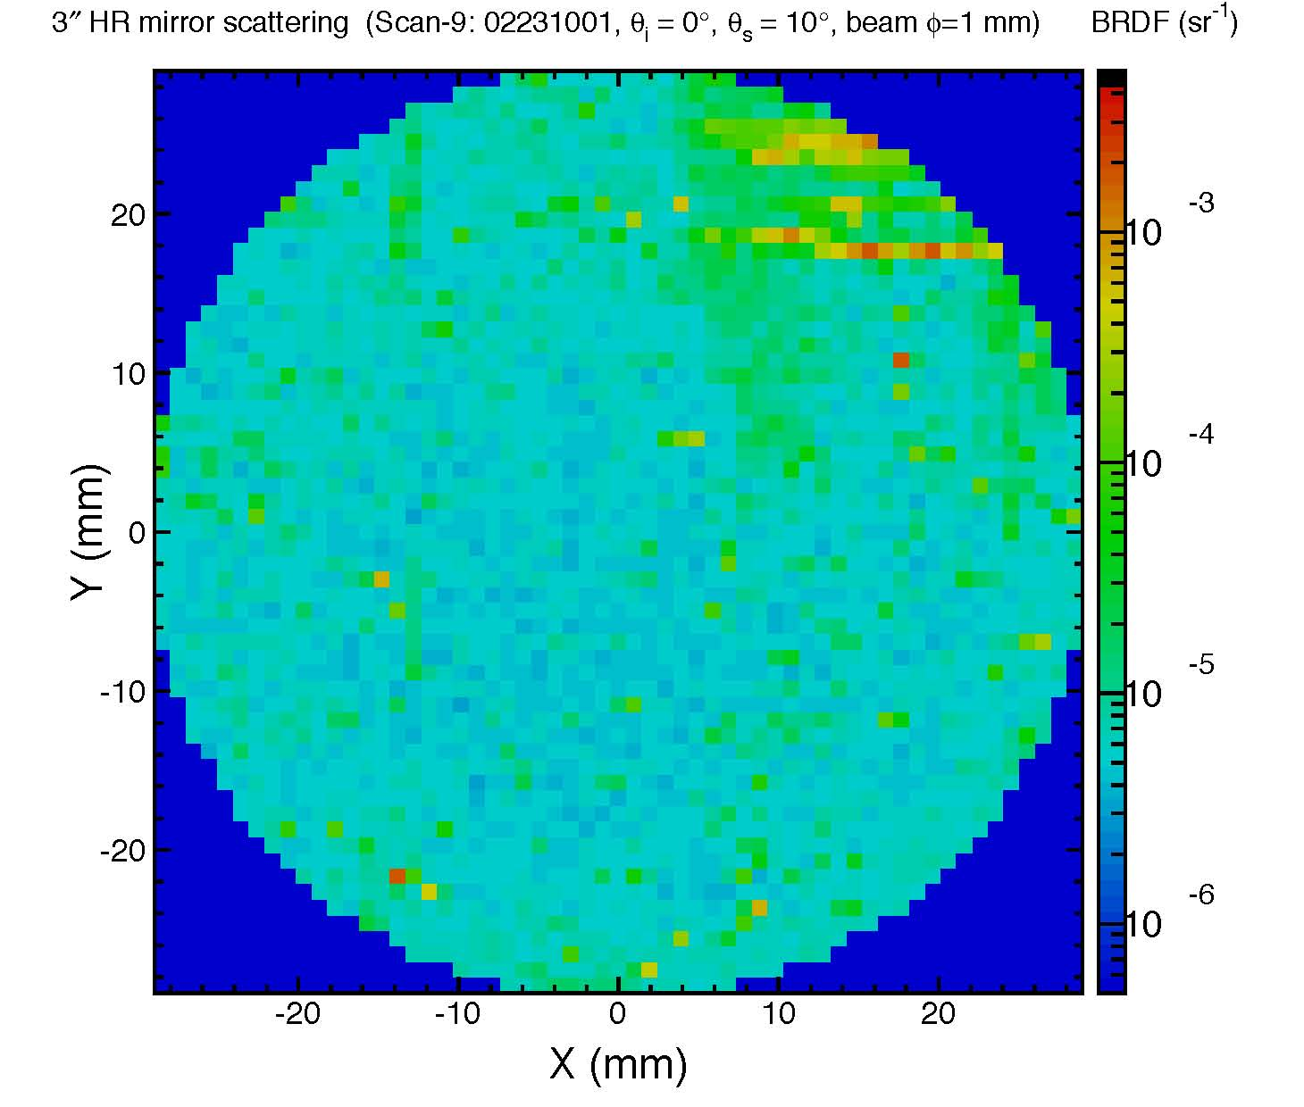
Figure 8: 20.1 ppm scatter after eight consecutive first contact cleanings.

Conclusions
After analyzing each BRDF scan one can see that First Contact is better than drag wiping at reducing particle count overall, as Photonic Cleaning claims. First Contact also has the added advantage of being able to keep the optic clean and somewhat protected for a long period of time if left on the surface.
Since methanol dissolves FC, and drag wiping an optic that has some FC on it results in residue it is advised not to use methanol to clean an optic that has been cleaned prior with First Contact. Using First Contact without any methanol drag wipes works best to keep the optic clean and to clean a dirty optic, so using methanol is unnecessary. There is acetone already in the first contact solvent, so using gradient grade acetone to drag wipe is acceptable if absolutely necessary.

