LIGO Laboratory / LIGO Scientific Collaboration

LIGO-T1000115-v1 Advanced LIGO 2 March 2010

AOSEM Flexible Circuit Board Design Details

R. Abbott, C. Osthelder

Distribution of this document:
LIGO Scientific Collaboration

This is an internal working note
of the LIGO Laboratory.

California Institute of Technology  LIGO Project – MS 18-34  1200 E. California Blvd.  Pasadena, CA 91125  Phone (626) 395-2129  Fax (626) 304-9834  E-mail: info@ligo.caltech.edu | Massachusetts Institute of Technology  LIGO Project – NW22-295  185 Albany St  Cambridge, MA 02139  Phone (617) 253-4824  Fax (617) 253-7014  E-mail: info@ligo.mit.edu
LIGO Hanford Observatory  P.O. Box 1970  Richland WA 99352  Phone 509-372-8106  Fax 509-372-8137 | LIGO Livingston Observatory  P.O. Box 940  Livingston, LA 70754  Phone 225-686-3100  Fax 225-686-7189
http://www.ligo.caltech.edu/

Overview
A flexible circuit board solution has been designed to improve the reliability and manufacturability of the electrical portion of the aLIGO OSEM head (AOSEM). The circuit board is a hybrid of polyimide film flexible printed circuit board technology, and laser cut alumina stiffeners that form a UHV compatible solution to the electrical connectivity of the AOSEM.
The flexible circuit board provides connection to the AOSEM photodiode and companion LED (Honeywell Inc. SME2470 and SME2420 respectively). Two gold pads are provided to interface to the AOSEM coil windings.

Implementation
Some photographs showing a complete AOSEM assembly are shown below. In these assembly photos, the flexible circuit board (shown in Figure 4) has been folded and inserted inside the black plastic AOSEM body.

Figure 1 shows the white alumina stiffeners with the LED (or photodiode) lens visible through the hole in the alumina
Figure 1
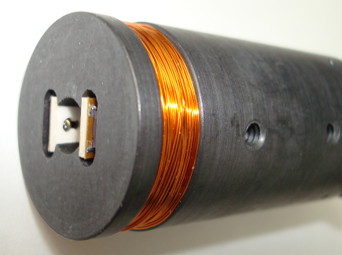

Figure 2 shows a side view of the entire AOSEM. Two threaded set screw holes are shown that clamp the arms of the flexible board in position. The relative position of the LED with respect to the photodiode can be adjusted prior to tightening the set screws.

Figure 2
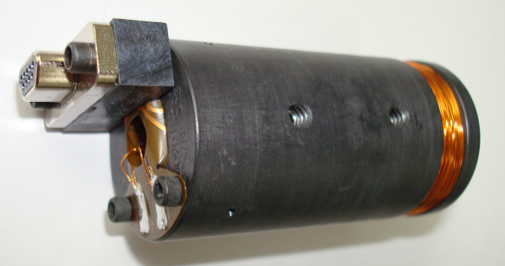

Shown in Figure 3 is another view of the AOSEM showing the LED and photodiode bodies visible on top and bottom of the white alumina stiffeners.
Figure 3
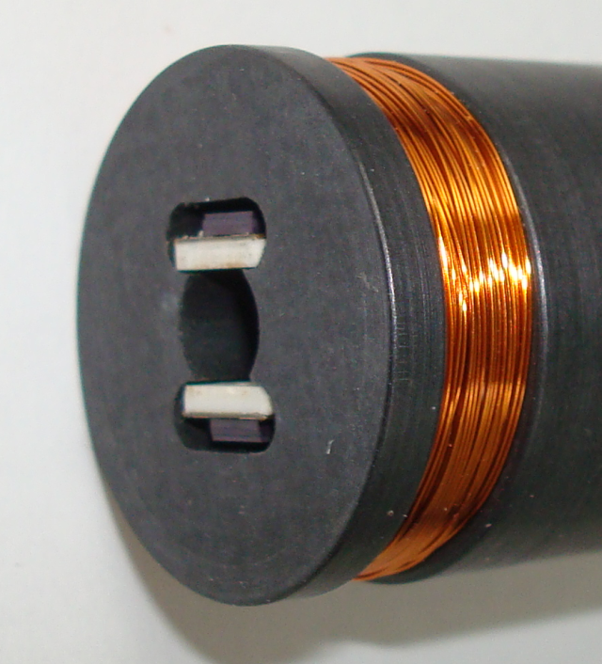

To provide a stable platform for soldering the LED and photodiode, stiffened sections have been added to the flexible circuit. The overall assembly is shown in Figure 4
Figure 4
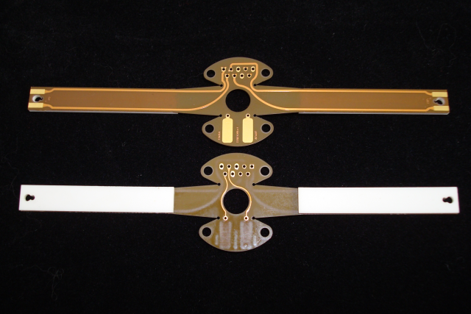

The tip design of the circuit board allows the LED and photodiode to be indexed by inserting their lens into the larger of the two intersecting holes as detailed in Figure 5
Figure 5
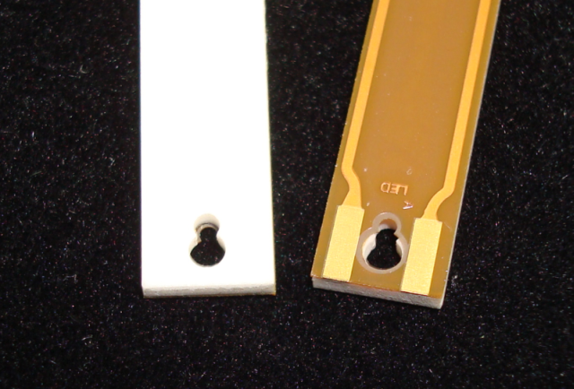

The stiffened portions of the flexible circuit assembly are constructed from alumina as shown in Figure 6. All dimensions shown are in inches. The alumina assembly is laser cut, and then bonded to the polyimide film using DuPont Inc. Pyralux LF film adhesive. This adhesive has been previously approved by the Vacuum Review Board (VRB) in conjunction with the Birmingham OSEM design (BOSEM) for use in the LIGO UHV environment. This type of previous approval is not sufficient to allow blanket approval of other applications of Pyralux. Each application requires approval from the VRB
Figure 6
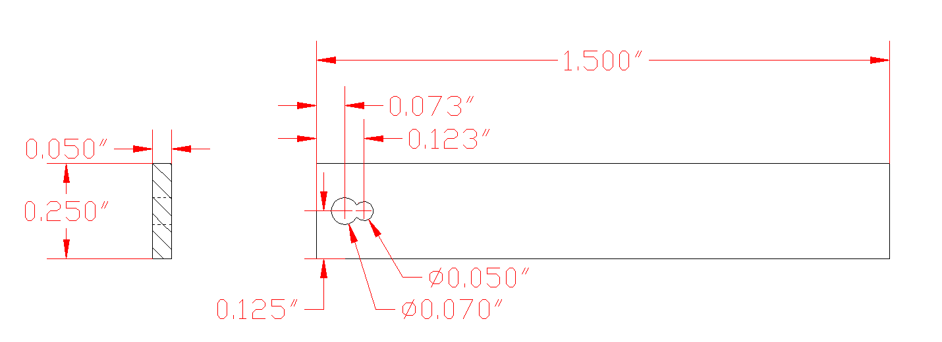

Other Details
A close examination of Figure 4 reveals several important details. All circuit board copper tracks are implemented with gentle curves which taper into the pads at the end of each runs. This permits the board to flex with minimal likelihood of work hardening the metal circuit board tracks. All through-hole pads have additional lobes projecting from them to improve the bonding of the metal pad to the polyimide film. The copper traces are sandwiched between two layers of polyimide for durability. The total thickness of the resulting two layer polyimide assembly is 0.01 inches.
Each arm of the circuit board is labeled to identify whether LEDs or photodiodes are to be mounted. The anode of each type of component is also indicated on the circuit board tip as shown in Figure 5 by a small printed letter A. A general part number and revision is printed in copper on each flexible circuit.
The pads used to attach the coil wires are labeled “start” and “finish” as a way of identifying the ends of the coil windings. All pads are gold plated for connection reliability.
The holes cut in each end of the alumina stiffener serve two functions. The lens of the LED or photodiode fits in the larger hole; the smaller hole is to ensure no trapped air volume exists between the component body and the circuit board.
The entire assembly was manufactured per LIGO drawings by Hughes Circuits Inc. of San Diego, CA. Design guidelines for flexible circuits are included in section 5 of LIGO-T060123-04, Standard LIGO Electrical Interfaces.

