LIGO Laboratory / LIGO Scientific Collaboration
LIGO-T1000114-v1 ADVANCED LIGO 15th March 2010

ALIGO NP-type: - Ear Bonding at LASTI - February 2010

M. Van Veggel, N. Beveridge, G. Moreno, B. Shapiro, M. Maxwell, A. Bell, M. MacInnis, A. Cumming, L. Cunningham, R. Kumar, G. Hammond, G. Harry, R. Mittleman
Institute for Gravitational Research, University of Glasgow

Distribution of this document:
LIGO Science Collaboration.
This is an internal working note
of the LIGO Project.

California Institute of Technology  LIGO Project – MS 18-34  1200 E. California Blvd.  Institute for Gravitational Research  University of Glasgow  Kelvin Building  Glasgow G12 8QQ  Phone: +44 (0)141 330 3340  Fax: +44 (0)141 330 6833  Web: www.physics.gla.ac.uk/igr/  Pasadena, CA 91125  Phone (626) 395-2129  Fax (626) 304-9834  E-mail: info@ligo.caltech.edu | Massachusetts Institute of Technology  LIGO Project – NW22-295  185 Albany St  Cambridge, MA 02139  Phone (617) 253-4824  Fax (617) 253-7014  E-mail: info@ligo.mit.edu
LIGO Hanford Observatory  P.O. Box 1970  Mail Stop S9-02  Richland WA 99352  Phone 509-372-8106  Fax 509-372-8137 | LIGO Livingston Observatory  P.O. Box 940  Livingston, LA 70754  Phone 225-686-3100  Fax 225-686-7189
http://www.ligo.caltech.edu

Contents
1 Contents 2
2 Document history 3
3 Introduction 3
4 Reference documents 4
5 Actual time schedule 5
6 Log 5
6.1 Tuesday 16th February 2010 5
6.1.1 Setting up lab 5
6.1.2 Glueing slides to prisms 6
6.2 Wednesday 17th February 2010 7
6.2.1 Check prism spacers 7
6.2.2 Using the ergo arm 7
6.2.3 Setting the bonding jig 8
6.2.4 Preparing bonding solution 9
6.2.5 Cleaning the ear 10
6.2.6 Cleaning the mass 10
6.2.7 Bonding 10
6.2.8 Glueing prism 13
6.3 Thursday 18th February 14
6.3.1 Using the Ergo-arm 14
6.3.2 Setting the bonding jig: 14
6.3.3 Preparing bonding solution 15
6.3.4 Cleaning the ear 15
6.3.5 Cleaning the mass 15
6.3.6 Bonding 15
6.3.7 Gluing prism 16
6.4 Friday 19th February 17
6.4.1 Prism bond inspection 17
6.4.2 Test mass moving 18
6.4.3 Test mass prism removal 19
6.4.4 Ear removal 20
6.5 Saturday 20th February 21
6.5.1 Removing prism side 2 TM 21
6.5.2 Removing the ears from side 2 TM 21
6.5.3 Setting the bonding jig 22
6.5.4 Preparing bonding solution 22
6.5.5 Cleaning the ear 23
6.5.6 Cleaning the mass 23
6.5.7 Bonding 23
6.6 Sunday 21st February 24
6.6.1 Setting the bonding jig 24
6.6.2 Preparing bonding solution 25
6.6.3 Cleaning the ear 25
6.6.4 Cleaning the mass 25
6.6.5 Bonding 25
6.7 Monday 22nd February 26
6.7.1 Glueing slides to other 2 prisms 27
6.8 Tuesday 23rd February 27
7 Conclusions 28
8 Filled in inspection sheets bonds 30

Document history
Version v1 | 15th March 2010 | First version of report for comment (M. Van Veggel, N. Beveridge)

Introduction
In the second half of February 2010 an exercise was done at LASTI to bond the “new” silica ears to the second penultimate mass and reglue the prisms onto the penultimate mass, remove the current prisms and ears from the test mass and bond the “new” silica ears to the test mass.
In July 2009 the “old” ears and prisms were already removed from the penultimate mass. This has been reported in T0900369-v1.
This document reports on the work described above in the form of a log. A summary can be found at the end of the document.

Reference documents
Additional documentation after preps
T1000016-v2 | ALIGO NP-type: - Preparations of Ear Bonding at LASTI (February 2010)
T1000082-v1 | Ergo Arm Users Manual - Quick start
Design documentation ‘glass’ essentials
D050421-05-K | NP- type ETM Penultimate Mass
D040431-C-D | Quad ETM Silica Test Mass
D080751-v2 | NP-type Ear (second prototype)
D090007-v1 | NP-type Ear with recess (second prototype)
D060099-03 | NP-type Penultimate Mass break-off prism
D060039 | NP-type Fully Bonded ETM Silica Test Mass assembly
D060437 | NP-type Fully Bonded Penultimate Mass Assembly
Design documentation of the alignment jigs
D0901592 | ASSEMBLY DRAWING – NP-type bonding jig
D0901591 | Baseplate – NP-type bonding jig
D1000128-v1 | Penultimate mass prism holder
Measurement reports on ‘glass’ essentials
GNL-4025-R1 | Penultimate mass 1 measurements
GNL-4027-R2 | Penultimate mass 2 measurements
C070035-00 | Test mass measurements
T0900557-v3 | N/P-type monolithic suspension: testing record for test ears
Back ground documents
E050228-00-D | (Specification) Silicate Bonding Procedure
E070070-00-D | LASTI Test Mass, Handling and Shipping Procedures
T070223-00-K | ALIGO NP-type: - Report on Ear Bonding at LASTI 27th August – 31st August
E970154-D-D | Large optics suspension balancing: component specification
T0900369-v1 | Removal of the ears and prisms at LASTI in July 2009
T0900447-v3 | Ear fabrication readiness review
T070138-00-K | Ribbon/Fibre Length Budget
T0900374-v1 | The new D2 value for the ALIGO Quad suspension
T0900372-v1 | Assembly Data for the Quad Noise Prototype
T080041-01 | ALIGO NP-type - Report on prism bonding at LASTI on 11th -17th February 2008

Actual time schedule
Table 5.1 Actual time schedule
 | Tuesday  16-02-2010 |  | Wednesday  17-02-2010 |  | Thursday  18-02-2010 |  | Friday  19-02-2010
Preparations (plus glue slides to prisms)
Bond ears to side 1 penultimate mass
Glue prism to side 1 penultimate mass
Bond ears to side 2 penultimate mass
Glue prism to side 2 penultimate mass
Move test mass from structure to bonding lab
Remove prism side 1 test mass
Remove ears side 1 test mass

 | Saturday  20-02-2010 |  |  | Sunday  21-02-2010 |  | Monday  22-02-2010 |  | Tuesday  23-02-2010
Remove prism side 2 test mass
Remove ears side 2 test mass
Bond ears to side 1 test mass
Bond ears to side 2 test mass
Clearing up
Clearing up

Log

Tuesday 16th February 2010

Setting up lab
- Gregg unpacked the ergo-arm, wiped it down twice and put in clean room. We thoroughly wiped down the ergo arm one more time inside the clean-room.
- Myron helped with finding things and clearing stuff from the lab, which would be in our way.
- We cleaned the bonding cart and wrapped the top surface with UHV aluminium foil.
- We set-up the ultrasonic bath on top of the cart and wrapped the lid in aluminium foil.
- Cleaned all work surfaces and wrapped the table in fresh aluminium foil.
- Checked the ergo-arm, but did not yet operate it with the vacuum pump.

Glueing slides to prisms
- In preparation of glueing the prisms onto the penultimate mass, we glued the slides we prepared in Glasgow to the prisms (Figure 1).
- We selected the two best prisms from the four we unglued from the two masses. We noticed that on two prisms the grooves were visibly off-set from the center. We therefore chose to use the other two.
- We wiped copper wire clean with acetone.
- We cleaned the prisms and slides thoroughly with acetone and methanol. One of the two prisms still had smudges after that clean. We therefore decided to clean that prism with cerium oxide and bicarbonate of soda until clean and wipe again with methanol.
- We sat the prisms upside down into the prism holders to ensure that the bonding flat would be horizontal.
- We mixed the vac-seal for about two minutes and put some in an aluminium tray.
- A hose to fit the vacuum chamber to de-bubble the adhesive could not be found. As this step already seemed to have limited effectiveness in previous experience, this evacuation step was skipped.
- We dipped the copper wire into the mixed adhesive and applied it as uniformly and thinly as possible over the prism surface (Figure 2).
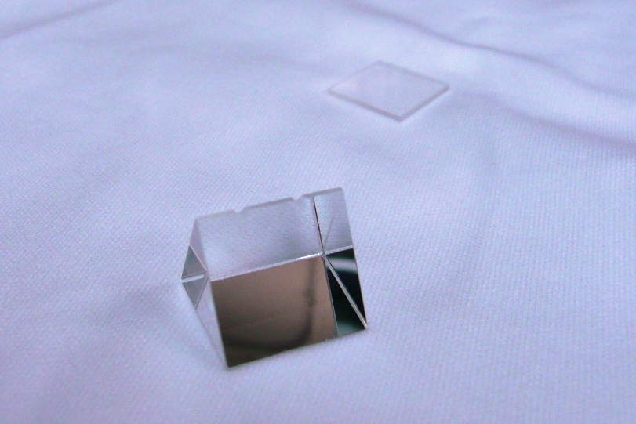  Figure 1 Prism and prism shim | 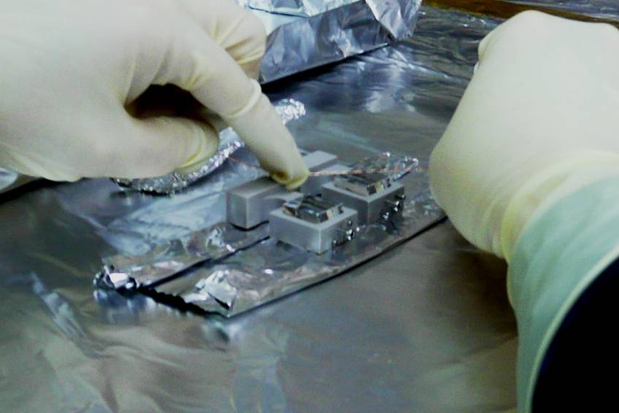  Figure 2 Applying vac-seal to prism base using a copper wire

- The prisms and slides were glued together at 17.20.
- We left the prisms under the heat lamp overnight. We also left the left-over adhesive, so that we could check that the adhesive has cured overnight in the morning (Figure 3).

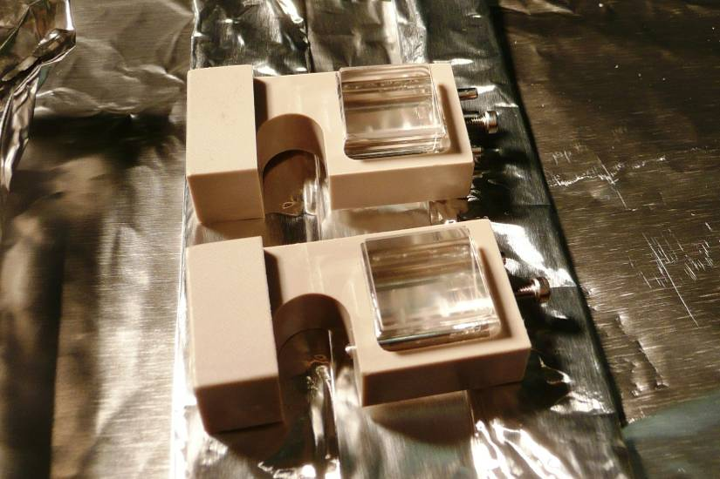
Figure 3 Prism and prism shims curing post-gluing under infra-red light

Wednesday 17th February 2010
- Myron had arranged a fresh nitrogen dewar for us in the morning.

Check prism spacers
- We checked if the adhesive had set properly on the aluminium tray. This was the case.
- Slides looked well aligned on the prisms.

Using the ergo arm
- We wrapped the crash mat of the ergo-arm in UHV aluminium foil and took it into the clean area.
- We read the user manual as provided by Calum Torrie (T1000082).
- We followed the manual but found that the pressure receiver box was not reading the pressure. We ended up trouble shooting with Calum in which we found that the receiver box had some loose wires that we reconnected, though this did not solve the problem. In the end we found that the battery inside the pressure gauge was not connecting properly. After taking it out, checking its voltage (which was nominal), and reinserting it in to the gauge, the receiver started working again.
- After this the ergo-arm worked fine. We put the mass onto the washing bath without any problems (see Figure 4 and Figure 5).
- As far as I can see there are only improvements on the previous ergo-arm (except maybe the annoying warning beep for pressure). It still has very low friction (and therefore extremely controllable) degrees for freedom. Without reference measurement you can probably align to a roll angle of 0.5/170 = 3 mrad, but if you have a measurement running I think you could probably do a little bit better. All degrees of freedom are lockable, which is nice.
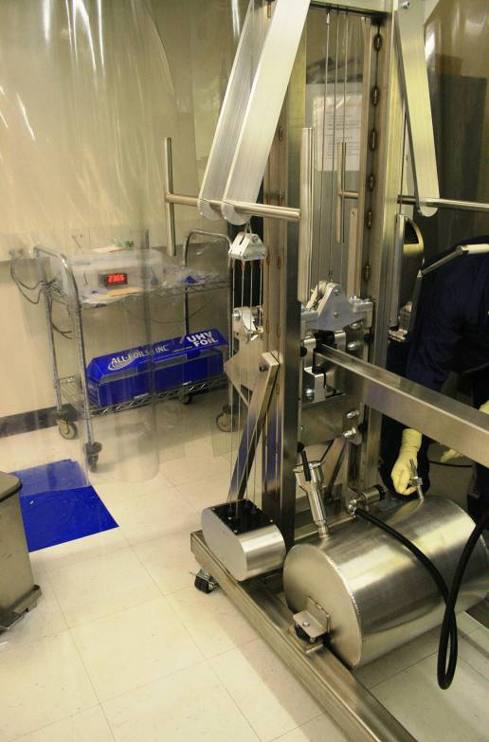  Figure 4 Ergo arm with pressure gauge receiver box in background | 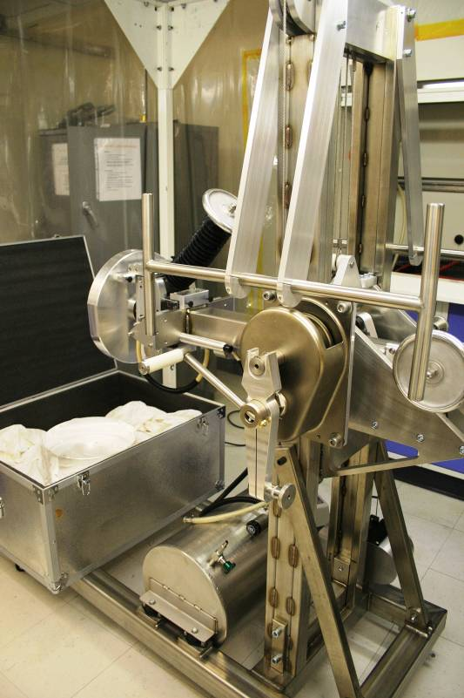  Figure 5 Removing PUM from container with Ergo Arm

Setting the bonding jig
- We set the bonding jig no. 2 for ear no. 46 on side 1 (this is D050421-05-D_Surface “S2” just outside zone “D8”. Template referenced to front face, surface “S3”).

Figure 6 Schematic of ear with bonding jig with critical reference dimensions

- The width of the PUM is w_{2ndPM} = 200.42 mm
- Measurements on the jig were done in Glasgow:
  - y_{pin1} = 58.21 mm
  - y_{pin2} = 58.23 mm
  - x_{j1} = 72.89 mm
  - x_{j2} = 132.88 mm
- Measurements on ear 46 were:
  - x_{h1} = 13.7 mm
  - x_{h2} = 43.9 mm
  - y_{h} = 27.6 mm
  - h_{horns} = 14 mm (this value was decided with the Glasgow team for the PUM in the morning of the 17th February to account for the current status in fibre manufacturing. The fibres will be fitted with the longer neck at the PUM side and the shorter neck on the TM side for LASTI).
- Using the following equations (also in the preparation document)
$$D_{\text{screw}1}=\left(x_{j1}+x_{h1}+\frac{x_{h2}−x_{h1}}{2}+1\text{.}5\right)−\frac{w_{2\text{ndPM}}}{2}$$
$$D_{\text{slider}1}=y_{\text{pin}1}−y_{h}−h_{\text{horns}}$$
this led to the following jig settings:
  - D_{screw} = 2.98 mm
  - D_{slider} = 16.61 mm
- We set D_{screw} using two slip gauges (1.8 mm and 1.18 mm to get 2.98 mm).
- We preset the digital callipers to set D_{slider}.

Preparing bonding solution
- We prepared a volumetric ratio of 1:6 of sodium silicate solution (Sigma-Aldrich) to DI water in a 15 ml tube (Figure 7).
- We poured the solution into 1.5 ml centrifuge tubes and centrifuged.
- We then transferred the solution to a 0.2 μm medical filter.
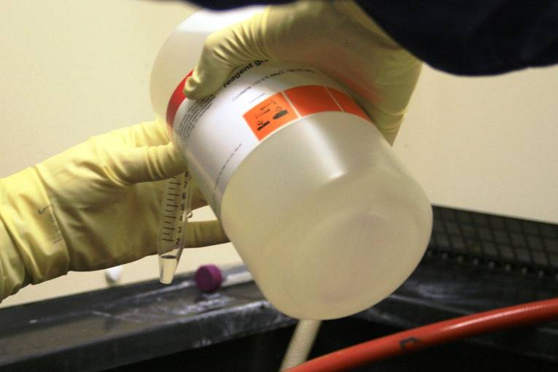
Figure 7 Making Bonding Solution using Sigma-Aldrich Sodium Silicate Solution

Cleaning the ear
- We cleaned the ear in the laminar flow cabinet
- Rubbed it carefully with cerium oxide on an optical wipe. And rinsed thoroughly with DI water.
- Rubbed it carefully with bicarbonate of soda and rinsed thoroughly.
- Rubbed it carefully again with bicarbonate of soda and rinsed thoroughly.
- Rinsed it carefully with methanol and blow dried with nitrogen.

Cleaning the mass
- We cleaned the bonding flat on the washing bath using the same procedure as used for the ear. We brought the water to the bonding flat through the hose that is connected to the water supply (Figure 8).
- Following this we lifted the mass up onto the table for bonding using the ergo-arm.
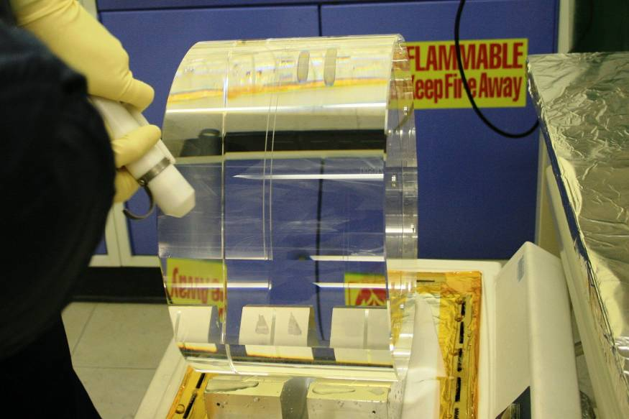
Figure 8 Drying the PUM with Nitrogen gas after cleaning

Bonding
- We carefully inspected the bonding flat of the mass with the Osram working light and wiped with methanol.
- We then placed the bonding jig on the mass. It turned out that it was resting on the remnants of the old ears, but this did not appear to be an issue for alignment (Figure 9).
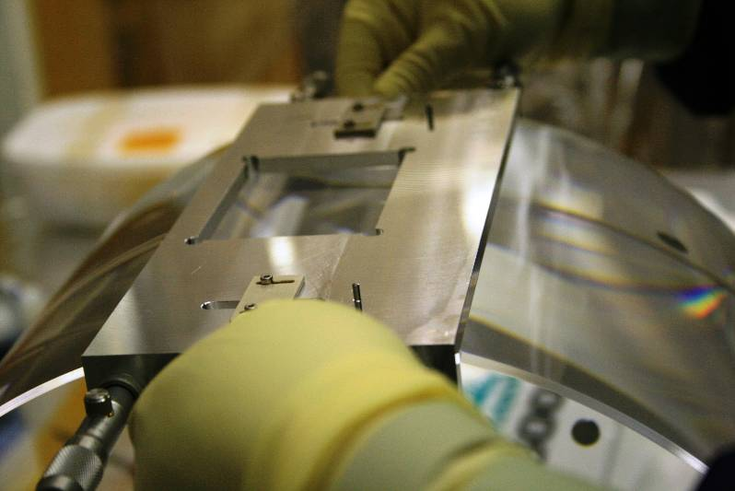
Figure 9 Placing jig onto optic
- The surface was inspected again.
- The ear was wiped with methanol and carefully inspected with the light.
- It turned out the pipette here can only do a maximum volume of 2.5 μl. So we decided to quickly deposit 4 drops of 2.5 μl in the middle of the bonding area on the mass (Figure 10 and Figure 11).
- We then placed the ear with one more glance at the surface (we wiped off a speck) (Figure 12).
- The bond looked good immediately with only a few small air bubbles in the center.
- We inspected once every hour after that. The bond seemed to settle well. After 2 hours we removed the jig carefully. The development of the bond has been recorded on a bond quality monitoring sheet (see Figure 34).
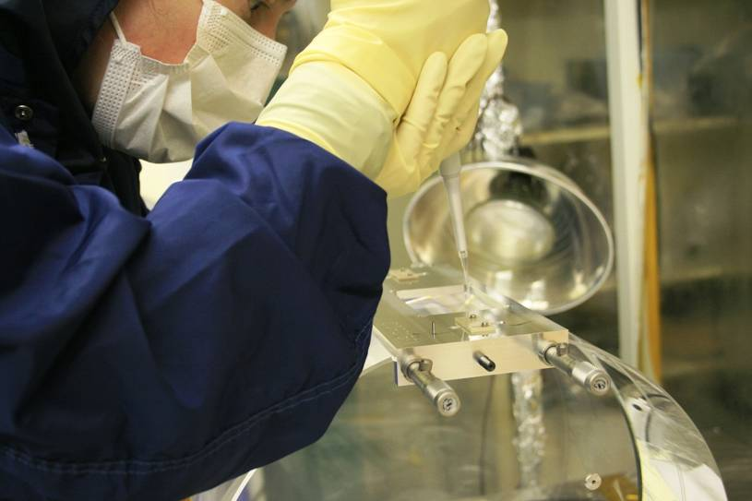  Figure 10 Pipetting bonding solution onto optic surface | 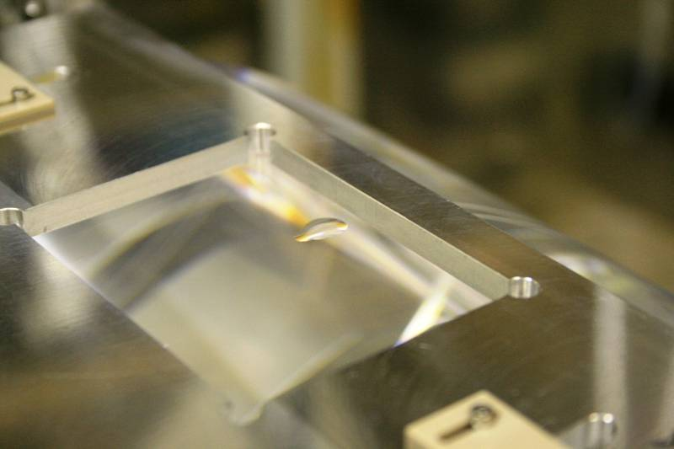  Figure 11 Bonding solution on optic surface immediately prior to bonding
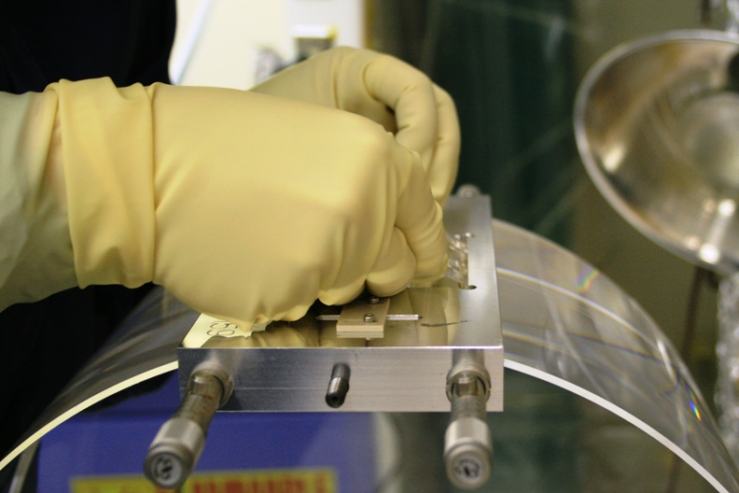  Figure 12 Placement of the ear into the optic surface | 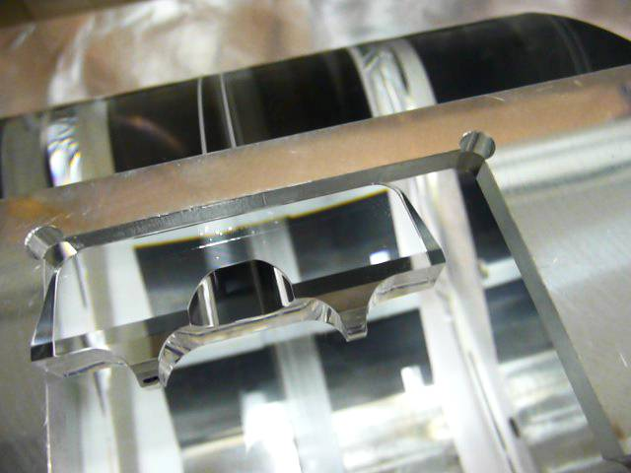  Figure 13 Ear 46 in place immediately after bonding with small bubbles visible
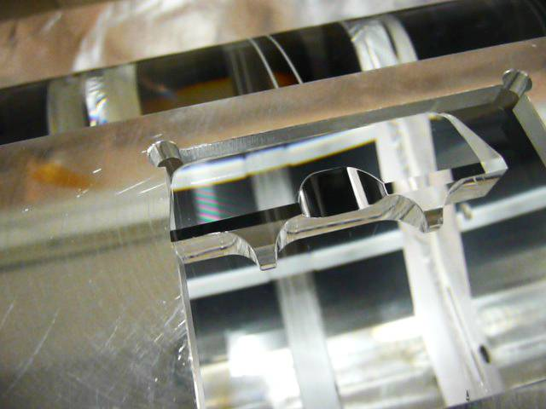  Figure 14 Ear 46 in place immediately after bonding with fringes visible | 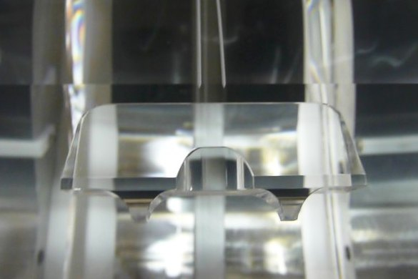  Figure 15 Finished bond between ear 46 and PUM

Glueing prism
- The width of the PUM is w_{2ndPM} = 200.42 mm
Figure 16 Relevant dimensions for the prism bonding jig settings
- Measurements on the jig were done in Glasgow:
  - y_{pin1} = 58.21 mm
  - y_{pin2} = 58.23 mm
  - x_{j1} = 72.89 mm
  - y_{recess} = 55.7 mm
- Measurements on the prism were:
  - w_{p} = 15.08 mm
  - y_{ph} = 10.6 mm
- Using the following equations (also in the preparation document)
$$D_{\text{screw}1}=\left(x_{j1}+x_{\text{ph}}+\frac{w_{p}}{2}\right)−\frac{w_{2\text{ndPM}}}{2}$$
$$D_{\text{slider}1}=y_{\text{pin}}−y_{\text{recess}}+y_{\text{ph}}+2\text{.}6$$
this led to the following jig settings:
  - D_{screw} = 2.92 mm
  - D_{slider} = 15.71 mm
- Set the bonding jig onto the mass. The friction caused by the old ears made it slightly awkward, but we got there.
- Prepared adhesive by mixing thoroughly.
- Put the prism in its holder.
- Wiped prism and mass carefully with methanol.
- Inspected the surfaces.
- Applied adhesive to the prism with copper wire and made it as thin as possible.
- Put the prism on the flat and pressed down to make the adhesive spread (Figure 17).
- Bond made at 17.40.
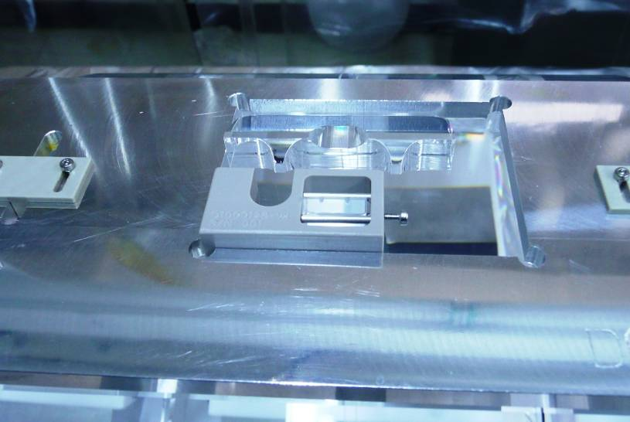
Figure 17 Prism (in prism holder) in place

Thursday 18th February
- We checked the adhesive on the prism had set properly – it had. The completed product on side 1 of the PUM is shown in Figure 18 and Figure 19.
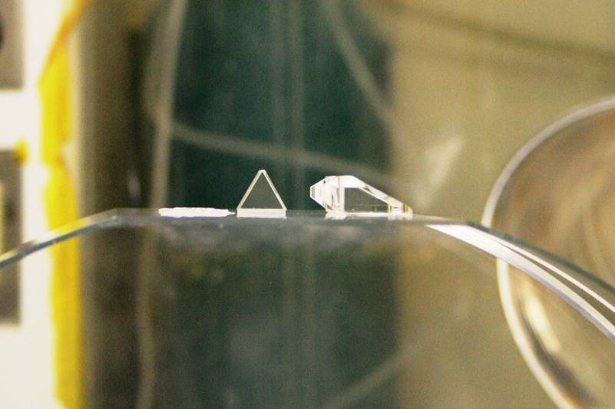  Figure 18 Prism and ear bonded onto PUM. (Remains of old ears visible) | 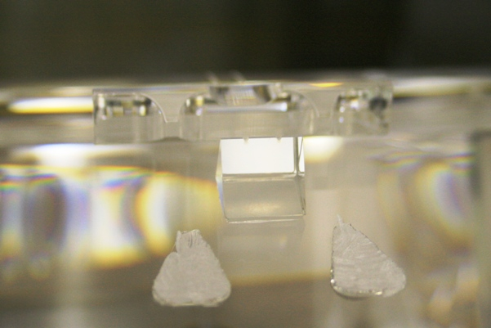  Figure 19 Bond between prism and PUM

- Gerardo arrived to help

Using the Ergo-arm
- The battery in the pressure gauge on the ergo-arm had run out over night – voltage reading was 2.09V.
- Gerardo bought two new batteries (1/2 AA, 3.6v) from Radioshack. The battery would now be removed from the ergo-arm when not in use to save power.

Setting the bonding jig:
- Jig number 2 used for ear 51 on side 2 (this is D050421-05-D_Surface “S1” in zone “D8”. Template referenced to front face, surface “S3”)of PUM.
- The width of the PUM is w_{2ndPM} = 200.42 mm
- Measurements on the jig were done in Glasgow:
  - y_{pin1} = 58.21 mm
  - y_{pin2} = 58.23 mm
  - x_{j2} = 132.88 mm
- Measurements on ear 51 were:
  - x_{h1} = 13.6 mm
  - x_{h2} = 43.9 mm
  - y_{h} = 27.6 mm
  - h_{horns} = 14 mm
- Using the following equations (also in the preparation document)
$$D_{\text{screw}2}=\left(x_{j2}−x_{h1}−\frac{x_{h2}−x_{h1}}{2}−1\text{.}5\right)−\frac{w_{2\text{ndPM}}}{2}$$
$$D_{\text{slider}2}=y_{\text{pin}}−y_{h}−h_{\text{horns}}$$
this led to the following jig settings:
  - D_{screw} = 2.37 mm
  - D_{slider} = 16.63 mm
- We set D_{screw} using two slip gauges (1.2 mm and 1.17 mm to get 2.37 mm).
- We preset the digital callipers to set D_{slider}.

Preparing bonding solution
- We prepared a volumetric ratio of 1:6 of sodium silicate solution (Sigma-Aldrich) to DI water in a 15 ml tube.
- We poured the solution into 1.5 ml centrifuge tubes and centrifuged.
- We then transferred the solution to a 0.2 μm medical filter. (prepared at 0950)

Cleaning the ear
- We cleaned the ear in the laminar flow cabinet
- Rubbed it carefully with cerium oxide on an optical wipe. And rinsed thoroughly with DI water.
- Rubbed it carefully with bicarbonate of soda and rinsed thoroughly.
- Rubbed it carefully again with bicarbonate of soda and rinsed thoroughly.
- Rinsed it carefully with methanol and blow dried with nitrogen.

Cleaning the mass
- We cleaned the bonding flat on the washing bath using the same procedure as used for the ear. We brought the water to the bonding flat through the hose that is connected to the water supply.
- Following this we lifted the mass up onto the table for bonding using the ergo-arm.

Bonding
- We carefully inspected the bonding flat of the mass with the osram working light and wiped with methanol.
- The surface was inspected again.
- The ear was wiped with methanol and carefully inspected with the light.
- 4 drops of 2.5 μl were quickly deposited in the middle of the bonding area on the mass.
- We then placed the ear with one more glance at the surface at 10.50
- The bond looked good immediately with only tiny air bubbles at either end of the ear. The bond development has been recorded on the bond quality sheet in Figure 35. Also, see Figure 20 for an impression of the fringes and bubbles shortly after bonding.
- We inspected once every hour after that. The bond seemed to settle well. After 3 hours we removed the jig carefully.
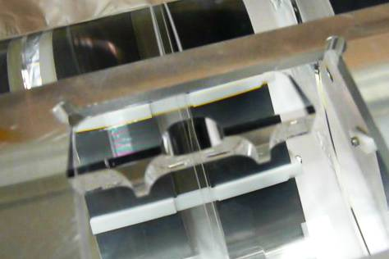
Figure 20 A few bubbles and fringes visible shortly after bonding between ear 51 and PUM

Gluing prism
- Measurements on the jig were done in Glasgow:
  - y_{pin1} = 58.21 mm
  - y_{pin2} = 58.23 mm
  - x_{j2} = 132.88 mm
  - y_{recess} = 55.7 mm
- Measurements on the prism were:
  - w_{p} = 15.08 mm
  - y_{ph} = 10.6 mm
- Using the following equations (also in the preparation document)
$$D_{\text{screw}1}=\left(x_{j1}+x_{\text{ph}}+\frac{w_{p}}{2}\right)−\frac{w_{2\text{ndPM}}}{2}$$
$$D_{\text{slider}1}=y_{\text{pin}}−y_{\text{recess}}+y_{\text{ph}}+2\text{.}6$$
this led to the following jig settings:
  - D_{screw2} = 2.47 mm
  - D_{slider} = 15.73 mm
- Prepared adhesive by mixing thoroughly.
- Put the prism in its holder.
- Wiped prism and mass carefully with methanol.
- Inspected the surfaces. The flat has a few small scratches on the gluing area.
- Applied adhesive with copper wire and made it as thin and even as possible.
- Put the prism on the flat and pressed down to make the adhesive spread.
- Bond made at 16.00.

Friday 19th February

Prism bond inspection
- The glue underneath the prism looked cloudy, and bubbles were visible. Some of the bubbles might be scratches as a large number of small scratches was observed in the PUM surface in and around the prism bonding location. The witness glue also had not cured properly – it was sticky and bendy rather than completely hard (Figure 21).

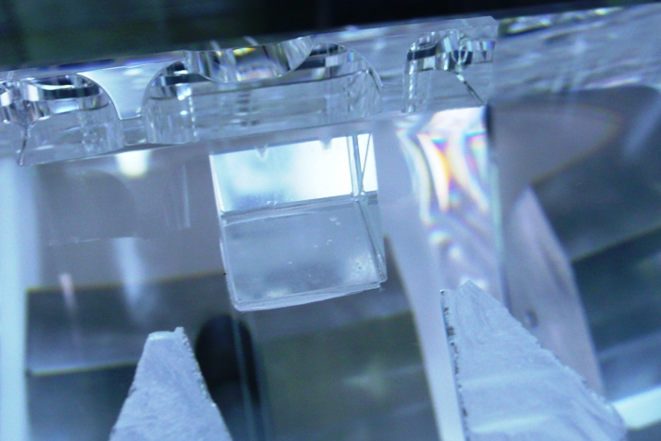
Figure 21 Cloudy bond on prism of side 2 of PUM. Bubbles or scratches visible underneath prism.

- We spoke with Angus Bell about the bond. It was decided to still pack the PUM away to allow the ear bond to cure completely before de-bonding the prism so the removal process would not damage the ear or ear bond. This was also discussed with Rich Mittleman.
- The witness glue has been stored with the PUM to check on the curing process.
- The PUM ears and prisms were covered with protective cups (Figure 22) and the mass was put back into its box.
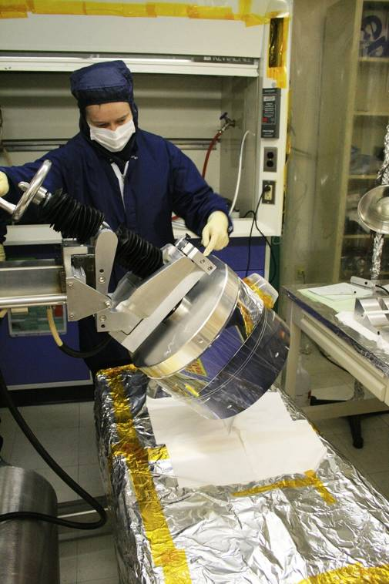
Figure 22 Packing PUM away, with protective cases over ears and prisms

Test mass moving
- The test mass was moved from the high-bay to the bonding lab on the ergo-arm since the cake tin and storage box were missing.
- First contact was applied to the front and back faces of the optic the night before.
- The ergo arm face plate was gently moved to the optic face and the vacuum valve opened.
- The crash-mat was placed underneath the optic onto the base of the ergo arm, and the optic was rotated and lowered until it was face down ~5mm above the crash mat (covered with UHV aluminium foil and lined with clean room cloths).
- More clean room cloths were used to cover the barrel of the optic, and the whole set-up was covered before it was moved to the bonding lab.
- Gerardo and Nicola filmed the process.
- The pressure drop once the vacuum valve was opened was 3 Hg inches. When the PUM was moved without first contact on the surface, the pressure drop was 1.5 Hg inches.
- The pressure gauge was left in the high-bay and was still working at a distance when the ergo-arm arrived in the bonding lab which is more than 50 m away.
- It was observed after the mass had been put on the V-block on the table, that the barrel was very dusty. A brief discussion with Brett led to the conclusion that this was already the case when the mass came out of the BSC.
- Furthermore, the silica tips in the earthquake stops had left some scratches on the barrel surface. Interestingly, these scratches were not all white in colour. Some were black (Figure 23). This observation was discussed with Rich and Norna. Joe has designed caps for over the silica tips for use during installation to reduce the risk of damaging the test mass this way.
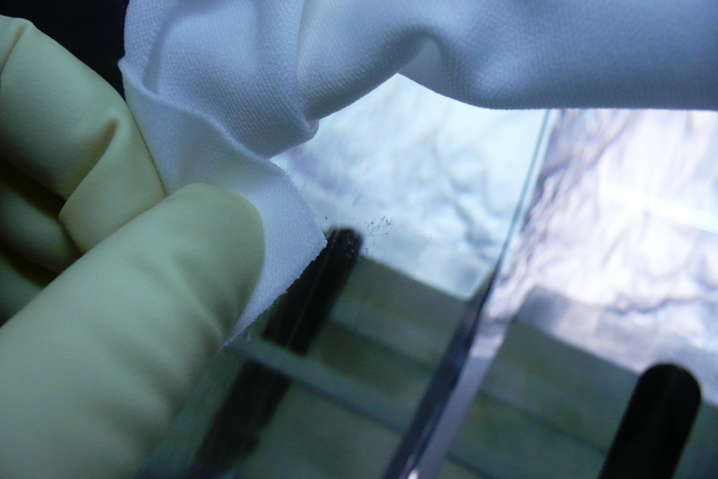
Figure 23 Marks on bottom half of test mass from earthquake stops

Test mass prism removal
- Once the test mass was moved into the bonding lab, the prism prepared for removing the prism (Figure 24).
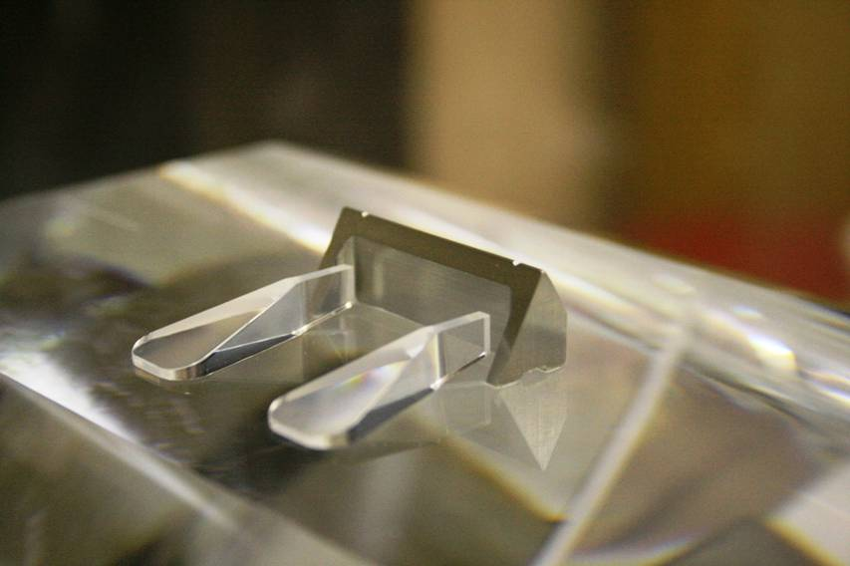
Figure 24 Prism and ears to be removed from test mass

- Kapton tape was used to create small walls to stop any liquid running down the barrel or onto either face. Clean room cloths were cut to size to soak the feet of the prism (Figure 25).
- A small bath was placed next to the ears and prism with a cloth wick keeping the area around the prism wet. Liquinox was used as the detergent.
- Unfortunately, this leaked so it was decided to remove the bath and monitor the prism carefully, adding more moisture by hand.
- After 2.5 hours, we turned the heat lamp on to encourage the glue to soften.
- After 4 hours, the prism was removed.
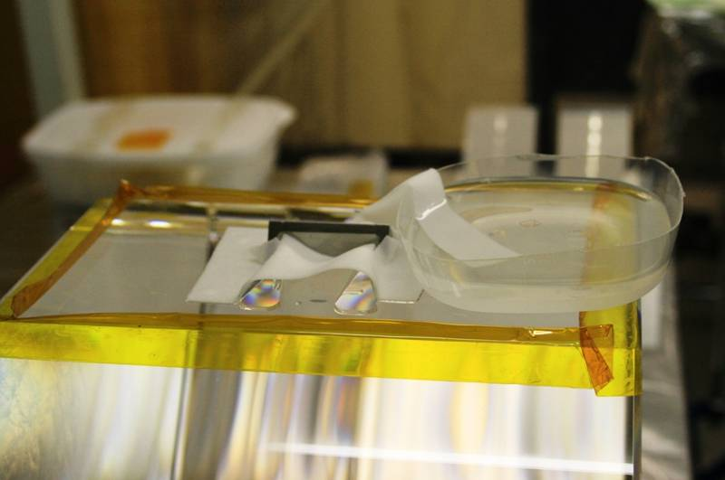
Figure 25 Degrading the prism glue with detergent and RO water

Ear removal
- The test mass was dressed in clean room cloths and then covered in aluminium foil house and taped off completely (Figure 26).
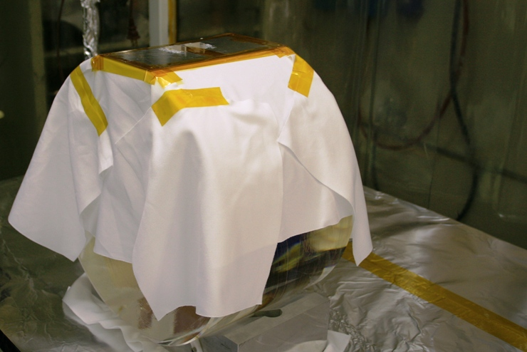 | 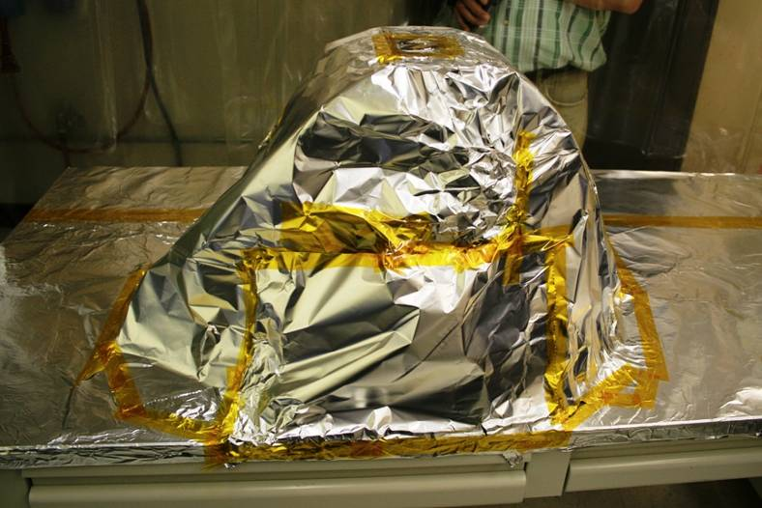
Figure 26 Protecting the test mass prior to removing old ears
- The metal template was also secured with kapton tape.
- The Dremel only worked at maximum power due to the lower voltage supply in the US. The diamond blade quickly blunted: a fresh blade was needed for each ear.
- The Nilfisk cleaner was used to collect and silica parts and dust.
- Once both ears were ground down (Figure 27), the foil ‘house’ was carefully lifted over the test mass and taken outside the clean room area.
- The flat and ear outlines were thoroughly cleaned with swaps and clean room cloths using methanol and compressed nitrogen.

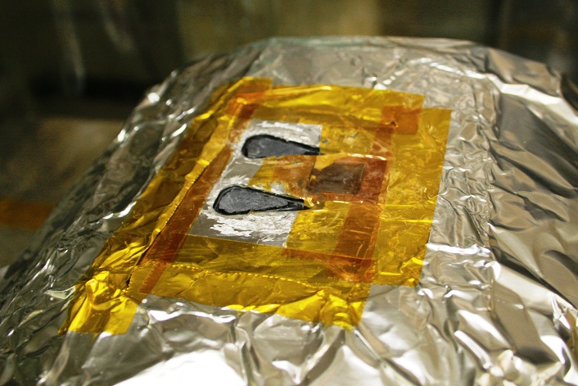
Figure 27 Ears mostly removed

Saturday 20th February

Removing prism side 2 TM
- We turned the mass 180° using the ergo arm. This time the pressure drop was only 1.6, so possibly there just might have been a small misalignment or speck yesterday when lifting the mass with first contact.
- We used Kapton tape to create small walls to stop any liquid running down the barrel or onto either face.
- A small bath was placed next to the ears and prism with a cloth wick keeping the area around the prism wet.
- We turned the heat lamp on from the start to encourage the glue to soften.
- After 2 ½ hours, the prism was removed (Nicola won the bet).
- At the same she managed the break off the horns of the ears.

Removing the ears from side 2 TM
- The test mass was dressed in clean room cloths and then covered in aluminium foil house and taped off completely.
- The metal template was also secured with kapton tape.
- The Nilfisk cleaner was used to collect and silica parts and dust.
- The first ear was ground down like all the others. The last ear was the ear with the poor bond. After a bit of grinding the whole ear came of on the bond. Except for some bond residue around the edges that ear has been removed completely (Figure 28).
- Once both ears were ground down/removed, the foil ‘house’ was carefully lifted over the test mass and taken outside the clean room area.
- The flat and ear outlines were thoroughly cleaned with swaps and clean room cloths using methanol and compressed nitrogen.
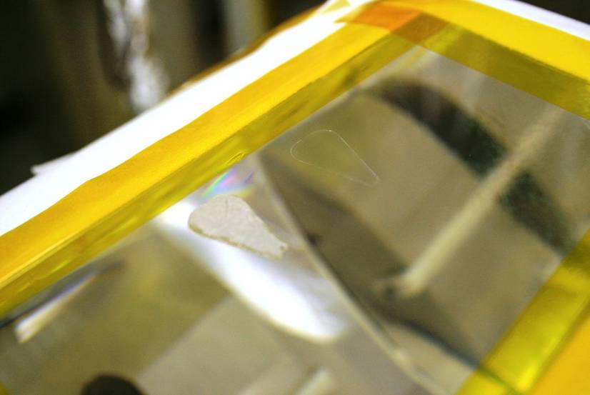
Figure 28 Ears removed from side 2 of the test mass, one ear was known to have a bad bond and came away completely during removal

Setting the bonding jig
- Jig number 1 used for ear 41 on side 1 (this is D040431-C-D_ Flat in zone “B8” of drawing) of the TM (see Figure 6).
- The width of the TM is w_{TM} = 199.95 mm (on average, it is a wedged mass)
- Measurements on the jig were done in Glasgow:
  - y_{pin1} = 58.19 mm
  - y_{pin2} = 58.19 mm
  - x_{j1} = 72.91 mm
  - x_{j2} = 133.04 mm
- Measurements on ear 41 were:
  - x_{h1} = 13.4 mm
  - x_{h2} = 43.4 mm
  - y_{h} = 27.6 mm
  - h_{horns} = 12.8 mm
- Using the following equations:
$$D_{\text{screw}1}=\left(x_{j1}+x_{h1}+\frac{x_{h2}−x_{h1}}{2}+1\text{.}5\right)−\frac{w_{\text{TM}}}{2}$$
$$D_{\text{slider}1}=y_{\text{pin}}−y_{h}−h_{\text{horns}}$$
this led to the following jig settings:
  - D_{screw} = 2.84 mm
  - D_{slider} = 17.79 mm
- We set D_{screw} using two slip gauges (1.7 mm and 1.14 mm to get 2.84 mm).
- We preset the digital callipers to set D_{slider}.

Preparing bonding solution
- We prepared a volumetric ratio of 1:6 of sodium silicate solution (Sigma-Aldrich) to DI water in a 15 ml tube.
- We poured the solution into 1.5 ml centrifuge tubes and centrifuged.
- We then transferred the solution to a 0.2 μm medical filter. (prepared at 15.00)

Cleaning the ear
- We cleaned the ear in the laminar flow cabinet
- Rubbed it carefully with cerium oxide on an optical wipe. And rinsed thoroughly with DI water.
- Rubbed it carefully with bicarbonate of soda and rinsed thoroughly.
- Rubbed it carefully again with bicarbonate of soda and rinsed thoroughly.
- Rinsed it carefully with methanol and blow dried with nitrogen.

Cleaning the mass
- We cleaned the bonding flat on the washing bath using the same procedure as used for the ear. We brought the water to the bonding flat through the hose that is connected to the water supply.
- Following this we lifted the mass up onto the table for bonding using the ergo-arm.

Bonding
- We carefully inspected the bonding flat of the mass with the osram working light and wiped with methanol.
- The surface was inspected again.
- The ear was wiped with methanol and carefully inspected with the light.
- 4 drops of 2.5 μl were quickly deposited in the middle of the bonding area on the mass.
- We then placed the ear with one more glance at the surface. The ear was bonded at 15.40.
- The bond looked good immediately with only 2 bubbles in the middle that proceeded to move towards the top edge. The bond quality control form can be found in Figure 36. A photograph of the fresh bond is shown in Figure 29.
- We inspected once every hour after that. The bond seemed to settle well. After 2 hours we removed the jig carefully.
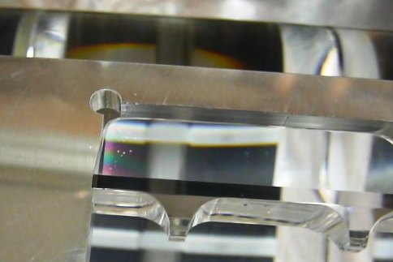
Figure 29 A few bubbles and fringes visible shortly after bonding between ear 41 and test mass

Sunday 21st February
- The test mass was rotated and placed onto the v-block ready for cleaning

Setting the bonding jig
- Jig number 1 used for ear 42 on side 2 ((this is D040431-C-D_ Flat in zone “B6” of drawing)) of the TM (see Figure 6).
- The width of the TM is w_{TM} = 199.95 mm (on average, it is a wedged mass)
- Measurements on the jig were done in Glasgow:
  - y_{pin1} = 58.19 mm
  - y_{pin2} = 58.19 mm
  - x_{j1} = 72.91 mm
  - x_{j2} = 133.04 mm
- Measurements on ear 41 were:
  - x_{h1} = 13.5 mm
  - x_{h2} = 43.5 mm
  - y_{h} = 27.5 mm
  - h_{horns} = 12.8 mm
- Using the following equations
$$D_{\text{screw}2}=\left(x_{j2}−x_{h1}−\frac{x_{h2}−x_{h1}}{2}−1\text{.}5\right)−\frac{w_{\text{TM}}}{2}$$
$$D_{\text{slider}2}=y_{\text{pin}}−y_{h}−h_{\text{horns}}$$
this led to the following jig settings:
  - D_{screw} = 3.07mm
  - D_{slider} = 17.89 mm
- We set D_{screw} using two slip gauges (1.07 mm and 2.0 mm to get 3.07 mm).
- We preset the digital callipers to set D_{slider}.

Preparing bonding solution
- We prepared a volumetric ratio of 1:6 of sodium silicate solution (Sigma-Aldrich) to DI water in a 15 ml tube.
- We poured the solution into 1.5 ml centrifuge tubes and centrifuged.
- We then transferred the solution to a 0.2 μm medical filter. (prepared at 09.20)

Cleaning the ear
- We cleaned the ear in the laminar flow cabinet
- Rubbed it carefully with cerium oxide on an optical wipe and rinsed thoroughly with DI water.
- Rubbed it carefully with bicarbonate of soda and rinsed thoroughly.
- Rubbed it carefully again with bicarbonate of soda and rinsed thoroughly.
- Rinsed it carefully with methanol and blow dried with nitrogen.

Cleaning the mass
- We cleaned the bonding flat on the washing bath using the same procedure as used for the ear. We brought the water to the bonding flat through the hose that is connected to the water supply.
- Following this we lifted the mass up onto the table for bonding using the ergo-arm.

Bonding
- We carefully inspected the bonding flat of the mass with the osram working light and wiped with methanol.
- The surface was inspected again.
- The ear was wiped with methanol and carefully inspected with the light.
- 4 drops of 2.5 μl were quickly deposited in the middle of the bonding area on the mass.
- We then placed the ear with one more glance at the surface. The ear was bonded at 10.00
- The bond looked good immediately with only a few larger bubbles in the middle that proceeded to move towards the top edge. The filled in bond inspection form is shown in Figure 37.
- By 10.30, the larger bubbles had disappeared completely, and the number of tiny bubbles was falling (see Figure 30).
- At 12.30 the tiny bubbles had mostly disappeared and the jig was removed.

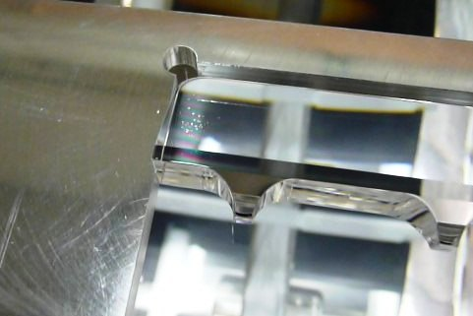
Figure 30 A few small bubbles and fringes visible shortly after bonding between ear 42 and test mass

Monday 22nd February
- Inspected the prism with the less transparent adhesive. We used a razor blade to check if the adhesive had cured. It had cured. The glue still looked hazy and there were still bubbles, though some of them might be the small scratches we observed in the PUM surface.
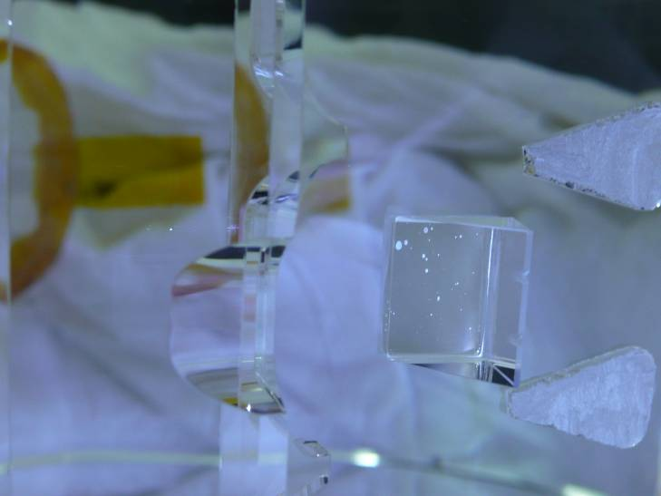
Figure 31 Prism on side two of the PUM with bubbles still visible
- Furthermore we noticed a slight haze in the bond (as seen in shearing incidence through the face of the mass) of the ear on that same side (Figure 32). This is believed to be a remnant fringe (probably the bond is thicker there). It was known that the penultimate mass flats were not quite as flat and on that side of the mass a ridge in the flatness was observed in the June 2009 (Figure 33), which corresponds to the location of the fringe in the ear bond.

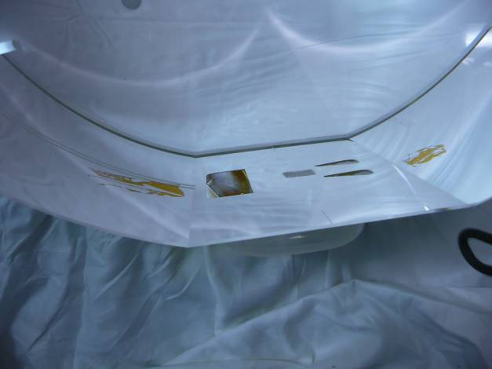  Figure 32 Slight haze in the bond on side 2 of the PUM | 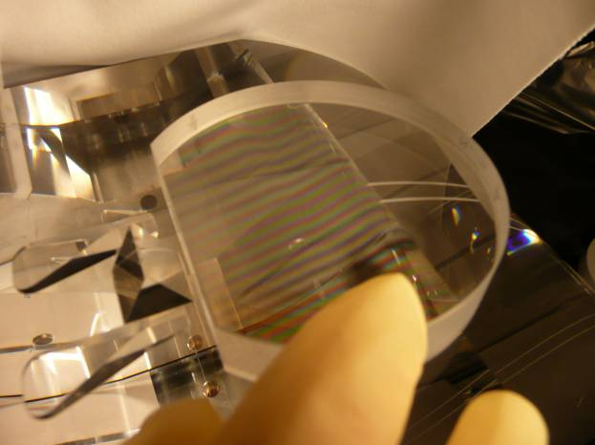  Figure 33 Ridge in the fringes on side 2 of the PUM as seen on 24/06/2010 with a bi-coloured light source
- We checked the bond on the test mass. It was unchanged.

Glueing slides to other 2 prisms
- For the case the decision is made that we want to remove the cloudy glue prism from the PUM, we prepared the two remaining prisms.
- We cleaned both prisms and two slides by cleaning with acetone and then with methanol.
- We cut two pieces of copper wire and cleaned with acetone and methanol.
- We prepared the Vacseal.
- We deposited the Vacseal after careful inspection of the prism and slide surfaces using the copper wire and applied the slide to the prism.
- We used the heat lamp to make the adhesive run to the edges properly.
- We observed after glueing that the witness adhesive looked less cloudy already than the adhesive we used on side two of the PUM.

Tuesday 23rd February
- We checked if the adhesive of the prisms we glued on Monday had cured. It had.
- We carefully packed the prisms away.
- We received the test mass container and cake tin from Florida
- We took the cake tin out of the container
- We wiped the outside with isopropanol
- We opened it and cleaned the inside with isopropanol as well.
- We put the crash matt on the ergo arm
- We lifted the mass on its HR side (with the first contact still on)
- We then placed the cake tin on the crash mat and lowered the mass into the cake tin using the controls on the ergo arm.
- Finally we closed the cake tin and lifted it out through the clean room into the orange container.

Conclusions
- Ears were bonded successfully to the 2nd PUM using hydroxide catalysis bonding. Only a few small bubbles have been observed. And a fringe due to known non-flatness on side 2 of the PUM has been observed which is not expected to affect performance negatively. Alignment of the ears looks good on basic (to the eye) assessment.
- Prisms were glued to the PUM as well. On side 2 of the PUM the adhesive cured more slowly than normal and is cloudy with a few bubbles and/or scratches.
- The metal wire stand-off prisms were removed successfully from the ETM using a combination of a heat lamp and detergent.
- The ears were removed successfully from the ETM as well. The fourth ear popped off the mass over the bond. It was known that the bond on this ear had only been successful over about 2/3 of the surface area and it was expected to come off partially. Research is ongoing to quantify the possible loss associated with this.
- Ears were also bonded successfully to the ETM. Like the PUM, only a few small bubbles have been observed. Also the alignment looks good to the eye.
- The actual locations of the ears with respect to the COM in vertical and the front face of the masses (HR coating side of TM) are expected to be as summarized in Table 7.2. The positions of the ears have been set to aim for d₃ = d₄ = 7.2 mm and they have been centred on the masses as mass as possible in horizontal direction.
Table 7.2 Measurable ear position numbers on the PUM and TM
 | Ear no. | Tip horn to COM (h_{horn}) [mm] | Left corner on left horn tip of ear to front face mass [mm] | Centre ear to front face mass [mm]
PUM Side 1 (D050421-05-D_Surface “S2” just outside zone “D8”) | 46 | 14.0 | 83.61 | 100.21
PUM Side 2 (D050421-05-D_Surface “S1” just outside zone “D8”) | 51 | 14.0 | 116.91 | 100.21
TM Side 1 (D040431-C-D_ Flat in zone “B8” of drawing) | 41 | 12.8 | 83.47 | 99.97
TM Side 2 (D040431-C-D_ Flat in zone “B6” of drawing) | 42 | 12.8 | 116.47 | 99.97

- The actual prism positions on the PUM with respect to the COM in vertical and the front face are expected to be as summarized in Table 7.2. The positions of the prism have been set to aim for d₂ = 0.3 mm and they have been centred on the masses as mass as possible in horizontal direction.
Table 7.3 Measurable ear position numbers on the PUM and TM
 | Apex prism to COM [mm] | Left side of prism tip of ear to front face mass [mm] | Centre ear to front face mass [mm]
PUM Side 1 (D050421-05-D_Surface “S2” just outside zone “D8”) | 2.6 | 92.67 | 100.21
PUM Side 2 (D050421-05-D_Surface “S1” just outside zone “D8”) | 2.6 | 107.75 | 100.21

- A few observations were made on the test mass coming out of the structure. The test mass was very dusty around the barrel. Furthermore scratches were observed at the locations of the silica tipped earth-quake stops on the barrel. These scratches have both a white and a black appearance. During installation Flourel covers will be used in future to limit this.
- The refurbished ergo-arm was tried out with great success. The added brakes and ratched are a true improvement. Also the vacuum tank on the ergo-arm with radio-transmitted pressure gauge has improved the ease of use. We observed a few small glitches with the battery of the pressure gauge (we have had to replace it). Furthermore a square crash mat which is the width and of the ergo-arm base would be useful instead of a rectangular mat.

Filled in inspection sheets bonds
Figure 34 Filled in inspection sheet bond side 1 of the PUM made on 17/02/2010 at 13.15
Figure 35 Filled in inspection sheet bond side 2 of the PUM made on 18/02/2010 at 10.50
Figure 36 Filled in inspection sheet bond side 1 of the TM made on 20/02/2010 at 15.40
Figure 37 Filled in inspection sheet bond side 2 of the TM made on 21/02/2010 at 10.00

