AUTHOR: Phelps, M. | DATE:04/04/10 | Document Change Notice, Release or Approval
 |  | see LIGO DCC record Status

Objective
This document explains the procedure that was developed for applying and removing First Contact(FC) to vertical Advanced LIGO optics in situ. This procedure works equally well for applying First Contact to horizontal optics.

Applicable Documents
T060161 Armandula, H. FTIR and scatter measurements indicate FC leaves no residue on clean optics.
T070280 Technical information from Photonic Cleaning Technologies.
T0900351 Dannenburg, R. FC Peeling and Charging Tests
T1000137 Phelps, M. Drag Wiping and First Contact

Materials

List of required materials, manufacturer and part number:

1. First Contact, Photonic Cleaning Technologies Part# FCL for 1 Liter
2. First Contact thinner, Photonic Cleaning Technologies Part#TFCL for 1 Liter
3. Clean room gloves, VWR Part #79999-xxx
4. Fine PEEK mesh, McMaster Carr Part# 9289T11
5. Nylon brushes, Purdy 100% Nylon Brushes from Home Depot
6. Flashlight, Stinger from Copquest Part#10-1552-000 OR barlight from Fiber Optic Systems, Part# FSI-060-250
7. Kapton tape, McMaster Carr part#7639A75
8. Ion gun, Terra Univeral Part#2005-55

Application
1. Put on gloves (LIGO approved kind for cleanroom use, see Materials item #3)
2. Pour some First Contact(Materials item #1) into a clean glass petri dish.(Fig.1)
3. Pour thinner (Materials item #2) or acetone into a small beaker.(Fig.1)
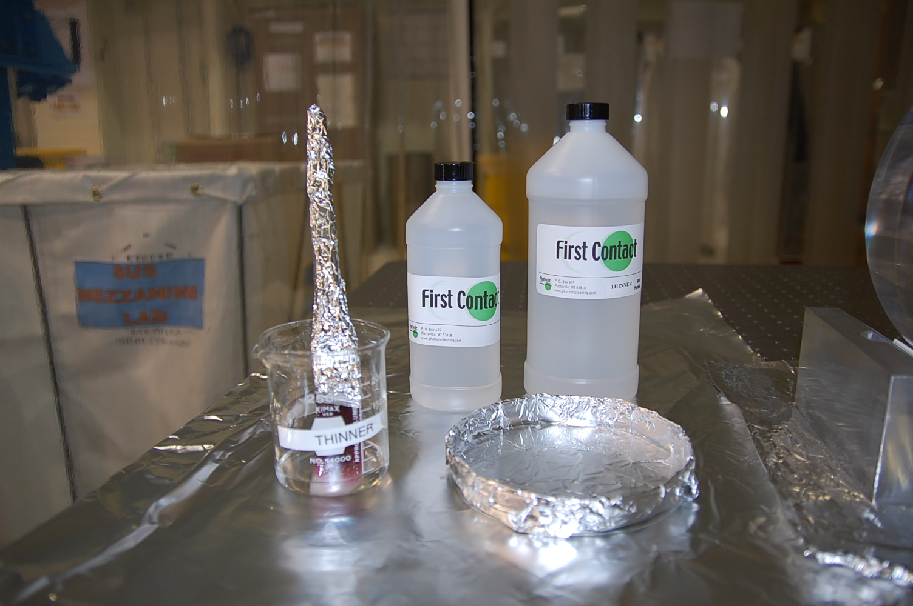
Figure 1: To keep from having sticky petri dishes, wrap them in foil, pour in the FCand then discard the foil when finished.
4. Situate your flashlight (see Materials item #6 for the flashlight) so that you can see the FC you are applying. Resituate flashlight throughout procedure if you cannot see what you are doing. This is to avoid getting FC too close to the barrel of the optic, and to avoid drips. You can also use a fiberoptic barlight from FiberOptic Systems Inc. This light illuminates the surface much better but is quite large and unwieldy, it needs either an extra person to hold it or a Bunsen burner stand to keep it in place.
5. Immerse brush into First Contact. Wipe off excess against side of petri dish. J. Hamilton at Photonics Cleaning recommends Purdy 100% nylon brushes from Home Depot. Only nylon, PEEK or natural hair brushes can be used.
NOTE: If the optic is vertical it is important that the brush does not drip FC onto the barrel, or let it run down to the bottom edge. If there is not too much on the brush, this should not be a problem.

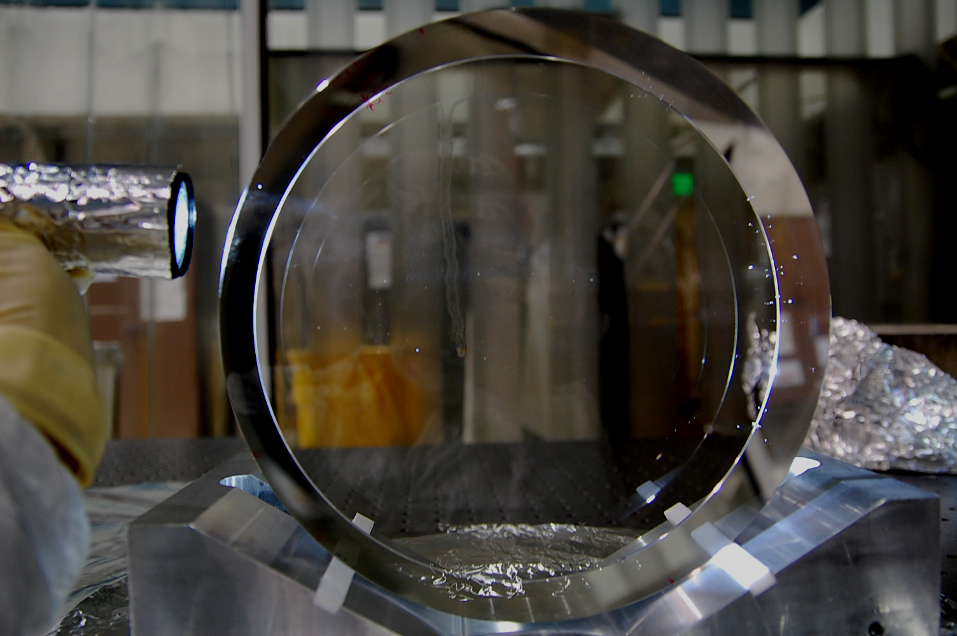
Figure 2: Avoid drips like this one. If it reaches the edge it will be hard to remove. Here the flashlight is used to illuminate but a barlight can be used as well.

6. Begin brushing the FC onto the top of the optic. Brush slowly and lightly, avoiding as much bristle to optic contact as possible. Brush FC on in a circle that starts at least 5mm from the optic’s edge, taking special care that the FC does not drip or run off the optic face near the bottom. A circle helps keep dripping to a minimum.
7. After you complete the initial circle of FC, go back in and fill in the rest using slow, uniform sweeps across the face, as if you were drag wiping.
8. Now that one layer is done set your brush in acetone/thinner and wait 20 minutes. First Contact includes acetone, so it is ok to use acetone as a thinner to keep your brush from stiffening. However the thinner sold by Photonic Cleaning works better. Do NOT use methanol as thinner.
9. Repeat twice for a total of 3 layers.
10. Leave to dry for as long as possible before removing, at least 12 hours.

Removal
- Cut a strip of PEEK mesh about 1’’x 5’’. The PEEK mesh is shown here:
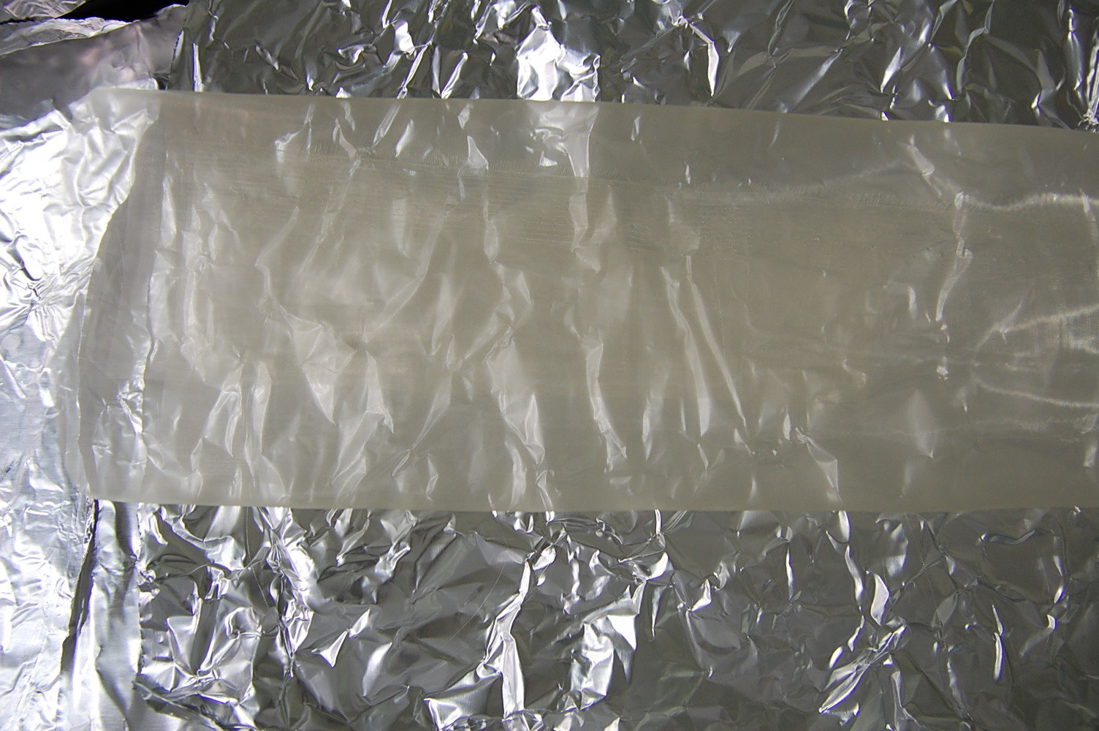
Figure 3: Roll of PEEK mesh on aluminum foil
- Hold mesh against the top of the optic. Leave about half the strip sticking up off the top of the optic (Fig.4).
- With one hand hold the PEEK mesh strip, and with your other hand dip your brush into FC and spread a thin layer over the part of the mesh that is on the optic. Be careful to only brush FC onto the layer that is already there. Try not to spread FC all the way to the barrel! It may form a very thin layer, which will be hard to get off. Small strips that get left on near the edge by accident can be wiped off with acetone. Do not use methanol.
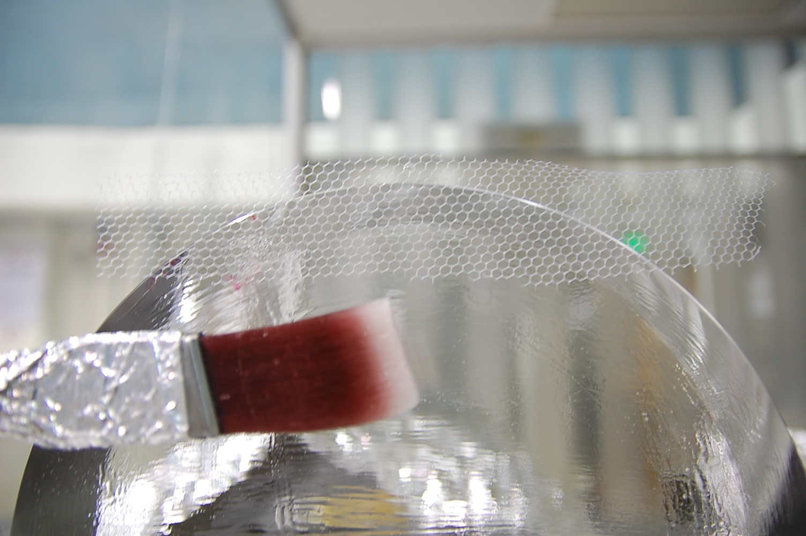
Figure 4: Leave mesh sticking up enough to grab it for removal. Note: The mesh in this picture is nylon mesh, not PEEK.
- Let the mesh dry for at least an hour. If the FC film is really stretchy and breaks when you try to remove it, wait longer until it does not stretch when pulled.
- Holding the ion gun in position, begin to peel the PEEK mesh off from the surface. If the dried FC does not come off in one piece STOP, reapply a thicker layer if it has broken apart. As soon as the dry FC film starts coming off, start blowing nitrogen from the ion gun (Materials item #8) onto the optic. Hold the gun parallel to the optic face, focusing most on the area where the film is detaching itself from the optic. Use the flashlight and pay close attention to the edges when peeling it off to make sure nothing is left behind on the optic.
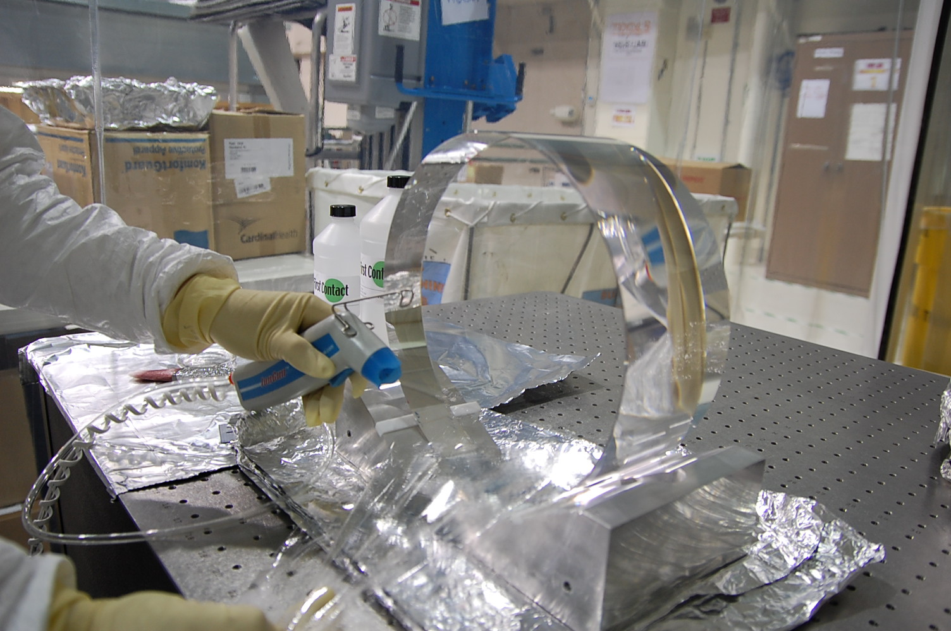
Figure 5: Keep a steady stream of nitrogen while peeling.
- Once the film is off completely continue blowing off the optic for about 30 seconds to ensure the surface charge is zero. Try to keep the gun at the same angle and avoid waving your arm around, as you want to avoid disturbing the surrounding particles in the air. You can also point the ion gun towards your gloves before removal, they are plastic and tend to charge up very quickly.
- Shine the flashlight around the outer surface of the optic face to check for any stray dried First Contact. Remove any last bits by wiping a clean lens wipe around the edge in a circular fashion. The middle of the optic will be the cleanest part so wiping from edge to middle to edge will probably drag any contaminants you have into the center.
- Done!

Alternative Removal(not allowed in vacuum chamber)

- Stick a piece of kapton tape (Materials item #7) against the dried first contact.
- Wait a few seconds, and then pull sharply towards you, the film should come with the tape.
- Do not use this to remove FC in a vacuum chamber where tape is not allowed.

Additional Information
DO NOT use methanol to drag wipe an optic that has been cleaned with first contact. See First Contact wiki or LIGO #T1000137 for reasons why.
Each layer of FC will take about 20 minutes to “set”, ie to be dry enough to allow for the next layer to be applied. For three layers it is good to leave them overnight to ensure it is completely dry.
Dry time is longer at cooler temperatures.
If the layer sticks or stretches enough to break while removing it is not dry.
The dried film must leave the optic in one single INTACT piece.
If the dried film is too thin it will break while peeling. If this happens, stop peeling and brush another layer over the dry layer to make a thicker coating and allow re-drying before peeling off again.
When brushing on polymer with a brush do not allow bristles to scour the optic surface.

