LIGO Laboratory / LIGO Scientific Collaboration

LIGO-E1000006-v14 ADVANCED LIGO 12 May 2011

Advanced LIGO Quad Suspension Metal-Build Assembly Procedure

Mark Barton, Betsy Bland, Jodi Fauver, Joe O’Dell, Brett Shapiro, Ian Wilmut, and Robert Lane.

Distribution of this document:
DCC

This is an internal working note
of the LIGO Project.

California Institute of Technology  LIGO Project – MS 18-34  1200 E. California Blvd.  Pasadena, CA 91125  Phone (626) 395-2129  Fax (626) 304-9834  E-mail: info@ligo.caltech.edu | Massachusetts Institute of Technology  LIGO Project – NW22-295  185 Albany St  Cambridge, MA 02139  Phone (617) 253-4824  Fax (617) 253-7014  E-mail: info@ligo.mit.edu
LIGO Hanford Observatory  P.O. Box 1970  Mail Stop S9-02  Richland WA 99352  Phone 509-372-8106  Fax 509-372-8137 | LIGO Livingston Observatory  P.O. Box 940  Livingston, LA 70754  Phone 225-686-3100  Fax 225-686-7189
http://www.ligo.caltech.edu/

Table of Contents
1 Introduction 4
1.1 Purpose and Scope 4
1.2 References 4
1.3 Version history 6
2 Preparation 7
2.1 Receiving/inventory 7
2.1.1 Receiving/inventory of metal parts 7
2.2 Cleaning/Baking 7
2.3 HeliCoils 8
3 Subassemblies 8
3.1 Dummy test mass (D060355) 8
3.2 Dummy main chain penultimate mass (D0902075) 9
3.3 Dummy CP or ERM (D060356) 10
3.4 Penultimate Reaction Mass for CP or ERM (D060341) 10
3.5 Ring heater 10
3.6 Wire assemblies 10
3.7 Top wires (D0902643) 11
3.8 Middle wires (D0902644) 11
3.9 Bottom/Final wires (D0902645) 11
3.10 General clamp-wire-clamp assembly procedure 11
3.11 Magnets 13
3.12 Flags 13
3.13 Earthquake Stops 13
3.14 OSEMs 14
3.15 Top Stage Blade Cartridges 14
3.16 Top mass 15
3.17 UI Mass 16
3.18 Lower structure 17
3.19 Sleeve 18
4 Main assembly 18
4.1 Top stage and Upper Structure 18
4.2 Tablecloth and top mass 18
4.3 Lower structure 19
4.3.1 LSAT 19
4.3.2 Reaction chain 19
4.3.3 Main chain 20
4.4 Mate Lower Structure 20
5 Pitch Adjustment and Suspension Tuning 21
5.1 Hints Before You Begin 21
5.2 Preparation 21
5.3 Suspend and Balance the Masses 26
5.4 Align the Chains 30
5.5 OSEMs and Eddy Current Dampers (ECDs) 35
6 Quad Structure Prep Prior to Glass Install 36
7 Glass Preparation 36
7.1 CP electrical connections 36
7.2 Using the triple-hang tooling 37
7.3 Lower structure wrap-up 39
7.4 3-in-1 assembly 39
7.5 Suspending 40
7.6 Final assembly 41
8 Storage 41
9 Tools 41
10 Useful procedures 42
10.1 Aligning the Brunson transit 42
10.2 Using the ergo-arm 43
10.3 Applying/removing First Contact 44
10.3.1 Applying 44
10.3.2 Removing 44
10.3.3 Drag-wiping 45
11 Appendix A: Useful Balancing and Alignment Data 46
12 Appendix B: Sample Transfer Functions 46
13 Appendix C: Related Documents 51

Introduction

Purpose and Scope
This document describes the assembly procedure for the production version of the quad suspension, from receiving of parts through to a balanced and aligned all-metal build in storage.
Mark Barton and Betsy Bland wrote most of the final version, flagrantly recycling from documents by Joe O’Dell, Brett Shapiro, and Ian Wilmut.

References
D1001090: Sleeve to Lower Structure Wedges – Description and Instructions
E070292: Optics Cleaning Specification - First Contact™
E0900168: Advanced LIGO OSEM Assembly Specification
E1000494: aLIGO SUS Quad Suspension Metal Build Testing Procedure
E960022: LIGO Vacuum Compatibility, Cleaning Methods and Qualification Procedures
G070359: LASTI Tooling (instructional DVD)
T040108: Blade, wire and clamp process specification
T050113: Advanced LIGO SEI/SUS Test Stand
T060040: Noise prototype Assembly procedure.
T080108: Notes on Lower Quad Installation at LASTI.
T080165: Metal Quad Noise Prototype Balancing and Alignment Procedure.
T1000337: Quadruple Suspension Monolithic Stage Final Design
T1000407: Quad Suspension balancing and alignment procedure
T1000407: Quad Suspension, balancing, and alignment procedure
T1100120: Technical Note on inspecting / accepting (existing) music wire

Top level assembly:
D0901346: Advanced LIGO Quadruple Suspension
E0900316: ALIGO QUAD DRAWING TREE
E0900167: Bill of Materials for the ETM / ITM Quad Suspension Assembly (Production)
T0900590: Quad production status

Subassembly drawings:
D060310: QUAD N-PTYPE TABLECLOTH, Tablecloth (Noise Prototype)
D060324: Quad N-Ptype Top Stage, BLADE CARTRIDGE
D060341: QUAD N-PTYPE, PENULTIMATE REACTION MASS, ETM CONFIGURATION
D060355: Quad N-Ptype, Dummy Test Mass Assembly Tooling
D0902075: Quad N-Ptype, DUMMY PENULTIMATE MASS
D060356: Quad N-Ptype, Dummy Test Reaction Mass Assembly Tooling
D060375: Quad N-Ptype, UI MASS
D0902233: QUAD UI MASS REACTION CHAIN
D060403: Quad N-Ptype Top Mass, TOP MASS - MAIN CHAIN
D0902031: Quad N-Ptype Top Mass - REACTION CHAIN
D060454: QUAD Lower Inner Structure Suspension
D060492: Quad ETM/ITM, Upper Structure Weldment
D070056: Quad N-PType, Quad Dog Clamp
D070214: Quad N-PType Wiring Harness, Top Ring Wire Clamp
D070217: Quad N-PType Wiring Harness, Upper Structure Stay Wire Clamp
D070538: Quad ITM/ETM, Implementation Ring Test Chain
D070539: Quad ITM/ETM, Implementation Ring Reaction Chain
D070552: ITM/ETM Structure, ITM/ETM Sleeve
D080241: Earthquake Stop Assembly
D090433: THIS, TRANSPORT PADS, QUAD SUS
D090434: THIS, FRONT TRANSPORT PAD, QUAD SUS
D0901342: SLEEVE - LS - WEDGE 1
D0901343: SLEEVE - LS - WEDGE 2

8851A23: McMaster-Carr Chucking Reamer
D060236: QUAD Top Mass Middle Blade Spring
D060237: QUAD UI Mass Bottom Blade Spring
D060321: QUAD Position Adjuster for Front Pitch OSEM
D060326: QUAD Top Stage Blade Clamp Top Half
D060327: QUAD Top Stage Blade Clamp Bottom Half
D060329: QUAD Top Stage Stiff Back (Back Bone)
D060334: QUAD Wire Clamp Jaw
D060370: QUAD Top Stage Blade Tooling
D060399: QUAD Top Mass Stop Bridge
D060421: QUAD Mass and Support Member
D060430: QUAD Top Mass Base Plate
D060516: Wire jig assembly drawing (with usage diagrams)
D070235: QUAD Magnet Holder
D070238: QUAD Steel Disk
D070548: UI Mass Stop, Both Chains
D080580: Penultimate Mass Magnet & Flag Holder Assembly
D0901439: QUAD Top Stage Modified Back Bone
D0902643: Top Wire Clamp Wire Assembly
D0902644: Bottom/Final Clamp Wire Clamp Assembly
D1001222: QUAD Lower Structure Assembly Tooling, Top Plate Large
D1001223: QUAD Lower Structure Assembly Tooling, Top Plate Small
D1001517: TCS Ring Heater In-Vac Cable Assembly
D1001838: aLIGO TCS Ring Heater Assembly, Upper Segment
D1001895: aLIGO TCS Ring Heater Assembly, Lower Segment
E0900047: aLIGO Contamination Control Plan
F0900052: Inventory Control System Part Import Template
F1000008: QUAD Suspension Assembly Process Traveler Template
M0900034: Magnets in Advanced LIGO Suspensions
M1000312: RODA for use of SS316 in AOSEMs and BOSEMs
T080230: Quad Pendulum Structure Pushers
T1000068: QUAD Blade and Clamp Pairing and Characterization Data
T1000279: Inventory Control Manual
T1000377: Silica Insertion Tool and Instruction Manual
T1000674: Wire Safety Procedure for Suspensions
HeliCoil Inspection/Insertion Wiki Page (https://awiki.ligo-wa.caltech.edu/aLIGO/HeliCoils)
Holo-Krome Bolt Torque Data Sheet (http://www.holo-krome.com/pdf/techbk34-40.pdf)

Version history
1/14/10: First pre-v1 draft, adapting T060040-v1
1/18/10: Second pre-v1 draft adding stuff from Brett’s T080165-00.
2/24/10: Third-pre-v1 draft with input from Betsy on ICS, receiving, cleaning/baking, making of clamp-wire-clamp assemblies, etc.
2/26/10: v1. Tidying up by Mark B. Still very much a work in progress but released for comment.
01/03/2011: v9. By R. Lane: Further completion of TBD/TBR, glass assembly outline created, document number reference list updated, further TBD/TBR/possible corrections are noted in red highlighter.
01/21/2011: v10 By R. Lane: Added 5.4, included paragraphs on compensating for mass of glass mirror in metal build with additional add on masses.
03/16/2011: v11 By R. Lane: Incorporated T080165 “Brett’s Document” Metal Quad Noise Prototype Balancing and Alignment Procedure. Cleared all TBDs left in document.
03/29/2011: v12 By R. Lane: Modified Cam on Left and Right OSEM brackets.
04/20/2011: v13 By R. Lane: Updated Blade Tip Heights and LS Installation. Updated section 5.5, OSEM installation and testing.
05/12/2011: v14 By R. Lane: Updated assembly installation instructions and BOSEM clarification.

Preparation
Advanced LIGO has implemented a new Inventory Control System (ICS) which is designed to record all aLIGO hardware as it moves through receiving, inspection, clean, bake, storage, shipment, and assembly processes. The ICS is meant to replace the shipping type paper traveler used in iLIGO. While the ICS is still in final development as of this writing, the hope is that the engineering teams will be able to utilize ICS to record many aspects of the lifetime of a part from its initial receipt through the clean and bake processes previously documented in the iLIGO traveler. The sites have dedicated staff to help with managing the data related to the processing of parts in ICS. Engineering staff should become familiar with the ICS such that they can utilize it for their own record keeping and data management. If the ICS fails to facilitate data that you need to record, process travelers (PT) can be placed on the DCC. In either case, make sure to record all serial numbers and data in the ICS or the DCC during the following steps.

Receiving/inventory

Receiving/inventory of metal parts
Upon receipt of shipments of SUS parts, the following steps should be performed:
Basic inspection by the receiver prior to unpacking the shipment (crate damage, etc). Packing slips should be sent (hardcopy or emailed) to Jennie Murdock at LHO. Person performing this step should notify site subassembly lead of the shipment arrival.
Inventory Control and inspection performed by ICS person and site subsystem lead as parts are unpacked. Drawing numbers, serial numbers, and quantities will be imported into the ICS database via spreadsheet templates (F0900052). This is a good time for QA/QC and engineering inspections. The following processes can now be recorded in ICS by grouping the parts into Loads.
Parts get separated into cleaning loads based on their level of cleanliness, and moved to the appropriate cleaning station.
Parts get separated into clean and bake loads based on their material – see E960022. Sorting should be reflected in the Load records in ICS, where instructions to technicians can be added for any special handling or material considerations.
Parts will be processed as per E960022.
Parts will be stored in clean storage areas until assembly.

Cleaning/Baking
Process all parts except for the Dummy Masses as Class A per E960022. Dummy Mass D0603XX is to be processed as Class B, as it will later be swapped out with Class A glass mass. All Parts should be processed as Class A or B prior to Helicoil installation.

HeliCoils
Install all the HeliCoils in all the parts and make sure they are free running and not cross threaded, remove the tangs. Perform HeliCoil inspections as per the instructions listed on the Advanced LIGO HeliCoil Wiki page for installation and inspection.

Subassemblies
Assign each subassembly with a unique serial number based on the parent number which can be used for referencing data taken on that subassembly. For example, if 3 Top Mass Assemblies are assembled from drawing number D060421, the units should be assigned serial numbers like:
D060421-001
D060421-002
D060421-003, and so on.
As individual parts are added to the subassembly, record their serial numbers as part of that subassembly. The overall subassembly number (i.e. D060421-001) can now be used in the ICS to track further operations performed on that subassembly. These subassemblies will eventually become associated with their parent QUAD which will have its own serial number, such as D0901346-001 (aka QUAD 001). Label the bag with the newly designated subassembly and serial number after wrapping and bagging.
When weighing subassemblies, use the high precision scale dedicated for the SUS assemblies.

Dummy test mass (D060355)
Steps for assembly are as follows:
- Prior to assembly, the half masses (D060358) can be processed as CLASS B, as it will be swapped with a glass mass.
- Assemble each mass with the addable masses such that each has the appropriate weight, as per the drawing. Install a beamsplitter optic such as BS1-633-50-2025-45UNP from CVI on the front surface.
The weight of the beamsplitter optic on the front face should be taken into account and offset on the reverse face with addable masses. Note: You will not be able to add the mass centered on the rear face of the mass. Therefore the addable masses will have to be added symmetrically around the mass. Ensure that the symmetric placement of the masses on the rear side of the Test Mass forms a vector with the alignment mirror on the front side that goes through the center of the mass.
Masses should weigh as per specified to +/- 5 grams. Weight can be over or under, but should be as close as possible. Use washers with the fasteners if needed, to minimize the weight error. If the Dummy Test Mass is underweight a bit, make the Penultimate Dummy Mass over weight by the same amount.
Symmetry of addable mass: Add masses to each face of the dummy mass such that the center-of-gravity is maintained, i.e. When you add a 100g mass to the 3 o’clock position of the front face, add a 100g mass to the 3 o’clock position of the back face. The vector between the 2 added masses goes through the center of the dummy mass.
If possible, leave the 1:30, 4:30, 7:30, and 10:30 o’clock holes available, as these will be needed when attaching the adaptor plate for the ergo arm.
- Record the weight of the assembly, along with the serial numbers of the half masses in the ICS/PT.
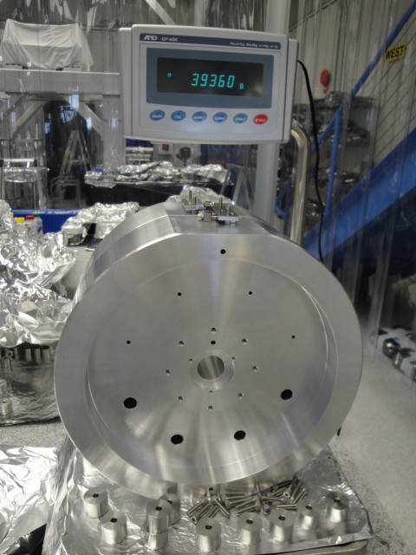
Figure 1 Main Chain Dummy Test Mass (D060355)

Dummy main chain penultimate mass (D0902075)
- Prior to assembly, this mass (D060358) can be processed as CLASS B, as it will be swapped with a glass mass.
- Assemble all masses as per their assembly drawings. Assemble each mass with the addable masses such that each has the appropriate weight. Install a flat, parallel mirror such as PS-PM-2037-C from CVI on the front surface.
Note: See D0902075 for the drawing. See E0900316 QUAD Drawing Tree Dummy Pen Mass for BOM.
The weight of the alignment mirror on the front face should be taken into account and offset on the reverse face with addable masses. Note: You will not be able to add the mass centered on the rear face of the mass. Therefore the addable masses will have to be added symmetrically around the mass. Ensure that the symmetric placement of the masses on the rear side of the Penultimate Mass forms a vector with the alignment mirror on the front side that goes through the center of the mass.

Dummy CP or ERM (D060356)
ERM stands for End Reaction Mass (chosen to avoid confusion with Recycling Mirror), which is also known as Re Test Mass. Note that due to abandonment of a plan to have an ERM of heavy glass, the production dummy ERMs are identical to the dummy CPs and lighter (approximately 22 kg) than the dummy ERM used in the all-metal build of the LASTI prototype (approximately 40 kg).
Prior to assembly, this mass (D060357) can be processed as CLASS B, as it will be swapped with a glass mass. Assemble all masses as per their assembly drawings. Assemble each mass with the addable masses such that each has the appropriate weight. Install a flat, parallel mirror such as PS-PM-2037-C from CVI on the front surface.
The weight of the alignment mirror on the front face should be taken into account and offset on the reverse face with addable masses. Note: You will not be able to add the mass centered on the rear face of the mass. Therefore the addable masses will have to be added symmetrically around the mass. Ensure that the symmetric placement of the masses on the rear side of the End Reaction Mass forms a vector with the alignment mirror on the front side that goes through the center of the mass.

Penultimate Reaction Mass for CP or ERM (D060341)
This mass is also known as Pen Re. Just as all CPs and ERMs are now identical (see note in previous section), so are all the penultimate reaction masses. This mass needs to be cleaned to CLASS A because it is not a dummy and will be installed in vacuum.
See D060341 Picture Book assembly guide and instructions.
Note: Isopropanol should be used to help insert the Cans into the mass.

Ring heater
ITM configuration only.
The Ring Heater Assembly is a combination of: D1001838 aLIGO TCS Ring Heater Assembly, Upper Segment, D1001895 aLIGO TCS Ring Heater Assembly, Lower Segment, and D1001517 TCS Ring Heater In-Vac Cable Assembly.

Wire assemblies
Follow the safety instructions below in Section 4.10 and detailed in T1000674
Perform a pre-inspection on the wire used for each assembly as per T1100120. Perform the pre-inspection every time an assembly is made.
Follow the procedure in Section 3.10 for each assembly, taking account of the general notes immediately below, and the per-assembly-type notes in Sections 3.7 through 3.9.
Pay attention to the exploded views in the D060516 wire assembly drawings – these show when to use what grooves in the jaws.
Take care to not over stress or bend the wires when releasing the wire sets from the jig. Also take care when storing. Wire sets should be stored in dry storage along with the spools of wire.
When setting up the wire in the jig, note that it should never bend around any fixture pieces except for at the clamp and the tuners. If the wire bends around any of the fixture, then recheck the fixture setup.

Top wires (D0902643)
There are 2 grooves in the D060334 jaws, but only one groove will be used for the Top Wire assembly. Use ~1” segments of wire inserted into the empty wire groove in each clamp.
Use the groove that is more centrally located in the wire clamp assembly to mount the wire. Use the outer groove for the “dummy” wire.

Middle wires (D0902644)
Note in the drawings which grooves to use in the clamps of this assembly. Some are used, some are not.

Bottom/Final wires (D0902645)
This is a compound assembly which includes the UIM-PM wires and the loop supporting the TM/CP/ERM.

General clamp-wire-clamp assembly procedure
- Class B the wire jig assembly. Helicoil the assembly.
- Using the Wire Jig assembly drawings as a guide, set up the jig fixture for the wire segment you will be assembling. There are 4 segments of wire assemblies to assemble for every QUAD. The jig can be reconfigured for each of these segment lengths. Note: Use gauge blocks of the thickness listed on the assembly drawings to set the jig fixture pieces the appropriate distance apart, and square relative to each other.
- The wire used for all suspensions is a hard temper carbon steel. It is wound around spools, and when unwound for cleaning, cutting and preparation for clamp-wire-clamp assembly, care must be taken such that the wire’s strong potential energy (making it act like a coiled spring) does not cause injury to personnel.
- Step 4
  - Glove liners should be worn under latex clean-room gloves, as a protective layer and an extra barrier. For information on glove liners, see the Contamination Control Plan, E0900047, page 13.
  - Take the end of the wire and bend a small section, say 3” or so, for easier holding. The bent wire section can be hooked around your thumb, and held by your index finger.
  - Un-spool the proper length of wire, including extra for handling, and control the area of the wire that needs to be cut. Add a bend at the other end, if handling it that way is easier for you.
  - Inspect length of wire for rust. If rust is found, discard wire and obtain a new length of wire.
  - Clean the end with the first bend. Change your gloves and grab the cleaned, bent end around your thumb.
  - Prepare the cleaning wipes with methanol. Wipe wire clean with methanol changing wipes until the wire is completely clean. Clean the wire while it is coiled; do not stretch the wire until it is taut for cleaning. It can be laid down on a clean surface during this process. Clean a section at a time.

  - Transfer the wire to the wire jig. Use the wire jig clamps to hold down the wire. Cut the bent ends off and remove, after the wire is secured.
- Take care to secure the free ends tightly in the outer fixture jaws and the guitar tuner.
- Snug up the “real” wire clamps such that the wire is free to slide through them, but does not chatter when the wire is strummed during the following tuning steps.
- Setup an oscilloscope (such as Tektronix TDS 2012B) to trigger on the peak of the frequency specified in the assembly drawings for the segment you are working on.
- Set cursors at +/-2Hz from the specified frequency.
- Hook the guitar pickup BNC to the scope.
- Place the guitar pickup on the jig just under the wire such that it will be able to pick up the sound of the wire when strummed.
- Strum the wire like you would on a guitar, to see the frequency peak on the scope. Tension the wire by turning the guitar tuner until the peak is centered between the cursors on the scope.
- Tighten the QUAD wire clamps and check that the frequency peak has not moved out of the cursor range. If it has, loosen the clamps slightly and retune by adjusting the tension. This might take a few iterations.
- Remove wire from jig by first loosening the guitar tuners, and the fixture jaws. Take care not to induce any stretching in the wire segment when removing it from the fixture.
- Repeat wire assembly steps above for each segment length necessary for the full QUAD assembly.
- Assign each wire assembly a unique serial number and record final resonance frequencies for each in the ICS/PT.
- Store as CLASS A in dry storage until ready for installation into a full QUAD Assembly.

Magnets
Make Gauss measurements on all magnets and upload to the DCC as per M0900034. Use appropriate magnets in appropriate sub assemblies as per M0900034.

Flags
- Insert and glue the steel disks (D070238) into the magnet holder (D070235).
- Cure the steel disk and magnet holder assembly as per E960022.
- Scribe the faces of the steel disks and the magnet holder as shown below in Figure 2.
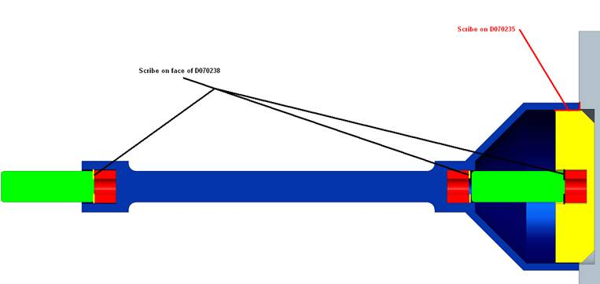
Figure 2 Penultimate Mass Magnet & Flag Holder Assembly (D080580)

Earthquake Stops
Assemble Flourel EQ Stops as per T1000377.
Note: Venting of the Flourel was a step added after the initial document was created.

OSEMs
Assemble AOSEMs as per E0900168. BOSEMs should be delivered by Birmingham, fully assembled and ready for Class A use.
Note: 316sst fasteners need to be used in some OSEM applications, see RODA M1000312.

Top Stage Blade Cartridges
- Assemble the Top Stage Blade Cartridge Tooling as per D060370. Clamp tooling to optical table.
- Choose blades which are a matched sets with the appropriate Blade Clamps D060326 and D060327. See T1000068 for sets of blades and clamps with corresponding serial numbers.
- Assemble 4 cartridges as per assembly picture book D060370. Note that 3 of the cartridges will have a D060329 Backbone and 1 will have a D0901439 Backbones.

It is important to align all holes in the clamps and blades the first time they are stacked together. Misalignments will mean that screws inserted later in the assy will not mate well.
- Perform Creak bake on all Top Stage Blade cartridges at 120 deg C for 100 hours, as per T040108.
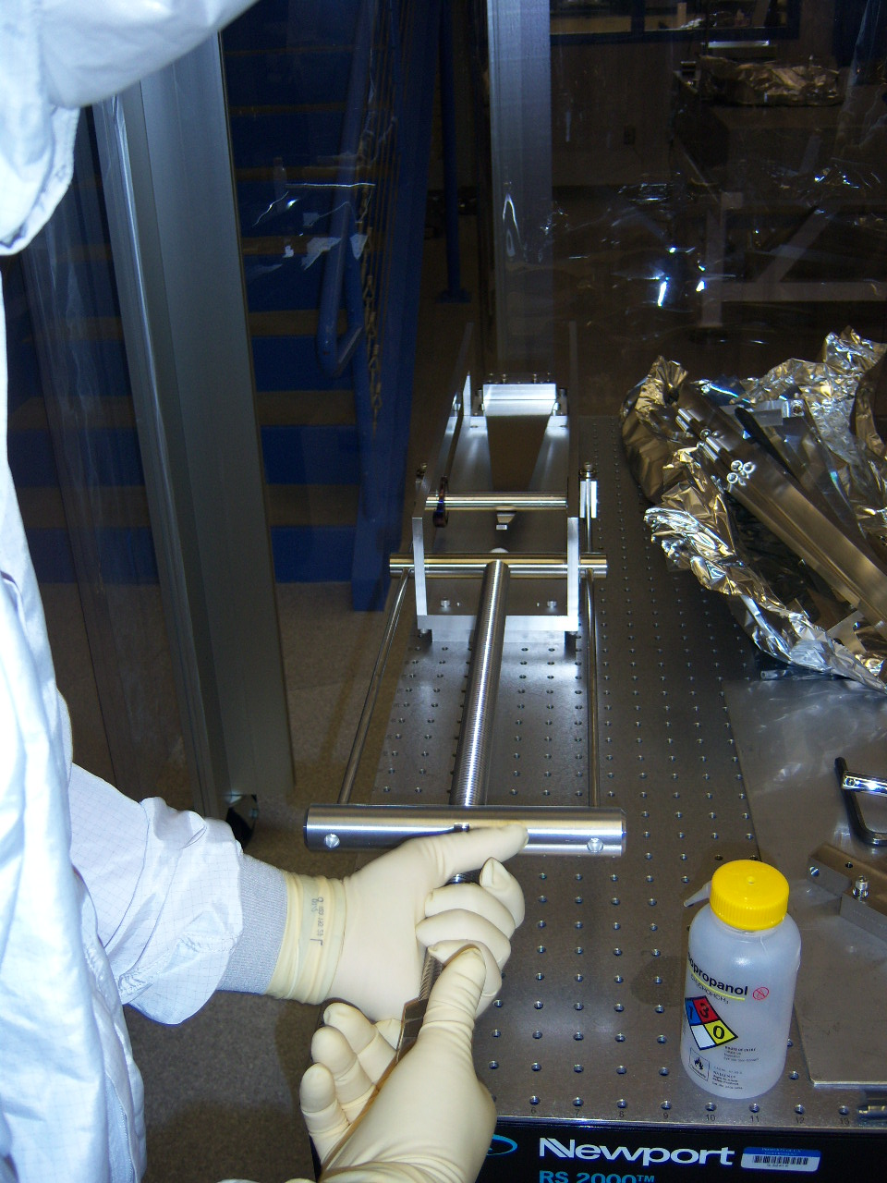
Figure 3 TS Blade Tooling D060370
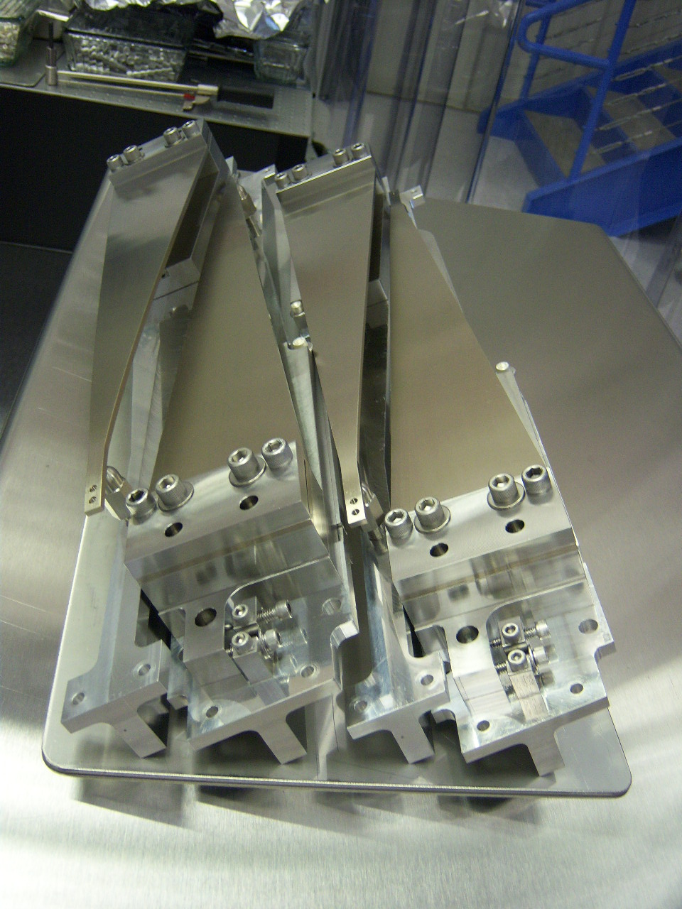
Figure 4 TS Blade Cartridge Assembly D060324

Top mass
In general, the more carefully each assembly and alignment step is done, the easier later steps will become. For example, the more accurately the blade springs were installed during assembly, the easier it will be to balance pitch.
- Insert helicoil repair in all D060430 top plates. (Not in picture book.)
- Choose Middle Blades (D060236) which have been characterized as a set of 4 (2 for test chain and 2 for reaction chain) designated in T1000068.
- Assemble one Top Mass as per the D060403 picture book, and one Reaction Top Mass as per the picture book D0902031 stopping at page 15.
- Perform Creak Bake on Top Masses in air at 120 deg C for 100 hours as per T040108.
- Install the 12 Top Mass OSEMs. Make sure that one and only one OSEM is fully characterized (Serial Number greater than 560) and is installed in the Main Chain Top Mass.
- Complete assembly of the Top Mass and Reaction Top Mass as per the picture books.
Notes: Take care when pressing the steel disks into the aluminum ECD and flag holders, as the aluminum can be easily bent.
Handle magnets carefully as they are very strong and some are brittle. As well, be careful with tools in proximity to the magnets as many tools in the kits are magnetic.
- Torque all fasteners as per the assembly picture book.
- Weigh the assembly. Add or remove Addable Mass symmetrically to the assembly until the unit weighs 22kg +/- 10g.
- Store the sub assemblies until you are ready to install them into a QUAD.
Notes: Magnets should be removed from assembly and stored with the unit separately.

UI Mass
In general, the more carefully each assembly and alignment step is done, the easier later steps will become. For example, the more accurately the blade springs were installed during assembly, the easier it will be to balance pitch.
- Choose Bottom Blades (D060237) which have been characterized as a set of 4 (2 for test chain and 2 for reaction chain) designated in T1000068.
- Assemble one UIM and one Reaction UIM as per the picture book D060375 stopping at page 9.
- Perform Creak Bake on UIMs in air at 120 deg C for 100 hours as per T040108.
- Connect the 4 UI Mass BOSEMS. Note: none of the OSEMS on the UIM should be characterized.
- Complete assembly of the UIM and Reaction UIM as per the picture book.
Notes: Take care when pressing the steel disks into the aluminum ECD and flag holders, as the aluminum can be easily bent.
Handle magnets carefully as they are very strong and some are brittle. As well, be careful with tools in proximity to the magnets as many tools in the kits are magnetic.
The Blade ECD magnet is not tall enough to extend into the copper ECD shaft. Stack 2 magnets on the blade, such that the top magnet fits into shaft.
Torque all fasteners as per the assembly picture book.
- Weigh the assembly. Add or remove Addable Mass symmetrically to the assembly until the unit weighs 22kg +/- 10g.
- Store the sub assemblies until you are ready to install them into a QUAD.
Notes: Magnets should be removed from assembly and stored with the unit separately.

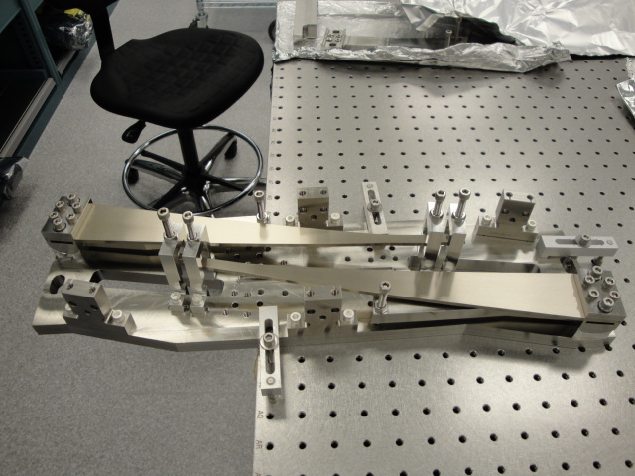
Figure 5 UI Mass clamped to optical table for blade pull down
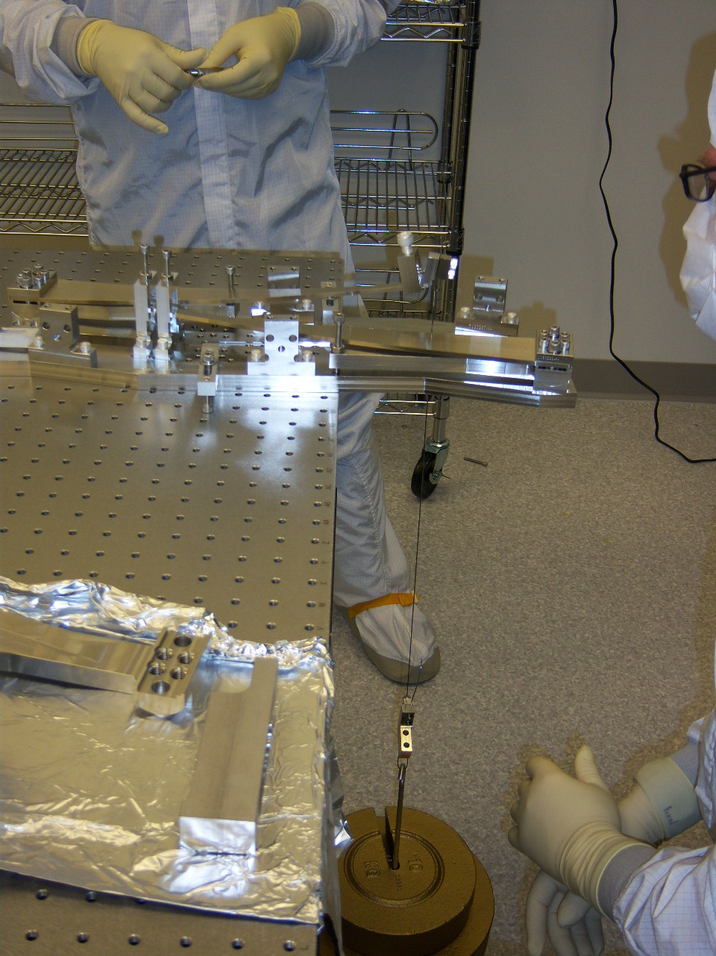
Figure 6 UI Mass with hanging weight to pull blade flat

Lower structure
Assemble all EQ stop Brackets.
Note: The callout on some of the drawings which specify that the PFA440 bushings need to be reamed out after assembly into the Aluminum bracket. A Class B reamer (such as McM-Carr 8851A23) will be needed for this step. The reamer will be used clean, and can be done by hand. Work in an area where the particulate can be removed easily and completely from the clean room.

Sleeve
Ensure by trial fit that the upper and lower structure correctly interface to the sleeve. Matching of serial numbers between the sleeve and upper structure is unnecessary – the structures are interchangeable with each other.

Main assembly
- Download the quad traveler template, F1000008 (a Microsoft Excel spreadsheet), start a new copy under a new DCC number and title as described in the instructions sheet of the template.
- Record the new traveler DCC number in the Related Documents field of E0900371 [and in the inventory control system in the record for the suspension being assembled].
- In the steps below, record the called-for data in the traveler spreadsheet. After each work session, resubmit the updated traveler to the DCC as a new version.

Top stage and Upper Structure
- Install empty upper structure on the gazebo/Test Stand, attach with as many as possible: 16 dog clamps, 4 per side, with 2 per corner, are desirable. (Breadboard surface of Test Stand should be level to ±0.25mRad as per T050113 aLIGO SEI/SUS Test Stand.)
- Install all four top stage blade units in place. Check the tips are central, and the location holes align.
- Ensure all blade tips are held well down with blade stops. Target is that the tips are 2mm below nominal (108mm from the optic table to the blade top).

Tablecloth and top mass
- Lie two ~36mm cross bars across the lower structure bottom ring and rest the two top masses approximately in place (the upper structure removable braces work well.)
- Optional step which replaces step 11: With plenty of slack, attach the wire clamps to the Top Stages and the Top Masses (note – the wire clamps can be attached to the Top Masses while still on the bench for ease).
- Assemble the tablecloth side plates in place with no OSEMs/ECD assemblies. Install all the dowels to locate it nominally WRT to the structure. Adjust the plates until the dowel hole pins line up.
- With the stops raise the top masses into place. Position nominally in x and y using dowels and approximately 10mm too high in z (do this by inserting the stops too far).
- Connect the top two masses to the top stage, bolting the top wire clamps to the top blade tips and the top mass. The top plate of the top masses can be removed to make this easier.
- Replace the inside cam blocked by the Top Stage wires on the Left and Right OSEM brackets of the main and reaction chains with washers. Note: one or more washers may be required in order to span the over-sized slot in the OSEM bracket and in order to fit the SHCS it may require stacking a ¼-20 washer and 8-32 washer together.
- Lower top two masses to nominal position - note the top stage blade tips may need to be pushed down for this.

Lower structure

LSAT
- Assemble both halves of the lower structure assembly tooling side by side on either the floor or a low table. Note when viewed from above they should look something like: ┌┐└┘ ideally with the rear of the penultimate mass easily accessible.
- Install the respective halves of the lower structure into the tooling.

Reaction chain
Note the test and reaction chains are subtly different approaches, either is acceptable, the only reason they are different is that they are more-representative of the glass procedure.

- Add the reaction UI mass into place onto stops which are retracted such that the tips are ~10mm above the UIM bracket. This will allow slack to clamp the wires on later.
Note: OSEMS should be in place.
- Add the Penultimate reaction mass in to a position in its nominal position WRT lower structure (on fixed PFA440HP pads); set roll (approximately) Note: OSEMS should be present and in the approximately correct position.
- Add the reaction test mass; approximately set roll by eye.
- Add the UIM-PenRe-TestRe wire assemblies to both sides. Roll test mass and Pen mass as required.
- Lower test reaction mass to its nominal position.
- Raise the UI mass to its nominal position on the vertical stops taking care to keep it horizontal.
- Raise the UI mass further to lift the PenRe mass and remove the PFA440HP pads below the PenRe mass. Lower the UI mass to get the PenRe mass back into its original position.
- Remove the stops from below the test mass to ensure everything hangs stable and with no gross pitch.
- Lock all three masses in their nominal positions (leaving the wires all in tension).
- Install magnets on Top Mass – see T080165.

Main chain
- Add the test UIM into place on partially retracted vertical stops 10mm below nominal.
- Rough level the UIM with the vertical stops.
- Add the Penultimate test mass in its nominal position WRT lower structure, with magnets omitted, onto the fixed PFA440HP pads. Set roll by eye.
- Add the Test Mass into the LS. Set roll by eye.
- Attach the Bottom-Final wire assemblies to all 3 masses, note the UIM blade tips and masses may need to be worked down to make room for the wire clamp.

The outer blade tip stop in the bridge will need to be retracted in order to bolt the wire clamp onto the tip. Replace the tip stop when clamp is attached.
- Lower TM stops such that mass is hanging. Check that it is about nominally positioned in LS.
- Raise the UI mass to its nominal position (line up the EQ stop holes on the D070548 plate with the UIM holes) on the vertical stops taking care to keep it horizontal.
- Re-Level UIM on the vertical stops.
- Slightly raise the UIM mass allowing the Penultimate mass to raise and remove its PFA440HP pads (upper stops need to be retracted). Lower the UIM to its nominal along with penultimate mass suspending it.
- Check that the PM is hanging – if not, check wire lengths and positions of TM and UIM again. Care should be taken that no unexpected pitches occur, although it is unlikely.
- Check and adjust if needed the 5mm lateral and 15 mm height positions of the UIM blade tips WRT the bridge.
If there is an error in the 15 mm height, it is better to have the blade tips low than high.
- Clamp all blades via blade stops such that blades are stored flat until installation.
- All masses can now be locked in place. The simplest thing to do is to lock them in their nominal positions. A more representative thing to do is to raise the test mass 8mm as it will be when there is glass. For now nominal positions are recommended.

Mate Lower Structure
- Put the two Lower Structure halves together while still in LSAT.
- Mate to Upper Structure.

Pitch Adjustment and Suspension Tuning
For additional information or troubleshooting, see procedure T1000407, “Quad Suspension Balancing and Alignment Procedure.”

Hints Before You Begin
In general, the more carefully each assembly and alignment step is done, the easier later steps will become. For example, the more accurately the blade springs were installed during assembly, the easier it will be to balance pitch. The more precisely pitch is balanced on the first time through the alignment procedure the fewer iterations will be needed to align all OSEMs, ECDs, and ESD.

While making adjustments on the quad, make sure to watch out for touching stops and for interferences between the chains at every step. In particular the top masses have tight clearance around the blade spring clamp bolts. These bolts tend to get caught under the top plate of the opposing top mass if pitch and roll are not carefully aligned. There is nothing worse than spending an hour making adjustments only to discover that it was all for naught because a screw you did not see was touching one of the masses.

Remember that the blade springs magnify the tilts of the masses below them because their compliance allows for differential tilt between the masses.

Pitch is likely to cause a lot of trouble if the blade spring alignment within the rectangular masses is off. Pitch specifically is sensitive to errors in the blade assembly because any lateral misalignment of the blade tips away from the center of mass at each stage will generate a torque that will introduce a differential pitch between that stage and the one above it. If this problem is too extreme, it will be impossible to meet all the constraints of the OSEMs and test masses simultaneously, and the springs will need to be repositioned. Each blade tip should have exactly 5 mm of clearance on either side. Intolerable errors are on the order of a few tenths of a mm. More details on the spring positioning are in the procedure below.

Preparation
- Put on safety glasses. Lock all the masses in level (by eye) position. Take care not to over stress the wires, especially the lowest ones since they are the most delicate and have no added compliance from springs.

Much of the leveling and balancing of the masses throughout this procedure can quickly and easily be gauged by eye. A small, light, and reliable bubble level is also useful. Figures Figure 7, Figure 8, and Figure 9 show useful places to inspect by eye how level each mass is. Figure 23 in Appendix B illustrates the coordinate systems referenced throughout this document.
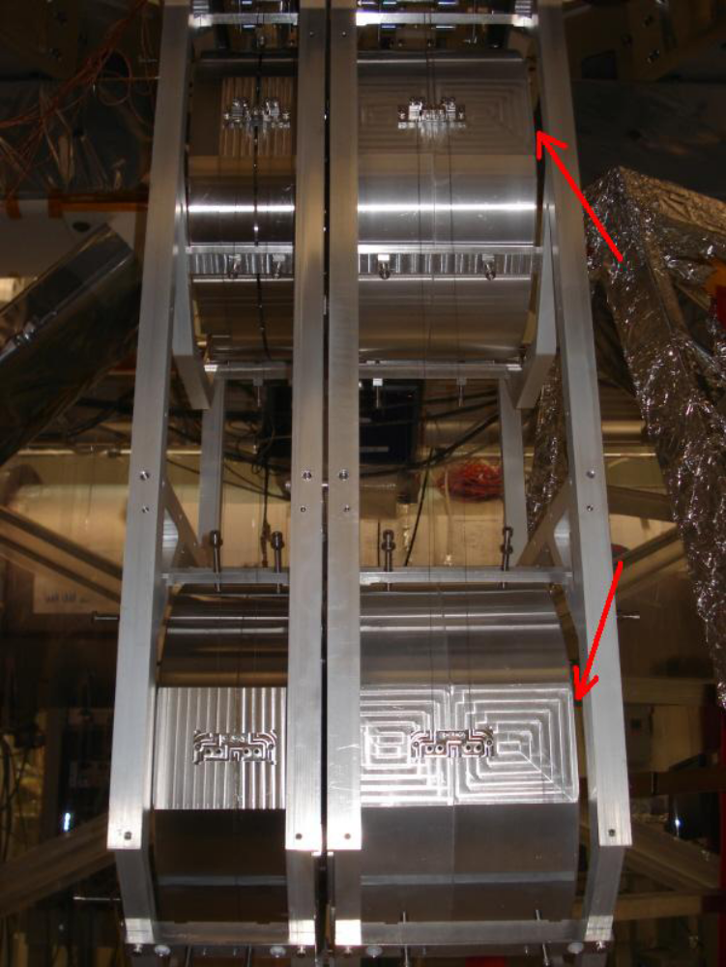
Figure 7 A quick and rough idea of the pitch of the 2 bottom masses is obtainable by inspecting the relative angle between each mass and the front/back edge of the structure. The red arrows indicate the gap between the main chain and front edge of the structure.

- Make sure all the final suspended bits are installed so that the masses have the correct balance and weight. For example, if the UI mass flag-magnet assemblies are not yet installed, it will be necessary to align the pitch of the entire suspension again when they are installed. Other things to check for are all flags, magnets and bolts. Also check that all pitch adjusters are centered. The UI and penultimate mass OSEMs must be installed to have the correct weight in each mass. The top mass OSEMs are supported by the structure and should not yet be installed, they will just get in the way later. If suspended bits are added to the masses, they should be weighed first, so that the final weights can be kept track of.

- The orientation of the ECD magnets and shielded magnet pairs is important and should be double checked. The intention is to create magnetic dipoles in order to reduce the coupling of the magnets to stray fields. This means that the poles of the ECD magnets are placed in a checker board pattern around the top mass; see Figure 10. Two OSEMs around each top mass have shield magnets placed directly behind the coil magnet, the side OSEM and the OSEM at the front and center ('Side' and 'Face 1' respectively by LASTI notation). Additionally, the main chain UI mass has similar shield magnets behind the OSEM coil magnets. Figure 11 and Figure 12 show the locations and orientations of the shielded magnet pairs.

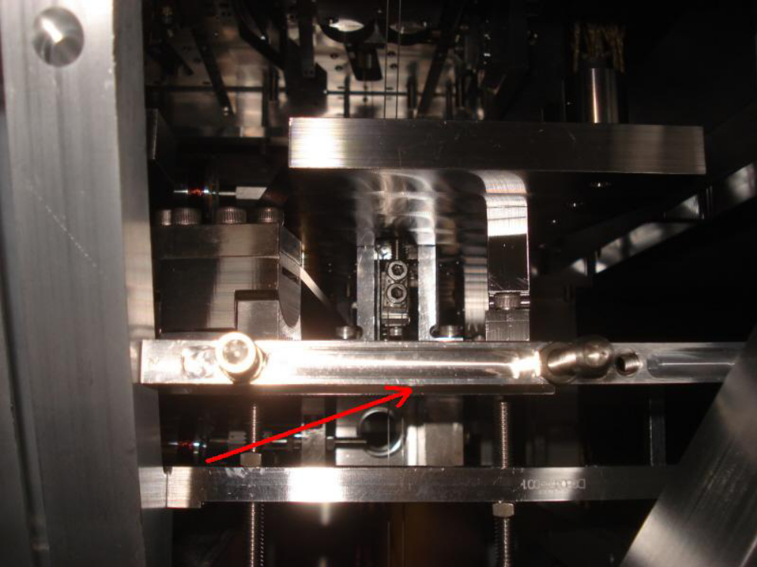
Figure 8 The pitch of the UI masses is visible by inspecting the relative angle between the mass's bottom plate and the stop mount bar indicated by the red arrow. This bar, along with the corresponding one on the other side, will also highlight roll by comparing the relative heights of the left and right sides of the mass.
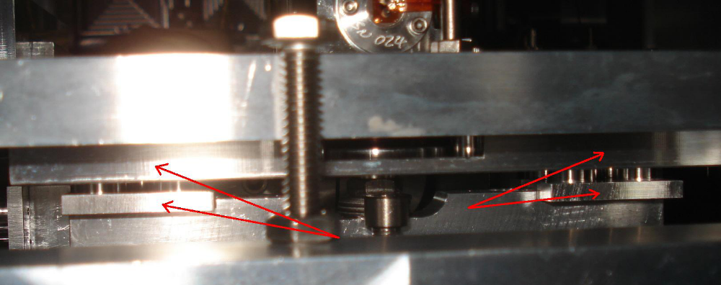
Figure 9 The pitch of the top masses is visible by inspecting the relative angle between the top ECD arrays and the bottom of the adjustable top OSEM plate indicated by the red arrows. Roll is also visible by inspecting the relative height of the top mass with these references on either side of the structure.
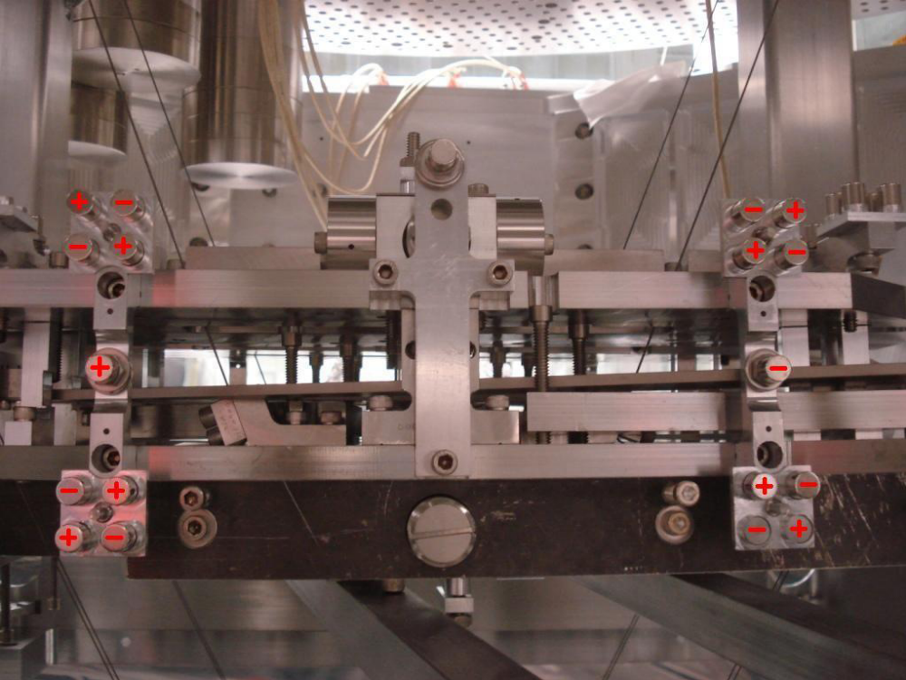
Figure 10 This photograph shows the checker board pattern of the ECD magnet polarity. There is an identical pattern for the ECD magnets on top of the top mass. This photograph does not show the tablecloth simply because it was taken during the assembly stages.
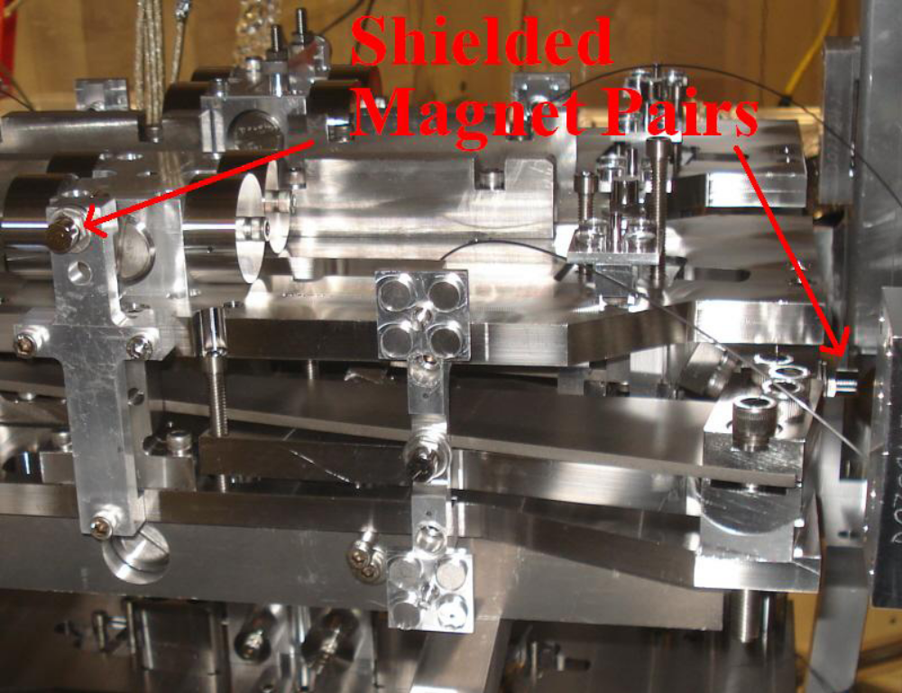
Figure 11 This photograph shows the locations of the shielded magnet pairs around the top mass. In LASTI notation these are the magnets belonging to the 'Side' and 'Face 1' OSEMs. The UI mass OSEMs also have shielded magnet pairs.
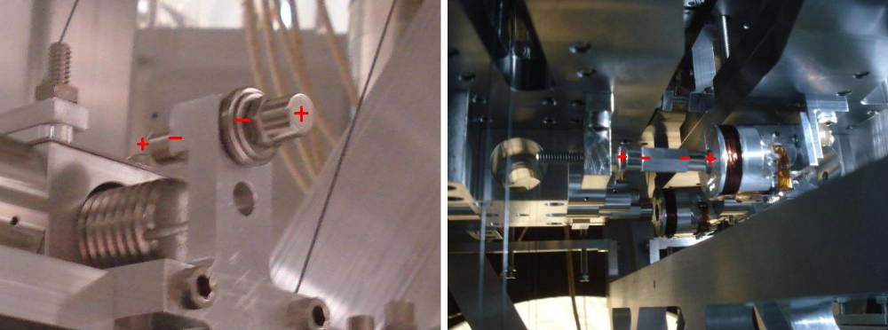
Figure 12 The left photograph shows the orientation of the 'Face 1' OSEM magnet pair. Which side is north and which is south is arbitrary as long as two like poles are facing each other so that magnets tend to cancel. The side magnet pair, and the UI magnets in the right hand side picture function in a similar way.

Suspend and Balance the Masses
Start the alignment process on one chain at a time. Both can be done simultaneously, but experience proved that balancing one chain at a time is the most reliable. Later on it will be necessary to consider both chains simultaneously. The main goals here are to set the blade spring tip positions and set the differential pitch of all the masses. It is important to make sure early on that the differential pitch is no greater than a few mRad.

- Choose a chain and release the bottom mass. It should stay level and have the same pitch and roll as the penultimate mass. If this is not true, the wires have not been made or clamped properly and should be changed.

- Release the penultimate mass. If you are on the main chain, both lower masses should now hang free and level in pitch on their own. If you are on the reaction chain, you may have to adjust the penultimate mass pitch adjuster to bring both masses to a level state. Figure 13 describes this adjuster. Errors in pitch are likely due to the errors in the wires. Errors in roll may be due to blade spring tip heights, which will be sorted next.

- While the UI mass is still locked, release the blade spring tip stops and adjust the spring tip height to set the vertical height (d parameter in model). The blade tip height should be 15 mm from its reference point. Instructions for adjusting the height are in Figure 14. There should also be 5 mm of clearance on either side of the blade tip, as shown in Figure 9. If the clearance is o_ by more than a few tenths of a millimeter the spring may have to be adjusted, which may not be allowed in situ for risk of undoing a heat treatment of the blade spring. Note that if the UI mass is not locked in a level position the wires will pull on the tip making it appear mal-positioned even if it is not. The two lower masses should now be level in both pitch and roll.

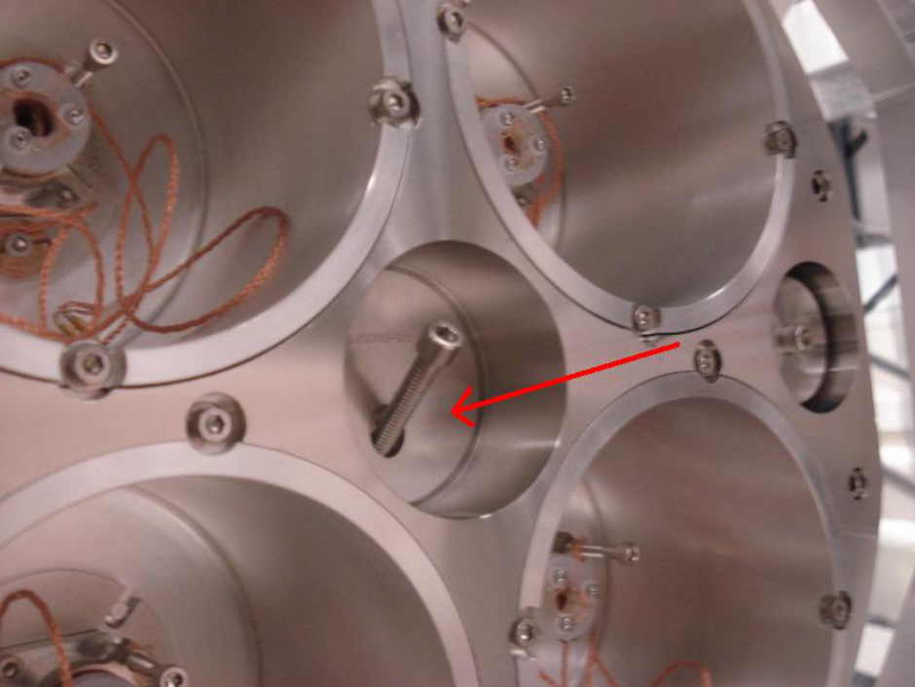
Figure 13 The reaction chain penultimate mass has a large pitch adjuster indicated by the red arrow. The long diagonal screw is a lock. If the lock is loosened the adjuster will slide back and forth altering pitch.
- Problems are most likely to become visible when releasing the next two stages. Release the UI mass. At this point any significant pitch is likely due to lateral offsets on the blade spring tips. If the pitch is small enough you can compensate by repositioning some of the removable mass. If it is off by a large amount the spring will have to be repositioned. At the time of writing it is still uncertain whether repositioning the spring in situ will be an option because of a risk of undoing a heat treatment of the spring. If it is an option, the spring clamp bolts can be loosened and the spring tip can be forced to slide back and forth. The mass should be locked while making this adjustment. Make sure to retighten the bolts when the adjustment is complete. Clamp torque values are listed in Figure 14 and Appendix A.

- Before releasing the top mass check the blade tip positions in the same way that they were checked on the UI mass. The vertical height should be 9.6 mm from the reference lip, and the lateral position should again allow 5 mm of clearance on either side.

- Release the top mass. Check to make sure the other top mass is not interfering, see Figure 15. This stage has additional options to compensate for pitch errors. There are two coarse pitch adjusters underneath the top mass that slide the attachment of the top wires along the bottom plate. There are also two fine pitch adjusting 'screws' on the top mass as well. One is below the bottom plate, the other above the top plate behind the center OSEM. These can be turned in and out to adjust the pitch balance. See Figure 16. You should only use the coarse adjusters if the fine adjusters run out of range. Please note that using them will introduce a yaw and longitudinal displacement. These yaw and longitudinal offsets can be compensated for by adjusting the top stage springs, but doing so may impose additional pitch-roll coupling, making damping and control more difficult.

- Tighten the set screw in the turret for the pitch adjuster.

Ideally you should now have a level suspension chain with no differential pitch between the masses. A small amount of differential pitch below a few mRad is OK. If this is the case, keep the top masses as level as possible for the time being since the next few steps will require it.

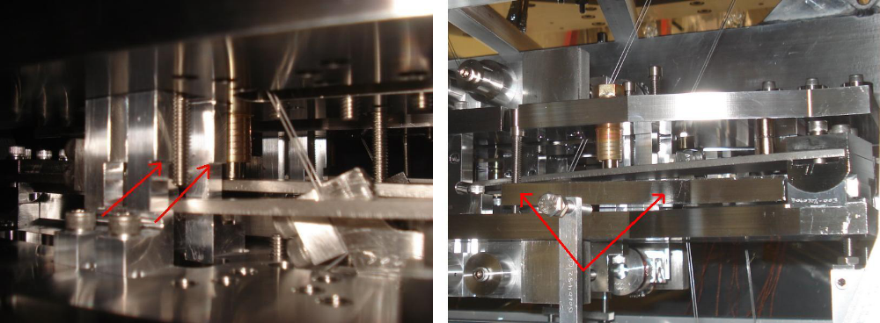
Figure 14 The left photograph shows the vertical blade tip reference points indicated by the red arrows. The arrows are pointing to a lip on one of the two upright U shaped aluminum parts that arch over the blade tip. For the UI mass, there should be 15 mm between the top of the blade and that lip when the round masses are suspended below. There should also be 5 mm of clearance on either side between the tip and these U shaped parts [3]. The right photograph shows the adjusting arm for the blade tip height. Just above the left red arrow is a long upright 1 4-20 bolt. Turning this bolt will adjust the angle at which the blade leaves its clamp, allowing the tip to move up and down. It may be necessary to slightly loosen the two outer bolts in the clamp (the ones closest to and furthest from the opposing chain). The UI spring clamp bolts should be torqued back to 100 in-lbs (8.3 ft-lbs, 11.3 Nm) [6]. The top mass springs are referenced and adjusted in a similar way. The top mass clamp bolts get torqued to 330 in-lbs (27.5 ft-lbs, 37.3 Nm) [6].
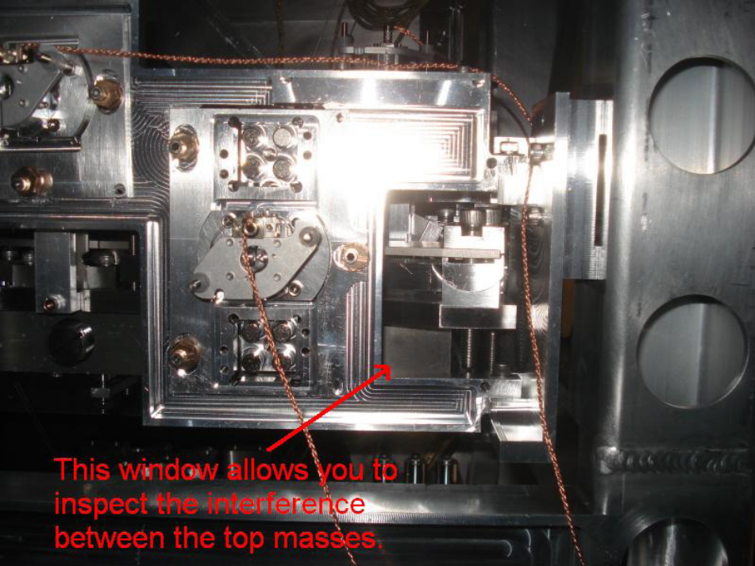
Figure 15 The clearance between the blade clamp bolt heads of one top mass and the top plate of the opposing top mass is small. When adjusting the top mass positions, always keep this possible interference in mind. This picture shows one of 4 possible windows to inspect the clearance. Getting the roll of each chain correct will help prevent pitch headaches later on since both of these adjustments alter the amount of space here.
- The second chain should now be suspended. If it interferes with the first because of global roll, yaw, or longitudinal errors, the first chain should simply be held out of the way with stops. These offsets will be dealt with in the next section.

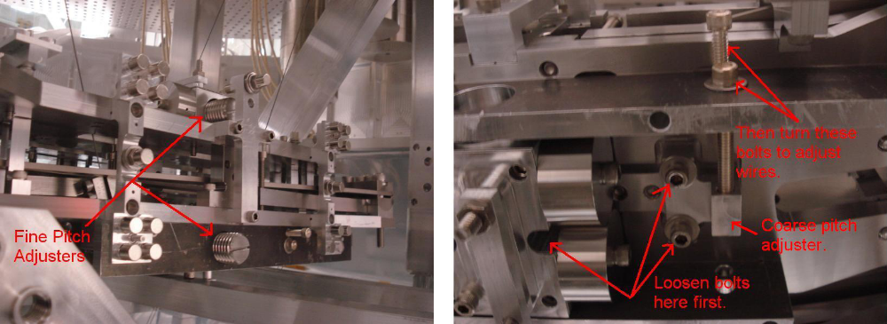
Figure 16 The left photograph shows the fine pitch adjusting screws. The tablecloth is not in place to show the pitch adjusters. The right photograph shows one of the two coarse pitch adjusters. The coarse adjusters should only be used if the fine adjusters have insufficient range. They work by moving the attachment points of the top wires. To use them, loosen the 3 ¼-20 bolts (one is hidden inside the center block) and turn the 2 ¼-20 pusher-puller screws to slide the adjuster forwards and backwards. Retighten the bolts after completing the adjustment.

Align the Chains
The following steps will now guide the alignment of the chains relative to each other, the structure, and the global coordinate system (i.e. pitch and yaw of the test masses). Virtually all adjustments at this point will couple to each other, so there will likely be some iterating back and forth until everything is met within its constraints.

- Install the OSEM mount plates and set them to the center of their range. In the next few steps this will allow you to quickly inspect the alignment of each chain relative to the structure, help ensure that all the plates have enough range to adjust the OSEMs, and roughly set the spacing between the chains. See Figure 17.

- Assuming the pitch of the top masses are roughly leveled, the offsets of the flags and magnets from their midpoints in the OSEM plates will tell you about longitudinal, yaw, vertical and roll relative to the structure. Use the top stage blade springs to adjust these degrees of freedom. Any transverse offset will also be visible, however there is no adjustment for this degree of freedom because there needs to be a gross error, likely in one of the top wires, for this to be the case. If so, wires may need to be remade.

- Make sure all the spring stops are free. Roll and vertical can then be adjusted by packing the 0.5 mm and/or 1.0 mm shims underneath the blade tip clamps. These shims only allow one to raise, not lower one side of a chain at a time. If the chain appears too high, the masses may not be heavy enough, some wires were set too short, the tablecloth was not assembled correctly, or possibly the springs are stiffer than the design. See Figure 18.
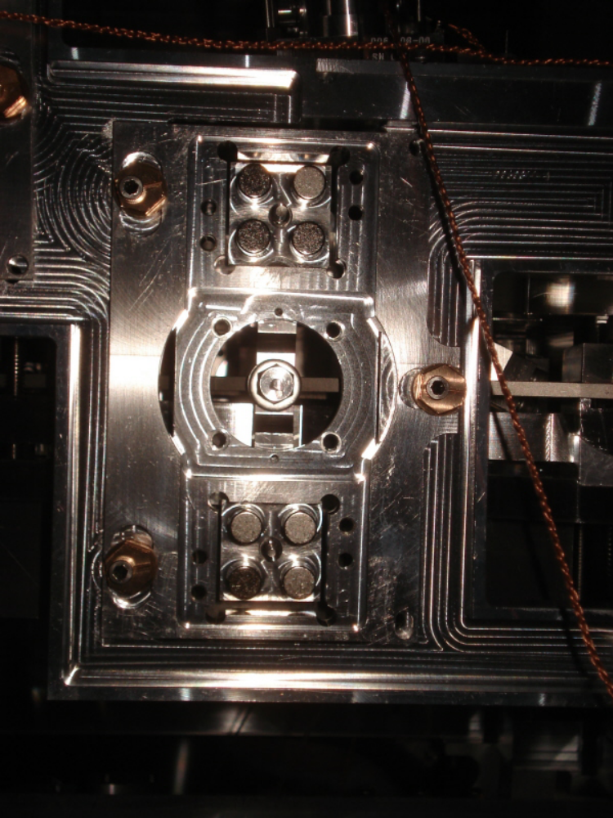
Figure 17 This figure shows one of the OSEM plates without the OSEM. Centering the plate on the structure using the 3 copper cams will allow you to quickly eyeball longitudinal, yaw, vertical and roll of the top masses relative to the structure.
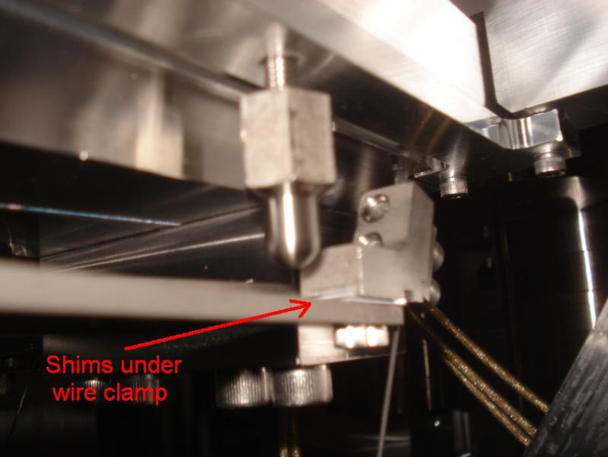
Figure 18 The red arrow points to a top stage wire clamp with shims packed underneath to alter the height of one end of the suspension. To insert these shims the clamp needs to be removed which requires giving the wire some slack by either raising the top mass or lowering the spring.
- Adjust the yaw and longitudinal degrees of freedom using the top stage rotational adjusters. See Figure 19. To make this adjustment the top mass should be locked and the outer top stage blade clamp bolts loosened (the ones closest to and furthest from the opposing chain). The rotational adjuster has a push-pull bolt pair setup at the back of the spring to rotate the tip. The blade pivots near its midpoint, so tightening the pulling screw moves the tip away from you while tightening the pushing screw brings it toward you. After each adjustment, re-suspend to check the alignment. Set the space between the test masses close to 5 mm. The spacing will be fine tuned further down the procedure. When finished, tighten the pusher and puller bolts to lock the blade spring in place and torque the clamp bolts back to 330 in-lbs (27.5 ft-lbs, 37.3 Nm) [6]. The blade spring rotation may need to be tweaked again later on to optically align the test mass, but that will be a quick adjustment if this is done properly first.

- Before moving onto the optical alignment, double check that there are no interferences preventing the suspensions from resting in their natural positions. This includes checking all the stops, all around the tablecloth, and the spaces between the masses. The most rigorous check is to install OSEMs and measure transfer functions; however the OSEMs will likely need to come out again to continue the alignment procedure, since they themselves can introduce interference and at best will need realigning later. Nonetheless, installing one or two OSEMs is not much work and damping loops can make the final yaw alignment go much faster, so the preferred option can be chosen on a case by case basis. Section 8 describes how to install OSEMs.

- The next two steps concern the optical alignment of the test mass. The main chain test mass should be aligned to within 100 µRad in pitch and 10 µRad in yaw. Yaw is conceptually the simplest and also the most stable, so it should be done first. Yaw can be roughed to 1 mRad by turning the entire structure with a couple of structure pushers anchored to the optics table, see Figure 20. The 5 axis table should be placed under the quad for safety. Using the 5 axis table requires installing the lower structure tooling around the lower structure of the quad. The table should not take the full weight of the quad because the lower structure was not designed to take the full weight of the upper structure (testing shows that it can, but there is a small risk of deforming the structure). The adjustment is done by loosening the dog clamps and adjusting the pushers until yaw is set within 1 mRad. If you do better than 1 mRad at this point you will likely lose it when you tighten the dog clamps. The remainder of the alignment can be achieved by using the top stage spring rotational adjusters. Alternatively, light tapping on the blade tips with a hammer may be sufficient to take up the last mRad. The reaction chain should be aligned such that its test mass is within 5±0.25 mm of the main test mass in yaw and longitudinal. At the time of writing this document the method for measuring this gap is still being reworked. Previously it was simply done with a 5 mm slip gauge or shim, preferentially with some damping loops running. Torque the blade spring bolts with the torque wrench up to 330 in-lb (27.5 ft-lbs, 37.3 Nm) [6].

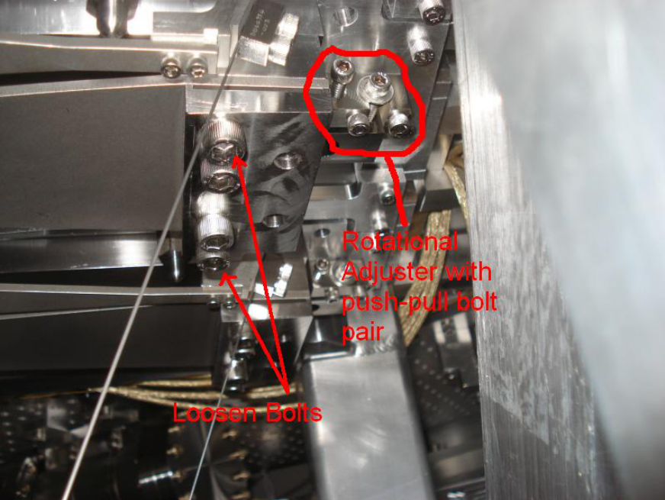
Figure 19 To rotate the top stage blade springs _rst lock the top mass and then loosen the two outer bolts indicated. The spring rotates by means of the push-pull bolt pair system shown at the back of the spring. The blade pivots near its midpoint, so tightening the pulling screw moves the tip away from you while tightening the pushing screw brings it toward you.
- A note about pitch hysteresis: pitch has the added complication of a hysteresis problem related to the wires which will cause the pitch alignment to drift. The sizes of the drifts are proportional to the amplitude of mass oscillations and inversely proportional to damping time. Thus, if the quad is given a large bump where the masses repeatedly bang into the stops and each other, the pitch alignment may find a new equilibrium which will need to be adjusted. For similar reasons, damping loops should not be used while making pitch adjustments. Small drifts can be removed by allowing the suspension to oscillate freely for a few minutes.
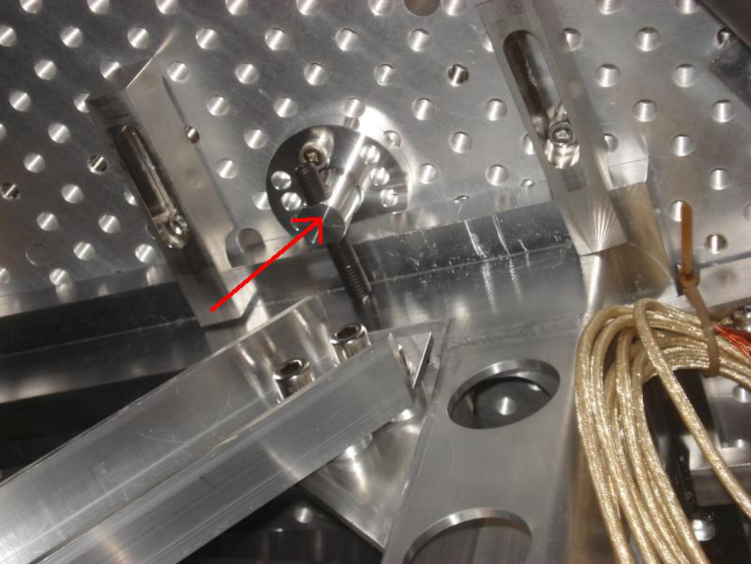
Figure 20 The entire structure should be rotated to further tune the main test mass yaw to within 1 mRad (after the top mass yaw has been aligned to the structure). This photograph shows one of the structure pushers that are useful for rotating the structure. To make this adjustment the dog clamps need to be slightly loosened. The 5 axis table should be placed under the lower structure (with the lower structure tooling) for added safety, however it should not take the full weight of the suspension because the lower structure is not designed to support the weight of the upper structure. To use this adjuster simply bolt it to the optics table with the large bearing tipped screw (black screw in this picture) facing the structure. When the screw is in contact with the structure tighten it to push on the structure [7].
- To remove any hysteresis effects tap on one of the masses from each chain to set a pitch oscillation of a couple mRad. Allow the oscillation a few minutes to ring down. Pitch should now be close enough to be within range of the fine pitch adjusters. With a flat head screw driver, turn one of the main chain adjusters until pitch is within 100 µRad. Because of hysteresis there is no sense in doing better than 100 _Rad. Adjust the reaction chain test mass to follow. The comments from step 6 on measuring the gap between the test masses apply here as well, with the caveat that damping loops may be undesirable because of the hysteresis problem.

- Check again that everything is fully suspended.

OSEMs and Eddy Current Dampers (ECDs)
The experience at LASTI at the time of writing this document is that the clearance between the magnet-flag assembly and the inner bore of the OSEM is extremely tight and the assembly will often make contact with that inner bore. The vertical OSEMs on top of the tablecloth are most likely to present trouble since it is difficult to see inside the bore. Thus, they should be the last OSEMs installed and the first suspected for interference.

The following steps pair closely with E1000494 Quad Metal-Build Testing Procedure. The testing procedures will not be detailed here since they are covered explicitly covered in the testing procedure document. It will be necessary to utilize both procedures at the same time to prevent “skipping” any steps and being required to go back to redo them. e.g. If the Decoupling Procedure was performed prior to recording the White Counts, the decoupling procedure would have to performed again after removing the OSEMs to measure the White Counts.

- Connect the 12 Top Mass OSEMs to the in-vacuum cables. Make sure that one and only one OSEM is fully characterized (Serial Number greater than 560) and is installed in the Main Chain Top Mass. Connect the 4 UI Mass BOSEMS and the 4 Penultimate Mass AOSEMS. Note: none of the OSEMS on the UI or Penultimate Stage should be characterized.
- Record all of the DC Open Light Voltages.
- Starting with one at a time, install the OSEMs and zero them out (< 2% of the open light voltage). Record the Dark Light Voltages.
- Enter their calculated White Count Offsets and Gains in the MEDM Input Filter Screen. Center the OSEMs at 0 ± 1000 Counts DC.
- Complete all steps of Testing Procedure up to the OSEM Decoupling.
- Install the copper ECDs. The pin in the center of each 4 magnet group is designed such that it will hit the ECD before the magnets do. This step is at the end of the procedure because damping is one of the signs for interference (such as a rubbing stop). The ECDs also introduce an additional source of interference. Thus, it will be easier to install these once everything else is taken care of first. Need to determine a method to set the ECD block empirically.
- Perform OSEM decoupling steps of the testing procedure.
- Remove copper ECD blocks. Note: Do not adjust the pusher screws when removing the copper ECD blocks. Only remove the two puller screws when removing the copper ECD blocks. This will preserve the depth adjustment and simplify the re-installation.
- Complete all steps of testing procedure up to the ECD Transfer Functions.
- Re-Install the copper ECD blocks.
- Measure transfer functions again to check that the ECDs are functioning properly.
- Measure transfer functions again after Sleeve and Wedges have been installed.

Quad Structure Prep Prior to Glass Install
- Assemble wire loops for main Penultimate and Reaction CP
- Check for rust
- Check for wire slippage
- Clean suspension
- Switch in Silica Tipped Flourel EQ Stops
- Install Ring Heater Assembly and route cables
- Install ESD cables where appropriate and route cables

Glass Preparation
See T1000337 Quadruple Suspension Monolithic Stage Final Design for test mass bonding, etc.

CP electrical connections
- Check the electrical continuity of the ESD cables. (The cables are extremely prone to failure at the end where the gold connectors have been crimped on.)
- Take the CP out of its case, remove the face-plate from the ESD side, and lay it with the ESD side up in a clean room. [It was very difficult to remove the face plates because they were quite tight and there were no vent grooves in them.]
- Carefully wipe the face and sides of the optic with lint-free wipes moistened with methanol [acetone?] to remove dust and dirt.
- Cut gold tabs to appropriate size: width about the same as the traces in the ESD mask, length sufficient to protrude about 5 mm off the edge of the optic. (This will be different for different traces.) [Brett: 5 mm turned out to be too much given the narrow clearance between the CP and the structure – it should be more like 2-3 mm.)
- Crimp a furrow across the end of the gold tab which will be used to support the coax cable at a later step.
- Set up a bottle of clean, dry nitrogen with a regulator and nozzles to direct a flow of nitrogen across the work area.
- Repeat the next few steps for each tab to be soldered:
- Point the nozzles at the end of the ESD trace that the tab is to be attached to.
- Place a small bead of indium on the end of the trace, lay the flat end of the tab on top and cover with an aluminum button.
- Press a soldering iron heated to 600 degrees F onto the button and keep it there until 10 seconds after the indium melts. The button will visibly sag when the solder melts. Remove the button and inspect the joint. Too much heat can damage the pattern, so do not keep the iron there longer than necessary.
- Remove a length of shield approximately 1.5” long from the end of the coax, exposing the (very delicate) central conductor and inner insulation.
- Carefully strip the inner insulation exposing 2 to 3 mm of the central conductor.
- Lay the end of the intact section of shield into the groove in the tab and roll the end of the tab over so that the shield is gripped.
- Carefully bend the inner conductor around towards the body of the tab and solder it there, using the same procedure as for the tab. Maintain slight pressure on the tab at all times so that it does not move if it the solder behind it should melt.
- Test the electrical continuity from the pattern to the end of the cable.

Using the triple-hang tooling
- Assemble the Triple Hang Tooling (D060321) as Class B. This involves making up 2 single wire lengths with Top wire d=1.1mm using the wire clamps provided with the tooling. The wire lengths need to be 160mm between clamps. Use a ruler to set these lengths. Use Spare Middle Blades for this tooling.
- Start with main or reaction chain lower structure with all masses and wires in place, with the UIM approximately 4 mm high of nominal on its stops, and with UIM blades overloaded by 5 mm.
- Check if the UIM is level and if it is not, adjust the earthquake stops till.
- Retract upper earthquake stops on bottom mass.
- Screw in lifting screws on lower earthquake stops a tiny amount to ease weight on pad spacers.
- Remove pad spacers.
- Retract lifting screws on lower earthquake stops until optic is suspended.
- Check that optic is level relative to structure by eye – debug if not.
- Retract upper earthquake stops on PM.
- Retract overload screws on UIM blades, monitoring lower masses. If blade strength is matched to payload, PM should be about 4 mm off lower stops (same as UIM was high to begin with).
- Place 15 mm slip gauge on top of each UIM blade in turn and adjust blade height until top of slip gauge is level with reference notch in upright of UIM blade stop bridge (D060399).
- Check that PM is level relative to structure by eye – debug if not.
- On reaction chain, remove pitch adjuster, remove cable clamp, refit pitch adjuster.
- Fit wire assemblies from triple-hang tooling to UIM.
- Fit triple-hang tooling spacer blocks to top of lower structure.
- Fit triple-hang tooling top plate to spacer blocks.
- Connect wire assemblies to blades on triple hang tooling.
- Release the overload screws on triple-hang tooling.
- Check that all three masses are level relative to structure by eye – debug if not.
- Reapply the overload screws on triple-hang tooling until tension is off wire assemblies.
- Disconnect wire assemblies at blades triple-hang tooling.
- Remove triple-hang tooling top plate and spacer blocks.
- Disconnect wire assemblies at UIM.
- On reaction chain, remove pitch adjuster, fit cable clamp, and replace pitch adjuster.
- Repeat with other chain.
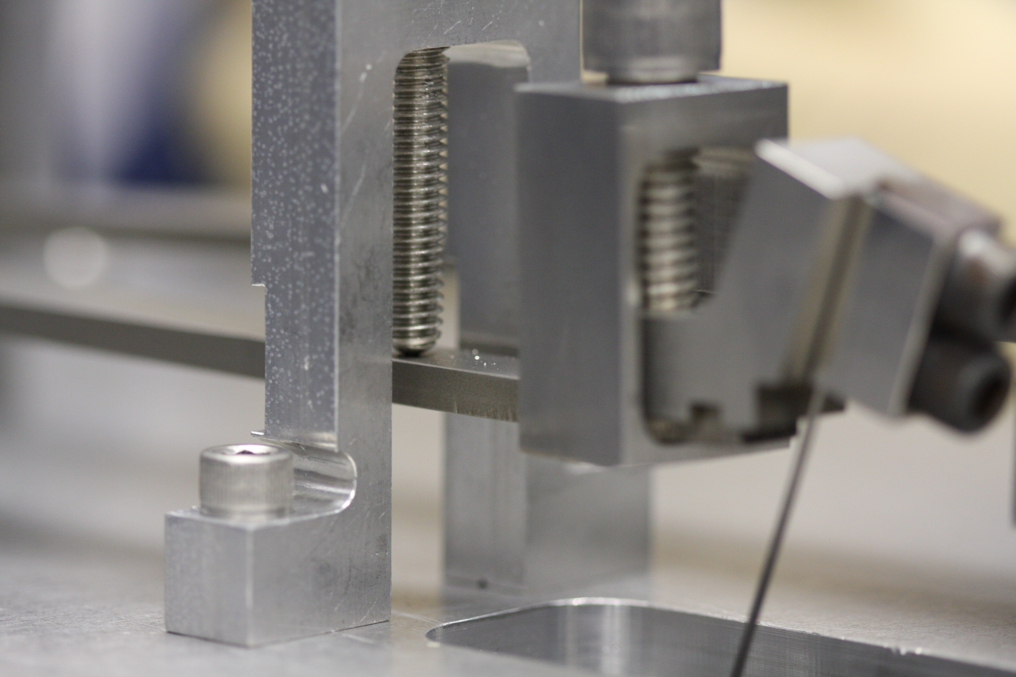
Figure 21 Triple Hang Tooling Blade Clamp
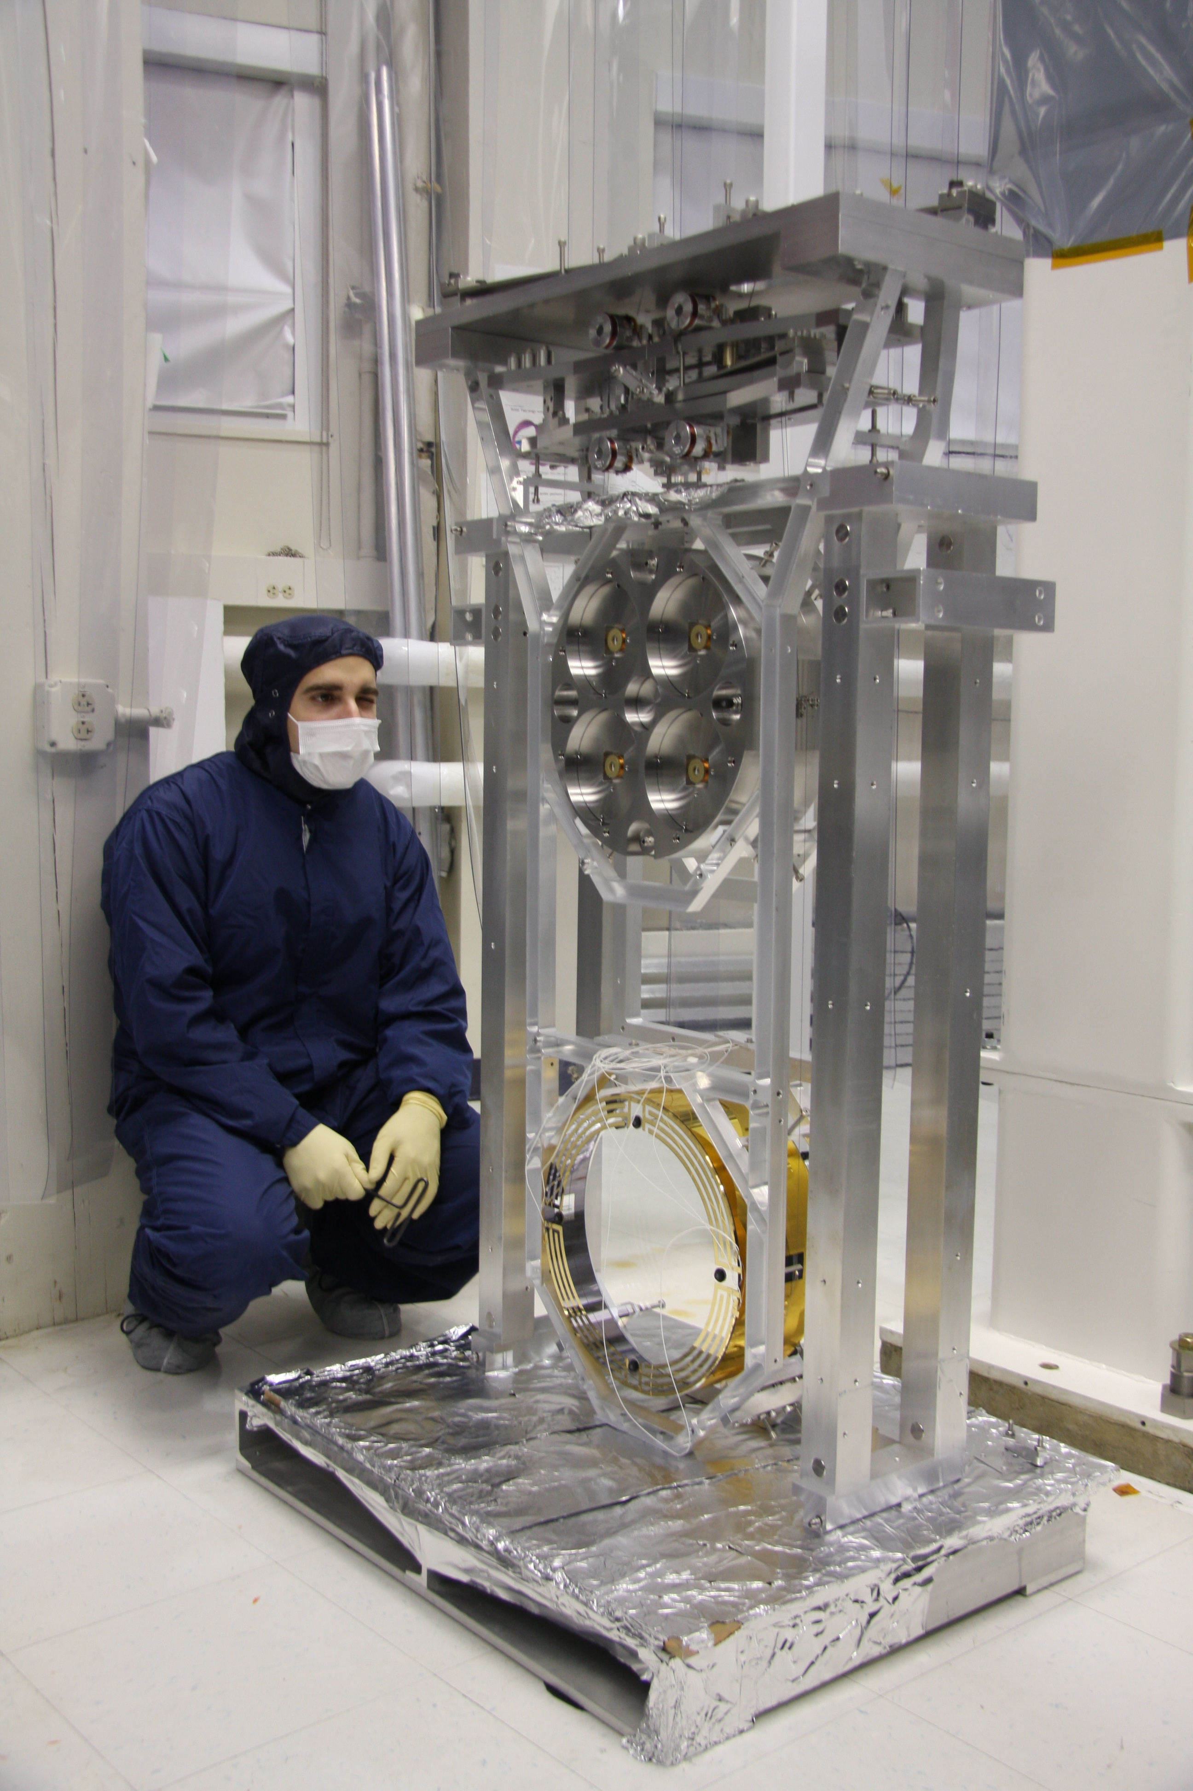
Figure 22 Brett Shapiro Inspecting alignment of Reaction Chain LASTI Quad

Lower structure wrap-up
- Ensure all 6 masses are in their nominal positions and are secured with stops that are wrench (not finger) tightened.
- Use the genie to manipulate the two structures so that they are face to face. This may involve moving one or both of them.
- Bolt two halves of the lower structure together, also bolt the two halves of the lower structure assembly tooling together with the connection plates (4 off)
- Unlock test and penultimate masses in both chains and verify that the penultimate masses are parallel, and that the test reaction mass is hanging at the correct angle. Also verify that there is no differential yaw in each chain. Correct if required (locking the round masses, releasing the UIM masses and manipulating them is the recommended method).

3-in-1 assembly
- Lift lower structure and tooling on to the 5 axis table, ensure that is correctly centered, and that the table will go low enough that the lower structure will fit under the upper, bolt down with dog clamps (8 min).
- Wheel trolley and lower structure under upper structure on gazebo.
- Raise lower structure as far as it will go (~28mm above nominal), so that the legs of the lower structure pushes up against the upper structure, note the lower structure must be correctly orientated, (test mass on test chain side).
- Use the slack in the UI wires to connect them to the top masses. Note that the top masses are in their nominal positions WRT the upper structure and the UI masses are in their nominal position WRT the lower structure. If necessary lower the blades on top mass using the stops in order to allow the wires to be connected.
- Let down the Lower structure into its nominal position, (28mm gap)
- Insert implementation shim and connect lower and upper structures, 8 bolts.

Suspending
In general, the more carefully each assembly and alignment step is done, the easier later steps will become. For example, the more accurately the blade springs were installed during assembly, the easier it will be to balance pitch. The more precisely pitch is balanced on the first time through the alignment procedure, the fewer iterations will be needed to align all OSEMs, ECDs, and ESD.
While making adjustments on the quad make sure to watch out for touching stops and for interferences between the chains at every step. In particular the top masses have tight clearance around the blade spring clamp bolts. These bolts tend to get caught under the top plate of the opposing top mass if pitch and roll are not carefully aligned. There is nothing worse than spending an hour making adjustments only to discover that it was all for naught because a screw you did not see was touching one of the masses.
Remember that the blade springs magnify the tilts of the masses below them because their compliance allows for differential tilt between the masses.
Pitch is likely to cause a lot of trouble if the blade spring alignment within the rectangular masses is off. Pitch specifically is sensitive to errors in the blade assembly because any lateral misalignment of the blade tips away from the center of mass at each stage will generate a torque that will introduce a differential pitch between that stage and the one above it. If this problem is too extreme, it will be impossible to meet all the constraints of the OSEMs and test masses simultaneously, and the springs will need to be repositioned. Each blade tip should have exactly 5 mm of clearance on either side. Intolerable errors are on the order of a few tenths of a mm. More details on the spring positioning are in the procedure below.
- While ensuring that the test and reaction chains are not interacting, focus on one chain at a time.
- Starting from the bottom of the chain and working upward, release masses one at a time continuing to check for interference.
- With the Test, Penultimate, and UI Masses released the chain should behave as it did during the triple hang tooling section above.
- If pitch or roll is observed revisit blade tip height and lateral adjustments on the UI Mass with the UI Mass clamped level. If pitch is still observed, mass may need to be adjusted at the PEN stage, depending on where the differential pitch is observed. Release the UI Mass.
- Release the Top Mass, and Top Stage.
- If pitch or roll is observed adjust the blade tip heights and lateral positions to nominal positions on the Top Mass with the Top Mass clamped level. If pitch is still observed, mass may need to be adjusted at the UIM stage, depending on where the differential pitch is observed. Release the Top Mass.
- Repeat steps 1 though 6 on the remaining chain.
- With both chains hanging take reference measurements as per dimensioned D0901346 to check overall heights at various stages.
- Overall height (Z), roll, and side shift (test masses not being lined up barrel to barrel) should now be adjusted out at the Top Stage with the 0.5mm and 1.0mm shims. Shim stacks should not exceed 6.0mm.
Note: Shim stack size is dependent on the stiffness’s of all blades combined.
Refer to Section T1000407 Quad Suspension, Balancing, and Alignment Procedure on fixing problems.

Final assembly
- Balance and align the quad to the point where both chains are at the correct height and are correctly pitched, and yawed.
Note: alignment of the OSEMs will affect the pitch.
- Add the front and back plates to the tablecloth omitting the ECD and OSEM mounts.
- Add sleeve before cartridge installation. Use wedges as per D1001090 Sleeve to Lower Structure Interface Wedges.

Storage
Using the D1001222 and D1001223 Modified LSAT Top Plates hang the LS from the Installation Genie. Set the Top Plates (and LS) into the LS QUAD Storage Container. Use the end caps on the shelves in the storage box to clamp the LS down to the box. Remove the Genie. (The Top Plates stay with the Lower Structure until the cartridge is installed.)

Tools
Ian’s list
Test stand: | Mechanical Test Stand mounted with Solid Stack Assembly
Manual fork truck: | Similar to Caltech Genie
Bench: | May be an optics bench but this is not mandatory
Tools: | All the appropriate hand tools and measuring devices
Masses: | These will be necessary to load blades flat.
Lower structure assembly tooling:
Wire jig:

Brett’s list
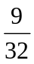 inch nut driver or wrench for axial OSEM positioning.
 inch nut driver or wrench for lateral OSEM positioning.
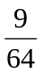, 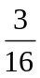, , and 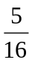 inch allen wrenches.
A flat head screw driver for turning the top mass pitch adjusters.
Torque wrench for the blade clamp bolts capable of 400 in-lb (33 ft-lbs, 45 Nm).
Slip or block gauges for measuring 5 mm, 9.6 mm, and 15 mm gaps.
Dentist Mirror.
Flashlight or small lamp.
Structure pushers for rotating the structure on the optical table (see Figure 14).
5 axis table for safety while rotating the structure.
Lower structure tooling for use with the 5 axis table.
Safety goggles for working around the wires.
An optical alignment tool with 10 Rad accuracy, such as an autocollimator.
A small, light, reliable level to place on suspended masses (optional).

Useful procedures

Aligning the Brunson transit
- Set up the Brunson about 10’-15’ from the structure, with the telescope at very roughly the height of the mass to be clocked. If you get too close you won’t be able to see both ears/prisms/clamps and if you get too far away, the ears will be too small in the viewfinder to have their height read accurately. If there is a very large difference in height then you need to be careful that the structure is facing the telescope accurately (so that the ears/prisms/clamps are the same distance away), but this is not at all critical. Midway in height between the bottom mass and the penultimate mass is probably good enough, and gets you two clockings for the one setup.
- Make sure the lock on the vertical height adjustment is tight and that upper mechanism is firm against moderate horizontal pressure.
- Level the upper section as accurately as possible using the circular bubble level in the base of the rotating section.
- Turn the telescope pitch adjustment screw until it is roughly in the middle of its range.
- Unlock the telescope pitch clamp screw, roughly level the barrel of the telescope, and relock the clamp screw.
- Using the pitch adjustment screw, level the telescope as accurately as possible looking by eye at the barrel.
- Pick an opposing pair of the brass leveling discs in the leveling section and rotate the upper section until telescope is parallel with the line between the discs.
- Rotate the prism in the knurled housing near the top bubble level so that the aperture is at right angles to the telescope.
- Look into the prism aperture and adjust the long mirror to reflect the most ambient light into the side of the bubble level as indicated by the brightest view in the prism.
- Adjust the pitch adjustment screw until both ends of the bubble can be seen in the prism and are aligned with each other.
- Rotate the telescope by 180°, and then rotate the prism by a further 180° to bring the aperture back to the original direction. Readjust the long mirror if necessary.
- Grip the telescope pitch adjustment screw knob and note its position. Keep careful track of the amount of adjustment required in the next step, either by keeping a grip on the knob (if the amount is not too great), or counting the number of quarter turns of adjustment.
- Adjust the pitch adjustment screw until both ends of the bubble are aligned in the prism.
- Back the pitch adjustment screw off to a point as near as possible to halfway between the initial and final positions.
- Redo the second half of the leveling using the two brass discs identified earlier, rotating them in opposite directions, so as to tighten one as the other is loosened.
- Rotate the telescope another 180° and readjust the prism and long mirror. Hopefully the ends of the bubble will be very nearly aligned. Repeat the previous six steps until convergence is achieved.
- Rotate the telescope by 90° to align with the other pair of brass discs and repeat the previous seven steps.
- Rotate the telescope back to the line of the first pair of brass disks and check that the alignment in that direction has not been disturbed.

Using the ergo-arm
- Connect ergo-arm reservoir to vacuum pump with hose. [According to Mike Gerfen, the hose should be permanently band-clamped to the reservoir, with the quick release fitting at other end connecting alternately to pump and suction plate. We were doing this backwards, and the following procedure has been revised to reflect what we should have done.]
- Start pump, open valve at reservoir, evacuate reservoir to 30 psi, close valve, stop pump, and disconnect hose.
- Connect hose to ergo-arm suction plate.
- Close valve at suction plate, open valve at reservoir, monitor reservoir gauge for short time (e.g., 1 min) to check for stable pressure (i.e., no leaks in hose or connections).
- Bring suction plate near to mass and use horizontal, vertical, pitch and yaw DOFs to match position and angle.
- Hold suction plate firmly against mass and open valve at plate.
- Check that good suction has been achieved (reservoir pressure should still be around 23 psi). If the alignment was poor there will likely be no vacuum at all, in which case, repeat from the beginning, being more careful in Step 5.
- Close the valve at the suction plate, and then the valve at the reservoir. (The suction plate has a very slight leak and a small volume, so closing it requires constant attention to the pressure at the suction plate. If it drops it can be topped up by opening both valves momentarily. But if both valves are open and someone trips over the reservoir and pulls the hose off one of the connectors it’s an instant catastrophe.)
- Raise mass, checking pressures at suction plate and reservoir regularly, and keeping a hand on the crank handle at all times.

Applying/removing First Contact

Applying
See E070292-00.

Removing
- Carefully shave the entire bevel with a sharp single-sided razor blade to remove traces of First Contact that may have spilled there off the face.
- With the edge of the razor blade leading, scrape from the bevel toward the face to prise up a corner of the First Contact on the face. The corner between the straight and curved sections is a particularly good place to start.
- Grab the prised-up corner with gloved fingers and carefully pull the whole sheet off the face, avoiding tears as much as possible.
- If any small patches of First Contact remain, very carefully scrape them off with a razor blade and clean up the area with spectroscopic grade methanol and a lens tissue. (This should not happen if the First Contact was applied thickly enough originally.)

Drag-wiping
- Pour a little spectroscopic grade methanol into a small foil boat or dish.
- Repeatedly, bend a sheet of lens tissue (3”x5” is good) in half without creasing it, dip the bend in the methanol and drag slowly across the optic. (Doug: This bend technique is particularly good for vertical surfaces.)
- Work by strips, using a fresh sheet each time. If the lens tissue does not stick to the optic with surface tension, it is too dry. If it leaves streaks of liquid methanol behind (especially from the corners), it is too wet.

Appendix A: Useful Balancing and Alignment Data
Table 1 contains a summary of useful data needed to meet the alignment requirements for the metal suspension. Most of these parameters also apply to the glass suspension, those that do not are labeled with a * or **.

Parameter | Measurement
UI blade spring tip height [3] | 15 mm
UI blade spring lateral position [3] | 5 mm
UI blade spring clamp bolt torque [6] | 100 in-lbs (8.3 ft-lbs, 11.3 Nm)
Top mass blade spring tip height [3] | 9.6 mm
Top mass blade spring lateral positions [3] | 5 mm
Top mass blade spring clamp bolt torque [6] | 330 in-lbs (27.5 ft-lbs, 37.3 Nm)
Top stage blade spring clamp bolt torque [6] | 330 in-lb (27.5 ft-lbs, 37.3 Nm)
Main chain test mass pitch * | ±100 µRad
Main chain test mass yaw [4] | ±10 µRad
Reaction test mass to main test mass ** | 5±0.25 mm around the circumference
Table 1Table of useful balancing and alignment parameters. All the blade spring measurements are relative to the references discussed in 5.3. * The glass test mass pitch tolerance is ±10 µRad [4]. ** The glass reaction test mass still needs to be spaced 5±0.25 mm from the main test mass, however the parallelism requirement tightens to ±100 µRad [4].

Appendix B: Sample Transfer Functions
Figure 15 illustrates the coordinate system referenced in this document and used in the following transfer functions in Figure 25 through Figure 29. These transfer functions make good initial references while checking for interferences and debugging. Each suspension should eventually have a set of its own reference transfer functions. All the transfer functions here are measured only from the main chain since the reaction chain is nearly identical.
The preference for measuring transfer functions on the quad at LASTI has been to use either a white noise excitation or a Schroeder multi-sine excitation. Both of these methods are broadband and allow the entire interesting spectrum (0.1 Hz to 10 Hz) of the quad to be measured simultaneously. Using these methods, quick transfer functions are measurable in a few minutes or less which provide sufficient detail to search for interferences or debug. The Schroeder multi-sine excitation is the quickest because it injects many known sine waves simultaneously throughout the spectrum, thus providing enhanced coherence over white noise. The sample figures below, with the exception of pitch, were measured with the Schroeder approach (each measured over a few hours). Pitch, Figure 28, was measured with white noise.
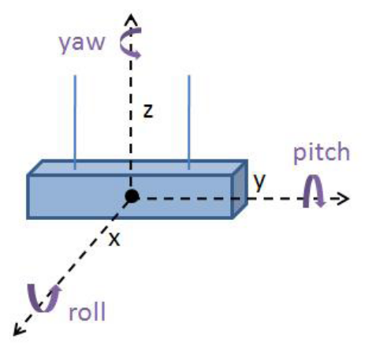
Figure 23 The coordinate system of one of the rectangular masses. All the masses have similar coordinate systems.
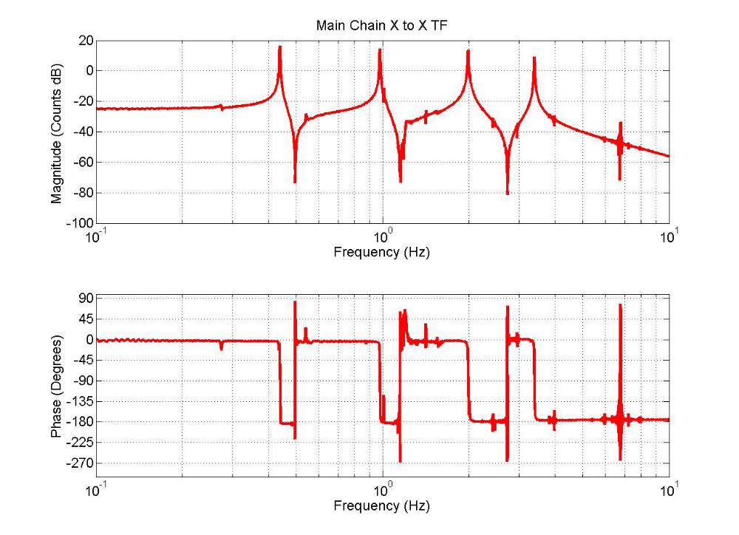
Figure 24 An x to x transfer function from the main chain top mass.
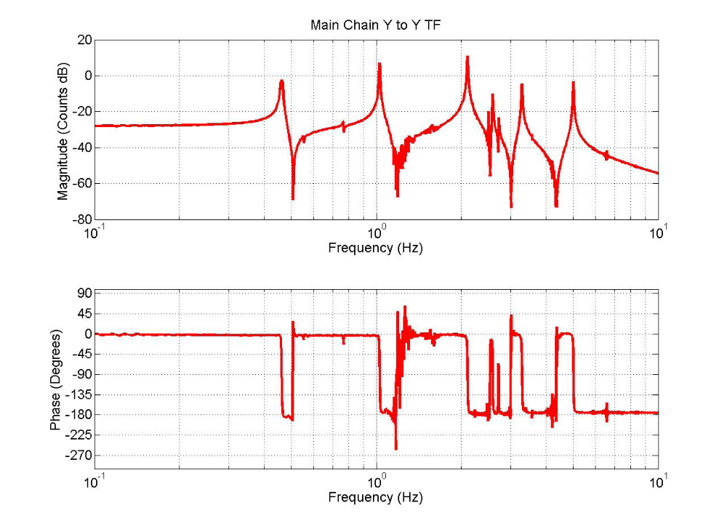
Figure 25 A y to y transfer function from the main chain top mass.
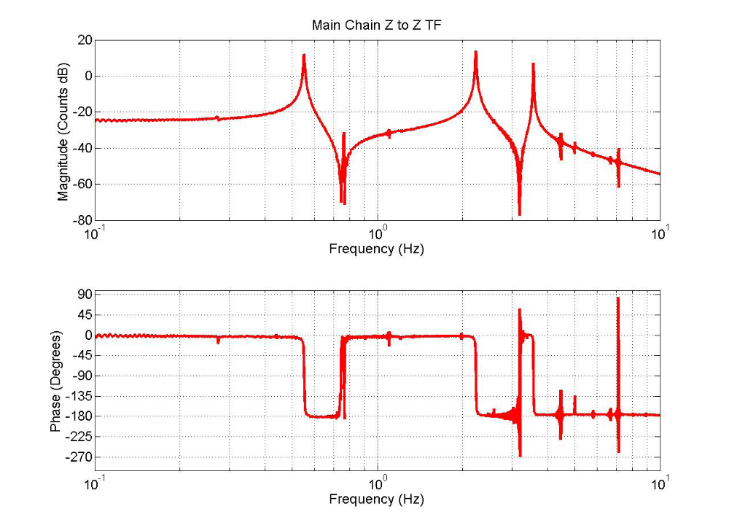
Figure 26 A z to z transfer function from the main chain top mass. The 4th vertical mode is near 17 Hz and is not observable from the top mass. The 4th mode exists mostly as the vibration of the wires between the two round masses.
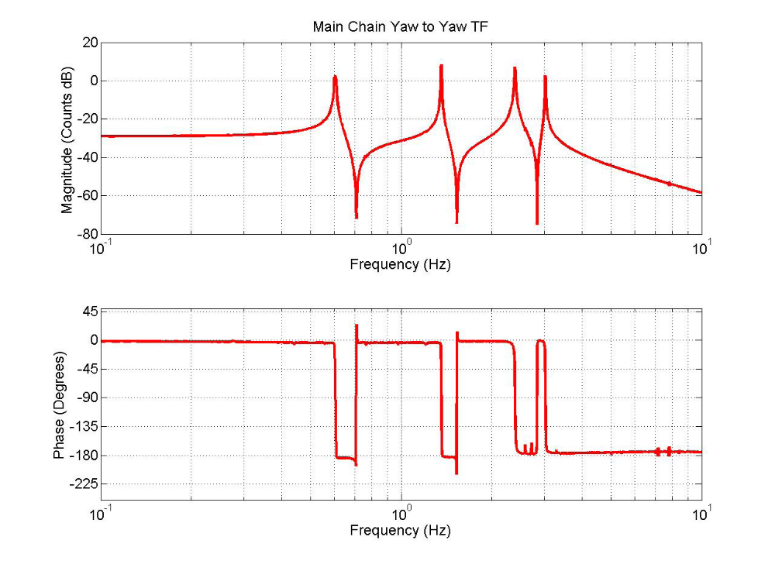
Figure 27 A yaw to yaw transfer function from the main chain top mass.
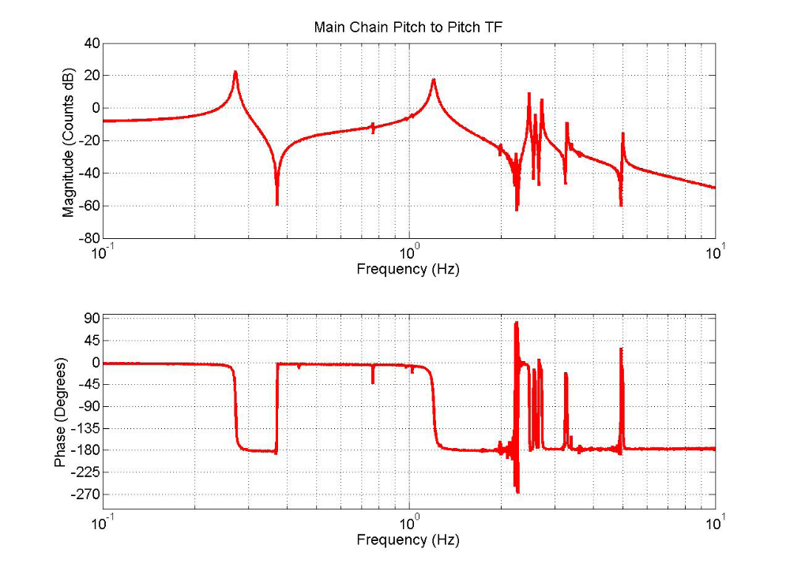
Figure 28 A pitch to pitch transfer function from the main chain top mass.
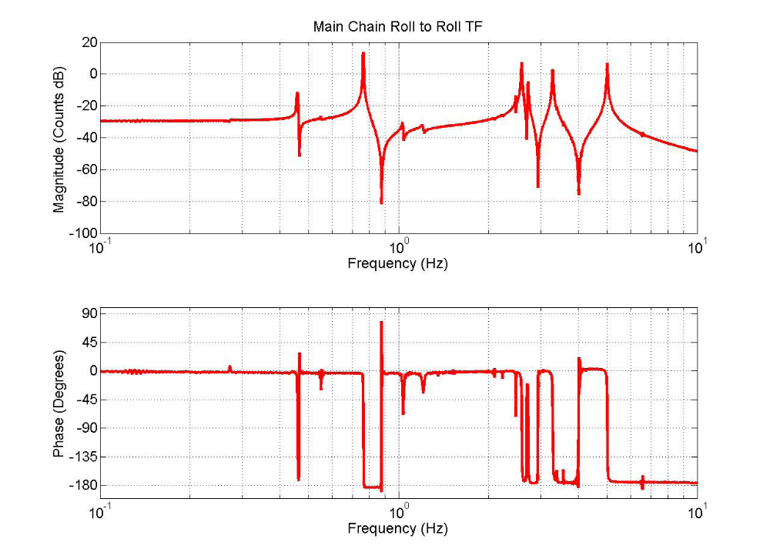
Figure 29 A roll to roll transfer function from the main chain top mass.

Appendix C: Related Documents
Numbers cited throughout this document refer to these documents.
1. Noise prototype Assembly procedure - T060040-05
URL: http://www.eng-external.rl.ac.uk/advligo/Reviews/FRR/Documents/t060040-06.doc
Description: This is the assembly procedure from RAL which should at this point be completed before balancing and alignment is to begin.
2. Quad Suspension Balancing and Alignment Procedure (UK Document)
URL: http://www.eng-external.rl.ac.uk/advligo/Reviews/FRR/Documents/Quad suspension Balancing and Alignment procedure.doc
Description: This document is the precursor to this updated procedure. It is a valuable reference since it contains additional details on how all the adjustments work and ideas on how to trouble shoot. This update should be considered a continuation, not a replacement.
3. Useful Data for Noise Prototype Quad Assembly (UK Document)
URL: http://www.eng-external.rl.ac.uk/advligo/documents/Useful data for Noise Prototype Quad assembly.pdf
Description: This document contains useful information about basic aspects of the quad such as weights, wire lengths and diameters, a description of how the blade tip positions are determined, and suspension stability.
4. Alignment Requirements for Quad - T080128-00-K
Description: All the final alignment requirements for the quad are listed here.
5. AdvLIGO Quad Suspension Controls Prototype Suspension and Adjustment Method - T060039-00
Description: This is the assembly and alignment procedure written for the quad controls prototype. Although the controls prototype clearly has some differences, many of the principles of aligning a quad are the same. As a result, this document is still a valuable reference of experience gained during the prototyping phases of the quad.
6. Holo-Krome Bolt Torque Data Sheet
URL: http://www.holo-krome.com/pdf/techbk34-40.pdf
Description: This data sheet provides recommended bolt torque values from Holo-Krome.
7. Quad Pendulum Structure Pushers - T080230-00-0
Description: This document provides additional detail on the use of the quad pendulum structure pushers used to align the quad structure on the seismic table.

