LIGO Laboratory / LIGO Scientific Collaboration

LIGO-T0900614-v1 aLIGO December 2009

aLIGO PSL Safety Plan

Peter King (ed.)

Distribution of this document:
LIGO Scientific Collaboration

This is an internal working note
of the LIGO Laboratory.

Albert-Einstein-Institut  Callinstraße 38  Hannover, D-30167  Federal Republic of Germany  Phone (05 11) 762 2229  FAX (05 11) 762 2784 | California Institute of Technology  LIGO Project – MS 18-34  1200 E. California Blvd.  Pasadena, CA 91125  Phone (626) 395-2129  FAX (626) 304-9834  E-mail: info@ligo.caltech.edu
Laser Zentrum Hannover  Hollerithallee 8  Hannover, D-30419  Federal Republic of Germany  Phone (05 11) 27 88 0  FAX (05 11) 27 88 100  E-mail: info@lzh.de | Massachusetts Institute of Technology  LIGO Project – NW22-295  185 Albany St  Cambridge, MA 02139  Phone (617) 253-4824  FAX (617) 253-7014  E-mail: info@ligo.mit.edu
LIGO Hanford Observatory  P.O. Box 159  Richland, WA 99352  Phone (509) 372-8106  FAX (509) 372-8137 | LIGO Livingston Observatory  P.O. Box 940  Livingston, LA 70754  Phone (225) 686-3100  FAX (225) 686-7189

http://www.ligo.caltech.edu/

Foreword
This document, aLIGO PSL Safety Plan (LIGO-T0900614-v1), replaces all other earlier versions of the document.

Introduction
The Advanced LIGO PSL Safety Plan is a set of procedures and recommendations designed to facilitate safety and accident prevention when working on the Advanced LIGO PSL. Whilst these recommendations are not steadfast rules, these are areas that bear attention.
It should be noted that the Advanced LIGO PSL falls under the umbrella of the LIGO Laser Safety Program (LIGO-M960001) and as such inherits its policies and procedures.

The Advanced LIGO Laser
The Advanced LIGO PSL is built around the Advanced LIGO Laser from Laser Zentrum Hannover. The Advanced LIGO Laser consists of a 200-W injection locked high power oscillator with a 35-W seed laser. The seed laser is a master-oscillator power-amplifier consisting of a 2-W InnoLight Mephisto laser, commonly referred to as the NPRO, followed by a four-stage power amplifier. A schematic of the Advanced LIGO Laser and its major optical components is shown in Figure 1.
The components of the Advanced LIGO Laser are split into two rooms: the Laser Area Enclosure (LAE) and the Laser Diode Room (LDR). The LDR houses the chillers that supply cooling water for the Advanced LIGO Laser and the many pump diodes used to pump the laser gain media. The LAE houses the PSL Table, on which the Advanced LIGO Laser sits, and the optical hardware and components that form the PSL subsystem.
Note that both the LAE and LDR are controlled access areas.

Laser Wavelengths
There are two wavelengths of concern with the Advanced LIGO PSL: the pump wavelength at 808 nm and the output wavelength at 1064 nm. Both wavelengths are in the infrared region of the electromagnetic spectrum and are therefore invisible to the naked eye.

Laser Classification and Output Powers
The Advanced LIGO Laser is a Class 4 laser and has a nominal output power of 200 W.
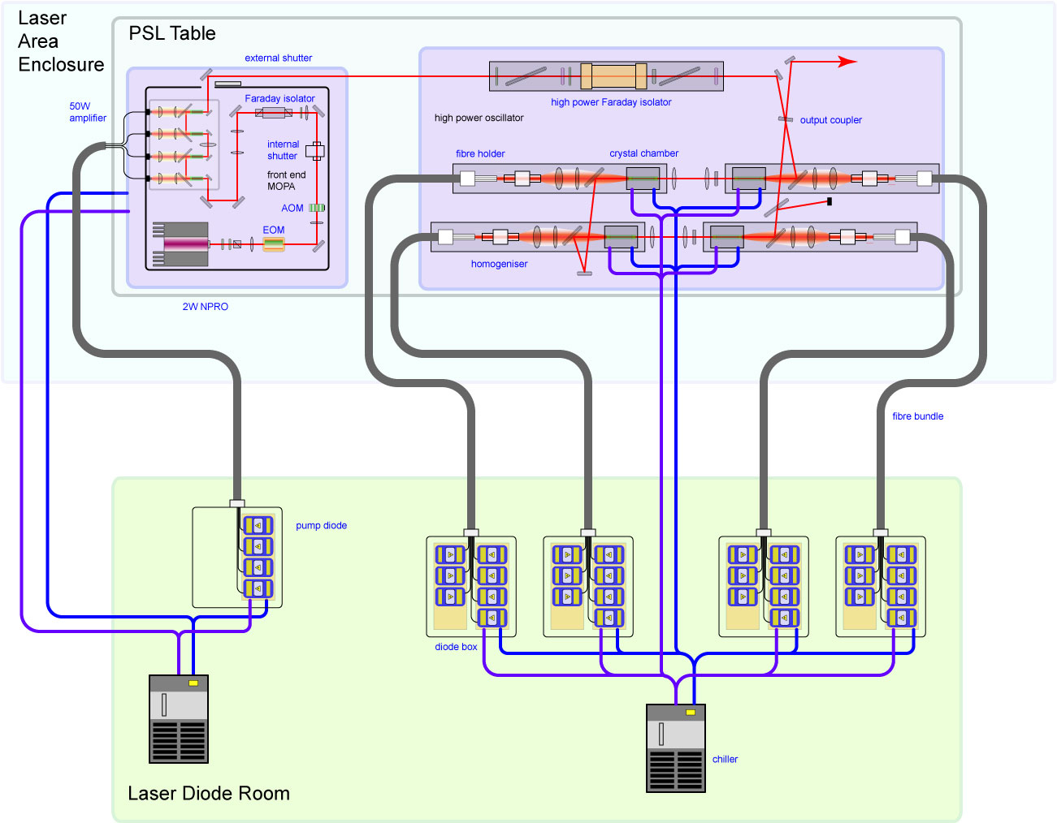
Figure 1. The major components of the Advanced LIGO Laser.

Safety Instruction
Personnel working with the Advanced LIGO PSL should receive specific training in addition to the basic laser safety training provided by the LIGO Project.

Safety Information and Work Permits
Any activity requiring that special safety precautions be taken, shall have a visual notification of that particular activity. For example alignment activities shall be clearly posted.
Activities involving changes to or manipulation of the configuration on the PSL Table shall be listed in a work permit. The work permit should list the precautions required for all personnel.

Proper Attire and Laser Safety Eyewear
Any personnel working on the PSL Table shall wear the proper cleanroom attire for the LAE. This is not a whimsical requirement. Experience at the AEI and LZH has demonstrated that the presence of dust near the Advanced LIGO Laser can cause damage to its optical surfaces.
Any personnel working on the PSL Table shall wear the proper laser safety eyewear when the Advanced LIGO Laser is on or energized.

Standard Operating Procedures
Any operation involving the Advanced LIGO Laser that is seldomly or infrequently performed shall have a written procedure that identifies the potential hazards of the operation and how to deal with them. Examples of such operations are:
- Operation of the 35-W seed laser without operating the high power oscillator
- Operation of the high power oscillator without operating the 35-W seed laser
- Measuring the pump power delivered at the end of each fibre bundle

Adjustments to the Advanced LIGO Laser Configuration
Unless covered by a procedure or written agreement, any adjustment or alteration to the Advanced LIGO Laser configuration must be agreed to by the PSL Task Leader or their designate. This safeguards against possible damage to the Advanced LIGO Laser.

Storage of Equipment
Any equipment that is not being used should be stored in the appropriate storage cupboard in the LAE. No equipment is to be stored on the PSL Table.

Accidents
Any and all accidents shall be reported to the Laser Safety Officer in a timely manner.

Monitoring
This safety plan is intended to be a living document to ensure that its contents are relevant and up to date. The document should be regularly reviewed, as is the case for standard operating procedures. Where a safety aspect falls down the plan should be reviewed to ascertain the system breakdown and if necessary the plan modified to prevent a recurrence.

NPRO is an acronym for Non-planar ring oscillator.
As per ANSI Z136.1-2007 American National Standard for Safe Use of Lasers

