1 Safety 2
2 Objective and Scope 2
3 Contamination Control 4
4 Hardware and Fasteners 5
5 Documents 7
6 Documenting the Assembly Process 8
7 Preparing the Structural Weldment 10
8 Assembling the Top Blade Guards 13
9 Assembling the Face Earthquake Stops 13
10 Assembling the Barrel Earthquake Stops 14
11 Assembling the AOSEM Alignment Assemblies 17
12 Assembling the Rotational Adjusters 20
13 Assembling the Upper Mass (M1) 24
14 Assembling Magnets – Upper Mass 34
15 Assembling the Intermediate Mass (M2) 36
16 Assembling the Lower Mass (M3) 38
17 Attaching the Top Blade Guards 40
18 Installing the Rotational Adjusters 40
19 Installing Barrel EQ Stops 40
20 Installing Intermediate and Lower Masses and Face EQ Stops 44
21 Safe Handling of Suspension Wire 47
22 Assembling the Intermediate Wires 48
23 Assembling the Upper Wires 52
24 Installing the Upper Mass and Coil Holder 56
25 Assembling the Lower Wire 61
26 Suspending the Masses 65
27 Balancing of the Suspended Masses 67
28 Removing the Suspended Components 75
29 Creep Baking the Upper and Lower Blades 75
30 Bonding Magnet Assemblies to Intermediate Mass 85
31 Bonding Magnet Assemblies to Lower Masses 88
32 Reinstalling the Suspended Components 93
33 Installing AOSEM Brackets 93
34 Installing AOSEMs and BOSEMs 94
35 Metal-Build Testing 96
36 Storage and Transport 96
37 Replacing the Lower Mass with the Optic 96
38 Glass-Build Testing and Installation into Chamber 97

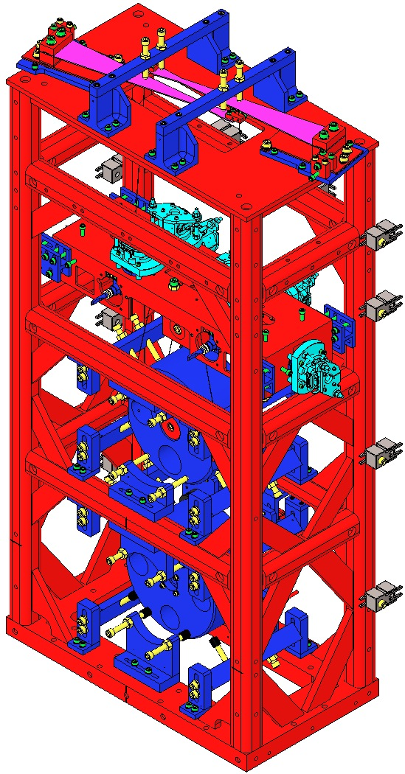  Fig 1: HSTS | 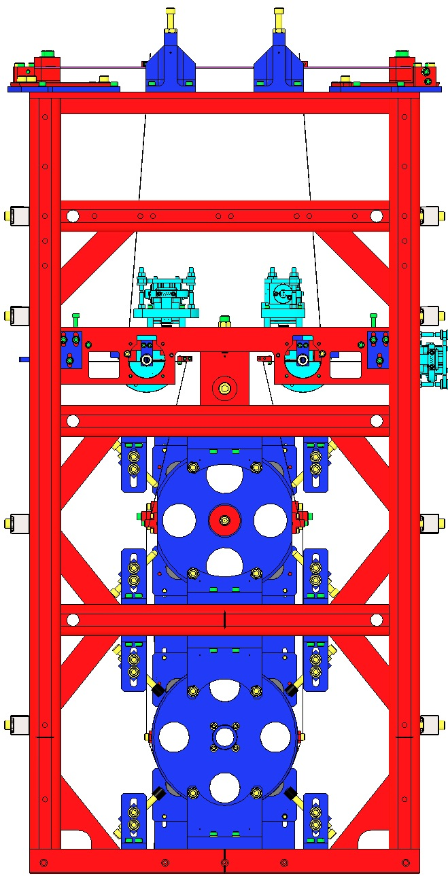  Fig 2: Front | 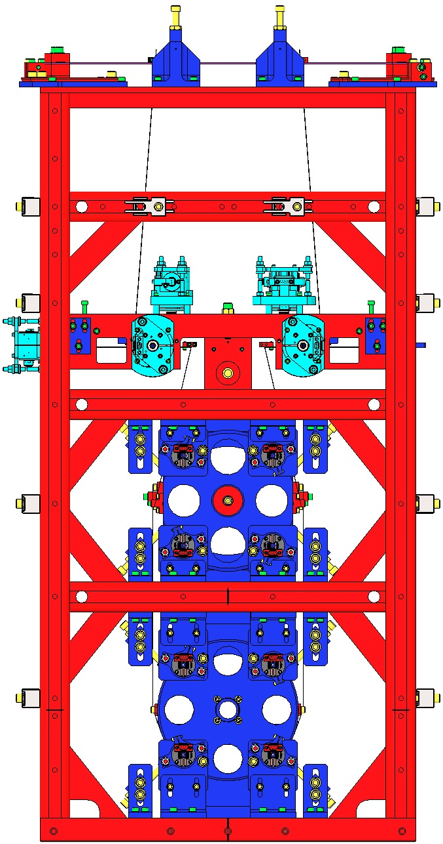  Fig 3: Rear

Safety
Read and understand the HSTS Assembly and Installation Hazard Analysis (E0900332). For specific safety information on wire handling, see Section 21.

Objective and Scope
The objection of this document is to outline and describe the steps necessary for the assembly of the HSTS. The following tasks are within the scope of this document:
- Assembly of subassemblies (Masses, Wires, Earthquake Stops, etc.), including the use of jigs and fixtures shown in D040391 (HSTS Overall Assembly and Assembly Fixtures)
- Installation of subassemblies into the suspension structure
- Balancing of the suspension
- Gluing magnets on the metal masses and optic
- Installation and alignment of OSEMs
- Creep baking of the maraging steel blades
- Installation of the optic into the suspension
- Transportation of the suspension using a storage container

The following tasks are outside the scope of this document:
- Testing and commissioning of the suspension – see Ideal Order/Contents of aLIGO Triple Suspension Testing/Commissioning (G1200070)
- Gluing primary and secondary prisms to the optic – see Prism Gluing for Input Optics (E1200211)
- Installation of the suspension into the chamber – see the HSTS Installation Document (E0900334)

Assembly Sequence
The steps required for the assembly of the HSTS are listed below. Some of the steps can be done in parallel with one another, while other steps can be rearranged to accommodate whatever tools, parts, or hardware are available.
- Prepare Structural Weldment Assembly (D020023)
- Assemble subassemblies, in any order:
  - Top Blade Guard Assemblies (2X D0901934)
  - Face Earthquake Stop Assemblies (2X D0902413 and 2X D0902205)
  - Barrel Earthquake Stop Assemblies (2X D0902203 and 6X D0902201)
  - AOSEM Alignment Assemblies (4X D0901924 and 2X D0902207 and 2X D0902208)
  - Rotational Adjusters (2X D1000045)
  - Upper Mass Assembly (1X D020534)
  - Intermediate Mass Assembly (1X D0901873)
  - Metal Lower Mass Assembly (1X D0901791 or D0902333 or D1200886)
- Attach Top Blade Guard Assemblies to Structural Weldment
- Attach Rotational Adjusters on Structural Weldment and flatten Upper Blades
- Attach Barrel Earthquake Stop Assemblies on Structural Weldment
- Install Intermediate and Metal Lower Mass Assemblies
- Attach Face Earthquake Stop Assemblies
- Assemble Intermediate Wire Assemblies (4X D0901905) and attach to Upper Mass Assembly
- Assemble Upper Wire Assemblies (2X D0901854) and attach to Upper Mass Assembly
- Place Coil Holder/Tablecloth (D020239) over Upper Mass Assembly and lock the two together
- Attach Upper Mass/Coil Holder Assembly (D020535) to Structural Weldment
- Connect Upper Wire Assemblies to Upper Blades
- Connect Intermediate Wire Assemblies to Intermediate Mass Assembly
- Assemble Lower Wire Assembly (D0901902)
- Attach Lower Wire Assembly to Intermediate Mass Assembly
- Suspend all masses
- Initial balancing
- Remove all Masses and Rotational Adjusters
- In parallel:
  - Creep baking of Upper Blades (in Rotational Adjusters) and Lower Blades (in Upper Mass Assembly)
  - Magnet gluing for Intermediate Mass and Metal Lower Mass Assemblies
- Reinstall Rotational Adjusters, Wires and Masses
- Rebalancing
- Install AOSEM Alignment Brackets
- Install BOSEMs on Coil Holder/Tablecloth
- Metal-Build Testing (Phase 1) (not covered in this document – see G1200070)
- Transport HSTS to chamberside using a storage container
- Metal-Build Testing, Continued (Phase 2a) (not covered in this document – see G1200070)
- Replace Metal Lower Mass with Glass Optic
- Rebalancing
- Glass-Build Testing (Phase 2b) (not covered in this document – see G1200070)
- Install HSTS into chamber (not covered in this document – see E0900334)
- In-Chamber Testing (Phase 3) (not covered in this document – see G1200070)

Contamination Control

Related Documents
E0900047 LIGO Contamination Control Plan
E960022 LIGO Clean and Bake Methods and Procedures

General Practices
All assembly procedures must be performed in a Class 100 clean room environment while wearing:
- Hood
- Face Mask
- Coverall
- Overshoe Boots
- LIGO-approved UHV Gloves
- Safety Glasses (when working around wires, blades under load, and/or chemicals)
- Glove Liners (when pulling Wire Assemblies)
All work surfaces used for Class A or B components should be wiped down at the beginning of each work day, first with Acetone, then with Isopropanol. All HSTS parts are Class A hardware and, once cleaned and baked, should not come into contact with anything but Class A or B hardware. Review the LIGO Contamination Control Plan (E0900047) for details.

Clean and Bake of Components
All parts and hardware must be cleaned and bake to Class A or B as described in E960022. Any part that comes into contact with anything other than an equivalent to a Class A or B part must be recleaned and rebaked.

Hardware and Fasteners

Applications of Screw Types
The table below lists the most common types of screws used in the assembly of the HLTS, along with their applications. These types and applications apply to socket head cap screws (SHCS), flat head cap screws (FHCS), and set screws.
Table 1: Common Types of Screws
Screw Type | Description | Applications
Stainless Steel (SSTL) | Most common type of screw | - Threaded holes in aluminum parts  - Helicoils, in any material
Stainless Steel, Vented | Stainless steel screw with a hole drilled through the shank of the screw | - Threaded holes in aluminum parts where the trapped volume in the hole must be vented  - Helicoils, in any material, where the trapped volume in the hole must be vented
Silver-Plated (Ag-Plated) Stainless Steel | Stainless steel screw plated with a thin layer of silver | - Threaded holes ONLY in stainless steel parts
Silver-Plated Stainless Steel, Vented | Stainless steel screw plated with a thin layer of silver with a hole drilled through the shank of the screw | - Threaded holes ONLY in stainless steel parts where the trapped volume in the hole must be vented

Silver-Plated Stainless Steel Screws
As listed in the table above, all Silver-Plated screws are made of stainless steel SSTL, so they may be labeled simply as “Ag-Plated”, not “Ag-Plated SSTL” in this document.

Torque Values
All Socket Head Cap Screws (SHCS) are required to be tightened to the proper torque value using a torque wrench. The proper torque values (unless otherwise specified in this document) come from T1100066 on the DCC and are listed in the table below. In future sections, the given torque values will be rounded to the nearest in-lb.
Torque values for Flat Head Cap Screws (FHCS) will be given in sections where the screws are used. In general, set screws are tightened by hand, not with a torque wrench.
Table 2: Torque Values for SHCS
Supplier | Generic | Holo-Krome | UC Components
Type | Unplated | Unplated | Unplated, Vented | Ag-Plated | Ag-Plated, Vented
SHCS Size | Torque (in-lb)
#2-56 | 2.5 | 4 | 2.9 | 4 | 2.9
#4-40 | 5.2 | 6 | 6.7 | 6 | 6.7
#8-32 | 19.8 | 30 | 25.2 | 30 | 25.2
¼-20 | 75.2 | 100 | 85.8 | 100 | 85.8

In this table, all values are for coarse-threaded (UNC) SHCS, as shown by the listed thread pitch. Torque values for fine-threaded (UNF) or specially-threaded (UNS) SHCS will be given in sections where they are used. The Supplier of a SHCS can be determined in this manner: all Ag-Plated SHCS and vented SHCS are supplied by UC Components; Holo-Krome SHCS are indicated by an “H-K” marking on the head; all other SHCS should be considered to be generic, unless UC Components is positively known to be the supplier.

Tightening Screw Patterns
To ensure proper alignment of components and to ensure even clamping pressure, it is important to tighten the final few threads of screws in a pattern evenly. That is, after all screws have been tightened initially by hand, each screw should be turned no more than ¼ turn (either by hand or with a torque wrench) before continuing to the next screw. Continue to tighten each screw ¼ turn in sequence until all screws are properly torqued.

Helicoils
Helicoils (also known as threaded inserts) are used in threaded holes in aluminum or SSTL parts for a number of reasons:
- Additional strength
- Additional durability (for example, where a screw is frequently tightened and loosened for adjustment or repeated assembly/disassembly)
- To avoid the use of Ag-Plated hardware in a SSTL part
- To lock a screw in place (screw-lock helicoils only)

All helicoils used in this assembly are to be made of Nitronic 60. As with any other type of hardware, helicoils are cleaned and baked to Class A and installed using clean tools in a Class 100 clean room. After installation but before removing the tang, all helicoils should be checked by inserting a SHCS of sufficient length.

Washers
The majority of washers used in assembly are flat washers made from stainless steel. In specific locations where parts slide against one another, Nitronic 60 flat washers (D1100785, various types) may be used; these locations will be called out in the assembly procedure.

Documents
E0900332 HSTS Assembly and Installation Hazard Analysis
E1100471 HSTS Assembly and Installation Documentation
G1100107 HSTS Introduction
T0900435 HSTS Final Design Document
E030518 HSTS Assembly Instructions (this document)
D040391 HSTS Overall Assembly and Assembly Fixtures
D020700 HSTS Overall Assembly
E0900334 HSTS Installation Procedure
G1200070 Ideal Order/Contents of aLIGO Triple SUS Testing/Commissioning
T0900559 HLTS/HSTS/OMCS Blade Groupings
E0900047 LIGO Contamination Control Plan
E1000169 Blade Characterization Spreadsheet
E960022 LIGO Vacuum Compatibility, Cleaning Methods and Qualifications Procedures
E990196 Magnet/Standoff Assembly Preparation Specification
T000053 aLIGO, Universal Suspension Subsystem Design Requirements
T010007 Cavity Optics Suspension Subsystem Design Requirements
T010103 aLIGO Suspension System Conceptual Design

Documenting the Assembly Process

Related Documents
T1100003 Building Suspensions Subassemblies in ICS
T0900559 HLTS/HSTS/OMCS Blade Groupings
E1200343 OSEM Chart
E1200145 HLTS/HSTS Optic Assemblies with Assembly Numbers

Inventory Control System (ICS)
For Advanced LIGO, all information on parts and assemblies will be recorded in the Inventory Control System (ICS). Information may also be stored in other documents, but it must be included in ICS as well.
As assembly progresses, each (sub)assembly should have an assembly record created in ICS and each part included in that assembly should be added to the corresponding assembly record. In general, this means that parts will be identified by serial number and assemblies will be identified by the serial number of a central part (as outlined in T1100003). Some parts are too small or too numerous to have serial numbers; these parts have been added to ICS in bulk. If the bulk quantities of a particular part have been divided into groups that match the number of parts in an assembly, then that part should be added to the assembly record.
In addition to part and serial numbers, there is important data that should be included in certain assembly records. This data should be included as a comment, but can be supported by images or other attachments. Data that should be recorded is listed in the table below.

Table 3: Data to be Recorded in Assembly Records
Assembly Record | Data to be Recorded
HSTS Overall Assembly (D020700) | - Overall weight information (including a list of parts that were included when the suspension was weighed)
Rotational Adjusters (D1000045) | - Rotational Adjuster position in Overall Assembly  - Blade serial number  - Blade clamp angle and orientation (blade tip up or down)  - Shim height
Upper Wire Assemblies (D0901854) | - Amount of mass used to pull Wire Assembly
Upper Mass Assembly (D020534) | - Blade serial numbers  - Blade positions  - Blade clamp angles and orientations (blade tip up or down)  - Pre-creep bake mass value and additional mass configuration  - Metal-build mass value and additional mass configuration  - Final mass value and additional mass configuration
Intermediate Wire Assemblies (D0901905) | - Amount of mass used to pull Wire Assembly
Intermediate Mass Assembly (D0901873) | - Pre-creep bake mass value and additional mass configuration  - Metal-build mass value and additional mass configuration  - Final mass value and additional mass configuration
Lower Wire Assembly (D0901902) | - Amount of mass used to pull Wire Assembly
Metal Lower Mass Assembly (D0901791 or D0902333) | - Pre-creep bake mass value and additional mass configuration  - Metal-build mass value and additional mass configuration
Coil Holder Assembly (D020535) | - BOSEM serial numbers and positions
AOSEM Bracket Assemblies (D0901924, D0902207, and D0902208) | - AOSEM serial number  - AOSEM and bracket position
Optic Assembly (see E1200145) | - Mass value of glass only  - Total mass value (including magnets and prisms)

Process Travelers
Process travelers may be used to temporarily record information about part and serial numbers and other relevant data. Any final information recorded in a process traveler must be transferred to the corresponding assembly record in ICS.

aLogs
The Advanced LIGO logbooks (or aLogs) are used at the Livingston and Hanford Observatories to keep a daily record of activity on the site. Progress reports during assembly should be posted regularly, along with information important to the assembly process and any other relevant data. Any final data must be transferred to the corresponding assembly record in ICS.

Other Documents
A number of other documents on the DCC and elsewhere are used to record data for certain important suspension parts. These documents are listed below:
- HLTS/HSTS/OMCS Blade Groupings (T0900559) – This document lists suggested groupings of Upper and Lower Blades, along with blade clamp angles and orientations; final information on actual blade positions and blade clamp angles and orientations should be added to this document.
- OSEM Chart (E1200343) – This document lists information on BOSEMs and AOSEMs, including open-light counts and other data; the BOSEMs and AOSEMs are arranged by suspension and then position within the suspension. Final information on OSEM positions and other data should be added to this document.
- Nebula – This webpage, maintained by the Core Optics group, lists all COC and IO optics along with relevant information, such as mass values.

Preparing the Structural Weldment

Related Documents
D020700 HSTS Overall Assembly
D020023 Structural Weldment Assembly, HSTS

Materials
Qty | Unit | Part Number | Description
1 | Each | D020023 | Structural Weldment Assembly, HSTS
6 | Each | 1185-2EN492 | Helicoil, #8-32 X 0.492” Long, Nitronic 60
4 | Each | 1185-4EN250 | Helicoil, ¼-20 X 0.25” Long, Nitronic 60
4 | Each | D980184 | LOS Clamp, Long
4 | Each | N/A | SHCS, ¼-20 X 1.5” Long, Ag-Plated SSTL
4 | Each | N/A | Flat Washer, ¼”, SSTL
1 | Each | N/A | Helicoil Go/No Go Gage, #8-32
1 | Each | N/A | Tap, #8-32 Helicoil
1 | Each | N/A | Helicoil Insertion Tool, #8-32
1 | Each | N/A | Helicoil Tang Removal Tool
1 | Each | N/A | Helicoil Go/No Go Gage, ¼-20
1 | Each | N/A | Tap, ¼-20 Helicoil
1 | Each | N/A | Helicoil Insertion Tool, ¼-20
1 | Each | N/A | Tap, #8-32 +0.005” Oversize
1 | Each | N/A | Tap, ¼-20 +0.005” Oversize
1 | Bag | PNHS-99 | Polynit Heatseal Wipes
1 | Bottle | N/A | Methanol

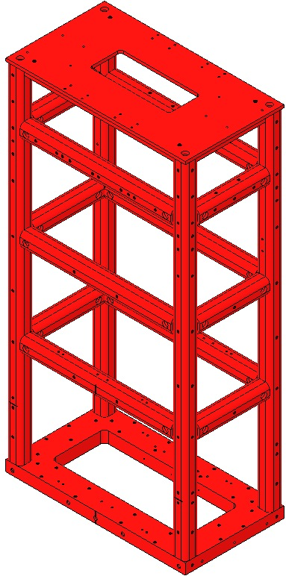
Frame of Reference

Using the Right-Hand-Rule when viewed from behind the Weldment, with the origin at the center bottom of the Weldment, the positive X, Y and Z directions are shown at right. | Fig 4: Frame of Reference  Front

Procedure
Verify usability of every tapped hole in the Structural Weldment, including holes for Helicoils.  Use a properly-sized Ag-Plated SSTL SHCS of sufficient length to check every tapped hole. If the silver plating is stripped from the SHCS, replace it before continuing to other holes.  Use a properly-sized Helicoil Go/No Go Gage to check every Helicoil hole (4X ¼-20 Helicoil and 6X #8-32 Helicoil). Wipe the Gage down using Methanol after checking each hole.  If any holes need to be retapped, use a clean tap of the proper size and type (tapped hole or Helicoil hole). After tapping, clean the hole and the tap thoroughly using Methanol and recheck the hole.  Insert 6X Helicoils, #8-32 X 0.492” Long, into the base plate of the Structural Weldment, 3X on each of the short sides. Before removing the tangs, thread a SSTL SHCS into each Helicoil to be sure that the Helicoil is threaded correctly.  Insert 4X Helicoils, ¼-20 X 0.25” Long, into the top plate of the Structural Weldment. Before removing the tangs, thread a SSTL SHCS into each Helicoil to be sure that the Helicoil is threaded correctly.  Secure the Structural Weldment to an Optical Table using at least 4X Long LOS Clamps (D980184), 4X ¼-20 X 1.5” Long Ag-Plated SSTL SHCS and 4X ¼” Flat Washers. Orient the Structural Weldment so that there is easy access to the back (-y) side, which is the side with 8X #8-32 tapped holes in the top side of the base plate. Do not cover any of the #8-32 tapped holes. | 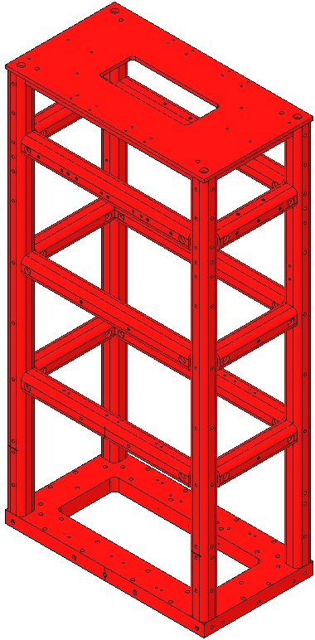  Figure 1: HSTS Structural Weldment

Assembling the Top Blade Guards

Related Document
D0901934 Top Blade Guard Assembly, HSTS

Materials
Qty | Unit | Part Number | Description
4 | Each | D0901936 | Blade Guard Riser
2 | Each | D0901935 | Blade Guard Crossbeam
8 | Each | N/A | SHCS, #8-32 X 0.625” Long, SSTL
4 | Each | 1185-4EN375 | Helicoil, ¼-20 X 0.375” Long, Nitronic 60
4 | Each | N/A | Hex Nut, ¼-20, Ag-Plated SSTL
4 | Each | D0900999 | SHCS, ¼-20 x 2” Long, Fully Threaded, Rounded End, SSTL

Procedure
Insert 2X Helicoils, ¼-20 X 0.375” Long, into the Blade Guard Crossbeam (D0901935). Before removing the tangs, thread a SSTL SHCS into each Helicoil to be sure that the Helicoil is threaded correctly.  Attach 2X Blade Guard Risers (D0901936) to the Blade Guard Crossbeam (D0901935) using 4X #8-32 X 0.625” Long SSTL SHCS. Torque the SHCS to 30 in-lb using a torque wrench.  Thread 1X ¼-20 Hex Nut, Ag-Plated SSTL onto each of 2X ¼-20 X 2” Long, Fully Threaded, Rounded End, SSTL SHCS (D0900999). Thread the 2X Rounded End SHCS into the Blade Guard Crossbeam with the rounded ends facing down, as shown in the figure at right.  Create an assembly record in ICS and record the serial numbers of the Blade Guard Crossbeam and Blade Guard Risers.  Repeat Steps 1 through 4; each HSTS Overall Assembly has 2X Top Blade Guard Assemblies. | 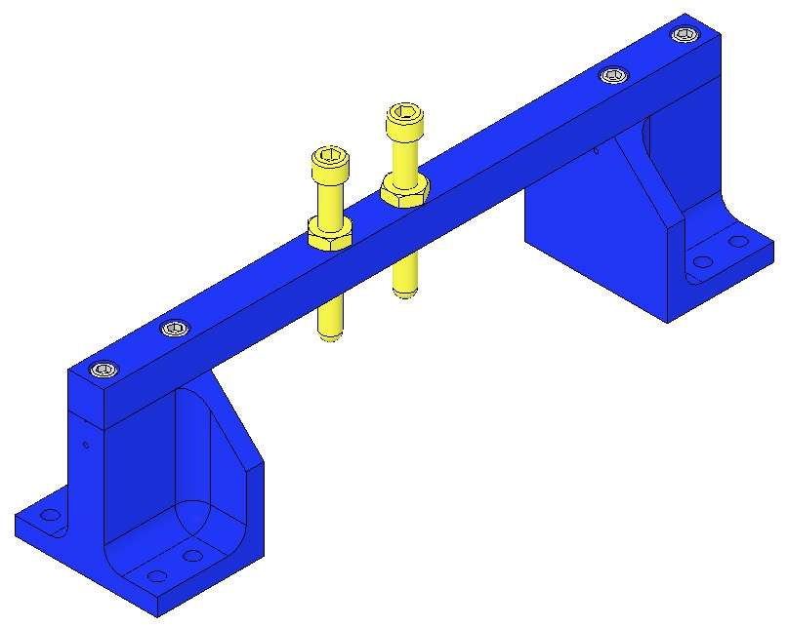  Crossbeam  ¼-20 x 2.00  Riser  8-32 x .625 SSTL  Figure 2: Top Blade Guard Assembly

Assembling the Face Earthquake Stops

Related Documents
D0902413 Face Earthquake Stop Assembly, Intermediate Mass
D0902205 Face Earthquake Stop Assembly, Lower Mass

Materials
Qty | Unit | Part Number | Description
4 | Each | D0901923 | Face Earthquake Stop Base
2 | Each | D0902204 | Face Earthquake Stop Bracket, Intermediate Mass
2 | Each | D0901922 | Face Earthquake Stop Bracket, Lower Mass
4 | Each | 1185-4EN375 | Helicoil, ¼-20 X 0.375” Long, Nitronic 60
4 | Each | N/A | SHCS, #8-32 X 0.625” Long, SSTL
4 | Each | N/A | Hex Nut, ¼-20, Ag-Plated SSTL
4 | Each | D0900999 | SHCS, ¼-20 X 2” Long, Fully Threaded, Rounded End, SSTL

Procedure
Insert 2X Helicoils, ¼-20 X 0.375” Long, into the Face Earthquake Stop Bracket, Intermediate Mass (D0902204). Before removing the tangs, thread a SSTL SHCS into each Helicoil to be sure that the Helicoil is threaded correctly.  Attach 1X Face Earthquake Stop Base (D0901923) to the Face Earthquake Stop Bracket using 2X #8-32 X 0.625” Long SSTL SHCS. Torque the SHCS to 30 in-lb using a torque wrench.  Thread 1X ¼-20 Hex Nut, Ag-Plated SSTL onto each of 2X ¼-20 X 2” Long, Fully Threaded, Rounded End, SSTL SHCS (D0900999). Thread the 2X Rounded End SHCS into the Face Earthquake Stop Bracket with the rounded ends facing away from the slot in the Face Earthquake Stop Base, as shown in the figure at right.  Create an assembly record in ICS and record the serial numbers of the Face Earthquake Stop Base and Bracket.  Repeat Steps 1 through 4 once more; each HSTS Overall Assembly has 2X Intermediate Mass Face Earthquake Stop Assemblies.  Repeat Steps 1 through 4 twice more, substituting the Face Earthquake Stop Bracket, Lower Mass (D0901922) for the Face Earthquake Stop Bracket, Intermediate Mass; each HSTS Overall Assembly has 2X Lower Mass Face Earthquake Stop Assemblies. | 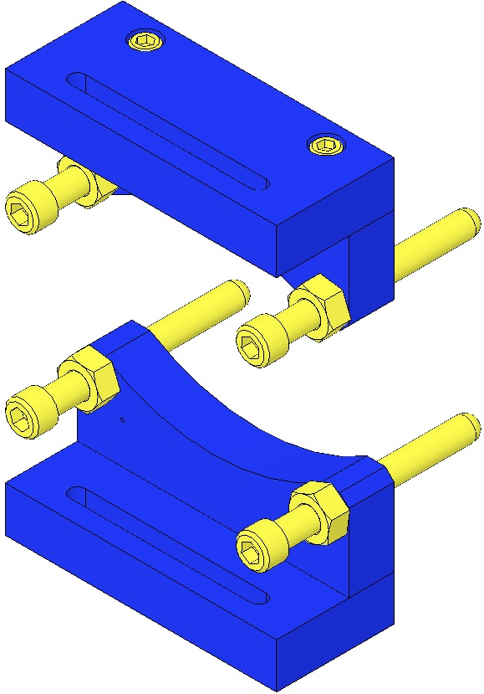  Hex Nut  ¼-20 x 2.25”  D0901923  D0902204  8-32 x 0.625”  Fig 5: 2 Assemblies

Assembling the Barrel Earthquake Stops

Related Documents
D0902203 Barrel Earthquake Stop Assembly, Intermediate Wire
D0902201 Barrel Earthquake Stop Assembly, Lower Wire

Materials
Qty | Unit | Part Number | Description
16 | Each | D0902008 | Barrel Earthquake Stop Bracket
16 | Each | D0902009 | Barrel Earthquake Stop Base
2 | Each | D0901925 | Barrel Earthquake Stop Crossbar, Intermediate Wire
6 | Each | D0902202 | Barrel Earthquake Stop Crossbar, Lower Wire
32 | Each | N/A | SHCS, #4-40 X 0.375” Long, SSTL
16 | Each | 1185-4EN500 | Helicoil, ¼-20 X 0.5” Long, Nitronic 60
32 | Each | N/A | SHCS, ¼-20 X 0.875” Long, SSTL
32 | Each | N/A | Flat Washer, ¼”, SSTL
16 | Each | N/A | Hex Nut, ¼-20, Ag-Plated SSTL
16 | Each | D030022 | SHCS, ¼-20 X 2.25” Long, Fully Threaded, Rounded End, SSTL
1 | Each | N/A | Machinist Square

Procedure
Attach 1X Barrel Earthquake Stop Base (D0902009) to 1X Barrel Earthquake Stop Bracket (D0902008) using 2X #4-40 X 0.375” Long SSTL SHCS, so that the vent holes in the Barrel Earthquake Stop Bracket face the slots in the Barrel Earthquake Stop Base. Use a Machinist Square to keep the two parts aligned. Torque the SHCS to 6 in-lb using a torque wrench.  Repeat Step 1 once more.  Insert 2X Helicoils, ¼-20 X 0.5” Long, into the Intermediate Wire Barrel Earthquake Stop Crossbar (D0901925). Before removing the tangs, thread a SSTL SHCS into each Helicoil to be sure that the Helicoil is threaded correctly.  Attach 2X Barrel Earthquake Stop Brackets (D0902008) to either end of the Intermediate Wire Barrel Earthquake Stop Crossbar (D0901925) using 4X ¼-20 X 0.875” Long SSTL SHCS and 4X ¼” Flat Washers. Hand-tighten the SHCS; do NOT torque them at this time.  Thread 1X ¼-20 Hex Nut, Ag-Plated SSTL onto each of 2X ¼-20 X 2.25” Long, Fully Threaded, Rounded End, SSTL SHCS (D030022). Thread the 2X Rounded End SHCS into the Barrel Earthquake Stop Crossbar so that the rounded ends face away from the Barrel Earthquake Stop Base.  Create an assembly record in ICS and record the serial numbers of the Barrel Earthquake Stop Brackets, Barrel Earthquake Stop Bases and Barrel Earthquake Stop Crossbars.  Repeat Steps 1 through 6 once more; each HSTS Overall Assembly has 2X Intermediate Wire Barrel Earthquake Stop Assemblies.  Repeat Steps 1 through 6, but substitute the Lower Wire Barrel Earthquake Stop Crossbar (D0902202) for the Intermediate Wire Barrel Earthquake Stop Crossbar (D0901925). Assemble a total of 6X Lower Wire Barrel Earthquake Stop Assemblies. | 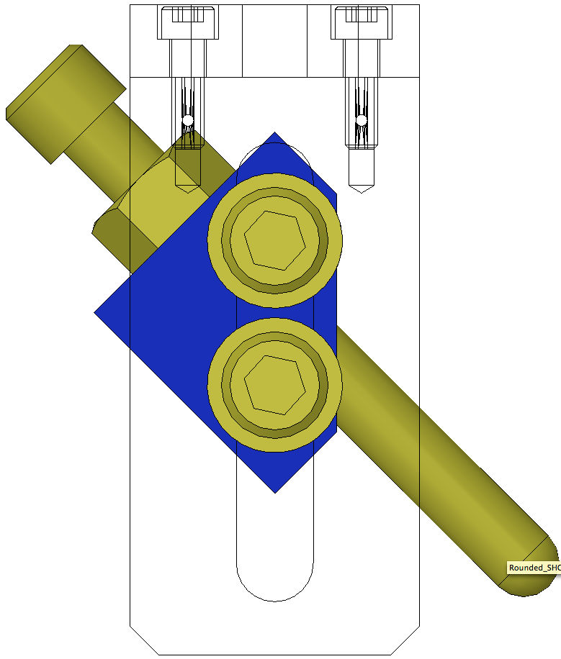  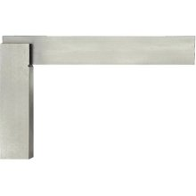  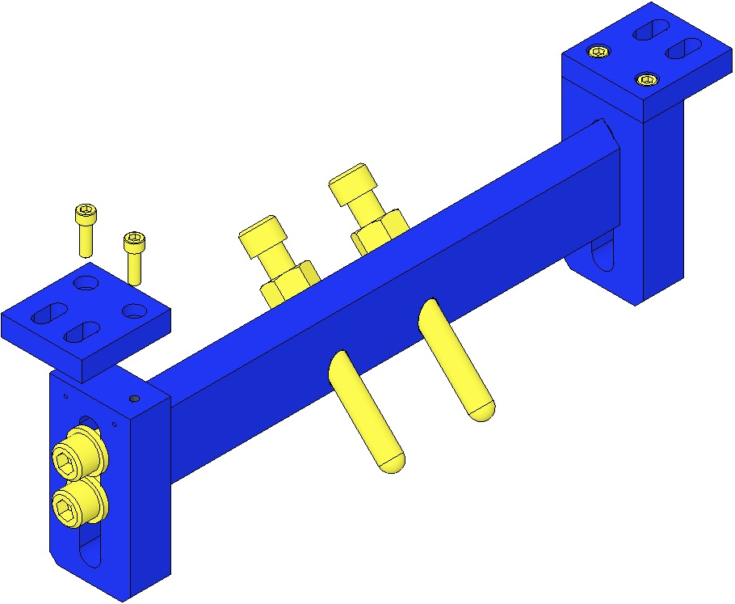  Bolt  Orientation  Precision  Square  D0902009  ¼-20 x 2.25”  ¼-20 x .875” Loose  4-40 x 0.375”  D0902008  Hex Nut  D0901925  Vent Holes facing outboard.  D0902008  Fig 6: Build 2 Assemblies

Assembling the AOSEM Alignment Assemblies

Related Documents
D0901924 AOSEM Alignment Assembly, Intermediate Mass
D0902207 Upper AOSEM Alignment Assembly, Lower Mass
D0902208 Lower AOSEM Alignment Assembly, Lower Mass

Materials
Qty | Unit | Part Number | Description
4 | Each | D0902414 | AOSEM Alignment Bracket, Intermediate Mass
8 | Each | D0901548 | AOSEM Adjustment Collar
16 | Each | D1000659 | AOSEM Adjuster Shaft
16 | Each | D1000660 | Adjustment Nut, AOSEM Alignment Assembly
4 | Each | D0902206 | AOSEM Alignment Bracket Mount, Intermediate Mass
16 | Each | 1185-2EN246 | Helicoil, #8-32 X 0.246” Long, Nitronic 60
8 | Each | 1185-4EN250 | Helicoil, ¼-20 X 0.25” Long, Nitronic 60
1 | Each | N/A | Helicoil Insertion Tool, #8-32
1 | Each | N/A | Helicoil Tang Removal Tool
1 | Each | N/A | Helicoil Insertion Tool, ¼-20
8 | Each | N/A | SHCS, #2-56 X 0.375” Long, SSTL
16 | Each | N/A | SHCS, #8-32 X 0.625” Long, SSTL
16 | Each | N/A | Flat Washer, ¼”, SSTL
8 | Each | Stop | Stop
8 | Each | N/A | Hex Nut, ¼-20, Ag-Plated SSTL
4 | Each | D0902417 | AOSEM Alignment Bracket, Lower Mass
2 | Each | D0902416 | Upper AOSEM Alignment Bracket Mount, Lower Mass
2 | Each | D0902415 | Lower AOSEM Alignment Bracket Mount, Lower Mass

Procedure – Intermediate Mass
Placeholder

Procedure – Lower Mass, Upper
Placeholder

Procedure – Lower Mass, Lower
These assemblies are identical, with 3 exceptions:
- Intermediate Mass assemblies have a shorter Alignment Bracket;
- LH / RH versions (Alignment Bracket is reversed);
- 3 heights of Alignment Bracket Mounts, depending on PN.
Brackets are shown with AOSEMs in place, but AOSEMs are actually installed later on.
D0901924 (4)  AOSEM Alignment Assy  Intermediate Mass  Used in all 4 locations at the Intermediate Mass. | 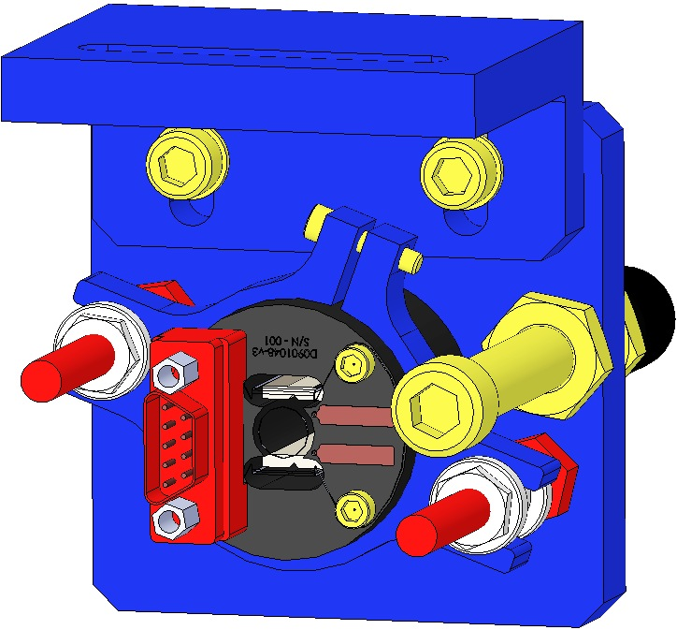 | Small Mount  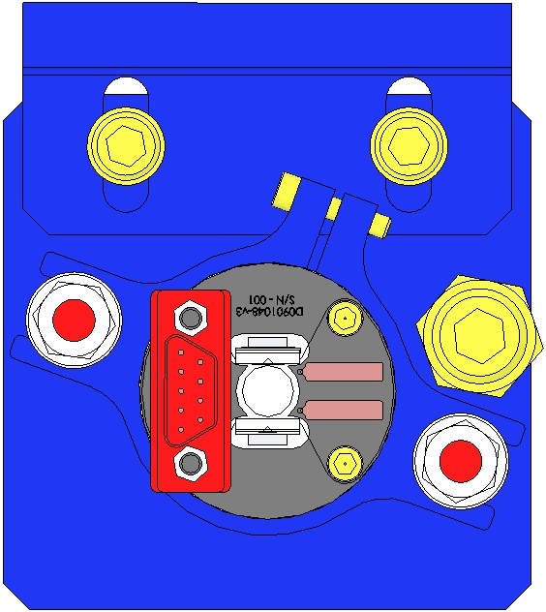  LH  Configuration  Shorter Bracket | RH  Configuration
D0902207 (2)  Upper AOSEM Alignment Assy  Lower Mass  Used in the top 2 positions at the Lower Mass. | 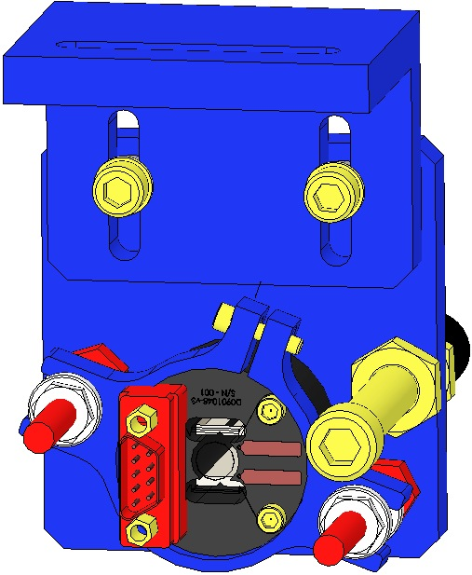 | Medium Mount  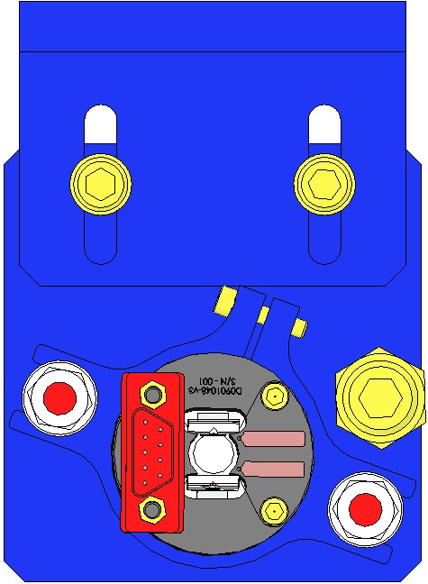  LH  Configuration | RH Configuration
D0902208 (2)  Lower AOSEM Alignment Assy  Lower Mass  Used in the lower 2 positions at the Lower Mass. | 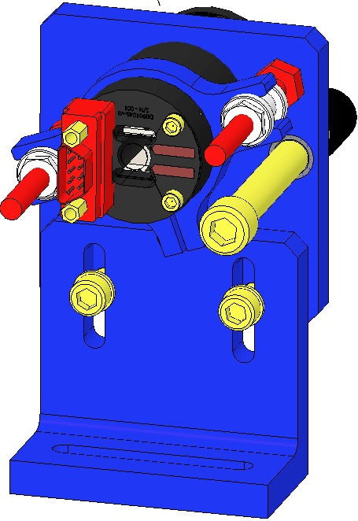 | Large Mount  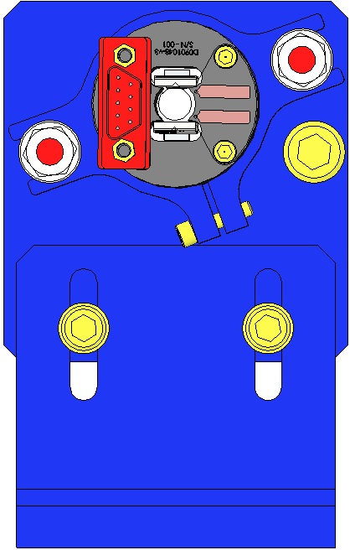  LH  Configuration | RH  Configuration

Procedure
Assembly procedure is nearly identical for all 3 units, but varies by the part number and orientation of the Alignment Bracket, and Mount.
Assemble D1000659 Adjustment Shafts to an Alignment Bracket, ensuring you have the correct Alignment Bracket and ensuring the correct orientation of the Shafts to the Bracket to enable the LH/RH configuration.  Assemble to the D0901548 Adjustment Collar:  - 1 Socket Head Cap Screw  2-56 x 0.375” SSTL  Do not tighten Screw  Assemble the Adjustment Collar to the D1000659 Adjustment Shafts using D1000660 Adjustment Nuts  The Adjustment Nut threads MUST be tapped; as is, the Nuts are tight and will seize  Be extremely careful to not strip the Heads of the Nuts  Assemble the correct Bracket Mount to the Alignment Bracket using:  - Correct Socket Head Cap Screw 8-32  - Flat Washer #8  Assemble EQ Stop to Alignment Bracket with Hex Nuts | 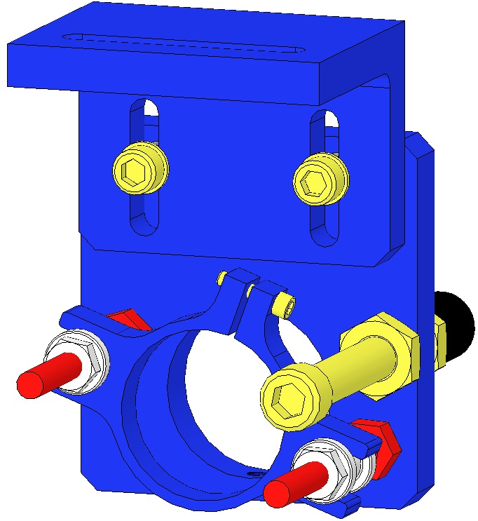  EQ Stop  8-32 Screw  Adjustment Collar  Adjustment Shaft  Bracket Mount  Adjustment Nut  2-56 Screw  Alignment Bracket  Fig 7: Assembly without AOSEM

Assembling the Rotational Adjusters

Related Documents
D1000045 Rotational Adjuster Assembly, HSTS
E1000169 HAM Suspension Blade Characterization Spreadsheet
T0900559 HLTS/HSTS/OMCS Blade Groupings
D020677 HSTS/OMCS Library of Clamps

Materials
Qty | Unit | Part Number | Description
2 | Each | D030447 | Rotating Plate, Rotational Adjuster
2 | Each | D020679, D020680, D1100844, or D1102145 | Upper Blade Clamp, Lower Side, Shim, 1mm  Upper Blade Clamp, Lower Side, Shim, 2mm  Upper Blade Clamp, Lower Side, Shim, 4.77mm  Upper Blade Clamp, Lower Side, Shim, Custom
2 | Each | Various | Upper Blade Clamp, Lower Side, 0.0 Degree through 3.5 Degree
2 | Each | D1001812 | Upper Blade
2 | Each | Various | Upper Blade Clamp, Upper Side, 0.0 Degree through 3.5 Degree
4 | Each | N/A | SHCS, ¼-20 X 1.375” Long, Ag-Plated SSTL
4 | Each | N/A | Flat Washer, ¼”, SSTL
2 | Each | D1002440 | Upper Blade Baking Fixture, HSTS/OMC
1 | Each | D020660 | Blade Pulldown Device, HAM Suspensions
1 | Set | N/A | Interlocking Test Weights (1kg, 2kg)
1 | Set | N/A | Test Weights (1g – 500g)
2 | Each | N/A | Machinist Square
2 | Each | D030448 | Base Plate, Rotational Adjuster
6 | Each | N/A | SHCS, ¼-20 X 0.375” Long, SSTL
6 | Each | D1100785-472 | Flat Washer, ¼” X 0.472” Outer Diameter, Nitronic 60
2 | Each | D030450 | Pull Plate, Rotational Adjuster
4 | Each | N/A | SHCS, #8-32 X 0.75” Long, Ag-Plated SSTL
2 | Each | D030449 | Push Plate, Rotational Adjuster
4 | Each | N/A | SHCS, #8-32 X 1” Long, SSTL
2 | Each | N/A | SHCS, #8-32 X 1” Long, Ag-Plated, SSTL
2 | Each | D1100785-359 | Flat Washer, 0.20” X 0.359” Outer Diameter, Nitronic 60
2 | Each | D030025 | SHCS, #8-32 X 1” Long, Fully Threaded, Rounded End, SSTL

Procedure
Use Safety Glasses and Glove Liners per E0900332.
Prepare 2 D020660 Blade Pulldown Devices per Materials List above. |  | 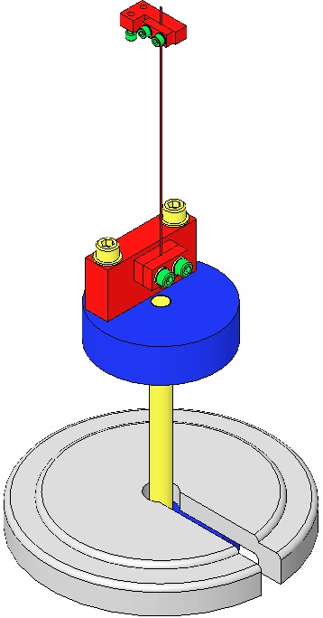  Fig 8: Blade Pulldown Device

Select pairs of D1001812 Blades and Blade Clamps per the T0900559 Blade Pairings Spreadsheet.

Correlate each Blade to a location within the Suspension:
- The Blade with the higher tip goes to the +X, -Y corner (meaning that the blade with the higher tip is installed in the Rotational Adjuster that is mounted on the +X, -Y corner).
- The Blade with the lower tip goes to the -X, +Y corner (meaning that the blade with the lower tip is installed in the Rotational Adjuster that is mounted on the –X, +Y corner).
- Blade launch angle is set by Blade Clamps. These range from 0-3.5 deg. in .5 deg. increments.
- Select Clamps from the D020677 HSTS Library of Clamps
- Select Clamps according to Blade Characterization data for stiffness and expected load.
- Select Blades in pairs according to Blade Characterization data.
- Record the Blade serial numbers and Blade clamp angles and orientations within ICS.
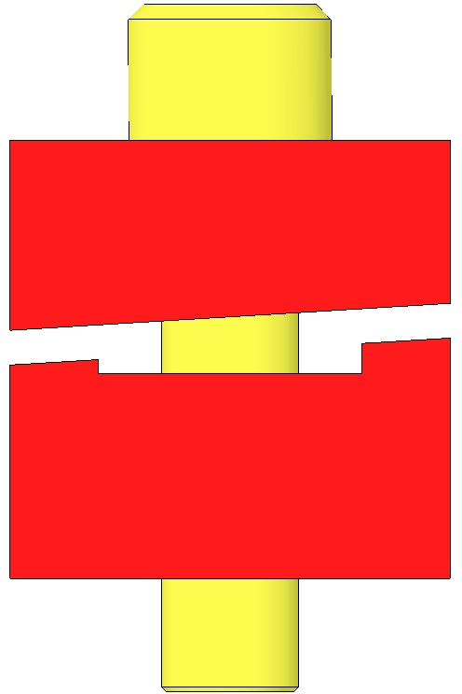  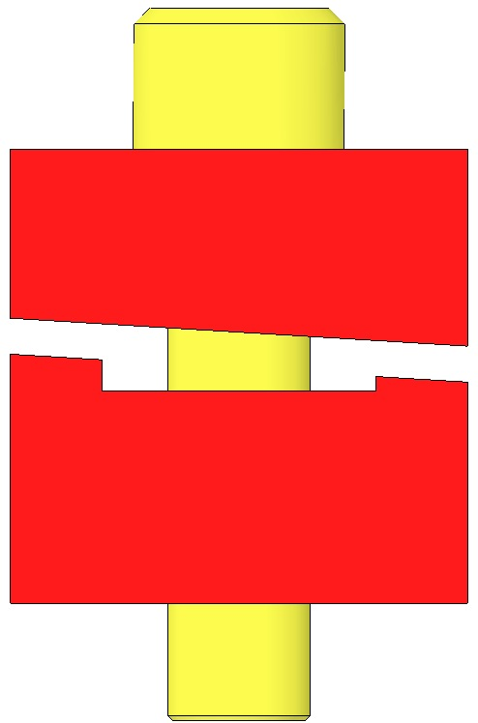  Fig 9: Clamps Control Launch Angle | 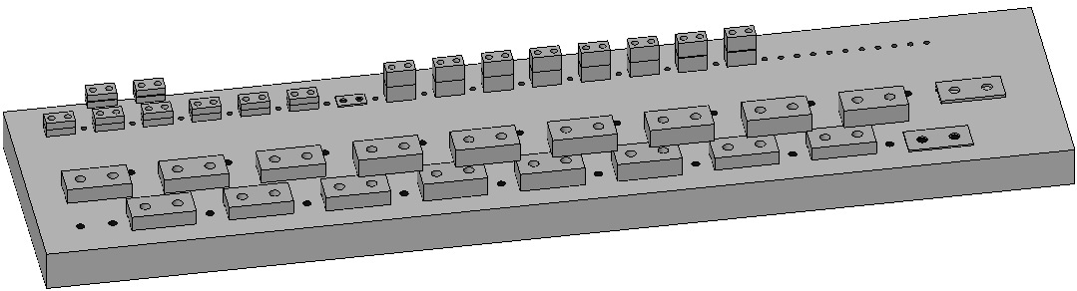  Fig 10: HSTS Library of Clamps
Mount the D1002440 Baking Fixture to an Optics Table, aligning the Crossbar side with the Table edge to allow clearance for the Blade Pulldown Device.  Remove a D1002443 Crossbar from the Baking Fixture.  Assemble to the Baking Fixture:  - 2 D030447 Rotating Plates  Beveled-side-down  - 4 Socket Head Cap Screws  ¼-20 x 0.375” SSTL  - 4 D1100785-472 Flat Washers  Tighten the Screws firmly | 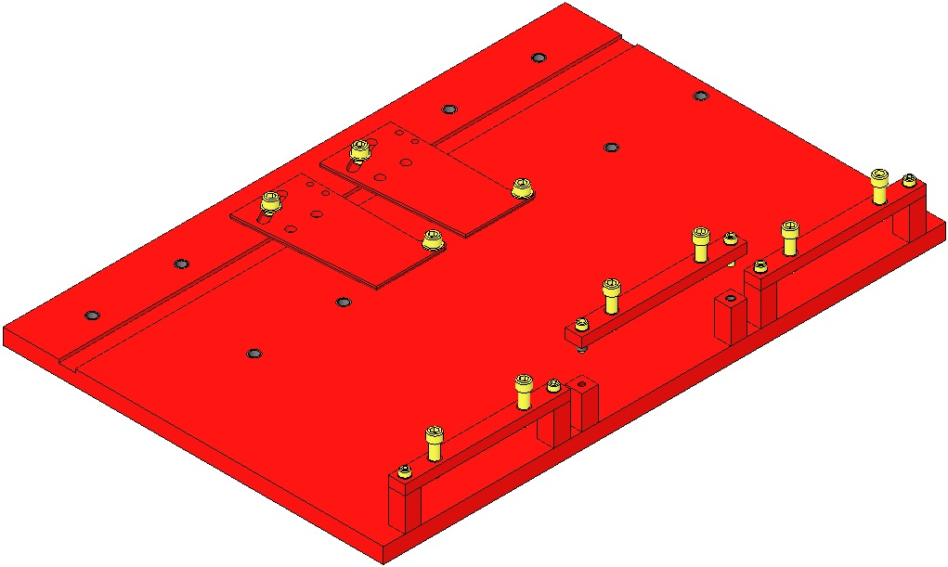  Table Edge  Fig 11: Base Plates in Baking Fixture
Assemble to each Rotating Plate:  - 1 DXXXXXX Shim, Upper Blade Clamp  Each Weldment is packaged with 2 Rotational Adjuster Shim’s, each marked with the Weldment Serial Number  - 1 DXXXXXX Lower Clamp  - 1 D1001812 Upper Blade  - 1 DXXXXXX Upper Clamp  - 2 Socket Head Cap Screws  ¼-20 x 1.375” SSTL  - Flat Washer ¼” SSTL  Hand-tighten the 2 Screws | 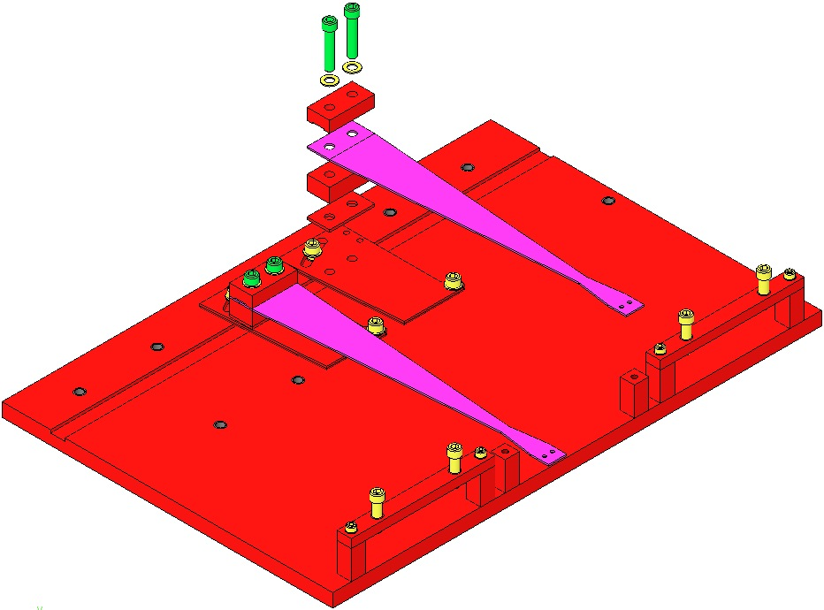  Machinist’s  Square  Fig 12: Shim, Clamps, Blade, Screws, Washers

Attach a Pulldown Device from each Upper Blade Tip to flatten the Blades.

Assemble to the Bake Fixture:
- 1 D1002443 Bake Fixture Crossbar
- 2 Socket Head Cap Screws 8-32 x 0.625” SSTL
- 2 Flat Washers #8 SSTL
Tighten the Screws firmly
- 2 Socket Head Cap Screws ¼-20 x 1.0 Full-Thread, Round-Tip SSTL

Turn down the Round-Tip Screws until the weighted Blade tip is level with the Blade root.
Be careful not to damage the nickel plating on the blade

Leaving the Wire Clamp attached to the Blade, remove the rest of the Blade Pulldown Device.

Using the Machinist’s Square, square the Blade, Clamps, and Shim to each other and to the Rotating Plate.

Tighten the ¼-20 Screws that clamp the Blade, to 100 in-lb.

Re-attach the Blade Pulldown Device to the Wire Clamp.

Turn back the Rounded-End Screws and remove the D1002443 Crossbar again.

Slowly lift and then disconnect the Blade Pulldown Device, allowing each Blade to curve fully upward.

Disassemble the Rotational Adjuster(s) from the Upper Blade Baking Fixture.
Assemble to a D030448 Base Plate:  A just-assembled Rotational Adjuster  3 Socket Head Cap Screw  ¼-20 x 0.375” SSTL  3 D1100785-472 N-60 Flat Washers  Hand-tighten only  D030450 Pull Plate  2 Socket Head Cap Screw  8-32 x 0.75” AgPlated  Torque to 30 in-lb | 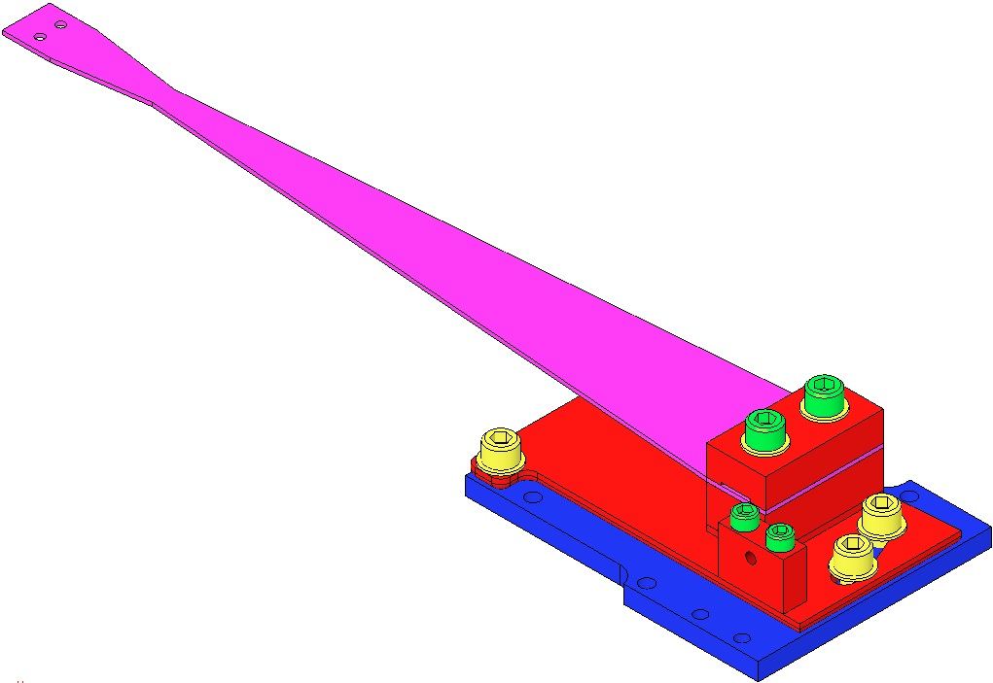  Rotating Plate  Pull Plate  8-32 x 0.75  ¼-20 x 0.375” (3)  Flat Washer ¼” (3)  Base Plate  Fig 13: Base Plate and Pull Plate added
Assemble to the Base Plate:  - D030449 Push Plate  - 2 Socket Head Cap Screws  8-32 x 1.00” SSTL  Torque to 20 in-lb  Assemble through the Push Plate, into the Pull Plate:  - 1 Socket Head Cap Screw  8-32 x 1.00” AgPlated  - 1 D1100785-359 N-60 Flat Washer  - 1 Socket Head Cap Screw  8-32 x 1.00” Round Tip AgPlated | 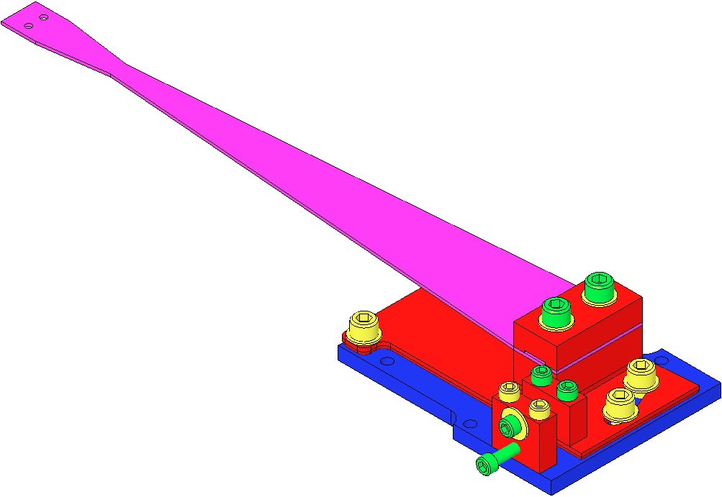  8-32 x 1” SSTL  8-32 x 1” AgPlated  8-32 x 1” AgPlated Round Tip  Fig 14: Adding Push Plate

Assembling the Upper Mass (M1)

Related Documents
D020534 Upper Mass Assembly, HSTS
E1000169 HAM Suspension Blade Characterization Spreadsheet
T0900559 HLTS/HSTS/OMCS Blade Groupings
D020677 HSTS/OMCS Library of Clamps

Materials
Qty | Unit | Part Number | Description
1 | Each | D020134 | Main Section, Upper Mass
4 | Each | 1185-04EN336 | Helicoil, #4-40 X 0.336” Long, Nitronic 60
1 | Each | N/A | Helicoil Insertion Tool, #4-40
1 | Each | N/A | Helicoil Tang Removal Tool
1 | Each | D020136 | T-Section, Upper Mass
1 | Each | D040259 | Tablecloth and Upper Mass Jig
1 | Each | 1185-4EN250 | Helicoil, ¼-20 X 0.25” Long, Nitronic 60
1 | Each | N/A | Helicoil Insertion Tool, ¼-20
2 | Each | N/A | SHCS, ¼-20 X 0.375” Long, Ag-Plated SSTL
1 | Each | D020137 | Pitch Insert, T-Section, Upper Mass
1 | Each | N/A | Screw, Socket Set, ½-20 X 2” Long, Ag-Plated SSTL
4 | Each | N/A | Screw, Socket Set, #8-32 X 0.25” Long, Ag-Plated SSTL
1 | Each | D020676 | Roll Insert, T-Section, Upper Mass
4 | Each | Various | Lower Blade Clamp, Lower Side, 0.0 Degree through 3.5 Degree
4 | Each | D080761 | Upper Blade
4 | Each | Various | Lower Blade Clamp, Upper Side, 0.0 Degree through 3.5 Degree
8 | Each | N/A | SHCS, #8-32 X 1” Long, Ag-Plated SSTL
16 | Each | N/A | Flat Washer, #8, SSTL
2 | Each | D020660 | Blade Pulldown Device, HAM Suspensions
2 | Set | N/A | Interlocking Test Weights (1kg, 2kg)
2 | Set | N/A | Test Weights (1g – 500g)
2 | Each | N/A | Machinist Square
2 | Each | D0902030 | Blade Guard, Upper Mass
4 | Each | 1185-04EN168 | Helicoil, #4-40 X 0.168” Long, Nitronic 60
4 | Each | N/A | SHCS, #4-40 X 0.5” Long, SSTL
4 | Each | D0900980 | SHCS, #4-40 X 0.375” Long, Fully Threaded, Rounded End, SSTL
4 | Each | D020482 | Screwdrive System, Upper Mass
8 | Each | N/A | SHCS, #8-32 X 0.625” Long, SSTL
4 | Each | N/A | SHCS, #8-32 X 0.75” Long, Fully Threaded, SSTL
3 | Each | D0902494 | Magnet Holder (Short), Upper Mass
6 | Each | D0902423 | Magnet Holder (Long), Upper Mass
9 | Each | D1001534 | Magnetic Plug, BOSEM
1 | Each | ? | Plate to Press Disks
9 | Each | D1100573 | Flag, BOSEM
9 | Each | D1100574 | Flat Flag Disk, BOSEM
9 | Each | N/A | Flat Head Cap Screw, #4-40 X 0.1875” Long, SSTL
9 | Each | D394197N35UHP | Sintered NdFeB Magnet, Ni-Plated, 10mm X 5mm
2 | Each | D020199 | Magnet/Flag Base (Short), Upper Mass
9 | Each | N/A | SHCS, #8-32 X 0.3125” Long, SSTL
4 | Each | N/A | SHCS, #4-40 X 0.625” Long, SSTL
18 | Each | N/A | Flat Washer, #4, SSTL
7 | Each | D0902493 | Magnet/Flag Assembly Base Plate, Upper Mass
4 | Each | D020211 | Magnet Holder Brace
8 | Each | N/A | SHCS, #4-40 X 1.25” Long, Ag-Plated SSTL
2 | Each | N/A | SHCS, #4-40 X 0.625” Long, Ag-Plated SSTL
4 | Each | N/A | SHCS, #4-40 X 0.625” Long, Vented, Ag-Plated SSTL

Procedure – Main Section, T-Section, and Blades
Assemble to the T-Section D020136:  - Roll Insert D020676  - Pitch Insert D020137  - 4 Socket Set Screws  8-32 x .25” AgPlated  Torque to 30 in-lb | 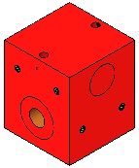  Screws (2)  Roll Insert  Pitch Insert  Screws (2)  Fig 15: Upper Mass T-Section
Attach the D040259 Upper Mass Jig to an Optics Table with a ¼-20 Ag-Plated Bolt.  Thread the T-Section onto the ¼-20 stud at the top of the Jig.  The Jig will not be shown for the remainder of the assembly steps, but is necessary to secure the Upper Mass during the assembly process. | Fig 16: Upper Mass Jig and T-Section
Assemble the D020134 Upper Mass Main Section to the T-Section using:  2 Socket Head Cap Screws  ¼-20 x .375” AgPlated  Torque to 100 in-lb | 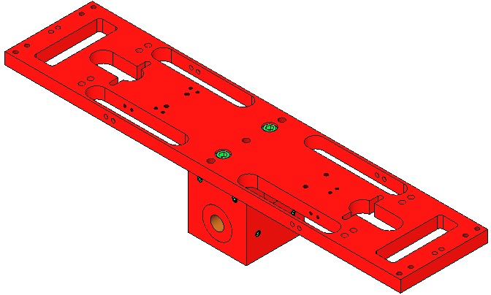  Upper Mass  Main Section  T-Section  Screws (2)  Fig 17: Main Section assembled to T-Section

Procedure – Lower Blades & Screw Drives
Wear Safety Glasses and Glove Liners per E1000043.  Blades are shown flattened but are curved upward until weighted.  Prepare 2 D020660 Blade Pulldown Devices per Materials List.  Per the data in T0900559 Blade Pairings, retrieve:  A matched set of 4 D080761 Lower Blades.  4 sets of Blade Clamps from the D020677 Library of Clamps, each with an Angle corresponding to a specific Blade.  Identify the Blades for installation in the Upper Mass as follows:  - Blade with highest tip in +X, +Y corner  - Blade with next to highest tip in –X, +Y corner  - Blade with next to lowest tip in +X, -Y corner  - Blade with lowest tip in –X, -Y corner | Fig 18: Blade Pulldown Device
 | Assemble Blade Assemblies with:  - 2 Socket Head Cap Screws  8-32 x 1” AgPlated  - 2 #8 Flat Washers SSTL  - 1 D0XXXXX Blade Clamp, Lower  - 1 D080761 Lower Blade  - 1 D0XXXXX Blade Clamp, Upper | 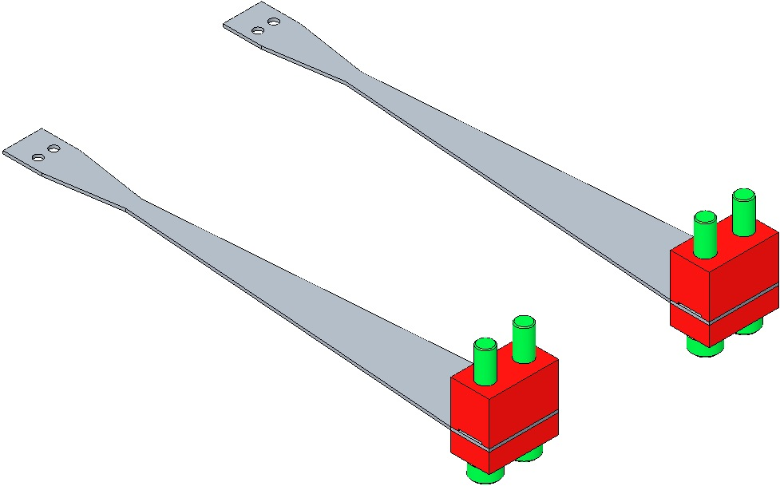  8/32 x 1” AgPlated  Blade Clamp Lower Side  Blade Clamp Upper Side  Fig 19: Lower Blade Assemblies
The Upper Mass remains on the Upper Mass Jig, as shown in Step 2.  Attach each Blade assembly to the Main Section in the location specified in the T0900559 Blade Pairings file; snug the Screws tight.  Square Blades and Clamps with the Main Section using the Machinist’s Square. Ensure the Blade tips won’t touch the oval cutout walls.  Attach the Blade Pulldown Device to the tip of each Blade. The Blade tips will pass through the cutouts until the Blades are essentially flat.  Torque the Blade Clamp Screws to 30 in-lb AFTER the Blades are flattened. |  | 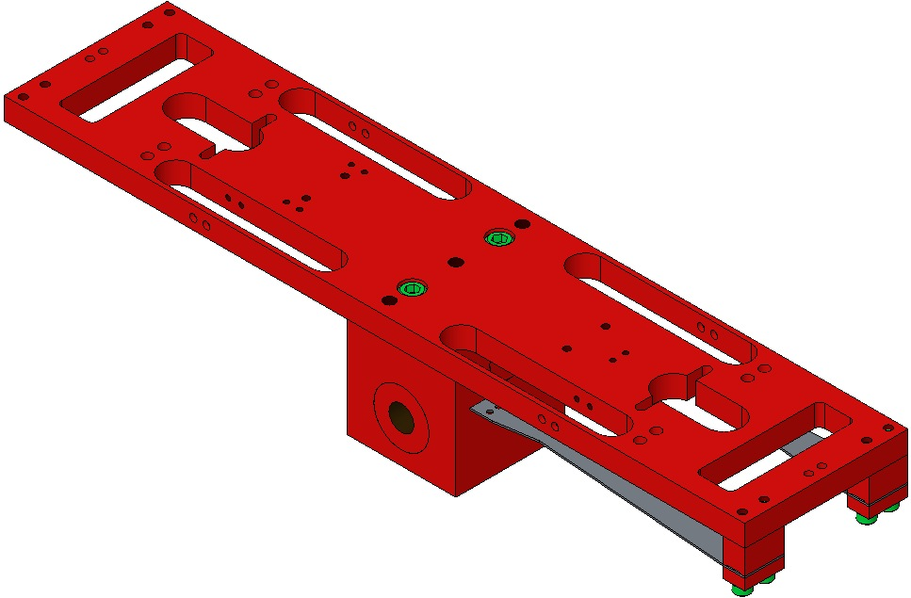  Blade tips must not touch cutouts as they pass through  Machinist’s  Square  Fig 20: Attaching the Blades to the Main Section
When using Blade Clamp pairs other than 0° ensure the orientation of Upper Clamp to Lower Clamp is such that the bolt holes are concentric (visibly, the Clamp sidewalls must be parallel). |  | Measure  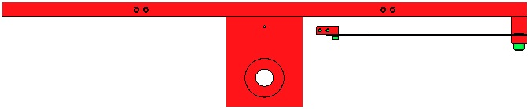  Non-Concentric  Concentric  Fig 21: Profile Matching & Blade Clamp Alignment
Assemble a D0902030 Blade Guard to the Main Section with:  2 Socket Head Cap Screw  4-40 x .5” SSTL  Torque to 5 in-lb  Assemble to the Blade Guard:  2X SHCS, #4-40 X 0.375” Long, Fully Threaded, Rounded End, SSTL (D0900980)  Diagram shows SHC Screws  Turn the Screws down as far as possible.  Disconnect the Pulldown Devices from the Blade tips. |  | 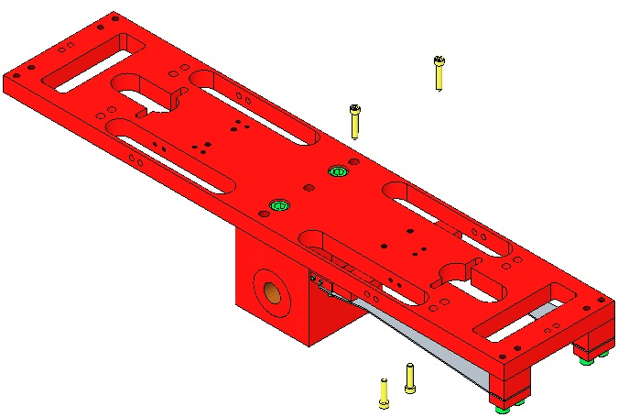  #4-40 X 0.375, Rounded End  #4-40 x 0.5”  Blade Guard  Fig 22: Adding Blade Guards

Repeat steps 7–14 to assemble the 2nd pair of Lower Blades and Blade Guards.
Assemble to Pitch Insert:  1 Socket Set Screw  ½”-20 x 2.00” AgPlated  Assemble 4 D020482 Screw Drive bodies to Main Section with:  8 Socket Head Cap Screws  8-32 x .625” SSTL  8 Flat Washers #8  Torque to 20 in-lb  Use a Machinist’s Square to ensure Screw Drive bodies are square with the Upper Mass Main Section.  Assemble to Screw Drive System bodies:  4 SHCS 8-32 x .75”  Fully-Threaded SSTL |  |  | 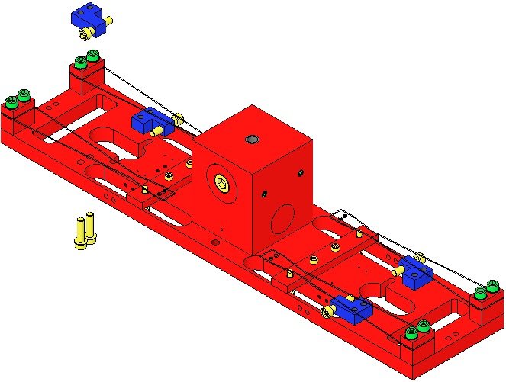  Socket Set Screw  8-32 x .625”  8-32 x .75”  Screw Drive (4)  Fig 23: Adding Screw Drives  Machinist’s  Square

Procedure – Magnets
The Magnet Holders and Wires that follow, are vulnerable to damage and therefore must ONLY be added JUST PRIOR to the Upper Mass being assembled (with the Coil Holder) to the Weldment. The Magnet/Flag Assemblies are left off until all Masses and Wires are installed and suspended.
The Upper Mass continues to be mounted on the Upper Mass Jig, as shown in Section 24.3 Step 2.  Assemble:  2X D0902494 Magnet Holder (Short)  2X D0902493 Magnet/Flag Assembly Base Plate  2X SHCS, #8-32 X 0.3125” Long  Torque to 20 in-lb.  Assemble the Base Plates to the upper side of the Main Section in the T2 and T3 positions with:  4X SHCS, # 4-40 X 0.625” Long, Ag-Plated, Vented  4X #4 Flat Washers  Use a Machinist’s Square to keep the Base Plates square to the Main Section. Torque to 7 in-lb. |  | 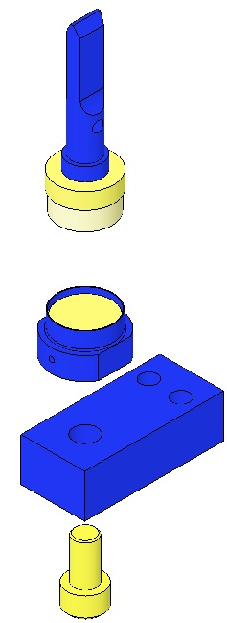  Base Long  Magnet Holder  Short  8-32 x .3125  Remove Flag for ease of assembly  Fig 24: 2 Short Assemblies attached to Main Section
Assemble:  1X D0902494 Magnet Holder (Short)  1X D0902493 Magnet/Flag Assembly Base Plate  1X SHCS, #8-32 X 0.3125” Long  Torque to 20 in-lb.  Assemble the Base to the upper side of the Main Section in the T1 position with:  2X SHCS, # 4-40 X 0.625” Long, Ag-Plated, Vented  2X #4 Flat Washers  Use a Machinist’s Square to keep the Base Plates square to the Main Section. Torque to 7 in-lb. |  | 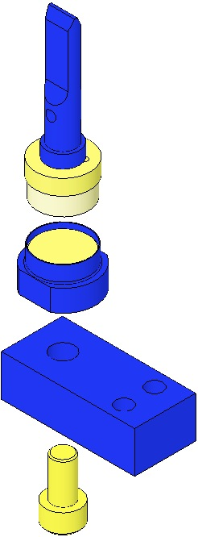  Base Long  Remove Flag for ease of assembly  Magnet  Holder  Short  8-32 x .3125  Fig 25: 1 Short Assembly attached to Main Section
Assemble:  4X D0902423 Magnet Holder (Long)  4X D0902493 Magnet/Flag Assembly Base Plate  4X SHCS, #8-32 X 0.3125” Long  Torque to 20 in-lb. | 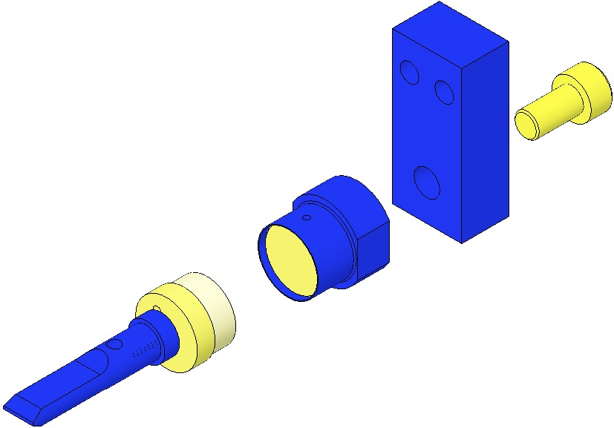  Base Long  Magnet Holder Long  Remove Flag for ease of assembly  Fig 26: 4 Long Assemblies

Attach the 4X Base Plates to the long sides of the Main Section using:  - 4X D020211 Magnet Holder Brace  - 8X SHCS, #4-40 X 1.25” Long, Ag-Plated  - 8X #4 Flat Washers  Use a Machinist’s Square to keep the Base Plates square to the Main Section. Torque to 6 in-lb. | 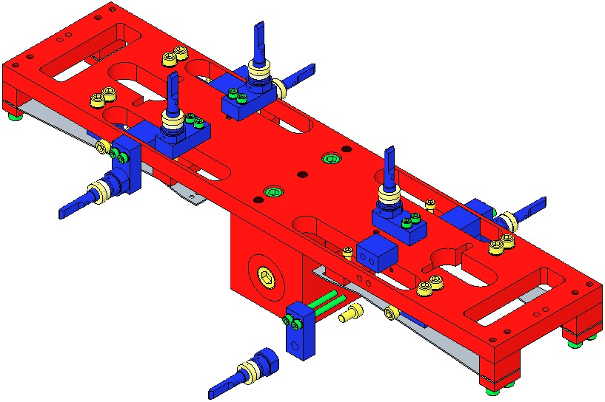  Magnet Holder Brace  Fig 27: 4-7 of 9 Magnet Assemblies
Assemble:  - 2X D020199 Magnet/Flag Assembly Base Plate (Short)  2X D0902423 Magnet Holder (Long)  - 2X SHCS, #8-32 X 0.3125” Long  Torque to 20 in-lb. | 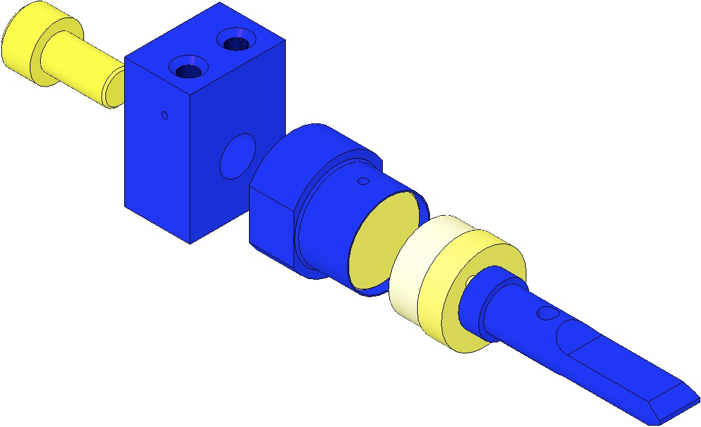  Remove Flag for ease of assembly  Magnet Holder Long  Base Short  8-32 x .5”  Fig 28: 2 Short Assemblies
Attach one Base Plate to the lower side of each short side of the Main Section using:  - 4X SHCS, #4-40 X 0.625” Long  - 4X #4 Flat Washers  Use a Machinist’s Square to keep the Base Plates square to the Main Section. Torque to 5 in-lb.  One of these Base Plates will need to be removed to allow the Coil Holder to fit over the Upper Mass, and then reattached. The Base Plate that should be removed is the one that will NOT be covered by the Side BOSEM (+/-y direction depends on the particular suspension), since it is difficult to keep the Base Plate square to the Main Section after the Coil Holder is placed over the Upper Mass. | Fig 29: LH end of Main Section; 8 of 9 Magnet Assys  Fig 30: RH end of Main Section; 9 of 9 Magnet Assys

Weigh the following items to arrive at the Upper Mass total weight of 3115 gm., and record with the Upper Mass Serial Number in ICS:  1 Upper Mass assembly just completed, including the 9 Magnet Flags  2 Lower Clamps (with bolts) from the Upper Wire Assembly:  - 2 D020481 Upper Mass C-Clamp  - 2 D0901999 Upper Mass Wire Clamp, Inside  - 2 D0901998 Upper Mass Wire Clamp, Outside  - 4 Socket Head Cap Screws  2-56 x .375” AgPlated SSTL  - 4 Flat Washers, #2 SSTL  - 4 Socket Head Cap Screws  8-32 x 1.00” AgPlated SSTL  - 4 Flat Washer, #8, D1100785-281  4 Upper Clamps (with bolts) from the Lower Wire Assembly:  - 4 D020132 Lower Blade Wire Clamp  - 4 D030044 Lower Blade Wire Clamp Plate, angled  - 8 Socket Head Cap Screws  2-56 x .375” AgPlated SSTL  - 8 Washers, Flat, #2  - 8 Socket Head Cap Screws  2-56 x 0.25” AgPlated SSTL  - 8 Washers, Flat #2, SSTL  Hand-tighten the Screws. | Fig 31: Upper Mass subassembly  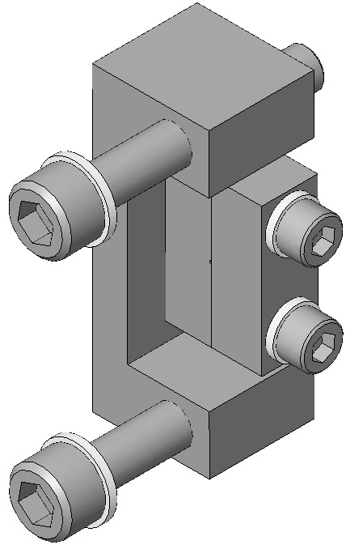  2-56 x .375”  (2)  D0901999  (2)  8-32 x 1.00”  (2)  D020481  (2)  D0901998  (2)  Fig 32: Lower Clamp from Upper Wire Assy  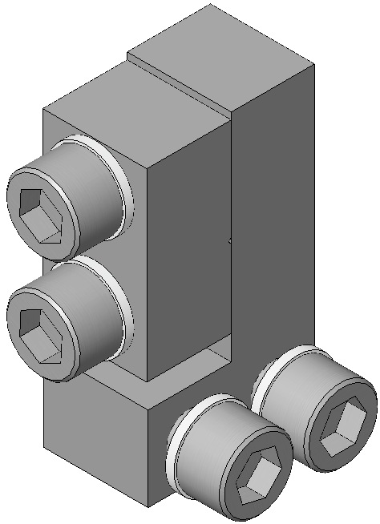  2-56 x .25”  2-56 x .375”  D030044  D020132  Fig 33: Upper Clamp from Lower Wire Assy

Procedure – Lower Wires
The Upper Mass continues to be mounted on the Upper Mass Jig, as shown in Section 24.3 Step 2.  Assemble the L-Clamps of the 4 D0901905 Lower Wire Assemblies to the tips of the 4 Lower Blades, using:  - 8 Socket Head Cap Screws  2-56 x 0.25” AgPlated  - 8 Flat Washers #2, SSTL  Hand-tighten the Screws.  Note that the Clamp mounts above the Blade and the Screw assembles from beneath the Blade.  Note the orientation of each Clamp is the same relative to each Blade tip.  If any Wire becomes kinked during assembly, replace with another Wire Assembly. | 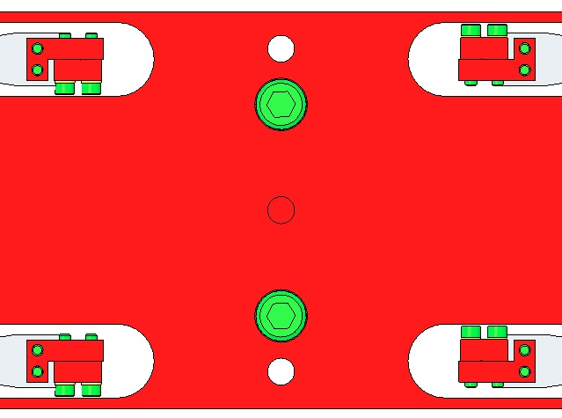  Fig 34: Top View of Clamps  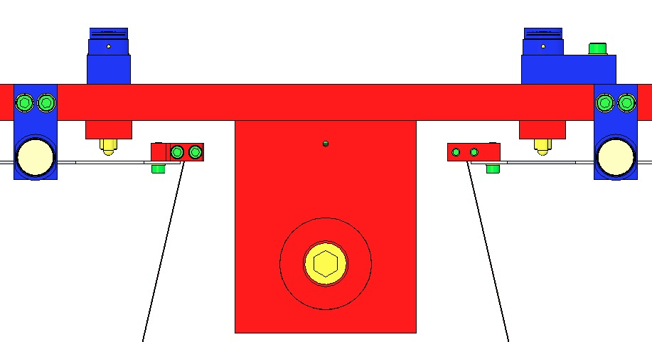  Fig 35: Lower Wire Assemblies added
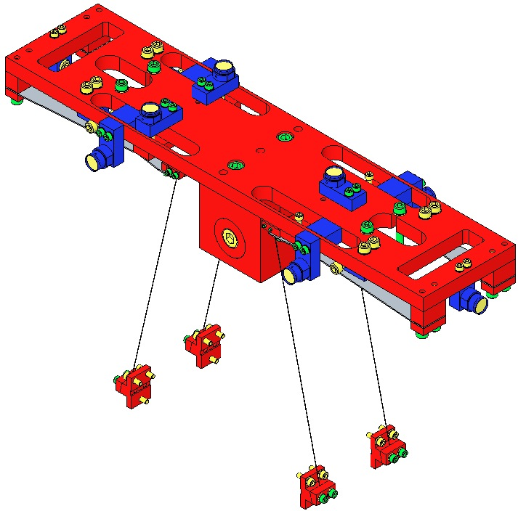
Fig 36: Upper Mass (Magnet Flags removed) with Lower Wires

Procedure – Coil Holder
The Upper Mass continues to be mounted on the Upper Mass Jig, as shown in Section 24.3 Step 2.  Remove the previously hand-tightened Magnet Holder at the +Y side of the Upper Mass, to allow assembly clearance for the Coil Holder.  Place the D020239 Coil Holder over the Upper Mass and secure with:  - 2 Socket Head Cap Screws  ¼-20 x 1.125” AgPlated  - 2 Hex Nuts ¼-20 SSTL | 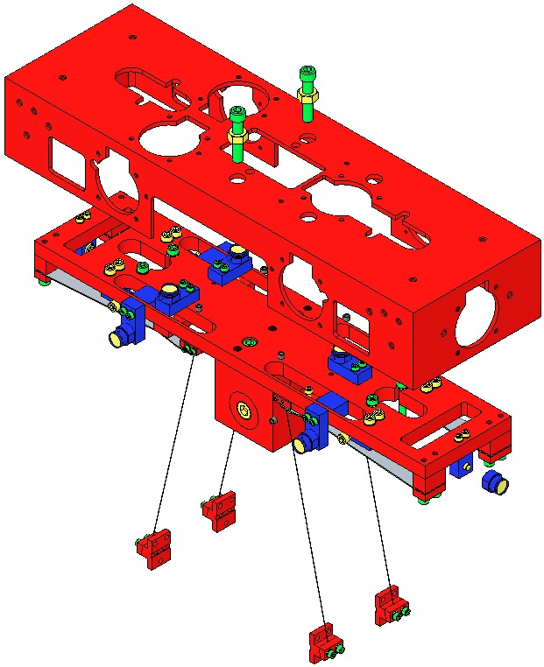  Hex Nut  ¼-20  Magnet  Holder  removed  Fig 37: Assembling Upper Mass to Coil Holder
Using the 2 ¼-20 Screws, draw the Upper Mass fully upwards into the Coil Holder, to optimize later assembly steps.  Re-attach the end Magnet Holder.  Torque to 30 in-lb  Assemble into the Coil Holder:  - 12 Socket Head Cap Screws  8-32 x 1.00” Round Tip, AgPlated  - 12 Hex Nuts 8-32 SSTL  Diagram will be updated to show Hex Nuts.  Adjust the Screws to protrude 10 mm inside the Coil Holder. | 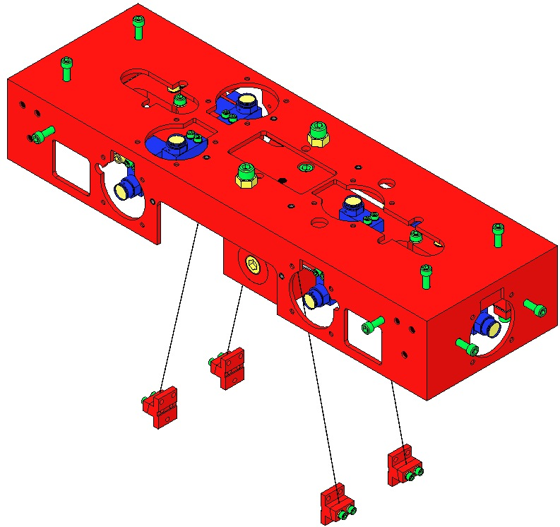  Ensure Upper Mass is fully raised into the Coil Holder  Magnet  Holder  re-attached  Fig 38: 12 Screws added

Assembling Magnets – Upper Mass

Materials – Upper Mass Magnets
Qty | U | ID | Description

Assembly Procedure – Upper Mass Magnets
Assemble 3 D0902492 BOSEM Magnet / Flag Assemblies, Short, each with (shown left-to-right, at right):  D1100573 BOSEM Flat Magnet Flag  D1100574 BOSEM Flat Magnet Flag Disk  94518A108 Screw, Countersunk  Magnet DCNI 00626/N Sintered NdFeB Ni-Plated  10 mm x 5 mm  D1001534 BOSEM Magnetic Plug  See Plug Insertion procedure, below  D0902494 BOSEM Magnet Holder, Short  Handle with care; thin sidewalls are easily damaged. | 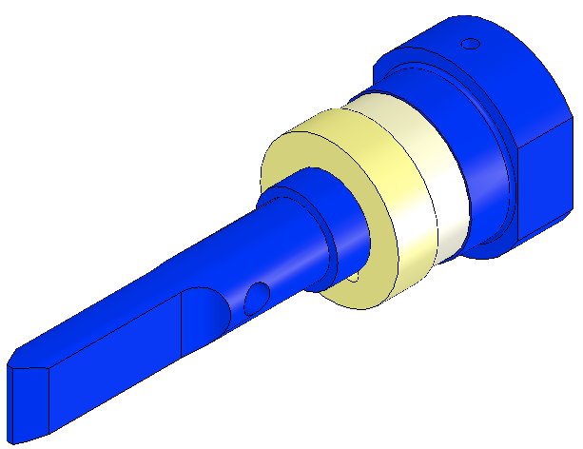  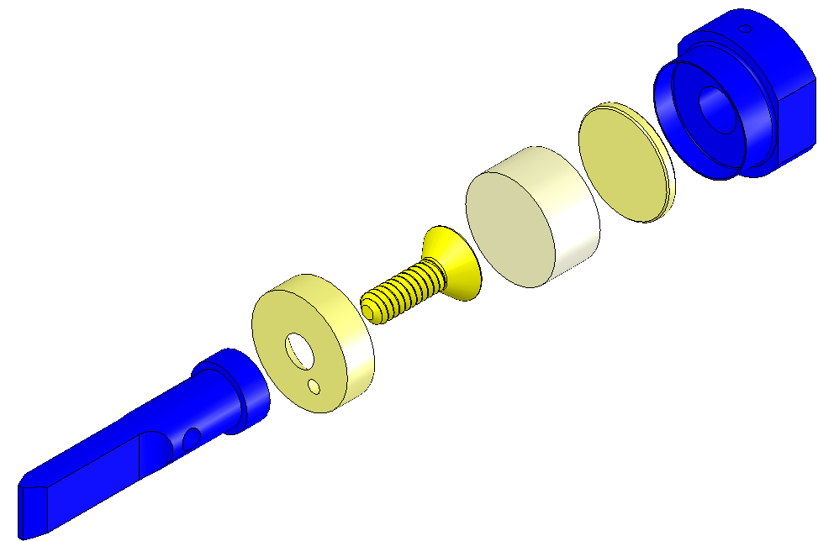  Plug  Magnet  Screw  Disk  Flag  Short Magnet Holder  Fig 39: Short Magnet Assembly
Assemble 6 D0902418 BOSEM Magnet / Flag Assemblies, Long, each with (shown left-to-right, at right):  D1100573 BOSEM Flat Magnet Flag  D1100574 BOSEM Flat Magnet Flag Disk  94518A108 Screw, Countersunk  Magnet DCNI 00626/N Sintered NdFeB Ni-Plated  10 mm x 5 mm  D1001534 BOSEM Magnetic Plug  See Plug Insertion procedure, below  D0902423 Magnet Holder, Long  Handle with care; thin sidewalls are easily damaged. | 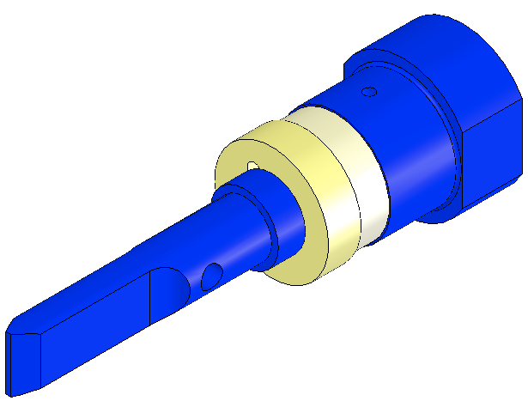  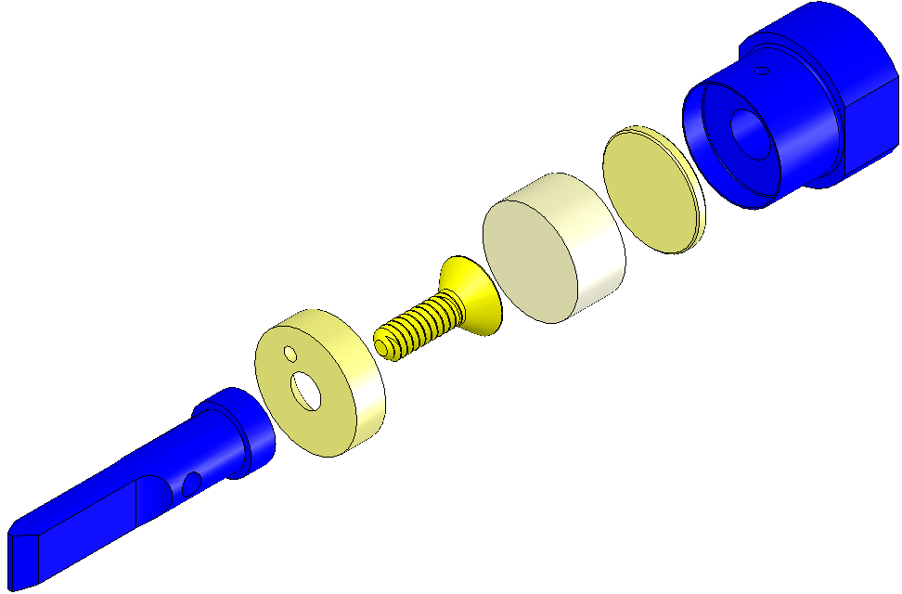  Screw  Magnet  Plug  Long Magnet Holder  Disk  Flag  Fig 40: Long Magnet Assembly

Procedure – Plug Insertion
Procedure for assembling D1001534 Plug to Magnet Holder:  Heat Air Bake Oven to 70°C;  Attach Magnet Holders to Heating Fixture with:  - Socket Head Cap Screw  8-32 x 0.3125” SSTL  Screws must be Class A or B clean  Place Heating Fixture in Oven for 10 min. minimum;  Remove Heating Fixture from Oven and inspect Magnet Holders for out-of-round condition, using tapered end of the Disk Insertion Tool to address any out-of-round conditions.  Place Disk on a Magnet Holder, Place non-tapered end of Disk Insertion Tool on Disk, and tap Insertion Tool until Disk is fully seated within Holder.  Return Heating Fixture to Oven for another 5 minutes, minimum.  Remove Heating Fixture from Oven, and repeat Step 5, above.  Remove Magnet Holders from Heating Fixture. | 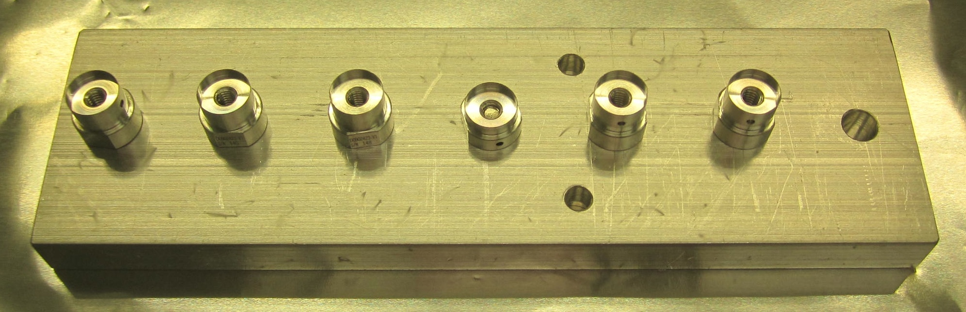  Fig 41: Heating Fixture with Holders  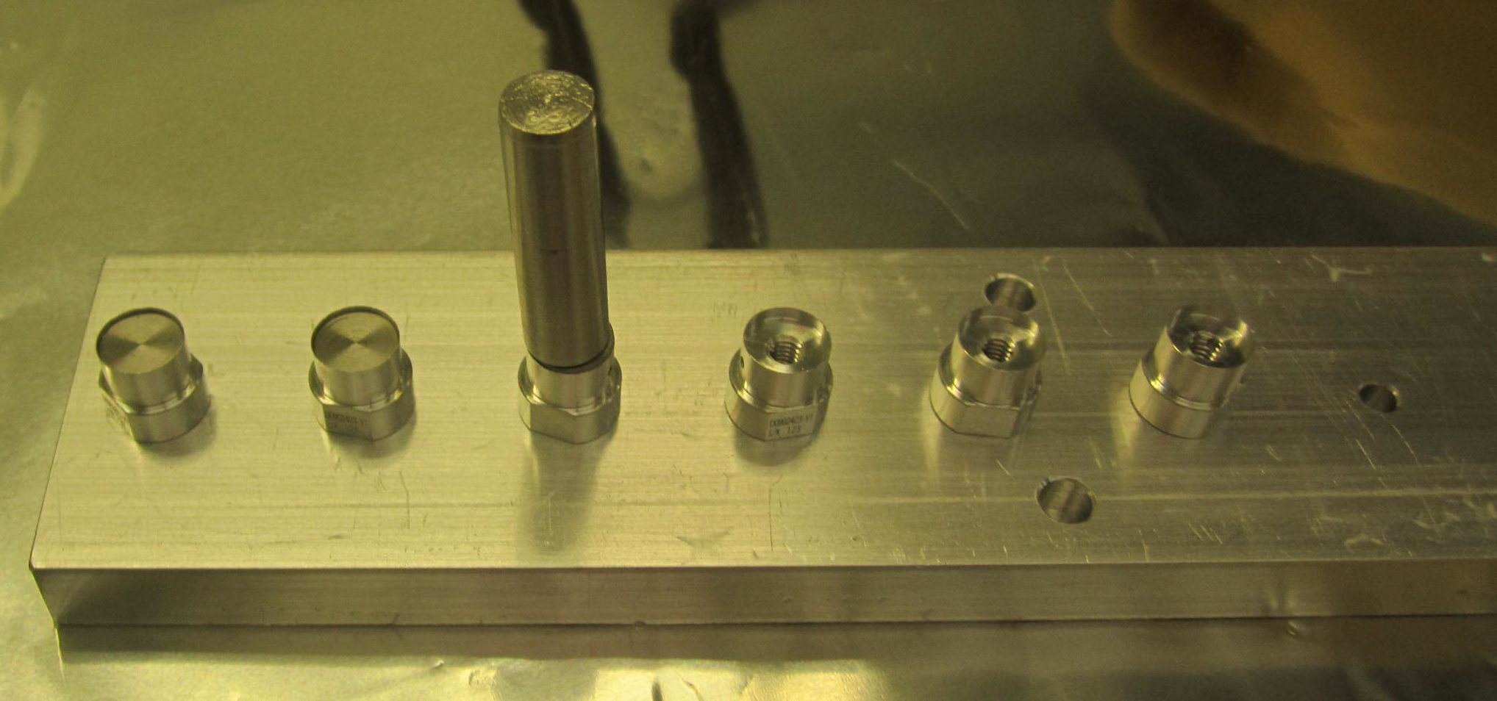  Fig 42: Insertion Tool in position  Note: Tapered end of Tool is up  Note: Seated Disks on left 2 Holders

Assembling the Intermediate Mass (M2)

Related Document
D0901873 Intermediate Mass Assembly, HSTS

Materials
Qty | Unit | Part Number | Description
1 | Each | D0901792 | Intermediate Mass
2 | Each | D020350 | Add-On Mass, 100g
2 | Each | N/A | SHCS, ¼-20 X 0.875” Long, Vented, SSTL
2 | Ea | NA | Socket Head Cap Screw ¼-20 x .875” Vented
2 | Ea | Several | Add-On Masses
2 | Ea | D020202 | Lower Wire Clamp, Inside
4 | Ea | D020203 | Lower Wire Clamp, Outside
6 | Ea | NA | Socket Head Cap Screw, 8-32 x .5” SSTL
4 | Ea | NA | Socket Head Cap Screw, 8-32 x .625” AgPlated
10 | Ea | NA | Flat Washer #8 SSTL
4 | Ea | D0901904 | Intermediate Wire Clamp Mount
4 | Ea | D0901903 | Intermediate Wire Clamp, Lower
8 | Ea | NA | Socket Head Cap Screw 4-40 x .375” AgPlated
12 | Ea | NA | Socket Head Cap Screw 4-40 x .375” SSTL
20 | Ea | NA | Flat Washer #4 SSTL

Procedure
Weigh the following items, selecting Add-On Weights to arrive at 2963.30 total:  - Intermediate Mass  - Lower Wire Clamps per list above  - Intermediate Wire Clamps per list above  - Add-On Masses for the Intermediate Mass  D1100894 2g  D1100863 5g  D1100855 10g  D030078 20g  D020351 50g  D020350 100g | 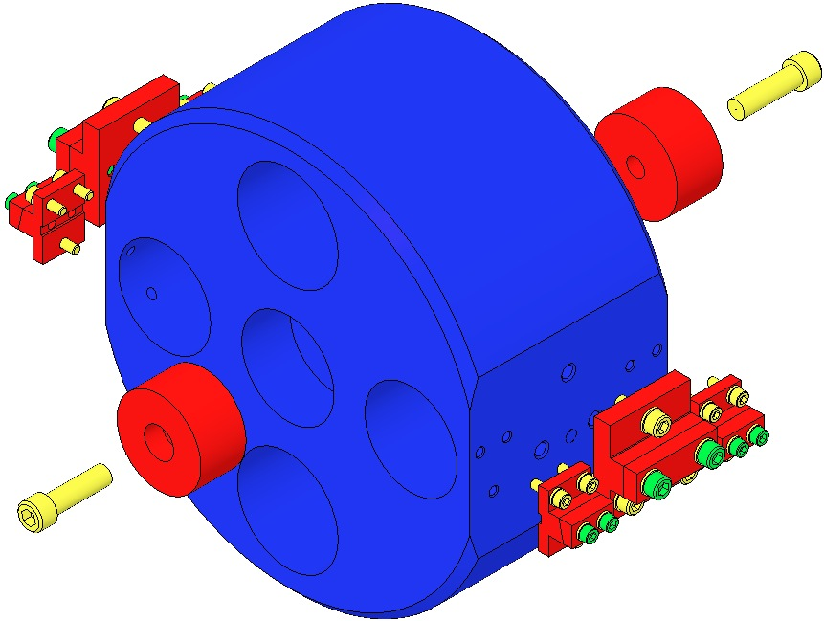  Fig 43: Add-On Weights and Wire Clamps
Assemble the Add-On Masses to the Intermediate Mass.  The grooves on the Add-On Masses must face inboard | 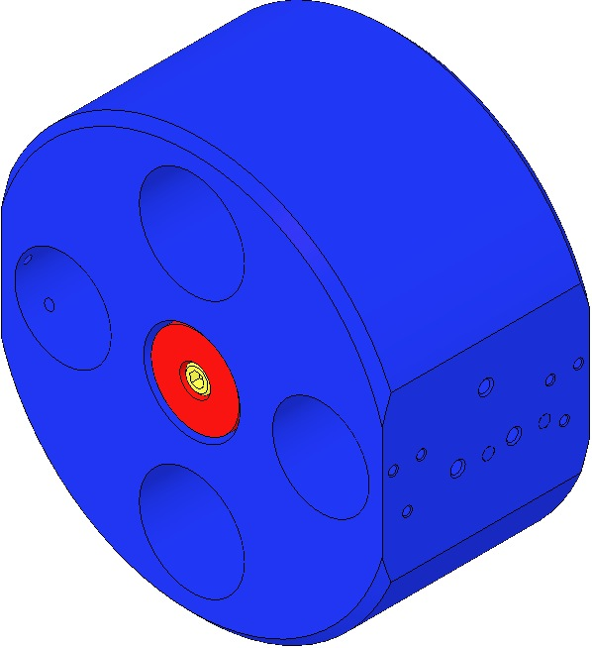  Fig 44: Intermediate Mass with Add-On Masses

Assembling the Lower Mass (M3)

Related Documents
D0901791 Metal Lower Mass Assembly (MC), HSTS
D0902333 Metal Lower Mass Assembly (PR/SR), HSTS

Materials
Qty | Unit | Part Number | Description
1 | Each | D020234 or D0902332 | Metal Lower Mass (MC) or Metal Lower Mass (PR/SR)
2 | Each | D0901790 | Primary Metal Breakoff Prism
4 | Each | N/A | SHCS, #8-32 X 0.375 Long, SSTL
12 | Each | N/A | Flat Washer, #8, SSTL
2 | Each | D1100197 | Spacer, Bottom Mass
8 | Each | N/A | SHCS, #4-40 X 0.375” Long, SSTL
8 | Each | N/A | Flat Washer, #4, SSTL
2 | Each | 033-0280 (OptoSigma) | Metallized Mirror, Round
1 | Ea | D0902658 | Optic Holder
4 | Ea | D980184 | LOS Clamps
4 | Ea | NA | Socket Head Cap Screw ¼-20 x 1.5” AgPlated

Procedure
Mount the D0902658 Optic Holder to an Optic Table using 4 D980184 Clamps and 4 Socket Head Cap Screws, ¼-20 x 1.5” AgPlated.  Place the D0901792 Intermediate Mass into the D0902658 Optic Holder. | 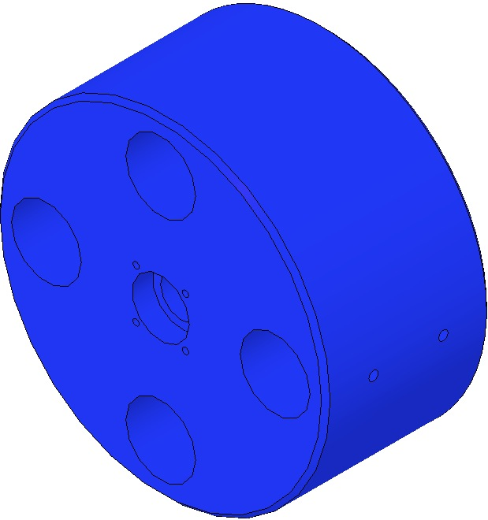  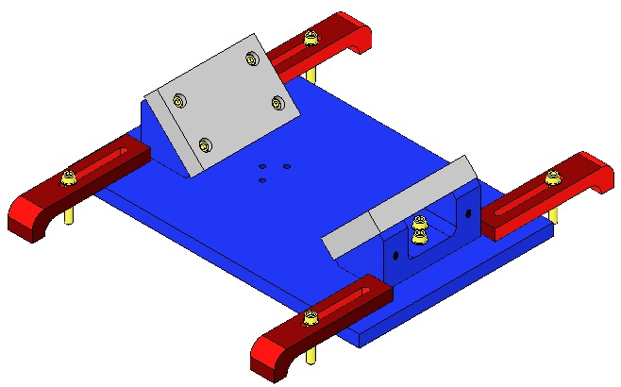  Fig 45: Optic Holder and Bottom Mass
Assemble to the Lower Mass:  - 2 Y1-1037-0 Laser Mirrors  - 8 Socket Head Cap Screws  4-40 x 0. 375” SSTL  - 4 Flat Washers #4 SSTL  - 4 Flat Washers #8 SSTL  Torque to 5 in-lb  Mirror Arrow must face outwards.  - 2 D0901790 Prism Breakoffs  - 4 Socket Head Cap Screws  8-32 x 0.375 SSTL  - 4 Flat Washers #8 SSTL  Torque to 20 in-lb | 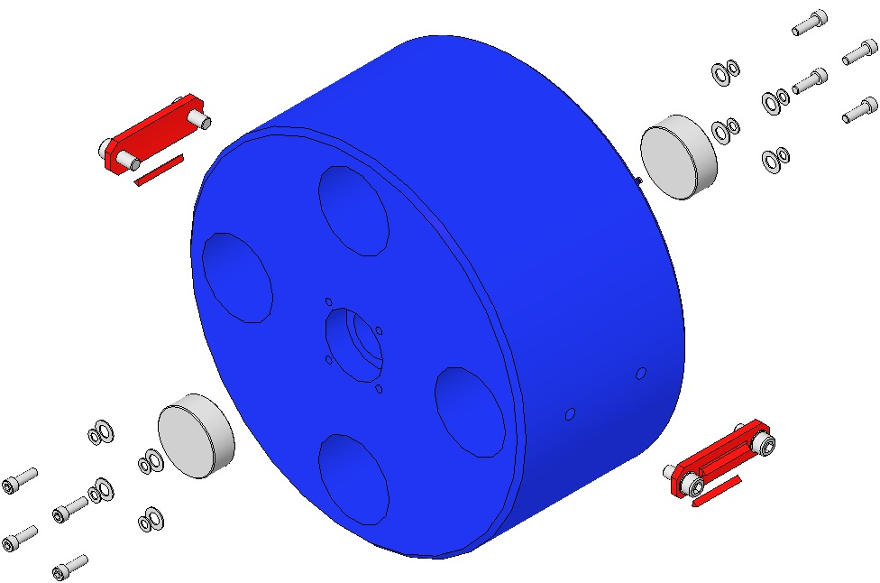

With the assembly process complete, weigh the Bottom Mass Assembly, including the D0901278 Secondary Metal Prism Breakoffs; the combined weight should be 2888.695g. Record this value in ICS. The Lower Mass is not designed to be weight-adjusted; weight is added to or subtracted from the Intermediate Mass. So adjusting Lower Mass weight is actually adjusting the combined weight of the Intermediate and Lower Masses, a total of 2963.30g + 2888.69g = 5851.99g.

Attaching the Top Blade Guards

Installing the Rotational Adjusters

Installing Barrel EQ Stops

Materials
Qty | U | ID | Description
2 | Ea | D0902203 | Barrel EQ Stop, Intermediate Wire
6 | Ea | D0902201 | Barrel EQ Stop, Lower Wire
32 | Ea | NA | Socket Head Cap Screw 8-32 x 0.5” AgPlated
32 | Ea | NA | Flat Washer #8
1 | Ea | NA | Machinist’s Square

Procedure
Assemble to the Weldment:  - 2 D0902203 Assemblies above the Intermediate Mass  Raise Crossbars  Retract Stop Screws  - 2 D0902201 Assemblies beneath the Intermediate Mass  Lower Crossbars  Extend Stop Screws to support the Mass  - 2 D0902201 Assemblies above Bottom Mass / Optic  Crossbars at midpoint  Stop Screws at midpoint  - 2 D0902201 Assemblies beneath Bottom Mass / Optic  Raise Crossbars  Extend Stop Screws  - 32 Socket Head Cap Screw  8-32 x 0.675” AgPlated  - 32 Flat Washer #8  Torque to 30 in-lb | 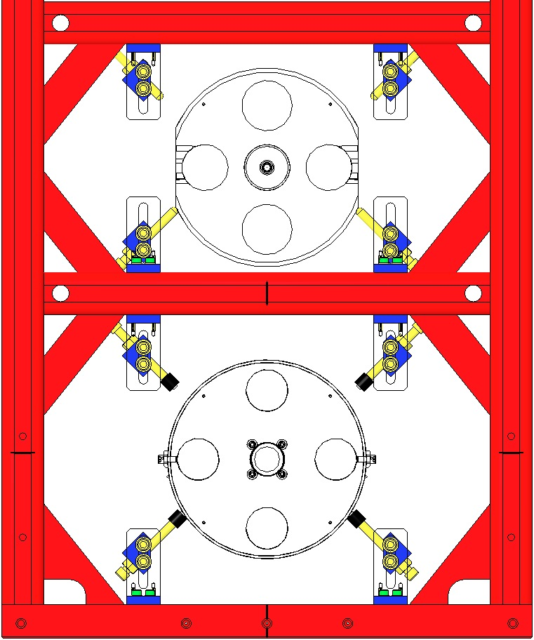  D0902201 Lower Crossbars, Screws support Mass  D0902201 Screws Halfway, Crossbars Halfway  D0902201 Raise Crossbars, Extend Screws  D0902203 Raise Crossbars, Retract Screws  Fig 46: Weldment / Front View

Related Documents
D020023 HSTS Weldment Assembly

Materials
Qty | U | ID | Description
2 | Ea | D020660 | Blade Pulldown Device
2 | Ea | D0901815 | Upper Clamp Inside
2 | Ea | D0901813 | Upper Clamp Outside
4 | Ea | NA | 2 Socket Head Cap Screw 4-40 x 0.375” AgPlated
4 | Ea | NA | Flat Washer #4 Vented, SSTL
4 | Ea | NA | Socket Head Cap Screw 4-40 x 0.25” AgPlated
1 | Kg | NA | 4.483 kg in weight
2 | Ft | NA | Music Wire .024” dia. min.
2 | Ea | D1102119 | Blade Pulldown Support Class B cleaned
2 | Ea | D1000045 | Upper Blade Rotational Adjustment Assemblies
2 | Ea | D0901934 | Blade Guard Assembly
24 | Ea | NA | Socket Head Cap Screw 8-32 x .625” AgPlated SSTL
24 | Ea | NA | Washer, Flat #8 SSTL
1 | Roll | NA | UHV Foil

Process
Wear Safety Glasses and Glove Liners per E1000043.  Prepare 2 D020660 Blade Pulldown Devices per Materials List. | Fig 47: Blade Pulldown Device
Attach 2 D0901934 Upper Blade Guard Assemblies to the Weldment using:  16 Socket Head Cap Screws  8-32 x 0.625” AgPlated SSTL  16 Washers, Flat #8 SSTL  Torque to 30 in-lb | 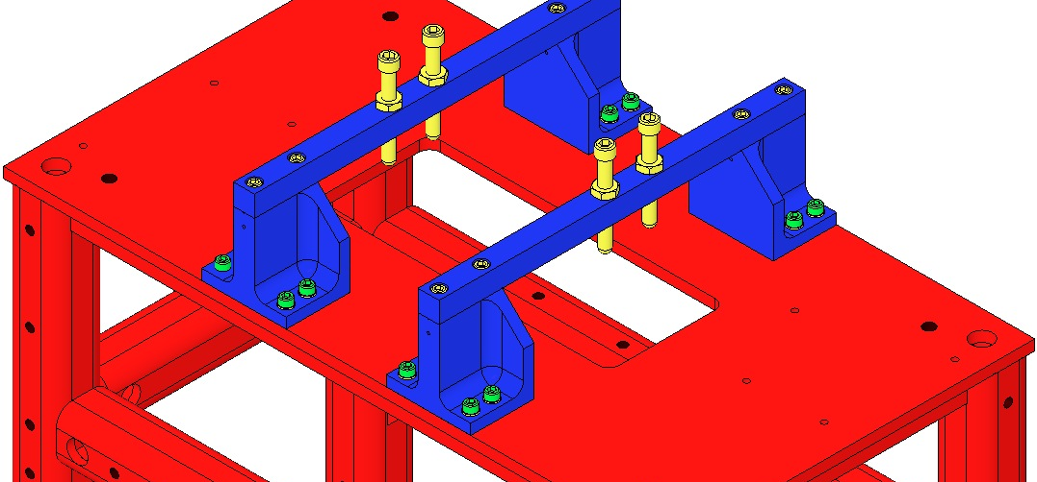  Fig 48: Base Plates and Blade Guards
Remove the 2 D0901935 Blade Guard Bars  Attach the Rotational Adjusters to the Weldment with:  8 Socket Head Cap Screws  8-32 x 0.625” AgPlated SSTL  8 Washers, Flat #8 SSTL  Torque to 20 in-lb.  Blades are shown flat but are actually curved upward at this point.  Record the serial number and location of both Upper Blades in ICS in the RA assembly load. | 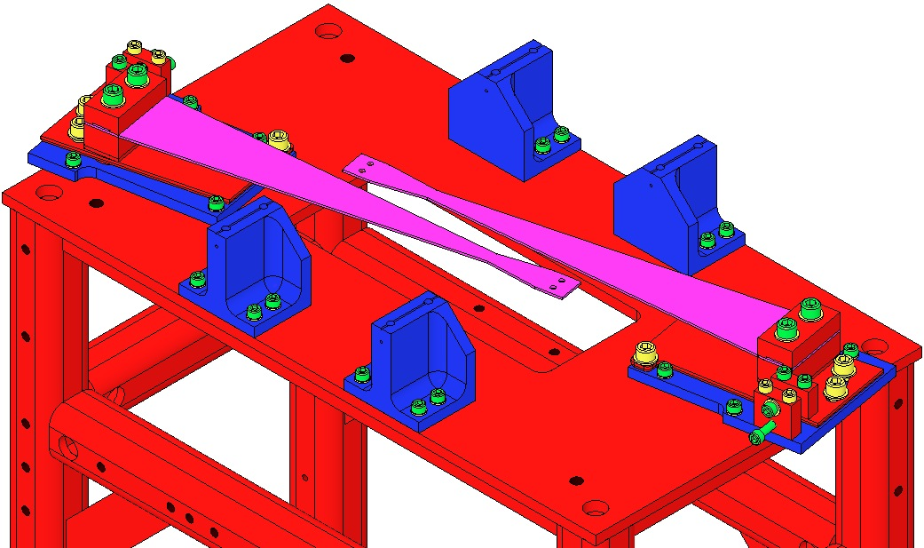  Fig 49: Crossbars removed
Ensure the 2 D1102119 Blade Pulldown Supports are Class B clean.  Attach the Blade Pulldown Supports to the center of the Weldment cross member shown, Clevis extending outboard.  Cover each end of the Weldment Structure and surrounding Optical Table areas with UHV Aluminum Foil, to protect them from the dirty Pulldown Device.  2 workers required:  1st person holds the Pulldown Weight.  2nd person passes Wire Clamp of the Pulldown Device through the Weldment side opening, up toward the Upper Blade Tip, then attaches the Clamp to the Blade tip with:  - 2 Socket Head Cap Screws  4-40 x .375” AgPlated SSTL  1st person gently drapes the wire over the Clevis, and slowly releases the Weight.  Repeat Steps 11-13 for the second Pulldown Device. | 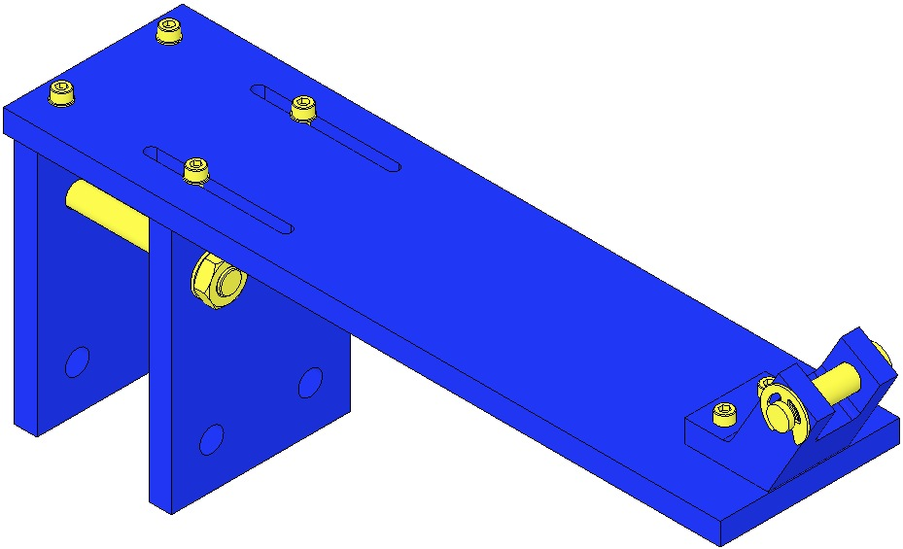  Fig 50: Blade Pulldown Support  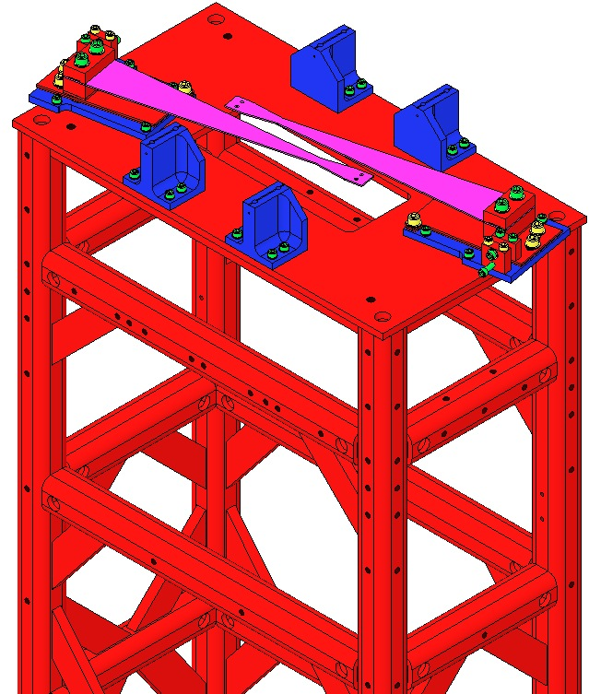  Blade Pulldown Supports  Fig 51: Location of Blade Pulldown Support
Re-Assemble the 2 D0901935 Blade Guard Bars to the Risers, using the original:  - 4 Socket Head Cap Screws  8-32 x .625” SSTL  Torque to 20 in-lb  Ensure the Bars are oriented with the EQ Stop Screws directly over the Blades.  The EQ Stop Screws should be adjusted so the Blades are flat. Once adjusted, the Screws should be secured with the Hex Nuts.  Carefully remove the 2 Blade Pulldown Devices.  Remove the 2 Blade Pulldown Supports. | 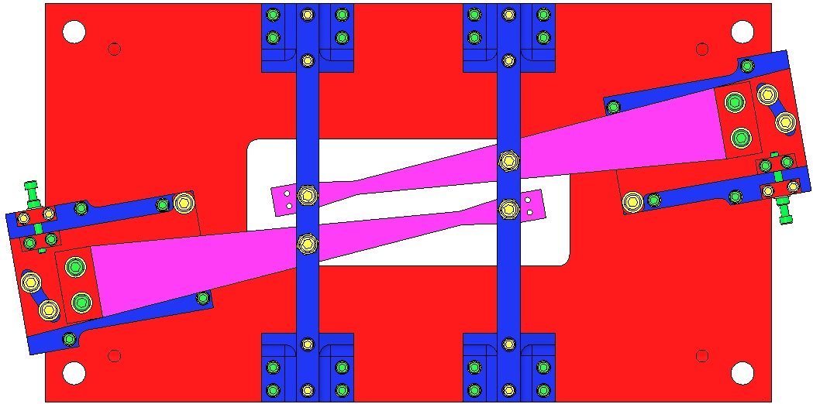  Fig 52: Bar orientation  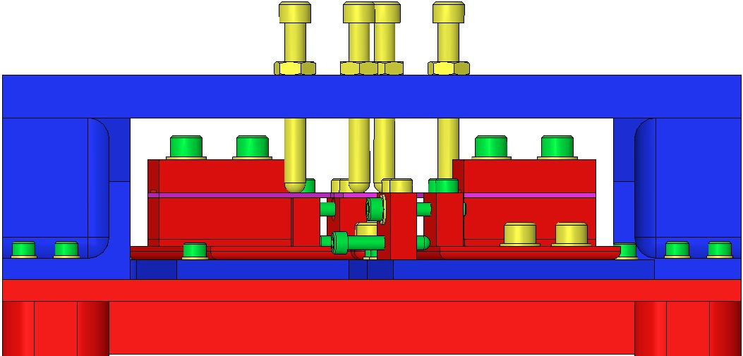  Fig 53: EQ Stops turned to flatten Blades

Installing Intermediate and Lower Masses and Face EQ Stops

Materials
Qty | U | ID | Description
1 | Ea | D0901873 | Intermediate Mass Assembly
1 | Ea | D0901791 | Lower Mass Assembly

Procedure

Place a 0901873 Intermediate Mass Assembly on top of the 4 Barrel EQ Stop Screws at the Intermediate Mass level.
- Magnets on the Mass face the rear of the Weldment.
- Top/Bottom of the Mass is identified per the Screw hole pattern in the side of the Mass.

Level the Mass (flat sides vertical) by adjusting the 4 EQ Stop Screws such that the lower four corners of the Mass are equidistant from the Optic Table surface.
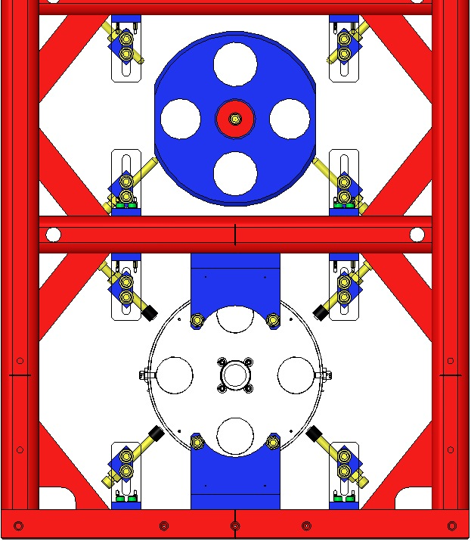  Fig 54: Intermediate Mass on Stops | 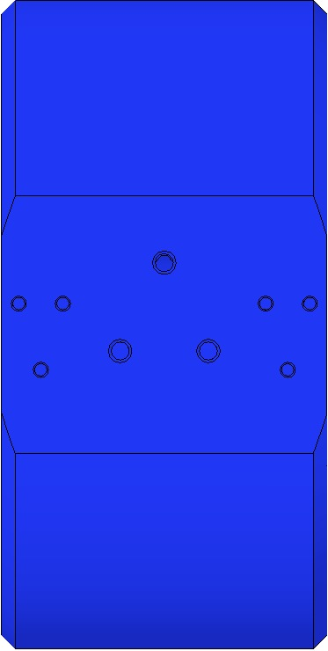  Mass  Right-Side Up | 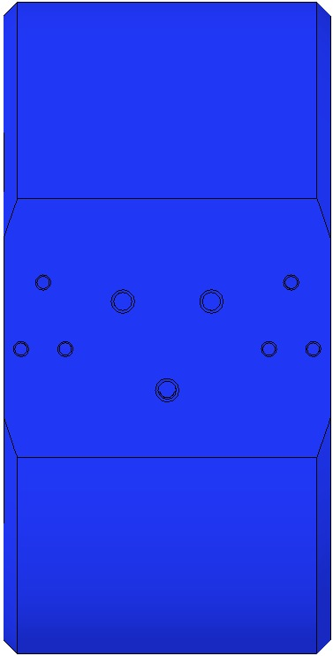  Mass  Upside Down
 | Fig 55: Right-Hand View of Mass

Assemble 2 D0902413 Face EQ Stops to the Weldment in front of the Mass, using:  - 4 Socket Head Cap Screws  8-32 UHC x .75” AgPlated  - 4 Flat Washers #8 SSTL  Torque to 30 in-lb | 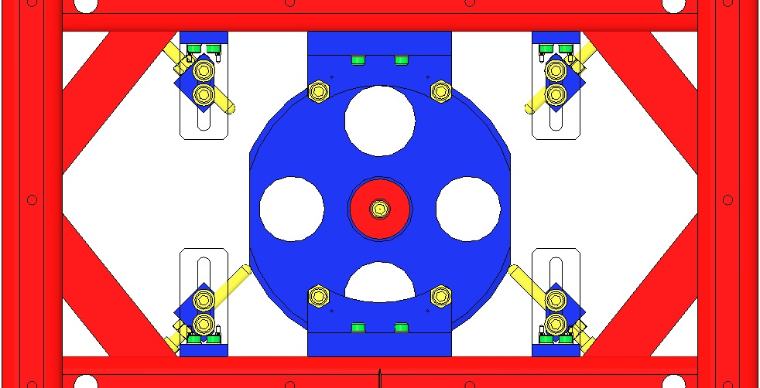  Fig 56: Face EQ Stops
Assemble both ends of the D0901902 Lower Wire Assembly to the Intermediate Mass with:  - 6 Socket Head Cap Screws  8-32 x 0.5” SSTL  - 6 Flat Washers #8 SSTL  Torque to 20 in-lbs  Use the Machinist’s Square to square the Wire Clamps with the front side of the Mass.  Machinist’s  Square |  | 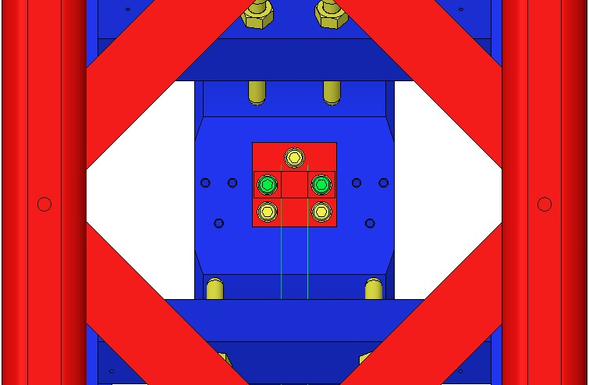  Fig 57: Lower Wire Assembly / Side View
Place a D0901791 Lower Mass within the twin wires of the D0901902 Lower Wire Assembly, but resting on the lower Stop Screws. Ensure:  - The 2 Crossbeams are raised fully;  - The 4 Stop Screws are extended fully.  - Each wire is seated in a Prism notch.  Retract the 4 Stop Screws until the Lower Wires are almost taught. Retract the Screws equally, turning each no more than 1 revolution at a time.  Level the Mass by adjusting the 4 Stop Screws such that both ends of each Prism are equidistant from the Optic Table surface. |  | 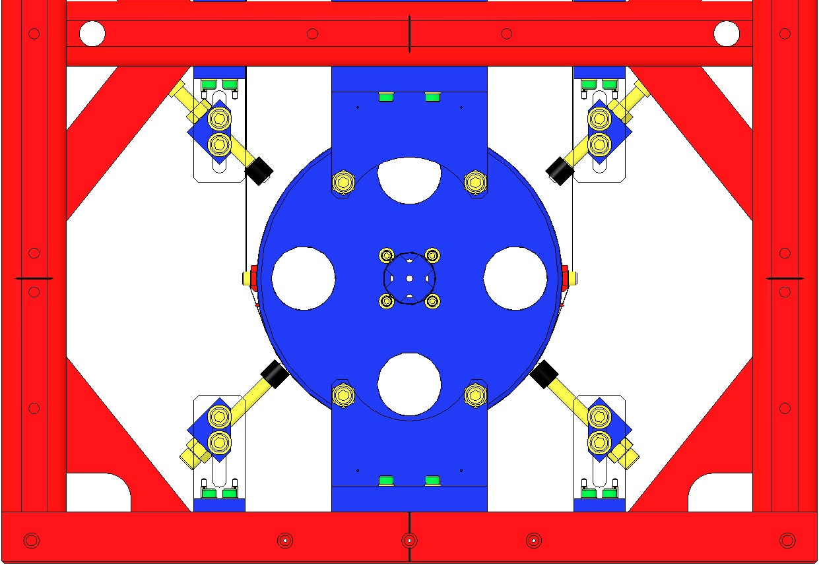  Crossbars Raised  Prism  Screws Extended  Fig 58: Lower Mass installed

Seat the 2 Lower Wires within the tiny grooves in the 2 Prisms. Adjust the 2 Wire loops such that they are equally spaced beneath the Mass.

Retract the 4 Stop Screws to lower the Mass until it is fully supported by the Lower Wires.
Adjust the Screws equally, turning each Screw no more than 1 revolution at a time.

Level the Lower Mass: Raise the Mass evenly on the 4 Stop Screws until the wire is slack but does not leave the Prism Grooves.

Reposition the 2 Wires to achieve leveling. If leveling is not possible, then the Lower Wire Assembly is defective and must be replaced (the 2 wires likely are of different lengths).
Install 2 D0902205 Face EQ Stops in front of the Lower Mass, using:  - 4 Socket Head Cap Screws  ¼-20 UHC x 0.375” SSTL  - 4 Flat Washers ¼” SSTL  Torque to 75 in-lb  Back off the lower Stop Screws (4) so that the Mass hangs free and the Lower Wires (2) are therefore taught. |  | 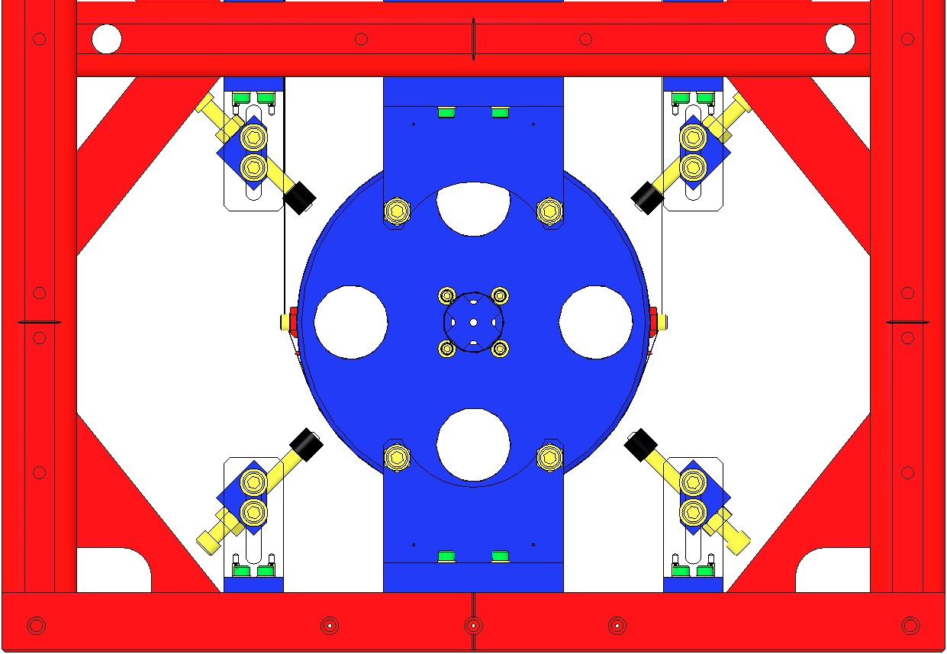  Wires Taught  Fig 59: Lower Mass and Face EQ Stops

Safe Handling of Suspension Wire
The wire used in all stages of the HSTS is a hard temper carbon steel, delivered and stored on large spools. When unspooled for cleaning, cutting, and preparation for assembly, safety precautions must be followed so that the large amount of potential energy stored in the coiled wire and sharp wire ends do not cause injury.

Personal Protective Equipment
The following items of personal protection equipment must be work when working with wire:
- Safety Glasses (available in all clean room garbing areas) must be worn at all times when working with wire or near Wire Assemblies under load
- Glove Liners (also available in all clean room garbing areas) must be worn under UHV Gloves at all times when working with wire to avoid puncture injuries by providing an additional layer of protection

Cleaning Suspension Wire
Follow the steps listed below to cut a section of wire from a spool and clean it for use in producing a Wire Assembly. Two people are needed to cut and clean a section of wire.
    - After removing the spool from its bag, remove the protective layer of paper and set it aside so that it can be replaced after cutting the wire.
    - Unspool a short length of wire and bend the wire over approximately 3” from the end. This helps to make the wire easier to hold and to avoid puncture injury.
    - Unspool the proper length of wire needed for the Wire Assembly, including extra for handling.
    - (Person 1) Hold on to the wire near the free end and the section to be cut so that the loose ends do not spring out of control away from the spool.
    - (Person 2) Cut the wire using dirty wire cutters.
    - (Person 2) Bend the cut end of the wire over approximately 3” from the end.
    - (Person 1) Hold on to both ends of the wire, keeping it from touching the floor.
    - (Person 2) Change gloves.
    - (Person 2) Spray a clean wipe with Methanol. Take one end of the wire from Person 1 and wipe the entire wire starting from that end. When finished, take the other end from Person 1.
    - (Person 1) Change gloves.
    - (Person 1) Spray a clean wipe with Acetone. Take one end of the wire from Person 2 and wipe the entire wire starting from that end. When finished, take the other end from Person 2.
    - (Person 2) Change gloves.
    - (Person 2) Spray a clean wipe with Isopropanol. Take one end of the wire from Person 1 and wipe the entire wire starting from that end. When finished, take the other end from Person 1.
    - Repeat Steps 8-13, alternating holding the wire between Person 1 and Person 2, until nothing is left on the wipe after cleaning.
    - The wire is now considered to be clean and should only be handled with clean gloves. Transfer the wire to the Assembly Jig. Use the Wire Clamps on the Assembly Jig to hold the wire in place.
    - After using the wire spool, tape the free end of the wire to the spool with the small piece of tape on the spool. Replace the protective layer of paper and place the spool back into its bag.

Assembling the Intermediate Wires

Related Documents
E0900332 HSTS Assembly and Installation Hazard Analysis
D0901905 Intermediate Wire Assembly, HSTS
E960022 Vacuum Compatibility, Cleaning Methods and Qualification Procedures

Materials
Qty | Unit | Part Number | Description
1 | Each | D0902526 | Intermediate Wire Jig Assembly, HSTS
4 | Each | D980184 | LOS Clamp, Long
1 | Each | D020132 | Lower Blade Wire Clamp, HSTS
1 | Each | D030044 | Lower Blade Wire Clamp Plate, Angled, HSTS
1 | Each | D0901904 | Intermediate Wire Clamp Mount, Lower, HSTS
1 | Each | D0901903 | Intermediate Wire Clamp, Outside, HSTS
2 | Each | N/A | SHCS, #2-56 X 0.375”, Ag-Plated SSTL
2 | Each | N/A | #2 Flat Washer
2 | Each | N/A | SHCS, #4-40 X 0.375”, Ag-Plated SSTL
2 | Each | N/A | #4 Flat Washer
1 | Spool | N/A | Steel Music Wire, 0.0079” Diameter
1 | Each | N/A | Weight Hanger
1 | Each | N/A | Interlocking Test Weight (1kg)
1 | Set | N/A | Test Weights (1g – 500g)
1 | Bag | PNHS-99 | Polynit Heatseal Wipes
1 | Bottle | N/A | Methanol
1 | Bottle | N/A | Acetone
1 | Bottle | N/A | Isopropanol

Procedure
Table Edge

Jig

Clevis
4 Intermediate Wire Assemblies are required per HSTS. Wire Assemblies should only be assembled as needed (NOT assembled ahead of time and stored for later use).  Wear safety glasses and glove liners per E0900332.  Ensure that all parts of the Intermediate Wire Jig Assembly (D0902526) have been processed to Class B per E960022.  Confirm that the Wire Jig is assembled completely and correctly per the drawing.  Attach the Jig to an Optical Table using 4X LOS Long Clamps (D980184). Position the Jig so that the end with the Wire Jig Pin Support (D0900563) extends beyond the edge of the Optical Table by approximately 3” to allow clearance for the Interlocking Test Weights. |  | 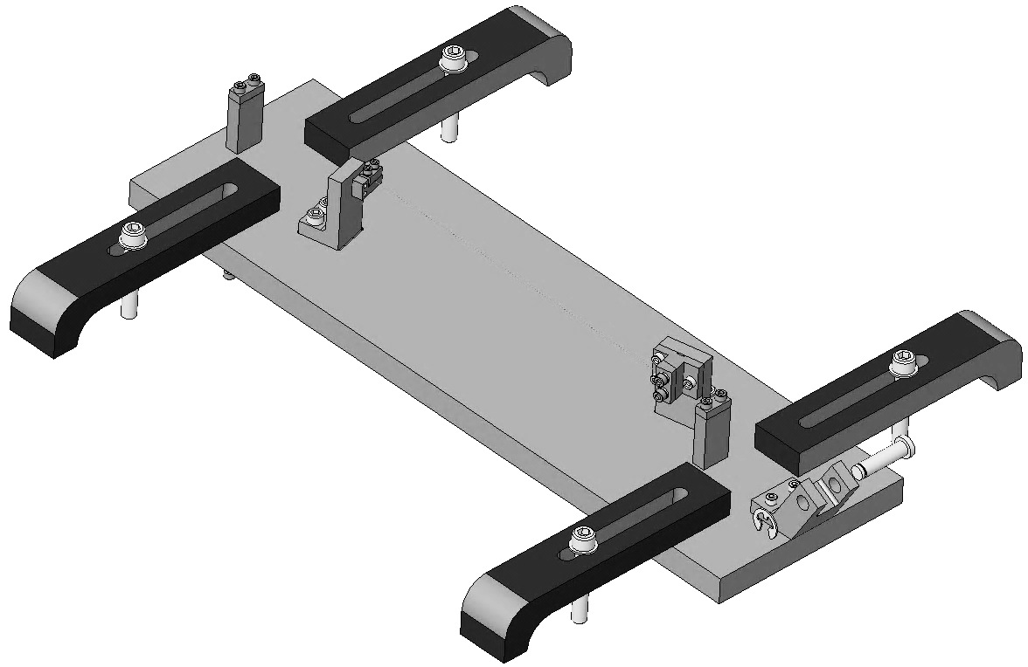  Table Edge  Clevis  Jig  Clamp  Fig 60: Intermediate Wire Jig (to be changed)
Assemble the two ends of the Wire Assembly (referred to as the Lower Blade Wire Clamp and the Intermediate Wire Clamp) before attaching them to the Wire Jig. Do not tighten the SHCS.  Each Lower Blade Wire Clamp includes:  1X D020132 Lower Blade Wire Clamp, HSTS  1X D030044 Lower Blade Wire Clamp Plate, Angled, HSTS  2X SHCS #2-56 X 0.375”, Ag-Plated SSTL  2X #2 Flat Washers  Each Intermediate Wire Clamp includes:  - 1X D0901904 Intermediate Wire Clamp Mount, Lower, HSTS  - 1X D0901903 Intermediate Wire Clamp, Outside, HSTS  - 2X SHCS, #4-40 X 0.375”, Ag-Plated SSTL  - 2X #4 Flat Washers |  |  |  | 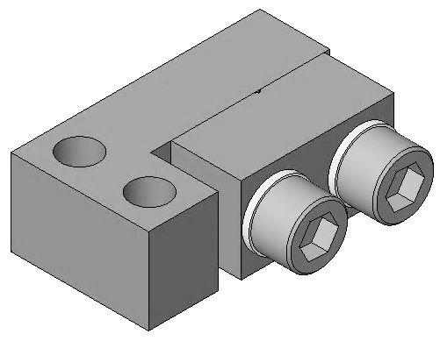  D020132  D030044  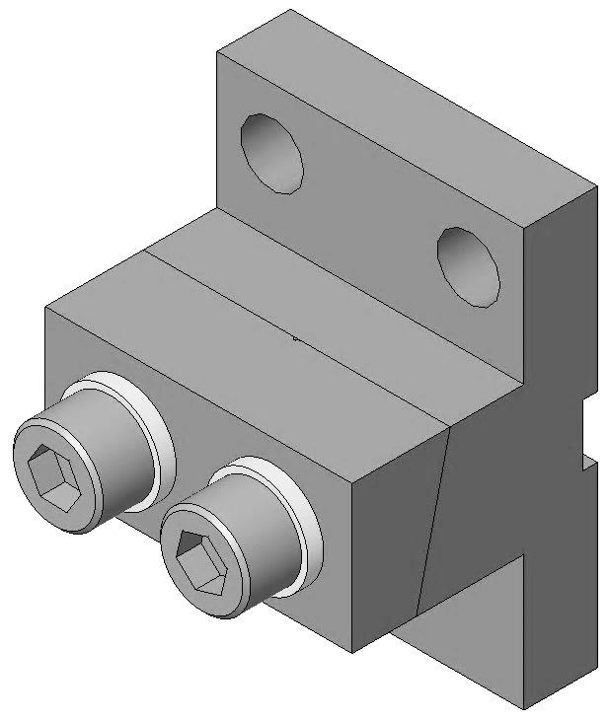  D0901904  D0901903  Fig 61: Clamps
On the Wire Jig, attach one Lower Blade Wire Clamp to the outboard side of the Blade Wire Clamp Bracket (D0902532) using:  - 2X SHCS, #2-56 X 0.375”, Ag-Plated SSTL  On the Wire Jig, attach one Intermediate Wire Clamp to the outboard side of the Mass Wire Clamp Bracket (D0902533), using:  - 3X SHCS, #4-40 X 0.375”, SSTL |  |  | L-Clamp  Intermediate Clamp  Fig 62: Clamps Mounted on Wire Jig
Unspool approximately 24” of 0.0079” diameter Steel Music Wire. Clean the Steel Music Wire as described in Section 12.4. Cut the Steel Music Wire from the spool using dirty wire cutters.  Feed the Steel Music Wire through theWire Jig and Clamps in the order shown:  1) Over the Clevis Pin  2) Through the first Wire Start Post (D1000628 and D1000583)  3) Through the Intermediate Wire Clamp  4) Through the Lower Blade Wire Clamp  5) Through the second Wire Start Post  Tighten the SHCS in the second Wire Start Post after feeding approximately 0.5” of Steel Music Wire through the clamp. |  |  | 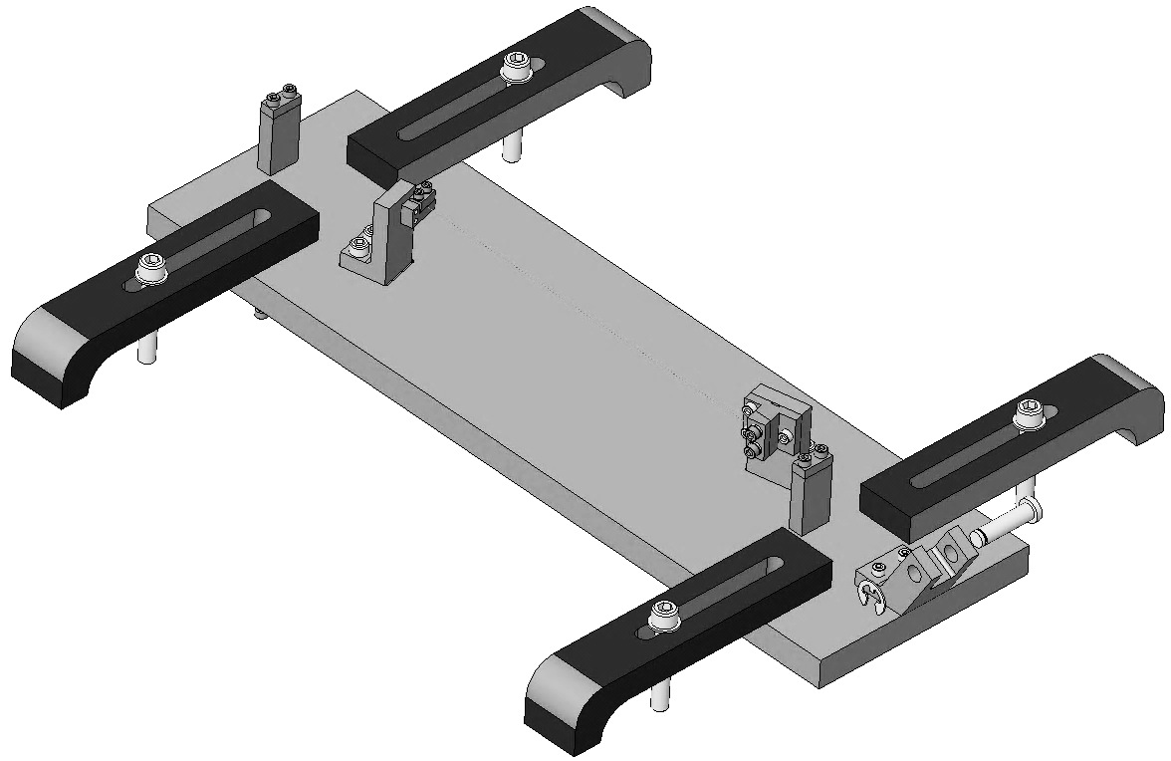  2  5  4  1  3  Fig 63: Wire Path
Using a Weight Hanger and a set of Small Test Weights, make up a hanging weight with a mass of 1.460 kg. Note that the Weight Hanger and Test Weights are not clean.  Tie the end of the Steel Music Wire hanging over the Clevis Pin around the hook on the Weight Hanger. The Steel Music Wire should now be taut, due to the hanging weight.  Allow the hanging weight to hang from the Steel Music Wire for at least 5 minutes. Be careful of hands and feet underneath the hanging weight. |  |  |  |  | Fig 64: Hanging Weight
Measure the length of the wire between the inboard sides of the Lower Blade Wire Clamp and the Intermediate Wire Clamp. The desired length is 167.02 mm.  Tighten the SHCS in the clamps in the order shown. The SHCS in clamp 2 (Lower Blade Wire Clamp) should be torqued to 4 in-lb, while the SHCS in clamp 3 should be torqued to 6 in-lb. When tightening the SHCS, ensure that the inboard surfaces of the two halves of each clamp are completely parallel.  Remove the hanging weight from the wire.  Using clean wire cutters, cut the Steel Music Wire in two locations as shown, as close to the outboard sides of the clamps as possible. | Cut Wire  2  3  Cut Wire  1  Fig 65: Clamping and Cutting the Wire (backwards)
Before removing the Wire Assembly from the Wire Jig, record part serial numbers, the measured wire length and the mass of the hanging weight to be included in the ICS assembly load.  Loosen the #2-56 X 0.375 and #4-40 X 0.375 SHCS holding the clamps to the Wire Jig (NOT the ones holding the clamps together) Loosen the SHCS in the Wire Start Posts and discard the leftover Steel Music Wire. The completed Intermediate Wire Assembly is shown in Figure 18.  Create an assembly load in ICS for the Intermediate Wire Assembly. Use the serial number of D0901904 as the serial number of the assembly (D0901905). |  |  |  | Fig 66: Intermediate Wire Assembly
NOTE: If a wire breaks, the Intermediate Wire Assembly can be disassembled and certain parts can be reused. Parts that can be reused include D020132, D0901904 and hardware. These parts can only be used if there is no damage caused to the part (grooves, nicks, etc.) caused by wire clamping.
Parts that CANNOT be reused include D030044 and D0901903. These parts must be marked as defective in ICS and quarantined from usable production parts.

Assembling the Upper Wires

Related Documents
E0900332 HSTS Assembly and Installation Hazard Analysis
D0901854 Upper Wire Assembly, HSTS
E960022 Vacuum Compatibility, Cleaning Methods and Qualification Procedures

Materials
Qty | Unit | Part Number | Description
1 | Each | D0902108 | Upper Wire Jig Assembly, HSTS
4 | Each | D980184 | LOS Clamp, Long
1 | Each | D020481 | Upper Mass C-Clamp, HSTS
1 | Each | D0901999 | Upper Mass Wire Clamp, Inside, Angled, HSTS
1 | Each | D0901998 | Upper Mass Wire Clamp, Outside, Angled, HSTS
1 | Each | D020198 | Upper Blade Wire Clamp, HSTS
1 | Each | D0901994 | Upper Blade Wire Clamp, Outside, Angled, HSTS
2 | Each | N/A | SHCS, #4-40 X 0.375”, Ag-Plated SSTL
4 | Each | N/A | #4 Flat Washer
2 | Each | N/A | SHCS, #4-40 X 0.625”, Ag-Plated SSTL
1 | Spool | N/A | Steel Music Wire, 0.014” Diameter
1 | Each | N/A | Weight Hanger
1 | Set | N/A | Interlocking Test Weights (1kg, 2kg)
1 | Set | N/A | Test Weights (1g – 500g)
1 | Bag | PNHS-99 | Polynit Heatseal Wipes
1 | Bottle | N/A | Methanol
1 | Bottle | N/A | Acetone
1 | Bottle | N/A | Isopropanol

Procedure
2 Upper Wire Assemblies are required per HSTS. Wire Assemblies should only be assembled as needed (NOT assembled ahead of time and stored for later use).  Wear safety glasses and glove liners per E0900332.  Ensure that all parts of the Upper Wire Jig Assembly (D0902108) have been processed to Class B per E960022.  Confirm that the Wire Jig is assembled completely and correctly per the drawing.  Attach the Jig to an Optical Table using 4X LOS Long Clamps (D980184). Position the Jig so that the end with the Wire Jig Pin Support (D0900563) extends beyond the edge of the Optical Table by approximately 3” to allow clearance for the Interlocking Test Weights. |  | 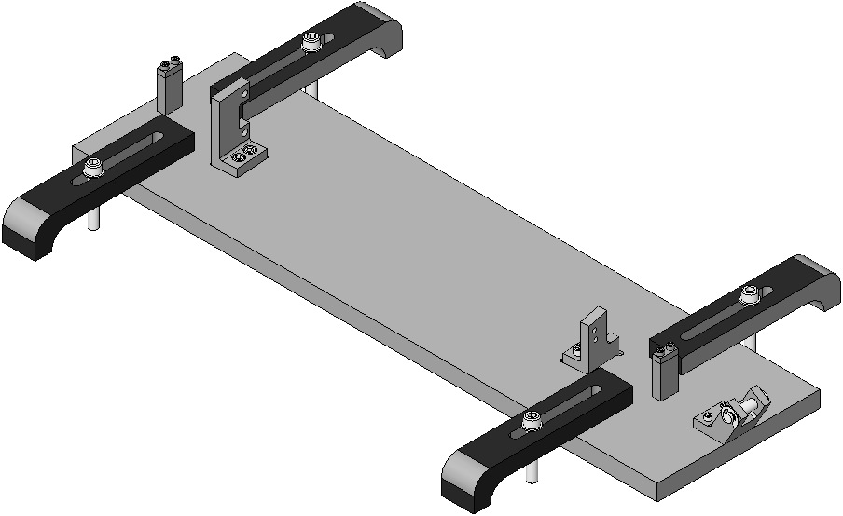  Class B  Table Edge  Clevis  LOS Clamp  Class A  Fig 67: Upper Wire Jig (to be changed)
Assemble the two ends of the Wire Assembly (referred to as the C-Clamp and L-Clamp) before attaching them to the Wire Jig. Do not tighten the SHCS.  Each C-Clamp includes:  - 1X D020481 Upper Mass C-Clamp, HSTS  - 1X D0901999 Upper Mass Wire Clamp, Inside, Angled, HSTS  - 1X D0901998 Upper Mass Wire Clamp, Outside, Angled, HSTS  - 2X SHCS, #4-40 X 0.625”, Ag-Plated SSTL  - 2X #4 Flat Washers  Each L-Clamp includes:  - 1X D020198 Upper Blade Wire Clamp, HSTS  - 1X D0901994 Upper Blade Wire Clamp, Outside, Angled, HSTS  - 2X SHCS, #4-40 X 0.375”, Ag-Plated SSTL  - 2X #4 Flat Washers |  |  |  | 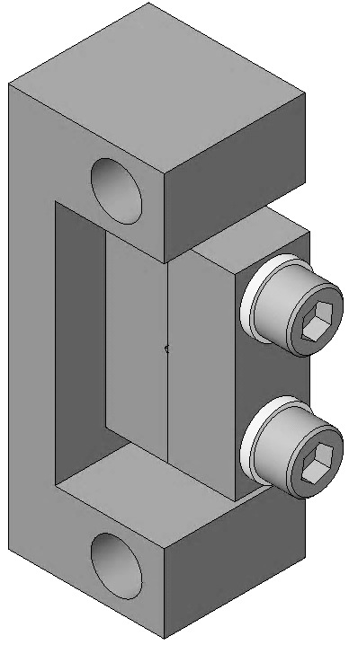  D020481  (2)  D0901999  (2)  D0901998  (2)  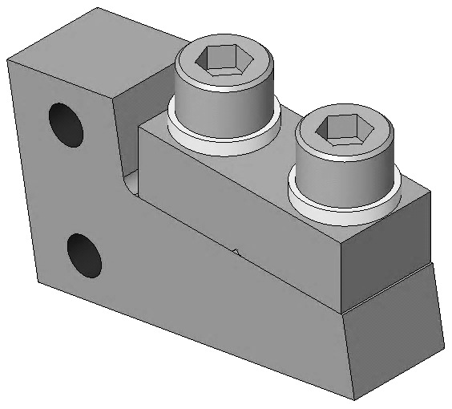  D0901994  (2)  D020198  (2)  Fig 68: Clamps
On the Wire Jig, attach one C-Clamp to the outboard side of the Upper Wire Clamp Mount (D0902110) using:  2X SHCS, #8-32 X 0.5”, Ag-Plated SSTL  On the Wire Jig, attach one L-Clamp to the outboard side of the Blade Clamp Mount (D0902111) using:  2X SHCS, #4-40 X 0.5”, Ag-Plated SSTL |  |  |  | 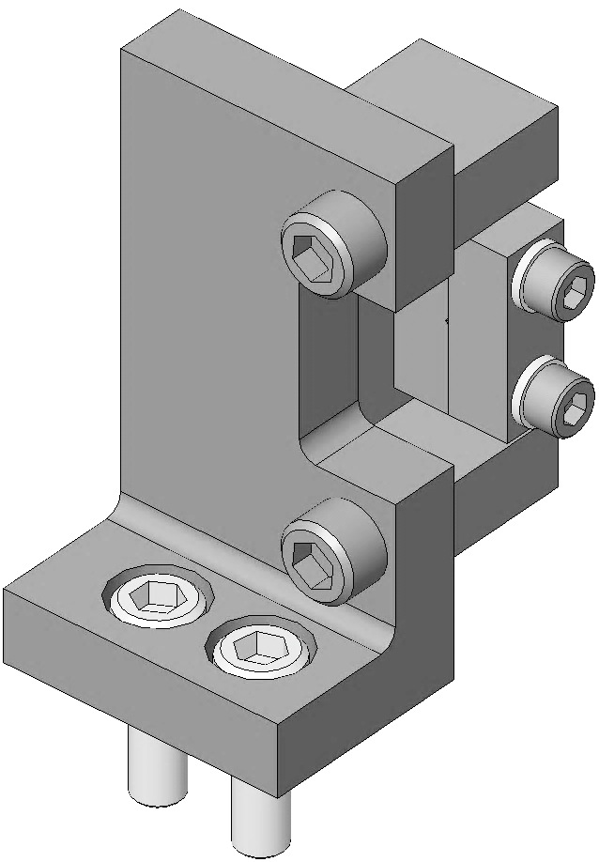  D0902110  Screws (2)  (2)  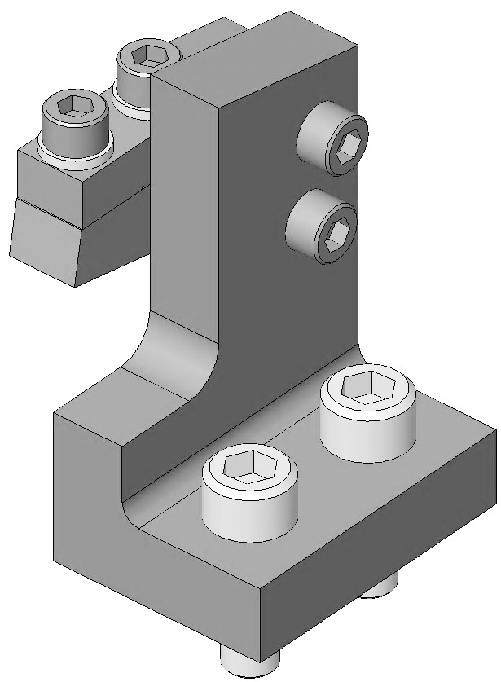  D0902111  (2)  Screws (2)  (2)  Fig 69: Clamp Mounts
Unspool approximately 36” of 0.014” diameter Steel Music Wire. Clean the Steel Music Wire as described in Section 12.4. Cut the Steel Music Wire from the spool using dirty wire cutters.  Feed the Steel Music Wire through the Wire Jig and Clamps in the order shown:  1) Over the Clevis Pin  2) Through the first Wire Start Post (D1100580 and D1000583)  3) Through the L-Clamp  4) Through the C-Clamp  5) Through the second Wire Start Post  Tighten the SHCS in the second Wire Start Post after feeding approximately 0.5” of Steel Music Wire through the clamp. |  |  | 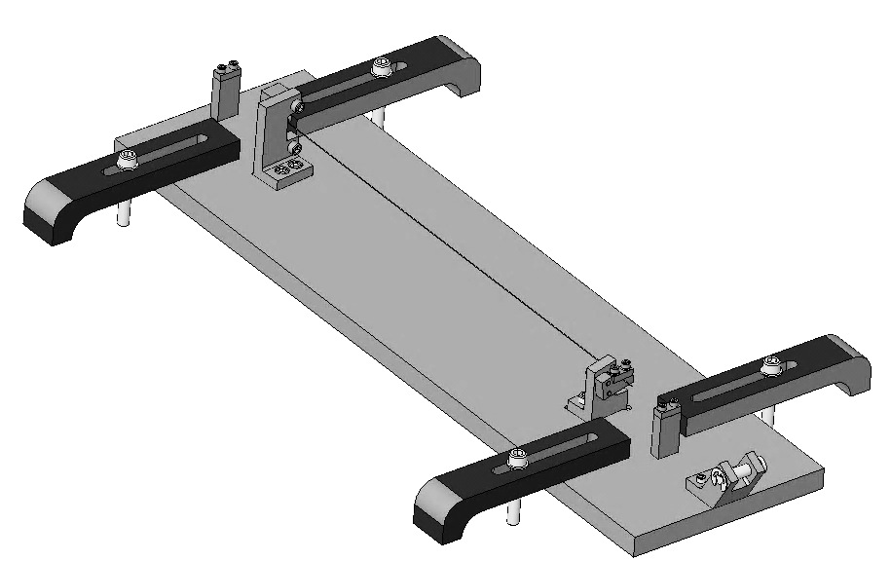  5  4  2  1  3  Fig 70: Wire Path
Using a Weight Hanger, Interlocking Test Weights and a set of small Test Weights, make up a hanging weight with a mass of 4.483 kg. Note that the Weight Hanger and Test Weights are not clean.  Tie the end of the Steel Music Wire hanging over the Clevis Pin around the hook on the Weight Hanger. The Steel Music Wire should now be taut, due to the hanging weight.  Allow the hanging weight to hang from the Steel Music Wire for at least 5 minutes. Be careful of hands and feet underneath the hanging weight. |  |  |  |  | Fig 71: Hanging Weight
Measure the length of the wire between inboard sides of the C-Clamp and L-Clamp. The desired length is 294.13 mm.  Tighten the SHCS in the clamps in the order shown. The SHCS in clamps 2 (C-Clamp) and 3 (L-Clamp) should be torqued to 6 in-lb. When tightening the SHCS in the C-Clamp and L-Clamp, ensure that the inboard surfaces of the two halves of each clamp are completely parallel.  Remove the hanging weight from the wire.  Using clean wire cutters, cut the Steel Music Wire in two locations as shown, as close to the outboard sides of the C-Clamp and L-Clamp as possible.  Before removing the Wire Assembly from the Wire Jig, record part serial numbers, the measured wire length and the mass of the hanging weight to be included in the ICS assembly load. |  |  | 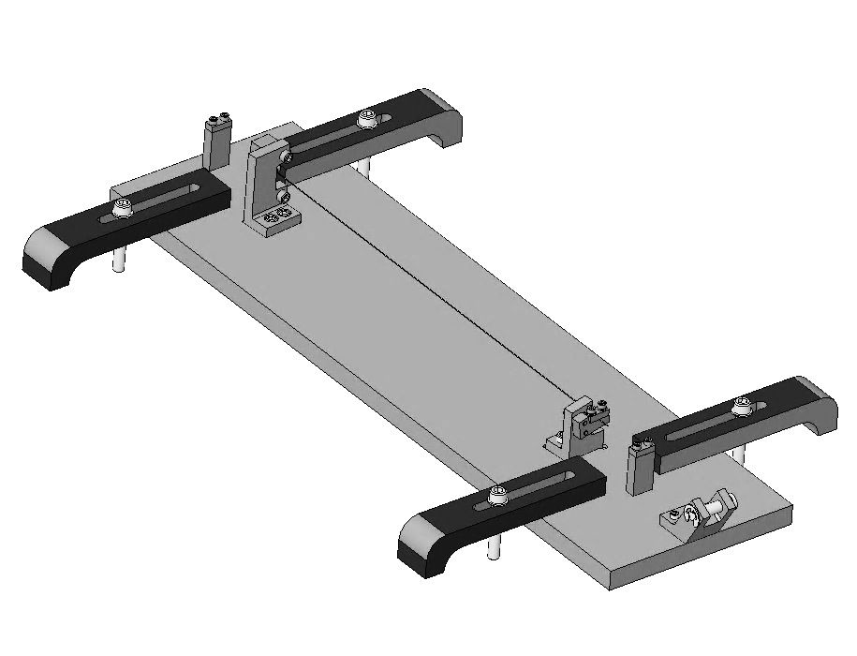  3  1  2  Cut Wire  Cut Wire  Fig 72: Clamping and Cutting the Wire (backwards)
Loosen the #8-32 X 0.5” and #4-40 X 0.5” SHCS to remove the Wire Assembly from the Wire Jig. Loosen the SHCS in the Wire Start Posts and discard the leftover Steel Music Wire. The completed Upper Wire Assembly is shown in Figure 11.  Create an assembly load in ICS for the Upper Wire Assembly. Use the serial number of D020481 as the serial number of the assembly (D0901854). | Fig 73: Upper Wire Assembly

NOTE: If a wire breaks, the Upper Wire Assembly can be disassembled and certain parts can be reused. Parts that can be reused include D020481, D0901998, D020198 and hardware. These parts can only be used if there is no damage caused to the part (grooves, nicks, etc.) caused by wire clamping.
Parts that CANNOT be reused include D0901999 and D0901994. These parts must be marked as defective in ICS and quarantined from usable production parts.

Installing the Upper Mass and Coil Holder

Materials
Qty | U | ID | Description
1 | Ea | D040259 | Upper Mass Jig
1 | Ea | D020239 | HSTS Coil Holder
4 | Ea | D020346 | HSTS Coil Holder Bracket
16 | Ea | NA | Socket Head Cap Screw 8-32 x .375” AgPlated
16 | Ea | NA | Flat Washer #8 SSTL
12 | Ea | D030025 | Socket Head Cap Screw, 8-32 x 1.00”, Round Tip, AgPlated
1 | Ea | D020534 | HSTS Upper Mass Assembly
4 | Ea | D020482 | HSTS Screw Drive System
9 | Ea | D0902418 | Magnet/Flag Assembly Long
7 | Ea | D0902493 | Magnet/Flag Assembly Base
2 | Ea | D020199 | Magnet/Flag Assembly Base Short
4 | Ea | D020211 | HSTS Magnet Holder Brace
8 | Ea | NA | Socket Head Cap Screw 4-40 x 1.25” AgPlated
4 | Ea | NA | Socket Head Cap Screw 4-40 x .625” Vented AgPlated
6 | Ea | NA | Socket Head Cap Screw 4-40 x .625” AgPlated
18 | Ea | NA | Flat Washer #4
4 | Ea | NA | Socket Head Cap Screw 4-40 x 0.375” AgPlated SSTL
1 | Ea | NA | Allen Head Wrench #4 T-Handle

It is important that the Upper Wires NOT be assembled to the Upper Mass / Coil Holder until it is ready to be installed in the Weldment.

Procedure – Assembling Upper Mass & Coil Holder to Weldment
Coil Holder brackets are made to match each Weldment.  Assemble loosely to one end of the Weldment (LH end of Weldment shown):  - 2 D020346 Coil Holder Brackets  - 4 Socket Head Cap Screws  8-32 x .375” AgPlated SSTL  - 4 Flat Washers #8 SSTL  Attach Bracket to the Weldment through the horizontal Screw Slots. | 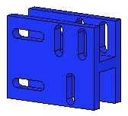  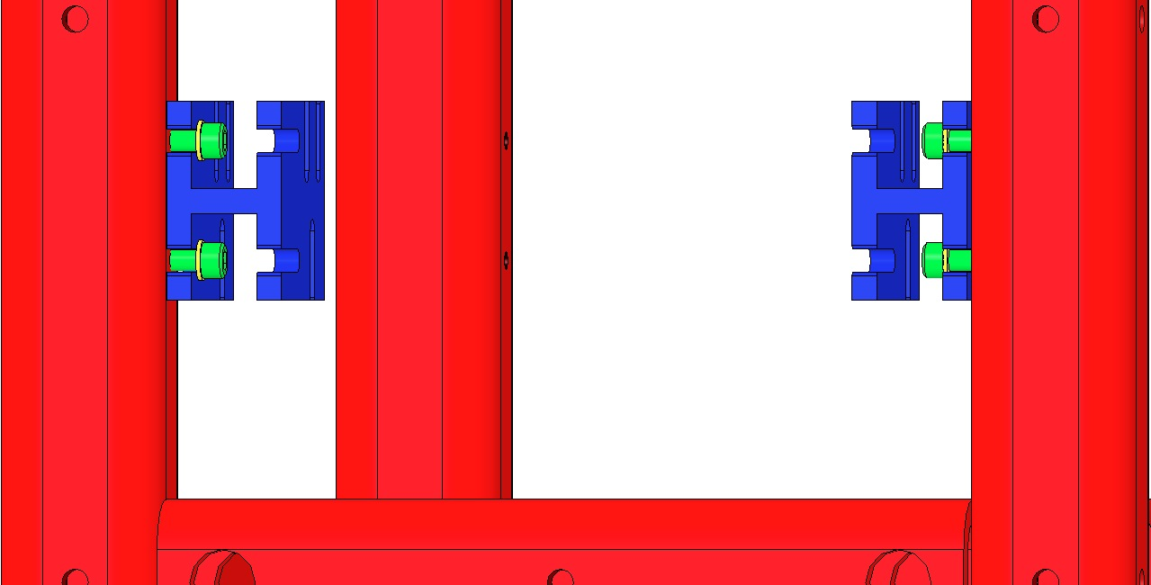  Coil Holder Slots  Weldment Slots  Fig 74: 1st pair of Coil Holder Brackets
Assemble loosely to the 2 Brackets:  - The D020239 Coil Holder  - 4 Socket Head Cap Screws  8-32 x .375” AgPlated SSTL  (2 shown)  - 4 Flat Washers #8 SSTL  Although each Coil Holder Bracket has 3 Screw slots for the Coil Holder, only 2 Screw slots are usable due to clearance issues with the Weldment.  Assemble loosely to the other end of the Weldment:  - 2 D020346 Coil Holder Brackets  - 4 Socket Head Cap Screws  8-32 x .375” AgPlated SSTL  - 4 Flat Washers #8 SSTL  Assemble loosely to the 2 Brackets:  - The D020239 Coil Holder  - 4 Socket Head Cap Screws  8-32 x .375” AgPlated SSTL  - 4 Flat Washers #8 SSTL  Align Coil Holder to Weldment and with the 4 Coil Holder Brackets:  - Horizontally: Visually centered  - Vertically: Low in the Bracket Slots  Torque all 8 Screws that connect the Brackets to the Weldment to 30 in-lb. Leave the 8 Screws that connect the Brackets to the Coil Holder loose. | 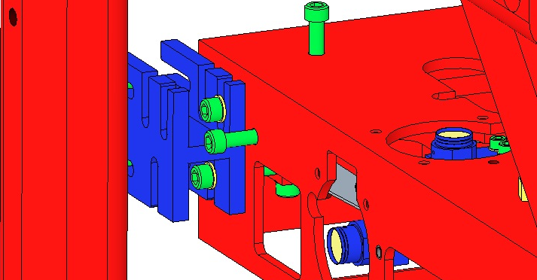  Fig 75: Assemble Coil Holder to 2 Brackets  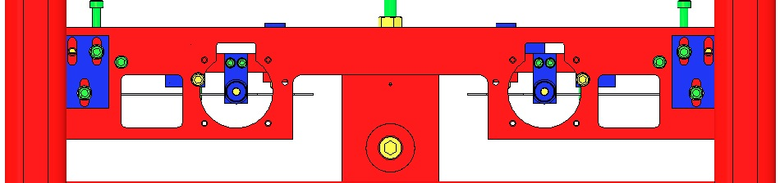  Fig 76: Unusable Screw locations  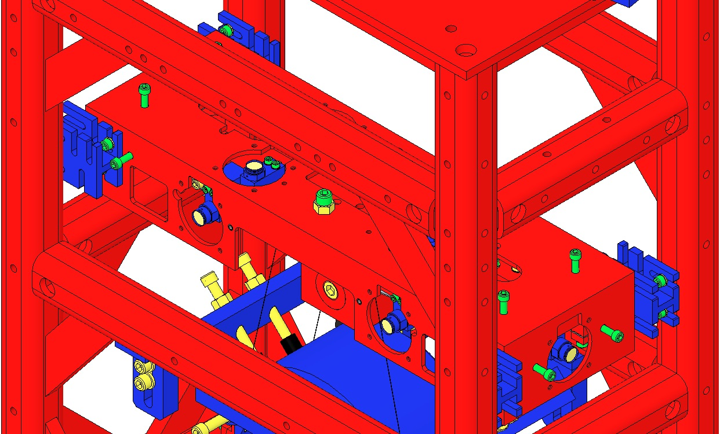  Fig 77: 2nd pair of Coil Holder Brackets

Procedure – Assembling Intermediate Wires to Intermediate Mass
Extend the Intermediate Mass lower Barrel EQ Stop screws (4) as far as possible. These will raise both the Intermediate and Lower Masses.  While extending these screws, observe the 8 screws within the 4 upper Barrel EQ Stops, and retract those screws if it appears either Mass will come in contact with any of them. | 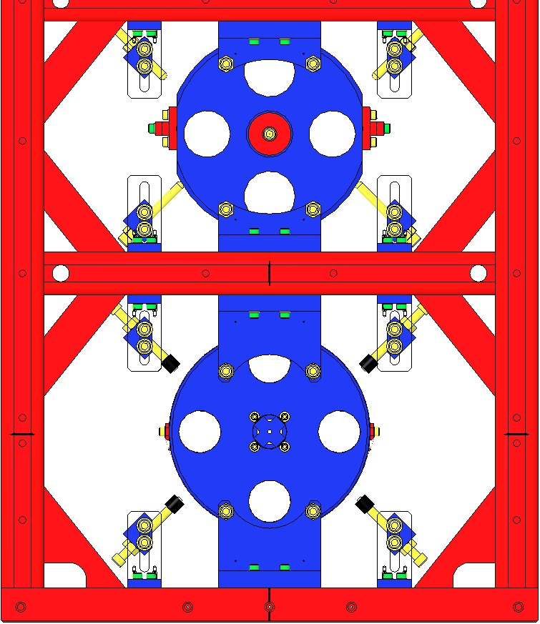  Lower  Mass  Intermediate Mass  Fig 78: Raising the Masses
Ensure the Coil Holder is fully raised within the Coil Holder Brackets. The Screws may be left loose at this point.  Using the 2 center ¼-20 Screws, lower the Upper Mass fully, within the Coil Holder (shown transparent here). | 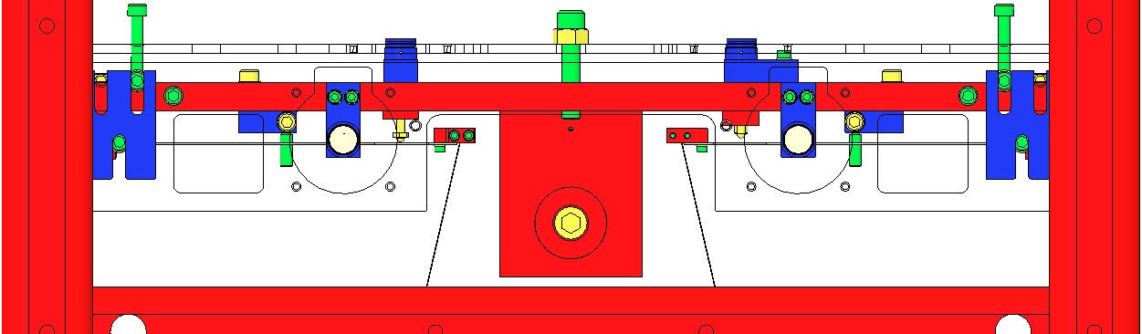  Fig 79: Coil Holder lowered
Assemble the 4 Intermediate Clamps of the D0901905 Intermediate Wire Assemblies to the Intermediate Mass with:  - 12 Socket Head Cap Screws  4-40 x 0.375” SSTL  - Flat Washer #4 SSTL  Torque to 5 in-lb | 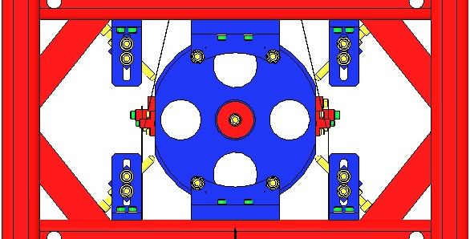  Fig 80: Intermediate Mass and Face EQ Stops
Raise the Coil Holder fully within the Coil Holder Brackets and then tighten the Screws.  Using the 2 center ¼-20 Screws, raise the Upper Mass fully, within the Coil Holder (shown transparent here). | 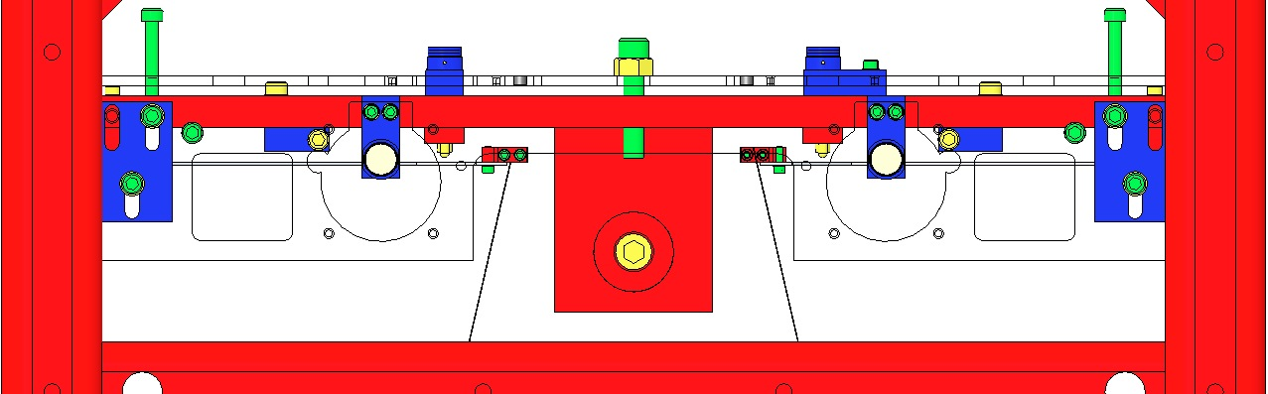  Fig 81: Coil Holder raised

Procedure – Assembling Upper Wires to Upper Mass
To improve clarity, the diagrams for this procedure do not show the Weldment.  Grasp the L-Clamp end of each D0901854 Upper Wire Assembly and feed the Assemblies upwards through the oval openings in the Upper Mass and Coil Holder.  If any Wire becomes kinked during assembly, replace with another Wire Assembly. | 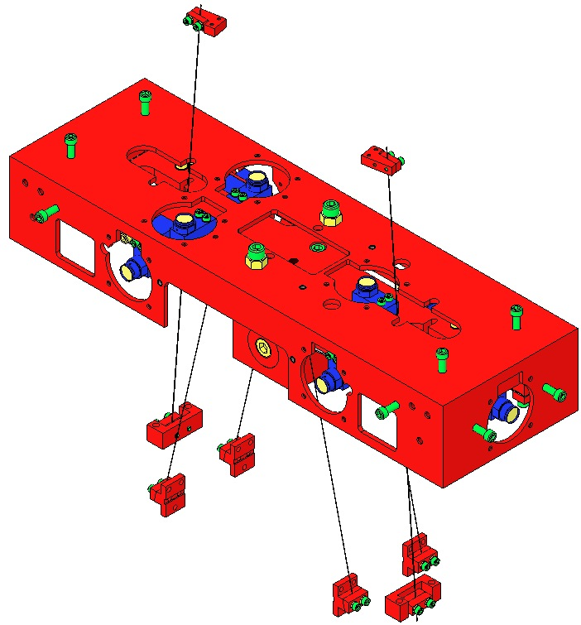  Fig 82: Upper Wires fed through Upper Mass
Assemble the C-Clamps of the Upper Wire Assemblies to the Upper Mass, using:  - 4 Socket Head Cap Screws 8-32 x 1.00” AgPlated SSTL  Use Screws that have only ½” of shaft threaded; fully-threaded Screws will not fit in the slots.  - 4 Washers Flat, #8, SSTL  Torque to 30 in-lb | 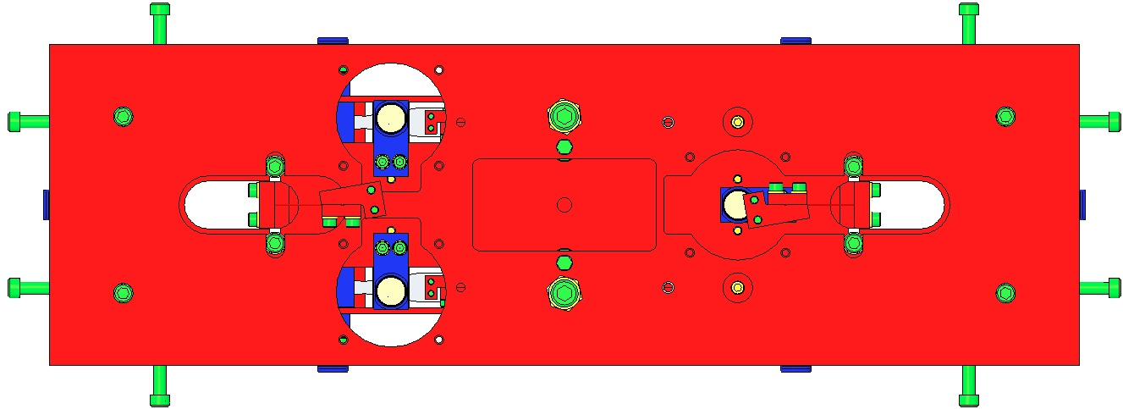  C-Clamp Screws  Fig 83: Attaching Upper Wires to Upper Mass
Use the 4 Screws from the Screw Drive Systems to center the C-Clamps on the oval openings. | 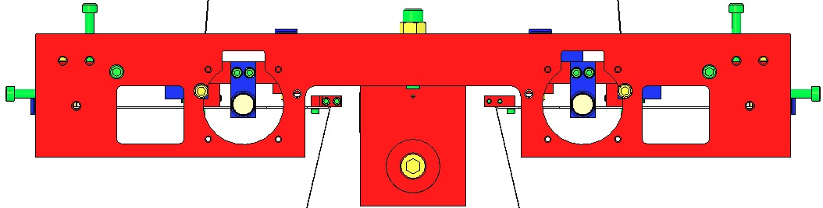  Screw Drive Screws  Fig 84: Centering the C-Clamps with the Screw Drives

Procedure – Assembling Upper Wires to Upper Blades
Fasten the 2 L-Clamps of the Upper Wire Assemblies to the Upper Blades using:  - 4 Socket Head Cap Screws  4-40 x .375” AgPlated SSTL  When assembling the Screws, use a T-Handle Allen Wrench, approaching the Screws from below. Hand-tighten only; do not use a Torque Wrench.  The L-Clamps are mounted ON TOP OF each Upper Blade.  Note the orientation of the L-Clamps, relative to each Blade.  If any Wire becomes kinked during assembly, replace with another Wire Assembly. | 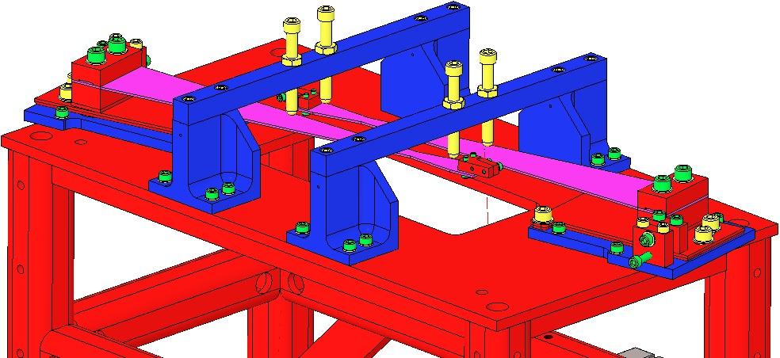  Use T-Wrench from below Blade  Clamps ON TOP of Blades  Fig 85: Upper Wire L-Clamps  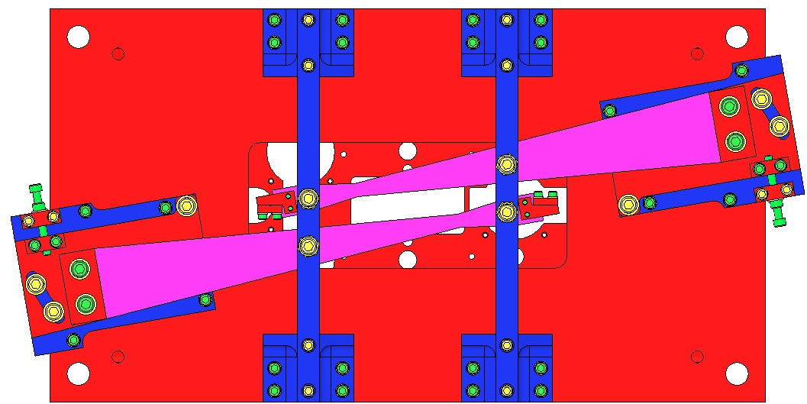  Fig 86: Orientation of Clamps

Assembling the Lower Wire

Related Documents
E0900332 HSTS Assembly and Installation Hazard Analysis
D0901902 Lower Wire Assembly, HSTS
E960022 Vacuum Compatibility, Cleaning Methods and Qualification Procedures

Materials
Qty | Unit | Part Number | Description
1 | Each | D0902524 | Lower Wire Jig Assembly, HSTS
4 | Each | D980184 | LOS Clamp, Long
2 | Each | D020202 | Lower Wire Clamp Mount, HSTS
4 | Each | D1200188 | Lower Wire Clamp Blank Top, HSTS
4 | Each | N/A | SHCS, #8-32 X 0.625” Long, Ag-Plated SSTL
4 | Each | N/A | #8 Flat Washer
1 | Spool | N/A | Steel Music Wire, 0.0047” Diameter
2 | Set | N/A | Test Weights (1g – 500g)
2 | Each | N/A | Ameristat Bag
1 | Bag | PNHS-99 | Polynit Heatseal Wipes
1 | Bottle | N/A | Methanol
1 | Bottle | N/A | Acetone
1 | Bottle | N/A | Isopropanol
1 | Each | N/A | Vise Grip, 6”, Needle Nose
A/R | N/A | N/A | Shims
1 | Each | N/A | Machinist’s Square

Procedure
2 Lower Wire Assemblies are required per HSTS – one to hang the metal lower mass and one to hang the actual glass optic. Lower Wire Assemblies should only be assembled as needed (NOT assembled ahead of time and stored).  Wear safety glasses and glove liners per E0900332.  Ensure that all parts of the Lower Wire Jig Assembly (D0902524) have been processed to Class B per E960022.  Confirm that the Wire Jig is assembled completely and correctly as per the drawing.  Attach the Jig to a corner of an Optical Table such that both ends of the Wire Jig extend beyond the edges of the Optical Table. Use 4X LOS Long Clamps (D980184) to clamp the Wire Jig to the Optical Table. |  | 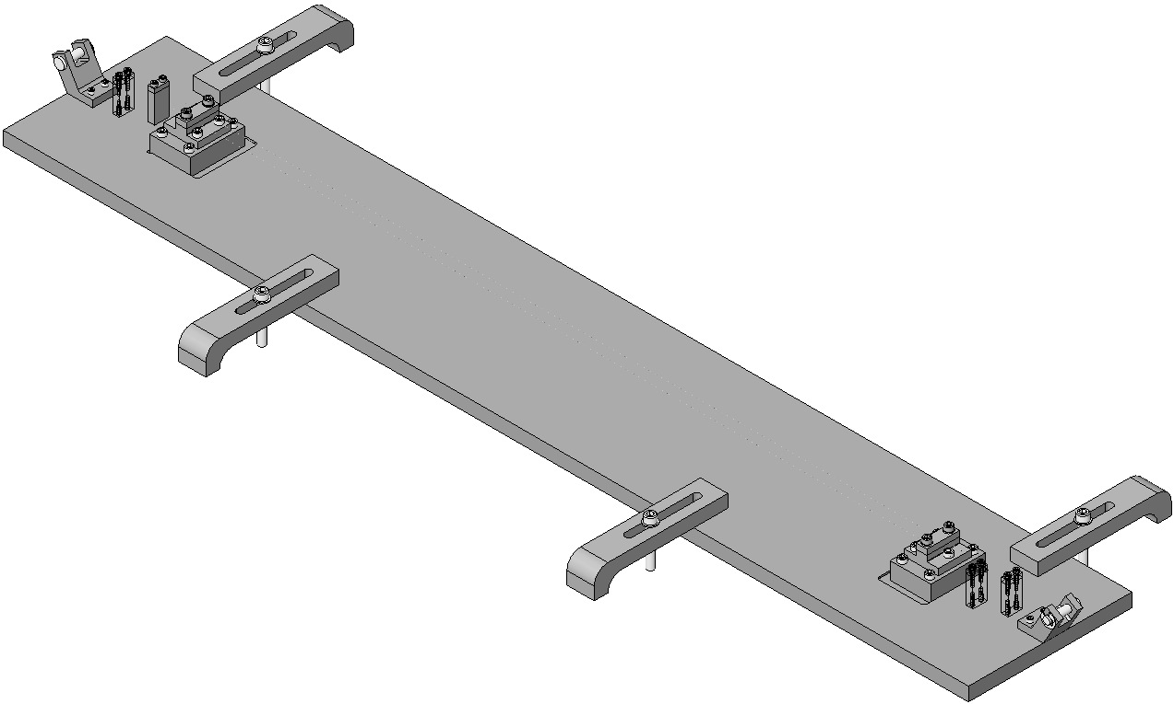  Table  Edge  Fig 87: Lower Wire Assembly Jig
Assemble to the Jig:  2X D020202 Wire Clamp Mount  2X D1200188 Wire Clamp Blank Top  4X SHCS, #8-32 X 0.50” Long  2X SHCS are omitted to provide clearance for the Machinist’s Square.  Align the Clamp Bases with the Wire Clamp Blocks using the Machinist’s Square, and torque to 20 in-lb. |  |  | Base with 2X SHCS  Machinist’s  Square  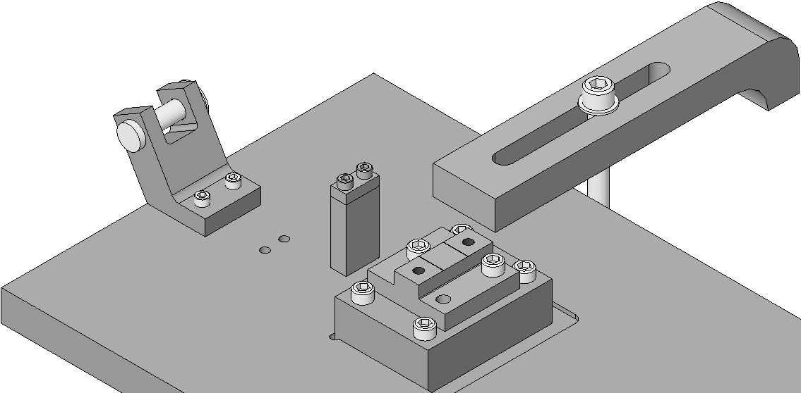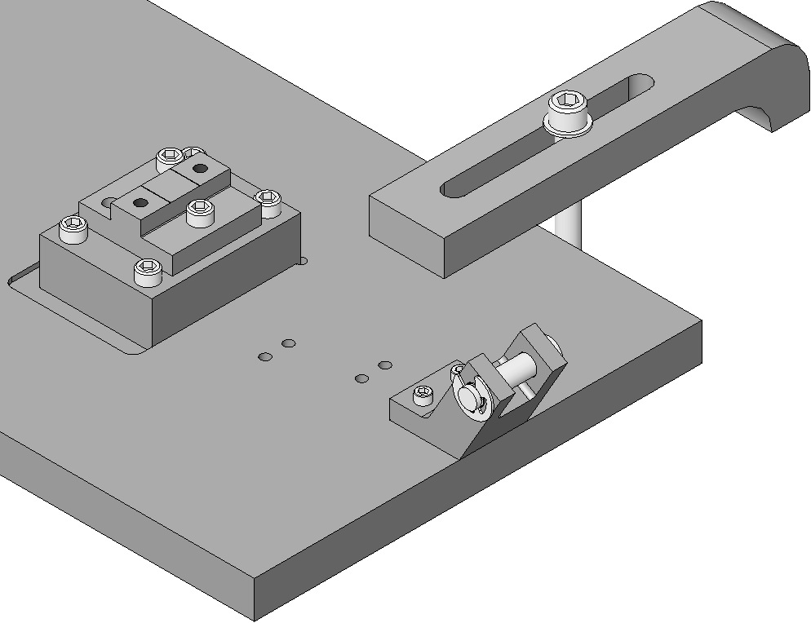  Block  Fig 88: Clamps with 2X SHCS each
Place the First Wire  Cut 1 piece of 0.0047” Diameter Steel Music Wire, 48” long, from the spool.  Clean the Wire per Section 12.4.  Feed one end of the wire through a Wire Start Clamp, leaving about ½” of wire beyond the Wire Start Clamp.  Feed the other end of the wire through the corresponding Wire Start Clamp so that the wire is parallel to the long edge of the Wire Jig Base Plate. Drape the end of the wire over the Clevis Pin.  Torque the 2X SHCS in the Wire Start Clamp away from the Clevis Pin to 6 in-lb.  Using the Test Weights, place 720 grams into an Ameristat bag. Confirm the mass using a digital scale. Cut a small slot in the bag for the wire to pass through. | 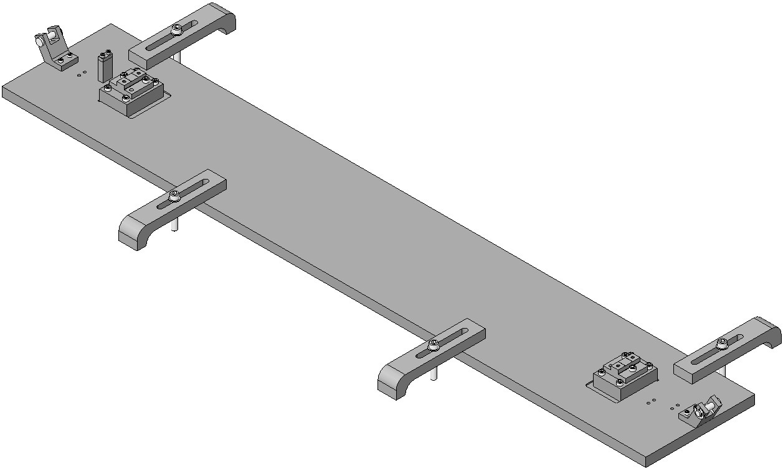  Fig 89: Placing First Wire (some Wire Start Clamps missing)
Tie the free end of the wire around the Ameristat bag.  Ensure that the wire lies smooth and straight from the Wire Start Clamp, across the 2 Wire Clamp Bases and over the Clevis Pin. The edge of the wire should touch the edges of the 2X Wire Jig Combs (D12009089) as shown in Figure 22.  Keep the bag with the Test Weights hanging on the wire. |  |  | 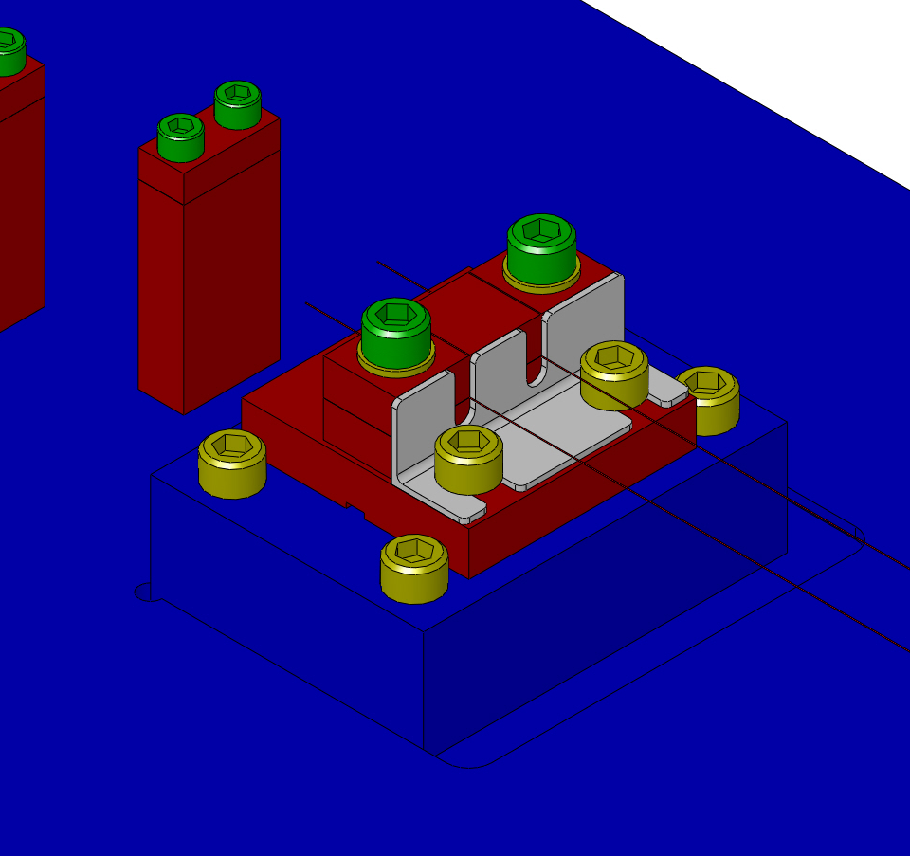  Wires against Wire Jig Comb  D1200909  Fig 90: Hang Weight
Place the Second Wire  Repeat Steps 5-13 for the second wire. Note that the arrangement of the Wire Start Clamps and the Clevis Pin is reversed from the first wire segment.  Clamp the Wires  On top of the two wires:  2X D1200188 Wire Clamp Blank Top  4X SHCS, #8-32 X 0.625” Long, Ag-Plated  - 4X #8 Flat Washers  Keep the Wire Clamp Blank Tops aligned with the Wire Clamp Mount using a Machinist’s Square. Keep the inside faces of each pair of Wire Clamp Blank Tops aligned using Shims.  Torque the SHCS to 30 in-lb. | 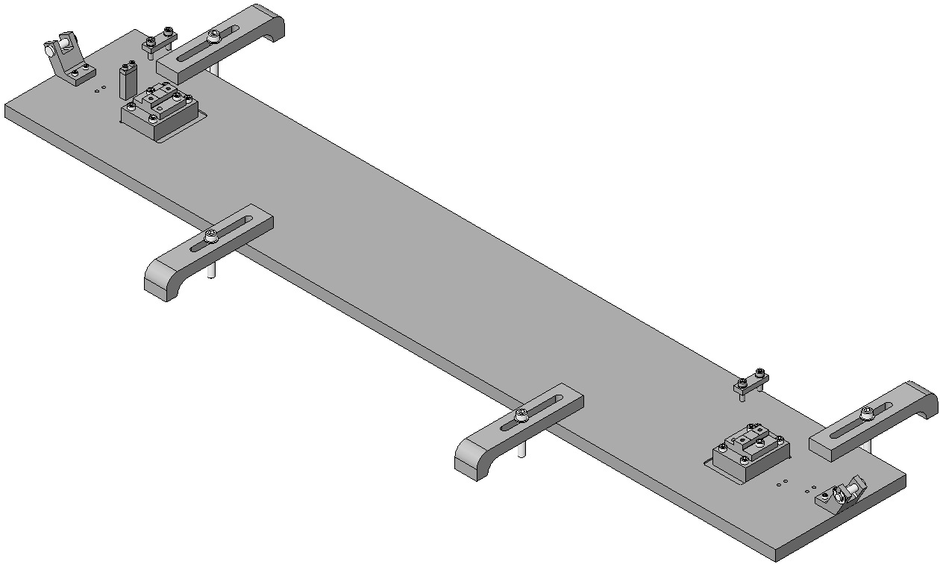  Fig 91: Installing the 2nd Wire

Keep the bags with the Test Weights hanging on the wires for at least 5 minutes after torqueing the Wire Clamps.

Torque the 2X SHCS in each of the 2 Wire Start Clamps near the Clevis Pins to 6 in-lb.  Cut the wires just outboard of the 2 Lower Wire Clamps, making four cuts total. Make the cuts as close as possible to the Wire Clamps.  Remove the Lower Wire Assembly from the Lower Wire Jig. Loosen the 2X inboard SHCS first, then loosen the 2X outboard SHCS. Only SSTL SHCS should be loosened; do NOT loosen any Ag-Plated SSTL SHCS. Carefully remove the 2X Wire Jig Combs. | 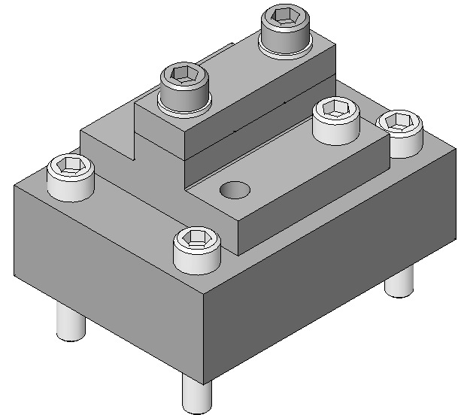  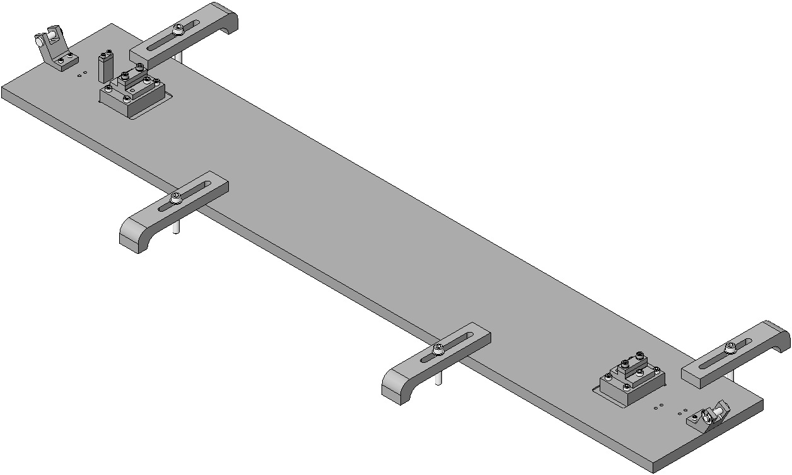  Loosen inboard Screw first  Cut  Cut  Fig 92: Measuring and cutting, first Wire
Carefully store the completed Lower Wire Assembly.  Replace the 2X Wire Jig Combs and 4X SHCS that were removed in Step 19.  Loosen the Ag-Plated SSTL SHCS in each of the Wire Start Clamps. Remove the Ameristat bags with the Test Weights from the leftover wire. Dispose of the 4 sections of leftover wire. |  |  |  | 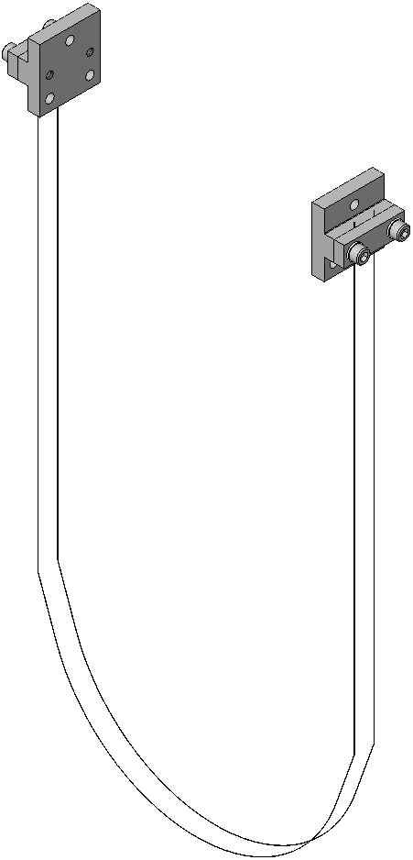  Fig 93: Completed Lower Wire Assembly

Suspending the Masses

Procedure
Lower the Coil Holder halfway within the Coil Holder Brackets and then tighten the 8 Screws.  Using the 2 center ¼-20 Screws, lower the Upper Mass halfway within the Coil Holder (shown transparent here). |  | 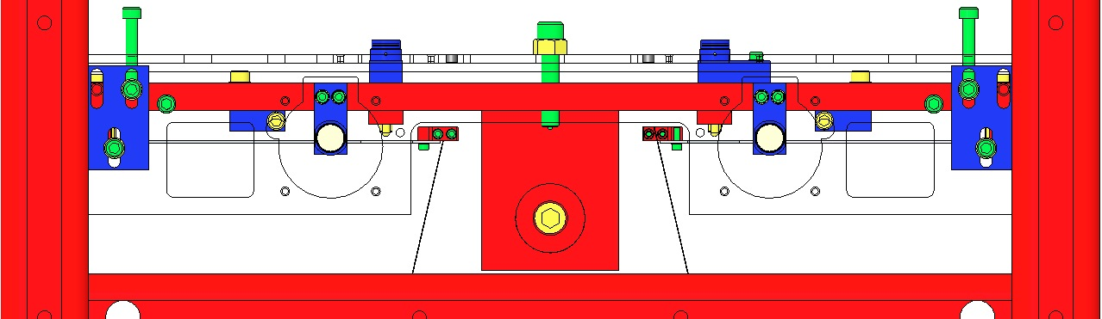  Fig 94: Coil Holder & Upper Mass lowered
Retract the 4 screws of the Intermediate Mass lower Barrel EQ Stops until the Intermediate Wires are taught (until the Intermediate and Lower Masses are supported by the Upper Mass, and not the EQ Stops). The EQ screws should barely contact the Mass. |  | Fig 95: Lower Screws retracted
Adjust all 24 EQ Stop Screws so they contact the 2 Masses, but with no pressure.  Turn these Screws ¾ turn counterclockwise to leave a 1 mm gap at the 2 Masses:  Adjust Lower Mass Screws first:  - 8 Barrel EQ Stop Screws  - 4 Face EQ Stop Screws  Adjust Intermediate Mass last:  - 8 Barrel EQ Stop Screws  - 4 Face EQ Stop Screws  Tighten each Hex Nut at all 24 of the above Screws, to ensure each Screw is locked in the 1 mm gap position. |  | 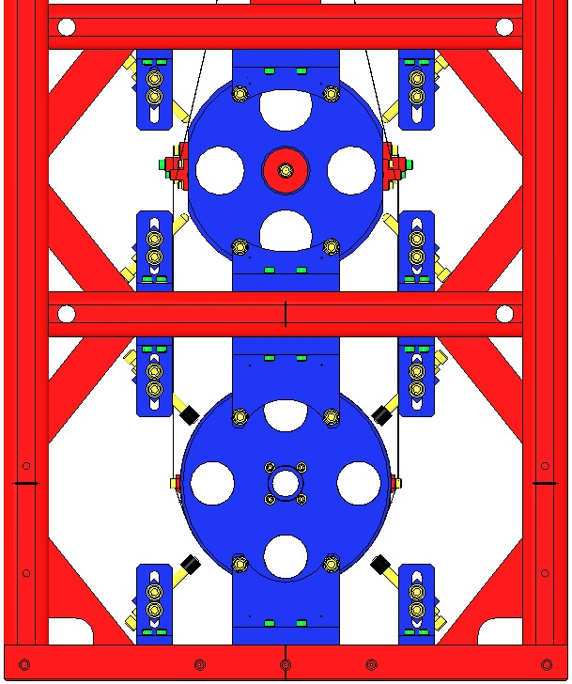  Adjust  Lower Mass Screws first  Adjust  Int. Mass Screws second  Fig 96: Adjusting Screws to 1 mm gaps
Separate the Upper Mass from the Coil Holder by completely removing the 2 ¼-20 Screws and Hex Nuts (the Upper Mass is then supported by the Upper Blades).  Adjust the 12 8-32 round-tipped Coil Holder Screws so that they contact the Upper Mass, but with no pressure.  Turn the #8-32 SHCS counterclockwise 1 ¼ turns, to leave a 1 mm gap with the Upper Mass. | 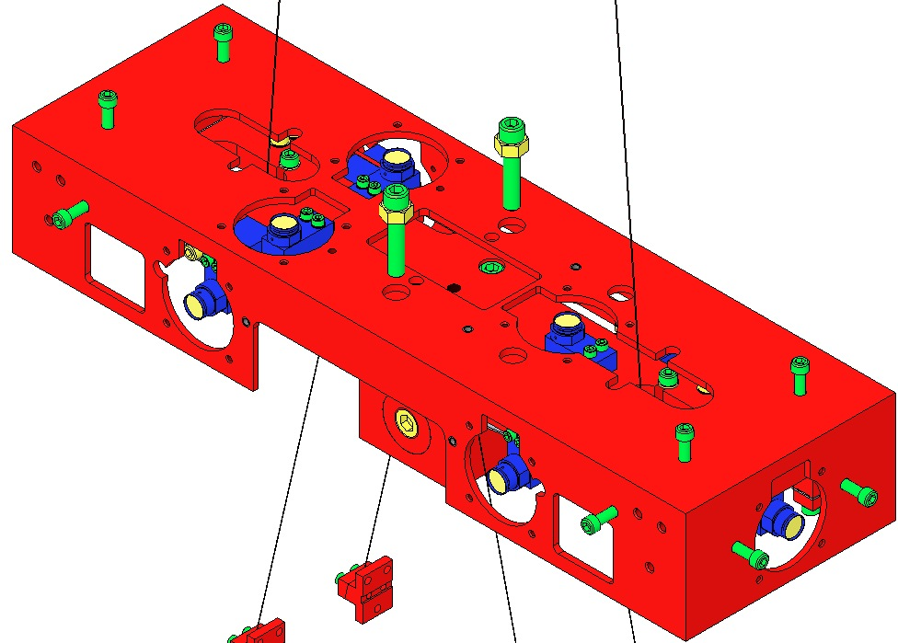  Fig 97: Suspending the Upper Mass
Adjust the 4 Lower Blade Guard Screws so they contact the Blades, but with no pressure.  2 Magnet Holder Assemblies will need to be removed to access 2 of the Screws.  Turn the 4 Screws counterclockwise 3 turns each, to leave a 2mm gap at the Lower Blades.  Replace the 2 Magnet Holders when finished. | 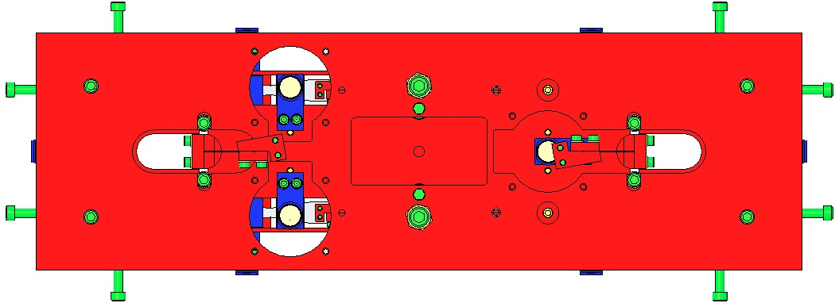  Fig 98: Top View / Adjusting Blade Guard Screws  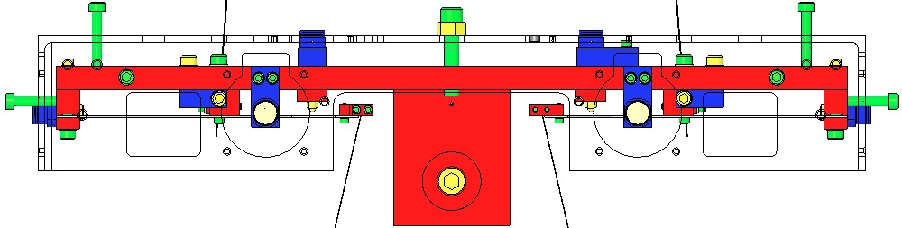  Fig 99: Side View / Adjusting Blade Guard Screws
Turn the 4 Upper Blade Guard Screws down until they contact the Upper Blades, but apply no pressure.  Turn Screws counterclockwise ¾ turn, to leave a 1 mm gap with the Blades.  Tighten each Hex Nut to ensure each Screw is locked in the new position. | 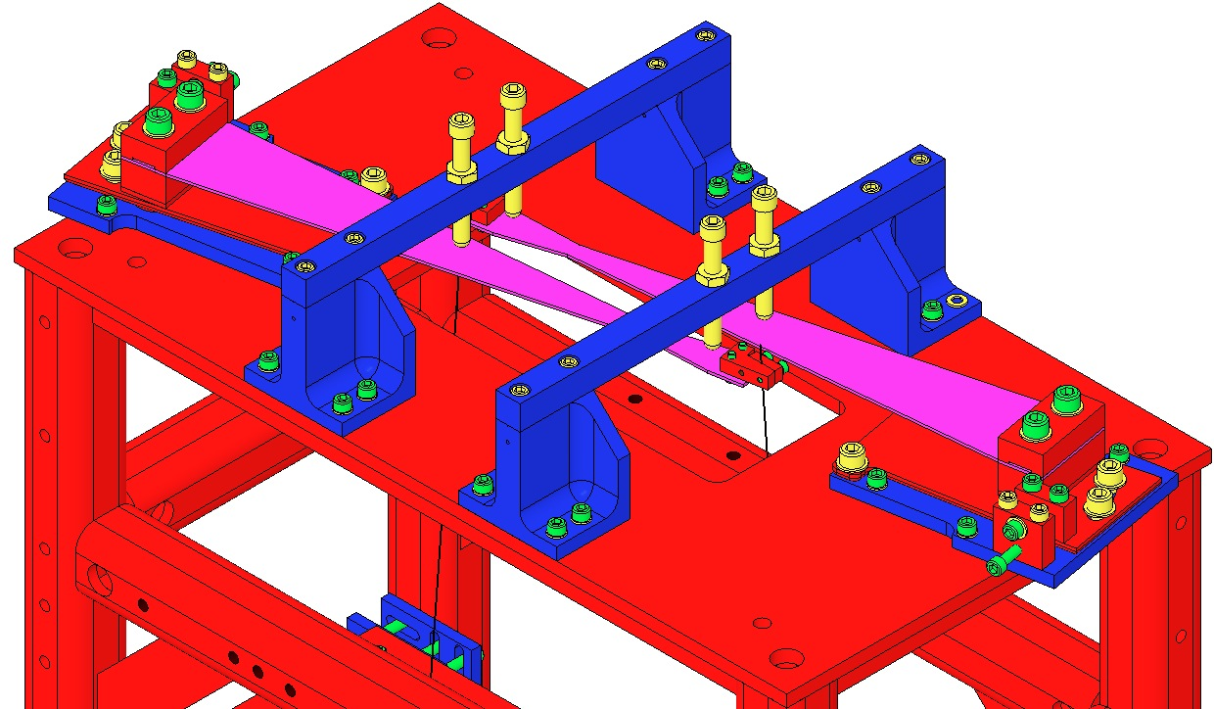  Fig 100: Suspending the Upper Blades

Balancing of the Suspended Masses
The alignment tolerance for the Metal Build is much greater than that for the Optic Build. This procedure references the Optic requirements.
(Intermediate Mass with addable weights
drawing in progress 1/2012)

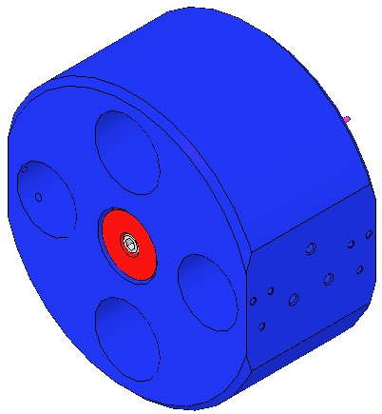
Fig 101: Intermediate Mass with Add-on Masses
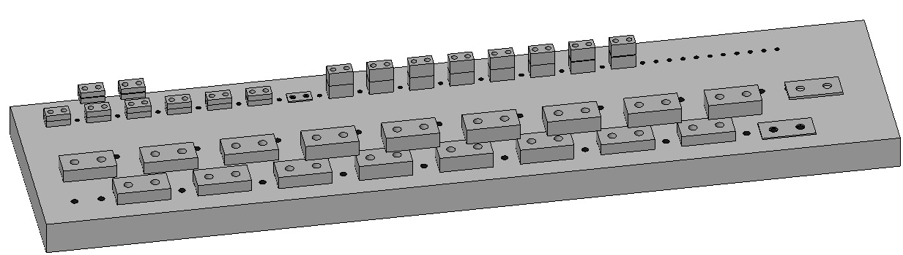
Fig 102: HSTS Library of Clamps

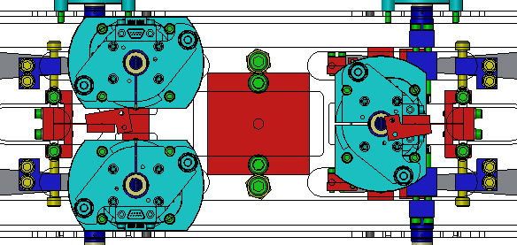
Screw Drive

C-Clamp

Fig 103: Adjusting Upper Wire Clamps to address Pitch
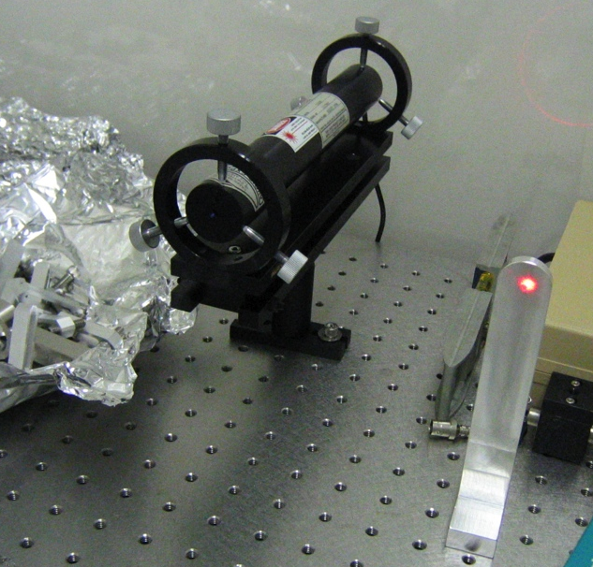
Fig 104: Using Laser & Target to adjust Pitch
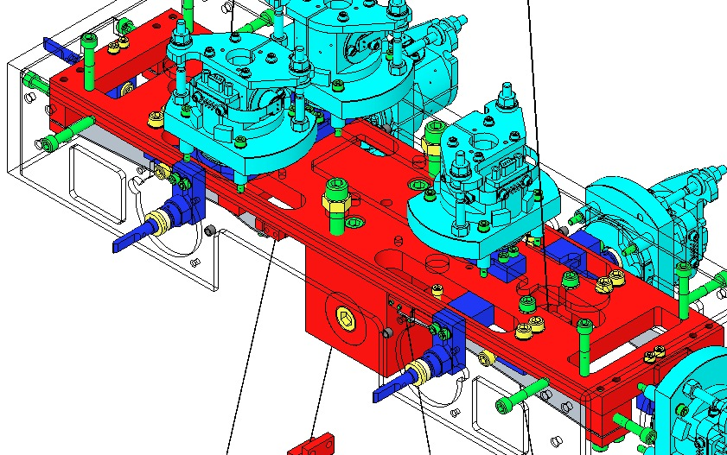
Pitch Mass

Fig 105: Adjusting the Pitch Mass

Related Documents
T1200209 Balancing of HSTS Suspensions
E0900342 ALIGO IO HSTS and HLTS Optic Orientations
T010076-v1 Optical Layout for Advanced LIGO, beam height requirement, Table 2, page 26 of v1
M1100192 RODA: Accuracy of Height of Mirrors in HSTS and HLTS. Accuracy of the height of the mirrors for HSTS & HLTS is +/- 1mm. This RODA supersedes just the vertical positioning static alignment requirements in the Cavity Optics Suspensions, Table 1, page 9
T010007 Core Optics Suspension Subsystem Design Requirements, Table 1, page 9

Materials
Qty | Unit | Part Number | Description
TBD | TBD | TBD | TBD

Desired Results of Balancing
The goal of balancing is to produce a suspension with the following key attributes:
- All suspension stages are balanced and free of pitch and roll
- Blade tips are set to the correct d-value of 2mm. In practice, setting the d-values to between 2 and 3mm has yielded very good results in testing.
- Blade tips are within .5mm of each other
- The height of the lower optic is within +/-1mm of its correct height of 215mm.

Additionally, for the sake of uniformity between suspensions, it is desirable to keep the mass of the system as close to nominal as possible. This is not, however, a strict requirement.

Adjustments Available for Balancing
There are several different ways in which the various masses are able to be adjusted:
Rotational Adjusters (Upper Blades)
  - Push-Pull Plates
These screw-driven plates adjust the yaw of the upper mass by adjusting where the tip of the blade falls.
  - Upper Blade Clamps
This adjusts the height of the upper blade tips. Each 0.5 degree increment amounts to nominally 2mm of tip height adjustment.
Upper Mass
  - Screwdrives
These adjust the attachment position of the upper wires to the upper mass. Sliding the clamp left and right will alter the pitch of the mass (and will also very slightly alter the yaw).
  - Sliding Mass
This sliding mass will adjust the roll of the upper mass.
  - Adjustment Screw
A large silver plated screw in the upper mass is the fine adjustment for pitch.
  - Addable Masses
Adjusts the height of the upper mass while leaving the relative heights below it unchanged. Useful for final optic height adjustments.
  - Lower Blade Clamps
Adjusts the height of each blade tip. One blade clamp swap of 0.5 degrees is nominally 1mm of independent height adjustment. It is important to note that this is not the case when it is installed in the structure because the load is shared between all the springs. This is discussed in more detail below.
Intermediate Mass
  - Addable Masses
The addition and removal of addable masses does two things. Firstly, it can lower and raise the intermediate mass (thereby adjusting the blade tip height relative to the upper mass) and it can adjust pitch of the intermediate mass if addable masses are removed from either the front or the back. It has been determined that each side of the intermediate mass works relatively independent from the other. So, in order to correct pitch, mass need only be removed or added to one side at a rate of roughly 1 gram for .1mm adjustment.
Lower Mass
  - Lower Wire
The lower mass can be adjusted in the lower wire (i.e. where the prism contacts the wire) to compensate for roll. There is no way to compensate for pitch differences between the lower and intermediate masses.

Theory of Balancing
The theory behind the balancing of this suspension is in some ways unintuitive. Because of the way each stage plays off the ones below and above it, it is important to understand how one adjustment can affect the other parts of the system.

Upper Blades
When it is necessary to make a clamp swap to the upper blades, the added height of one of the blade tips will affect the height of everything below it. A clamp swap of 0.5 degrees will change the blade height by 2mm. Because there are two blades and only one of them is being switched, the net effect on the center of mass of the lower levels is that they will rise by 1mm. This effect adds linearly. Therefore, the total change of the height of the lower levels is given by the total clamp angle difference multiplied by 2mm. For example, if both clamps are switched upward by 0.5 degrees, the net change would be (0.5+0.5)*2mm = 2mm rise in the center of mass of the intermediate mass.

Upper Mass
The upper mass seems to have strange effects on things such as d-values when it is not level. It is very important to make sure the upper mass is as level as possible before taking any measurements. In practice, .25mm corner-to-corner height difference has been shown to be sufficient. Failure to do so will result in sometimes large errors for critical parts of the balancing process.

Lower Blades
The blade tips are rigidly attached to the intermediate mass by the intermediate wires. Before beginning the balancing method, it should be ensured that the clamps are pushed to their highest position on the intermediate mass. This will cause the clamps to be square with respect to the intermediate mass. There are other ways of doing this, but this has been found to be an effective method. Failure to mount the clamps properly will result in meaningless data.
Once this is done, the blade tips should all be equal distance from the intermediate mass. This is guaranteed by the assumption that the intermediate wires are all the same length. Using this assumption, we can see that if the clamp holes in the intermediate mass are drilled straight, then the blade tips must also be parallel.
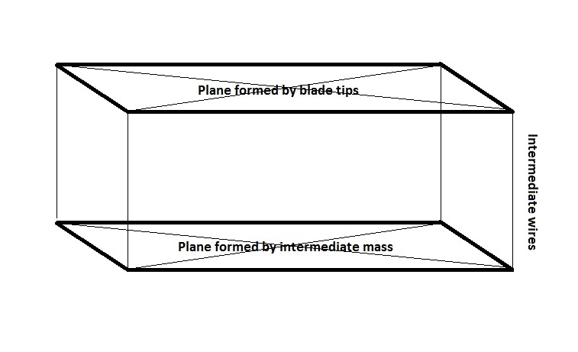

As the figure above shows, the blade tips must have two criteria: Firstly, they must form a plane. Because we know that the intermediate mass has its holes drilled properly and the wires are the same length, the 4 blade tips must also be planar. It is not possible for 3 blade tips to be equal with one blade tip either too high or too low. If this condition occurs, there is an error with the wire length and it must be replaced. Secondly, in addition to the blade tips being in plane with each other, the plane it forms must be parallel to the plane formed by the intermediate mass. Therefore, the pitch and roll of the blade tip “plane” must be the same as the pitch and roll of the intermediate mass.
This has serious implications for balancing. It is very important to understand that correction of one blade tip while leaving the others alone is not possible. When adjusting only one of the blade clamps on the lower blades, you will ultimately have an effect on the other 3 lower blades. The best idea is to attempt to correct pitch and roll independently, as these are very easy to control by switching two clamps at a time.
A one-clamp swap will, in theory, have the following effect on the blade tips: The adjusted blade will move by 1.5mm/degree, the two adjacent blade tips will move by 0.5mm/degree, and the opposite blade tip will move by -.5mm/degree as illustrated below.
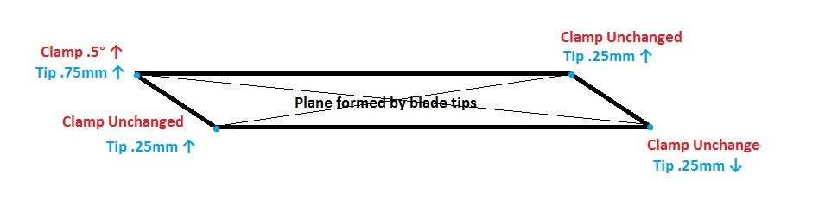
These effects can be superpositioned. Therefore, switching two clamps on one side will cancel out the effects on the opposite side. This is why it is very important to switch two clamps at a time.
The overall effect of a clamp swap on the stages below it is roughly 0.5mm/degree of net clamp swap. Therefore, if two clamps are switched by 0.5 degrees upward, the net clamp change is 1 degree and will move the center of mass of the intermediate and lower masses upward by .5mm. Similarly (and intuitively) if 4 clamps are each switched by 0.5 degrees upward, the net effect will be a change of 1mm upward in the lower and intermediate masses.

Intermediate Mass
The intermediate mass is adjustable with the one set of weights on either side of the mass. Addition and removal of these masses will affect the pitch of the blade tips, intermediate mass, and lower mass because all three are rigidly attached with wires. The rate of pitch adjustment is roughly .1mm/gram per side. This means that if 10 grams are removed from the +X side, the +X blade tips will move by 1mm, the +X side of the intermediate mass will move by 1mm, and the +X side of the lower mass will move by 1mm. The -X side, however, will remain relatively unchanged, thus isolating pitch adjustment. Note that the upper mass will need to be re-balanced after any mass is changed on the intermediate mass.
The rate of the center of mass rising is roughly equal to .05mm/gram of weight added or removed. So, if 10 grams are removed, it is expected that the center of mass of the intermediate mass will rise by .5mm.

Lower Mass
The lower mass is of course rigidly attached to the intermediate mass and cannot be adjusted in pitch. It is, however, infinitely adjustable in roll. It is a good idea to correct a bit of roll from the lower mass before attempting to take measurements. Within +/- 1mm between the tops of the horizontal holes has been found to be adequate. Subsequent roll reduction of the lower mass showed little to no effect on the upper stages. Final balancing will require that all of the roll be removed [INSERT REQUIREMENT] before testing.

Steps in the Balancing Process
Once the suspension has been assembled and is hanging freely, the following steps should be performed to balance the suspension.

Ensure All Hardware is Present
The first step is to ensure all hardware is present on the upper mass. Double check with ICS that the correct addable masses are present on the top and bottom of the mass. Also check that the magnet and flag assemblies have been installed and that the upper wires are roughly centered (these will be adjusted in a later step). Unlock all stages, starting with the bottom.

Adjust Upper Mass Yaw
The yaw needs to be adjusted next. In theory it should have no effect on the pitch and roll of the upper mass, but keeping the mass correctly centered in the tablecloth has additional benefits such as keeping the mass away from rubbing on the earthquake stops and tablecloth. This adjustment can be made by loosening the 3 x 1/4-20 bolts on the upper blade rotational adjusters and using the push pull plates to move the blade tips. The position of the upper mass can be determined by looking through the +Y and -Y OSEM holes. At this stage, a visual alignment is sufficient.

Balance the Upper Mass
Before anything else, the upper mass must be as level as possible. In practice, it has been found that the upper mass needs to be level to within .25mm corner-to-corner. Failure to do so will result in incorrect d1-values.
The first step to balancing the mass is to place a bubble level on top of the upper mass (on the actual upper mass itself, not atop the addable masses). Then adjust the screw drives to correct for pitch. Once pitch is correct, use the slider to adjust the roll of the mass. If it is found that the slider is all the way or nearly all the way out, an upper clamp must be switched.
If it is necessary to switch an upper clamp, the height of the lower mass should first be measured (the nominal height of the top of the optic is 215mm). Any clamp swap at the upper level will have a 1mm effect on the lower mass. So, if the lower mass is too high, switch to a lower upper clamp and vice versa. Once the swap has been performed, begin the balancing process again.

Take Measurements of the Whole System
The next step is to measure the heights of all critical points in the system. The purpose of this is to determine the following:
- Upper blade tip heights
- Upper mass pitch and roll
- Lower blade tip heights (and therefore d1-values, pitch, and roll)
- Intermediate mass pitch and roll
- Lower mass pitch and roll
In order to achieve this, the following points must be measured:
- Upper blade wire breakoffs – Measure where the wire enters the upper clamp of the upper wire assembly.
- Upper mass through the OSEM holes – Measure the top side of the upper mass through the (+X+Y), (+X-Y), (-X+Y), and (-X-Y) OSEM holes. These 4 measurements give pitch and roll.
- Lower blade wire breakoffs – Measure the upper clamp of the intermediate wire assembly where the wire enters the clamp. This is used to calculate d-values
- Top of the intermediate mass holes – Measure the tops of the (+X+Y), (+X-Y), (-X+Y), and (-X-Y) holes in the intermediate mass. These will give the pitch and roll of the intermediate mass.
- Top of the lower mass – This will give you the height of the lower mass (which should be 215mm)
- Top of the lower mass holes – Measure the tops of the (+X+Y) and (+X-Y) (or (-X+Y) and (-X-Y)) holes to determine the roll of the lower mass.
Enter all of the values into a spreadsheet as they are measured from the top of the table. This will make the next steps easier.

Determine What Changes Must Be Made
This is probably the most difficult part of the process because each stage depends on each other. Recall our objectives in this procedure: We want to have a suspension with the lower mass at 215mm (+/-1mm), d1-values between 2 and 3, and as little pitch and roll of each stage as possible.

Determine the Wire Lengths
First, before any adjustment can be made, it must be determined whether or not the blade tips are coplanar with the intermediate mass. That is to say, the pitch and roll of the blade tips must be identical (or nearly identical) to that of the intermediate mass. This should be readily observable by looking at the spreadsheet you created in 5.4. If there appears to be a wire that is too short or too long with respect to the other three, it must be switched. If there seems to be no correlation between the blade tip plane and the intermediate mass plane, they should all be re-pulled and replaced.
A simple way to check that the blade tips are planer is to use the following equation:
Height(+X+Y) + Height(-X-Y) = Height(+X-Y) + Height(-X+Y)
Next, look at the pitch difference between the lower and intermediate mass. They should be very close, if not identical. If there is a difference between the two, check with the wire comb that the wire is properly in the prism grooves and is the correct width all the way around the metal mass. After this, re-balance and re-shoot the system. If the problem persists, try flipping the wire around so that the clamp that was on the +Y side is now situated on the -Y side. Readjust the wire, re-balance the upper mass, and re-shoot. If it is still incorrect, you will need to replace the lower wire. A correct lower wire will show no pitch difference between the two masses. Because the lower wires are so precious (due to a shortage of wire), it may be necessary to live with wires that are incorrect. Since the wire is to be replaced when the actual optic is inserted, we can get away with less than .5 mm or so of pitch difference, but know that this means a more time-consuming adjustment period after the optic goes in (the adjustment will need to be made with intermediate addable masses) and less accurate testing. Additionally, if there is a pitch difference, you should be trying to correct the pitch in the lower mass, not the intermediate mass and upper blades. The pitch of the lower mass is far more critical than the the d1-value difference in the lower blades, so if there is a problem with the wire, make sure you are not trying to correct both, as it is a Sisyphean task.
After any wires are replaced, the suspension must be re-balanced and re-shot. Return to the top of Section 5. Proceed to 5.7 ONLY when the wires are as correct as possible.

Adjusting the Lower Blades
Once the wire lengths are correct, the most isolated item to adjust is first the lower blade clamps. The d1-values only depend upon the clamp angle and the mass of the intermediate mass. For consistency between suspensions, it is preferable to adjust the clamps before adjusting mass (which will slightly alter the frequency of the blades).
Look at the spreadsheet and determine the pitch and roll of the blade tips. If there is more than 1mm of pitch in the blade tips or more than 0.75mm of roll, a blade clamp swap will be necessary. It is almost always preferable to adjust either pitch or roll (but not both) with a clamp single swap. This is because the manufacturing inconsistencies in the clamps can actually cause an effect in both roll and pitch, even when only trying to correct one. You may find, for example, that switching clamps to only fix pitch will also fix your roll issue (conversely, it can exacerbate your problem).
The amount of pitch and roll adjustment is theoretically 1mm per 0.5 degrees of adjustment. If there needs to be 1.5mm of adjustment, for example, it is preferable to only move your clamps by the smaller increment (that is to say, round down). It has been found in practice that the blade tips move sometimes more than the clamp swap would predict them to.
Let's look at an example (Center of Mass = 20mm below top of upper mass):
 | +X+Y | +X-Y | -X+Y | -X-Y
Top of Upper Mass | 549.25 | 549.25 | 549.25 | 549.25
Blade Tips | 527 | 527 | 525.5 | 525.5
d1-Values | 2.25 | 2.25 | 3.75 | 3.75
Current Clamp Angle | .5 | 1 | 0.5 | 1
Recommended New Clamp Angle | .5 | 1 | 1 | 1.5
Expected New d1-Values | 2.25 | 2.25 | 2.75 | 2.75
In this simple example, we only dealt with a correction in pitch. Obviously, these fictitious numbers will not be so nice in a real-world setting. This is just to illustrate the method in which clamp swaps should be performed: They should be 2 or 4 clamps at a time, by the same amount, between adjacent blades.
After each clamp swap, it will be necessary to re-balance and re-shoot the entire system. If you are careful and thorough in your approach, you will eventually dial in the pitch and roll of the system. It is vital, therefore, that clamp angles and serial numbers be recorded with each swap, in case you need to return to a previous configuration. It is also a very good idea to keep the wires on the same blade tips. This will eliminate any error associated with different wire lengths (though in theory we correct this in the previous step).

Adjusting the Intermediate Mass
By this point, roll and pitch of the blade tips should be roughly correct and the d1-values should be between 2 and 3. Unfortunately, there is no roll correction available for the intermediate mass, so we are limited to adjusting pitch with weights. Take another look at your d1-values. Weight should be added to the side for blade tips that need to be brought down and weight should be removed from sides that are too low at a rate of around 10grams/mm. If everything was done properly in the previous step, very little weight will need to be removed from the mass. After adjustments of the weights, you will need to re-level the upper mass and re-shoot the blade tips. Do this until all pitch has been eliminated from all 3 levels of the suspension (or, if you know that your lower wire is wrong, do this until the lower mass shows no pitch).

Adjusting the Height of the Lower Mass
The lower mass height adjustment should be the absolute last thing you do because it can be adjusted in two ways without affecting other critical parts of the system. The upper blade clamps can be swapped and mass can be added/removed from the upper mass. If the lower mass needs to move by more than 2mm, it is preferable to attempt to switch clamps on the upper mass. This can be a trying experience, so getting it correct will take patience. Hopefully, because we have up until this point not adjusted weights too much, the lower mass will be in roughly the correct place. If it is more than 2mm high or low, the upper clamps should be switched up or down by .5 degrees (the rate of movement is, in theory, 2mm per half degree). In practice, the blade clamps used at LLO are wildly inconsistent. We have found 0.5 degree clamps that are actually more than 1.0 degrees. Care should be taken to inspect the clamps for obvious defects such as this (holding the two profiles up to one another has proven useful more than once). If you see inconsistent movement when switching clamps, it is likely that either the one that was replaced was bad or the one that replaced it is bad. Trial and error here is the only advice I can give. Fortunately, upper clamp swaps do not require the removal of the upper mass and can be done reasonably quickly. It is especially important that serial numbers of clamps be recorded for this process as well, so that incorrect clamps can be identified and removed from circulation.
After the upper mass is level and the optic is within 2mm of where it should be, weights should be added and removed from the upper mass. The easiest way I have found to do this is to remove the weights from the top of the upper mass and have a partner set the optical level to 215mm (the nominal height of the top of the lower mass). Place the crosshairs over the lower mass and re-add the weights to the upper mass until the top of the lower mass just touches the crosshairs. After a final weight has been determined, the weight should nearly evenly split between the top and bottom of the mass. This keeps the center of mass roughly the same which keeps your d1-values from changing too much.

Final Steps
At this stage, you should have a well-balanced suspension. Now, everything must be balanced, shot, and recorded. Finally, when all looks good, the suspension can be pulled apart and placed into a creep bake. The spreadsheet containing your shootings, angles, and weights should be placed into an aLOG.

Removing the Suspended Components

Creep Baking the Upper and Lower Blades
All Blades (2 Upper, 4 Lower) are exposed to 120°C @ 168 hr., accelerating the microscopic yielding of the Blade material, to reduce mechanical noise of the Suspension when in operation.

Related Documents
T1100289 Notes on Creep/Creak Bakes for Blades
E0900023 Process for Manufacturing Cantilever Spring Blades

Materials
Qty | U | ID | Description
1 | Ea | D1002440 | Upper Blade Baking Fixture
2 | Ea | D020660 | Blade Pulldown Device
2 | Ea | D0901815 | Upper Clamp Inside
2 | Ea | D0901813 | Upper Clamp Outside
4 | Ea | NA | 2 Socket Head Cap Screw 4-40 x 0.375” AgPlated
4 | Ea | NA | Flat Washer #4 Vented SSTL
4 | Ea | NA | Socket Head Cap Screw 4-40 x 0.25” AgPlated
1 | Kg | NA | 4.483 kg in weight
2 | Ft | NA | Music Wire .024” dia. min.

Procedure
 | Wear Safety Glasses and Glove Liners per E1000043.  Prepare 2 D020660 Blade Pulldown Devices per Materials List. | Fig 106: Blade Pulldown Device
Lock down the 2 Upper Blades by extending the 4 EQ Stop Screws until they just contact the Blades.  Disconnect the 2 Upper Clamps from the Upper Blade tips. Handle the Wire Assemblies carefully to ensure they are not kinked. |  | 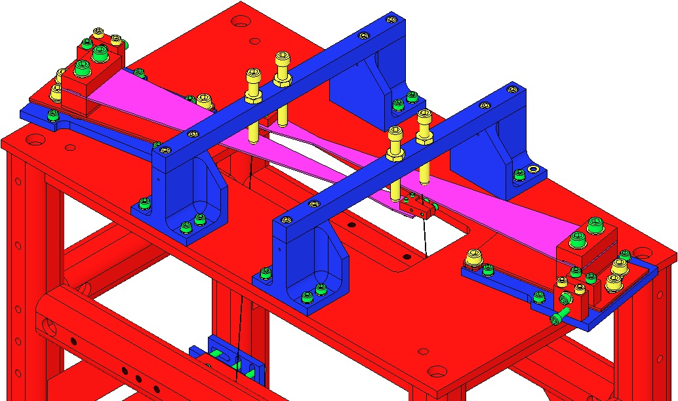  Wire Clamps  Fig 107: EQ Stop Screws contact Blades
Ensure the 2 D1102119 Blade Pulldown Supports are Class B clean.  Attach the Blade Pulldown Supports to the center of the Weldment cross member shown, Clevis extending outboard.  Cover each end of the Weldment Structure and surrounding Optical Table areas with UHV Aluminum Foil, to protect them from the dirty Pulldown Device.  2 workers required:  1st person holds the Pulldown Weight.  2nd person passes Wire Clamp of the Pulldown Device through the Weldment side opening, up toward the Upper Blade Tip, then attaches the Clamp to the Blade tip with:  - 2 Socket Head Cap Screws  4-40 x .375” AgPlated SSTL  1st person gently drapes the wire over the Clevis, and slowly releases the Weight.  Repeat Steps 7-9 for the second Pulldown Device. |  | Fig 108: Blade Pulldown Support  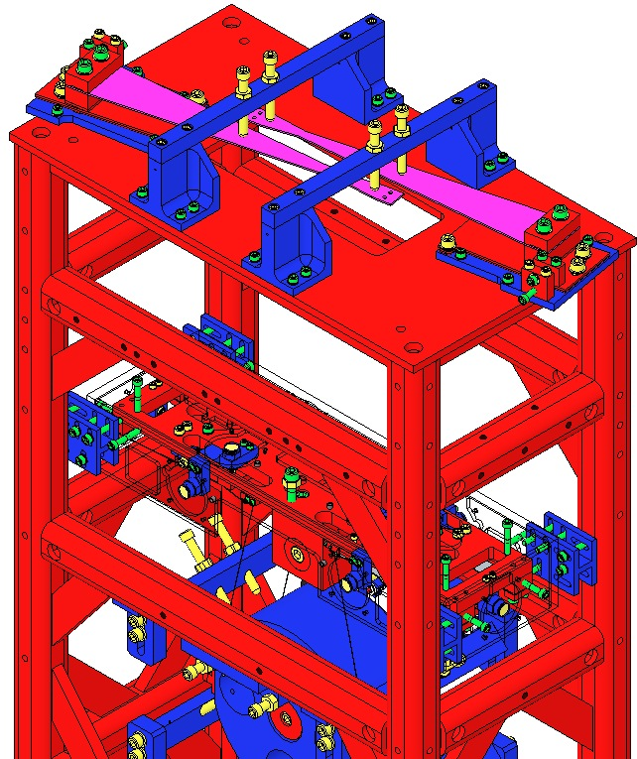  Blade Pulldown Supports  Fig 109: Location of Blade Pulldown Support
Remove the 2 D0901935 Blade Guard Bars.  Slowly lift the Pulldown Devices and then disconnect the Wire Clamps from the Blade tips. The Blades will be left curving upward.  Remove the Rotational Adjusters from the Weldment, down to the Rotating Plate (leaving the Base Plate attached to the Weldment).  Record the serial number and location of both Upper Blades in ICS in the RA assembly load. |  | 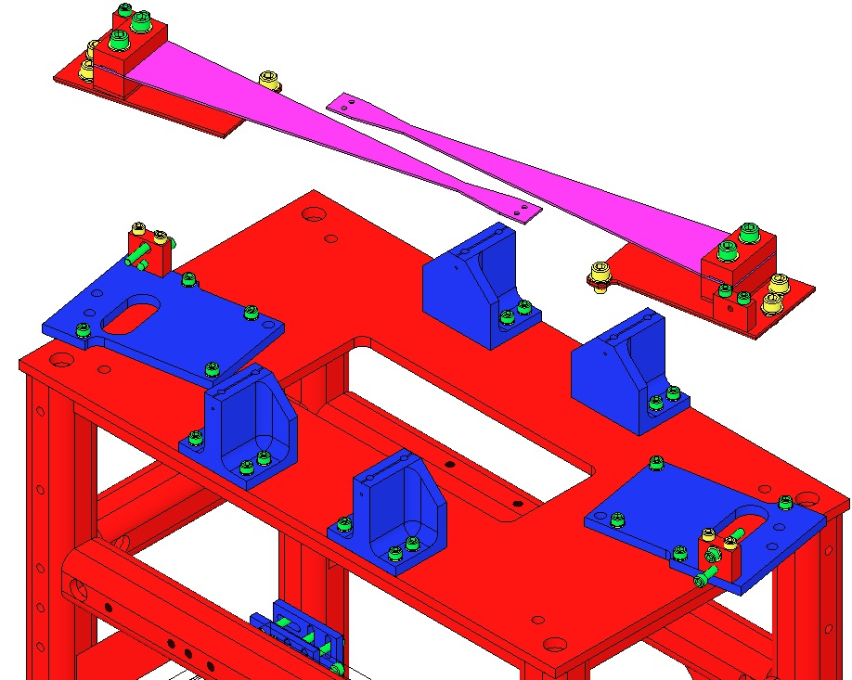  Fig 110: Rotational Adjusters removed
Ensure the D1002440 Baking Fixture is Class B clean.  Mount the Baking Fixture to an Optics Table, aligning the Crossbar side with the Table edge to allow clearance for the Blade Pulldown Device.  Remove a D1002443 Crossbar from the Baking Fixture. | 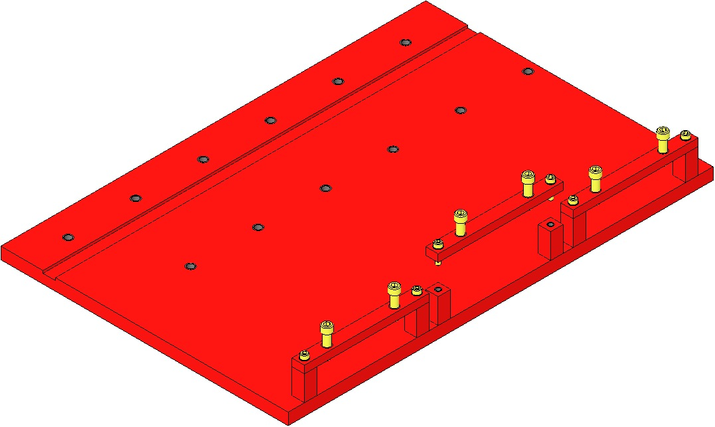  Table Edge  Fig 111: Base Plates in Baking Fixture
Assemble to the Baking Fixture the 2 Rotational Adjuster assemblies using the same Screws from the Suspension:  - 4 Socket Head Cap Screws  ¼-20 x 0.375” SSTL  - 4 D1100785-472 Flat Washers  Tighten the Screws firmly  The Blades are shown here as flat, but are actually curved upward at this point. | 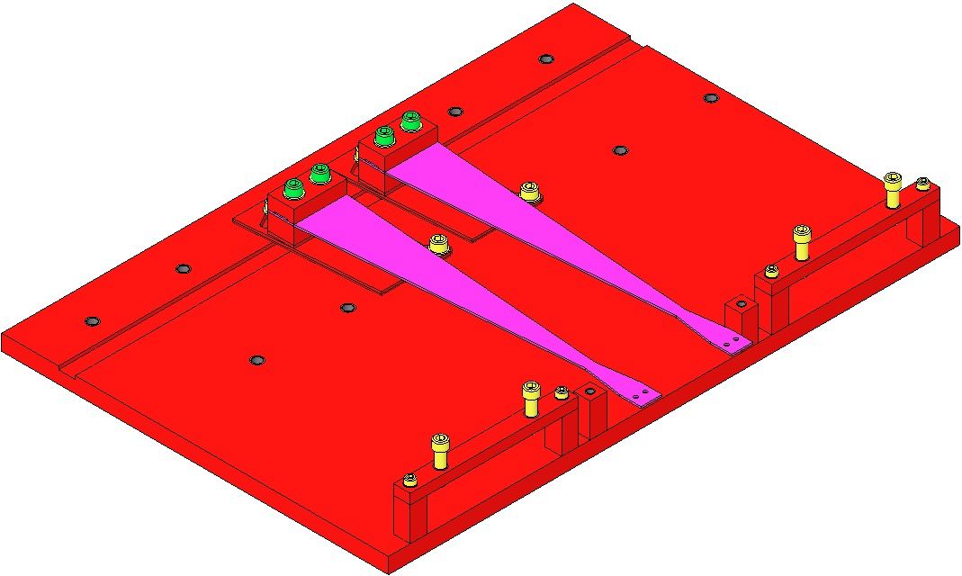  Machinist’s  Square  Fig 112: Shim, Clamps, Blade, Screws, Washers

Attach a Pulldown Device to each Upper Blade Tip to flatten the Blades.

Re-assemble the Crossbar to the Bake Fixture:
- 1 D1002443 Bake Fixture Crossbar
- 2 Socket Head Cap Screws 8-32 x 0.625” SSTL
- 2 Flat Washers #8 SSTL
Tighten the Screws firmly
- 2 Socket Head Cap Screws ¼-20 x 1.0 Full-Thread, Round-Tip SSTL

Turn down the Round-Tip Screws until the weighted Blade tip is level with the Blade root.
Be careful not to damage the nickel plating on the blade

Remove the Blade Pulldown Devices.
The Rotational Adjusters and Baking Fixture are now ready for the Creep Bake.
Fully retract the 8 Screws in the 4 Upper Barrel EQ Stops. |  | 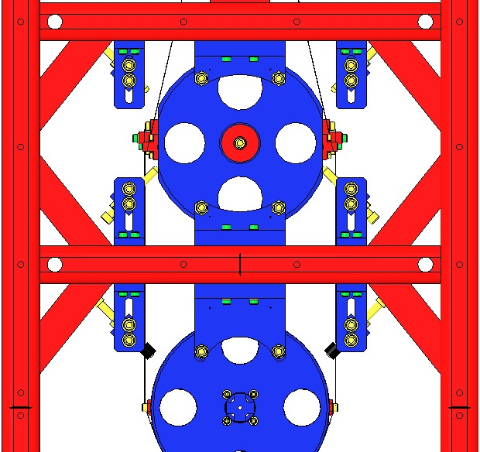  Fig 113: 8 Screws in Upper Barrel EQ Stops
Fully raise the Coil Holder within it’s 4 corner Brackets (The Screws will be at the top of their Bracket slots). |  | 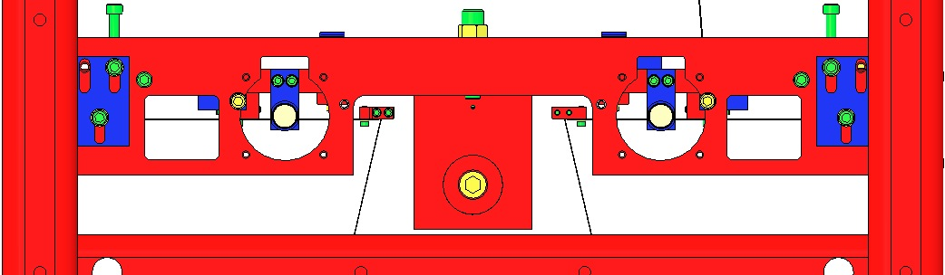  Fig 114: Coil Holder Raised in Brackets
Using the two ¼-20 Screws, fully raise the Upper Mass within the Coil Holder.  The Upper Wires will go slack at this point. |  | 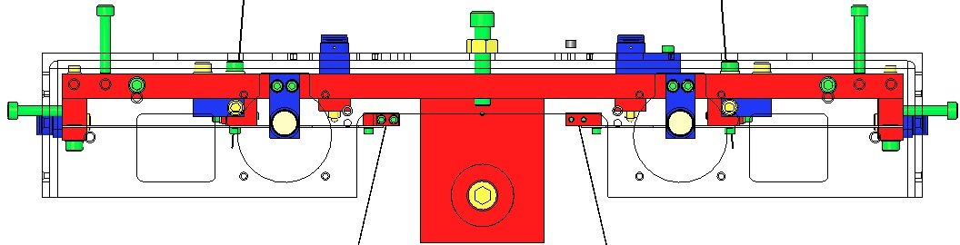  Fig 115: Upper Mass raised within Coil Holder
Fully retract the 4 Adjustment Screws within the 4 Screw Drives. |  | 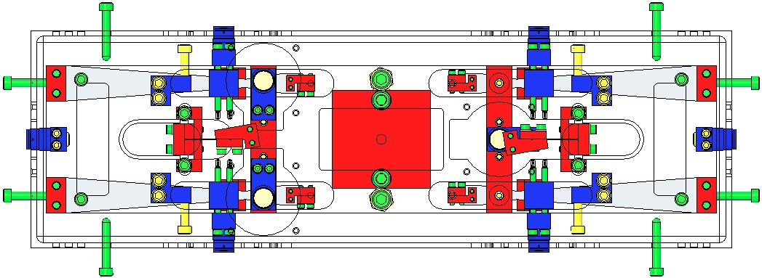  Fig 116: Top View – 4 Screws Retracted  Fig 117: Side View – 4 Screws retracted
Disconnect the Upper Wire Assemblies:  - Remove the 4 C-Clamp Screws at the Upper Mass |  | 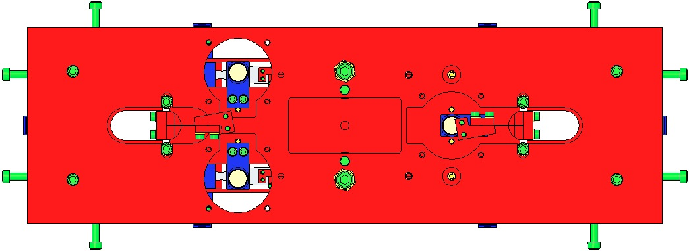  Fig 118: Top View – 4 C-Clamp Screws
Remove the Upper Wire Assemblies completely by grasping the L-Clamps and lowering the Assemblies down through the openings in the Coil Holder and Upper Mass.  Record in ICS, which Wire Assembly correlates to which Upper Blade.  Handle the Wire Assemblies with great care and store them in a protected container until the Creep Bake process is complete. |  | 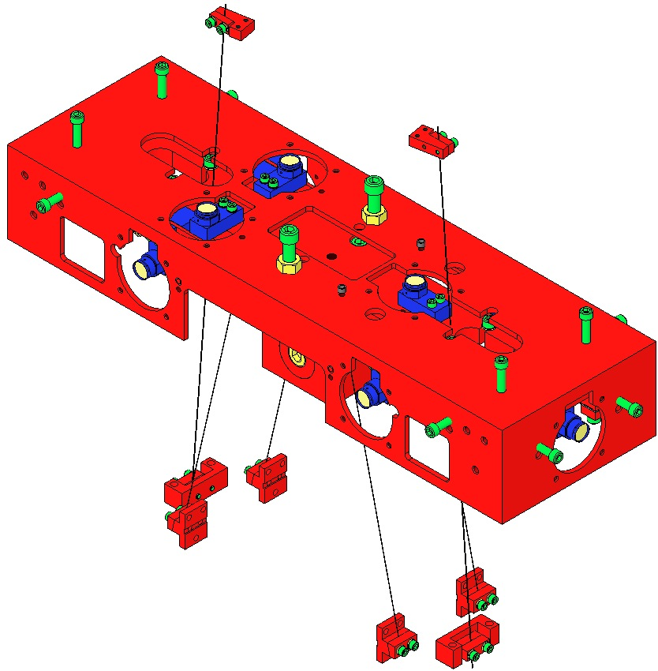  Fig 119: Upper Wires fed downward  Fig 120: 2 Upper Wire Assemblies removed

Fully extend the 8 Screws within the lower 4 Barrel EQ Stops. | 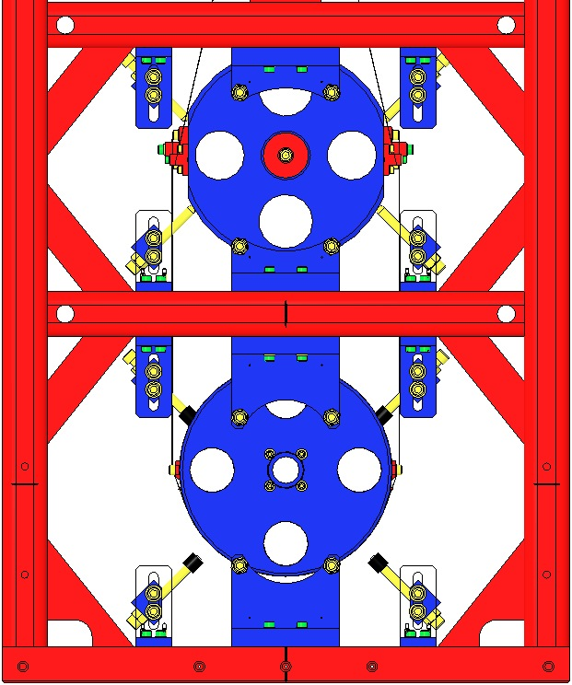  Fig 121: 8 Screws extended
Remove the 4 Screws that attach the pair of Magnet Holders on top of the Upper Mass.  Remove the 2 Magnet Holders. | 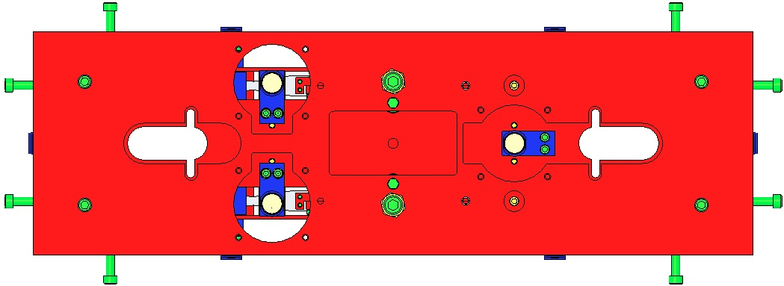  Fig 122: 4 Screws to remove
Extend the 4 Blade Guard Screws until they just touch the Lower Blades. | 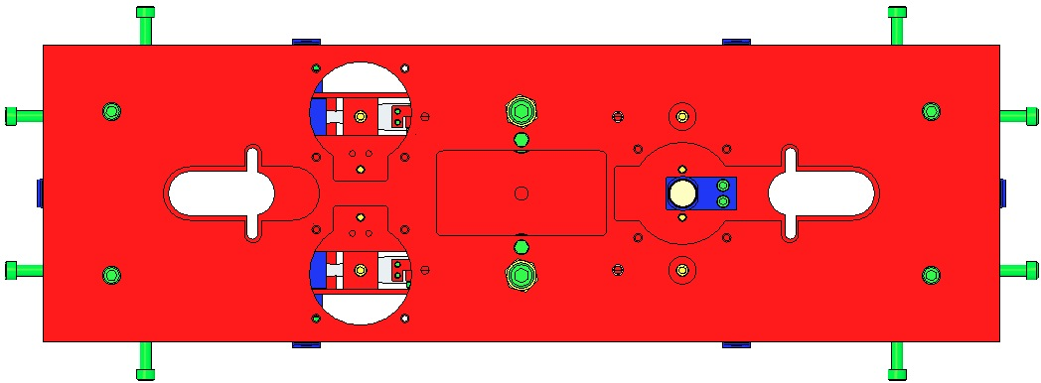  Fig 123: Top View - 4 Blade Guard Screws  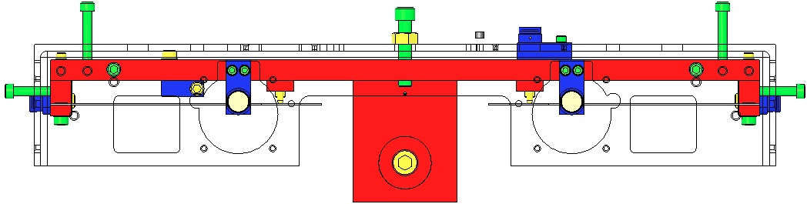  Fig 124: Side View – 4 Screws extended
Using the 2 ¼-20 Screws, lower the Upper Mass within the Coil Holder.  The Intermediate Wires will go slack at this point. | 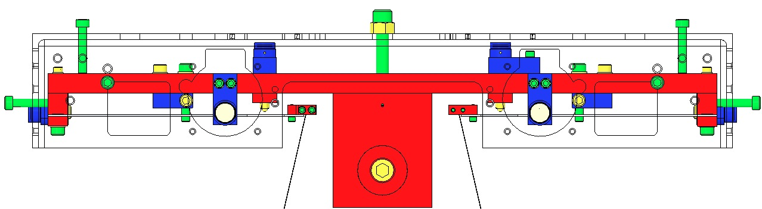  Fig 125: Upper Mass lowered within Coil Holder
Disconnect the Intermediate Wires from the Intermediate Mass by removing the 12 Screws from the 4 Lower Clamps of the Intermediate Wire Assemblies. | Fig 126: Lower Clamps of Intermediate Wires
Remove the Upper Face EQ Stop from in front of the Intermediate Mass. | Fig 127: Upper Face EQ Stop
Remove the 8 Screws attaching the L-Clamps of the Intermediate Wire Assemblies to the 4 Lower Blades.  Remove the 4 Intermediate Wire Assemblies.  Record in ICS, which Wire Assembly correlates to which Lower Blade.  Handle the Wire Assemblies with great care and store them in a protected container until the Creep Bake process is complete. | 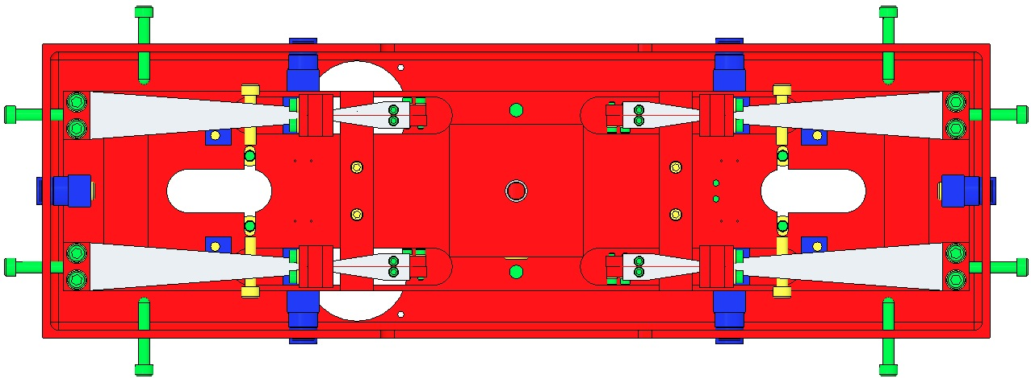  Fig 128: Bottom View – L-Clamp Screws  Fig 129: Intermediate Wire Assemblies
Remove the 8 Screws from the 4 Coil Holder Brackets.  Remove the Coil Holder / Upper Mass Assembly from either short side opening in the Weldment. | 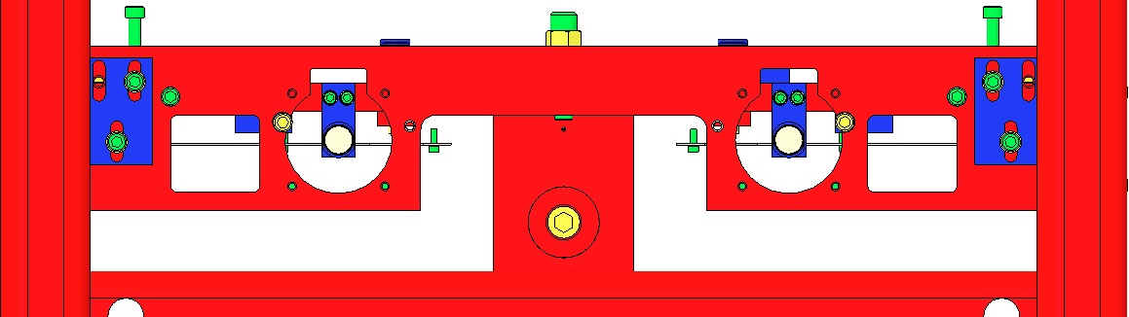  Fig 130: Coil Holder Screws
From one of the two Magnet Holders assembled to the ends of the Upper Mass, remove 1 Magnet Holder from it’s Base. This will provide clearance for separation of the Upper Mass from the Coil Holder.  Remove the 2 ¼-20 Screws from the Coil Holder.  Separate the Upper Mass Assembly from the Coil Holder.  Re-attach the Magnet Holder to its Base. | 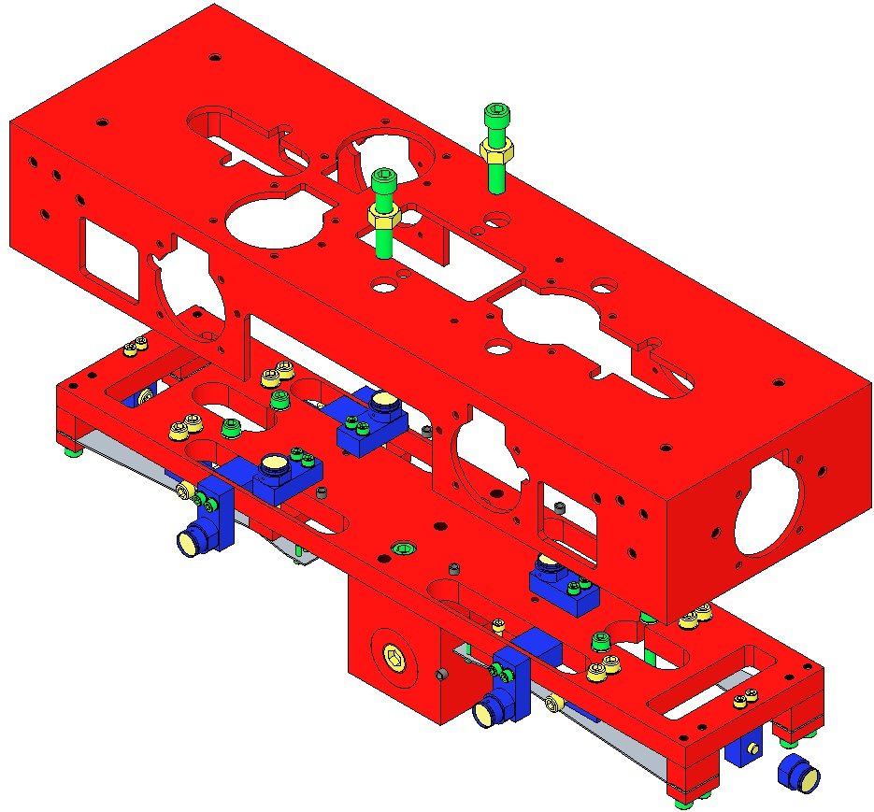  Fig 131: Upper Mass and Coil Holder seperated
Remove all 9 Magnet Holder / Base Assemblies from the Upper Mass. This includes the 4 Braces for the Magnet Assemblies attached to the sides of the Upper Mass.  Remove all 4 Screw Drives from the Upper Mass.  Remove the T-Section from the Upper Mass Main Section. | 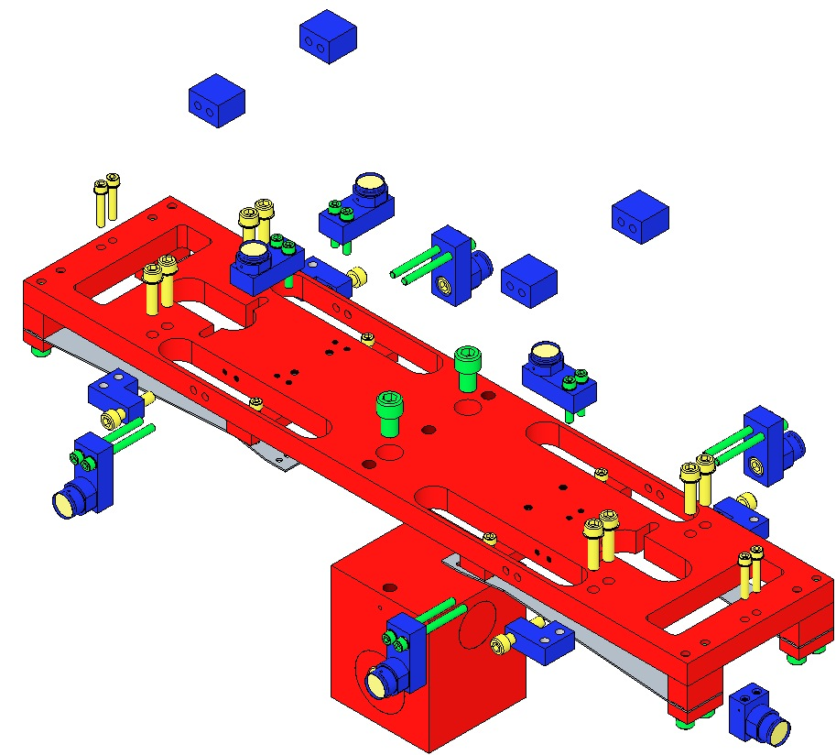  Fig 132: Disassembled Upper Mass
The remaining Assembly, ready for Creep Bake, consists only of:  1 Main Section;  4 clamped Lower Blades;  2 Blade Guards with 4 Screws each. | 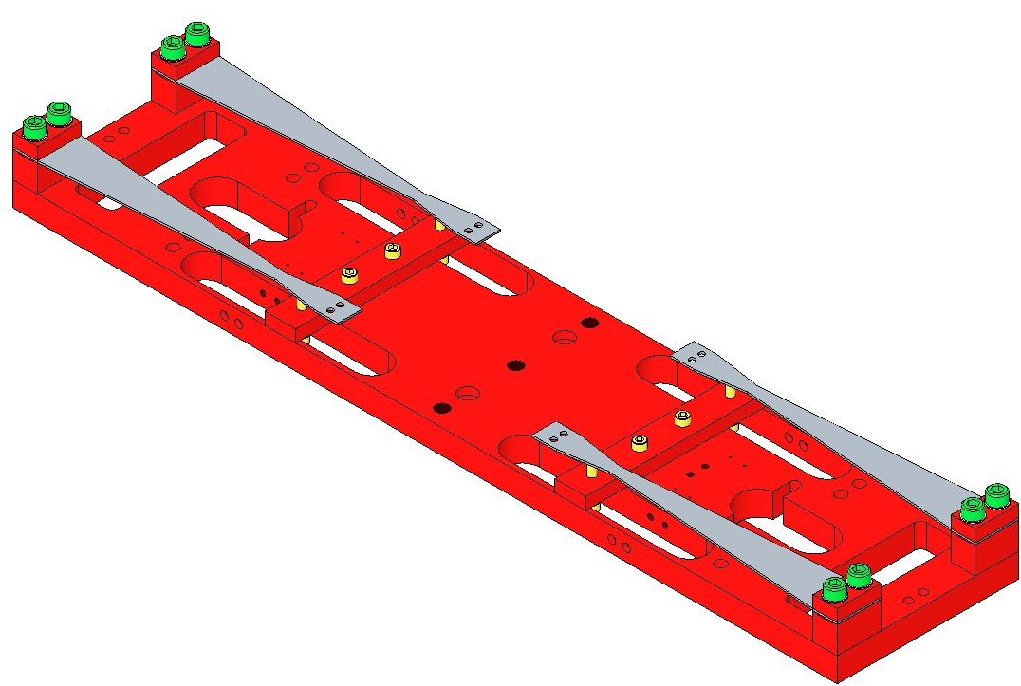  Fig 133: Assembly Ready for Creep Bake

Follow the process outlined in E0900023 for baking all 6 Blades for 120°C @ 168 hr.
- 2 Upper Blades (2 Rotational Adjusters);
- 4 Lower Blades (clamped in 1 Main Section);

Re-assemble and install in the Weldment:
- The Upper Blades in their Rotational Adjusters, per the section, “Installing the Rotational Adjusters”;
- The Upper Mass per the sections, “Assembling the Upper Mass” and “Installing the Upper Mass and Coil Holder”.

Bonding Magnet Assemblies to Intermediate Mass

Related Documents
M0900034 Use of Magnets in Suspensions
E990196 HSTS HLTS Magnet/Standoff Assembly Preparation
E960022 Vacuum Compatibility, Cleaning Methods and Qualification Procedures

Materials
Qty | U | ID | Description
1 | Ea | D1100356 | Triple Optic Base Assembly
4 | Ea | D980184 | LOS Clamps
4 | Ea | NA | Socket Head Cap Screw ¼-20 x 1.5” AgPlated
1 | Ea | D0901873 | HSTS Intermediate Mass Assembly
2 | Ea | D020661 | North magnet/dumbbell assembly, Intermediate Mass
2 | Ea | D020661 | South magnet/dumbbell assembly, Intermediate Mass
1 | Ea | D1002606 | Intermediate Mass Ring Fixture Assembly
1 | Ea | TBD | Gun Applicator, MasterBond
1 | Ea | EP30-2 | Epoxy, Double Barrel Cartridge with Mix Tube, MasterBond
1 | Ea | NA | Machinist Square, approx. 6” in length
1 | Ea | NA | Depth Gage; either Vernier Calipers or Spring-Type Needle Gage
1 | Ea | NA | Tweezers
1 | Btl | NA | Isopropanol
X | Ea | NA | Lint Free Wipes
X | Ea | TBD | Sewing Needle
X | Ea | TBD | Razor Blade
X | Roll | NA | UHV Aluminum Foil
1 | Ea | NA | Bake Oven with Thermocouple
1 | Ea | NA | Heat Lamp, 120W Bulb (for magnet repair)

Procedure
Mount the D1100356 Base Assembly to an Optics Table with the 4 D980184 LOS Clamps and ¼-20 x 1.5” AgPlated Screws.  Place the D0901873 Intermediate Mass Assembly on the Base Plate.  Place the D1002606 Intermediate Mass Ring Fixture Assembly on top of the Intermediate Mass.  For clarity, the Base Plate is not shown after this point. | 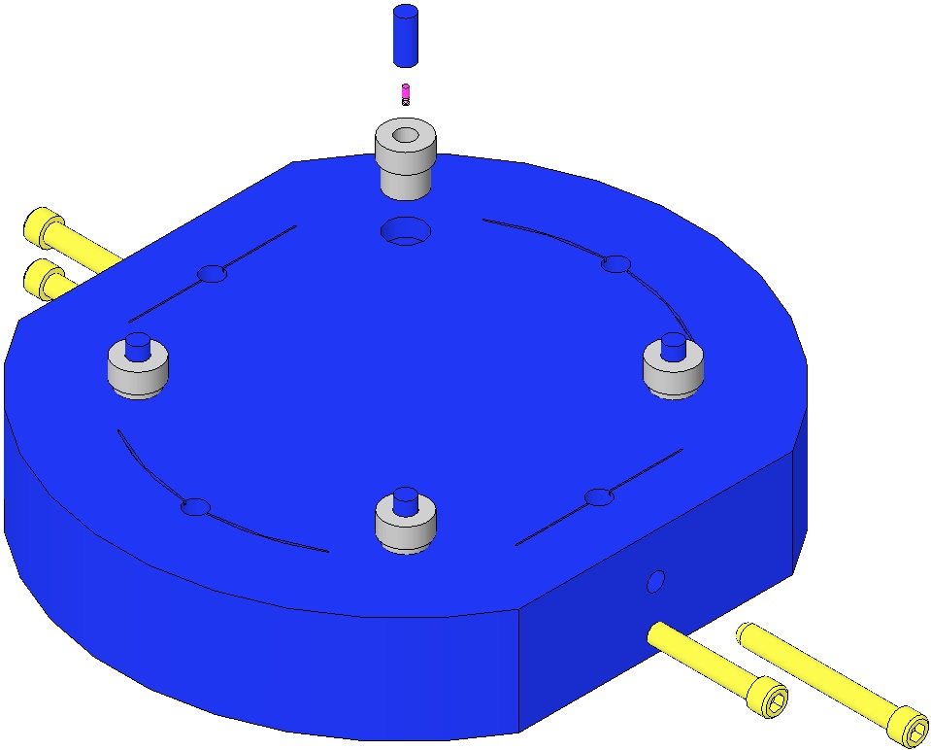  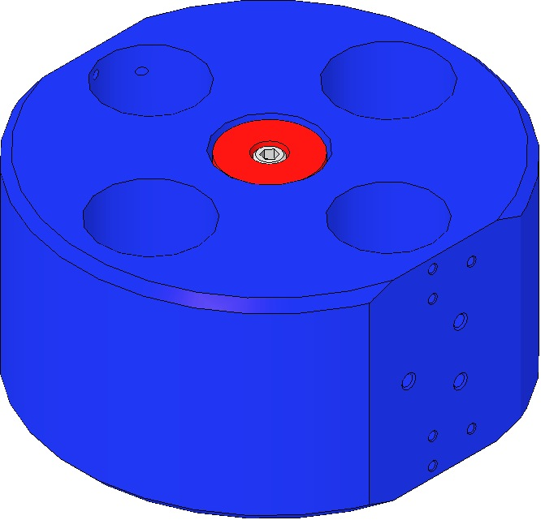  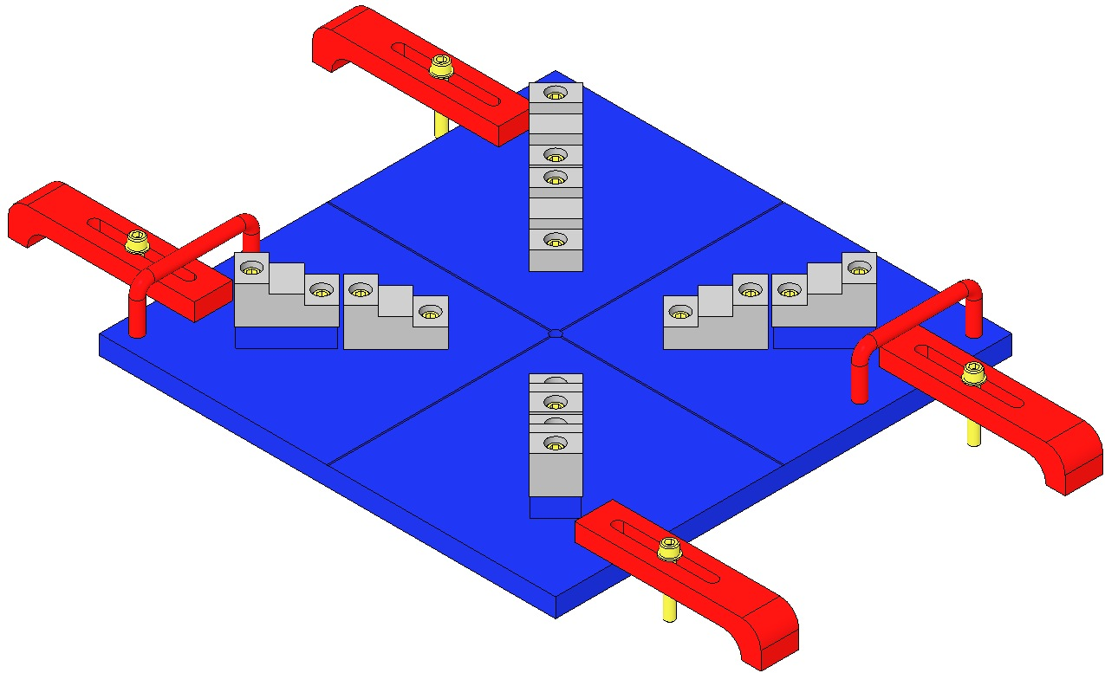  Fig 134: Ring Fixture, Mass, Base Plate
Align the Ring Fixture and Mass  Center the Ring Fixture on the Mass by obtaining equidistant readings between opposing parallel sides of the Fixture and Mass, using a Depth Gage. The Ring Fixture Screw tips must barely contact and not “clamp” the Mass.  Note the locations of the 4 Magnet Plungers. | Magnet Plunger  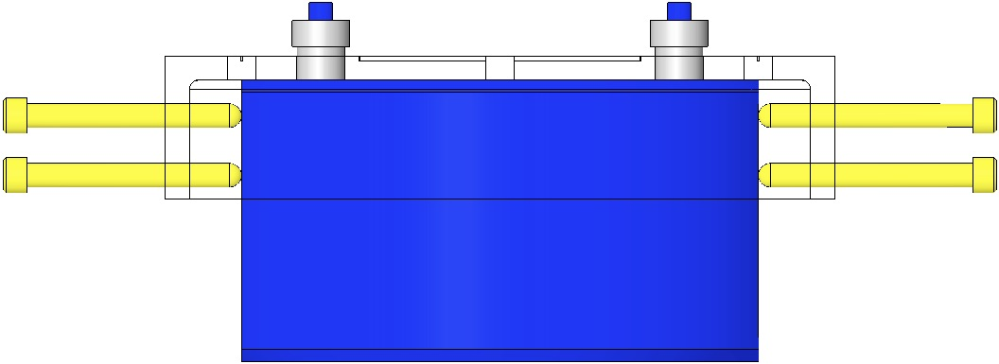  Fig 135: Ring Fixture Aligned with Mass
Prepare 2 “N” and 2 “S” D020661 Intermediate Mass Magnet/Standoff assemblies as per the E990196 Preparation procedure. Use nickel-plated magnets for all Intermediate Mass Assemblies. | 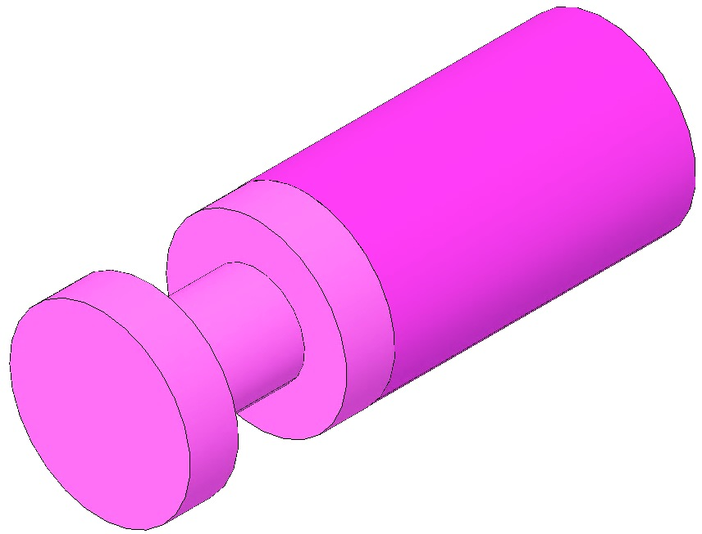  Fig 136: D020661 Magnet/Standoff Assembly
Load Plungers  Remove the 4 Magnet Plungers from the Fixture and wipe the counterbore end of each plunger with Isopropanol and a Wipe.  Using the Tweezers, load 4 Magnet/Standoff assemblies into the 4 Plungers, 2 North Magnets and 2 South Magnets. The Magnet end of each assembly rests within the Plunger counterbore.  The Magnet/Standoffs are held to the Plungers magnetically. | 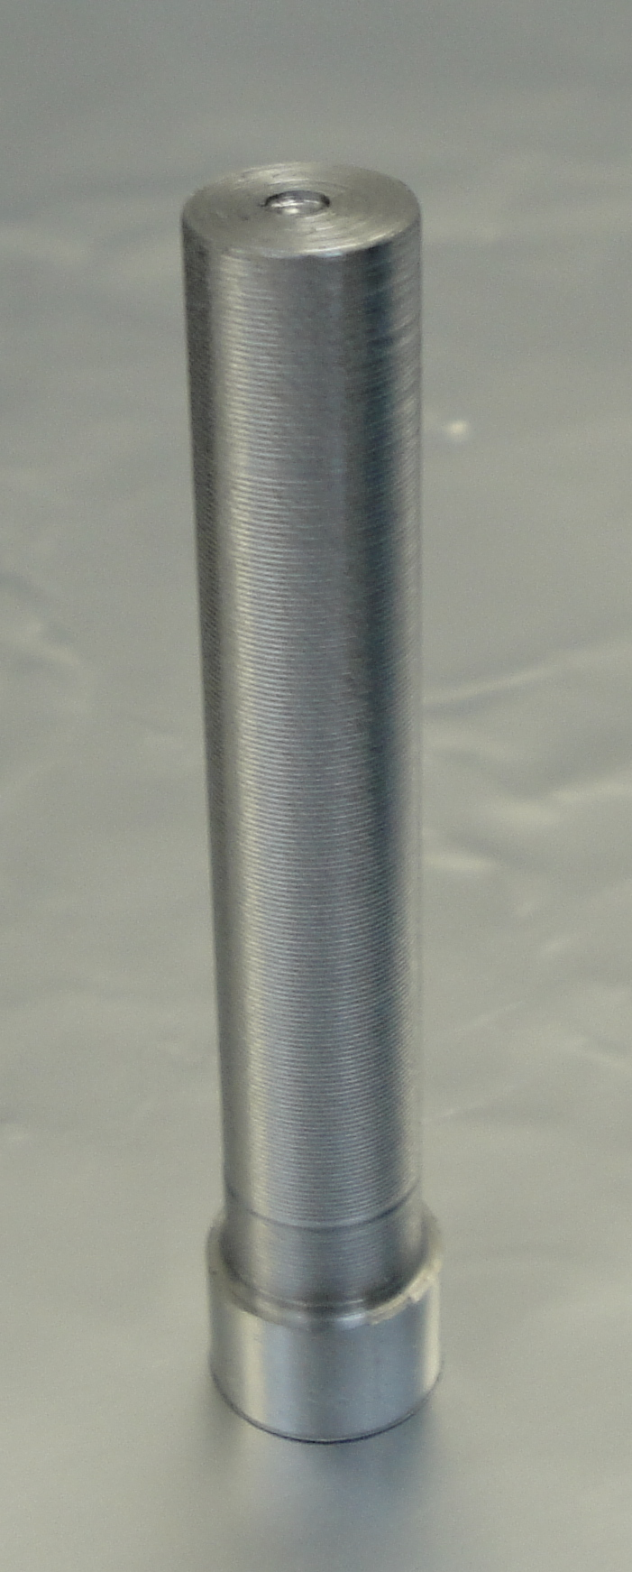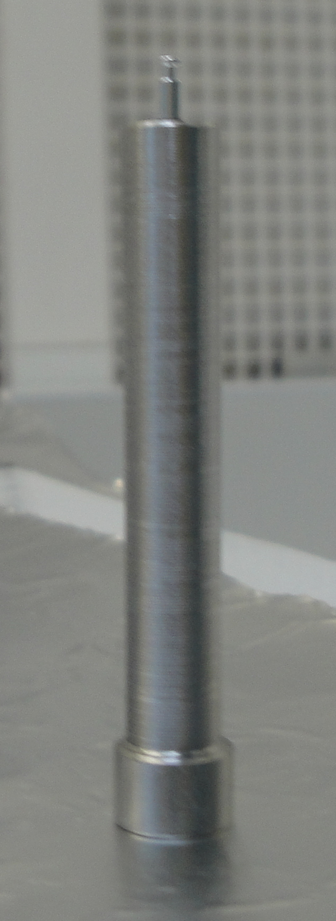  Counterbore  Assembly held to Plunger Magnetically  Fig 137: Plungers Empty and Loaded

Determine the correct Magnet Polarity Layout by identifying the in-use top of the Mass. The Wire Assembly Clamp Hole patterns on the sides of the Mass identify the top of the Mass.
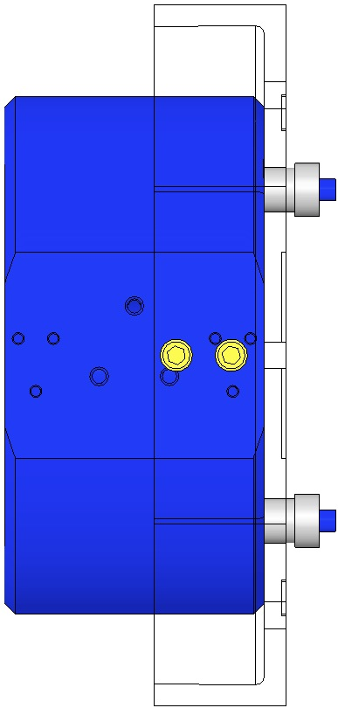  Top of Mass | 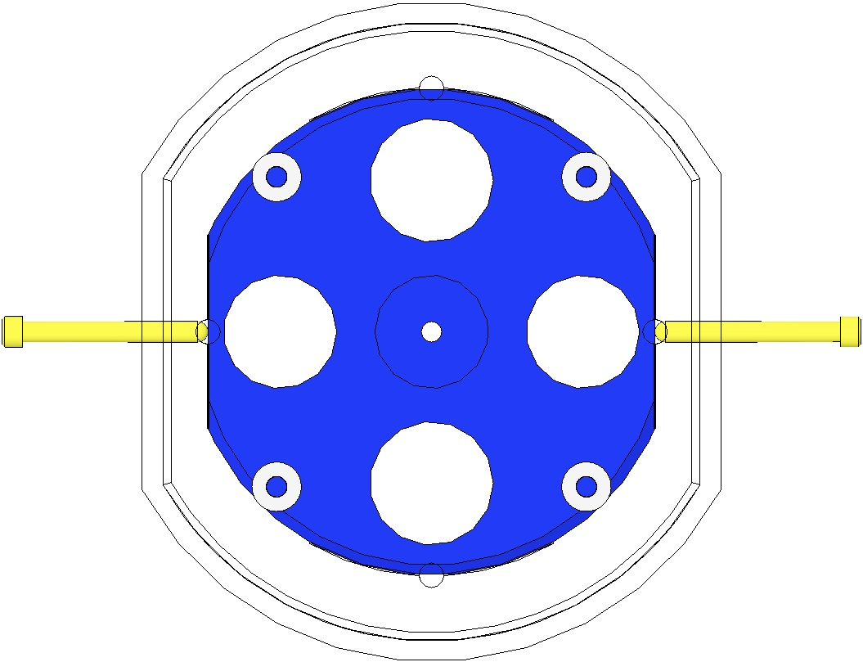  N  S  N  S  Top of Mass
Fig 138: Top of Mass identified by Hole Pattern | Fig 139: Magnet Polarity Layout

Bond Magnets to Mass/Optic

Load the EP30-2 Cartridge with Mix Tube attached, into the Gun Applicator.

Pull the trigger on the Gun Applicator 1 full stroke, to purge the Mix Tube of under-mixed adhesive.

Dispense a “quarter-sized” pool of Adhesive onto a small piece of clean UHV aluminum foil.

Pick up a Plunger loaded with a Magnet/Standoff assembly and hold it vertically, with the Magnet/Standoff end facing up. Clean the Standoff with Isopropanol and a Wipe.

Dip the end of a Sewing Needle in the pool of Epoxy and withdraw it, leaving a tiny drop on the Needle tip. Apply approximately ½ mm of Epoxy to the center of the Standoff end.

Load the Plunger, Magnet/Standoff down, into the appropriate Bushing in the Ring Fixture. Slide the Plunger down within the Bushing until the Standoff contacts the Mass/Optic. Press down on the Plunger lightly with one finger for about 2 seconds, then release.

Repeat steps 13-15 to load all 4 Plungers into the Placement Fixture.

Allow the Epoxy to cure within the Fixture at room temperature for 12 to 16 hours.

Carefully remove the 4 Plungers from their Bushings, and remove the Fixture from the Mass/Optic.

Place the Intermediate Mass in a Bake Oven with a thermocouple. Cure the Epoxy at 34°C for 3 to 4 hours, ramping the temperature up at the beginning and down at the end by no more than 1.5°C per minute. Use the oven thermocouple to monitor the temperature.

The assembly process is complete.

Bonding Magnet Assemblies to Lower Masses

Related Documents
M0900034 Use of Magnets in Suspensions
E990196 HSTS HLTS Magnet/Standoff Assembly Preparation
D020234 HSTS Metal Lower Mass, 0.5 Degree Wedge
D0902332 HSTS Metal Lower Mass, 1.0 Degree Wedge
E0900342 HSTS Optic Orientations
E960022 Vacuum Compatibility, Cleaning Methods and Qualification Procedures

Materials
Qty | U | ID | Description
1 | Ea | D1100356 | Triple Optic Base Assembly
4 | Ea | D980184 | LOS Clamps
4 | Ea | NA | Socket Head Cap Screw ¼-20 x 1.5” AgPlated
1 | Ea | D020427 | HSTS Magnet Gluing Ring Fixture, Lower Mass
1 | Ea | D0901791 | HSTS Lower Mass Assembly
1 | Ea | Various | Optic, HSTS
4 | Ea | D0902432 | Magnet/Standoff Assemblies, 2 N and 2 S configurations
1 | Ea | NA | Machinist Square, approx. 6” in length
1 | Ea | NA | Depth Gage; either Vernier Calipers or Spring-Type Needle Gage
1 | Ea | EP30-2 | Epoxy, Double Barrel Cartridge with Mix Tube, MasterBond
1 | Ea | TBD | Gun Applicator, MasterBond
1 | Ea | NA | Generic Compass mounted on non-magnetic isolation post
1 | Ea | NA | Tweezers
1 | Btl | NA | Isopropanol
X | Ea | NA | Lint Free Wipes
X | Ea | TBD | Sewing Needle
X | Ea | TBD | Razor Blade
X | Ea | NA | UHV Aluminum Foil
1 | Ea | NA | Bake Oven with Thermocouple
1 | Ea | NA | Heat Lamp, 120w Bulb (for magnet repair)

Procedure
Notes:
- Glue Magnets after gluing Prisms (primary and secondary).

Ensure the Main Section of the Mass has been cleaned and baked before attaching the Magnet/Dumbbell assemblies.
- Thoroughly Class B clean all parts of the Magnet Gluing Ring Fixture.
- Magnet/Standoff Assemblies are produced per E990196 HSTS HLTS Magnet/Standoff Assembly Preparation.
Prepare 2 “N” and 2 “S” D0902432 Lower Mass Magnet/Standoff assemblies as per E990196 Preparation procedure. For metal dummy masses, use unplated magnets; for glass optics, use nickel-plated magnets. |  | 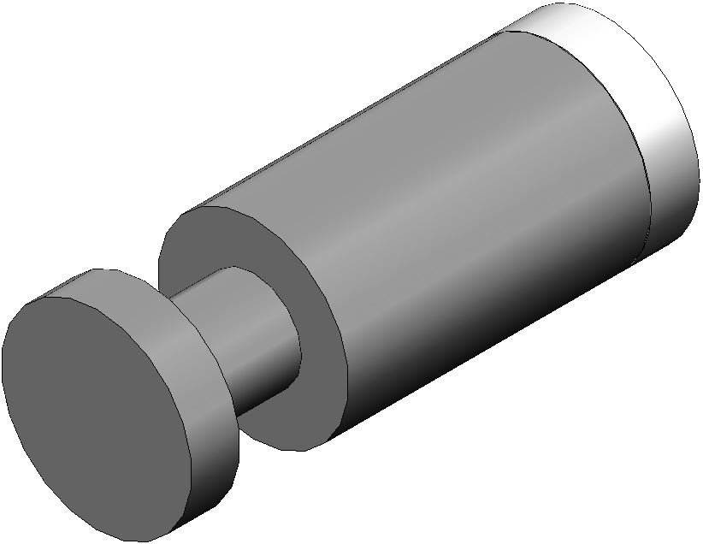  Fig 140: D0902432 Assembly
Mount the D1100356 Base Assembly to an Optics Table with the 4 D980184 LOS Clamps and ¼-20 x 1.5” AgPlated Screws.  Place the Mass/Optic Assembly on the Base Plate with arrows pointing down.  Place theD020427 Magnet Gluing Fixture Assembly on top of the Mass/Optic.  Note the Scribe Lines on both the Fixture and the Mass / Optic.  For clarity, the Base Plate is not shown after this point. | 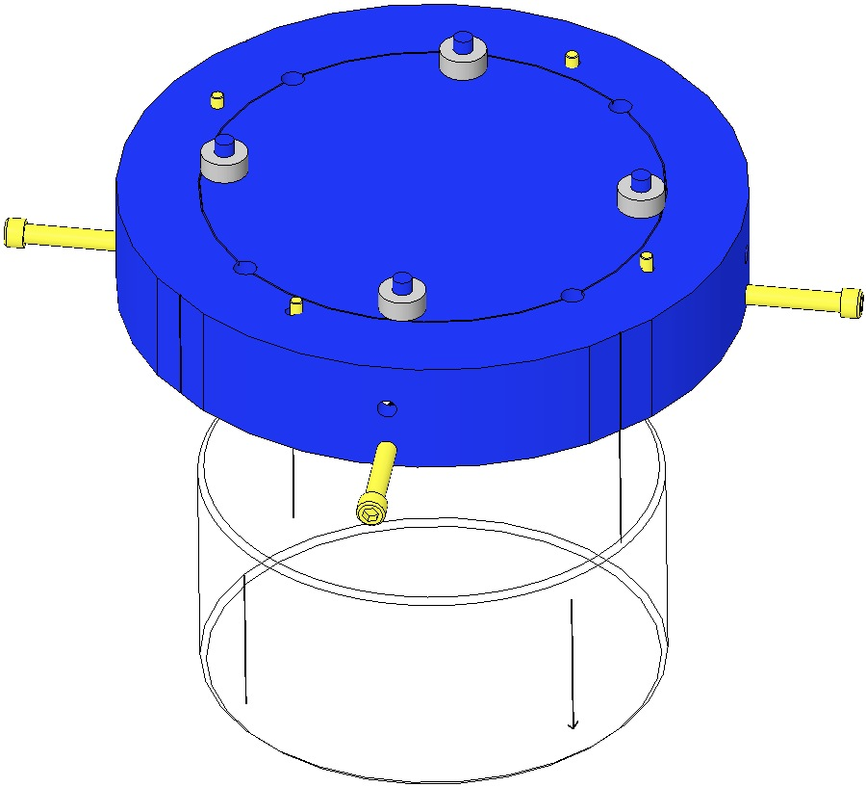  Scribe Lines  Arrow  Fig 141: Magnet Gluing Ring Fixture
Center the Mass / Optic within the Fixture by using the 4 Stop Screws. Use a Depth Gage to obtain equidistant readings at opposing pairs of Mass / Optic Scribe Lines, between the Fixture and Mass / Optic perimeters. The Screw tips must barely contact and not “clamp” the Mass/Optic. | 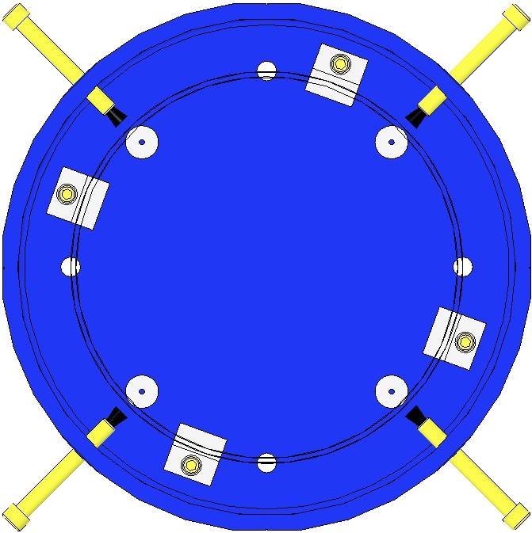  Stop Screw  Equal measurements  Fig 142: Top View of Centering
For a Metal Mass, rotate the Gluing Fixture while aligning the Mass and Fixture Scribe Lines with a Machinist’s Square. Align at 2 Line positions 90° apart.  For an Optic, sight across (through) the glass through 2 opposing Scribe Lines, then rotate the Gluing Fixture to align the Optic and Fixture scribe lines with a Machinist’s Square. | 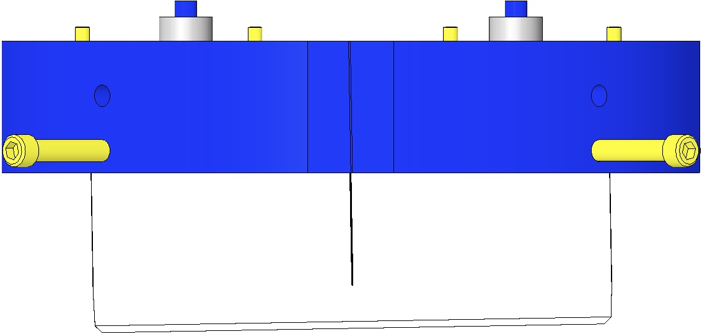  Machinist’s  Square  Scribe Lines Aligned  Fig 143: Centering the Mass / Optic in the Fixture
Load Plungers  Remove the 4 Magnet Plungers from the Fixture and wipe the counterbore end of each plunger with Isopropanol and a Wipe.  Using the Tweezers, load 4 Magnet/Standoff assemblies into the 4 Plungers, 2 North Magnets and 2 South Magnets. The Magnet end of each assembly rests within the Plunger counterbore.  The Magnet/Standoffs are held to the Plungers magnetically. |  | Counterbore  Assembly held to Plunger Magnetically  Fig 144: Plungers Empty and Loaded

Determine the correct Magnet Polarity Layout by identifying the in-use top of the Mass/Optic. The prisms on the sides of the Mass and the arrow on the Optic and the identify the top of the Mass.
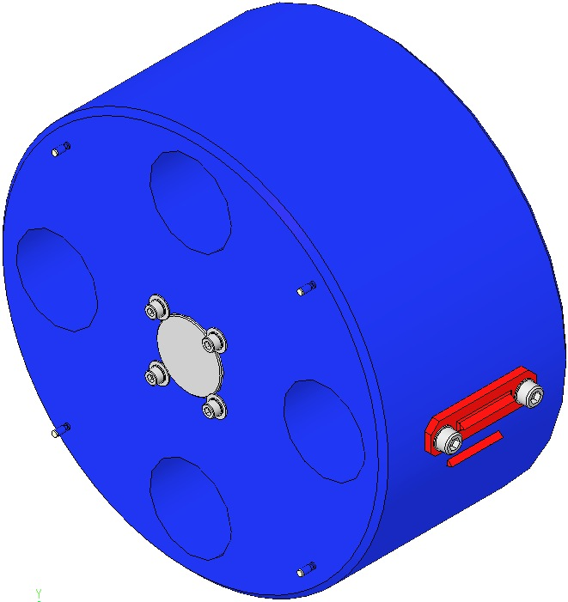  Magnet  Fig 145: HSTS Lower Mass Assembly | 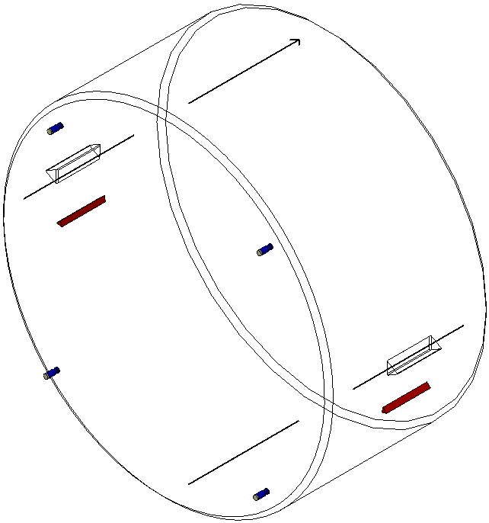  Magnet  Fig 146: HSTS Optic Assembly

Bond Magnets to Mass/Optic  Load the EP30-2 Cartridge with Mix Tube attached, into the Gun Applicator.  Pull the trigger on the Gun Applicator 1 full stroke, to purge the Mix Tube of under-mixed adhesive.  Dispense a “quarter-sized” pool of Adhesive onto a small piece of clean UHV aluminum foil.  Pick up a Plunger loaded with a Magnet/Standoff assembly and hold it vertically, with the Magnet/Standoff end facing up. Clean the Standoff with Isopropanol and a Wipe.  Dip the end of a Sewing Needle in the pool of Epoxy and withdraw it, leaving a tiny drop on the Needle tip. Apply approximately ½ mm of Epoxy to the center of the Standoff end.  Load the Plunger, Magnet/Standoff down, into the appropriate Bushing in the Ring Fixture. Slide the Plunger down within the Bushing until the Standoff contacts the Mass/Optic. Press down on the Plunger lightly with one finger for about 2 seconds, then release.  Repeat steps 11-13 to load all 4 Plungers into the Placement Fixture.  Allow the Epoxy to cure within the Fixture at room temperature for 12 to 16 hours.  Carefully remove the 4 Plungers from their Bushings, and remove the Fixture from the Mass/Optic.  Place the Mass/Optic in a Bake Oven with a thermocouple. Cure the Epoxy at 34°C for 3 to 4 hours, ramping the temperature up at the beginning and down at the end by no more than 1.5°C per minute. Use the oven thermocouple to monitor the temperature.  The assembly process is complete. | Top of Mass  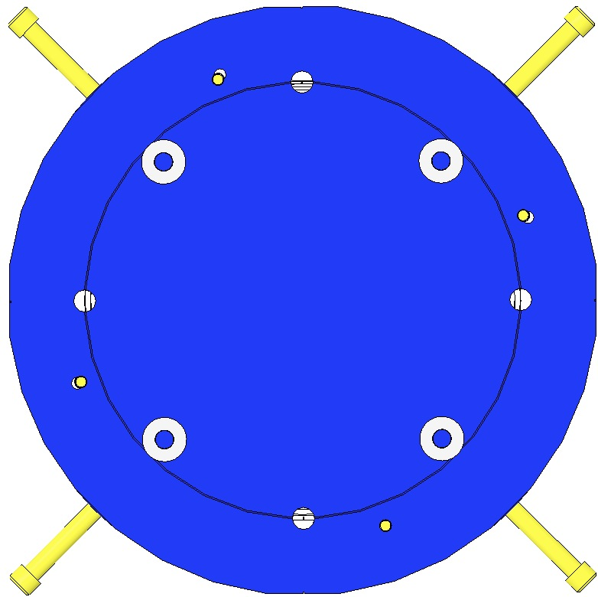  N  S  N  S  Fig 147: Magnet Polarity Layout

Reinstalling the Suspended Components

Installing AOSEM Brackets

Materials
Qty | U | ID | Description
4 | Ea | D0901924 | AOSEM Alignment Assemblies
2 | Ea | D0902207 | AOSEM Alignment Assemblies
2 | Ea | D0902208 | AOSEM Alignment Assemblies
16 | Ea | NA | Socket Head Cap Screws 8-32 x 0.5 AgPlated
16 | Ea | NA | Flat Washer #8 SSTL

Procedure
AOSEMS are assembled in LH and RH configurations per section Error! Reference source not found.. Note the configuration at each location within the Weldment.  The AOSEM Assemblies are attached using:  - 16 Socket Head Cap Screws  8-32 x 0.5” AgPlated  - 16 Flat Washers #8 SSTL  Torque to 30 in-lb  Assemble 4 D0901924 AOSEM Alignment Assemblies into the Intermediate Mass section of the Weldment.  Assemble 2 D0902207 AOSEM Alignment Assemblies into the upper half of the Lower Mass section of the Weldment.  Assemble 2 D0902208 AOSEM Alignment Assemblies into the lower half of the Lower Mass section of the Weldment. | 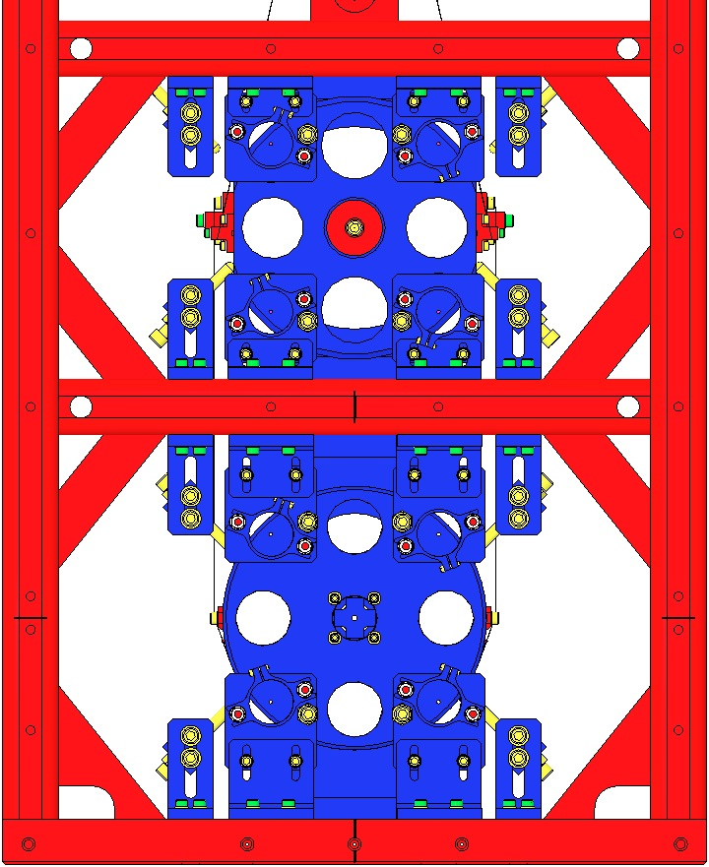  D0901924 RH  D0902208 RH  D0902207 RH  D0901924 LH  D0901924 RH  D0902207 LH  D0902208 LH  D0901924 LH  Fig 148: Rear view of Weldment

Installing AOSEMs and BOSEMs

Related Documents
D060218 BOSEM Assembly
D0901065 AOSEM Assembly

Materials
Qty | U | ID | Description
8 | Ea | D0901065 | AOSEM Assembly
6 | Ea | D060218 | BOSEM Assembly
24 | Ea | NA | Socket Head Cap Screw 4-40 x 1.0 AgPlated
24 | Ea | NA | Flat Washer #4 SSTL

Procedure

Review the test data that comes with the BOSEMs & the AOSEMs.
Position each BOSEM such that it is centered around its magnet. Assemble each to the Coil Holder with:  - 4 Socket Head Cap Screw  4-40 x 1.0” AgPlated  - 4 Flat Washers #4 SSTL  Torque to 6 in-lb  Each HSTS assembly must contain 1 fully-characterized  BOSEM, mounted at the T2 position (the –Y location). | 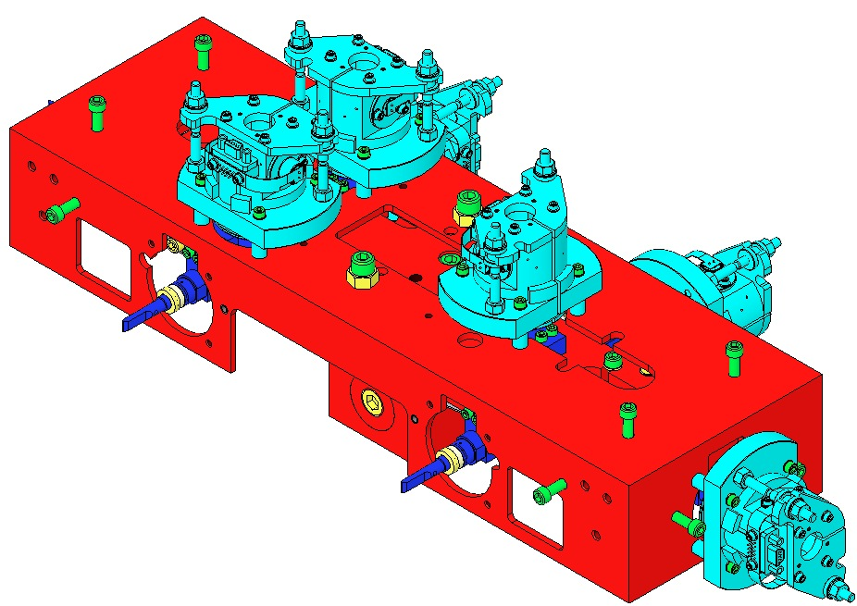  4-40 x 1”  Characterized  BOSEM  Fig 149: BOSEMS mounted on Coil Holder

Using the electronics test stand, read the open light voltage for each BOSEM, and position the BOSEM longitudinally to 50% open light voltage.
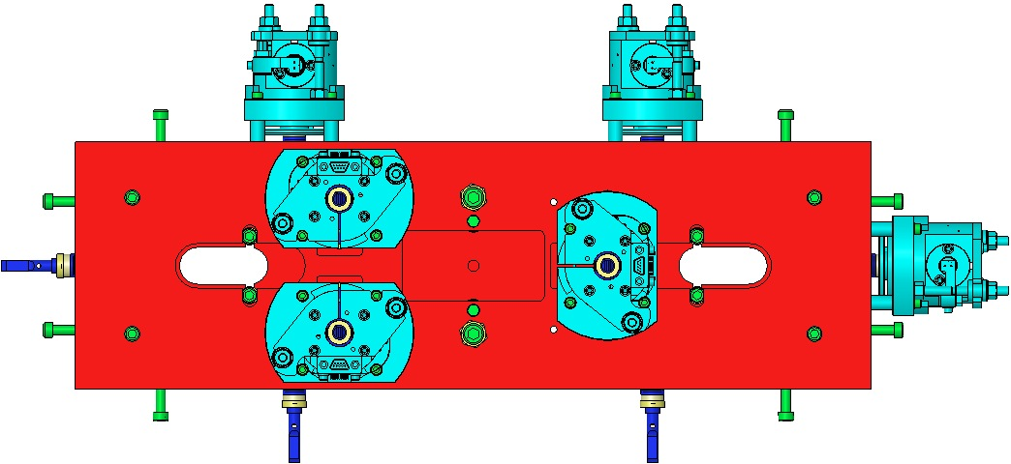
N/S indicates polarity of the outward-facing side of the magnet
S
S
N
S
N
S
+X
+Y
Fig 150: Top View of Upper Mass and BOSEMS

Place 4 AOSEMs in the Brackets behind the Intermediate Mass. Place another 4 AOSEMs in the Brackets behind the Lower Mass or Optic. Position each AOSEM such that it is centered around its magnet. | 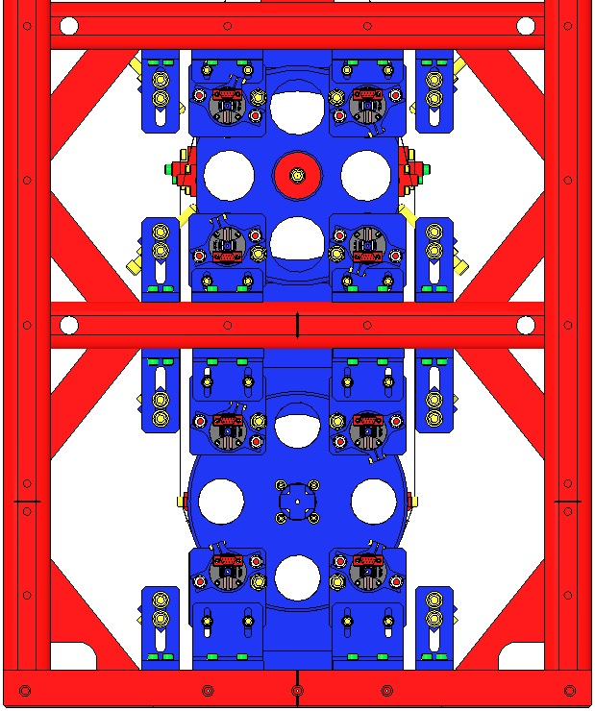  Fig 151: AOSEMs installed in Brackets

Metal-Build Testing

Storage and Transport

Replacing the Lower Mass with the Optic

Related Documents

Materials
Qty | Unit | Part Number | Description
TBD | TBD | TBD | TBD

Procedure
The D0901791 Metal Test Mass assembly has bolted-on D0901790 Primary Prisms similar to the bonded-on D0810033 Primary Prisms for the Optic.  The D0901278 Secondary Prisms are the same for each. | 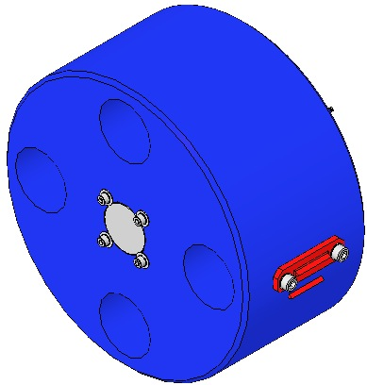  Primary Prism  Secondary Prism  Fig 152: Metal Test Mass
Weigh the Test Mass and Optic, including:  - 4 Magnet Assemblies  - 2 Primary Prisms  - 2 Secondary Prisms  - 2 Mirrors  - 8 Screws  - 8 Washers  The weights must be within a few hundred grams of each other. Compensation can be made at the Upper or Intermediate Masses.  Document the data in ICS. | 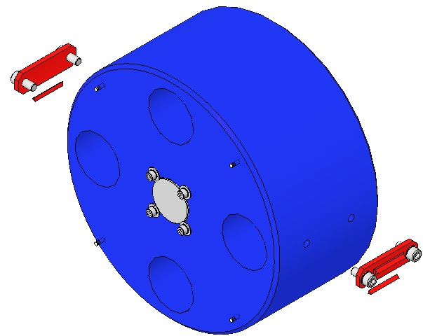  Fig 153: Test Mass Assembly

Bond the sapphire prisms to the optic using epoxy TBD and the bonding fixture, D0902543.

Bond magnet/standoff assemblies to the optic, per the procedure detailed in Section 6.3.

Move the bottom EQ stops up onto the metal test mass. Remove the front stops and brackets. Move the stops up even further to provide slack in the wire. Remove and set aside the secondary prisms. Carefully remove the metal test mass, while leaving the wires intact.

Replace all of the test mass EQ stops with silica tipped ones: Earthquake Stop For Glass (Glass Tip), Simplified, 2 Inch, D0900932. Cover all glass tips with PFA slide covers (part number TBD).

Carefully, move the optic in place of the metal test mass, onto the bottom EQ stops. Make sure the wires are securely positioned in the v-grooves of the sapphire prisms and the secondary prisms. Replace the front stops and brackets. Back down on the bottom EQ stops, until the optic is just suspended.

Realign the BOSEMs & AOSEMs. Check for damping with the electronics test stand.

Torque all bracket screws to 20 in-lb. Check torque on all blade clamp screws at 30 in-lb.

Adjust all earthquake stops on the Intermediate and Lower Masses to have a gap of approximately 0.75 mm (between ½ and ¾ of a turn for ¼-20 earthquake stop screws).

Measure the distance from the face of the optic to the base plate of the Structural Weldment.
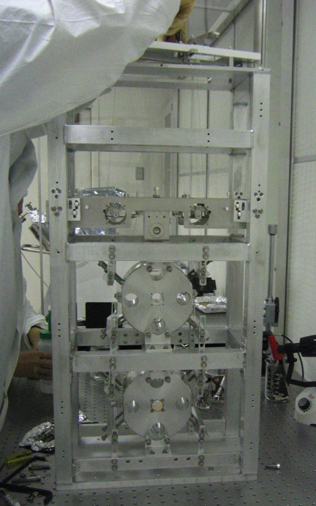  Fig 154: Prototype Small Triple Suspension | 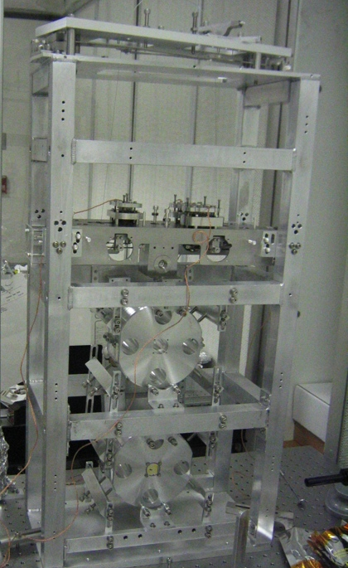  Fig 155: Prototype Small Triple Suspension with Control System

Glass-Build Testing and Installation into Chamber
Placeholder

