- Loosen the omega-shaped clamps that hold the magnet to the base, remove the small aluminum shims from between the magnet and the magnet base, then re-tighten the large clamps. There are four shims to remove.
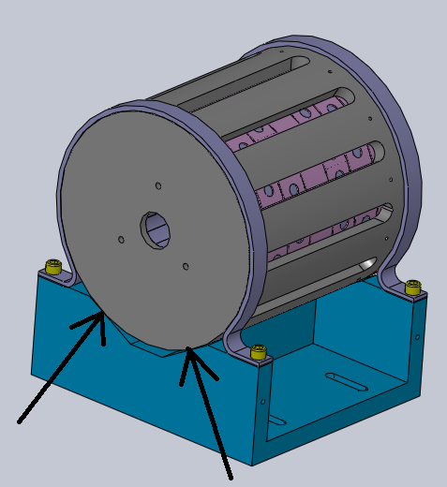

- Get the spacer plate (pictured) and the breadboard to assemble with the magnet assembly.
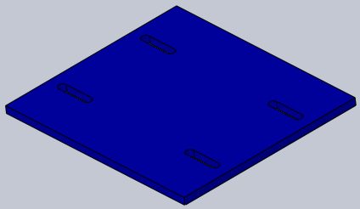

- Attach the magnet assembly and spacer to the breadboard with four ¼-20 x 1” screws and four ¼” washers. Make sure the location of the serial number, the end cap, and the number of holes to the end of the breadboard matches the figure.
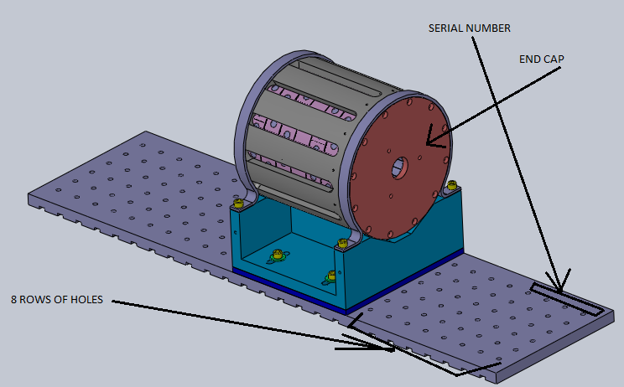

- Attach the post alignment fixtures to the breadboard with two ¼-20x1” screws. Make sure the alignment edges are flush with the breadboard on all faces.
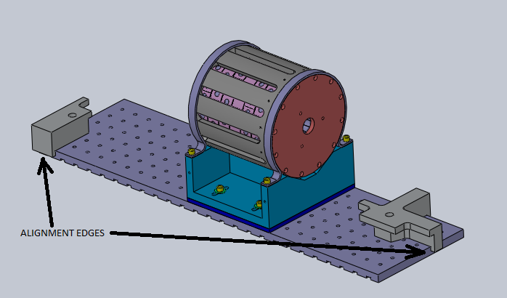
- Take three of the posts with the engraving “L1 HAM2 FI 3.735” and set them on the breadboard so that they are flush against the alignment fixtures.
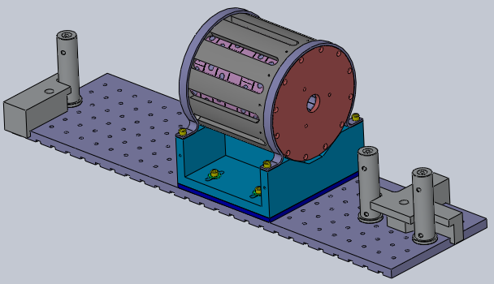
- Get three forks and three ¼-20x5/8” screws and use the forks to clamp the posts to the breadboard.
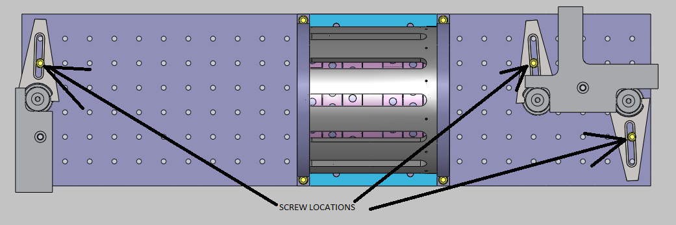
- Remove the alignment fixtures.

