LIGO Laboratory / LIGO Scientific Collaboration

LIGO-T0900386-v7 LIGO DATE \@ "M/d/yy" 5/15/2013

Advanced LIGO Input Optics Final Design:
Baffles, Layouts, Mode-Matching Telescope, Alignment

R. Martin, G. Mueller, D. . Tanner, L. Williams, J. Gleason, D. Feldbaum, C. Mueller, M. Heintze

Distribution of this document:
LIGO Scientific Collaboration

This is an internal working note
of the LIGO Laboratory.

California Institute of Technology  LIGO Project – MS 18-34  1200 E. California Blvd.  Pasadena, CA 91125  Phone (626) 395-2129  Fax (626) 304-9834  E-mail: info@ligo.caltech.edu | Massachusetts Institute of Technology  LIGO Project – NW22-295  185 Albany St  Cambridge, MA 02139  Phone (617) 253-4824  Fax (617) 253-7014  E-mail: info@ligo.mit.edu
LIGO Hanford Observatory  P.O. Box 1970  Richland WA 99352  Phone 509-372-8106  Fax 509-372-8137 | LIGO Livingston Observatory  P.O. Box 940  Livingston, LA 70754  Phone 225-686-3100  Fax 225-686-7189

http://www.ligo.caltech.edu/

Introduction

Purpose
This document along with supporting analysis documents presents the final design for the Advanced LIGO Input Optics. The design information in this document supersede that presented in the Input Optics Preliminary Design LIGO-T060269-02-D and are intended to present a detailed preliminary design for the LIGO Input Optics Subsystem which conform to the Advanced LIGO Input Optics Design Requirements, LIGO-T020020-04-D.
The intended audience for this document is the Advanced LIGO Detector Group.
Version 5 of this document was reviewed prior to assembly, installation, and commissioning of the Input Optics in Advanced LIGO. Starting with Version 6, links to the as-built designs and drawings were added during the acceptance review phase.

Scope

The Input Optics Subsystem includes the RF modulation of the light, the input mode cleaner, optical isolation, mode matching of the light to the interferometer, and beam steering into the interferometer. The scope of the IO includes the following hardware: phase modulation Pockels cells, photodetectors and related protective shutter, active jitter suppression system, input mode cleaner optics, suspensions, Faraday isolator, and mode matching telescopes.
The Input Optics (IO) subsystem consists of the following units:

- Outside vacuum
  - RF modulation
  - Power control into the IFO
  - Steering and mode matching optics for the input mode cleaner
  - Required IO diagnostics
- In vacuum
  - Input mode cleaner cavity
  - IFO mode matching and beam steering
  - Faraday isolation and signal extraction for ISC
  - Signal extraction for PSL intensity control

Included in this document
Since Version 6 all aspects of the IO final design:
- IO layouts (PSL, in-vacuum, IOT tables)
- Baffles
- Mode matching (including adaptive mode matching)
- Interfaces
- Alignment
- the electro-optic modulators
- Faraday isolators
- Input mode cleaner optics
will be presented in this document.
Version 5 did not include:
- the electro-optic modulators
- Faraday isolators
- Input mode cleaner optics
as their final designs were already completed at the time of the review. Their preliminary designs were presented in the Input Optics Procurements Readiness Document LIGO-T080075-01-D and Upgrading the Input Optics for High Power Operation LIGO T060267-00-D.
In addition, we cover final design aspects given in the “Generic Requirements & Standards for Detector Subsystems” LIGO-E010613-01-D.

Not included in this document
Some of the drawings and specifications for these have been modified since the PRR in response to design changes. All of the revised specs and drawings are available on the AdvLIGO IO FDR wiki page via links to the DCC. The documents are:
Components
- ALIGO RTP crystals for Phase Modulators E080128
- ALIGO TGG crystals for Input Optics Faraday isolator E080125
- ALIGO IO Calcite Wedge Polarizers E0900330

Input Optics mirror blanks specs
- ALIGO Input Mode Cleaner Flat Mirror (IMCF) E070071
- ALIGO Input Mode Cleaner Curved Mirror (IMCC) E070072
- ALIGO Steering Mirror (SM1 and SM2) E070077
- ALIGO Pre-Mode Matching Telescope Mirror 1 and 2 (PMMT) E080133

Input Optics mirror polishing specs
- ALIGO Mode Cleaner Flat Mirror (IMCF) E070078
- ALIGO Input Mode Cleaner Curved Mirror (IMCC) E070079
- ALIGO Input Mode Cleaner Curved Mirror (F-IMCC) E080503
- ALIGO Steering Mirror (SM) E070084
- ALIGO Pre Mode Matching Telescope Mirror #1 (PMMT1) E080135
- ALIGO Pre Mode Matching Telescope Mirror #1 (F-PMMT1) E080504
- ALIGO Pre Mode Matching Telescope Mirror #2 (PMMT2) E080136
- ALIGO Pre Mode Matching Telescope Mirror #2 (F-PMMT2) E080505

Input Optics mirror coating specs
- ALIGO Input Mode Cleaner Flat Mirror (IMCF and F-IMCF) E070085
- ALIGO Input Mode Cleaner Curved Mirror (IMCC and F-IMCC) E070086
- ALIGO Pre-Mode Matching Telescope Mirror #1 (PMMT1 and F-PMMT1) E080137
- ALIGO Pre-Mode Matching Telescope Mirror #2 (PMMT2 and F-PMMT2) E080138
- ALIGO Steering Mirror #1 (SM1) E070091
- ALIGO Steering Mirror #2 (SM2) E070092

Drawings:
- PSL Layout D0902114
- Straight IFO IOT Layout D0902284
- Folded IFO IOT Layout D0902285
- In-Vacuum Layout - Straight interferometer D0900919
- In-Vacuum Layout - Folded interferometer D0900888
- Optics Transport Containers D0901237, D0901260, D0901261, D0901262, D0901263, D0901264, and D0901265
- Small Optics Storage Containers D980509-00-D
- Adaptive Optical Element D0901578
- ALIGO IO PSL TFP Power Control Assembly D0902365
- Calcite Wedge Polarizers D0902253
- High Power Baffles D0902373
- Low Power Baffles D990490-00-D
- RTP Drawings D990490-00-D
- EOM Housing D0902170, D0902171, D0902172, D0902173, D0902174, D0902175, D0902176, D0902177, D0902178, D0902179, and D0902180
- Faraday Housing D080169-00-D, D080170-00-D, D080176-00-D, D070530-00-D, D070493-00-D, D070492-00-D, D070475-00-D, D070474-00-D, D070473-00-D, D070472-00-D, D070471-00-D, D070469-00-D, D070468-00-D, D070467-00-D, D070465-00-D, D070464-00-D, and D070462-00-D
- TGG Drawings D080154-00-D
Mirror Blank Drawings
- ALIGO Input Mode Cleaner Flat Mirror Blank D070083
- ALIGO Input Mode Cleaner Curved Mirror Blank D070084
- ALIGO Aligo Steering Mirror Blank D070089
- ALIGO Pre-Mode Matching Telescope Mirror Blank D080158
Mirror Substrate Drawings
- ALIGO Input Mode Cleaner Flat Mirror Substrate D070091
- ALIGO Input Mode Cleaner Curved Mirror Substrate D070092
- ALIGO Steering Mirror Substrate D070097
- ALIGO Pre Mode Matching Telescope #1 Substrate D080160
- ALIGO Pre Mode Matching Telescope #2 Substrate D080161
- ALIGO Folded Input Mode Cleaner Curved Mirror Substrate D080740
- ALIGO Folded Pre Mode Matching Telescope #1 Substrate D080741
- ALIGO Folded Pre Mode Matching Telescope #2 Substrate D080742

Applicable IO System Documents
The aLIGO Input Optic Acceptance Documentation, LIGO-E1201013

Top level design documents
Input Optics Subsystem Design Requirements Document, LIGO-T020020-04-D
Advanced LIGO Input Optics Preliminary Design Document, LIGO T-020020-03-D
Input Optics Procurement Readiness, LIGO-T080075-01-D

Specific IO design documents
Pointing Requirements for Advanced LIGO, LIGO-T0900142
Alignment for the Input Optics, LIGO-T0900267
IO Stray Light Analysis and Baffle Design, LIGO-T0900486
Engineering Specifications of adaptive ring heater in IOO for advanced LIGO, LIGO-E0900268
Pre Mode Matching Telescope Parameters, Adaptive Mode matching and Diagnostics, LIGO-T0900407

IO interfaces with other subsystems
The IO has interfaces with the subsystems. Here we list the interface (type of interface) – and description and details.

PSL
- Main beam handoff on PSL table (optical) – IO will use the waist size 550 µm and location (2900 mm, 300 mm) (in PSL coordinates) in the PMC as the handoff point from the PSL to IO. See LIGO-D0902114.
- PSL intensity stabilization beam (optical) – IO will deliver the beam to the in- vacuum PSL intensity stabilization diodes in HAM2. In each IFO there are two diodes, each preceded by a tip/tilt stage. The following obsolete table gives the waist sizes of the beams and locations of the photodiodes in BCS coordinates. The BCS coordinates are defined in LIGO-T0900340.
The interface between IO and PSL was ill-defined. See T1400176 for details and fixes.
  - Power delivered to each ISS PD: 150 mW
Table 1. Waist sizes of the beams and locations of the photodiodes.
PD | IFO | TIP/TILT | X (mm) | Y (mm) | Z (mm) | WAIST SIZE (mm)
1 | Straight | yes | -20910.0 | 200 | -103.8 | 2.20
2 | Straight | no | -21025.0 | 75 | -103.8 | 2.17
1 | Folded | yes | 30110.0 | 9490.0 | -192.2 | 2.32
2 | Folded | no | 30256.3 | 9600.0 | -192.2 | 2.30

- PSL Table (mechanical) - The IO shares an optical table with the PSL (PSL/IO table). See .LIGO-D0902114
- High Power Beam Dump (water) – cooling water is needed for a high power beam dump located on the PSL table.
  - See E1300444 for details

COC
- Main beam handoff in HAM2 (optical) - The IO delivers the main beam to the power recycling mirror (PRM) in the following locations:
  - L1 - LIGO Global Coordinates (-20191.4 mm, -628.0 mm, -107.1 mm), direction cosines (0.9999827, 0.0058782, 0.0006484).
  - H1- LIGO Global Coordinates (-20191.4 mm, -628.0 mm, -96.8 mm), direction cosines (0.999827, 0.0058782, 0.0006435).
Note that these locations are estimations and that the as-built coordinates are available at T1300384 and maintained by SYS.

CDS
The IO interfaces to CDS through a number of electrical and data channels. A complete list of IO/CDS channels and their requirements can be found here: T0900400.

ISC
- Interferometer Length and Alignment Sensing Beams (optical) – ISC receives the REFL beam from IO Faraday isolator for IFO length and alignment sensing. The beam is delivered into HAM 1 through a viewport on the septum plate between HAM1 and HAM2. The septum plate is provided by FMP. The viewport is provided by AOS/SLC. At the viewport, the beam will have the following approximate parameters:
  - Beam radius: 2.10 mm
  - Power (IFO locked): ~1 W – ~16.5 W (for 10 W – 165 W at the input of the IO)
  - Straight IFO:
Beam waist: 2.12 mm
Beam waist location: 174 mm upstream of viewport
- IMC length and alignment sensing beams (optical) - ISC receives the MC_REFL beam from IMC1 for mode cleaner length and alignment sensing. The beam is delivered to the IOT2 table through a viewport which was provided by AOS/SLC to the MC locking photodiode, the MC_WFS, and associated diagnostics.
  - The IO is responsible for laying out and procuring the components the IOT2 table (IOT8 table). The MC_REFL PD and WFS are fabricated by ISC.
- RF signals for the EOMs (electrical) – ISC/CDS provides RF drive signals for the two IFO sensing sidebands. Requirements are listed in the CDS section above.

SUS
- HAM small triple suspensions (mechanical) - SUS supplies the IMC triple suspensions (HSTS) to the IO. The IO supplies shims needed for bringing the HSTSs to the proper heights.

SEI
- HAM ISI platforms (mechanical) - All in-vacuum IO components are located on HAM ISI seismic isolation platforms in HAMs 2,3.

AOS/TCS
- Hartmann Probe Beams (optical) - TCS injects two Hartmann probe beams through the PR2 and SR2 mirrors. The exact injection scheme (ports, wavelengths, and polarizations is described in the final TCS design.
- PSL pick-off for phase camera (optical) – AOS needs to tap off light on the PSL table for a phase camera.
  - IO will deliver a 1.0 mm waist and location (4025 mm,1200 mm) (in PSL coordinates) in the PMC as the handoff point from the PSL to IO.

Facilities
The IO uses Facilities for on-site assembly, storage, staging, and installation. The IO will need:

Clean Assembly and Storage
- 4 cubic meters of clean storage for the IO mirrors (including the small recycling mirrors) prior to suspension
- two 6’ tall x 2.5’ wide x 1.5’ deep cabinets (approximate dimensions; metal with glass doors) per site for storage of out-of-vacuum IO inventory
- a clean area with 4’ x 8’ optical table and laser for clean assembly of IO suspensions and Faraday isolator
- a 2’ x 4’ clean laminar flow bench for assembly of other IO in-vacuum clean components
- a set of clean tools for assembling class A components

Staging and Installation
- At least 2 clean transport carts (approximately 4’ x 2’ table area, 200 lb capacity) for moving class A equipment from storage into the LVEA
- A method of egress into the HAM chambers allowing unfettered access to the surface of the HAM ISI platforms
- a set of clean tools for installing class A components

IO Optical Layout
Layouts for AdvLIGO are maintained in Solidworks in the Caltech PDMWorks Vault with the exception of the PSL table, which is a Visio drawing. Rather than show snapshots here, we link to the drawings showing the PSL table and HAMs.

PSL Table
The layout for the PSL table can be found at D0902114:
- as a Visio drawing
- as a pdf file
A list of the IO components on the PSL table is available at E0900325. A master entry for the PSL-IO table is available at T1300019.

Straight Interferometer
The layout for the straight interferometer can be found at D0900919:
- as a 3D Solidworks drawing
- as a 3D e-drawing
- as 2D pdf drawings
Detailed descriptions of the HAM2 and HAM 3 layouts are available at T1300021 and T13000022, respectively. A list of the IO components in the vacuum is available at E0900340

IOT Tables
The master entry for the IOT Tables is available at T1300023. The layout for the IOT tables can be found at IOT2 D0902284 (Visio and jpg). An IOT2 table inventory can be found here: E0900323

Power Control
The power control system provides continuous power adjustment into the IMC from ~ 0 W to the maximum available power. The minimum incremental power step is such that the resultant radiation pressure kick will not knock the IMC out of lock. The Power Control is described at T1300089.
Model | SMC100CC
Number of Axis | 1
Motion | Basic
Drive Type | DC Servo
Communication Interfaces | RS232, USB
ESP Compatibility | ESP Stage Detection
Error Compensation | Linear, Backlash
Programming | 40+ intuitive, 2 letter ASCII commands. Command set includes software limits, user units, synchronized motion start, stop all
DC Motor Control | 48 VDC @ 1.5 A rms, 3 A peak, 100 kHz PWM switching frequency
Dimensions (W x D x H) (mm) | 161 x 140 x 33

Design
A design similar to that used in initial LIGO based on a polarizer and rotating half wave plate as shown in Fig. 1, below.

Components
- Power control: Details are available at T1300089.
  - Briefly: HWP and rotation control – A standard laser HWP will be rotated by a Newport URS100BCC DC rotation stage, which can provide quasi-continuous rotation of 0.0005⁰/step. An SMC100CC controller will be used to interface to CDS. The specifications are as follows:

- A two thin film polarizer design identical to that used in E-LIGO will be used to separate the s- and p-polarizer beams. A Solidworks drawing is available at D0902365

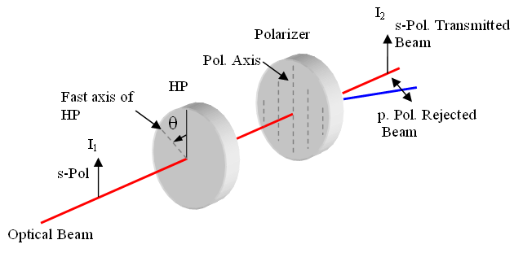
Figure 1 - Conceptual Design of Power Control System.
- One of our water-cooled beam dumps E1300444 is used to absorb the rejected laser power.

Mode Cleaner
The master entry for the Input Mode Cleaner (IMC) is available at T1300090. Test results are available from there.
The IMC is a 3 mirror ring cavity. The IMC mirrors are 150 mm diameter, 75 mm thick mirrors suspended by wires on the MC triple suspensions provided by SUS. The mode cleaner nomenclature is shown in Fig. 2. IMC1 and 3 are identical flat mirrors. IMC2 is a curved mirror.
IMC1
IMC3
IMC2
From PSL
To SM1

Figure 2 - Diagram of the input mode cleaner, defining the names of the mirrors.

Optical Parameters of the IMC mirrors
The mode cleaner design has been presented and reviewed in the Input Optics Subsystem Preliminary Design Document (LIGO-T060269-02-D, 8/20/07) and in the Input Optics Procurement Readiness document (LIGO-T080075-01-D, 4/28/08). At the present time, the mirror polishing is complete and coating is in contract negotiations. The parameters of the mode cleaner mirrors were revised since the Procurement Readiness review to account for final choices in of arm cavity lengths and of modulation frequencies. This document lists in Tables 2 and 3 (below) the final design values of the mode cleaner parameters.

Table 2. Optical design parameters for the IMC of the straight IFOs
Parameter | Unit | Value
Length | m | 16.473
Free spectral range | Hz | 9,099,471
Sideband frequency for locking | Hz | 24,078,360*
Polarization |  | ‘s’
IMC1, 3 radius of curvature | m | >10000
IMC1, 3 transmittance |  | 0.006
IMC1, 3 reflectance |  | 0.994
IMC1, 3 angle of incidence | Deg. | 44.59
IMC2 radius of curvature (cold) | m | 27.24 +/- 0.14
IMC2 reflectance |  | >0.9999
IMC2 angle of incidence | Deg. | 0.82
Scatter loss budget per mirror | ppm | < 15 over central 40 mm diameter
Absorption loss per mirror | ppm | < 1
Finesse |  | 522
Cavity Pole Frequency | Hz | 8717
g-factor (cold) |  | 0.394
IMC waist (radius) | mm | 2.12
Rayleigh range | m | 13.3

*This is the frequency that will be used for ASC of the mode cleaner.

Baffles

IO ghost beam analysis
Stray light in the Input Optics subsystem has been modeled in ZEMAX, to determine the power and the direction of the ghost beams, as well as the sway range of the high power beams when the suspended optics swing over their full dynamic range.
Detailed results of the ghost beams analysis and performance of SiC under high power irradiation are presented in T0900486. Here we summarize the results.
The main source of ghost beams in the IO is the Faraday isolator. It contains a total of 7 crystals, of which 5 are oriented close to normal incidence. In addition, two more normal incidence optics, HWP and AOE are placed up-stream from it, between the input mode cleaner and the pre-mode matching telescope, also contributing to the amount of ghost beams in the chamber.
The following parameters were used for the ZEMAX ghost beam analysis:
Table 4. Parameters for ghost beam analysis.

Parameter | Units | 2 x CWP  (calcite wedge polarizer) | 2 x HWP  1 x QR  (half waveplate / quartz rotator) | 2 x TGG  (magneto-optical crystal) | 1 x DKDP  (negative dn/dt material) | 1 x AOE  (adaptive optical element)
Material |  | Calcite | Quartz | Terbium Gallium Garnet | Deuterated Potassium Di-hydrogen Phosphate | SF57
Index of Refraction |  | n_{s}=1.64237  n_{p}=1.47968 | 1.534 | 1.94366 | 1.4931 | 1.81174
Angle of Incidence | deg | 6.5 | 0.286 | 0.286 | 0.286 | 0.286
AR Coating Reflectivity | ppm | 500 | 250 | 1000 | 500 | 300
Bulk Absorption | % per cm | 1 | - | 0.15 | 0.5 | 0.04

The stray light analysis for the as-built IO is still missing.

IO in-vacuum baffles
Based on the amount of optical power and the purpose of the baffle, there will be three classes of baffles in the IO in Advanced LIGO:
  - Parking Beam Baffle and Beam Dumps – P > 1 W
  - Hard Apertures and Baffles for Wire Protection – P <165 W
  - Low Power Baffles or Black Glass – P < 100 mW

Baffle Material and Performance
The individual types of baffles are described in Table 5, below.
Table 5. IO Baffle Description and Performance
Baffle Type | Notation on the optical layout | Power | Functionality | Material | Location
Parking Beam Dump | V1 | 150 W | Park beam reflected from PRM when IFO not in science mode. It has a V-shape, oriented with the vertex in the horizontal plane. The p-polarized beam hits the first surface at Brewster’s angle, with measured reflectivity of 0.1%, so the beam looses 3 orders of magnitude in the first bounce.  Will not be used in science mode, therefore there are no scattering concerns. | Polished SiC | Between the FI and PMMT2
Beam Dump for the depolarization in the Faraday isolator | V2 | <1.5 W | Dumps the s-polarized beam due to depolarization and other thermal effects in the Faraday isolator. The design is similar to the parking beam dump, but it will be rotated by 90 deg (vertex is vertical), so that the polarization is again in the plane of incidence of the first surface.  Is used continuously, including in science mode, so we address scattering concerns by using polished SiC | Polished SiC | Between PMMT2 and SM2, In front of the SM2 suspension tower.
Baffles for wire protection | BW1-BW5 | Up to 150 W | Protect the suspension wires from accidental exposure to high power beam for 3” optics (SM1, SM2, PMMT1 and PMMT2). | Unpolished SiC | Baffles BW1-4 are for the 3” suspended optics are bolted to the SOS towers.  BW5 is a blocking baffle near MC3
Hard Apertures | HA1-HA8 | Up to 200 W | Define a narrow stay-clear tube to reduce the amount of ghost beams from propagating into the IFO and to avoid the high power beam hitting the edge of the small (1”) optics, in particular the indium layer that wraps the TGG crystals. Also preventing the beam entering the IMC from swinging across the table when the mode cleaner looses lock.  And third, HA8 is a supplemental baffle that reduces the range of motion for the high power beam reflected from PRM, if large swings of PMMT2, SM2 and PRM occur simultaneously. | Unpolished SiC | From SM1 to PMMT2 and on the AR side of MC1. HA8 is between PMMT2 and SM2.
Low Power Baffles | BG1-BG3 | <100 mW | Block the beams that leak through the High Reflectors: PMMT1, PMMT2, SM1 for the transmitted fraction of the isolation ratio (IR) beam, MC3-AR side for the reflected fraction of the IR and ghost beams from the AOE and HWP1. | Black Glass | Everywhere low power beams need to be blocked.

Baffle Layouts
A baffle layout for HAM 2 is shown in Fig. 3, following the color code and the description in Table 5.
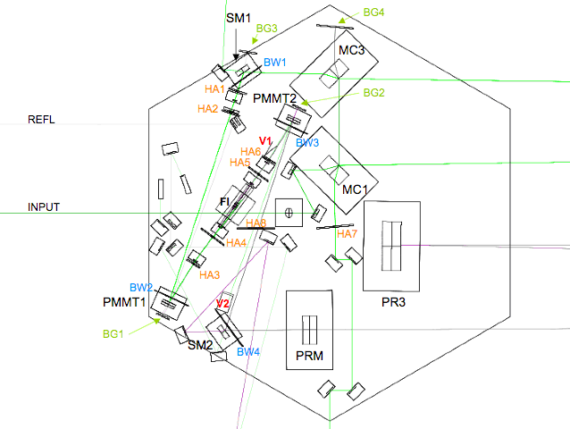
BW5
Figure 3. Baffle layout for HAM2 table.

Baffle Designs –
D0902373 is an example of the high power protection baffles that mount to the SOSs. Low power baffles and stand alone high power baffles will use the same mounts that were used in initial LIGO, D990490.

Mode Matching
The here listed values are the nominal solutions for the initial mode matching. The as-built values depend on the as-built radii of curvatures and differ from interferometer to interferometer. The mode-matching details will be reported and tracked under the aLIGO IO Testing and Commissioning Documentation entry E1300439 and the layout documents T1300019 (PSL) and T1300021 (HAM2).

PSL – MC mode matching
Mode matching from PSL to IMC is done in two steps. First the beam waist from the PMC is mode matched to a 940 ∝m beam waist inside the electro-optic modulator (EOM). This number is selected because of diffraction losses considerations. The diffraction loss of such a beam when passing through a 4 mm EOM is 50 ppm. This beam waist is then mode matched to IMC using a two lens telescope. The design is selected to reduce the sensitivity of mode matching to positioning and ROC errors.

Mode Matching from PSL to EOM
The conceptual layout of the mode matching from PSL to EOM is shown in Fig. 4. The hand off location of the beam waist from PMC is at (2600,300) with a beam waist of 550 ∝m.
L₂
550 ∝m
940 ∝m
L₁
d₁
d₂
d₃

Figure 4: Conceptual layout of mode matching from PSL to EOM₂.
Here we use a combination of positive and negative lenses to reduce the distance required to mode match. The values of the parameters are given in Table 6.
Table 6: Parameters for Mode Matching from PSL to EOM
Definition | Unit | Value)
w₁ = Waist Size in PMC | mm | 0.550
d₁= Distance b/w MC waist and L₁ | mm | 416.73
F₁ = Focal length of L₁ | mm | -299.0
Part No. for F₁ |  | PLCC-50.8-103.0-UV
F₂ = Focal length of L₂ | mm | 401.1
Part No. for F₂ |  | PLCX-50.8-180.3-UV
d₂= Distance b/w L₁ and L₂ | mm | 144
d₃= Distance b/w L₂ and EOM | mm | 70.85
w₂ = Waist Size in EOM | mm | 0.940

The components used in this design use industry-standard lens designs, but will be fabricated using low absorption fused silica blanks (either class 0A Corning 7980 or Hereaus 312) and specially AR-coated. The beam size propagations is shown in Fig. 5.
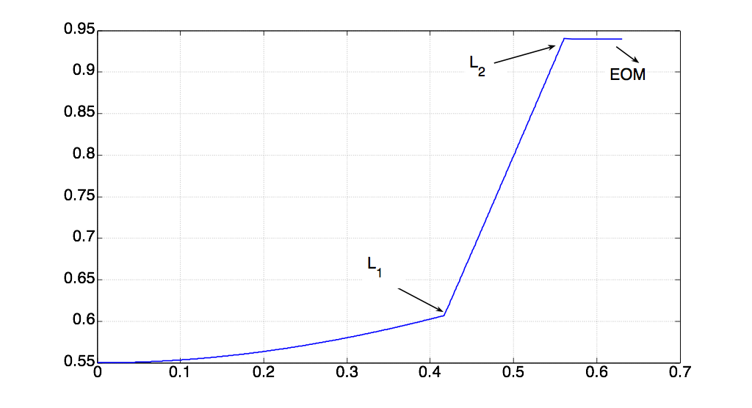
Figure 5: Beam propagation from PSL to EOM

Mode Matching from EOM to MC
A two element mode matching solution similar to the one used for EOM matching is proposed for MC mode matching. Since the beam path in IMC is such that the beam after transmitting through MC1 goes to MC₂ first, the effective beam waist of the MC is located at a conjugate location to the IMC waist inside the MC. This conjugate beam waist is located before MC1 such that the optical path length from the MC1 to this point is equal to the path length from MC1 to the MC waist (midway between MC1 and MC3 HR sides). However, longer focal lengths are used to reduce the sensitivity to mode matching due to positioning and ROC errors. The distances are selected in such a way that industry-standard lenses are used. The parameters of the mode cleaner mode matching telescope (MCMMT) are given in Table 7. The beam size propagation from the waist inside the EOM to IMC conjugate beam waist location is shown in Fig. 6.
Table 7: Parameters for MCMMT
Definition | Unit | Straight(Folded)
w₂ = Waist Size in EOM | mm | 0.930
d₁= Distance b/w EOM waist and MCMMT₁ | mm | 319.5
F₁ = MCMMT₁ Focal length | mm | -459.5
Part No. for MCMMT₁ |  | PLCC-50.8-206.6-UV
d₂= Distance b/w MCMMT₂ and MCMMT₃ | mm | 750 (754)
F₂ = MCMMT₂ Focal length | mm | 1145.6
Part No. for MCMMT₂ |  | PLCX-50.8-515.1-UV
d₃= Distance b/w MCMMT₂ and IMC Waist | m | 9.75(9.284)

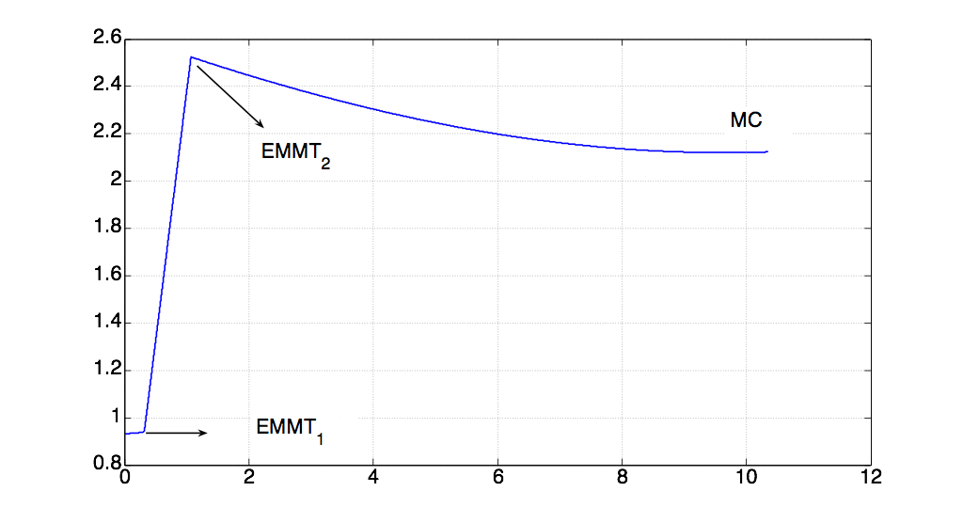
MCMMT₂
MCMMT₁
.Figure 6: Beam propagation from EOM to MC

MC – IFO mode matching
The input mode cleaner waist defines the mode in the IO section. This mode is different than the mode required by the recycling cavities. Therefore, a mode matching telescope is required between MC and PRM. We adopt a two mirror design. The specifications of the mirrors are given in Table 8.
Table 8: Mirror specifications for MC mirrors and PMMT Mirrors

Mode matching measurement
The IOO’s responsibility is to provide a beam at the PRM interface that matches the ROC and the beam size for the IFO assuming as-installed ROCs, 20W input power and nominal absorption in the test mass coatings. Mode matching measurements are done through beam size measurements at various ports to ensure proper mode matching. The summary is that the beam size at PRM is relayed to the IOT table which ensures that the right beam size is delivered to PRM. The beam size at SM2 (now IM4) mirror for the forward going beam and beam reflected from PRM is relayed also to the IOT for table where GigE camera measures the beam size. When the ROC matches, the two beam size will be identical.
The mode matching diagnostics will use the following components.
Table 9: Mode Matching Diagnostic Sensors
Sensor | Type | Function | Purpose | Virtual Location | Relationship with Monitored value
BSS1 | GigeCCD | Beam Size monitoring | MC Beam Size | SM1 Transmitted | Almost same as MC beam waist
BSS2 | GigeCCD | Beam Size monitoring | PRM Beam Size | SM2 Transmitted (forward) | Conjugate PRM beam size
BSS3 | GigeCCD | Beam Size monitoring | SM2 Beam size | SM2 Transmitted (forward) | Indirect ROC matching
BSS4 | GigeCCD | Beam Size monitoring | PRM reflected | SM2 Transmitted (backward) | Indirect ROC matching

Adaptive mode matching
In the IOO, the main mode mismatch may occur due to wavefront ROC errors. The accumulative Gouy phase between IMC waist and PRM is around 20 degree. Thus any ROC error will mainly change the ROC of the beam at PRM. The main ROC error sources could be MC substrate thermal lensing and FI thermal lensing. A passive compensation consisting of negative dn/dT material (DKDP) is present. The IMC thermal lens will be astigmatic. We are developing adaptive optical elements (SF57 based) that can provide some degree of freedom for ROC correction. These adaptive optical elements can provide thermal compensation using four electrical heaters thus enabling astigmatic correction. Two places between IMC and the PRM have been reserved for these elements but none will be installed unless mode-matching requires it. The details of the installation and commissioning of adaptive mode matching element are summarized in the supporting documents.,
Optics ROC (m) Beam Size (mm) Sag (µm) ROC Tolerance in % and mm Tol. Sag (nm)
Straight Folded Straight Folded Straight Folded Both (%) Straight (mm) Folded (mm) Straight Folded
MC1 Inf Inf 2.1 2.2 0.00 0.00 0.1 80E6 80E6 0.03 0.03
MC2 27.24 28.54 3.4 3.5 0.21 0.21 0.5 136.0 143.0 0.4 0.4
MC3 Inf Inf 2.1 2.2 0.00 0.00 0.1 80E6 80E6 0.03 0.03
PMMT1 12.80 6.70 2.2 2.2 0.18 0.36 1 128.0 67 1.8 3.5
PMMT2 -6.24 -3.18 1.8 1.4 -0.26 -0.33 1 -62.4 -31.6 -2.6 -3.2

Alignment
The alignment is described in LIGO-T0900267-v2 Alignment for the Input Optics. Three types of active sensors will be used for monitoring the alignment status of the IO.
- Optical Levers (provided by AOS) are used for each HAM table
- BOSEMs are used on each triple suspension used for each IMC-mirror
- OSEMs are used on each small suspended optic: SM1, SM2, PMMT1, PMMT2
- Quadrant photodiodes (QPDs) on IOT tables outside the chambers to provide references for beams leaving the chambers.
- GigE video cameras will be used to monitor the alignment and the beam size.

Optical Levers
The angular alignment of each HAM table will be controlled by one optical lever for each table. The optical lever signals after the first successful lock of the IMC will be recorded to realign the HAM tables after loss of lock or to maintain alignment of the HAM tables over long time scales.

BOSEMs
The position of all three mode cleaner mirrors (IMC1, IMC2, and IMC3) with respect to their frames and consequently with respect to the HAM table will be sensed by BOSEMs on the triple suspensions. The BOSEM signals after the first successful lock of the IMC will be recorded. After loss of lock, the recorded signals will be used to realign all mode cleaner mirrors into their initial position for lock acquisition.

QPDs
QPDs will be placed outside the vacuum chambers on IOT tables on both sides of HAM2. An additional QPD will be placed on one of the viewports on HAM3. The QPDs will be used to provide an absolute reference for the beam position for transmitted and/or reflected beams from specific IO mirrors. Once the initial IO alignment has been completed and verified to be adequate based on IO power throughput and noise requirements beam and mode changes in the IO can be tracked by these sensors.

GigE video camera
GigE video cameras located on tables and platforms outside of the vacuum system will be also be used to monitor the alignment and the beam size. In direct imaging mode, beams will be directed into cameras and the beam location and profile measured.
In indirect imaging mode, cameras located on viewports outside the vacuum system will view the front surfaces of the mirrors. The use of framegrabber cards together with image processing algorithms will allow for image digitization and beam position and beam size measurements.

Fixtures
The procedures for installing the IO optics into HAMs 2 and 3 will follow those developed for installing the Faraday Isolator of enhanced LIGO. Class B fixtures will be designed and manufactured for each major component. (See list below and Figures 7-10.)
- The Installation plan is described in T1000097.
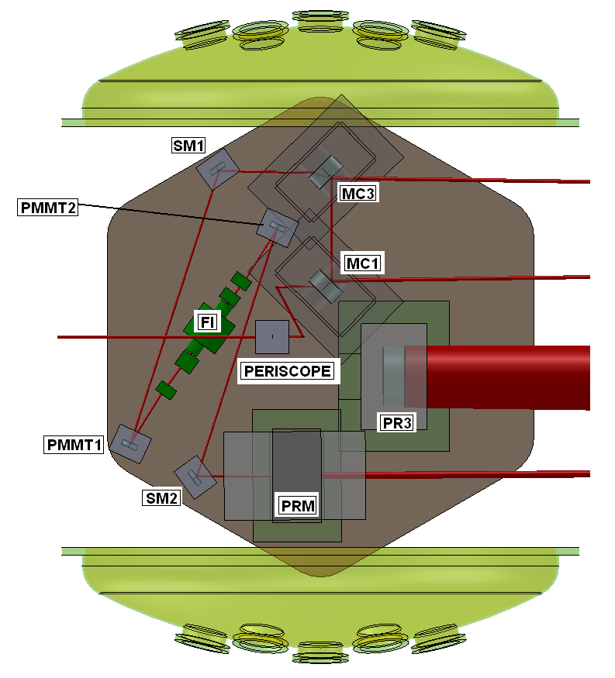
Figure 7. Ham 2 with its components.
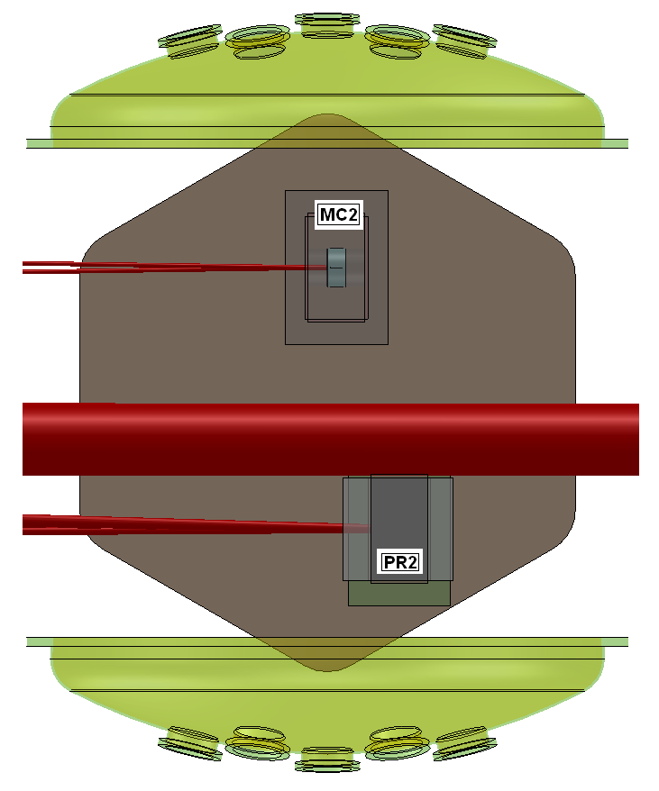
Figure 8. Ham 3 with its components.
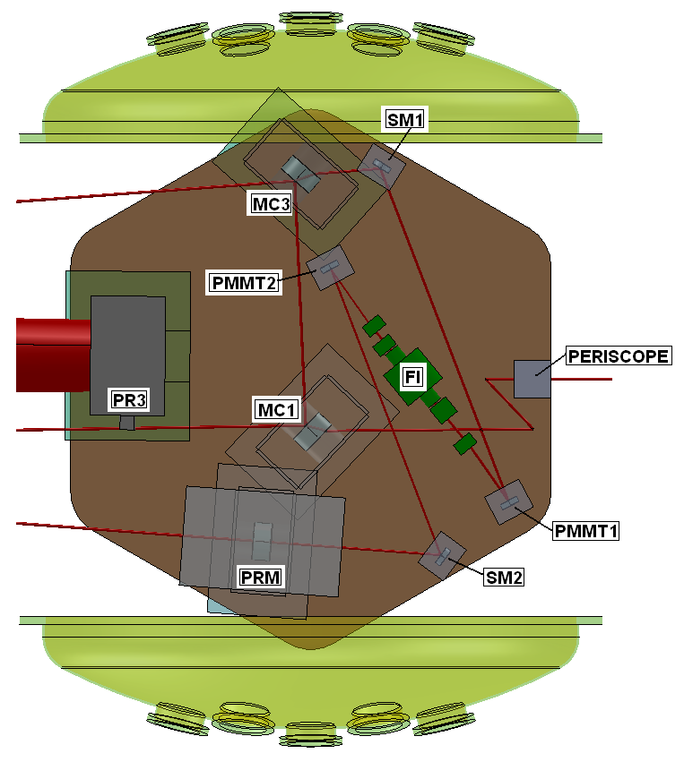
Figure 9 Ham 8 with its components.
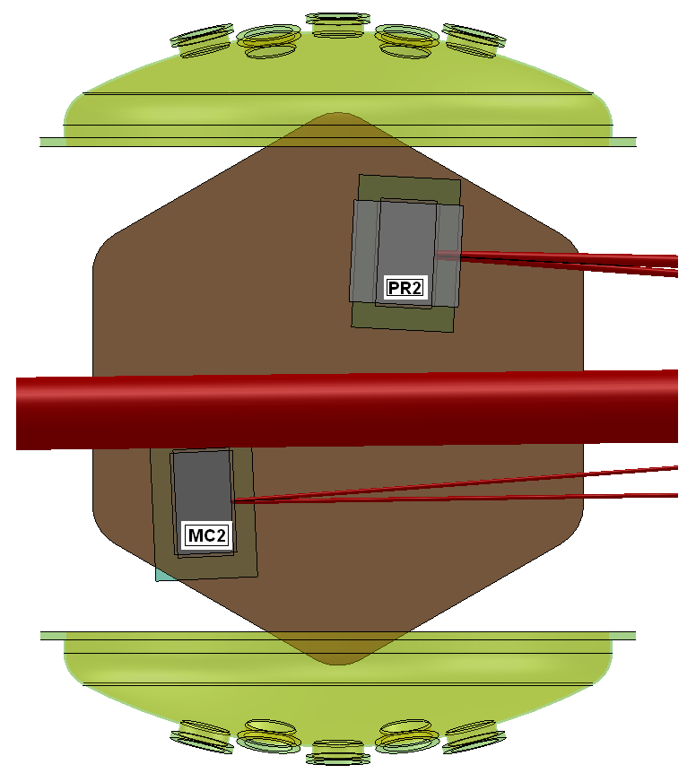
Figure 10. Ham 9 with its components.

Major subassemblies (Faraday isolator, HAM periscope, and all suspended optics) will be prepared in the optics lab or vacuum prep lab, aligned there, and placed into the detector as a unit. Other units (non-suspended steering mirrors) will be placed in position individually.

Mechanical installation
The fixtures will index the assembly (suspension or breadboard) to the holes on the table, which are believed to be good to +\- 50 ∝m (0.002 inch) A complete Solidworks model of the IO exists, and this will be used to determine the position of the part on its table. Errors in the fixtures themselves will be also +\- 50 ∝m (0.002 inch), assuming good shop practices, making the cumulative error ~+\- 75 ∝m (0.003 inch). Chamber separation is known to +/-1 mm, based on the properties of the initial LIGO mode cleaner.
The fixtures will be in essence L-shaped brackets with circular or spherical bosses, touching the part at two points along one edge and at one point along a perpendicular edge. These three touches will set the translational and angular position of the part. They will have clearance holes for bolting to the table with ¼-20 class B shoulder bolts. The clearance holes in the fixture will be reamed to have close- tolerance fits on the shaft of the shoulder bolt.
These fixtures are simple and can be manufactured in-house at Florida, so costs will not be large. They will be cleaned and baked to class B standards.
Figure 11 shows the fixture designed for the enhanced LIGO Faraday Isolator breadboard in HAM1.
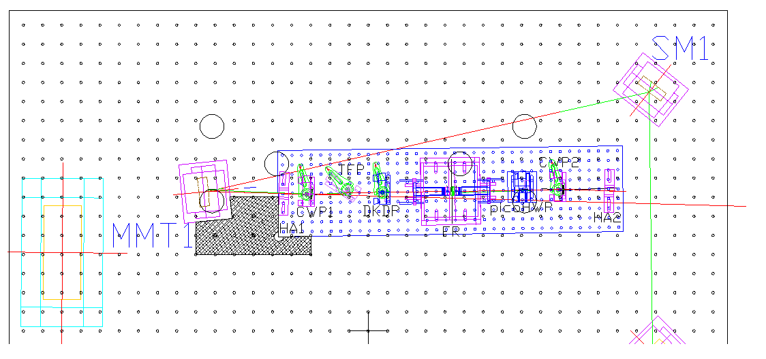
Figure 11. Fixture for installing the eLIGO Faraday isolator.

The fixtures will be different for the straight and folded interferometers. Fixtures will be made for the following assemblies. (The order in the list is the tentative order of installation in the straight interferometer.)
- Faraday isolator
- Input beam periscope
- PR3
- MC1
- PMMT2
- MC3
- PRM
- SM2
- PMMT1
- SM1
- MC2
- PR2

Mechanical alignment
IO will produce a set of pushers that will allow assemblies to be moved on the table. A drawing is in Fig. 12. Two pushers acting together will translate the part parallel to its edge, and pushing on two sides will allow any specific translation to be accomplished. The 40-tpi pitch means that a 12 degree rotation of the actuator moves the part by 20 ∝m.

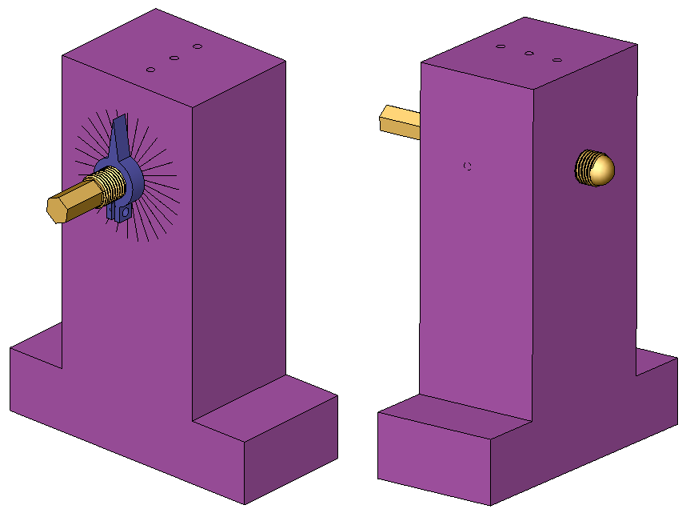
Figure 12. Device for moving assemblies on the HAM table.
To rotate the assembly, a set of goniometer wings (eDrawing at D0902361) will force the rotation to be about the center of the HR surface. A 12 degree turn of the actuator will give ~100 ∝rad rotations of an IMC suspension, given the dimensions of the base of an IMC triple suspension.

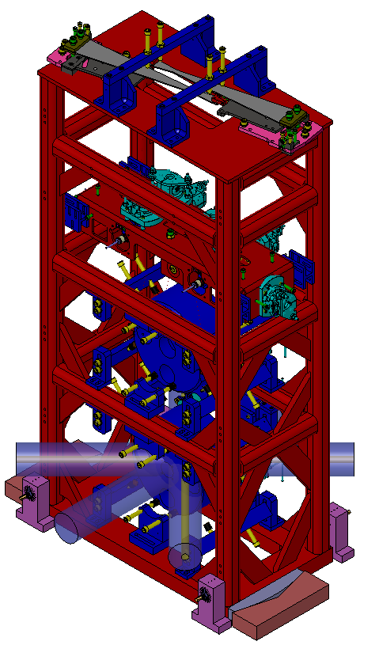
Figure 13. Pushers and goniometer wings in place against a MC triple suspension.

These designs were taken from the CVI Laser catalog. CVI has confirmed that they can polish user-supplied blanks
Muzammil A. Arain, Luke F. Williams, Guido Mueller, and David H. Reitze, “Pre-Mode Matching Telescope Parameters, Adaptive Mode matching and Diagnostics,” LIGO- T0900407 available at: https://dcc.ligo.org/cgi-bin/private/DocDB/ShowDocument?docid=6003.
Muzammil A. Arain et al., “Adaptive control of modal properties of optical beams using photothermal effects,” Manuscript in preparation, LIGO DCC document LIGO-P0900116.

