Advanced LIGO Single-Stage HAM Vibration Isolation Table
Assembly Procedure
Document Number: E070154-v1

This procedure is intended to supplement the assembly drawings.
In nearly every instance, screws in this system will have vented washers. Some exceptions are the Actuator pivot screws and the mounting brackets on the Stage 0 side.
When threading screws into parts, make sure you are not inserting a bare stainless steel male thread into a bare stainless steel female thread. In most instances (e.g., plain stainless screws into Nitronic 60 Heli-Coils), the two materials are suitably dissimilar to prevent galling. However, the original design calls out some bolted interfaces where plain stainless screws thread into, e.g., plain stainless Gang Barrel Nuts. If not corrected, these interfaces gall, destroying the threads. (This is corrected in later revisions of the assembly.)
Before bolting parts together, always make sure there is no dust or debris in the interface.

Chapter 0 – Pre-Conditions 13
Chapter 1 – Stage 0 Assembly 13
Chapter 2 – Stage 1 Assembly 30
Chapter 3 – Hang Stage 1 from Stage 0 79
Appendix A – Torque Table 178
Appendix B – Part Thumbnails 179
Appendix C – Tools Required 195

Figure 1.1. Fully assembled Test Stand, with Support Tubes and Riser Assemblies. Note: this procedure assumes the Riser Assemblies will be mounted to the Support Tubes. It is possible to build the HAM ISI without the Riser Assemblies, without making significant changes to this procedure. 13
Figure 1.2. The Assembly Stand, which provides a platform for building up Stage 0 and Stage 1, before final integration on the Test Stand. 14
Figure 1.3. Stage 0 Base resting on Assembly Stand. Note orientation of (3) pockets for Spring Pull-Down tooling. 15
Figure 1.4. Back edge of Stage 0 Base should be close to back edge of Assembly Stand. 15
Figure 1.5. Press (2) dowel pins into the top surface of each Support Post. 16
Figure 1.6. The pins must not stick into the Gang Barrel Nut holes. 17
Figure 1.7. First step for installing Stiffener Assembly: hang vertical plates (D071006) from Stage 0 Base. The widest plates (-00) should hang from the middle 3 rows. The next widest (-01) should hang on either side of the -00 plates. Finally, the smallest (-02) should hang from the last row on either side. 18
Figure 1.8. Next, place the smaller horizontal plate (D071007-01) underneath one of the -02 vertical plates. After snugging all of the screws for this plate, torque the side screws to their final spec. 19
Figure 1.9. After both of the outer -01 horizontal plates are secured, install one of the inner -01 horizontal plates. Snug all of the screws for this plate, then torque the side bolts to final spec. 20
Figure 1.10. After both of the inner -01 horizontal plates are secured, the center -00 horizontal plate. Snug the bolts, but do not torque, yet. 21
Figure 1.11. Bolt End Caps to both ends of the Stiffener Assembly. Leave top bolts turned back 1/4 turn, then snug all side bolts. 22
Figure 1.12. Torque top Stiffener Assembly bolts to final spec. Start from the middle column, and work toward the ends. After tightening a column on one side, tighten the same column on the opposite side. 23
Figure 1.13. Torque bottom Stiffener Assembly bolts to final spec. Start from the middle row, and work toward the ends. After tightening a row on one side, tighten the same row on the opposite side. 23
Figure 1.14. Torque side End Cap screws to final spec. Start in the middle, and work toward the edges. Exact order of tightening is not important. 24
Figure 1.15. Using crane, lower Support Posts onto Stage 0 Base. Allow pins in Base to seat properly into the hole/slot combinations underneath the Posts. 25
Figure 1.16. This view shows the correct orientation of the (3) Support Posts on the Stage 0 Base. 25
Figure 1.17. (2) Gang Barrel Nuts are inserted into each of the (3) Support Posts. The 1/2”-13 holes should line up with the thru holes in the Stage 0 Base. Thread in all the screws from underneath, and torque to final spec. 26
Figure 1.18. Support Post Caps placed on the Support Posts. Later, the Springs will be mounted on top of the Caps. 27
Figure 1.19. Place (3) Main and (3) Auxiliary Support Post Gussets against the sides of the Support Posts. Orient as shown in this image. 28
Figure 1.20. Transparent view of a Support Post, showing Gang Barrel Nuts with screws engaged. Note that Barrel Nuts are recessed deeply within the Posts’ holes, so it may be difficult to position them properly. 28
Figure 1.21. Transparent view of Support Post Gussets, showing Gang Barrel Nuts with screws engaged. 29
Figure 1.22. Stage 0 Assembly mounted to the Test Stand. 30
Figure 2.1. Stage 1 Floor resting on the Assembly Stand, for initial stage build-up. This orientation allows good access to the Boxwork mounting screws. 31
Figure 2.2. Side view of Stage 1 Floor on Assembly Stand. 31
Figure 2.3. Dowel pin pressed into side of Radial Rib (D071068). Pin should sit .25” proud of surface. 32
Figure 2.4. Dowel pins pressed into side of Radial Rib (D071069). Heli-Coils are installed from the same side as the pins are pressed. 33
Figure 2.5. Dowel pins pressed into side of Tangential Rib (D071070). 34
Figure 2.6. Dowel pins pressed into one side of Tangential Rib (D071052). 34
Figure 2.7. Dowel pins pressed into opposite side of Tangential Rib (D071052). 35
Figure 2.8. Dowel pins pressed into side of Tangential Rib (D071053). 35
Figure 2.9. Dowel pins pressed into Keel Wall (D071063). Note orientation of counterbores on side mounting holes. 36
Figure 2.10. Dowel pins and fixturing bolts on the Outer Walls, Small Panel. 37
Figure 2.11. Dowel pins pressed into bottom of Kinematic Lock Base. 38
Figure 2.12. Dowel pins pressed into top of Locker Base. 38
Figure 2.13. Kinematic Lock Housing bolted onto Locker Base. 39
Figure 2.14. Locker Sleeve is inserted in the Kinematic Lock Housing. Run the Sleeve’s thread into the internal thread in back of Housing. 40
Figure 2.15. Retaining ring in groove on back of Locker Sleeve. 41
Figure 2.16. Spherical Pin being inserted into Locker Sleeve. 41
Figure 2.17. Engage two sides of the Locker Assembly by laying Spherical Pin in Kinematic Lock Base. Note the orientation of Locker Sleeve with respect to the Base. 42
Figure 2.18. Kinematic Lock Caps clamped over the ends of the Spherical Pin. 43
Figure 2.19. After tightening the screws for the Caps, there will still be some clearance between the Base and each Cap. Ideally, the gap on either side of a Cap should be equal, though this is not essential. 44
Figure 2.20. Locker Assembly in (a) “unlocked” and (b) “locked” positions. To lock the assembly, turn the knurled end of the Locker Sleeve counterclockwise, until the retaining ring comes against the back of the Locker Housing. 44
Figure 2.21. Step 1 of Boxwork Assembly. Radial Ribs are placed against Mid-Tangential Ribs. 45
Figure 2.22. Preferred orientation of Barrel Nuts. Flat side should always face away from the screw, to minimize stress concentrations. Virtual leaks are not a concern here. 46
Figure 2.23. Partial assembly of Boxwork, showing screws threaded into Barrel Nuts. 46
Figure 2.24. Step 2 of Boxwork Assembly. Center-Tangential Rib is placed against the Radial Ribs. 47
Figure 2.25. Partial assembly of Boxwork, showing screws threaded into Barrel Nuts. Center-Tangential Rib is shown transparent, here. 48
Figure 2.26. Boxwork Assembly screws should be tightened in the order shown here. 48
Figure 2.27. A top view of the Boxwork Assembly, showing (2) 60 Deg Rib Brackets screwed to the sides of the Radial Ribs. Note the orientation of the Brackets. 49
Figure 2.28. 90 Deg Outer Wall Brackets mounted to Boxwork Assembly. The screws for both sets of Brackets are not torqued until later in the assembly of Stage 1. 50
Figure 2.29. Dowel pins pressed into bottom of Boxwork Assembly. After this step, the Boxworks are ready for installation in Stage 1. 50
Figure 2.30. Step 1 of Pitchfork Assembly. The Mid-Radial Rib is seated against the Mid-Tangential Rib. Note location of lower dowel pin hole in Mid-Radial Rib. 51
Figure 2.31. Preferred orientation of Barrel Nuts. Flat side should always face away from the screw, to minimize stress concentrations. 52
Figure 2.32. Partial assembly of Pitchfork. Screws should be torqued to final spec, before continuing. 52
Figure 2.33. Step 2 of Pitchfork Assembly. Center-Tangential Rib is pressed against back end of Mid-Radial Rib. 53
Figure 2.34. Bolt Center-Tangential Rib to Mid-Radial Rib, using Type 00 Barrel Nuts. Torque to final spec. 54
Figure 2.35. Step 3 of Pitchfork Assembly. GS-13 Out 2 Rib mates with dowel pins on back of Mid-Tangential Rib. Note orientation of bottom dowel pin hole in GS-13 Out 2 Rib. 54
Figure 2.36. Bolt GS-13 Out 2 Rib to Mid-Tangential Rib, using Type 01 Barrel Nuts. Torque to final spec. 55
Figure 2.37. Step 4 of Pitchfork Assembly. GS-13 Out 1 Rib mates with Mid-Tangential Rib. Check orientation of Ribs. 55
Figure 2.38. Bolt GS-13 Out 1 Rib to Mid-Tangential Rib, using Type 01 Barrel Nuts. Torque to final spec. 56
Figure 2.39. 90 Deg Outer Wall Bracket mounted to Pitchfork Assembly. The screws for the Bracket are not torqued until later in the assembly of Stage 1. 57
Figure 2.40. Dowel pins pressed into bottom of Pitchfork Assembly. After this step, the Pitchforks are ready for installation in Stage 1. 57
Figure 2.41. Boxworks placed on top surface of Stage 1 Floor. 58
Figure 2.42. Type 00 (length = 3/4”) Barrel Nuts are used in the Center-Tangential Rib. Type 01 (length = 1”) Barrel Nuts are used in the Radial and Mid-Tangential Ribs. 59
Figure 2.43. Snug (102) screws into Boxwork Barrel Nuts, from underneath Stage 1 Floor. 60
Figure 2.44. Stage 1 Floor must be rotated 60 degrees, to allow access for the Pitchfork Assembly mounting screws. 60
Figure 2.45. (3) Flexure Posts are installed on the Stage 1 Floor. Note the orientation of the flats on the side of the Post. 61
Figure 2.46. Insert screws into bottom of Flexure Posts. 61
Figure 2.47. Install (3) Tangential Flexure Post Brackets. Insert screws in the order shown here, to reduce difficulty accessing the side screws. 62
Figure 2.48. Install (3) Radial Flexure Post Brackets. Insert the screws highlighted here. 63
Figure 2.49. View of last Pitchfork Assembly being lowered onto Stage 1. When doing this, watch for interference between the Mid-Tangential Rib and the 60 Deg Rib Brackets on either side. Also, remember there are (4) dowel pins locating the Pitchfork plates to the Stage 1 Floor. 64
Figure 2.50. Top view of Stage 1 Frame, with Pitchforks and Boxworks in place. 64
Figure 2.51. Type 00 (length = 3/4”) Barrel Nuts are used in the Mid-Radial and Center-Tangential Ribs. Type 01 (length = 1”) Barrel Nuts are used in the GS-13 Out Radial and Mid-Tangential Ribs. 65
Figure 2.52. Snug (102) screws into Pitchfork Barrel Nuts, from underneath Stage 1 Floor. 66
Figure 2.53. Start screws in all (6) 60 Deg Rib Brackets. 67
Figure 2.54. Temporarily remove the (3) Tangential Flexure Post Brackets, to provide access for torquing the screws for the 60 Deg Rib Brackets. 67
Figure 2.55. Torque the 60 Deg Rib Bracket screws in the sequence shown here. For each bracket, first torque the (6) screws on the Boxwork side to the final spec, then torque the (7) screws on the Pitchfork side to the final spec. 68
Figure 2.56. The highlighted screws are difficult to access. These likely will require hand tightening to achieve (approximately) the specified torque. 69
Figure 2.57. Rotate Stage 1 Assembly, to the orientation shown here. Note the location of the holes for the Locker Assemblies. 70
Figure 2.58. Bottom view of the Stage 1 Assembly, after rotation. Note the location of the (4) sets of Locker Assembly mounting holes. 70
Figure 2.59. Screws hanging from the Stage 1 Floor. These will be used to clamp the Keel Assembly to the Stage 1 Frame. 71
Figure 2.60. Slip in (4) Type 01 Barrel Nuts through the top holes of the Keel Wall. Note the dowel pins are below the mid-plane. 72
Figure 2.61. Bolt on a single Keel Wall. 73
Figure 2.62. All (6) Keel Walls mounted underneath Stage 1. 73
Figure 2.63. 120 Brackets installed inside the Keel. All screws should be snug, so mating surfaces are all in good contact. 74
Figure 2.64. When torquing the screws for the Keel Walls, use a star-shaped tightening pattern. Note a wrench extension is needed, to allow proper access for the torque wrench. 75
Figure 2.65. Tightening order for the 120 Brackets. The exact order is not important, as long as the tightening is staggered. Start by torquing (3) screws along one side of each Bracket (marked by the red circles), then torque (3) screws on opposite side of each Bracket (pink circles). 75
Figure 2.66. (24) Type 01 Barrel Nuts are placed in the holes lining the bottom of the Keel Walls. 76
Figure 2.67. Keel Base added to the Keel Assembly. 77
Figure 2.68. Locker Assemblies bolted to bottom of Stage 1 Floor. Knurled ends of Locker Sleeves must face outward. 78
Figure 2.69. Pin used to temporarily locate the Locker Assemblies to the Stage 0 Base. The shaft collar prevents the pin from slipping through the clearance hole in the Locker Base. 78
Figure 2.70. Slip (8) pins into the 1/2” holes in the Locker Bases. The shaft collar sits on the surface above the hole counterbore. 79
Figure 3.1. Press dowel pins into Small Panel Outer Wall. Note that counterbores all face same direction as pins. 80
Figure 3.2. Clamp hex head screws to Wall, using hex jam nut. Threaded portion should point in same direction as protruding dowel pins. 80
Figure 3.3. Flexure Mount in Flexure Lower Plate. Relative angle between these parts is not important. 81
Figure 3.4. Tighten nut against the Flexure Mount. Make sure that the hex flange on the Flexure Mount seats firmly against the bottom surface of the Flexure Lower Plate. 82
Figure 3.5. Insert Flexure. 82
Figure 3.6. The Flexure Cups must sit flush inside the Flexure Mount. Next, we will seat the Flexure within the Flexure Cups. These are the most critical joints in the entire assembly! 83
Figure 3.7. Shaft collar must be placed over the end of the Flexure Mount. Its orientation does not matter. Do not tighten the screws, yet. 84
Figure 3.8. The heads of the shaft collar screws must be turned down, so the bottom of the Flexure Assembly can fit inside the Flexure Post. 84
Figure 3.9. Seat the Flexure within the Flexure Mount, then apply a small amount of clamping force from the shaft collar. 85
Figure 3.10. Carefully tap the Flexure into the Flexure Mount, to improve seating. 86
Figure 3.11. The top of the Flexure Assembly will be installed after Stage 1 is placed on Stage 0. 86
Figure 3.12. Press (2) pins into Set-Up Fixture Base Plate. 87
Figure 3.13. Bolt on Set-Up Fixture Side Plate. 88
Figure 3.14. Actuator Magnet Mount with Captive Screws and dowel pins installed. 89
Figure 3.15. (4) shoulder screws are included when the Actuator is shipped, to “lock” the Bobbin to the Field Assembly. Make sure these are tight before proceeding with the rest of the assembly. 90
Figure 3.16. Carefully press (2) pins into the Bobbin. Note these pins go into the side opposite the Field Assembly dowel pins (see next step). 90
Figure 3.17. Press (2) pins into the Field Assembly. 91
Figure 3.18. Bolt Coil Support to Actuator Bobbin. Set orientation as shown above, using locations of Bobbin terminal block and (2) counterbores in Coil Support for reference. Make sure pins in Bobbin mate properly with hole and slot in Coil Support. 92
Figure 3.19. Bolt on (2) Thermal Bars. Surfaces must make good contact to properly pull heat out of Bobbin. 93
Figure 3.20. Actuator Magnet Mount bolted to Field Assembly. Note (2) counterbores in Coil Support face in same direction as tab on Magnet Mount. 94
Figure 3.21. Remove the (2) lower shipping screws. 94
Figure 3.22. Install Actuator in Set-Up Fixture. Now, Field Assembly is fixed to Fixture. Location of Bobbin has not yet been defined. 95
Figure 3.23. Upper (2) shipping screws are removed. Now, the Bobbin is loosely held to the Set-Up Fixture. You may want to insert a Teflon shim between the lower magnets and the Bobbin, to prevent hard contact. 96
Figure 3.24. Install (2) alignment pins, then tighten Coil Support to Fixture. Now, location of Bobbin relative to Field Assembly is fully defined. 96
Figure 3.25. Install Setup Bar. Setup Bar is used to lock Bobbin position relative to Field Assembly, until Actuator is installed in HAM ISI. 97
Figure 3.26. Actuator after removal from Set-Up Fixture. 97
Figure 3.27. Actuator Stops installed. These help prevent “crashes” of Bobbin into magnets during HAM ISI operation. 98
Figure 3.28. Actuator L-Bracket, with screw and washers. Two of these mount to Coil Support on Horizontal Actuator. Spherical washers and loose thru holes compensate for machining and assembly tolerances, when Actuators are installed in HAM ISI. 99
Figure 3.29. Horizontal Actuator, ready for installation in HAM ISI. 99
Figure 3.30. Actuator U-Bracket, with screw and washers (refer to Figure 3.28 for more detail). Two of these mount to Coil Support on Vertical Actuator. Spherical washers and loose thru holes compensate for machining and assembly tolerances, when Actuators are installed in HAM ISI. 100
Figure 3.31. Vertical Actuator, ready for installation in HAM ISI. 101
Figure 3.32. Press fit Target Post into Target Body, until the face on the bottom of the Post is flush with the bottom face of the Body. 102
Figure 3.33. Screw Sensor Target to top of Sensor Target Body. This is the Position Sensor Target Face Assembly (D071462). 103
Figure 3.34. Use shaft collar to clamp Sensor Target Face Assembly to Sensor Target Mount. 103
Figure 3.35. Completed Position Sensor Target Assembly. 104
Figure 3.36. Exploded view of sensor spherical mount. This is a sub-assembly of the Position Sensor Assembly (D071464). 105
Figure 3.37. Assembled spherical mount. Roughly align Base to Mount, so sides are parallel to one another. Tighten jam nut until assembly is rigid. 105
Figure 3.38. Add Standoff and Base Plate, to complete Horizontal Position Sensor Assembly (accept for sensor). 106
Figure 3.39. Vertical Sensor Head Bracket mounted to Sensor Head Mount. 107
Figure 3.40. Add Base Plate, to complete Vertical Position Sensor Assembly (accept for sensor). 107
Figure 3.41. ADE sensor mounted in Horizontal Position Sensor Assembly. Note orientation of sensor cable. 108
Figure 3.42. ADE sensor mounted in Vertical Position Sensor Assembly. Note orientation of sensor cable. 108
Figure 3.43. Close-up view of ADE sensor mounted to Sensor Head Base. Heads of sensor mounting screws stand approximately .020” proud of sensor face. This prevents contact between center of Sensor Target Face and active area on sensor probe. 109
Figure 3.44. GS-13 Pod, Horizontal configuration. Note centered location of connector flange. 110
Figure 3.45. GS-13 Pod, Vertical configuration. Note offset location of connector flange. 110
Figure 3.46. Adapter Plate bolted onto GS-13 Baseplate. Tapped holes are blind, so vented screws must be used. 111
Figure 3.47. Stabilizer Assembly resting on back end of GS-13 Pod. 112
Figure 3.48. Thread (2) screws into tapped holes. Do not torque, yet. 113
Figure 3.49. Insert screw through Stabilizer and Pod. Fasten onto Pod with hex lock-nut. 114
Figure 3.50. Add Captive Screws to Adapter Plate. These are used later, during installation of GS-13’s into Stage 1. 115
Figure 3.51. After drilling a hole through the ACME Screw and nut, press in the spring pin. The pin transfers torque from the nut to the Screw. 116
Figure 3.52. Press (2) dowel pins into Spring Pull-Down Cap. 117
Figure 3.53. Pull-Down Nut bolted onto Pull-Down Base. 118
Figure 3.54. Combination bearing (radial + thrust) must be pressed into the Pull-Down Bar. Make sure the force of the press is applied evenly over the bearing’s top surface, and that the bearing seats properly within the Bar. 118
Figure 3.55. The parts should look like this, after the press. 119
Figure 3.56. Conversion Bushing sitting inside the bearing. 119
Figure 3.57. The retaining ring and Offset Washer prevent the Conversion Bushing from sliding out of the bearing. 120
Figure 3.58. ACME Screw placed through the Conversion Bushing. The shaft collar locks the Screw to the Pull-Down Bar. 121
Figure 3.59. Pull-Down Nut threaded onto end of ACME Screw. The bottom part of the Spring Pull-Down Assembly is complete. 121
Figure 3.60. Thread the jam nut onto the end of the Pull Rod with 2” of thread. 122
Figure 3.61. The rod end should be fully engaged, minus a 1/2-turn. 123
Figure 3.62. Torque the jam nut against the rod end. 123
Figure 3.63. Place one retaining ring on each pivot pin now. After inserting through the rod ends, the other end of each pin will get a ring. 124
Figure 3.64. Pivot pins are pushed through the Pull-Down Cap, passing through the rod ends and spacers. 125
Figure 3.65. After the retaining rings are clamped on, the top part of the Spring Pull-Down Assembly is complete. Set aside for later use. 125
Figure 3.66. Slider-Stops mounted to bottom face of Install Base. 126
Figure 3.67. Right rail mounted to Install Base. 127
Figure 3.68. Attach Standoff to outside of Left Rail, using top row of screws. 127
Figure 3.69. Use GS-13 Installation Tool to support Horizontal GS-13’s inside Stage 1. No special tool is needed for Vertical GS-13’s. 128
Figure 3.70. Stage 1 positioned over Stage 0 (lifting straps and crane not shown). 129
Figure 3.71. The (3) Support Posts stick through cut-outs in the Stage 1 Floor. When lowering Stage 1 into place, take care to maintain some clearance around each Post. 130
Figure 3.72. Lower Stage 1 close to its final position, but leave enough space between the Lockers and Stage 0 to slip in .125” Shims. 130
Figure 3.73. As Stage 1 is lowered, try to engage the temporary pins from the Lockers in the mating holes in Stage 0. Stage 1 will not be parallel to Stage 0 while it’s hanging from the crane, so start with the lowest Locker. It may not be possible to engage all (8) pins, depending on tolerance stack-up. 131
Figure 3.74. Slide (8) .125” Shims underneath the Locker Bases. Make sure the Shims slide around the bosses on the bottom of the Locker Bases. 132
Figure 3.75. Two of the Shims must be inserted “backwards”, or they will interfere with the Wiring Breadboards, which are installed later. 132
Figure 3.76. Snug the screws holding the Locker Bases to the Stage 0 Base. 133
Figure 3.77. Remove (8) pins from the Locker Assemblies, before torquing the mounting screws to final spec. 134
Figure 3.78. Slide (2) large Gang Barrel Nuts into each Support Post. These will capture the mounting screws for the Springs. 135
Figure 3.79. A Spring positioned on a Support Post. 135
Figure 3.80. High-strength Alloy A286 hex bolts hold the Springs to the Support Posts (Support Post Caps are sandwiched in between). 136
Figure 3.81. A staggered bolt tightening pattern. Use a similar pattern when torquing the Spring bolts. 137
Figure 3.82. These plastic bushings protect the Stage 1 Floor during assembly and use of the Spring Pull-Down Assemblies. 137
Figure 3.83. The hardware for the top Flexure Mount must go on before the Flexure Assemblies are inserted into the Springs. 138
Figure 3.84. Pass the Flexure through the slot at the end of the Spring. Hold it in place during the next few steps. 139
Figure 3.85. Slip a Flexure Mount over the end of the Flexure, then engage it in the Spring. 139
Figure 3.86. Torque the jam nut against the hex flange on the Flexure Mount. 140
Figure 3.87. Flexure Assemblies temporarily mounted in all (3) Springs. Next, the Springs will be loaded flat. 141
Figure 3.88. The (3) Spring Pull-Down Bases mount inside pockets in the Stage 0 Base. 142
Figure 3.89. Screws holding the bottom of the Spring Pull-Down Tooling to Stage 0. 142
Figure 3.90. Set the starting length for the ACME Screw, leaving 4” between the bottom of the shaft collar and the top of the Pull-Down Base. The Spring Pull-Down Assembly must pull through 3.5” to flatten the Springs. The ACME Screw is not fully engaged in the Pull-Down Nut during the first .5” of travel, but the tension is small over this range. 143
Figure 3.91. Engage the Pull-Down Cap with the end of the Spring. The (2) dowel pins in the Cap should seat in the matching Spring holes. 144
Figure 3.92. Pass the Pull-Down Rods all the way through the holes in the Pull-Down Bar. Note the triangular pocket in the top of the Pull-Down Bar should face to the right – this allows better access for tightening the ACME Screw. 144
Figure 3.93. Hardware for the bottom ends of the Pull-Down Rods. 145
Figure 3.94. Carefully tighten the coupling nuts, so both Pull-Down Rods on each Pull-Down Assembly have the same tension. 146
Figure 3.95. Load the Springs by tightening the ACME Screws. The Springs may be tightened in any order. 147
Figure 3.96. Preparing to clamp the Flexure Assemblies to Stage 0 and Stage 1: start by inserting (2) Flexure Cups into each Flexure Mount. 147
Figure 3.97. Shaft collars will be used to clamp the top of each Flexure to its Flexure Mount. The screw heads must face outward. 148
Figure 3.98. Place a straightedge on the Spring, to check the flatness. 148
Figure 3.99. Slightly over-extend Spring, so Flexure Lower Plate seats fully on Flexure Post. There should be a small (internal) gap between Flexure and Flexure Cups. 149
Figure 3.100. Bolt the Flexure Lower Plates to the Flexure Posts. 150
Figure 3.101. Particle Fences are added to prevent debris from Optical Table surface migrating down into Actuators. 151
Figure 3.102. Orientation of Flexure Mid Cover is not important. 152
Figure 3.103. Barrel Nuts inserted along top of Stage 1 Ribs. Refer to Figure 2.42 and Figure 2.51 for detailed identification of which Nut types match with each Rib. 153
Figure 3.104. Optical Table positioned over Stage 1. There is only one orientation that works: vent grooves in Table running parallel to Support Tube axes, and (3) thru pockets positioned over (3) Spring Pull-Down Assemblies. 154
Figure 3.105. Place shaft collars toward the bottom end of (3) 1/2”x12” long dowel pins. These will help orient the Optical Table to the Stage 1 Ribs. 154
Figure 3.106. Drop (3) long pins through holes in top of Optical Table. These pins will locate to the slots in (3) of the Stage 1 Ribs, as shown in Figure 3.107. 155
Figure 3.107. View from above ISI, with transparent Optical Table. The (3) slots marked with red circles are alignment slots in the Ribs. When lowering the Optical Table, mate the (3) long pins with these slots. 155
Figure 3.108. With Optical Table resting on the Ribs, start (177) screws into the Barrel Nuts. 156
Figure 3.109. Loosen all (3) Spring Pull-Down Assemblies evenly, until the Flexure Assemblies are fully tensioned. 157
Figure 3.110. Torque the shaft collar screws on all (3) Spring/Flexure Assemblies. 158
Figure 3.111. Remove the spherical washers and coupling nuts from under the Spring Pull-Down Bar. 158
Figure 3.112. Pull out the top part of all (3) Spring Pull-Down Assemblies. 159
Figure 3.113. Remove the (6) plastic Bushings from the Stage 1 Floor. 159
Figure 3.114. Pull out the bottom part of the (3) Pull-Down Assemblies, and store with the rest of the Assemblies. 160
Figure 3.115. Mount (3) Spring Hatches to top of Optical Table. 161
Figure 3.116. Populate Barrel Nut holes around entire perimeter of Stage 1 Floor. Flats on Nuts should face away from screw thru holes. 161
Figure 3.117. Populate Barrel Nut along exposed sides of Radial Ribs. Orient Nuts with flats facing away from screw thru holes. 162
Figure 3.117. Cable Restraint holds cable to Adapter Plate on Horizontal GS-13 Assemblies. (Cable not shown here.) 163
Figure 3.118. A special tray (D071496) is used to hold the Horizontal GS-13 in place during installation. 164
Figure 3.119. Horizontal GS-13 mounted to Radial Rib in Pitchfork. The seismometer’s cable should exit from the notch indicated by the arrow. 165
Figure 3.120. Couple the Stabilizer flexure to the other Pitchfork Rib using (1) screw. 166
Figure 3.121. Vertical GS-13 placed on Stage 1 Floor. Note location of cable notch, indicated by arrow. 167
Figure 3.122. Couple the Stabilizer flexure to the Optical Table using (1) screw. 168
Figure 3.123. Attach Horizontal Actuators to Stage 1. Leave Setup Bar in place. 169
Figure 3.124. Attach Vertical Actuators to Stage 1. Leave Setup Bar in place. 170
Figure 3.125. Attach Sensor Targets for Horizontal Sensors. 171
Figure 3.126. Horizontal Sensor Target must be retracted before Sensor Assembly is installed. 171
Figure 3.127. Attach Sensor Targets for Vertical Sensors. 172
Figure 3.128. Vertical Sensor Target must be retracted before Sensor Assembly is installed. 173
Figure 3.129. Attach Horizontal Sensor Probes. 173
Figure 3.130. Attach Vertical Sensor Probes. 174
Figure 3.131. Clip retaining ring into groove on one side of Type 02 Barrel Nut. This is in preparation for setting the Nuts along the tops of the Outer Walls. 174
Figure 3.132. Type 02 Barrel Nuts are clipped into place along the top row of holes in all of the Stage 1 Outer Walls. 175

– Pre-Conditions

Safety

Clean Protocols

– Stage 0 Assembly
- 1.0.1 Prep Work - General
- Build the Test Stand (D070278). Fasten to the floor. Mount (2) Support Tubes (D972610) to the Stand, as shown in Figure 1.1. Bolt a HAM Riser Assembly (D070300) to each Tube. Align the Test Stand to gravity. Torque all screws to final spec.
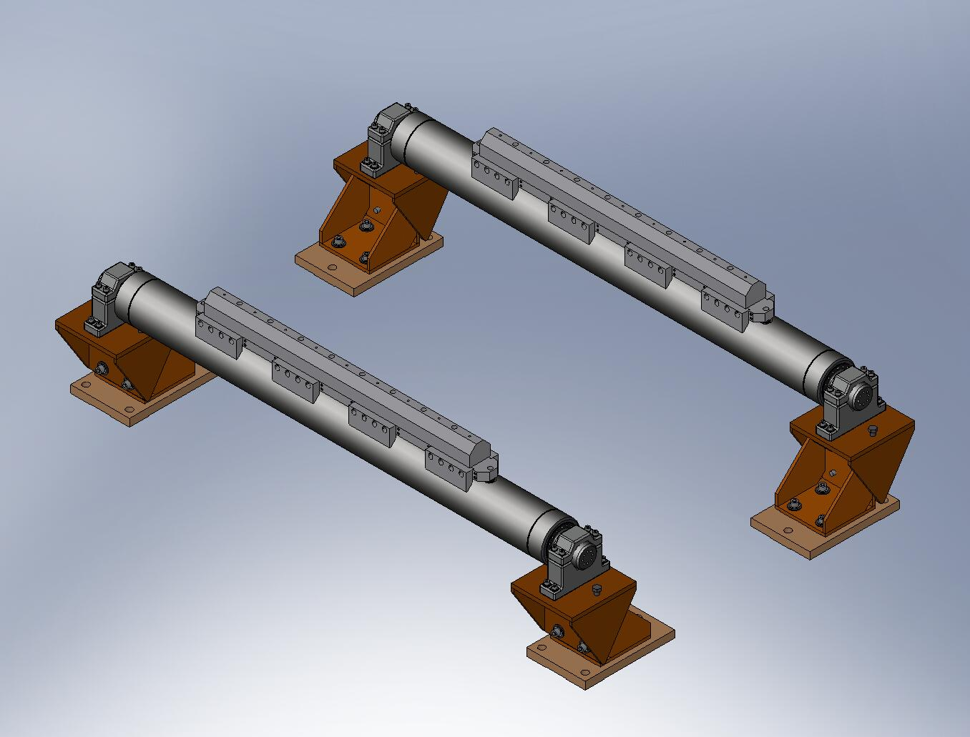
Figure 1.1. Fully assembled Test Stand, with Support Tubes and Riser Assemblies. Note: this procedure assumes the Riser Assemblies will be mounted to the Support Tubes. It is possible to build the HAM ISI without the Riser Assemblies, without making significant changes to this procedure.

- Build the Assembly Stand (D070350). Place it near location of Test Stand. Caution: do not lean on back corners of Assembly Stand, since the frame can rock on its 3 feet!
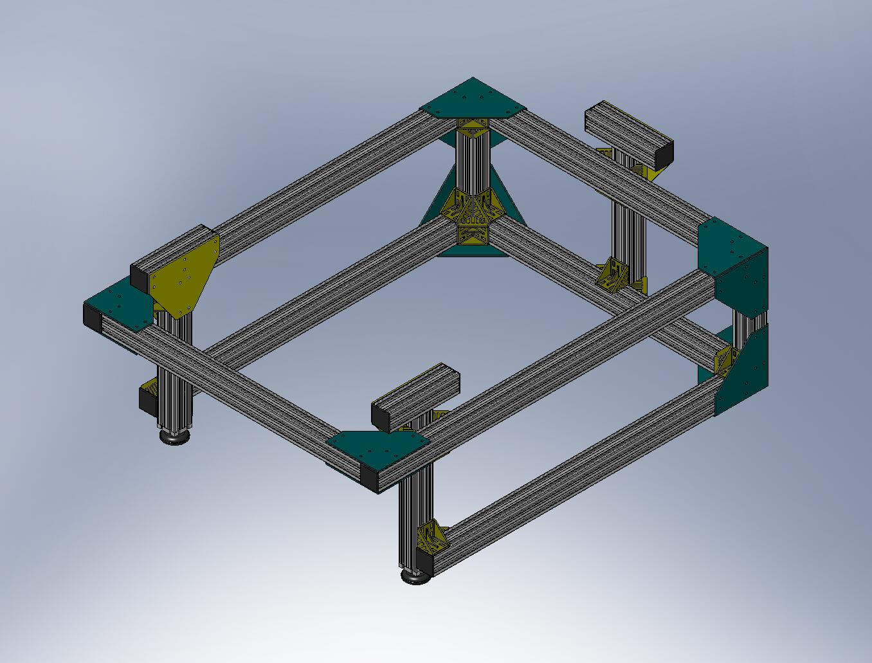
Figure 1.2. The Assembly Stand, which provides a platform for building up Stage 0 and Stage 1, before final integration on the Test Stand.

1.0.2 Prep Work – Stage 0 Base
- Insert Heli-Coils into Stage 0 Base (D071001) for lifting eyes:
  - (3) 3/4”-10x2.0*Dia.
- Pick up the Stage 0 Base, using lifting eyes threaded into the newly installed Heli-Coils, and place it onto Assembly Stand. Orientation should be as shown in Figure 1.3 and Figure 1.4.
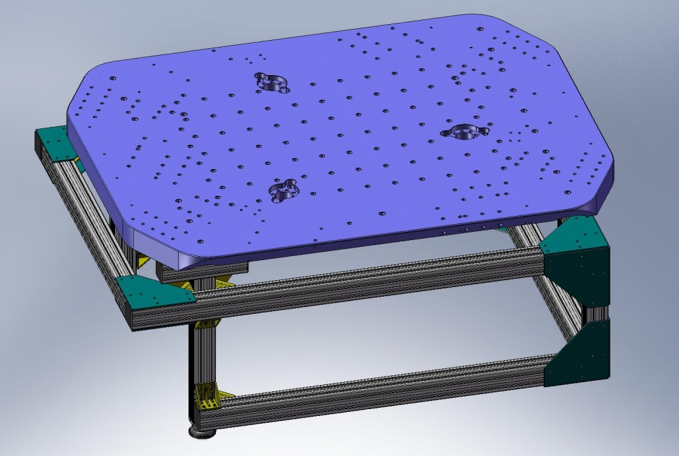
Figure 1.3. Stage 0 Base resting on Assembly Stand. Note orientation of (3) pockets for Spring Pull-Down tooling.

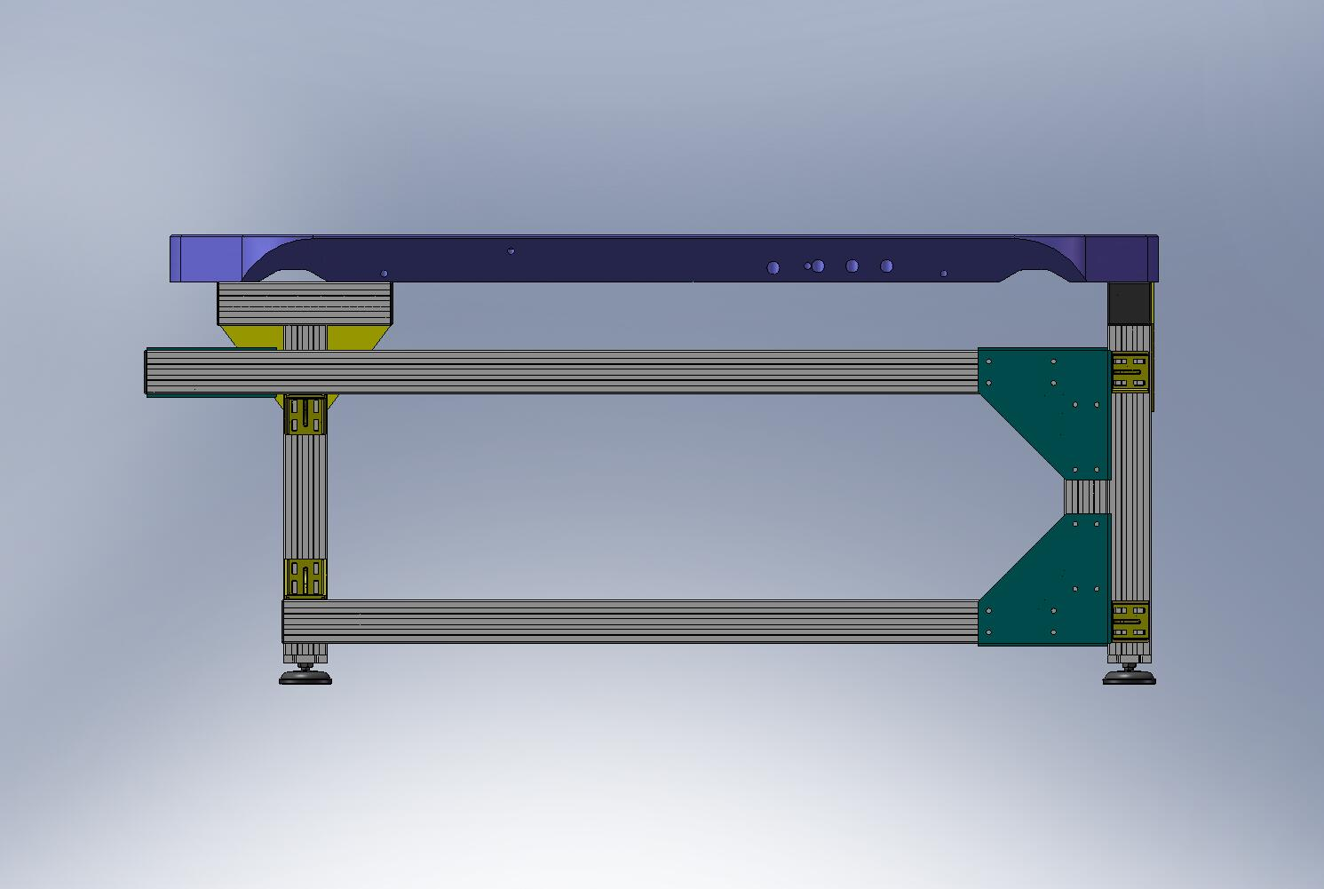
Figure 1.4. Back edge of Stage 0 Base should be close to back edge of Assembly Stand.

- Insert more Heli-Coils into Stage 0 Base:
  - (16) 1/4”-20x2.0*Dia. – for Wiring Breadboards
  - (12) 1/4”-20x2.0*Dia. – for Vertical Position Sensor mounts
  - (52) 3/8”-16x2.0*Dia. – for Vertical Actuator mounts and Shipping Braces
  - (24) 3/8”-16x2.0*Dia. – for Spring Pull-Down Bases
  - (16) 1/2”-13x2.0*Dia. – for Locker Bases
- Press (6) 1/2”x1.5” dowel pins (McMaster-Carr #90145A716) into Stage 0 Base, for locating the Support Posts. Pins should sit .45”+/-.02” above the surface of the Base. Caution: if the pins protrude more than .48” above the Base, they will interfere with the Gang Barrel Nuts.
1.0.3 Prep Work – Support Posts
- Insert Heli-Coils into (3) Support Posts (D071002):
  - (3x 18) 1/4”-20x2.0*Dia. – for Horizontal Actuator and Sensor mounts, cable clamps, and Particle Fence
- Press (2) 1/2”x1.5” dowel pins (McMaster-Carr #90145A716) into each of the (3) Support Posts, for locating Springs. Pins should sit about 1.10” above top surface of Posts, as shown in Figure 1.5 and Figure 1.6.
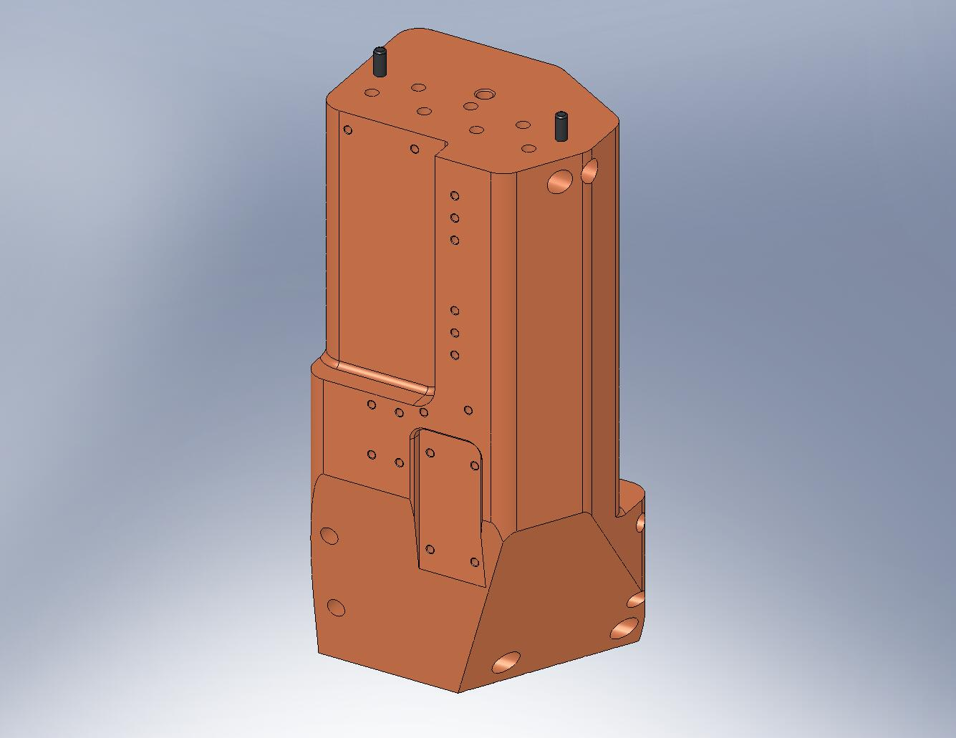
Figure 1.5. Press (2) dowel pins into the top surface of each Support Post.
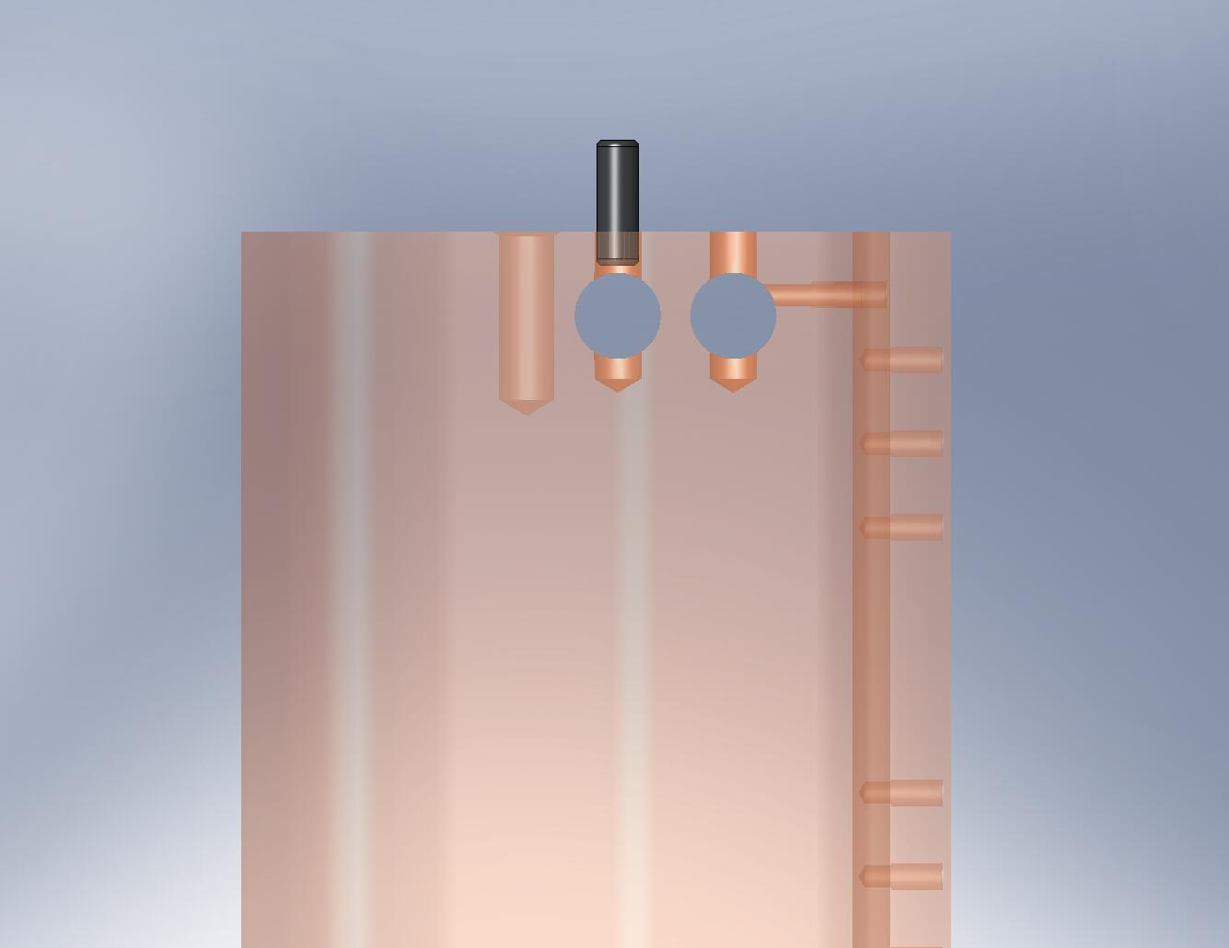
Don’t press the pins too far!

Figure 1.6. The pins must not stick into the Gang Barrel Nut holes.

  - Build Stiffener Assembly (D071412) underneath Stage 0
- Screw the vertical (7) Stage 0 Stiffener Ribs (3x D071006-00, 2x -01, and 2x -02) to the bottom of the Stage 0 Base (D071001). Turn all of the screws snug, then back off 1/4-turn. Now, all of the plates should hang slightly below the Base, with all the screws backed off by the same amount.
Hardware:
(74) 3/8"-16x1.75" SHCS (Holo-Krome)
(74) 3/8" vented washers (U-C Components)
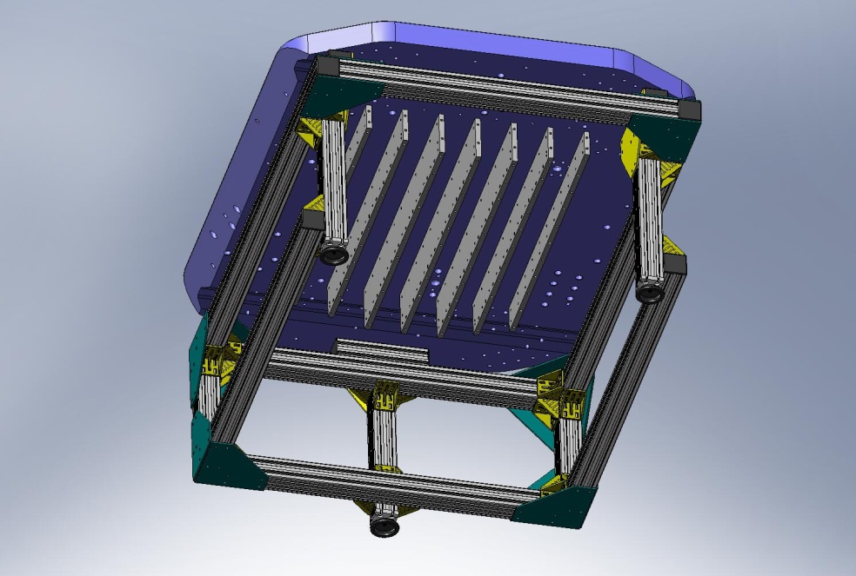
Figure 1.7. First step for installing Stiffener Assembly: hang vertical plates (D071006) from Stage 0 Base. The widest plates (-00) should hang from the middle 3 rows. The next widest (-01) should hang on either side of the -00 plates. Finally, the smallest (-02) should hang from the last row on either side.

- Place one of the outermost horizontal Stage 0 Stiffener Plates (D071007-01) and snug all screws. Try to bring ends even with the ends of the adjacent vertical Ribs (D071006-02 and -01). Torque the inner/side bolts to final spec. Bottom screws should not be torqued, yet.
Hardware:
(21) 3/8"-16x1.5" SHCS (Holo-Krome)
(21) 3/8" vented washers (U-C Components)
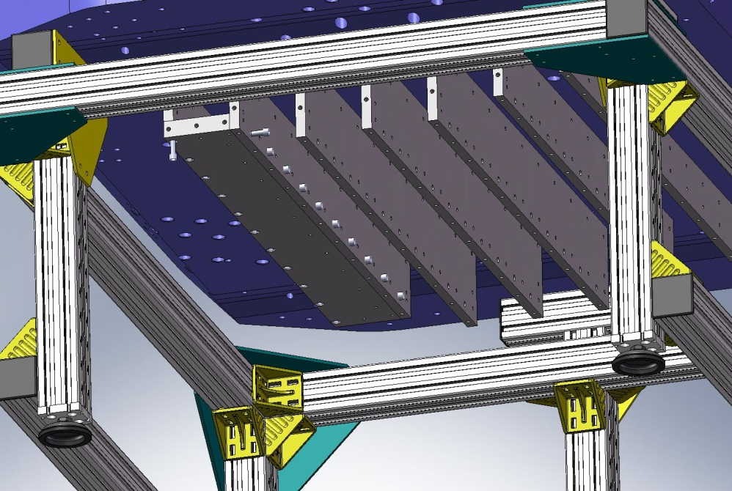
Torque to spec
Figure 1.8. Next, place the smaller horizontal plate (D071007-01) underneath one of the -02 vertical plates. After snugging all of the screws for this plate, torque the side screws to their final spec.

- Repeat last step, for outermost D071007-01 Plate on other side of assembly.
Hardware:
(21) 3/8"-16x1.5" SHCS (Holo-Krome)
(21) 3/8" vented washers (U-C Components)

- Place next horizontal Stage 0 Stiffener Plate (D071007-01) and snug all screws. Again, try to bring ends flush with ends of adjacent vertical ribs. Torque the inner/side bolts to final spec. Bottom screws should not be torqued, yet.
Hardware:
(21) 3/8"-16x1.5" SHCS (Holo-Krome)
(21) 3/8" vented washers (U-C Components)

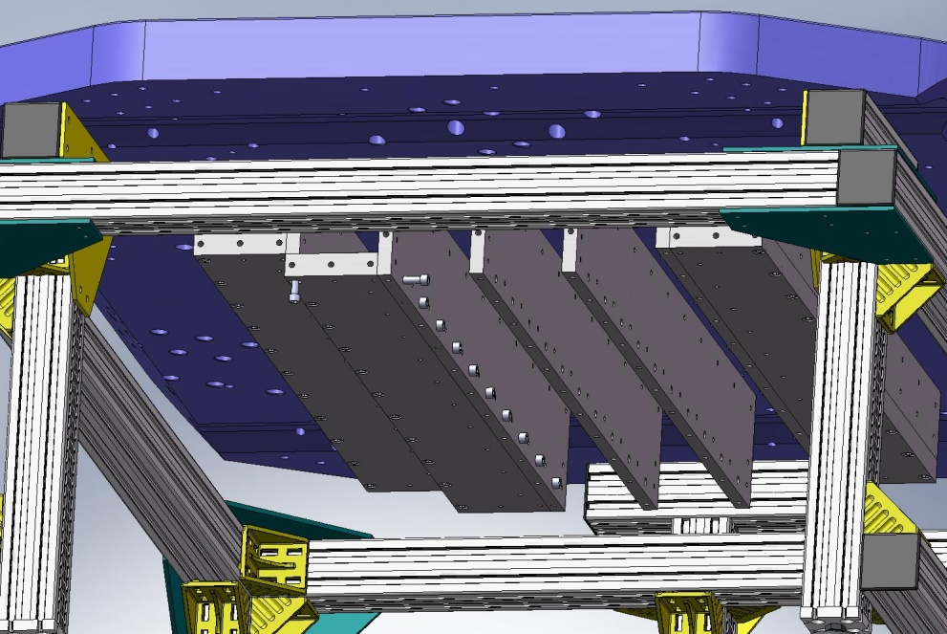
Torque to spec
Figure 1.9. After both of the outer -01 horizontal plates are secured, install one of the inner -01 horizontal plates. Snug all of the screws for this plate, then torque the side bolts to final spec.

- Repeat last step, for fourth (and final) D071007-01 Plate (on other side of assembly).
Hardware:
(21) 3/8"-16x1.5" SHCS (Holo-Krome)
(21) 3/8" vented washers (U-C Components)

- Place large Stage 0 Stiffener Plate (D071007-00) under center of Stiffener Assembly. Caution: this plate is heavy (54 lbs)! Snug all bolts.
Hardware:
(33) 3/8"-16x1.5" SHCS (Holo-Krome)
(33) 3/8" vented washers (U-C Components)
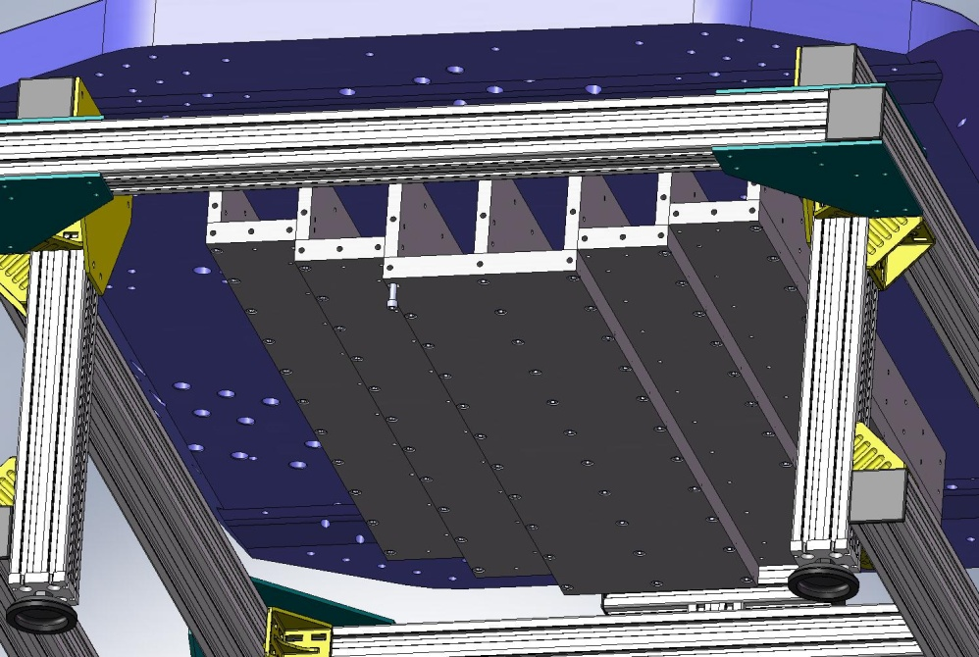
Figure 1.10. After both of the inner -01 horizontal plates are secured, the center -00 horizontal plate. Snug the bolts, but do not torque, yet.

- Place Stage 0 Stiffener End Cap (D071008) under Stage 0 Base, on one end of Stiffener Assembly. Thread in top bolts, from above the Base. Turn them snug, then back off 1/4-turn. Thread in side bolts. Snug all side bolts.
Hardware:
(6) 3/8”-16x1.75” SHCS (Holo-Krome) – from above
(29) 3/8"-16x1.5" SHCS (Holo-Krome) – from side
(35) 3/8" vented washers (U-C Components) – all screw locations
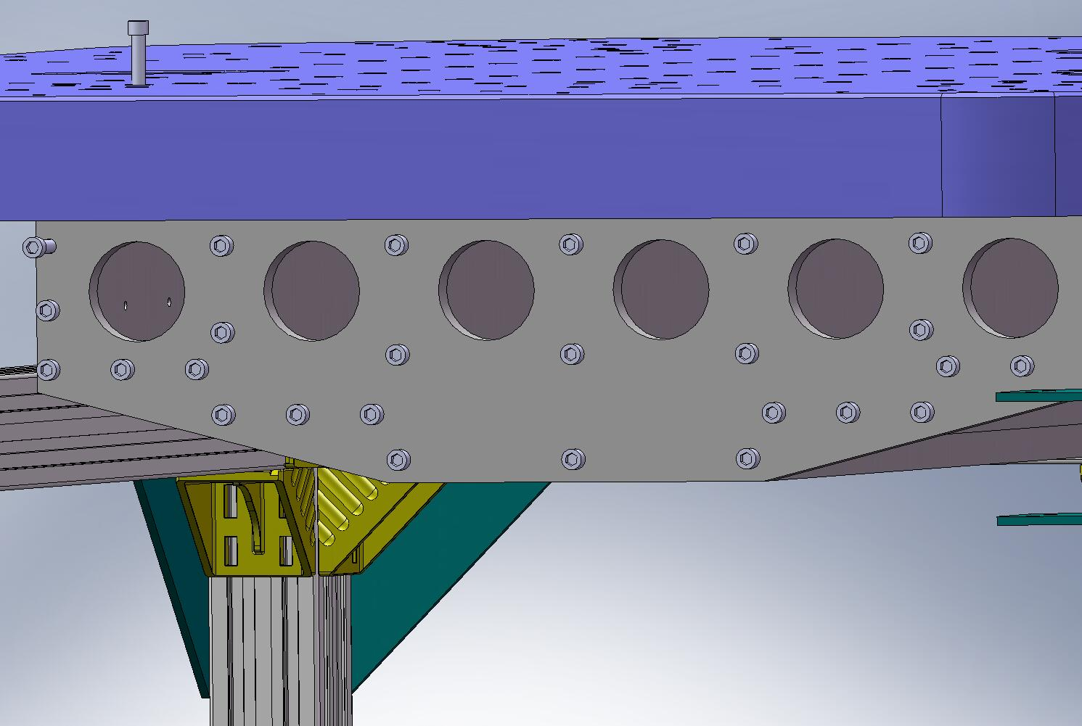
Figure 1.11. Bolt End Caps to both ends of the Stiffener Assembly. Leave top bolts turned back 1/4 turn, then snug all side bolts.

- Repeat last step, mounting the second End Cap to the other end of the Stiffener Assembly.
Hardware:
(6) 3/8”-16x1.75” SHCS (Holo-Krome) – from above
(29) 3/8"-16x1.5" SHCS (Holo-Krome) – from side
(35) 3/8" vented washers (U-C Components) – all screw locations

- Torque all (86) top bolts (thru Stage 0 Base / into Stage 0 Stiffener Assembly) to final spec. Start from the middle, torquing one column at a time (columns being aligned with the Base's short axis). End Cap bolts come last.
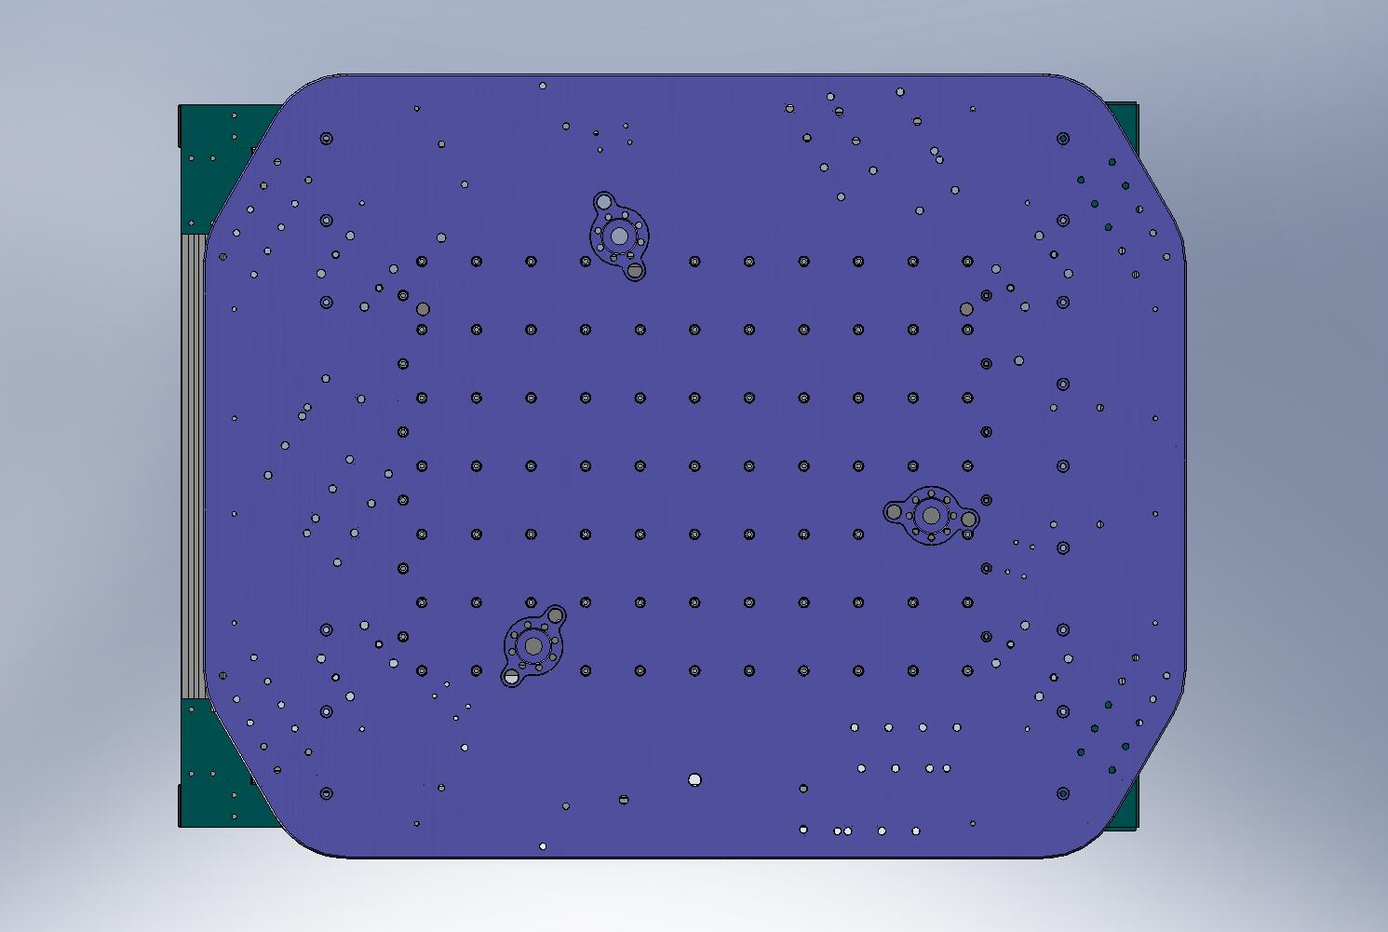
Torque to spec
Figure 1.12. Torque top Stiffener Assembly bolts to final spec. Start from the middle column, and work toward the ends. After tightening a column on one side, tighten the same column on the opposite side.

- Torque all (77) bottom screws to final spec. Start from the middle, torquing one row at a time (rows being aligned with the Base’s long axis).
- 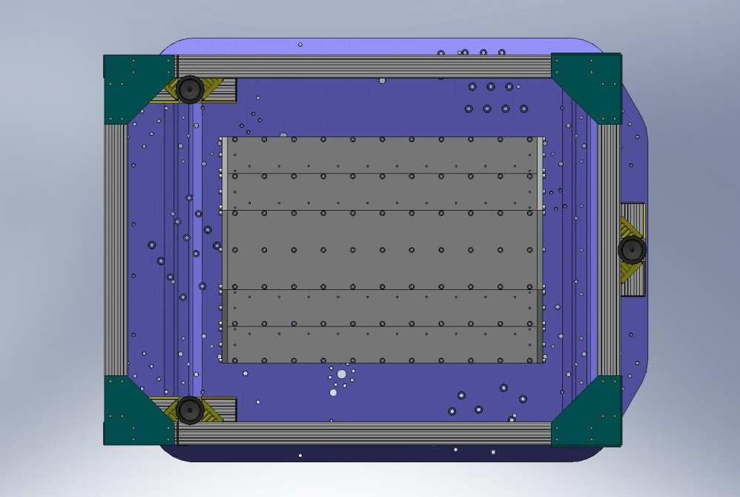
Torque to spec
Figure 1.13. Torque bottom Stiffener Assembly bolts to final spec. Start from the middle row, and work toward the ends. After tightening a row on one side, tighten the same row on the opposite side.

- Torque (2x 29) side End Cap screws to final spec. Work from the middle out.
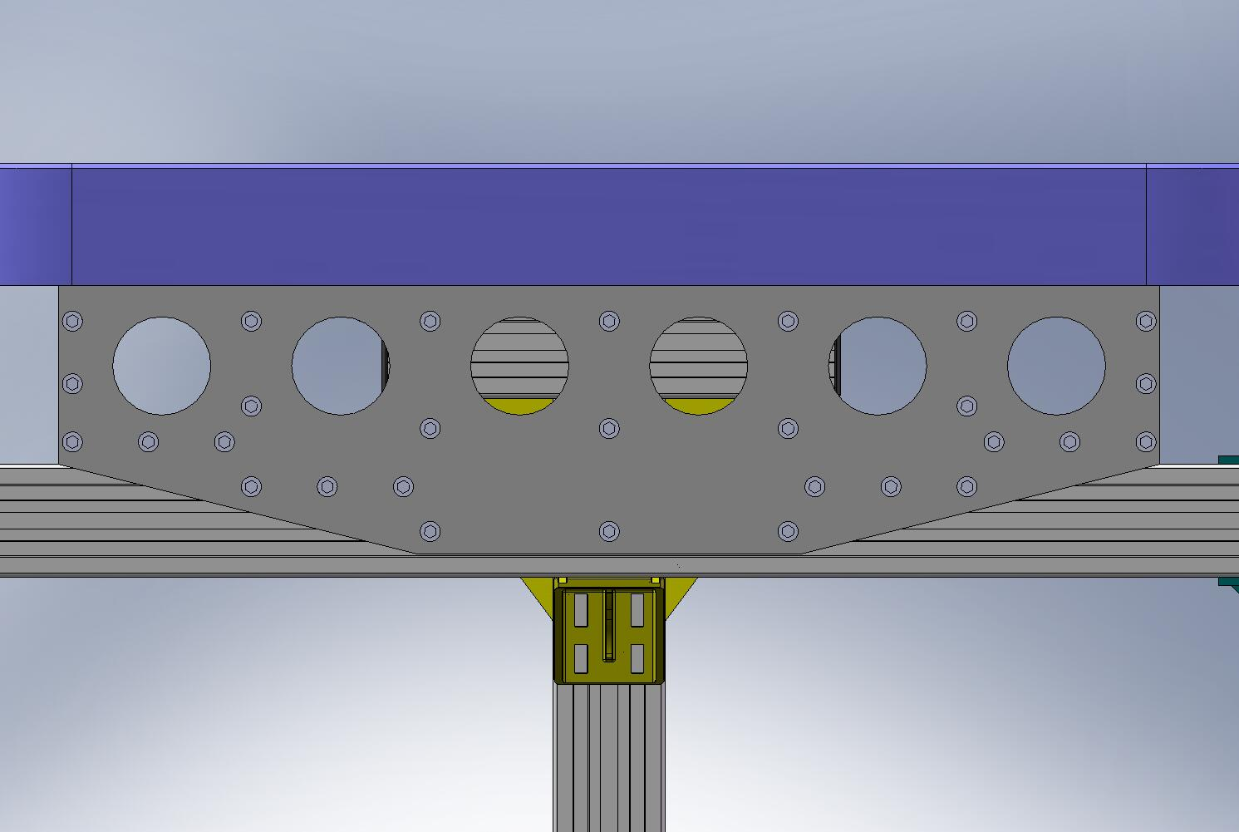
Torque to spec
Figure 1.14. Torque side End Cap screws to final spec. Start in the middle, and work toward the edges. Exact order of tightening is not important.

  - Mount Support Posts and Gussets
- Lower (3) Support Posts (D071002) onto Stage 0 Base, allowing pins to seat in pin-holes and slots in bottom of Posts. Caution: Support Posts are heavy (180 lbs, each)! Use overhead crane to lower onto Base.
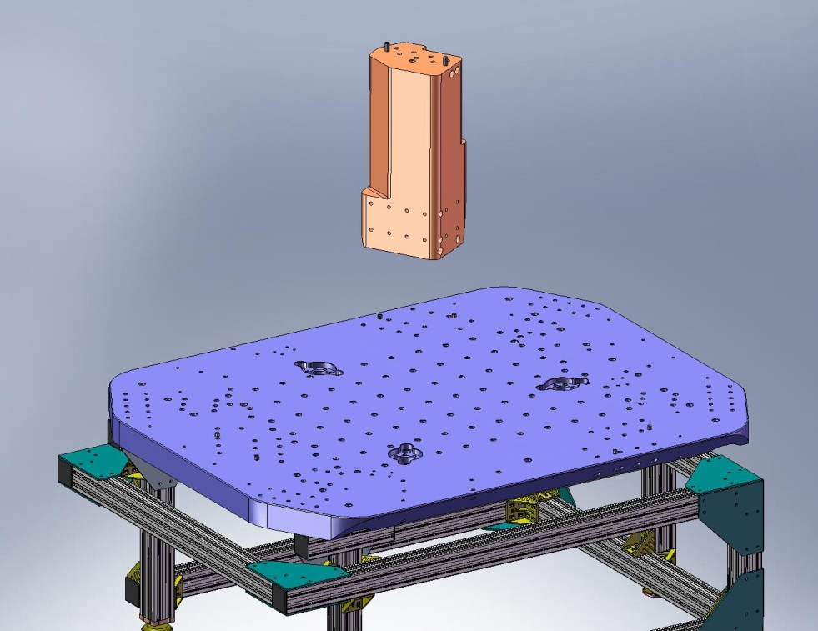
Figure 1.15. Using crane, lower Support Posts onto Stage 0 Base. Allow pins in Base to seat properly into the hole/slot combinations underneath the Posts.
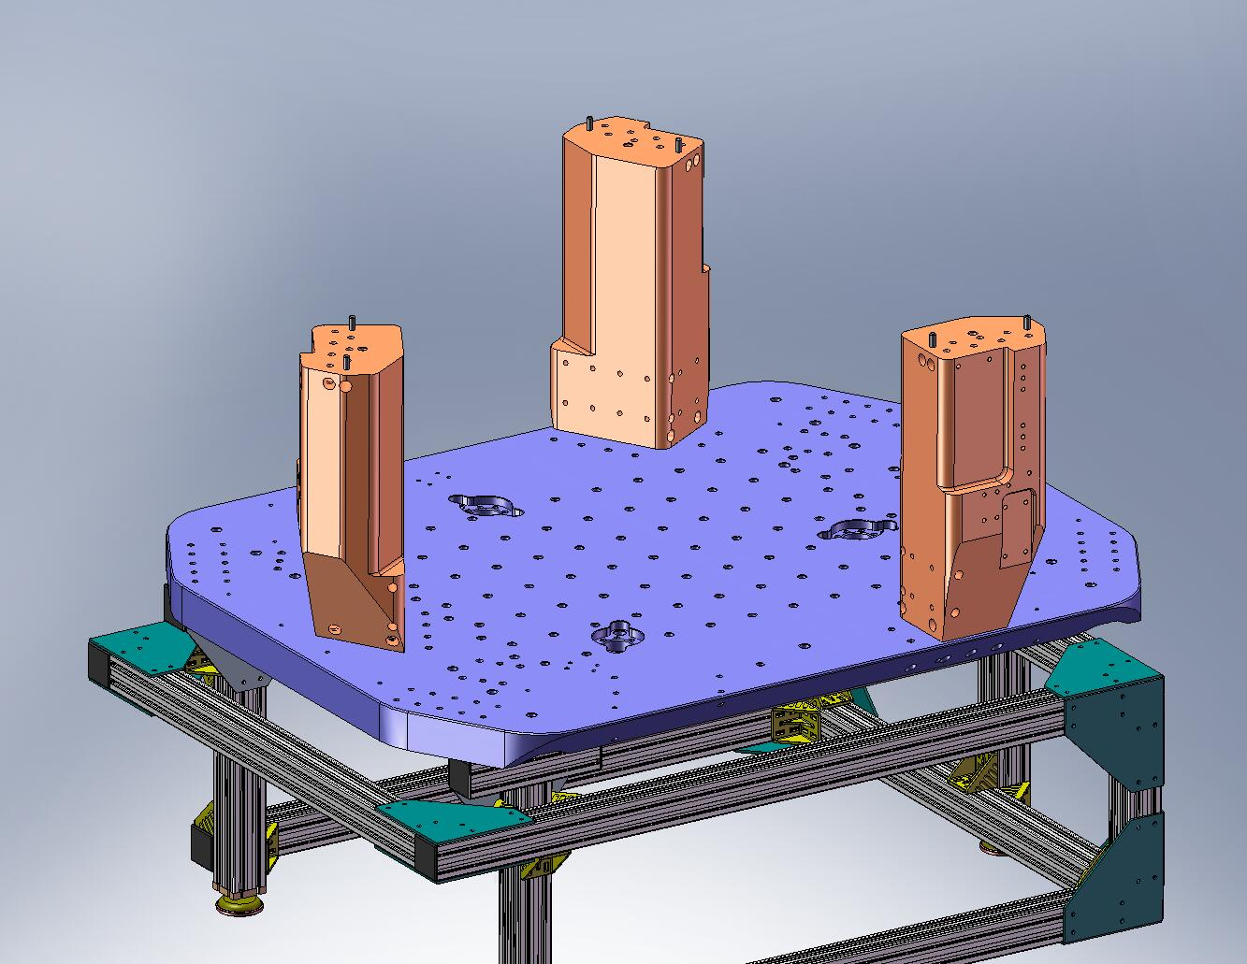
Figure 1.16. This view shows the correct orientation of the (3) Support Posts on the Stage 0 Base.

- Insert (2) 3-hole 1/2”-13 Gang Barrel Nuts (D071251-03) in bottom of each Support Post. Thread in screws from underneath the Stage 0 Base. Torque to final spec.
Hardware:
(18) 1/2”-13x2.0” SHCS (McMaster-Carr)
(18) 1/2” vented washers (U-C Components)
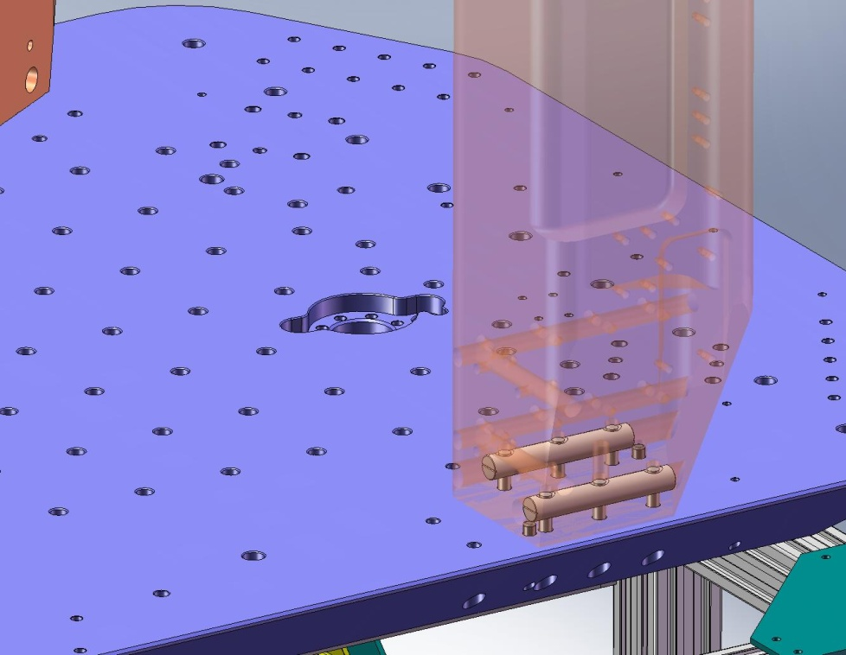
Figure 1.17. (2) Gang Barrel Nuts are inserted into each of the (3) Support Posts. The 1/2”-13 holes should line up with the thru holes in the Stage 0 Base. Thread in all the screws from underneath, and torque to final spec.

- Place (3) Support Post Caps (D071003) on top of the Support Posts, as shown in Figure 1.18. There are a hole and a slot in each Cap, which should slip around the dowel pins in the Posts. We start using the (Stainless Steel) Caps now, to reduce the risk of accidental damage to the tops of the (Aluminum) Posts.
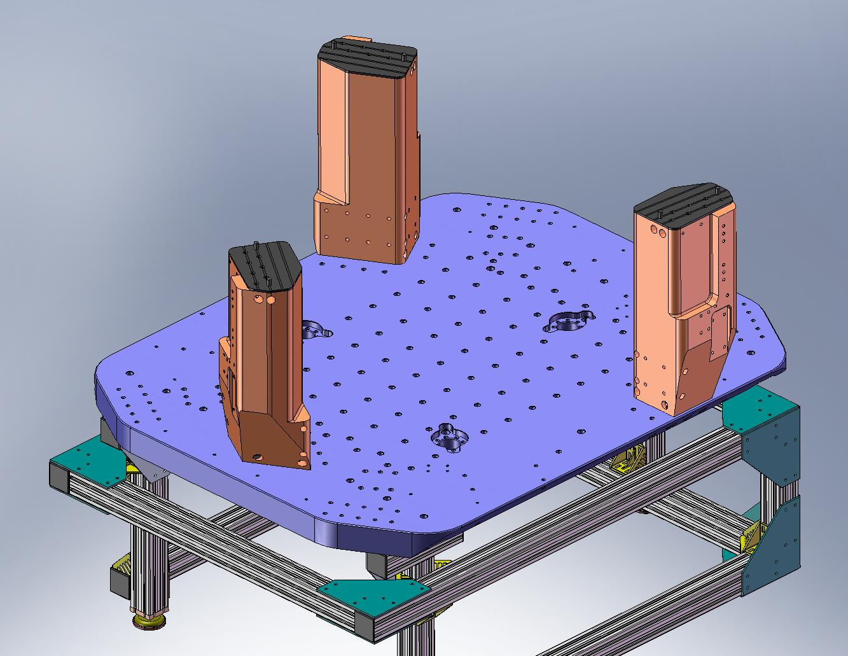
Figure 1.18. Support Post Caps placed on the Support Posts. Later, the Springs will be mounted on top of the Caps.

- Place (6) Support Post Gussets (D071004 and D071005) on Stage 0 Base, next to Support Posts. Proper orientation is shown in Figure 1.19.
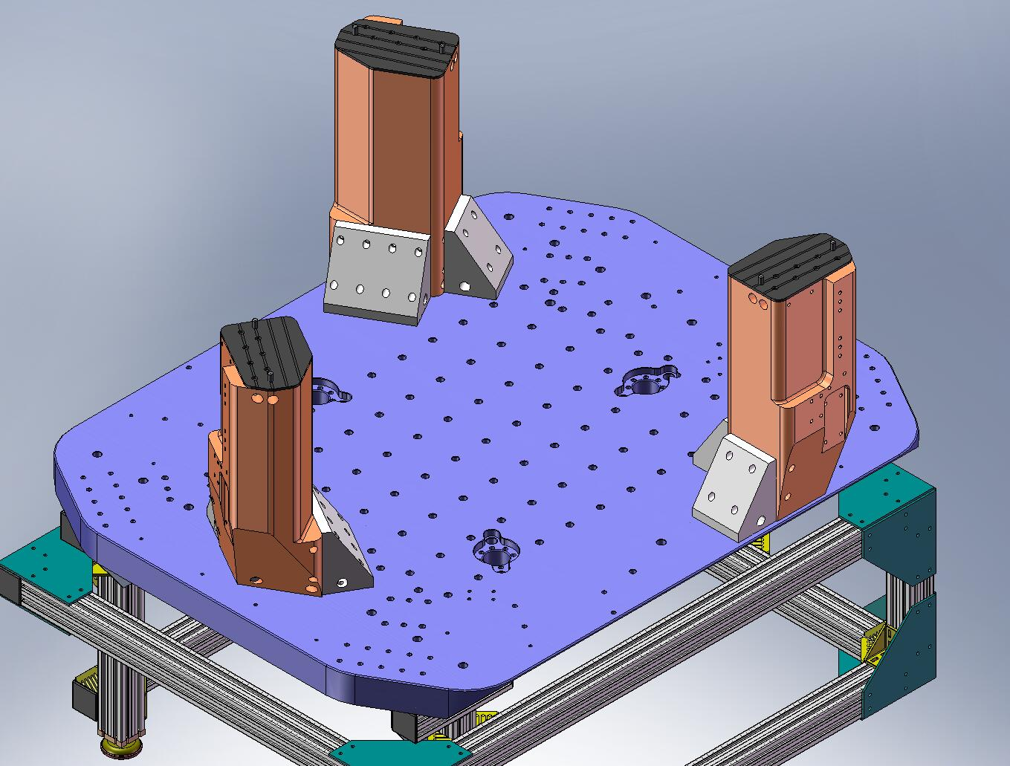
Figure 1.19. Place (3) Main and (3) Auxiliary Support Post Gussets against the sides of the Support Posts. Orient as shown in this image.

- Insert (2) 2-hole and (2) 4-hole 3/8”-16 Gang Barrel Nuts (D071251-00 and -01, respectively) into each of the Posts. Start screws through sides of Gussets. Snug, but do not torque, yet.
Hardware:
(36) 3/8”-16x2.5” SHCS (Holo-Krome)
(36) 3/8” vented washers (U-C Components)
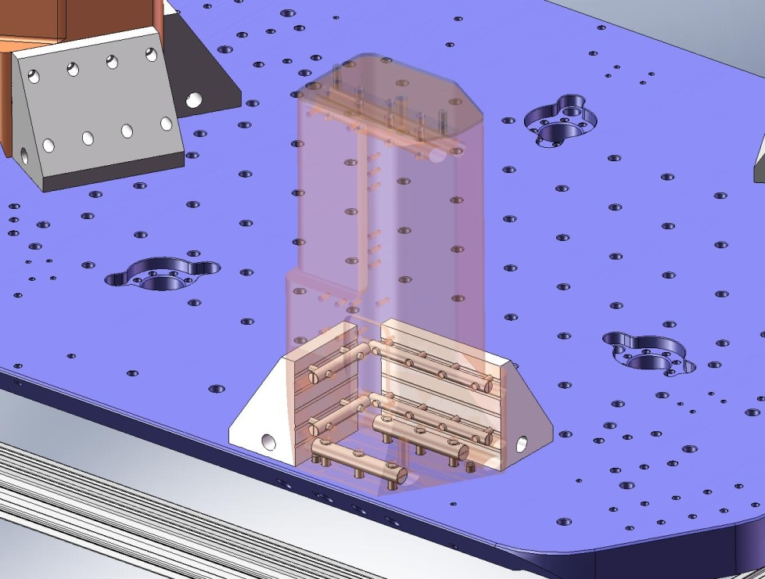
Figure 1.20. Transparent view of a Support Post, showing Gang Barrel Nuts with screws engaged. Note that Barrel Nuts are recessed deeply within the Posts’ holes, so it may be difficult to position them properly.

- Insert 2-hole 1/2”-13 Gang Barrel Nuts (D071251-02) into each Support Post Gusset, Aux (D071004). Insert 4-hole 1/2”-13 Gang Barrel Nuts (D071251-04) into each Support Post Gusset, Main (D071005). Start screws into the Nuts, from underneath the Stage 0 Base. Torque screws to final spec.
Hardware:
(18) 1/2”-13x2.0” SHCS (McMaster-Carr)
(18) 1/2” vented washers (U-C Components)
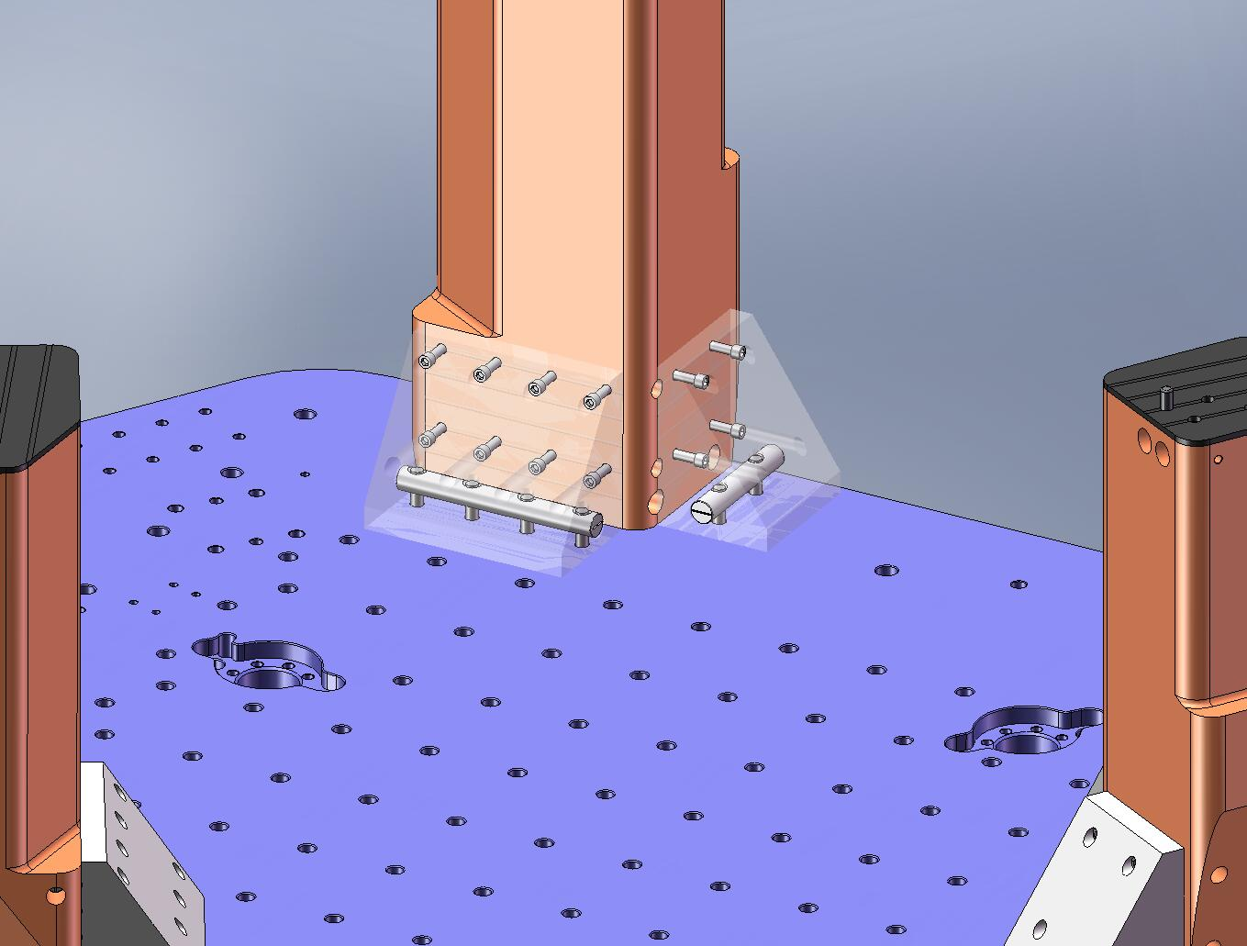
Figure 1.21. Transparent view of Support Post Gussets, showing Gang Barrel Nuts with screws engaged.

- Torque (36) screws in sides of Gussets to final spec.

  - Transfer Stage 0 to Test Stand
- Screw (3) 3/4”-10 (?) lifting eyes into Stage 0 Base.
- Lift Stage 0 Assembly (2,150 lbs) with crane and translate over Test Stand. Check that orientation of HAM ISI will be convenient for loading into the HAM chamber, after build is finished.
- Gently lower Stage 0 Assembly onto Test Stand. Start screws into HAM Upper Riser (D070304) (or Support Tube bosses, if Risers are not used), to help locate Stage 0. Note there are 6 mounting holes on one side of the Stage 0 Base, and 9 on the other.
Hardware:
(15) 3/8”-16x2.5” SHCS (Holo-Krome) – if Risers are used
(15) 3/8”-24x2.5” SHCS (McMaster-Carr) – if Risers are not used
(15) 3/8” vented washers (U-C Components)
- Continue lowering Stage 0 until full load is supported by Test Stand. Torque mounting screws to final spec.
- Remove lifting eyes.
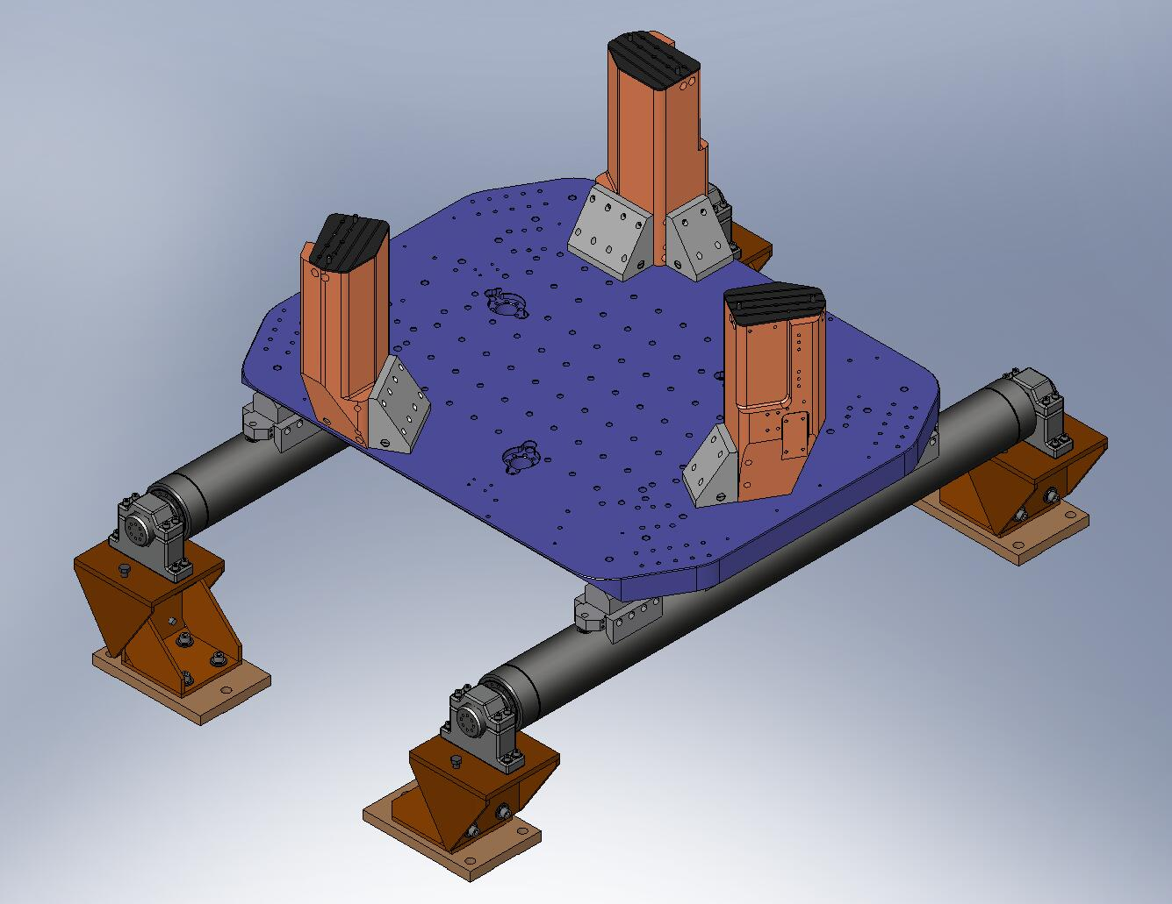
Figure 1.22. Stage 0 Assembly mounted to the Test Stand.

- Check level of Stage 0 Base at several points on its top surface, using bubble level. Record the numbers. Are they within spec?

– Stage 1 Assembly
- 2.0.1 Prep Work – Stage 1 Floor
- Insert Heli-Coils into Stage 1 Floor (D071051) for lifting eyes:
  - (6) 3/4”-10x2.0*Dia.
- Insert Heli-Coils into bottom of Stage 1 Floor: (how and where? On Assembly Stand?):
  - (12) 1/4”-20x2.0*Dia. – for Vertical Actuator mounts
  - (12) 1/4”-20x2.0*Dia. – for Vertical Position Sensor mounts
  - (16) 3/8”-16x2.0*Dia. – for Locker Base
- Pick up the Stage 1 Floor, using lifting eyes threaded into the newly installed Heli-Coils, and place it onto Assembly Stand. Orientation should be as shown in Figure 2.1 and Figure 2.2.
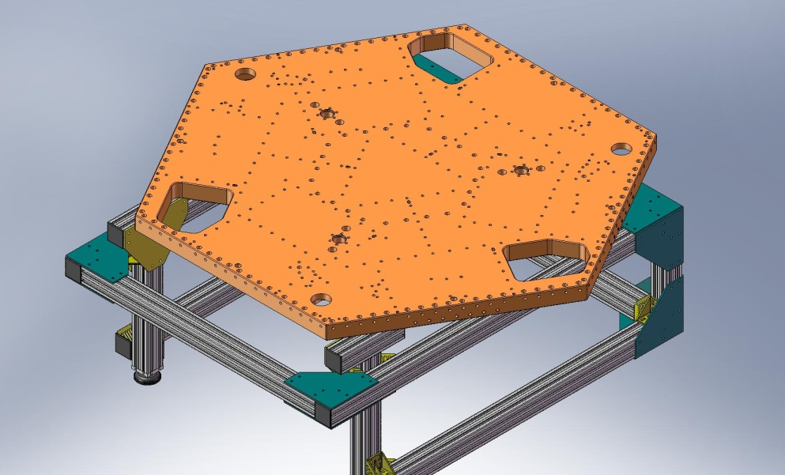
Figure 2.1. Stage 1 Floor resting on the Assembly Stand, for initial stage build-up. This orientation allows good access to the Boxwork mounting screws.

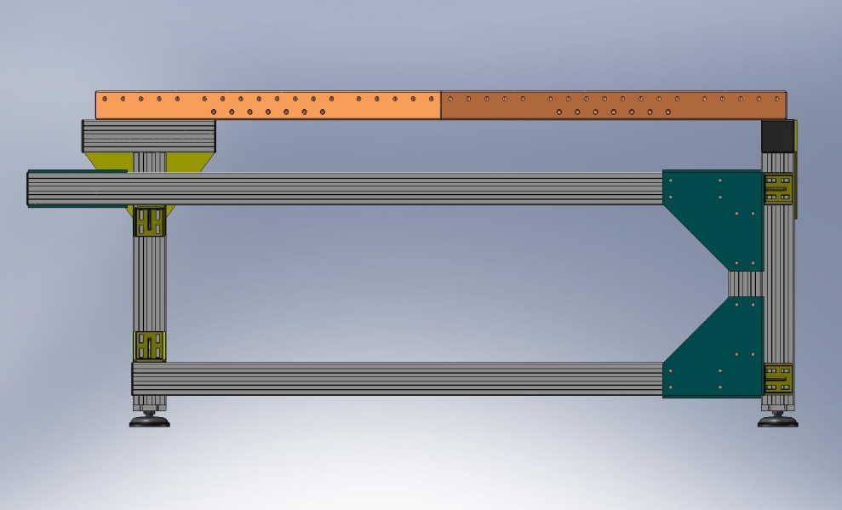
Figure 2.2. Side view of Stage 1 Floor on Assembly Stand.

- 2.0.2 Prep Work – Barrel Nuts, Brackets, Posts, and Hatches
- Insert Heli-Coils into (897) Barrel Nuts (D071250) (Note: for LHO build, we’re using Barrel Nuts made from Al 2024, which do not require Heli-Coils.):
  - (174x 1) 3/8”-16x1.5*Dia. – for .75”-long Barrel Nuts (Type -00)
  - (615x 1) 3/8”-16x1.5*Dia. – for 1.0”-long Barrel Nuts (Type -01)
  - (108x 1) 3/8”-16x1.5*Dia. – for 1.3”-long Barrel Nuts with retaining rings (Type -02)
- Insert Heli-Coils into (12) Outer Wall, Bracket 120 pieces (D071060):
  - (6x 14) 3/8”-16x2.5*Dia. – for long version (Type -00)
  - (6x 6) 3/8”-16x2.5*Dia. – for short version (Type -01)
- Insert Heli-Coils into (9) Outer Wall, Bracket 90 pieces (D071061):
  - (9x 13) 3/8”-16x2.0*Dia.
- Insert Heli-Coils into (6) Rib Bracket, 60 Deg pieces (D071073):
  - (6x 13) 3/8”-16x2.0*Dia.
- Insert Heli-Coils into (3) Flexure Posts (D071074):
  - (3x 20) 3/8”-16x2.0*Dia.
- Insert Heli-Coils into (3) Spring Hatch, Optics Table pieces (D071067):
  - (6) 1/4”-20x2.0*Dia.

- 2.0.3 Prep Work – Ribs
- Press (1) 3/8”x.75” dowel pin (McMaster-Carr #90145A622) into side of each of the (3) Rib, Rad, Flexure Out 1 plates (D071068) as shown in Figure 2.3. Pin should sit .25” proud of the mating surface. Do not press pin into bottom of this plate, yet!
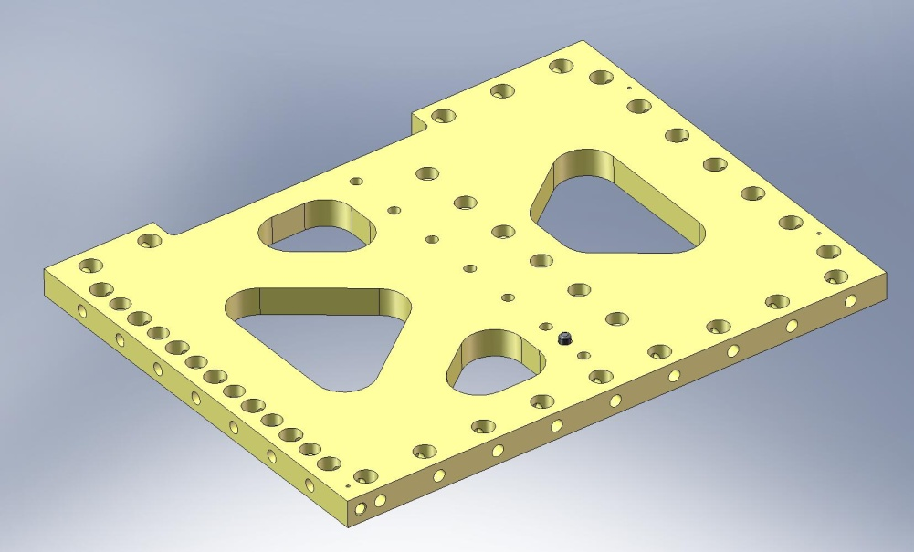
Figure 2.3. Dowel pin pressed into side of Radial Rib (D071068). Pin should sit .25” proud of surface.

- Insert Heli-Coils into (3) Rib, Rad, Flexure Out 2 plates (D071069):
  - (3x 4) 3/8”-16x2.0*Dia. – for Flexure Post Bracket
- Press (2) 3/8”x.75” dowel pins (McMaster-Carr #90145A622) into side of each of (3) Rib, Rad, Flexure Out 2 plates (D071069) as shown in Figure 2.4. Pins should stand .25” proud of mating surface. Do not press pins into bottom of this plate, yet!
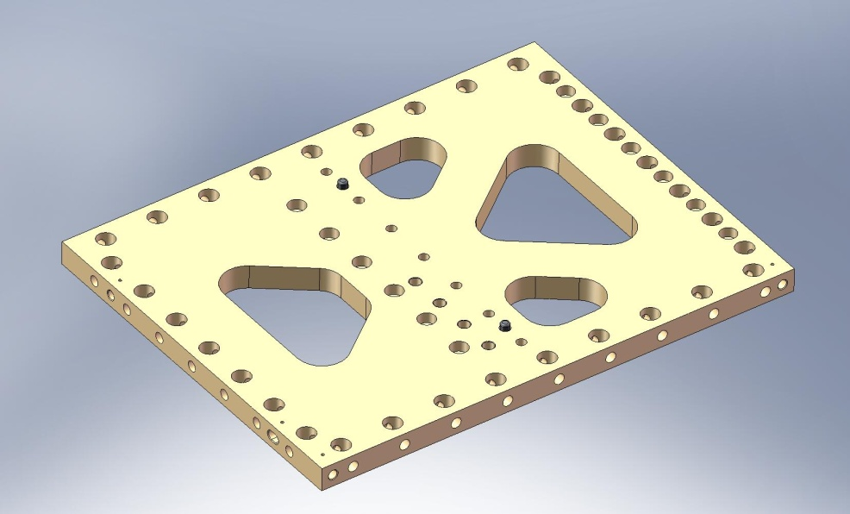
(4) Heli-Coils
Figure 2.4. Dowel pins pressed into side of Radial Rib (D071069). Heli-Coils are installed from the same side as the pins are pressed.

- Press (4) 3/8”x.75” dowel pins (McMaster-Carr #90145A622) into each of (3) Rib, Tan, Flexure Cen plates (D071070). The pins should all stand .25” proud of the plate surface, as shown in Figure 2.5.
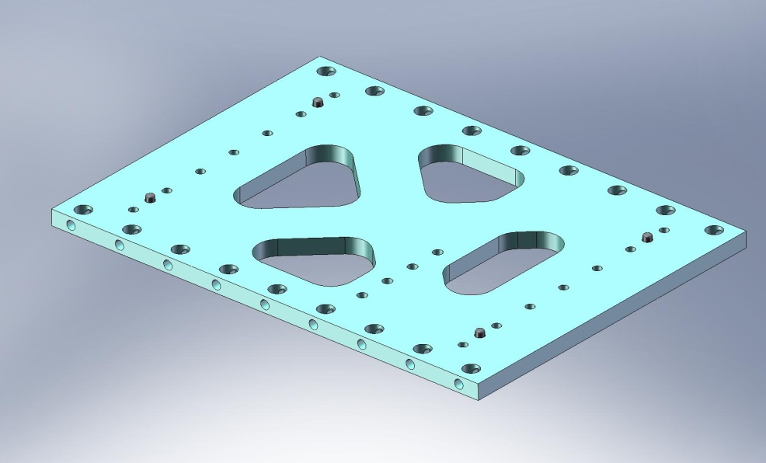
Figure 2.5. Dowel pins pressed into side of Tangential Rib (D071070).

- Insert Heli-Coils into (3) Rib, Tan, Flexure Mid plates (D071071):
  - (3x 16) 1/4”-20x2.0*Dia. – for Flexure Cover Rib
- Press (4) 3/8”x.75” dowel pins (McMaster-Carr #90145A622) into one side of each of (3) Rib, Tan, GS-13 Mid plates (D071052), as shown in Figure 2.6. The pins should all stand .25” proud of the plate surface. For each plate, press (2) more 3/8”x.75” pins into the opposite face, as shown in Figure 2.7. Again, the pins should sit .25” proud of the plate surface.
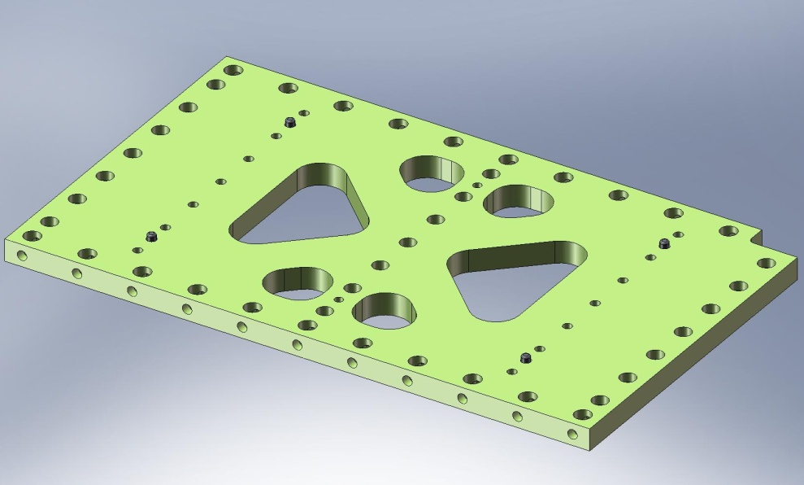
Figure 2.6. Dowel pins pressed into one side of Tangential Rib (D071052).
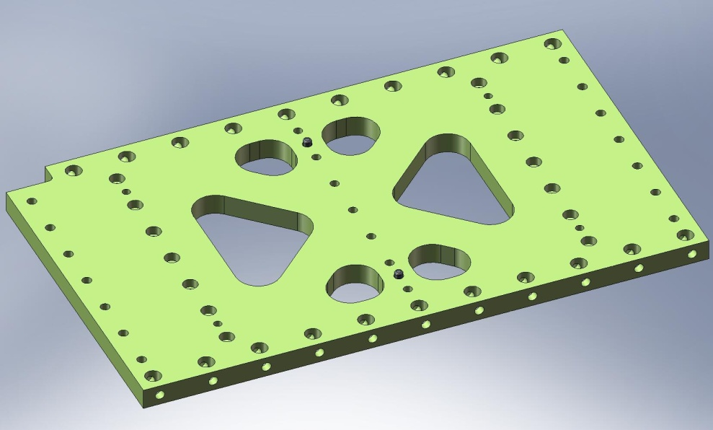
Figure 2.7. Dowel pins pressed into opposite side of Tangential Rib (D071052).

- Press (2) 3/8”x.75” dowel pins (McMaster-Carr #90145A622) into one side of each of (3) Rib, Tan, GS-13 Cen plates (D071053), as shown in Figure 2.8. The pins should stand .25” proud of the plate surface.
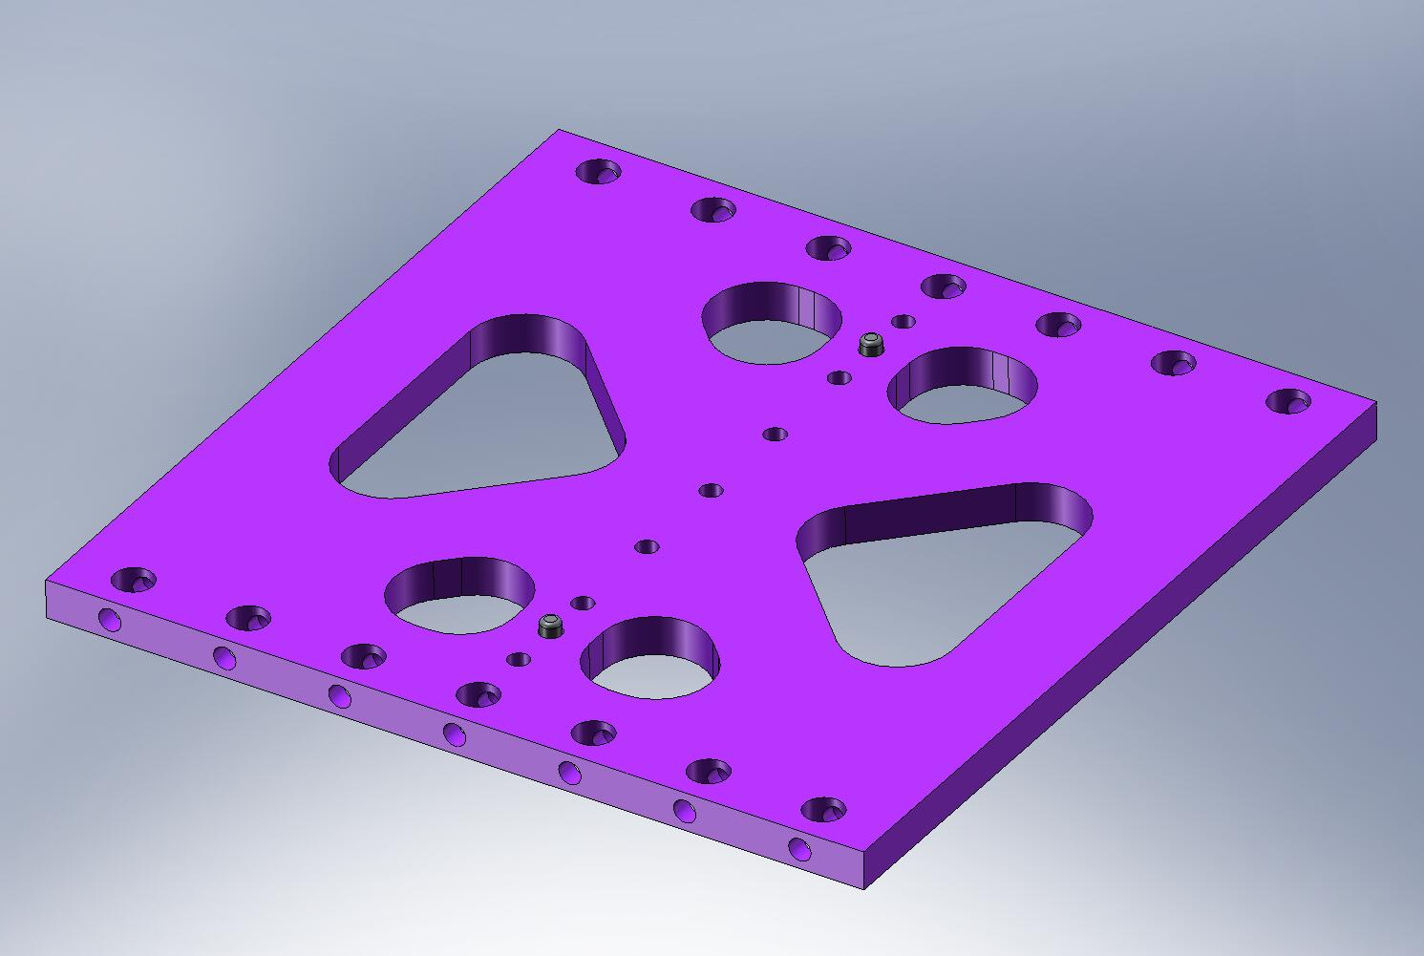
Figure 2.8. Dowel pins pressed into side of Tangential Rib (D071053).

- Insert Heli-Coils into (3) Rib, Rad, GS-13 Out 1 plates (D071055):
  - (3x 9) 1/4”-20x2.0*Dia. – for GS-13 Adapter Plates
  - (3x 4) 1/4”-20x2.0*Dia. – for Horizontal Actuator mounts
  - (3x 4) 1/4”-20x2.0*Dia. – for Horizontal Position Sensor mounts

- 2.0.4 Prep Work – Wall Plates
- Insert Heli-Coils into (6) Keel Walls (D071063):
  - (6x 2) 1/2”-13x1.5*Dia.
- Press (2) 1/2”x4.0” dowel pins (McMaster-Carr #90145A729) into each of (6) Keel Walls, as shown in Figure 2.9. Pins should come flush with back surface on Wall. This completes the Keel Wall Assembly (D071425).
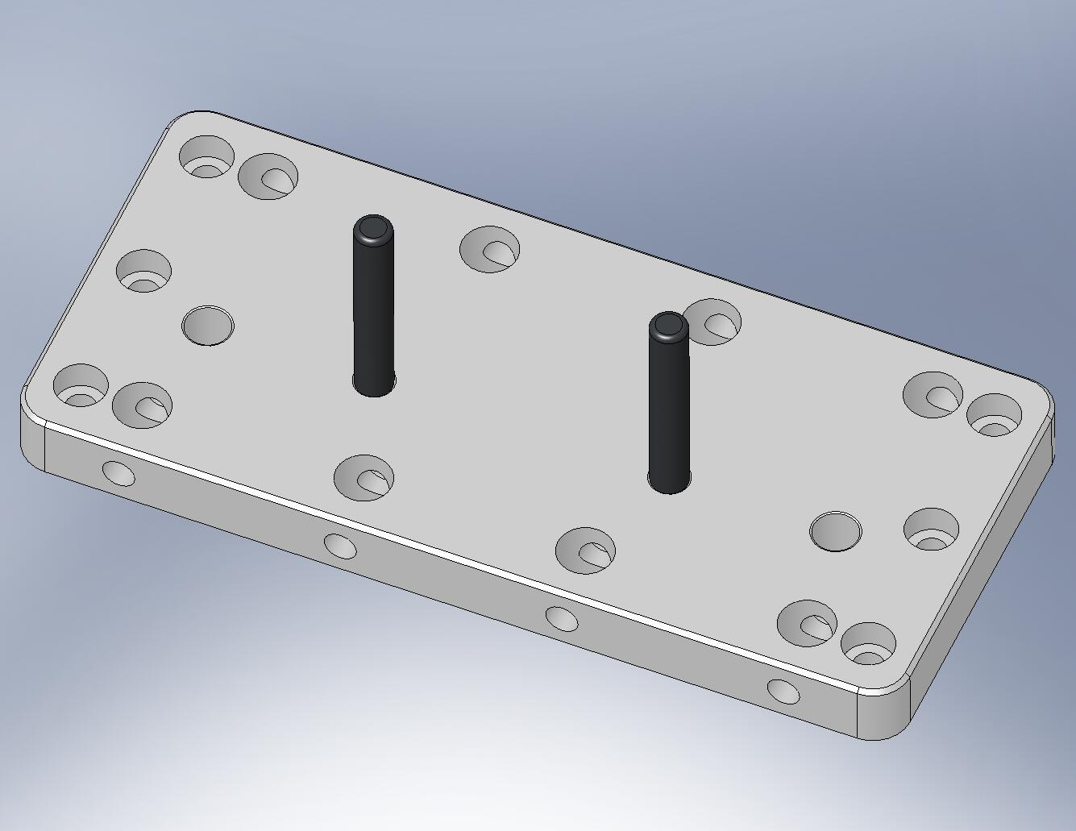
Figure 2.9. Dowel pins pressed into Keel Wall (D071063). Note orientation of counterbores on side mounting holes.

- Press (2) 1/2”x4.0” dowel pins (McMaster-Carr #90145A729) into each of (9) Outer Walls, Small Panel (D071059). Pin should come flush with back surface of wall.
- Thread (2) hex bolts through the back side of each Outer Wall, Small Panel. Torque the bolts to final spec. Tighten (2) jam nuts on the other side of the Wall, as shown in Figure 2.10. Torque the nut to final spec. Use vented washers on both sides.
Hardware:
(18) 1/2”-13x4.0” hex bolts (McMaster-Carr)
(18) 1/2”-13 thin jam nuts (McMaster-Carr)
(36) 1/2” vented washers (U-C Components)
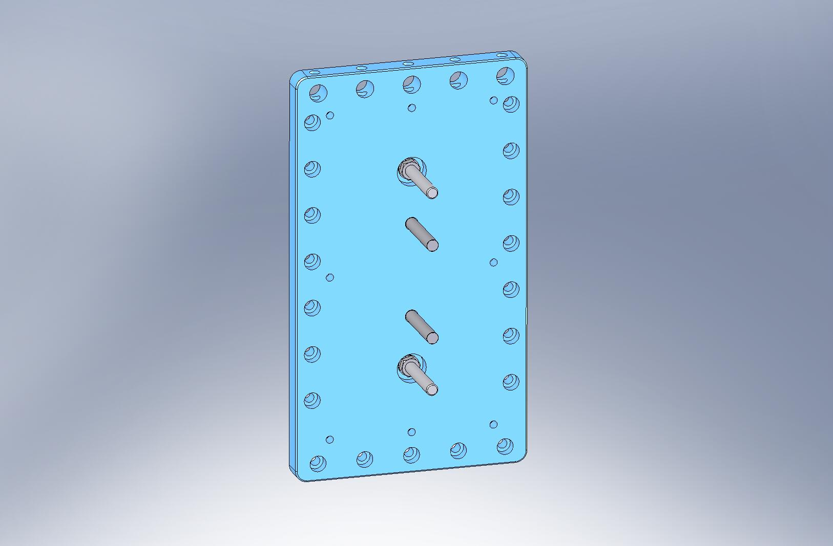
Jam nuts recessed within counterbores.
Figure 2.10. Dowel pins and fixturing bolts on the Outer Walls, Small Panel.

- 2.0.5 Prep Work – Optical Table
- Insert Heli-Coils into Optical Table (D071050):
  - (1,045) 1/4”-20x2.0*Dia. – to mount optics
  - (18) 1/4”-20x2.0*Dia. – for Spring Hatches
  - (4) 3/4”-10x2.0*Dia. – for lifting eyes
    - Prep Work – Build (4) Locker Assemblies (D071450)
- Press (2) 3/8”x1.0” dowel pins (McMaster-Carr #90145A624) into each of (4) Stage 1-2 Kinematic Lock Bases (20007936-1), as shown in Figure 2.11. Pins should stand .25” proud of the bottom surface.
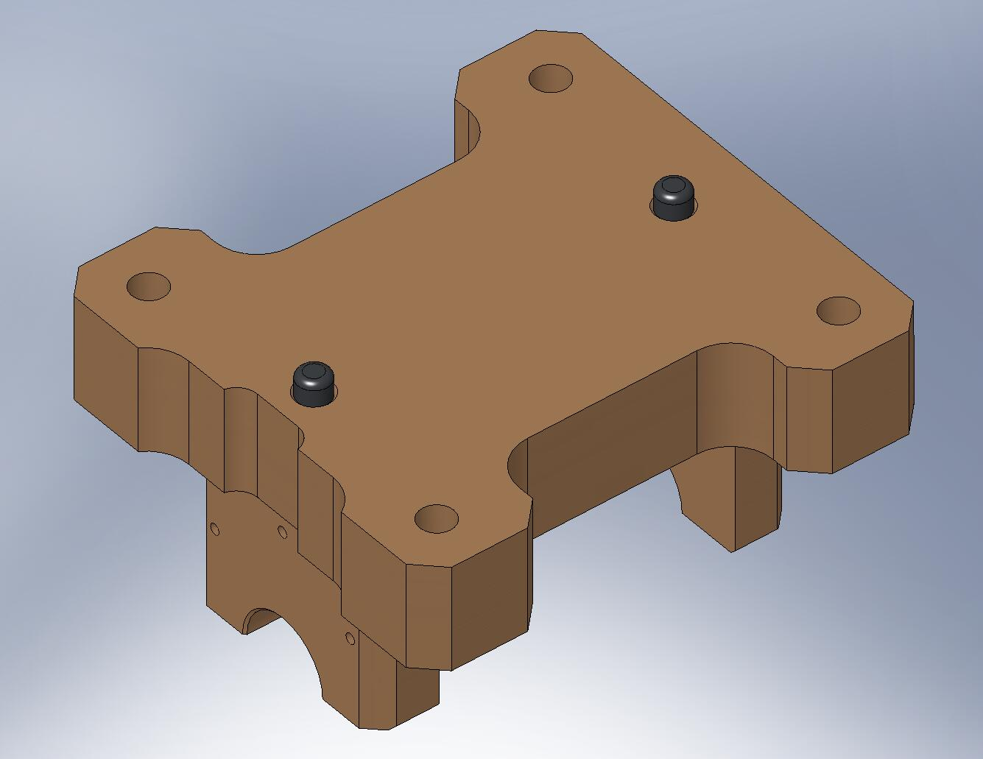
Figure 2.11. Dowel pins pressed into bottom of Kinematic Lock Base.

- Press (2) 3/8”x1.0” dowel pins (McMaster-Carr #90145A624) into each of (4) Locker Bases (D071140), as shown in Figure 2.12. Pins should stand .25” proud of the top surface.
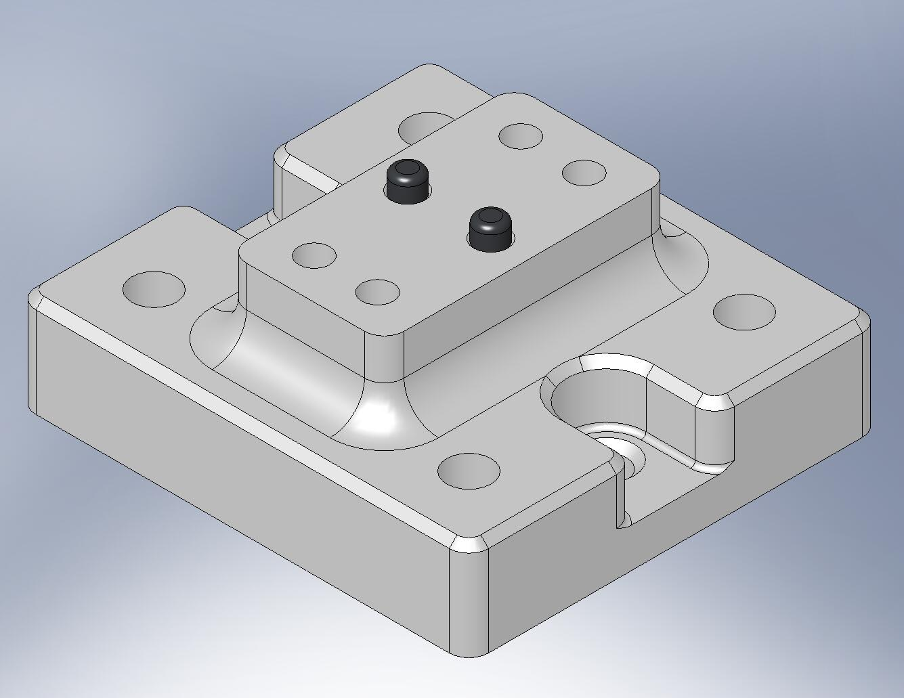
Figure 2.12. Dowel pins pressed into top of Locker Base.

the following procedure describes the assembly of one D071450 assembly. This should be repeated for the other three D071450’s, as well:
- Place Kinematic Lock Housing (20007932) on top of Locker Base, allowing pins to seat properly in mating hole and slot. Relative orientation of two parts does not matter. Start screws. Snug all (4), then torque to final spec.
Hardware:
(4) 3/8”-16x2.25” SHCS (McMaster-Carr)
(4) 3/8” vented washers (U-C Components)
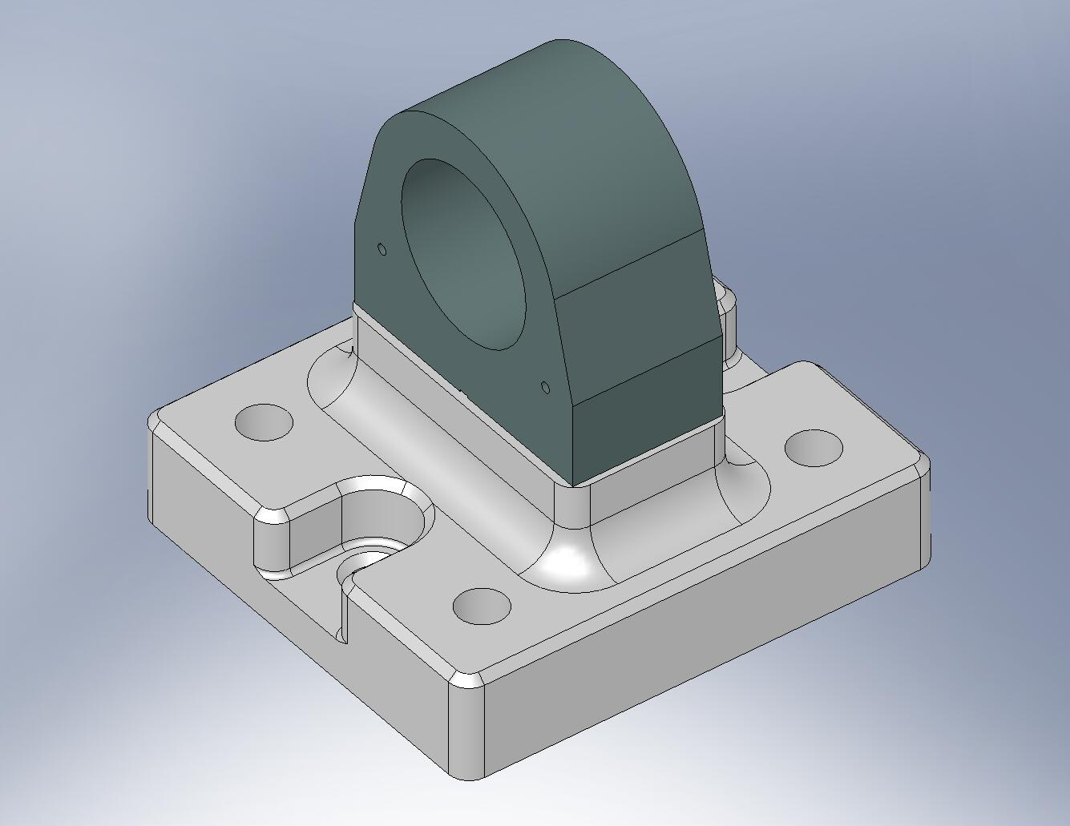
Figure 2.13. Kinematic Lock Housing bolted onto Locker Base.

- Insert Locker Sleeve (D070270) into Kinematic Lock Housing as shown in Figure 2.14. The fit is very tight! Rotate Sleeve during insertion, to reduce risk of binding. Thread Sleeve all the way into the Housing.
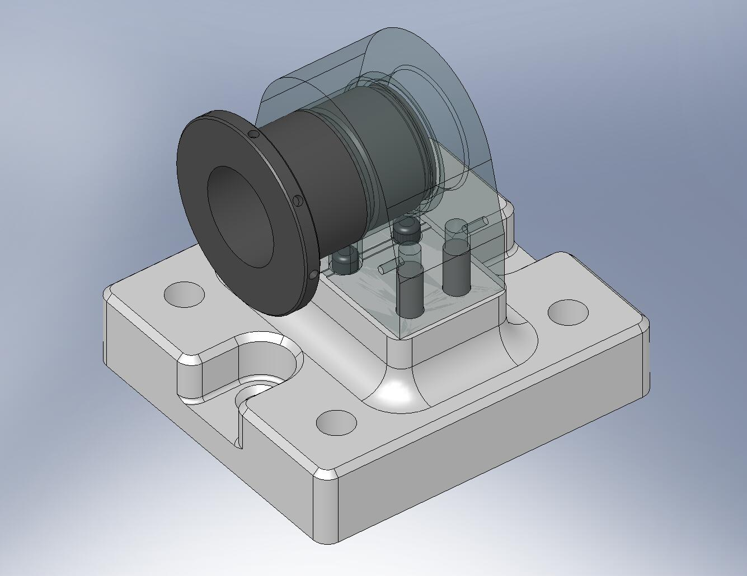
Figure 2.14. Locker Sleeve is inserted in the Kinematic Lock Housing. Run the Sleeve’s thread into the internal thread in back of Housing.

- Check that the Sleeve runs smoothly in and out of the Housing’s threads. If it does not, the Housing’s bore may be too tight!

- Clip retaining ring (Smalley FSE-0175-S02) over groove at the end of the Locker Sleeve, as shown in Figure 2.15.
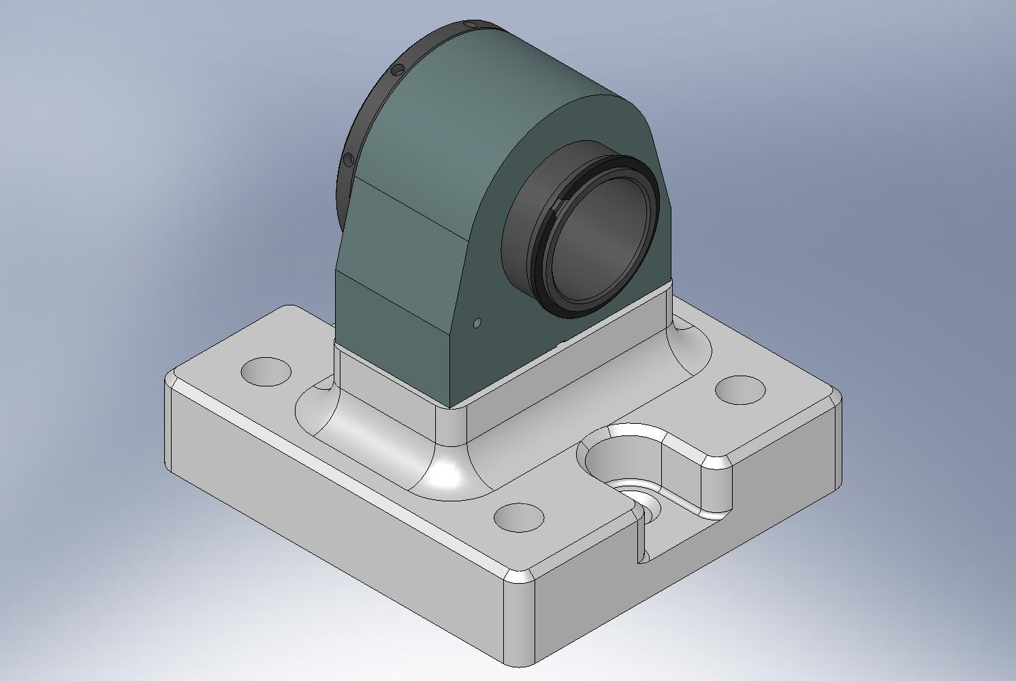
Figure 2.15. Retaining ring in groove on back of Locker Sleeve.

- Insert Spherical Pin (20007935) into Locker Sleeve, as shown in Figure 2.16. Orientation is critical: short end of Pin should stick out of knurled end of Sleeve.
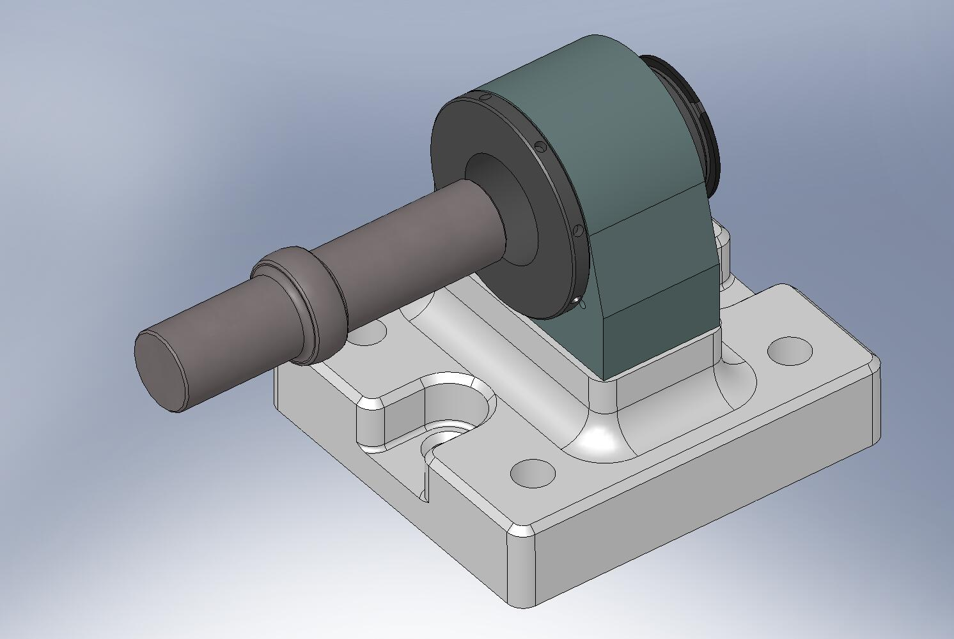
Knurled End
Figure 2.16. Spherical Pin being inserted into Locker Sleeve.

- With the Kinematic Lock Base sitting on a flat surface, pick up the Locker Base/Housing/Sleeve/Spherical Pin, and place the ends of the Pin in the Base’s mating grooves. The knurled end of the Sleeve should face the flat side of the Base, as shown in Figure 2.17.
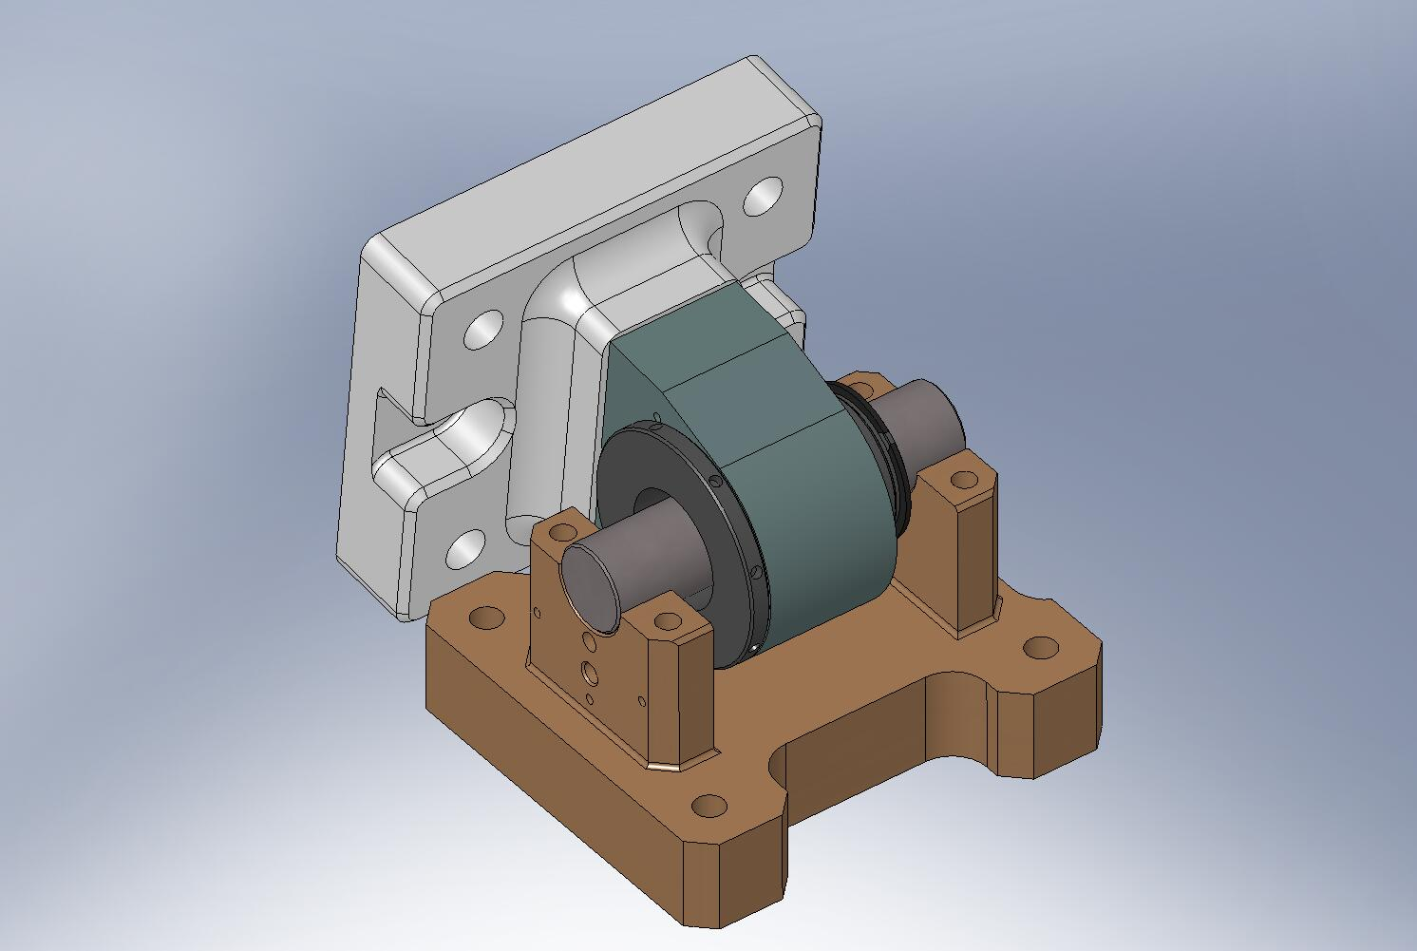
Flat side
Notched side
Figure 2.17. Engage two sides of the Locker Assembly by laying Spherical Pin in Kinematic Lock Base. Note the orientation of Locker Sleeve with respect to the Base.

- Place (2) Kinematic Lock Caps (20007936-2) over the ends of the Spherical Pin, orienting them as shown in Figure 2.18. Start the screws into the Kinematic Lock Base.
Hardware:
(4) 3/8”-16x1.75” SHCS (Holo-Krome)
(4) 3/8” vented washers (U-C Components)
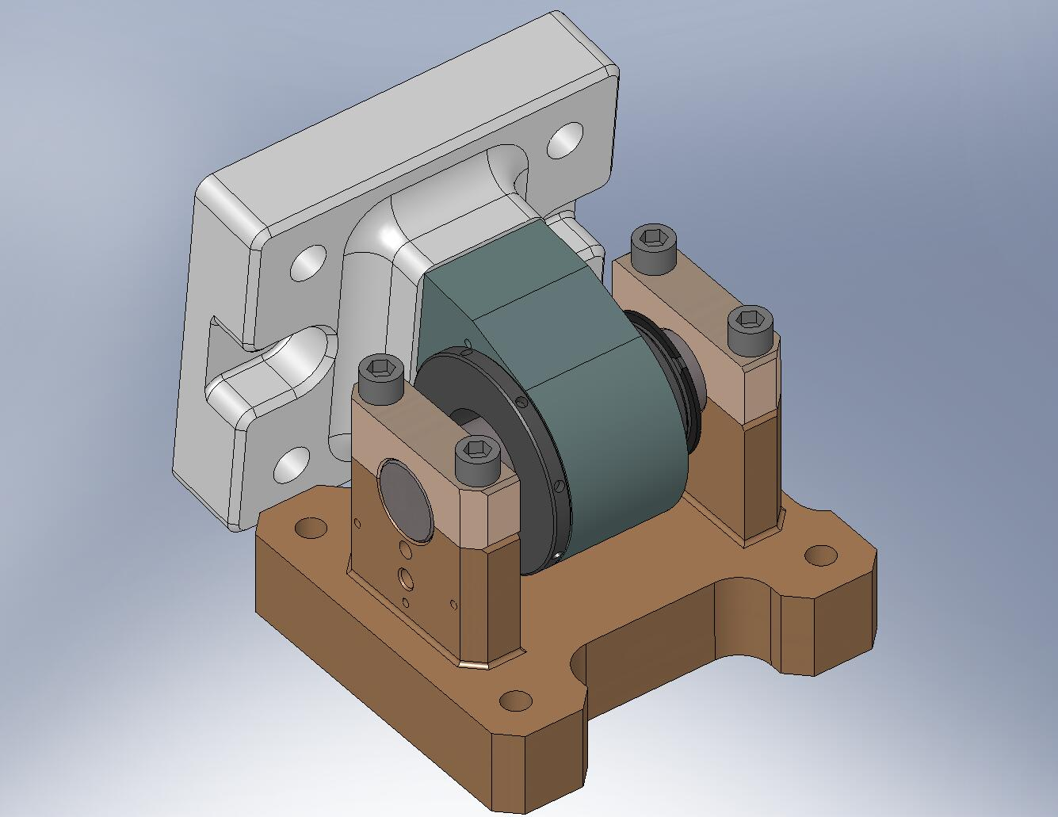
Figure 2.18. Kinematic Lock Caps clamped over the ends of the Spherical Pin.

- Iteratively tighten screws over Caps, until final torque is reached on all of them. There will be a small gap left between the top surfaces of the Base and the bottom of each Cap. Ideally, the gaps on either side of each Cap should be equal, but this is not required.
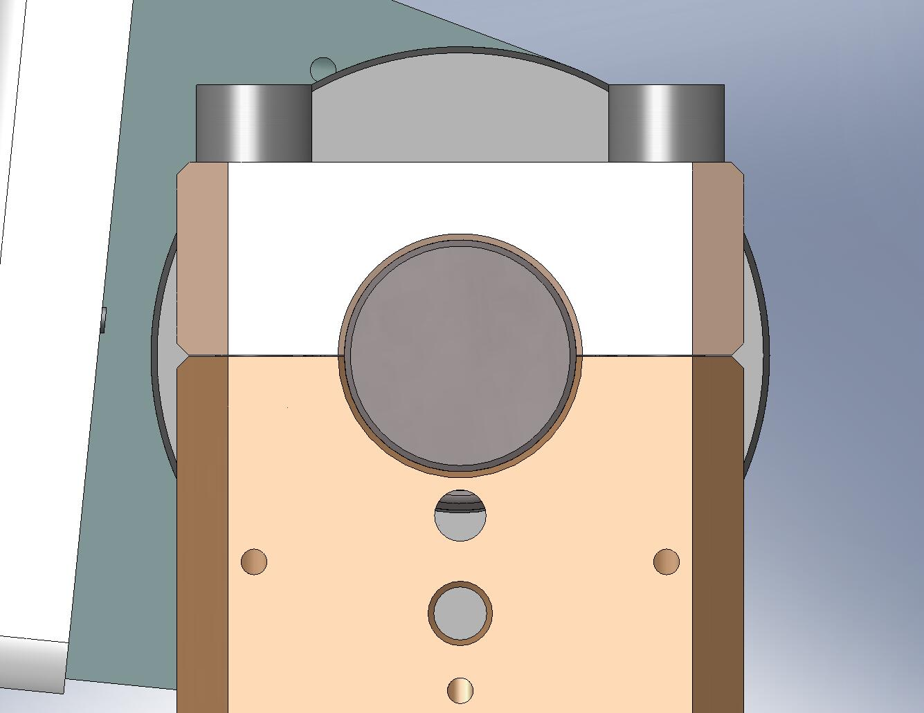
Figure 2.19. After tightening the screws for the Caps, there will still be some clearance between the Base and each Cap. Ideally, the gap on either side of a Cap should be equal, though this is not essential.

- The Locker Assemblies are complete. Set all (6) Lockers to the “locked” position, as shown in Figure 2.20 b, and set aside for later use.
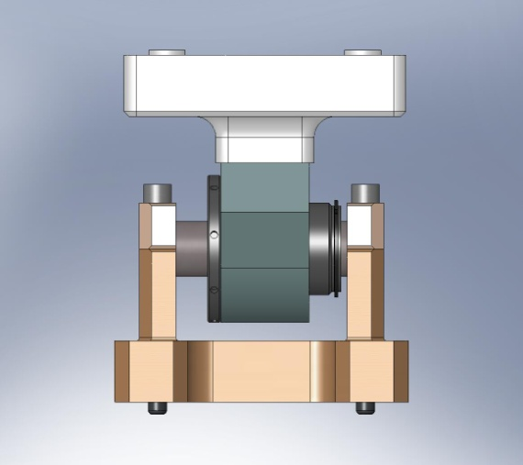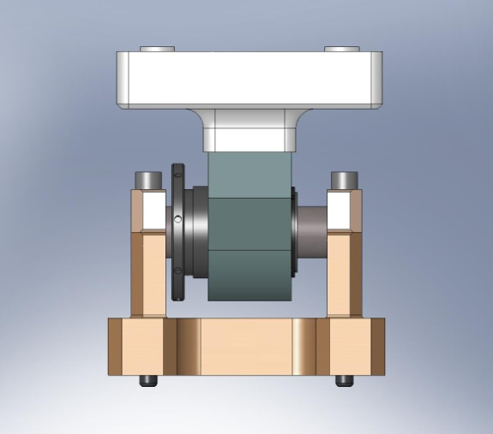
(b)

(a)

Figure 2.20. Locker Assembly in (a) “unlocked” and (b) “locked” positions. To lock the assembly, turn the knurled end of the Locker Sleeve counterclockwise, until the retaining ring comes against the back of the Locker Housing.

    - Assemble (3) Boxwork Assemblies (D071422)
- On a clean, flat surface, arrange the following plates:
  - (3) Rib, Tan, Flexure Cen (D071070)
  - (3) Rib, Rad, Flexure Out 2 (D071069)
  - (3) Rib, Rad, Flexure Out 1 (D071068)
  - (3) Rib, Tan, Flexure Mid (D071071)

the following procedure describes the assembly of one D071422 assembly. This should be repeated for the other two D071422’s, as well:
- With plates standing vertically, butt the Radial Ribs (D071069 and D071068) against either side of the Mid-Tangential Rib (D071071), as shown in Figure 2.21. Make sure pins seat properly into mating holes and slot.
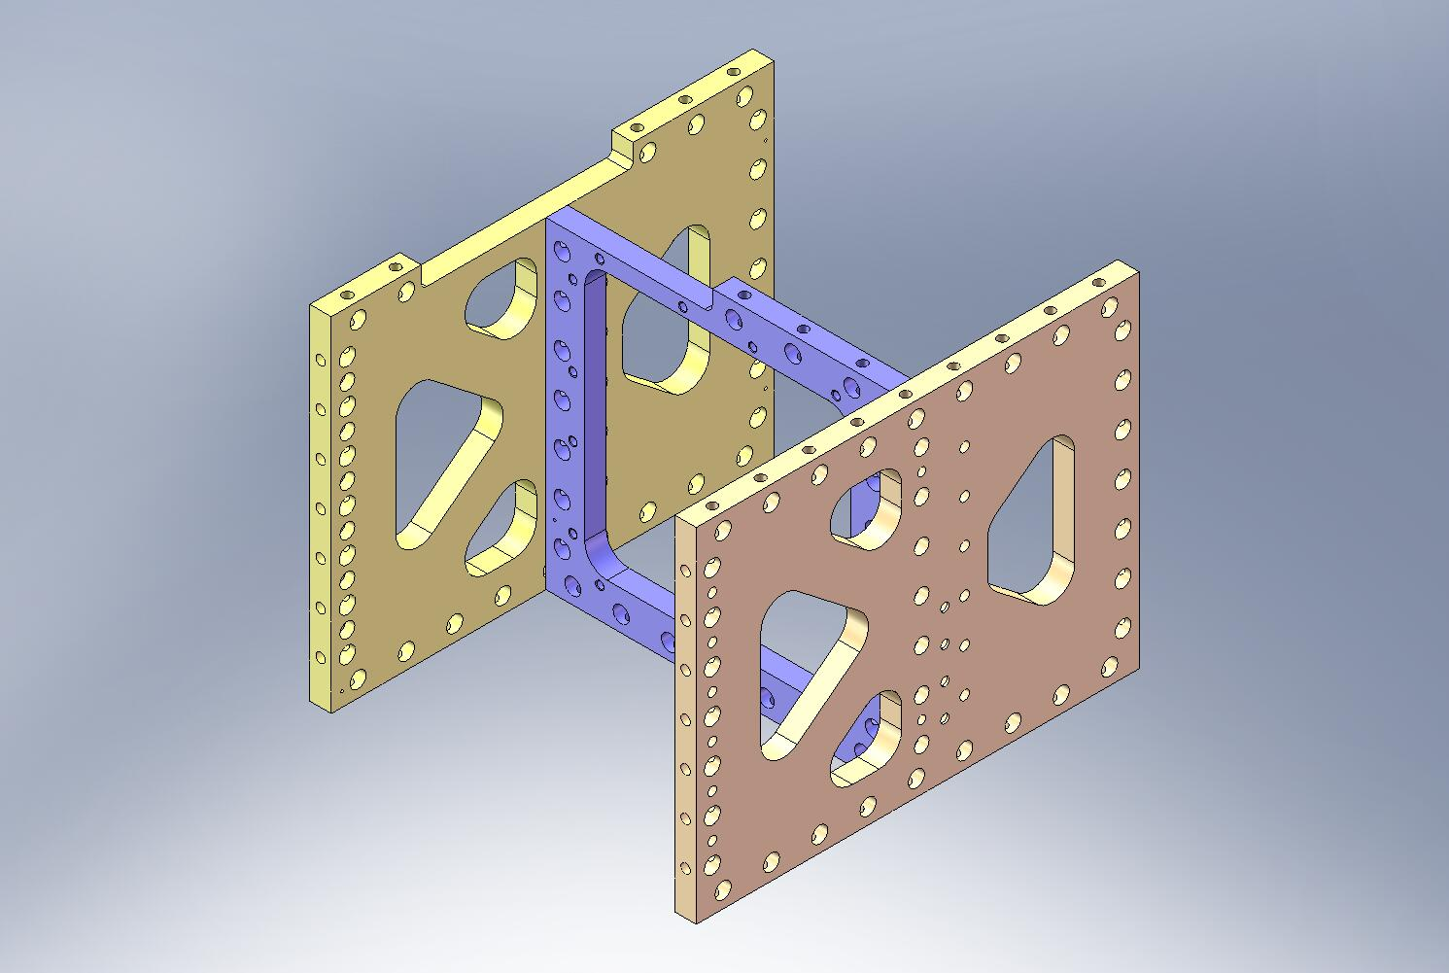
Figure 2.21. Step 1 of Boxwork Assembly. Radial Ribs are placed against Mid-Tangential Ribs.

- Place (14) Type 01 Barrel Nuts (D071250-01) into holes along the sides of the Mid-Tangential Rib (D071071). Flat side of each Nut should face away from its screw, as shown in Figure 2.22. Thread in mating screws. Snug, but don’t torque, yet.
Hardware:
(14) 3/8”-16x1.75” SHCS (Holo-Krome)
(14) 3/8” vented washers (U-C Components)
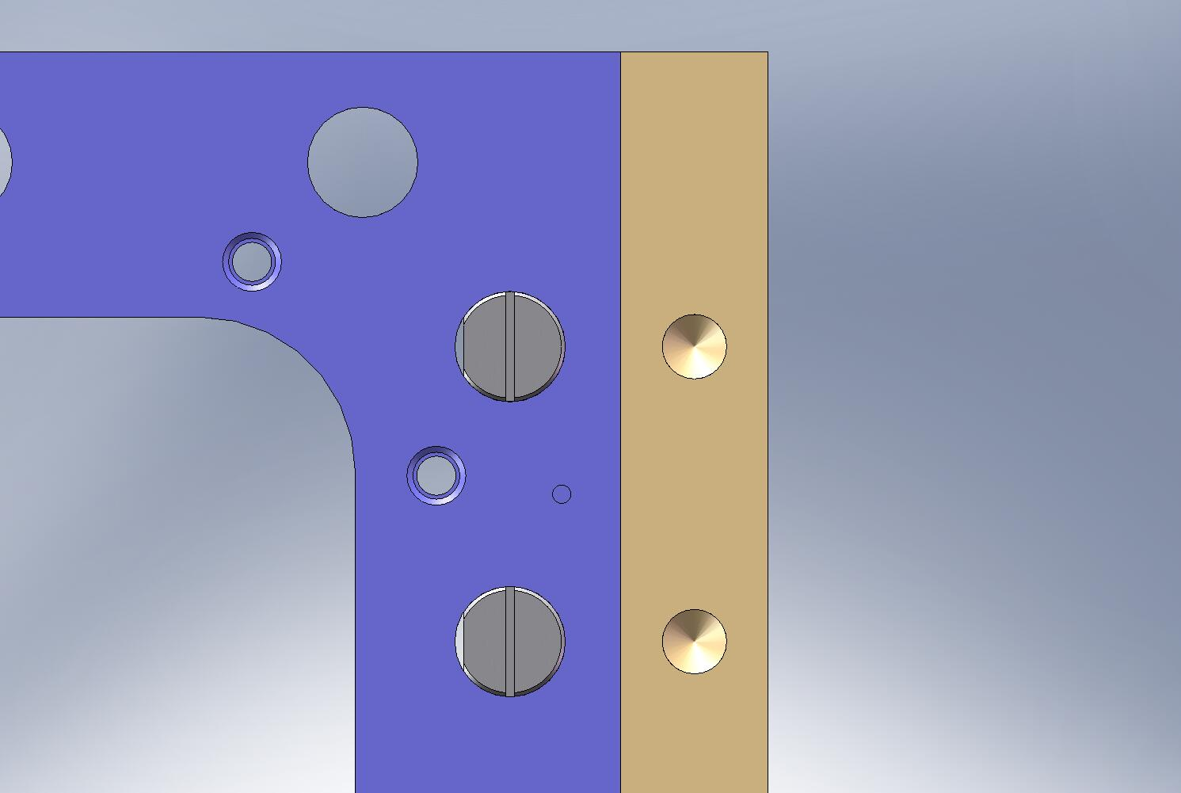
Screw enters from this side.
Air Gaps
Figure 2.22. Preferred orientation of Barrel Nuts. Flat side should always face away from the screw, to minimize stress concentrations. Virtual leaks are not a concern here.
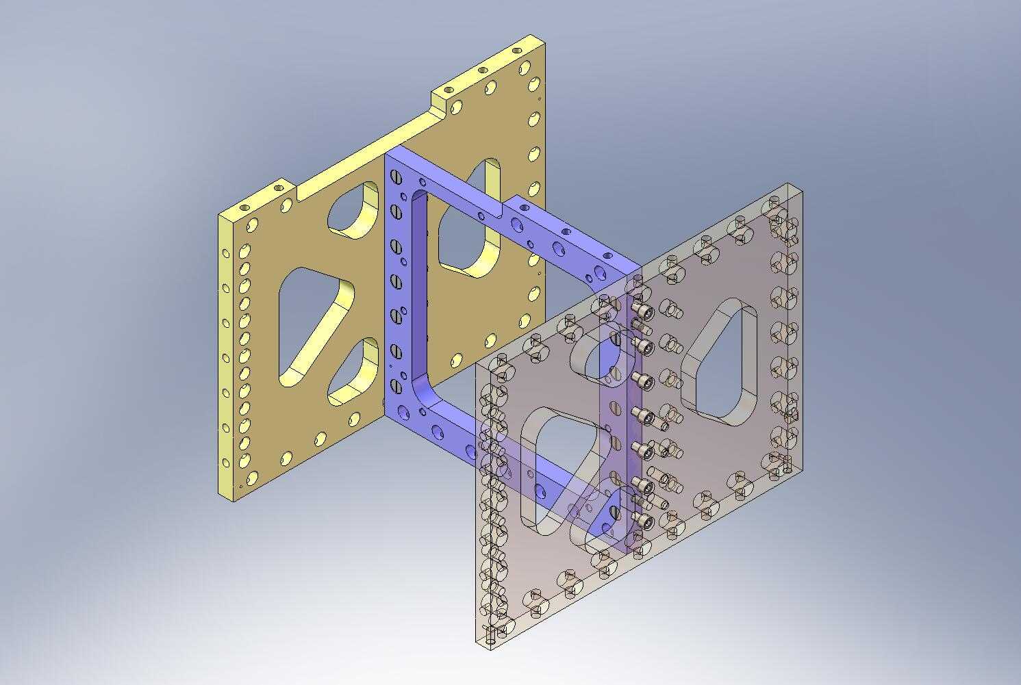
Barrel Nuts
Figure 2.23. Partial assembly of Boxwork, showing screws threaded into Barrel Nuts.

- Push Rib, Tan, Flexure Cen plate (D071070) onto ends of the two Radial Ribs (D071068 and D071069), as shown in Figure 2.24. Make sure pins seat properly into mating holes and slots.
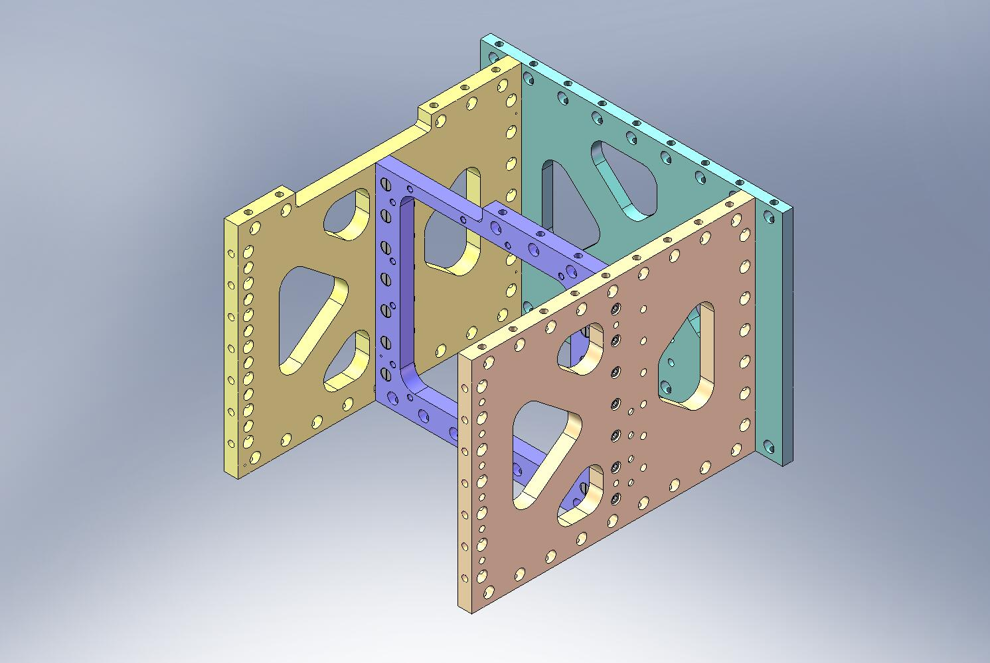
Figure 2.24. Step 2 of Boxwork Assembly. Center-Tangential Rib is placed against the Radial Ribs.

- Place (14) Type 01 Barrel Nuts (D071250-01) into holes along sides of radial plates (D071068 and D071069). Flats should face away from screws. Thread in screws. Snug, but don’t torque, yet.
Hardware:
(14) 3/8”-16x1.75” SHCS (Holo-Krome)
(14) 3/8” vented washers (U-C Components)
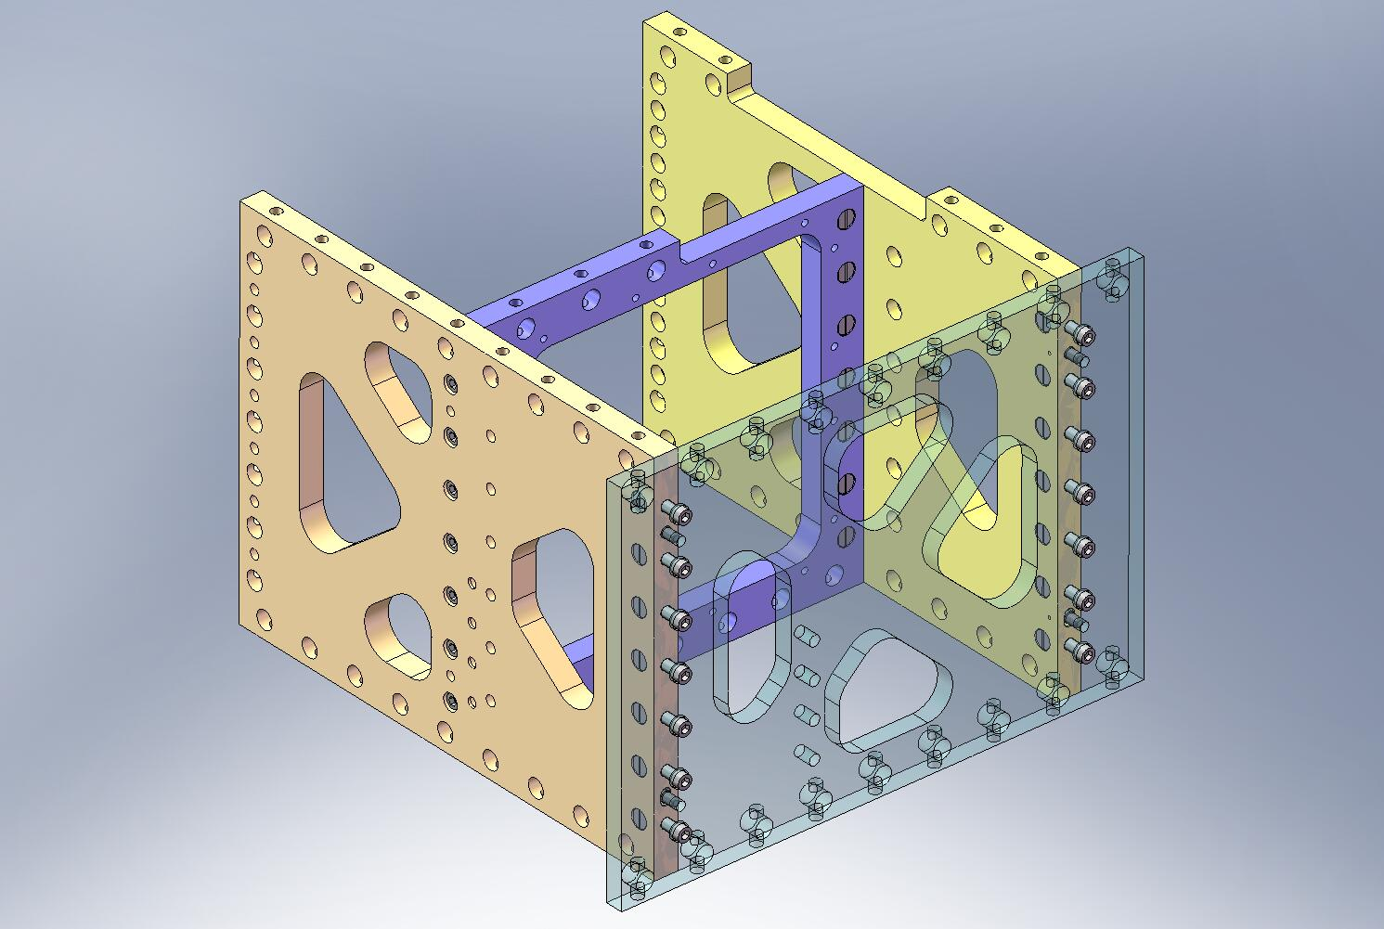
Barrel Nuts
Figure 2.25. Partial assembly of Boxwork, showing screws threaded into Barrel Nuts. Center-Tangential Rib is shown transparent, here.

- Make sure there are no large gaps between mating surfaces. Torque screws to final spec, starting with screws in Center-Tangential Rib (D071070). Next, torque screws for Mid-Tangential Rib (D071071) to spec – order here does not matter.
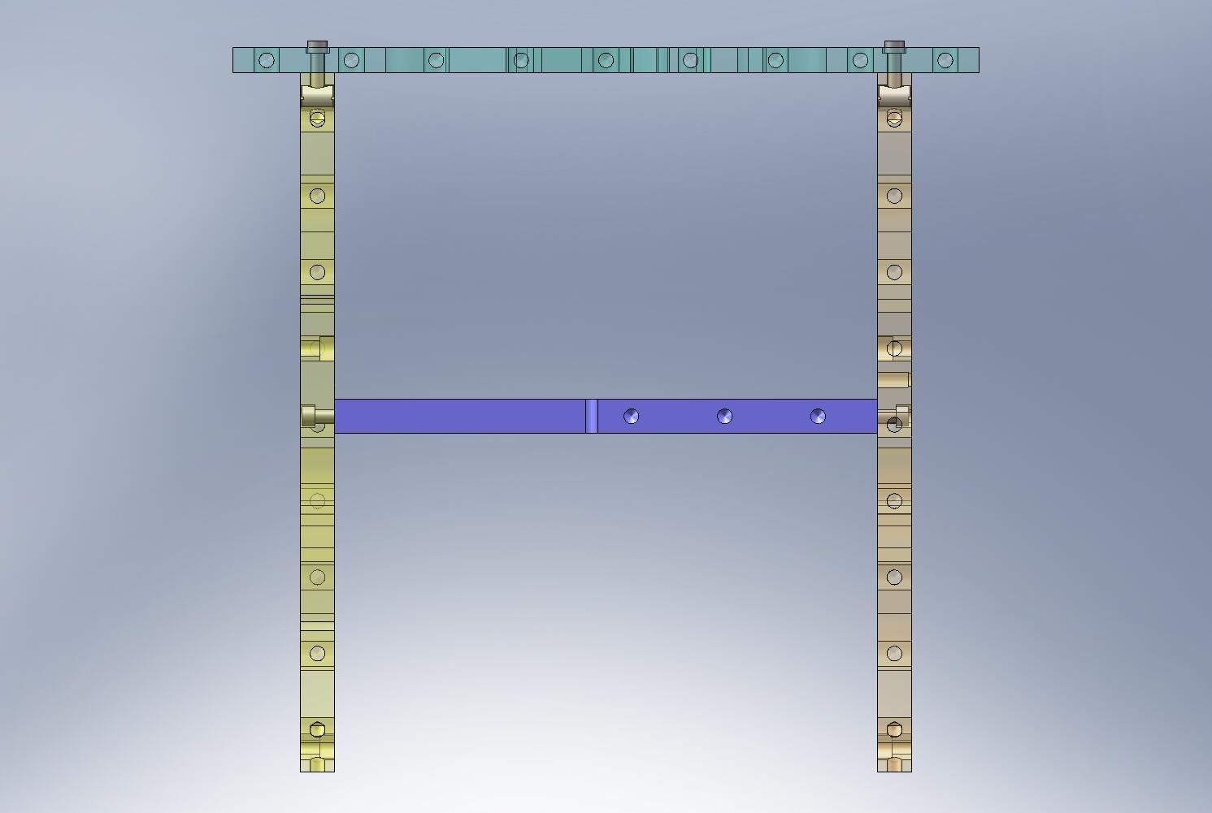
… Torque side screws last.
Torque front screws first…
Figure 2.26. Boxwork Assembly screws should be tightened in the order shown here.

- Screw on (2) 60 Deg Rib Brackets (D071073), in orientation shown in Figure 2.27. Snug screws, but do not torque. These will not be torqued until near the end of the assembly of the Stage 1 Frame (D071421).
Hardware:
(12) 3/8”-16x1.5” SHCS (Holo-Krome)
(12) 3/8” vented washers (U-C Components)
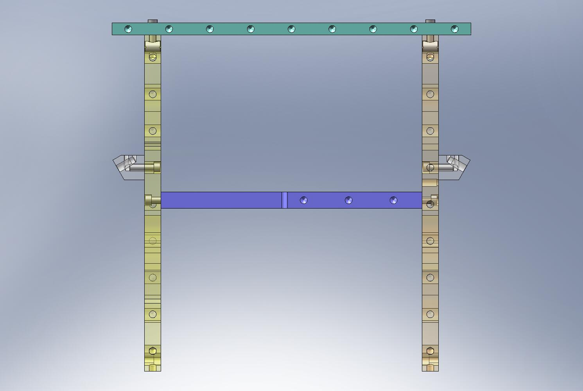
Figure 2.27. A top view of the Boxwork Assembly, showing (2) 60 Deg Rib Brackets screwed to the sides of the Radial Ribs. Note the orientation of the Brackets.

- Screw on (2) Outer Wall, Bracket 90 parts (D071061), in orientation shown in Figure 2.28. Snug screws, but do not torque, yet.
Hardware:
(12) 3/8”-16x1.5” SHCS (Holo-Krome)
(12) 3/8” vented washers (U-C Components)
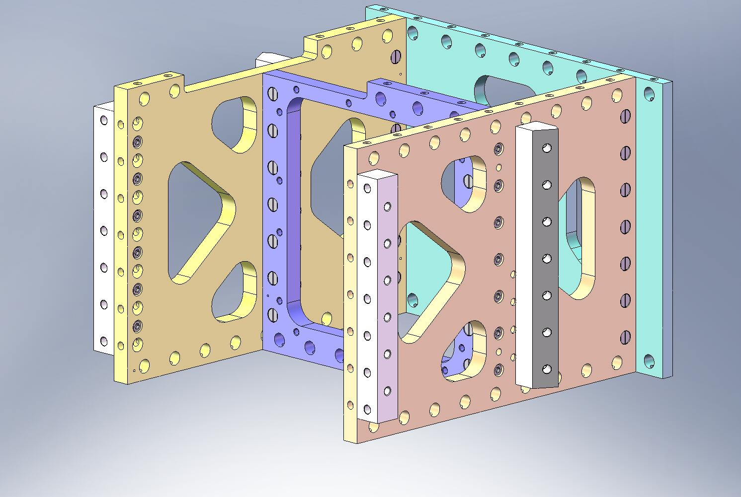
Figure 2.28. 90 Deg Outer Wall Brackets mounted to Boxwork Assembly. The screws for both sets of Brackets are not torqued until later in the assembly of Stage 1.

- Flip over Boxwork Assembly. Caution: assembly is heavy (92 lbs)! Press (3) 3/8”x.75” pins into bottom of Radial Ribs (D071068 and D071069). Pins should remain .25” proud of the plate surfaces.
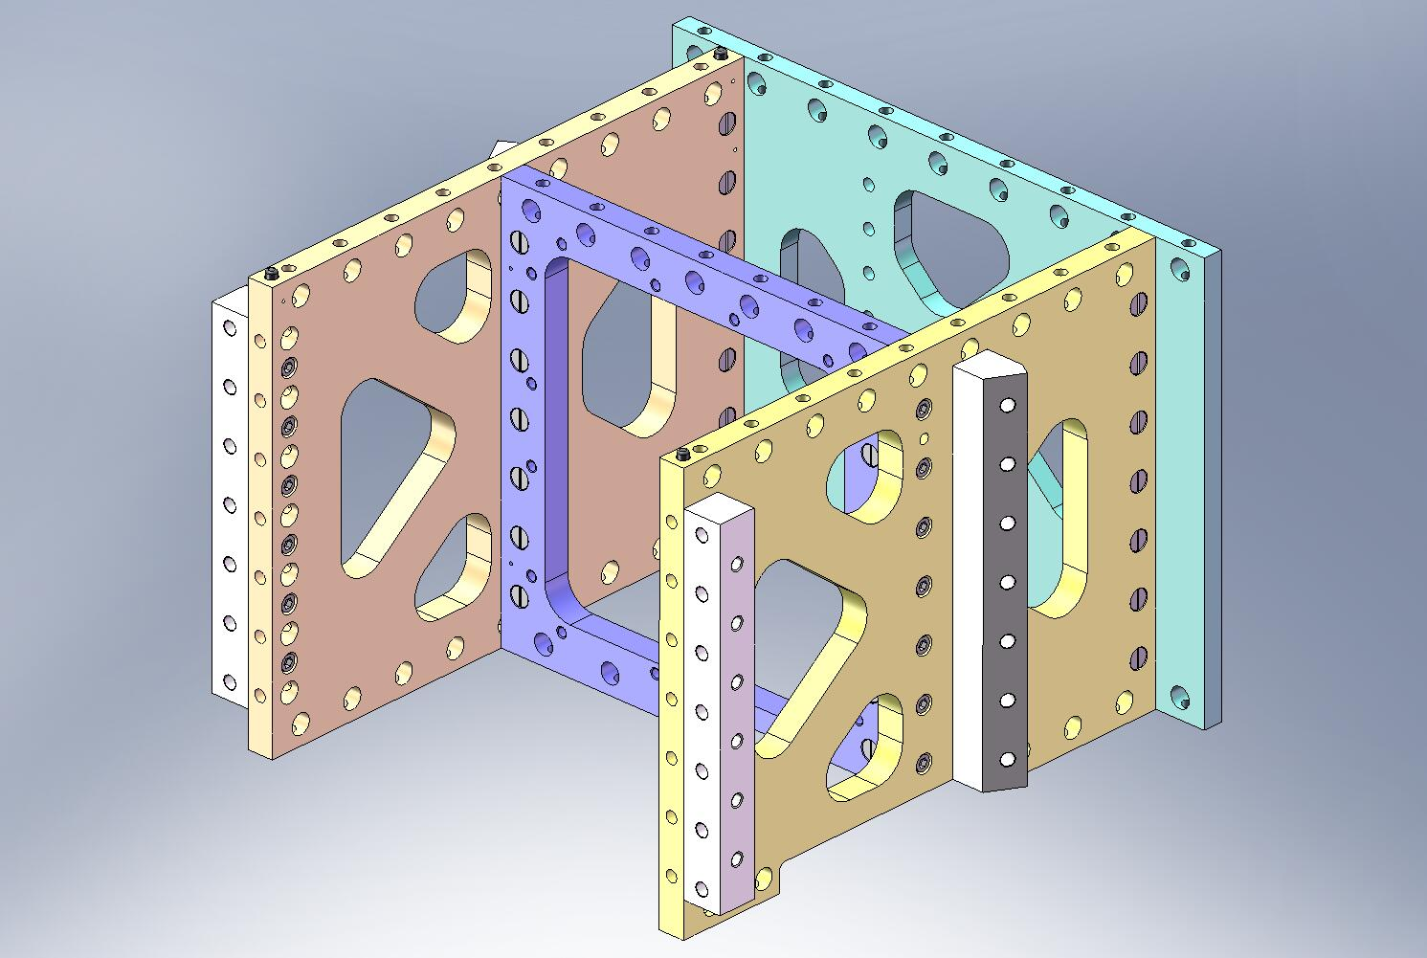
Figure 2.29. Dowel pins pressed into bottom of Boxwork Assembly. After this step, the Boxworks are ready for installation in Stage 1.

- Boxwork Assembly is now complete. Set aside for later use.

    - Assemble (3) Pitchfork Assemblies (D071423)
- On a clean, flat surface, arrange the following plates:
  - (3) Rib, Tan, GS-13 Mid (D071052)
  - (3) Rib, Tan, GS-13 Cen (D071053)
  - (3) Rib, Rad, GS-13 Mid (D071054)
  - (3) Rib, Rad, GS-13 Out 1 (D071055)
  - (3) Rib, Rad, GS-13 Out 2 (D071056)

the following procedure describes the assembly of one D071423 assembly. This should be repeated for the other two D071423’s, as well:
- Place Mid-Radial Rib (D071054) against Mid-Tangential Rib (D071052), allowing pins to seat properly in hole and slot.
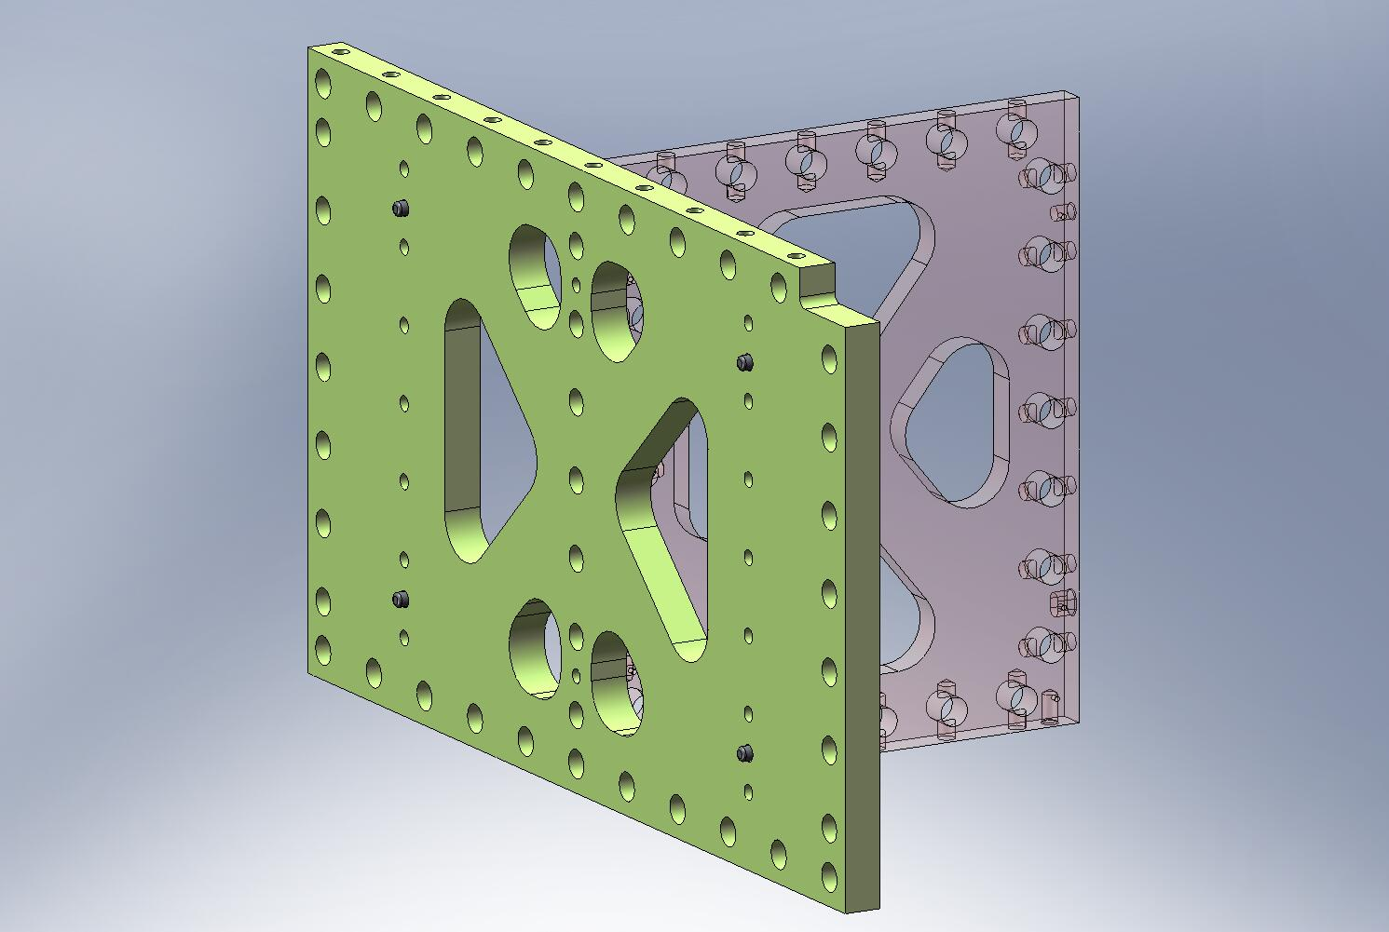
Figure 2.30. Step 1 of Pitchfork Assembly. The Mid-Radial Rib is seated against the Mid-Tangential Rib. Note location of lower dowel pin hole in Mid-Radial Rib.

- Place (7) Type 00 Barrel Nuts (D071250-00) into holes along the side of the Mid-Radial Rib (D071054). Flat side of each Nut should face away from its screw, as shown in Figure 2.31. Thread in mating screws. Torque to final spec.
Hardware:
(7) 3/8”-16x1.75” SHCS (Holo-Krome)
(7) 3/8” vented washers (U-C Components)
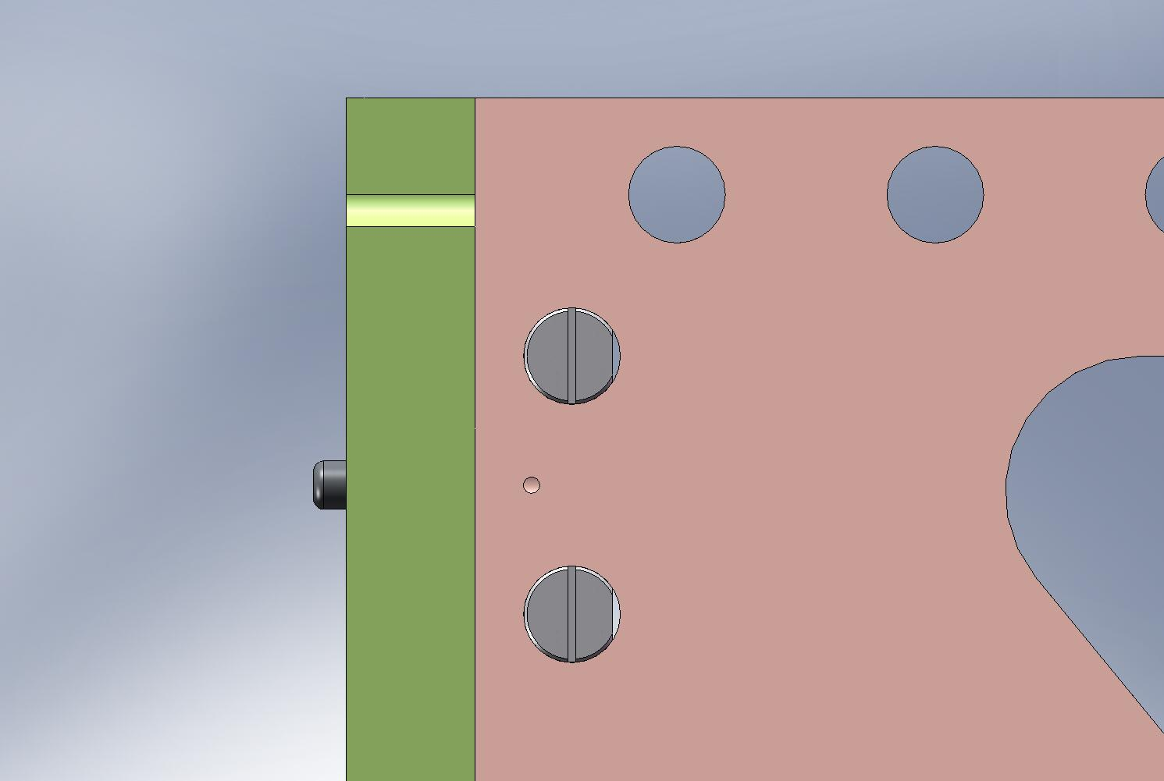
Screw enters from this side.
Air Gaps
Figure 2.31. Preferred orientation of Barrel Nuts. Flat side should always face away from the screw, to minimize stress concentrations.
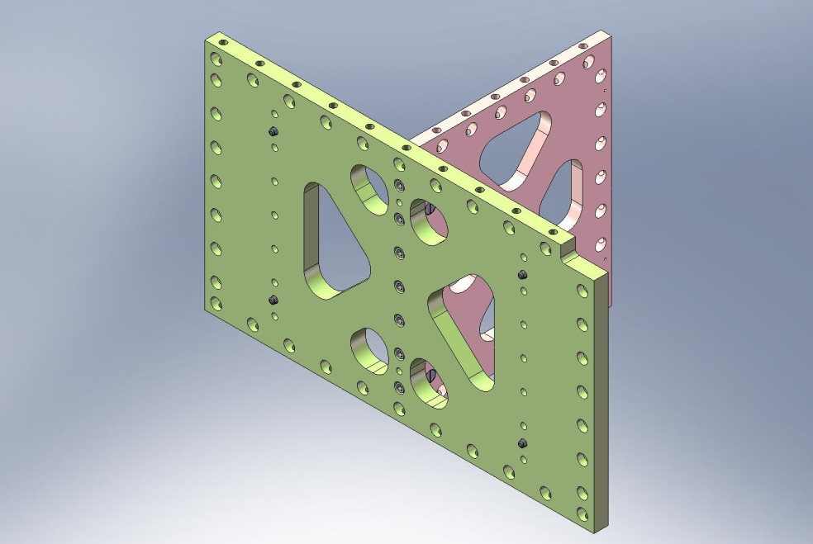
Torque to final spec.
Figure 2.32. Partial assembly of Pitchfork. Screws should be torqued to final spec, before continuing.

- Place Center-Tangential Rib (D071053) against other end of Mid-Radial Rib (D071054), allowing pins to seat properly in hole and slot. Orientation of Center-Tangential Rib does not matter (it has mirror symmetry).
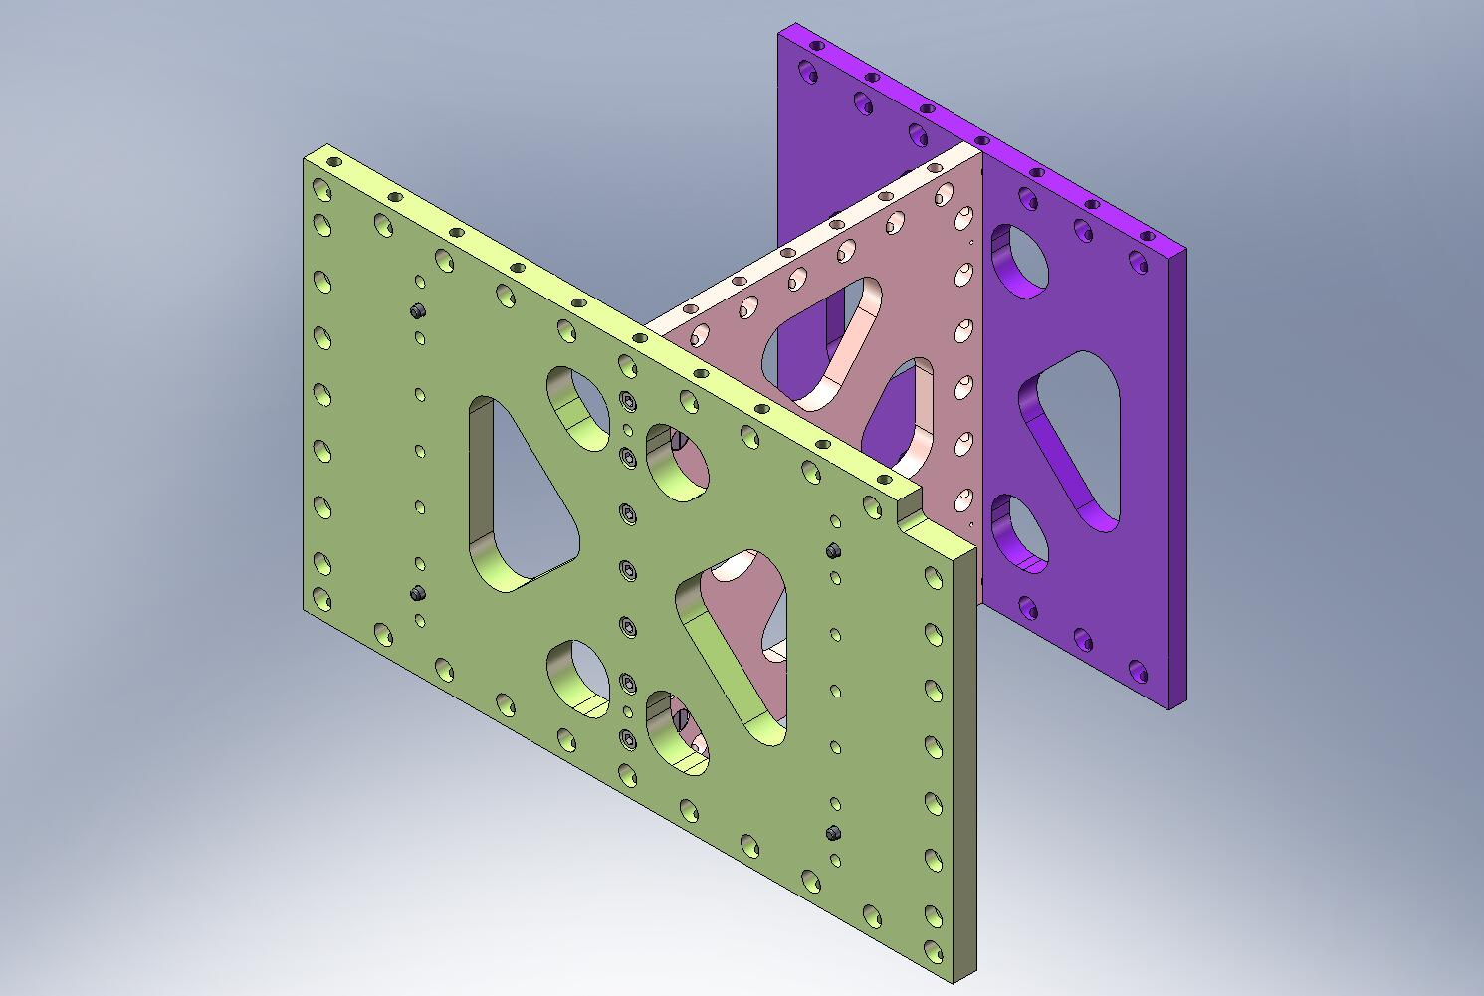
Figure 2.33. Step 2 of Pitchfork Assembly. Center-Tangential Rib is pressed against back end of Mid-Radial Rib.

- Insert (7) Type 00 Barrel Nuts (D071250-00) into holes along the side of the Mid-Radial Rib (D071054). Flats should face away from screws. Thread in screws. Torque to final spec.
Hardware:
(7) 3/8”-16x1.75” SHCS (Holo-Krome)
(7) 3/8” vented washers (U-C Components)
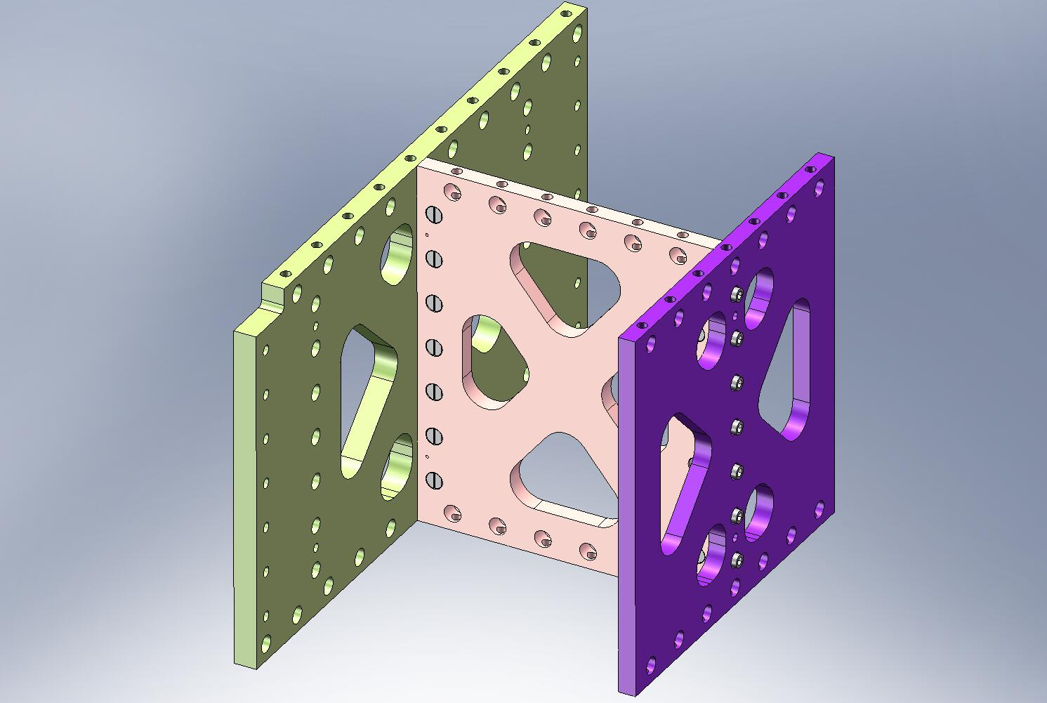
Torque to final spec.
Figure 2.34. Bolt Center-Tangential Rib to Mid-Radial Rib, using Type 00 Barrel Nuts. Torque to final spec.

- Mate GS-13 Out 2 Rib (D071056) against back side of Mid-Tangential Rib (D071052). Pins should seat properly in hole and slot.
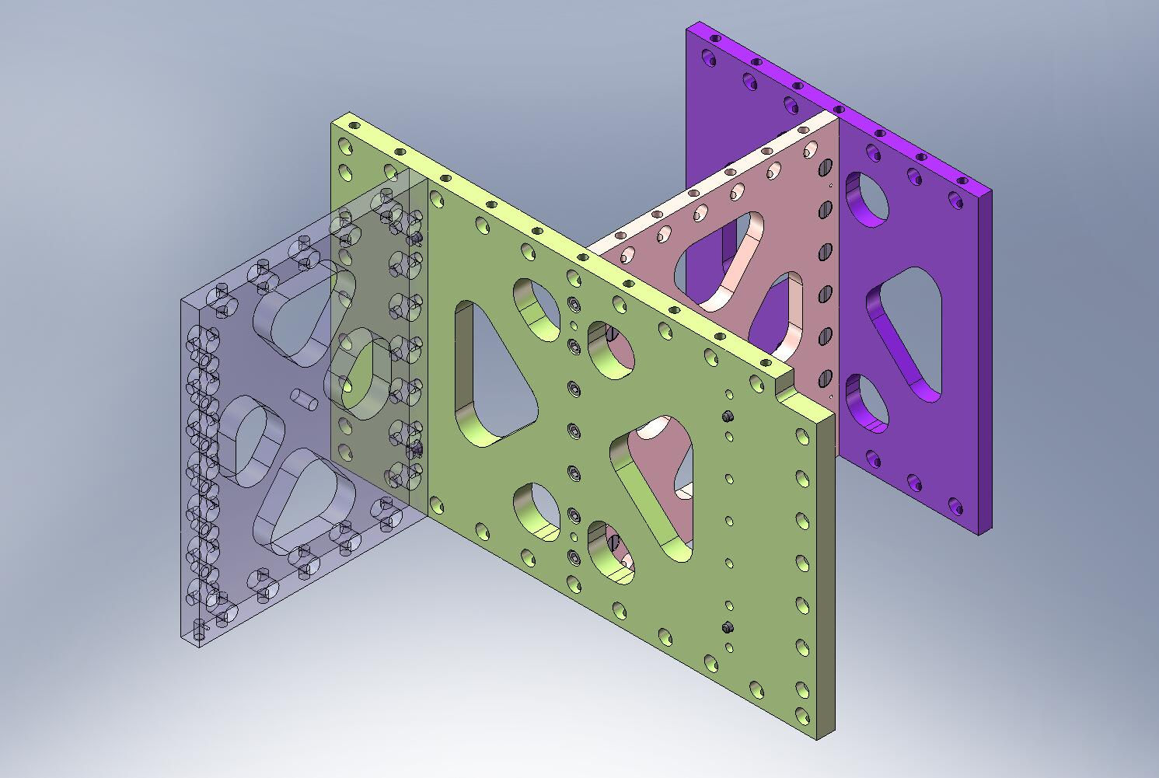
Figure 2.35. Step 3 of Pitchfork Assembly. GS-13 Out 2 Rib mates with dowel pins on back of Mid-Tangential Rib. Note orientation of bottom dowel pin hole in GS-13 Out 2 Rib.

- Insert (7) Type 01 Barrel Nuts (D071250-01) into holes along the side of the GS-13 Out 2 Rib (D071056). Flats should face away from screws. Thread in screws. Torque to final spec.
Hardware:
(7) 3/8”-16x1.75” SHCS (Holo-Krome)
(7) 3/8” vented washers (U-C Components)
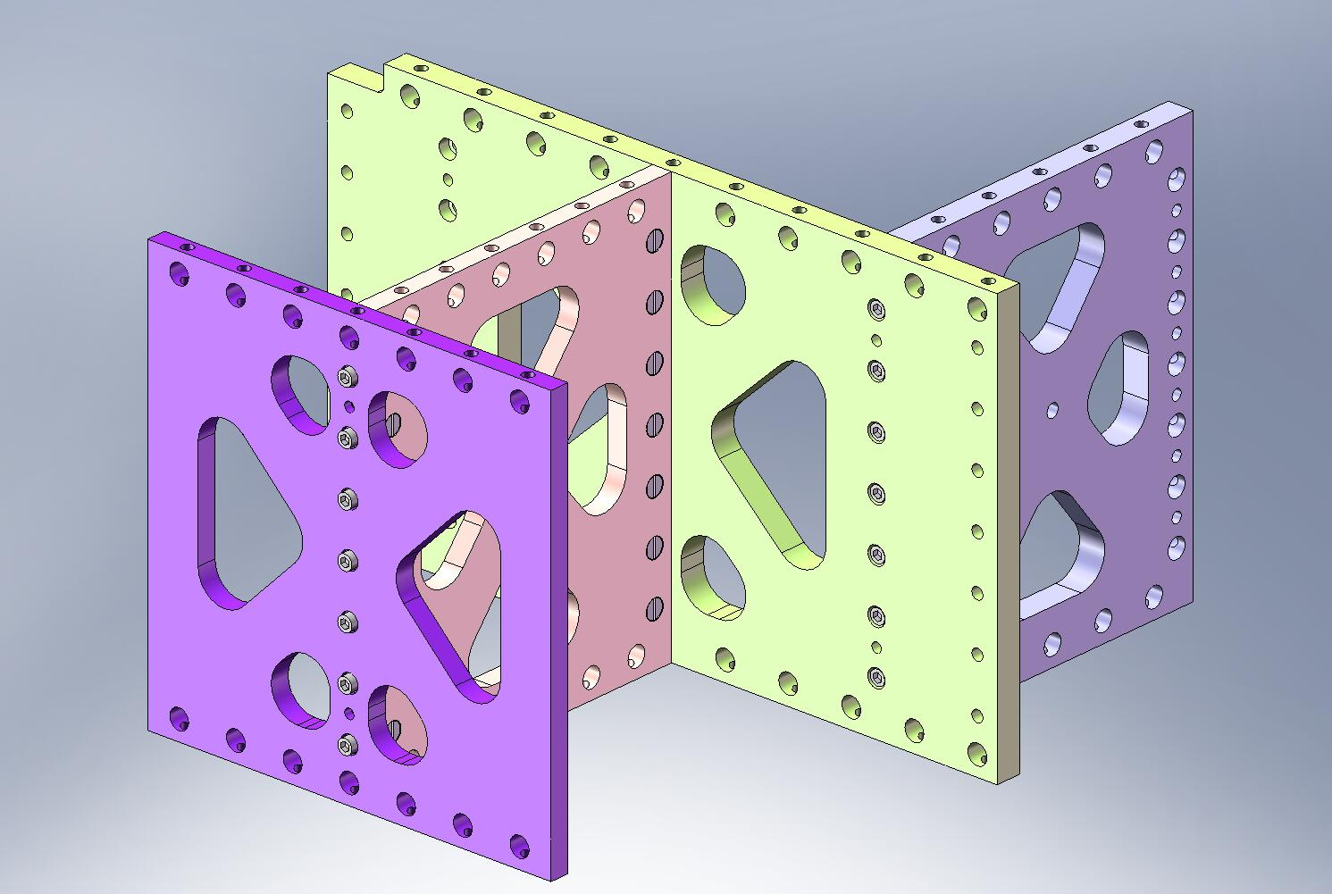
Torque to final spec.
Figure 2.36. Bolt GS-13 Out 2 Rib to Mid-Tangential Rib, using Type 01 Barrel Nuts. Torque to final spec.

- Mate GS-13 Out 1 Rib (D071055) to Mid-Tangential Rib (D071052). Allow pins to seat properly in hole and slot.
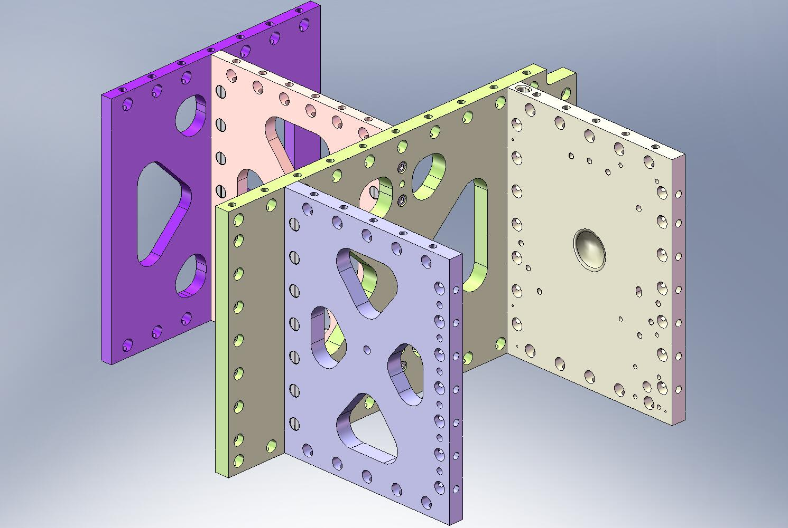
Figure 2.37. Step 4 of Pitchfork Assembly. GS-13 Out 1 Rib mates with Mid-Tangential Rib. Check orientation of Ribs.

- Insert (7) Type 01 Barrel Nuts (D071250-01) into holes along the side of the GS-13 Out 1 Rib (D071055). Flats should face away from screws. Thread in screws. Torque to final spec.
Hardware:
(7) 3/8”-16x1.75” SHCS (Holo-Krome)
(7) 3/8” vented washers (U-C Components)
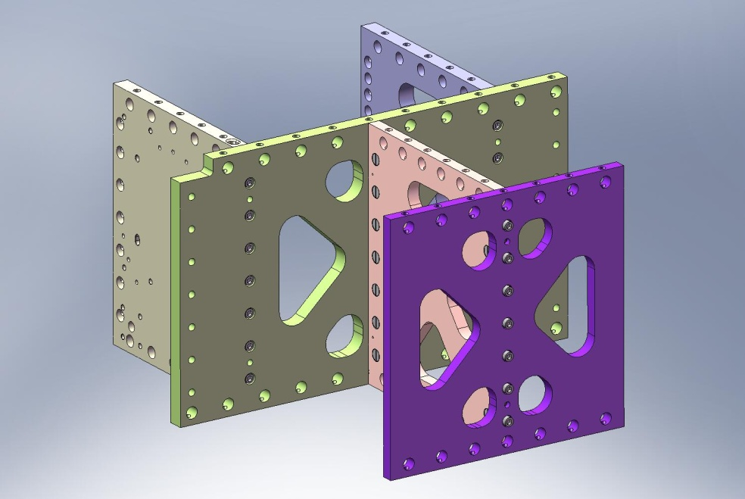
Torque to final spec.
Figure 2.38. Bolt GS-13 Out 1 Rib to Mid-Tangential Rib, using Type 01 Barrel Nuts. Torque to final spec.

- Screw Outer Wall, Bracket 90 (D071061) onto side of GS-13 Out 2 Rib (D071056), in orientation shown in Figure 2.39. Snug screws, but do not torque, yet.
Hardware:
(6) 3/8”-16x1.5” SHCS (Holo-Krome)
(6) 3/8” vented washers (U-C Components)
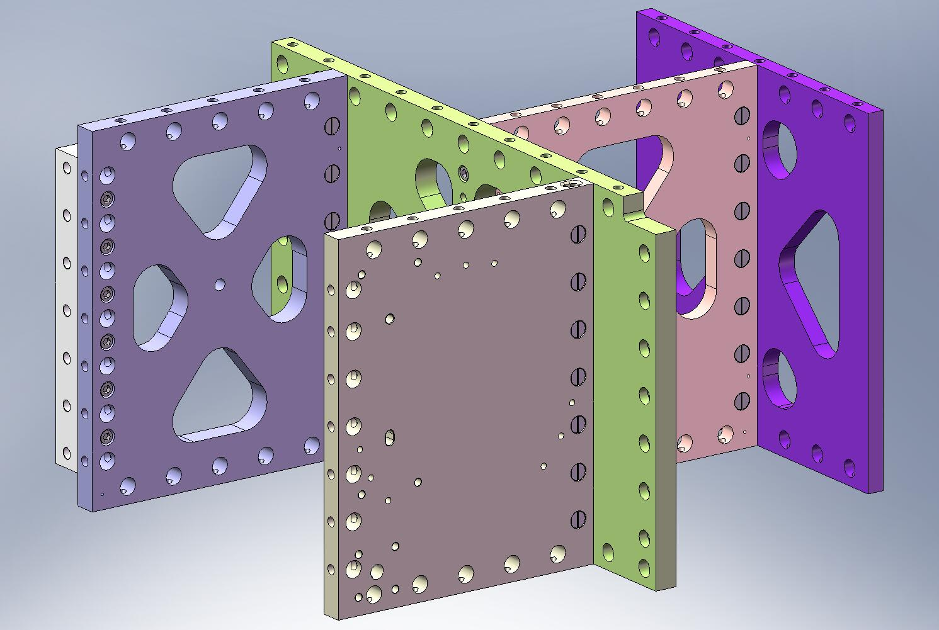
Figure 2.39. 90 Deg Outer Wall Bracket mounted to Pitchfork Assembly. The screws for the Bracket are not torqued until later in the assembly of Stage 1.

- Flip over Pitchfork Assembly. Caution: assembly is heavy (96 lbs)! Press (4) 3/8”x.75” pins into bottom of Radial Ribs (D071068 and D071069). Pins should remain .25” proud of the plate surfaces.
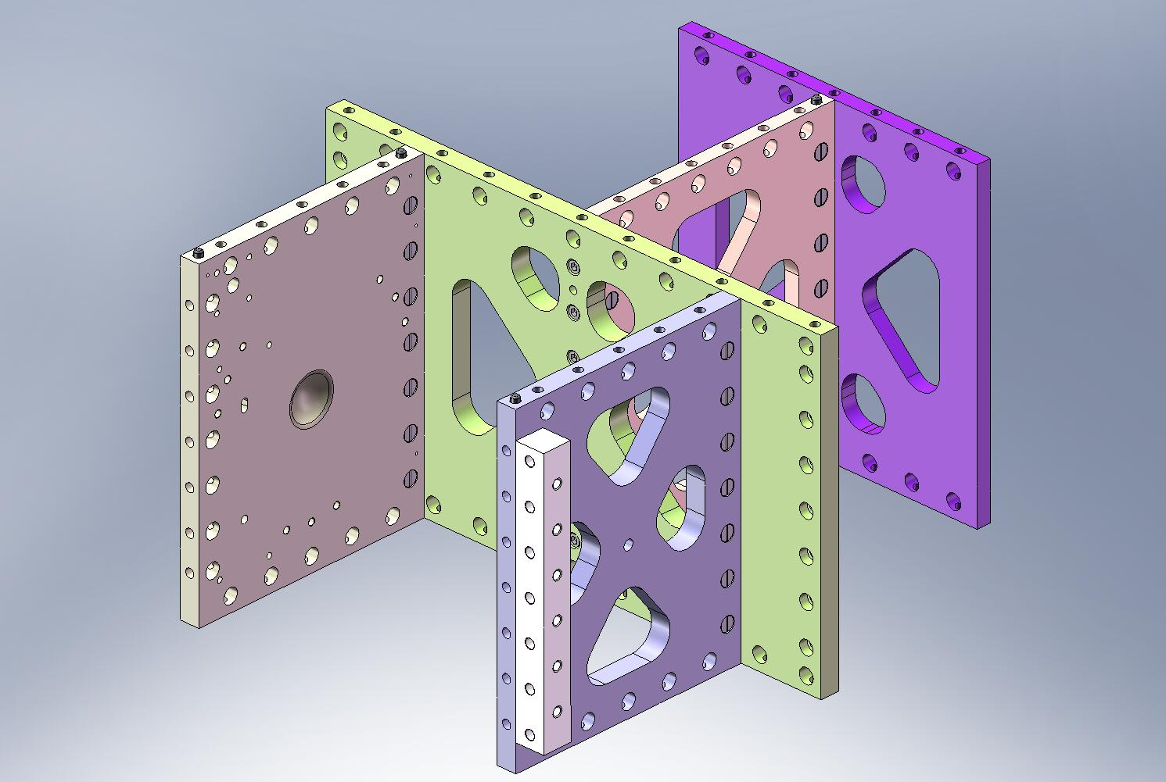
Figure 2.40. Dowel pins pressed into bottom of Pitchfork Assembly. After this step, the Pitchforks are ready for installation in Stage 1.

- Pitchfork Assembly is now complete. Set aside for later use.

2.2 Build Up top of Stage 1 Frame Assembly (D071421)
- Lower each of (3) Boxwork Assemblies (D071422) onto Stage 1 Floor (D071051). Make sure all (3) pins in bottom of each Boxwork seat properly in their mating holes and slots. Caution: Boxwork Assemblies are heavy (92 lbs)!
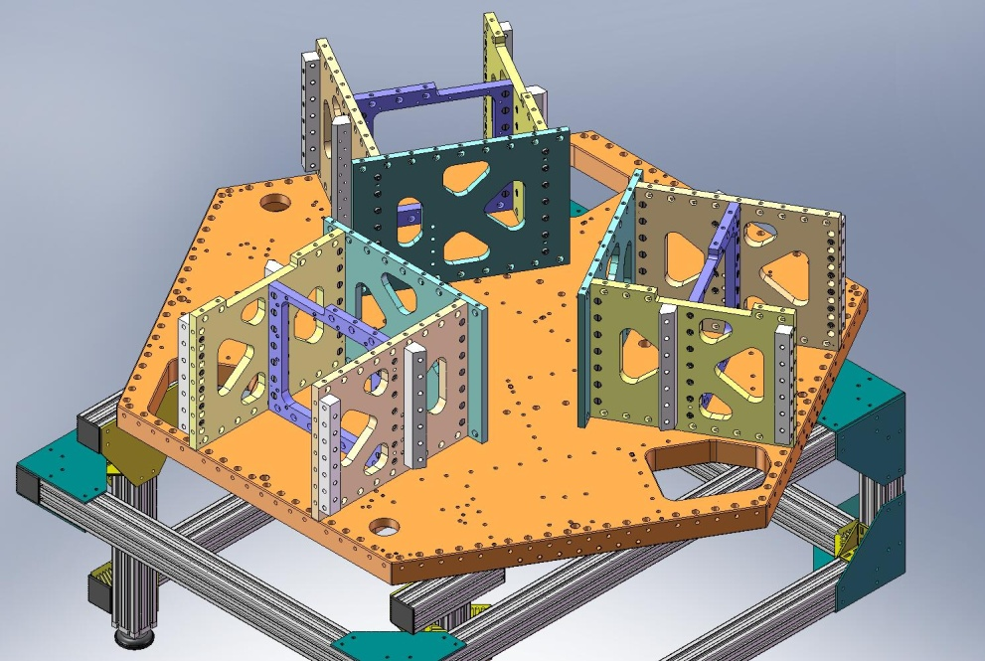
Figure 2.41. Boxworks placed on top surface of Stage 1 Floor.

- Place (75) Type 01 Barrel Nuts (D071250-01) in holes lining the bottom of the Radial and Mid-Tangential Ribs within each Boxwork Assembly. Place (27) Type 00 Barrel Nuts (D071250-00) in holes lining the bottom of the Center-Tangential Ribs. Align flats opposite screws.
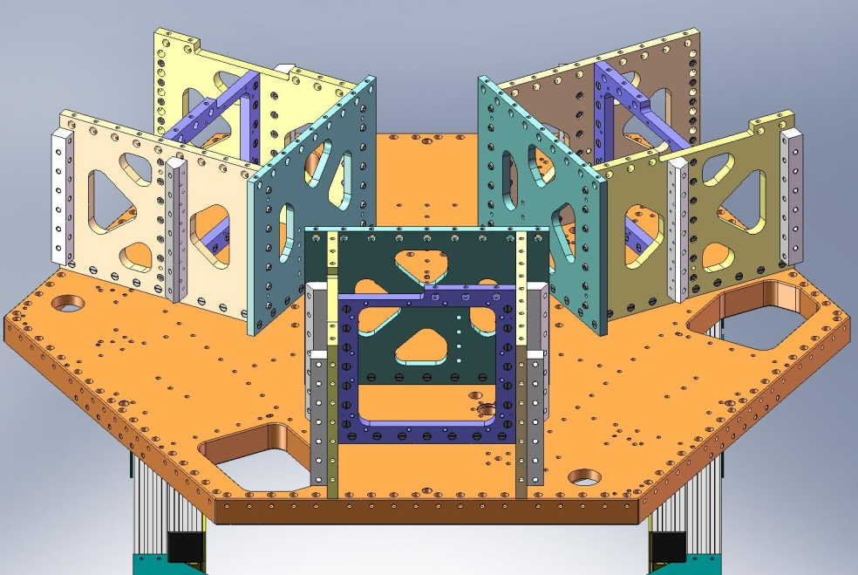
Type 01
Barrel Nuts
Type 00
Barrel Nuts
Figure 2.42. Type 00 (length = 3/4”) Barrel Nuts are used in the Center-Tangential Rib. Type 01 (length = 1”) Barrel Nuts are used in the Radial and Mid-Tangential Ribs.

- Thread screws into Barrel Nuts, from underneath Stage 1 Floor. Snug, but don’t torque, yet.
Hardware:
(102) 3/8”-16x1.75” SHCS (Holo-Krome)
(102) 3/8” vented washers (U-C Components)
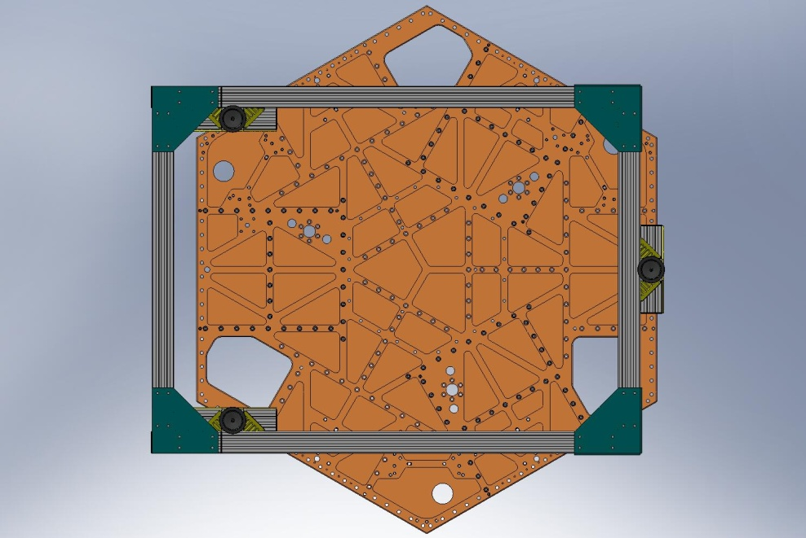
Figure 2.43. Snug (102) screws into Boxwork Barrel Nuts, from underneath Stage 1 Floor.

- Torque all (102) screws to final spec, in the following order:
    - (3x 7) Mid-Tangential Rib screws
    - (3x 9) Flexure Out 1 Radial Rib screws
    - (3x 9) Flexure Out 2 Radial Rib screws
    - (3x 9) Center-Tangential Rib screws

- Lift the Stage 1 Floor and rotate it 60 degrees, as shown in Figure 2.44. This will allow access for bolting on the Pitchfork Assemblies (D071423), later in the procedure.
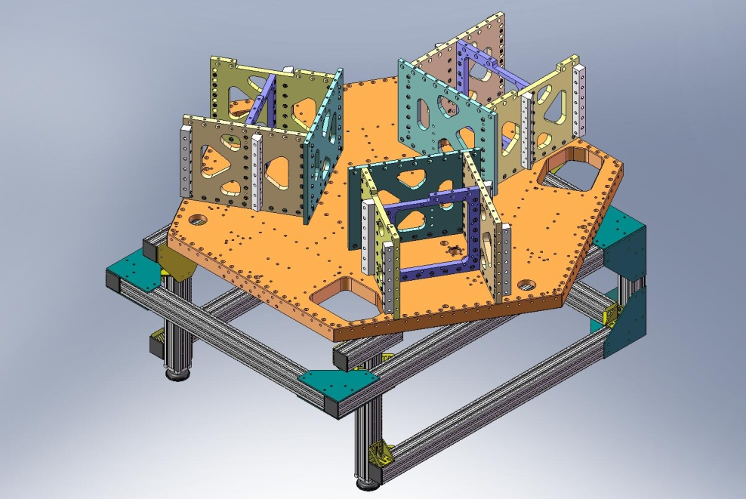
Figure 2.44. Stage 1 Floor must be rotated 60 degrees, to allow access for the Pitchfork Assembly mounting screws.

- Place (3) Flexure Posts (D071074) on top of the Stage 1 Floor. Check that the rim on the bottom of each Post seats properly in the mating counterbore. Start screws from underneath the Floor. Snug, but do not torque.
Hardware:
(18) 3/8”-16x1.75” SHCS (Holo-Krome)
(18) 3/8” vented washers (U-C Components)
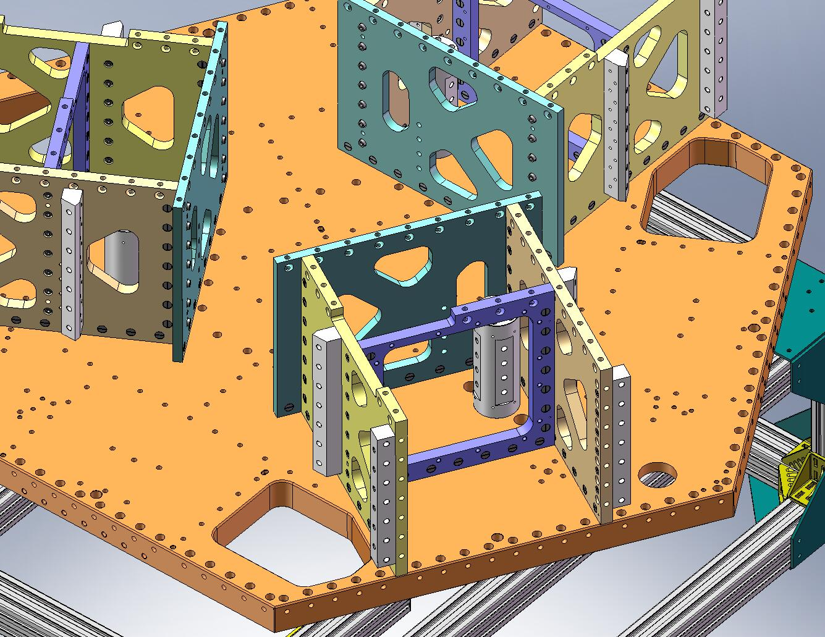
Figure 2.45. (3) Flexure Posts are installed on the Stage 1 Floor. Note the orientation of the flats on the side of the Post.
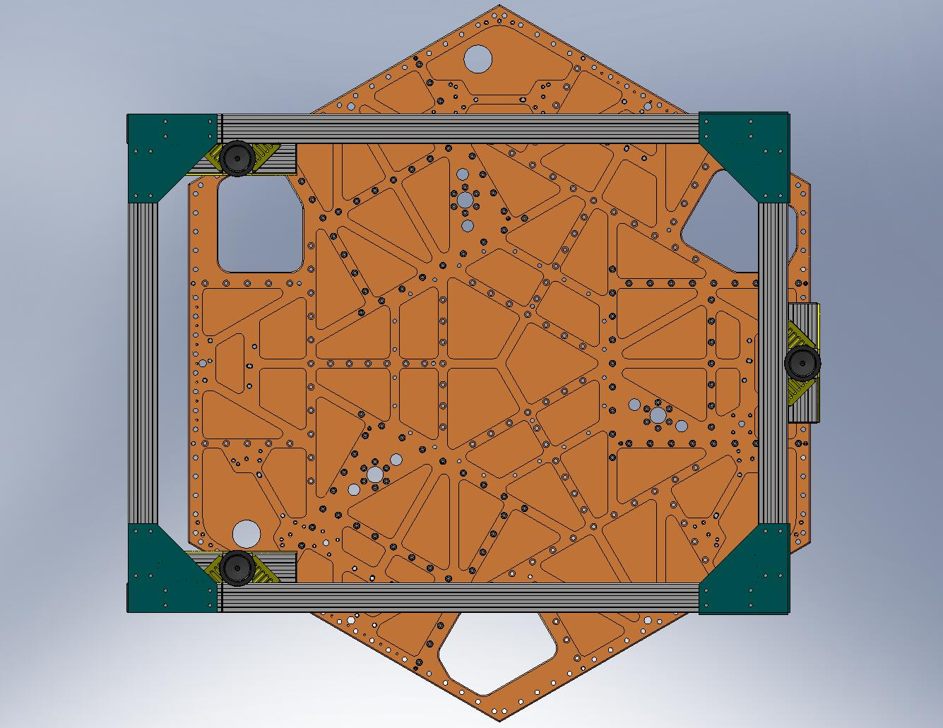
Figure 2.46. Insert screws into bottom of Flexure Posts.

- Place (3) Tangential Flexure Post Brackets (D071076). Start screws into Boxwork Radial Ribs first, then start screws into Flexure Posts. Snug, but don’t torque.
Hardware:
(12) 3/8”-16x1.5” SHCS (Holo-Krome) – into the Boxwork Radial Ribs
(12) 3/8”-16x3.25” SHCS (McMaster-Carr) – into the Flexure Posts
(24) 3/8” vented washers (U-C Components)
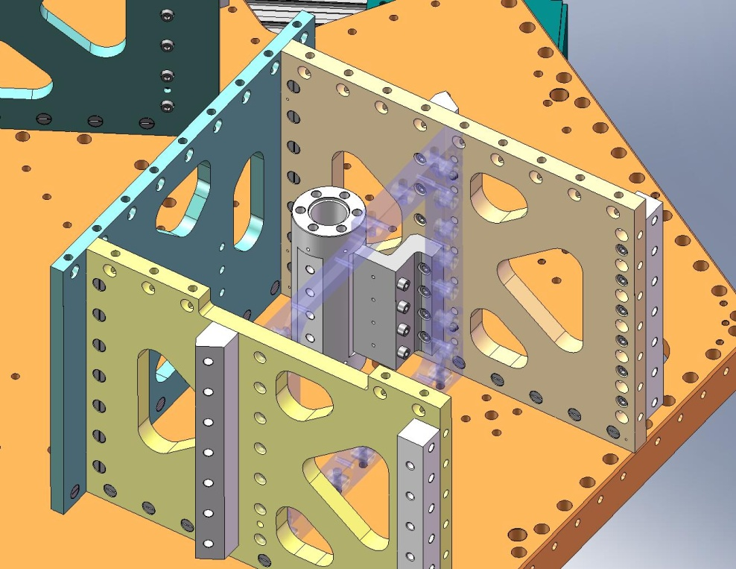
Start these screws first…
… then start these.
Figure 2.47. Install (3) Tangential Flexure Post Brackets. Insert screws in the order shown here, to reduce difficulty accessing the side screws.

- Place (3) Radial Flexure Post Brackets (D071075). Thread screws into Radial Flexure Post Brackets and Flexure Posts – order does not matter. Snug, but don’t torque.
Hardware:
(12) 3/8”-16x1.5” SHCS (Holo-Krome) – for Radial Flexure Post Brackets
(12) 3/8”-16x1.75” SHCS (Holo-Krome) – for Flexure Posts
(24) 3/8” vented washers (U-C Components)
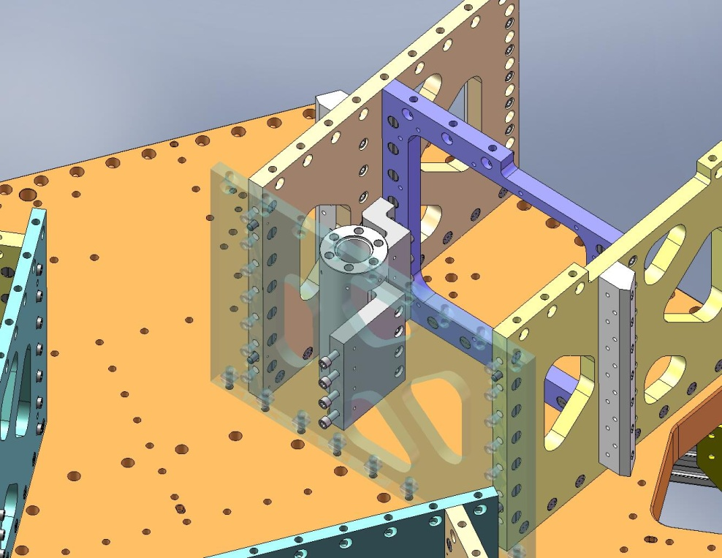
Figure 2.48. Install (3) Radial Flexure Post Brackets. Insert the screws highlighted here.

- Torque the (3x 6) screws underneath the Flexure Posts to the final spec (see Figure 2.46).
- Hand tighten the (3x 4) screws through the Tangential Flexure Post Brackets/into the Flexure Posts. These will be removed later, so do not bother using a torque wrench here.
- Torque the (3x 4) screws through the Radial Flexure Post Brackets/into the Flexure Posts to the final spec.
- Hand tighten the (3x 4) screws through the Tangential Flexure Post Brackets/into the Boxwork Radial Ribs. These will be removed later, so do not bother using a torque wrench here.
- Torque the (3x 4) screws through the Center-Tangential Ribs/into the Radial Flexure Post Brackets to the final spec.

- Carefully lower all (3) Pitchfork Assemblies onto Stage 1 Floor. Make sure the Pitchforks stay clear of the 60 Deg Rib Brackets (D071073) on the sides of the Boxworks. Make sure all (4) pins in bottom of each Pitchfork seat properly in their mating holes and slots. Caution: Pitchfork Assemblies are heavy (96 lbs)!
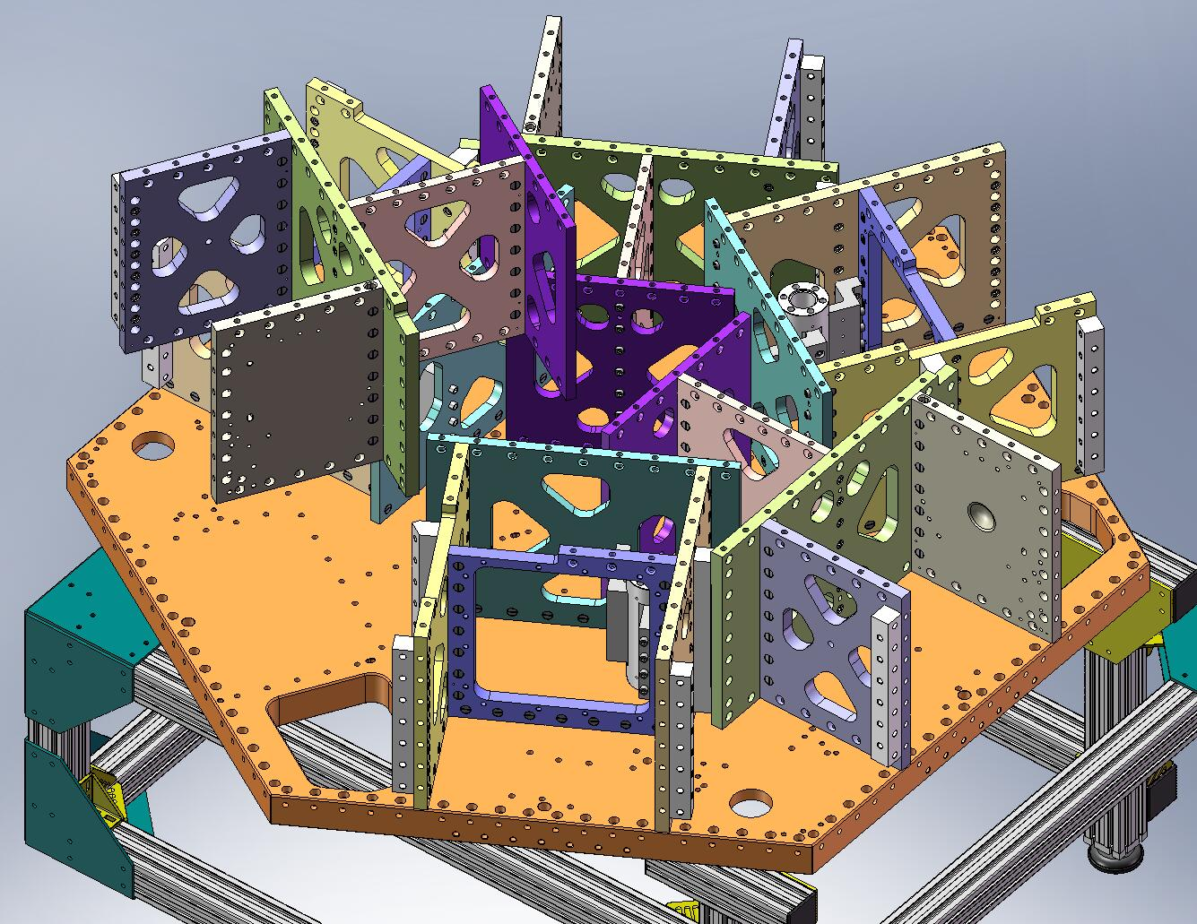
Figure 2.49. View of last Pitchfork Assembly being lowered onto Stage 1. When doing this, watch for interference between the Mid-Tangential Rib and the 60 Deg Rib Brackets on either side. Also, remember there are (4) dowel pins locating the Pitchfork plates to the Stage 1 Floor.
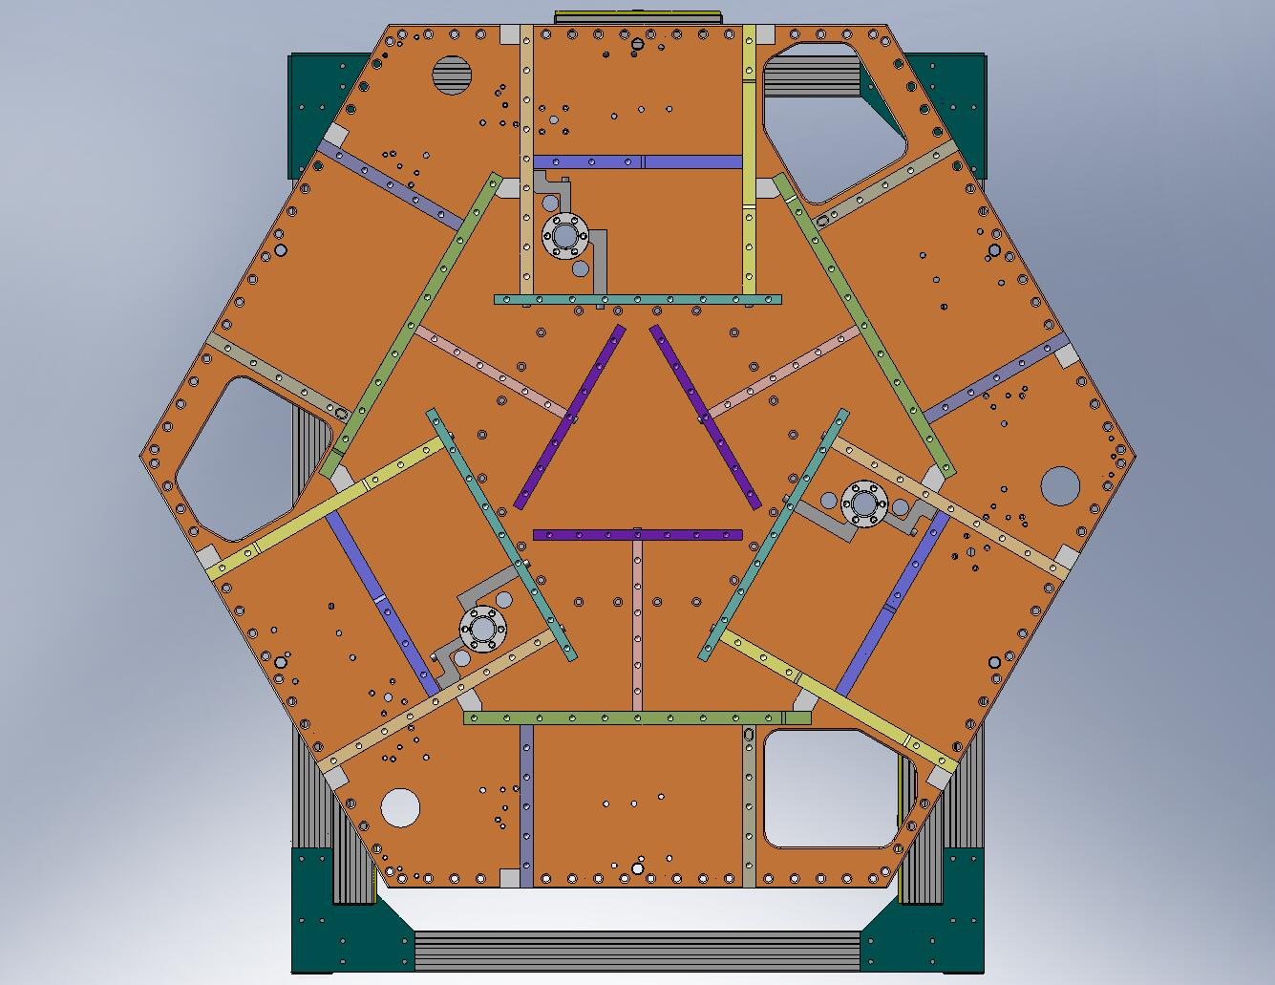
Figure 2.50. Top view of Stage 1 Frame, with Pitchforks and Boxworks in place.

- Place (63) Type 01 Barrel Nuts (D071250-01) in holes lining the bottom of the GS-13 Out Radial and Mid-Tangential Ribs within each Pitchfork Assembly. Place (39) Type 00 Barrel Nuts (D071250-00) in holes lining the bottom of the Mid-Radial and Center-Tangential Ribs. Align flats opposite screws.
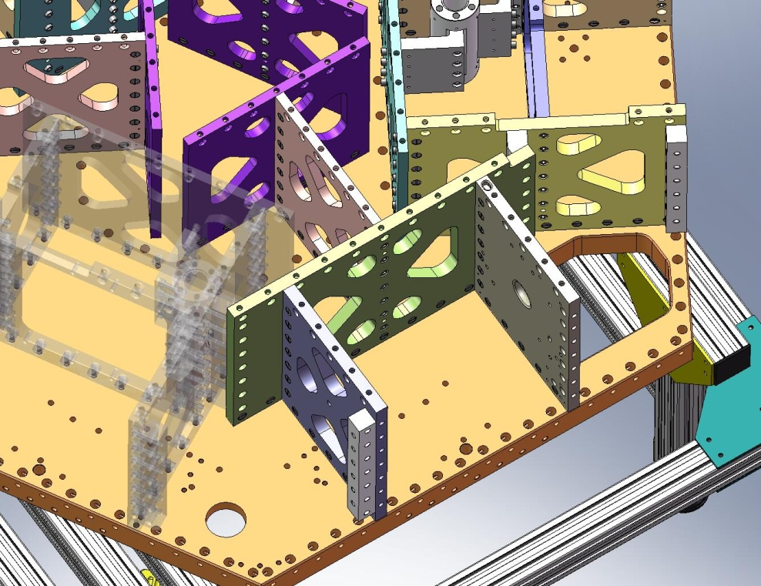
Type 01
Barrel Nuts
Type 00
Barrel Nuts
Figure 2.51. Type 00 (length = 3/4”) Barrel Nuts are used in the Mid-Radial and Center-Tangential Ribs. Type 01 (length = 1”) Barrel Nuts are used in the GS-13 Out Radial and Mid-Tangential Ribs.

- Thread screws into Barrel Nuts, from underneath Stage 1 Floor. Snug, but don’t torque, yet.
Hardware:
(102) 3/8”-16x1.75” SHCS (Holo-Krome)
(102) 3/8” vented washers (U-C Components)
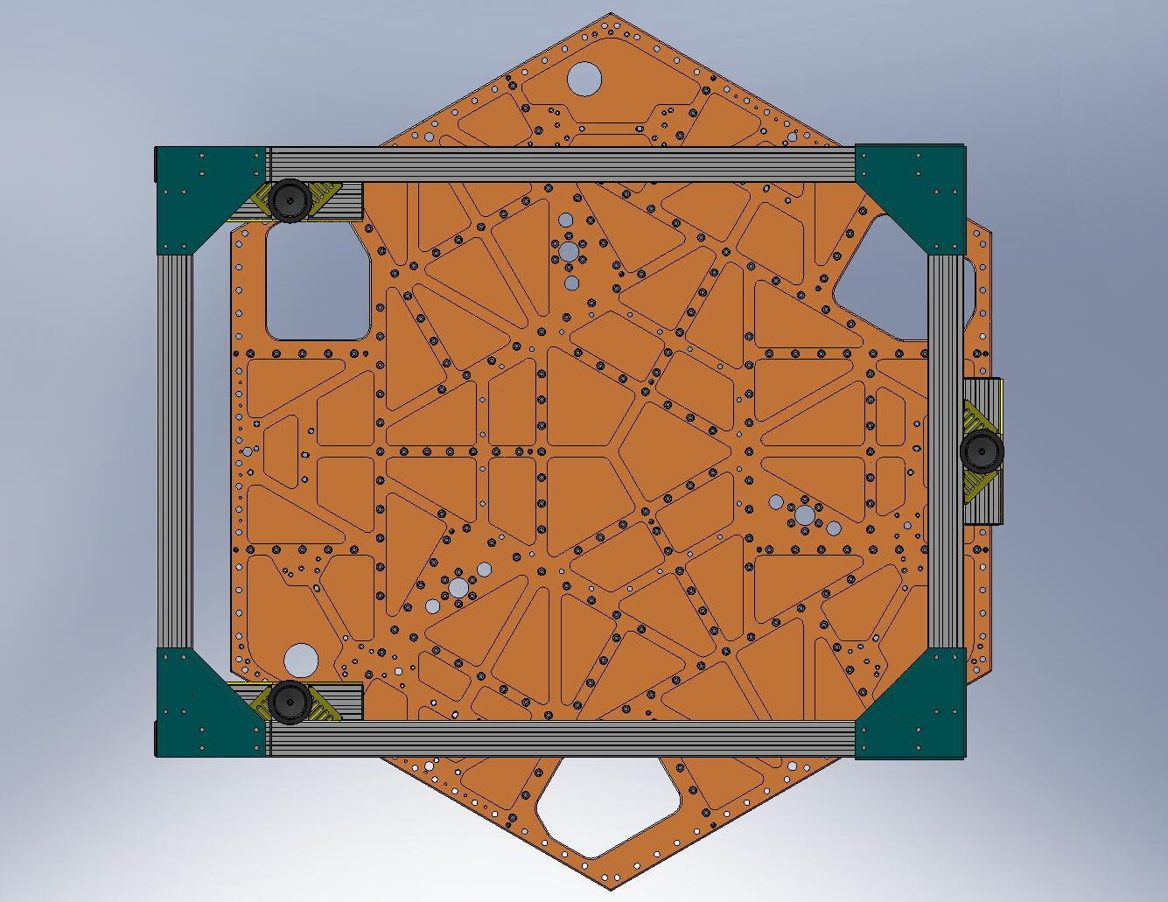
Figure 2.52. Snug (102) screws into Pitchfork Barrel Nuts, from underneath Stage 1 Floor.

- Torque all (102) screws to final spec, in the following order:
- (3x 11) Mid-Tangential Rib screws
- (3x 5) GS-13 Out 1 Radial Rib screws
- (3x 5) GS-13 Out 2 Radial Rib screws
- (3x 6) Mid-Radial Rib screws
- (3x 7) Center-Tangential Rib screws

- Start screws through the Pitchforks’ Mid-Tangential Ribs into all (6) 60 Deg Rib Brackets (D071073). Snug, but don’t torque, yet.
Hardware:
(42) 3/8”-16x1.5” SHCS (Holo-Krome)
(42) 3/8” vented washers (U-C Components)
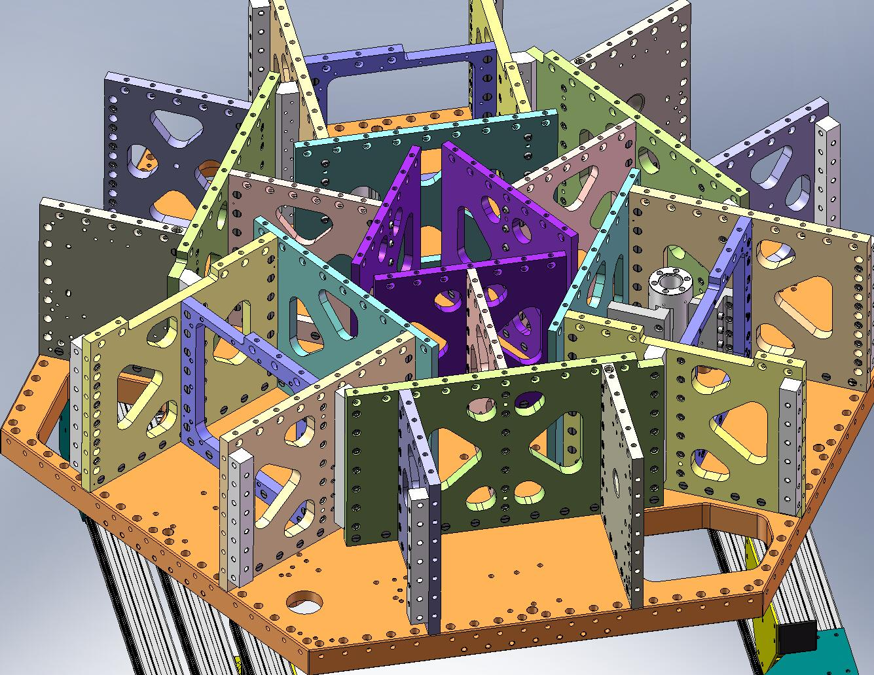
Figure 2.53. Start screws in all (6) 60 Deg Rib Brackets.

- Remove the (3) Tangential Flexure Post Brackets, to allow access to the Boxwork Assemblies’ 60 Deg Rib Bracket screws, as shown in Figure 2.54.
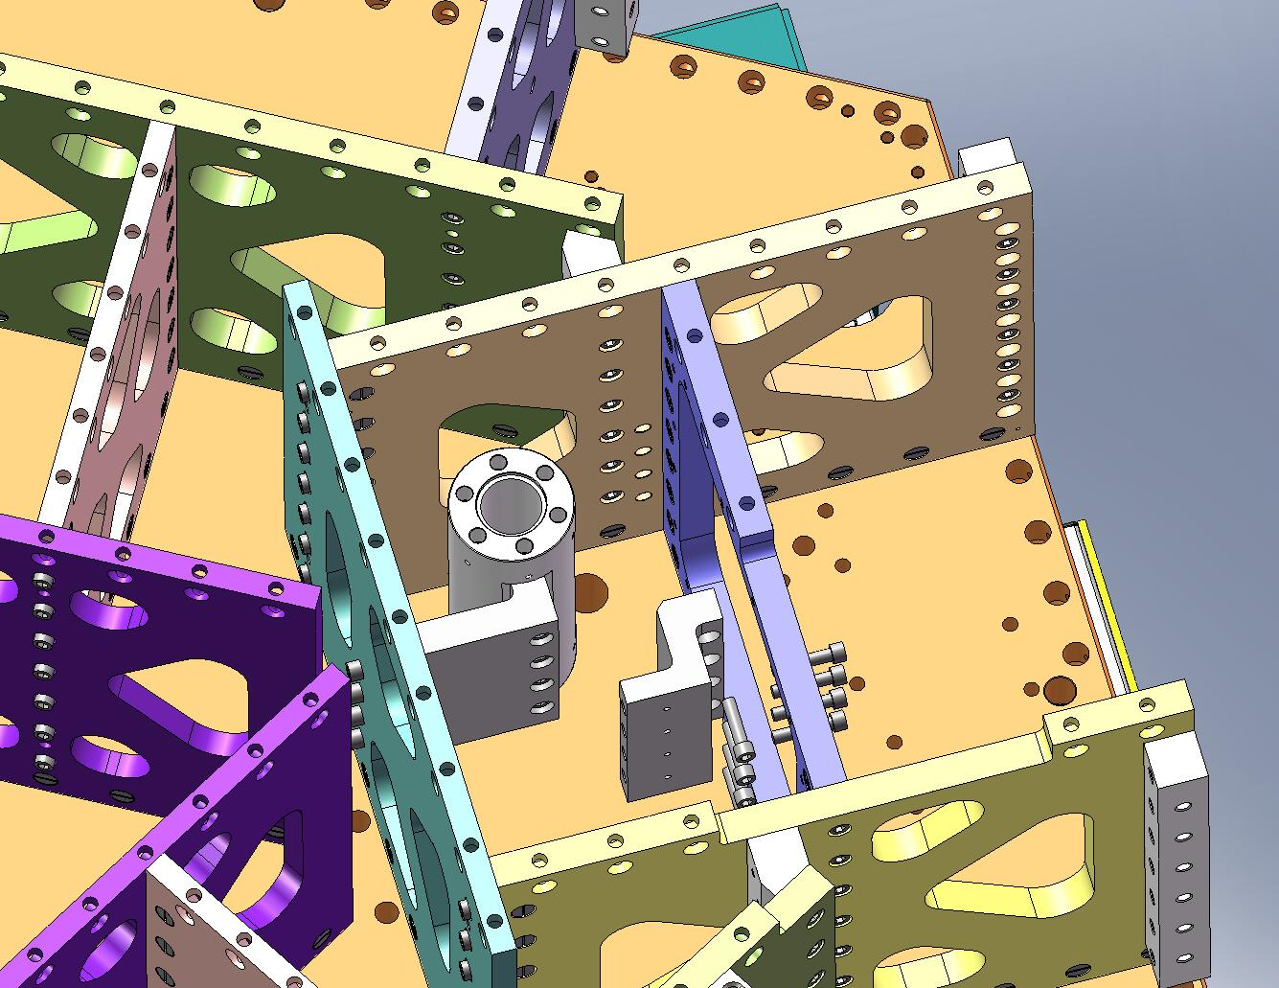
Need access to torque these screws.
Figure 2.54. Temporarily remove the (3) Tangential Flexure Post Brackets, to provide access for torquing the screws for the 60 Deg Rib Brackets.

- Torque screws for 60 Deg Rib Brackets to the final spec, in the sequence shown in Figure 2.55.
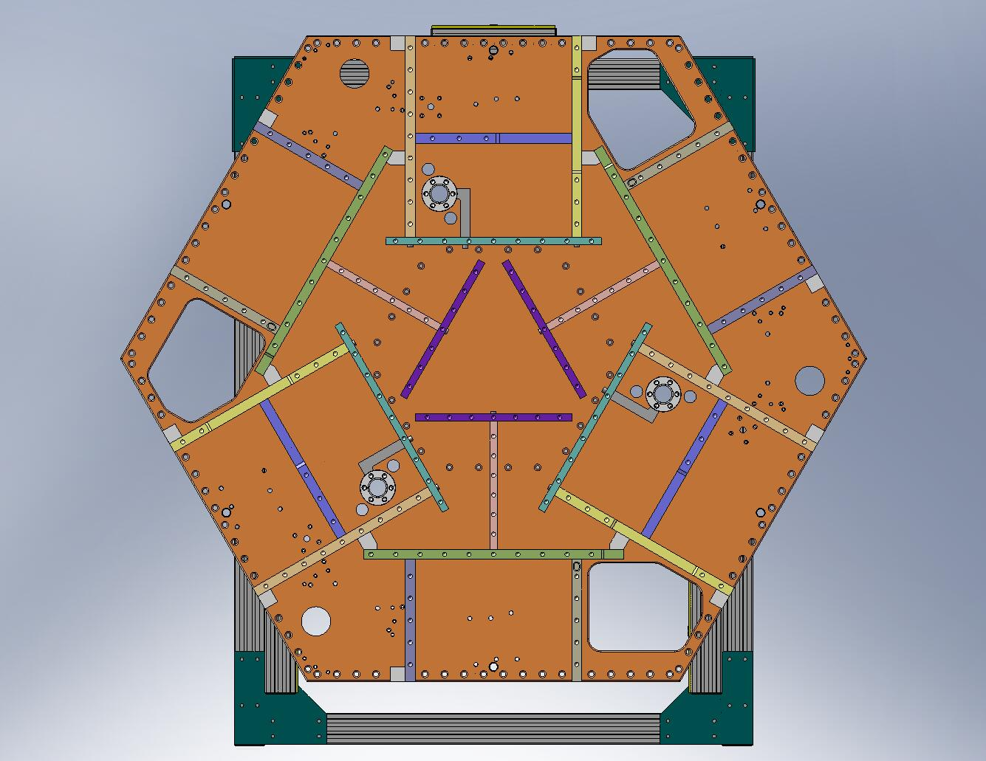
Figure 2.55. Torque the 60 Deg Rib Bracket screws in the sequence shown here. For each bracket, first torque the (6) screws on the Boxwork side to the final spec, then torque the (7) screws on the Pitchfork side to the final spec.

- Replace each of the (3) Tangential Flexure Post Brackets. Snug all the screws, then torque them to final spec. It is difficult to access the Bracket/Radial Rib screws (see Figure 2.56), so these will likely need to be “torqued” by hand.
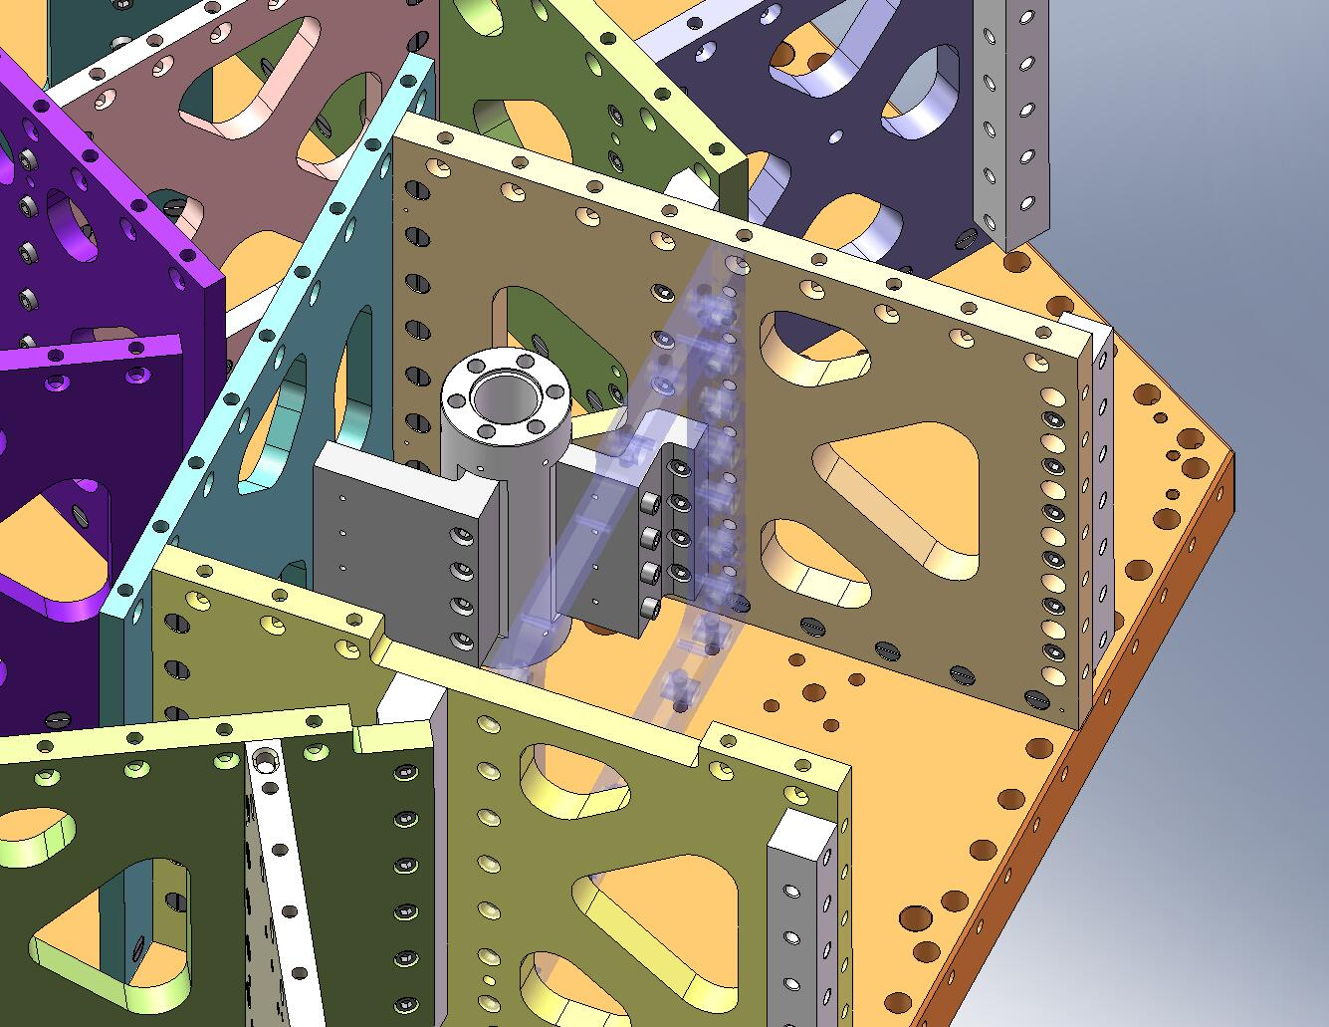
Figure 2.56. The highlighted screws are difficult to access. These likely will require hand tightening to achieve (approximately) the specified torque.

2.3 Build Keel Assembly (D071424) onto Stage 1 Assembly
- Lift the (partially built) Stage 1 Assembly (D071421) and rotate it 150 degrees, as shown in Figure 2.57 and Figure 2.58. This will allow access for bolting on the Locker Assemblies (D071450), later in the procedure.
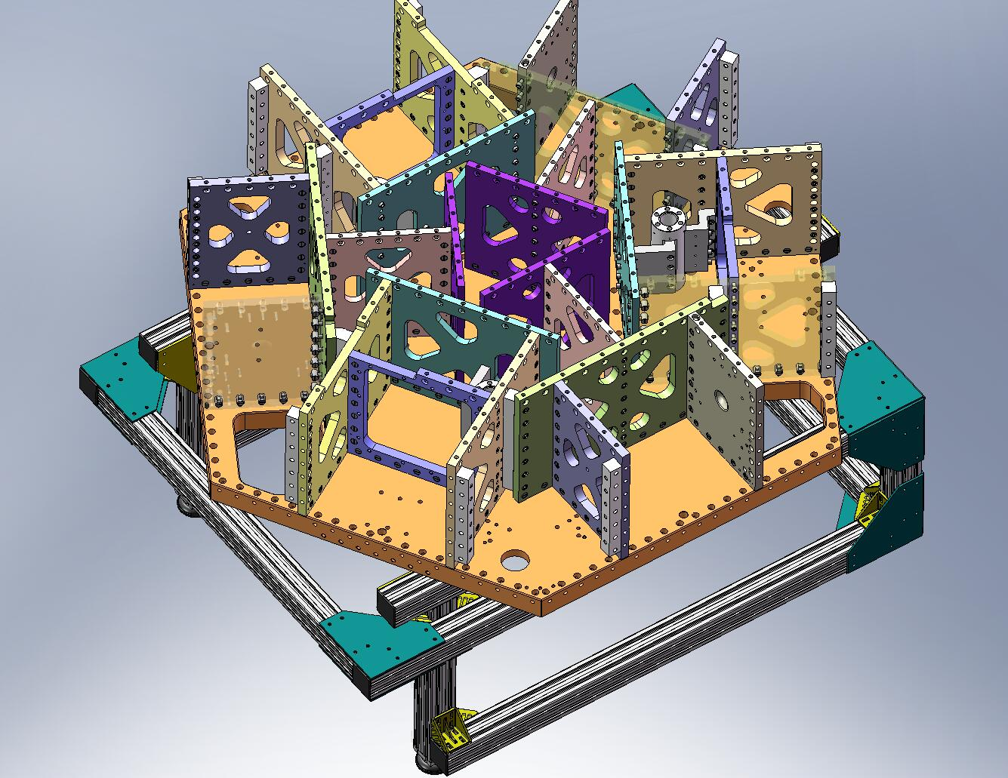
Figure 2.57. Rotate Stage 1 Assembly, to the orientation shown here. Note the location of the holes for the Locker Assemblies.
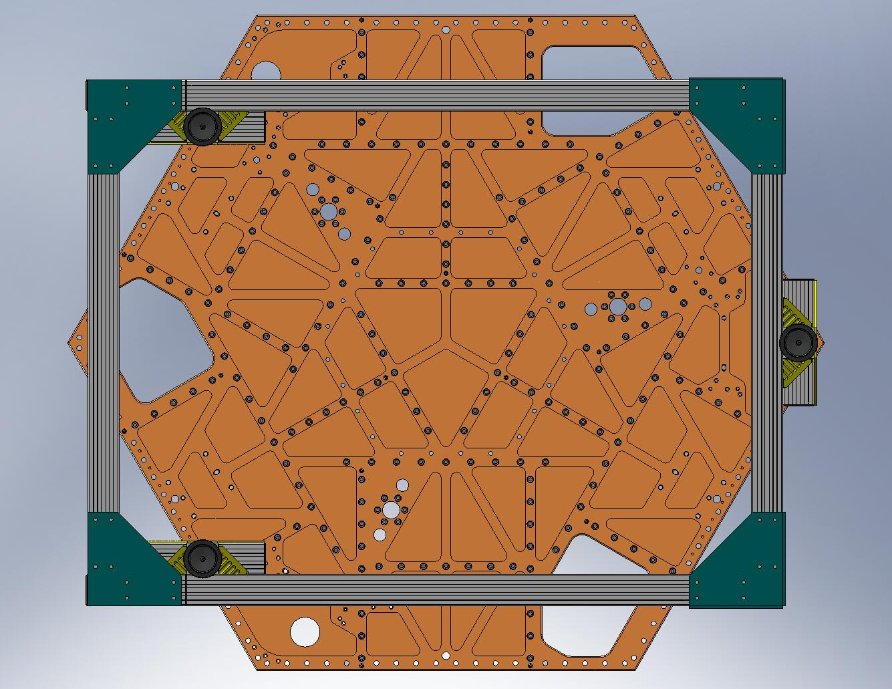
Figure 2.58. Bottom view of the Stage 1 Assembly, after rotation. Note the location of the (4) sets of Locker Assembly mounting holes.

- Drop screws through the top of the Stage 1 Floor, for the Keel Walls.
Hardware:
(24) 3/8”-16x1.75” SHCS (Holo-Krome)
(24) 3/8” vented washers (U-C Components)
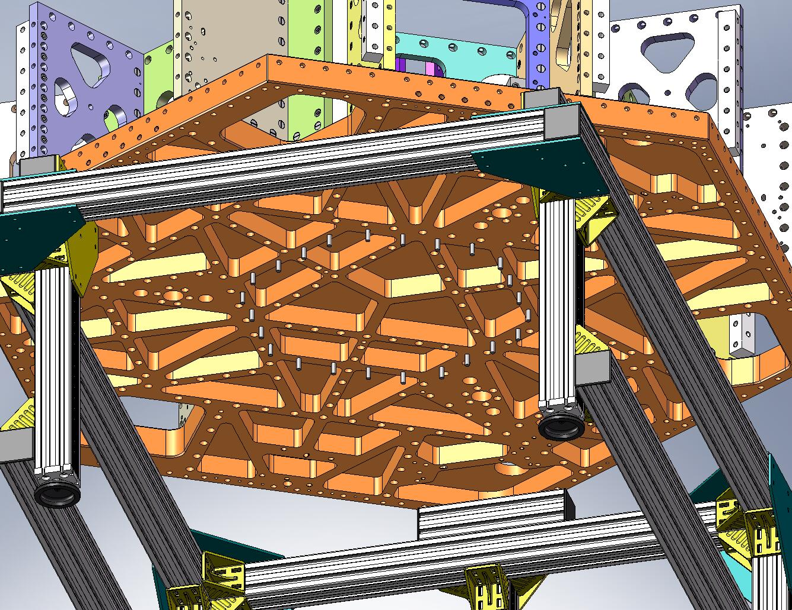
Figure 2.59. Screws hanging from the Stage 1 Floor. These will be used to clamp the Keel Assembly to the Stage 1 Frame.

- Place (4) Type 01 Barrel Nuts (D071250-01) into the holes lining the top of a Keel Wall, as shown in Figure 2.60. The flats should face away from the screw holes.
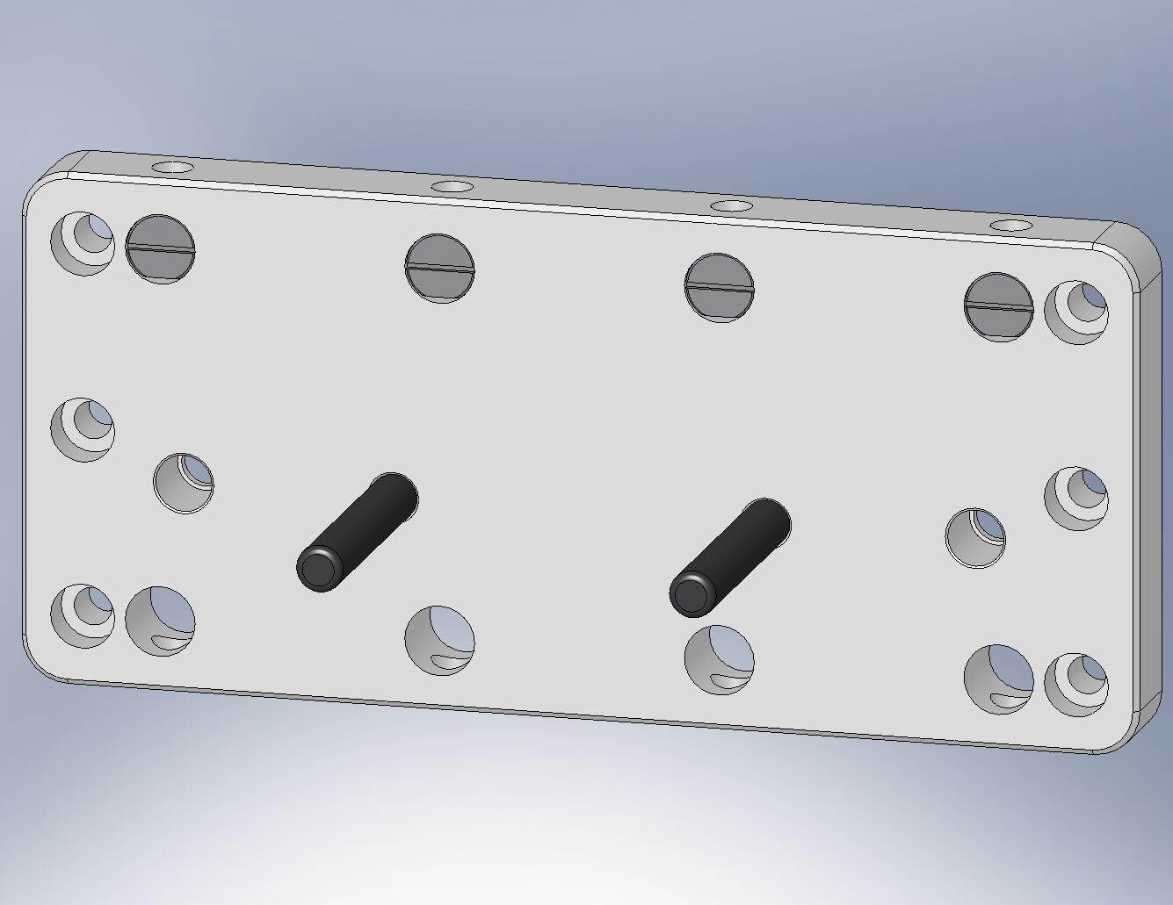
Figure 2.60. Slip in (4) Type 01 Barrel Nuts through the top holes of the Keel Wall. Note the dowel pins are below the mid-plane.

- Lift the Keel Wall against the bottom of the Stage 1 Floor, allowing one line of screws to fit into the top row of holes in the Wall. Start the screws into the Barrel Nuts – requires two people. Snug, but don’t torque, yet.
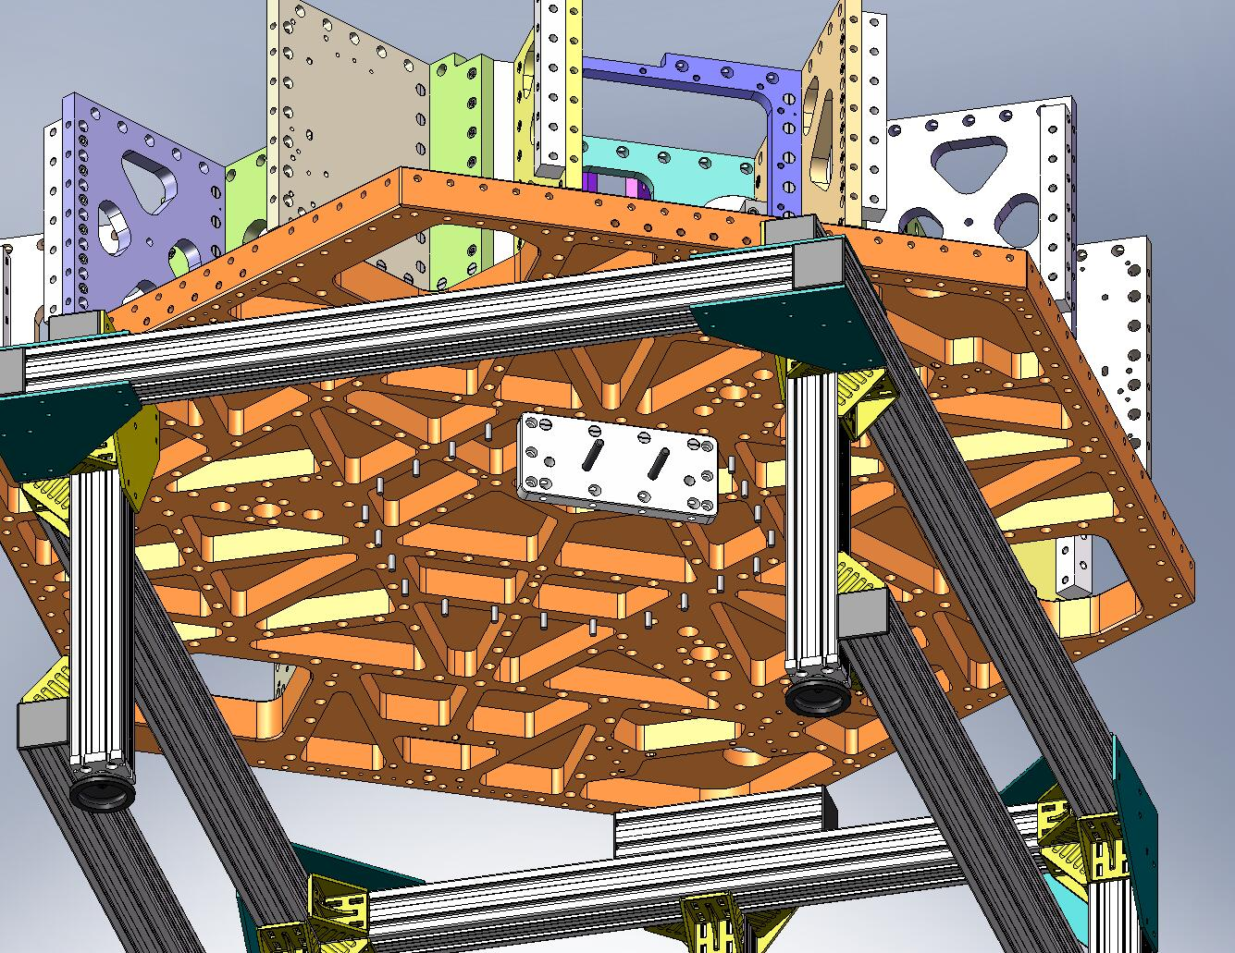
Figure 2.61. Bolt on a single Keel Wall.

- Repeat the last two steps, until all (6) Keel Walls are mounted to Stage 1. All (24) screws should be snug, but not fully torqued, yet.
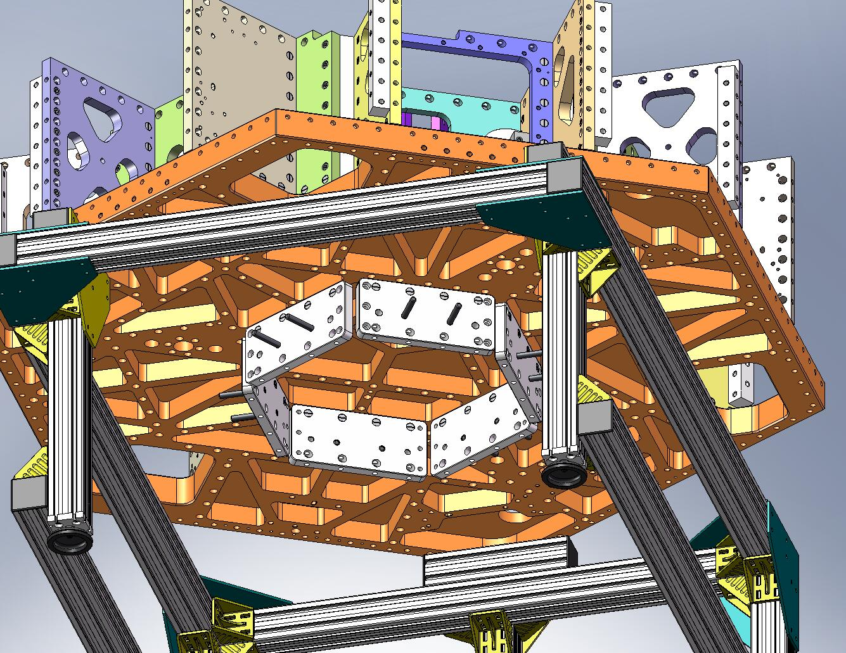
Figure 2.62. All (6) Keel Walls mounted underneath Stage 1.

- Place (6) Type 01 Outer Wall, Bracket 120 (D071060-01) pieces inside the (partially built) Keel. Start screws into all of the Brackets. Snug, but don’t torque, yet.
Hardware:
(36) 3/8”-16x1.25” SHCS (Holo-Krome)
(36) 3/8” vented washers (U-C Components)
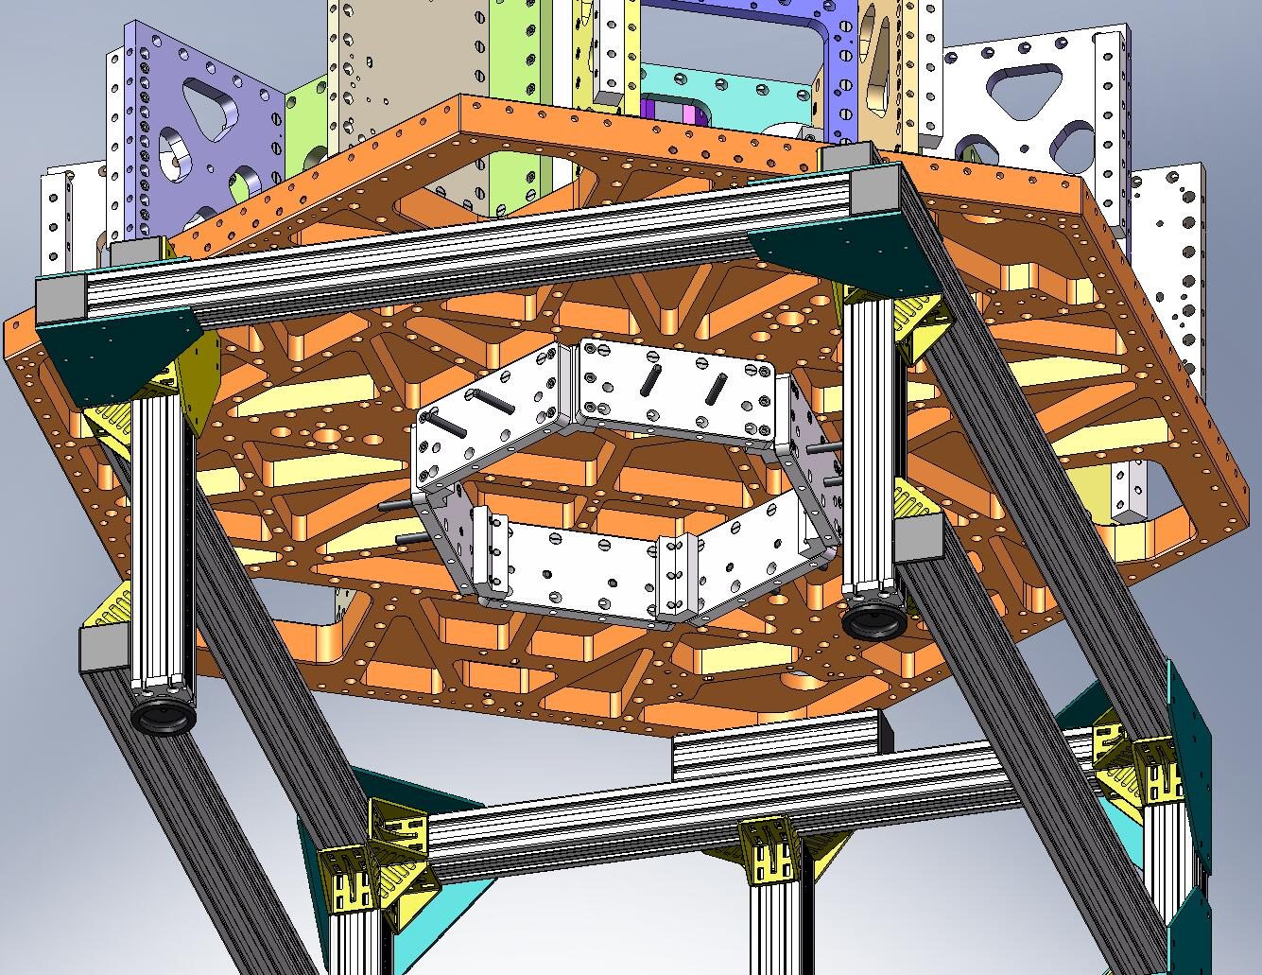
Figure 2.63. 120 Brackets installed inside the Keel. All screws should be snug, so mating surfaces are all in good contact.

- Torque all (24) screws through the Stage 1 Floor / into the Keel Walls. Use a star-shaped tightening sequence, such as the one shown in Figure 2.64.
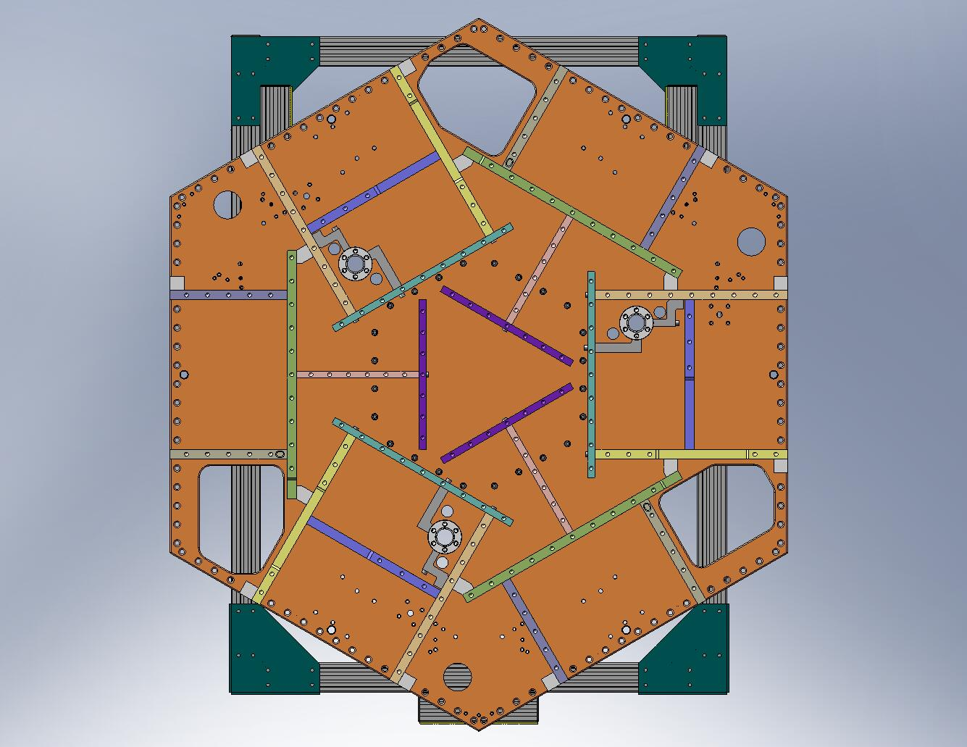
Figure 2.64. When torquing the screws for the Keel Walls, use a star-shaped tightening pattern. Note a wrench extension is needed, to allow proper access for the torque wrench.

- Torque all (36) screws for the 120 Brackets to final spec, using a staggered sequence like the one shown in Figure 2.65.
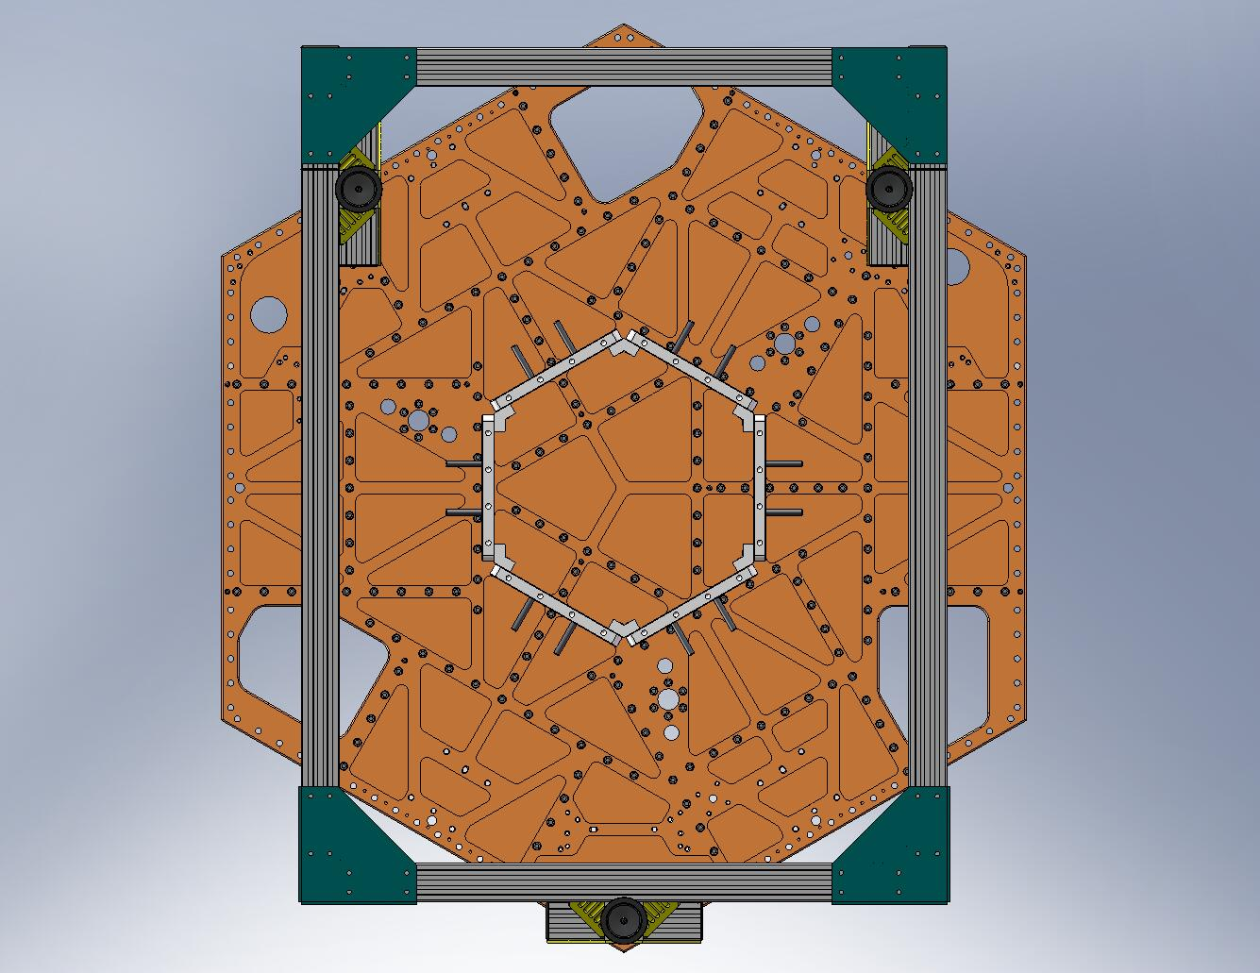
Figure 2.65. Tightening order for the 120 Brackets. The exact order is not important, as long as the tightening is staggered. Start by torquing (3) screws along one side of each Bracket (marked by the red circles), then torque (3) screws on opposite side of each Bracket (pink circles).

- Place (24) Type 01 Barrel Nuts (D071250-01) into the holes lining the bottom of all (6) Keel Walls, as shown in Figure 2.66. The flats should face away from the screw holes.
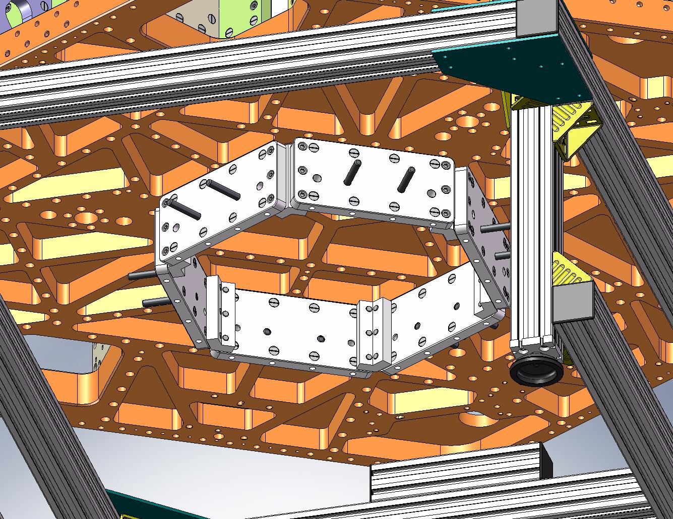
Figure 2.66. (24) Type 01 Barrel Nuts are placed in the holes lining the bottom of the Keel Walls.

- Lift Keel Base (D071065) into position, beneath Stage 1. Start screws through the Base and into the Keel Wall Barrel Nuts. Snug all the screws.
Hardware:
(24) 3/8”-16x1.75” SHCS (Holo-Krome)
(24) 3/8” vented washers (U-C Components)
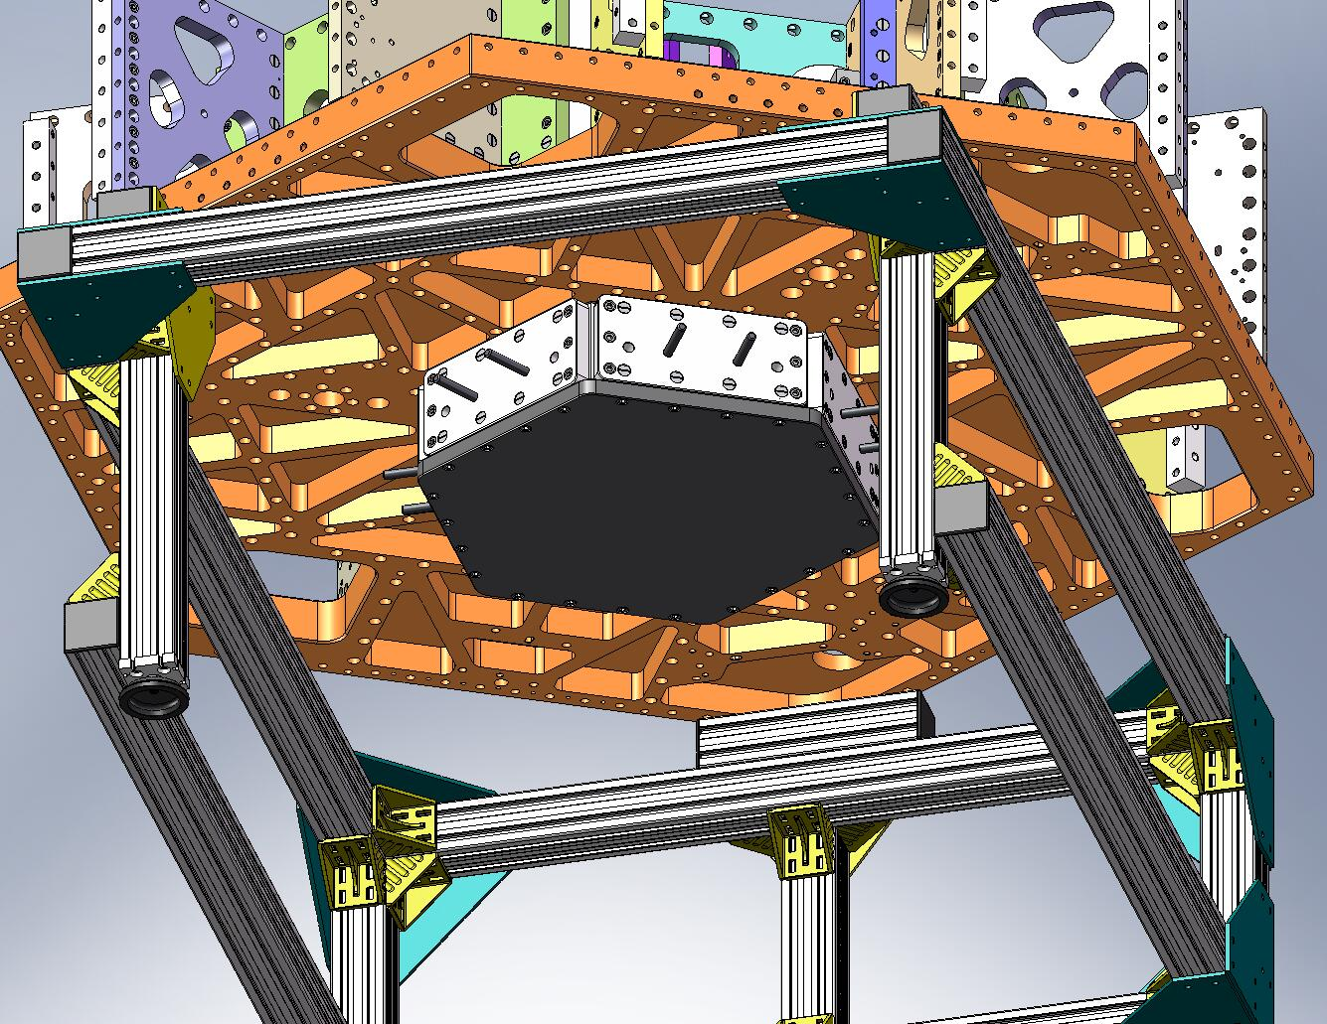
Figure 2.67. Keel Base added to the Keel Assembly.

- Torque all (24) screws for the Keel Base, using a star-shaped pattern similar to the one shown in Figure 2.64. This completes the Keel Assembly (D071424).

2.4 Mount (4) Locker Assemblies underneath Stage 1
- Lift each Locker Assembly up against the bottom of the Stage 1 Floor, as shown in Figure 2.68. Make sure that pins seat properly in mating holes and slots. Orientation is important: the knurled end of the Locker Sleeves should face outward, so later they can be accessed for locking/unlocking. Start screws into the Floor. Snug all (4) screws on each unit, then torque to final spec.
Hardware:
(16) 3/8”-16x2.25” SHCS (McMaster-Carr)
(16) 3/8” vented washers (U-C Components)
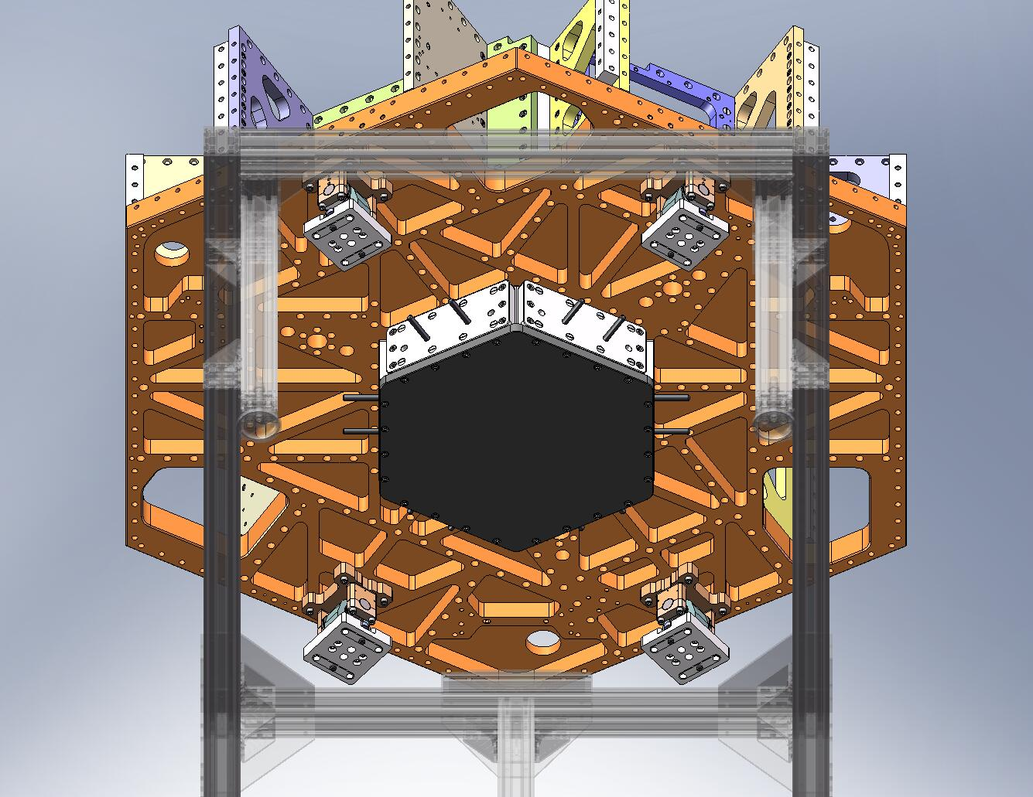
Figure 2.68. Locker Assemblies bolted to bottom of Stage 1 Floor. Knurled ends of Locker Sleeves must face outward.

- Assemble temporary pins for locating the Locker Bases to the Stage 0 Base. Clamp a 1/2”-bore shaft collar (McMaster-Carr #9421T700) onto one end of each of (8) 1/2”x2.0” dowel pins (McMaster-Carr #90145A720), as shown in Figure 2.69.
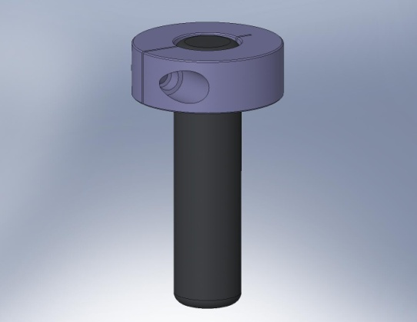
Figure 2.69. Pin used to temporarily locate the Locker Assemblies to the Stage 0 Base. The shaft collar prevents the pin from slipping through the clearance hole in the Locker Base.

- Slip all (8) temporary pins through the oversized 1/2” holes in the Locker Bases, as shown in Figure 2.70.
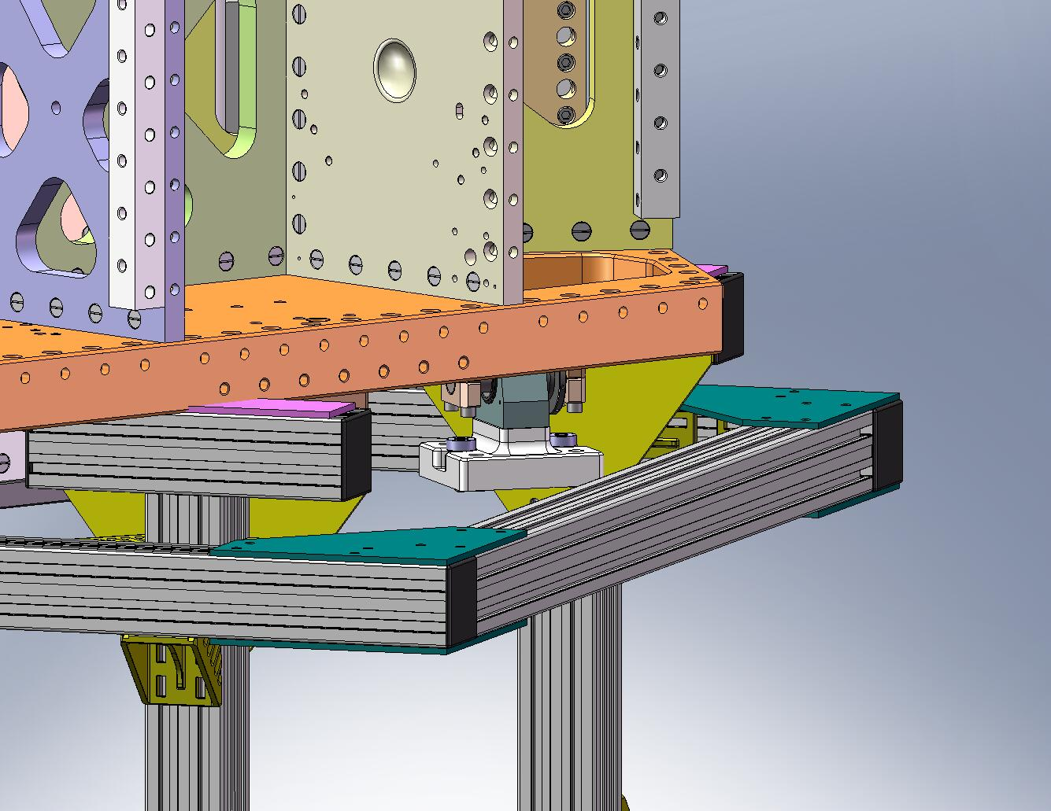
Figure 2.70. Slip (8) pins into the 1/2” holes in the Locker Bases. The shaft collar sits on the surface above the hole counterbore.

– Hang Stage 1 from Stage 0
    - Assemble (6) Small Panel Outer Wall Assemblies (D071427)
- Press (2) 1/2”x4.0” dowel pins into each Small Panel Outer Wall (D071059), as shown in Figure 3.1. (If necessary, first heat Wall and cool pins, to reduce interference.)
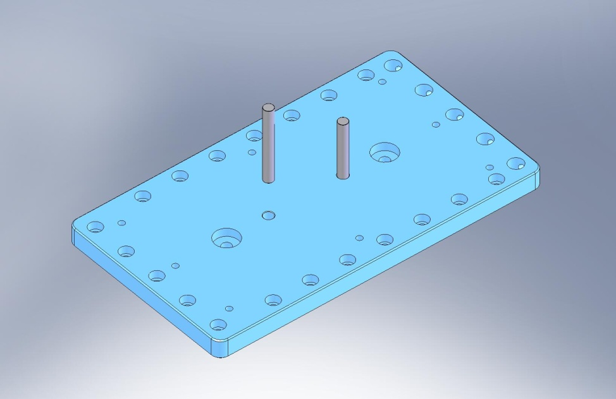
Figure 3.1. Press dowel pins into Small Panel Outer Wall. Note that counterbores all face same direction as pins.

- Insert hex head cap screws, with washer on either side. Tighten to Wall, using jam nut on each screw, as shown in Figure 3.2.
Hardware:
(6x 2) 1/2”-13x4.0” full-thread HHCS (McMaster-Carr)
(6x 2) 1/2”-13 hex jam nut (McMaster-Carr)
(6x 4) 1/2” vented washer (U-C Components)
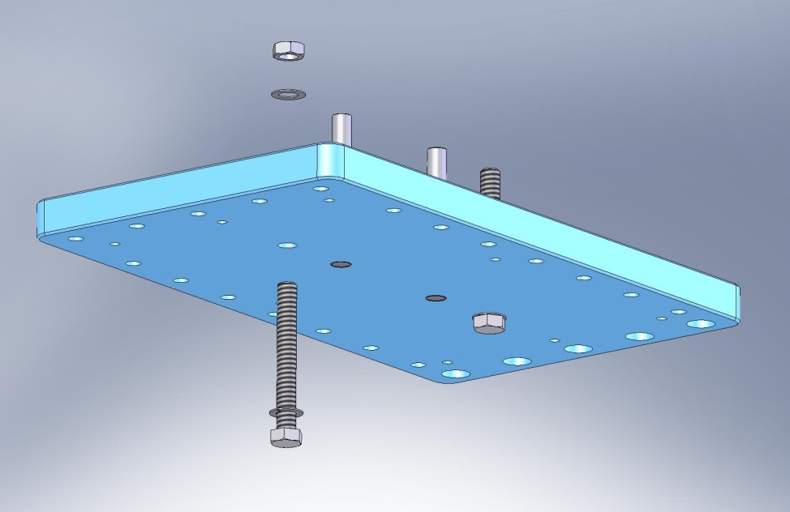
Figure 3.2. Clamp hex head screws to Wall, using hex jam nut. Threaded portion should point in same direction as protruding dowel pins.

    - Prep Work – Prepare (3) Flexure Assemblies (D071431)
- The Flexures are fragile! Before starting this section, check that all (3) are still straight (e.g., by rolling on a surface plate).
the following procedure describes the assembly of one D071431 assembly. This should be repeated for the other two D071431’s, as well:
- Insert Flexure Mount (D071103) through bottom of Flexure Lower Plate (D071105), as shown in Figure 3.3.
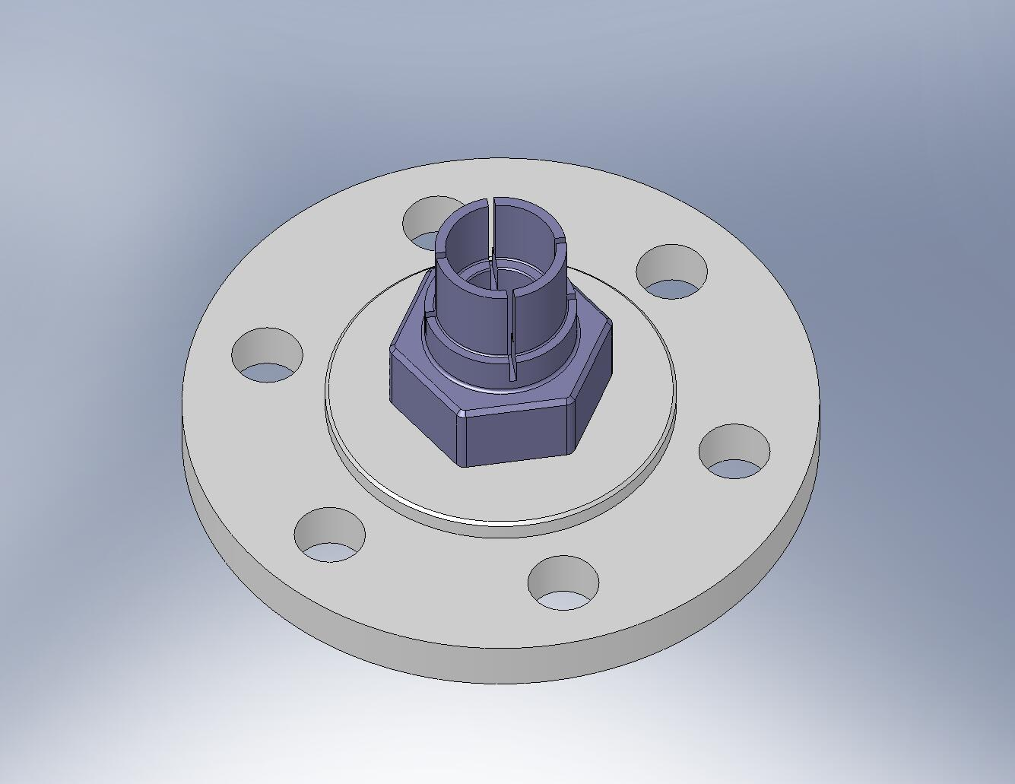
Figure 3.3. Flexure Mount in Flexure Lower Plate. Relative angle between these parts is not important.

- On other side of Flexure Lower Plate, place a washer. Thread nut onto Flexure Mount. Torque nut to final spec.
Hardware:
(1) 3/4”-10 thin jam nut (McMaster-Carr #91847A550)
(1) 3/4” washer (McMaster-Carr #98017A220)
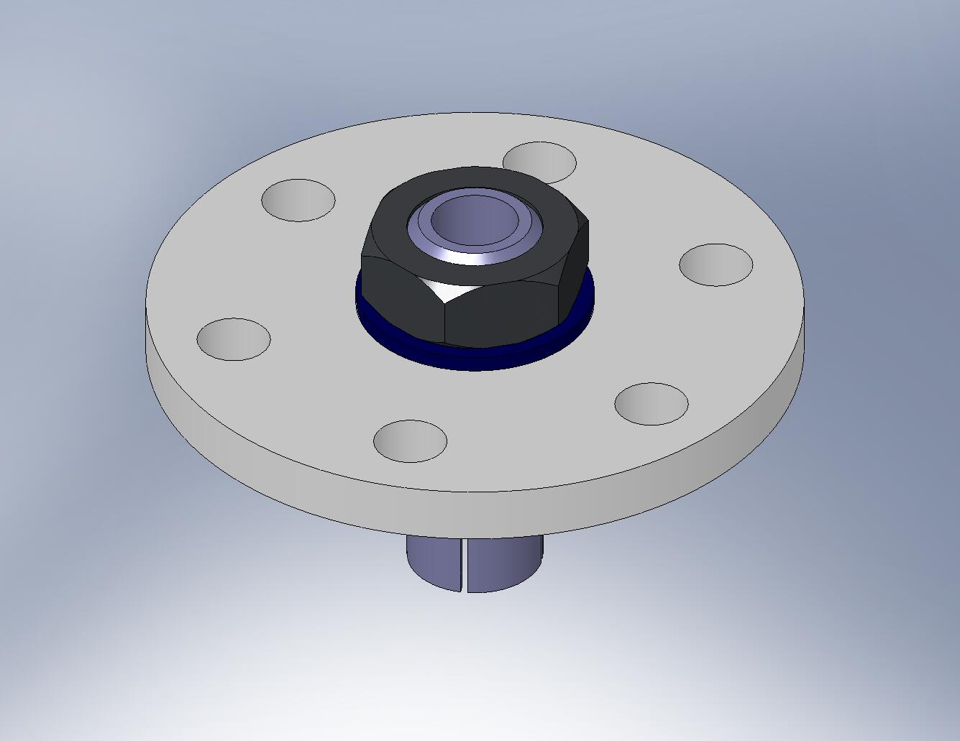
Washer

Figure 3.4. Tighten nut against the Flexure Mount. Make sure that the hex flange on the Flexure Mount seats firmly against the bottom surface of the Flexure Lower Plate.

- Insert Flexure (D071102) through Flexure Mount, as shown in Figure 3.5.
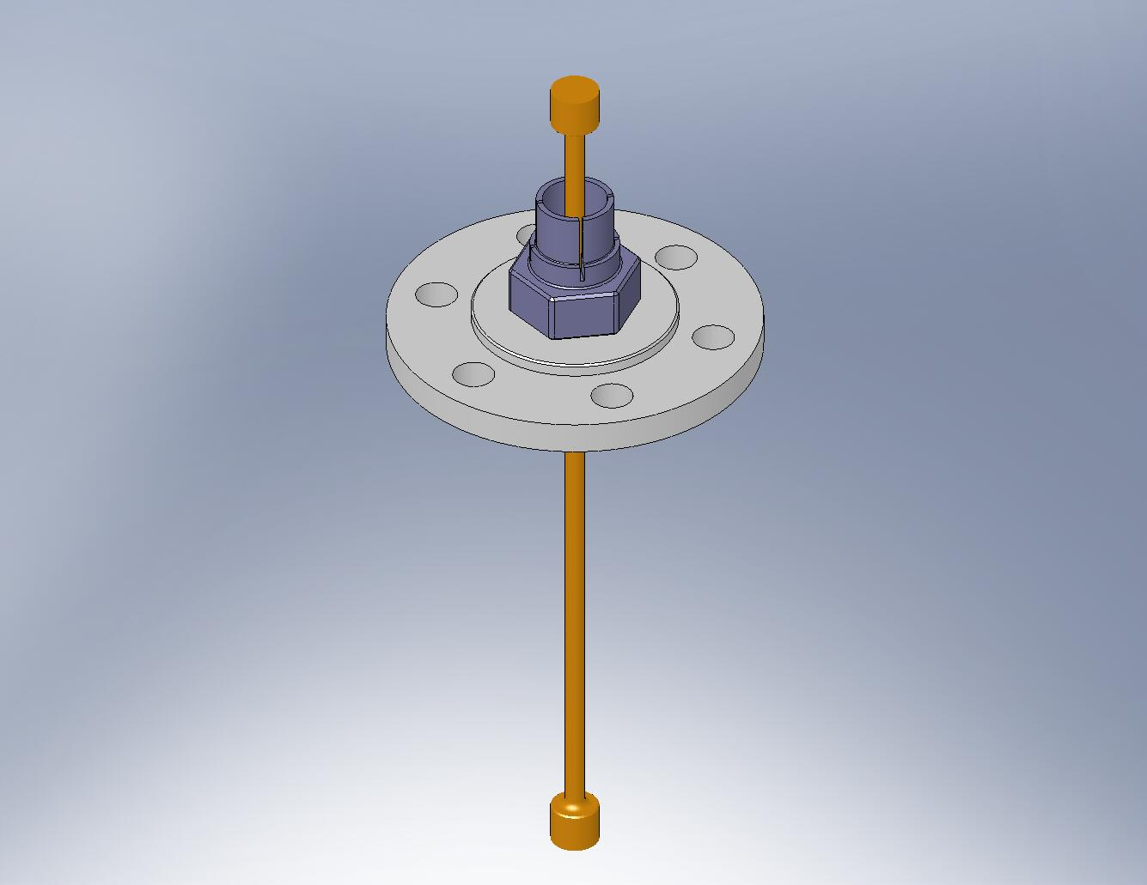
Figure 3.5. Insert Flexure.

- Place (2) Flexure Cups (D071104) inside the Flexure Mount, as shown in Figure 3.6. Try to align the Cups with the grooves in the Mount.
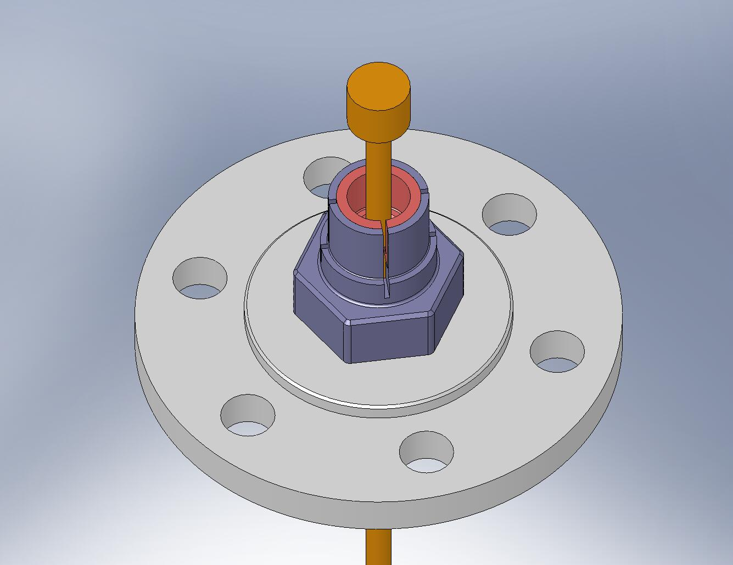
Align the sides of the Flexure Cups with the grooves in the Flexure Mount.

Figure 3.6. The Flexure Cups must sit flush inside the Flexure Mount. Next, we will seat the Flexure within the Flexure Cups. These are the most critical joints in the entire assembly!

- Place shaft collar (McMaster-Carr #9633T15) over the collet end of the Flexure Mount, as shown in Figure 3.7. The screws on these collars must be modified, to avoid interference when the Flexures are mounted to the Flexure Posts (D071074) (see Figure 3.8).
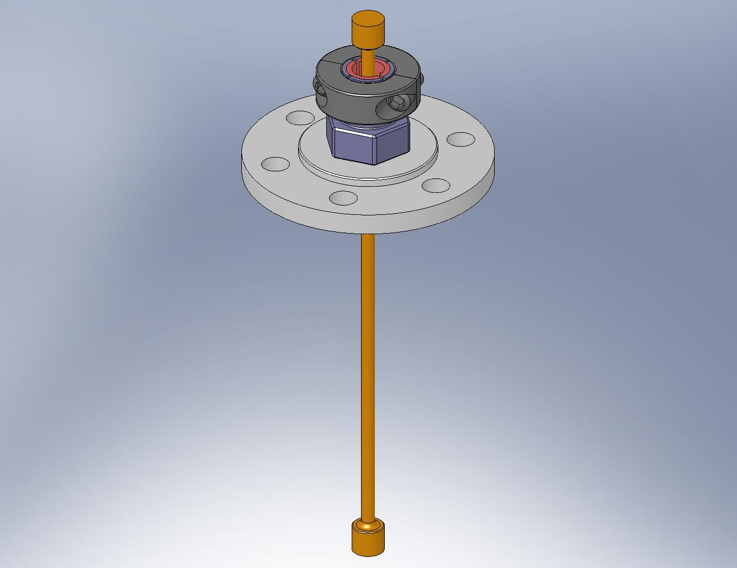
Figure 3.7. Shaft collar must be placed over the end of the Flexure Mount. Its orientation does not matter. Do not tighten the screws, yet.
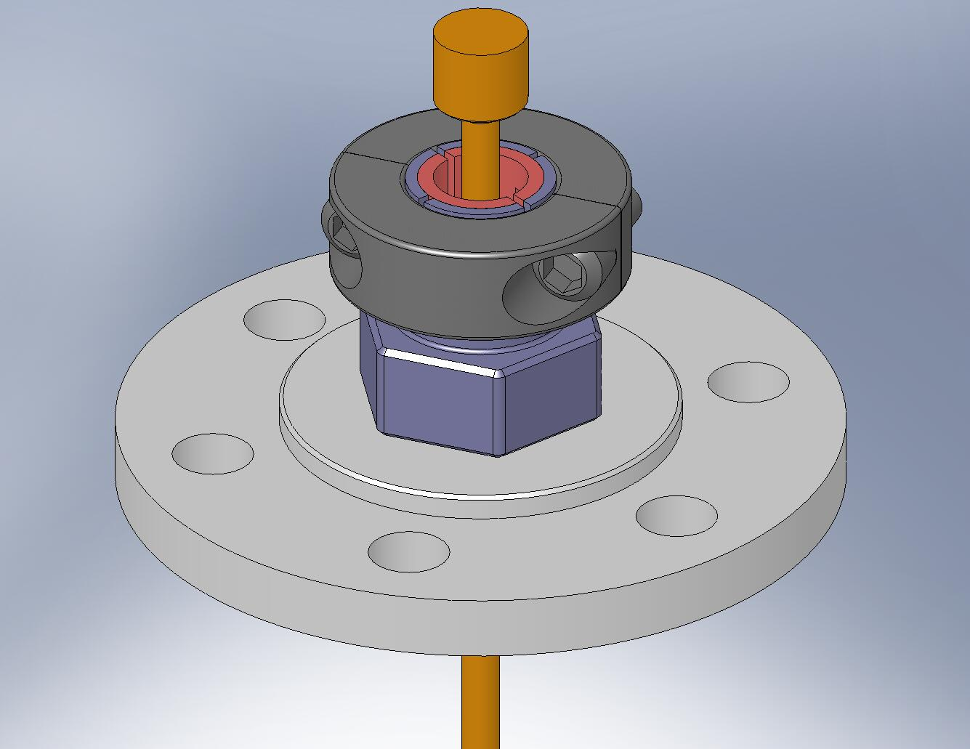
Chamfer the top edge of these bolt heads, to prevent interference.
Figure 3.8. The heads of the shaft collar screws must be turned down, so the bottom of the Flexure Assembly can fit inside the Flexure Post.

- Hold the jam nut tightly (e.g., using a vice), in the orientation shown in Figure 3.9. Push the head of the Flexure into the Flexure Mount, until the Flexure and Flexure Cups are all fully seated. Partially tighten the shaft collar screws.
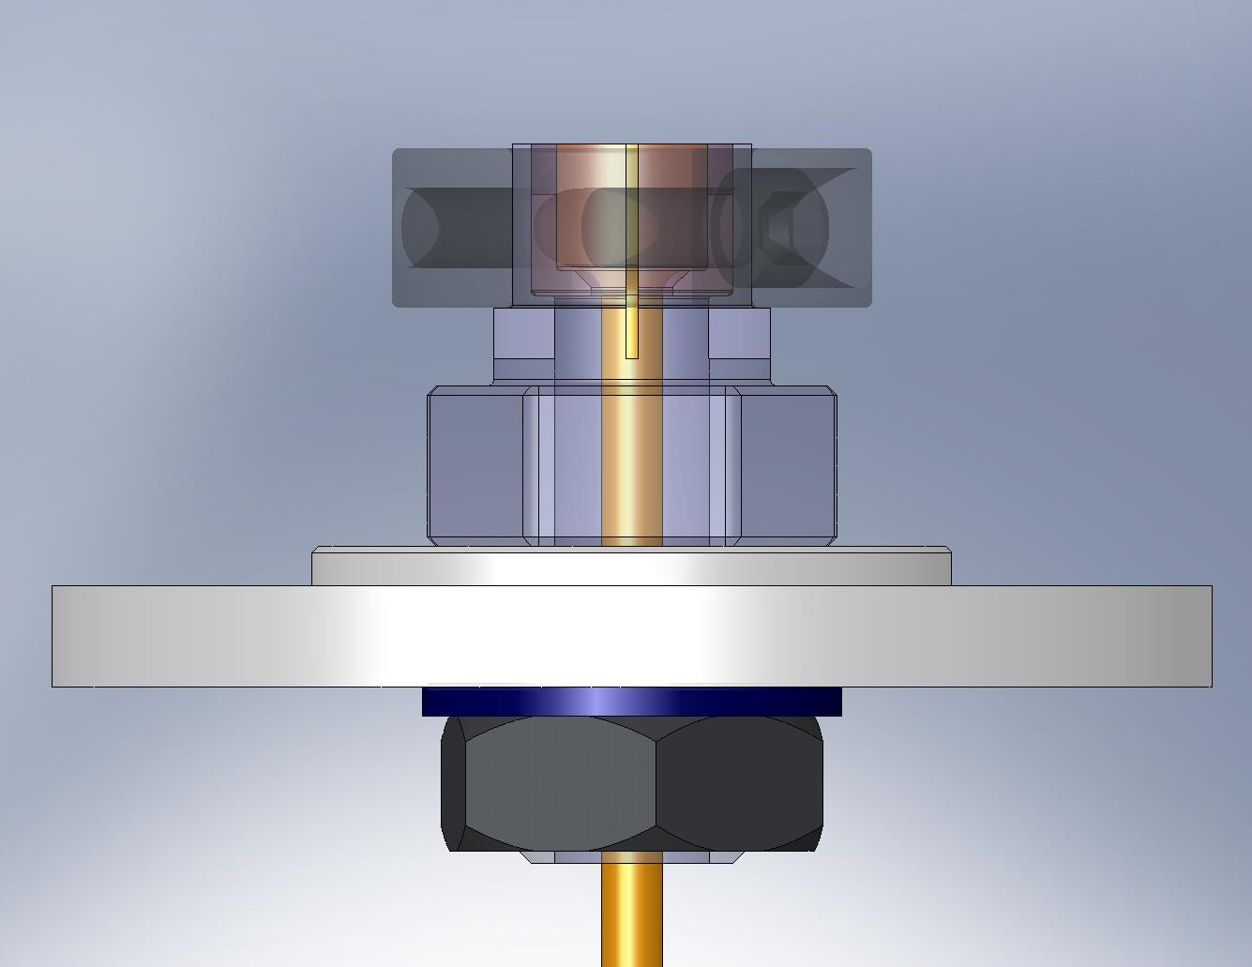
Place nut in vice.

Figure 3.9. Seat the Flexure within the Flexure Mount, then apply a small amount of clamping force from the shaft collar.

- To improve the seating of the Flexure and Flexure Cups within the Flexure Mount, lightly tap the Flexure with a hammer. When you are satisfied that the there is good metal-on-metal contact everywhere, torque the shaft collar screws to final spec.
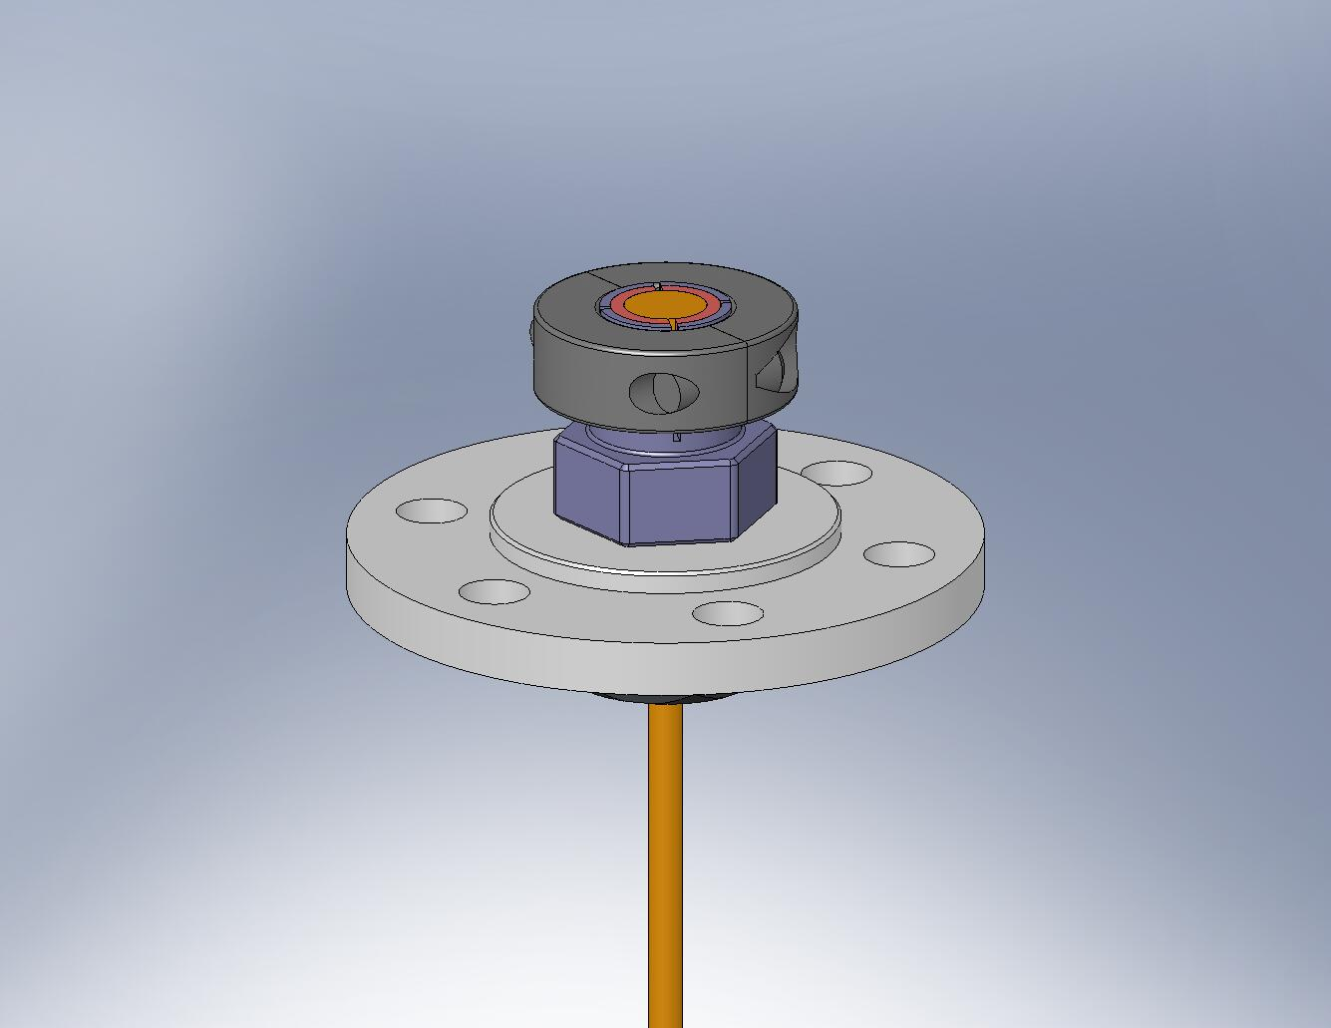
Tap with a hammer, to seat the Flexure.
Figure 3.10. Carefully tap the Flexure into the Flexure Mount, to improve seating.

- Set aside the partially assembled Flexure Assemblies for later use.
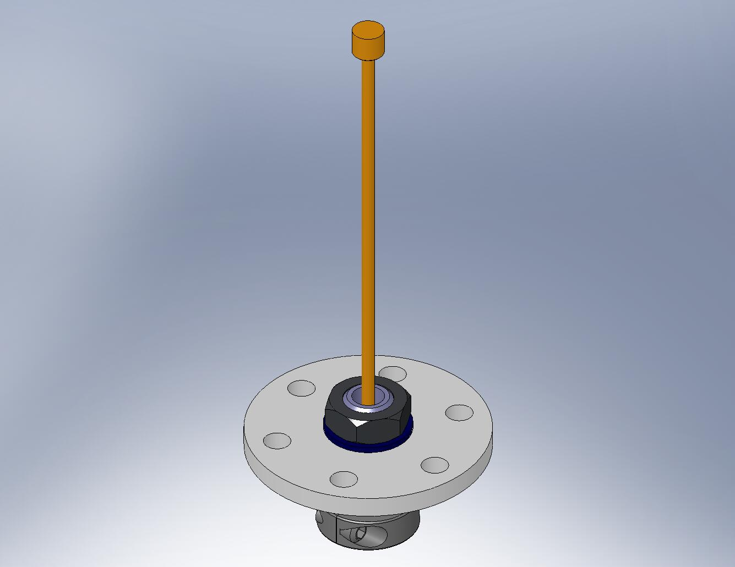
Figure 3.11. The top of the Flexure Assembly will be installed after Stage 1 is placed on Stage 0.

    - Prep Work – Assemble Actuators (D071442)
- Install Heli-Coils in Actuator parts (D071120, D071121, D071316, and D071317), as specified in their engineering drawings.
the following procedure describes the partial assembly of one D071442 assembly, using the Actuator Set-Up Fixture. Repeat the process for all six Actuators. Afterwards, different sets of brackets will be installed for the horizontal and vertical Actuator configurations.
- Assemble Actuator Set-Up Fixture (D071497). Refer to Figure 3.12 and Figure 3.13.
Hardware:
(3) 3/8”-16x1.0” SHCS (Holo-Krome #78098)
(2) 3/8”x.75” dowel pins (McMaster-Carr #90145A622)
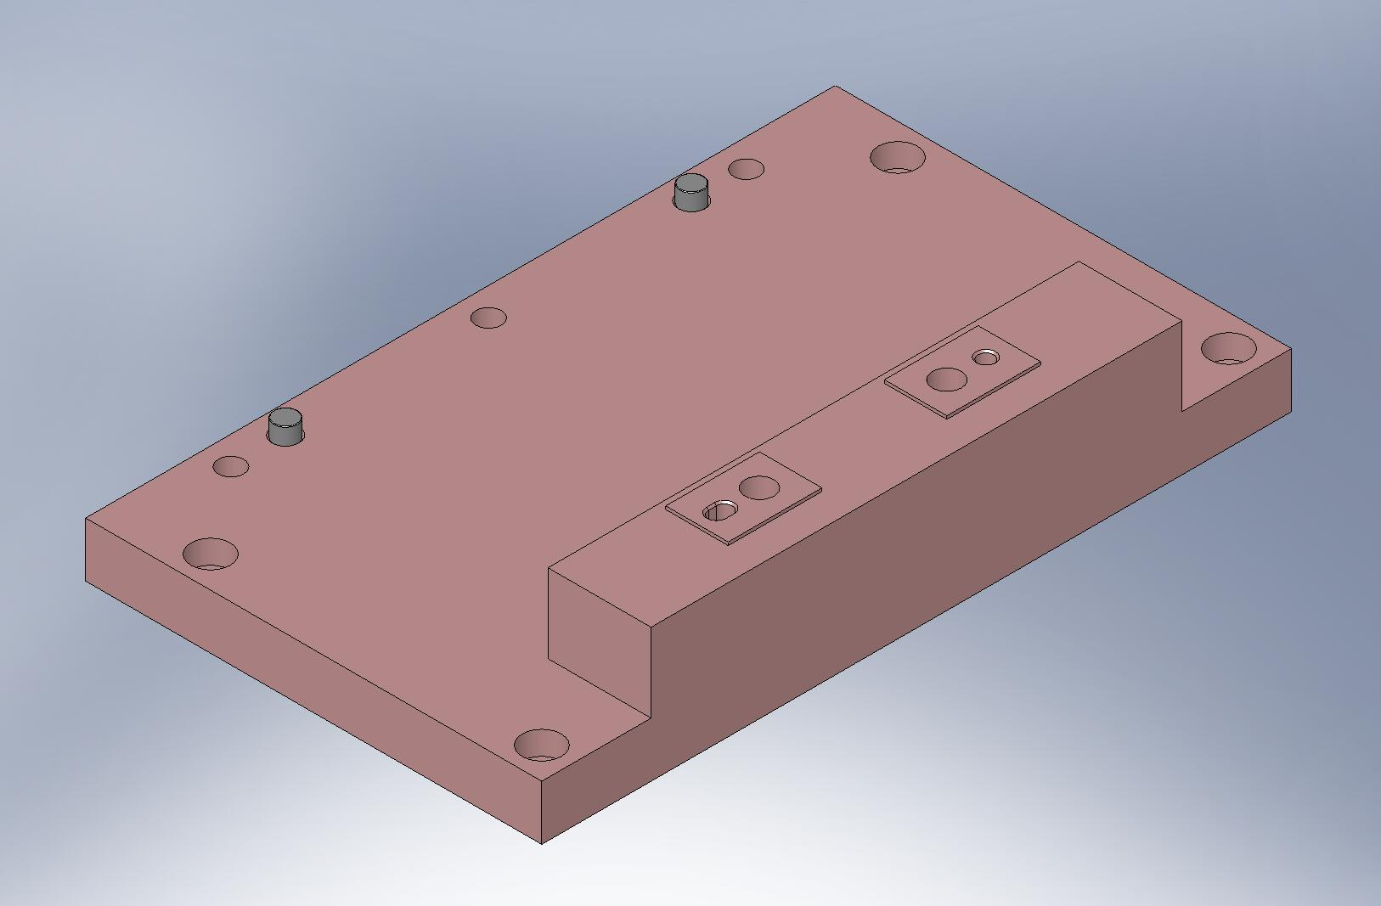
Figure 3.12. Press (2) pins into Set-Up Fixture Base Plate.
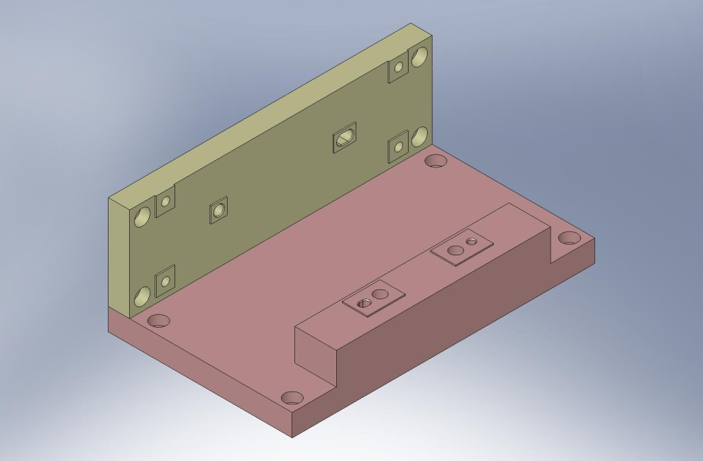
Figure 3.13. Bolt on Set-Up Fixture Side Plate.

- Press (2) 3/8”x.75” dowel pins into bottom of Actuator Magnet Mount (D071120). Pins should remain .25” proud of the plate surfaces.
- Install (4) Captive Screws in the Actuator Magnet Mount, as shown in Figure 3.14. These are later used to mount the Actuator Assemblies to Stage 1, but are also needed to bolt to the Set-Up Fixture.
Hardware:
(4) 1/4”-20x1.5” (1.0” Clear) Captive SHCS (D071136-00)
(4) 1/4" vented washers (U-C Components)
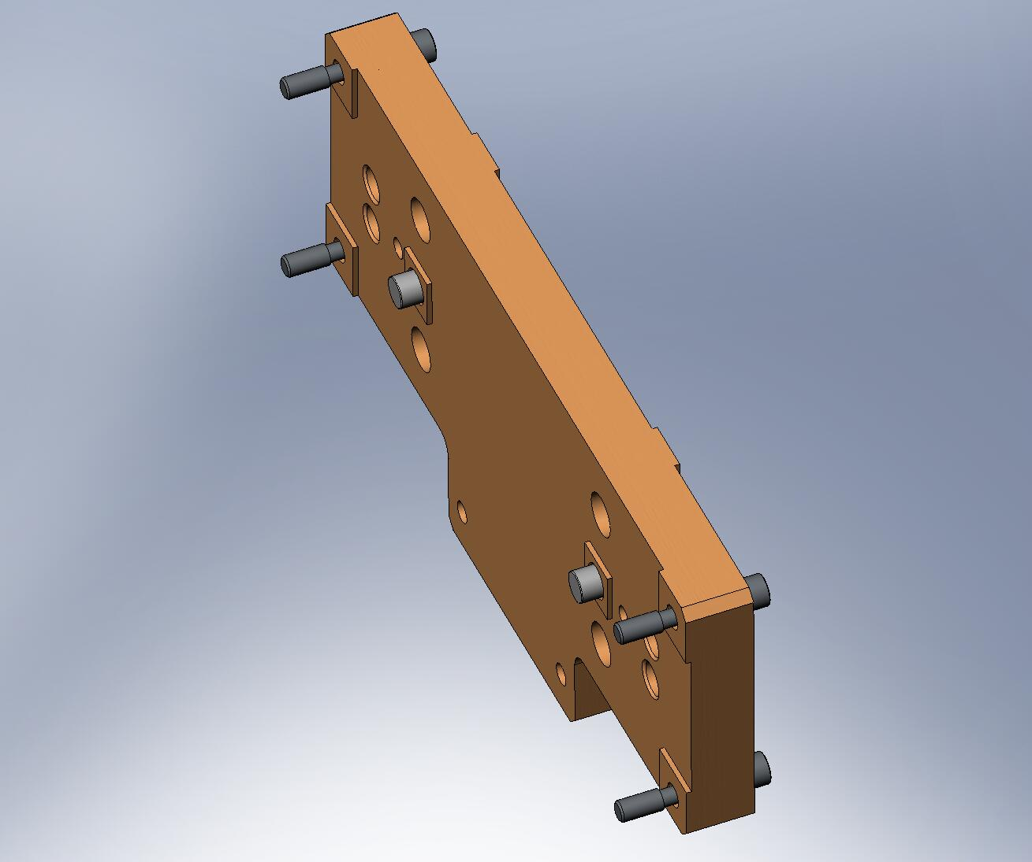
Figure 3.14. Actuator Magnet Mount with Captive Screws and dowel pins installed.

- Prepare PSI Actuator for assembly. Shoulder screws connecting Bobbin to Field Assembly should be installed and tightened, as shown in Figure 3.15.
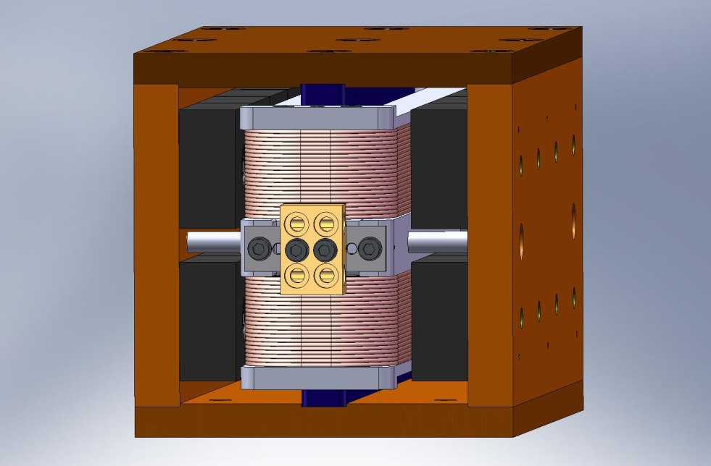
Figure 3.15. (4) shoulder screws are included when the Actuator is shipped, to “lock” the Bobbin to the Field Assembly. Make sure these are tight before proceeding with the rest of the assembly.

- Press (2) 1/8”x.375” dowel pins into the PSI Actuator Bobbins, as shown in Figure 3.16. The pins should remain proud of the Bobbin surface by .195” +.010”/-0. Do not touch the coil wires with these pins! Use care when pressing the pins, to avoid yielding the Aluminum.
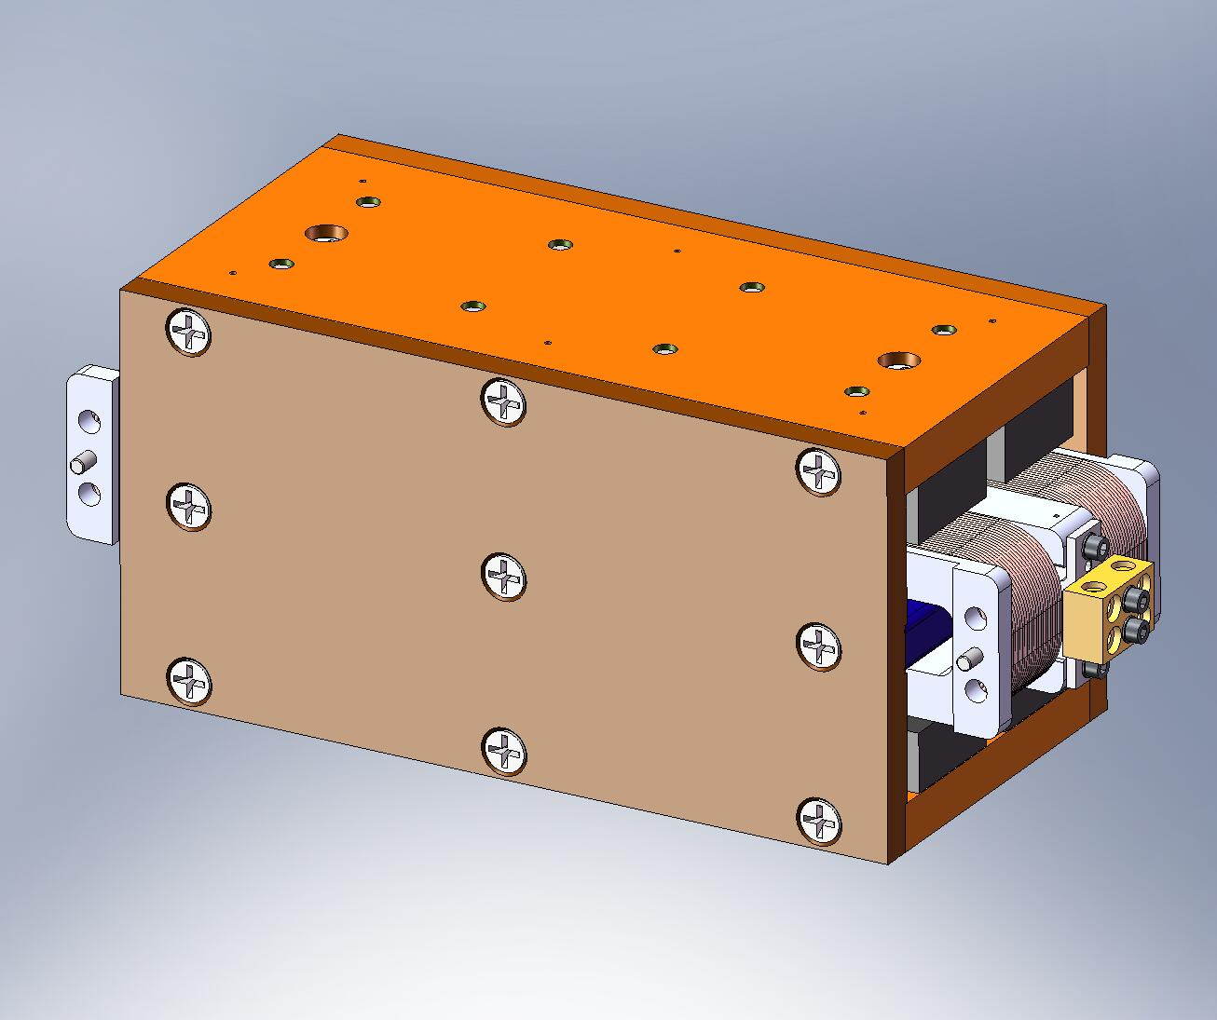
Figure 3.16. Carefully press (2) pins into the Bobbin. Note these pins go into the side opposite the Field Assembly dowel pins (see next step).

- Press (2) 1/8”x.50” dowel pins into the PSI Actuator Field Assembly, as shown in Figure 3.17. These pins should stick out of the Field Assembly’s Bottom Plate by .025”.
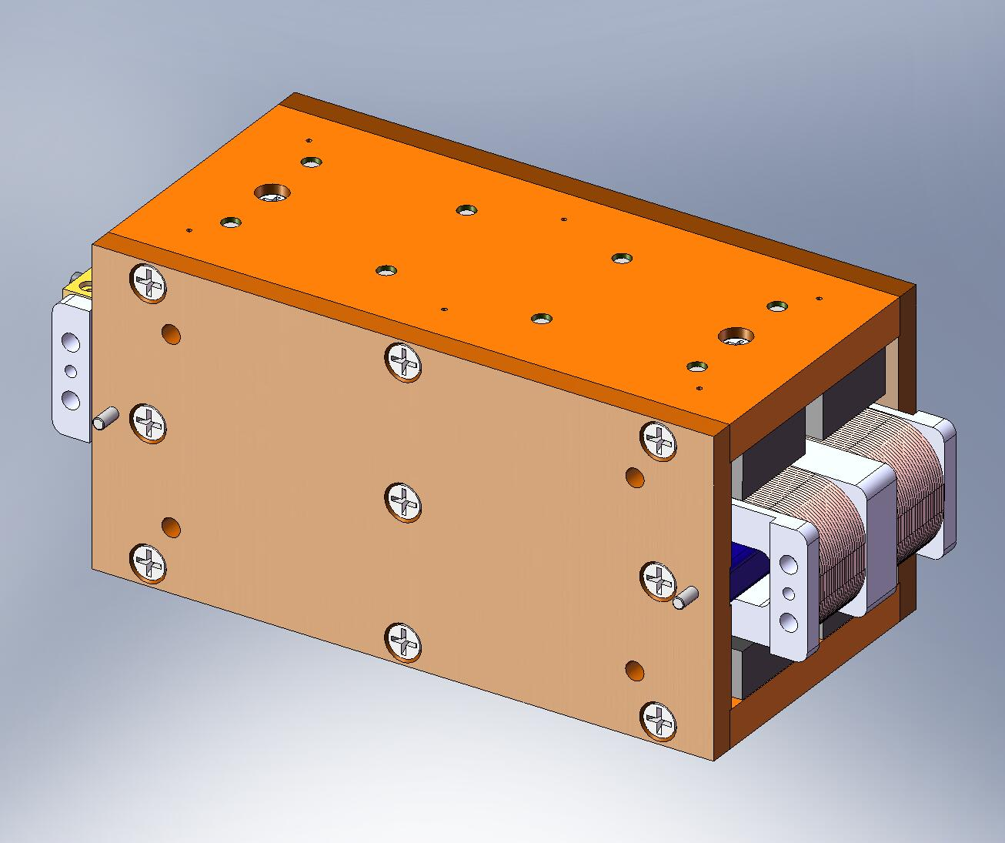
Figure 3.17. Press (2) pins into the Field Assembly.

- Attach Actuator Coil Support (D071121) to pinned-side of Bobbin. Start hardware through Bobbin’s tapped holes. Caution: if screws are longer than specified, they will damage the coil wire! Torque screws to final spec.
Hardware:
(4) #10-32x1.25” SHCS (Holo-Krome)
(4) #10 vented washers (U-C Components)
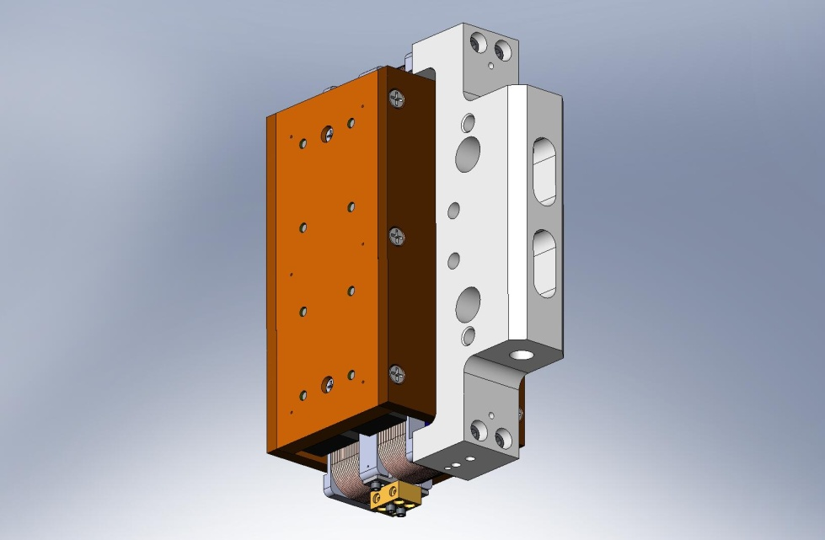
Counterbores (for reference).
Terminal block.
Figure 3.18. Bolt Coil Support to Actuator Bobbin. Set orientation as shown above, using locations of Bobbin terminal block and (2) counterbores in Coil Support for reference. Make sure pins in Bobbin mate properly with hole and slot in Coil Support.

- Place (2) Actuator Thermal Bars (D071123) on Coil Support/Actuator Bobbin. Start hardware into both Coil Support and Bobbin. Caution: if screws are longer than specified, they will damage the coil wire! Snug all screws, so each Thermal Bar makes good contact over both of its mating surfaces. Torque to final spec.
Hardware:
(4) #10-32x.25” SHCS (McMaster-Carr) – for Bobbin
(4) #10-32x.50” SHCS (Holo-Krome) – for Coil Support
(8) #10 vented washers (U-C Components)
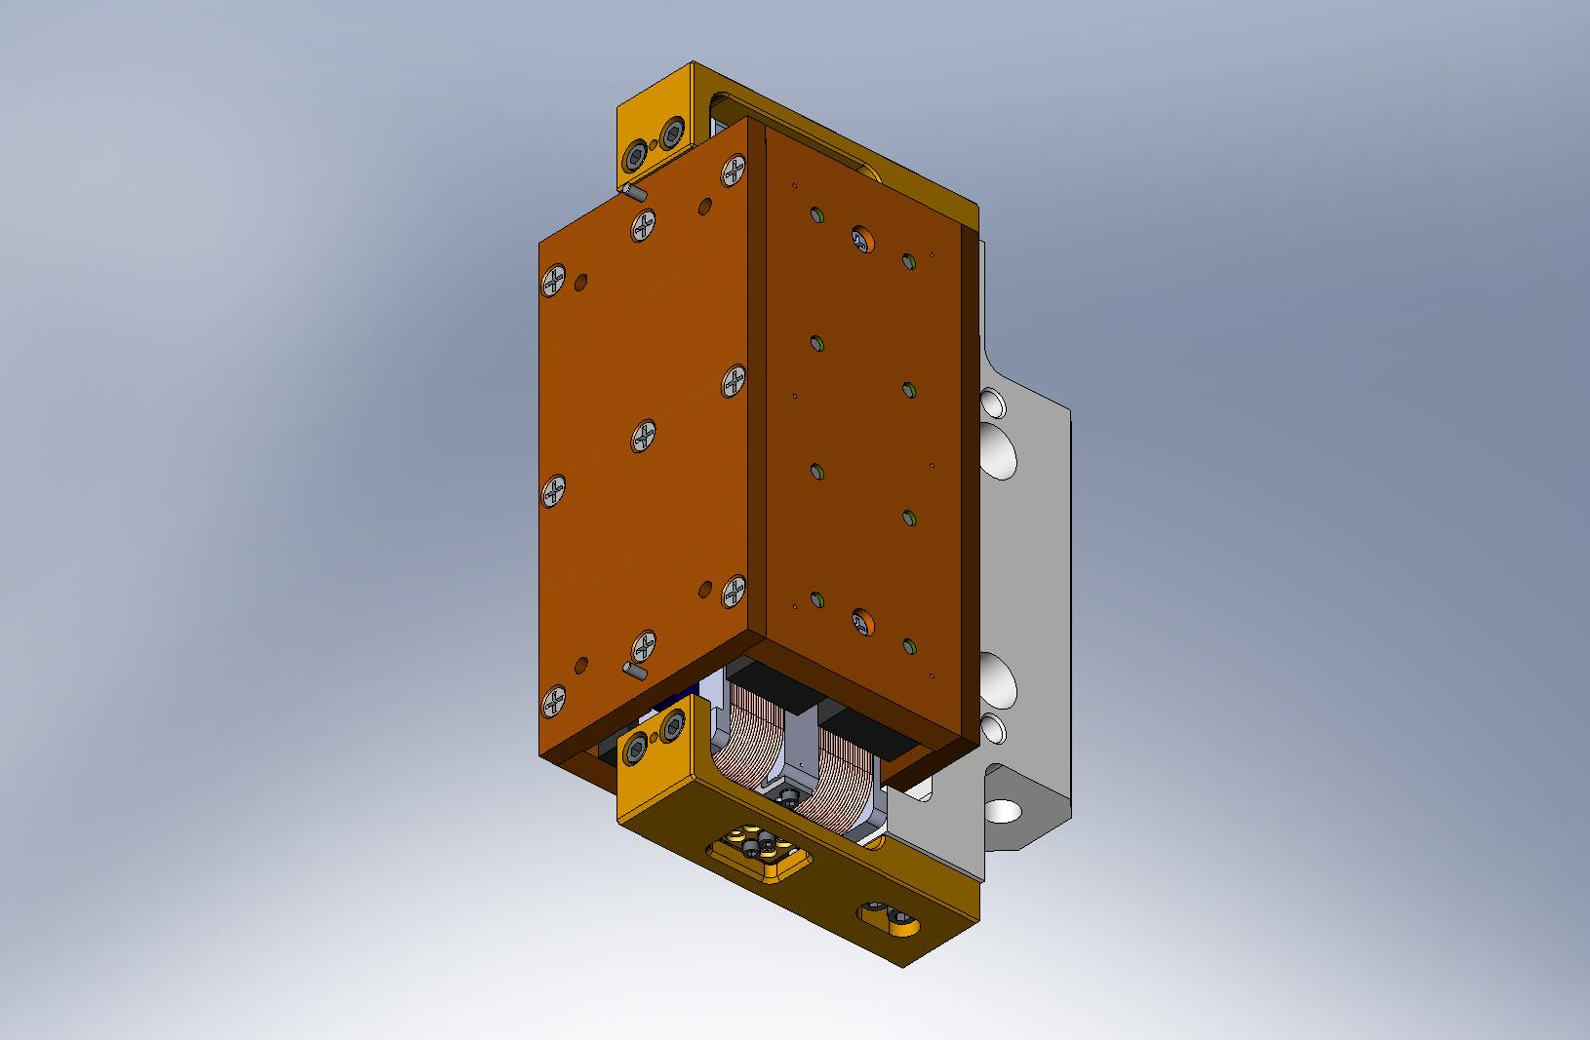
Figure 3.19. Bolt on (2) Thermal Bars. Surfaces must make good contact to properly pull heat out of Bobbin.

- Mate Actuator Magnet Mount to Field Assembly, allowing dowel pins to slip into hole and slot in Actuator Magnet Mount. Proper orientation of parts is shown in Figure 3.20. Start hardware into tapped holes in Field Assembly. Torque to final spec.
Hardware:
(4) 1/4”-20x.625” SHCS (Holo-Krome)
(4) 1/4" vented washers (U-C Components)
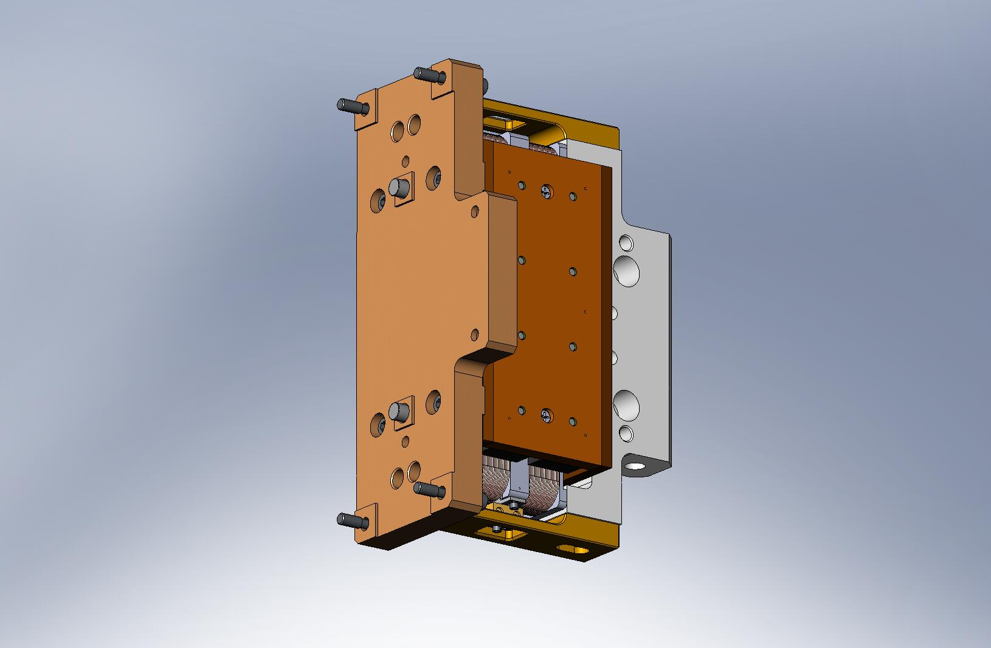
Tab
Counterbores
Figure 3.20. Actuator Magnet Mount bolted to Field Assembly. Note (2) counterbores in Coil Support face in same direction as tab on Magnet Mount.

- Hold partially-assembled Actuator horizontal, with the Magnet Mount tab pointing up. Remove (2) shoulder screws from the Field Assembly to the Bobbin. Careful: it is now possible to strike the magnets with the Bobbin. Handle with care!
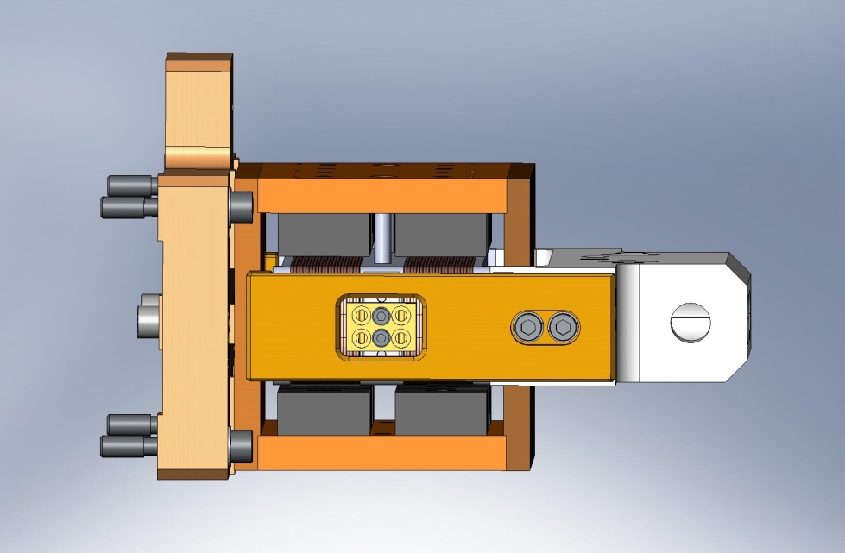
Figure 3.21. Remove the (2) lower shipping screws.

- Install partially-assembled Actuator in the Actuator Set-Up Fixture. Pins in Magnet Mount must fit into hole and slot in Set-Up Fixture Side Plate. Start (4) Captive Screws into Side Plate. Torque to final spec.
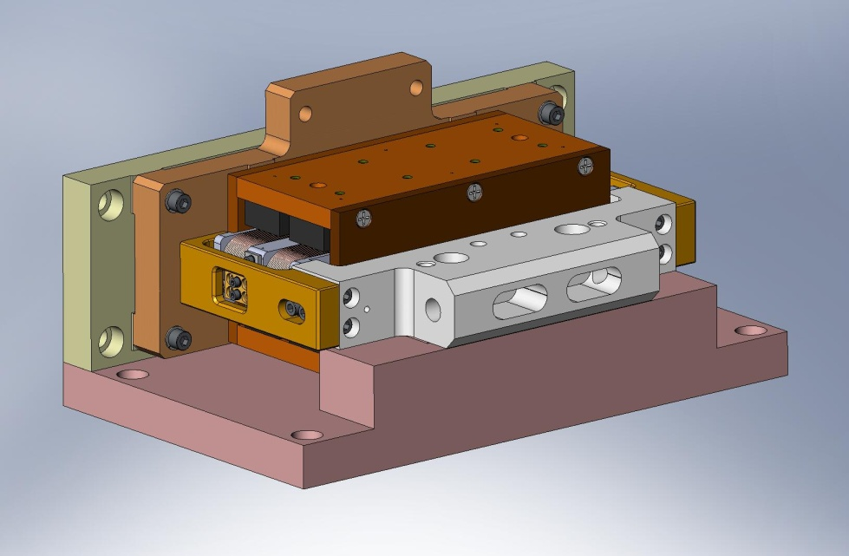
Figure 3.22. Install Actuator in Set-Up Fixture. Now, Field Assembly is fixed to Fixture. Location of Bobbin has not yet been defined.

- Start screws from Coil Support to Fixture Base Plate. Do not tighten, yet.
Hardware:
(2) 3/8”-16x1.25” SHCS (Holo-Krome)
(2) 3/8" vented washers (U-C Components)
- While supporting the Bobbin with your hand, remove the (2) remaining shoulder screws holding the Bobbin to the Field Assembly.
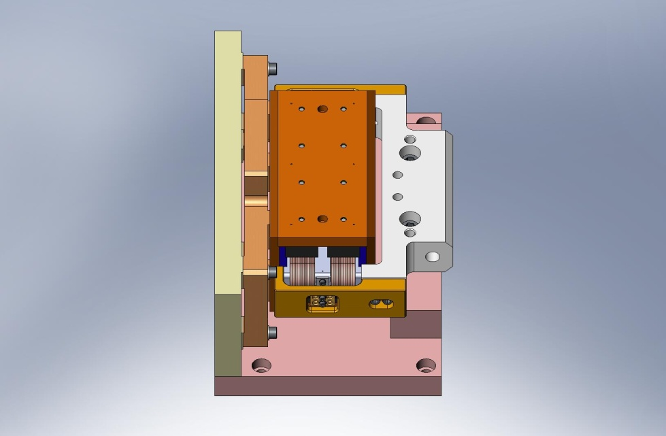
Shipping screws removed.
Screws installed, but not tightened, yet.
Figure 3.23. Upper (2) shipping screws are removed. Now, the Bobbin is loosely held to the Set-Up Fixture. You may want to insert a Teflon shim between the lower magnets and the Bobbin, to prevent hard contact.

- Slip (2) 1/4”x3.0” dowel pins (McMaster-Carr #90145A553) through Coil Support and into Fixture Base Plate. Now, tighten (2) SHCS from Coil Support to Fixture Base Plate. Torque to final spec.
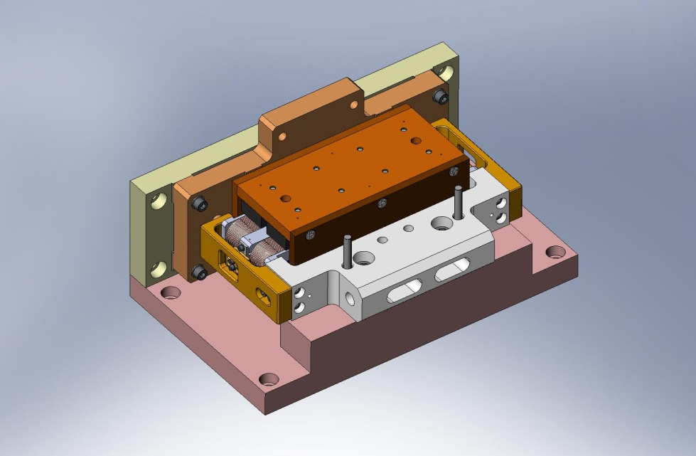
Alignment pins.
Figure 3.24. Install (2) alignment pins, then tighten Coil Support to Fixture. Now, location of Bobbin relative to Field Assembly is fully defined.

- Remove 1/4”x3.0” alignment pins.
- Install Actuator Setup Bar (D071129). Snug hardware connecting Setup Bar to both Actuator Magnet Mount and Coil Support, then torque to final spec.
Hardware:
(2) 1/4”-20x1.25” SHCS (Holo-Krome) – for Actuator Magnet Mount
(2) 1/4”-20x1.5” SHCS (Holo-Krome) – for Actuator Coil Support
(4) 1/4” vented washers (U-C Components)
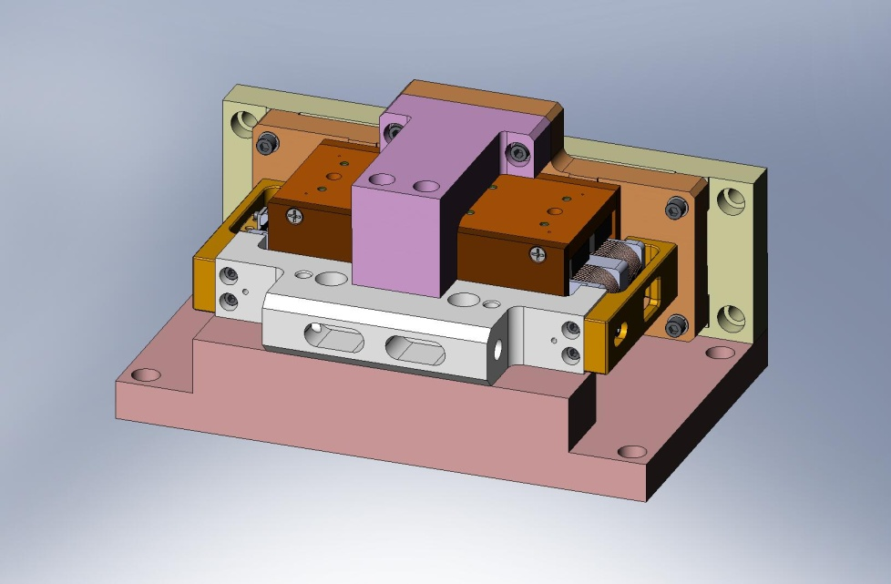
Figure 3.25. Install Setup Bar. Setup Bar is used to lock Bobbin position relative to Field Assembly, until Actuator is installed in HAM ISI.

- Remove (2) 3/8”-16x1.25” SHCS between Coil Support and Set-Up Fixture.
- Loosen (4) Captive Screws from Set-Up Fixture. Remove Actuator Assembly from Set-Up Fixture.
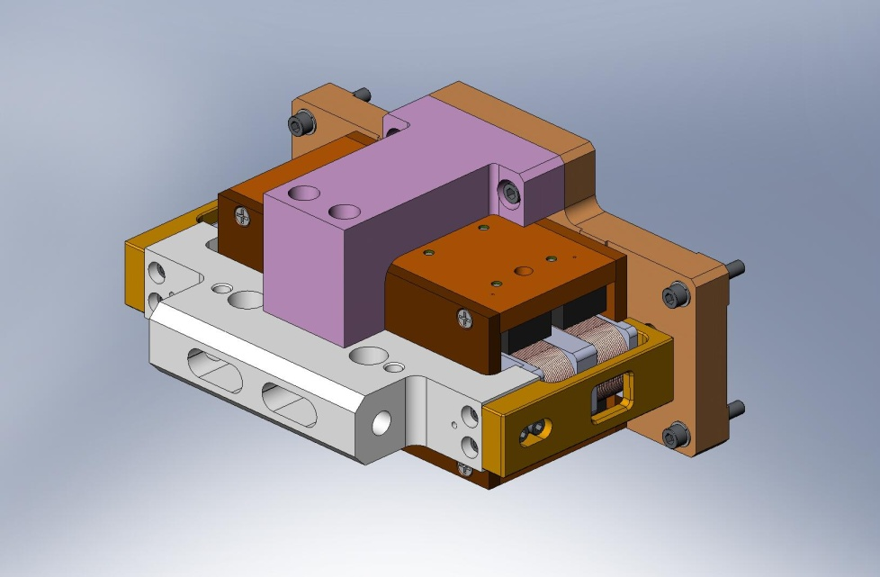
Figure 3.26. Actuator after removal from Set-Up Fixture.

- Slide (2) Actuator Stops (D070534) into Field Assembly, between rows of magnets as shown in Figure 3.27. Start hardware, snug, and torque to final spec.
Hardware:
(4) #8-32x.625” SHCS (Holo-Krome)
(4) #8 vented washers (U-C Components)
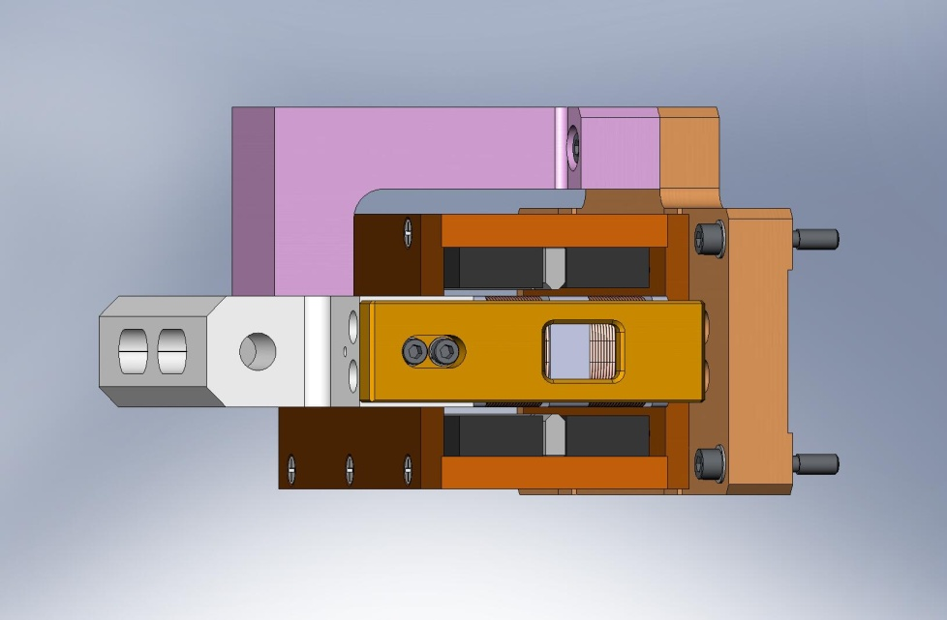
Figure 3.27. Actuator Stops installed. These help prevent “crashes” of Bobbin into magnets during HAM ISI operation.

- Use stacked Teflon shims to check several gaps between Bobbin and Field Assembly. Refer to Sheet 4 of drawing D071442 for nominal gap values. If any measured values are significantly different from values given there, inspect Actuator Assembly for possible machining and/or assembly errors.
- Repeat preceding steps until all (6) Actuator Assemblies are complete.
the following steps complete assembly of (3) Horizontal Actuators:
- Prepare (2) Actuator L-Brackets (Horizontal) (D071132), with the hardware listed below.
Hardware:
(2) 3/8”-16x3.0” SHCS (McMaster-Carr)
(4) 3/8” spherical washers, female (McMaster-Carr)
(4) 3/8” spherical washers, male (McMaster-Carr)
(6) 3/8” fender washers (McMaster-Carr)
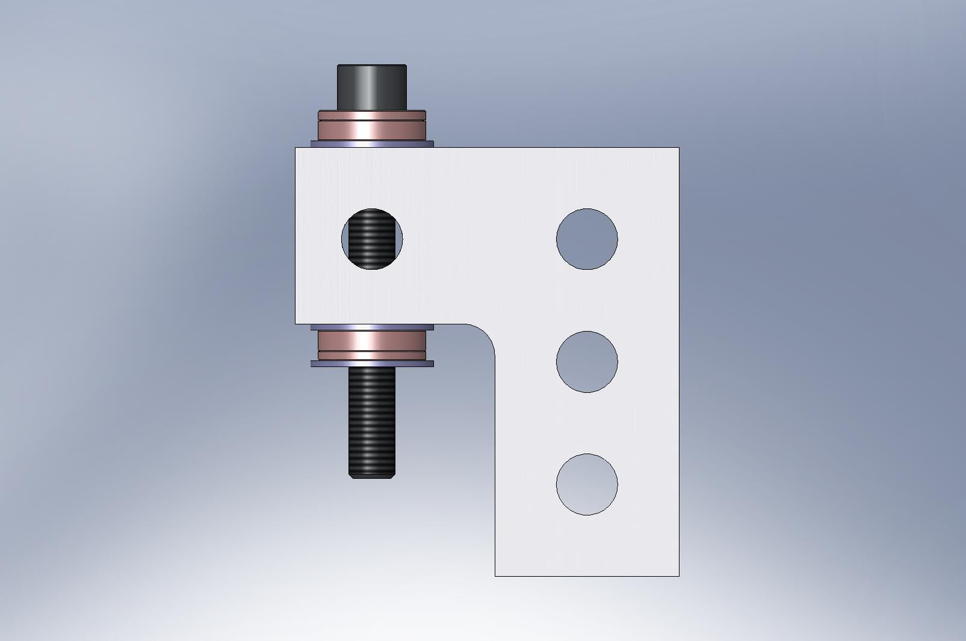
Spherical washers, female
Spherical washers, male
Fender washers
Figure 3.28. Actuator L-Bracket, with screw and washers. Two of these mount to Coil Support on Horizontal Actuator. Spherical washers and loose thru holes compensate for machining and assembly tolerances, when Actuators are installed in HAM ISI.

- Attach both L-Brackets to Actuator Assembly, by threading 3/8”-16x3.0” screws into Coil Support. Finger-tighten screws, so Brackets do not shift easily. Do not torque.
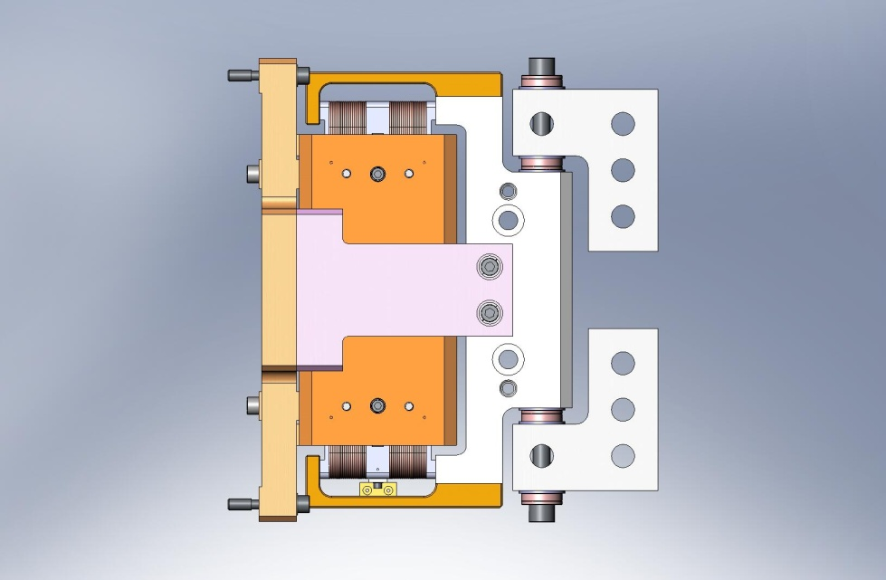
Figure 3.29. Horizontal Actuator, ready for installation in HAM ISI.
- Finish all (3) Horizontal Actuators, and set aside for later use.

the following steps complete assembly of (3) Vertical Actuators:
- Prepare (2) Actuator U-Brackets (Vertical) (D071122), with the hardware listed below.
Hardware:
(2) 3/8”-16x3.0” SHCS (McMaster-Carr)
(4) 3/8” spherical washers, female (McMaster-Carr)
(4) 3/8” spherical washers, male (McMaster-Carr)
(6) 3/8” fender washers (McMaster-Carr)
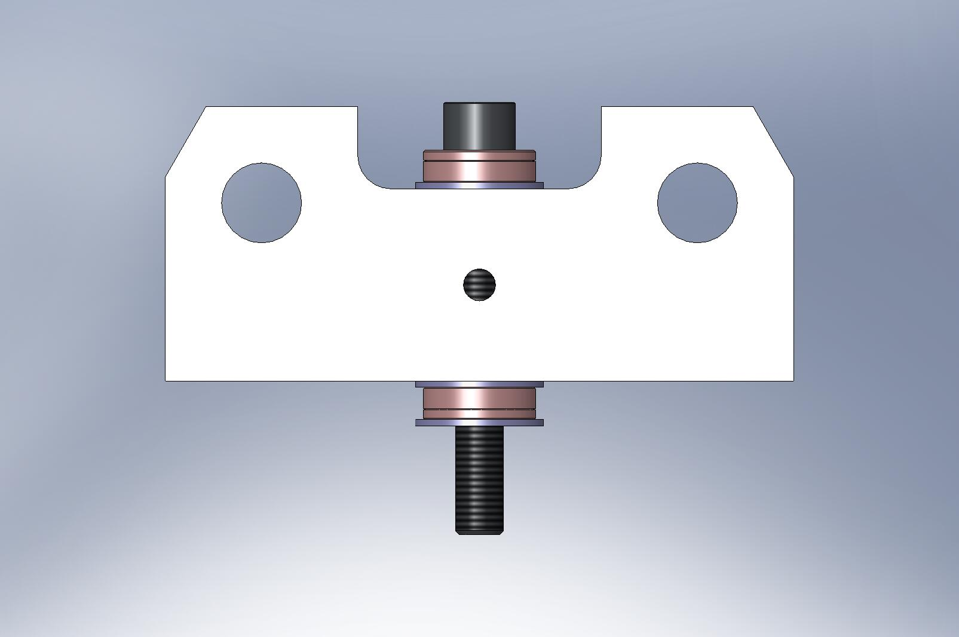
Figure 3.30. Actuator U-Bracket, with screw and washers (refer to Figure 3.28 for more detail). Two of these mount to Coil Support on Vertical Actuator. Spherical washers and loose thru holes compensate for machining and assembly tolerances, when Actuators are installed in HAM ISI.

- Attach both U-Brackets to Actuator Assembly, by threading 3/8”-16x3.0” screws into Coil Support. Finger-tighten screws, so Brackets do not shift easily. Do not torque.
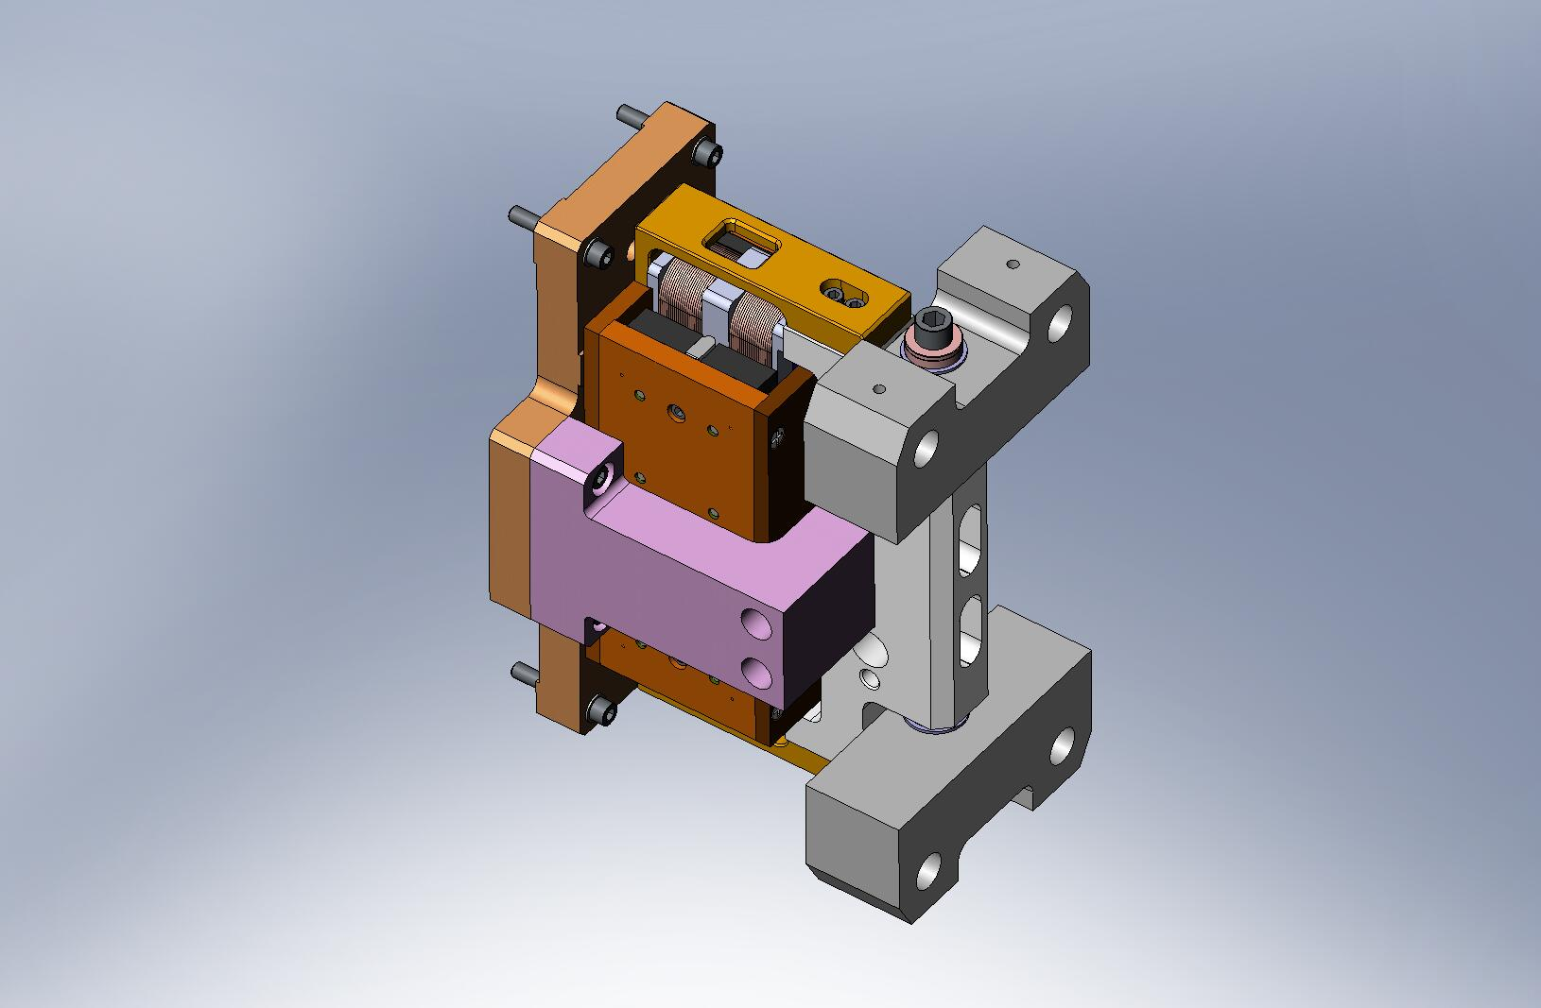
Figure 3.31. Vertical Actuator, ready for installation in HAM ISI.
- Finish all (3) Vertical Actuators, and set aside for later use.

    - Prep Work – Assemble Sensors (D071463 & D071464)
- Insert Heli-Coils into (6) Sensor Target Body pieces (D071166):
  - (6x 3) #8-32x2.0*Dia.
the following procedure describes the assembly of one D071463. Repeat for all (6) Sensor Targets:
- Press Sensor Target Post (D071167) into Sensor Target Body (D071166), until Post comes flush with back face of Body. Note: the Target Body has a slightly over-sized lead-in on one side of the center hole - the Target Post should be inserted from this side.
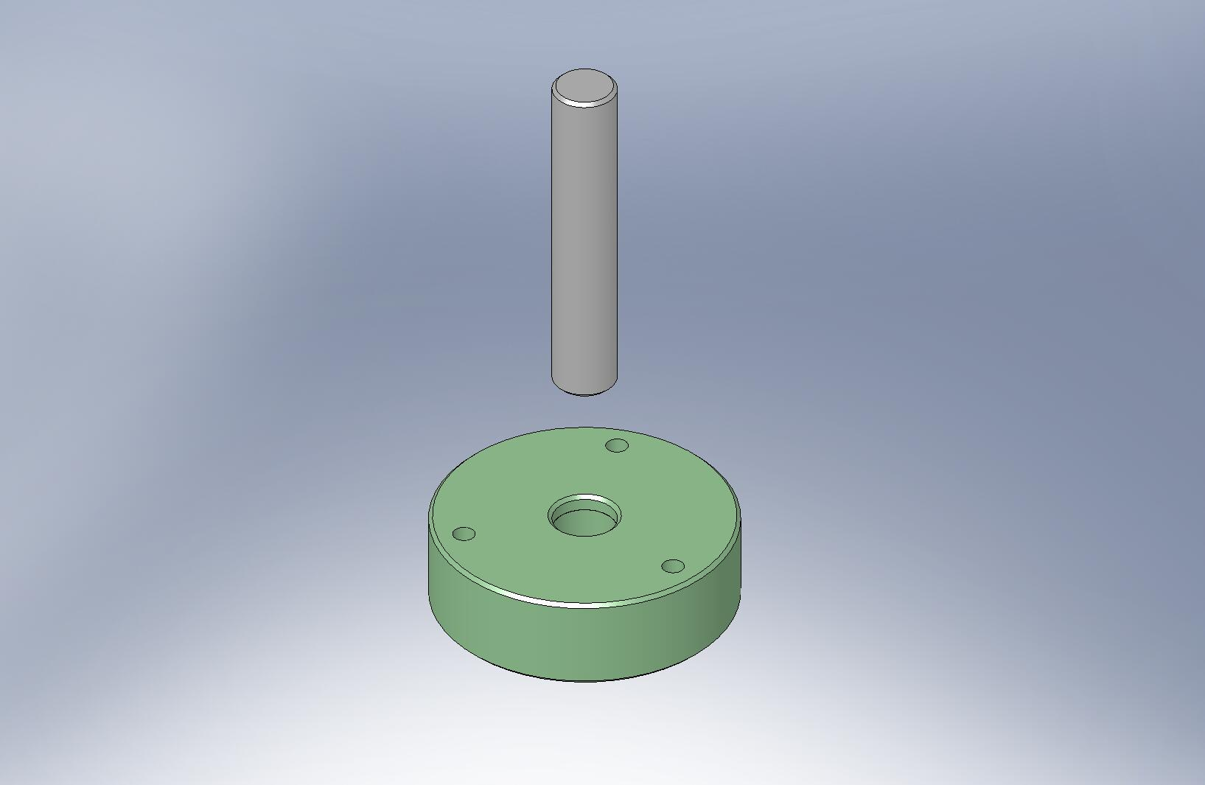
Over-sized lead-in.
Figure 3.32. Press fit Target Post into Target Body, until the face on the bottom of the Post is flush with the bottom face of the Body.

Caution: surface of Sensor Target (D071165) is delicate. Handle with care!
- Mount Sensor Target to Sensor Target Body. Carefully add hardware, and torque screws to final spec.
Hardware:
(6x 3) #8-32x.625” SHCS (Holo-Krome)
(6x 3) #8 vented washers (U-C Components)
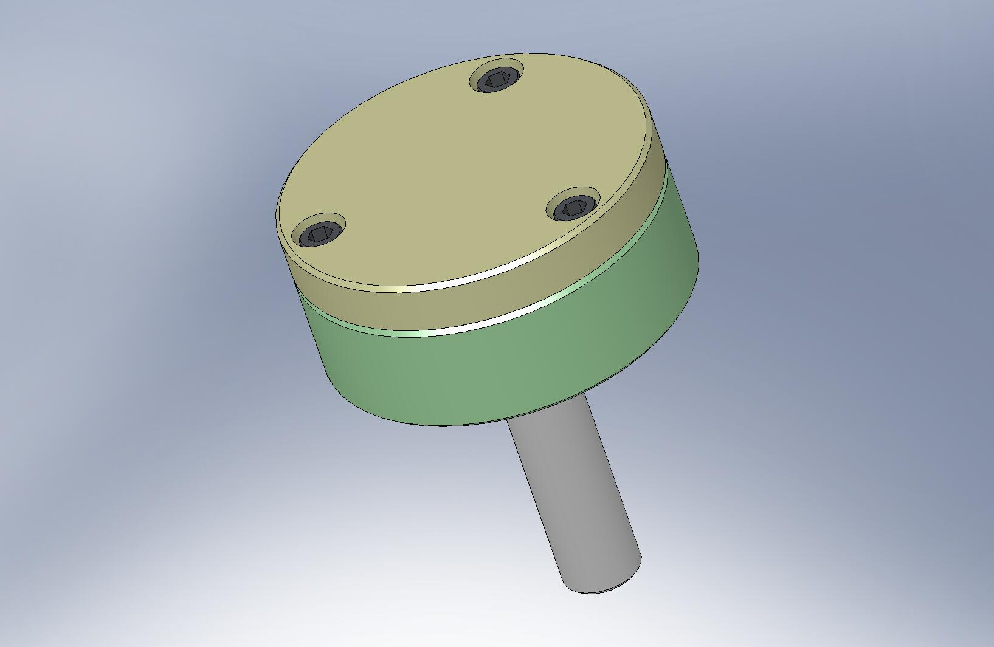
Do not scratch this surface!
Figure 3.33. Screw Sensor Target to top of Sensor Target Body. This is the Position Sensor Target Face Assembly (D071462).

- Slide a loosened shaft collar over the collet in the Sensor Target Mount (D071160). Next, insert the Sensor Target Face Assembly, as shown in Figure 3.34.
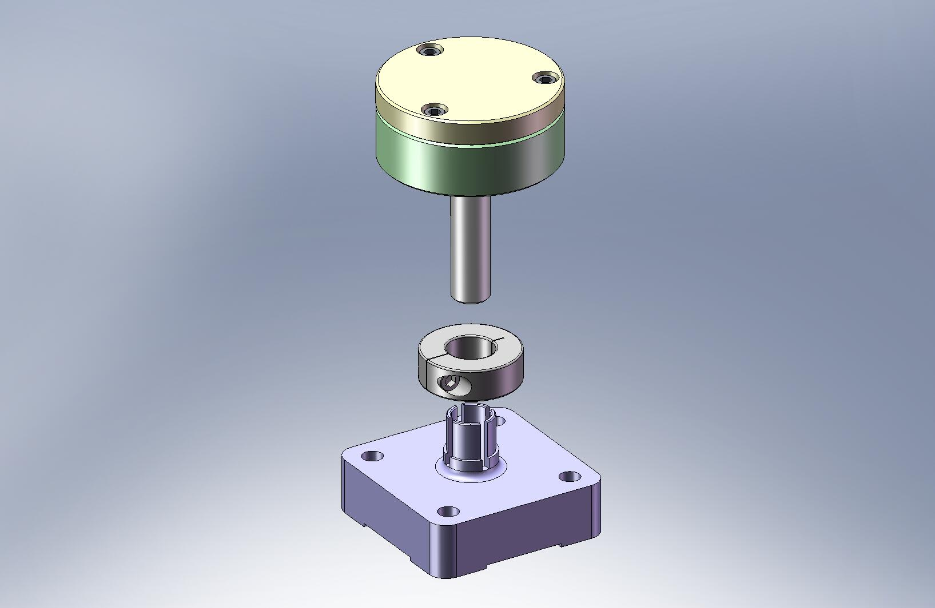
Figure 3.34. Use shaft collar to clamp Sensor Target Face Assembly to Sensor Target Mount.

- Insert Target Face Assembly until bottom of Post is roughly in same plane as bottom of Mount. Tighten shaft collar, so Target Face Assembly does not slide. Store for later installation. Target Face must be protected from accidental damage!
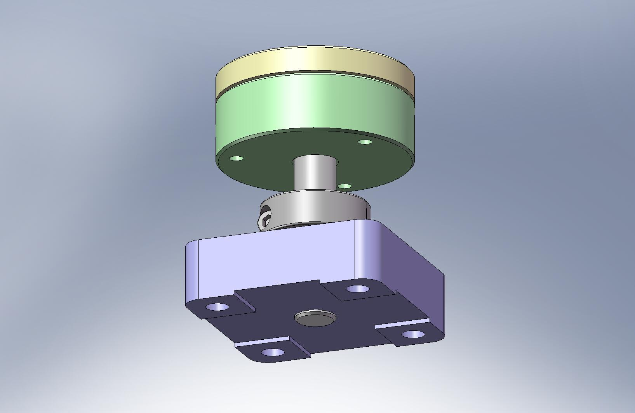
Figure 3.35. Completed Position Sensor Target Assembly.

- Repeat preceding steps for all (6) Position Sensor Target Assemblies.

- Assemble spherical mount, as shown in Figure 3.36 and Figure 3.37. Slide a hex head cap screw through the Sensor Head Base (D071161), Sensor Head Mount (D071163), and Sensor Head Washer (D071162), in that order. Place washers over exposed end of screw, and tighten nut until assembly is rigid. Repeat for all (6) Position Sensor Assemblies (D071464).
Hardware:
(6x 1) 3/8”-16x2.5” HHCS (McMaster-Carr)
(6x 1) 3/8” flat washer (McMaster-Carr)
(6x 1) 3/8” curved spring washer (McMaster-Carr)
(6x 1) 3/8”-16 hex jam nut (McMaster-Carr)
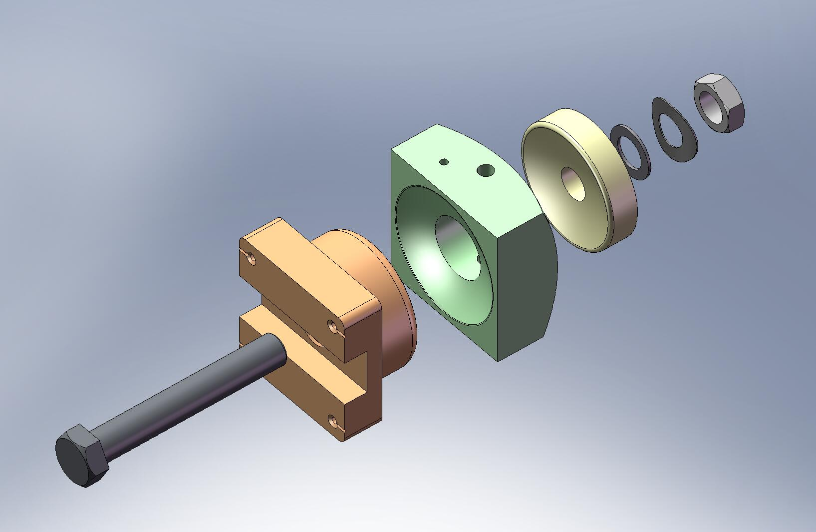
Figure 3.36. Exploded view of sensor spherical mount. This is a sub-assembly of the Position Sensor Assembly (D071464).
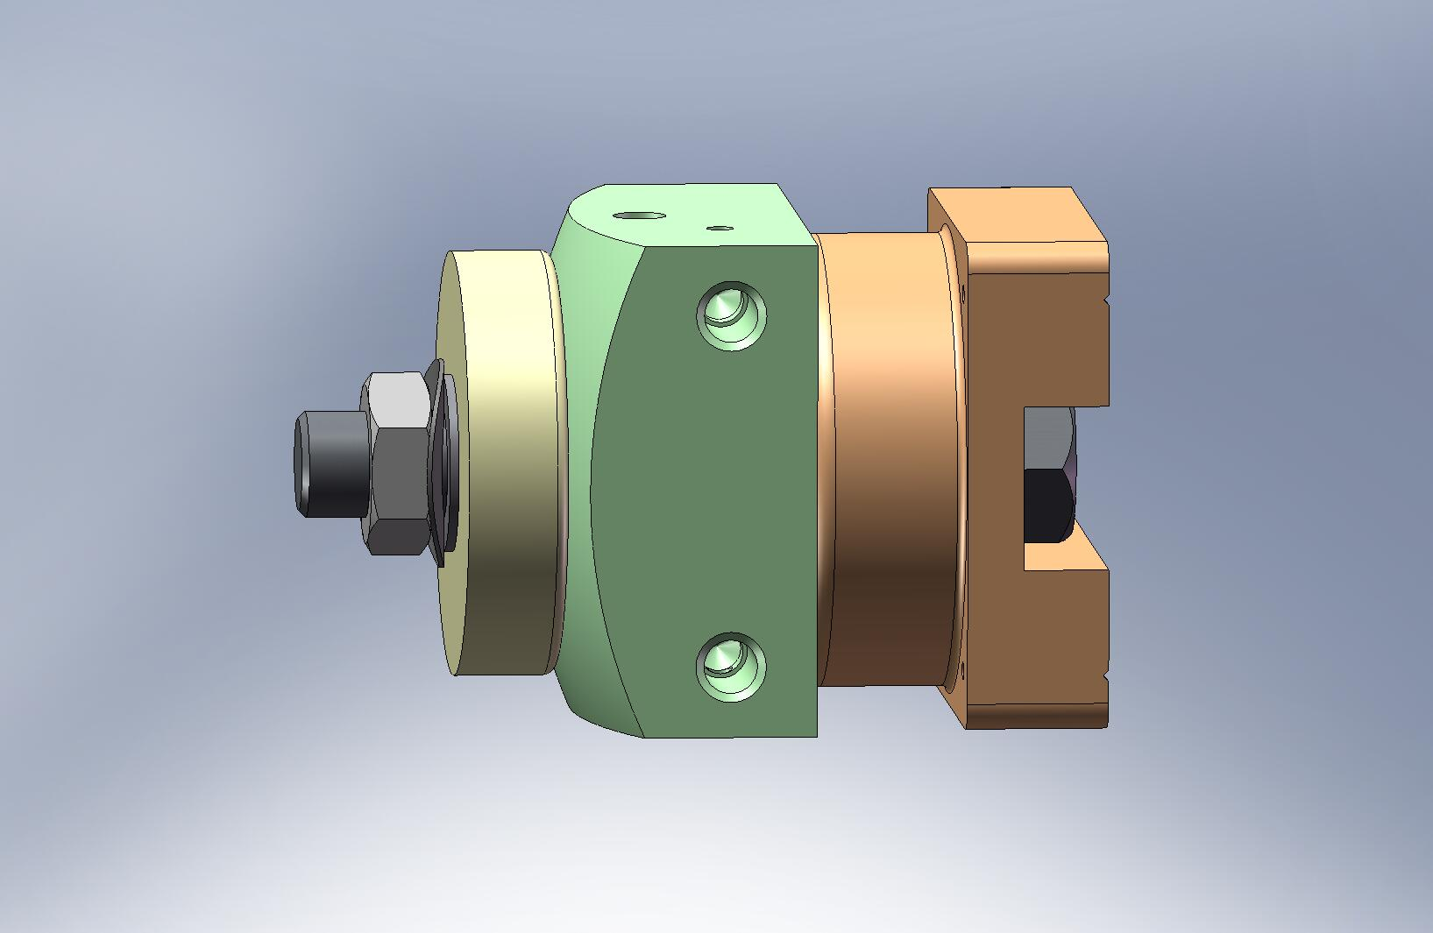
Figure 3.37. Assembled spherical mount. Roughly align Base to Mount, so sides are parallel to one another. Tighten jam nut until assembly is rigid.

- For (3) Horizontal Position Sensor Assemblies, place Horizontal Sensor Head Standoff (D071170) between Sensor Head Mount and Sensor Head Base Plate (D071164), as shown in Figure 3.38. Add screws and torque to final spec.
Hardware:
(3x 2) #10-32x.75” SHCS (Holo-Krome)
(3x 2) #10 vented washer (U-C Components)
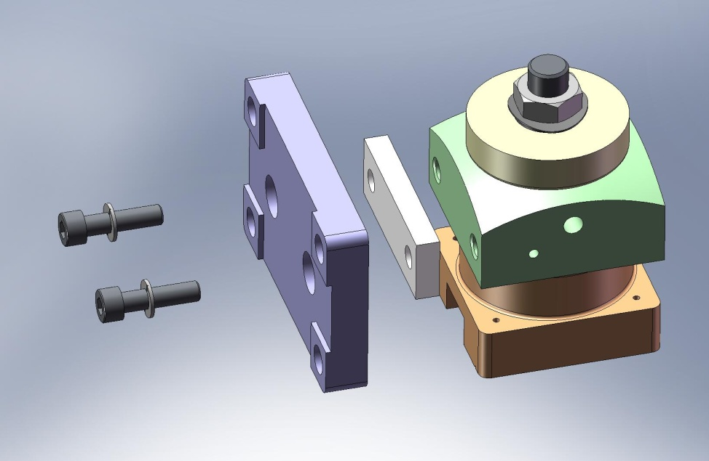
Figure 3.38. Add Standoff and Base Plate, to complete Horizontal Position Sensor Assembly (accept for sensor).

- For each of (3) Vertical Position Sensor Assemblies, attach Vertical Sensor Head Bracket (D071175) to Sensor Head Mount, as shown in Figure 3.39. Add screws and torque to final spec.
Hardware:
(3x 2) #10-32x1.25” SHCS (Holo-Krome)
(3x 2) #10 vented washer (U-C Components)
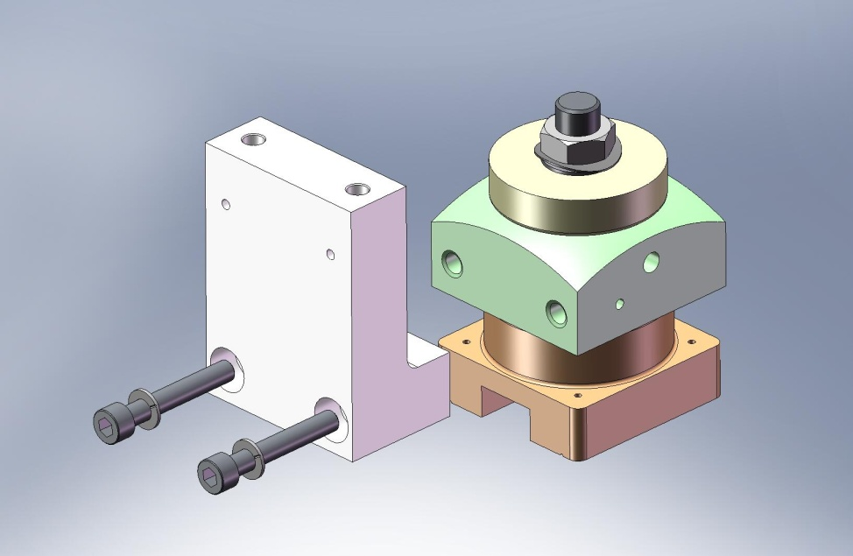
Figure 3.39. Vertical Sensor Head Bracket mounted to Sensor Head Mount.

- Mount Sensor Head Base Plate to Vertical Sensor Head Bracket, as shown in Figure 3.40. Add screws and torque to final spec.
Hardware:
(3x 2) #10-32x.50” SHCS (Holo-Krome)
(3x 2) #10 vented washer (U-C Components)
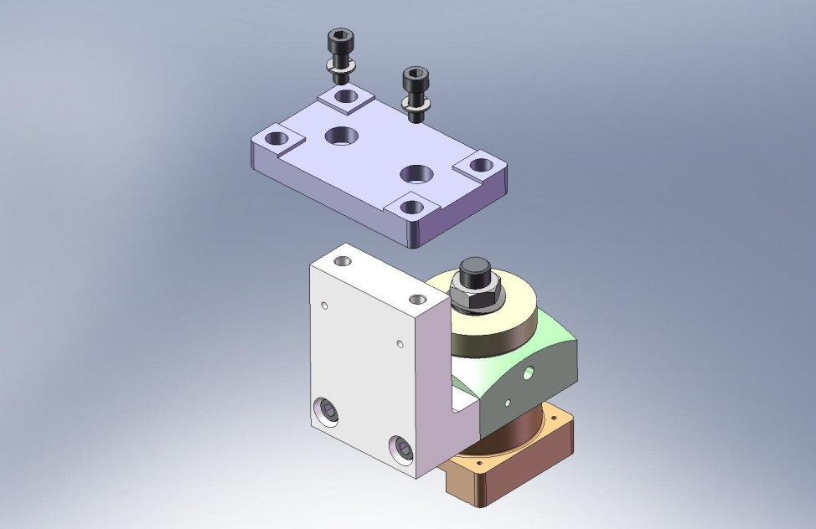
Figure 3.40. Add Base Plate, to complete Vertical Position Sensor Assembly (accept for sensor).

- Mount ADE capacitance sensor to each of the (3) Horizontal and (3) Vertical Position Sensor Assemblies, as shown in Figure 3.41 and Figure 3.42, respectively. Use (2) precision washers under each screw head. The top of each screw should protrude slightly above the sensor face, to prevent crashing the Sensor into the Target (Figure 3.43).
Hardware:
(6x 4) M2-.4x8mm SHCS (McMaster-Carr)
(6x 8) precision washer (McMaster-Carr)
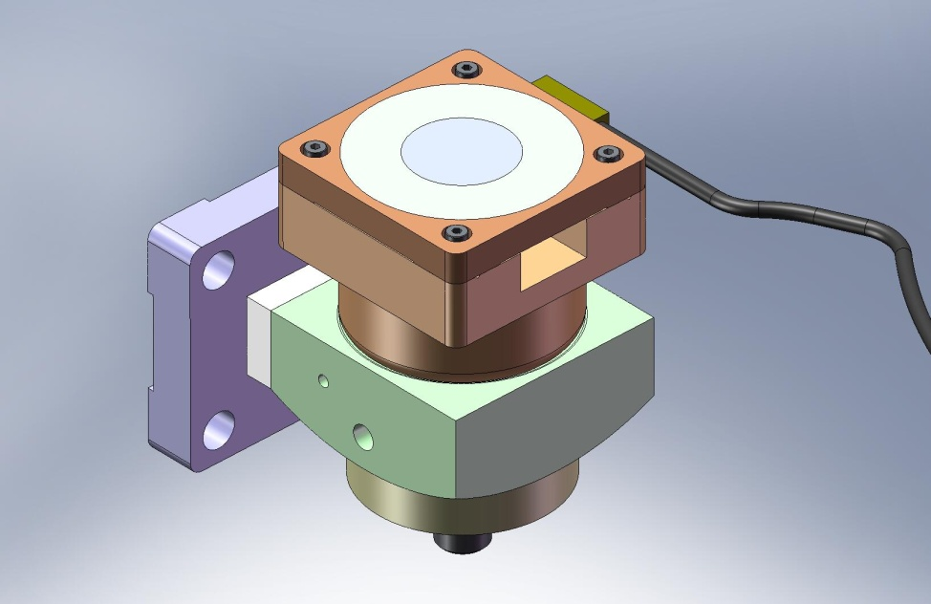
Figure 3.41. ADE sensor mounted in Horizontal Position Sensor Assembly. Note orientation of sensor cable.
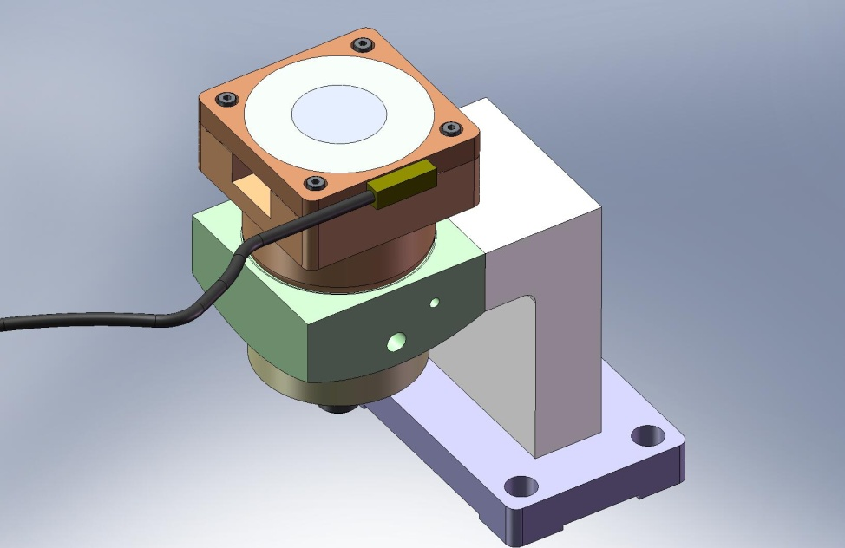
Figure 3.42. ADE sensor mounted in Vertical Position Sensor Assembly. Note orientation of sensor cable.
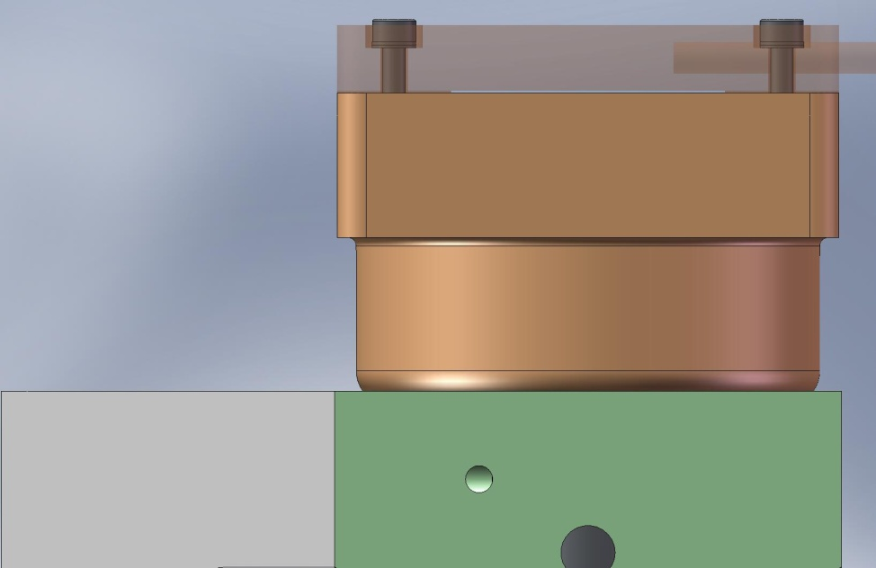
Figure 3.43. Close-up view of ADE sensor mounted to Sensor Head Base. Heads of sensor mounting screws stand approximately .020” proud of sensor face. This prevents contact between center of Sensor Target Face and active area on sensor probe.

- Set aside all (6) Position Sensor Assemblies for later installation. Sensor must be protected from accidental damage!

    - Prep Work – Finish (6) GS-13 Assemblies (D071470)
- Follow instructions given in separate document for assembly of (6) GS-13 Seismometer Pods (D047810). Of these Pods, (3) should be in the Horizontal configuration (shown in Figure 3.44) and (3) should be in the Vertical configuration (shown in Figure 3.45).
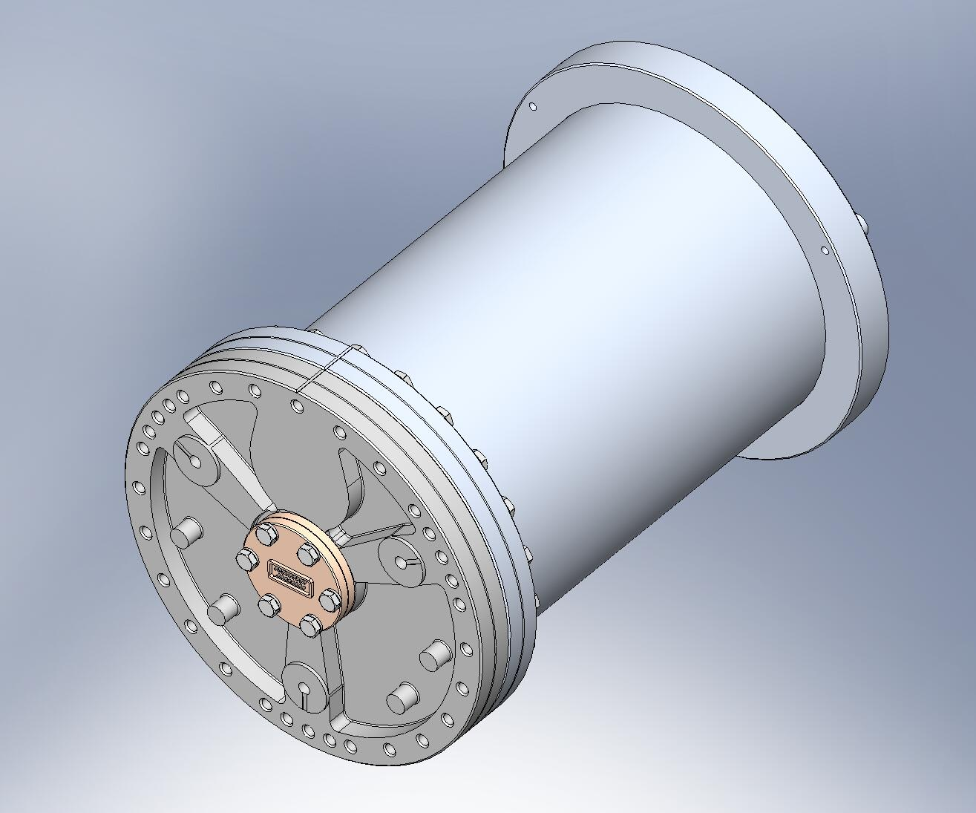
Connector flange.
Figure 3.44. GS-13 Pod, Horizontal configuration. Note centered location of connector flange.
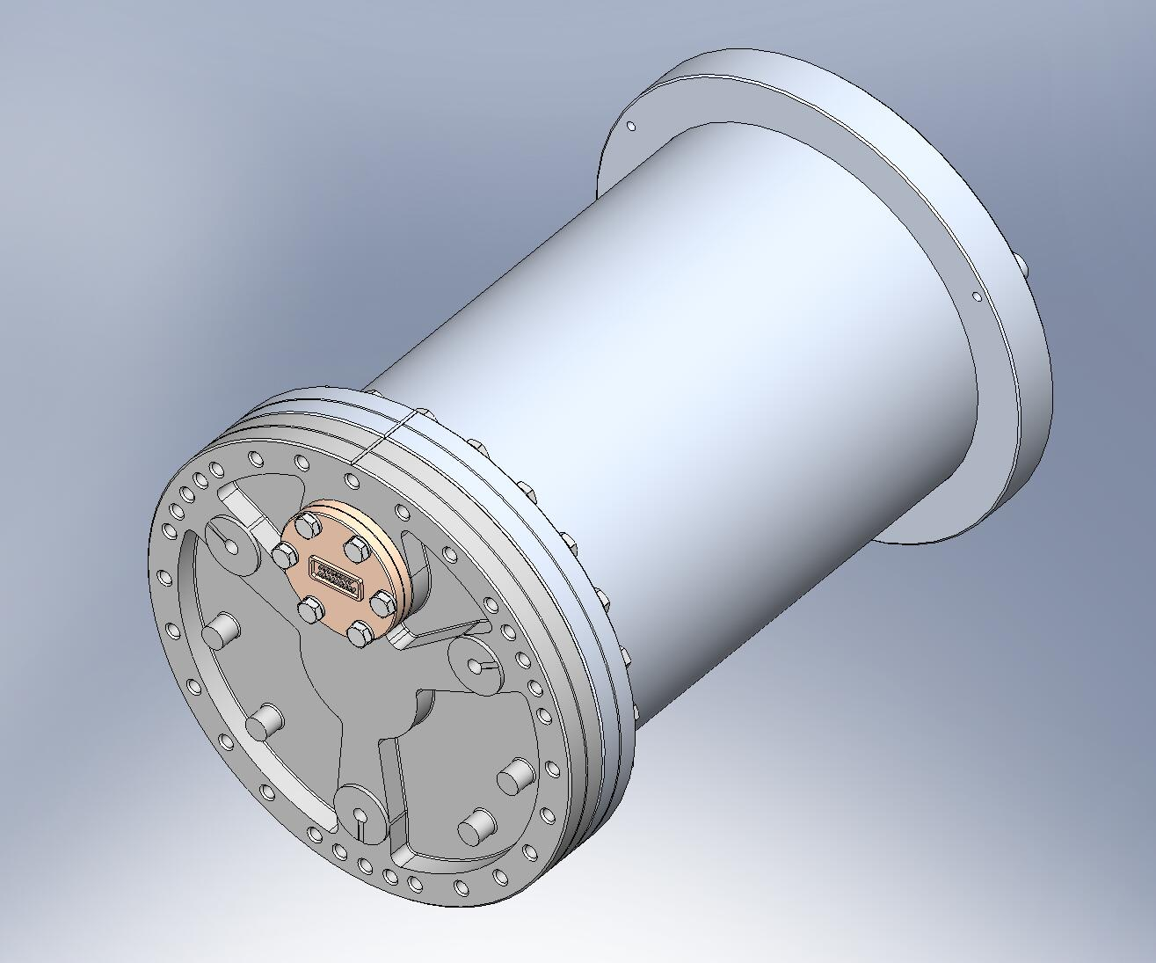
Connector flange.
Figure 3.45. GS-13 Pod, Vertical configuration. Note offset location of connector flange.

the remaining steps from this section apply to both the Horizontal and the Vertical configurations:
- Insert Heli-Coils into (6) GS-13 Adapter Plates (D071180):
  - (6x 9) 1/4”-20x1.0*Dia.
- Mount GS-13 Adapter Plate to Pod Baseplate (20007813). Cable channel in Adapter Plate must line up with alignment etching on Baseplate (as shown in Figure 3.46). Add vented hardware and torque to final spec.
Hardware:
(6x 6) 5/16”-24x1.5” vented SHCS (U-C Components)
(6x 6) 5/16” vented washer (U-C Components)
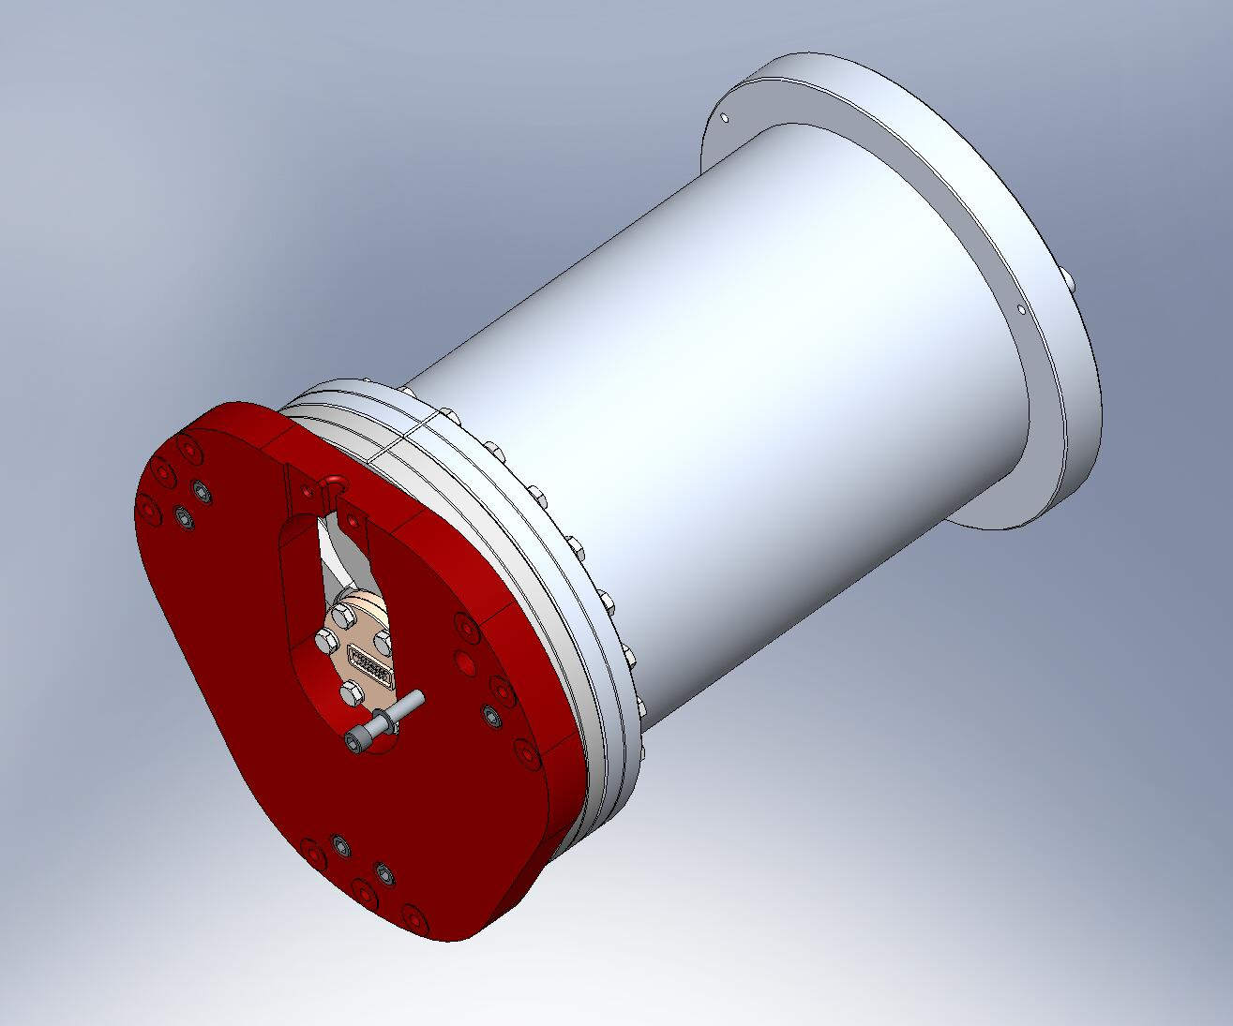
Adapter Plate’s cable channel must be oriented with Baseplate’s alignment etching.
Figure 3.46. Adapter Plate bolted onto GS-13 Baseplate. Tapped holes are blind, so vented screws must be used.

- Lift GS-13 and place it vertically on flat surface, with Adapter Plate facing down. Do not dent any of the (9) circular mounting pads on Adapter Plate!
- Place (3) 1/8”-thick spacers (McMaster-Carr) on round bosses on back end of GS-13 Pod, then rest GS-13 Stabilizer Assembly (D071471) on top. Weld Nut (D071182) should face up.
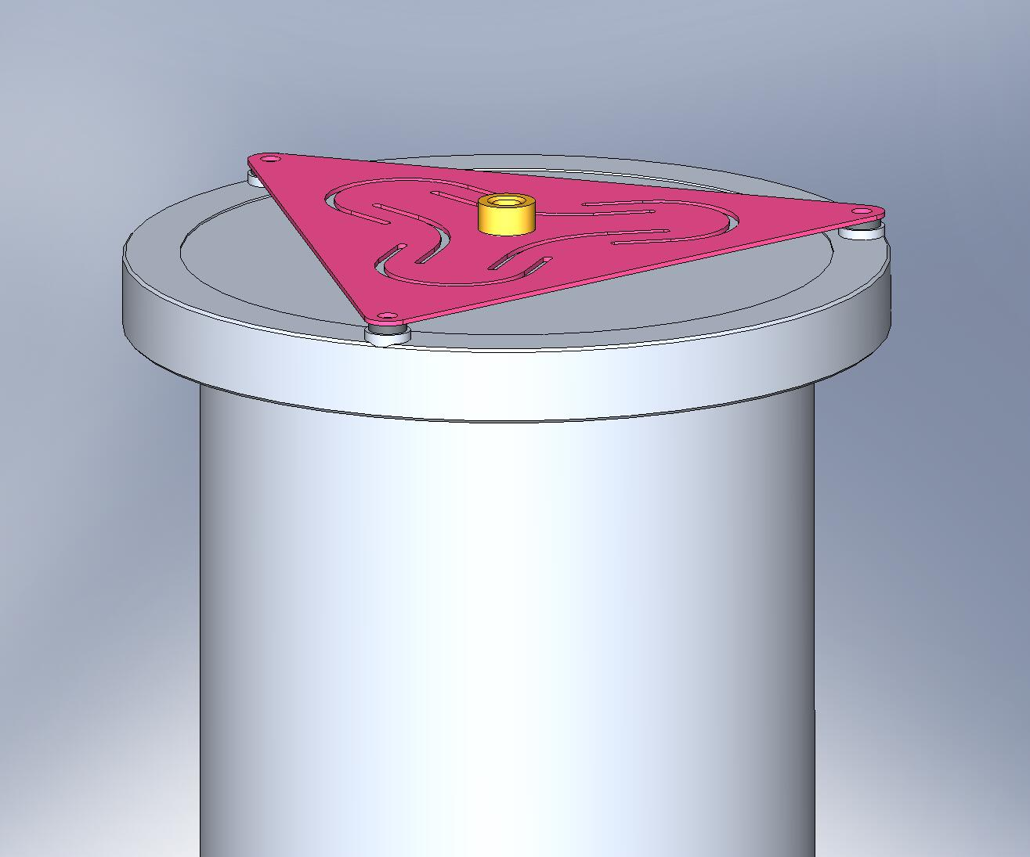
Weld Nut
Spacers
Figure 3.47. Stabilizer Assembly resting on back end of GS-13 Pod.

- Two of the holes under the spacers are tapped. Add hardware to these, and finger tighten.
Hardware:
(6x 2) 1/4”-20x1.0” SHCS (U-C Components)
(6x 2) 1/4” vented washer (U-C Components)
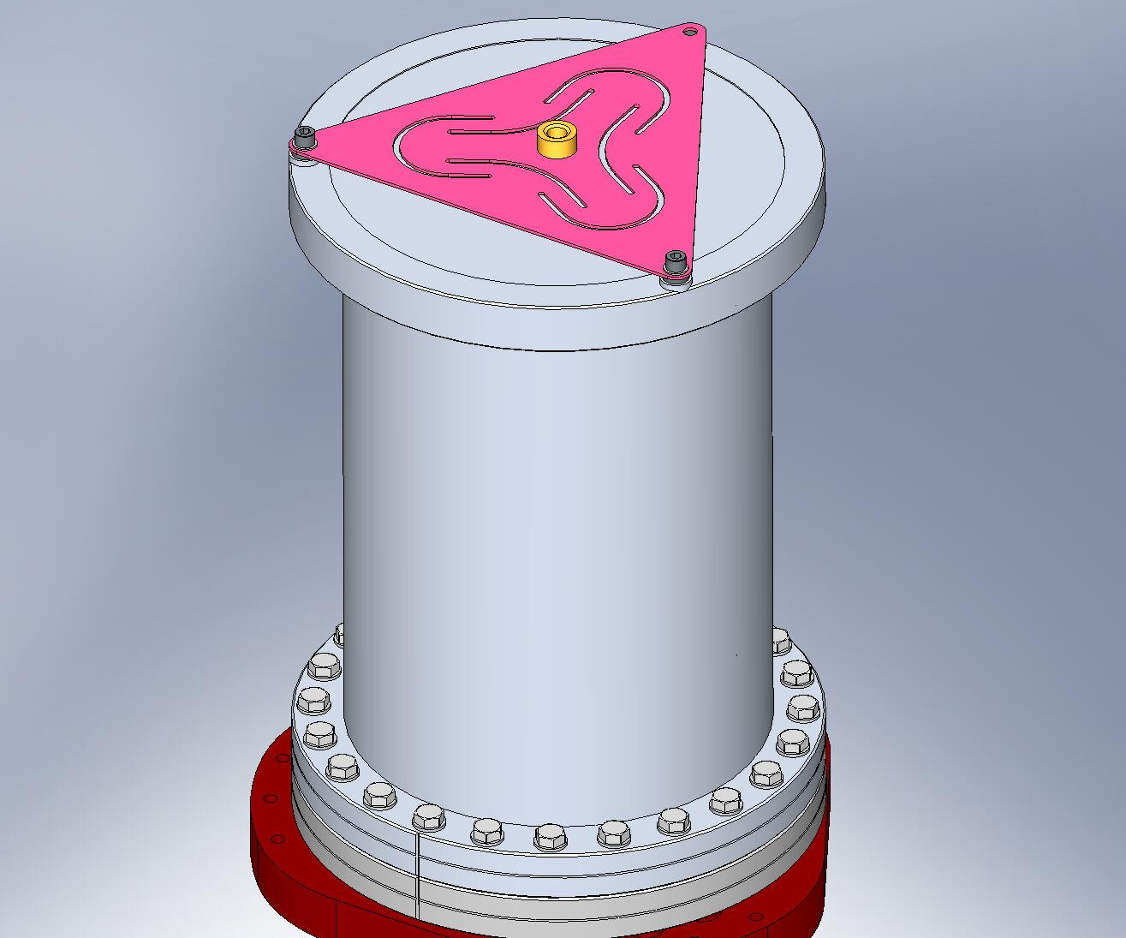
Figure 3.48. Thread (2) screws into tapped holes. Do not torque, yet.

- Insert last screw through Stabilizer and fasten to Pod with hex lock-nut. Do not torque nut, yet.
Hardware:
(6x 1) 1/4”-20x1.75” SHCS (U-C Components)
(6x 2) 1/4” vented washer (U-C Components)
(6x 1) 1/4”-20 hex lock nut (McMaster-Carr)
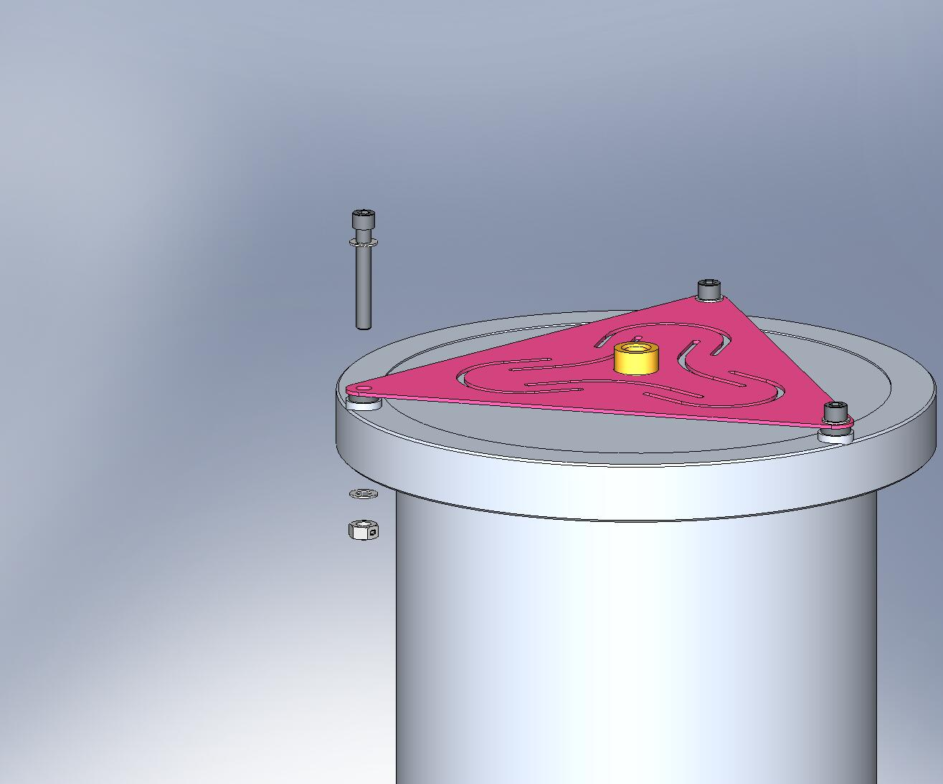
Figure 3.49. Insert screw through Stabilizer and Pod. Fasten onto Pod with hex lock-nut.

- Torque all (3) Stabilizer screws to final spec.
- Thread in (9) Captive Screws through Adapter Plate, as shown in Figure 3.50.
Hardware:
(6x 9) 1/4”-20x1.75” (1.125” Clear) Captive SHCS (D071136-01)
(6x 9) 1/4" vented washers (U-C Components)
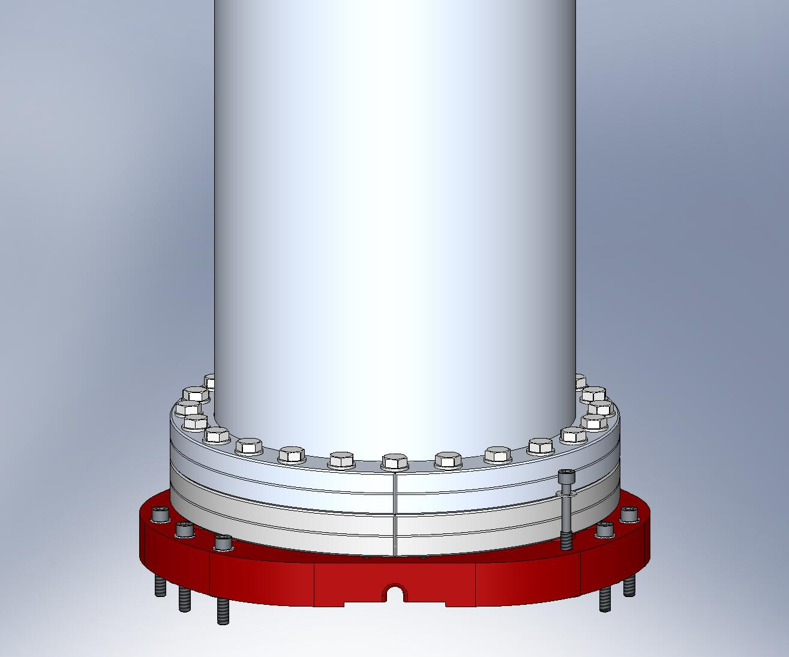
Figure 3.50. Add Captive Screws to Adapter Plate. These are used later, during installation of GS-13’s into Stage 1.

- Set aside all (6) GS-13 Assemblies, for later installation. (GS-13 Cable Restraints (D071180) will be added to Horizontal GS-13 Assemblies immediately prior to installation in Stage 1.)

    - Prep Work – Prepare (3) Spring Pull-Down Tooling Assemblies (D071500)
- Thread ACME hex nut (Dependable ACME, 3/4”-10 Hex 303) onto one end of 3/4”-10x8.0” ACME Screw (D071309), until its top is flush with the end of the Screw. Drill a 1/4” hole through the side of the nut/Screw combination (refer to drawing D071499 for instructions on making the hole). Press 1/4” spring pin (McMaster-Carr #95765A524) into this hole, as shown in Figure 3.51.
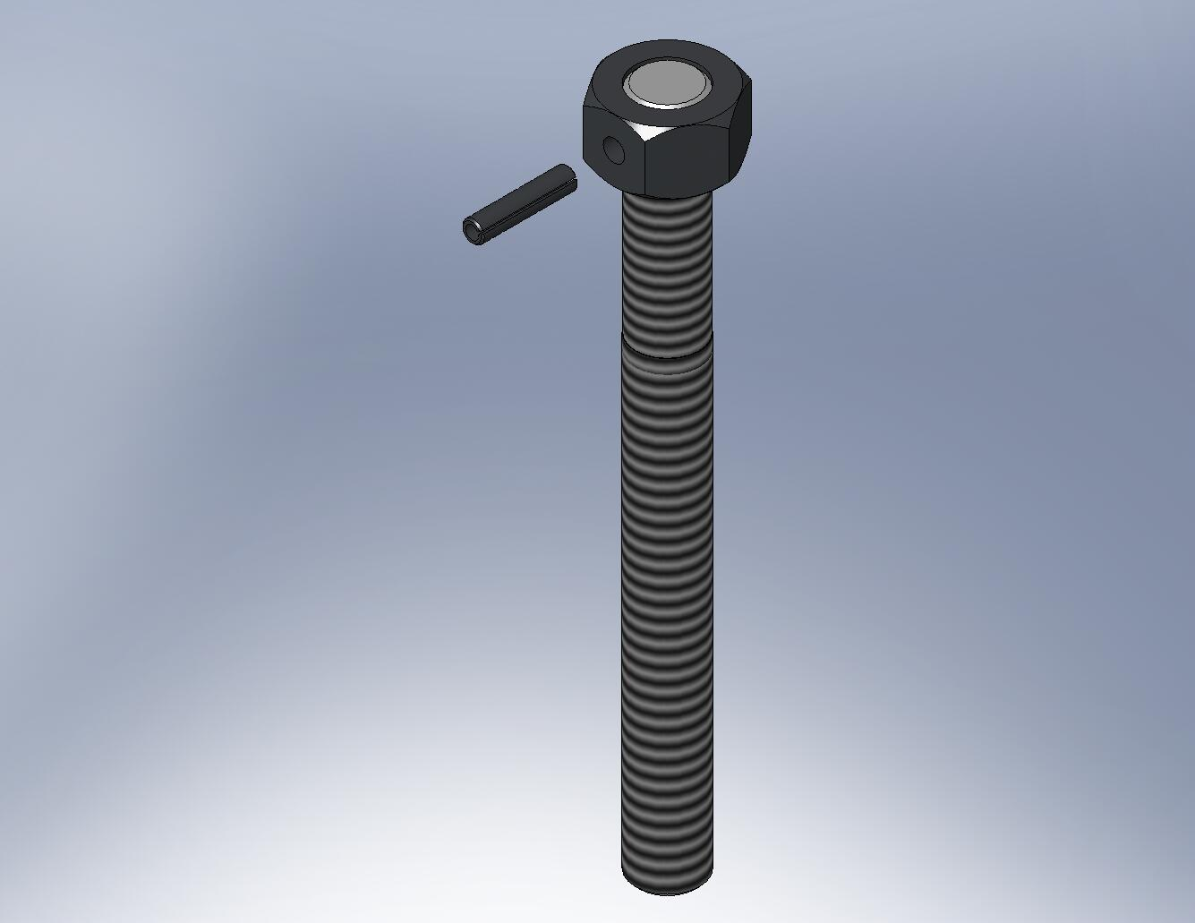
Figure 3.51. After drilling a hole through the ACME Screw and nut, press in the spring pin. The pin transfers torque from the nut to the Screw.

- Insert Heli-Coils into (3) Spring Pull-Down Caps (D071305):
  - (3x 2) 1/4”-20x2.0*Dia.
- Press (2) 1/4”x.875” dowel pins (McMaster-Carr #90145A541) into holes in pocket of each of (3) Spring Pull-Down Caps, as shown in Figure 3.52. The pins should stand .375” proud of the pocket’s surface.
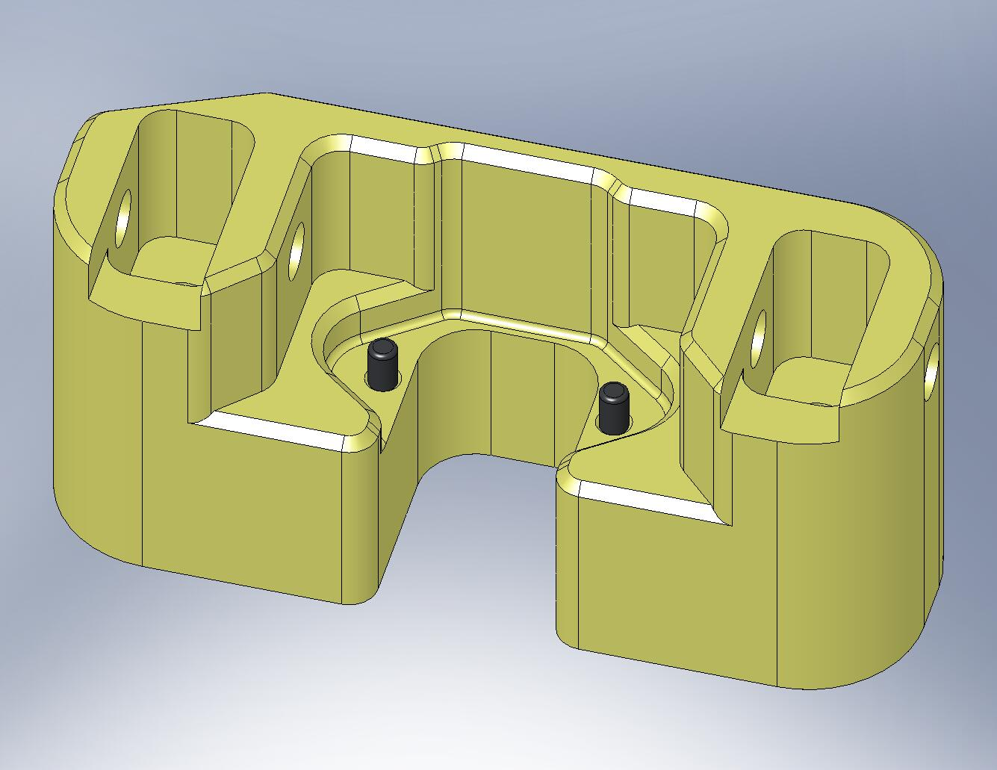
Figure 3.52. Press (2) dowel pins into Spring Pull-Down Cap.

the following procedure describes the assembly of one D071500 assembly. This should be repeated for the other two D071500’s, as well:
- Insert Spring Pull-Down Nut (D071308) through bottom of Spring Pull-Down Base (D071307), as shown in Figure 3.53. Snug all (3) screws, then torque to final spec. Set aside for later use.
Hardware:
(3) 1/4”-20x1.5” SHCS (Holo-Krome)
(3) 1/4” washers (need not be vented)
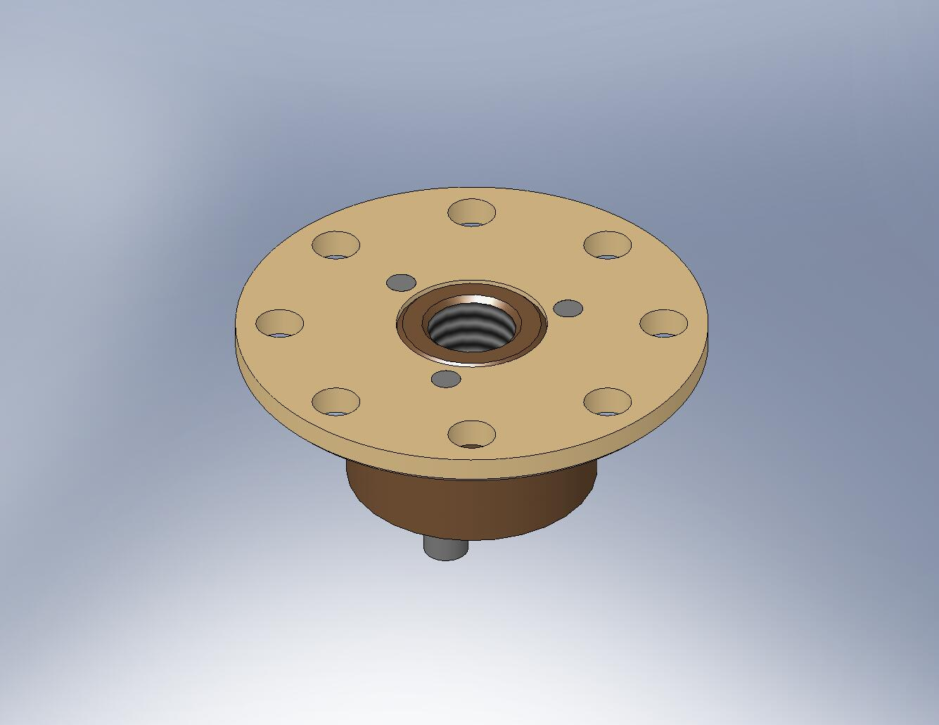
Figure 3.53. Pull-Down Nut bolted onto Pull-Down Base.

- Press combination bearing (INA model NKX25-Z) into Spring Pull-Down Bar (D071306), as shown in Figure 3.54 and Figure 3.55.
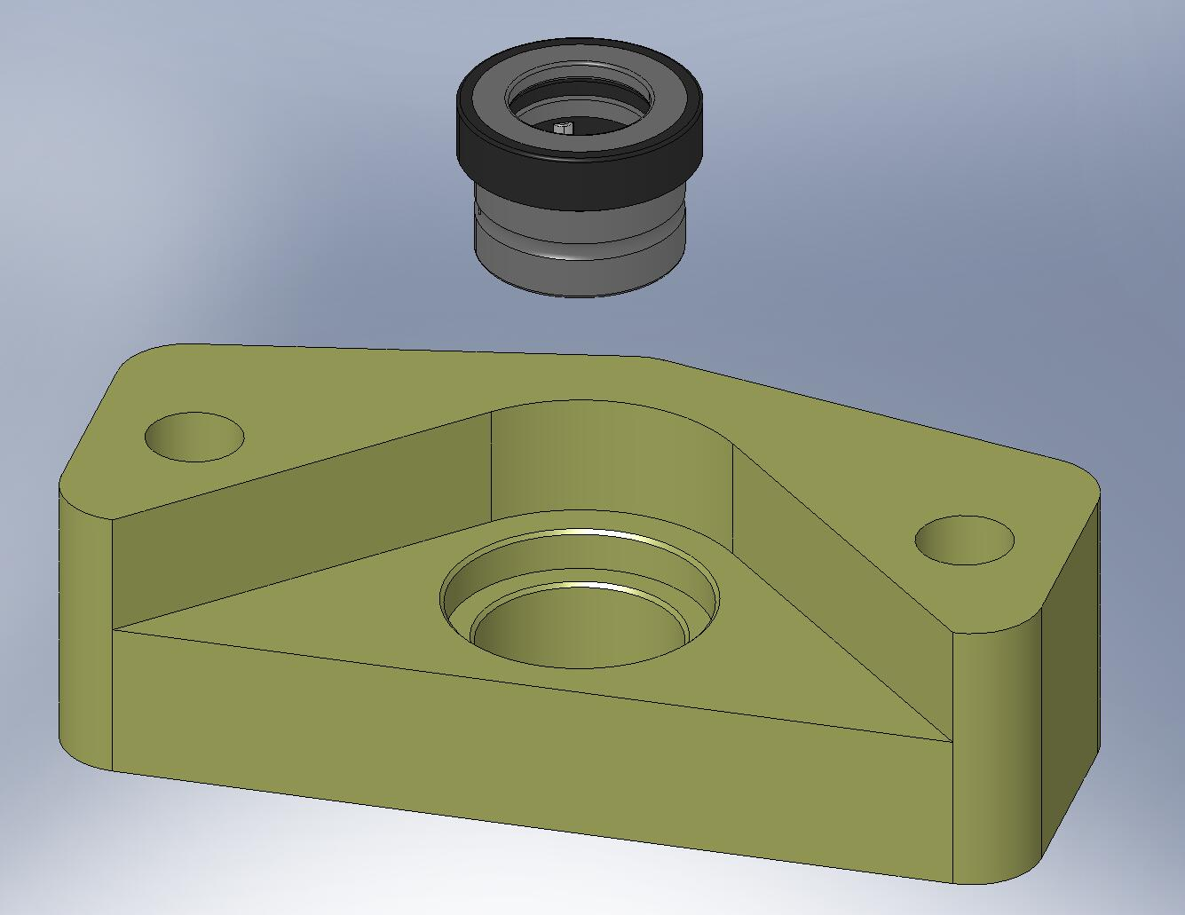
Bearing seats here.
Figure 3.54. Combination bearing (radial + thrust) must be pressed into the Pull-Down Bar. Make sure the force of the press is applied evenly over the bearing’s top surface, and that the bearing seats properly within the Bar.

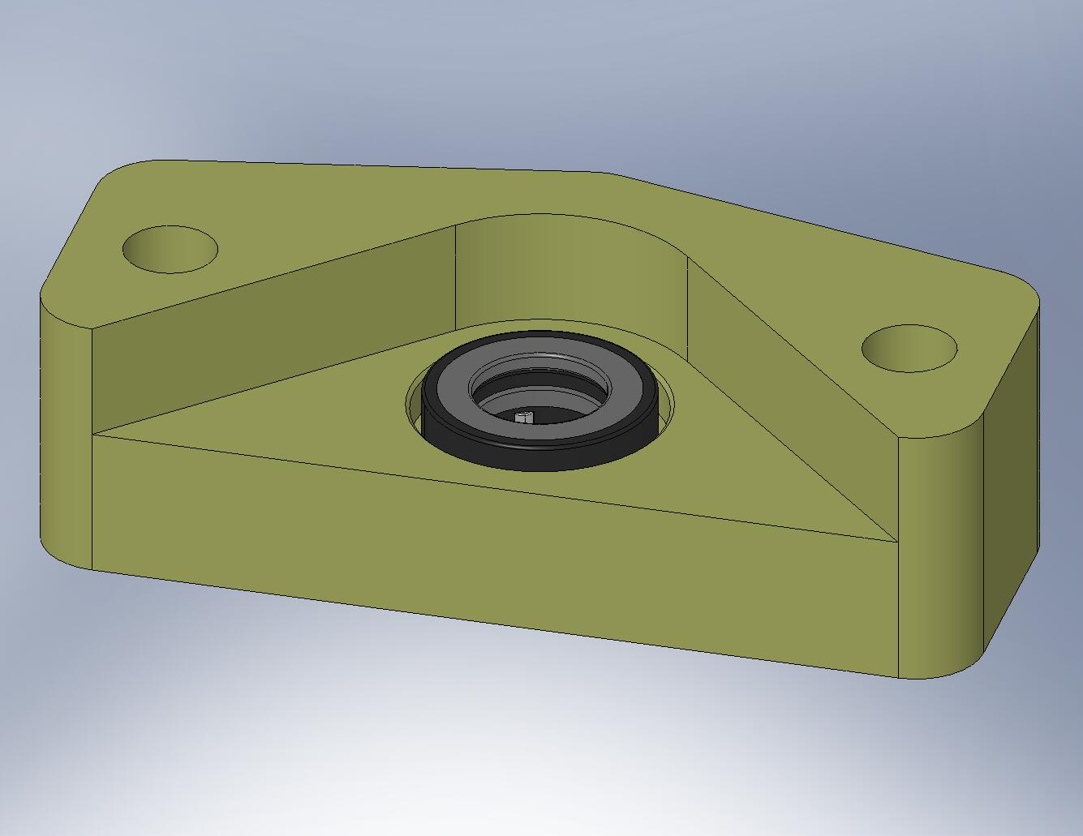
Figure 3.55. The parts should look like this, after the press.

- Insert Spring Pull-Down Conversion Bushing (D071304) through top side of combination bearing, as shown in Figure 3.56. (The Bushing allows us to use the metric bearing with our English ACME Screw.)
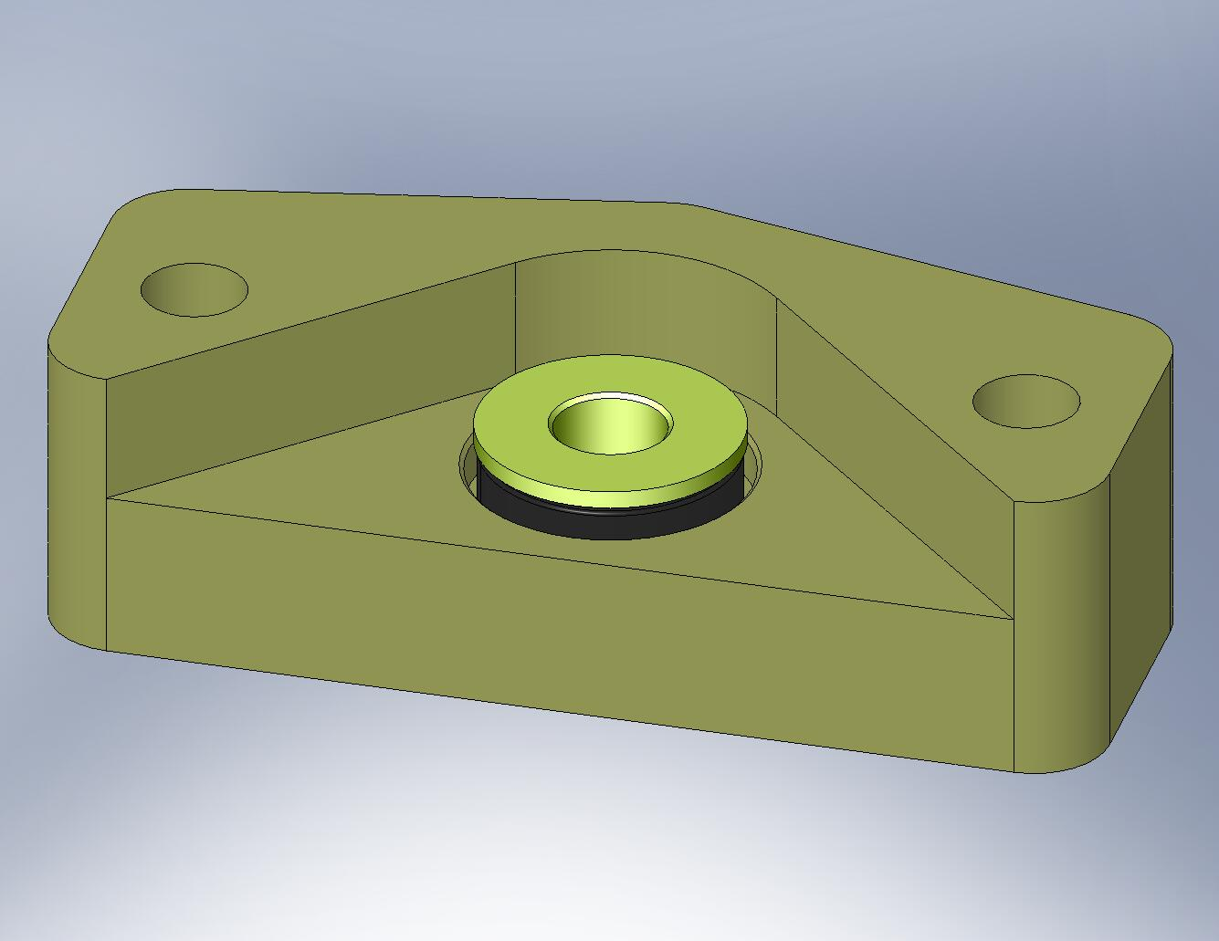
Figure 3.56. Conversion Bushing sitting inside the bearing.

- Place Spring Pull-Down Offset Washer (D071320) over bottom of Conversion Bushing. Clip retaining ring (McMaster-Carr #91590A134) onto the groove in the Bushing.
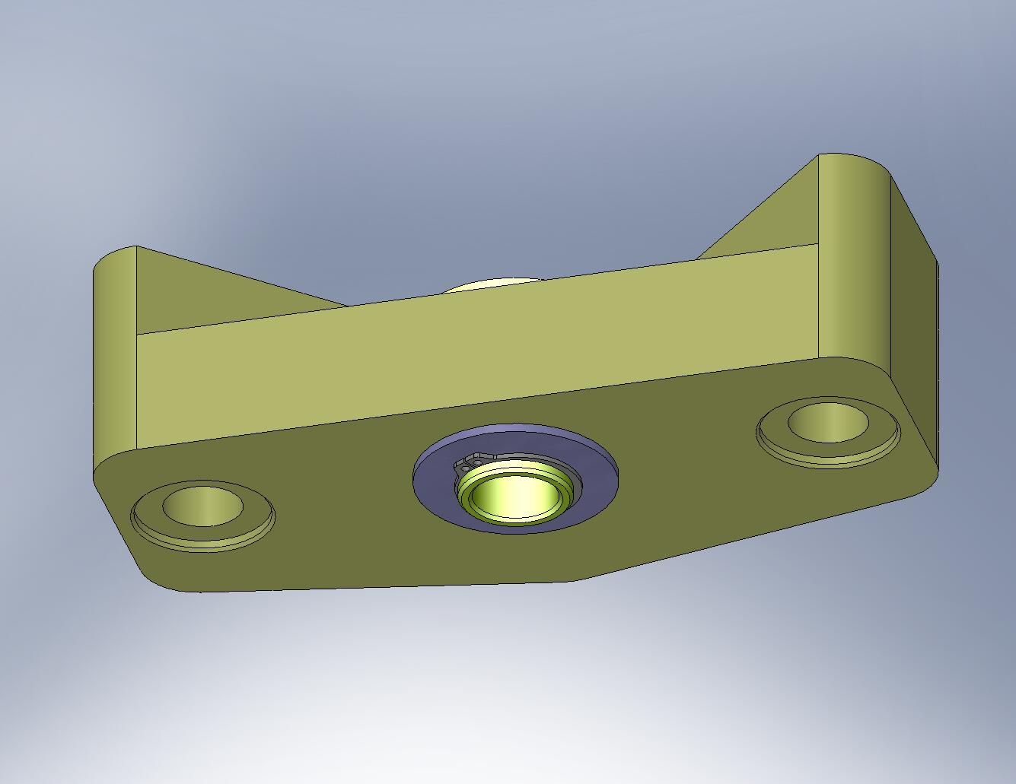
Figure 3.57. The retaining ring and Offset Washer prevent the Conversion Bushing from sliding out of the bearing.

- Drop ACME Screw through top of Conversion Bushing, as shown in Figure 3.58. Slide shaft collar (McMaster-Carr #9633T15) over Screw, directly below the Bushing. Tighten the collar.
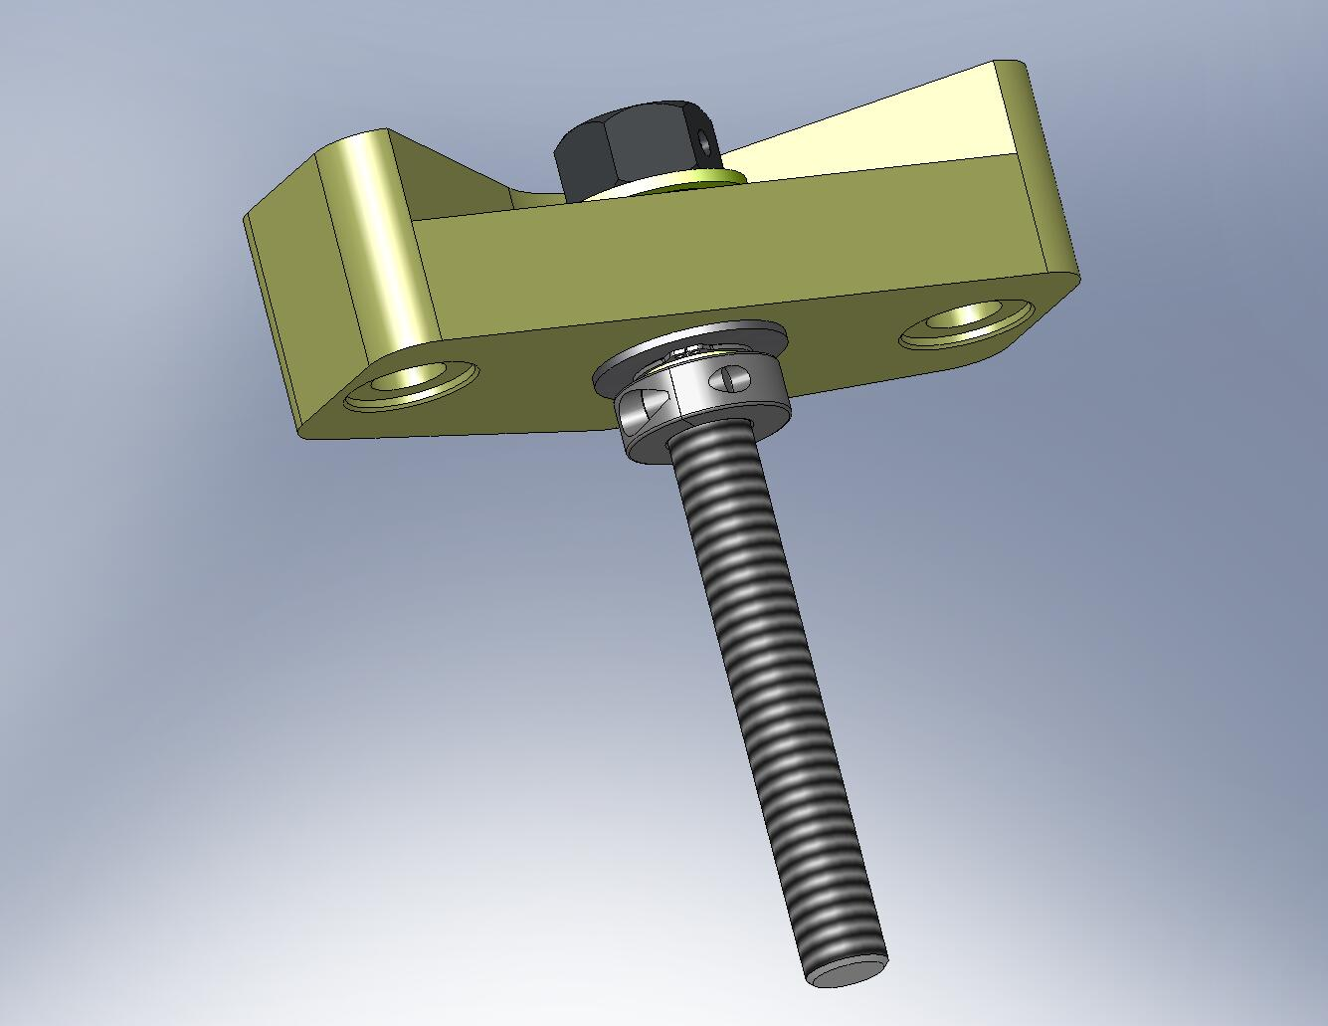
Figure 3.58. ACME Screw placed through the Conversion Bushing. The shaft collar locks the Screw to the Pull-Down Bar.

- Thread ACME Screw into Spring Pull-Down Nut, as shown in Figure 3.59. Set aside.
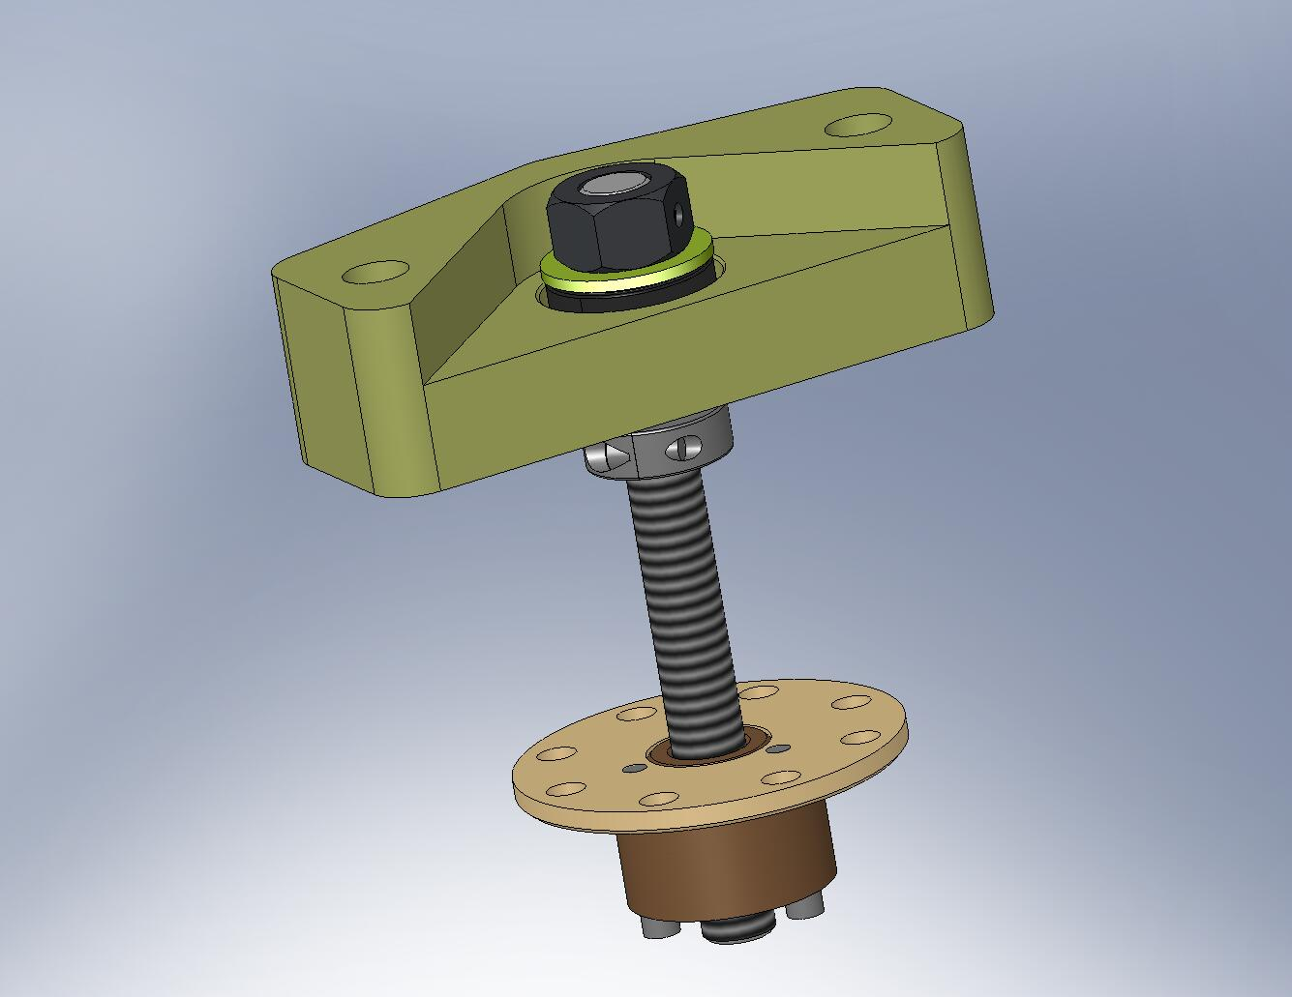
Figure 3.59. Pull-Down Nut threaded onto end of ACME Screw. The bottom part of the Spring Pull-Down Assembly is complete.

- Thread a 1/2”-20 jam nut (McMaster-Carr #91847A525) onto the short threaded end of each of (2) Spring Pull-Down Pull Rods (D071303), as shown in Figure 3.60.
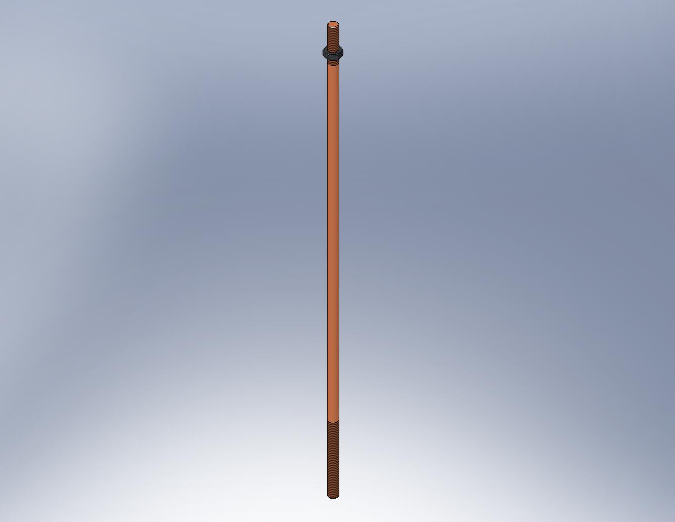
Figure 3.60. Thread the jam nut onto the end of the Pull Rod with 2” of thread.

- Thread a 1/2”-20 ball joint rod end (McMaster-Carr #59915K486) onto the same end of each Pull Rod. Continue screwing the rod end onto the Pull Rod, until it reaches the end of the female thread. Back off a 1/2-turn.
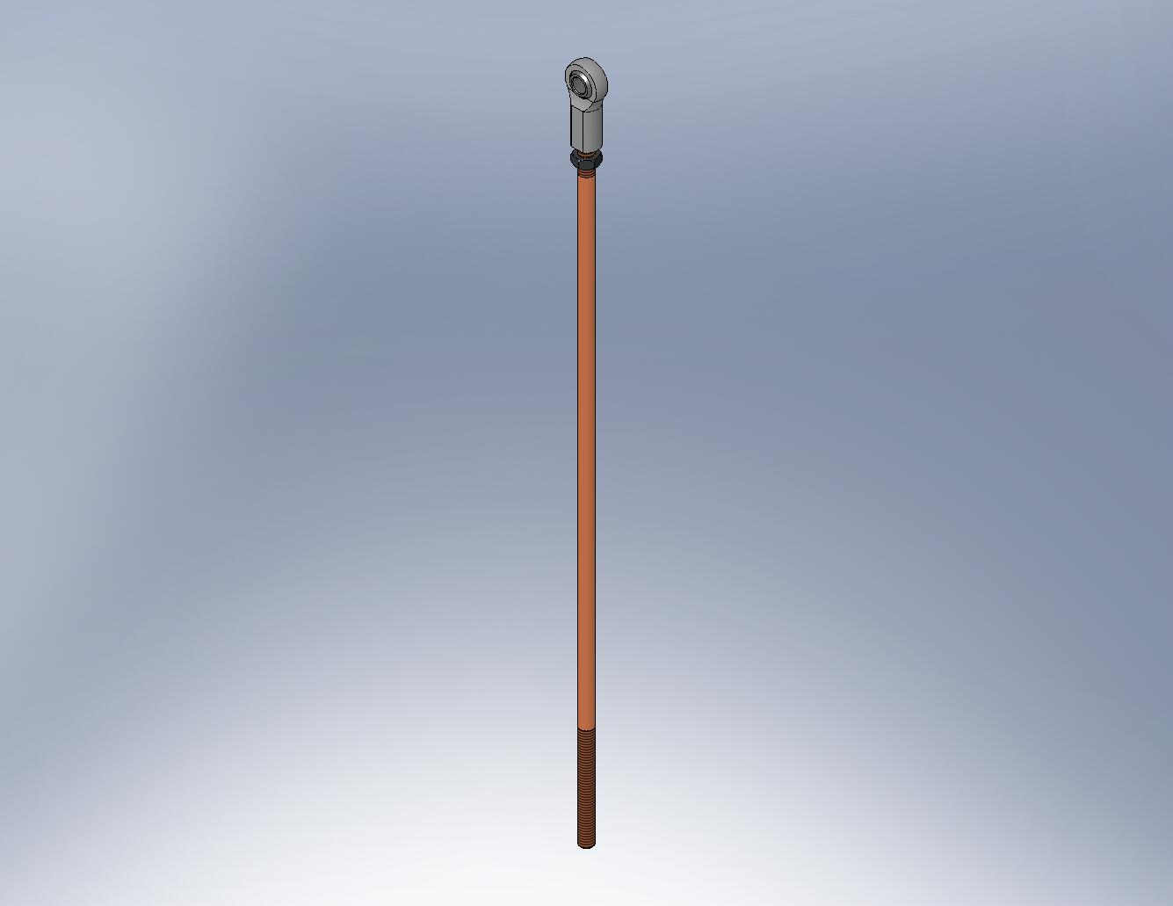
Figure 3.61. The rod end should be fully engaged, minus a 1/2-turn.

- Unscrew the jam nut, until it touches the rod end. Torque the nut against the rod end, using a pair of open-end wrenches. The desired preload is 2x the maximum tensile load the Pull Rod will see – this requires a large torque.
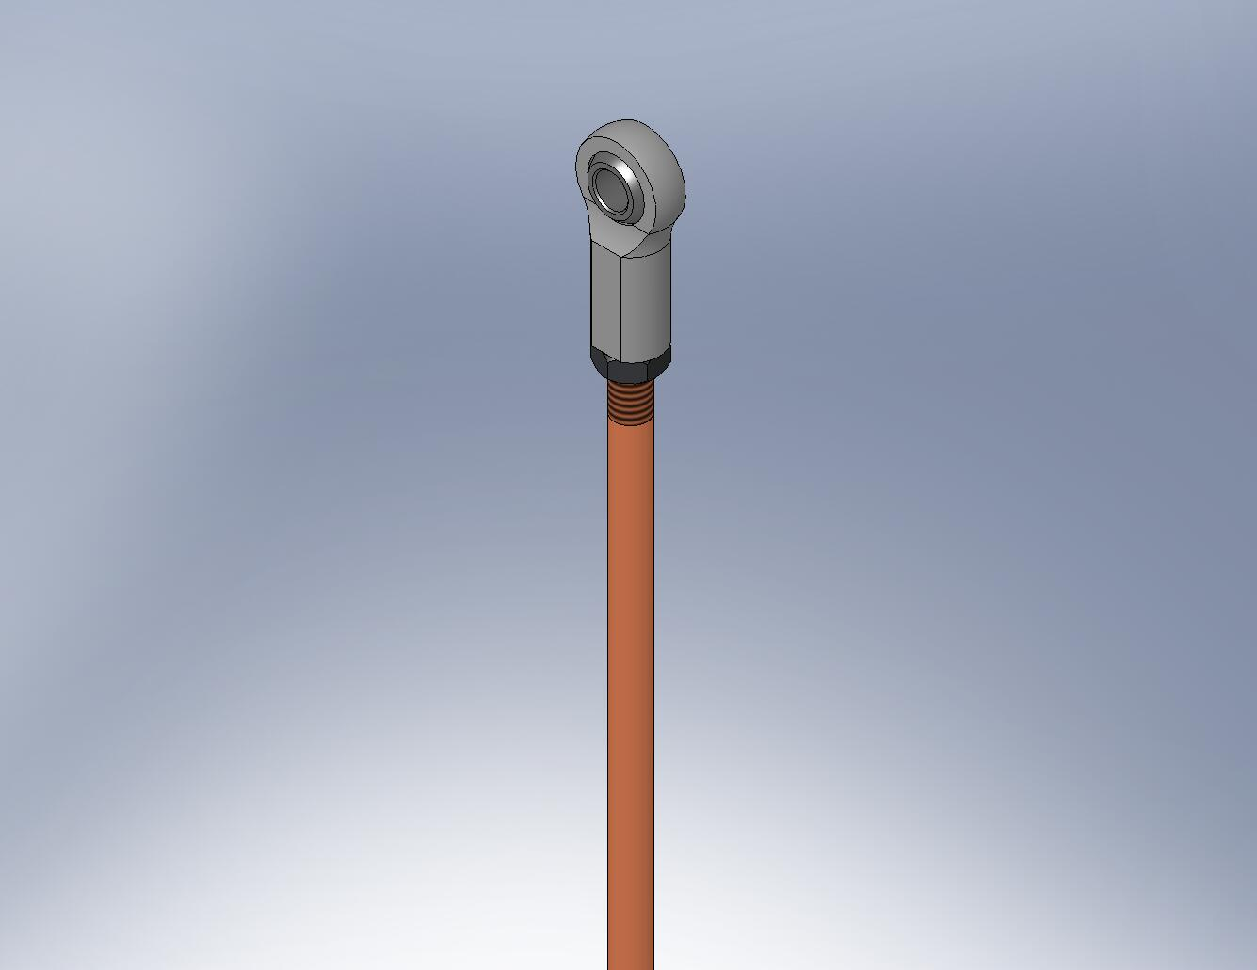
Figure 3.62. Torque the jam nut against the rod end.

- Snap a 1/2” retaining ring (McMaster-Carr #91590A122) on one end of each of (2) 1/2” pivot pins (Misumi #U-SCDG0.50-L2.00), as shown in Figure 3.63.
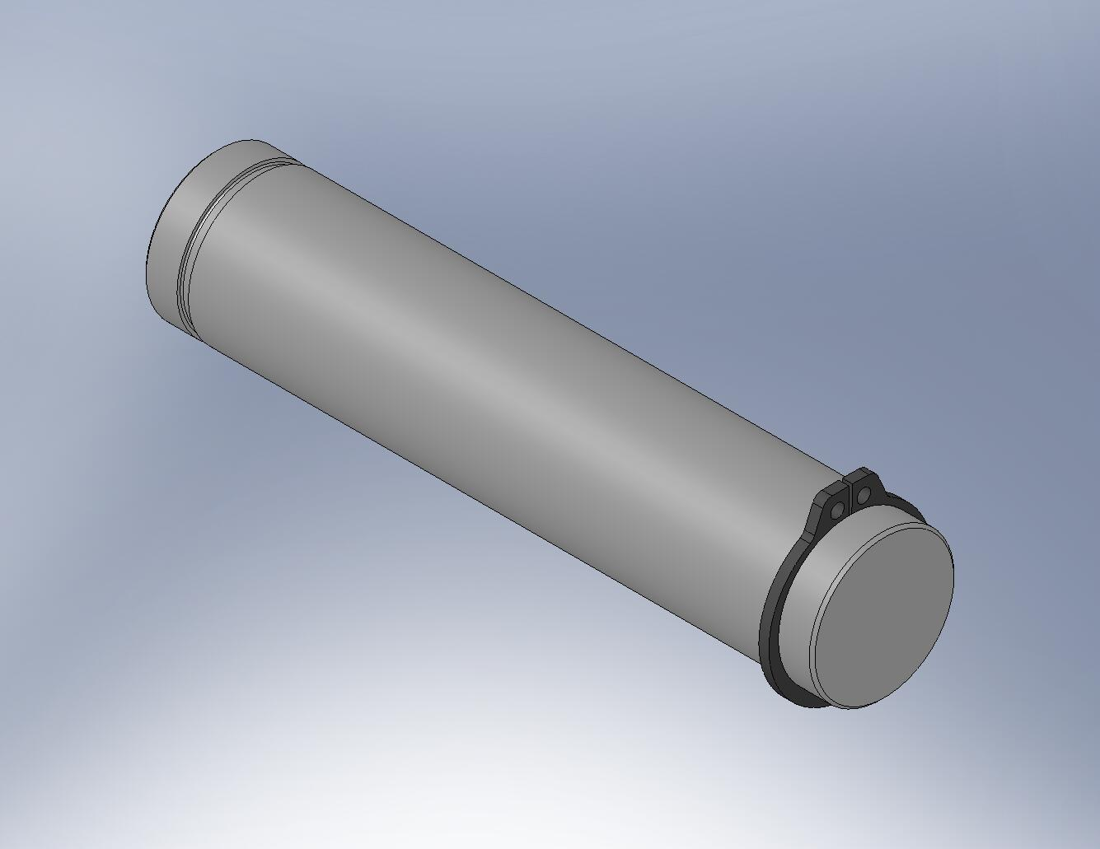
Figure 3.63. Place one retaining ring on each pivot pin now. After inserting through the rod ends, the other end of each pin will get a ring.

- Push each pivot pin through opposite sides of the Pull-Down Cap, as shown in Fig x. Each pin should pass through i) a Spring Pull-Down Rod End Spacer (D071302), ii) a rod end at the end of a Pull Rod, and iii) another Rod End Spacer, before pushing back through the Pull-Down Cap.
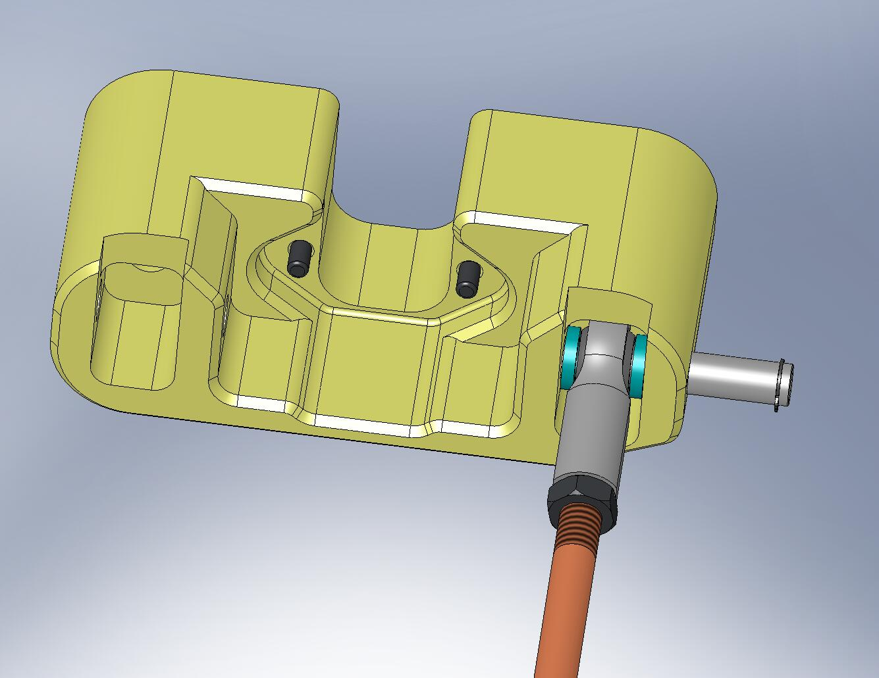
D071302, plastic spacers
Figure 3.64. Pivot pins are pushed through the Pull-Down Cap, passing through the rod ends and spacers.

- Snap 1/2” retaining rings onto the pivot pins, to hold the assembly together.
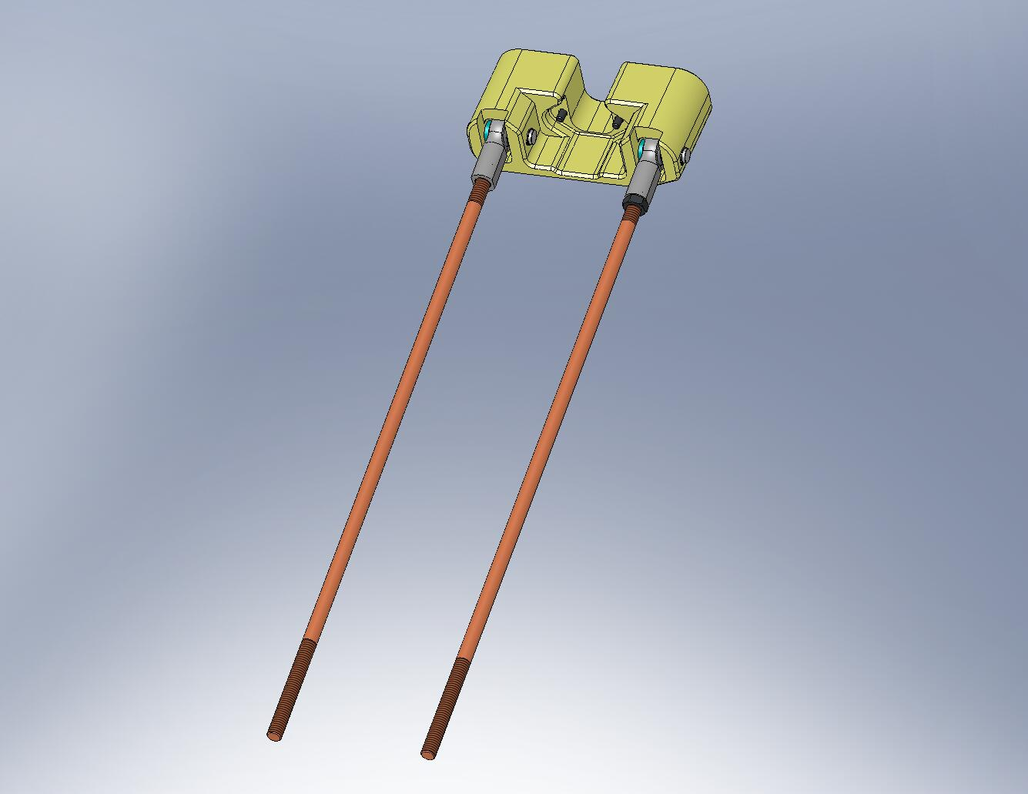
Figure 3.65. After the retaining rings are clamped on, the top part of the Spring Pull-Down Assembly is complete. Set aside for later use.

    - Prep Work – Assemble GS-13 Horizontal Install Tool (D071496)
- Screw (2) GS-13 Install Slider-Stops (D071310) onto bottom of GS-13 Install Base (D071313). Install hardware and hand-tighten.
Hardware:
(4) 1/4”-20x.50” SHCS (Holo-Krome #78054)
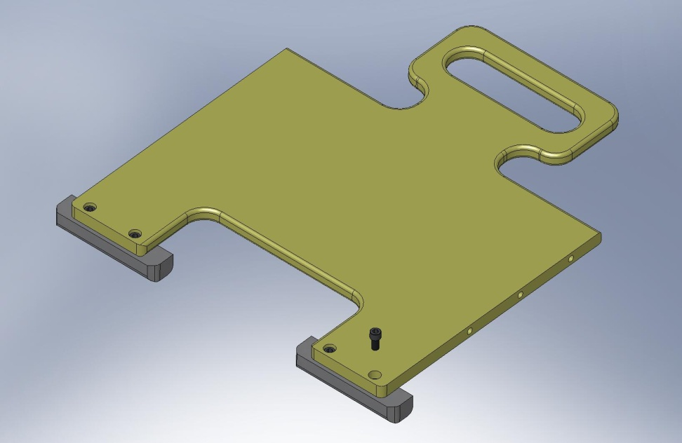
Figure 3.66. Slider-Stops mounted to bottom face of Install Base.

- Attach GS-13 Install Right Rail (D071314) to right side of GS-13 Install Base. Install hardware and hand-tighten.
Hardware:
(3) 1/4”-20x.875” SHCS (Holo-Krome #78060)
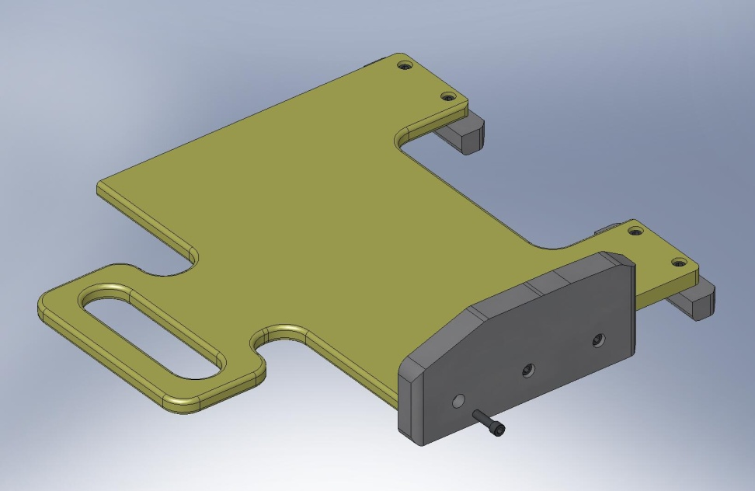
Figure 3.67. Right rail mounted to Install Base.

- Screw GS-13 Install Standoff (D071312) onto outside of GS-13 Install Left Rail (D071311), as shown in Figure 3.68.
Hardware:
(3) 1/4”-20x.50” SHCS (Holo-Krome #78054)
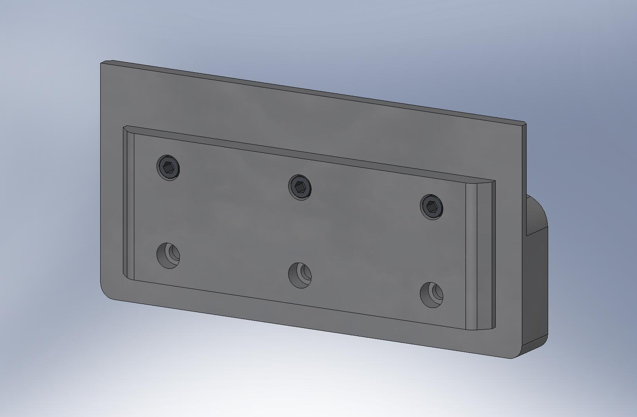
Figure 3.68. Attach Standoff to outside of Left Rail, using top row of screws.

- Attach GS-13 Install Standoff and GS-13 Install Left Rail to left side of GS-13 Install Base.
Hardware:
(3) 1/4”-20x1.25” SHCS (Holo-Krome #78064)
- GS-13 Horizontal Installation Tool is complete. Set aside for later use.
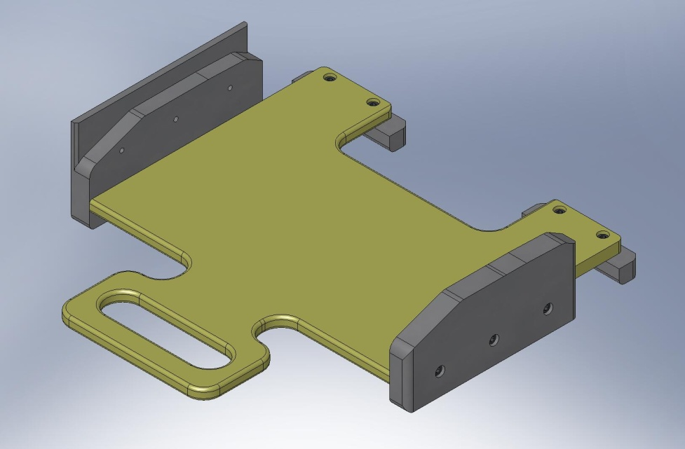
Figure 3.69. Use GS-13 Installation Tool to support Horizontal GS-13’s inside Stage 1. No special tool is needed for Vertical GS-13’s.

    - Place Stage 1 on Stage 0
- Use overhead crane to lift Stage 1 (D071420) off the Assembly Stand. Move Stage 1 over Stage 0 (D071410), as shown in Figure 3.70.
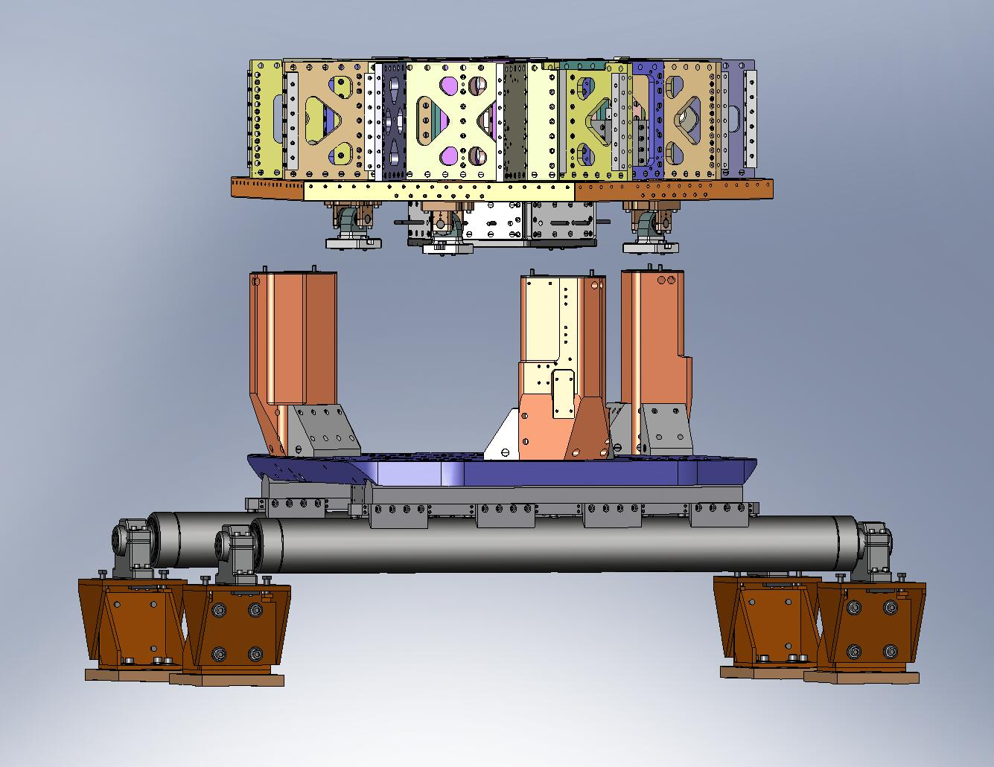
Figure 3.70. Stage 1 positioned over Stage 0 (lifting straps and crane not shown).

- Slowly lower Stage 1. Check clearance between (3) Support Posts (D071002) and the cut-outs in the Stage 1 Floor (D071051). Note: this clearance is nominally just 1/4”.
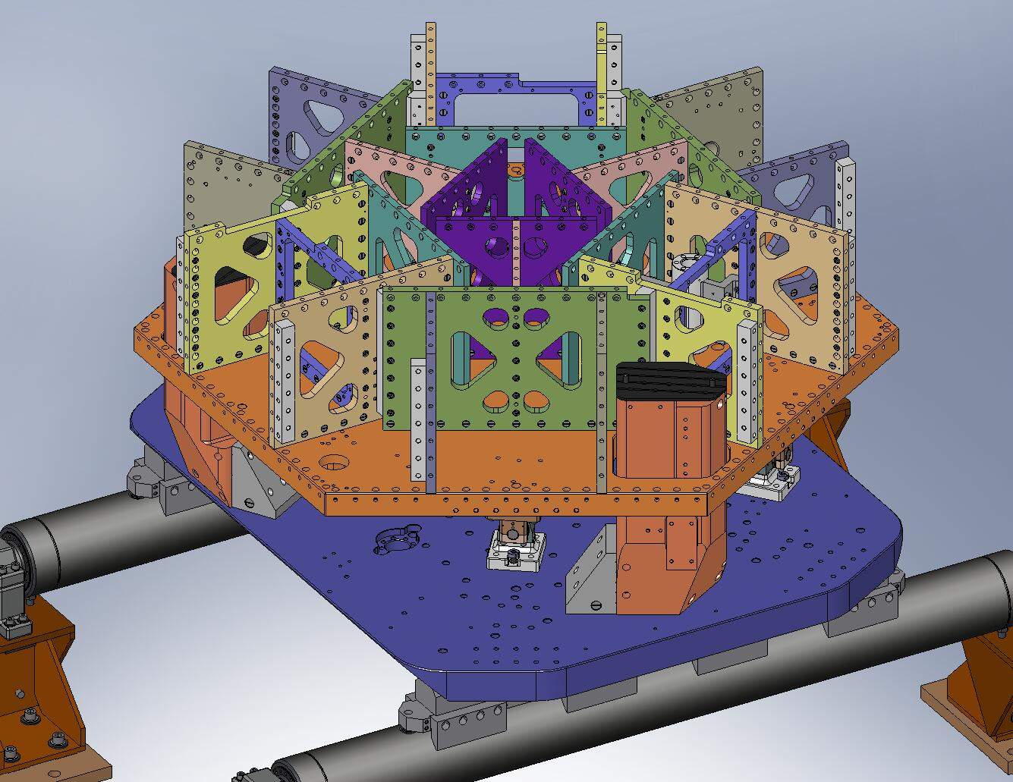
Try to prevent hard contact against the Support Posts.
(3 places)

Figure 3.71. The (3) Support Posts stick through cut-outs in the Stage 1 Floor. When lowering Stage 1 into place, take care to maintain some clearance around each Post.

- Stop lowering Stage 1 when the lowest Locker Base (D071140) is about 1/4” above the Stage 0 Base (D071001), as shown in Figure 3.72. Try to engage the (8) temporary pins in the Locker Bases with the mating holes in the Stage 0 Base, as shown in Figure 3.73.
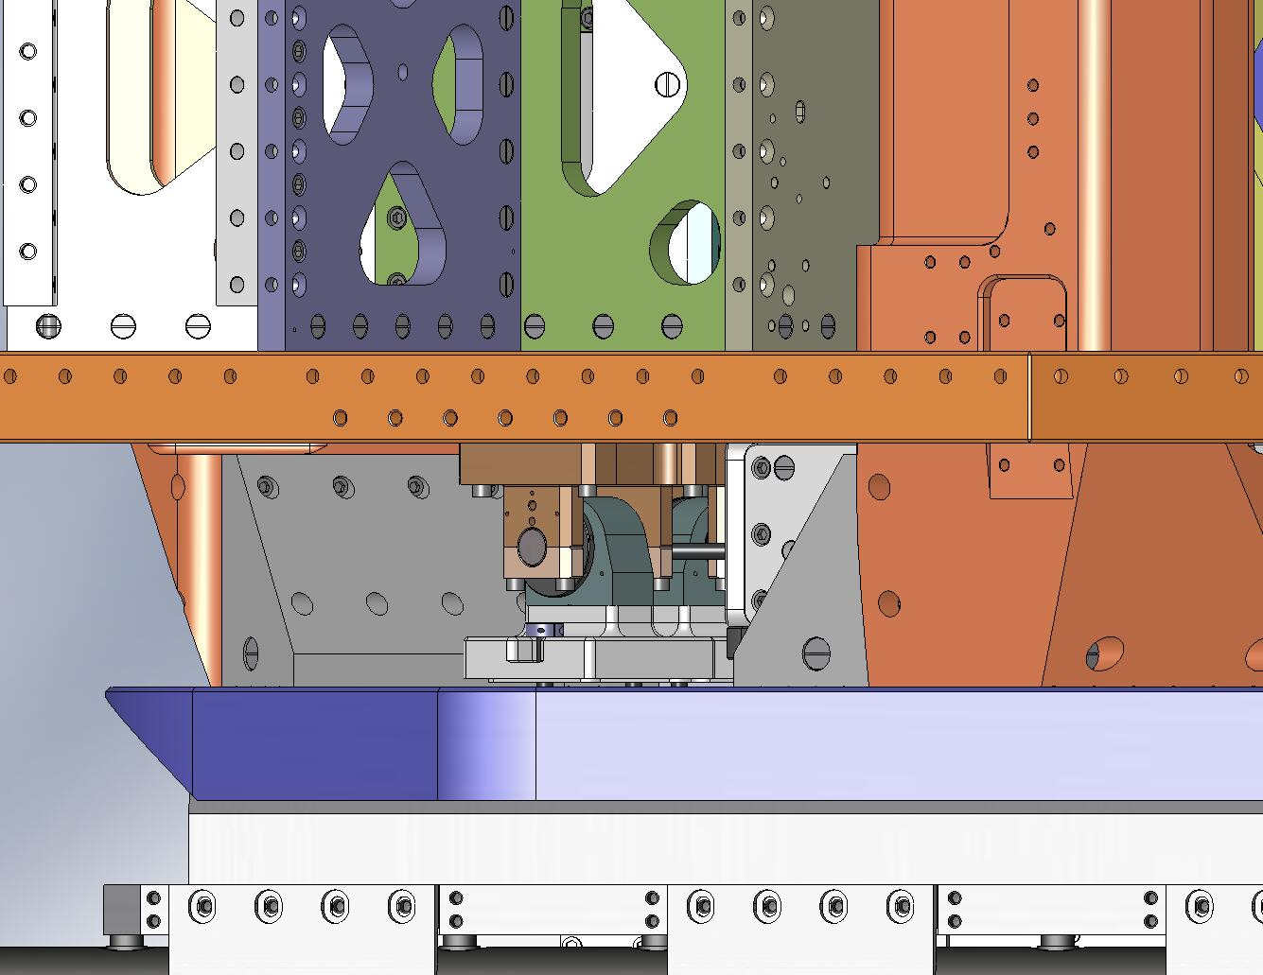
Leave space to slide in the Shims.

Figure 3.72. Lower Stage 1 close to its final position, but leave enough space between the Lockers and Stage 0 to slip in .125” Shims.
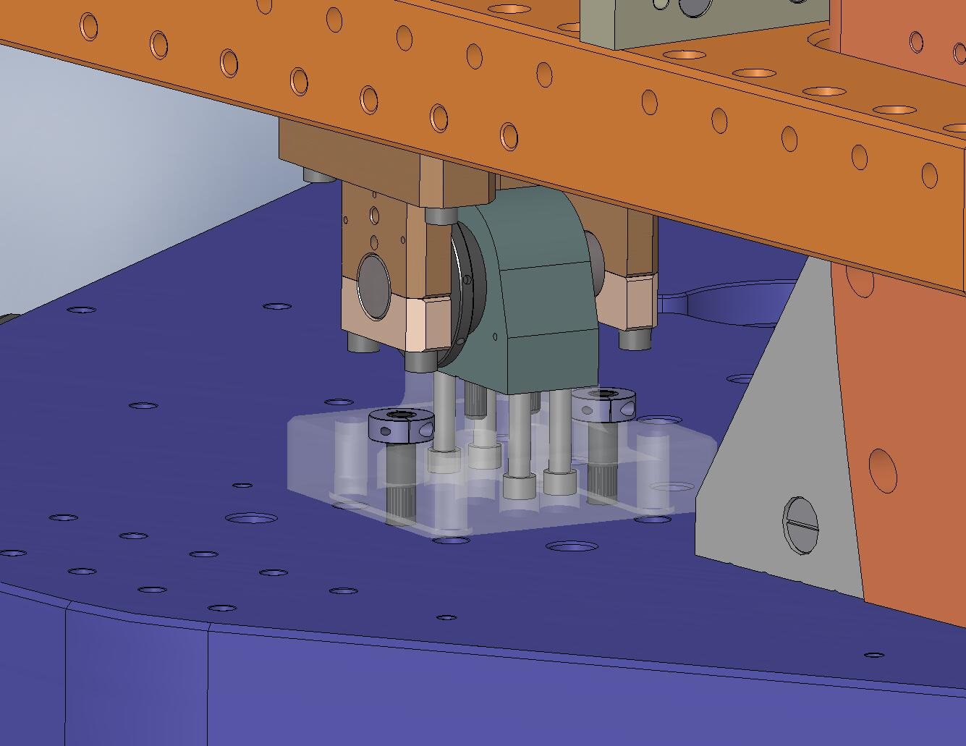
Try to engage these pins in the Stage 0 Base. (4 places)

Figure 3.73. As Stage 1 is lowered, try to engage the temporary pins from the Lockers in the mating holes in Stage 0. Stage 1 will not be parallel to Stage 0 while it’s hanging from the crane, so start with the lowest Locker. It may not be possible to engage all (8) pins, depending on tolerance stack-up.

- Slide (8) .125” Shims (D071141-05) between the Locker Bases and the Stage 0 Base, as shown in Figure 3.74 and Figure 3.75. The Shims should fit closely around the bosses on the bottom of the Locker Bases. Since Stage 1 will not be level to Stage 0 when it’s on the crane, first place the Shims under the lowest Base(s), then carefully lower Stage 1 until all the Shims can be inserted around the bosses.
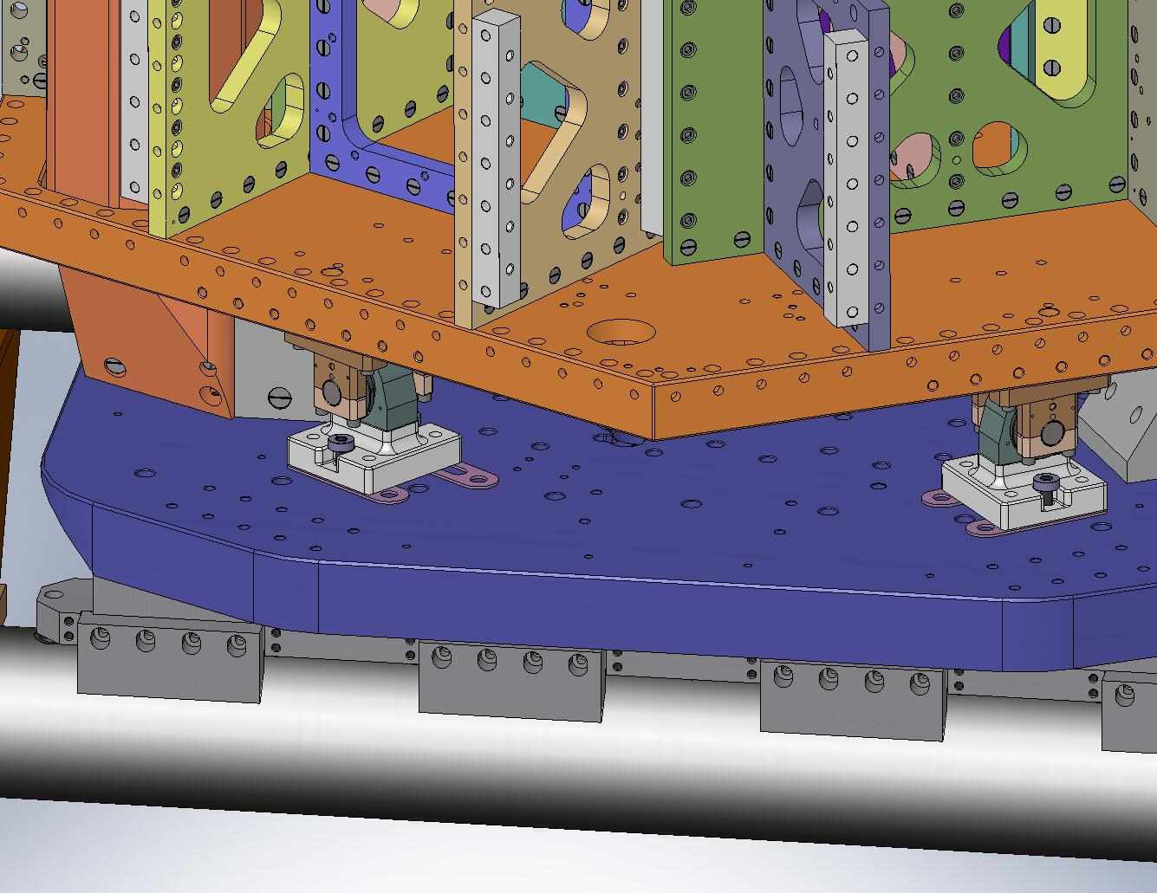
Slide the Shims in.
Figure 3.74. Slide (8) .125” Shims underneath the Locker Bases. Make sure the Shims slide around the bosses on the bottom of the Locker Bases.
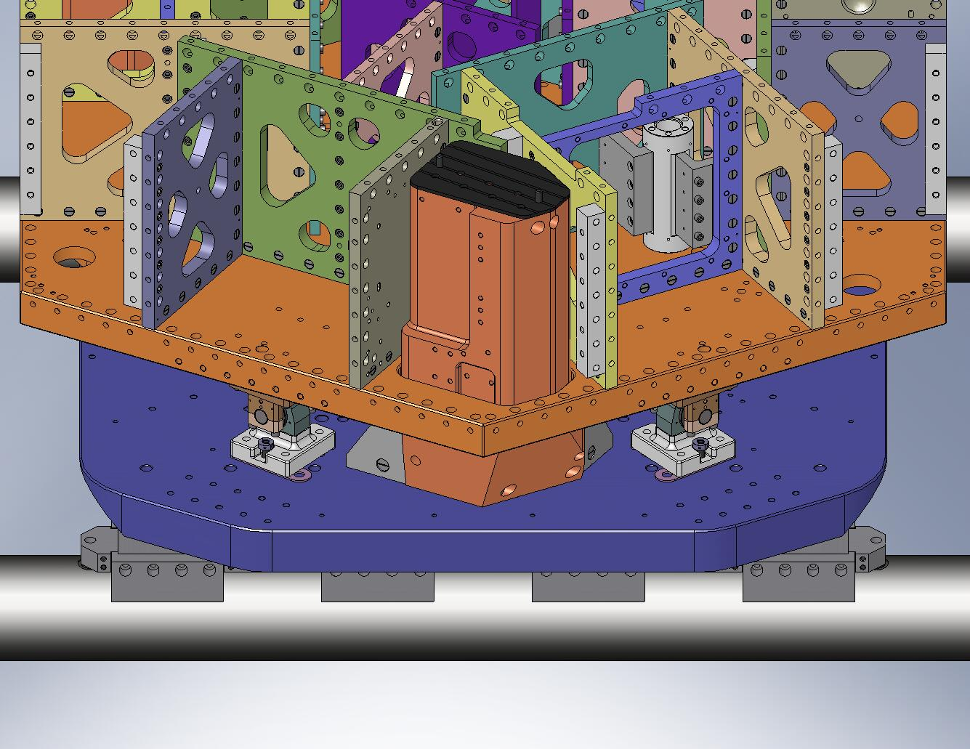
These Shims must point in the opposite direction.
These are mounting holes for Wiring Breadboards.

Figure 3.75. Two of the Shims must be inserted “backwards”, or they will interfere with the Wiring Breadboards, which are installed later.

- Lower Stage 1 until its full weight is supported by Stage 0. Detach the crane.
- Try to slide the Shims under all (4) Locker Bases. Find the Locker with the loosest Shims. Replace these Shims with thicker ones, so they barely slip in.
- Insert screws through the Locker Bases and into the Stage 0 Base. Snug, but don’t torque, yet.
Hardware:
(16) 1/2”-13x2.5” SHCS (McMaster-Carr)
(16) 1/2” vented washers (U-C Components)
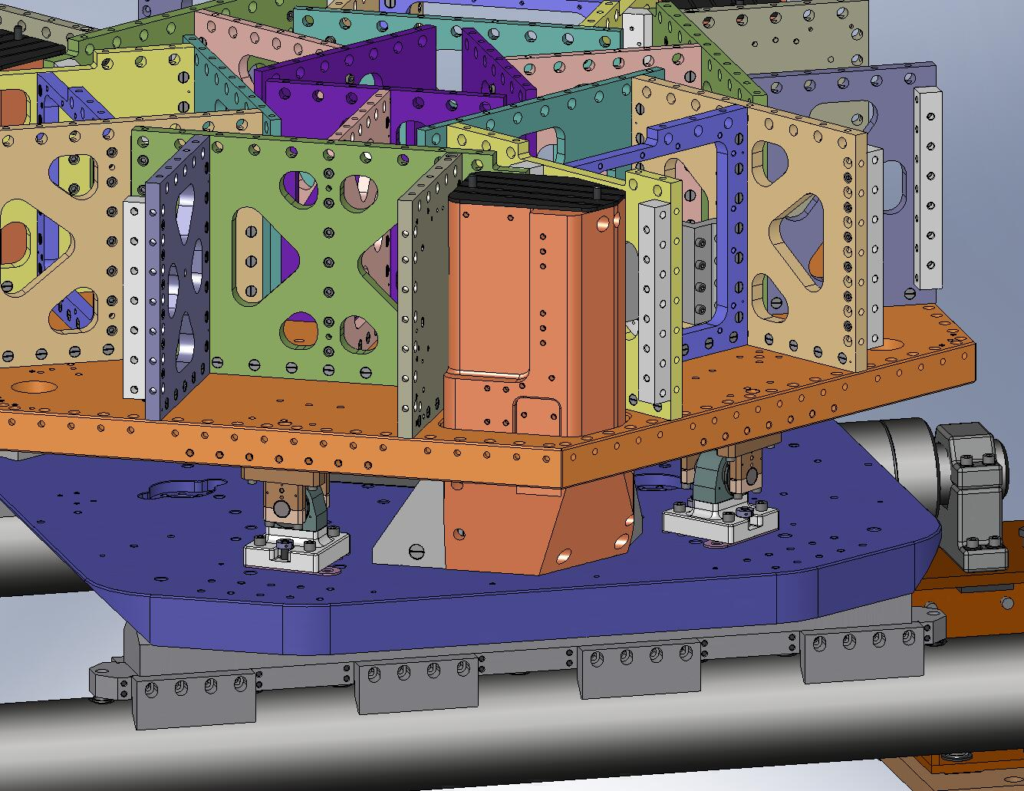
Figure 3.76. Snug the screws holding the Locker Bases to the Stage 0 Base.

- Remove (8) temporary pins from Locker Bases. Now, torque (16) Locker Base screws to final spec.
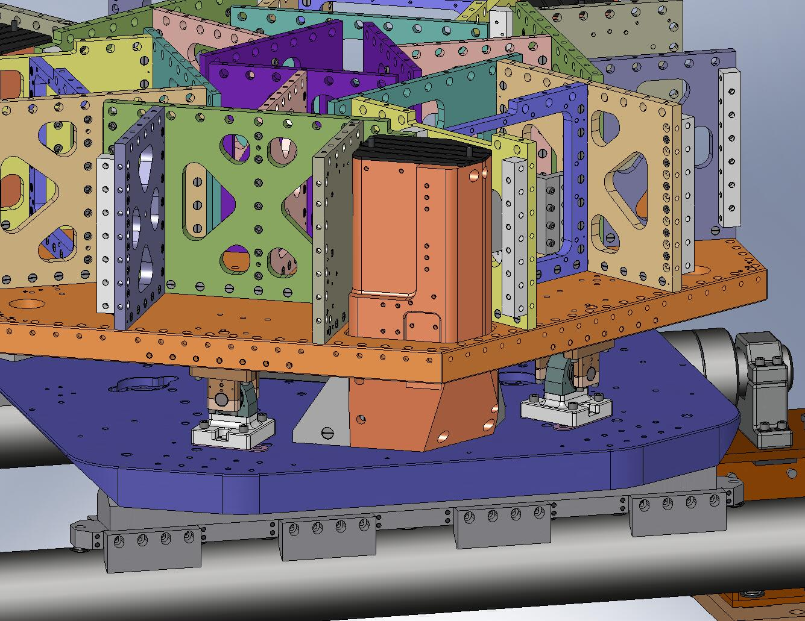
Figure 3.77. Remove (8) pins from the Locker Assemblies, before torquing the mounting screws to final spec.

    - Attach and Load Springs
- Insert a 3-hole and a 4-hole 1/2”-13 Gang Barrel Nut (D071251-03 and -04, respectively) into each of the Support Posts, as shown in Figure 3.78.
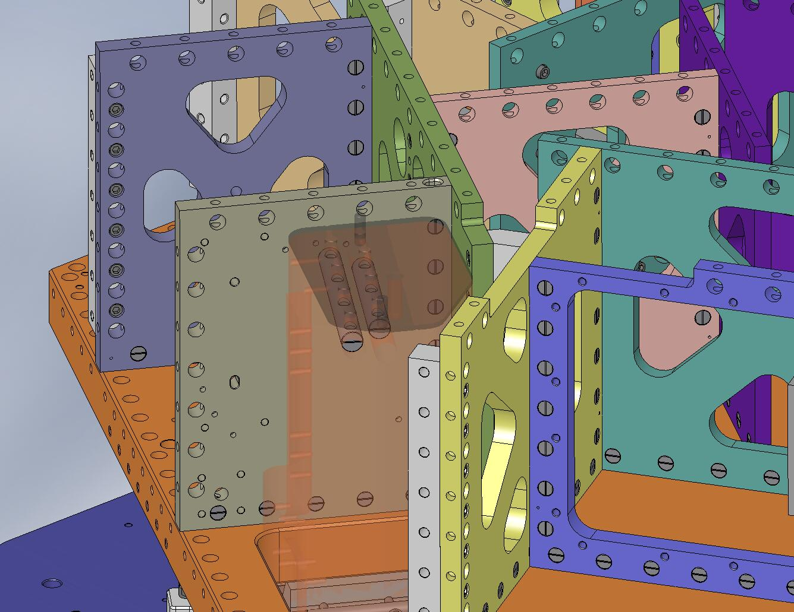
Figure 3.78. Slide (2) large Gang Barrel Nuts into each Support Post. These will capture the mounting screws for the Springs.

- Place a Spring (D071100) on each Support Post, as shown in Figure 3.79. A hole and a slot in each Spring should slip around the dowel pins in the Posts. Start screws, to keep the Spring from tipping over.
Hardware:
(21) 1/2”-13x3.0” A286 hex bolt (McMaster-Carr)
(21) 1/2” vented washer (U-C Components)
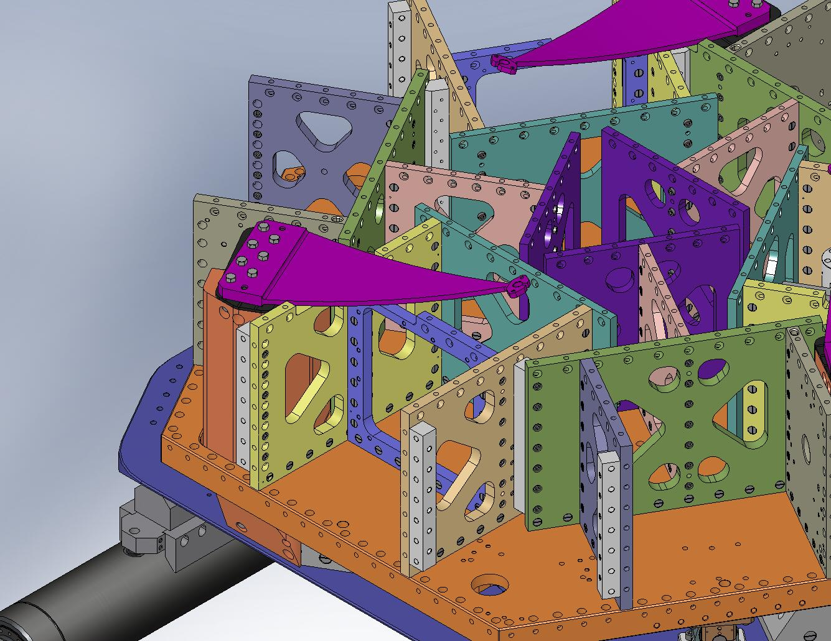
Figure 3.79. A Spring positioned on a Support Post.
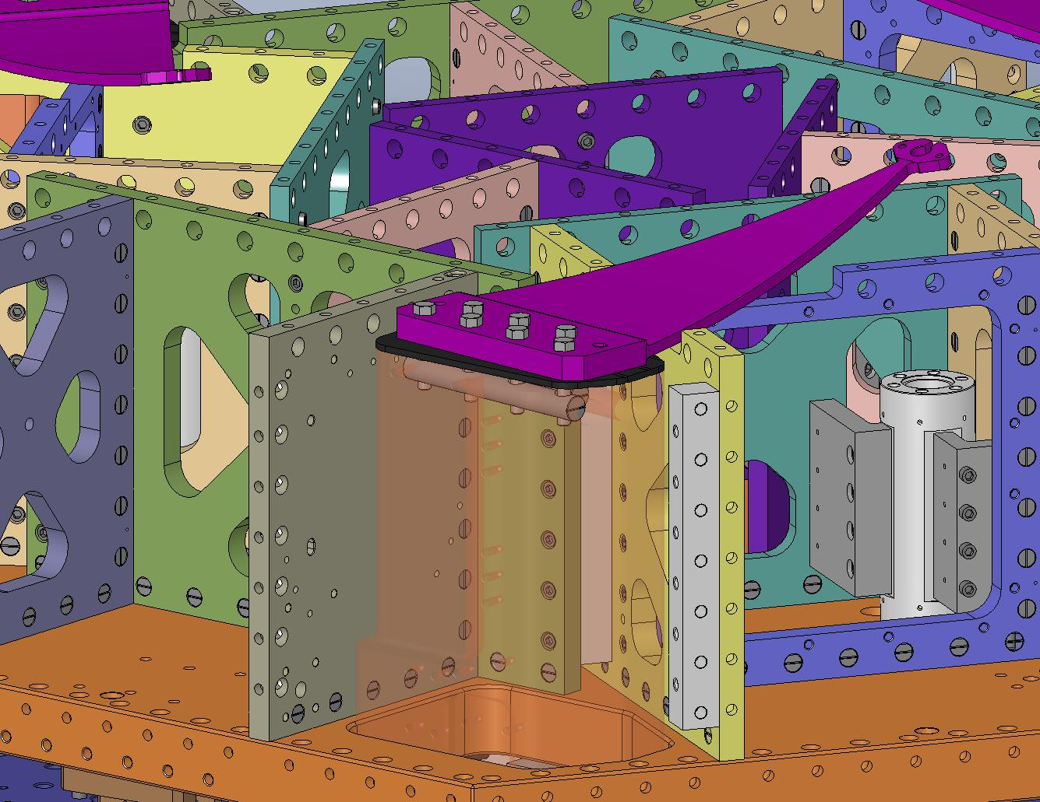
Figure 3.80. High-strength Alloy A286 hex bolts hold the Springs to the Support Posts (Support Post Caps are sandwiched in between).

- Snug all (7) hex bolts on each Spring, then torque to spec. Use a staggered tightening pattern, e.g. the one shown in Figure 3.81.
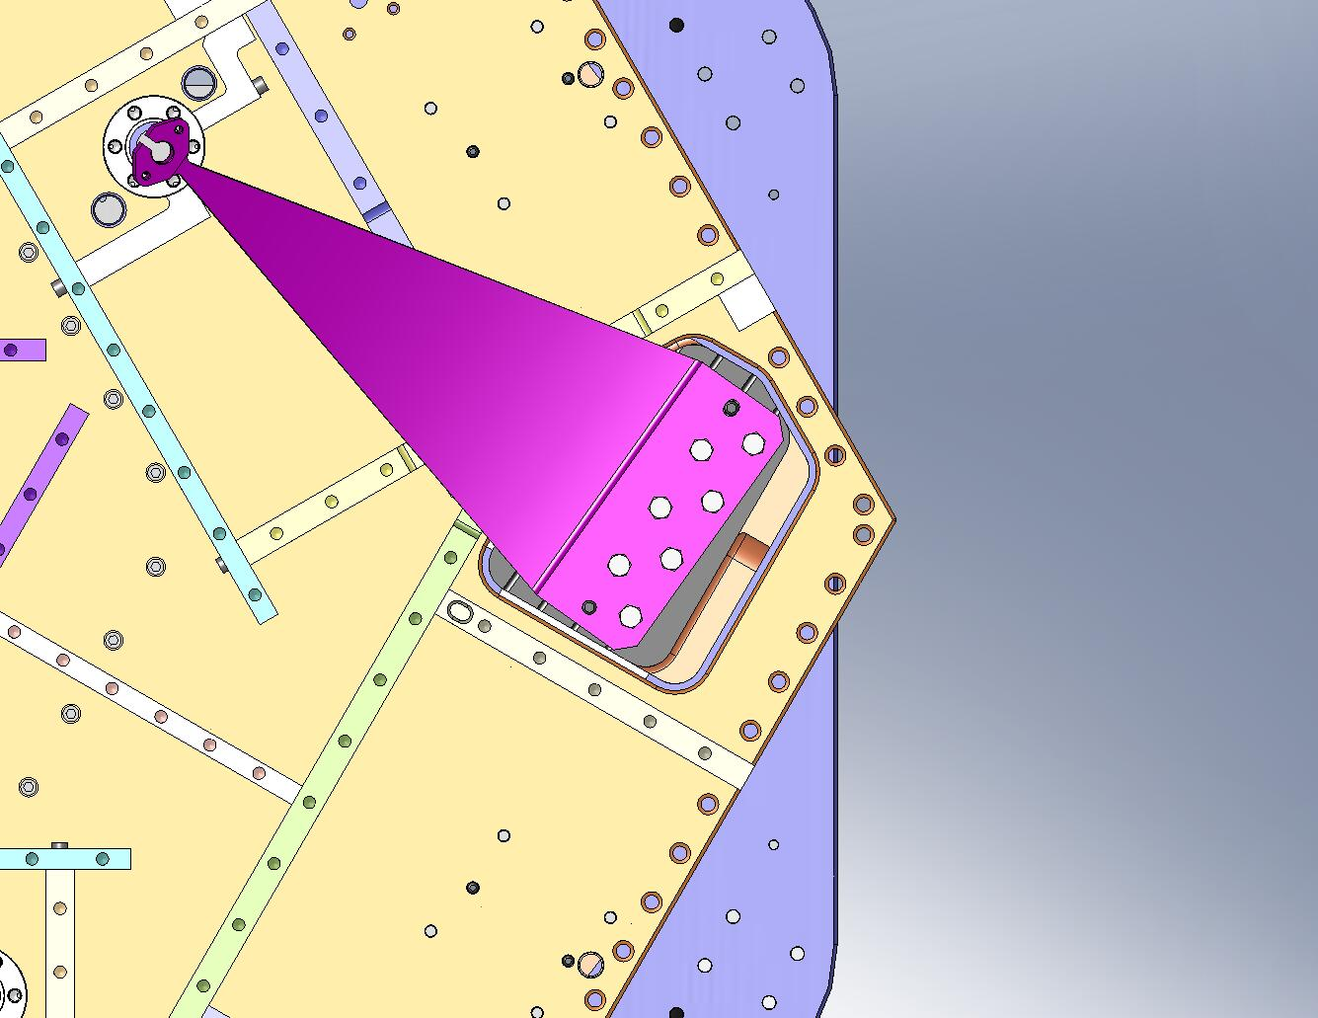
Start here…

… end here.
Figure 3.81. A staggered bolt tightening pattern. Use a similar pattern when torquing the Spring bolts.

- Insert (6) Spring Tension Bushings (D071321) in the Stage 1 Floor, on either side of the (3) Flexure Posts.
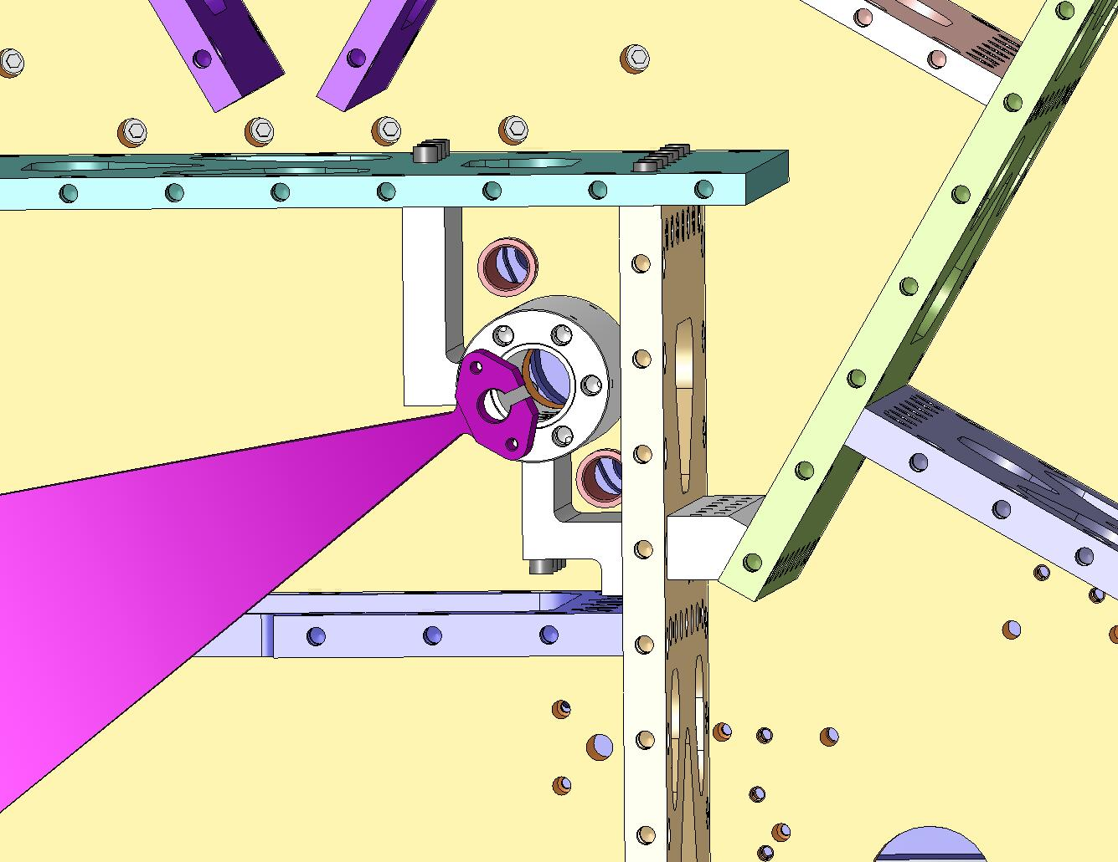
Figure 3.82. These plastic bushings protect the Stage 1 Floor during assembly and use of the Spring Pull-Down Assemblies.

- Slip a nut and a washer onto all (3) of the Flexure Assemblies (D071431), as shown in Figure 3.83.
Hardware:
(1) 3/4”-10 thin jam nut (McMaster-Carr #91847A550)
(1) 3/4” washer (McMaster-Carr #98017A220)
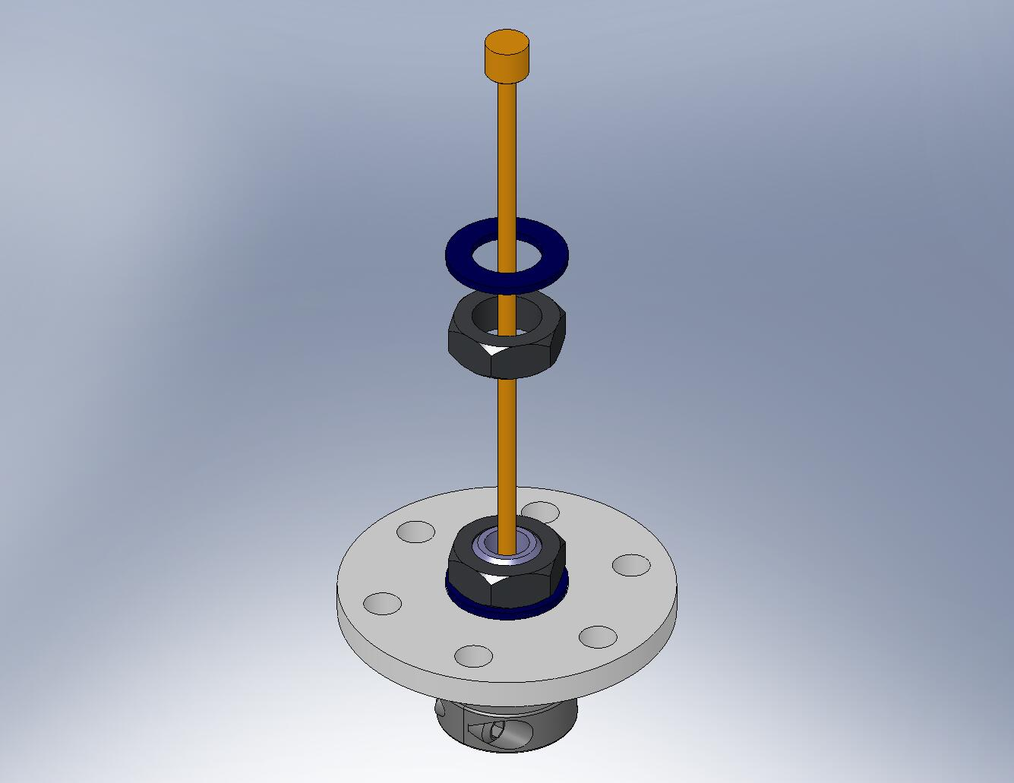
Figure 3.83. The hardware for the top Flexure Mount must go on before the Flexure Assemblies are inserted into the Springs.

- Pass a Flexure Assembly through the slot at the end of one of the Springs, as shown in Figure 3.84.
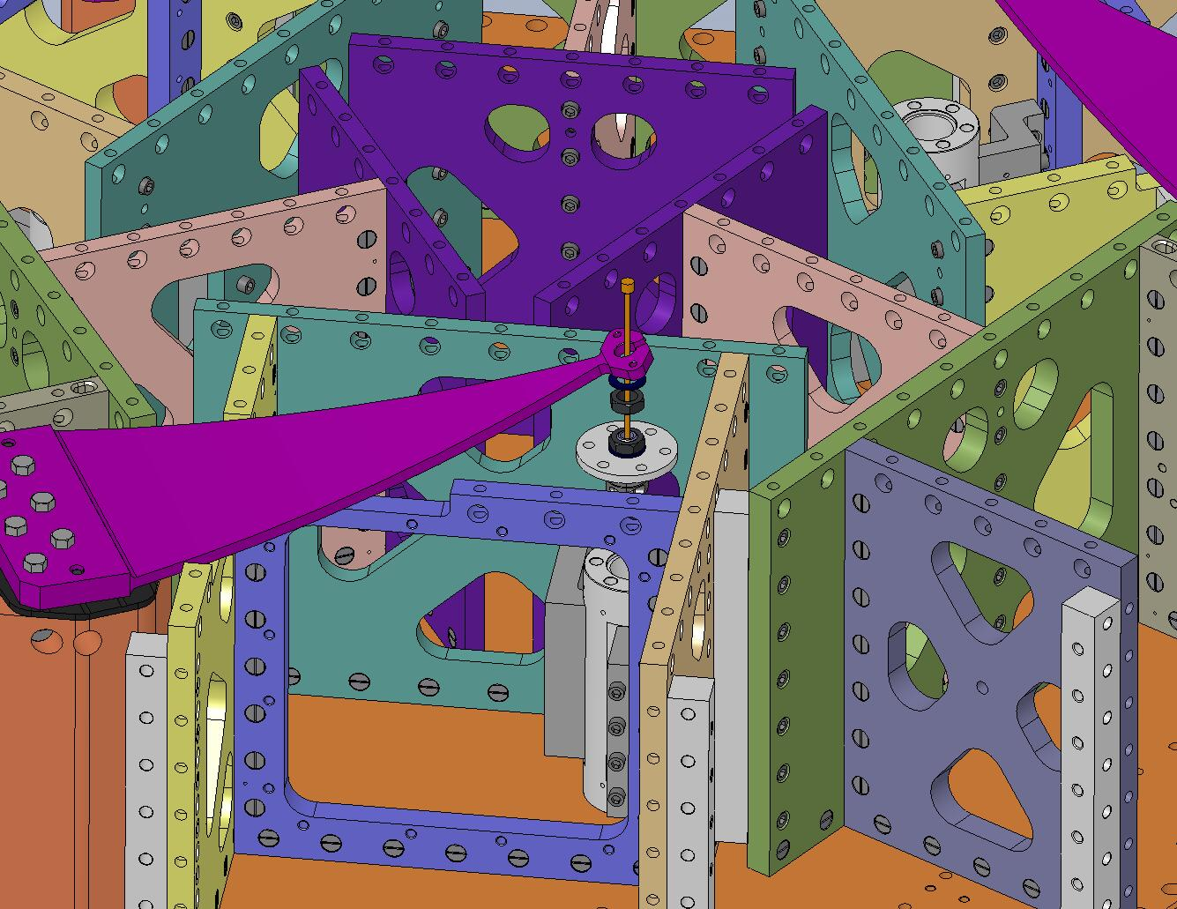
Figure 3.84. Pass the Flexure through the slot at the end of the Spring. Hold it in place during the next few steps.

- Slide a Flexure Mount (D071103) over the top of the Flexure, as shown in Figure 3.85. Seat the Flexure Mount within the mating hole in the Spring.
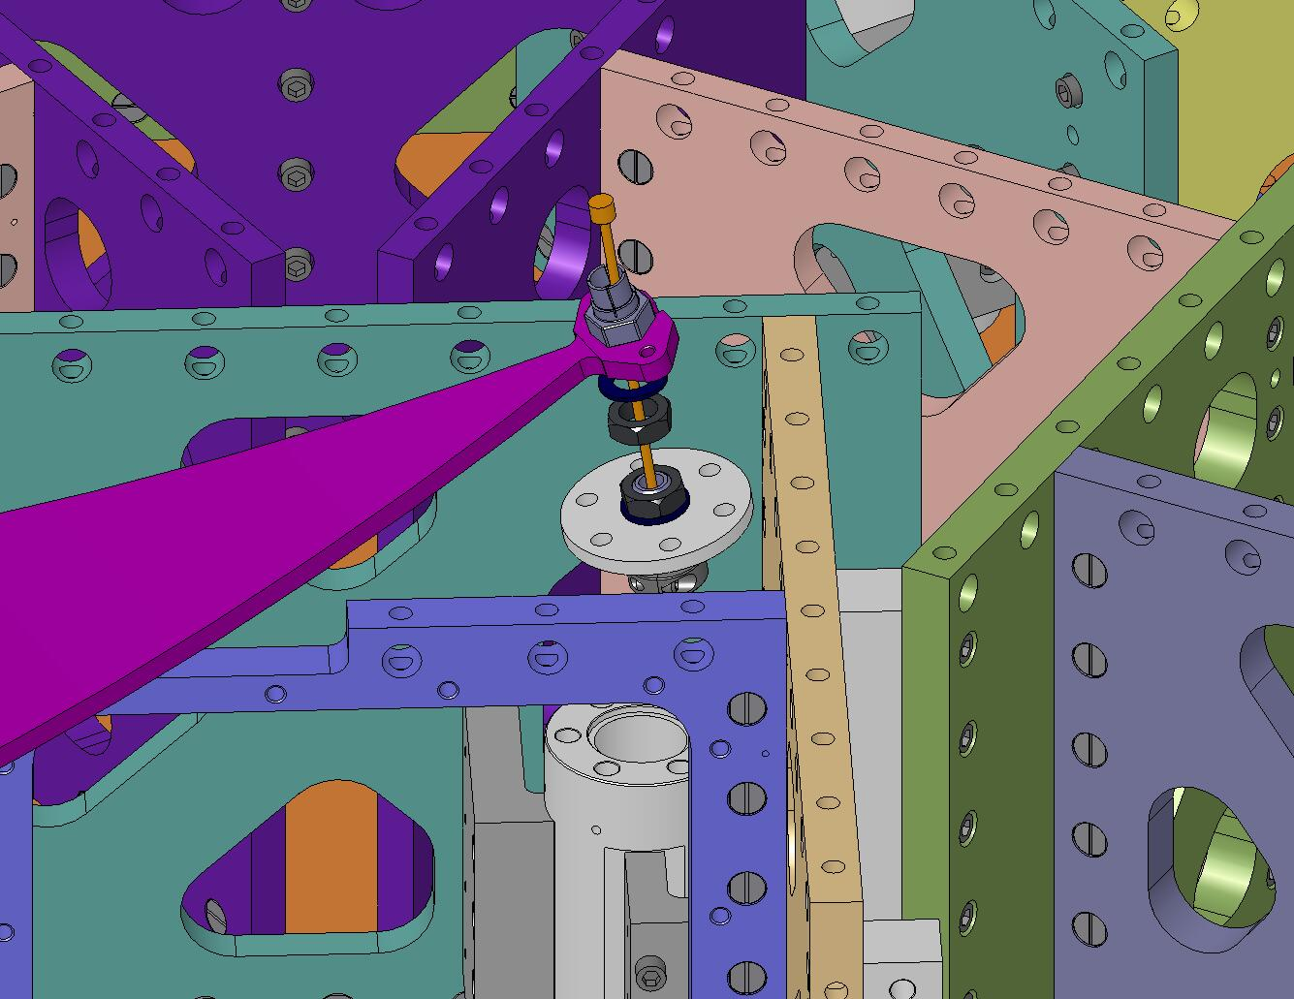
Figure 3.85. Slip a Flexure Mount over the end of the Flexure, then engage it in the Spring.

- Thread the jam nut onto the Flexure Mount, as shown in Figure 3.86. Make sure there is good contact between the Mount’s hex flange and the top of the Spring. Torque the nut to final spec.
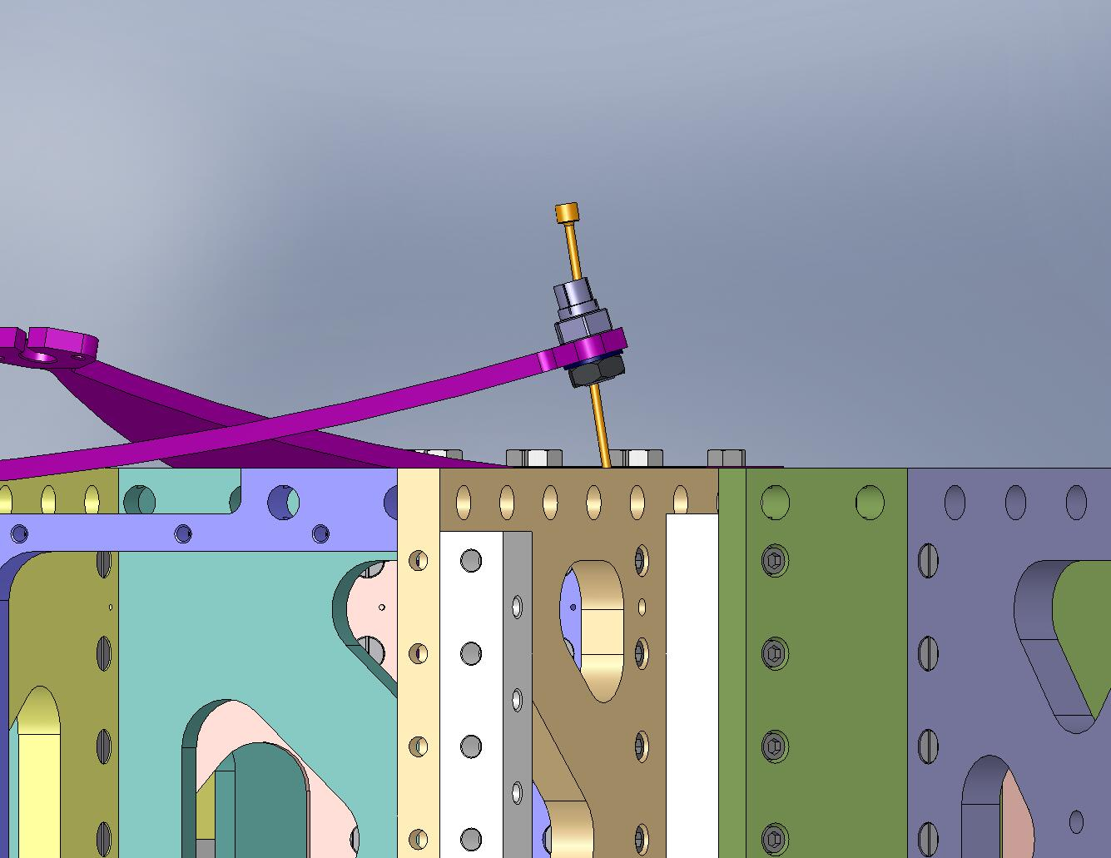
Figure 3.86. Torque the jam nut against the hex flange on the Flexure Mount.

- Place something (e.g., a twisted O-ring) between the top end of the Flexure and the inside of the Flexure Mount, to prevent the Flexure from seating. This reduces the risk of accidentally bending the Flexure when the Springs are loaded.
- Repeat the last few steps with the other (2) Flexure Assemblies.
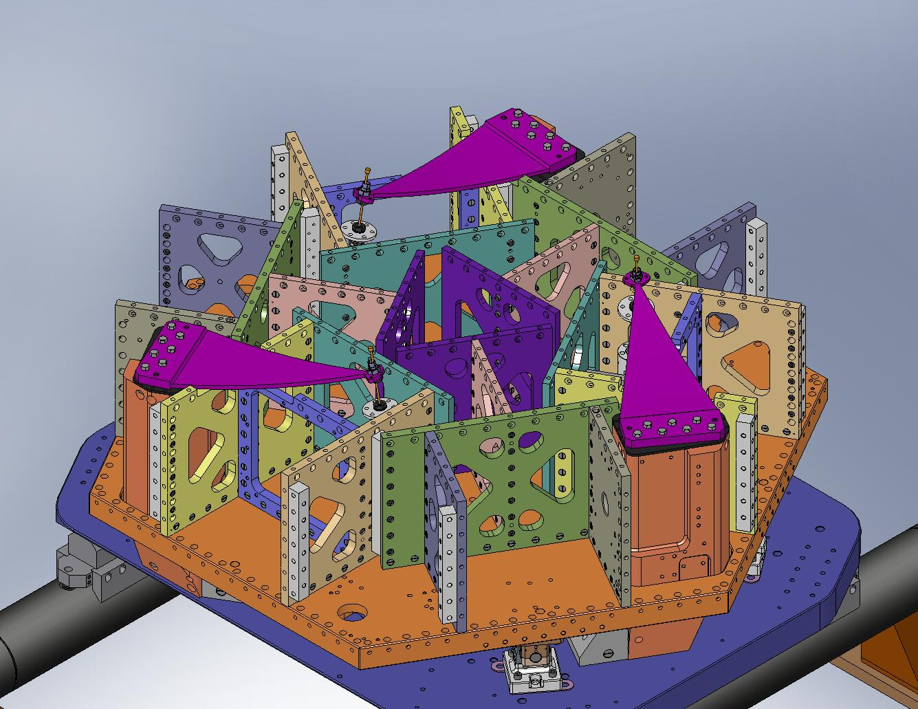
Figure 3.87. Flexure Assemblies temporarily mounted in all (3) Springs. Next, the Springs will be loaded flat.

- Move the (3) bottom parts of the Spring Pull-Down Assemblies (above, Figure 3.59) between Stage 0 and Stage 1. Insert the Spring Pull-Down Bases (D071307) in the (3) matching pockets in the Stage 0 Base, as shown in Figure 3.88.
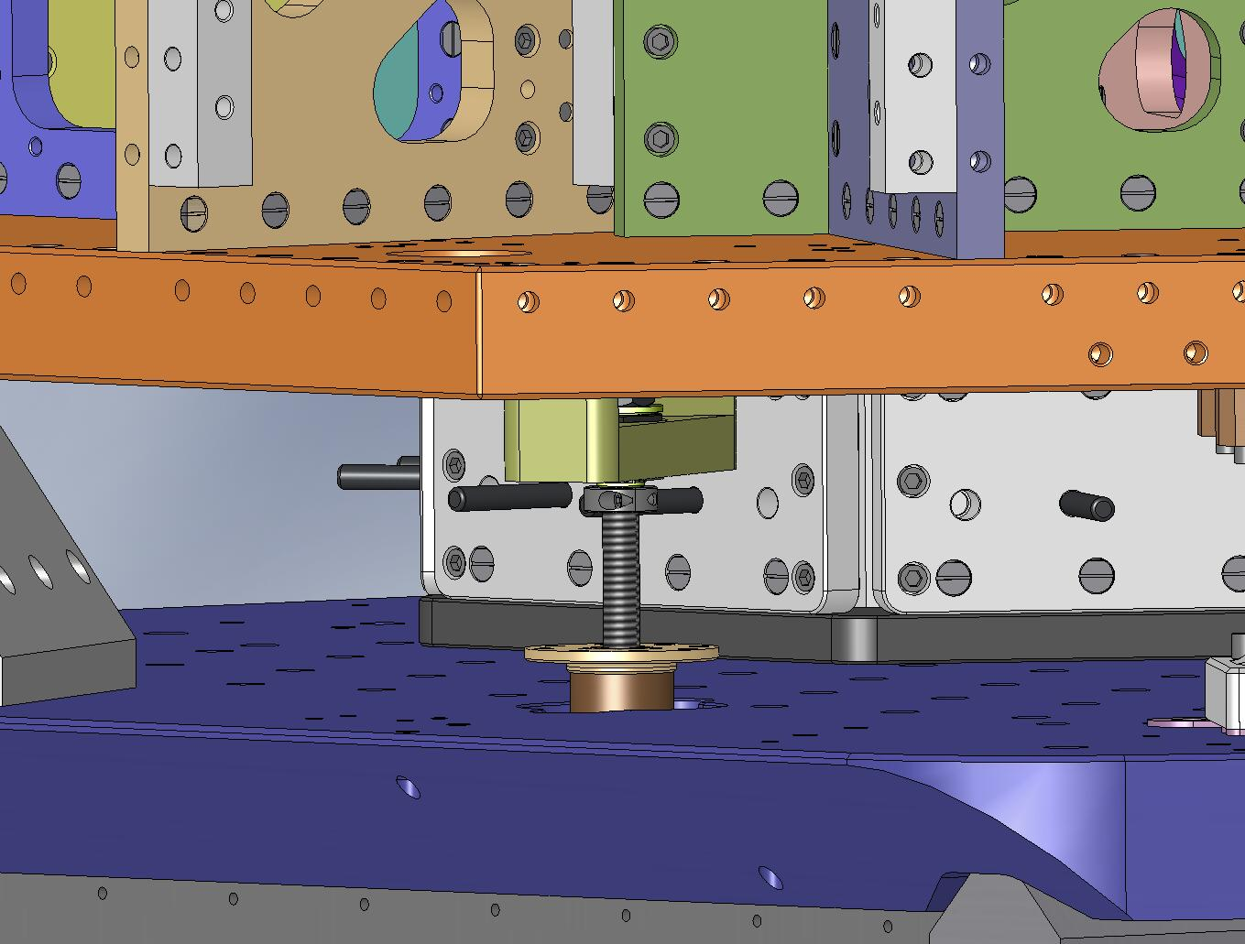
Figure 3.88. The (3) Spring Pull-Down Bases mount inside pockets in the Stage 0 Base.

- Start the screws holding the Pull-Down Bases to the Stage 0 Base. Snug them all, then torque them to final spec.
Hardware:
(24) 3/8"-16x1.0" SHCS (Holo-Krome)
(24) 3/8" vented washers (U-C Components)
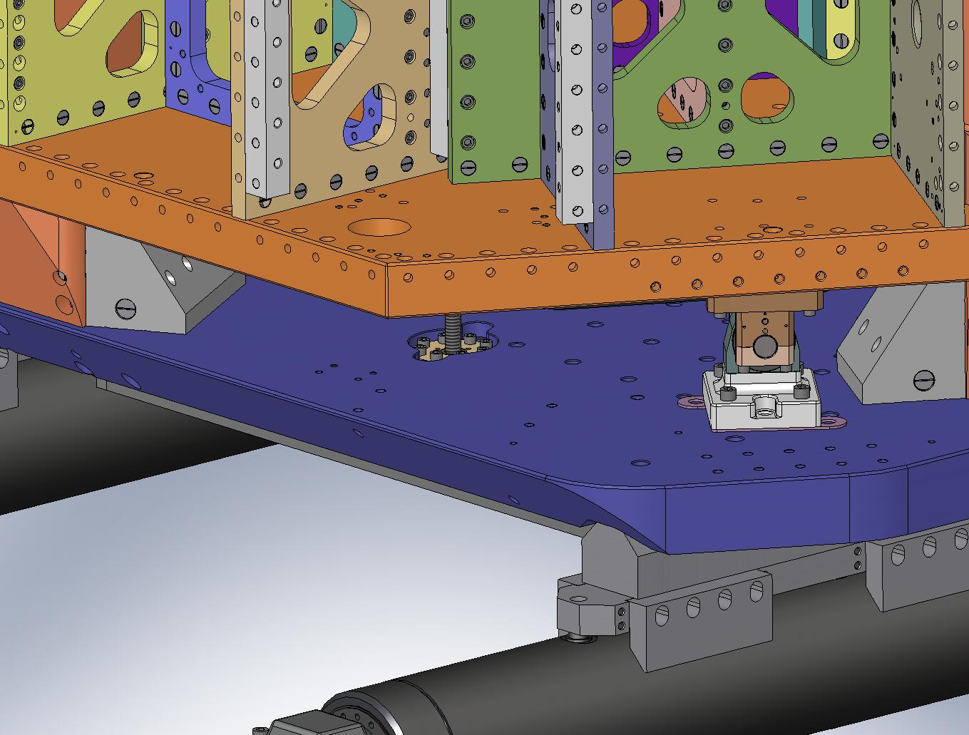
Figure 3.89. Screws holding the bottom of the Spring Pull-Down Tooling to Stage 0.

- Unscrew the ACME Screw (D071309), until the bottom of the shaft collar is 4” above the Pull-Down Base, as shown in Figure 3.90.
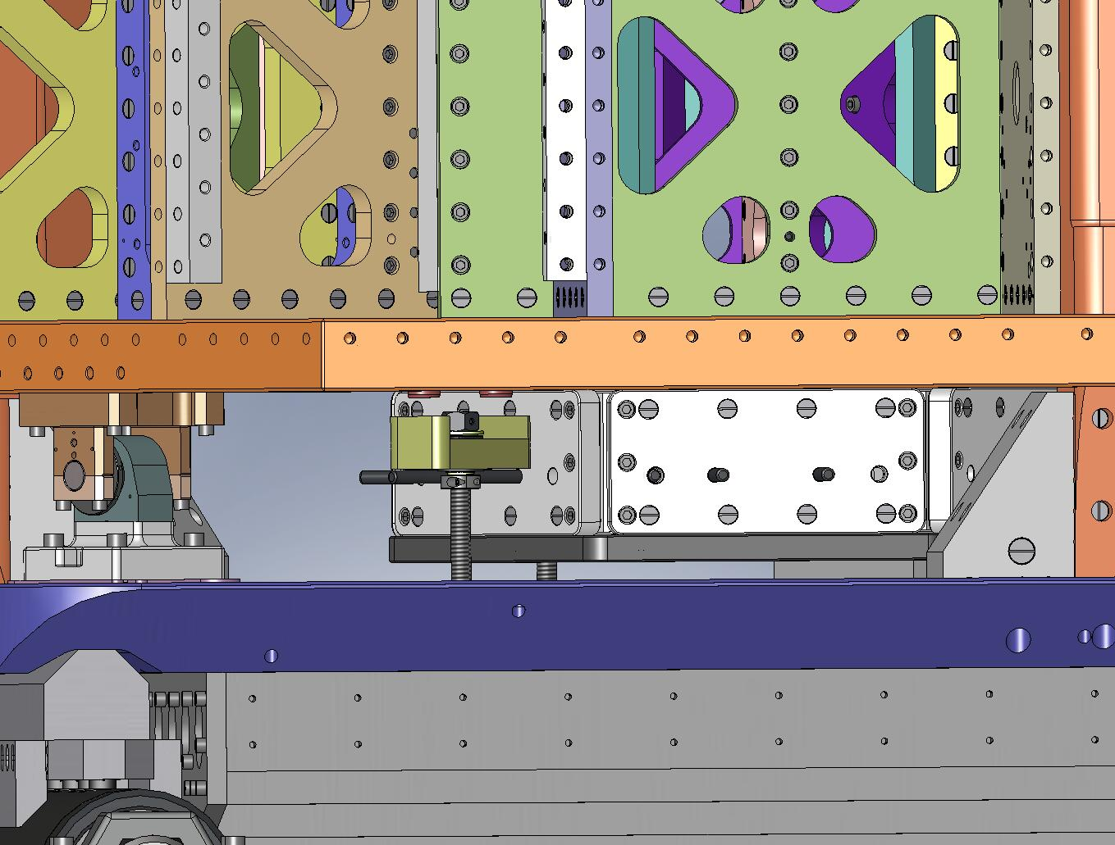
Figure 3.90. Set the starting length for the ACME Screw, leaving 4” between the bottom of the shaft collar and the top of the Pull-Down Base. The Spring Pull-Down Assembly must pull through 3.5” to flatten the Springs. The ACME Screw is not fully engaged in the Pull-Down Nut during the first .5” of travel, but the tension is small over this range.

- Lay the (3) top parts of the Spring Pull-Down Assemblies (above, Figure 3.65) on top of the Springs, as shown in Figure 3.91. Carefully pass the ends of the Pull-Down Rods (D071303) through i) the Spring Tension Bushings in the Stage 1 Floor and ii) the Spring Pull-Down Bars (D071306), as shown in Figure 3.92.
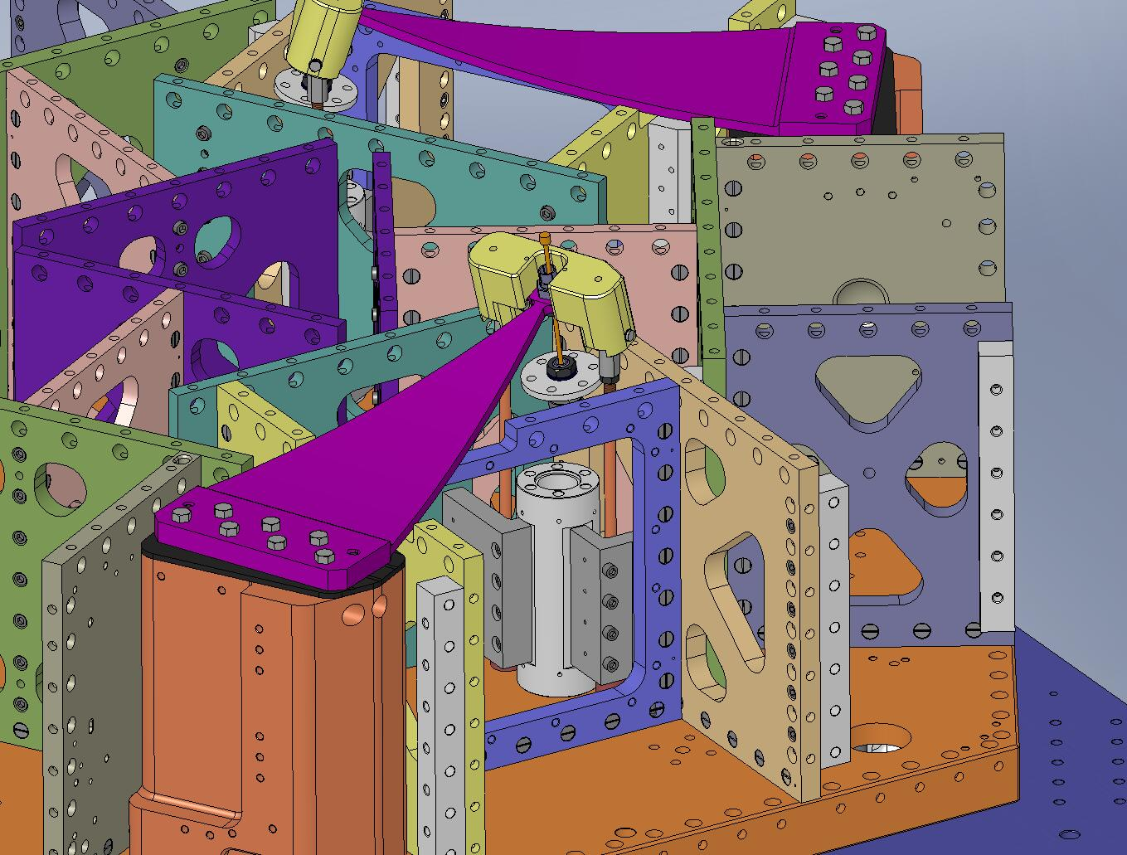
Figure 3.91. Engage the Pull-Down Cap with the end of the Spring. The (2) dowel pins in the Cap should seat in the matching Spring holes.
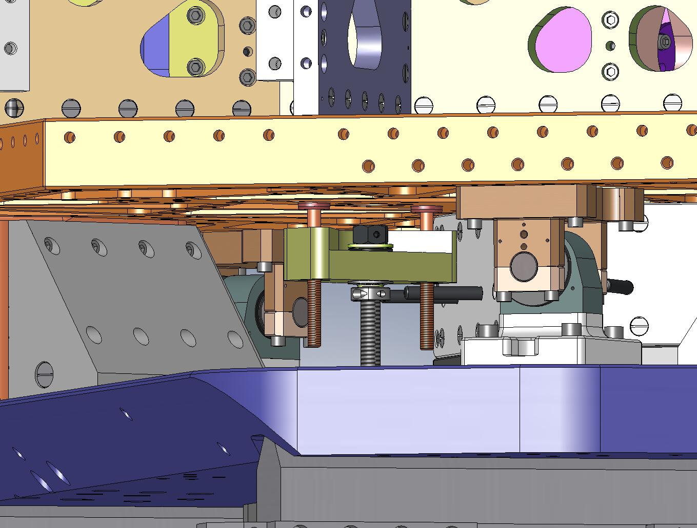
Figure 3.92. Pass the Pull-Down Rods all the way through the holes in the Pull-Down Bar. Note the triangular pocket in the top of the Pull-Down Bar should face to the right – this allows better access for tightening the ACME Screw.

- Place a spherical washer set (McMaster-Carr #91944A470) on each Pull-Down Rod, followed by a 1/2”-20 coupling nut (McMaster-Carr #90268A345), as shown in Figure 3.93.
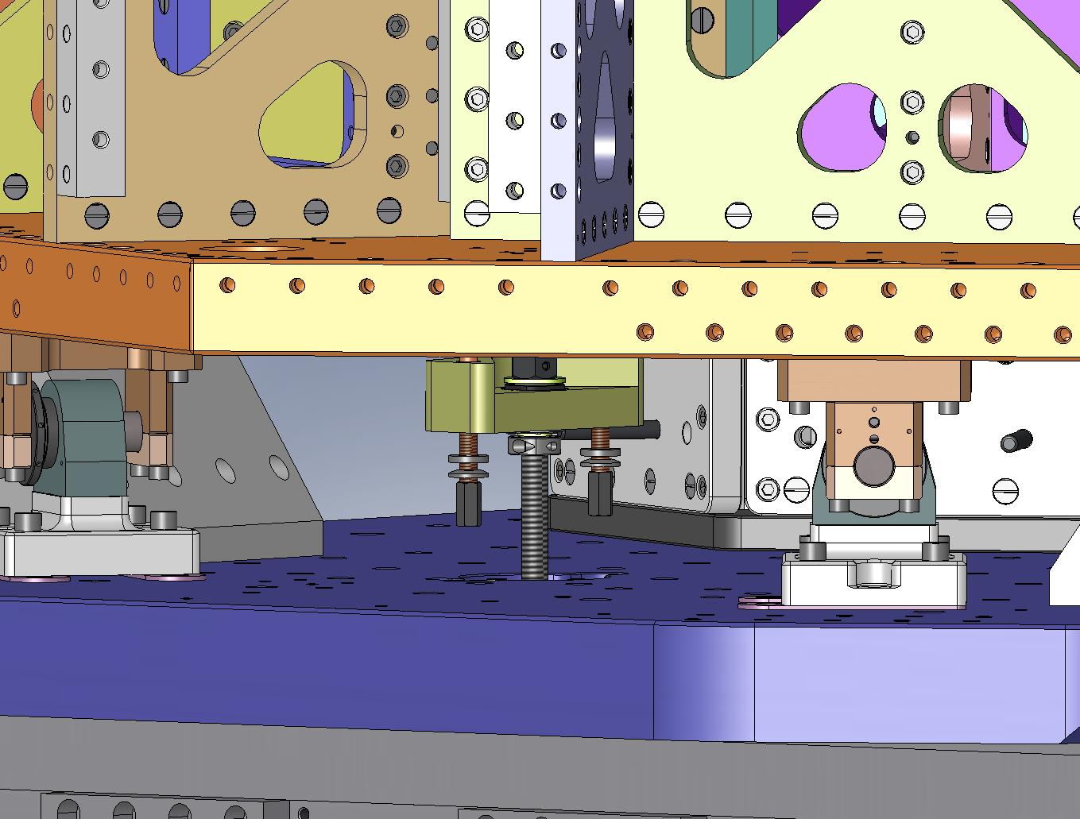
Coupling Nut
Spherical Washer, Female
Spherical Washer, Male
Figure 3.93. Hardware for the bottom ends of the Pull-Down Rods.

- With the Pull-Down Caps seated flush to the tops of the Springs, tighten the coupling nuts enough to cause a little tension on each Pull-Down Rod. Use equal torque for the (2) coupling nuts on a single Pull-Down Assembly – this is necessary to avoid twisting the Spring during loading.
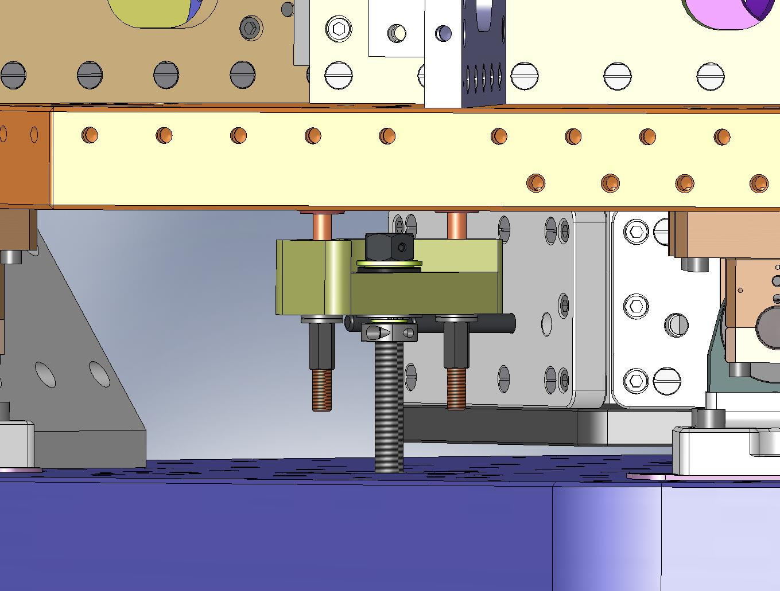
Pull-Down Rods should have equal tension.
Figure 3.94. Carefully tighten the coupling nuts, so both Pull-Down Rods on each Pull-Down Assembly have the same tension.

- Using a ratcheting box wrench, begin tightening all (3) ACME Screws, as shown in Figure 3.95. As the load on each Spring increases, its shape will approach the final, flat profile.
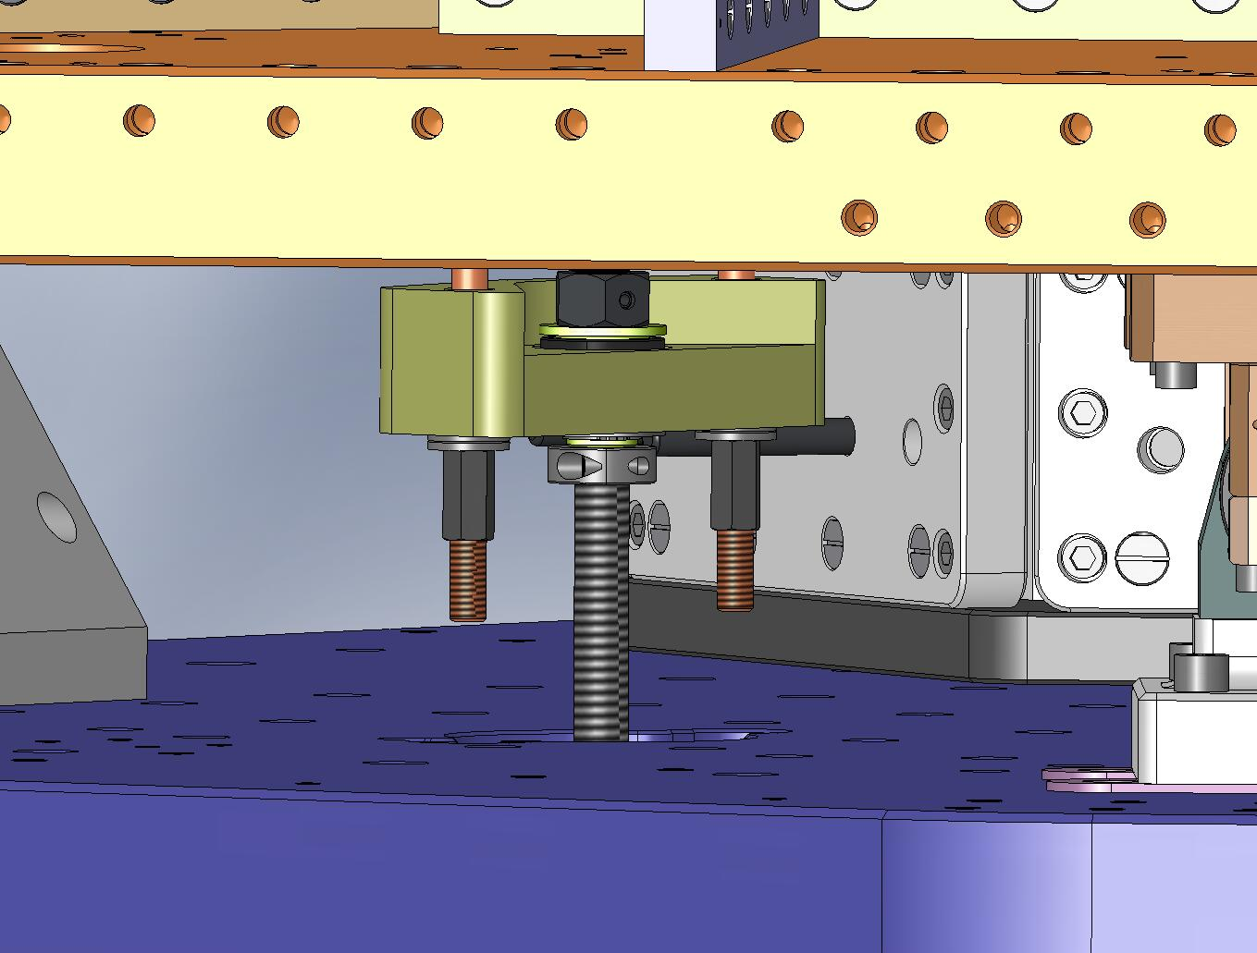
Tightening the Screw tensions the Springs.
Figure 3.95. Load the Springs by tightening the ACME Screws. The Springs may be tightened in any order.

- When loading the Springs, make sure that the Flexure Assemblies do not become wedged against anything on Stage 1.
- As each Spring approaches horizontal, remove the O-ring from its top Flexure Mount, and insert (2) Flexure Cups (D071104), as shown in Figure 3.96. Try to align the Cups with the grooves in the Mount (refer to Error! Reference source not found.).
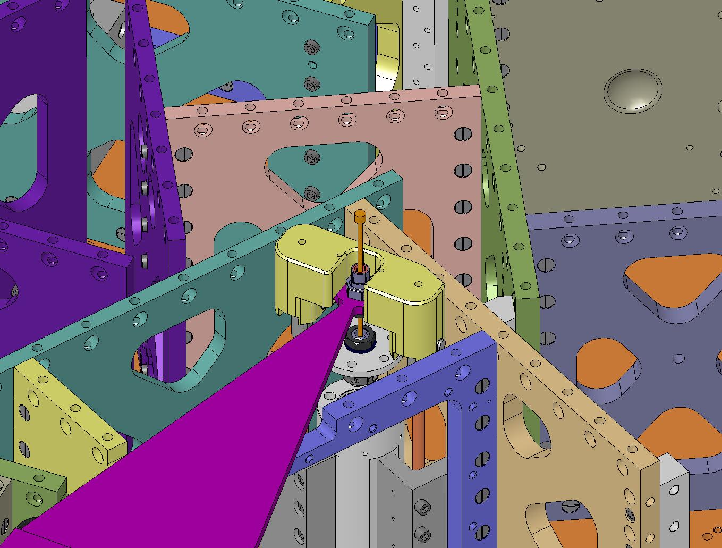
Insert (2) Flexure Cups into each Flexure Mount.
Figure 3.96. Preparing to clamp the Flexure Assemblies to Stage 0 and Stage 1: start by inserting (2) Flexure Cups into each Flexure Mount.

- Place a shaft collar (McMaster-Carr #9633T15) around the top of each Flexure Mount, as shown in Figure 3.97. Leave the collar loose, so the Flexure can slip in and out of the Flexure Cups without a lot of force.
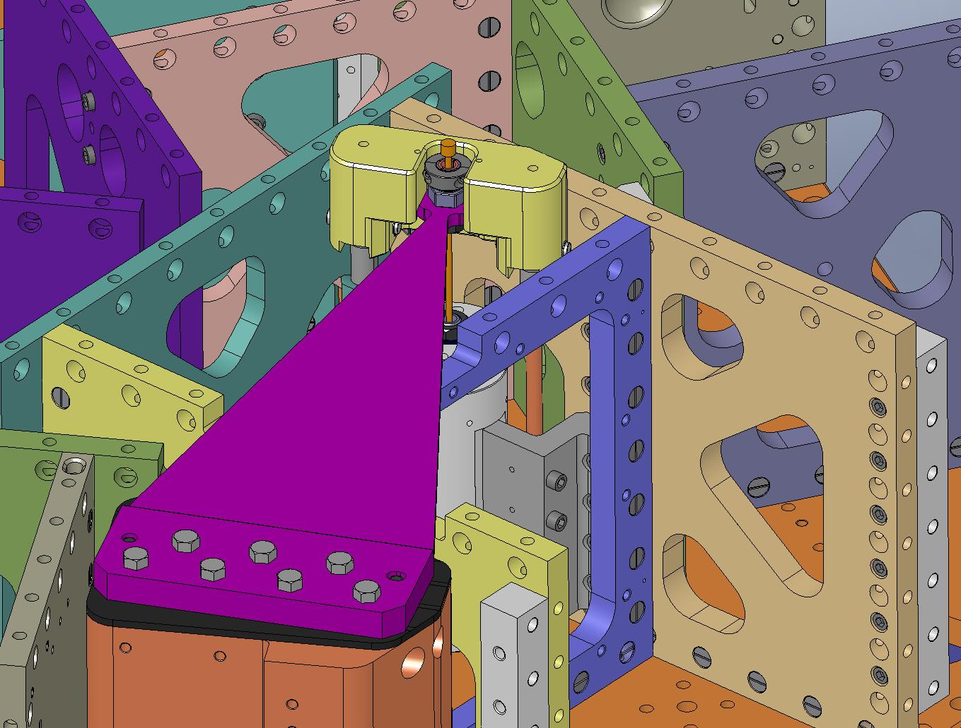
Figure 3.97. Shaft collars will be used to clamp the top of each Flexure to its Flexure Mount. The screw heads must face outward.

- Hold the top ends of the Flexures above the Flexure Cups, while continuing to load each Spring. Place a straightedge on the Spring to check for flatness. Adjust the tension on the Pull-Down Tooling, until the Spring is flat (to within ~.005”-.010”).
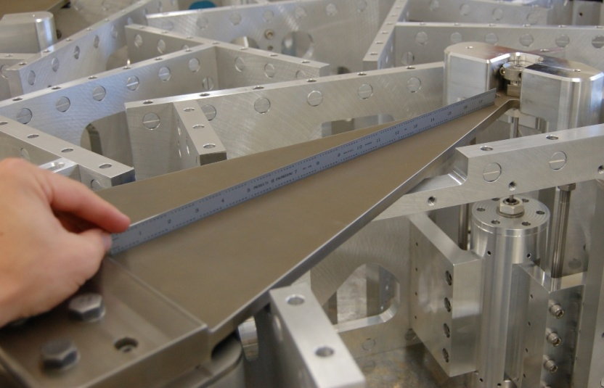
Figure 3.98. Place a straightedge on the Spring, to check the flatness.

- Carefully pull the Flexure into the Flexure Cups. Depending on the height of the Spring tip, either i) the Flexure will seat fully in the Flexure Cups, before the Flexure Lower Plate touches the Flexure Post, or ii) the Flexure Lower Plate will seat first.
- Adjust the Spring tension until you can seat the Flexure Lower Plate, with the top of the Flexure protruding about .005” above the top Flexure Mount, as shown in Figure 3.99.
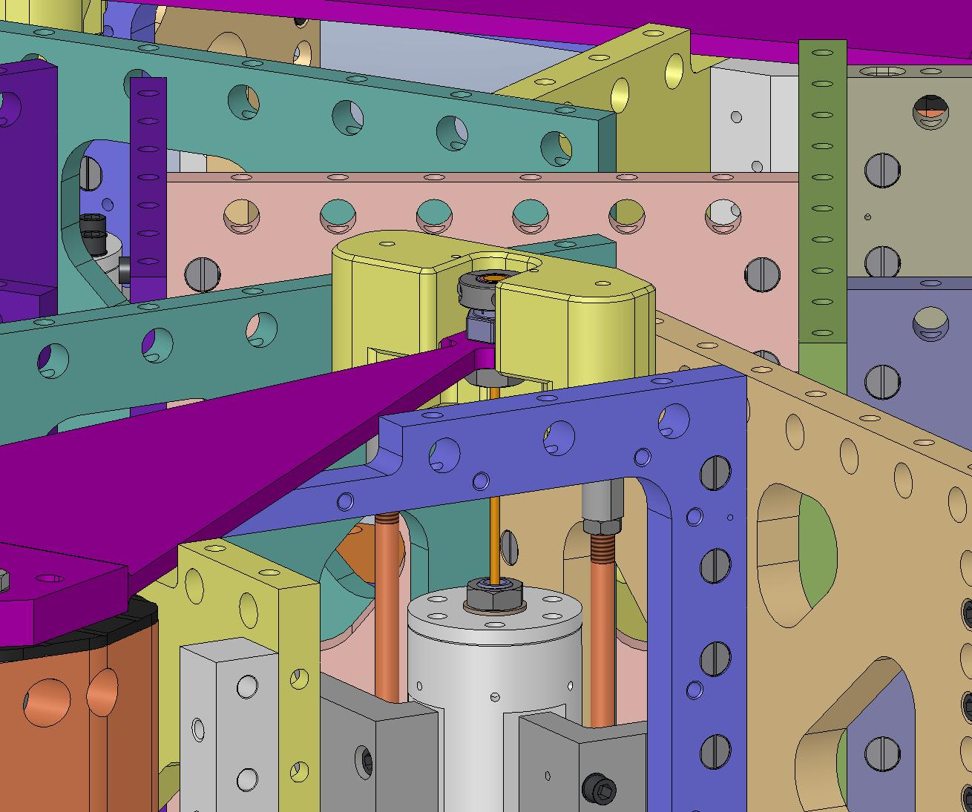
Flexure Lower Plate seated on Flexure Post.
Flexure Cup protrudes ~.005” above Flexure Cups.
Figure 3.99. Slightly over-extend Spring, so Flexure Lower Plate seats fully on Flexure Post. There should be a small (internal) gap between Flexure and Flexure Cups.

- Add hardware to Flexure Lower Plate. Snug all screws on a Plate, then torque to final spec, using a staggered pattern.
Hardware:
(24) 3/8"-16x1.25" SHCS (Holo-Krome)
(24) 3/8" vented washers (U-C Components)
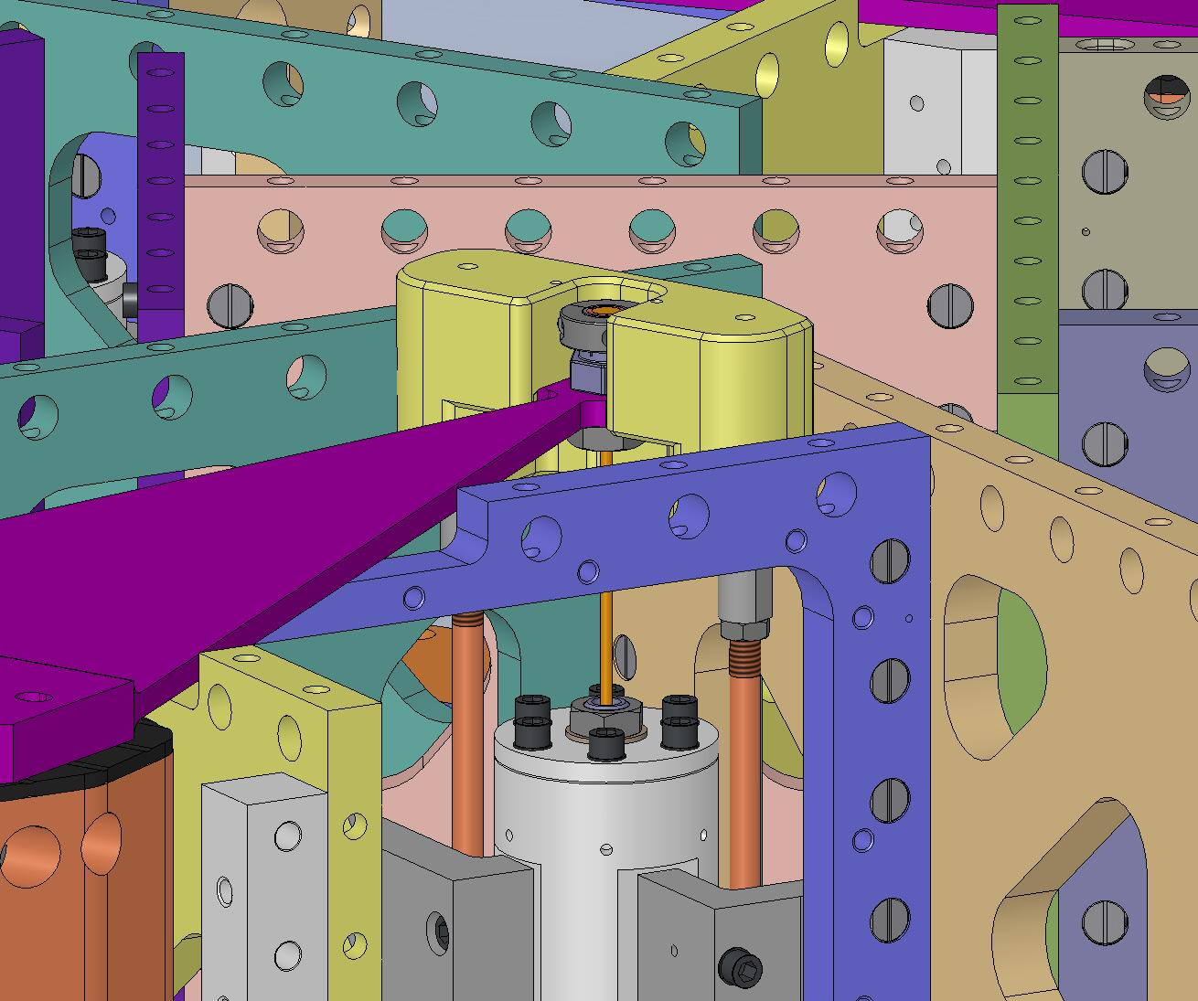
Figure 3.100. Bolt the Flexure Lower Plates to the Flexure Posts.

- Before moving onto next step, all (3) Springs should be loaded and all (3) Flexure Lower Plates should be bolted in.

    - Mount Optical Table to Stage 1 Assembly
- Bolt (3) Particle Fences (D071009) to the Support Posts, as shown in Figure 3.101. Torque screws to final spec.
Hardware:
(6) 1/4"-20x.75" SHCS (Holo-Krome)
(6) 1/4" vented washers (U-C Components)
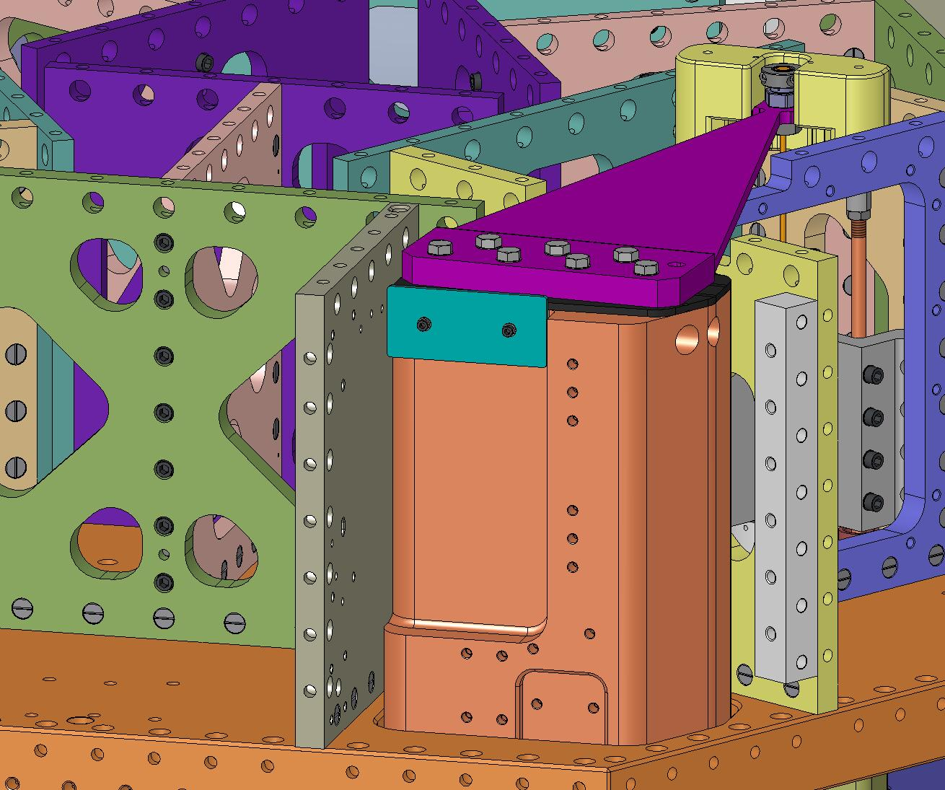
Figure 3.101. Particle Fences are added to prevent debris from Optical Table surface migrating down into Actuators.

- Bolt (3) Rib, Tan, Flexure Mid Covers (D071072) to Rib, Tan, Flexure Mid plates (D071071), as shown in Figure 3.102. For each Cover, first snug all screws, then torque to final spec.
Hardware:
(48) 1/4"-20x1.0" SHCS (Holo-Krome)
(48) 1/4" vented washers (U-C Components)
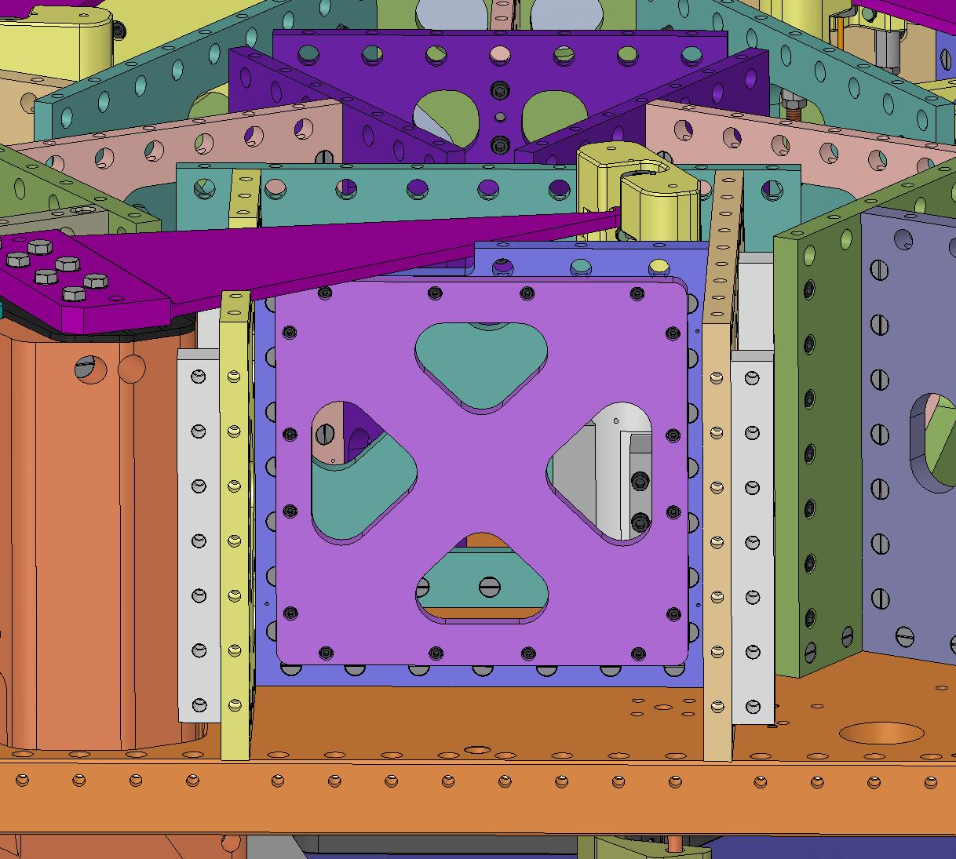
Flexure Cover
Figure 3.102. Orientation of Flexure Mid Cover is not important.

- Place (66) Type 00 Barrel Nuts (D071250-00) and (111) Type 01 Barrel Nuts (D071250-01) in openings along tops of Stage 1 Ribs, as shown in Figure 3.103. Flats should all face down (i.e., away from screws). Check that every tapped hole will be accessible after Optical Table (D071050) is installed.
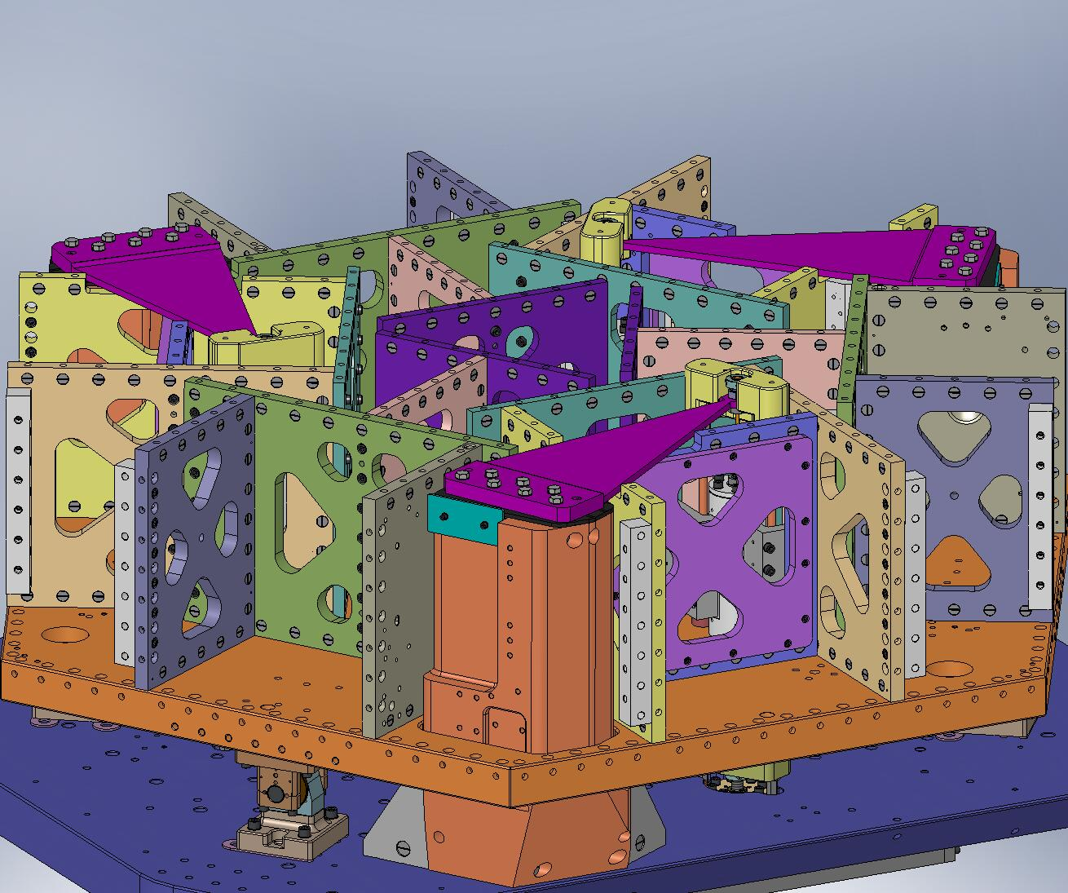
Figure 3.103. Barrel Nuts inserted along top of Stage 1 Ribs. Refer to Figure 2.42 and Figure 2.51 for detailed identification of which Nut types match with each Rib.

- Top of Optical Table must be handled with care, to keep it free of scratches!
- Install (2) 3/4”-10 lifting eyes into top of Optical Table. Note: Table has (4) tapped holes for lifting – use (2) that are on same mid-line to help maintain balance.
- Lift Optical Table with overhead crane. Position over Stage 1. Orientation is important: vent grooves must run parallel to Support Tubes, while (3) pockets line up with Spring Pull-Down Assemblies.
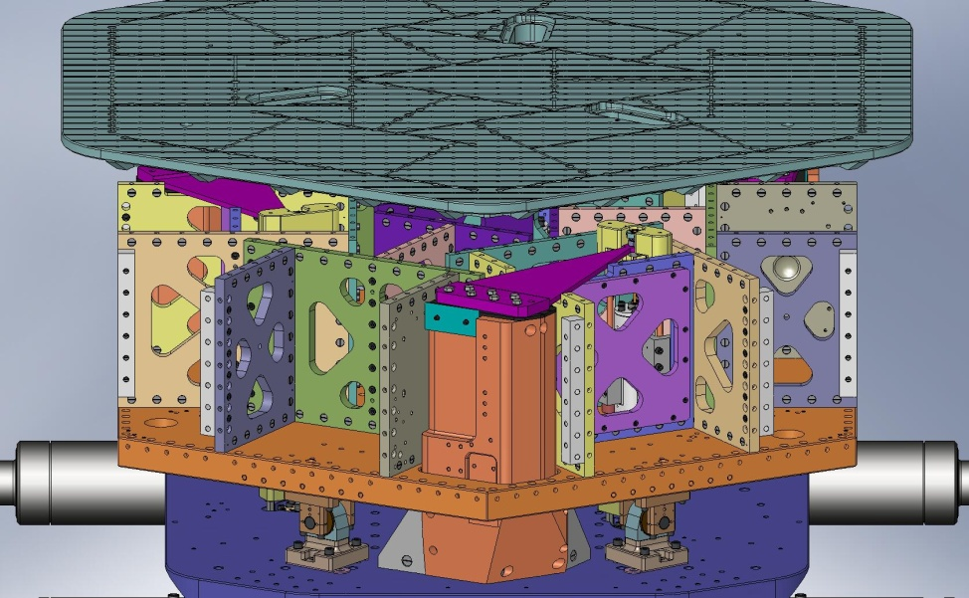
Figure 3.104. Optical Table positioned over Stage 1. There is only one orientation that works: vent grooves in Table running parallel to Support Tube axes, and (3) thru pockets positioned over (3) Spring Pull-Down Assemblies.

- Place a 1/2” shaft collar (McMaster-Carr #9421T700) on one end of each of (3) 1/2”x12” steel shafts (McMaster-Carr #6253K52). Leave about 2.75” of the shaft below the collar, and clamp the collar in place. See Figure 3.105.
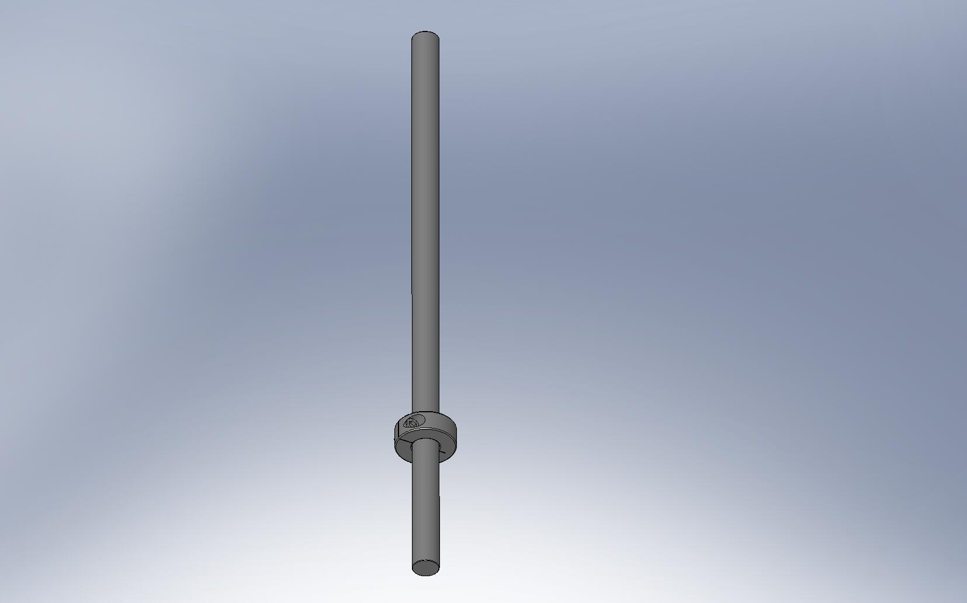
Figure 3.105. Place shaft collars toward the bottom end of (3) 1/2”x12” long dowel pins. These will help orient the Optical Table to the Stage 1 Ribs.

- Drop the 1/2” shafts through the holes in the Optical Table, so approximately .25” stick below the Table’s bottom surface. These will align the Table to the Stage 1 Ribs, by mating with slots in the top of the (3) Rib, Rad, GS-13 Out 1 plates (D071055).
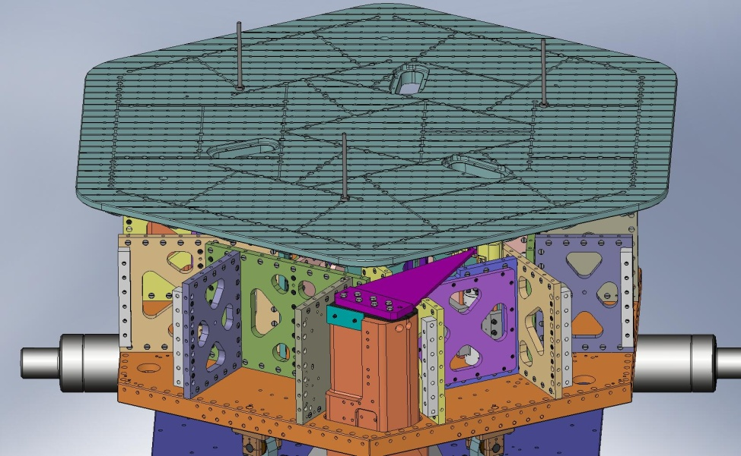
Figure 3.106. Drop (3) long pins through holes in top of Optical Table. These pins will locate to the slots in (3) of the Stage 1 Ribs, as shown in Figure 3.107.
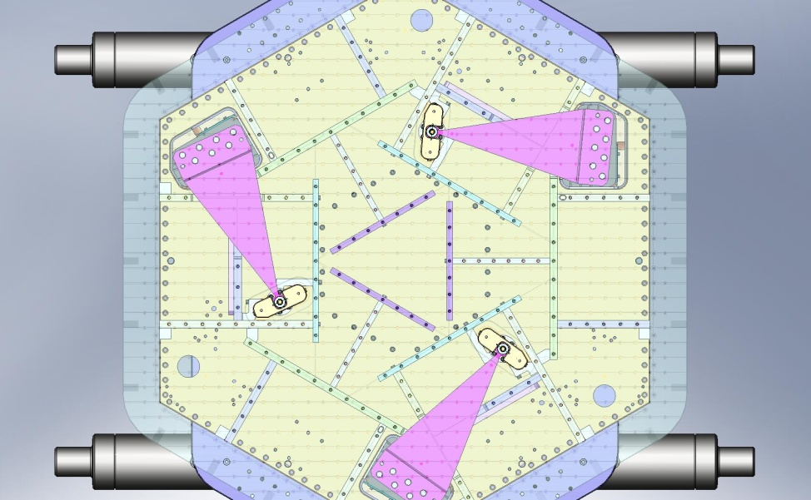
Figure 3.107. View from above ISI, with transparent Optical Table. The (3) slots marked with red circles are alignment slots in the Ribs. When lowering the Optical Table, mate the (3) long pins with these slots.

- Slowly lower the Optical Table, while guiding the 1/2” shafts into the mating slots.
- Once the Table is resting firmly on Stage 1, lower the crane and remove the lifting straps.
- Start all of the screws through the Optical Table. Do not tighten any of them, yet.
Hardware:
(177) 3/8"-16x1.75" SHCS (Holo-Krome)
(177) 3/8" vented washers (U-C Components)
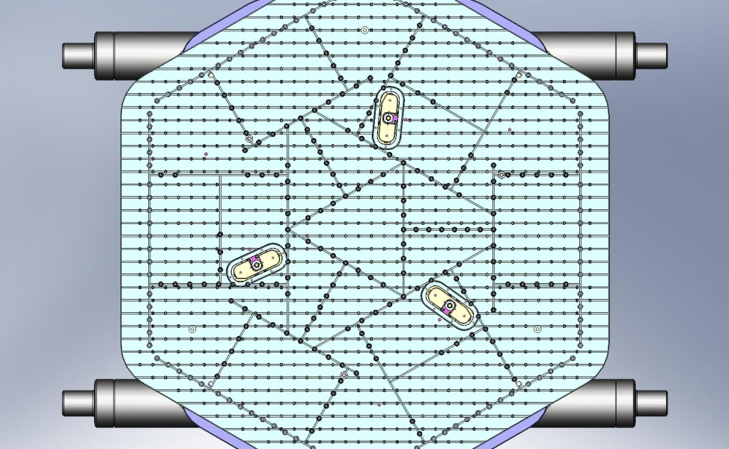
Figure 3.108. With Optical Table resting on the Ribs, start (177) screws into the Barrel Nuts.

- Tighten several screws near each of the (3) dowel pins. Remove the dowel pins.
- Snug all (177) screws in the Optical Table. After they are all snug, torque all of the screws to the final spec.

    - Release Springs
- Before Springs are released, the total load on the Locker Assemblies is Stage 1 mass minus mass of Outer Walls and Sensors/Actuators. Note that at least one of the Lockers could see significantly more than 1/3 of the total load, since the (4) Lockers over-constrain the system.
- Release tension from the (3) Spring Pull-Down Assemblies, evenly. Now, the Springs are pulling up on the Locker Assemblies.
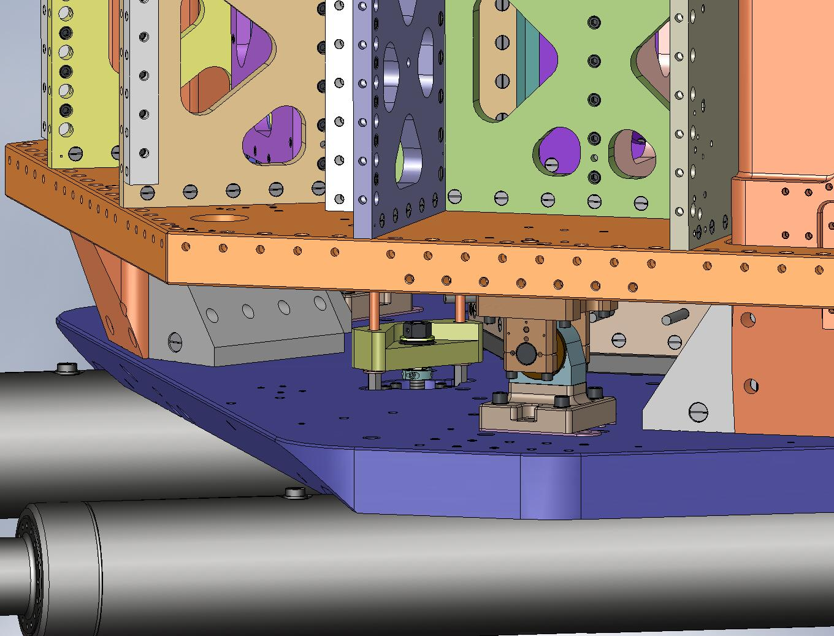
Figure 3.109. Loosen all (3) Spring Pull-Down Assemblies evenly, until the Flexure Assemblies are fully tensioned.

- Torque the screws on the (3) shaft collars on the Flexure Mounts, to final spec.
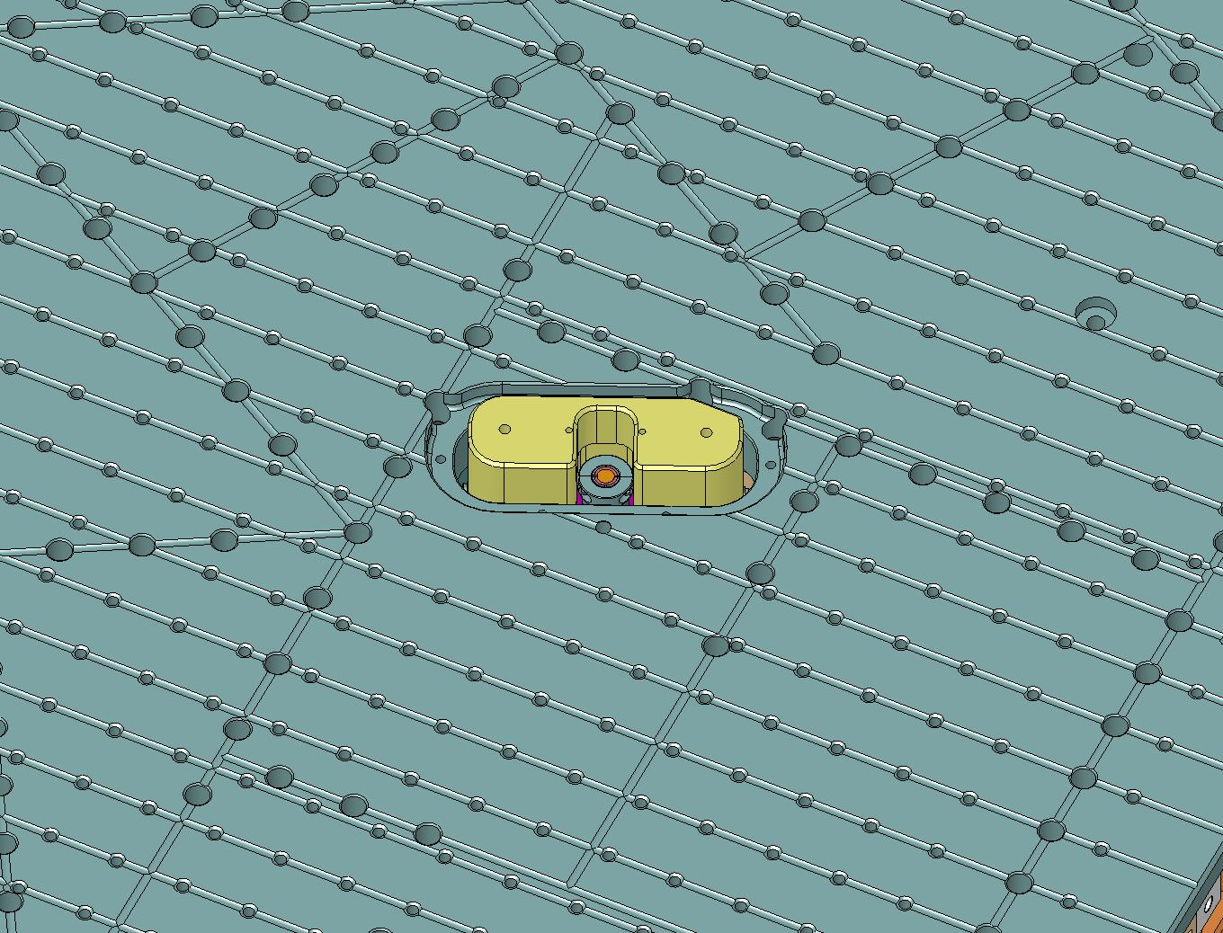
Figure 3.110. Torque the shaft collar screws on all (3) Spring/Flexure Assemblies.

- When the Spring Pull-Down Assemblies are loose, disconnect the coupling nuts on the bottom of all (6) Pull-Down Rods. Remove the spherical washers.
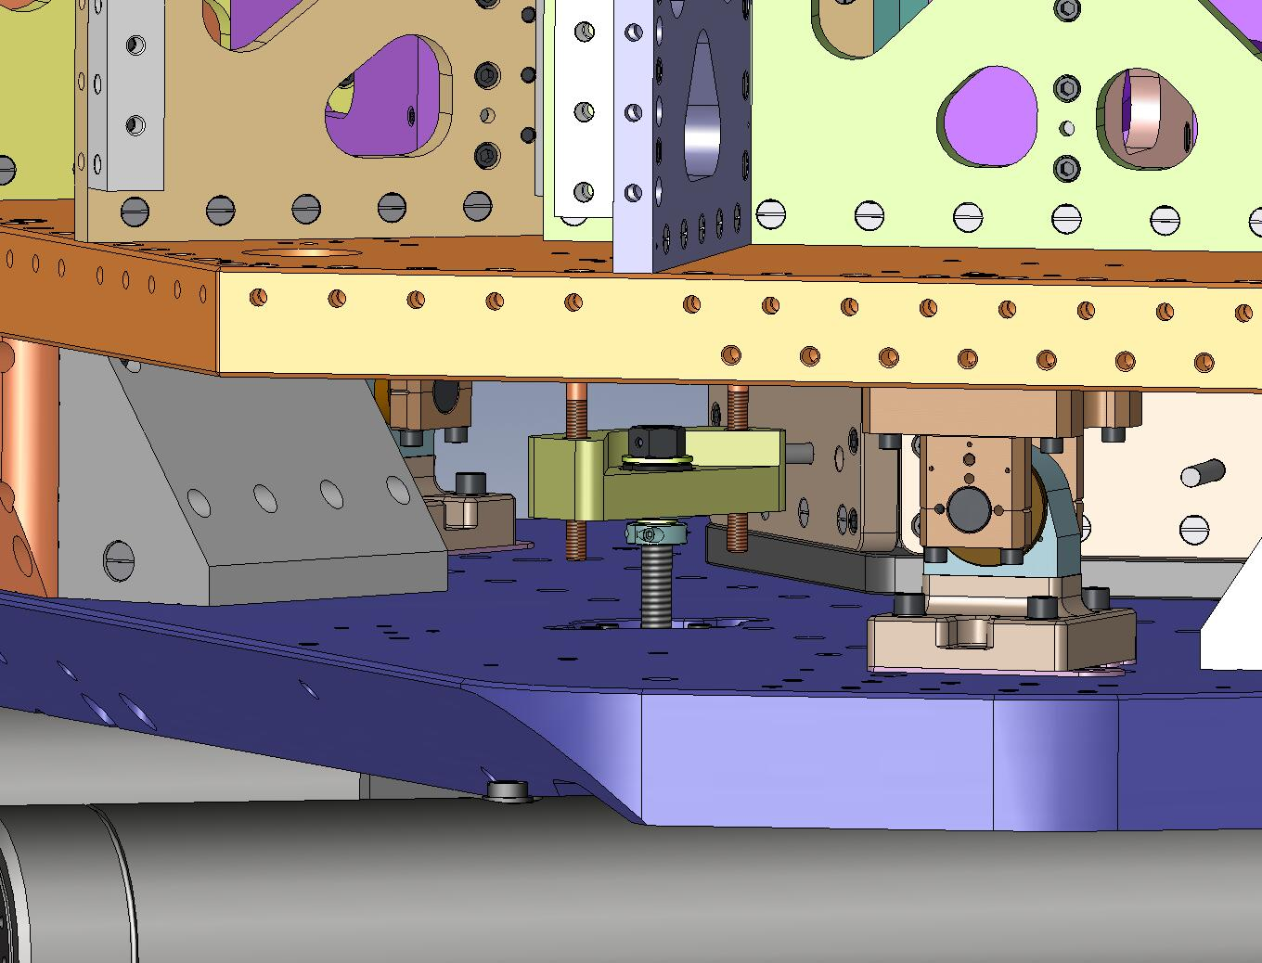
Figure 3.111. Remove the spherical washers and coupling nuts from under the Spring Pull-Down Bar.

- Pull the top part of the (3) Pull-Down Assemblies up through the Optical Table.
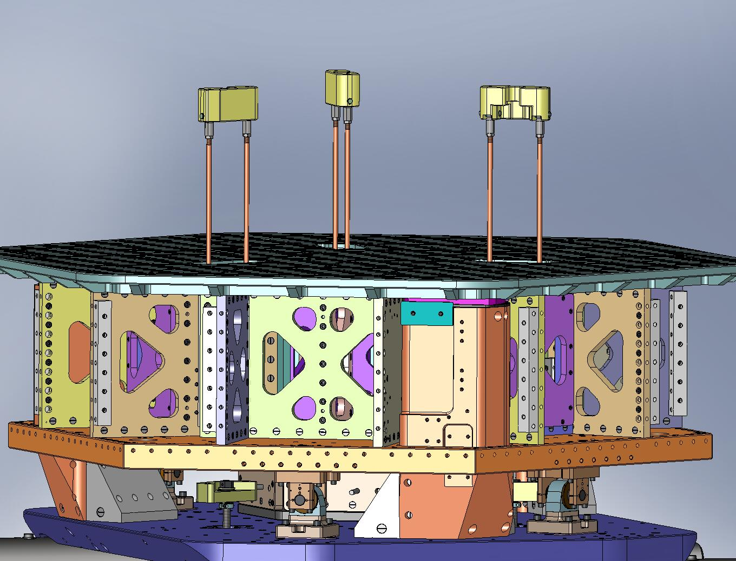
Figure 3.112. Pull out the top part of all (3) Spring Pull-Down Assemblies.

- Remove the (6) Spring Tension Bushings.
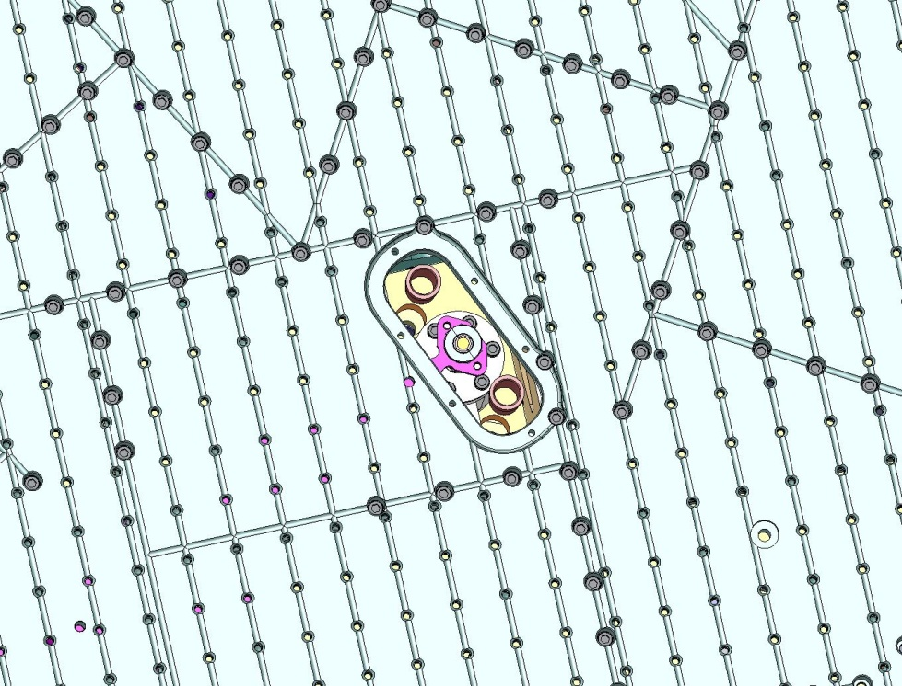
Figure 3.113. Remove the (6) plastic Bushings from the Stage 1 Floor.

- Unscrew the (3) ACME Screws from the Pull-Down Nuts.
- Unscrew the mounting hardware for the (3) Spring Pull-Down Bases, and remove the bottom part of the Spring Pull-Down Assemblies from the ISI. Move to long-term storage, along with top part and hardware. (Note: the Pull-Down Nuts (D071308) are made of 660 Bronze, which is not vacuum compatible – they must be removed from the ISI.)
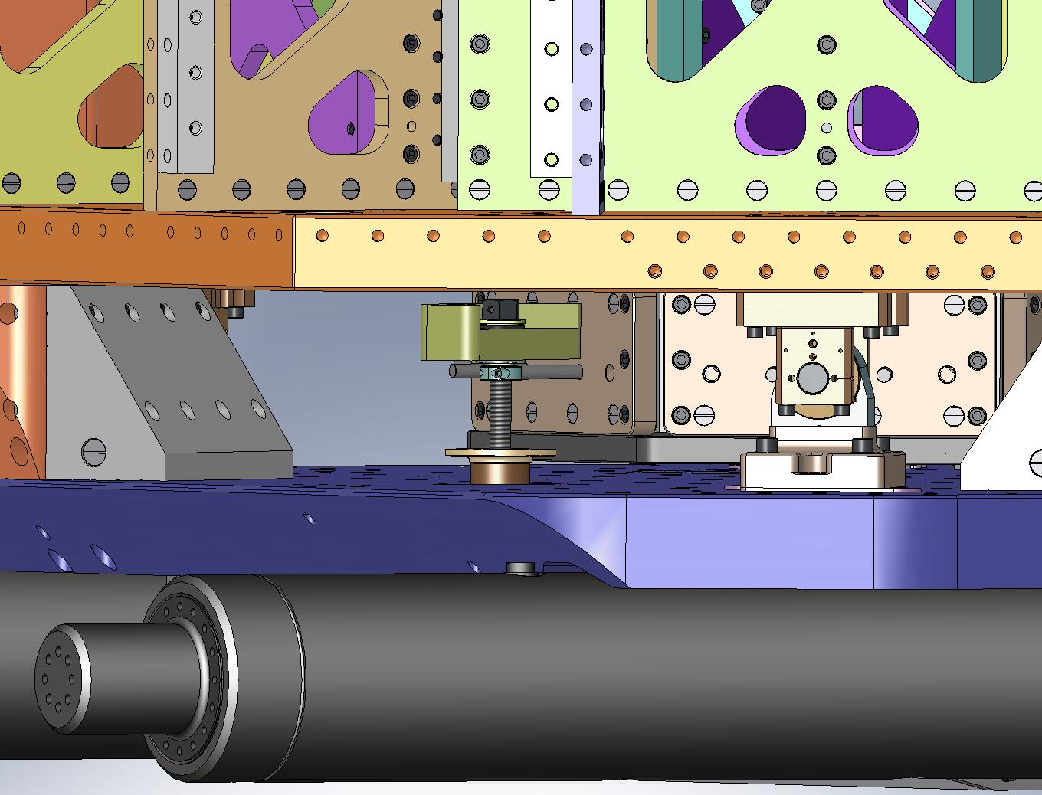
Figure 3.114. Pull out the bottom part of the (3) Pull-Down Assemblies, and store with the rest of the Assemblies.

- Place (3) Spring Hatches (D071067) in the Optical Table, over the Flexure Assemblies.
- Insert the mounting hardware for the Spring Hatches. Torque all the screws to final spec.
Hardware:
(18) 1/4"-20x.625" SHCS (Holo-Krome)
(18) 1/4" vented washers (U-C Components)
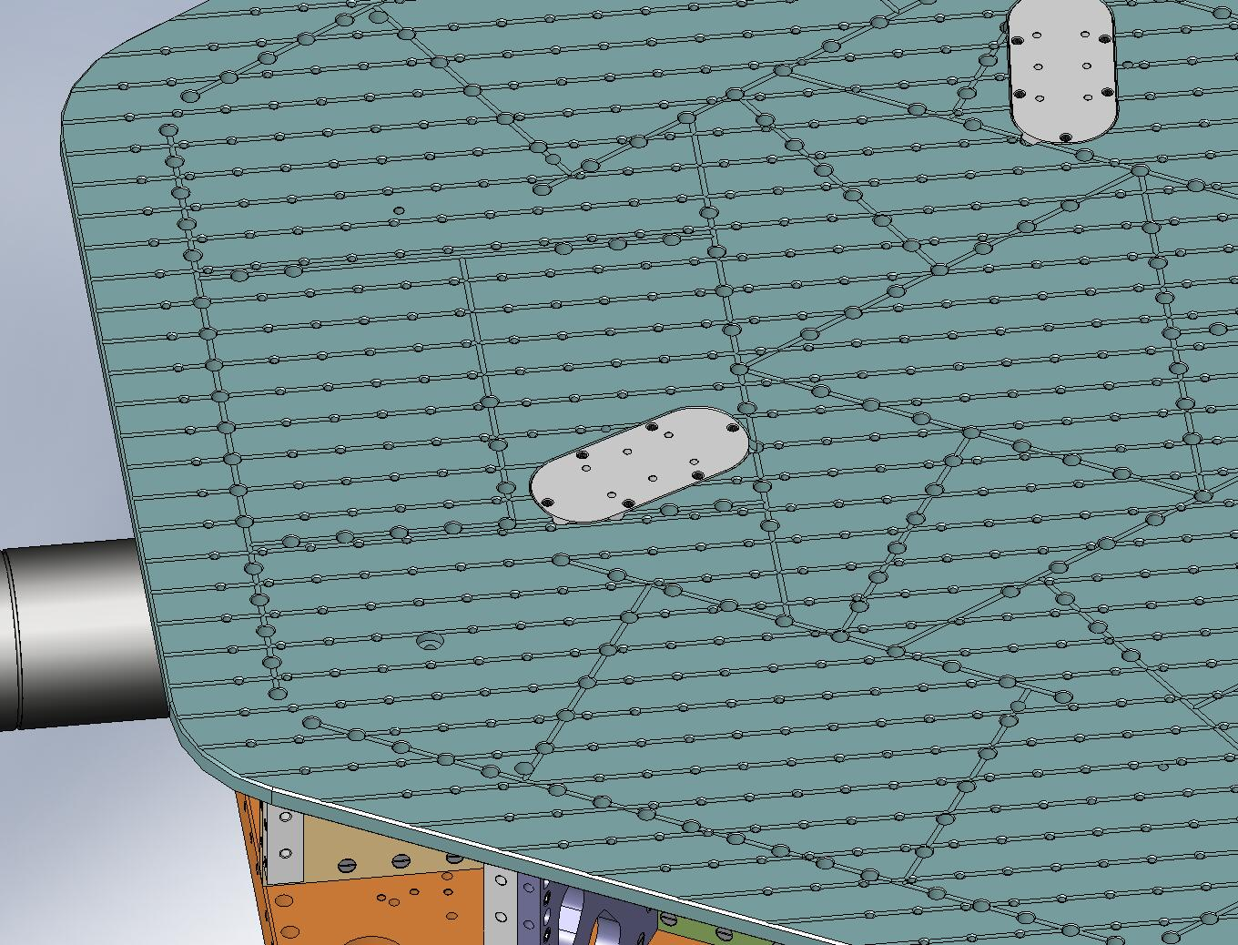
Figure 3.115. Mount (3) Spring Hatches to top of Optical Table.
- Insert (108) Type 01 Barrel Nuts (3/8”-16 x 1.0”) along perimeter of Stage 1 Floor, with flats turned away from screw thru holes.
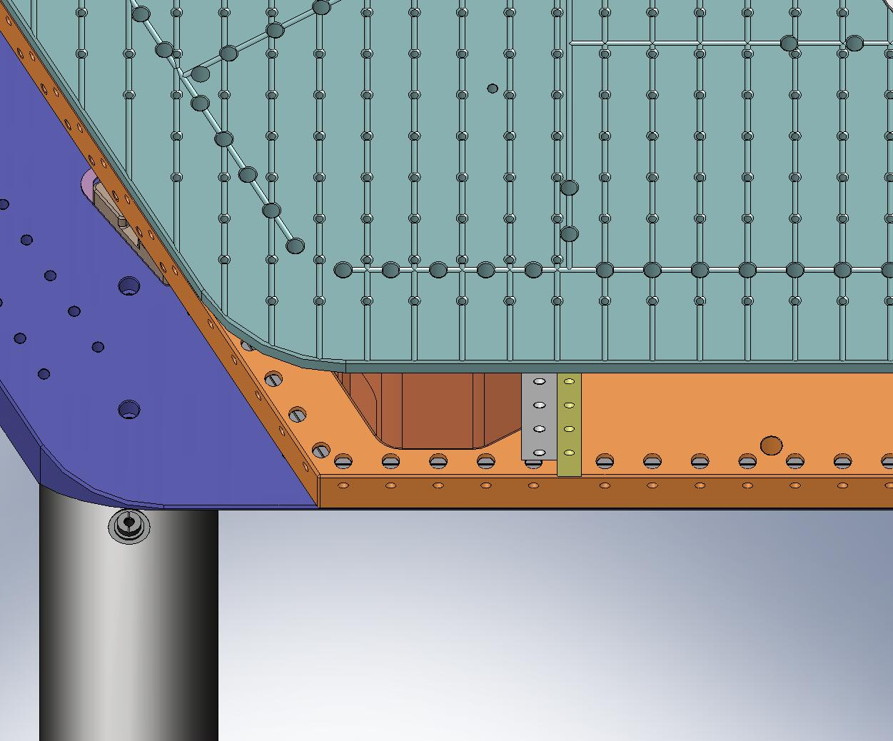
Figure 3.116. Populate Barrel Nut holes around entire perimeter of Stage 1 Floor. Flats on Nuts should face away from screw thru holes.
- Insert (84) Type 01 Barrel Nuts along vertical edges of exposed Boxwork and Pitchfork Ribs. Again, flats on Nuts should face away from screw thru holes.
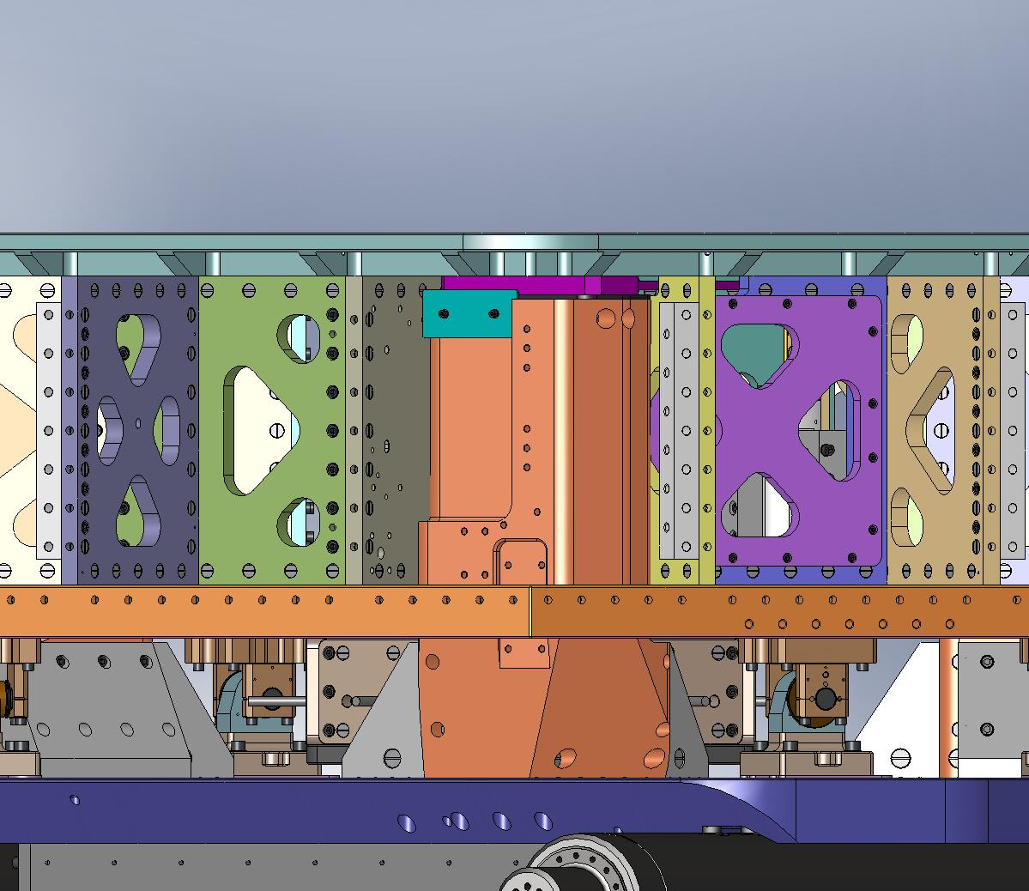
Figure 3.117. Populate Barrel Nuts along exposed sides of Radial Ribs. Flat side of each Nut should face away from screw hole.

    - Mount Sensors and Actuators
- Plug cable into feedthru connector on Horizontal GS-13.
- Route cable through channel in GS-13 Adapter Plate. Cover with GS-13 Cable Restraint. Add flat head screws and torque to final spec.
Hardware:
(2) #8-32x.375" FHSCS (McMaster-Carr)
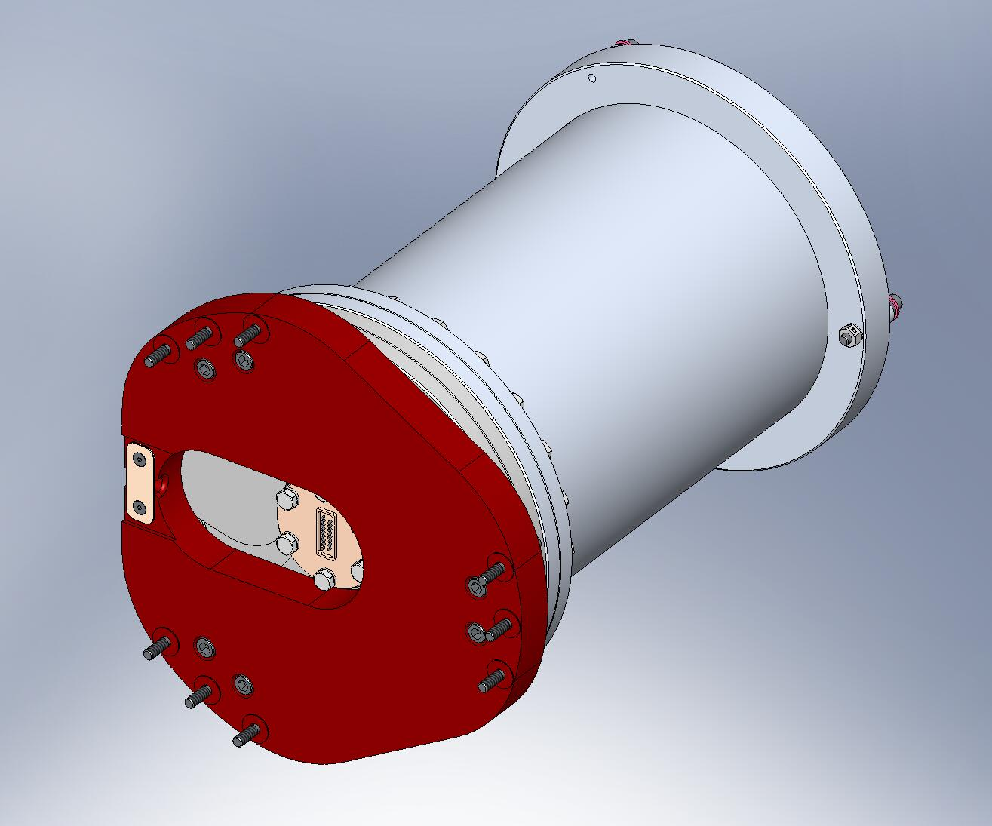
Figure 3.118. Cable Restraint holds cable to Adapter Plate on Horizontal GS-13 Assemblies. (Cable not shown here.)

- Slide the GS-13 Horizontal Install Tool (D071496) into Stage 1, between the Radial Ribs (D071055) of one of the Pitchforks (see Figure 3.119).
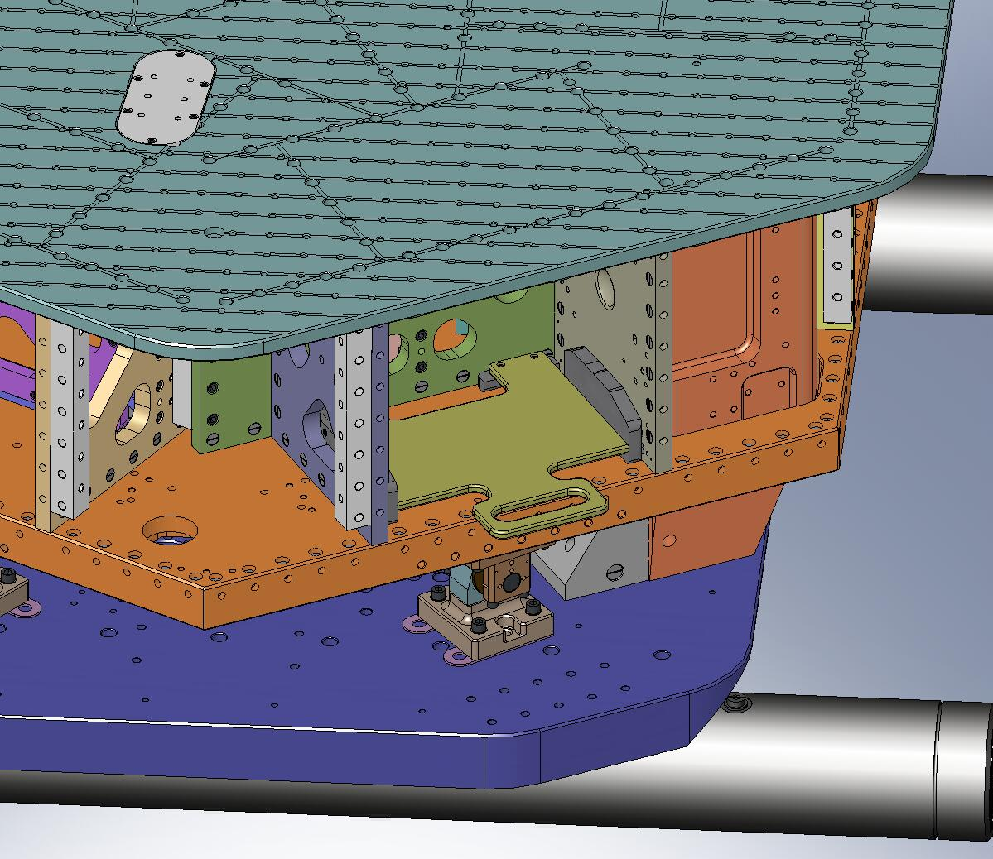
Figure 3.119. A special tray (D071496) is used to hold the Horizontal GS-13 in place during installation.
- Slide the Horizontal GS-13 onto the Install Tool. (The Captive Screws (D071136) must be pushed back into the Adapter Plate (D071180) to pass by the Radial Rib.) Note the orientation of the cable notch in the Adapter Plate, shown in Figure 3.120.
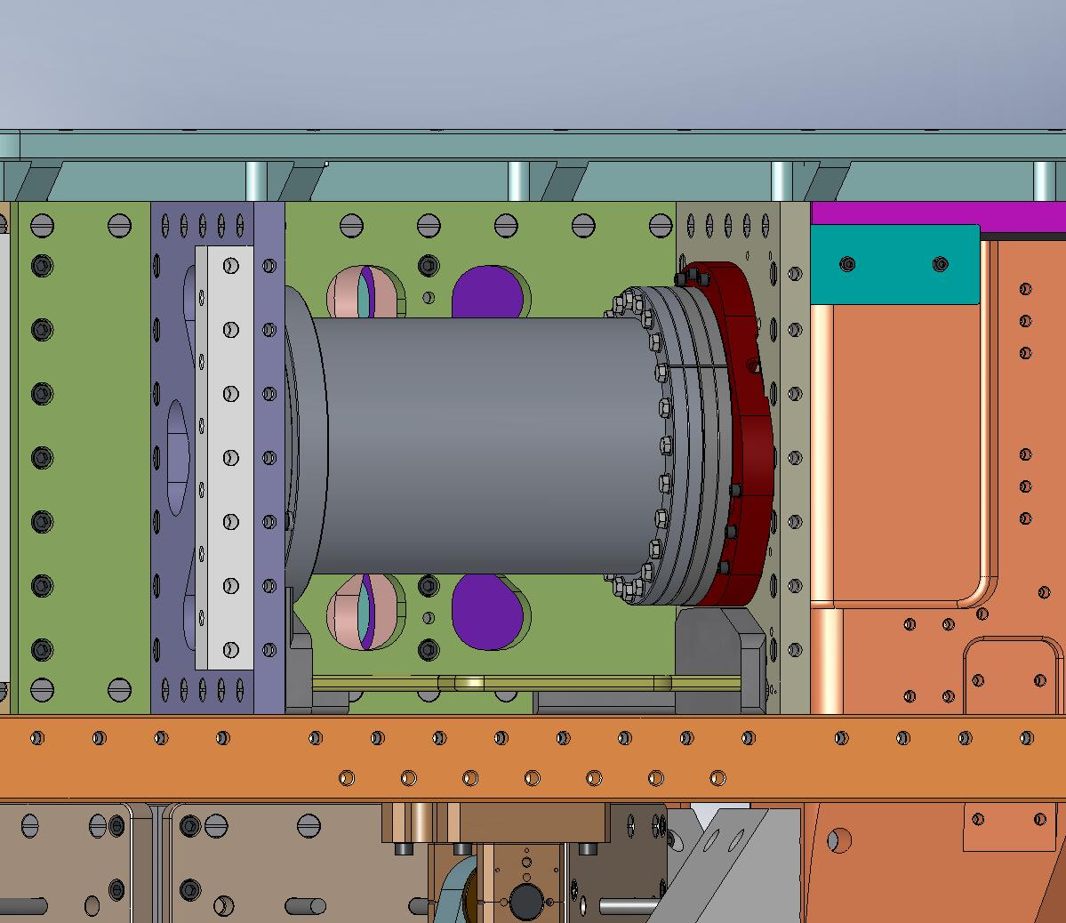
Cable exits here.
Figure 3.120. Horizontal GS-13 mounted to Radial Rib in Pitchfork. The seismometer’s cable should exit from the notch indicated by the arrow.
- Lift GS-13 slightly, to allow (9) Captive Screws to engage into Radial Rib. Snug all (9) Captive Screws, then torque to final spec. (The Install Tool should now be free and can be removed at any time.)
- Thread screw into Nut (D071182) in Stabilizer flexure. Torque to final spec.
Hardware:
(1) 3/8"-16x1.5" SHCS (Holo-Krome)
(1) 3/8" fender washer (McMaster-Carr)
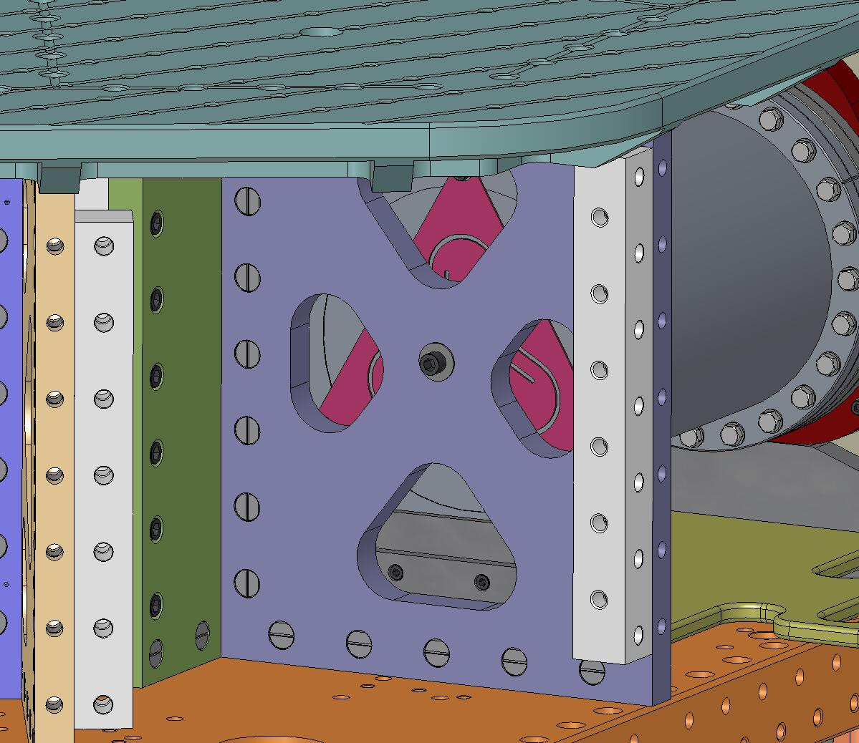
Figure 3.121. Couple the Stabilizer flexure to the other Pitchfork Rib using (1) screw.
- Repeat last (6) steps, to install remaining (2) Horizontal GS-13’s.

- Place Vertical GS-13 at corner of Stage 1 Floor directly to the left of one of the Horizontal GS-13’s. Again, pull Captive Screws into Adapter Plate, to provide adequate clearance. Note the orientation of the Adapter Plate, as shown in Figure 3.122.
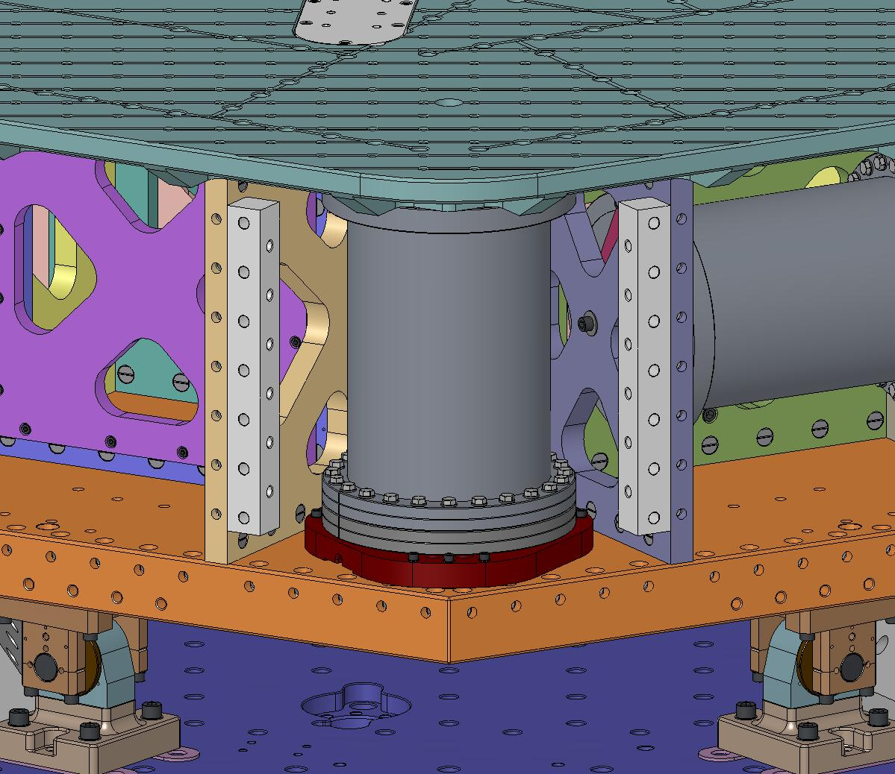
Figure 3.122. Vertical GS-13 placed on Stage 1 Floor. Note location of cable notch, indicated by arrow.
- Snug all (9) Captive Screws, then torque to final spec.
- Thread screw into Nut (D071182) in Stabilizer flexure. Torque to final spec.
Hardware:
(1) 3/8"-16x2.25" SHCS (McMaster-Carr)
(1) 3/8" fender washer (McMaster-Carr)
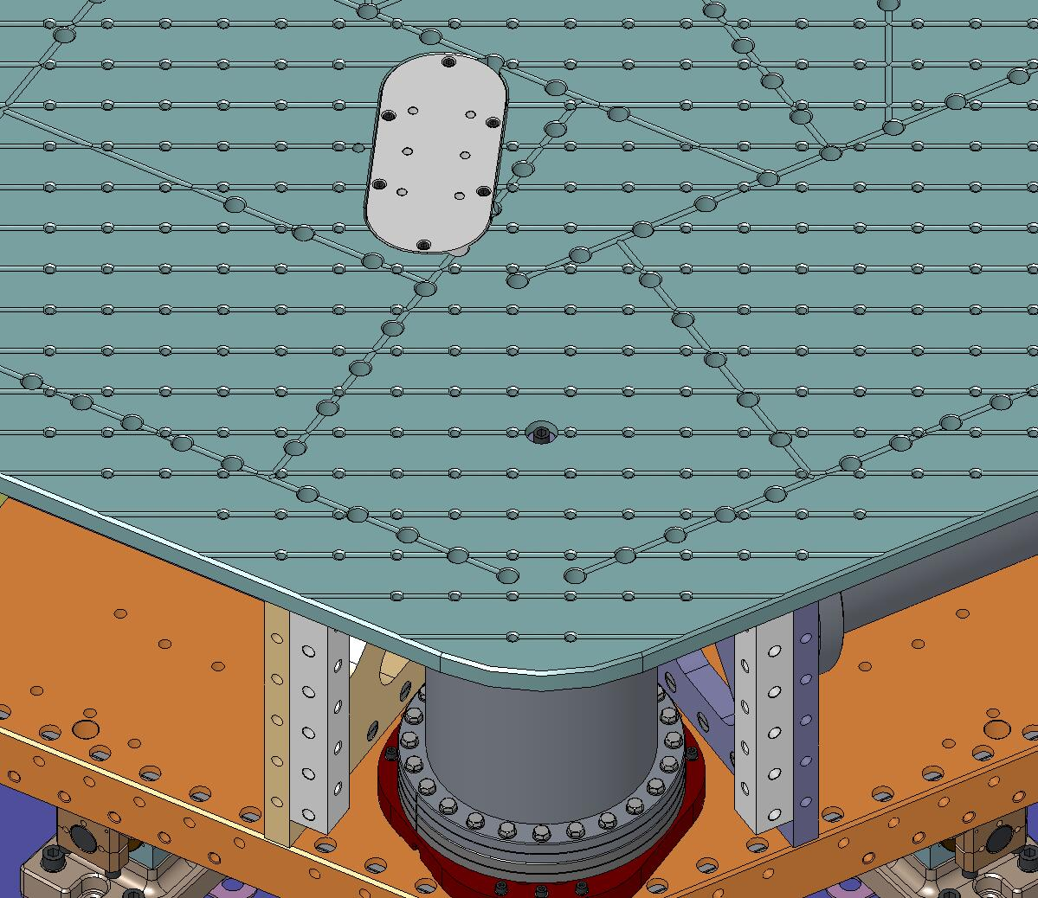
Figure 3.123. Couple the Stabilizer flexure to the Optical Table using (1) screw.
- Repeat last (3) steps, to install remaining (2) Vertical GS-13’s.

- Attach (3) Horizontal Actuators to the Radial Rib opposite the Horizontal GS-13’s. Dowel pins locate the Actuators to the Ribs. Snug (4) Captive Screws, then torque to spec. (Do not remove Setup Bar. Do not bolt to Support Post.)
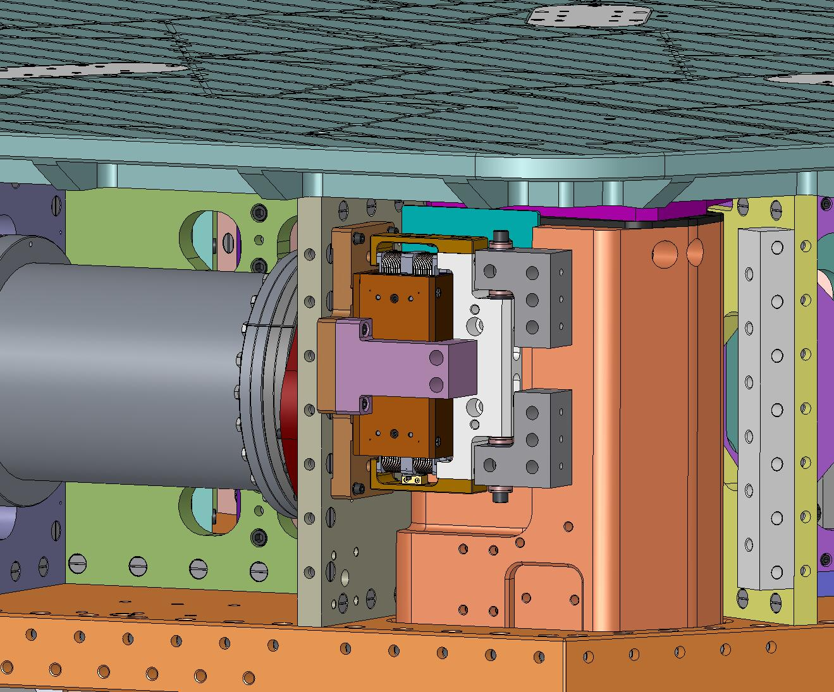
Figure 3.124. Attach Horizontal Actuators to Stage 1. Leave Setup Bar in place.

- Attach (3) Vertical Actuators to bottom of Stage 1 Floor. Dowel pins locate the Actuators to the Floor. Snug (4) Captive Screws, then torque to spec. (Do not remove Setup Bar. Do not bolt to Stage 0 Base.)
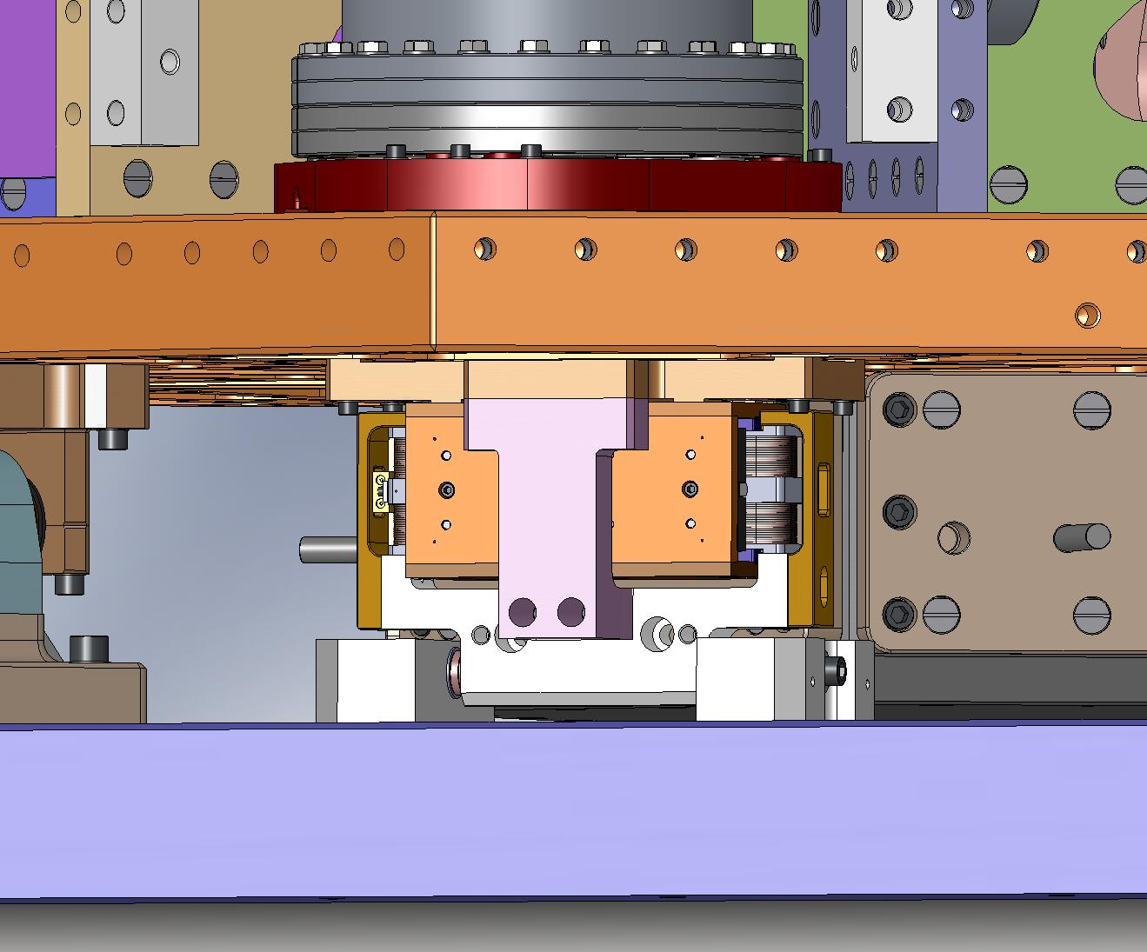
Figure 3.125. Attach Vertical Actuators to Stage 1. Leave Setup Bar in place.

- Bolt (3) Sensor Targets to Radial Rib directly below Horizontal Actuators. Do not scratch diamond-turned target surface! Torque screws to final spec.
Hardware:
(4) 1/4"-20x1.5" SHCS (Holo-Krome)
(4) 1/4” vented washer (U-C Components)
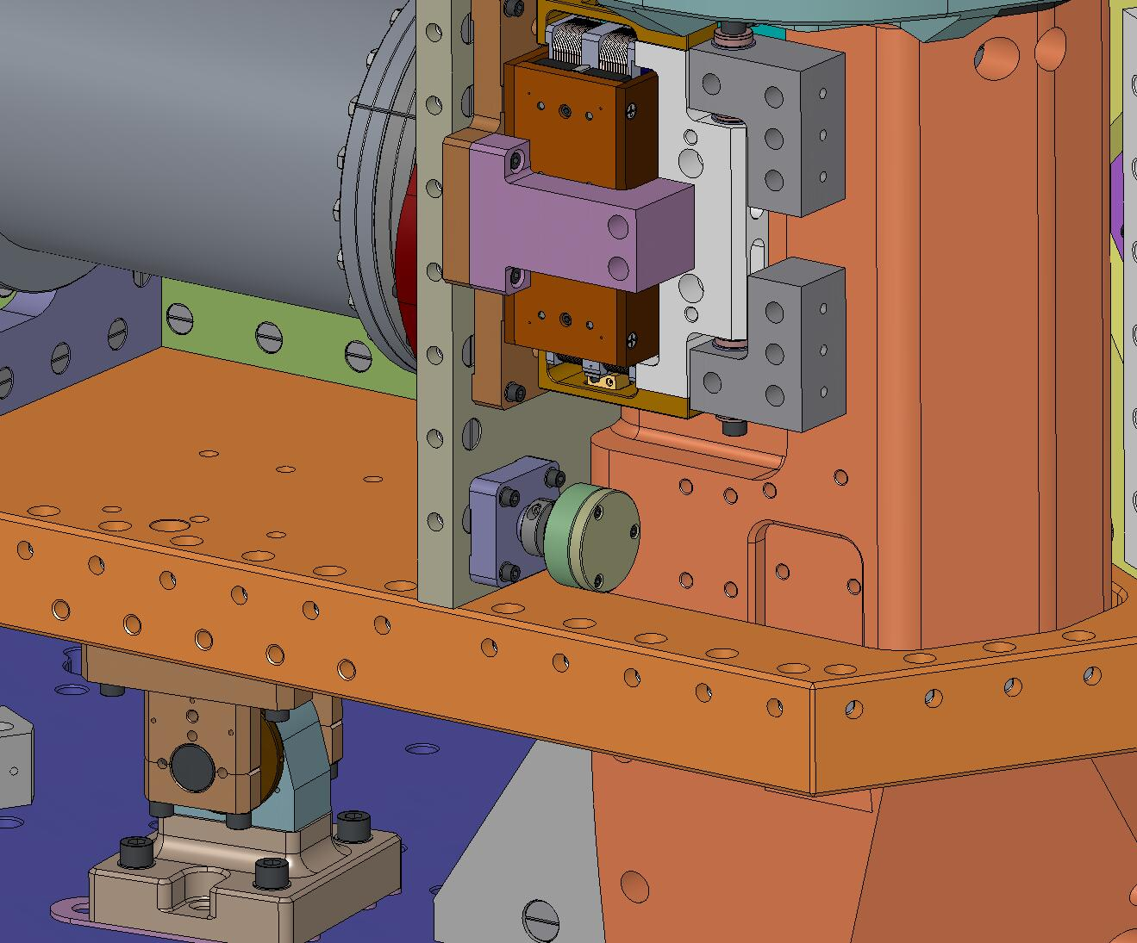
Figure 3.126. Attach Sensor Targets for Horizontal Sensors.

- Loosen collar clamp on Sensor Target collet. Push Target as far in as possible (to maximize gap, when Sensor Probe is installed). Retighten collar clamp.
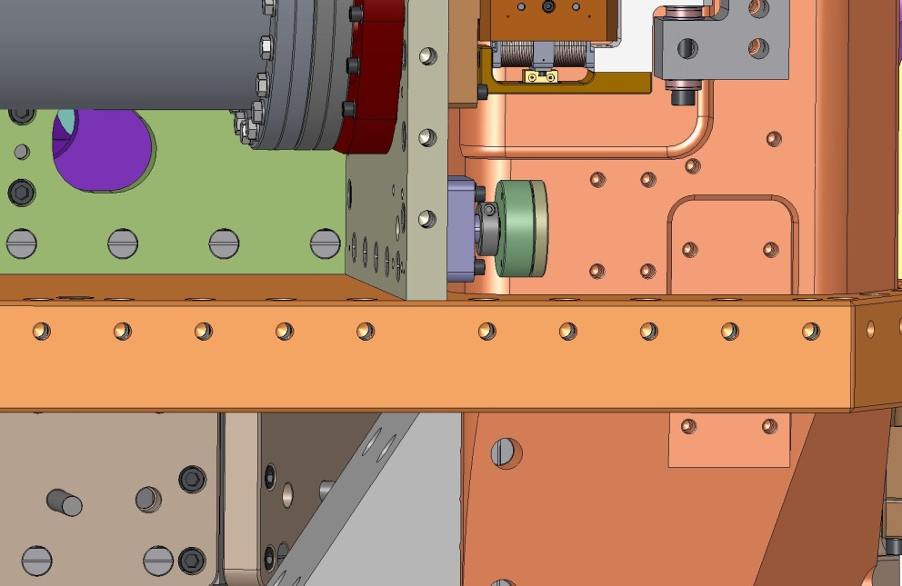
Figure 3.127. Horizontal Sensor Target must be retracted before Sensor Assembly is installed.

- Bolt (3) Sensor Targets to bottom of Stage 1 Floor, next to Vertical Actuators. Do not scratch diamond-turned target surface! Torque screws to final spec.
Hardware:
(4) 1/4"-20x1.5" SHCS (Holo-Krome)
(4) 1/4” vented washer (U-C Components)
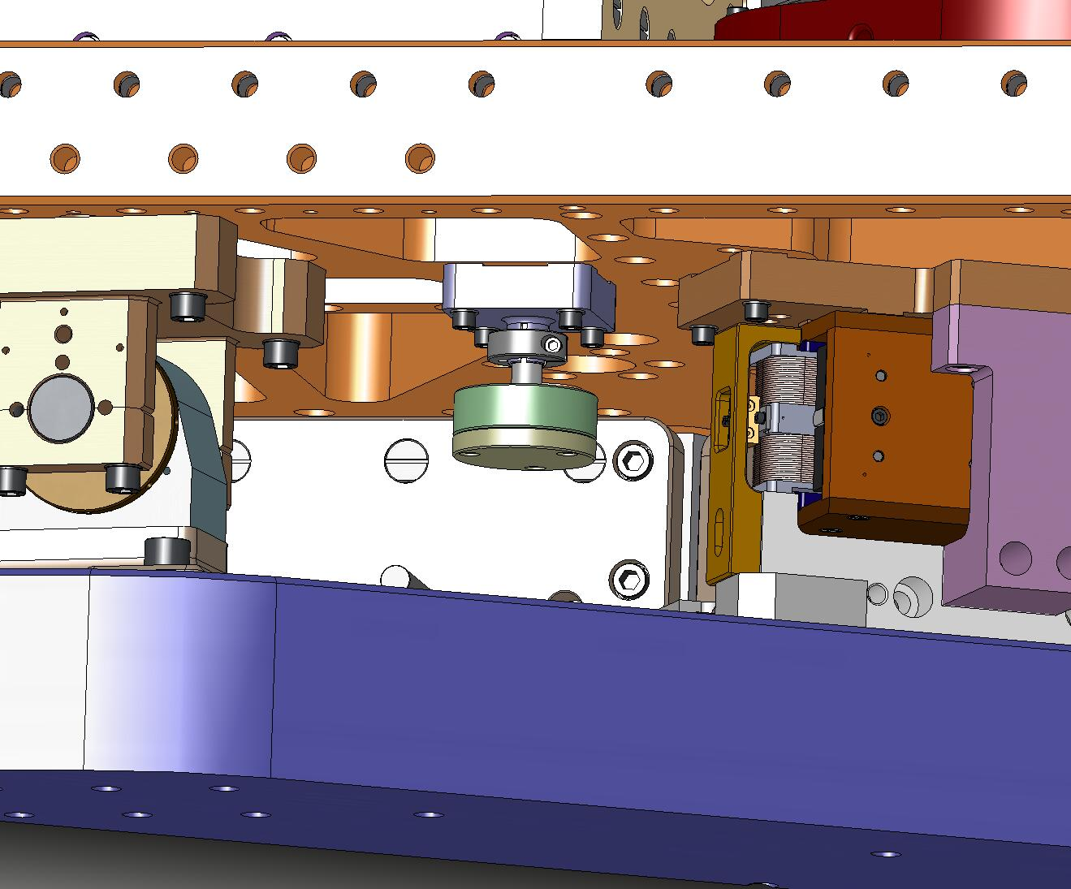
Figure 3.128. Attach Sensor Targets for Vertical Sensors.

- Loosen collar clamp on Sensor Target collet. Push Target as far up as possible (to maximize gap, when Sensor Probe is installed). Retighten collar clamp.
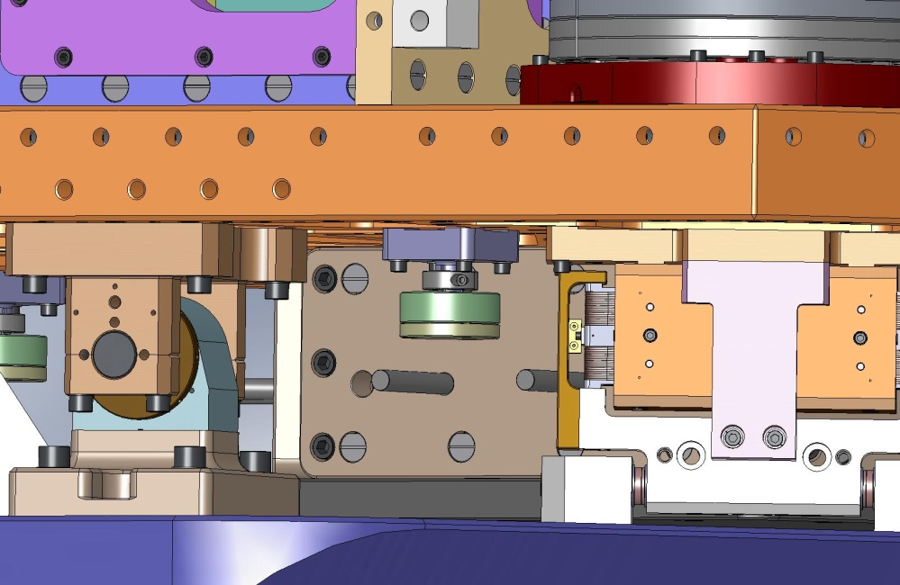
Figure 3.129. Vertical Sensor Target must be retracted before Sensor Assembly is installed.

- Bolt (3) Horizontal Sensor Assemblies to Support Posts. Torque screws to final spec.
Hardware:
(4) 1/4"-20x.875" SHCS (Holo-Krome)
(4) 1/4” vented washer (U-C Components)
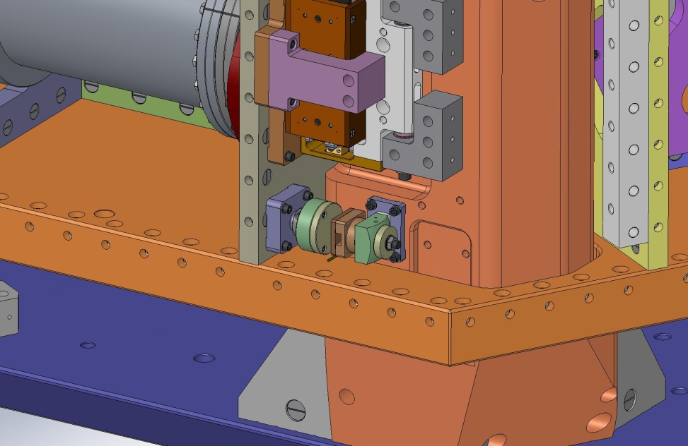
Figure 3.130. Attach Horizontal Sensor Probes.

- Bolt (3) Vertical Sensor Assemblies to Stage 0 Base. Torque screws to final spec.
Hardware:
(4) 1/4"-20x.875" SHCS (Holo-Krome)
(4) 1/4” vented washer (U-C Components)
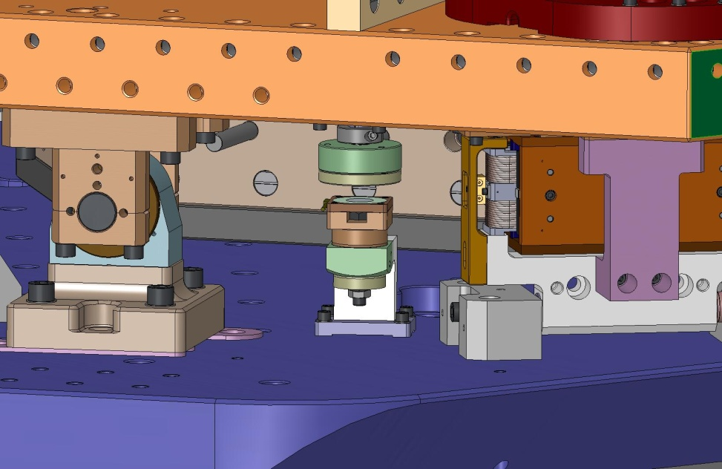
Figure 3.131. Attach Vertical Sensor Probes.

    - Attach Outer Walls
- Clip E-style retaining rings onto one side of each of (108) Type 02 Barrel Nuts (D071250-02), as shown in Figure 3.132.
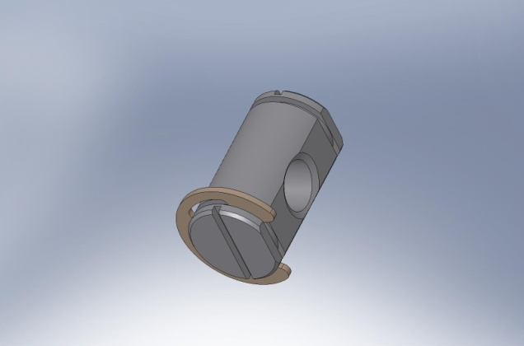
Figure 3.132. Clip retaining ring into groove on one side of Type 02 Barrel Nut. This is in preparation for setting the Nuts along the tops of the Outer Walls.

- Slide these Barrel Nuts into holes along the top of each of the Outer Walls (3x D071057, 3x D071058, and 9x D071427). Clip retaining rings onto the other end of all of the Nuts, to prevent them from sliding out of their holes during handling of the Outer Walls. Turn each Nut so the flat side faces away from its screw.
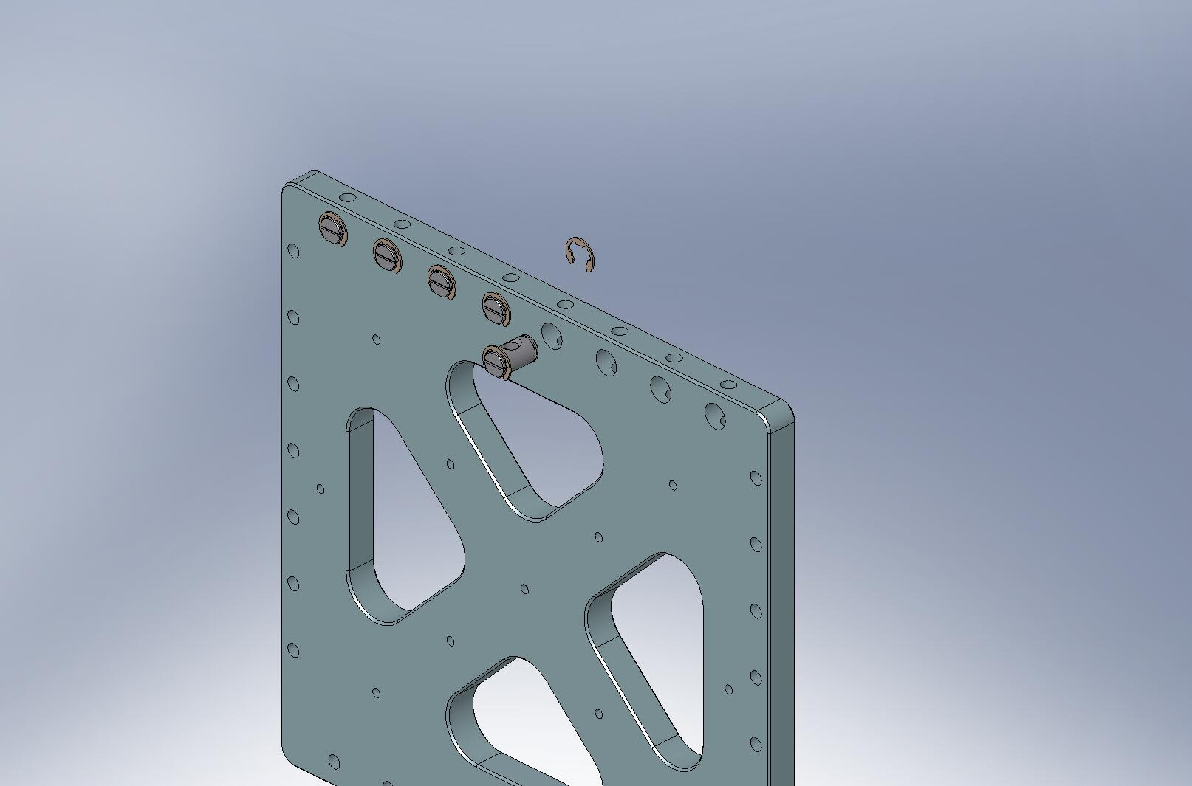
Figure 3.133. Type 02 Barrel Nuts are clipped into place along the top row of holes in all of the Stage 1 Outer Walls.

- Before continuing with Outer Wall installation, check that all the mating Barrel Nuts in Stage 1 are properly aligned, so mounting screws can all be easily threaded in.

- (to be continued…)

    - Float Stage 1
- Goal of alignment:
  - Stage 0 Base is aligned to gravity – to better than 100 urad.
  - One of the Springs is flat to within .001” – where flatness is defined as the difference between depth of Spring from top of Optical Table at i) the base of the Spring, and ii) the tip of the Spring... As we saw in the HPD build, it may not be possible to get a Spring this close to flat. Presumably, this was caused by tolerance stack-up.
  - With Stage 1 floating, top of Optical Table is aligned to gravity – to better than 100 urad.
  - With Stage 1 floating and Lockers disengaged, the gap between the Spherical Pin and the Sleeve is even to within .001” all around each Pin.
  - All 4 Lockers can be engaged (i.e. “locked”) at the same time.
  - Displacement between locked and unlocked Stage 1 position is less than .005”?
  - Position Sensor readings at aligned floating position is recorded – for use after the ISI is loaded in the chamber and loaded with payload. This will assist is adjusting the ballast mass.
- gage depth of each Spring at base and tip (referenced to top of Optics Table). Record numbers for later use.
- load nominal Adjustment Mass onto Stage 1. Nominal adjustment mass is 63 kg, total. Distribute in following manner...
- load nominal dummy payload mass onto Stage 1. Nominal payload is 510 kg, total. Distribute in following manner... Do not cover "peep" holes for gaging Spring depth (at both tip and base, 6 holes total).
- place dial indicators next to 3 of the 4 Lockers. For each Locker, the dials should measure vertical and tangential displacement.
- for the 1 Locker without indicators: loosen the screws which hold it to Stage 0. Remove shims between it and Stage 0. This Locker will not be used until the end of the Stage 1 adjustment process.
- push on Stage 1. Does it move? Can it be lifted or pushed down?
- if Stage 1 is sitting down in the 3 engaged Lockers, then remove some weight from the dummy payload.
- if Stage 1 is sitting up in the 3 engaged Lockers, then add some weight to the dummy payload. (slide shims between Spherical Pins and Sleeves, to see where the gaps are).
- release 3 engaged Lockers. Now, Stage 1 should be floating. If it isn't, add or remove dummy payload until Stage 1 can move freely in all 6 degrees of freedom.
- place precision level in middle of Optics Table. Add mass to high side, until level is zeroed.
- rotate precision level 90 degrees, and repeat step 11. Now, Stage 1 should be leveled to gravity.
- pick one of the engaged Lockers. We'll use this as the vertical reference for Stage 1. Remove the cap over the front end of its pin.
- adjust tangential position and yaw of Locker. To do this, first remove the dowel pins used to align it to Stage 0. Then, loosen the (4) SHCS's holding the Locker housing to Stage 0. Check gaps with plastic shims and dial indicators.
- add/subtract mass from the center of the Optics Table, until the pin is centered within the Sleeve. Screw cap back onto Pin. Re-check range of motion within Locker, using dial indicators.
- take cover off of second Locker. Adjust tangential position.
- change shim under Locker, until Pin is centered vertically in Sleeve. Readjust lateral position as necessary. Replace cover on second Locker.
- take cover off of third Locker. Adjust tangential position.
- change shim under Locker, until Pin is centered vertically in Sleeve. Readjust lateral position as necessary. Replace cover on third Locker.
- shim and align fourth Locker.
- move all four Sleeves to the "locked" position. Record displacement seen on dial indicators. Repeat 4 more times, checking for repeatability.
- check depth of each of the 3 Springs, checking at base and tip of each (referenced off of Optics Table surface).
- (to be continued…)

- – Torque Table

Material: Stainless Steel (tensile strength ≥ 70 ksi)
Screw Type: Socket Head Cap Screw (SHCS)
Mfgr./Vendor: McMaster-Carr, or U-C Components
Spec # | Thread | Torque (in-lbs) | Torque (ft-lbs)
a1 | M2-.4mm
a2 | #10-32 | 31.7 | 2.6
a3 | 1/4”-20 | 75.2 | 6.3
a4 | 5/16”-24 | 142 | 11.8
a5 | 3/8”-16 | 236 | 19.7
a6 | 3/8”-24 | 259 | 21.6
a7 | 1/2”-13 | 517 | 43.1
a8 | 1/2”-20 | 541 | 45.1

Material: Stainless Steel
Screw Type: Socket Head Cap Screw (SHCS)
Mfgr./Vendor: Holo-Krome
Spec # | Thread | Torque (in-lbs) | Torque (ft-lbs)
b1 | #8-32 | 30 | 2.5
b2 | #10-32 | 48 | 4.0
b3 | 1/4”-20 | 100 | 8.3
b4 | 3/8”-16 | 329 | 27.4

Material: Stainless Steel
Screw Type: Captive Socket Head Cap Screw (SHCS)
Mfgr./Vendor: modified from McMaster-Carr (LIGO P/N: D071136)
Spec # | Thread | Torque (in-lbs) | Torque (ft-lbs)
c1 | 1/4”-20

Material: Stainless Steel
Screw Type: Hex Head Cap Screw (HHCS)
Mfgr./Vendor: McMaster-Carr
Spec # | Thread | Torque (in-lbs) | Torque (ft-lbs)
d1 | 3/8”-16
d2 | 1/2”-13

Material: Stainless Steel A-286
Screw Type: Hex Head Cap Screw (SHCS)
Mfgr./Vendor: McMaster-Carr
Spec # | Thread | Torque (in-lbs) | Torque (ft-lbs)
e1 | 1/2”-13 | 1,320 | 110

- – Part Thumbnails

Note: scale is not the same for all thumbnails. Relative size is specified in caption (small, medium, or large). Approximate weights are also listed, as well as quantity required for (1) HAM ISI Assembly.

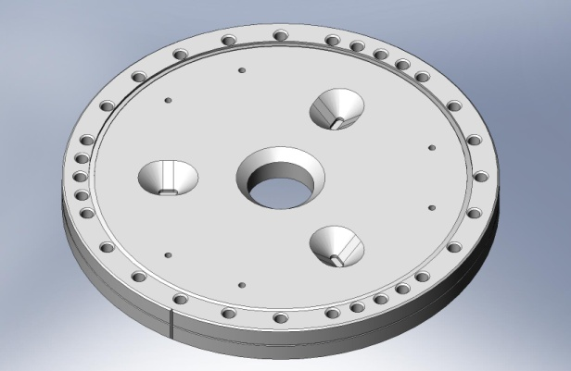  20007813, Type -1 - 3x - Medium - 15 lbs | 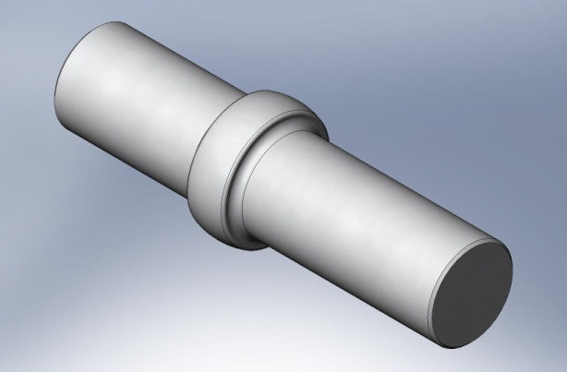  20007935 - 4x - Small - 2 lbs
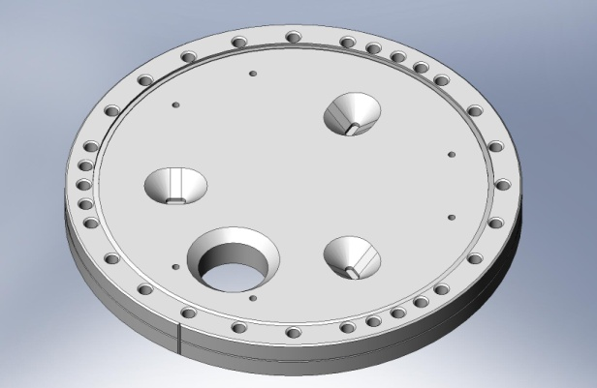  20007813, Type -2 - 3x - Medium - 15 lbs | 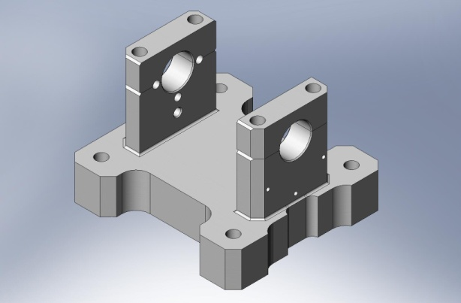  20007936 - 4x - Small - 4 lbs
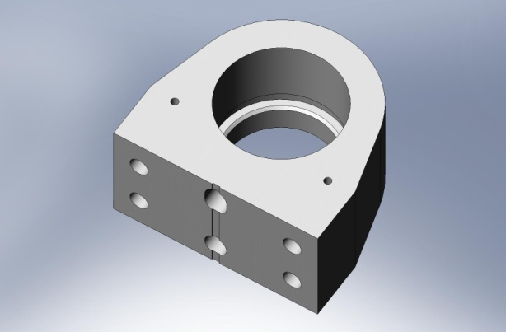  20007932 - 4x - Small - 1 lb | 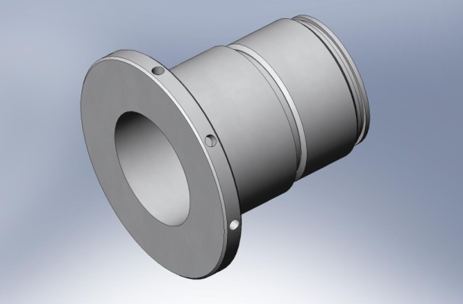  D070270 - 4x - Small - 1 lb

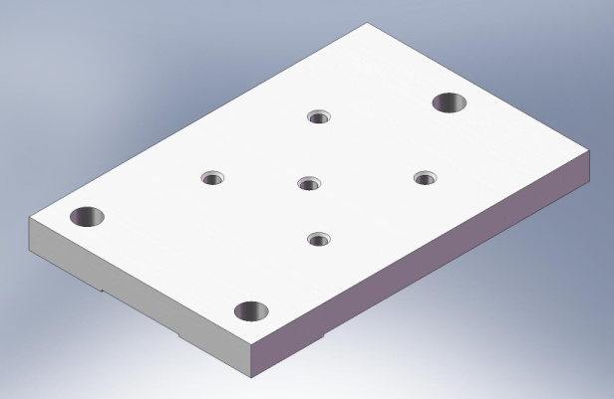  D070274 - 4x - Medium - 78 lbs | 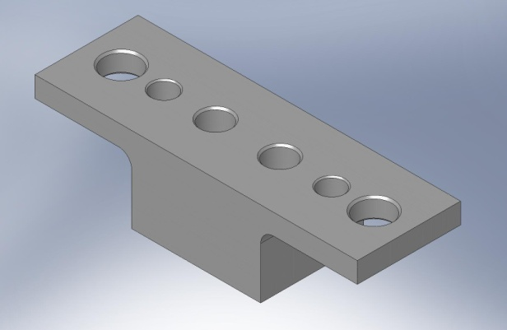  D070378 - Small - < 1 lb (in PSI Actuator)
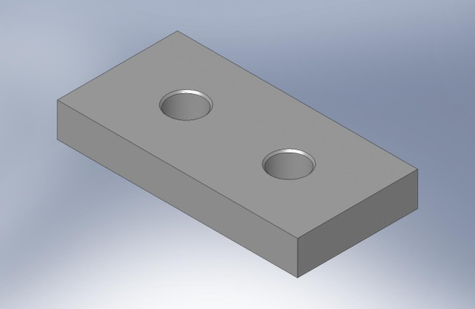  D070275 - 8x - Small - 1 lb | 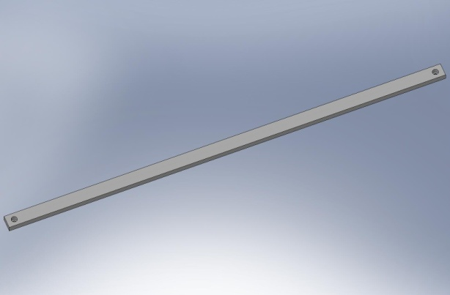  D070398 - 1x - Large - 11 lbs
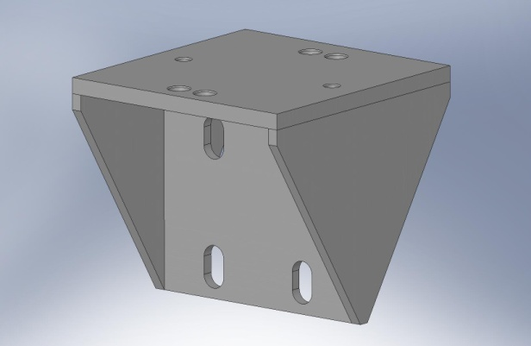  D070276 - 4x - Medium - 64 lbs | 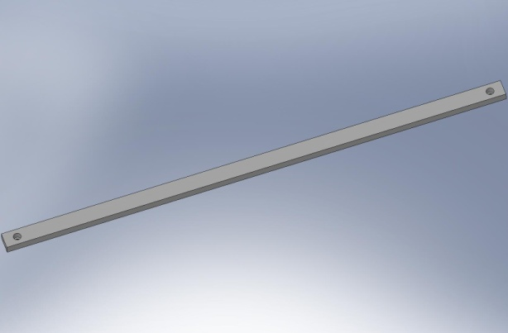  D070399 - 2x - Large - 9 lbs
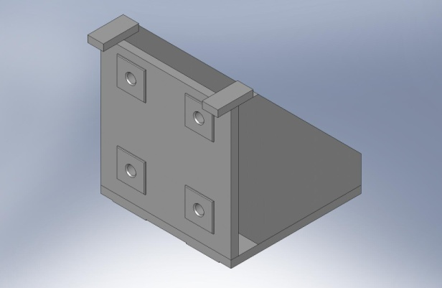  D070277 - 4x - Medium - 47 lbs | 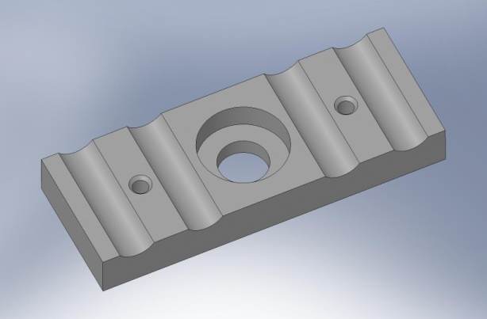  D070494 - Small - < 1 lb

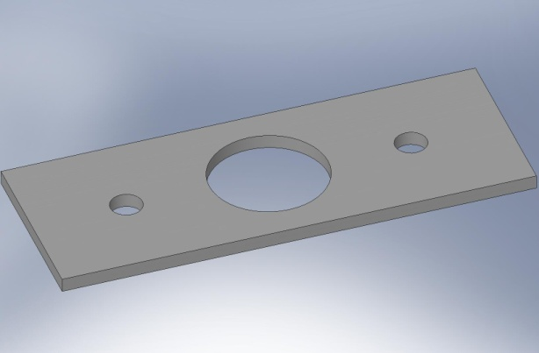  D070495 - Small - < 1 lb | 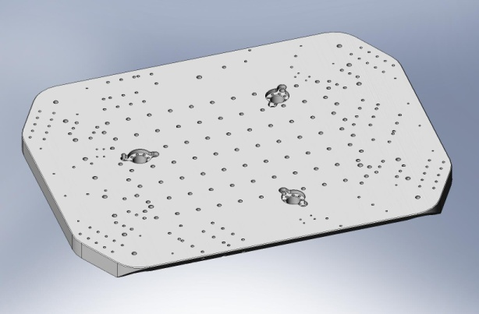  D071001 - 1x - Large - 1,193 lbs
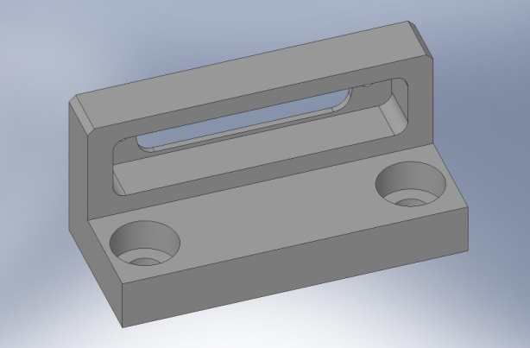  D070502 - Small - < 1 lb | 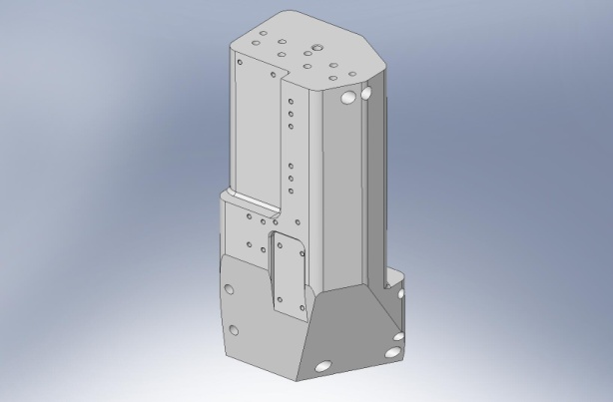  D071002 - 3x - Large - 180 lbs
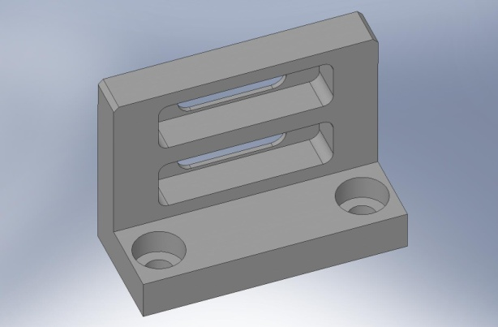  D070503 - Small - < 1 lb | 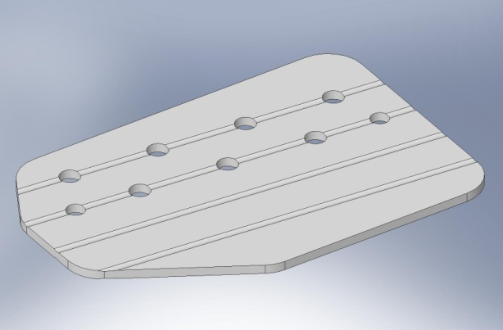  D071003 - 3x - Medium - 5 lbs
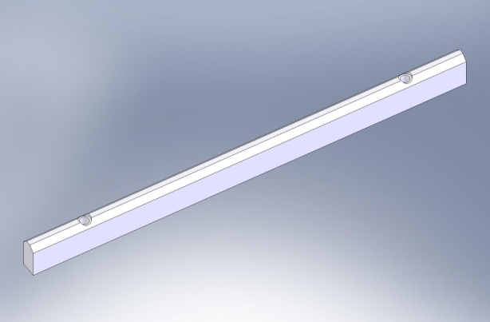  D070534 - 12x - Small - < 1 lb | 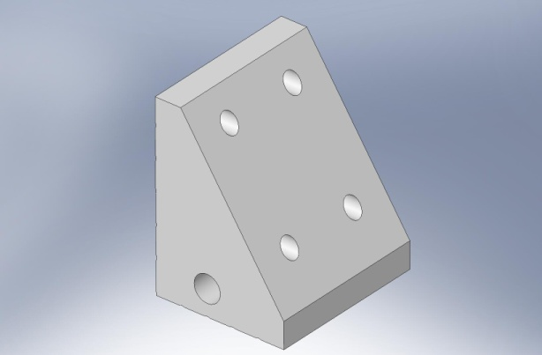  D071004 - 3x - Medium - 13 lbs

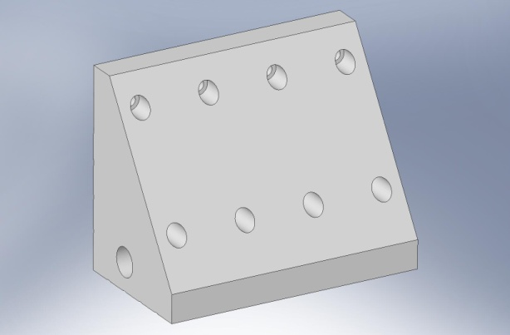  D071005 - 3x - Medium - 19 lbs | 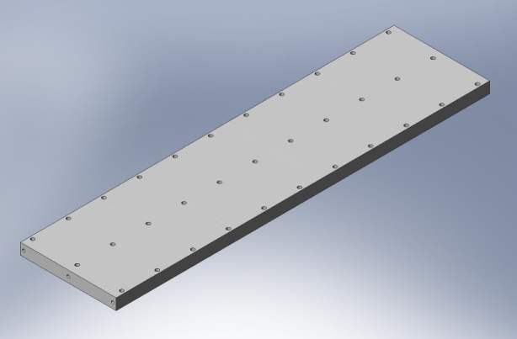  D071007, Type 00 - 1x - Large - 54 lbs
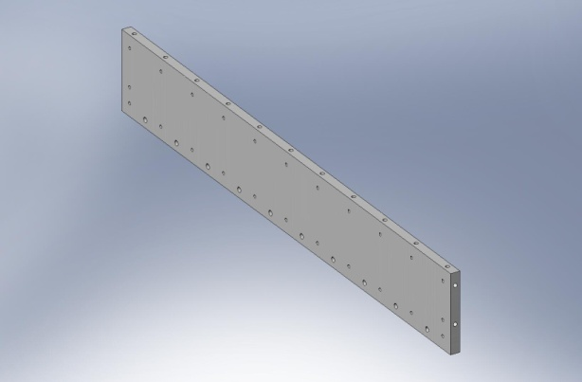  D071006, Type 00 - 3x - Large - 19 lbs | 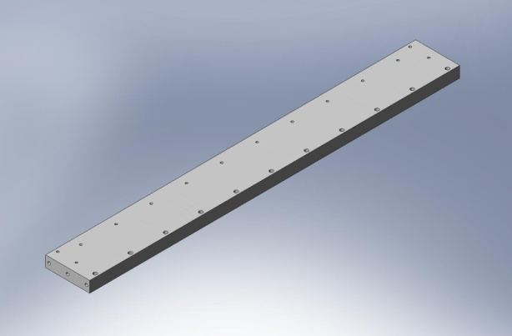  D071007, Type 01 - 4x - Large - 25 lbs
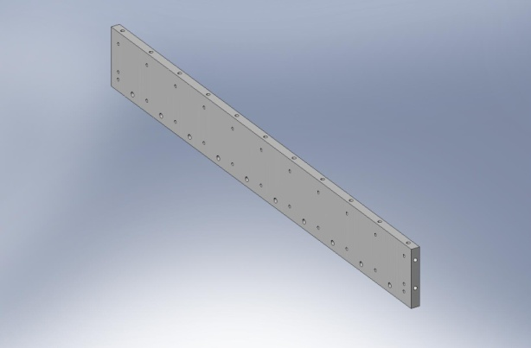  D071006, Type 01 - 2x - Large - 15 lbs | 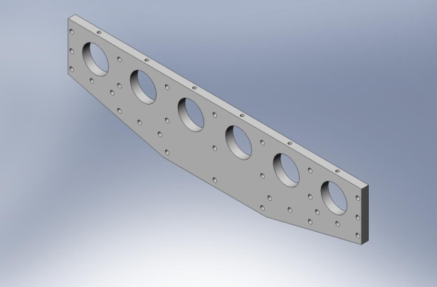  D071008 - 2x - Large - 12 lbs
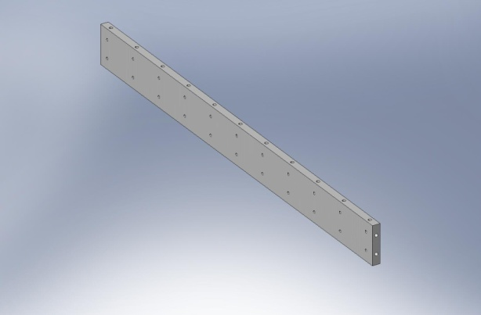  D071006, Type 02 - 2x - Large - 11 lbs | 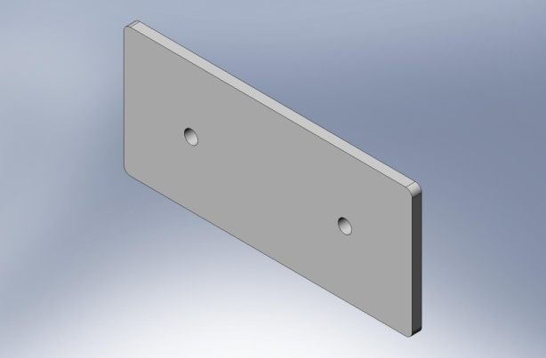  D071009 - 3x - Small - < 1 lb

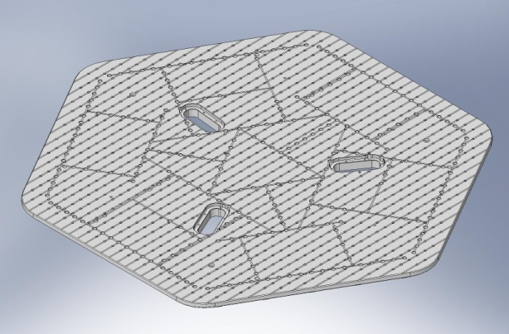  D071050 - 1x - Large - 637 lbs | 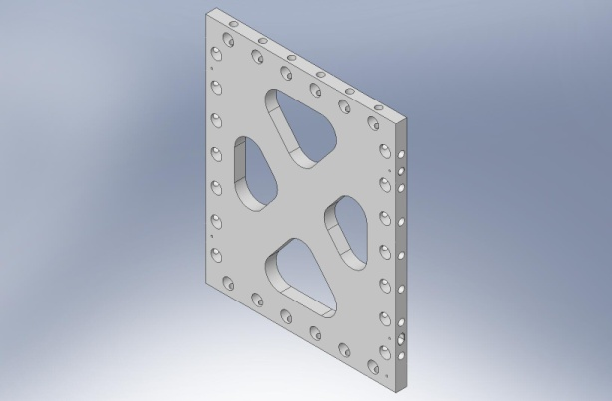  D071054 - 3x - Medium - 11 lbs
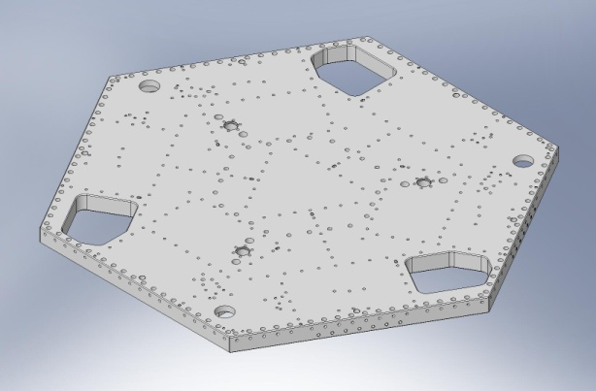  D071051 - 1x - Large - 570 lbs | 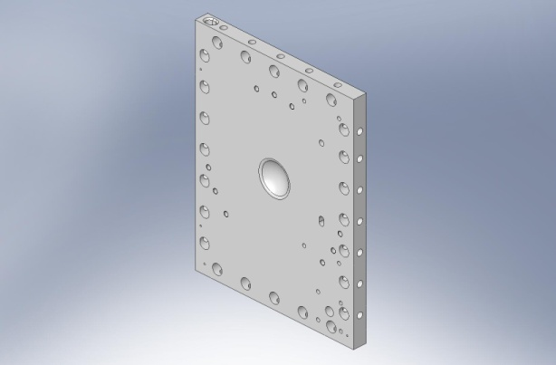  D071055 - 3x - Medium - 18 lbs
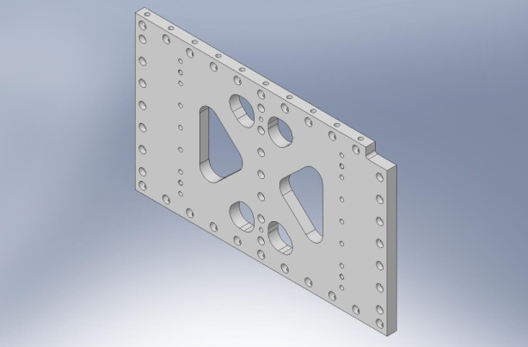  D071052 - 3x - Medium - 33 lbs | 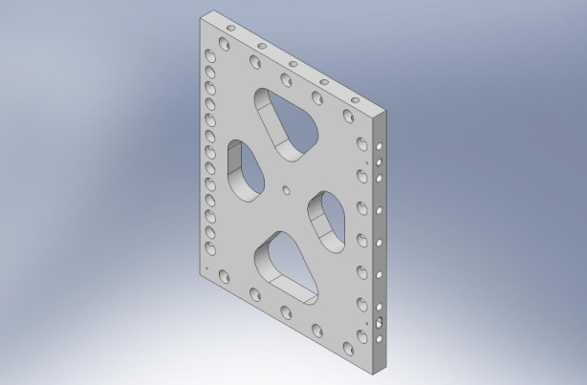  D071056 - 3x - Medium - 14 lbs
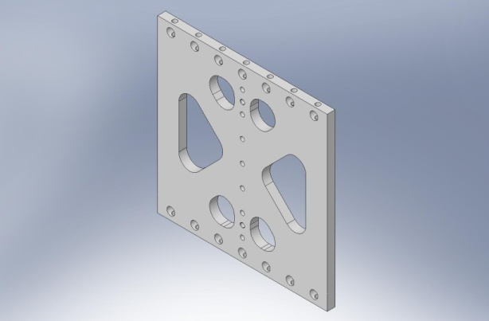  D071053 - 3x - Medium - 14 lbs | 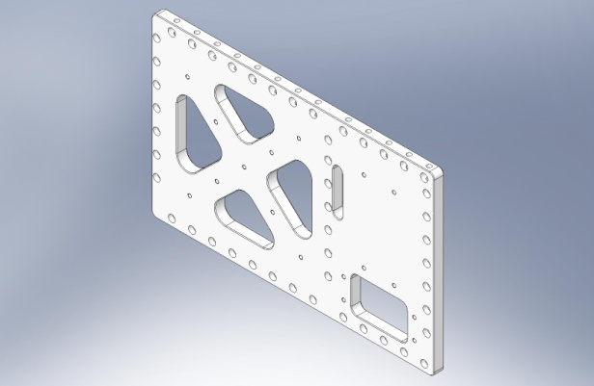  D071057 - 3x - Medium - 37 lbs

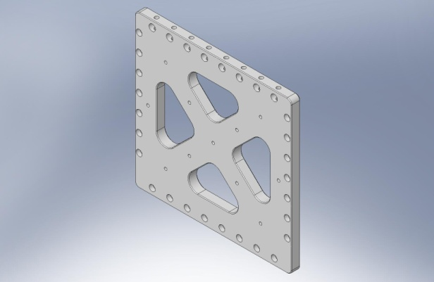  D071058 - 3x - Medium - 23 lbs | 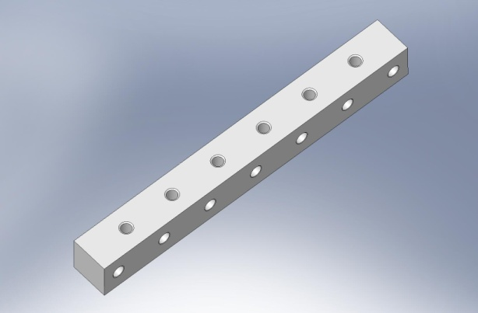  D071061 - 9x - Medium - 3 lbs
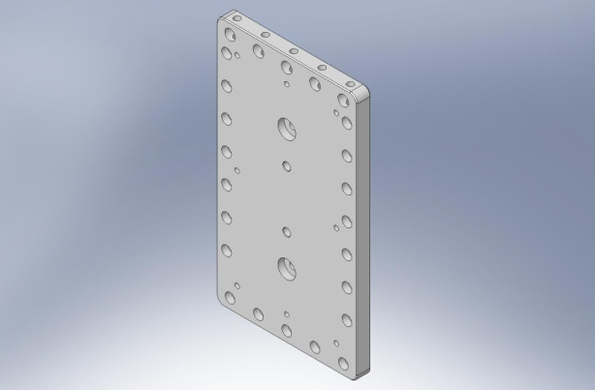  D071059 - 9x - Medium - 16 lbs | 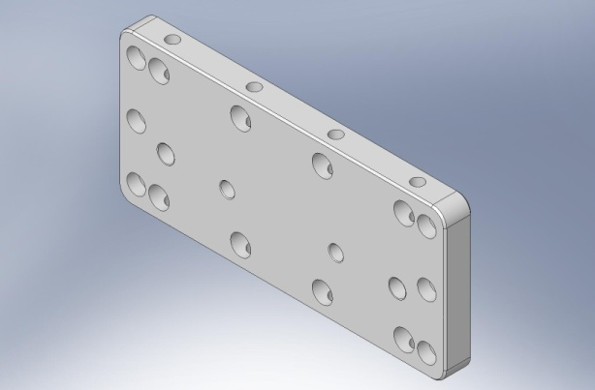  D071063 - 6x - Medium - 6 lbs
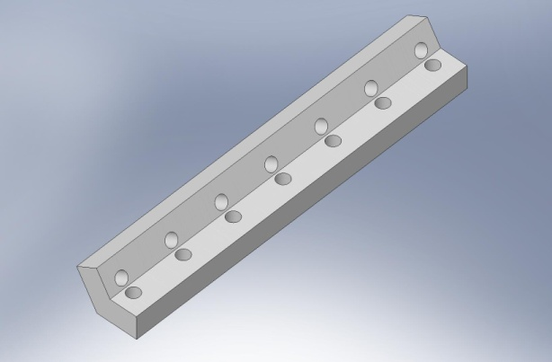  D071060, Type 00 - 6x - Medium - 3 lbs | 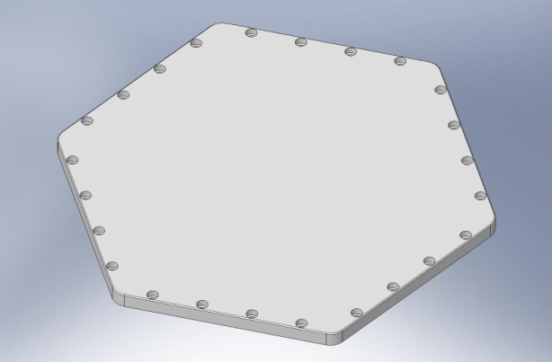  D071065 - 1x - Large - 45 lbs
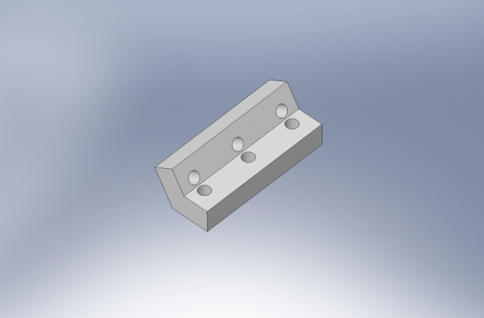  D071060, Type 01 - 6x - Small - 1 lb | 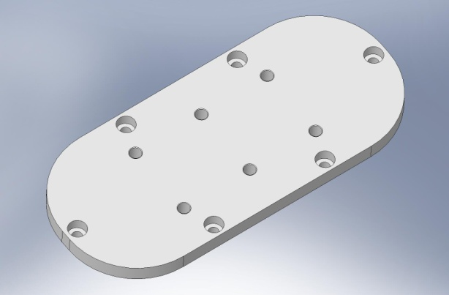  D071067 - 3x - Small - 2 lbs

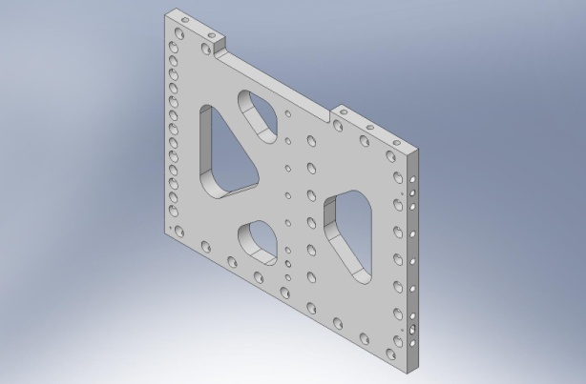  D071068 - 3x - Medium - 23 lbs | 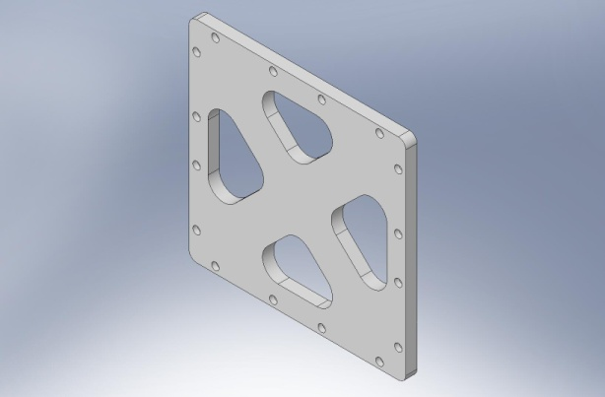  D071072 - 3x - Medium - 11 lbs
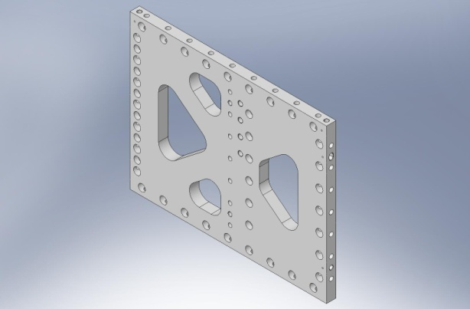  D071069 - 3x - Medium - 24 lbs | 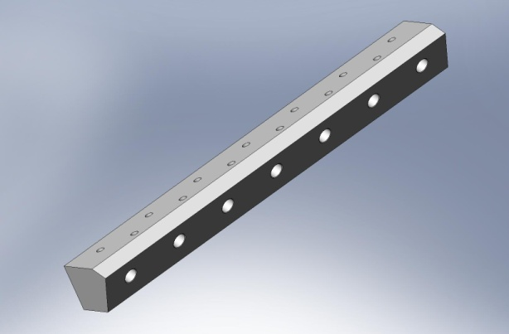  D071073 - 6x - Medium - 3 lbs
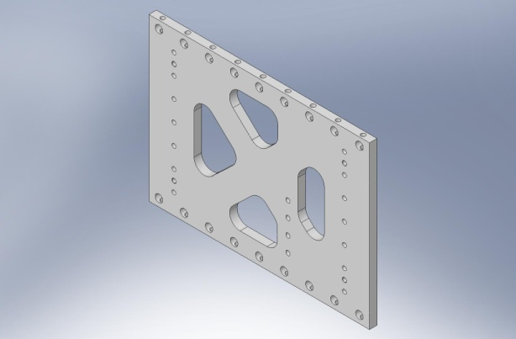  D071070 - 3x - Medium - 20 lbs | 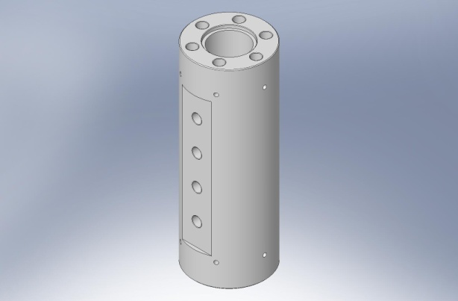  D071074 - 3x - Medium - 7 lbs
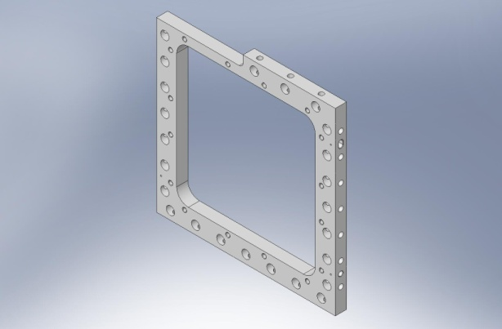  D071071 - 3x - Medium - 8 lbs | 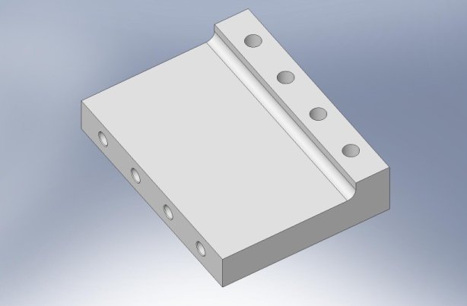  D071075 - 3x - Medium - 3 lbs

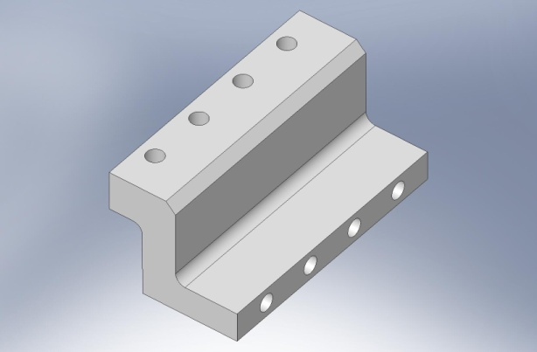  D071076 - 3x - Medium - 3 lbs | 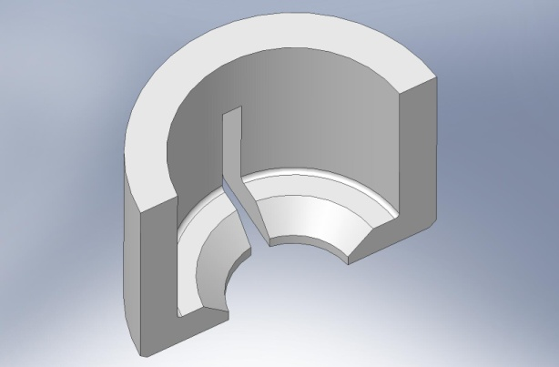  D071104 - 12x - Small - < 1 lb
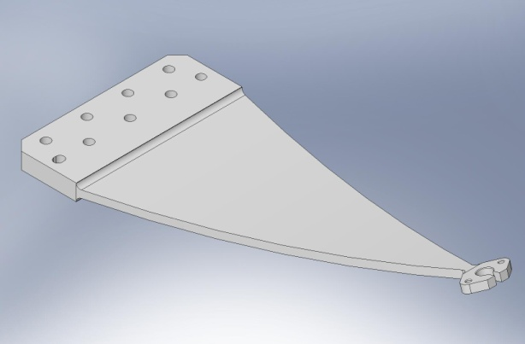  D071100 - 3x - Large - 23 lbs | 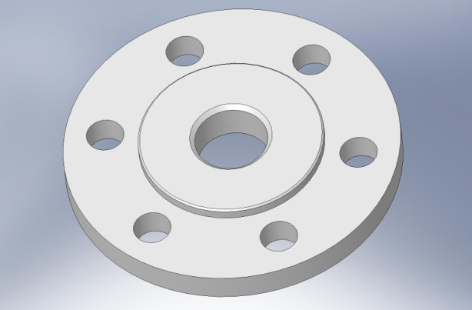  D071105 - 3x - Small - < 1 lb
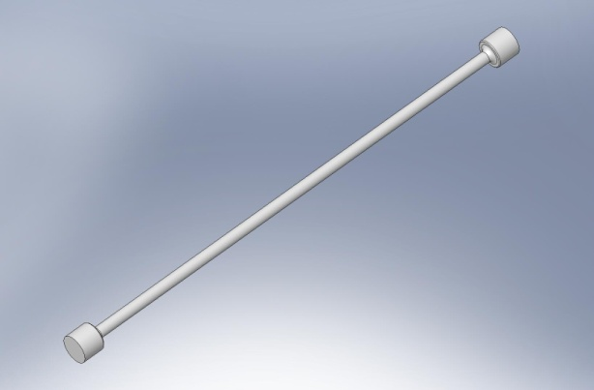  D071102 - 3x - Medium - < 1 lb | 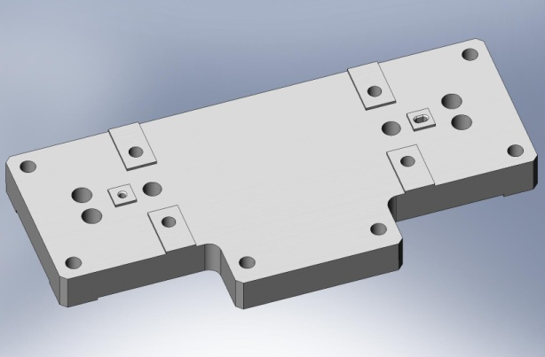  D071120 - 6x - Medium - 3 lbs
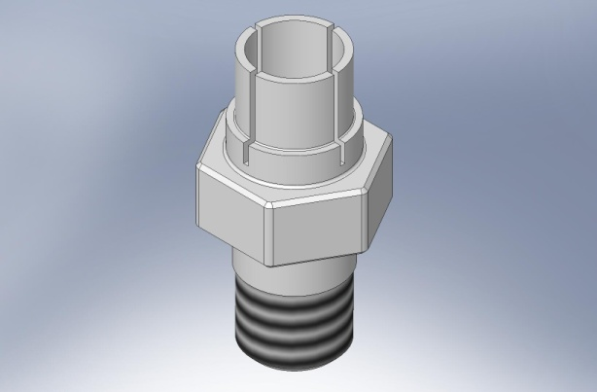  D071103 - 6x - Small - < 1 lb | 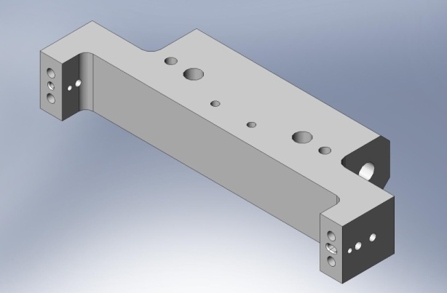  D071121 - 6x - Medium - 2 lbs

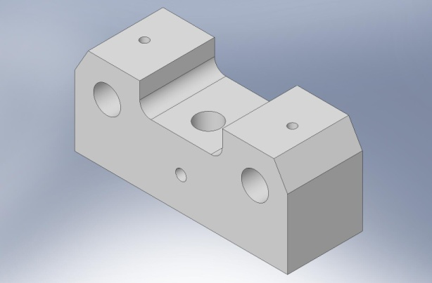  D071122 - 6x - Small - 1 lb | 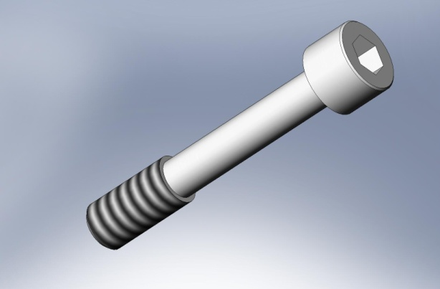  D071136, Type 00 - 24x - 1.5”L - < 1 lb
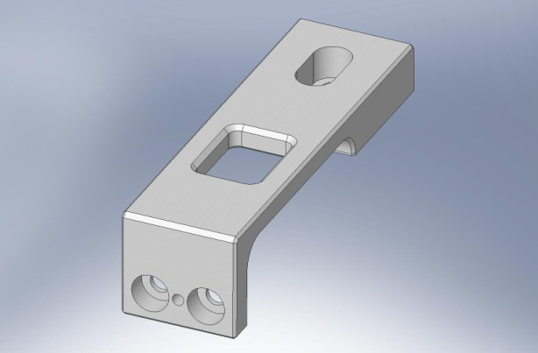  D071123 - 12x - Small - 1 lb | 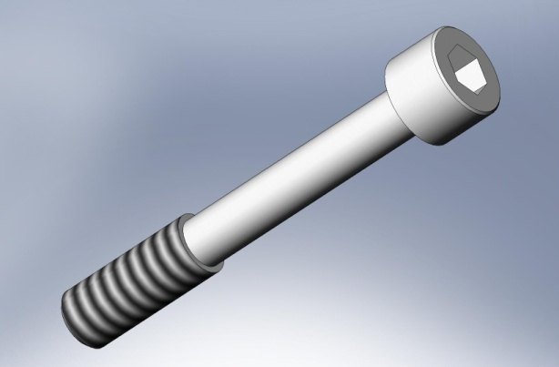  D071136, Type 01 - 54x - 1.75”L - < 1 lb
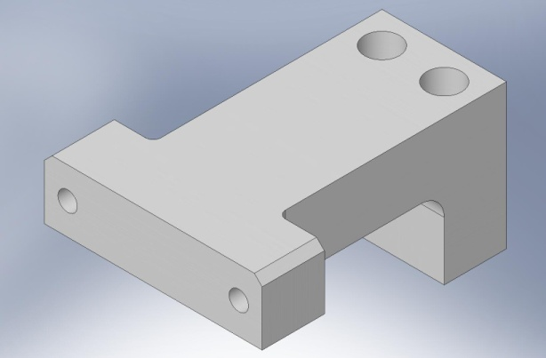  D071129 - 6x - Small - 1 lb | 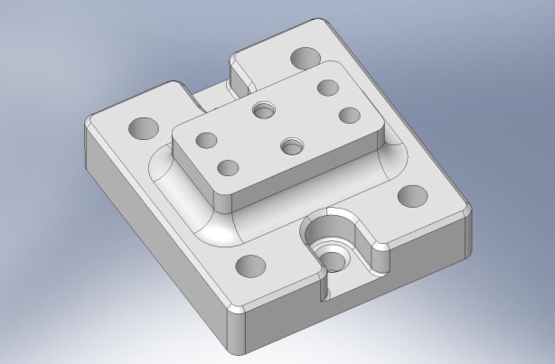  D071140 - 4x - Medium - 4 lbs
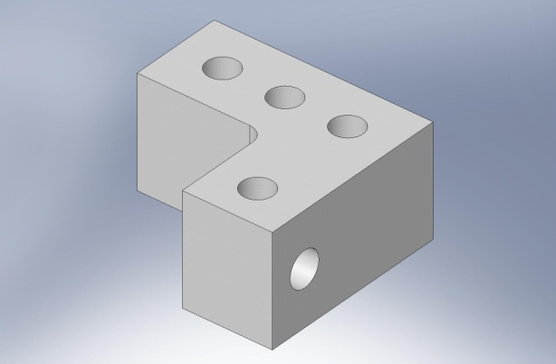  D071132 - 6x - Small - 1 lb | 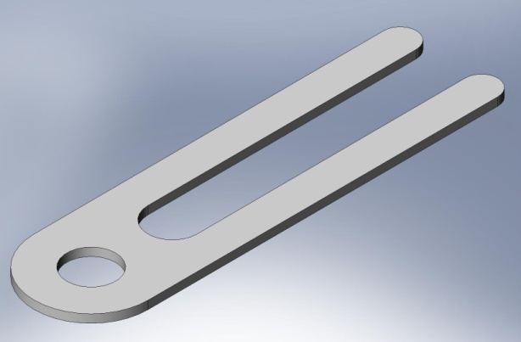  D071141 - Small - < 1 lb

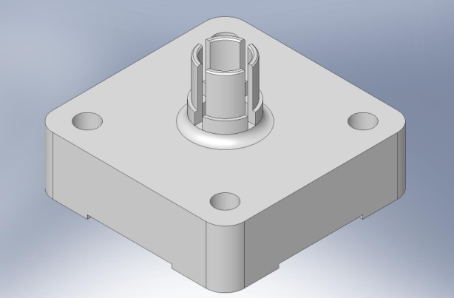  D071160 - 6x - Small - < 1 lb | 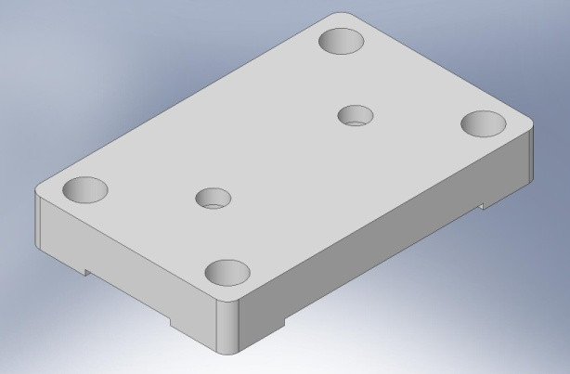  D071164 - 6x - Small - < 1 lb
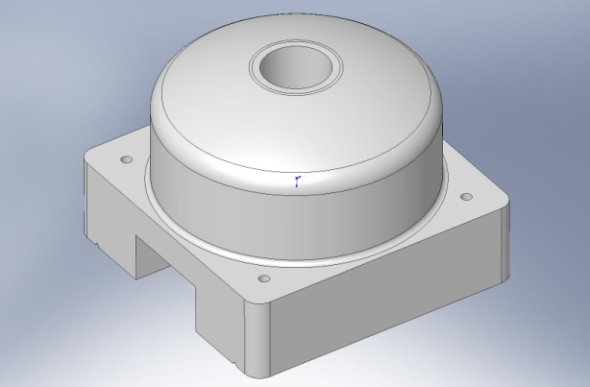  D071161 - 6x - Small - < 1 lb | 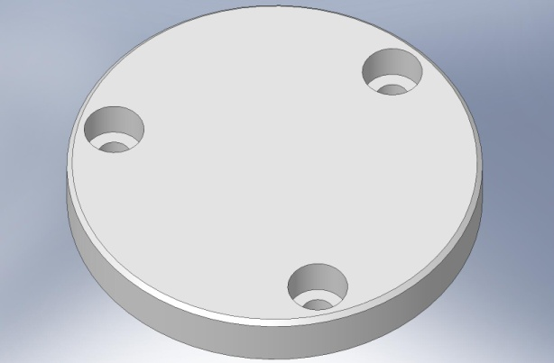  D071165 - 6x - Small - < 1 lb
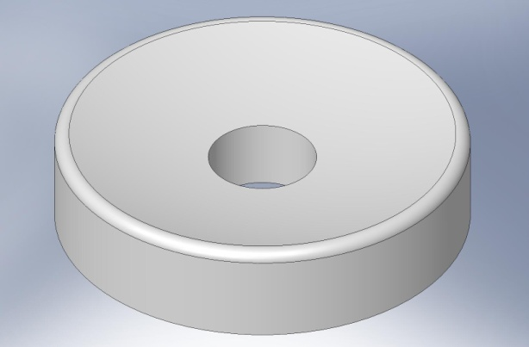  D071162 - 6x - Small - < 1 lb | 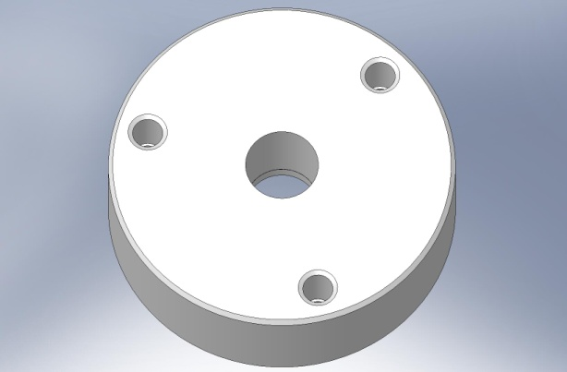  D071166 - 6x - Small - < 1 lb
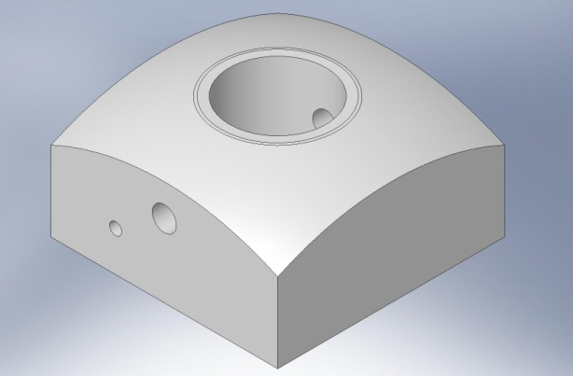  D071163 - 6x - Small - < 1 lb | 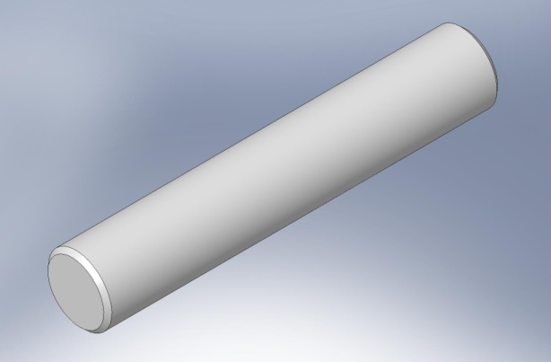  D071167 - 6x - Small - < 1 lb

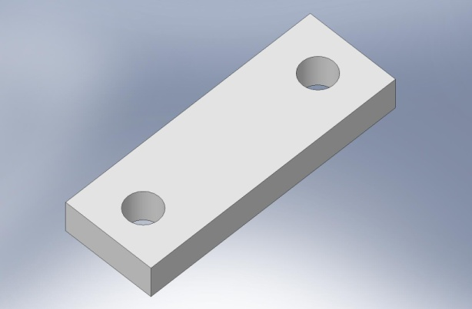  D071170 - 3x - Small - < 1 lb | 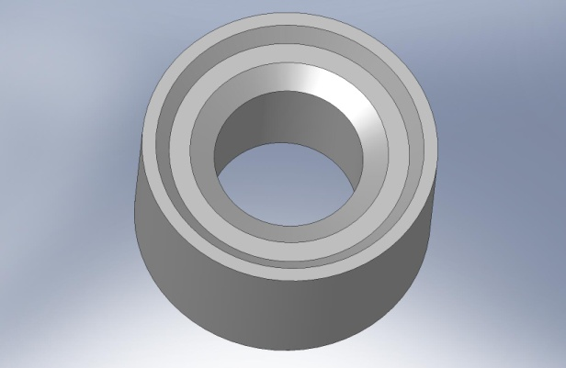  D071182 - Small - < 1 lb (in D071471)
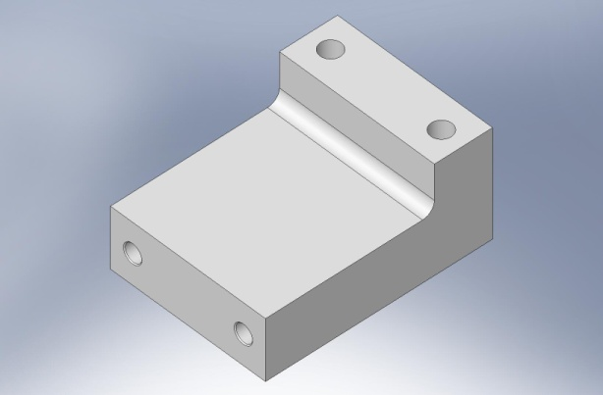  D071175 - 3x - Small - < 1 lb | 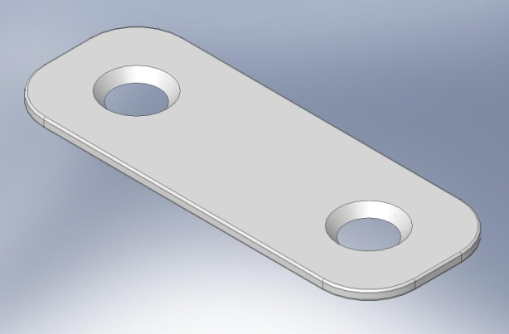  D071183 - 3x - Small - < 1 lb
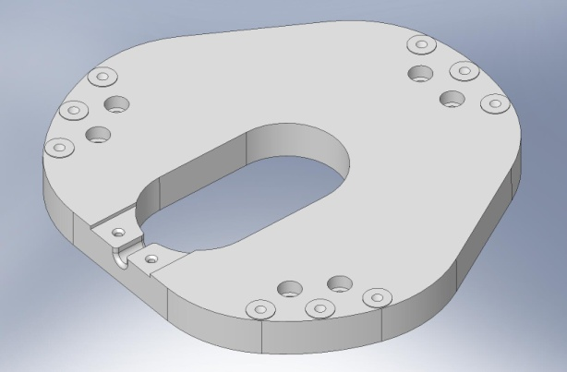  D071180 - 6x - Medium - 8 lbs | 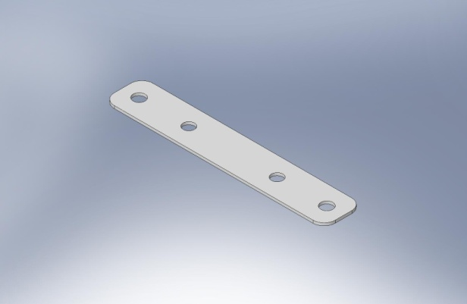  D071200, Type 00 - Medium - 0.6 lbs
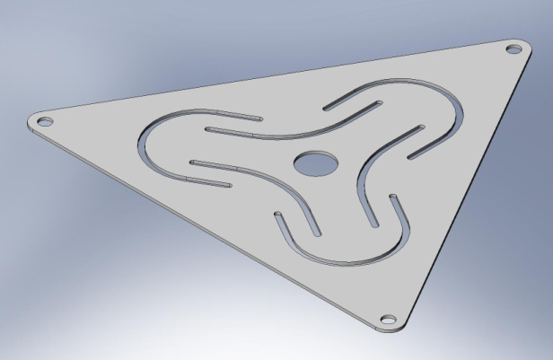  D071181 - 6x - Medium - 1 lb | 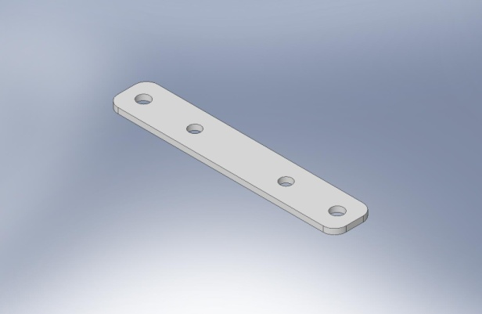  D071200, Type 01 - Medium - 1.1 lbs

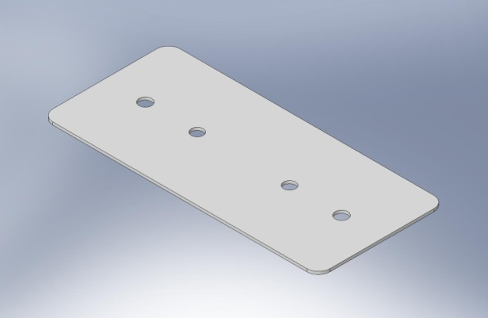  D071200, Type 02 - Medium - 2.3 lbs | 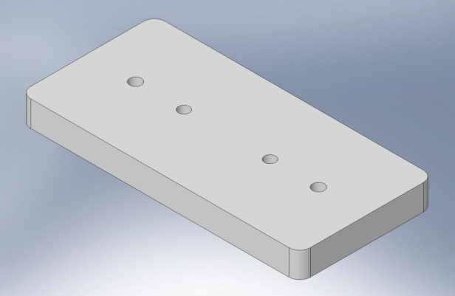  D071200, Type 06 - Medium - 28 lbs
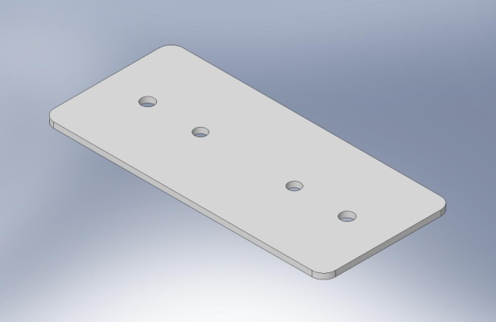  D071200, Type 03 - Medium - 4.5 lbs | 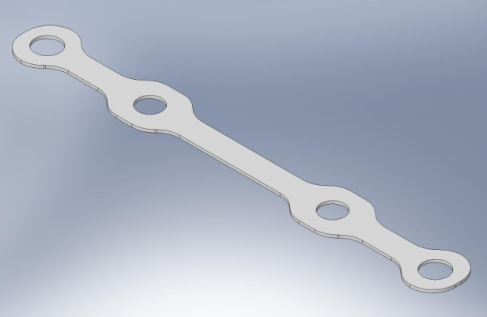  D071201 - Medium - 0.1 lbs
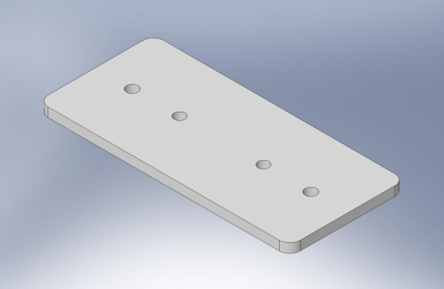  D071200, Type 04 - Medium - 8.3 lbs | 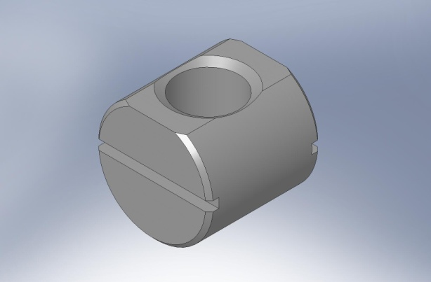  D071250, Type 00 - 174x - Small - < 1 lb
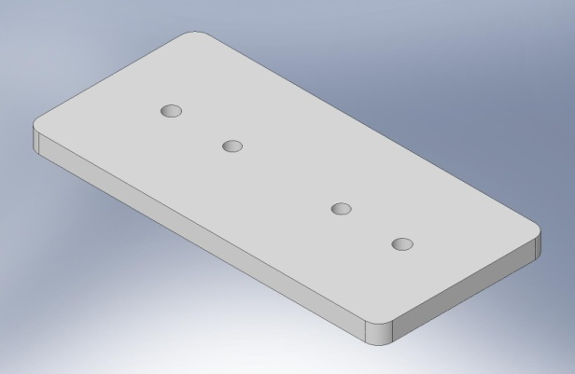  D071200, Type 05 - Medium - 16 lbs | 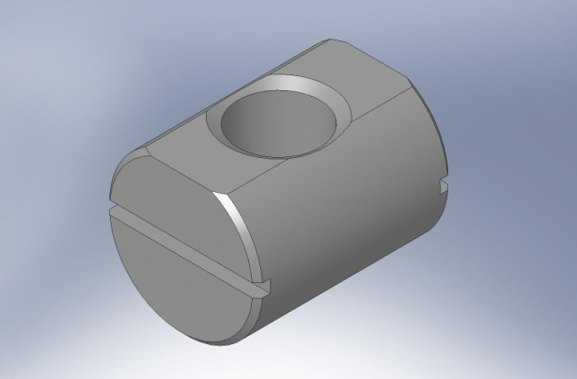  D071250, Type 01 - 615x - Small - < 1 lb

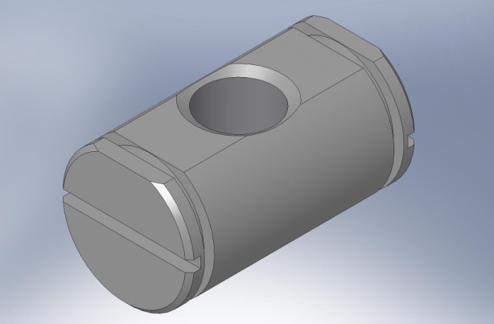  D071250, Type 02 - 108x - Small - < 1 lb | 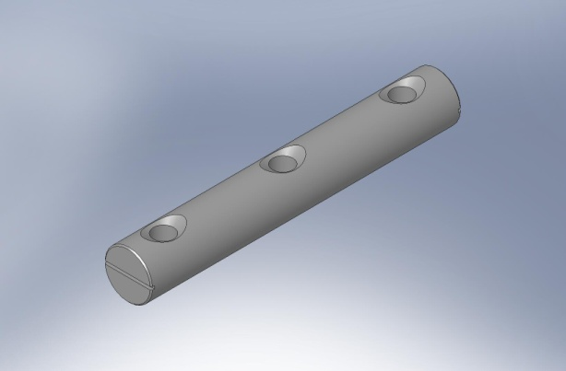  D071251, Type 03 - 9x - Medium - 1 lb
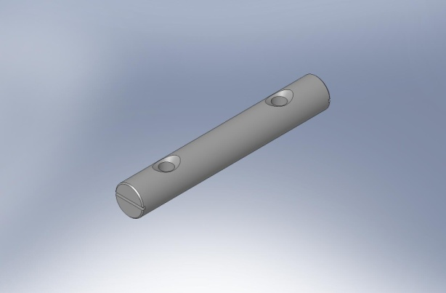  D071251, Type 00 - 6x - Medium - 1 lb | 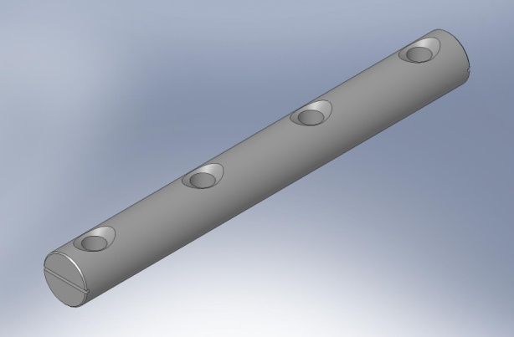  D071251, Type 04 - 6x - Medium - 2 lbs
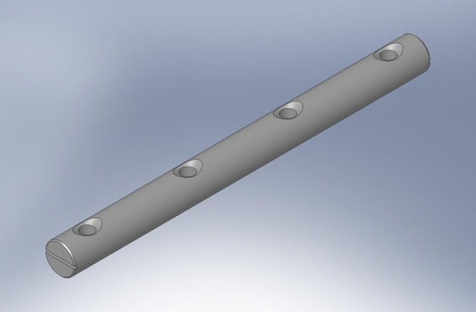  D071251, Type 01 - 6x - Medium - 1 lb | 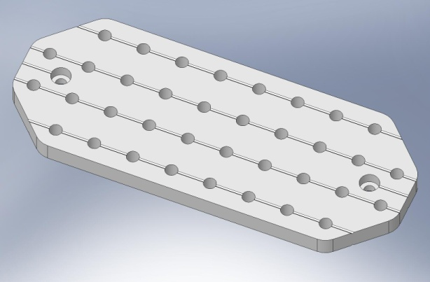  D071255 - 8x - Medium - 2 lbs
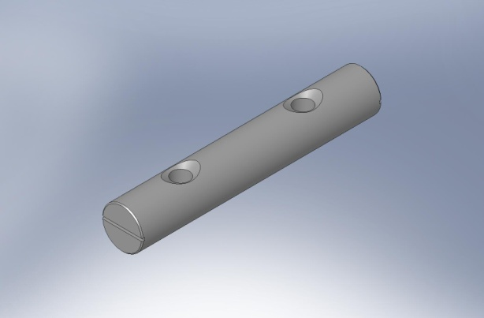  D071251, Type 02 - 3x - Medium - 1 lb | 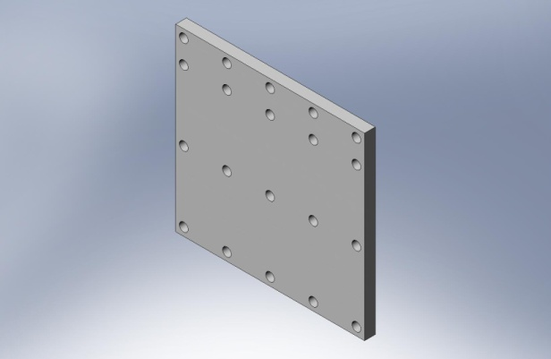  D071300 - 4x - Medium - 3 lbs

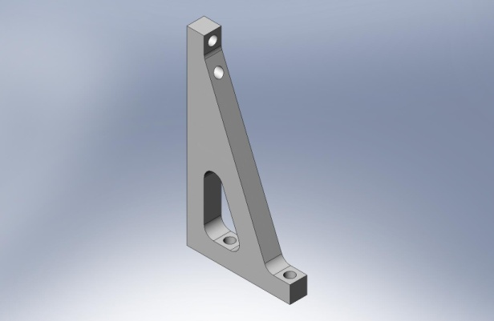  D071301 - 12x - Medium - 1 lb | 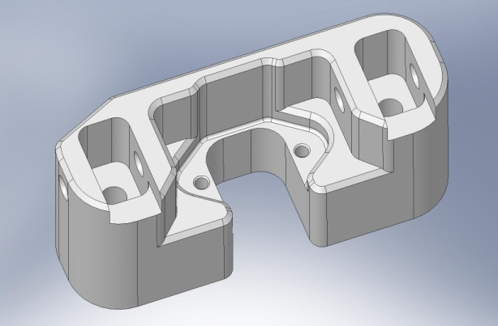  D071305 - 3x - Medium - 4 lbs
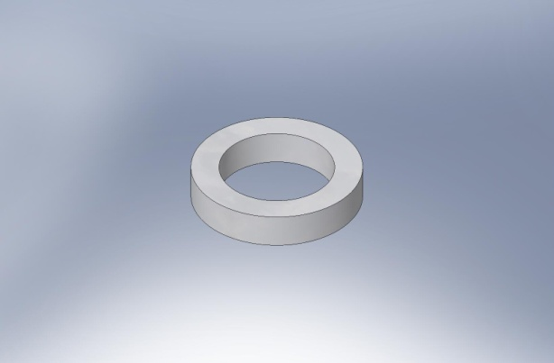  D071302 - 12x - Small - < 1 lb | 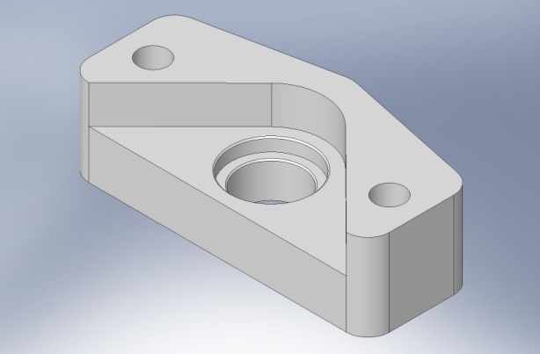  D071306 - 3x - Medium - 3 lbs
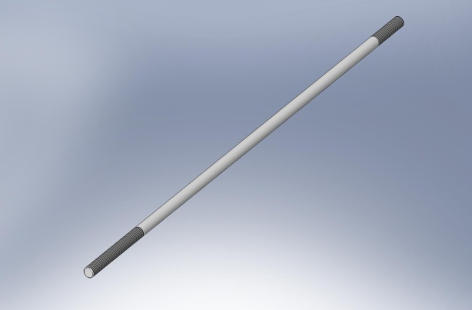  D071303 - 6x - Medium - 1 lb | 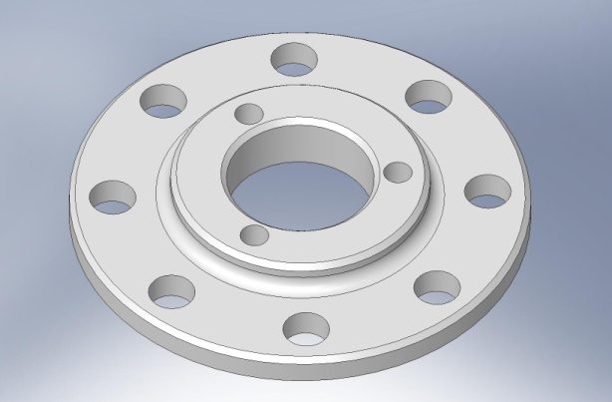  D071307 - 3x - Small - < 1 lb
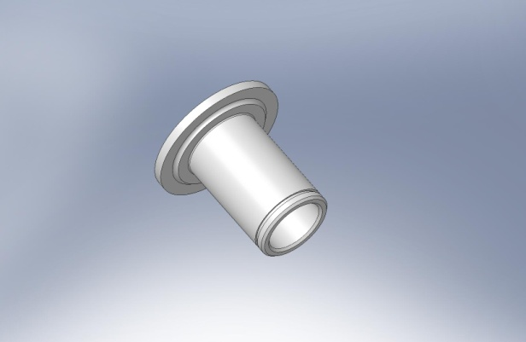  D071304 - 3x - Small - < 1 lb | 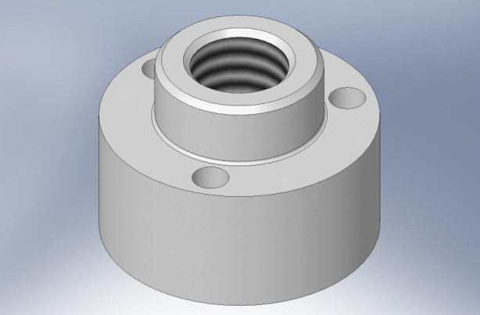  D071308 - 3x - Small - 1 lb

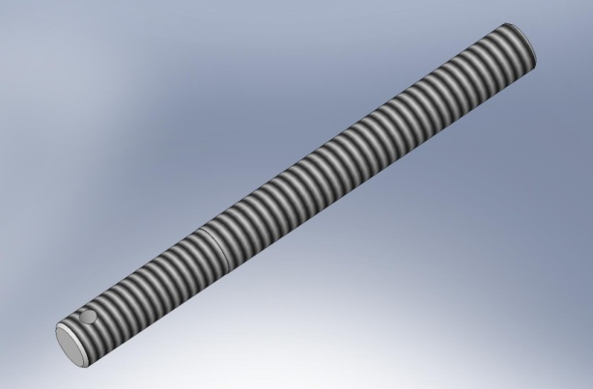  D071309 - 3x - Medium - 1 lb | 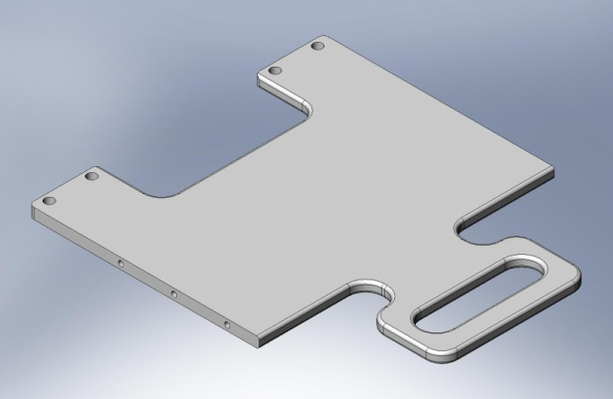  D071313 - 1x - Medium - 7 lbs
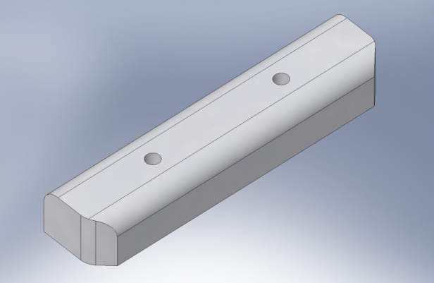  D071310 - 2x - Small - < 1 lb | 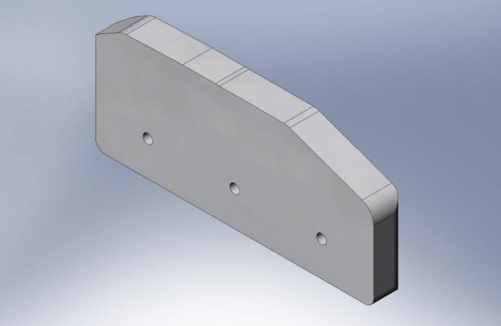  D071314 - 1x - Medium - 2 lbs
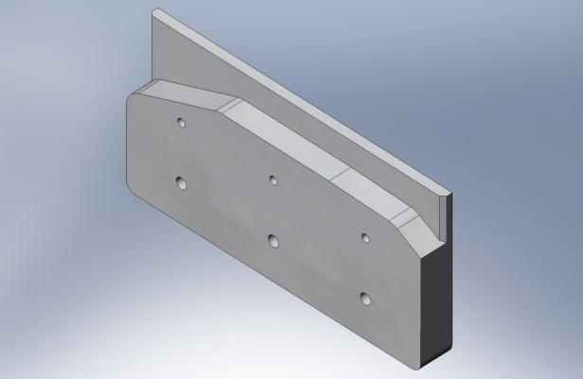  D071311 - 1x - Medium - 2 lbs | 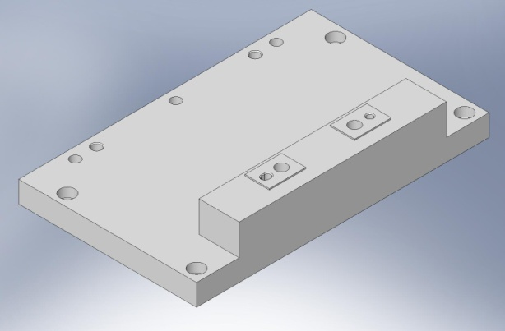  D071316 - 1x - Medium - 9 lbs
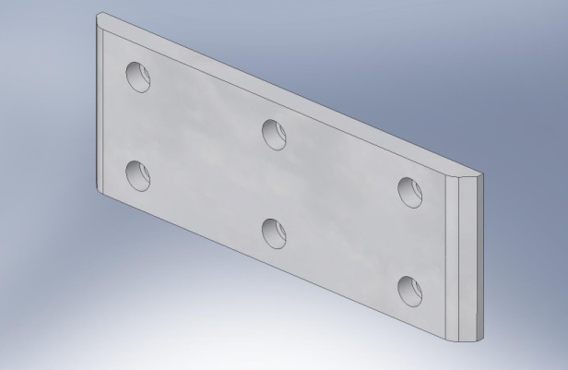  D071312 - 1x - Medium - 1 lb | 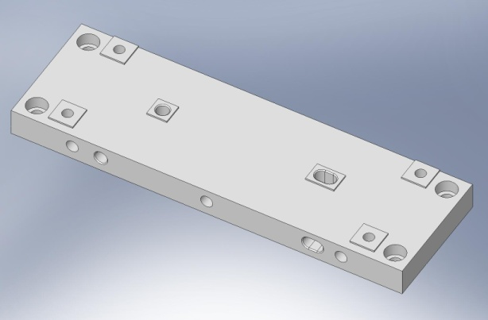  D071317 - 1x - Medium - 4 lbs

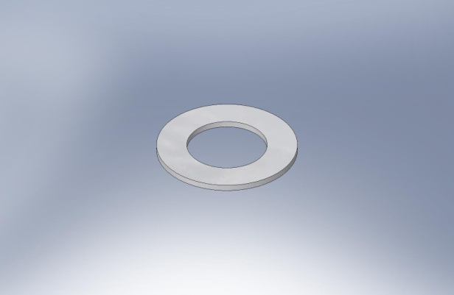  D071320 - 3x - Small - < 1 lb | 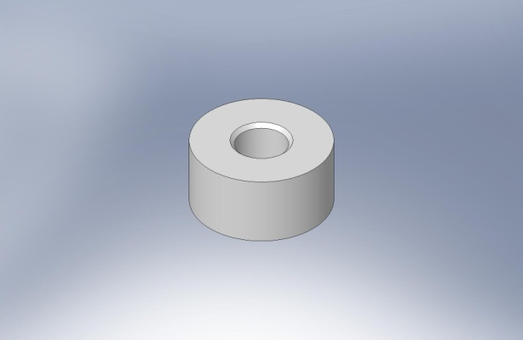  D071326 - Small - < 1 lb
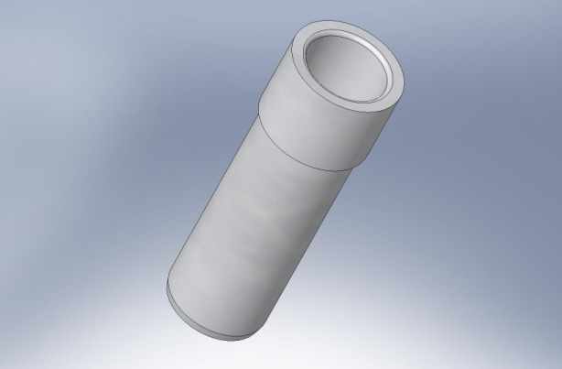  D071321 - 6x - Small - < 1 lb | 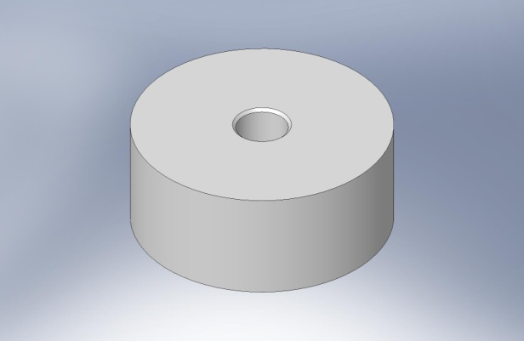  D071327 - Small - < 1 lb
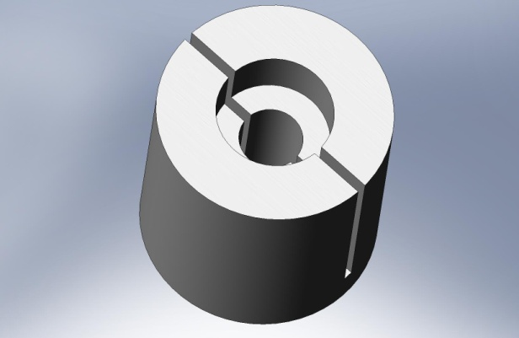  D071322 - Small - < 1 lb | 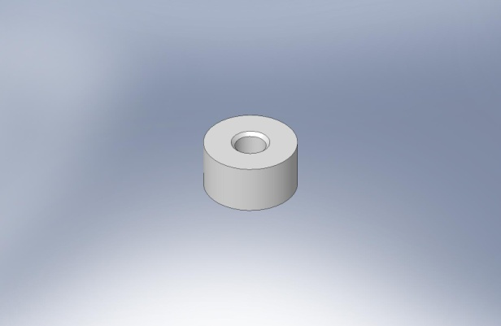  D071328 - Small - < 1 lb
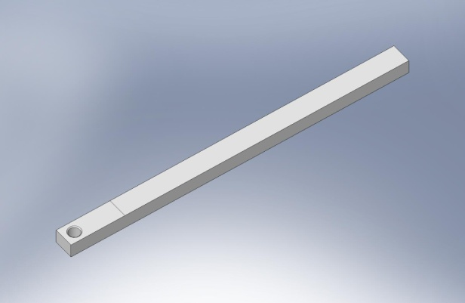  D071325 - Medium - < 1 lb | 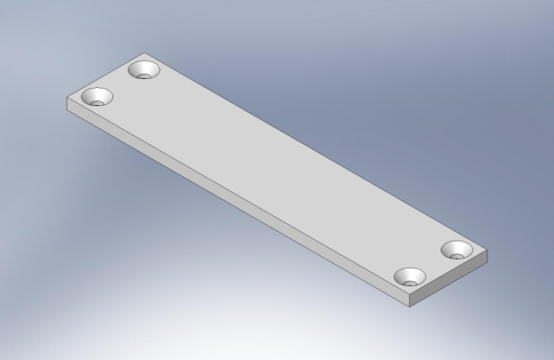  D071330 - 3x - Medium - 1 lb

- – Tools Required
- ratchet wrench for Spring Pull-Down ACME screw
- torque wrenches (ranges?)
- extensions for torque/ratchet wrenches (e.g., for access to bolts through Stage 1 Floor, into the Keel Assembly)
- depth gage (?), to measure distance from Optical Table to top of Springs
- straightedge & Brunson tool (?), to set level of Test Stand
- install tools for retaining rings (on Locker Sleeve, Al Barrel Nuts, other locations?)
- shims for checking actuator gaps
- shims for checking Locker gaps
- precision level

