LIGO Laboratory / LIGO Scientific Collaboration

LIGO-T0900324-v2 LIGO 6/22/10

Design Equations for Initially Flat Blade Springs at Arbitrary Mounting Angles

Michael Smith, Jesse Amato-Grill

Distribution of this document:
LIGO Scientific Collaboration

This is an internal working note
of the LIGO Laboratory.

California Institute of Technology  LIGO Project – MS 18-34  1200 E. California Blvd.  Pasadena, CA 91125  Phone (626) 395-2129  Fax (626) 304-9834  E-mail: info@ligo.caltech.edu | Massachusetts Institute of Technology  LIGO Project – NW22-295  185 Albany St  Cambridge, MA 02139  Phone (617) 253-4824  Fax (617) 253-7014  E-mail: info@ligo.mit.edu
LIGO Hanford Observatory  P.O. Box 1970  Mail Stop S9-02  Richland WA 99352  Phone 509-372-8106  Fax 509-372-8137 | LIGO Livingston Observatory  P.O. Box 940  Livingston, LA 70754  Phone 225-686-3100  Fax 225-686-7189
http://www.ligo.caltech.edu/

Introduction
The purpose of this document is to describe the design equations for a cantilevered flat blade spring, mounted at an arbitrary tilt angle, which takes a precise circular curvature under load with the tip of the spring having a horizontal slope. The test results of two specimen blade spring designs are shown.

Design Equations
The bending and deflection of a flat blade cantilever spring are calculated from fundamental principles.
The geometry of the cantilever blade spring is shown in Figure 1.

Figure 1: Geometry of the Cantilever Blade Spring

Theory

Beam Bending
The maximum normal stress at any cross section of the blade occurs at the outer surface of the blade and is proportional to applied moment, to the distance from the neutral axis of the cross section to the outer surface, and inversely proportional to the area moment of inertia of the cross section.
Bending moment M
Thickness of blade t
Width of blade b
Moment of inertia of cross section I
For a rectangular cross section

Maximium normal stress

The maximum strain at the outer surface of the blade is inversely proportional to the bending radius of the blade at the particular cross section.
maximum strain

Introducing the modulus of elasticity through the stress/strain relationship for a material that obeys Hook’s law,

In general, the width of the blade is >> than the thickness, and the effective modulus of elasticity must be increased to account for the additional stiffness caused by the Poisson’s ratio, μ.

The deflected shape of the blade spring will be circular with a constant radius, R, if the stress is equal at every cross section. The design will use a safe working stress for the material, which does not exceed the elastic limit.

Vertical Bounce Frequency
The vertical bounce frequency of a mass on a spring with a spring constant k is

The spring constant is defined as the ratio of vertical force to vertical displacement.

Substituting the spring constant into the frequency equation, we obtain

which is the equation for the frequency of a pendulum of length y. This result relies on the spring being linear with a single spring const.
Strangely enough, even though the blade spring is non-linear and the spring constant varies with deflection, the measured vertical bounce frequency of the blade spring can be predicted precisely by using the pendulum formula and by choosing y = ymax, the total deflection of the blade spring under the load.

Design Equations

Blade spring Test 45 deg
7/2/09
acceleration of gravity, m/s^2
BLADE SPRING TEST @ 45 deg
Faraday upper blade spring design
yield strength of 1095 spring steel, psi
Poisson's ratio
modulus of elasticity, psi
modulus of elasticity, Pa
working stress of 1095 spring steel, psi
working stress of 1095 spring steel, Pa
radius of blade spring, m
radius of blade spring, in
thickness of blade spring, m
thickness of blade spring, in
arc of blade spring, rad
blade arc angle, deg

length of blade spring, in
length of blade spring, m
horizontal distance of suspension point from blade spring mount, in
vertical height of suspension
from blade spring mount, m
unloaded height of blade spring, m
vertical distance blade moves, m
approximate vertical resonant frequency based on blade depression, Hz
distance along spring, m
distance along spring, in
mass supported by each
blade spring, kg
load on blade spring, N

Blade Shape
blade width at l from end, m
blade width at l from end, in
alternative formula
Solid Works equation

stress at Pa

Test Results
A drawing of the loaded blade spring was placed behind and adjacent to the spring under test to measure the deviation from the designed radius of curvature. A vertical scale was read to measure the height of the tip of the blade spring above the mounting point. The spring was loaded with mass until the height of the loaded spring matched the design height. With this amount of load, the spring was given a vertical impulse, and the oscillation period was measured with a stop watch.

45 Degree, 11 inch Blade Spring

Design Values
Material 1095 steel
Modulus of elasticity, psi 30 E6
Length of flat blade, in 11.00
Width at base, in 2.786
Thickness, in 0.020
Vertical height of loaded spring, in 4.10
Mass load, kg 0.200
Radius of curvature, in 14.00
Vertical bounce frequency, Hz 1.63

Experimental Results
The spring loaded with mass at the design height is shown in Figure 2. With this amount of load, the spring was given a vertical impulse, and the oscillation frequency was determined.
The following experimental results were obtained.
Mass load for design height 0.186 kg error = 0.07
Radius of curvature 14.00 +/- 0.02
Frequency 1.65 error = 0.01
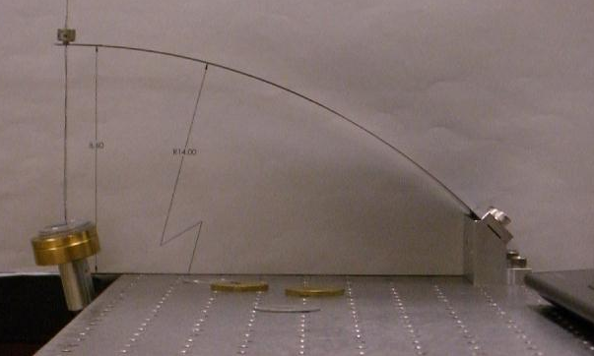

Figure 2: Measured Curvature of 11 in Blade Spring under Balanced Load

Faraday Isolator Prototype Blade Spring

Design Values
Material C-250 maraging steel
Modulus of elasticity, psi 27 E6
Length of flat blade, in 11
Width at base, in 2.83
Thickness, in 0.0625
Vertical height of loaded spring, in 4.1
Mass load, kg 5.6
Radius of curvature, in 14.03
Vertical bounce frequency, Hz 1.63

Experimental Results
The two springs supporting the Faraday Isolator optics table with dummy masses are shown in Figure 3. A full scale drawing of the loaded spring is shown behind the actual springs in the picture. The curvature and the height of the loaded springs match reasonably well to the design values. The vertical resonance frequency is approximately 1.4 Hz, as shown in the transmissibility curve in Figure 4.
The following experimental results were obtained.
Mass load for design height, kg 11
Frequency, Hz 1.4
Radius of curvature, in 14

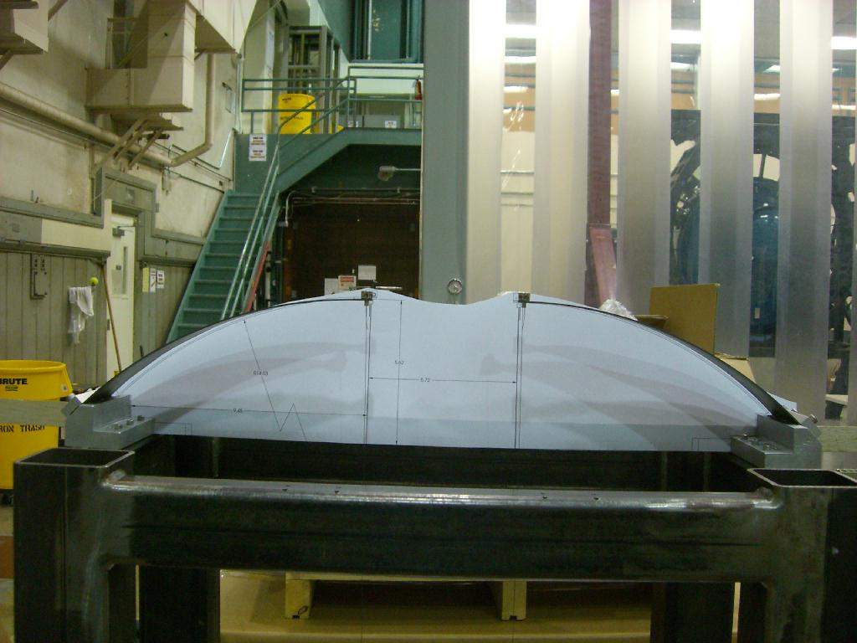
Figure 3: Prototype C-250 Faraday Isolator Blades under Design Load

Figure 4: Output Faraday Isolator SUS Transmissibility in Vertical Direction.

45 Degree, 6.7 inch Blade Spring

Design Values
Material 1095 steel
Modulus of elasticity, psi 30 E6
Length of flat blade, in 6.68
Width at base, in 2.350
Thickness, in 0.015
Vertical height of loaded spring, in 2.49
Mass load, kg 0.200
Radius of curvature, in 8.50
Vertical bounce frequency, Hz 2.09

Experimental Results
The spring loaded with mass at the design height is shown in Figure 5. With this amount of load, the spring was given a vertical impulse, and the oscillation frequency was determined.
The following experimental results were obtained.
Mass load for design height 0.184 kg error = 0.08
Frequency 2.09 error = 0.00
Radius of curvature 6.68 +/- 0.04

The radius of curvature matched the printed design profile within twice the thickness of the blade, as shown in the photograph in Figure 5.
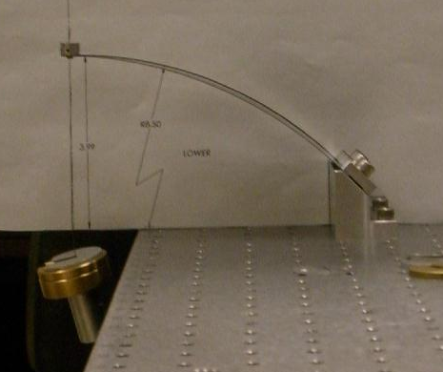
Figure 5: Measured Curvature of 6.7 in Blade Spring under Balanced Load

22.5 Degree, 28 inch Blade Spring

Design Values
Design Values:
Length of flat blade 11.00 in
Vertical height of loaded spring 4.10 in
Mass load 0.200 kg
Radius of curvature 14.00 in

Experimental Results
TBD

Design of Machine Elements, M.R. Spotts, 2nd ed. 1953, Prentice-Hall, N.J

