LIGO Laboratory / LIGO Scientific Collaboration

LIGO-T0900267-v3 ADVANCED LIGO 11/23/2026

Alignment for the Input Optics

Muzammil Arain, Rodica Martin, Volker Quetschke, Guido Mueller, David Reitze, David Tanner

Distribution of this document:
LIGO Science Collaboration

This is an internal working note
of the LIGO Project.

California Institute of Technology  LIGO Project – MS 18-34  1200 E. California Blvd.  Pasadena, CA 91125  Phone (626) 395-2129  Fax (626) 304-9834  E-mail: info@ligo.caltech.edu | Massachusetts Institute of Technology  LIGO Project – NW17-161  175 Albany St  Cambridge, MA 02139  Phone (617) 253-4824  Fax (617) 253-7014  E-mail: info@ligo.mit.edu
LIGO Hanford Observatory  P.O. Box 1970  Mail Stop S9-02  Richland WA 99352  Phone 509-372-8106  Fax 509-372-8137 | LIGO Livingston Observatory  P.O. Box 940  Livingston, LA 70754  Phone 225-686-3100  Fax 225-686-7189
http://www.ligo.caltech.edu/
Table of Contents
1 Introduction 3
1.1 Scope 3
1.2 Applicable Documents 3
1.2.1 LIGO documents 3
2 Requirements 4
3 Overview of Alignment Plan 5
3.1 Optical Levers 5
3.2 QPDs 5
3.2.1 QPDs 6
3.3 GigE video camera 7
4 The IO Auto-Alignment System 8
4.1 Input Mode Cleaner 10
4.1.1 IMC injection path (on PSL table) 10
4.1.2 IMC1 10
4.1.3 IMC2 11
4.1.4 IMC3 11
4.1.5 IMC initial alignment procedure 11
4.1.6 IMC QFS Gouy Phase Design 12
4.2 Refl beam / PRC 13
4.2.1 SM1 and PMMT1 14
4.2.2 HA1 and HA2 14
4.2.3 PMMT2 and SM2 14
4.2.4 PRM 14
4.2.5 PR2 15
4.2.6 PR3 15
4.2.7 Beam through FI alignment procedure (initial alignment) 15
4.2.8 Refl beam initial alignment 15
4.2.9 FI and refl beam optimal alignment reference and control 16
5 LIST OF HARDWARE 16
6 LIST OF INTERFACES TO CDS 16
7 Frequency alignment sensing and control 16
8 Camera Views on optical elements 17
8.1 IMC1, IMC2, IMC3, PRM, PR2 and PR3 HR side view 17
8.2 SM1 HR side 17
8.3 HA1 front side 18
8.4 HA2 back side 19
8.5 HA2 front side 20
8.6 PMMT2 HR side 21
8.7 SM2 HR side 22

Table of Figures
Figure 1 Beam size and Gouy phase change as a function of distance from IMC waist for the IMC WFS1 and IMC WFS2. 7
Figure 2 Beam size and Gouy phase change as a function of distance from the IMC waist for the SM2 transmitted forward going beam for the two QPDs. 7
Figure 3 Layout of alignment related diagnostic beams and camera views for HAM2. 8
Figure 4 Figure 3 Layout of alignment related diagnostic beams and camera views for HAM2 9
Figure 5 Layout of IOT layout for straight interferometer. The folded layout is similar. 10
Figure 6 Conceptual layout of IMC WFS Gouy Phase Telescope design. The design for the straight and folded interferometer is similar. 12
Figure 7 Beam size and Gouy phase change as a function of distance from IMC waist for the IMC WFS1 and IMC WFS2. 13

Introduction
This document presents the requirements and procedures related to the alignment of the in-vacuum components of the Advanced LIGO Input Optics (IO).

Scope
The scope of the IO alignment includes:
- the initial alignment of the input mode cleaner and other in-vacuum IO optics – this document provides the method for optically aligning the IO mirrors sufficiently to allow the IMC to resonate and to center the IO beam on the PRM and get the back reflected field through the REFL port.
- auto-alignment of the input optics during interferometer operations – this document provides a slow loop design for maintaining the IO alignment during extended periods and for quickly restoring the alignment to a pre-determined optimal position.
The scope does not include the IMC WFS system or any global alignment sensing and control system.

Applicable Documents

LIGO documents
[1] LIGO-T010075, “Advanced LIGO Systems Design”, P. Fritschel, ed.
[2] LIGO-T010076, “Optical Layout for Advanced LIGO”, D. Coyne
[3] LIGO-T020020, “Advanced LIGO Input Optics Design Requirements Document” Muzammil A. Arain, A. Lucianetti, Rodica Martin, Guido Mueller, Volker Quetschke, David Reitze, David Tanner, Luke Williams, Wan Wu
[4] LIGO-T060269, “Advanced LIGO Input Optics Subsystem Preliminary Design Document”, Muzammil A. Arain, A. Lucianetti, Rodica Martin, Guido Mueller, Volker Quetschke, David Reitze, David Tanner, Luke Williams, Wan Wu
[5] LIGO-T060267, “Upgrading the Input Optics for High Power Operation”, UF LIGO Group, IAP Group

Requirements
The alignment requirements flow down from SYS is detailed in the Input Optics Design Requirements Document [3]. The relevant requirements from the IO DRD are:
- Mode Cleaner Beam Centering (section 3.4.4 in IO DRD) - The beam spot must be centered in the mode cleaner mirrors to a precision of 1 mm to avoid length-to frequency couplings.
- The beam has to be centered with a precision of better than 5 mm on each of the power recycling mirrors to keep length to alignment fluctuation within the allowed limits. As far as the IO is concerned, the routing of the beam between PR2 and PR3 (alignment of PR2) is not part of this document.
- Mode Matching Telescope Alignment (section 3.7.3 in IO DRD) - The coupling efficiency from the Input Optics to the Main Interferometer GW carrier and sidebands TEM₀₀, mode parameters as described in interfaces, (COC) shall be 0.95 or higher. Drifts in the alignment can reduce the mode-matching efficiency.
- The IMC mirrors are suspended in triple suspension systems and their angular fluctuations are expected to be much lower than the angular fluctuations of the PSL beam within the entire AdvLIGO band. Therefore the optical axis of the IMC will provide the in-band reference for the input beam. The WFS will measure and control the angular pointing and displacement of the input beam with reference to the IMC eigenmode. The WFS system for the IMC is outside the scope of the IO.
- Because of the superior suspensions the stable power recycling cavity mirrors are much quieter than SM1,2 and PMMT1,2. In addition, below the AdvLIGO band the PR mirrors are also sensed and controlled by BOSEMs to reduce the rms motion. Consequently, the input beam will follow the power recycling cavity while the power recycling cavity mirrors will follow the arm cavities. All this is part of the overall ASC plan which is still evolving.

Overview of Alignment Plan
Three types of active sensors will be used for monitoring the alignment status of the IO.
- Optical Levers (provided by AOS) are used for each HAM table
- BOSEMs are used on each triple suspension used for each IMC-mirror
- OSEMs are used on each small suspended optic: SM1, SM2, PMMT1, PMMT2
- Quadrant photodiodes (QPDs) - OSI Opto-electronics model FCI InGaAs Q3000. This is the standard QPD designed by the CDS for Advanced LIGO.
- GigE video cameras – Prosilica model GC1380 gigabit Ethernet camera.

Optical Levers
The angular alignment of each HAM table will be controlled by one optical lever for each table. The optical lever signals after the first successful lock of the IMC will be recorded to realign the HAM tables after loss of lock or to maintain alignment of the HAM tables over long time scales.

BOSEMs
The position of all three mode cleaner mirrors (IMC1, IMC2, and IMC3) with respect to their frames and consequently with respect to the HAM table will be sensed by BOSEMs on the triple suspensions. The BOSEM signals after the first successful lock of the IMC will be recorded. After loss of lock, the recorded signals will be used to realign all mode cleaner mirrors into their initial position for lock acquisition.

QPDs
QPDs will be placed outside the vacuum chambers on IOT tables on both sides of HAM2. An additional QPD will be placed on one of the viewports on HAM3. The QPDs will be used to provide an absolute reference for the beam position for transmitted and/or reflected beams from specific IO mirrors. Once the initial IO alignment has been completed and verified to be adequate based on IO power throughput and noise requirements beam and mode changes in the IO can be tracked by these sensors.
In detail:
- IO_IMC_REF_QPD1 and IO_IMC_REF_QPD2 on IOT1 will be used to monitor the position and alignment of the MC_REFL beam. The IO_IMC_REF_QPD1 and IO_IMC_REF_QPD2 signals will be recorded and stored after the IMC is locked and used to reestablish the alignment of the PSL beam into the IMC.
  - In addition, irises will be placed in front of the IO_IMC_REF_QPD1 and IO_IMC_REF_QPD2 to have mechanical fiducials on the table to help during commissioning activities on the floor.
- IO_IMC2_QPD will be installed on a viewport on HAM2 and used to monitor the field transmitted through IMC2. The power is likely too small during low power lock acquisitions of the IMC. But after lock has been achieved, the IO_IMC2_QPD signal provides an additional diagnostic tool to monitor the optical axis of the IMC eigenmode and to ensure that for example the optical lever signals are reasonable.
- IO_IMC_TRNS_QPD1 and IO_IMC_TRNS_QPD2 (with irises) on ISCT1 will be used to monitor the IMC optical axis by monitoring the position and angle of the beam transmitted through SM1. Similarly to IO_IMC2_QPD, this signal will not be available during lock acquisition but will provide an ‘out-of-loop’ measure of the performance of the optical levers.
- IO_PMMT_QPD1 and IO_PMMT_QPD2 (near and far field) on the IOT table will monitor the IFO input beam transmitted through SM2 to sense the alignment of SM1 and PMMT1.
- PRM_REF_QPD1 and PRM_REF_QPD2 on the IOT table monitor the IFO reflected beam transmitted through SM2.
Note: The beams for these QPDs will not be routed through actuated mirrors (tip/tilt or PZT). In contrast to this, our plan is that the WFS beams, the beam used for IMC length sensing and control, and beams used to measure the mode matching will be routed through actuated mirrors to keep the beam position centered on these detectors during science operation. The reason is that we don't want to rely on the repeatability of the tip/tilts and PZT actuators for lock acquisition.
    - QPDs
We have three sets of QPD pairs that need to be set with 90⁰ Gouy phase apart. The beams on which we need to put these QPDs are:

- IMC Reflected beam
- SM1 Transmitted beam for IMC alignment
- SM2 Transmitted Forward Beam
- SM2 transmitted back-propagating beam from PRM

All these beams have more or less the same size (2.1 mm to 2.2 mm) on HAM2 and have same Gouy phase (within about 20 degree). Therefore we have designed a general two QPD block that can be placed anywhere on IOT1 table such that we have 90⁰ Gouy phase difference between the two QPD detectors with reasonable beam sizes. The layout is shown in Fig. 1.
L₂
L₁
QPD1
QPD2
350 mm
208 mm
L1 Focal length = 229mm with part number PLCX-25.4-103.0-UV
L1 Focal length = -22.9 mm with part number PLCC-25.4-13.1-UV

Figure 1 Beam size and Gouy phase change as a function of distance from IMC waist for the IMC WFS1 and IMC WFS2.
The beam size and the Gouy phase change as a function of the distance from the IMC waist is shown in Fig. 2 for the SM2 transmitted forward going beam. The beam size and Gouy phase relationship between the other two beams is similar.
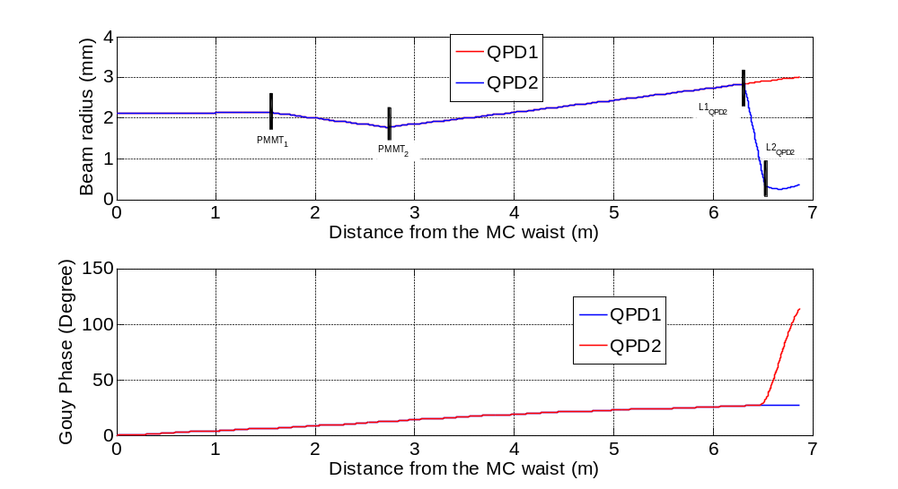
Figure 2 Beam size and Gouy phase change as a function of distance from the IMC waist for the SM2 transmitted forward going beam for the two QPDs.

GigE video camera
GigE video cameras will be also be used to monitor the alignment and the beam size.
- Direct imaging mode - in the direct imaging mode, beams will be directed into cameras located on tables and platforms outside of the vacuum system. Direct imaging requires the beam diameter to be less than 5 mm and a power of a few µW is sufficient as the beam is directed directly on the CCD chip.
- Indirect imaging mode - In situations where it is impossible to directly image the beam, we will use indirect imaging. In the indirect imaging mode, cameras located on viewports outside the vacuum system will view the front surfaces of the mirrors. The use of frame-grabber cards together with image processing algorithms will allow for image digitization and beam position and beam size measurements.

The IO Auto-Alignment System
Figures 3 and 4 show a preliminary view of the diagnostic alignment beams and camera views for HAM2 and HAM8. A description of the diagnostic beams is described in the following sections.

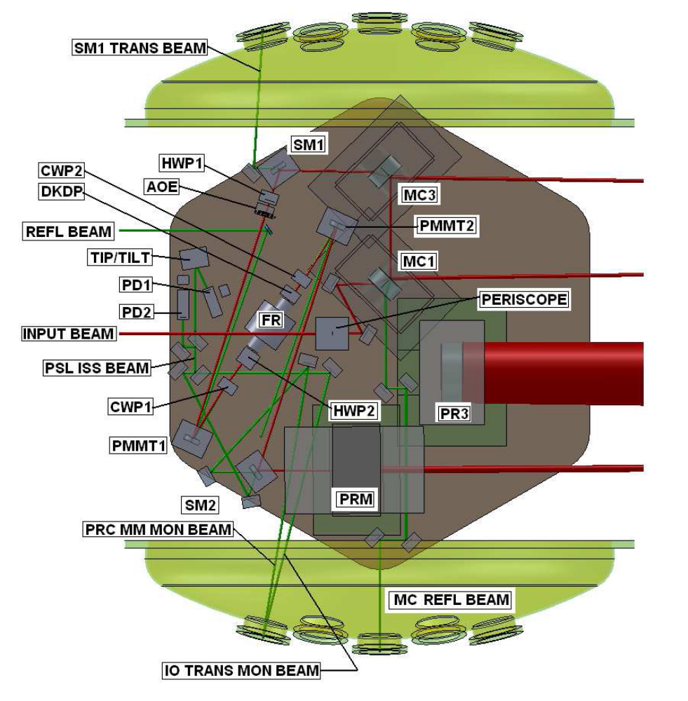
Figure 3 Layout of alignment related diagnostic beams and camera views for HAM2.

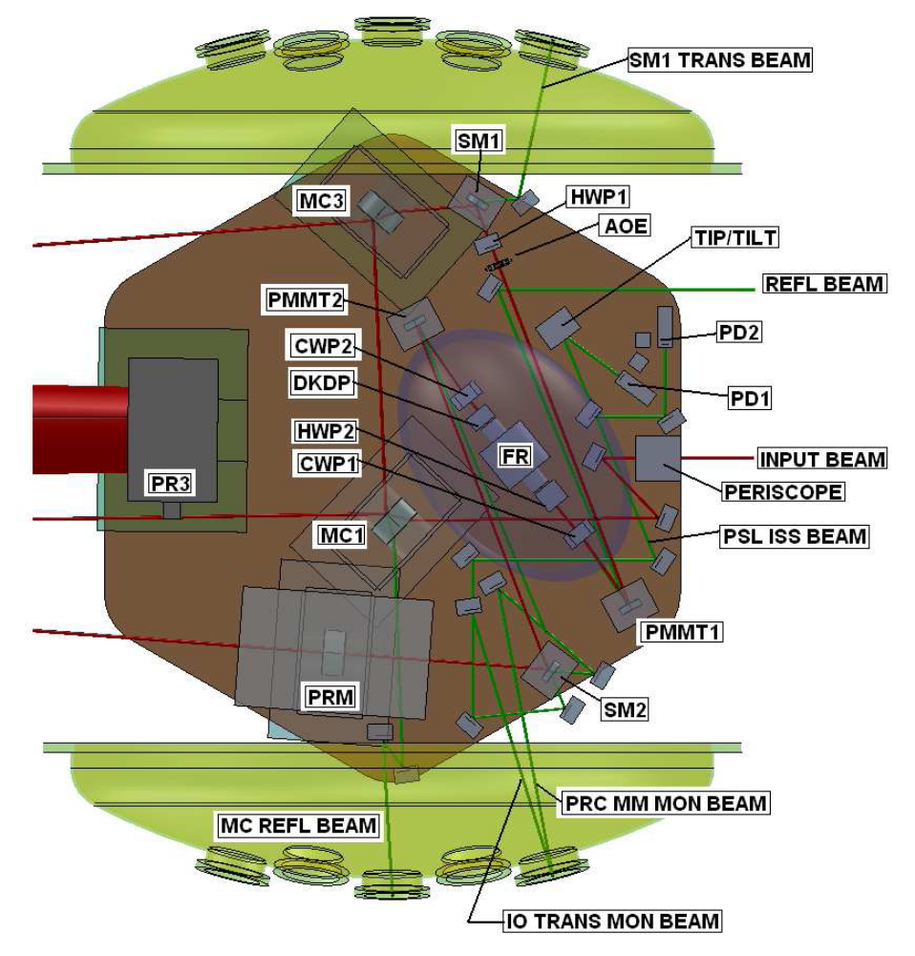
Figure 4 Layout of alignment related diagnostic beams and camera views for HAM2
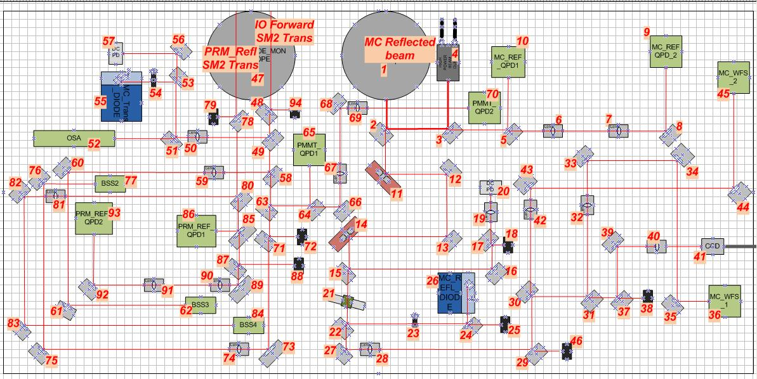
Figure 5 Layout of IOT layout for straight interferometer. The folded layout is similar.
The camera views and routing of diagnostic beams in HAM1,2 were verified using 3D views in the preliminary SolidWorks layout design. These drawings will be updated when the final design of the entire interferometer evolves.
Below, ‘sensor’ describes what information is available for a specific optical element or group of elements and ‘controlled’ indicates whether the alignment of that element can be actuated.

Input Mode Cleaner

IMC injection path (on PSL table)
Sensors:
- IO_IMC_REF_QPD1 and IO_IMC_REF_QPD2 (near and far field) on the IOT table monitors the beam reflected at IMC1.
Controlled: yes (PZTs)

IMC1
Sensors:
- IO_CAM_MC1 view onto IMC1 HR side through viewport on beam tube between HAM2,3.
- BOSEM senses motion of MC1 with respect to frame and HAM2 table. Optical Lever measures HAM2 table with respect to Pier.
Controlled: Yes, in angle below the LIGO band. In length as part of the overall ISC (outside the scope of IO).

IMC2
Sensors:
- IO_CAM_MC2 view onto IMC2 HR side through viewport on beam tube between HAM2,3.
- BOSEM senses motion of MC1 with respect to frame and HAM3 table. Optical Lever measures HAM3 table with respect to Pier.
Controlled: See IMC1

IMC3
Sensors:
- IO_CAM_MC3 view onto IMC3 HR side through viewport on beam tube between HAM2,3.
- BOSEM senses motion of MC1 with respect to frame and HAM2 table. Optical Lever measures HAM2 table with respect to Pier.
Controlled: See IMC1 Note: IO_IMC2_QPD, IO_IMC_TRNS_QPD1, and IO_IMC_TRNS_QPD2 will verify independently the alignment of the optical axis after lock has been acquired.

IMC initial alignment procedure
The initial IMC alignment procedure will largely follow that used in initial LIGO, although we will have to rely on mechanical rotation of the HSTS towers due to the limited dynamic yaw range of the suspended mirrors. The initial procedure will be used to align the mode cleaner until it locks reliably and the WFS-based auto alignment system can take over.
This alignment procedure assumes the IMC HSTSs have been installed and pre-positioned to the required tolerances.
- Misalign IMC3.
- Use input beam actuators to walk the beam in the IMC, and roughly center the beam on IMC1 and IMC2, using IO_CAM_MC1 and IO_CAM_MC2 to verify the centering. (The cameras need to see 20 mW * IMC1 transmission on IMC2 surface)
- Align IMC2 yaw using the HSTS alignment fixture and the pitch using the suspension control to retro-reflect the beam back to the center IMC1, overlapping the initial spot. (The mirrors should be balanced such that the pitch dynamic range of the controller is adequate to center the beam in height).
- Adjust the pitch and yaw of IMC1 to position the beam on the center of IMC3. The camera needs to see 20 mW * IMC1 transmission on IMC3 surface.
- Align IMC3 pitch and yaw to direct the beam back to the center of IMC2.
- Re-align IMC2 yaw using the HSTS alignment fixture and the pitch using the suspension control to direct the beam to the center of IMC3. At this point, the IMC should be in a very good alignment state and possibly flashing at this point.
- Small adjustments of IMC1,2,3 pitch and yaw will be needed to align the IMC to achieve an alignment sufficient to lock the IMC. This is an iterative procedure; optimal alignment has been achieved when the flashes have no structure and look like bright Gaussians.
- At this point, error signals as well as resonantly enhanced light in transmission will be available. Continue to manually optimize the alignment of IMC1 to IMC3 until the mode cleaner can be locked and the wave-front sensing/control loops be enabled.
- After the alignment of the IMC has been optimized using WFS, store the optical lever signals as reference signals to be used during future lock acquisitions.
- Verify that the output beam is leveled and hits SM1 near the center.
- Align the QPDs: IO_IMC_REF_QPD1 and IO_IMC_REF_QPD2, QPDHAM3, IO_IMC_TRNS_QPD1, IO_IMC_TRNS_QPD2

IMC QFS Gouy Phase Design
IO will provide the Gouy phase telescope design for the IMC WFS. The design for the straight and folded interferometer is similar. The conceptual layout of the IMC Gouy phase telescope is shown in Fig. 6.
WFS1 L₂
L₁
d₁
d₂
d₁
WFS2 L₂

Figure 6 Conceptual layout of IMC WFS Gouy Phase Telescope design. The design for the straight and folded interferometer is similar.
Note that first lens L1 is common to both WFSs. The light is then divided by a beam splitter for the two WFSs. The beam size evolution and the Gouy phase evolution is shown in Fig. 7.
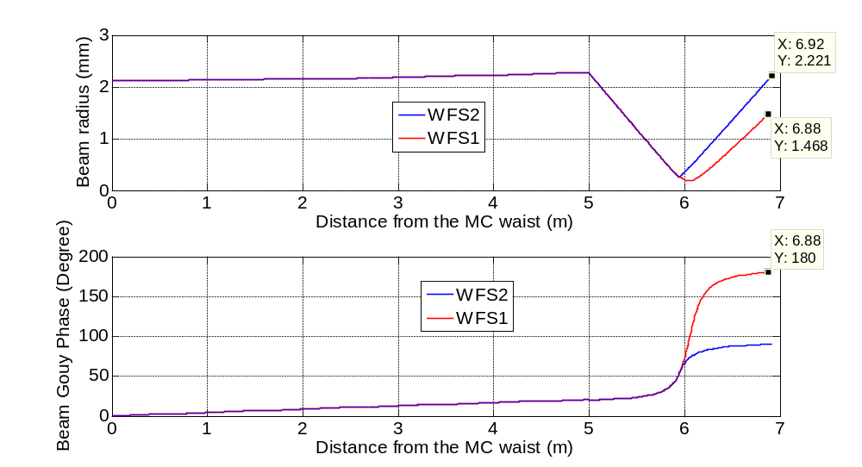

Figure 7 Beam size and Gouy phase change as a function of distance from IMC waist for the IMC WFS1 and IMC WFS2.

The parameters for the designs are shown in Table 1.
Table 1 Parameters for IMC WFS Telescopes
Definition | Unit | Value)
Definition | Unit | WFS1 | WFS2
w₁ = Waist Size in IMC | mm | 2.1 | 2.1
d₁= Distance b/w IMC waist and L₁ | m | 5 | 5
F₁ = Focal length of L₁ | mm | 1.0167 | 1.0167
Part No. for F₁ |  | PLCX-25.4-515.1-C | PLCX-25.4-515.1-C
F₂ = Focal length of L₂ | mm | -610 | -76.3
Part No. for F₂ |  | BICC-25.4-618.4-C | BICC-25.4-77.6-C
d₂= Distance b/w L₁ and L₂ | mm | 0.915 | 0.947
d₃= Distance b/w L₂ and EOM | m | 0.965 | 0.973
w₂ = Waist Size at WFS | mm | 1.46 | 2.22
The components used in this design are off-the-shelf lenses.

Refl beam / PRC
The IMC output beam will be folded via SM1 and PMMT1 through the Faraday isolator. The FI output beam will be folded via PMMT2 and SM2 such that the beam is centered on PRM and PM2.
In contrast to initial LIGO the IO beam does not has to be aligned all the way to the ITM. This is now the task of the core optics using the mirrors inside the folded stable power recycling cavity.

SM1 and PMMT1
Sensors on both mirrors:
- OSEM signals
- IO_PMMT_QPD1 and IO_PMMT_QPD2 (near and far field) on the IOT table will monitor the transmitted beam through SM2.
- Video camera view onto HR surface is possible for SM1 (see 8.2) but not necessary as long as during the initial placement of SM1 it is verified that centering on IMC3 guarantees a centered beam on SM1. Video camera view on PMMT1 is probably not possible.
Controlled: both yes. BW below AdvLIGO band.

HA1 and HA2
The Faraday isolator (FI) uses hard apertures (HA1 and HA2) to protect it from misaligned high power laser beams. These hard apertures are part of the FI and will be aligned in the optics lab prior to installing the FI in HAM2.
Sensors:
- HA1: Video camera view onto aperture from laser side, see appendix 8.3.
- HA2: Video camera view onto aperture from IF side, see appendix 8.4.
Controlled: no

PMMT2 and SM2
Sensors:
- OSEM signals
- PRM_REF_QPD1 and PRM_REF_QPD2 on the IOT table monitor the IFO reflected beam transmitted through SM2
- PMMT2: Video camera view on HR surface, see appendix 8.6. Alternatively a screen can be placed behind the mirror and a camera view onto this screen could be obtained from the beam tube between HAM2 and HAM3. The PMMT2 view can be used to align the beam coming from PMMT1 as well as from SM2.
- SM2: Video camera view, see appendix 8.7.
Controlled: yes

PRM
Not IO
Sensors:
- Video camera view. (Optional, but nice to have and easily accessible from the beam tube between HAM2 and HAM3, see appendix 8.1.
- BOSEMs control PRM with respect to frame and HAM2. An optical lever controls the HAM2 alignment
Controlled: yes

PR2
Not IO
Sensors:
- Video camera view, see appendix 8.1.
- BOSEMs control PR2 with respect to frame and HAM3. An optical lever controls the HAM3 alignment.
Controlled: yes

PR3
Not IO
Sensors:
- Video camera view, see appendix 8.1.
- See PRM
Controlled: yes

Beam through FI alignment procedure (initial alignment)
- Put all components on table in nominal positions based on layout.
- Install temporary Beam block before Adaptive Optics Element AOE2 or SM2 to avoid back reflection from PRM
- Use SM1 to center the beam on HA1.
- Center AOE1 relative to beam, re-center beam on HA1 using SM1 if needed.
- Use PMMT1 to center the beam on PMMT2.
- Move FI assembly such that beam passes through center of HA2.
- Iterate until beam is centered in on AOE1, HA1, HA2, and on PMMT2

Refl beam initial alignment
- Remove beam block
- Steer PRM such that the reflected beam hits the beam park position
- Use PMMT2 to center the beam on SM2
- Center AOE2 and check centering on SM2 again
- Use SM2 to center the beam on PR2 (weekly transmitted beam through PRM)
- Use PMMT2 to center beam on PRM
- Check and optimize centering on AOE2 and SM2
- Iterate until the beam is centered on SM2, PRM and PR2
- Align PRM – use camera view on PMMT2 to verify that the return beam is centered and on top of the incoming beam.
- Check Refl beam out of FI and check alignment on PR2
- Align last folding mirrors to route the following beams through their respective viewports:
REFL from IO_, REFL through PRM_REF, IO_PMMT through SM2, Trans MC through IO_IMC_TRNS, and IO_IMC_REF. (This is confusing). Can we delete this.

FI and refl beam optimal alignment reference and control
After closing the vacuum system, the IOT tables will be installed, the MC will be locked, the PR mirror will be kept in its nominal position and all QPDs will be installed on the IOT tables. The OSEMs are used to maintain or recover the alignment of SM1, SM2, PMMT1, PMMT2. The QPDs are used to verify that the beam directions are maintained.
A faster control loop of the beam coming from the FI and going toward PRM is part of the ASC system.

LIST OF HARDWARE
See IO/CDS Channel list.

LIST OF INTERFACES TO CDS
See IO/CDS Channel list.⁶

Frequency alignment sensing and control

The in-band alignment sensing and control is the responsibility of the ISC/ASC group. The IO group is responsible for low frequency ASC to relock the interferometer after loss of lock; the earlier described sensors will ensure this, and to compensate for any long term drifts of optical components. The same optical lever, BOSEMs, OSEMs, quad detector signals, and camera frames will generate the necessary error signals to maintain the alignment throughout the system. The bandwidth of these feedback loops will be well below the AdvLIGO band and probably even below the first resonance frequency of 0.6Hz of the IMC suspension system to simplify the cross over between this ASC system and the main ISC/ASC system. Still, both systems have to be well coordinated and the details are still TBD.

Camera Views on optical elements

IMC1, IMC2, IMC3, PRM, PR2 and PR3 HR side view
Views on the following elements are not documented with pictures as they are easily achievable from viewports on the beam tube between HAM2 and HAM3:
- IMC1 HR side
- IMC2 HR side
- IMC3 HR side
- PRM HR side
- PR2 HR side
- PR3 HR side

The remaining views are documented with 3D picture views generated in Solidworks.

SM1 HR side
This view could be obscured by PRM if the PRM is pushed back to its full range of motion. This viewport is also used to view the HA2 front side.
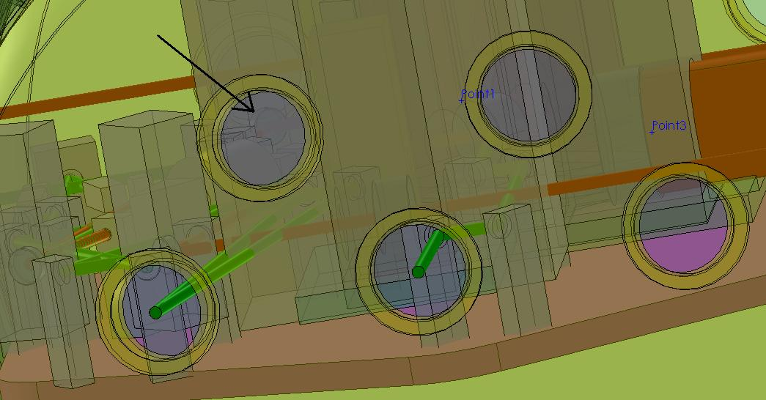
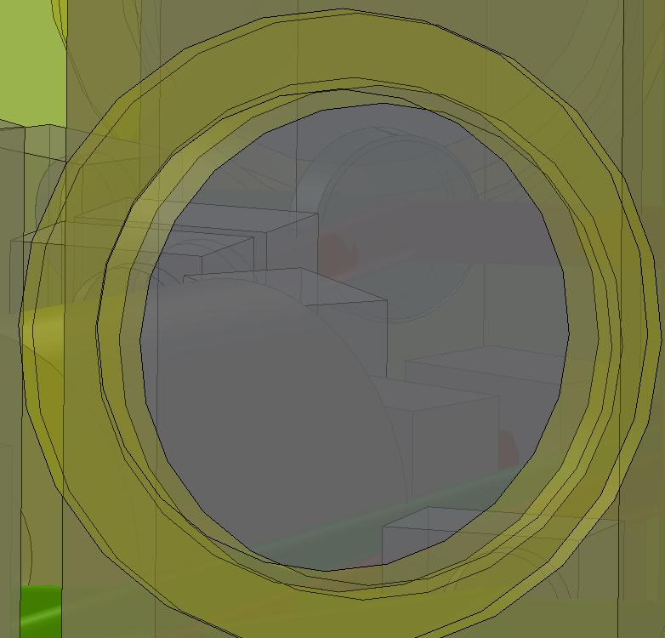

HA1 front side
This view has to look through the septum plate that separates HAM1 and HAM2. This viewport is also used to view PMMT2 HR.
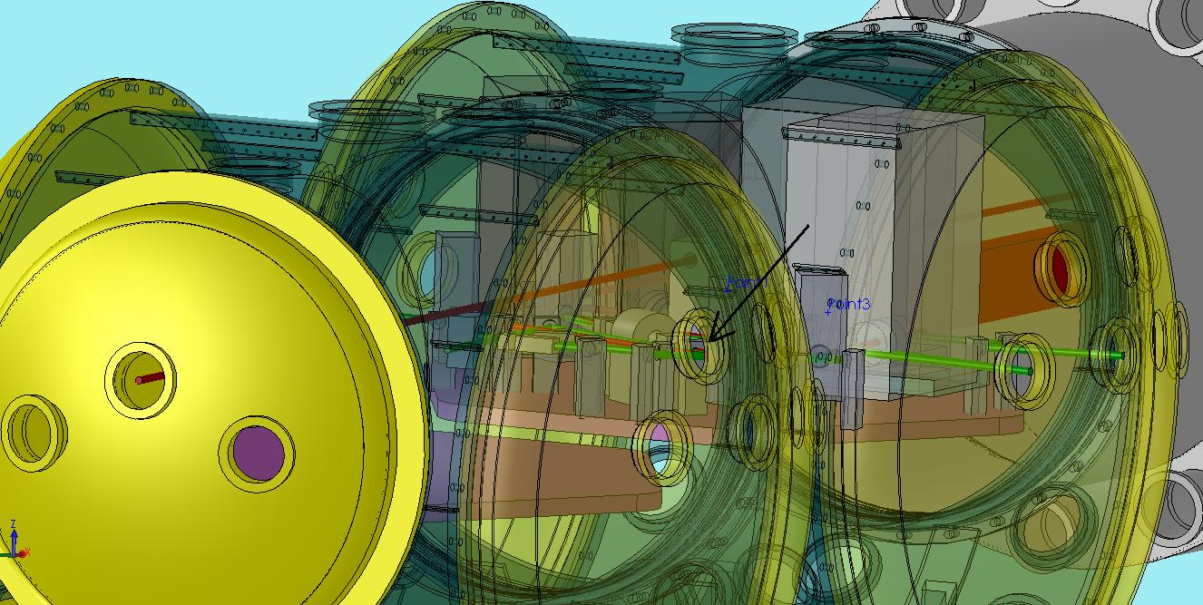

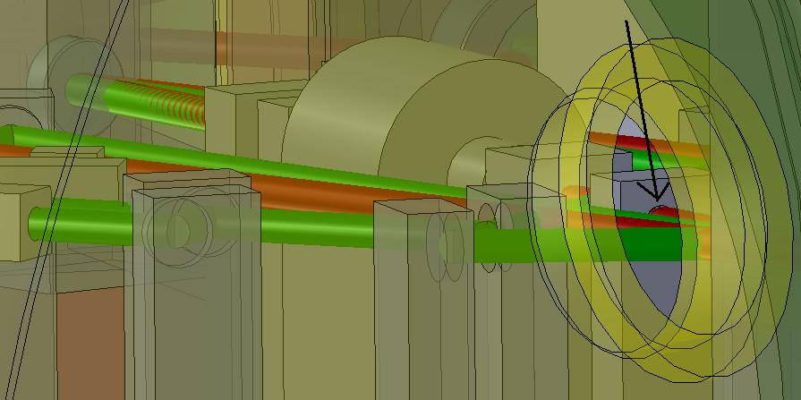

HA2 back side
This view is easily achievable.

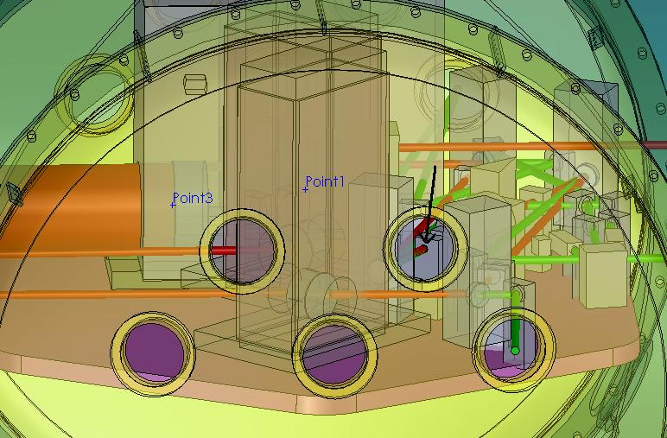

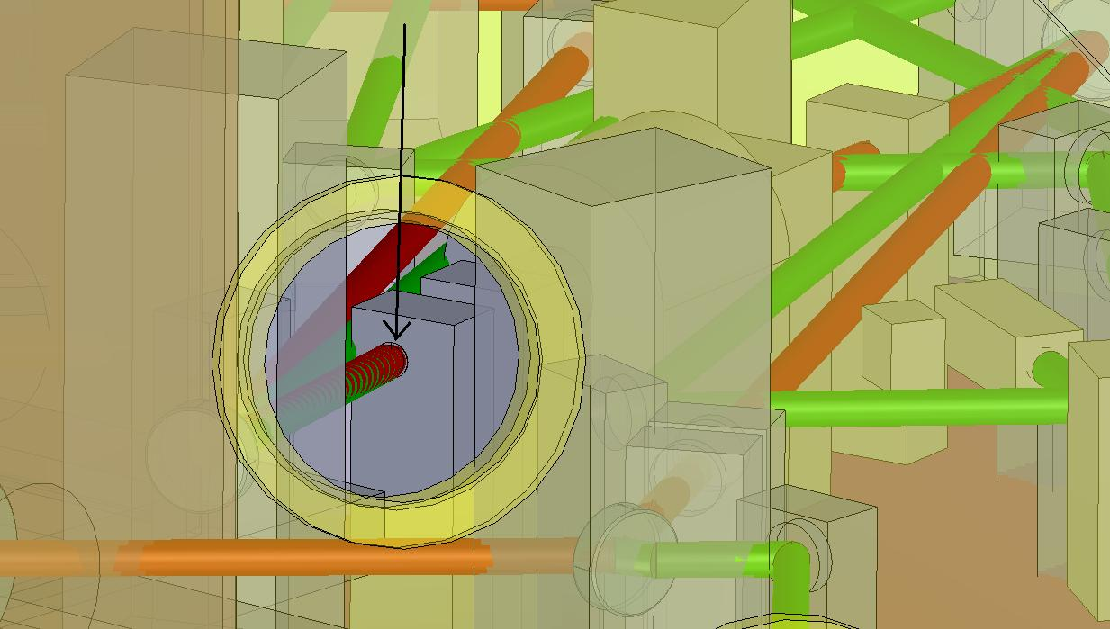

HA2 front side
The envelope for the DKDP mount blocks part of this view, although the real mount may not occupy that region of the envelope. This view can be obscured by PRM if PRM is pushed back to its full range of motion. This viewport is also used to view SM1.

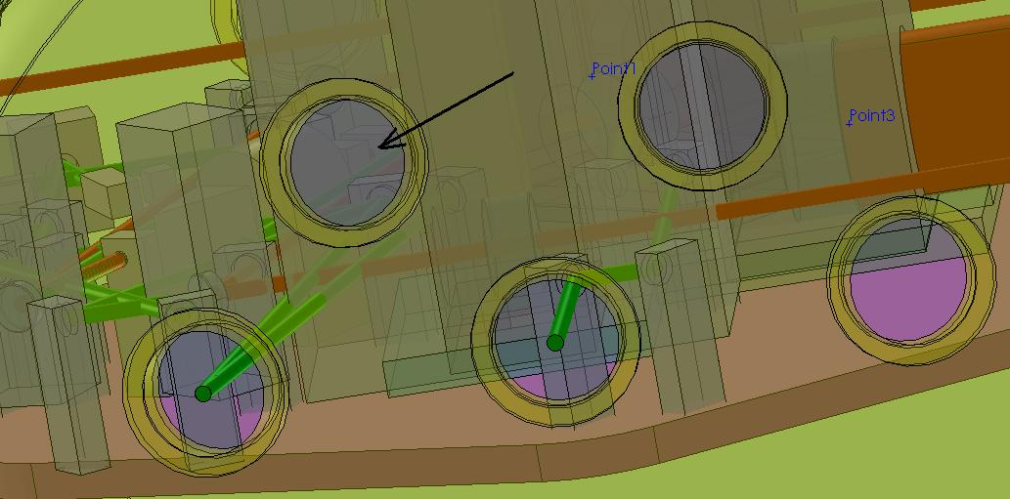

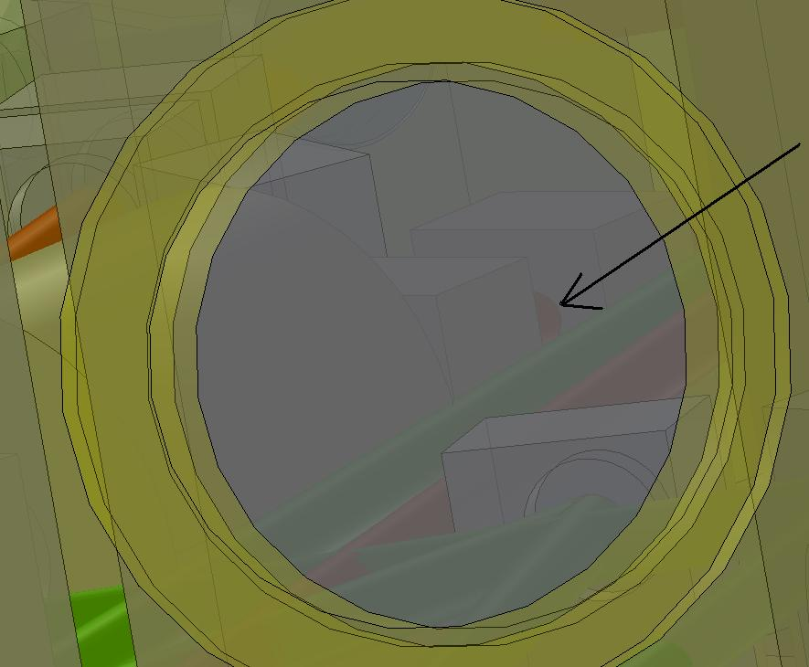

PMMT2 HR side
This view has to look through the septum plate that separates HAM1 & HAM2. This viewport is also used to view HA1 front side.

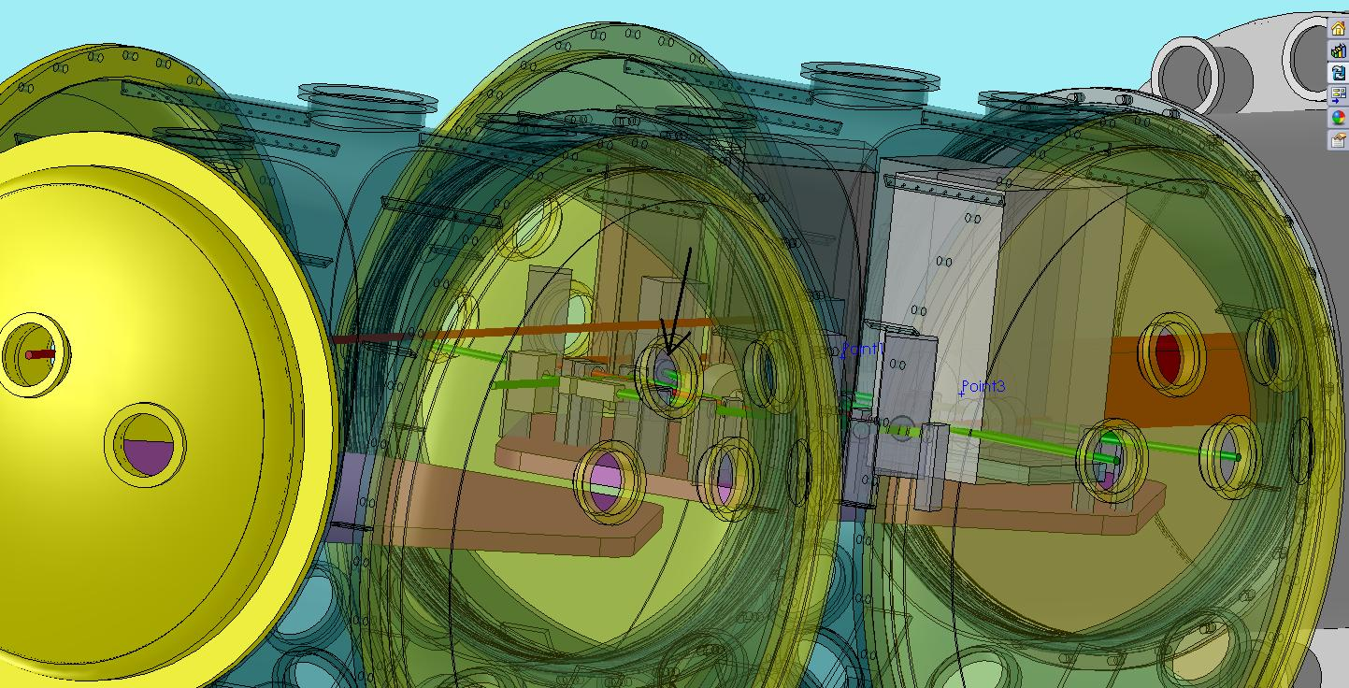
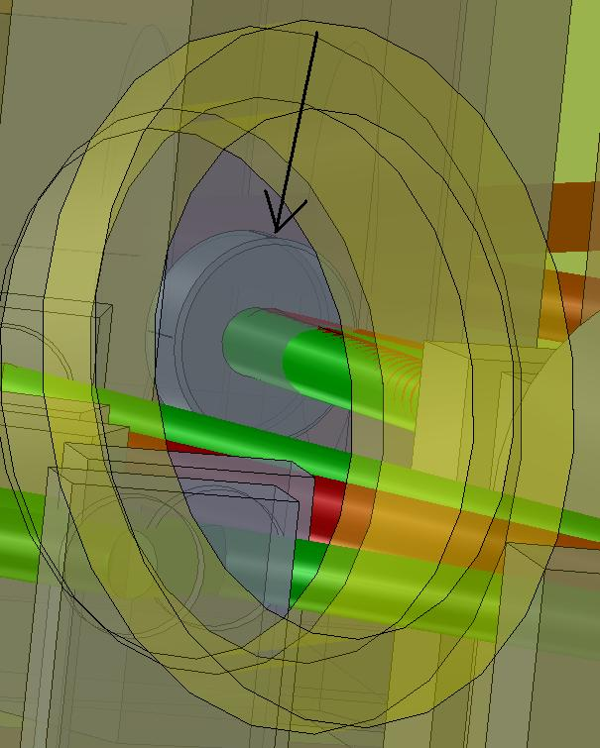

SM2 HR side
This view is best taken from the top port on the chamber, which may already be used for vacuum equipment.
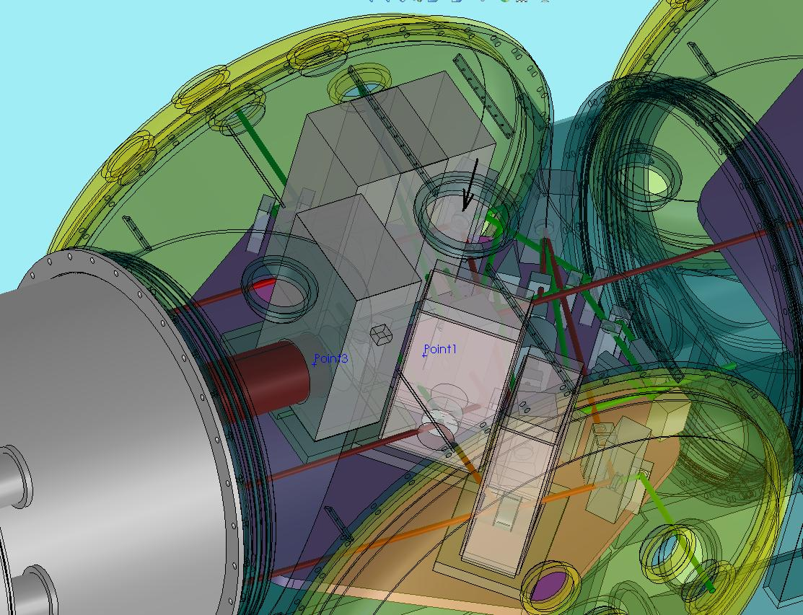
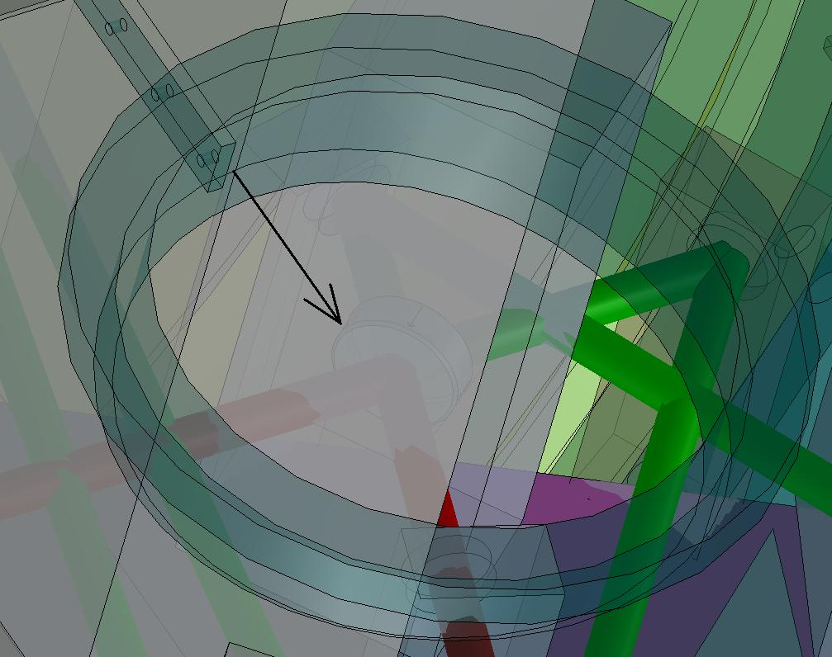

LIGO-T020020-03-D Input Optics Subsystem Design Requirements Document, M.Arain et al
LIGO-T070247-01-I AdvLIGO Interferometer Sensing and Control Conceptual Design, R. Abbott et al
Not a hard requirement, the beam diameter can be changed using a telescope.
1. Straight Interferometer IOT Layout, LIGO-D0902284, available at https://dcc.ligo.org/cgi-bin/private/DocDB/ShowDocument?docid=5943. 2. Folded Interferometer IOT Layout, LIGO-D0902285, available at https://dcc.ligo.org/cgi-bin/private/DocDB/ShowDocument?docid=5944.
This is only required for aligning/locking in air. Under vacuum conditions this beam can be significantly stronger.
David. H. Reitze, “Advanced LIGO Input Optics Channel list for CDS,” LIGO-T0900400-v1, available at https://dcc.ligo.org/cgi-bin/private/DocDB/ShowDocument?docid=4864

